A marker of glutathione S-transferase-mediated resistance to insecticides is
- associated with higher Plasmodium infection in the African malaria vector
- Anopheles funestus
4

Authors and Affiliations
- Magellan Tchouakui1,2,3*, Mu-Chun Chiang4, Cyrille Ndo1,2,5, Carine K. Kuicheu1,2,3,
- Nathalie Amvongo-Adjia1,3,6, Murielle J. Wondji1,2,4, Micareme Tchoupo1,2, Michael O.
- Kusimo2, Jacob M. Riveron 1,2,4 , Charles S. Wondji1,2,4*
9
10 1Research Unit LSTM/OCEAC P.O. BOX 288, Yaoundé, Cameroon
11
- 2Centre for Research in Infectious Diseases (CRID) P.O. BOX 13591, Yaoundé,
- Cameroon
14
- 3Department of Animal Biology and Physiology, Faculty of Science, University of
- Yaoundé 1, P.O. Box 812, Yaoundé, Cameroon
17
- 4Department of Vector Biology, Liverpool School of Tropical Medicine, Pembroke
- Place, L35QA, Liverpool, UK
20
21 5University of Douala, P.O. Box 2701, Douala, Cameroon
22
- 6 Centre for Medical Research, Institute of Medical Research and Medicinal Plants
- Studies (IMPM), P.O. Box 13033, Yaoundé, Cameroon
25
- *corresponding author; email address: charles.wondji@lstmed.ac.uk;
- mtchouakui@yahoo.fr

Abstract

- Metabolic resistance to insecticides is threatening malaria control in Africa.

- However, the extent to which it impacts malaria transmission remains unclear. Here,

- we investigated the association between a marker of glutathione S-transferase

- mediated metabolic resistance and Plasmodium infection in field population of

- Anopheles funestus s.s. in comparison to the A296S-RDL target site mutation.

- The 119F-GSTe2 resistant allele was present in southern (Obout) (56%) and

- central (Mibellon) (25%) regions of Cameroon whereas the 296S-RDL resistant allele

- was detected at 98.5% and 15% respectively. The whole mosquito Plasmodium and

- sporozoite infection rates were 57% and 14.8% respectively in Obout (n=508) and

- 19.7% and 5% in Mibellon (n=360). No association was found between L119F-

- GSTe2 genotypes and whole mosquito infection status. However, when analyzing

- oocyst and sporozoite infection rates separately, the resistant homozygote 119F/F

- genotype was significantly more associated with Plasmodium infection in Obout than

- both heterozygote (OR=2.5; P=0.012) and homozygote susceptible (L/L119)

- genotypes (OR=2.10; P=0.013). In contrast, homozygote RDL susceptible

- mosquitoes (A/A296) were associated more frequently with Plasmodium infection

- than other genotypes (OR=4; P=0.03). No additive interaction was found between

- L119F and A296S. Sequencing of the GSTe2 gene showed no association between

- the polymorphism of this gene and Plasmodium infection.

- Glutathione S-transferase metabolic resistance is potentially increasing the

- vectorial capacity of resistant An. funestus mosquitoes. This could result in a possible

- exacerbation of malaria transmission in areas of high GSTe2-based metabolic

- resistance to insecticides.

52

- Keywords: Malaria, insecticides, metabolic resistance, Glutathione S-transferase,

- Anopheles funestus, Plasmodium

55

Background

- Malaria control in Africa mainly relies on insecticide-based interventions such
- as long-lasting insecticidal nets (LLINs) and indoor residual spraying (IRS)1. A

- significant decrease in the incidence of malaria was reported between 2000 and

- 2015, with about 70% of this success credited to insecticide-based vector control
- tools1. However, the emergence of insecticide resistance in vector populations

- resulting from widespread use of insecticides in public health, combined with

- pesticide use in agriculture, is a major problem that is jeopardizing the control of
- malaria2. The two main resistance mechanisms are target-site resistance (e.g.

- knockdown resistance, kdr) and metabolic resistance through over-expression of

- detoxification genes (e.g. cytochrome P450s, glutathione S-transferases and
- esterases)3. Insecticide resistance genes are often associated with pleiotropic effects
- on mosquito life-history traits4,5 which can modify their capacity to transmit parasites
- to different hosts4,6. The fitness cost of resistant alleles could affect various vector
- life-history traits, such as adult longevity, biting behavior, and vector competence7,

- which are important components of the vectorial capacity to transmit pathogens.

- However, despite the widespread distribution of resistance, its impact on malaria

- transmission remains unclear in many malaria vectors including Anopheles funestus.

- This is particularly true for metabolic resistance mechanisms since no molecular

- markers were previously available to assess such an impact, in contrast to target-site

- resistance (such as knockdown resistance kdr) for which DNA-based diagnostic
- tools have been available for many years 8.

- A better understanding of resistance mechanisms including metabolic

- resistance and, more importantly, their impact on vector life traits and disease
- transmission, is essential to design successful resistance management strategies 9.

- A decrease in the ability of resistant mosquitoes to transmit malaria may mean
- insecticide resistance is not detrimentally impeding the control of this disease7.

- Conversely, if insecticide resistance increased the ability of resistant mosquitoes to

- infect humans, this would lead to increased malaria transmission. Only a few studies

- mostly, in An. gambiae s.s, have investigated the impact of resistance on vectorial
- capacity4,6,10,11. For example, the study of Kabula et al. (2016) in Tanzania based on
- the target-site resistance kdr marker11, showed that the infection of field populations

- of An. gambiae s.s. by Plasmodium parasites was significantly associated with vgsc-

- 1014 point mutations. Insecticide resistance was recently shown to affect the vector

- competence of this same mosquito species for P. falciparum field isolates as a higher

- prevalence of infection was observed for mutations associated with insecticide
- resistance10. The impact of resistance on vectorial capacity has yet to be examined

- for metabolic resistance which is the most common resistance mechanism in

- mosquitoes. Metabolic resistance has consistently been reported to be the main

- driver of pyrethroids and DDT resistance in the malaria vector An. funestus. No kdr
- mutation has been detected so far in this species 12 despite the widespread report of

- insecticide resistance in An. funestus populations across Africa.

- Indeed, pyrethroid resistance has been reported in various An. funestus
- populations including southern [Mozambique13,14, Malawi15,16], eastern [Uganda and
- Kenya17,18 and Tanzania 19], central [Cameroon 20,21], and western Africa [Benin 22,23,
- Ghana 24,25, Senegal26 and Nigeria23]. Noticeably, resistance to pyrethroids and DDT

- in these populations is consistently conferred by detoxification enzymes including

- glutathione S-transferases (GSTs) and cytochrome P450s. The predominance of

- metabolic resistance in this species makes it suitable to investigate the impact of

- metabolic resistance on malaria transmission. The detection of a single amino acid

- change (L119F) in the glutathione S-transferase epsilon 2 (GSTe2) gene conferring
- DDT/pyrethroid resistance in An. funestus27, further offers the opportunity to assess

- this impact. In addition, the presence of target site mutations in An. funestus such as
- the A296S-RDL associated with dieldrin resistance20 and N485I-Ace1 mutation
- associated with bendiocarb resistance28 also allows to compare the effect of

- metabolic resistance to that caused by target-site resistance on vectorial capacity of

- this vector.

- Therefore, to assess the potential impact of metabolic resistance on malaria

- transmission, we investigated the association between the L119F-GSTe2 metabolic

- resistance marker and the natural infection of Plasmodium parasites in two pyrethroid

- and DDT resistant An. funestus populations from Cameroon. We established that the

- 119F-GSTe2 resistance allele is significantly associated with Plasmodium infection in

- resistant mosquitoes.

- Results

Field collection and mosquito species identification

- One thousand blood-fed female mosquitoes were collected in Obout and

- 1,147 in Mibellon after a week of collection in each site and in at least ten houses

- randomly selected in each village. Molecular identification of mosquitoes collected in

- both localities revealed that 95% of the mosquitoes belonged to the An. funestus

- group. The remaining 5% of mosquitoes were from An. gambiae species complex.

- Nearly all the An. funestus mosquitoes belonged to An. funestus s.s as only one

- mosquito belonging to another species of the An. funestus group (An. leesoni) was

- detected in Mibellon.

- Infection rate of An. funestus by Plasmodium parasites

- In Obout, a total of 508 females (whole mosquitoes) randomly selected from

- the field collected individuals were tested for Plasmodium infection. The overall

- Plasmodium infection rate was very high in this locality with a total prevalence of

- 57.1% (Figure 1a). Among the mosquitoes tested, 23% (119/508) were infected with

- P. falciparum (falcip+), 19% (95/508) were infected with P. ovale/vivax/malariae

- (OVM+), while 14.7% (76/508) were co-infected with both falcip+ and OVM+

- (Table1). In addition, the head plus thorax and abdomen were analyzed separately in

- 81 field-collected female mosquitoes to assess the proportion of mosquitoes

- harboring the infective stage of the parasite (sporozoite) and those having the

- oocysts. This is because sporozoites are predominantly present in the salivary glands

- of mosquitoes. TaqMan assay revealed a sporozoite infection rate of 14.8% (12/81)

143 including 9.9% (8/81) falcip+, 2.5% (2/81) falcip+/OVM+ and 2.5% (2/81) OVM+.

- Oocysts were detected in 30.8%(25/81) mosquitoes including 19.7% (16/81) falcip+,

- 3.7% (3/81) falcip+/OVM+ and 7.4% (6/81) OVM+. The nested PCR performed on all

- the infected mosquitoes confirmed all the 16 falcip+ by Taqman (Figure S1a)

- whereas the three falcip+/OVM+ mosquitoes were co-infected with P. falciparum and

- P. malariae. Out of 18 OVM+ by Taqman, 14 were infected with P. malariae (Figure
- S1b) and the four remaining were not confirmed29. This observation indicates that in

- this locality, P. falciparum, and P. malariae are in circulation.

- In Mibellon, out of the 360 whole mosquitoes tested (randomly selected from

- the total mosquitoes collected), 19.7% (71/360) were infected with Plasmodium

153 parasites including 10.8% (39/360) falcip+, 4.2% (15/360) OVM+, and 4.7% (17/360)

- co-infection falcip+/OVM+ (Figure 1b). Among the 60 mosquitoes dissected for

- head/thorax and abdomen, 20% (12/60) were oocyst-positive and 5% (3/60)

- sporozoite-positive with 3.3% (2/60) falcip+, 0% (0/60) falcip+/OVM+ and 1.7% (1/60)

- OVM+. The nested PCR validation of the TaqMan assay for oocyst positive

- mosquitoes confirmed all the six falcip+ whereas the two co-infected (falcip+/OVM+)

- were confirmed as P. falciparum and P. malariae-positive. From the four OVM-

- positive by Taqman assay, two were infected with P. ovale and two with P. malariae

- showing that P. falciparum, P. ovale (Figure S1c) and P. malariae are all present in

- Mibellon.

- In both locations, a significant difference was found between mosquitoes

- harboring the oocyst stage of the parasite and those with the infective sporozoite
- stage (χ2=5.82; P=0.01 in Obout and χ2=6.12; P=0.01 in Mibellon).

Association between L119F-GSTe2 mutation and total Plasmodium

- infection

- In total, 174 whole mosquitoes (infected and uninfected randomly selected

- from the 508 tested above) from Obout were genotyped for the L119F-GSTe2

- mutation (Table 2). All genotypes were successfully detected and later validated by

- direct sequencing, supporting the robustness of the new designed Allele Specific-

- PCR assay (Figure 2a-b). The 119F-GSTe2 resistant allele was found at a frequency

- of 56.8% when combining both infected and uninfected mosquitoes. For infected

- mosquitoes, 33.7% were 119F/F homozygous resistant, 47.2% L119F-RS

- heterozygote, and 19.1% L/L119 homozygote susceptible (Figure 3a). A similar
- distribution of the three genotypes was observed for uninfected mosquitoes (x2 =

178 0.34; P=0.82) with 31.7% for 119F/F, 49.4% for L119F-RS and 18.8% for L/L119

- susceptible genotype. The lack of significant correlation between L119F-GSTe2

- genotypes and whole mosquito Plasmodium infection was further supported by odds-

- ratio estimates (Table 2).

- In Mibellon, 184 whole mosquitoes randomly selected out of the 360 field-

- collected females tested above were successfully genotyped. The overall frequency

- of 119F-GSTe2 resistant allele was 26.3% in both groups of mosquitoes (infected

- and uninfected). No difference was found in the distribution of the L119F-GSTe2
- genotypes between infected and uninfected mosquitoes (X2=0.1 P=0.95) (Figure 3b)

- (Table 2).

Association between L119F-GSTe2 and oocyst and sporozoite infection

- rates

- In Obout, the distribution of L119F-GSTe2 genotypes in mosquitoes found

- positive for oocysts by TaqMan was as follows: 28% (7/25) homozygous resistant

- (119F/F), 40% (10/25) heterozygotes (L119F-RS) and 32% (8/25) homozygous

- susceptible (L/L119F) (Figure 3c). No significant difference was observed in the

- distribution of L119F-GSTe2 genotypes between infected and uninfected mosquitoes
- (X2=3.58 P=0.17) (Table 3). At the sporozoite stage, 50% (6/12) of infected

- mosquitoes were homozygous resistant, 33% (4/12) were heterozygotes and 17%

- (2/12) were homozygous susceptible (Figure 3d) (Table 3). Contrary to the oocyst

- stage, a significant difference was observed in the distribution of L119F-GSTe2

- genotypes (using the proportions) between infected and uninfected mosquitoes
- (X2=9.79 P=0.007). Assessing the odds-ratio between sporozoite infected and

- uninfected mosquitoes showed that, homozygous resistant mosquitoes were

- significantly more likely to be infected with sporozoites compared to both

- heterozygote (OR=2.10; IC 95%: 1.11–3.97; P=0.013) and homozygous susceptible

- (OR=2.46; IC 95%: 1.15–5.26; P=0.012) mosquitoes. There was no difference

- between heterozygote and susceptible mosquitoes (OR=1.17; P=0.41) (Table 4).

- In Mibellon, the 20% (12/60) of mosquitoes positive for oocysts were

- comprised of 8.3% (1/12) 119F/F homozygous resistant, 58.3% (7/12) L119F-RS

- heterozygotes and 33.3% (4/12) L/L119 homozygous susceptible (Figure 3e). A

- significant difference was observed in the distribution of L119F-GSTe2 genotypes
- between infected and uninfected mosquitoes (X2=13.05 P=0.001) with L119F-RS

- heterozygote mosquitoes the most often infected (Table 3). Assessing the odd ratio

- showed no difference between the two groups (Table 4). At the sporozoite stage,

- only 5% (3/60) of mosquitoes were sporozoite positive and all were genotyped to be

- homozygous susceptible (Figure 3f) (Table 3). No further comparisons were done

- because of low sample size.

Association between A296S–RDL mutation and Plasmodium infection

- The RDL mutation was genotyped using gDNA extracted from 100 and 142

- whole female mosquitoes from Obout and Mibellon respectively. In Obout, all

- mosquitoes carried the resistant allele with a very high frequency of homozygous

- resistant 296S/S genotypes (97%). In contrast, in Mibellon, only 22 (15.5%) of the

- mosquitoes examined had the A296S-RDL mutation including 4 (2.8%) 296S/S

- homozygous resistant, 18 (12.7%) A296S-RS heterozygotes and 120 homozygote

- susceptible (Figure 4a). In addition, the A/A296 homozygous susceptible were

- present in a higher proportion among the infected mosquitoes (90%) compared to

- uninfected mosquitoes (79%). Assessment of the odd ratio demonstrated that

- mosquitoes that were A/A296 homozygous susceptible were more likely to be

- Plasmodium positive compared to other genotypes (OR=4; IC 95%: 1.24–12.86;

230 P=0.03) (Table S1).

231

Combined impact of L119F-GSTe2 and A296S-RDL mutations on

- Plasmodium infection

- In total, 46 samples of each batch (infected and uninfected mosquitoes) were

- used to assess the combined impact of the two resistance mechanisms on

- Plasmodium infection in in An. funestus mosquitoes (Figure 4b). The most prevalent

- combinations between both groups were (SS/SS), (RR/SS), (RS/SS) for GSTe2/RDL.

- The SS/RR and RR/RR combinations were present only among the infected

- mosquitoes whereas the RR/RS and RS/RS combinations were observed only

- among the uninfected mosquitoes. Nevertheless, no statistically significant
- differences were detected (χ2=10.5; P=0.161). A significant difference was observed

- when comparing the odds ratio at the sporozoite stage between RR/RR vs SS/RR

- (OR=INF; P˂ 0.0001) and RS/RR vs SS/RR (OR=INF; P=0.003) indicating that

- double homozygote mosquitoes (RR/RR) were more likely to be infected. However,

- no significant difference was observed at oocyst stage P≥0.16) (Table S2). This

- supports the role of the L119F-GSTe2 allele in the ability of the mosquitoes to

- develop the parasite until the infective stage.

Association between GSTe2 polymorphism and Plasmodium infection

- Genetic diversity of GSTe2: The full length of the GSTe2 gene (881bp) was

- successfully sequenced in 26 whole mosquitoes from Mibellon including 11 infected

- and 15 uninfected (Figure 5a). The genetic diversity parameters are given in Table

- S3, according to the status of infection and genotypes. Overall, 23 polymorphic sites

- defining 28 haplotypes were detected corresponding to the haplotype diversity of

- 0.96. Heterozygous and uninfected mosquitoes showed at lower number of

- polymorphic sites (3) with only 3 haplotypes (hd: 0.83). The overall nucleotide

- diversity was 0.005 with an average number of differences between nucleotides

- estimated at 4.19 showing less differences between the sequences examined. In

- addition, negative values were obtained for Fu and Li Tajima and F * tests in many

- cases.

- Distribution of haplotypes and phylogeny: Analysis of the haplotype

- network of the GSTe2 gene based on L119F genotypes of the infection status shows

- that there are five major haplotypes (H1, H2, H3, H4 and H5) responsible for the

- differentiation of haplotypes in this An. funestus field population. The ancestral

- haplotype (H1) as well as the haplotypes (H2, H3 and H4) were identified in

- mosquitoes with 119Fresistant allele. However, haplotypes H1 and H2 were found

- only in uninfected mosquitoes whereas haplotypes H3 and H4 were present in both

- infected and uninfected mosquitoes (Figure 5b-c). Moreover, the H5 haplotype was

- found to be specific for mosquitoes with the L119 susceptible allele for both infected

- and uninfected individuals (Figure 5d-e). Similarly, analysis of phylogeny between the

- haplotypes identified did not reveal any haplotype groups associated with a specific

- infection status. However, there was a global clustering according to the alleles

- associated with the L119F mutation of the GSTe2 gene (Table S3). This suggests

- that there is no association between the polymorphism of the GSTe2 gene and

- infection by Plasmodium parasite.

Discussion

- Little information exists on the impact of metabolic resistance on the ability of

- mosquitoes to transmit Plasmodium parasites. This study is among the first to assess

- the association between metabolic resistance and vectorial capacity of natural

- populations of malaria vectors. We took advantage of the recent detection of the

- glutathione S-transferase L119F-GSTe2 marker in An. funestus to investigate the

- relationship between metabolic resistance and vectorial capacity in field collected

- mosquitoes. Mosquitoes used were collected from the same population at the same

- time for them to share a common genetic background but differ only by the presence

- of the resistant alleles to specifically discriminate this trait. Thus, any difference

- observed between the three genotypes would directly be associated with the

- insecticide resistance alleles.

- Role of An. funestus in malaria transmission

- An. funestus s.s. was found to be the most abundant mosquito species from

- the indoor collection in the two study sites correlating with the indoor feeding/resting

- behavior of this species and supported by the presence of permanent large pools of

- water in both locations. An. funestus s.s. is playing a major role in malaria

- transmission in these areas with a very high infection rate recorded at all stages

- including sporozoite infection rates (14.8% in Obout and 5% in Mibellon) in field

- collected females’ mosquitoes. The high infection rate observed in Obout and

- Mibellon for An. funestus s.s. is similar to high levels of infection rates recorded
- previously for this species across the continent such as 20%30 and 50%31 observed
- in Burkina Faso, 13.6%32 and 18%33 observed in Benin and 12.5% in Ghana25.

- Although, some of the variations between these rates could be attributed to the

- differences in the detection methods used (TaqMan, ELISA and Nested-PCR), the

- consistently high levels of infection support a high vectorial capacity of An. funestus

- across the continent. This is of great concern for malaria control as it shows that

- despite ongoing control interventions, the level of malaria transmission could remain

- high in areas where An. funestus is the dominant vector. In this study, we noticed that

- P. falciparum was the predominant malaria parasite in both study sites. However, the

- detection of other malaria parasites, although at lower frequencies, is an indication

- that control and elimination efforts should not ignore other Plasmodium species

- especially P. malariae.

Distribution of L119F-GSTe2 metabolic and A2926S target site resistance

- markers

- It was previously demonstrated that a single amino acid change (L119F) in the

- over-expressed GSTe2 enzyme in An. funestus s.s confers resistance against DDT
- and cross-resistance to permethrin in West Africa 27. The L119F mutation was

- detected in both localities with a higher frequency of the resistant allele in Obout. This

- resistance mechanism could have been selected in this population either by past
- DDT based IRS34 or by the scale up of pyrethroid-based LLINs. The presence of this

- resistance marker at high frequency in Obout supports previous observation in
- northern Cameroon (Gounougou) by Menze et al.21 suggesting that this mutation is

- strongly associated with DDT and permethrin cross resistance in Western and
- Central Africa 21,27,33. In Mibellon, the 119F-GSTe2 mutation was found at a lower

- frequency for the 119F-GSTe2 resistant allele (26.3%). Two hypotheses may explain

- this: either the mutation was recently introduced in that population or that a recent

- insecticide selection pressure is favoring its presence now.

- The A296S-RDL mutation in the GABA receptor gene associated with dieldrin

- resistance is fixed in the Obout population. In contrast, this mutation was found only

- at very low frequency in Mibellon. The high frequency of 296S resistant allele in An.

- funestus field populations from Obout is intriguing since cyclodienes are no longer

- used for vector control in Cameroon. It has previously been shown that dieldrin

- resistant mosquitoes exhibit significant fitness costs including behaviour and mating
- competitiveness35,36 that should lead to a decrease in the frequency of the resistant

- allele from the population overtime. Therefore, reversal of the resistance was

- expected in this field population in the absence of dieldrin selection pressure. The

- persistence of this dieldrin resistance marker in the An. funestus field population

- from Obout may be associated with the use of pesticides in the agricultural sector
- such as fipronil or lindane acting on same GABA receptor as dieldrin 37. A population

- of An. gambiae fully resistant to dieldrin (100% RR) was reported in 1961 in
- Mbalmayo, a location of south Cameroon close to Obout 38. This suggests also that

- the A296S resistant allele in An. funestus population in Obout could have become

- fixed before the removal of dieldrin as a vector control tool, thereby limiting the

- possibility of reversing dieldrin resistance.

Impact of L119F-GSTe2 metabolic and A2926S target site resistances on

- Plasmodium infection

- We did not detect any significant differences between L/L119 homozygote

- susceptible, L119F-RS heterozygote and 119F/F homozygote resistant genotypes

- and P. falciparum oocyst infection. However, mosquitoes with the A/A296 RDL

- susceptible genotype were found to be more often infected with Plasmodium

- parasites. It has previously been demonstrated that insecticide resistance

- mechanisms may alter the vector competence of the mosquito by affecting parasite

- development or susceptibility of the host to infection. This trend was not observed in

- this study for the A296S-RDL mutation. In a study assessing the link between

- insecticide resistance and vector competence, Alout and collaborators demonstrated

- that target site mutations (kdr and ace-1R) increased the prevalence of P. falciparum

- infection in pyrethroid resistant An. gambiae compared to their susceptible
- counterparts10. However, despite a higher prevalence of infection, the kdr resistant
- mosquito strain was found to harbour lower malaria parasite (oocyst) load10. Many

- factors can influence the ability of mosquitoes to be successfully infected by

- Plasmodium and harbour the parasites throughout their developmental stages until

- the sporozoite stage. Therefore, pleiotropic effects of insecticide resistance, immunity

- activation and other fitness related traits may be altered. McCarroll et al reported that

- insecticide resistance in Culex quinquefasciatus mosquitoes had negative effect on
- the parasitic worm Wuchereria bancrofti, which causes human lymphatic filariasis4,39.
- Furthermore, vector immunity could also be affected by insecticide resistance7. A

- possible link between resistance and mosquito immunity was observed when a gene

- driving pyrethroid resistance was up-regulated in the mosquito mid-gut infected with
- malaria parasites40. An. gambiae with metabolic resistance has also been shown to
- have increased infection rates compared to controls10. However, esterase

- metabolism or ace-1 mutation (target site resistance) did not appear to effect the
- infection rates or parasitic load in Culex pipiens mosquitoes6. Oxidative stress is part

- of the mosquito’s immune response against Plasmodium but may be neutralised by

- overproduction of GSTs. Previously, GST resistance mechanisms were shown to

- protect tissues from oxidative damage in plant hoppers and increase longevity in fruit

- flies 41. Therefore, neutralising oxidative stress could potentially predispose

- mosquitoes to higher parasite infection.

Assessing the association between the L119F-GSTe2 mutation and the

- ability of mosquitoes to develop malaria parasites to the sporozoite stage

- The high sporozoite infection rate of 14.8% observed in Obout was similar to

- recent observations in some GSTe2 related insecticide resistant populations of An.
- funestus in Benin33 and in Democratic Republic of Congo42. On the other hand, it was

- higher than the infection rates recorded in other pyrethroid resistant An. funestus
- populations in southern Africa such as in Malawi (4.8%)43 or in many African
- countries for other malaria vectors such as An. gambiae11,22. This high Plasmodium

- infection rate in An. funestus highlights the active transmission of malaria in southern

- Cameroon by this species. Furthermore, a significant association was found between

- the 119F/F-GSTe2 resistant genotype and the presence of P. falciparum sporozoite

- in An. funestus in Obout. The sporozoite infection rate in 119F/F homozygous

- resistant mosquitoes was three times higher than that of the homozygous susceptible

- mosquitoes. This suggests that parasites developed better in resistant mosquitoes

- than in susceptible counterparts which should be a cause for concern as possession

- of this resistance allele may potentially be allowing higher malaria transmission. A

- similar result was previously found in An. gambiae s.s. for the target-site vgsc-
- L1014S mutation11. The association between Plasmodium sporozoite infection and

- GSTe2-based resistant mosquitoes observed in this study could be due to three main

- possibilities. First, this could be caused by the phenotypic expression of L119F-

- GSTe2 such that the 119F/F homozygous resistant mosquitoes could live longer due

- to their ability to withstand exposure to insecticides in the field. In this case they are

- more likely to allow the Plasmodium parasites to complete their extrinsic incubation

- period compared to homozygous susceptible mosquitoes. This suggestion is

- supported by the fact that glutathione S-transferases have been shown to be
- associated with resistance27 and also to protect insect tissues from the damaging

- effects of oxidative stress and extent life span of insects by increasing solubility and
- excretion of free radicals44-47. The second possibility of the higher likelihood of

- sporozoite infection in mosquitoes with GSTe2-119F/F genotype is that insecticide

- resistance could alter mosquito immunity. Indeed, it is possible as suggested
- previously 47 that the over-expression of GSTs in homozygous mosquitoes could be

- protecting Plasmodium parasites against the damaging effects of reactive oxidative

- species (ROS). These ROS are known as key component of the mosquito immune
- responses against Plasmodium infection48. It is likely that over-expression of GSTs

- may affect parasite development or susceptibility of the mosquito to infection by

- neutralizing the oxidative response of the 119F/F mosquitoes to Plasmodium and

- thus potentially increasing their susceptibility to infection. This will need to be fully

- established possibly through experimental infection studies. Thirdly, the higher

- Plasmodium infection rate seen in homozygous resistant 119F/F mosquitoes could

- be due the potential reduction of immune-competence through a resource trade-off

- between increased over-expression of GSTs and the mosquito’s immune response. It

- has been shown that when certain energy resources are redirected towards the

- production of large amounts of detoxification enzymes such as GSTs, a resource-
- based trade-off is usually involved and affects the vector immuno-competence49. As

- a result, there is likely to be a depletion of energy resources which limits the vector’s

- ability to mount a sufficient immune response against Plasmodium leading to

- increased infection in those resistant mosquitoes as observed in our study. However,

- more studies are needed to establish the extent to which insecticide resistance

- affects the mosquito’s vectorial capacity to confirm the impact of resistance on

- malaria transmission.

Conclusion

- This study investigated the association between a molecular marker of GST-

- mediated metabolic resistance and Plasmodium infection in natural populations of a

- major malaria vector, An. funestus. The study revealed that mosquitoes that were

- homozygous for the resistance allele were more likely to harbor Plasmodium

- sporozoites. This suggests that the proliferation of this metabolic resistance marker

- could exacerbate malaria transmission in the field and thus have important public

- health consequences.

Methods

- Study site and sample collection

- Mosquito collections were performed in Cameroon in May 2016 and February

- 2017 in Obout (Southern Region, 3°28'17.0"N 11°44'09.4"E) and Mibellon
- (Adamaoua Region, 6°46’N, 110 70’E) for one week per site. Prior to mosquito

- collection, verbal consent was obtained from the village council chairpersons and

- from each household representative. Indoor resting female mosquitoes were

- collected using electric aspirators in both locations and transported to the insectary of

- LSTM Research Unit at OCEAC in Yaoundé, Cameroon.

DNA extraction

- Genomic DNA (gDNA) was extracted via the LIVAK method 50. Following

- extraction, NanoDrop™ spectrophotometer (Thermo Scientific, Wilmington, USA)

- was used to determine the concentration and purity of the extracted gDNA before

- storage at -20ºC.

Species identification

- The females used for oviposition were morphologically identified using the key
- of Gillies and De Meillon51. Molecular identification was achieved through a cocktail
- polymerase chain (PCR) reaction described by Koekemoer52 to determine species

- composition of An. funestus group in the two study sites.

- Detection of Plasmodium parasites
- A TaqMan assay described by Bass et al. 29 was used to establish the

- Plasmodium infection status of field collected mosquitoes. Two probes were used in

- this assay. The first, labelled with FAM, detects P. falciparum, and the second,

- labelled with VIC, to detect P. vivax, P. ovale and/or P. malariae (OVM). Firstly,

- gDNA was extracted from the whole mosquitoes to assess the overall proportion of

- An. funestus infected by Plasmodium parasites in the field. Secondly, another sets of

- field collected mosquitoes were dissected in two parts: the abdomens, used for the

- detection of Plasmodium infection at the oocyst stage, and the head plus thorax for

- the assessment of sporozoite infection rate. Results of TaqMan assay were
- confirmed by performing a nested PCR assay as previously described53.

Genotyping of the L119F-GSTe2 mutation

- The L119F-GSTe2 mutation previously shown to play a major role in DDT and
- permethrin resistance in An. funestus27 was genotyped in F0 field-collected
- mosquitoes using a newly designed allele-specific PCR (AS-PCR) diagnostic assay.

- Two pairs of primers were needed for the AS-PCR (two outer and two inner primers).

- Specific primers were designed manually to match the mutation and an additional
- mismatched nucleotide was added in the 3th nucleotide from the 3′ end of each inner

- primer to enhance the specificity. More details on the primer sequences are given in

- Table S4. PCR was carried out using 10 mM of each primer and 1ul of genomic DNA

- as template in 15 μl reactions containing 10X Kapa Taq buffer A, 0.2 mM dNTPs,

- 1.5 mM MgCl2, 1U Kapa Taq (Kapa biosystems). The cycle parameters were: 1 cycle

- at 95°C for 2 min; 30 cycles of 94°C for 30 s, 58°C for 30 s, 72°C for 1min and then a

- final extension step at 72°C for 10 min. PCR products were separated on 2%

- agarose gel by electrophoresis. This method detects homozygote resistant (119F/F)

- at 523bp, homozygote susceptible (L119F-RS) at 312bp, and heterozygote (L/L119)

- with both bands. Association between the GSTe2 mutation and malaria transmission

- potential was assessed by calculating the odds ratio of sporozoite infection rate

- between the homozygous resistant (119F/F), heterozygote (L119F-RS) and

- homozygous susceptible (L/L119) individuals compared to uninfected individuals,

- with statistical significance was computed based on the Fisher’s exact probability

- test.

Association between the genetic diversity of the GSTe2 gene and

- Plasmodium infection in An. funestus

- The entire GSTe2 gene of 881bp in An. funestus was amplified in 26 whole

- mosquitoes [11 infected by Plasmodium parasites (both stages) and 15 non-infected].

- Two primers; GSTe2F, 5’GGA ATT CCA TAT GAC CAA GCT AGT TCT GTA CAC

- GCT 3’ and GSTe2R, 5’ TCT AGA TCA AGC TTT AGC ATT TTC CTC CTT 3’ were

- used to amplify the gene in 15 μl reaction containing 10mM of each primer, 10X Kapa

- Taq buffer A, 0.2 mM dNTPs, 1.5 mM MgCl2, 1U Kapa Taq (Kapa biosystems). PCR

- conditions were 1 cycle at 95°C for 5 min; 30 cycles of 94°C for 30 s, 55°C for 30 s,

- 72°C for 1min and then final extension at 72°C for 10 min. PCR product was firstly

- visualized on 1.5% agarose gel stained with Midori green dye (Nippon Genetics

- Europe, Germany) and then purified using ExoSAP (Thermo Fisher Scientific,

- Waltham, MA, USA) according to manufacturer recommendations and directly

- sequenced on both strands. Sequences were visualized and corrected using BioEdit
- v7.2.5 software 54. Alignment of these sequences was done using ClustalW Multiple
- Alignment integrated in BioEdit 55. Genetic diversity parameters were assessed using
- DnaSP v5.10.01 56 and MEGA v7.0.21 57 softwares.

Genotyping of the A296S-RDL GABA receptor mutation

- To compare the role of metabolic resistance to that of target-site resistance

- mechanism, we genotyped the A296S-RDL mutation associated with dieldrin
- resistance 58 in Plasmodium infected and uninfected mosquitoes. The A296S-RDL
- mutation was genotyped using a protocol previously described by Riveron et al43.

- Furthermore, the combined effect of harboring both alleles of A296S-RDL and

- L119F-GSTe2 on the infection status of field collected mosquitoes was also

- assessed.

Additional Information

- Competing interests

- The authors declare that they have no competing interests.

- Author contributions: C.S.W. conceived and designed the study; M.C.C., J.

- M.R., and M.T. carried out the sample collection and performed WHO susceptibility

- assays; M.T., M.C.C., M.J.W., C.K.K., M.K and M.T. performed the Molecular

- analyses; M.T., N.A.A., C.K.K., C.N., J.M.R. and C.S.W. analyzed the data. M.T.,

- J.M.R. and C.S.W. wrote the manuscript with contribution from other co-authors. All

- authors read and approved the final manuscript.

Acknowledgements

- This study was funded by a Wellcome Trust Senior Fellowship in Biomedical

- Sciences to CSW (101893/13/Z).

References

- 1 Bhatt, S. et al. The effect of malaria control on Plasmodium falciparum in Africa between 537 2000 and 2015. Nature 526, 207 (2015).
538 2 Ranson, H. & Lissenden, N. Insecticide Resistance in African Anopheles Mosquitoes: A
539 Worsening Situation that Needs Urgent Action to Maintain Malaria Control. Trends Parasitol
540 32, 187-196, doi:10.1016/j.pt.2015.11.010 (2016).
- 3 Alout, H., Labbé, P., Chandre, F. & Cohuet, A. Malaria vector control still matters despite
- insecticide resistance. Trends in parasitology 33, 610-618 (2017).
- 4 McCarroll, L. & Hemingway, J. Can insecticide resistance status affect parasite transmission in
- mosquitoes? Journal Insect Biochemistry and Molecular Biology 32, 1345–1351 (2002).
- 5 Raymond, M., Berticat, C., Weill, M., Pasteur, N. & Chevillon, C. in Microevolution Rate,
- Pattern, Process 287-296 (Springer, 2001).
- 6 Vezilier, J., Nicot, A., Gandon, S. & Rivero, A. Insecticide resistance and malaria transmission:
- infection rate and oocyst burden in Culex pipiens mosquitoes infected with Plasmodium
- relictum. Malaria Journal 9 (2010).
- 7 Rivero, A., Vézilier, J., Weill, M., Read, A. F. & Gandon, S. Insecticide Control of Vector-Borne
- Diseases: When Is Insecticide Resistance a Problem? PLoS Pathog 6, e1001000, 552 doi:10.1371/journal.ppat.1001000 (2010).
553 8 Martinez-Torres, D. et al. Molecular characterization of pyrethroid knockdown resistance
554 (kdr) in the major malaria vector Anopheles gambiae s.s. Insect Mol Biol 7, 179-184 (1998).
555 9 WHO. Global plan for insecticide resistance management in malaria vectors (GPIRM). 2012. 556 ISBN 978, 4 (2012).
557 10 Alout, H. et al. Insecticide resistance alleles affect vector competence of Anopheles gambiae
558 s.s. for Plasmodium falciparum field isolates. PLoS ONE 8, e63849 (2013).
559 11 Kabula, B. et al. A significant association between deltamethrin resistance, Plasmodium
560 falciparum infection and the Vgsc-1014S resistance mutation in Anopheles gambiae
561 highlights the epidemiological importance of resistance markers. Malar J 15, 289, 562 doi:10.1186/s12936-016-1331-5 10.1186/s12936-016-1331-5 [pii] (2016).

563 12 Irving, H. & Wondji, C. S. Investigating knockdown resistance (kdr) mechanism against
564 pyrethroids/DDT in the malaria vector Anopheles funestus across Africa. BMC Genet 18, 76, 565 doi:10.1186/s12863-017-0539-x (2017).
566 13 Casimiro, S. L., Hemingway, J., Sharp, B. L. & Coleman, M. Monitoring the operational impact
567 of insecticide usage for malaria control on Anopheles funestus from Mozambique. Malar J 6, 568 142, doi:1475-2875-6-142 [pii] 10.1186/1475-2875-6-142 (2007).

569 14 Cuamba, N., Morgan, J. C., Irving, H., Steven, A. & Wondji, C. S. High level of pyrethroid
570 resistance in an Anopheles funestus population of the Chokwe District in Mozambique. PLoS
571 One 5, e11010, doi:10.1371/journal.pone.0011010 (2010).
572 15 Hunt, R. H., Edwardes, M. & Coetzee, M. Pyrethroid resistance in southern African Anopheles
573 funestus extends to Likoma Island in Lake Malawi. Parasites & Vectors 3, 122, 574 doi:10.1186/1756-3305-3-122 (2010).
575 16 Wondji, C. S. et al. Impact of pyrethroid resistance on operational malaria control in Malawi. 576 Proc Natl Acad Sci U S A 109, 19063-19070, doi:10.1073/pnas.1217229109 (2012).
577 17 Morgan, J. C., Irving, H., Okedi, L. M., Steven, A. & Wondji, C. S. Pyrethroid resistance in an
578 Anopheles funestus population from Uganda. PLoS One 5, e11872, 579 doi:10.1371/journal.pone.0011872 (2010).
580 18 Mulamba, C. et al. Widespread pyrethroid and DDT resistance in the major malaria vector
581 Anopheles funestus in East Africa is driven by metabolic resistance mechanisms. PLoS One 9, 582 e110058, doi:10.1371/journal.pone.0110058 (2014).

583 19 Lwetoijera, D. W. et al. Increasing role of Anopheles funestus and Anopheles arabiensis in
584 malaria transmission in the Kilombero Valley, Tanzania. Malar J 13, 331, doi:10.1186/1475- 585 2875-13-331 1475-2875-13-331 [pii] (2014).

586 20 Wondji, C. S. et al. Identification and distribution of a GABA receptor mutation conferring
587 dieldrin resistance in the malaria vector Anopheles funestus in Africa. Insect Biochem Mol
588 Biol 41, 484-491, doi:S0965-1748(11)00080-4 [pii] 10.1016/j.ibmb.2011.03.012 (2011).

589 21 Menze, B. D. et al. Multiple Insecticide Resistance in the Malaria Vector Anopheles funestus
590 from Northern Cameroon Is Mediated by Metabolic Resistance Alongside Potential Target
591 Site Insensitivity Mutations. PLoS One 11, e0163261, doi:10.1371/journal.pone.0163261 592 (2016).
593 22 Djouaka, R., Irving, H., Tukur, Z. & Wondji, C. S. Exploring Mechanisms of Multiple Insecticide
594 Resistance in a Population of the Malaria Vector Anopheles funestus in Benin. PLoS One 6, 595 e27760, doi:10.1371/journal.pone.0027760 (2011).
596 23 Djouaka, R. J. et al. Evidence of a multiple insecticide resistance in the malaria vector
597 Anopheles funestus in South West Nigeria. Malar J 15, 565, doi:10.1186/s12936-016-1615-9 598 (2016).
599 24 Okoye, P. N., Brooke, B. D., Koekemoer, L. L., Hunt, R. H. & Coetzee, M. Characterisation of 600 DDT, pyrethroid and carbamate resistance in Anopheles funestus from Obuasi, Ghana. Trans 601 R Soc Trop Med Hyg 102, 591-598, doi:S0035-9203(08)00094-1 [pii] 602 10.1016/j.trstmh.2008.02.022 (2008).

603 25 Riveron, J. M. et al. Multiple insecticide resistance in the major malaria vector Anopheles 604 funestus in southern Ghana: implications for malaria control. Parasit Vectors 9, 504, 605 doi:10.1186/s13071-016-1787-8 (2016).
606 26 Samb, B. et al. Investigating molecular basis of lambda-cyhalothrin resistance in an 607 Anopheles funestus population from Senegal. Parasit Vectors 9, 449, doi:10.1186/s13071- 608 016-1735-7 (2016).
609 27 Riveron, J. M. et al. A single mutation in the GSTe2 gene allows tracking of metabolically- 610 based insecticide resistance in a major malaria vector. Genome Biol 15, R27, doi:10.1186/gb- 611 2014-15-2-r27 (2014).
612 28 Ibrahim, S. S., Ndula, M., Riveron, J. M., Irving, H. & Wondji, C. S. The P450 CYP6Z1 confers 613 carbamate/pyrethroid cross-resistance in a major African malaria vector beside a novel 614 carbamate-insensitive N485I acetylcholinesterase-1 mutation. Mol Ecol 25, 3436-3452,
615 doi:10.1111/mec.13673 (2016).
616 29 Bass, C. et al. PCR-based detection of Plasmodium in Anopheles mosquitoes: a comparison 617 of a new high-throughput assay with existing methods. Malar.J. 7:177., 177 (2008).
618 30 Dabire, K. R. et al. Anopheles funestus (Diptera: Culicidae) in a humid savannah area of 619 western Burkina Faso: bionomics, insecticide resistance status, and role in malaria 620 transmission. J Med Entomol 44, 990-997 (2007).
621 31 Costantini, C., Sagnon, N., Ilboudo-Sanogo, E., Coluzzi, M. & Boccolini, D. Chromosomal and 622 bionomic heterogeneities suggest incipient speciation in Anopheles funestus from Burkina 623 Faso. Parassitologia 41, 595-611 (1999).
624 32 Sandeu, M. M. et al. Optimized Pan-species and speciation duplex real-time PCR assays for 625 Plasmodium parasites detection in malaria vectors. PLoS One 7, e52719, 626 doi:10.1371/journal.pone.0052719 PONE-D-12-23281 [pii] (2012).

627 33 Djouaka, R. et al. Multiple insecticide resistance in an infected population of the malaria 628 vector Anopheles funestus in Benin. Parasit Vectors 9, 453, doi:10.1186/s13071-016-1723-y 629 (2016).

630 34 Antonio-Nkondjio, C. et al. Review of the evolution of insecticide resistance in main malaria 631 vectors in Cameroon from 1990 to 2017. Parasites & Vectors 10, 472, doi:10.1186/s13071-
632 017-2417-9 (2017).
633 35 Rowland, M. Behaviour and fitness of γHCH/dieldrin resistant and susceptible female 634 Anopheles gambiae and An.stephensi mosquitoes in the absence of insecticide. Medical and 635 Veterinary Entomology 5, 193-206, doi:10.1111/j.1365-2915.1991.tb00542.x (1991).
636 36 Rowland, M. Activity and mating competitiveness of gamma HCH/dieldrin resistant and 637 susceptible male and virgin female Anopheles gambiae and An.stephensi mosquitoes, with 638 assessment of an insecticide-rotation strategy. Med Vet Entomol 5, 207-222 (1991).
639 37 Tantely, M. L. et al. Insecticide resistance in Culex pipiens quinquefasciatus and Aedes 640 albopictus mosquitoes from La Reunion Island. Insect Biochem Mol Biol 40, 317-324, 641 doi:S0965-1748(10)00034-2 [pii] 10.1016/j.ibmb.2010.02.005 (2010).

642 38 Gariou, J. & Mouchet, J. [Appearance of a dieldrin-resistant strain of Anopheles gambiae in 643 the antimalaria campaign zone in southern Cameroon's]. Bull Soc Pathol Exot Filiales 54, 870- 644 875 (1961).
645 39 McCarroll, L. et al. Insecticides and mosquito-borne disease. Nature 407, 961 (2000).
646 40 Felix, R. C., Muller, P., Ribeiro, V., Ranson, H. & Silveira, H. Plasmodium infection alters 647 Anopheles gambiae detoxification gene expression. BMC Genomics 11, 312, 648 doi:10.1186/1471-2164-11-312 (2010).
649 41 McElwee, J. J. et al. Evolutionary conservation of regulated longevity assurance mechanisms. 650 Genome Biol 8, R132, doi:10.1186/gb-2007-8-7-r132 (2007).
651 42 Riveron, J. M., Watsenga, F., Irving, H., Irish, S. R. & Wondji, C. S. High Plasmodium Infection 652 Rate and Reduced Bed Net Efficacy in Multiple Insecticide-Resistant Malaria Vectors in 653 Kinshasa, Democratic Republic of Congo. The Journal of infectious diseases 217, 320-328, 654 doi:10.1093/infdis/jix570 (2018).
655 43 Riveron, J. M. et al. Rise of multiple insecticide resistance in Anopheles funestus in Malawi: a 656 major concern for malaria vector control. Malar J 14, 344, doi:10.1186/s12936-015-0877-y 657 10.1186/s12936-015-0877-y [pii] (2015).

658 44 Parkes, T. L., Hilliker, A. J. & Phillips, J. P. Genetic and biochemical analysis of glutathione-S- 659 transferase in the oxygen defense system of Drosophila melanogaster. Genome 36, 1007- 660 1014 (1993).
661 45 Hayes, J. D. & McLellan, L. I. Glutathione and glutathione-dependent enzymes represent a co- 662 ordinately regulated defence against oxidative stress. Free Radic Res 31, 273-300 (1999).
663 46 Vontas, J. G., Small, G. J. & Hemingway, J. Glutathione S-transferases as antioxidant defence 664 agents confer pyrethroid resistance in Nilaparvata lugens. Biochem J 357, 65-72 (2001).
665 47 Rivero, A., Vézilier, J., Weill, M., Read, A. F. & Gandon, S. Insecticide Control of Vector-Borne 666 Diseases: When Is Insecticide Resistance a Problem? PLOS Pathogens 6, e1001000, 667 doi:10.1371/journal.ppat.1001000 (2010).
668 48 Kumar, S. et al. The role of reactive oxygen species on Plasmodium melanotic encapsulation
669 in Anopheles gambiae. Vol. 100 (2003).
670 49 Després, L. et al. Chemical and biological insecticides select distinct gene expression patterns 671 in Aedes aegypti mosquito. Biology Letters 10, 20140716, doi:10.1098/rsbl.2014.0716 (2014). 672 50 Livak, K. J. Organization and mapping of a sequence on the Drosophila melanogaster X and Y 673 chromosomes that is transcribed during spermatogenesis. Genetics 107, 611-634 (1984).
674 51 Gillies, M. & De Meillon, B. The Anophelinae of Africa South of the Sahara (Ethiopian 675 Zoogeographical Region). Inst Med Res, 54: 343 (1968).
676 52 Koekemoer, L. L., Kamau, L., Hunt, R. H. & Coetzee, M. A cocktail polymerase chain reaction 677 assay to identify members of the Anopheles funestus (Diptera: Culicidae) group. Am J Trop 678 Med Hyg 66, 804-811 (2002).

679 53 Snounou, G. et al. High sensitivity of detection of human malaria parasites by the use of 680 nested polymerase chain reaction. Molecular and Biochemical Parasitology 61, 315-320, 681 doi:https://doi.org/10.1016/0166-6851(93)90077-B (1993).
682 54 Hall, T. BioEdit: a user-friendly biological sequence alignment editor and analysis program for 683 Windows 95/98/NT. Nucleic Acids Symposium Series 41, 95-98 (1999).
684 55 Thompson, J., Higgins, D. & Gibson, T. CLUSTALW: improving the sensitivity of progressive 685 miltiple sequence alignment through sequence weighting, position specific gap penalties and 686 weght matrix choice. Nucleic Acids Research 22, 4673-4680 (1994).
687 56 Librado, P. & Rozas, J. DnaSP v5: a software for comprehensive analysis of DNA 688 polymorphism data. Bioinformatics 25, 1451-1452 (2009).
689 57 Kumar, S., Stecher, G. & Tamura, K. MEGA7: Molecular Evolutionary Genetics Analysis 690 Version 7.0 for Bigger Datasets. Molecular Biology and Evolution 33, 1870-1874 (2016).
691 58 Wondji, C. S. et al. Identification and distribution of a GABA receptor mutation conferring 692 dieldrin resistance in the malaria vector Anopheles funestus in Africa. Insect Biochemistry 693 and Molecular Biology 41, 484-491, doi:10.1016/j.ibmb.2011.03.012 (2011).

Figure legends

Figure 1: Plasmodium infection pattern in Obout (A) and Mibellon (B) falcip+, infection by Plasmodium falciparum; falcip+/OVM+, Co infection by Plasmodium falciparum and P.ovale/vivax/malariae; OVM+, infection by P. ovale/vivax/malariae.

Figure 2: Design of a new AS-PCR for genotyping the L119F-GSTe2 mutation.

a) Amplification by PCR of GSTe2 gene in An. funestus s.s. and an overview of the polymorphism of the GSTe2 gene at the L119F point mutation where Y represents the heterozygote genotype C/T. b) Agarose gel of AS-PCR to detect the L119F gste2 mutation in An. funestus s.s.. Top band 849 bp, fragment common of all genotypes; the middle (523bp) and the bottom (312bp), resistant and susceptible mosquitoes respectively; heterozygote mosquitoes, 523bp and the bottom 312bp fragments. M: Molecular ladder 100 bp; positive controls (S: homozygous susceptible, R : homozygous resistant and H : heterozygote) ; N: negative control; 1 – 15: samples genotyped (1, 6, 10: homozygous resistant; 7, 11: heterozygote; 2-5, 8, 12, 13, 15: homozygous susceptible; 9, 14: no amplification).

Figure 3: Impact of the GSTe2 glutathione S-transferase metabolic resistance (L119F-GSTe2) on the infection and transmission patterns of Plasmodium parasites in natural Anopheles funestus s.s. populations (a), (c) and (d); are whole mosquitoes, oocyst and sporozoite infection respectively in southern Cameroon (Obout); (b), (e) and (f); whole mosquitoes, oocyst and sporozoite infection respectively in Central (Mibellon).
Figure 4: Impact of A296S-RDL target-site mutation on Plasmodium infection: distribution of genotype (a) RDL and (b) combinations GSTe2 /RDL)) between infected and uninfected whole mosquitoes.

Figure 5: Genetic diversity parameters of GSTe2 in An. funestus s.s. from Mibellon in relation to Plasmodium infection. a) haplotype network and b) phylogenetic tree (using a maximum likelihood method) between infected and uninfected mosquitoes; c) haplotype network and d) phylogenetic tree (using a maximum likelihood method) between 119F resistant allele and L119 susceptible allele.

Table 1: Status of infection by Plasmodium parasites in whole mosquitoes

Plasmodium infection

Localities | N | Falcip+ | Falcip+/ OVM+ | OVM+ | Total infection
 |  | 119 (23 %) | 76(15 %) | 95(19 %) | 290 (57.1 %)
Obout | 508 | [20%-27%] | [12%-18%] | [15%-22%] | [52.7% - 61.3%]
 |  | 39 (11%) | 17(5%) | 15(4 %) | 71(19.7%)
Mibellon | 360 | [8%-14%] | [3%-7%] | [2%-7%] | [15.9% - 24.1%]
Abbreviations: N, total number of mosquitoes tested; Falcip+, infection by Plasmodium falciparum; Falcip+/OVM+, Co-infection by plasmodium falciparum and P.ovale/vivax/malariae; OVM+, infection by P. ovale/vivax/malariae

Table 2: Distribution of L119F-GSTe2 genotypes according to plasmodium infection.

phenotype | N | L119F GSTe2 genotypes RR RS SS | Statistic test | p value
Infected | 89 | 30 42 17
Obout non infected | 85 | 27 42 16 | x2 = 0.34 | 0.82
% infection |  | 52.6% 50% 51.5%
Infected | 41 | 2 18 21
Mibellon non infected | 143 | 8 59 76 | x2 = 0.11 | 0.94
% infection |  | 20% 23.3% 21.6%
N, total number of mosquitoes successfully genotyped; RR, homozygous resistant; RS, heterozygous; SS, homozygous susceptible.

Table 3: Distribution of L119F-GSTe2 genotypes between mosquitoes infected with
Plasmodium and the prevalence of infection at both oocyst and sporozoite stage in

Phenotype |  | N | RR | RS | SS | Statistic test | P  value
Obout
 | Infected | 25 | 7 10 |  | 8
Oocyst | Uninfected | 56 | 19 23 |  | 14 | x2 = 3.58 | 0.17
 | % infection |  | 29.9% 30.3% |  | 36%
 | Infected | 12 | 6 4 |  | 2
Sporozoite | non infected | 151 | 20 28 |  | 17 | x2 = 9.79 | 0.007*
 | % infection |  | 23.1% 12.5% |  | 10.5%
 |  |  | Mibellon
 | Infected | 11 | 1 7 |  | 4
Oocyst | non infected | 14 | 3 14 |  | 24 | x2 = 13.05 | 0.001*
 | % infection |  | 10% 38.1% |  | 18.75%
 | Infected | 3 | 0 0 |  | 3
Sporozoite | non infected | 49 | 4 21 |  | 25 | NA | NA
Obout and Mibellon (Fisher Exact probability test based on the proportions).

Table 4: Assessment of the association of different L119F-GSTe2 genotypes with
Plasmodium infection status in Obout and Mibellon.

 | Whole mosquitoes |  | Oocyst infection |  | Sporozoite | infection
Genotypes | Odds ratio P-value |  | Odds ratio P-value |  | Odds ratio | P-value
 |  |  | Obout
RR vs RS | 1.11 0.43 |  | 0.7 0.30 |  | 2.10 | 0.01*
 | (0.59– 2.07) |  | (0.41– 1.52) |  | (1.11 – 3.97)
RR vs SS | 1.06 0.52 |  | 0.64 0. 34 |  | 2.46 | 0.01*
 | (0.48-2.36) |  | (0.18 – 2.19) |  | (1.15– 5.26)
RS vs SS | 0.96 0.53 |  | 0.62 0.12 |  | 1.17
 | (0.45 – 2.03) |  | (0.31 – 1.25) |  | (0.54 – 2.51) | 0.41
 |  |  | Mibellon
RR vs RS | 0.77 0.47 |  | 0.67 0.33 |  | NA | -
 | (0.22– 2.74) |  | (0.22 – 2.01)
RR vs SS | 0.86 0.54 |  | 1.92 0.17 |  | NA | -
 | (0.25 – 3.01) |  | (0.66 – 5.95)
RS vs SS | 1.11 0.41 |  | 2.96 0.0002* |  | NA | -
 | (0.63 – 1.92) |  | (1.62 – 3.58)

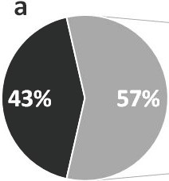
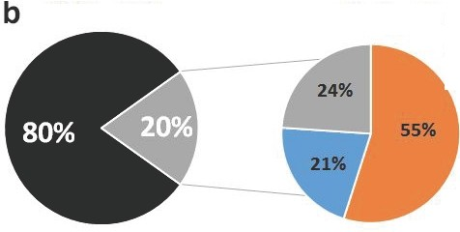Total= 508
•
•

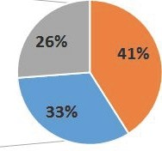
Total= 290
- Uninfected
- Infected
  - Falcip+
  - OVM+
  - Falcip+/OVM+

Uninfected
Infected

    - Falcip+
    - OVM+
    - Falcip+/OVM+

Total =360 Total= 71

849bp

.....
523pb

312pb
L119F-GSTe2
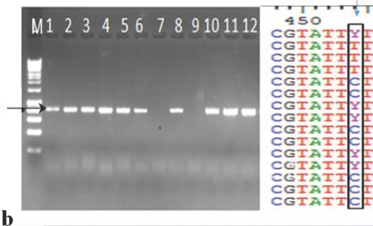I
a
460
T T T C T A C T T T C T A C T T T C T A C T T T C T A C T T T C T A C T T T C T A C T T T C T A C T T T C T A C T T T C T A C T T T C T A C T TI C T A C T T T C T A C T T T C T A C T T T C T A C T T T C T A C
15

M S R H N 1 2 3 4 5 6 7 8 9 10 11 12 13 14

- Whole Mosquito Obout C
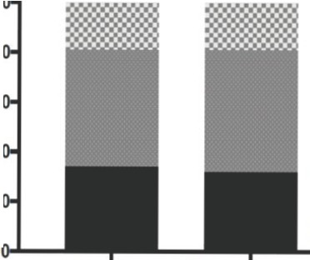10
>, CJ
; 8
:,
>, CJ C:
:,
QI
£C"
6
8. 4
C: 2
0
QI
(.')
C"
£
8.
C: QI (.')
Oocyst infection d Sporozoite infection

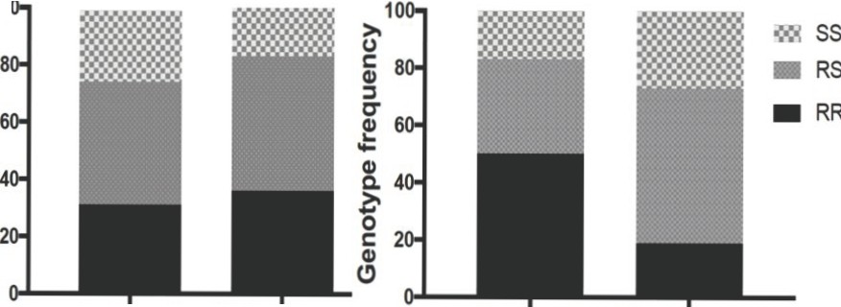Infected Non infected
10
- e
Whole mosquito Mibellon

Infected Uninfected Infected Non infected
Oocyst infection Sporozoite infection

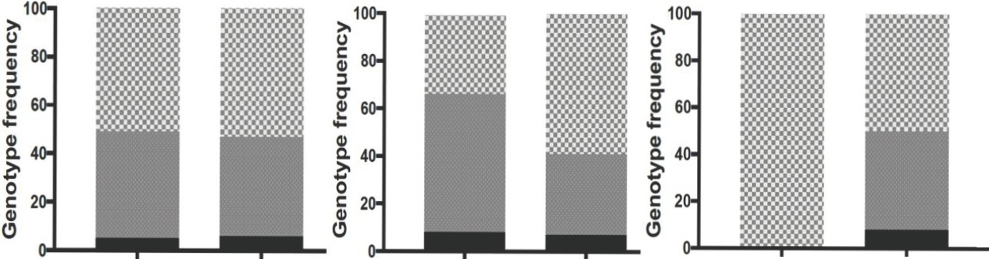
,m ss
- RS
- RR

Infected Non infected

Infected Non infected Infected Non infected

(a)

C

100

80

- RR
- RS
>,
(b)
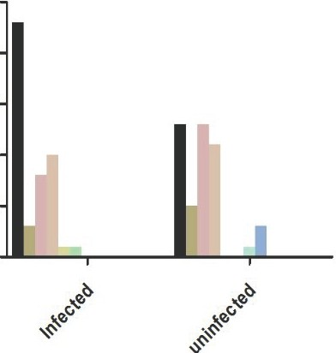
25

20
GSTe2/RDL genotypes

- SS /SS
- SS/RS
D RR/SS

I so
40

C 20
Cl

Infected uninfected
o ss 15
[ 10
u::
D RS/SS
D SS/RR
D RR/RR
D RR/RS
I!!!! RS/RS

.. .".

"cn'

.,,_
a 'J:
!-l!
.•-.
•

"?•
•-•
•!!
• .-.

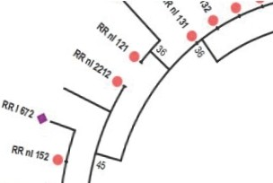

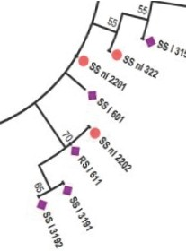
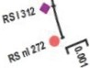
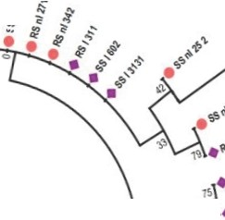.-. • •
16
- SSnl3%1

•... ""'' 2-

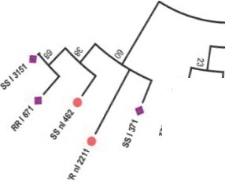..•..<ii • •
:: ..

en
";!.' a; t

'ti
s !•: .-ti.
""'' .".

lt. 't
!-! ..

{>•
" "•- •
!:
• -.:
.:-"'11V'

- ss11ll
76
12 . 5513132
- ssnu11

...,,q,, ,!q

••.,.,
.,./
%,,,
IJ151

" •

.'1'.
ii',.
•..
47,
.0,

.•. t'i
$

•ll:
fi
., •
lt. lt.
!! !!l

'Ct ai
,•"'
d},,

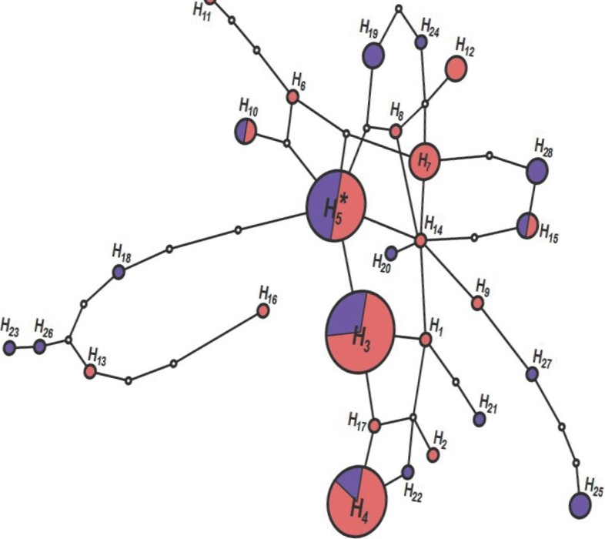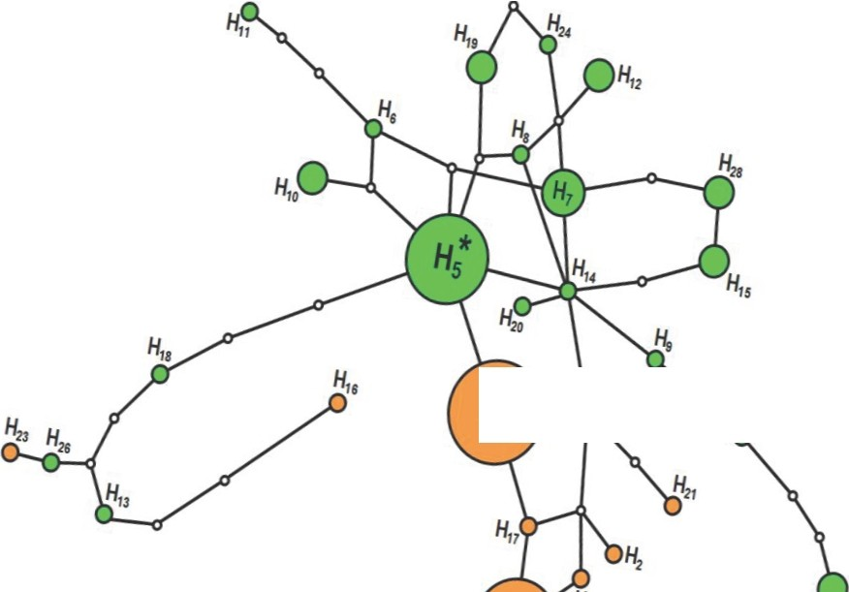
/
'lo<"\' ''IJ•
Rl!n/ fN.
RRnl1n e
50
.,.,.,,
'
flf/'6'!i. e
1191/11•
IIRnt 1SJ.
H,s
H3
Rll111171 •
RRnlln
e 44
Rftl\l'Z.Z1
1$1)\l .
is..,,i •
Hz
,
....•.

