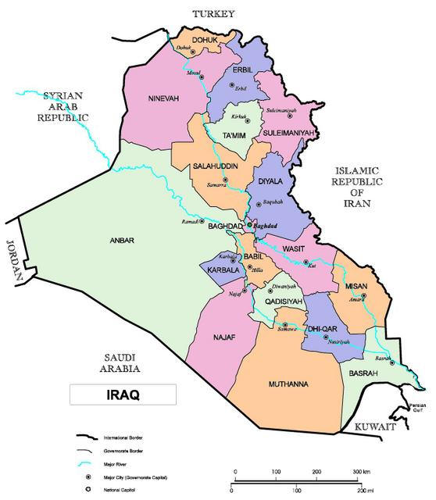

Figure 1: Map of Iraq showing the Governorates

