MARCO variants are associated with phagocytosis, pulmonary tuberculosis susceptibility and Beijing lineage

Nguyen Thuy Thuong Thuong^{1,2}, Trinh Thi Bich Tram^{1,2}, Tran Dinh Dinh^{1,2}, Phan Vuong Khac Thai³, Dorothee Heemskerk^{1,2}, Nguyen Duc Bang³, Tran Thi Hong Chau⁴, David Russell⁵, Guy E. Thwaites^{1,2}, Thomas R. Hawn⁶, Maxine Caws⁷, Sarah J. Dunstan⁸

1. Oxford University Clinical Research Unit, Ho Chi Minh City, Viet Nam
2. Centre for Tropical Medicine and Global Health, Nuffield Department of Medicine, University of Oxford, Oxford, United Kingdom
3. Pham Ngoc Thach Hospital for Tuberculosis and Lung Disease, Ho Chi Minh City, Viet Nam
4. Hospital for Tropical Diseases, Ho Chi Minh City, Viet Nam
5. College of Veterinary Medicine, Cornell University, Ithaca, New York, United States of America
6. School of Medicine, University of Washington Seattle, Washington, United States of America
7. Liverpool School of Tropical Medicine, Pembroke Place, Liverpool, United Kingdom
8. Peter Doherty Institute for Infection and Immunity, The University of Melbourne, Australia

Running title: MARCO and tuberculosis
Word count of the abstract: 177
Word count of the text: 4011
Correspondence should be addressed to:
Dr Nguyen Thuy Thuong Thuong
Oxford University Clinical Research Unit, Hospital for Tropical Diseases
764 Vo Van Kiet, W.1, Dist.5, Ho Chi Minh City
Tel: 84 8 924 1761; Fax: 84 8 923 8904; Email: thuongntt@oucru.org

Abstract
Macrophage receptor with collagenous structure (MARCO) plays an important role in the phagocytosis of Mycobacterium tuberculosis (M. tuberculosis). We hypothesized that MARCO polymorphisms are associated with phagocytosis, tuberculosis (TB) disease susceptibility and presentation, and infecting lineage.
We used a human cellular model to examine how MARCO genotype mediates the immune response; a case-control study to investigate tuberculosis host genetic susceptibility; and a host-pathogen genetic analysis to study host-pathogen interactions.
Two MARCO heterozygous (AG) genotypes (SNPs rs2278589 and rs6751745) were associated with impaired phagocytosis of M. tuberculosis TDM-cord factor and β-glucan coated beads in macrophages. The heterozygous genotypes of rs2278589 and rs6751745 were also associated with increased risk of pulmonary TB (rs2278589, p=0.001, OR=1.6; rs6751745, p=0.009, OR=1.4), and with severe chest X-ray abnormalities (p=0.007, OR=1.6). These two genotypes were also associated with the Beijing lineage (rs2278589, p=0.001, OR=1.7; rs6751745, p=0.01, OR=1.5).
Together, these results suggest that MARCO polymorphisms may regulate phagocytosis of M. tuberculosis and susceptibility and severity of pulmonary tuberculosis. They also suggest MARCO genotype and Beijing strains may interact to increase the risk of pulmonary tuberculosis.
Introduction
Although tuberculosis (TB) can be cured, it is still one of the most devastating diseases, and globally causes active TB in 9.6 million and kills 1.5 million people annually (1). Variation in the host and pathogen are involved in disease susceptibility and determine disease development and outcome. Studies suggest that polymorphisms in host immunity genes influence susceptibility to TB (2, 3), especially in genes encoding Toll-like receptors, C-type lectin and scavenger receptors, which are involved in recognizing, binding, and phagocytosing M. tuberculosis.
Scavenger receptors are cell surface receptors, which bind a variety of ligands, and have an important function in clearance of many foreign microorganisms. Class A and class B scavenger receptors are involved in the cytokine response to mycobacterial lipoarabinomannans (4) and lipopeptides (5). Macrophage receptor with collagenous structure (MARCO) is a member of the class A scavenger receptor family. MARCO, on the cell surface of macrophages, binds bacteria to facilitate phagocytosis and activates immune responses (6-8). As such, MARCO-deficient mice have a reduced ability to clear bacteria in pneumonia (7, 9). Class A scavenger receptors and MARCO participate in phagocytosis of mycobacterial species, including M. leprae (10), M. bovis Bacille Calmette-Guérin (11), M. marinum (6) and M. tuberculosis (12, 13). More specifically, it has been demonstrated that M. tuberculosis is captured by MARCO in vivo via its cell wall cord factor (trehalose 6,6'-dimycolate or TDM), which increases pro-inflammatory cytokine response through the interaction with Toll-like receptors and CD14 (14).
The genetic diversity of M. tuberculosis is another factor which contributes to the clinical consequences of TB (15-17). The emergence of Beijing strains, which account for approximately 50% of strains in East Asia and 13% of strains worldwide (18), may contribute to disease susceptibility, drug resistance and treatment outcome. There is a possibility of human-mycobacterial co-evolution based on the genetic interactions of genes in the host and pathogen (18, 19). This would help to explain the interactions between host and pathogen factors in the development of TB.
Altogether, due to the role of phagocytosis and the potential function of MARCO in the immune response against M. tuberculosis, we hypothesized that (i) Phagocytic activity is associated with developing different clinical phenotypes of TB, such as latent, pulmonary or extra-pulmonary TB; (ii) Polymorphisms in MARCO regulate macrophage phagocytic activity; (iii) Polymorphisms in MARCO, that contribute to the impairment of macrophage phagocytic activity, are associated with susceptibility to tuberculosis and influence clinical presentations and treatment failure; (iv) host and pathogen genotypes combined influence tuberculosis susceptibility.

Results
Phagocytosis and TB clinical phenotypes
We examined phagocytosis in human MDMs by bead-based internalization assays. Alexa 594-beads coated with IgG, TDM or β-glucan were added to MDMs and the percentage of macrophages with or without beads was measured using flow cytometry to assess phagocytic ability. Phagocytosis was assessed in macrophages isolated from patients with latent (N = 56), pulmonary (N = 52) or meningeal TB (N = 55). No association was observed between phagocytic activity and different clinical forms of TB (Figure 1).
There was a wide range of phagocytic activities, with up to 50% of beads coated with M. tuberculosis TDM in macrophages from latent, pulmonary and meningeal TB (Figure 1). To investigate how MARCO influences the heterogeneity of phagocytic activity, we next examined the association of MARCO variants and phagocytosis.
Association of MARCO SNPs with macrophage phagocytosis, mRNA expression and cytokines in response to M. tuberculosis
MARCO is a phagocytic receptor on macrophages which binds bacteria and facilitates phagocytosis to control and clear pathogens (6, 8). TDM from M. tuberculosis is a ligand of MARCO whereas β-glucan is not known to be a MARCO ligand. Scavenger receptors on human monocytes have been found to bind to β-glucan (20), and MARCO (on CpG-ODN-pretreated macrophages) has been found to participate in the uptake of zymosan (which is derived from β-glucan) (21); therefore β-glucan was used in this study to address the question of whether it might be a ligand for MARCO and to explore possible interaction between MARCO, tuberculosis and β-glucan.
We genotyped twelve MARCO haplotype-tagging SNPs from 41 healthy subjects and performed phagocytosis assays. The genotypes of two SNPs rs2278589 and rs6751745, were associated with phagocytosis of either TDM or β-glucan beads, but were not associated with phagocytosis of IgG beads (Figure 2A, 2B). The remaining 10 SNPs in MARCO were not associated with phagocytosis of any beads (Figure S1). Furthermore, the results show the heterozygous genotypes of both SNPs were associated with reduced phagocytosis of TDM and β-glucan beads (rs2278589, p = 0.04 and 0.03; rs6751745, p = 0.01 and 0.007) (Figure 2A, 2B).
We also examined the association between MARCO SNPs rs2278589 and rs6751745 and mRNA expression or cytokines in PBMCs from 31 healthy subjects. MARCO mRNA levels were up-regulated approximately 2 fold in PBMCs stimulated with LPS or M. tuberculosis whole cell lysate compared with un-stimulated cells (Figure 3A). The genotypes of rs2278589 and rs6751745 were marginally associated with MARCO mRNA expression in cells stimulated with M. tuberculosis (Figure 3B) (ANOVA, p = 0.068 and 0.039 respectively). For the heterozygous model, the AG genotype of these two SNPs was not significantly associated with reduced levels of MARCO mRNA in PBMCs stimulated with M. tuberculosis. For cytokine production, PBMCs were activated and produced pro-inflammatory cytokines TNF-α and IL-1β in response to both TDM and M. tuberculosis lysate. The anti-inflammatory cytokine IL-10 was induced by M. tuberculosis lysate stimulation, but not TDM (Figure 3C). In TDM or M. tuberculosis lysate stimulated cells, there was no association between the two SNP genotypes and TNF-α, IL-1β and IL-10 levels (Figure 3 D-E for rs2278589, and F-G for rs6751745).
Collectively, these data showed that the AG genotype of rs2278589 and rs6751745 in MARCO was not associated with MARCO mRNA expression or cytokine concentrations in PBMCs, but it was associated with reduced phagocytosis activated via TDM and β-glucan in macrophages.
MARCO polymorphisms are associated with susceptibility to pulmonary TB, but not with TB meningitis
We used a case–control study to determine whether MARCO polymorphisms SNPs rs2278589 and rs6751745 are associated with susceptibility to TB, as macrophages with the heterozygote genotypes of these SNPs displayed reduced phagocytosis of M. tuberculosis ligands (Figure 2). Therefore we applied the heterozygote advantage model to analyse the relationship between MARCO SNPs and clinical TB, both pulmonary and meningeal. The heterozygote genotypes of rs2278589 and rs6751745 are associated with susceptibility to PTB (rs2278589; p = 0.001, OR = 1.6 and rs6751745; p = 0.009, OR = 1.4; Table 1) and figure S2 shows that the two SNPs are in high LD (D' = 1, r² = 0.88) in our Vietnamese Kinh control population. Associations between these 2 SNPs and PTB remained significant after Bonferroni correction (p values x 2) (Table 1).
Interestingly, the genotype frequencies of these two SNPs were different between PTB and TBM under the heterozygote advantage model [(rs2278589; PTB 0.55, TBM 0.46; p = 0.005, OR = 1.4) (rs6751745; PTB 0.50, TBM 0.40; p = 0.003, OR = 1.5]. However the genotype frequencies of rs2278589 and rs6751745 in TBM patients were not different compared to the control groups using the genotypic model (p > 0.05).
To thoroughly examine the association between MARCO SNPs and TB a further 10 SNPs, within and upstream of the MARCO gene, were analyzed. Apart from the two associated SNPs described above, rs6748401 (1.5 kb upstream) was associated with PTB in a genotypic comparison (p = 0.039; Table 2), and none of others were associated with susceptibility to TB.
Collectively, two SNPs in the MARCO gene were associated with PTB, but not with TBM. The heterozygote genotypes of rs2278589 and rs6751745, which were associated with reduced phagocytic activity, were also associated with susceptibility to PTB.
MARCO polymorphisms are associated with CXR presentation
To investigate whether MARCO polymorphisms influence clinical presentation or disease outcome, we examined the relationship between the two associated SNPs (rs2278589 and rs6751745), pre-treatment CXR abnormalities, and 8-month treatment outcomes. Patients enrolled in this study were sputum smear-positive for pulmonary TB before treatment. Pre-treatment CXR showed 427/429 (99.5%) were abnormal with evidence of nodules (139, 32.4%), infiltrates (407, 94.9%), consolidation (40, 9.3%), cavities (139, 32.4%) and miliary disease (0, 0%).
SNPs rs2278589 and rs6751745 were associated with severity of CXR abnormality. SNP rs2278589 was associated with intermediate and severe CXR abnormality in the heterozygote model (p = 0.008 intermediate; p = 0.007 severe, OR = 1.6; Table 3). SNP rs6751745 was associated with severe CXR abnormality in the heterozygote model (p = 0.007, OR = 1.6; Table 3).
There was no association between rs2278589 and rs6751745 genotype and poor treatment outcome (29/429, 6%), which was defined by death, or failure to convert to sputum smear negativity, however this may be due to the lack of events in this dataset and consequent lack of power.
MARCO polymorphisms are associated with Beijing lineage
Our previous studies reported associations between lineages of M. tuberculosis, particularly the modern Beijing lineage, and TB clinical phenotypes (15, 17). Given a worldwide emergence of the M. tuberculosis Beijing strains (18), we hypothesized that variation in the scavenger receptor MARCO, which binds to Mycobacterium and enables phagocytosis by macrophages, might be preferentially associated with a specific lineage. Therefore, we next examined whether the rs2278589 and rs6751745 genotypes are associated with infection caused by a particular bacterial lineage and whether this relationship influences disease phenotype.
The genotypic frequencies of rs2278589 and rs6751745 in all PTB patients (N = 445) and in those patients where the lineage of the infecting M. tuberculosis isolate was determined (N = 370), were compared with controls (Table 4). There was no significant association between the two SNPs and infection with either Indo-Oceanic or Euro-American lineage, or when combined as non-Beijing lineages. However, we found a significant association between these SNPs and infection with Beijing isolates in a genotypic comparison (rs2278589, p = 0.005; rs6751745, p = 0.033; Table 4), and in a heterozygous model (rs2278589, p = 0.001, OR=1.7; rs6751745, p = 0.012, OR=1.5; Table 4).

Discussion
The primary finding of our study was that MARCO genotypes were associated with a reduction of phagocytosis of beads coated with pathogen-derived ligands, TDM from M. tuberculosis. These genotypes were also associated with increased susceptibility to pulmonary TB and severe chest radiography abnormality. Our results suggest that these polymorphisms may regulate phagocytosis of M. tuberculosis, and impairment of phagocytic ability could increase susceptibility to, and severity of, pulmonary TB. The MARCO genotypes were preferentially associated with Beijing rather than Indo-Oceanic or Euro-American lineages, which implies MARCO genotype may increase susceptibility to tuberculosis particularly of the Beijing lineage.
MARCO plays a key role in bacterial phagocytosis and clearance (6, 7, 9). Recognition of TDM by MARCO, in conjunction with TLR2/CD4, activates transcriptional expression of immunity genes (22) and cytokine production (14). However, no studies have yet shown the influence of MARCO genetic variation on the antimicrobial activity of macrophages such as phagocytosis or immune response. In this study, we found that MARCO SNPs rs2278589 and rs6751745 were not associated with gene expression and cytokine production in PBMCs but were associated with reduced phagocytosis of beads coated with pathogen-derived ligands, TDM or β-glucan in macrophages. We found that MARCO polymorphisms were not associated with cytokine production. In murine studies, MARCO-deficient macrophages were associated with a reduction of TNFα, IL-6 and IL-1β cytokine production in macrophages from MARCO knockout mice. The difference in study design could account for the differences seen in cytokine production between these two studies. We used human PBMCs, whereas in Bowdish et al (2009; 14) murine macrophages were used. In the macrophages from knockout mice, MARCO was absent, potentially having a major impact. In our study, MARCO was still produced, albeit a variant of MARCO with an unknown and potentially smaller impact. Another reason for the difference may be the limited numbers of samples in our study once stratified by genotype.
MARCO is involved in phagocytosis of bacteria, a step in pathogenesis which may be important in the development of pulmonary TB in the early phase of infection. The heterozygous genotypes of two MARCO SNPs were associated with reduced macrophage phagocytic function. The impairment of phagocytosis at the beginning of infection reduces the number of macrophages infected with M. tuberculosis, which then limits microbial killing and antigen presentation to lymphocytes (23, 24). The consequence of this could be the inadequate induction of innate and adaptive immune responses against M. tuberculosis, potentially increasing susceptibility to active disease. Deficient responses could also lead to increased microbial replication, which could manifest as severe abnormalities on CXR, such as was observed in TB patients carrying the heterozygous genotypes. Together, our data suggest that TB susceptibility and disease severity in patients with the MARCO AG genotype may be due to impairment of M. tuberculosis phagocytosis.
Our results show that variation in human MARCO is associated with susceptibility to pulmonary TB in the Vietnamese Kinh population. The associated intronic SNPs rs6748401 and rs2278589 are part of a wide haplotype block, suggesting they are markers in high LD with the unknown causative SNP(s). Two MARCO SNPs (rs17009726 or rs4491733) were previously associated with TB susceptibility in the Han Chinese Beijing and Gambian populations (25, 26) however we did not observe any association with these SNPs in our TB population. Conversely, the associated SNPs (rs6748401 and rs2278589) described in this study were not associated in the Gambian population and were not genotyped in the Chinese population. The discrepancy in our results may be due to different population LD structure. The frequencies of the associated SNPs found in the three studies were very different based on the 1000 Genomes Project (http://www.ncbi.nlm.nih.gov/projects/SNP; rs17009726 minor allele frequency in African 0.0008, Ad Mixed American 0.0014, European 0.0060, East Asian 0.1210 and South Asian 0.1483 super populations) and overall linkage (D' plots) across the MARCO SNPs in three populations are visually different (figure S2 and (25, 26)). LD in the Vietnamese Kinh population across this gene region contains larger haplotype blocks with more SNPs compared to both the Han Chinese (HCB) and Gambian populations. The differing population structures in this gene region may account for the inability to replicate individual SNP associations, however the accumulated evidence across these populations suggests that MARCO variation contributes to pulmonary TB susceptibility.
The remarkable emergence of Beijing lineage worldwide, including Vietnam, supports the hypothesis that the variation in the scavenger receptor MARCO, which binds Mycobacterium and promotes macrophage internalization, might support the emergence of the Beijing lineages. Our data shows associations of both MARCO variants and M. tuberculosis lineage with TB susceptibility suggesting potential for host-pathogen co-evolution, as reported previously with TLR2, NRAMP1 and EREG (15, 27, 28). Our associated SNPs may be markers of non-synonymous structural variants of MARCO that effects ability to bind ligands from Beijing lineage strains, reducing phagocytosis and increasing susceptibility to TB. Host-pathogen co-evolution in tuberculosis needs to be studied on a larger scale with respect to patients and genes, coupled with functional studies to determine the underlying mechanisms.
The role of MARCO in macrophage phagocytosis is important in clearance of pathogens. Our results suggest that MARCO polymorphisms may regulate phagocytosis of M. tuberculosis and thus influence susceptibility to and severity of pulmonary tuberculosis. The results also suggest that MARCO genotype and Beijing strains may interact to increase the risk of pulmonary tuberculosis.

Materials and Methods
Cellular studies
Ex vivo isolation of Peripheral blood mononuclear cells (PBMCs) and Monocyte-derived macrophages (MDMs)
PBMCs were separated from heparinized whole blood by Lymphoprep (Asix-Shield, Norway) gradient centrifugation according to the manufacturer’s protocol. From 20 ml of blood we obtained approximately 1-1.5x10⁷ PBMCs. To isolate monocytes by adherence, PBMCs were plated in cell-culture treated 48-well plates (Nunc, Denmark) with 9x10⁵ cells per well in media without serum, containing RPMI-1640 (Sigma, Germany), 2mM L-glutamine and 100 units of penicillin. Cells were incubated at 37⁰C, 5% CO₂ for 2 hours and the non-adhered cells were washed off gently two times by warm phosphate buffered saline (PBS) with 3% fetal calf serum (FCS; Sigma, Germany). Cells were re-suspended in 0.4 ml complete media, containing RPMI-1640, 2 mM L-glutamine, 100 units of penicillin, 10% FCS and 10 ng/ml human mCSF (R&D Systems, USA), and incubated at 37⁰C, 5% CO₂. To derive monocytes, adhered cells were incubated for 5 to 7 days. Complete media was changed at day 4, and phagocytosis assay was performed at day 7.
PBMC stimulation for MARCO mRNA and cytokine measurement
For MARCO mRNA expression, PBMCs were plated in 24-well plates (10⁶ cell/well). Cells were subsequently stimulated with either whole cell lysate (WCL) of M. tuberculosis H37Rv at 5 µg/ml (Colorado State University, USA), LPS at 100 ng/ml (Sigma-Aldrich, USA) or media. For cytokine measurement, PBMCs were plated in 96-well plates (10⁵ cell/well) and then stimulated with either WCL at 25 µg/ml, TDM at 100 µg/ml (Enzo Life Sciences, USA), LPS 100 ng/ml or media. For stimulation, TDM was coated on the plate and air-dried in the cabinet the day before, while other ligands were added directly into media after cell plating.
For real-time quantitative PCR (RTqPCR), after stimulation for 5 hours, RNA was extracted by Trizol according to the manufacturer’s protocol (Invitrogen, USA), dissolved in RNase-free water and stored at -70⁰C until use. Taqman real time PCR was performed to measure the expression level of MARCO gene using primers Forward 5'-GGGCTCACCTGGTGGTTATC-3' and Reverse 5'-TCGACAACCTGGTCTGACAGT-3' (Sigma-Aldrich Pte Ltd, Singapore), and probe 5'-Cyan500-CTCCGGGTCCTGGAGATGTATTTCCTCA-BHQ1-3' (TIB MOLBIOL Syntheselabor GmbH, Berlin, Germany). Samples were normalized to GAPDH and analyzed by using LightCycler 480 release 1.5.1.62 Relative Quantification software.
For Cytokine measurement, after stimulation for 24 hours, supernatants were collected for cytokine measurement, including TNF-α, IL-1β and IL-10. Cytokine levels were determined with a sandwich ELISA technique by the Luminex multiplex bead array technology (Bio-Rad Laboratories, Inc., Hercules, CA, USA).
Preparation of beads for phagocytosis
The procedure of coating beads was adopted from Yates et al (29). Carboxylate-modified silica particles (25 mg or 500 µl of 3 µm; Kisker Biotech, Germany) were washed three times in 1ml of PBS by vortexing and centrifugation at 2000 g for 1 min. Beads were incubated at room temperature in 25 mg/ml cyanamide (Sigma-Aldrich, USA), which works as a cross-linker, in PBS with agitation for 15 minutes. Beads were washed twice in 1 ml of coupling buffer (0.1 M borate buffer, pH 8.0) and then incubated in 0.5 ml coupling buffer with 1.0 mg defatted bovine serum albumin (Sigma-Aldrich, USA) and 0.1 mg human IgG (Molecular Probes, USA) or 0.25 mg ligands [TDM (Enzo Life Sciences) or β-glucan/ whole glucan particles (Invivogen, USA)] then dispersed for 12 hours with agitation. The coated beads were washed three times in 1 ml of quench buffer (250 mM glycine, Sigma-Aldrich) to quench unreacted cyanamide. The beads were re-suspended in 1 ml coupling buffer with 10 µl of 5 mg/ml Alexa Fluor 594 succidinimyl ester (Molecular Probes) in dimethyl sulfoxide (DMSO, Sigma-Aldrich) and agitated for 1 hour. The beads were washed three times in 1 ml quench buffer, re-suspended in 1 ml PBS with 0.02% sodium azide and stored at 4⁰C.
Phagocytosis assays

At day 7, MDMs from healthy subjects or TB patients were checked by microscope to ensure a monolayer with 80-90 % confluence had been achieved. After removing media, new media was added immediately with 200 µl per well in the 48 well plates. Stored beads were washed three times in PBS, then 10 µl of beads coated with Alexa Fluor 594 SE and IgG/ligand was added into each well with concentration to achieve an average of 1–2 beads internalized per macrophage. Binding and uptake of the beads was performed by incubating of macrophages with a suspension of the beads at 37⁰C, 5% CO₂ for 10 minutes. Cells were washed three times in PBS with 3% FBS to remove unbound beads, harvested by scraping in cold PBS with 1% para-formaldehyde and transferred into a tube for flow cytometry analysis.
Phagocytosis of macrophages was determined by the percentage of phagocytes which have internalized beads coated with Alexa Fluor 594 SE. Samples were run using BD FACSCanto II and FACSDiva acquisition software, and fluorescence intensity analyzed using FlowJo analysis software (BD Biosciences, USA). Bead ingestion was confirmed by the presence of bright green fluorescence in the proteolysis assay (Figure S3). The green fluorescence indicated that almost all of the MDM associated beads were internalized following 10 minute incubation.
Haplotype-tagging SNPs
We identified haplotype-tagging SNPs from the Han Chinese in Beijing (CHB) population from the International HapMap Project (http://www.hapmap.org) and obtained functional information of SNPs from UCSC Genome Bioinformatics (http://genome.ucsc.edu/). We searched a region on chromosome 2p14.2 encompassing MARCO and 10 kb upstream for tagged SNPs using an r² cutoff of 0.8 for linkage disequilibrium and a minor allele frequency cut-off of 10%. Haploview 4.2 (Broad Institute of MIT and Harvard, USA) was used to calculate r² and D' for linkage disequilibrium. Twelve haplotype-tagging SNPs including one SNP in the promoter region (3 bp upstream) and one missense SNP (in exon 10) were genotyped. SNPs in the MARCO gene were genotyped using the GoldenGate genotyping assay (Illumina, San Diego, USA).
Human Subjects
For cellular studies, in addition to the tuberculous meningitis (TBM) and pulmonary tuberculosis (PTB) patients described below, latent TB (LTB) subjects (N = 56) were recruited from healthy Vietnamese volunteers working at Oxford University Clinical Research Unit (OUCRU), Vietnam. They were diagnosed for LTB infection using T-SPOT.TB test (Oxford Immunotec, UK). Another group of healthy Vietnamese volunteers (N = 31) from OUCRU was enrolled in cellular studies in which we genotyped SNPs on MARCO and examined macrophage phagocytosis, mRNA expression and immune response.
The case-control genetics association study cases comprised of 900 HIV negative adults with TB treated from 2008 to 2011 for PTB (N=450), and in several clinical trials and observational studies from 2001 to 2013 for TBM (N=450). PTB patients were recruited through the network of district TB control units, and TBM patients were recruited from either Pham Ngoc Thach Hospital for Tuberculosis and Lung Disease or the Hospital for Tropical Diseases, in Ho Chi Minh City, Vietnam. PTB patients had acid fast bacilli in sputum and TBM patients had clinical meningitis in addition to specific clinical requirements that have been previously described(30). Population controls were 450 newborn babies born at Hung Vuong Obstetric Hospital, Ho Chi Minh City. Peripheral blood samples from TB patients or umbilical cord blood from babies were collected. All samples came from unrelated individuals who were ethnic Vietnamese Kinh.
Written informed consent was obtained from each volunteer. Protocols were approved by human subjects review committees at the Hospital for Tropical Diseases and Pham Ngoc Thach Hospital for TB and Lung Disease, HCMC, Vietnam. Ethical approval was also granted by the Oxford Tropical Research Ethics Committee (UK).
Case-control genetic association study and quality checking
Fourteen genotyped SNPs were tested for Hardy-Weinberg equilibrium (HWE) in control subjects using a Chi-square test. SNPs were excluded if they had >5% missing genotype calls, a minor allele frequency of < 10 % or a HWE p value of < 0.05.
Chest radiography
Chest X-rays (CXR) were examined at the time of TB diagnosis, with reports provided by clinicians from district TB control units. Abnormal features on a chest radiograph were recorded comprising of nodules, infiltrates, consolidation, cavities and miliary TB. To grade chest radiograph severity, the abnormal features were assessed and classified as mild if abnormal features were present in one lobe, intermediate if abnormal features were present in one lung, and severe if abnormal features were present in both lungs.
Statistical analysis

Host genetic analysis was performed using a Chi-squared test with two degrees of freedom in genotypic comparisons, or one in genotypic models (ie. dominant, recessive or heterozygous advantage model). A significance threshold of p < 0.05 was used. For multiple SNP comparisons, Bonferroni correction was applied.
Comparisons across three clinical groups (PTB, TBM, and controls) or genotypes were performed by using one-way Analysis of Variance (ANOVA) or two groups by using Mann-Whitney U test. Analyses were performed using SPSS version 14.0, USA. mRNA, cytokine and phagocytosis graphs were generated using GraphPad Prism version 6.04 for Windows, (GraphPad Software, La Jolla California USA, www.graphpad.com).
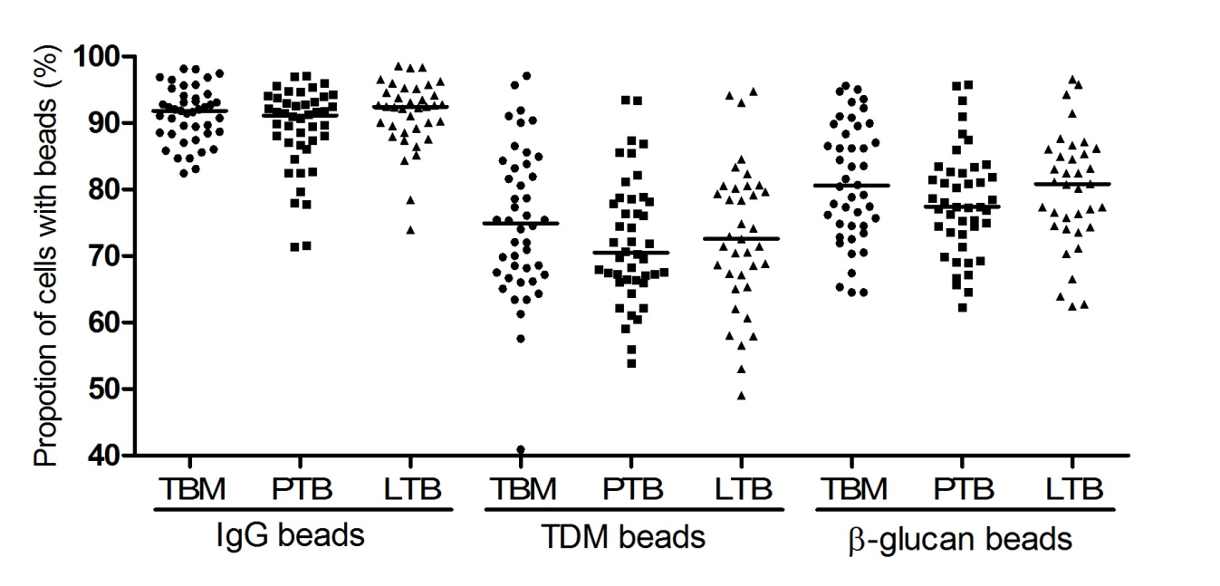
Figure 1. Phagocytic ability of macrophages from individuals with different TB phenotypes
Monocyte derived macrophages from patients at day 6 were treated with Alexa 547-beads coated with either IgG, TDM or β-glucan. Phagocytic ability was determined by the percentage of macrophages with beads. (A) Phagocytic ability of macrophages isolated from individuals with three TB phenotypes (55 TB meningitis, 52 pulmonary TB and 56 latent TB).
Bars in plots represent median values. Comparisons across three groups of TB forms or genotypes were performed by using one-way ANOVA. On these comparisons, p values > 0.05.

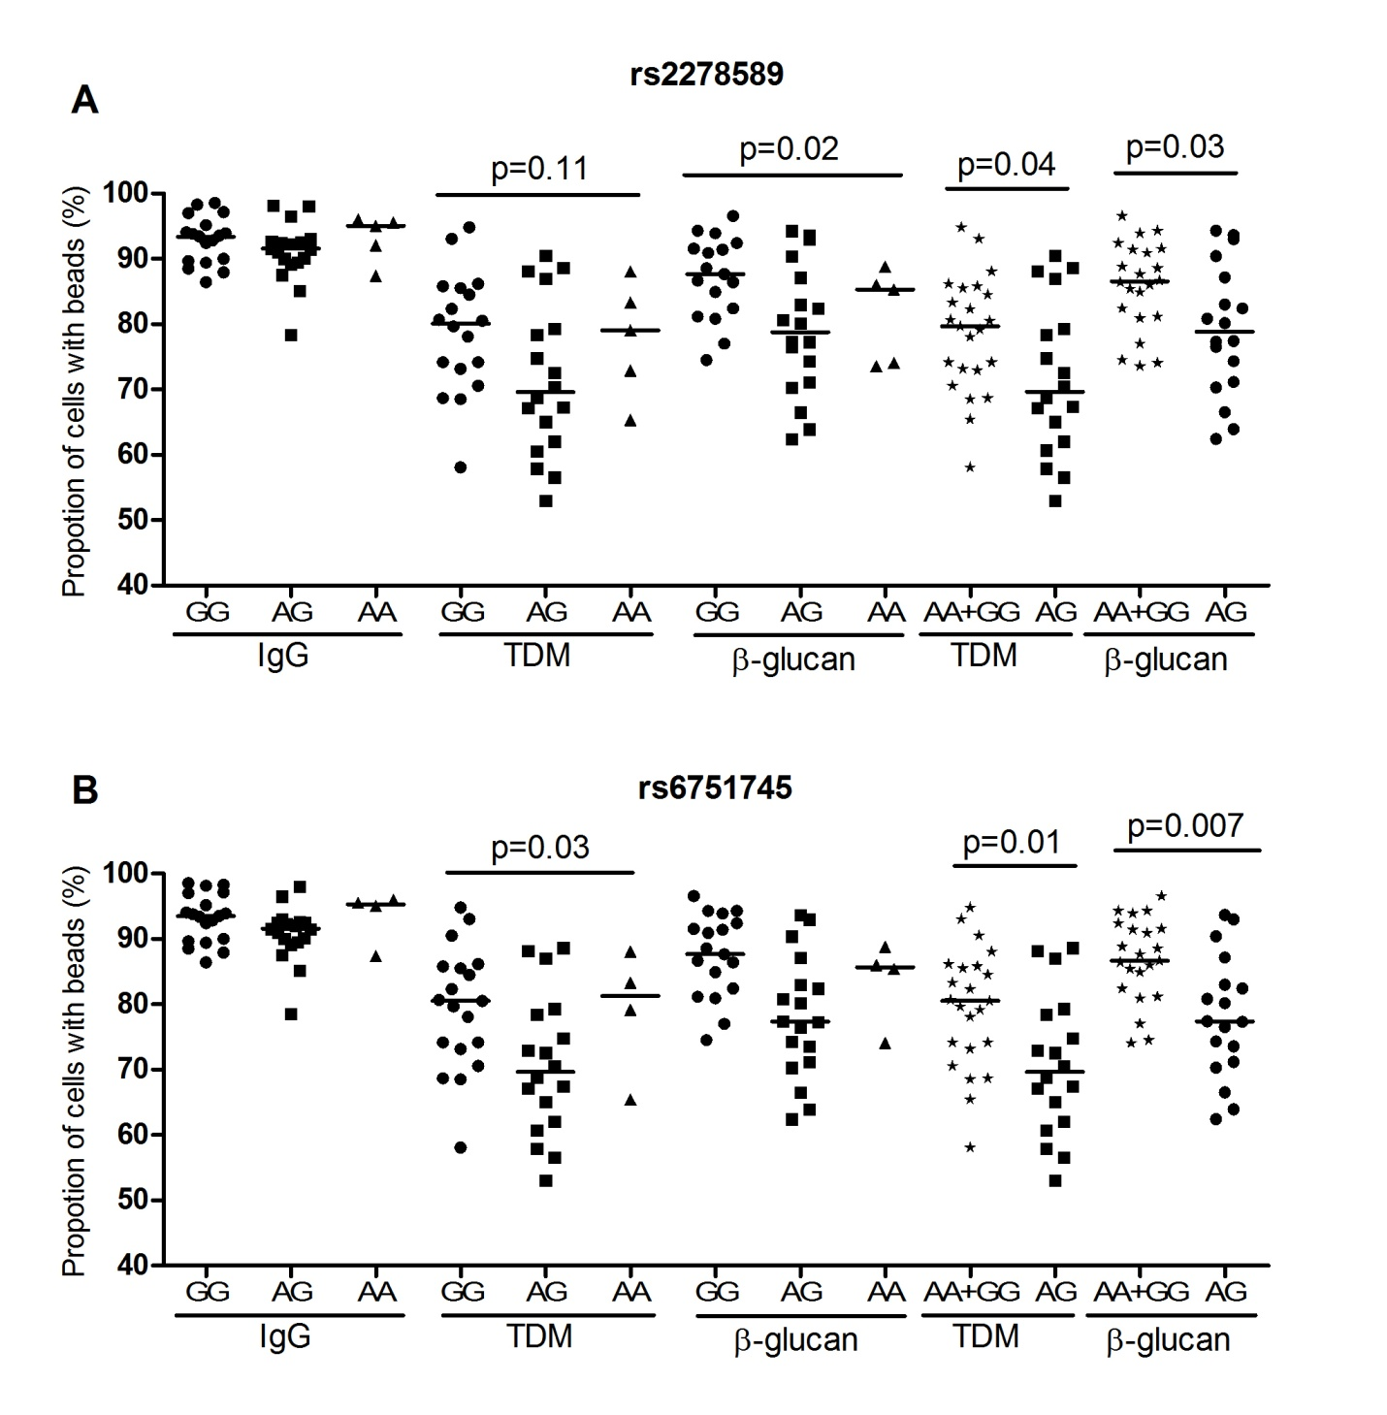
Figure 2. Phagocytic ability of macrophages from healthy subjects
Macrophage phagocytosis of beads was assessed according to MARCO SNP genotypes in healthy subjects; (A) rs2278589 (18 GG, 18 AG, 5 AA) and (B) rs6751745 (19 GG, 18 AG, 4 AA).
Bars in plots represent median values. Comparisons across three groups of TB forms or genotypes were performed by using one-way ANOVA, or two groups by using Mann-Whitney U test.

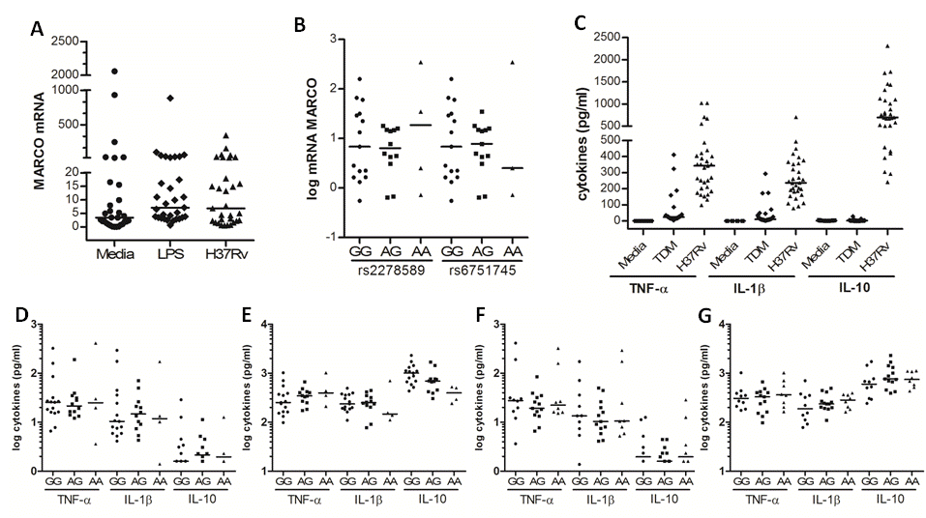
Figure 3. MARCO polymorphisms and variation in mRNA expression or cytokine production from healthy subjects
(A) mRNA was isolated from monocytes stimulated with Media, LPS at 100 ng/ml or M. tuberculosis whole cell lysate at 5ug/ml. MARCO mRNA expression was measured and normalizes to GAPDH. (B) Association of MARCO mRNA expression from cells stimulated with M. tuberculosis whole cell lysate was analysed with SNPs in MARCO: rs2278589 (4 AA, 12 AG, 15 GG), p = 0.068 and rs6751745 (3 AA, 13 AG, 15 GG), p = 0.039. (C) Cytokines were measured from monocytes stimulated with Media, TDM at 100ug/ml or M. tuberculosis whole cell lysate at 25ug/ml. Cytokines from cells stimulated with TDM (D) or M. tuberculosis whole cell lysate (E) were analysed with SNP rs2278589 (4 AA, 12 AG, 15 GG). Cytokines from cells stimulated with TDM (F) or M. tuberculosis whole cell lysate (G) were analysed with SNP rs6751745 (3 AA, 13 AG, 15 GG). Data were collected from duplicate samples. Bars in plots represent median values. Comparisons across three genotypes were performed by using one-way ANOVA.

Supplementary Figures
Figure S1. Phagocytic ability of macrophages from healthy subjects
Macrophage phagocytosis of IgG, TDM and β-glucan beads was plotted by MARCO SNP genotype. Data is shown for 10 tagging-SNPs in 41 healthy subjects. Bars in plots represent median values. Comparisons across three groups of TB forms or genotypes were performed by using one-way ANOVA. For all these comparisons the p value > 0.05.

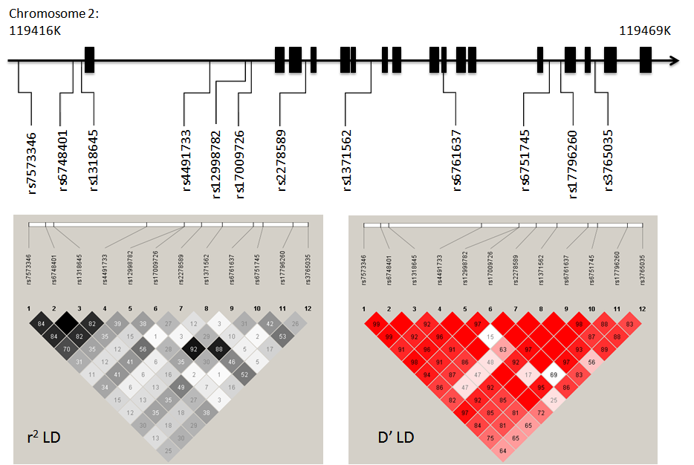
Figure S2. Chromosomal map and linkage disequilibrium of MARCO polymorphisms in a Vietnamese cohort
- Chromosomal map of polymorphisms in MARCO, located on chromosome 2, boxes show exonic regions. (B, C) Linkage disequilibrium values (r² and D') between SNPs were generated by Haploview 4.2 using genotype data from the control population (Vietnamese Kinh). Empty squares indicate complete linkage disequilibrium (r² or D'=1).

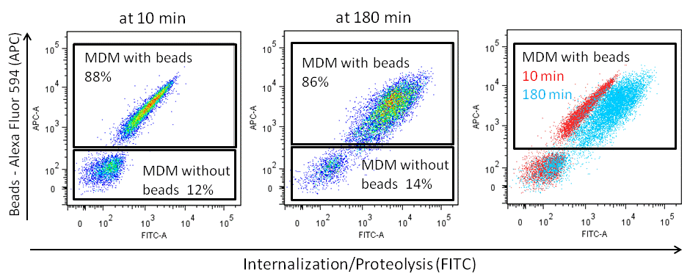
Figure S3. Assessment of monocyte derived macrophage (MDM) phagocytosis by flow cytometric analysis. Beads were coated with (1) Alexa Fluor 594 [y axis] and (2) DQ Green BSA substrate (Molecular Probes) [x axis]. Bright green fluorescence is achieved when beads are internalized by MDMs and DQ Green BSA substrate is cleaved by proteolysis to release green fluorescent protein fragments. MDMs were incubated with beads for 10 minutes to allow uptake, then cells were washed three times to remove loosely attached or unbound beads. Green fluorescence was measured at early (10 minutes) and late (180 minutes) time points.

Table 1: MARCO SNPs rs2278589 and rs6751745 are associated with pulmonary TB
SNP | rs2278589 |  |  | rs6751745
Control genotype (11, 12, 22) (N, %) | 194(0.45) | 190 (0.44) | 48 (0.11) | 210 (0.48) | 181 (0.42) | 43 (0.10)
PTB genotype (11, 12, 22) (N, %) | 165(0.37) | 245 (0.55) | 35 (0.08) | 194 (0.43) | 225 (0.50) | 27 (0.06)
Genotypic (p, p*) | 0.004 | 0.008 |  | 0.011 | 0.022
Dominant [p, p*, OR (95%CI)] | 0.101 | 0.202 | 1.5 (0.9-2.3) | 0.035 | 0.070 | 1.7 (1.0-2.8)
Recessive [p, p*, OR (95%CI)] | 0.018 | 0.036 | 0.7 (0.5-0.9) | 0.146 | 0.292 | 0.8 (0.6-1.1)
Heterozygous [p, p*, OR (95%CI)] | 0.001 | 0.002 | 1.6 (1.2-2.0) | 0.009 | 0.018 | 1.4 (1.1-1.8)

1: majority allele; 2: minority allele; Dominant is the comparison of 22 vs. (11+12)
p = p value
p* = corrected p value, Bonferoni correction by 2 SNPs (p value x 2)
OR (95%CI): odds ratio (95% confidence interval)

Table 2: Summary of genotyped SNPs in MARCO
rs ID | Cases |  | Controls |  | Genotypic
Location | PTB/TBM | 11/12/22 | 11/12/22 | HWE-p | p
rs7573346 | PTB | 131/233/84 | 122/213/105 | 0.524 | 0.175
4.9 Kb upstream | TBM | 127/216/101 |  |  | 0.913
rs6748401 | PTB | 108/245/90 | 120/215/100 | 0.845 | 0.039
1.5 Kb upstream | TBM | 115/223/109 |  |  | 0.788
rs1318645 | PTB | 109/246/92 | 119/215/100 | 0.879 | 0.057
3 bp upstream | TBM | 115/223/109 |  |  | 0.815
rs4491733 | PTB | 104/240/102 | 114/228/93 | 0.290 | 0.593
intron 1 | TBM | 120/222/101 |  |  | 0.782
rs12998782 | PTB | 228/184/34 | 243/160/31 | 0.510 | 0.345
intron 1 | TBM | 239/168/33 |  |  | 0.883
rs17009726 | PTB | 331/110/8 | 340/94/6 | 0.863 | 0.456
intron 1 | TBM | 342/99/5 |  |  | 0.911
rs2278589 | PTB | 165/245/35 | 194/190/48 | 0.885 | 0.004
intron 3 | TBM | 194/203/47 |  |  | 0.871
rs1371562 | PTB | 289/141/15 | 284/138/15 | 0.724 | 0.998
intron 6 | TBM | 286/140/15 |  |  | 0.998
rs6761637 | PTB | 323/114/8 | 335/89/9 | 0.289 | 0.202
exon 10 | TBM | 333/101/6 |  |  | 0.519
rs6751745 | PTB | 194/225/27 | 210/181/43 | 0.663 | 0.011
intron 13 | TBM | 223/178/39 |  |  | 0.752
rs17796260 | PTB | 293/139/13 | 283/135/18 | 0.708 | 0.622
intron 13 | TBM | 292/136/14 |  |  | 0.739
rs3765035 | PTB | 145/251/49 | 152/220/60 | 0.164 | 0.210
intron 15 | TBM | 183/199/60 |  |  | 0.149

1: majority allele; 2: minority allele
HWE: Hardy-Weinberg equilibrium, p: p value

Table 3. MARCO SNPs rs2278589 and rs6751745 are associated with level of CXR abnormality in PTB patients
Abnormality level | Genotype |  |  | Genotypic | Heterozygous
 | GG | AG | AA | p | p | OR (95%CI)
rs2278589
Controls | 194 (0.45) | 190 (0.44) | 48 (0.11)
Mild | 26 (0.38) | 39 (0.57) | 4 (0.06) | 0.112 | 0.052 | 1.7 (1.0-2.7)
Intermediate | 67 (0.37) | 101 (0.56) | 13 (0.07) | 0.022 | 0.008 | 1.6 (1.1-2.3)
Severe | 60 (0.35) | 96 (0.56) | 15 (0.09) | 0.026 | 0.007 | 1.6 (1.1-2.3)
rs6751745
Controls | 210 (0.48) | 181 (0.42) | 43 (0.10)
Mild | 31 (0.44) | 35 (0.50) | 4 (0.06) | 0.314 | 0.193 | 1.4 (0.8-2.3)
Intermediate | 82 (0.45) | 90 (0.50) | 9 (0.05) | 0.055 | 0.068 | 1.4 (1.0-2.0)
Severe | 68 (0.40) | 92 (0.54) | 11 (0.06) | 0.026 | 0.007 | 1.6 (1.1-2.3)

Table 4. MARCO SNPs rs2278589 and rs6751745 are associated with the Beijing strain
Group | Genotype |  |  | Genotypic | Heterozygous
 | GG | AG | AA | p | p | OR (95%CI)
rs2278589
Controls | 194 (0.45) | 190 (0.44) | 48 (0.11)
PTB | 165 (0.37) | 245 (0.55) | 35 (0.08) | 0.004 | 0.001 | 1.6 (1.2-2.0)
All isolates | 135 (0.36) | 205 (0.55) | 30 (0.08) | 0.005 | 0.001 | 1.6 (1.2-2.1)
Non-Beijing | 61 (0.42) | 77 (0.53) | 8 (0.05) | 0.060 | 0.066 | 1.4 (1.0-2.1)
East Asian/Beijing | 74 (0.33) | 128 (0.57) | 22 (0.10) | 0.005 | 0.001 | 1.7 (1.2-2.3)
rs6751745
Controls | 210 (0.48) | 181 (0.42) | 43 (0.10)
PTB | 194 (0.43) | 225 (0.50) | 27 (0.06) | 0.011 | 0.009 | 1.4 (1.1-1.9)
All isolates | 161 (0.47) | 187 (0.48) | 23 (0.05) | 0.021 | 0.014 | 1.4 (1.1-1.9)
Non-Beijing | 68 (0.47) | 70 (0.48) | 8 (0.05) | 0.174 | 0.188 | 1.3 (0.9-1.9)
East Asian/Beijing | 93 (0.41) | 117 (0.52) | 15 (0.07) | 0.033 | 0.012 | 1.5 (1.1-2.1)

Acknowledgements
We would like to acknowledge the work of the clinical and laboratory staff from the Hospital of Tropical Diseases, Pham Ngoc Thach Hospital and the District TB units in HCMC who initially diagnosed and studied the patients with TBM and PTB. We would like to thank Dr Nguyen Thi Hieu from Hung Vuong Obstetric Hospital and all Vietnamese individuals who were recruited into this study. This work was supported by a Wellcome Trust Training Fellowship in Public Health and Tropical Medicine awarded to NTTT (097124/Z/11/Z).
Conflict of interest
The authors declare no conflict of interest.

References
1. WHO. Gobal tuberculosis report 2015. 20th ed. Geneva: WHO; 2015.
2. Berrington WR, Hawn TR. Mycobacterium tuberculosis, macrophages, and the innate immune response: does common variation matter? Immunol Rev. 2007;219:167-86. Epub 2007/09/14.
3. Kleinnijenhuis J, Oosting M, Joosten LA, Netea MG, Van Crevel R. Innate immune recognition of Mycobacterium tuberculosis. Clin Dev Immunol. 2011;2011:405310. Epub 2011/05/24.
4. Jozefowski S, Sobota A, Pawlowski A, Kwiatkowska K. Mycobacterium tuberculosis lipoarabinomannan enhances LPS-induced TNF-alpha production and inhibits NO secretion by engaging scavenger receptors. Microb Pathog. 2011;50(6):350-9. Epub 2011/03/23.
5. Drage MG, Pecora ND, Hise AG, Febbraio M, Silverstein RL, Golenbock DT, et al. TLR2 and its co-receptors determine responses of macrophages and dendritic cells to lipoproteins of Mycobacterium tuberculosis. Cell Immunol. 2009;258(1):29-37. Epub 2009/04/14.
6. Benard EL, Roobol SJ, Spaink HP, Meijer AH. Phagocytosis of mycobacteria by zebrafish macrophages is dependent on the scavenger receptor Marco, a key control factor of pro-inflammatory signalling. Dev Comp Immunol. 2014;47(2):223-33. Epub 2014/08/03.
7. Dorrington MG, Roche AM, Chauvin SE, Tu Z, Mossman KL, Weiser JN, et al. MARCO is required for TLR2- and Nod2-mediated responses to Streptococcus pneumoniae and clearance of pneumococcal colonization in the murine nasopharynx. J Immunol. 2013;190(1):250-8. Epub 2012/12/01.
8. Thelen T, Hao Y, Medeiros AI, Curtis JL, Serezani CH, Kobzik L, et al. The class A scavenger receptor, macrophage receptor with collagenous structure, is the major phagocytic receptor for Clostridium sordellii expressed by human decidual macrophages. J Immunol. 2010;185(7):4328-35. Epub 2010/09/03.
9. Arredouani M, Yang Z, Ning Y, Qin G, Soininen R, Tryggvason K, et al. The scavenger receptor MARCO is required for lung defense against pneumococcal pneumonia and inhaled particles. J Exp Med. 2004;200(2):267-72. Epub 2004/07/21.
10. Montoya D, Cruz D, Teles RM, Lee DJ, Ochoa MT, Krutzik SR, et al. Divergence of macrophage phagocytic and antimicrobial programs in leprosy. Cell Host Microbe. 2009;6(4):343-53. Epub 2009/10/20.
11. Haworth R, Platt N, Keshav S, Hughes D, Darley E, Suzuki H, et al. The macrophage scavenger receptor type A is expressed by activated macrophages and protects the host against lethal endotoxic shock. J Exp Med. 1997;186(9):1431-9. Epub 1997/11/14.
12. Pedroza-Gonzalez A, Garcia-Romo GS, Aguilar-Leon D, Calderon-Amador J, Hurtado-Ortiz R, Orozco-Estevez H, et al. In situ analysis of lung antigen-presenting cells during murine pulmonary infection with virulent Mycobacterium tuberculosis. Int J Exp Pathol. 2004;85(3):135-45. Epub 2004/07/17.
13. Zimmerli S, Edwards S, Ernst JD. Selective receptor blockade during phagocytosis does not alter the survival and growth of Mycobacterium tuberculosis in human macrophages. Am J Respir Cell Mol Biol. 1996;15(6):760-70. Epub 1996/12/01.
14. Bowdish DM, Sakamoto K, Kim MJ, Kroos M, Mukhopadhyay S, Leifer CA, et al. MARCO, TLR2, and CD14 are required for macrophage cytokine responses to mycobacterial trehalose dimycolate and Mycobacterium tuberculosis. PLoS Pathog. 2009;5(6):e1000474. Epub 2009/06/13.
15. Caws M, Thwaites G, Dunstan S, Hawn TR, Lan NT, Thuong NT, et al. The influence of host and bacterial genotype on the development of disseminated disease with Mycobacterium tuberculosis. PLoS Pathog. 2008;4(3):e1000034. Epub 2008/03/29.
16. Gagneux S, Small PM. Global phylogeography of Mycobacterium tuberculosis and implications for tuberculosis product development. Lancet Infect Dis. 2007;7(5):328-37. Epub 2007/04/24.
17. Thwaites G, Caws M, Chau TT, D'Sa A, Lan NT, Huyen MN, et al. Relationship between Mycobacterium tuberculosis genotype and the clinical phenotype of pulmonary and meningeal tuberculosis. J Clin Microbiol. 2008;46(4):1363-8. Epub 2008/02/22.
18. Parwati I, van Crevel R, van Soolingen D. Possible underlying mechanisms for successful emergence of the Mycobacterium tuberculosis Beijing genotype strains. Lancet Infect Dis. 2010;10(2):103-11. Epub 2010/02/02.
19. Gagneux S. Host-pathogen coevolution in human tuberculosis. Philos Trans R Soc Lond B Biol Sci. 2012;367(1590):850-9. Epub 2012/02/09.
20. Rice PJ, Kelley JL, Kogan G, Ensley HE, Kalbfleisch JH, Browder IW, et al. Human monocyte scavenger receptors are pattern recognition receptors for (1-->3)-beta-D-glucans. Journal of leukocyte biology. 2002;72(1):140-6. Epub 2002/07/09.
21. Jozefowski S, Yang Z, Marcinkiewicz J, Kobzik L. Scavenger receptors and beta-glucan receptors participate in the recognition of yeasts by murine macrophages. Inflammation research : official journal of the European Histamine Research Society [et al]. 2012;61(2):113-26. Epub 2011/11/26.
22. Sakamoto K, Kim MJ, Rhoades ER, Allavena RE, Ehrt S, Wainwright HC, et al. Mycobacterial trehalose dimycolate reprograms macrophage global gene expression and activates matrix metalloproteinases. Infection and immunity. 2013;81(3):764-76. Epub 2012/12/25.
23. Fujiwara N, Kobayashi K. Macrophages in inflammation. Current drug targets Inflammation and allergy. 2005;4(3):281-6. Epub 2005/08/17.
24. Russell DG, Vanderven BC, Glennie S, Mwandumba H, Heyderman RS. The macrophage marches on its phagosome: dynamic assays of phagosome function. Nature reviews Immunology. 2009;9(8):594-600. Epub 2009/07/11.
25. Bowdish DM, Sakamoto K, Lack NA, Hill PC, Sirugo G, Newport MJ, et al. Genetic variants of MARCO are associated with susceptibility to pulmonary tuberculosis in a Gambian population. BMC Med Genet. 2013;14:47. Epub 2013/04/27.
26. Ma MJ, Wang HB, Li H, Yang JH, Yan Y, Xie LP, et al. Genetic variants in MARCO are associated with the susceptibility to pulmonary tuberculosis in Chinese Han population. PLoS One. 2011;6(8):e24069. Epub 2011/09/03.
27. van Crevel R, Parwati I, Sahiratmadja E, Marzuki S, Ottenhoff TH, Netea MG, et al. Infection with Mycobacterium tuberculosis Beijing genotype strains is associated with polymorphisms in SLC11A1/NRAMP1 in Indonesian patients with tuberculosis. J Infect Dis. 2009;200(11):1671-4. Epub 2009/10/30.
28. Thuong NT, Hawn TR, Chau TT, Bang ND, Yen NT, Thwaites GE, et al. Epiregulin (EREG) variation is associated with susceptibility to tuberculosis. Genes Immun. 2012;13(3):275-81. Epub 2011/12/16.
29. Yates RM, Hermetter A, Russell DG. Recording phagosome maturation through the real-time, spectrofluorometric measurement of hydrolytic activities. Methods Mol Biol. 2009;531:157-71. Epub 2009/04/07.
30. Thwaites GE, Nguyen DB, Nguyen HD, Hoang TQ, Do TT, Nguyen TC, et al. Dexamethasone for the treatment of tuberculous meningitis in adolescents and adults. The New England journal of medicine. 2004;351(17):1741-51. Epub 2004/10/22.

