Figures for REG asthma risk_10Oct2016
FIGURE 1. Calibration plot of mean observed risk versus mean predicted risk of A, ≥2 asthma attacks and B, ≥4 asthma attacks in the outcome period ; each dot represents one of the 500 groups encompassing all patients in the study (n=118,981).

A.  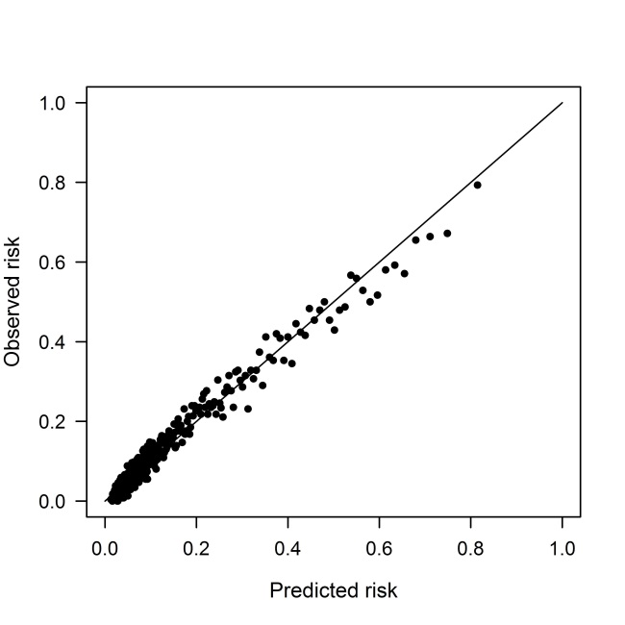 | B.  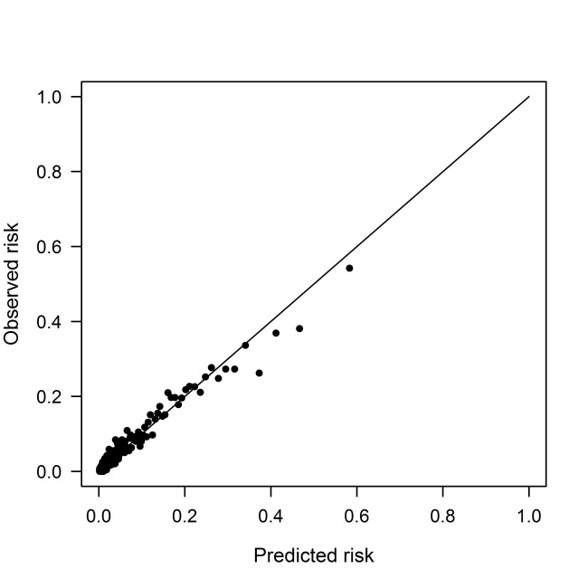

FIGURE E1. Patient flow chart showing selection of eligible patients in the Optimum Patient Care Database.
COPD, chronic obstructive pulmonary disease; OPCRD, Optimum Patient Care Research Database.

FIGURE E2. Receiver operating characteristic curve for the model predicting risk of ≥2 asthma attacks in the 2-year outcome period.
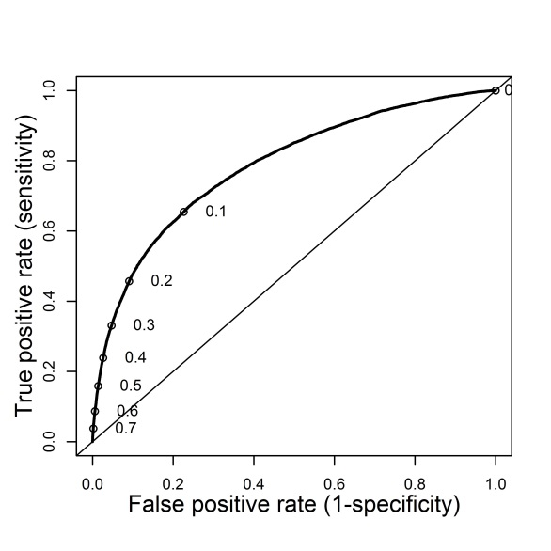

FIGURE E3. Receiver operating characteristic curve for the model predicting risk of ≥4 asthma attacks in the 2-year outcome period.
