Differential procoagulant effects of saw-scaled viper (Serpentes: Viperidae: Echis) snake venoms on human plasma and the narrow taxonomic ranges of antivenom efficacies.

Aymeric Rogalski¹^, Christoffer Soerensen¹^, Bianca op den Brouw¹^, Callum Lister¹^, Daniel Dashvesky¹, Kevin Arbuckle², Alexandra Gloria¹, Christina Zdenek¹, Nicholas R. Casewell³, José María Gutiérrez⁴, Wolfgang Wüster⁵, Syed A. Ali^{1,6}, Paul Masci⁷, Paul Rowley³, Nathaniel Frank⁸, Bryan G. Fry*

- Venom Evolution Lab, School of Biological Sciences, University of Queensland, St Lucia QLD 4072 Australia
- Department of Biosciences, College of Science, Swansea University, Swansea SA2, 8PP, UK
- Alistair Reid Venom Research Unit, Parasitology Department, Liverpool School of Tropical Medicine, Pembroke Place, Liverpool, L3 5QA, UK
- Instituto Clodomiro Picado, Facultad de Microbiología, Universidad de Costa Rica, San José, Costa Rica
- Molecular Ecology and Fisheries Genetics Laboratory (MEFGL), School of Biological Sciences, University of Wales, Bangor LL57 2UW
- HEJ Research Institute of Chemistry, International Centre for Chemical and Biological Sciences (ICCBS), University of Karachi, Karachi 75270, Pakistan
- Princess Alexandra Hospital, Translational Research Institute, University of Queensland, St Lucia, QLD 4072, Australia
- Mtoxins, 1111 Washington Ave, Oshkosh, WI 54901, USA

^ contributed equally to this work
* corresponding author

Abstract
Saw-scaled vipers (genus Echis) are one of the leading causes of snakebite morbidity and mortality in parts of Sub-Saharan Africa, the Middle East, and vast regions of Asia, constituting a public health burden exceeding that of almost any other snake genus globally. Venom-induced consumption coagulopathy, owing to the action of potent procoagulant toxins, is one of the most relevant clinical manifestations of envenomings by Echis spp. Clinical experience and prior studies examining a limited range of venoms and eected antivenoms have demonstrated for some antivenoms an extreme lack of antivenom cross-reactivity between different species of this genus, sometimes resulting in catastrophic treatment failure. This study undertook the most comprehensive testing of Echis venom effects upon the coagulation of human plasma, and also the broadest examination of antivenom potency and cross-reactivity, to-date. 10 Echis species/populations and four antivenoms (two African, two Asian) were studied. The results indicate that the venoms are, in general, potently procoagulant but that the relative dependence on calcium or phospholipid co-factors is highly variable. Additionally, three out of the four antivenoms tested demonstrated only a very narrow taxonomic range of effectiveness in preventing coagulopathy, with only the SAIMR antivenom displaying significant levels of cross-reactivity. These results were in conflict with previous studies using prolonged preincubation of antivenom with venom to suggest effective cross-reactivity levels for the ICP Echi-Tab antivenom. These findings both inform upon potential clinical effects of envenomation in humans and highlight the extreme limitations of available treatment. It is hoped that this will spur efforts into the development of antivenoms with more comprehensive coverage for bites not only from wild snakes but also from specimens widely kept in zoological collections.

Introduction
Envenoming and deaths resulting from snakebite represent an important public health concern, particularly throughout rural areas of South Asia and Sub-Saharan Africa in which access to sufficient medical facilities and antivenoms can be limited (Gutiérrez et al., 2006; Kasturiratne et al., 2008; Maduwage and Isbister, 2014). It is estimated that snakebite affects around 5 million people and accounts for more than 100,000 deaths annually (Chippaux, 1998; White, 2005; Kasturiratne et al., 2008). However these numbers are dramatic underestimations due to poor or entirely absent epidemiological data in many regions. Most severe cases of envenoming are attributed to species belonging to the Elapidae and Viperidae families (Gutiérrez et al., 2006). Typically, venoms from elapid snakes induce neuromuscular paralysis and are thus classed as neurotoxic, whereas viperid snake venoms most commonly target haemostasis (e.g., coagulation dysfunction, fibrinolysis, thrombosis) and induce local tissue damage, and are thus broadly categorised as cytotoxic and haemotoxic (Boyer et al. 2015; Markland, 1998; Sajevic et al., 2011; Warrell, 2010; White, 2005). Coagulopathy, which contributes to sustained bleeding and consequent haemodynamic disturbances (Warrell, 2010), is considered to be one of the most common serious systemic clinical pathologies induced by snake envenoming (Isbister, 2010). Accordingly, the Viperidae family contains some of the most medically significant snake genera worldwide (Gutiérrez et al., 2006; Warrell, 2010). Among them, saw-scaled or carpet vipers (Viperidae: Echis) are thought to be responsible for causing more snakebite deaths annually than any other genus (Warrell and Arnett, 1976).
Currently, the genus Echis is thought to comprise at least nine species, distributed across four main clades: E. carinatus E. coloratus, E. ocellatus, and E. pyramidum (Pook et al., 2009; Alencar et al. 2016). They can be found across the semi-arid and seasonal climate regions of Sub-Saharan Africa north of the Equator, Arabia, Iran, Afghanistan and Uzbekistan, and in Pakistan, India and Sri Lanka, often in relative abundance. These areas are typically remote, rural, with absent or inadequate medical facilities, and with inhabitants of low socio-economic status. This, in conjunction with yielding highly toxic venom, renders Echis a common cause of injurious or fatal snakebite in the regions they occupy (Habib and Warrell, 2013). Though accurate statistics are sometimes difficult to ascertain due to poor documentation of bite cases in such developing nations, Echis ocellatus is responsible for as many as 95% of snake bites in northern Nigeria, for example (Meyer et al., 1997; WHO 2010a). Victims are most commonly young males, a result of higher encounter rates arising from land cultivation or walking (Warrell and Arnett, 1976). In the absence of effective antivenom, case fatality rates following envenomation can be as high as 20% even with supportive medical treatment (Warrell and Arnett, 1976; Pugh and Warrell, 1980; Visser et al., 2008), and those who survive are often left with permanent disability and disfiguring sequelae (Abubakar et al., 2010). Local effects of Echis viper envenoming typically include pain, swelling, blistering, and haemorrhage, which, in severe cases, can lead to necrosis and amputation. In such cases, the long-term socio-economic impact upon both bite victims and their families can be severe and is an often-overlooked consequence of snakebite (Vaiyapuri et al., 2013).
In addition to localised effects, Echis toxins also induce dysfunctions of haemostasis, and mortality following envenomation is typically a result of systemic haemostatic disruption, which often leads to systemic haemorrhage (Warrell et al., 1977; Boyer et al. 2015). Of the three main processes involved in haemostasis (vasoconstriction, platelet plug formation and coagulation (Jin and Gopinath, 2016), the majority of snake venoms affecting haemostasis, including those of Echis, target the coagulation cascade. The coagulation cascade, whereby blood forms a clot following the stepwise activation of multiple clotting factors, requires the presence of Ca²⁺ ions and platelet-phospholipids. These molecules act as co-factors to clotting proteins present in plasma, ultimately inducing the proteolytic cleavage of prothrombin to thrombin (Berny et al., 2010; Davie et al., 1991; Jackson and Nemerson 1980; Munnix et al., 2007). Then, soluble fibrin monomers are formed by the cleavage of fibrinogen by the activated thrombin, and these monomers subsequently form an insoluble fibrin meshwork, resulting in a clot (Jin and Gopinath, 2016).
The snake venom components responsible for perturbing haemostasis are variable, although the majority can be classified into four categories according to the part of the coagulation pathway upon which they act: factor V activators, factor X activators, prothrombin activators, and thrombin-like enzymes (TLEs) or fibrinogenases (Lu et al., 2005; Kini and Koh, 2016; Slagboom et al. 2017). Within the genus Echis, the presence of prothrombin activators in species from each of the four main clades have been demonstrated (Gillissen et al., 1994; Mann, 1978; Mion et al., 2013; Porath et al., 1992; Warrell et al., 1977; Yamada et al., 1996). Prothrombin activators found within the genus are categorised into two subgroups according to their calcium dependence: ‘ecarin-like’ (Ca²⁺-independent) and ‘carinactivase-like’ activators (Ca²⁺-dependent), classified into groups A and B of snake venom prothrombin activators (Kini, 2005). Those belonging to the ‘ecarin-like’ group are named so following the discovery of a prothrombin activator (ecarin) with an unprecedented Ca²⁺-independent activity, isolated from Echis carinatus venom (Morita and Iwanaga, 1978). In contrast, ‘CA-like’ activators exhibit Ca²⁺-dependent activity, e.g., the prothrombin activator carinactivase, isolated from Echis leucogaster venom (Yamada et al., 1996). These toxins are responsible for the catalysis of prothrombin into thrombin. In natural prey items, this results in rapid subjugation through intravascular coagulation leading to cardiovascular collapse. However, in humans, the dilution of the venom into a much larger blood volume results in the formation of millions of microthrombi. In and of themselves, microthrombi are not lethal, but their formation consumes the majority of available essential clotting factors. Clinically, this leads to low or undetectable concentrations of fibrinogen (Isbister, 2010) and to multiple blood factor deficiencies, a potentially lethal condition known as venom-induced consumption coagulopathy (VICC) (Gillissen et al., 1994; Mann, 1978; Mion et al., 2013; Porath et al., 1992; Warrell et al., 1977). Coagulopathy also contributes to the generation of additional systemic pathologies in human bite victims, including internal haemorrhage, such as cerebrovascular accident (Boyer et al. 2015; Warrell et al., 1977).
Despite envenomation by all Echis species manifesting similar clinical symptoms, previous studies have documented considerable inter- and intraspecific variations in their venom composition (Barlow et al., 2009; Casewell et al., 2009, 2014; Schaeffer, 1987), apparently driven at least in part by natural selection for different diet spectra between the clades (Barlow et al., 2009; Richards et al., 2012, Savanur et al., 2014). This suggests that variation in the molecular mechanisms inducing these pathologies also exists. Such interspecific variation in toxin expression, and therefore in venom antigenicity, can greatly affect the ability of an antivenom to neutralise a given venom (Bénard-Valle et al. 2015; Fry et al., 2003; Harrison et al., 2003). Antivenoms consist of polyclonal antibodies purified from the serum or plasma of animals hyperimmunised with the target species’ venom (Bénard-Valle et al. 2015; Heard et al., 1999; Theakston and Warrell, 1991). Due to their polyclonal nature, antivenoms are able to neutralise multiple venom components (Gutiérrez et al., 2003; Gutiérrez et al 2014); however, the antibodies are specific to the venoms from which they were developed (Bénard-Valle et al. 2015). Consequently, while antivenoms are typically marketed as a therapeutic treatment for envenomation by a given species, intraspecific venom variation can reduce antivenom efficacy, dependent upon the difference between the venom composition of the individuals which were used for antivenom manufacture and the individual which delivered the bite (Bénard-Valle et al. 2015; Boyer et al. 2015). It is well documented that the success rates achieved by different antivenoms in treating Echis snakebites can vary significantly depending on the geographical location of the bite due to regional variation of the species’ venom (Abubakar et al., 2010; Calvete et al., 2016; Casewell et al., 2010), which can translate into catastrophic treatment failure and case fatality rates increased by an order of magnitude in a tropical clinical setting (Alirol et al. 2015; Visser et al., 2008; Warrell and Arnett, 1976; Warrell et al. 1980).
In light of the complications associated with Echis envenomings, from a clinical perspective, there is a distinct need to characterise the coagulant activity of venoms of this genus, with particular reference to geographical variation, and to explore the implications this may have for antivenom cross-reactivity. In this study, a comparative analysis of the venoms of six representative species belonging to the four main clades of Echis was conducted. Coagulation assays were used to explore the interspecific and intraspecific variations of coagulopathic toxicity within Echis. Antivenom cross-reactivity was investigated by comparing the neutralising capacity of four Echis antivenoms. This research has been conducted to provide the first comprehensive reference framework for Echis venom coagulopathic effects and differential response to antivenoms.
Materials and Methods
Venom samples
A total of ten Echis pooled-venom samples were included in this study, comprising six representative species belonging to the four main clades of the genus and from across its geographical distribution. The venoms were sourced from the cryogenic venom collection of the Venom Evolution Lab, University of Queensland and that of the Alistair Reid Venom Research Unit, Liverpool School of Tropical Medicine. Species and localities were as follows: E. carinatus (India), E. c. sochureki (Mithi, Tharparkar District, Sindh Province, Pakistan), E. c. sochureki (United Arab Emirates), E. coloratus (Saudi Arabia), E. jogeri (Bandafassi, Kédougou Region, Senegal), E. leucogaster (Mali), E. ocellatus (Ghana), E. ocellatus (Mali), E. ocellatus (Nigeria), and E. pyramidum leakeyi (Kenya). Pooled samples were used to account for any potential venom variation between individuals due to such variables as sex and age. Working stock solutions from freeze-dried venom were reconstituted to a concentration of 1mg/ml in 50% deionised water / 50% glycerol (Sigma-Aldrich) to prevent freezing and thus reduce enzyme degradation and preserve enzymatic activity. Working stocks were stored at -20°C and used for all subsequent analyses.

Human plasma
Human plasma was provided by the Australian Red Cross (44 Musk Street, Kelvin Grove, Queensland 4059). Three batches of pooled plasma (Lot#4456062 (Rhesus A+), Lot#4439715 (Rhesus A-), Lot#4439719 (Rhesus O-)) were further pooled and aliquoted. The plasma aliquots were then flash frozen in liquid nitrogen and stored at -80°C until use. For all coagulation analyses, plasma aliquots were defrosted in an Artic refrigerated circulator SC150-A40 for 5 minutes (min) at 37°C and immediately used for experimentation.

Coagulation analyses
Coagulation analyses were performed on a Stago STA-R Max® automated coagulation analyser (Stago, Asnières sur Seine, France) using Stago Analyser software v0.00.04 (Stago, Asnières sur Seine, France). To check the quality of the plasma, positive and negative controls were conducted and compared to pre-established plasma clotting parameters in the presence and absence of an activator (49-51 seconds (s) and 450-550 s respectively). The positive control was conducted by performing a standardised activated Partial Thromboplastin Time (aPTT) test (Stago Cat#T1203 TriniCLOT APTT HS). 50 µL Kaolin (STA C.K.Prest standard kit, Stago Cat#00597), a coagulation activator, was added to 50 µL plasma and incubated for 120 seconds. 50 µL CaCl₂ (0.025 M, Stago Cat#00367) was then added, and time until clot formation was measured. As a negative control, test conditions in the absence of venom were replicated. 50 µL buffer solution (30 µL 50% deionised H₂O / 50% glycerol in 270 µL Owren-Koller (OK) buffer) was added to 50 µL CaCl_{2,} 50 µL phospholipid and 25 µL OK buffer, and then incubated for 120 s at 37°C. 75 µL plasma was then added and clotting time measured. Both controls were run in triplicate before commencing any venom analyses.
In order to determine clotting times effected by the addition of varying venom concentrations, venom working stock solution was diluted with Owren Koller (OK) Buffer (Stago Cat# 00360) as appropriate in order to perform 10-point dilution series (µg/ml: 20, 10, 5, 2.5, 1.33, 0.66, 0.4, 0.2, 0.1, and 0.05). 50 µL of CaCl₂ with 50 µL phospholipid (cephalin prepared from rabbit cerebral tissue from STA C.K Prest standard kit, Stago Cat# 00597, solubilised in OK Buffer) were added to 50 µL of the diluted venom. An additional 25 µL of OK Buffer was added to the cuvette and incubated for 120 seconds at 37°C before adding 75 µL human plasma (total volume 250 µL /cuvette). Time until clot formation was then immediately monitored by the automated analyser. Tests were conducted in triplicate, with plasma and venom being replaced every 15-30 minutes to minimise enzyme degradation.

Phospholipid and calcium dependence
In order to test for co-factor dependence of the venoms, the aforementioned coagulation analyses were run both with and without CaCl₂ and/or phospholipid. The experimental protocol was identical, with the exception that 50 µL OK Buffer was added as a substitute for the removed co-factor to ensure consistency in final test volumes (250 µL). Tests were conducted in triplicate, with plasma and venom being replaced every 15-30 minutes to minimise enzyme degradation.

Antivenom tests
The relative efficacy of four polyvalent and monovalent antivenoms were investigated in this study. The previously measured whole plasma clotting times for each venom were used as a guide for antivenoms effects. Four antivenoms were assessed; three polyvalent: (a) EchiTAb-Plus-ICP, from Instituto Clodomiro Picado, Costa Rica (Lot 5620715PALQ), (b) Sii Polyvalent Anti-snake Venom Serum from Serum Institute Of India LTD, India (Lot 045D0004), and (c) Snake Venom Antiserum I.P. from VINS Bioproducts LTD, India (Lot 1081); and one monovalent: SAIMR Echis antivenom provided by South African Vaccine Producers (SAVP) (South Africa – Lot 2147) (Table 1).
Antivenoms which were provided in lyophilised form were reconstituted in sterile water (if indicated by the manufacturer), aliquoted, and stored at 4°C. In order to ascertain the potency, as each antivenom vial contained the same final volume (10ml) equal volumes of each antivenom were used for testing. For antivenom testing, all test conditions replicated that of the coagulation analyses, with the exception that 25µl of antivenom working solution (50 µL reconstituted antivenom in 950 µL OK buffer) used in place of 25µl of OK Buffer: 50 µL venom, 50 µL calcium, 50 µL phospholipid, 25 µL antivenom, 120 s incubation time, 75 µL plasma. Time until clot formation was then immediately measured. Experiments were conducted in triplicate, with plasma and venom being replaced every 15-30 minutes to minimise enzyme degradation.

Statistical analysis
Coagulation times (seconds) for each of the venoms and antivenoms were graphed using Prism 7.0 software (GraphPad Software Inc, La Jolla, CA, USA) to produce concentration response curves. Calculation of EC₅₀ (concentration of venom at which 50% of the effect is observed) values for the venom and antivenom concentration curves for each dataset were performed using Prism 7.0 software (GraphPad Software Inc, La Jolla, CA, USA). Data is expressed as mean ± SD. After EC₅₀s were calculated, the relative antivenom efficacy was calculated using the formula:
x=abc/def-1 with a= antivenom EC₅₀ x-axis, b= antivenom EC₅₀ y-axis, c= antivenom starting clotting time, d= venom EC₅₀ x-axis, e= venom EC₅₀ y-axis and f= venom starting clotting time.

The phylogenetic tree used was based upon a previously published species tree (Pook et al., 2009; Alencar et al. 2016) and created using Mesquite software (version 3.2), which was then imported into Rstudio using the APE package (Paradis et al., 2004). Ancestral states were estimated for all traits (including the proportional shift of the relative co-factor dependence and relative antivenom efficacy) using maximum likelihood as implemented in the contMap function of the R package phytools (Revell, 2012). We then fit pGLS models (Symonds and Blomberg, 2014) in caper (Orme et al., 2015) to test for relationships. Specific scripts for each step in R are as follows:

PHYTOOLS CODE
>library(ape)
>library(maps)
>library(phytools)
> # senci.contMap is a slight modification of errorbar.contMap that trims 95% CIs of ancestral state reconstructions to a sensible range, e.g. for traits bound between 0 and 1
# Example of code for implementing it would be as follows (lines separated by semicolons): pasr<-contMap(tree,mapdat,plot=F,lims=c(0,1)) ; plot(setMap(pasr,invert=T)) ; senci.contMap(setMap(pasr,invert=T),mini=0,maxi=1)
senci.contMap<-function(obj,...){
if (hasArg(x))
x <- list(...)$x
else x <- setNames(sapply(1:Ntip(obj$tree), function(x, obj) {
ii <- which(obj$tree$edge[, 2] == x)
ss <- names(obj$tree$maps[[ii]][length(obj$tree$maps[[ii]])])
obj$lims[1] + as.numeric(ss)/(length(obj$cols) - 1) *
diff(obj$lims)
}, obj = obj), obj$tree$tip.label)
if (hasArg(scale.by.ci))
scale.by.ci <- list(...)$scale.by.ci
else scale.by.ci <- TRUE
if (hasArg(lwd))
lwd <- list(...)$lwd
else lwd <- 14
tree <- obj$tree
aa <- fastAnc(tree, x, CI = TRUE)
if (hasArg(min))#added lines here
for (i in 1:length(aa$CI95[,1])){ #added lines here
aa$CI95[i,1]<-ifelse(aa$CI95[i,1]<list(...)$min,list(...)$min,aa$CI95[i,1]) #added lines here
} #added lines here
else aa$CI95[,1]<-aa$CI95[,1] #added lines here
if (hasArg(max)) #added lines here
for (i in 1:length(aa$CI95[,2])){ #added lines here
aa$CI95[i,2]<-ifelse(aa$CI95[i,2]>list(...)$max,list(...)$max,aa$CI95[i,2]) # added lines here
} #added lines here
else aa$CI95[,2]<-aa$CI95[,2] #added lines here
xlim <- range(aa$CI95)
if (xlim[2] > obj$lims[2] || xlim[1] < obj$lims[1]) {
cat(paste(" -----\n The range of the contMap object, presently (",
round(obj$lims[1], 4), ",", round(obj$lims[2], 4),
"), should be equal to\n or greater than the range of the CIs on ancestral states: (",
round(xlim[1], 4), ",", round(xlim[2], 4), ").\n",
sep = ""))
cat(paste(" To ensure that your error bars are correctly plotted, please recompute your\n",
" contMap object and increase lims.\n -----\n",
sep = ""))
}
d <- diff(obj$lims)
if (scale.by.ci) {
v <- aa$CI95[, 2] - aa$CI95[, 1]
v <- v/max(v)
}
else v <- rep(0.5, tree$Nnode)
n <- length(obj$cols) - 1
lastPP <- get("last_plot.phylo", envir = .PlotPhyloEnv)
h <- max(nodeHeights(tree))
for (i in 1:tree$Nnode) {
ii <- round((aa$CI95[i, 1] - obj$lims[1])/d * n)
jj <- round((aa$CI95[i, 2] - obj$lims[1])/d * (n + 1))
cols <- obj$cols[ii:jj]
add.color.bar(leg = 0.1 * h * v[i], cols = cols, prompt = FALSE,
x = lastPP$xx[i + Ntip(tree)] - 0.05 * h * v[i],
y = lastPP$yy[i + Ntip(tree)], title = "", subtitle = "",
lims = NULL, lwd = lwd)
}
}
>data<-read.csv(file.choose())
>dat<-data
>mapvar<-dat$var
>names(mapvar)<-dat$species
>tree<-read.tree(file.choose())
>tree<-chronos(tree)
>asr<-contMap(tree,mapvar,plot=F)

For red (warmer) zone for the higher numbers (eg antivenom shifts) the below was used.
>plot(setMap(asr,col=c(1,4,5,3,7,2,6,8)))
>senci.contMap(setMap(asr,col=c(1,4,5,3,7,2,6,8)),min=x,max=y)

For red (warmer) zone for smaller numbers (eg clotting time and co factors) the below was used
>plot(setMap(asr,col=c(8,6,2,7,3,5,4,1)),lwd=10)
>senci.contMap(setMap(asr,col=c(8,6,2,7,3,5,4,1)),min=x,max=y)

In both cases, the x and y for senci were the low and high numbers (respectively) for the particular dataset.

PHYLOGENETIC GENERALISED LEAST SQUARES REGRESSION (PGLS) STEP
>library(caper)
>data<-read.csv(file.choose())
>tree<-read.tree(file.choose())
>com<-comparative.data(tree,data,species)

For values of variable range in the responder column, these steps were used
>mod<-pgls(var1~var2,com,lambda="ML")
>summary(mod)

For 0 to 1 values in the responder column
>mod<-pgls(57.295*asin(sqrt(var1))~var2,com,lambda="ML")
>summary(mod)

Results and Discussion
Procoagulant activity was revealed to be a dynamic feature without a strong phylogenetic pattern, and also without any obvious relationship with the diet spectra of the clades, despite diet-specific differences in venom lethality to prey (Barlow et al., 2009), therefore suggesting this is a dynamic ancestral functional phenotype in Echis spp. Testing revealed all venoms to follow a similar dilution curve trajectory. However, clotting times at maximal venom concentration (20 µg/mL) varied from 19.53+/-1.30s for E. pyramidum leakeyi to 40.13+/-1.20s for E. carinatus (India), though most venoms induced a clot in around 20-25 seconds (Figure 1, Table 2). Only E. carinatus (India) and E. leucogaster (Mali) venoms took longer than 30 s to generate a clot (Figure 1). There was significant variation in clotting time within each of the three major clades. E. carinatus (India) was significantly slower than the two other venoms in the E. carinatus clade (E. c. sochureki (Pakistan) and E. c. sochureki (UAE), but with E. c. sochureki (Pakistan) and E. c. sochureki (UAE) not differing significantly from each other. E. leucogaster was also significantly slower than its closest relatives in this study (E. coloratus and E. pyramidum leakeyi), with E. coloratus and E. pyramidum leakeyi also being significantly different in their clotting times relative to each other. Within the E. jogeri/E. ocellatus clade all venoms differed significantly from each other, with coagulant activity for the four venoms ranging from 19.63s (E. jogeri (Senegal)) to 27.0s (E. ocellatus (Ghana)).
The interspecific variation in calcium cofactor dependence showed a strong phylogenetic pattern and varied from the almost independent E. carinatus (India locale), with a clotting time shift of only 0.42 +/- 0.02-fold in the absence of calcium, to total dependence in E. coloratus (Saudi Arabia), which was unable to induce a clot in the instrument’s maximum measurement time range (999 s) and thus has a clotting time shift of at least 17.5-fold (Figure 2, Table 2). The basally split E. carinatus clade ranged from strong to moderate calcium independence. The E. jogeri/E. ocellatus clade displayed consistent strong calcium-independence. In contrast, all venoms from the E. pyramidum clade exhibited a high degree of calcium dependence. Taken in the context of the phylogeny (Figure 2) this suggests that low levels of calcium dependence is the plesiotypic condition of the Echis genus.
In contrast to the extreme effect seen with regard to calcium cofactor dependence, relative shifts in clotting time in the absence of additional phospholipid cofactor were substantially less than those of calcium, and also lacked the strong phylogenetic pattern evident for calcium dependence (Figure 2, Table 2). Relative phospholipid dependence ranged from 0.04 +/- 0.01-fold for E. carinatus (India) through to 0.90 +/- 0.07-fold for E. c. sochureki (Pakistan). The third member of this clade, E. sochureki (UAE locale; 0.48 +/- 0.03-fold) demonstrated intermediate dependence. The other clades were also variable. Thus, while phospholipid dependence in general was less pronounced, the lack of phylogenetic consistency suggests that it is a labile character relative to that of calcium dependence.
A higher relative degree of calcium dependence predicted increased relative phospholipid dependence (PGLS: t=2.2734, p=0.03851), but the reverse was not true in that the relative degree of phospholipid dependence did not predict that of calcium dependence (PGLS: t=1.6467, p=0.13824). This may suggest that changes in calcium dependence subsequently lead to changes in phospholipid dependence, but this directional suggestion remains tentative. Higher relative degree of phospholipid dependence was associated with faster clotting times, though this effect was marginally non-significant (PGLS: t=-2.1562, p=0.063160) (Figure 3). In contrast, the relative calcium dependence did not predict clotting time (PGLS: t=-1.7817, p=0.11266). Thus there appears to be a positive correlation between the ability of the enzymes to use phospholipid and their ability activate prothrombin, which is consistent with neofunctionalisation of these enzymes for such an activity relative to their ancestral protease activity. Thus the more the enzymes are able to utilize phospholipid for the newly evolved prothrombin activation activity, the faster the reaction proceeds. The structural features responsible for this phospholipid utilisation are unknown and thus represent a rich area of future research. The dynamic nature of this in relationship to the phylogeny of the snakes themselves is a particularly fascinating riddle (Figure 2). Additional studies are required however to confirm this directionality and the biochemical mechanisms behind it.
The four antivenoms tested using equal volumes of each antivenom had extremely variable results both in potency and species targeted (Figures 4-7, Tables 3 and 4). EchiTAb-Plus-ICP antivenom had the strongest effect of all the antivenoms tested in this study, being for example twice as effective as SII in relation each antivenom’s best neutralised venom but not to the 6.6-fold ratio that may be anticipated from the package insert details (Table 1). Consistent with E. ocellatus venom being used in the immunising mixture, this antivenom demonstrated strong selectivity for the West African species E. ocellatus venoms and, to a lesser extent, the E. jogeri venom. The strongest effect was seen for E. ocellatus (Ghana) venom which had the clotting curve proportionally shifted with an effect of 65-fold. The other E. ocellatus populations were also well neutralised, but to a lesser extent. Unexpectedly, of the E. ocellatus samples tested, the population from Nigeria was the least affected by the EchiTab-ICP, despite the antivenom being manufactured from pooled venoms of E. ocellatus collected from Nigeria (Gutiérrez et al., 2005). While the precise locality of the Nigerian sample used in this study was not known, the results never-the-less indicative of geographical or individual variation within the region and follow-up studies should investigate this matter further. The antivenom also significantly shifted the clotting curve of E. jogeri. However, despite showing good efficacy for this clade, the EchiTab-ICP had little effect upon the other venoms thus demonstrating a narrow taxonomic range of efficiency.
In discordance with these findings (Figures 4-7, Tables 3 and 4), a previous study described the ability of the ICP antivenom to neutralise coagulant activity of the venoms of E. pyramidum and E. leucogaster (Segura et al., 2010). This discrepancy is likely to be attributable to differences in experimental protocol. Segura et al. (2010) used a more prolonged incubation time (30 minutes incubation) as compared to the protocol used in the present study (2 minutes incubation). Longer incubation times would likely conceal differences in efficacy between venom/antivenom pairs as slower, weaker binding combinations would have time to reach the levels more quickly obtained by faster, stronger binding combinations. The traditional protocols to assess the neutralizing ability of antivenoms at the preclinical level involve the incubation of venom and antivenom for 30 min or even for one hour before testing [see for example Christensen 1955, Bolaños 1977, and WHO 1981]. Moreover, the 30 min incubation protocol at 37 °C is indicated in the current version of the official WHO guidelines for antivenom production and quality control (WHO, 2010). In contrast, the new protocol used in this study introduces a more rigorous evaluation of the neutralizing capacity of antivenoms by reducing the incubation time to 2 min, thus demanding high affinity antibodies for the neutralization while also ascertaining the ability of the antivenoms to neutralise the coagulopathic enzymatic activity.
Consistent with E. pyramidum (Ethiopia/Eritrea) and E. ocellatus (Nigeria) venoms being used in the immunising mixture, the SAIMR antivenom had the strongest selectivity for the species within the E. pyramidum clade but also displayed significant cross-reactivity for E. ocellatus venoms as well as the E. jogeri venom from the same clade (Figures 4-7, Tables 3 and 4). Thus our results confirm that the SAIMR antivenom is effective against both East and West African Echis species and while it may require more antivenom for the treatment of West African species it clearly has the broadest coverage of African Echis species (Figures 4-7).
Neither Indian antivenom was able to neutralise the Indian-locale venom samples included in this study (Figures 4-7, Tables 3 and 4). While both antivenoms use the Chennai population of E. carinatus in the immunising mixture, the geographical locality within India for the venom used in this study is unknown. However, this clearly points to potential intra-country clinical issues and this disparity should be the focus of an urgent follow-up study as this country is notable for such variation (Kochar et al. 2007). The SII antivenom performed well against the Pakistan E. c. sochureki population and to a lesser but still significant extent, the UAE E. c. sochureki population. Despite having a package insert stated potency equivalent to that of SII (Table 1), the VINS antivenom performed comparatively poorly with values comparable with the low-level cross-reactivity of EchiTAb-Plus-ICP and SAIMR for the Pakistan and UAE E. c. sochureki populations. Both the SII and VINS antivenoms give the same stated neutralising ability against the lethal effect of venoms when tested through the historical method of 30 min preincubation of antivenom with venom and then injection of the mixture into mice (Table 1). However, their performance was markedly different in this study regarding ability to neutralize the coagulant activity (Tables 3 and 4). Thus the VINS antivenom can be predicted to have little or no likely clinical usefulness against the South Asian or African venoms tested in this study without requiring extremely large doses relative to the other antivenoms studied. These findings agree with a previous study showing that VINS antivenom is highly inefficient in the neutralisation of E. ocellatus from Cameroon (Calvete et al., 2016).
Our findings demonstrate that there is gradated calcium dependence throughout the genus (Figure 2). This presents an intriguing example of venom variability and one with profound clinical implications. As the procoagulant activity of Echis spp. venoms is driven by prothrombin activating SVMPs, the calcium dependency (Figure 2) may shed light on the type of predominant type in each. Prothrombin activating SVMP are divided into Class A (calcium independent) and Class B (calcium dependent) (Casewell et al. 2015; Kini and Koh, 2016). These functional/structural divisions are sometimes referred to as ecarin-like or carinativase-like based upon the first of each type described for each. These functional classes are also reflective of structural differences, with the monomeric P-IIIa SVMP making up Class A while Class B is a P-IIIa SVMP non-covalently linked to a lectin dimer (with the two lectin subunits covalently linked to each other) (Yamada et al. 1996; Casewell et al. 2015). This trimer differs from the classical P-IIId SVMP which are covalently linked to a lectin dimer (Casewell et al. 2015). As low levels of calcium dependence is the plesiotypic state (Figure 2), this suggests that the evolution of a monomeric calcium independent P-IIIa SVMP preceded the evolution of the apotypic trimeric calcium dependent P-III. The reasons for the requirement for calcium due to the structural derivation in the P-III SVMPs remains to be elucidated and highlights an area for future research. However, due to the structural differences in the two functional classes, the venoms used in the antivenom immunising mixture may bias the antivenom efficacy towards dependent or independent venom types and thus may be responsible in part for the extreme clade-specific antivenom effects in combination with diversification of the physico-chemical properties of the prothrombin activating SVMP toxins responsible for the lethal effects.
This study has demonstrated that the antivenoms were highly variable not only in comparative potency in neutralising procoagulant activity, but also in relative species selectivity (Figures 4-7, Tables 3 and 4). The most potent antivenom (EchiTAb-Plus-ICP) also displayed the extremely narrow species selectivity. Although procoagulant activity is not the sole mode of action of Echis venoms it does play a key role in lethality. Our results indicate that the different Echis antivenoms tested are of greatest usefulness for neutralisation of this activity within the clade of venoms from which the immunising venom was drawn, with limited regional cross-reactivity. This suggests that, in at least the case of Echis, phylogenetic affinities can be used as a roadmap for the selection of antivenoms to test for effectiveness for unstudied populations, and, in an emergency, for the treatment of bites by captive specimens, although other factors may also play a role (e.g., Gillissen et al., 1994). This underscores the importance of phylogenetic and systematic studies as a guide for antivenom design and testing in this genus (Fry et al., 2003; Williams et al., 2011).
The results of this study demonstrating very narrow taxonomic efficacy ranges (Figure 7) are in conflict with previous studies, which suggested much broader efficacy ranges but involved much longer (15x) incubation times of antivenom-venom mixtures and a protocol that selected for ability to impede lethality rather than directly measuring impedence of lethality (Warrell et al. 1980; Casewell et al., 2010; Segura et al. 2010). Future work should be undertaken to investigate whether the prolonged venom:antivenom pre-incubation times used as standard in preclinical testing (WHO, 2010b) are actually predictive of clinical efficacy. Venom binding by the antivenom under such idealised circumstances may not necessarily reflect what occurs in a clinical setting. Venom and antivenom interactions in the body are due to opportunistic encounters in a dynamic system. Thus the longer incubation times historically used in preclinical testing would allow time for low-affinity antibodies to bind as they are in forced proximity with the venom for biologically unrealistic period of time. Conversely the shorter incubation times used in this study may in fact better reflect the real-world opportunity for venom binding by the high affinity antibodies in the antivenom. Such considerations will however require rigorous future studies to resolve these important questions.
In conclusion, this study has revealed extreme cross-reactivity issues for Echis antivenoms (Figures 4-7) and highlights the urgent need for the development of cost-effective, pan-regional antivenoms for Africa and Asia that cover all the Echis venom clades in their corresponding continents. Moreover, the Mid-East region and Arabian Peninsula contain species from three of the four Echis clades, including the south Asian carinatus group (E. carinatus sochureki), the Arabian coloratus group (E. coloratus, E. omanensis) and the African pyramidum clade (E. borkini, E. khosatzkii). Consequently, there is a clear need to test antivenoms used in the region for efficacy against all relevant venoms using the biologically relevant incubation times in the protocol of this study. Further, there may be also a need for a combined African/Asian Echis antivenom. It is hoped that these results will stimulate such life-saving efforts. The results of our study are of particular immediate concern as some manufacturers are selling their products outside the region from which the immunising venom was obtained and this unscrupulous marketing of non-regional specific antivenoms has resulted, in some cases, in an over twenty-fold increase in fatality rate (Alirol et al. 2015; Visser et al., 2008; Warrell 2008).

Acknowledgements: BGF was the recipient of a University of Queensland Major Equipment and Infrastructure grant. BODB was the recipient of an Australian Postgraduate Award. DD and CZ were the recipients of Ph.D. scholarships from the University of Queensland. SAA was the recipient of postdoctoral fellowship (PDRF Phase IIBatch-V) from Higher Education Commission (HEC Islamabad) Pakistan. NRC acknowledges the support of a Sir Henry Dale Fellowship (200517/Z/16/Z) jointly funded by the Wellcome Trust and the Royal Society. NRC and WW acknowledge the support of J.F. Trape and Y. Mané for the collection of venom from specimens of E. jogeri.

Conflict of interest statement: J.M. Gutiérrez works at Instituto Clodomiro Picado (University of Costa Rica), where the antivenom EchiTAb-Plus-ICP is manufactured.

References:
Abubakar IS, Abubakar SB, Habib AG, Nasidi A, Durfa N, Yusuf PO, Larnyang S, Garnvwa J, Sokomba E, Salako L, Theakston RD, Juszczak E, Alder N, Warrell DA; Nigeria-UK EchiTab Study Group. (2010) Randomised controlled double-blind non-inferiority trial of two antivenoms for saw-scaled or carpet viper (Echis ocellatus) envenoming in Nigeria. PLoS Negl. Trop. Dis. 4(7):e767.
Abubakar SB, Habib AG, Mathew J. (2010) Amputation and disability following snakebite in Nigeria. Trop Doct. 40(2):114-6.
Alencar L.R., Quental T.B., Grazziotin F.G., Alfaro M.L., Martins M., Venzon M and H. Zaher. (2016) Diversification in vipers: Phylogenetic relationships, time of divergence and shifts in speciation rates. Mol. Phylogenet. Evol., 105: 50-62.
Alirol, E., Lechevalier, P., Zamatto, F., Chappuis, F., Alcoba, G. and Potet, J. (2015) Antivenoms for snakebite envenoming: what is in the research pipeline? PLOS Negl. Trop. Dis. 9(9): e0003896.
Altschul, S.F., Gish, W., Miller, W., Myers, E.W., and Lipman, D.J. (1990). Basic local alignment search tool. J. Mol. Evol. 215, 403–410.
Barlow A., Pook C.E., Harrison R.A. and Wüster W. (2009) Co-evolution of diet and prey-specific venom activity supports the role of selection in snake venom evolution. Proc. R. Soc. B., 276: 2443-2449.
Bénard-Valle M, Neri-Castro EE, Fry BG, Boyer L, Cochran C, Alam M, Jackson TNW, Paniagua, D, Olvera-Rodríguez F, Koludarov I, Sunagar K, Alagón A (2015) Antivenom research and development. In Venomous reptiles and their toxins: Evolutionary, pathophysiological and biodiscovery implications. Fry BG editor. Oxford University Press, New York. 61-72.
Benson, D.A., Cavanaugh, M., Clark, K., Karsch-Mizrachi, I., Lipman, D.J., Ostell, J., and Sayers, E.W. (2013). GenBank. Nucleic Acids Res. 41, D36-42.
Berny M.A., Munnix I.C., Auger J.M., Schols S.E., Cosemans J.M. Panizzi P., Bock P.E., Watson S.P., McCarty O.J.T., and J.W.M Heemskerk. (2010) Spatial distribution of factor Xa, thrombin, and fibrin(ogen) on thrombi at venous shear. PloS One. 5(4):e10415.
Bolaños, R. (1977) Antivenenos. In: Manual de Procedimientos. Producción y Pruebas de Control en la Preparación de Antisueros Diftérico, Tetánico, Botulínico, Antivenenos y de la Gangrena Gaseosa. Organización Panamericana de la Salud, Washington, D.C., USA, pp. 104-141.
Boyer L, Alagón A, Fry BG, Jackson TNW, Sunagar K, Chippaux J-P (2015) Signs, symptoms and treatment of envenomation. In Venomous reptiles and their toxins: Evolutionary, pathophysiological and biodiscovery implications. Fry BG editor. Oxford University Press, New York. 32-60.
Calvete JJ, Arias AS, Rodríguez Y, Quesada-Bernat S, Sánchez LV, Chippaux JP, Pla D, Gutiérrez JM. (2016) Preclinical evaluation of three polyspecific antivenoms against the venom of Echis ocellatus: Neutralization of toxic activities and antivenomics. Toxicon. 119:280-8.
Campbell J.A. and Lamar W.W. (2004) The Venomous Reptiles of the Western Hemisphere. Ithaca, NY: Cornell University Press
Casewell, N.R., D.A.N. Cook, S.C. Wagstaff, A. Nasidi, N. Durfa, W. Wüster & R.A. Harrison (2010) Pre-clinical assays predict pan-African Echis viper efficacy for a species-specific antivenom. PLoS Neglected Tropical Diseases, 4: e851.
Casewell N.R., Harrison R.A., Wüster W. and Wagstaff S.C. (2009) Comparative venom gland transcriptome surveys of the saw-scaled vipers (Viperidae: Echis) reveal substantial intra-family gene diversity and novel venom transcripts. BMC Genomics, 10: 564.
Casewell, N.R., Wagstaff, S.C., Harrison, R.A., Renjifo, C. and Wüster, W. Domain loss facilitates accelerated evolution and neofunctionalization of duplicate snake venom metalloproteinase toxin genes. Mol. Biol. Evol. 28: 2637-2649.
Casewell NR, Sunagar K, Takacs Z, Calvete JJ, Jackson TNW, Fry BG (2015) Snake venom metalloprotease enzymes (SVMP). In Venomous reptiles and their toxins: Evolutionary, pathophysiological and biodiscovery implications. Fry BG editor. Oxford University Press, New York. 347-363.
Casewell, N.R., S.C. Wagstaff, W. Wüster, D.A.N. Cook, F.M.S. Bolton, S.I. King, D. Pla, L. Sanz, J.J. Calvete & R.A. Harrison (2014) Medically important differences in snake venom composition are dictated by distinct post-genomic mechanisms. PNAS, 111: 9205-9210.
Chippaux JP (1998) Snake-bites: appraisal of the global situation. Bull World Health Organ. 76(5):515-24.
Christensen, P.A. (1955) South African Snake Venoms and Antivenoms. South African Institute for Medical Research, Johannesburg, South Africa.
Davie E.W., Fujikawa K. and Kisiel W. (1991) The coagulation cascade: initiation, maintenance, and regulation. Biochemistry, 30: 10363-10370.
Edgar, R.C. (2004). MUSCLE: multiple sequence alignment with high accuracy and high throughput. Nucleic Acids Res 32, 1792–1797.
Fry B.G., Winkel K.D., Wickramaratna J.C., Hodgson W.C. and Wüster W. (2003) Effectiveness of snake antivenom: species and regional venom variation and its clinical impact. J Toxicol Toxin Rev,. 22: 23-34.
Gillissen A., Theakston R.D., Barth J., May B., Krieg M. D. Warrell. (1994) Neurotoxicity, haemostatic disturbances and haemolytic anaemia after a bite by a Tunisian saw-scaled or carpet viper (Echis ‘pyramidum’ complex): failure of antivenom treatment. Toxicon, 32: 937-944.
Gutiérrez J.M., Leon G. and Lomonte B. (2003) Pharmacokinetic-pharmacodynamic relationships of immunoglobulin therapy for envenomation. Clin Pharmacokinet., 42: 721-741.
Gutiérrez J.M., Rojas E., Quesada L., León G. and Núñez J. (2005) Pan-African polyspecific antivenom produced by caprylic acid purification of horse IgG: an alternative to the antivenom crisis in Africa. Trans. R. Soc. Trop. Med. Hyg., 99: 468–475.
Gutiérrez J.M., Theakston R.D. and Warrell D.A. (2006) Confronting the Neglected Problem of Snake Bite Envenoming: The Need for a Global Partnership. PLoS Med., 3(6): e150.
Gutiérrez J.M., Lomonte B., Sanz L., Calvete J.J. and Pla D. (2014) Immunological profile of antivenoms: preclinical analysis of the efficacy of a polyspecific antivenom through antivenomics and neutralization assays. J Proteomics., 105: 340-350.
Habib AG and Warrell DA. (2013) Antivenom therapy of carpet viper (Echis ocellatus) envenoming: effectiveness and strategies for delivery in West Africa. Toxicon. 69:82-9.
Harrison R.A., Wüster W. and Theakston R.D. (2003) The conserved structure of snake venom toxins confers extensive immunological cross-reactivity to toxin specific antibody. Toxicon, 41: 441-449.
Heard K., O’Malley G.F. and Dart R.C. (1999) Antivenom therapy in the Americas. Drugs, 58: 5-15.
Isbister G.K. (2010) Snakebite doesn’t cause disseminated intravascular coagulation: coagulopathy and thrombotic microangiopathy in snake envenoming. Semin Thromb Hemost., 36: 444-451.
Jackson C.M. and Nemerson Y. (1980) Blood coagulation. Annu Rev Biochem., 49: 765-811.
Jin N.Z. and Gopinath S.C. (2016) Potential blood clotting factors and anticoagulants. Biomed & Pharmacotherapy, 84: 356-365.
Kasturiratne A., Wickremasinghe A.R., de Silva N., Gunawardena N.K. , Pathmeswaran A. Premaratna R., Savioli L., Lalloo D.G., de Silva H.J. (2008) The global burden of snakebite: a literature analysis and modelling based on regional estimates of envenoming and deaths. PLoS Med., 5(11): e218.
Kelley, L.A., Mezulis, S., Yates, C.M., Wass, M.N., and Sternberg, M.J.E. (2015). The Phyre2 web portal for protein modeling, prediction and analysis. Nat. Protocols 10, 845–858.
Kini R.M. (2015) The intriguing world of prothrombin activators from snake venom. Toxicon. 45(8):1133-45.
Kini RM and Koh CY (2016) Metalloproteases Affecting Blood Coagulation, Fibrinolysis and Platelet Aggregation from Snake Venoms: Definition and Nomenclature of Interaction Sites. Toxins. 8(10). pii: E284.
Kochar D. K. Tanwar P. D., Norris R.L. Sabir M., Nayak K.C., Agrawal T.D., Purohit V.P., Kochar A., Simpson I.D. (2007) Rediscovery of severe saw-scaled viper (Echis sochureki) envenoming in the Thar desert region of Rajasthan, India. Wilderness and Environmental Medicine.18:75-85.
Larsson, A. (2014). AliView: a fast and lightweight alignment viewer and editor for large datasets. Bioinformatics 30, 3276–3278.
Lu Q., Clemetson J.M. and Clemetson K.J. (2005) Snake venoms and hemostasis. J Thomb Haemost., 3: 1791-1799.
Maduwage K. and Isbister G.K. (2014) Current Treatment for Venom-Induced Consumption Coagulopathy Resulting from Snakebite. PLoS Negl Trop Dis., 8(10):e3220.
Mann G. (1978) Echis colorata bites in Israel: an evaluation of specific antiserum use on the base of 21 cases of snake bite. Toxicol Eur Res., 1: 365-369.
Markland F.S. (1998) Snake venoms and the hemostatic system. Toxicon, 36(12): 1749-1800.
Meyer W.P., Habib A.G., Onayade A.A., Yakubu A., Smith D.C., Nasidi A., Daudu I.J., Warrell D.A., and R.D. Theakston. (1997) First clinical experiences with a new ovine Fab Echis ocellatus snake bite antivenom in Nigeria: randomized comparative trial with Institute Pasteur Serum (Ipser) Africa antivenom. Am J Trop Med Hyg., 56(3): 291-300.
Mion G., Larreche S., Benois A., Petitjeans F. and Puidupin M. (2013) Hemostasis dynamics during coagulopathy resulting from Echis envenomation. Toxicon, 76: 103-109.
Morita T. and Iwanaga S. (1978) Purification and properties of prothrombin activator from the venom of Echis carinatus. J Biochem., 83(2): 559-570.
Munnix I.C., Kuijpers M.J., Auger J., Thomassen C.M., Panizzi P., van Zandvoort M.A., Rosing J., Bock P.E., Watson S.P., and J.W. Heemskerk. (2007) Segregation of platelet aggregatory and procoagulant microdomains in thrombus formation: regulation by transient integrin activation. Arterioscler Thromb Vasc Biol., 27(11): 2484-2490.
Murrell, B., Moola, S., Mabona, A., Weighill, T., Sheward, D., Pond, K., L, S., and Scheffler, K. (2013). FUBAR: A Fast, Unconstrained Bayesian AppRoximation for Inferring Selection. Mol Biol Evol 30, 1196–1205.
Murrell, B., Wertheim, J.O., Moola, S., Weighill, T., Scheffler, K., and Pond, S.L.K. (2012). Detecting Individual Sites Subject to Episodic Diversifying Selection. PLOS Genetics 8, e1002764.
Orme, D., Freckleton, R., Thomas, G., Petzoldt, T., Fritz, S., Isaac, N., Pearse, W. (2015) Caper: Comparative Analyses of Phylogenetics and Evolution in R, R Package Version 0.5.2, 2015. Available online: https://CRAN.R-project.org/package=caper (accessed on 101/02/17)
Paradis, E., Claude, J., Strimmer K (2004). APE: Analyses of Phylogenetics and Evolution in R language. Bioinformatics, 20: 289-290.
Pei, J., and Grishin, N.V. (2001). AL2CO: calculation of positional conservation in a protein sequence alignment. Bioinformatics 17, 700–712.
Pettersen, E.F., Goddard, T.D., Huang, C.C., Couch, G.S., Greenblatt, D.M., Meng, E.C., and Ferrin, T.E. (2004). UCSF Chimera—a visualization system for exploratory research and analysis. Journal of Computational Chemistry 25, 1605–1612.
Pond, S.L.K., Frost, S.D.W., and Muse, S.V. (2005). HyPhy: hypothesis testing using phylogenies. Bioinformatics 21, 676–679.
Pook C.E., Joger U., Stümpel N. and Wüster W. (2009) When continents collide: Phylogeny, historical biogeography and systematics of the medically important viper genus Echis (Squamata: Serpentes: Viperidae). Mol. Phylogenet. Evol., 53: 792-807.
Porath A., Gilon D., Schulchynska-Castel H., Shalev O., Keynan A., and J. Benbassat. (1992) Risk indicators after envenomation in humans by Echis coloratus (mid-east saw scaled viper). Toxicon., 30: 25-32.
Pugh, R.N.H. and Theakston, R.D.G. (1980) Incidence and mortality of snake bite in savanna Nigeria. Lancet 2(8205): 1181–1183.
Revell, L.J (2012). phytools: an R package for phylogenetic comparative biology (and other things). Methods in Ecology and Evolution, 3: 217-223.
Richards, D.P., A. Barlow & W. Wüster. (2012) Venom lethality and diet: Differential responses of natural prey and model organisms to the venom of the saw-scaled vipers (Echis), Toxicon, 59: 110-116.
Ronquist, F., Teslenko, M., van der Mark, P., Ayres, D.L., Darling, A., Höhna, S., Larget, B., Liu, L., Suchard, M.A., and Huelsenbeck, J.P. (2012). MrBayes 3.2: Efficient Bayesian Phylogenetic Inference and Model Choice Across a Large Model Space. Syst Biol 61, 539–542.
Rosing J. and Tans G. (1992) Structural and functional properties of snake venom prothrombin activators. Toxicon, 30(12): 1515-1527
Sajevic T., Leonard A. and Križaj I. (2011) Haemostatically active proteins in snake venoms. Toxicon, 57(5): 627-645.
Savanur A, Ali SA, Munir I, Abbasi A, Alam M, Shaikh HA. (2014) Pharmacological and biochemical studies on the venom of a clinically important viper snake (Echis carinatus) of Pakistan. Toxicon. 80: 47-57.
Schaeffer R.C. Jr (1987) Heterogeneity of Echis venoms from different sources. Toxicon, 25: 1343-1346.
Segura A, Villalta M, Herrera M, León G, Harrison R, Durfa N, Nasidi A, Calvete JJ, Theakston RD, Warrell DA, Gutiérrez JM. (2010) Preclinical assessment of the efficacy of a new antivenom (EchiTAb-Plus-ICP) for the treatment of viper envenoming in sub-Saharan Africa. Toxicon. 55(2-3):369-74.
Slagboom, J., Kool, J., Harrison, R.A. and Casewell, N.R. (2017) Haemotoxic snake venoms: their functional activity, impact on snakebite victims and pharmaceutical promise. Br. J. Haematol. 177: 947-959.
Symonds, M.R.E., Blomberg, S.P (2014) A primer on phylogenetic generalised least squares (PGLS). In: Modern Phylogenetic Comparative Methods and Their Application in Evolutionary Biology: Concepts and Practice (ed. LZ Garamszegi), Chapter 5, pp 105-130. Springer, Berlin
Theakston R.D. and Warrell D.A. (1991) Antivenoms: a list of hyperimmune sera currently available for the treatment of envenoming by bites and stings. Toxicon, 29: 1419-1470.
Vaiyapuri S Vaiyapuri R, Ashokan R, Ramasamy K, Nattamaisundar K, Jeyaraj A, Chandran V, Gajjeraman P, Fazil Baksh M.F., Gibbins JM and Hutchinson EG (2013) Snakebite and its socio-economic impact on the rural population of Tamil Nadu, India. PLoS One. 8(11): e80090.
Visser L.E., Kyei-Faried S., Belcher D.W., Geelhoed D.W., van Leeuwen J.S. and J. van Roosmalen. (2008) Failure of a new antivenom to treat Echis ocellatus snake bite in rural Ghana: the importance of quality surveillance. Trans R Soc Trop Med Hyg., 102: 445-450
Warrell DA (2010) Snakebite. Lancet. 375(9708):77-88.
Warrell DA and Arnett C (1976). The importance of bites by the saw-scaled or carpet viper (Echis carinatus): epidemiological studies in Nigeria and a review of the world literature. Acta Tropica 33(4):307-341
Warrell D.A., Davidson N.McD. and Greenwood B.M. (1977) Poisoning by bites of the saw scaled or carpet viper (Echis carinatus) in Nigeria. Quart. J. Med., 46(181): 33-62.
Warrell D.A., Warrell M.J., Edgar W., Prentice C.R., Mathison J. (1980) Comparison of Pasteur and Behringwerke antivenoms in envenoming by the carpet viper (Echis carinatus), Br. Med. J., 280: 607–609.
Warrell D.A. (2008) Unscrupulous marketing of snake bite antivenoms in Africa and Papua New Guinea: choosing the right product--‘what’s in a name?’. Trans R Soc Trop Med Hyg., 102: 397-399.
WHO (1981) Progress in the Characterization of Venoms and Standardization of Antivenoms. World Health Organization, Geneva. http://apps.who.int/iris/bitstream/10665/37282/1/WHO_OFFSET_58.pdf Accessed 26 June 2017
WHO (2010a) Guidelines for the prevention and clinical management of snakebite in Africa. Geneva, WHO. http://www.afro.who.int/en/essential-medicines/edm-publications/2731-guidelines-for-the-prevention-and-clinical-management-of-snakebite-in-africa.html Accessed June 16, 2017.
WHO (2010b) WHO Guidelines for the Production, Control and Regulation of Snake Antivenom Immunoglobulins. Geneva, WHO. http://www.who.int/bloodproducts/snake_antivenoms/snakeantivenomguideline.pdf. Accessed 26 June 2017.
White J. (2005) Snake venoms and coagulopathy. Toxicon, 45(8): 951-967.
Williams, D.J., J.-M. Gutiérrez, J.J. Calvete, W. Wüster, K. Ratanabanangkoon, O. Paiva, N.I. Brown, N.R. Casewell, R.A. Harrison, P.D. Rowley, M. O’Shea, S.D. Jensen, K.D. Winkel & D.A. Warrell (2011) Ending the drought: new strategies for improving the flow of affordable, effective antivenoms in Asia and Africa. J. Proteomics, 74: 1735-1767.
Yamada D., Sekiya F. and Morita T. (1996) Isolation and characterization of Carinactivase, a novel prothrombin activator in Echis carinatus venom with a unique catalytic mechanism. J Biochem., 271(9): 5200-5207.

Table 1: Antivenoms studied
Antivenom | Stated species coverage. | Stated neutralising capacity (per mL antivenom)
EchiTAb-Plus-ICP, Instituto Clodomiro Picado, Costa Rica; Lot 5620715PALQ. | Equine whole IgG; specific Echis ocellatus, Bitis arietans and Naja nigricollis (Nigerian locality) | No less than 3.0 mg E. ocellatus venom
Sii Polyvalent Anti-snake Venom Serum, Serum Institute Of India LTD, India; Lot 045D0004. | Equine F(ab’)₂; specific Echis carinatus, Daboia russelli, Naja naja and Bungarus caeruleus. | No less than 0.45 mg of E. carinatus venom
Snake Venom Antiserum I.P., VINS Bioproducts LTD, India; Lot 1081. | Equine F(ab’)₂; specific Echis carinatus, Daboia russelli, Naja naja and Bungarus caeruleus. | No less than 0.45 mg of E. carinatus venom
SAIMR Echis pyramidum leakeyi antivenom, South African Vaccine Producers (SAVP), South Africa; Lot NO2147. Note the insert says E. carinatus but this is reflective of outdated taxonomy. Immunising venom mixture has been a combination Echis pyramidum specimens from Ethiopia/Eritrea and E. ocellatus from Nigeria (Priscilla Fleisher, SVAP personal communication) | Equine F(ab’)₂; specific Echis carinatus, paraspecific Echis coloratus | Not stated

Table 2: clotting times and co-factor influence
Species | 20µg/ml clotting time (seconds) | Calcium dependence* | Phospholipid dependence*
Echis carinatus carinatus (India) | 40.13+/-1.20 | 0.42+/-0.02 | 0.04+/-0.01
Echis carinatus sochureki (Pakistan) | 20.83+/-0.77 | 4.07+/-0.01 | 0.90+/-0.07
Echis carinatus sochureki (UAE) | 21.60+/-0.96 | 3.4+/-0.04 | 0.48+/-0.03
Echis coloratus (Saudi Arabia) | 26.86+/-0.15 | >17.5 | 0.70+/-0.19
Echis jogeri (Senegal) | 19.63+/-0.32 | 1.05+/-0.01 | 0.32+/-0.08
Echis leucogaster (Mali) | 38.77+/-1.8 | 9.67+/-0.04 | 0.29+/-0.05
Echis ocellatus (Ghana) | 27.90+/-1.30 | 1.01+/-0.01 | 0.33+/-0.02
Echis ocellatus (Mali) | 22.83+/-1.79 | 0.80+/-0.04 | 0.17+/-0.05
Echis ocellatus (Nigeria) | 24.67+/-1.36 | 1.18+/-0.07 | 0.44+/-0.03
Echis pyramidum leakeyi (Kenya) | 19.53+/-1.30 | 7.73+/-0.36 | 0.63+/-0.07

*Co-factor dependence is the proportional shift in 20µg/ml clotting time without the presence of the co-facor.
Table 3: Relative potency for each antivenom. Values indicate x–fold shift in clotting curves
Species | ICP | SAIMR | SII | VINS
Echis carinatus carinatus (India) | 0.34+/-0.01 | 0.91+/-0.02 | 1.36+/-0.041 | 0.42+/-0.04
Echis carinatus sochureki (Pakistan) | 6.97+/-0.17 | 9.09+/-0.29 | 29.91+/-0.19 | 8.74+/-0.28
Echis carinatus sochureki (UAE) | 3.71+/-0.04 | 6.57+/-0.22 | 16.08+/-1.10 | 4.67+/-0.21
Echis coloratus (Saudi Arabia) | 1.39+/-0.29 | 21.75+/-2.61 | 2.21+/-0.21 | 1.21+/-0.42
Echis jogeri (Senegal) | 25.95+/-0.13 | 7.52+/-0.03 | 3.35+/-0.01 | 1.85+/-0.01
Echis leucogaster (Mali) | 2.07+/-0.55 | 22.58+/-0.40 | 1.55+/-0.24 | 0.35+/-0.01
Echis ocellatus (Ghana) | 64.40+/-1.16 | 14.35+/-0.50 | 0.75+/-0.05 | 0.50+/-0.07
Echis ocellatus (Mali) | 44.48+/-1.34 | 11.27+/-0.081 | 0.52+/-0.04 | 0.52+/-0.11
Echis ocellatus (Nigeria) | 34.28+/-0.56 | 14.40+/-0.26 | 2.13+/-0.08 | 1.71+/-0.66
Echis pyramidum leakeyi (Kenya) | 1.04+/-0.11 | 21.54+/-0.57 | 7.16+/-0.50 | 2.38+/-0.08

Table 4: Pairwise comparison in antivenom efficacy*.
Antivenom pairs | Eca-I | Ecs-P | Ecs-U | Eco-S | Ejo-S
ICP vs. SAIMR | <0.0001 | <0.0001 | 0.0012 | <0.0001 | <0.0001
ICP vs. SII | <0.0001 | <0.0001 | <0.0001 | 0.8708 | <0.0001
ICP vs. VINS | 0.0169 | <0.0001 | 0.24 | 0.9983 | <0.0001
SAIMR vs. SII | <0.0001 | <0.0001 | <0.0001 | <0.0001 | <0.0001
SAIMR vs. VINS | <0.0001 | 0.3637 | 0.0151 | <0.0001 | <0.0001
SII vs. VINS | <0.0001 | <0.0001 | <0.0001 | 0.7943 | <0.0001
Antivenom pairs | Ele-M | Eoc-G | Eoc-M | Eoc-N | Epl-K
ICP vs. SAIMR | <0.0001 | <0.0001 | <0.0001 | <0.0001 | <0.0001
ICP vs. SII | 0.3659 | <0.0001 | <0.0001 | <0.0001 | <0.0001
ICP vs. VINS | 0.0017 | <0.0001 | <0.0001 | <0.0001 | 0.0112
SAIMR vs. SII | <0.0001 | <0.0001 | <0.0001 | <0.0001 | <0.0001
SAIMR vs. VINS | <0.0001 | <0.0001 | <0.0001 | <0.0001 | <0.0001
SII vs. VINS | 0.0146 | 0.9594 | >0.9999 | 0.3898 | <0.0001
* p-values from Tukey's multiple comparisons test
Eca-I = E. carinatus (India), Ecs-P = E. c. sochureki (Pakistan), Ecs-U = E. c. sochureki (UAE), Eco-S = E. coloratus (Saudi Arabia), Ejo-S = E.jogeri (Senegal), Ele-M = E. leucogaster (Mali), Eoc-G = E. ocellatus (Ghana), Eoc-M = E. ocellatus (Mali), Eoc-N = E. ocellatus (Nigeria), Epl-K = E. pyramidum leakeyi (Kenya).

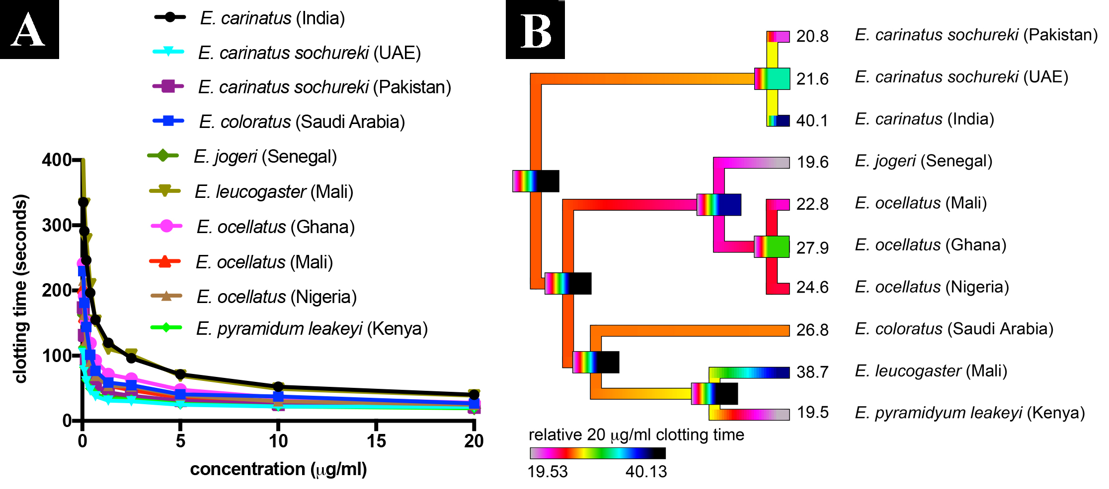
Figure 1: A) Venom dose-response curves with values of means from N=3 with error bars indicating standard deviation (error bars at most concentrations are smaller than the symbols), and B). Ancestral state reconstruction of clotting times, where warmer colours represent faster clotting times. Bars indicate 95% confidence intervals for the estimate at each node. Note that due to the high dynamicity of venom evolution the ranges quickly become broad as one moves down the tree. Numbers at tips are means of N=3 maximum clotting times from (A) (Table 2). Phylogenetic tree is based upon (Pook et al., 2009; Alencar et al. 2016).

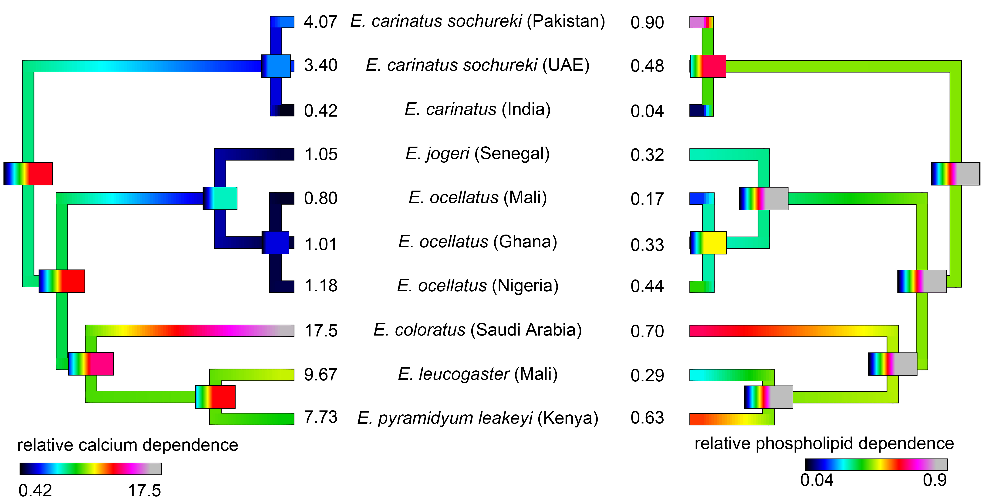Figure 2: Ancestral state reconstruction of relative co-factor dependence, where warmer colours represent greater cofactor dependence. Bars indicate 95% confidence intervals for the estimate at each node. Note that due to the high dynamicity of venom evolution the ranges quickly become broad as one moves down the tree. Numbers at tips are means from N=3 tests for x-fold shift in clotting time (Table 2). Phylogenetic tree is based upon (Pook et al., 2009; Alencar et al. 2016).

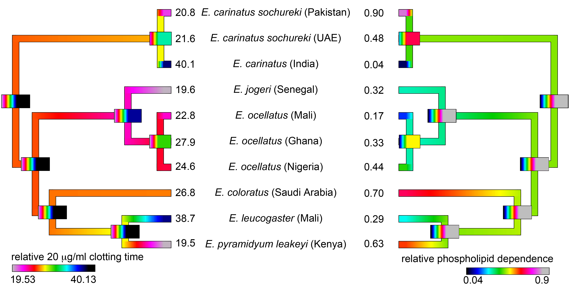Figure 3: Ancestral state reconstructions to show the inverse relationship between procoagulant activity (where warmer colours represent faster clotting times) and phospholipid cofactor dependence (where warmer colours indicate greater degree of dependence). Bars indicate 95% confidence intervals for the estimate at each node. Note that due to the high dynamicity of venom evolution the ranges quickly become broad as one moves down the tree. Numbers at tips are means from N=3 tests for x-fold shift in clotting time and phospholipid dependence (Table 2). Phylogenetic tree is based upon (Pook et al., 2009; Alencar et al. 2016).

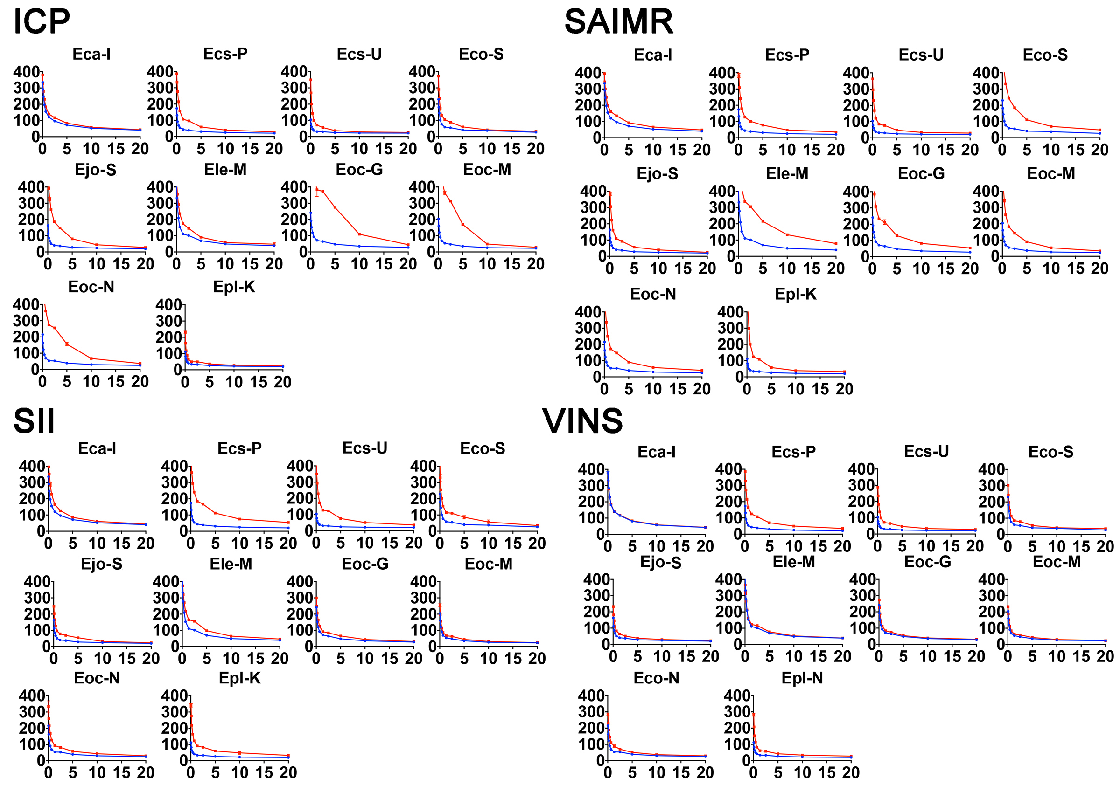Figure 4: Coagulation dose-response curves. Blue lines represent venom in optimal conditions (i.e. with calcium and phospholipid) while red line represents the clotting activity remaining after 2 minute preincubation of venom with antivenom and then the same dilution series were run as for the blue line protocol. The antivenom remained a constant in the second protocol while the venom was diluted against it as per the X-axis concentrations (µg/ml). The y-axis is time (seconds). Values are means from N=3 with error bars indicating standard deviation. Eca-I = E. carinatus (India), Ecs-P = E. c. sochureki (Pakistan), Ecs-U = E. c. sochureki (UAE), Eco-S = E. coloratus (Saudi Arabia), Ejo-S = E.jogeri (Senegal), Ele-M = E. leucogaster (Mali), Eoc-G = E. ocellatus (Ghana), Eoc-M = E. ocellatus (Mali), Eoc-N = E. ocellatus (Nigeria), Epl-K = E. pyramidum leakeyi (Kenya).

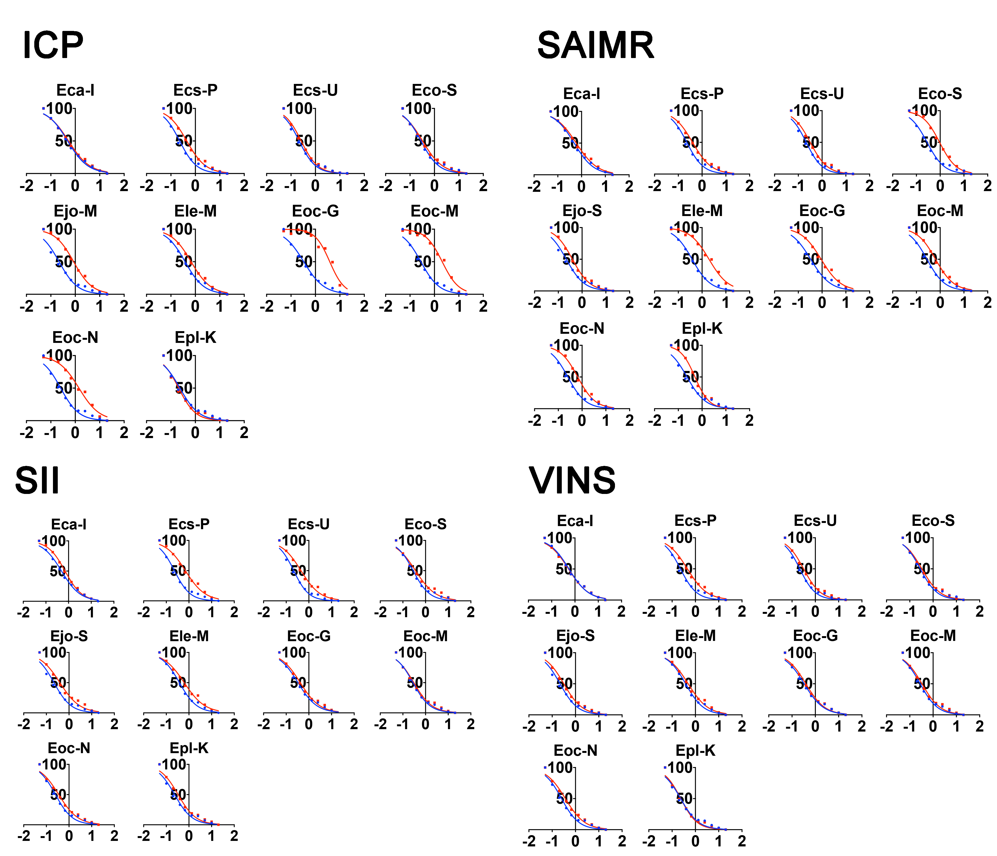Figure 5: Normalised logarithmic transformed views of clotting effects. Blue lines represent venom in optimal conditions (i.e. with calcium and phospholipid) while red line represents the clotting activity remaining after 2 minute preincubation of venom with antivenom and then the same dilution series were run as for the blue line protocol. The antivenom remained a constant in the second protocol while the venom was diluted against it. Values are means from N=3 with error bars indicating standard deviation. Eca-I = E. carinatus (India), Ecs-P = E. c. sochureki (Pakistan), Ecs-U = E. c. sochureki (UAE), Eco-S = E. coloratus (Saudi Arabia), Ejo-S = E.jogeri (Senegal), Ele-M = E. leucogaster (Mali), Eoc-G = E. ocellatus (Ghana), Eoc-M = E. ocellatus (Mali), Eoc-N = E. ocellatus (Nigeria), Epl-K = E. pyramidum leakeyi (Kenya).

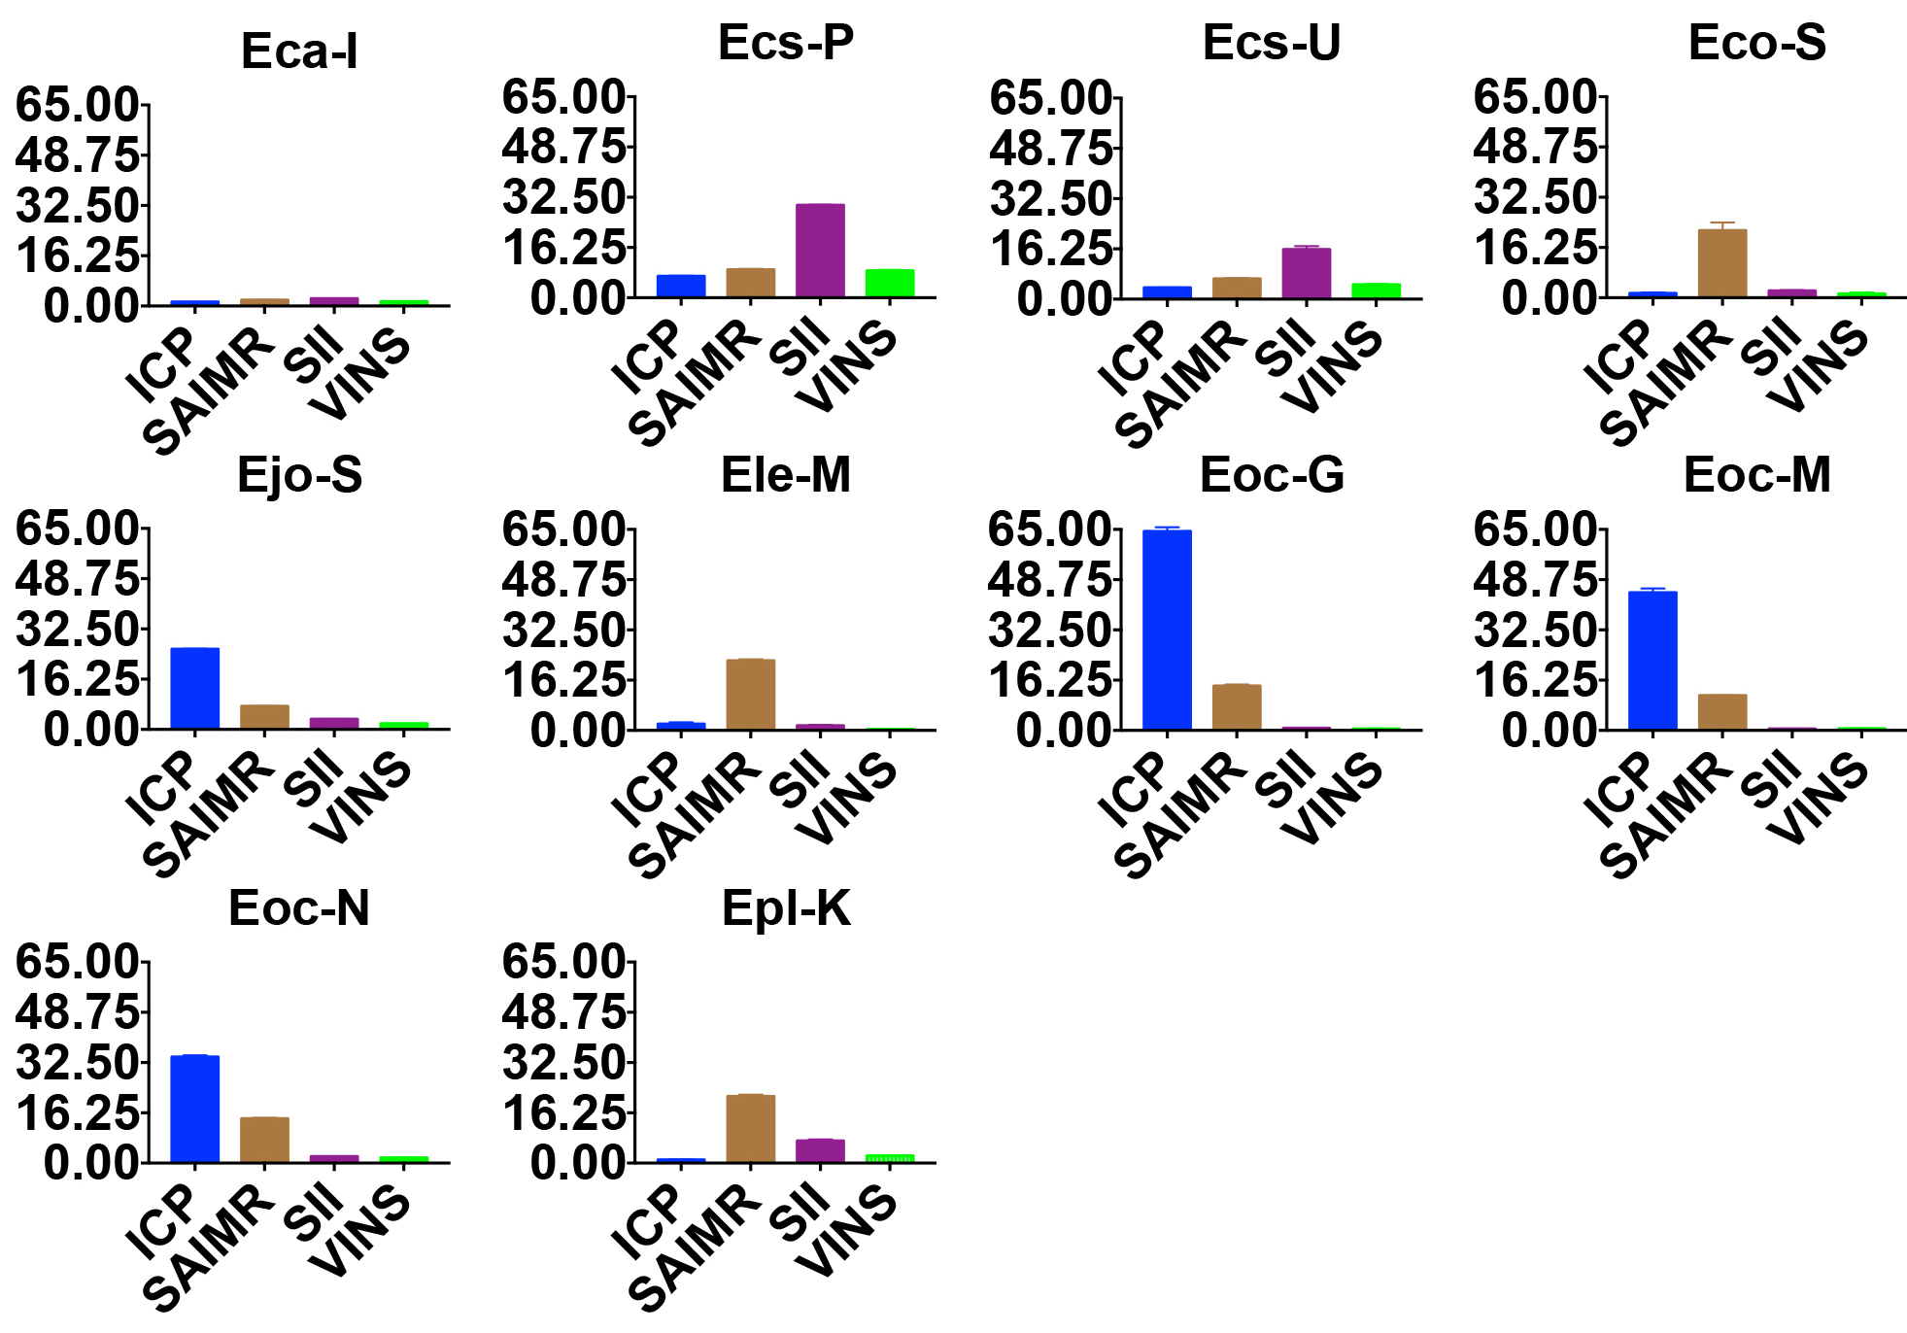Figure 6: Comparison of the performance of each antivenom against a particular species. Equal volumes from each of the antivenoms was used as they all were of the same 10ml vial size. Thus the potency is relative to a consistent amount of antivenom used by volume not by stated protein content or efficacy claims. The data are thus direct head to head comparisons in this regard. Values are means of the ability to proportionally shift a curve, with the highest effect being ICP against Ghana which shifted the venom cuve of E. occelatus nearly sixty five times over (N=3 with error bars indicating standard deviation). Eca-I = E. carinatus (India), Ecs-P = E. c. sochureki (Pakistan), Ecs-U = E. c. sochureki (UAE), Eco-S = E. coloratus (Saudi Arabia), Ejo-S = E.jogeri (Senegal), Ele-M = E. leucogaster (Mali), Eoc-G = E. ocellatus (Ghana), Eoc-M = E. ocellatus (Mali), Eoc-N = E. ocellatus (Nigeria), Epl-K = E. pyramidum leakeyi (Kenya).

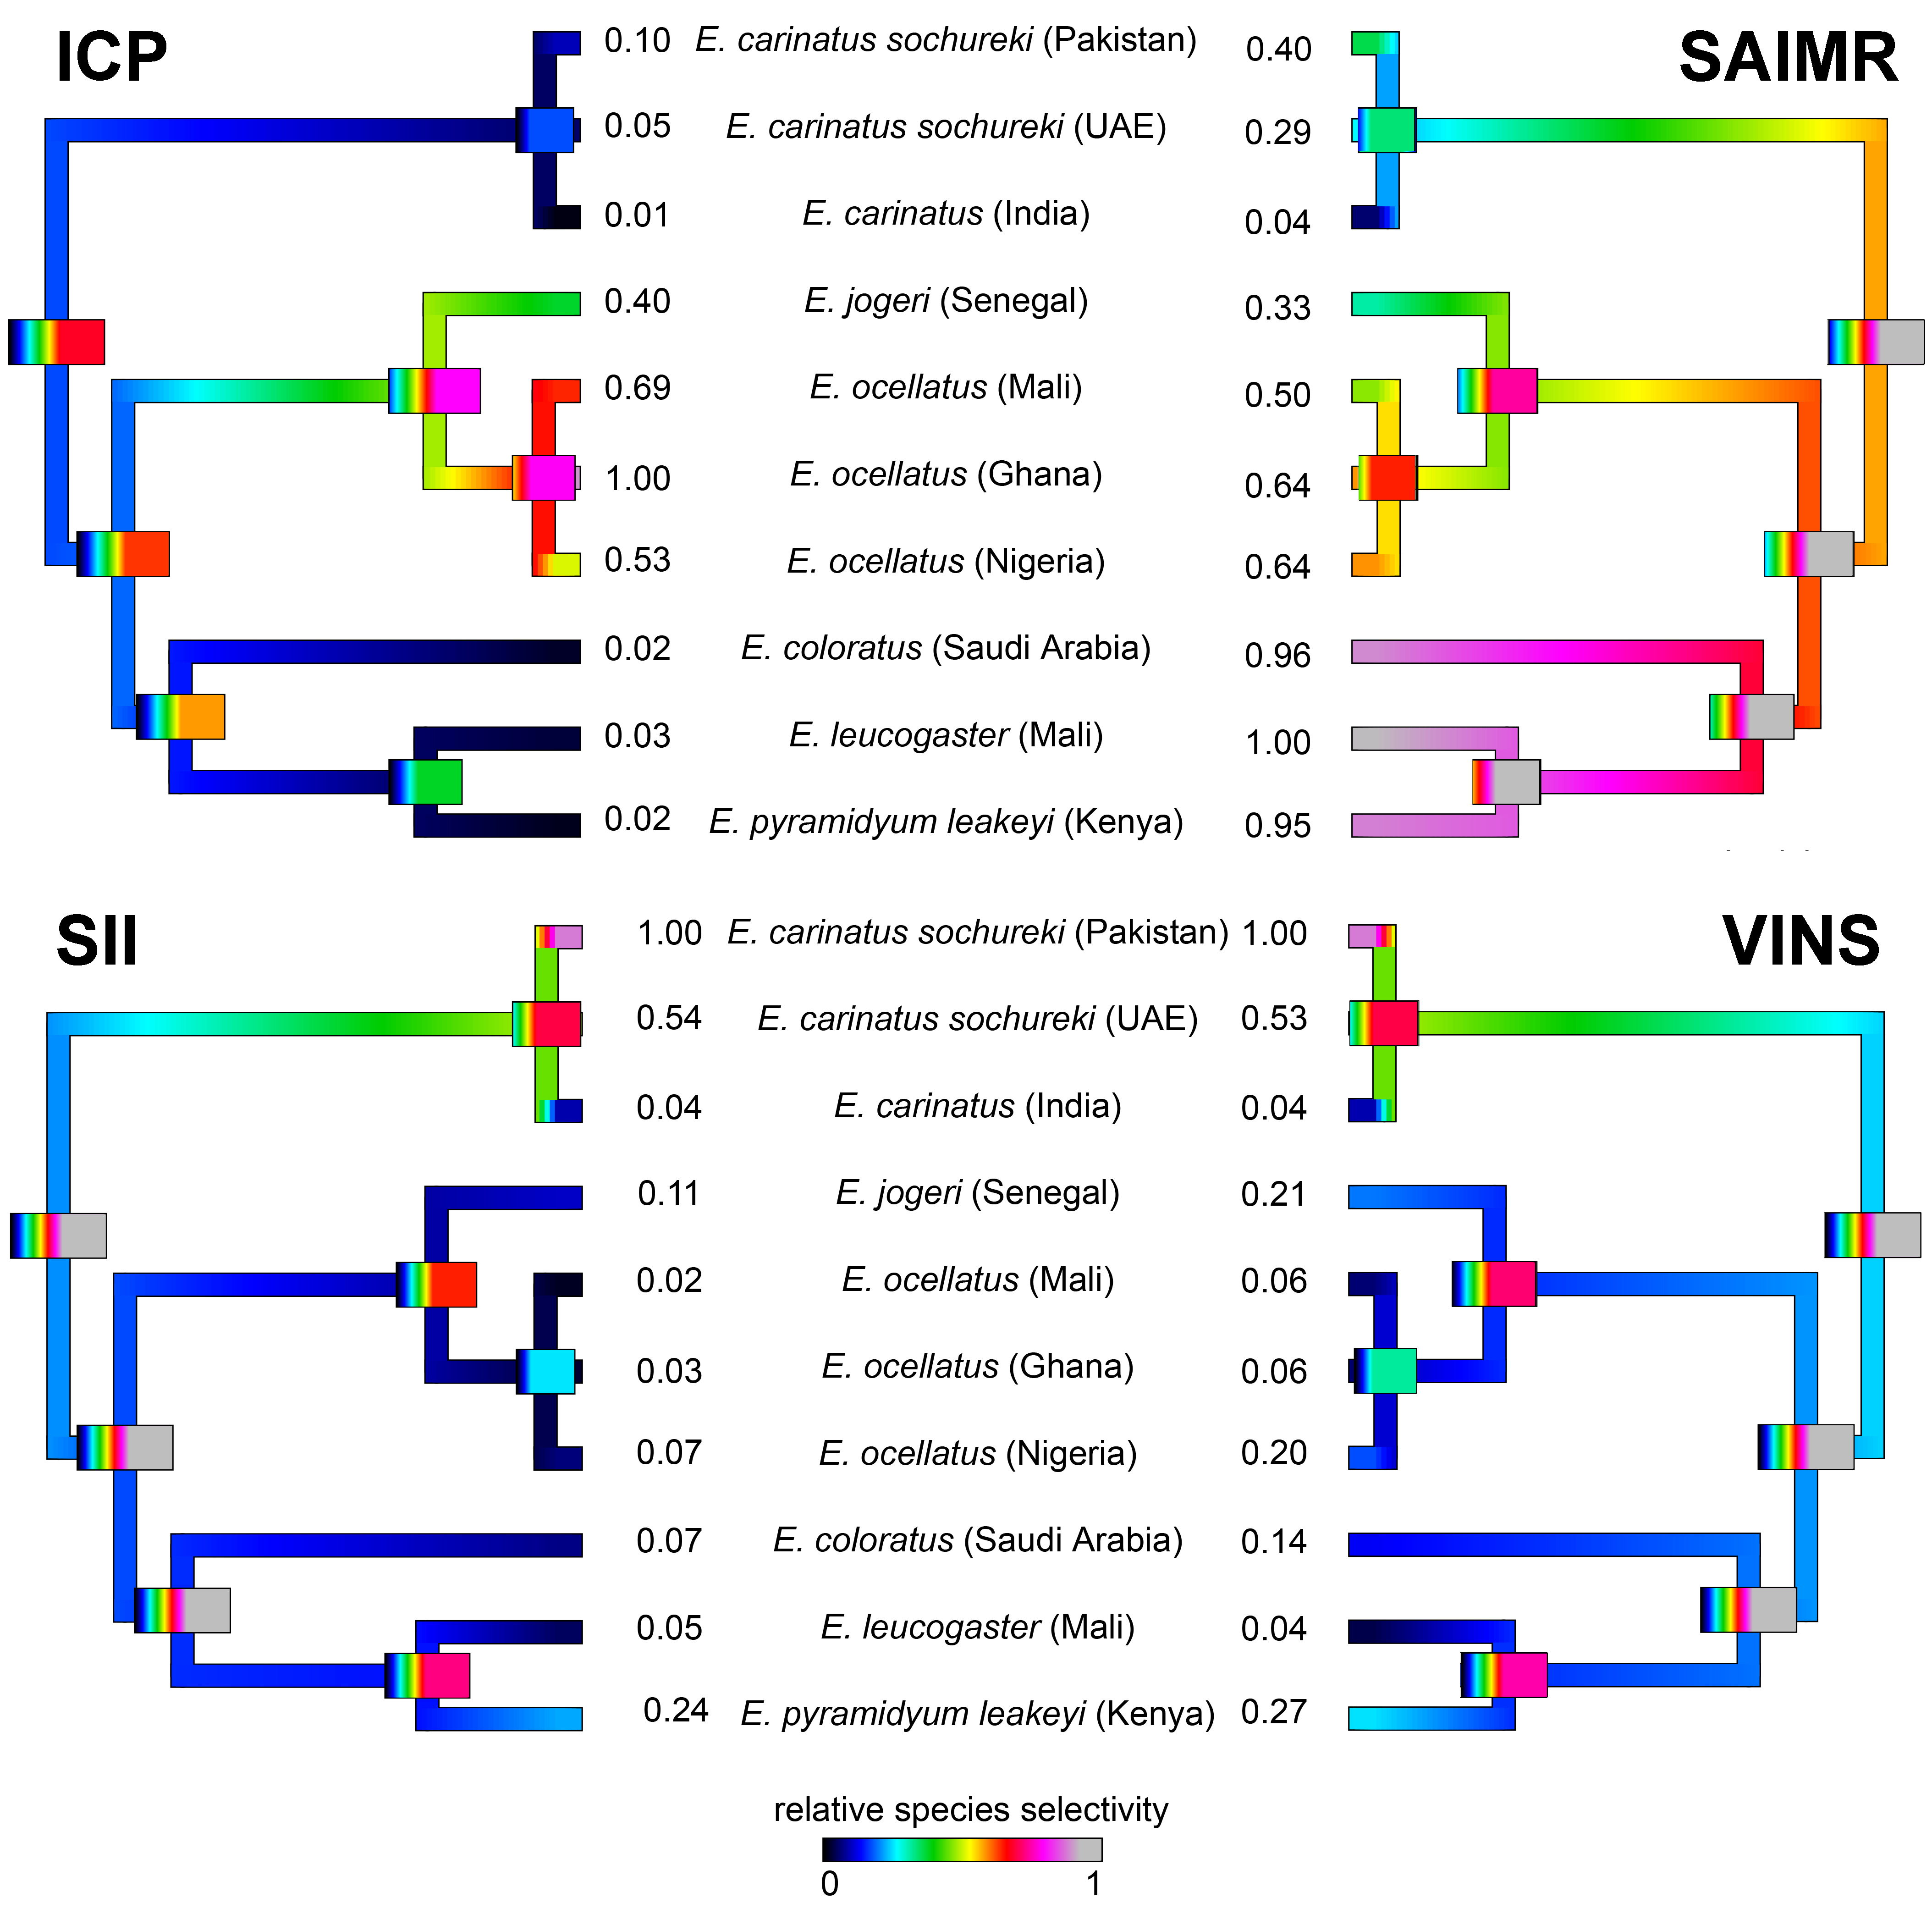Figure 7: Ancestral state reconstruction of relative species selectivity for each antivenom where warmer colours represent better antivenom cross-reactivity. Values are normalised N=3 means within an antivenom. Bars indicate 95% confidence intervals for the estimate at each node. Note that due to the high dynamicity of venom evolution the ranges quickly become broad as one moves down the tree. Phylogenetic tree is based upon (Pook et al., 2009; Alencar et al. 2016).

