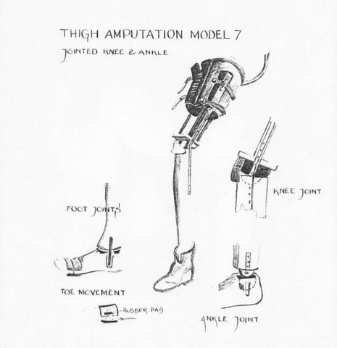

Figure 1. Drawing of post-amputation prostheses constructed in the workshop of Nakom Paton Camp - one of the base hospital camps (copyright Jack Chalker).

