Overexpression of two members of D7 salivary genes family is associated with pyrethroid resistance in the malaria vector Anopheles funestus s.s. but not in Anopheles gambiae in Cameroon
Emmanuel Elanga-Ndille^{1,2*}, Lynda Nouage^{1,3}, Achille Binyang^{1,3}, Tatiane Assatse^{1,3}, Billy Tene-Fossog^{1,2}, Magellan Tchouakui^{1,3}, Daniel Nguiffo Nguete^{1,4}, Helen Irving², Cyrille Ndo^{1,2,5, 6}, Parfait Awono-Ambene⁵ and Charles S. Wondji^{1, 2}
¹Centre for Research in Infectious Diseases (CRID) P.O. BOX 13591, Yaoundé, Cameroon; lnouage@gmail.com (L.N.); bjeromeachille@yahoo.fr (A.B.); mtchouaki@yahoo.fr (M.T.); billytene@gmail.com and billy.tene@crid-cam.net (B.T.)
²Vector group, Liverpool School of Tropical Medicine, Pembroke Place, Liverpool L3 5QA, UK; helen.irving@lstmed.ac.uk (H.I.),
³Department of Animal Biology and Physiology, Faculty of Science, University of Yaoundé 1, P.O. Box 812, Yaoundé, Cameroon; tatianeassatse@gmail.com (T.A.);
⁴Department of Animal Biology, Faculty of Science, University of Dschang, P.O. Box 67, Dschang, Cameroon, danielnguete@yahoo.fr (D.N.N)
⁵Malaria Research Laboratory, Organisation de Coordination pour la lutte Contre les Endémies en Afrique Centrale (OCEAC), P.O. Box 288, Yaoundé, Cameroon, hpaawono@yahoo.fr (P.A.A)
⁶Department of Biological Sciences, Faculty of Medicine and Pharmaceutical Sciences, University of Douala, P.O. Box 24157, Douala, Cameroon.cyrndo@yahoo.fr and cyrille.ndo@crid-cam.net (C.N.)
*Corresponding author: Elanga-Ndille Emmanuel, emmsdille@yahoo.fr and emmanuel.elanga@crid-cam.net; Charles S. Wondji charles.wondji@lstmed.ac.uk (C.S.W.)

Abstract: D7 family proteins are among the most expressed salivary proteins in mosquitoes. They facilitate blood meal intake of the mosquito by scavenging host amines that induce vasoconstriction, platelet aggregation and pain. Despite this important role, little information is available on the impact of insecticide resistance on the regulation of D7 proteins and consequently on the blood feeding success. In this study, qPCR analyses were performed to investigate how pyrethroid resistance could influence the expression of genes encoding D7 family proteins in An. gambiae and An. funestus s.s. mosquitoes from Elon in the Central Cameroon. Out of 328 collected mosquitoes, 256 were identified as An. funestus sl and 64 as An. gambiae sl. Within the An. funestus group, An. funestus s.s. was the most abundant species (95.95%) with An. rivulorum, An. parensis and An. rivulorum-like also detected. All An. gambiae s.l mosquitoes were identified as An. gambiae. High levels of pyrethroid resistance were observed in both An. gambiae and An. funestus mosquitoes. qPCR analyses revealed a significant overexpression of two genes encoding D7 proteins, D7r3 and D7r4, in pyrethroids resistant An. funestus. However, no association was observed between the polymorphism of these genes and their overexpression. In contrast, overall D7 salivary genes were under-expressed in pyrethroid resistant An. gambiae. This study provides preliminary evidences that pyrethroid resistance could influence blood meal intake through over-expression of D7 proteins although future studies will help establishing potential impact on vectorial capacity.
Keywords: D7 salivary proteins; gene expression; insecticide resistance; pyrethroids; Anopheles gambiae; Anopheles funestus; malaria disease

1. Introduction
In the early 2000s, thanks to the Abuja Declaration and the achievement of the Millennium Development Goals, immense efforts have been made to control malaria, with the goal to ultimately eliminate its transmission worldwide. These efforts have led to a significant and substantial progress in reducing malaria morbidity and mortality, despite the slight upward trend observed between the years 2016 and 2017 [1] [2]. This remarkable reduction of malaria burden is strongly associated with an increased coverage of people at risk with insecticide-treated bednets (ITNs), long-lasting insecticidal nets (LLINs) and to a lesser extent indoor residual spraying (IRS) with insecticides [3]. Unfortunately, this massive use of pyrethroids is also associated with the rapid expansion of insecticide resistance in both Anopheles funestus and Anopheles gambiae s.l., the two major African malaria vectors. To maximize the effectiveness of current and future insecticide-based interventions, it is imperative to better understand the impact of insecticide resistance on mosquito populations including their vectorial capacity.
Little is currently known about the impact of resistance on the ability of malaria vectors to take a blood meal which is a key parameter of vectorial capacity and malaria transmission. Blood meal intake has been shown to be influenced by specific salivary proteins including the D7 proteins family [4, 5]. Indeed, the members of the D7 salivary family are among the most abundantly expressed proteins in the salivary gland of blood-sucking Diptera [4, 5]. Through their vasodilation, anticoagulant and anti-platelet aggregation properties, these proteins are essential for the success of the mosquito blood meal intake [4, 5].
Interestingly, several studies assessing the transcriptomic changes associated with insecticide resistance have detected beside the overexpression of detoxification genes, a differential expression of some genes encoding for salivary proteins such as, D7 salivary proteins [6-11].
Despite the potentially important role of D7 in blood meal intake, far less information is available about the impact of pyrethroid resistance on the expression of the D7 family proteins and others mosquito salivary gland bioactive molecules implicated in the blood meal intake and in Plasmodium transmission. Indeed, the little information available about how resistance to pyrethroid impacts the expression of D7 family salivary proteins are provided by results of microarray analysis of the transcriptome of resistant Anopheles funestus and Anopheles gambiae sl mosquitoes [6-11]. The D7 salivary proteins family in Anopheles mosquito species was described to be composed with multiple genes. These genes can be distinguished in short and long forms [5, 12-14]. The An. gambiae genome carries eight members of the D7 gene family, among which, three genes encode long D7 proteins (D7L1, D7L2 and D7L3) and five code for short D7 proteins (D7r1, D7r2, D7r3, D7r4 and D7r5) [4, 13, 15]. In An. funestus, members of D7 gene family are currently known to be constituted by five genes coding for short proteins (D7r1, D7r2, D7r3, D7r4 and AFUN016458, an orthologous of An. gambiae D7r5 gene) and two coding for long proteins (D7L1 and D7L2) [5, 12-14]. Thus, the expression pattern of members of this family in relation to insecticide remains to be established as well as the associated polymorphisms.
The present study tends to fill this knowledge gap by reporting the results of differential gene expression of several members of the D7 salivary gene family and genetic diversity in relation to pyrethroid resistance in both Anopheles funestus and Anopheles gambiae wild mosquitoes from an area with high coverage of LLINs in Cameroon.

2. Methods

2.1. Study area and mosquito collection
An. funestus and An. gambiae mosquitoes were collected in the locality of Elon (N4.23051° E11.60120°), a forest area in the Central Cameroon. This rural area situated about 50 km from Yaoundé falls within a Guinea-type climate with high humidity and precipitation and rainfall averaging 1,000-2,000 mm each year. The village is populated by about 300 inhabitants who are mainly subsistence farmers cultivating maize, cassava, yams, groundnut and vegetables. In this locality, there is also a stone quarry belonging to a company specializing in civil engineering works. Activities of this quarry have led to the transformation of a small stream into an artificial lake potentially suitable for the development of some Anopheles mosquito species, particularly those of An. funestus group. Collections were implemented during the rainy season in June 2018. Following the acquirement of a verbal consent from the chief of the village and the household owners, indoor resting adult female Anopheles mosquitoes were collected on the walls and on the roof of different houses across the village between 6:00 and 10:00 AM during 3 consecutive days using electric aspirators (Rule In-Line Blowers, Model 240). Caught mosquitoes were kept in paper cups in a cool place prior to transport to the insectary at Centre for Research in Infectious Diseases (CRID) in Yaoundé. After species identification based on morphological keys [16], blood-fed female mosquitoes were kept in cages for four days until eggs became mature. Gravid mosquitoes were allowed to oviposit according to the forced egg-laying method as previously described [17]. Thereafter, F1 adults were randomly mixed in cages for subsequent experiments. All females mosquitoes (oviposited, non-oviposited and unfed) were conserved in microtubes containing desiccant for further experiments such as, PCR identification, genotyping of some resistance markers and determination the Plasmodium sporozoite infection rate of both An. funestus and An. gambiae mosquitoes.

2.2. Molecular species identification
Genomic DNA was extracted from whole collected An. funestus and An. gambiae mosquitoes using the Livak protocol [18]. The protocol previously described by Koekomoer et al [19] was used for the identification of the members of An. funestus group whereas, a SINE PCR [20] was performed for those belonging to An. gambiae complex.

2.3. Plasmodium sporozoite infection rate
Plasmodium infection rate of both An. funestus group and An. gambiae complex mosquitoes was determined using a TaqMan assay to detect four Plasmodium species (Plasmodium falciparum, Plasmodium vivax, Plasmodium ovale, and Plasmodium malariae)[21] from genomic DNA extracted from individual field-collected mosquitoes.

2.4. Insecticide susceptibility assays
WHO insecticide susceptibility test-kits and standard procedures [22] were used to assess the susceptibility to insecticides. For Anopheles funestus, F1 female mosquitoes aged 3-5 days were exposed for one hour to: three pyrethroids including permethrin (0.75 %), deltamethrin (0.05 %), and etofenprox (0.05%); two carbamates: bendiocarb (0.1%) and propoxur (0.1 %); one organochlorine: dieldrin (4 %); and, two organophosphates: malathion (5 %) and fenithrothion (1 %). For Anopheles gambiae because of low mosquito densities, only permethrin (0.75 %) and deltamethrin (0.05 %) were tested. For each insecticide, assays were carried out with five replicates of 20–25 mosquitoes: four batches were exposed to insecticide-impregnated papers and one was exposed to untreated filter paper as a control. The mortality rate was determined 24 h after exposure and the resistance status was evaluated according to the WHO criteria [22]. Dead mosquitoes were kept in silica gel whereas alive mosquitoes were stored in 1.5ml Eppendorf tubes containing RNA-later and kept in -80°C.
Piperonyl butoxide (PBO) synergist assays were also performed to assess the contribution of cytochrome P450s in the resistance to deltamethrin and permethrin in An. funestus and An. gambiae mosquitoes from Elon. After been pre-exposed to 4% PBO for one hour, F1 adult female mosquitoes (3–5 days old) were immediately exposed to permethrin (0.75%) and to deltamethrin (0.05%) for 1 h. Final mortality was recorded after 24 h and compared to the results obtained using deltamethrin and permethrin without PBO.
Additionally, cone bioassays were carried out following the WHO guidelines [23] in order to assess the bio-efficacy of common bed nets recommended by WHO against An. funestus and An. gambiae mosquito populations from Elon. Five replicates of ten unfed An. gambiae and An. funestus F₁ females (3-5 days old) were exposed for 3 minutes to netting pieces cut from 4 commercial nets: PermaNet® 2.0 (deltamethrin 1.8 g/kg), PermaNet® 3.0 (containing deltamethrin coated on the net’s polyester side panels and a mixture of deltamethrin and PBO on the polyethylene roof), Olyset®Net (2 % permethrin) and Olyset® plus (containing 2% permethrin combined with 1% of PBO in the whole net). In the same time, mosquitoes exposed to untreated nets were used as controls. After exposure, mosquitoes were removed and kept in holding paper cup provided with sugar solution and the mortality rate was scored after 24 hours.

2.5. Expression profile of D7 salivary genes using Real-time quantitative PCR
The expression profiles of members of the D7 family in insecticide resistant and susceptible mosquitoes of An. funestus s.s. and An. gambiae species were assessed using qRT-PCR. Taking into account the existence of two D7 subfamilies (long and short forms genes families) in mosquitoes [4], eight genes were used for An. gambiae: three long forms (D7L1-3) and five short forms (D7r1-5), while five were targeted for An. funestus s.s : one long form (D7L) and four short forms (D7r1-4). Two pairs of exon-spanning primers was designed for each gene using Primer3 online software (v4.0.0; http://bioinfo.ut.ee/primer3/). Only primers with PCR efficiency between 90 and 110% determined using a cDNA dilution series obtained from a single sample, were used for qPCR analysis. Details of the primers used for this study are listed in Table S1.
To run the analysis, for each species, total RNA was extracted from three batches of of 10 whole females of 3–5 days old from the following sample sets: (i) for resistant (R) strain, alive mosquitoes after exposure to 0.75% permethrin and 0.05% deltamethrin; (ii) for the control (C) strain, unexposed mosquitoes to insecticides and thus representative of the wild-type population; and (iii) unexposed mosquitoes from the fully susceptible laboratory strains (S), FANG (for An. funestus), KISUMU (for An. gambiae). RNA was isolated using the RNAeasy Mini kit (Qiagen) according to the manufacturer’s instructions. The RNA quantity was assessed using a NanoDrop ND1000 spectrophotometer (Thermo Fisher) and 1µg from each of the three biological replicates for resistant (R), control (C), and susceptible (S) for both species was used as a template for cDNA synthesis using the SuperScript III (Invitrogen) with oligo-dT20 and RNase H, following the manufacturer’s instructions. The qPCR assays were carried out in a MX 3005 real-time PCR system (Agilent) using Brilliant III Ultra-Fast SYBR Green qPCR Master Mix (Agilent). A total of 10 ng of cDNA from each sample was used as template in a three-step program involving a denaturation at 95 °C for 3 min followed by 40 cycles of 10 s at 95 °C and 10 s at 60 °C and a last step of 1 min at 95 °C, 30 s at 55 °C, and 30 s at 95 °C. The relative expression and fold-change of each target gene in R and C relative to S was calculated according to the 2^{−ΔΔCT} method incorporating PCR efficiency after normalization with the housekeeping RSP7 ribosomal protein S7 (VectorBase ID: AFUN007153; orthologous in An. gambiae: AGAP010592) and the actin 5C (vectoBase ID: AFUN006819, orthologous in An. gambiae: AGAP000651) genes for An. funestus and ii) RSP7 ribosomal protein S7 (vectoBase ID:AGAP010592) and Glyceraldehyde 3-phosphate dehydrogenase, GADPH (vectoBase ID:AGAP009945) for An. gambiae.

2.6. Sequencing of D7r3 and D7r4 genomic DNA from alive and dead An. funestus mosquitoes
DNA extracted using the LIVAK method from a total of 20 An. funestus s.s female specimens (10 alive and 10 dead after exposure to deltamethrin) was used as template for amplification and sequencing of a region of 974 bp (from 528 to 1501) and 951 bp (from 432 to 1382) from the genomic DNA sequences of D7r3 and D7r4 genes, respectively. The primers used were designed from Primer3 online software (v4.0.0; http://bioinfo.ut.ee/primer3/) and the sequences are listed in Table S1. DNA amplification, sequencing and analysis were carried out following a protocol previously described [24].

2.7. Genotyping of resistance molecular markers in An. funestus s.s. and in An. gambiae.
The L1014F-kdr and the L1014S-kdr mutations responsible for DDT and pyrethroid resistance in An. gambiae were genotyped in field collected mosquitoes using the protocol described by Martínez-Torres and colleagues [25]. TaqMan assays were performed for genotyping of A296S-RDL marker involved in the resistance to dieldrin in An. funestus s.s following a protocol previously described [26]. On the other hand, an allele specific PCR was performed as previously described [27, 28] to genotype the L119F-GSTe2 mutation which is associated to DDT/pyrethroid resistance in An. funestus vector species. For these markers, the genotyping was carried out using genomic DNA extracted from field-collected mosquitoes.

3. Results

3.1. Mosquito species composition
A total of 328 blood-fed female mosquitoes were collected indoor in Elon. 256 (78%) were morphologically identified as belonging to the An. funestus group, whereas 64 (19.5%) belonged to the An. gambiae complex and the remaining 8 (2.5%) were Culex spp. Of the 173 An. funestus s.l randomly selected and tested for molecular identification, An. funestus s.s. represented 95.95% and the remaining was constituted by An. rivulorum (1.73%), An. parensis (1.16%) and An. rivulorum-like (1.16%). Concerning An. gambiae sl, all the 64 individuals collected were identified as An. gambiae.

3.2. Plasmodium infection
For both An. funestus and An. gambiae, head-thorax from field-collected mosquitoes were separately used to assess the Plasmodium infection rate. For An. funestus, the analysis of head and thorax (153 individuals) revealed 21 mosquitoes infected (13.7%), with 20 (95%) infected with P. falciparum and one with either P. ovale, P. malariae, P. vivax. Regarding An. gambiae, seven (20.6%) out of the 34 head and thorax analyzed were infected only by P. falciparum.

3.3. Insecticide susceptibility bioassays

3.3.1. Insecticide susceptibility in An. funestus s.s.
A total of 765 F₁ female mosquitoes were exposed to seven insecticides (Figure 1A). An. funestus mosquito from Elon were resistant to all types of pyrethroids tested. A mortality rate of 62.5 ± 9.2 % and 36.25 ± 6.9 % was recorded after exposure to permethrin and deltamethrin respectively. For etofenprox a pseudo-pyrethroid, mortality rate of 56.4 ± 13.4% was observed. Regarding organochlorine, a full resistance was recorded for dieldrin. The exposure to carbamates indicated a susceptibility to propoxur (98.95 ± 1.25%), whereas a possible resistance was noticed for bendiocarb (91. 7 ± 4.4% of mortality). A full susceptibility was observed after exposure to fenitrothion and to malathion (100% mortality).
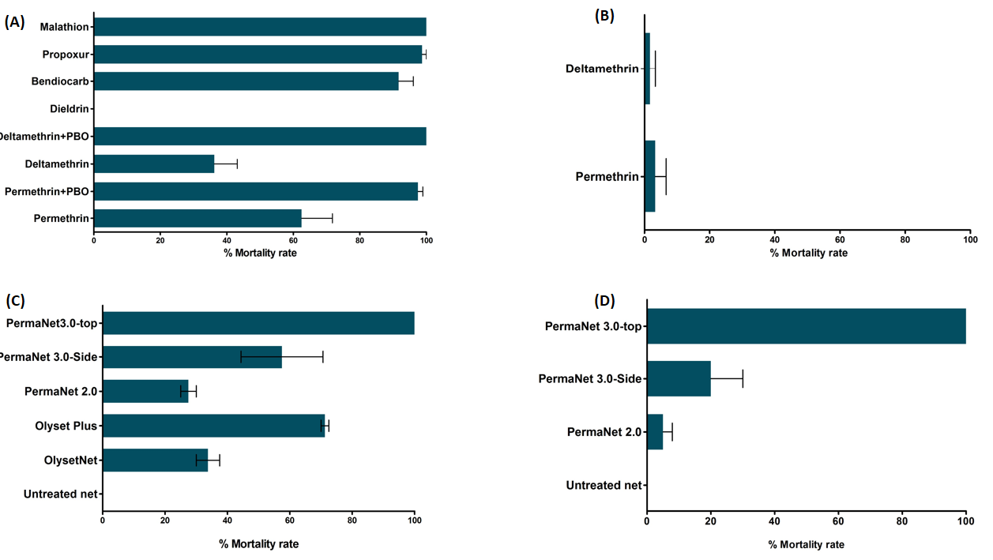
Figure 1: Susceptibility status of the An. funestus and An. gambiae populations from Elon and bio-efficacy of mosquito bednets: Mortality rates of An. funestus s.s. (A) and of An. gambiae (B) with WHO tube assays after 1hr exposure to insecticides. Recorded mortalities rates following 3-min exposure by cone assays with various nets for An. funestus (C) and An. gambiae (D). Data are shown as mean ± SEM.

3.3.2. Insecticide susceptibility in An. gambiae.
For An. gambiae, a total of 200 F₁ female mosquitoes were exposed to permethrin and deltamethrin only (Figure 1B). For both insecticides, a high resistance was observed, as only 3.33 ± 3.3% and 1.67 ± 1. 67% mortality rates were recorded for permethrin and deltamethrin respectively.

3.3.3. Synergist assays for pyrethroid resistance in An. funestus s.s.
To assess whether cytochrome P450s enzymes are involved in the resistance to pyrethroids in An. funestus s.s from Elon, a total of 160 F₁ female mosquitoes were exposed to deltamethrin and permethrin following pre-exposure to PBO. A high recovery of susceptibility was observed for both insecticides with 100% for deltamethrin and 97.5 ± 1.44% for permethrin (Figure 1A).

3.3.4. Insecticide treated bednets efficacy assessment
A loss of efficacy against An. funestus was observed for the two brands of bednets mostly used in Cameroon, with only 33.75 ± 3.75% and 27.50 ± 2.50 % mortality after 3 min exposure to Olyset and PermaNet 2.0, respectively. A high but not full recovery of the efficacy was observed with olyset Plus (71.25 ± 1.25 % mortality) and PermaNet 3.0 side (57.50 ± 13.15 % mortality), while a full recovery was noticed for PermaNet 3.0 roof with 100% mortality (Figure 1C).
For An. gambiae, because of low density of mosquitoes, only PermaNet brands bednets were tested. A loss of efficacy was observed for both PermaNet 2.0 (5 ± 2.9 % mortality) and PermaNet 3.0 side (20 ± 10% mortality), whereas PermaNet 3.0 still led to 100% mortality of field mosquitoes after exposure (Figure 1D).

3.4. Expression on D7 salivary genes family in An. funestus and An. gambiae mosquitoes
Analysis of the expression level of D7 genes in An. funestus from Elon indicated that D7r2, D7r3 and D7r4 are over-expressed in both permethrin and deltamethrin resistant field An. funestus mosquitoes compared to susceptible strain (Figure 2). However, this over-expression was statistically significant only for both D7r3 and D7r4 genes but not for D7r2 (Tables 1 and 2).
Table 1: Differential expression of some D7 family genes in permethrin resistant and unexposed An. funestus s.s. and An. gambiaes s.s. mosquitoes, as measured by qPCR analyses
Species | Gene | Fold change Resistant vs Susceptible | Log2FC | P-value | Fold change control vs Susceptible | Log2FC | P-value
An. funestus | D7r2 | 6.66 | 2.73 | NS | 2.24 | 1.16 | NS
 | D7r3 | 11.99 | 3.58 | 0.04 | 4.44 | 2.15 | 0.006
 | D7r4 | 6.24 | 2.64 | NS | 4.012 | 2 | 0.02
An. gambiae | D7r1 | 0.744 | -0.425 | NS | 0.659 | -0.60 | NS
 | D7r2 | 0.257 | -1.95 | 0.007 | 0.27 | -1.84 | 0.008
 | D7r3 | 0.535 | -0.90 | 0.01 | 0.44 | -1.15 | 0.01

Indeed, a fold-change of 11.99 (P= 0.04) and 4.44 (P = 0.006) for D7r3 and 6.24 (NS) and 4.012 (P = 0.02) for D7r4, were observed when comparing samples from Elon with FANG strain respectively for permethrin resistant and non-exposed mosquitoes (Figure 2A and Table 1). A similar pattern of over-expression of D7r3 and D7r4 was observed in deltamethrin resistant (FC=9.88, P=0.001 for D7r3; FC=4.45, P=0.026 for D7r4) and unexposed (FC=8.4, P<0.001 for D7r3; FC=6.76, P=0.04 for D7r4) mosquitoes compared to the susceptible strain (Figure 2B and Table 2).
Table 2: Differential expression of some D7 family genes in deltamethrin resistant and unexposed An. funestus s.s. and An. gambiae. mosquitoes, as measured by qPCR analyses.
Species | Gene | Fold change Resistant vs Susceptible | Log2FC | P-value | Fold change control vs Susceptible | Log2FC | P-value
An. funestus | D7r2 | 2.2 | 1.1 | NS | 4.19 | 2.06 | 0.0002
 | D7r3 | 9.88 | 3.304 | 0.001 | 8.404 | 3.07 | <0.0001
 | D7r4 | 4.45 | 2.15 | 0.026 | 6.76 | 2.75 | 0.04
An. gambiae | D7r1 | 0.36 | -1.44 | NS | 0.434 | -1.20 | NS
 | D7r2 | 0.163 | -2.61 | 0.001 | 0.245 | -2.02 | 0.02
 | D7r3 | 0.349 | -1.51 | 0.0002 | 0.353 | -1.5 | 0.006
 | D7r4 | 0.26 | -1.91 | 0.01 | 0.34 | -1.55 | 0.01

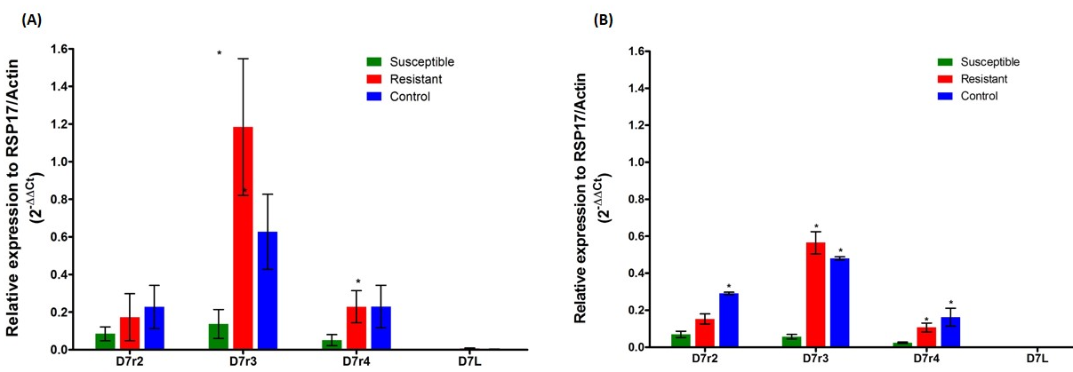
Figure 2: Transcription profile of members of D7 family genes in An. funestus s.s population. Comparison of the patterns of genes expression of four D7 genes (D7r2, D7r3, D7r4 and D7L) between field permethrin (A) or deltamethrin (B) resistant mosquitoes, field mosquitoes unexposed to insecticides (Control) and the laboratory susceptible strain FANG (Susceptible). The normalized relative expression of each gene against two housekeeping genes (RSP7 and Actin) is represented on the vertical axis. (*) indicates a significant differential expression in comparison with susceptible mosquito.
For An. gambiae, only three genes (D7r1, D7r2 and D7r3) were expressed in both permethrin resistant (field samples) and susceptible (KISUMU) strains (Figure 3A), whereas, for deltamethrin, D7r1, D7r2, D7r3 and D7r4 genes were expressed in resistant and susceptible mosquitoes (Figure 3b). Globally, members of D7 family genes were under-expressed in permethrin/deltamethrin resistant and unexposed mosquitoes from Elon compared to the susceptible strain (Figure 3A and 3B). This under-expression was significant for D7r2 gene in permethrin (FC=0.26, P=0.007 for resistant and FC =0.27, P=0.008 for non-exposed mosquitoes) and deltamethrin (FC=0.16, P=0.001 and FC=0.25; P=0.02 for resistant and non-exposed) field resistant mosquitoes (Tables 1 and 2). D7r3 (FC=0.54, P=0.0002 and FC=0.44; P=0.006 for resistant and non-exposed respectively) and D7r4 genes (FC=0.26, P=0.01 and FC=0.34; P=0.006 for resistant and non-exposed respectively) were significantly under-expressed only in deltamethrin resistant and non-exposed field mosquitoes compared to susceptible strain (Tables 1 and 2).
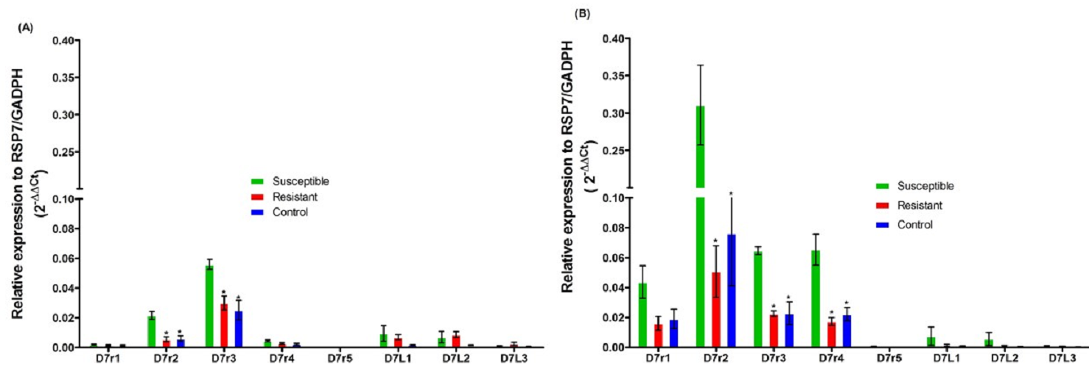
Figure 3: Transcription profile of members of D7 family genes in An. gambiae population. Comparison of the patterns of genes expression of eight D7 genes (D7r2, D7r3, D7r4, D7r5, D7L1, D7L2 and D7L3) between field permethrin (A) or deltamethrin (B) resistant mosquitoes, field mosquitoes unexposed to insecticides (Control) and the laboratory susceptible strain FANG (Susceptible). The normalized relative expression of each gene against two housekeeping genes (RSP7 and GADPH) is represented on the vertical axis. (*) indicates a significant differential expression in comparison with susceptible mosquito.

3.5. Sequencing of D7r3 and D7r4 genomic DNA from An. funestus mosquitoes
A comparative analysis of the polymorphism pattern of both D7r3 and D7r4 genes, significantly over-expressed in resistant mosquitoes, was carried out between sets of 10 alive and 10 dead mosquitoes after exposure to deltamethrin. A 718bp common sequence of D7r3 gene was aligned for 13 individuals (7 alive and 6 dead), while for D7r4 the alignment was done on a 776 bp common sequence for 11 individuals (4 alive and 7 dead). Overall, 84 and 77 polymorphic sites defining 18 haplotypes were detected for D7r3 and D7r4 respectively. The number of haplotypes (9) for D7r3 gene was similar between dead and alive mosquitoes, whereas for D7r4, alive mosquitoes showed a lower number of polymorphic sites with a reduced haplotype diversity (4 haplotypes; Hd= 0.86) compared to dead individuals (14 haplotypes; Hd=1). The high haplotype diversity was associated with high genetic diversity for both genes (Table 3 and 4).
Table 3: Summary statistics for polymorphism in D7r3 gene in deltamethrin susceptible and resistant An. funestus s.s. from Elon
 | 2N | H | S | Hd | π | D | D*
Alive | 14 | 9 | 52 | 0.956 | 0.00142 | 0.175 | 1.132
Dead | 12 | 9 | 49 | 0.955 | 0.0022 | -0.53006 | 0.0895
Total | 26 | 18 | 84 | 0.978 | 0.024 | -1.04 | -1.54
2N, number of sequences; D, Tajima’s statistics; D*, Fu and Li’s statistics; H, number of haplotypes; Hd, haplotype diversity; π, nucleotide diversity multiplied by 103; S, number of polymorphic sites.

Table 4: Summary statistics for polymorphism in D7r4 gene in deltamethrin susceptible and resistant An. funestus s.s. from Elon
 | 2N | H | S | Hd | π | D | D*
Alive | 8 | 4 | 28 | 0.857 | 0.017 | 0.98 | 5.27*
Dead | 14 | 14 | 67 | 1 | 0.022 | -0.95 | -4.19*
Total | 22 | 18 | 77 | 0.983 | 0.022 | -0.98 | -2.610*
2N, number of sequences; D, Tajima’s statistics; D*, Fu and Li’s statistics; H, number of haplotypes; Hd, haplotype diversity; π, nucleotide diversity multiplied by 103; S, number of polymorphic sites
Analysis of the haplotypes network for both D7r3 and D7r4 showed no major haplotypes of these genes in An. funestus population from Elon (Figure 4a and 4b). Overall, Tajima’s D index (D=- 1.04 for D7r3 and D=-0.98 for D7r4) were negative but not statistically significant for both genes whereas, the Fu’s F index (F= -1.54 for D7r3 and F=-2.63 for D7r4) even negative for both genes, was significant only for D7r4. The maximum likelihood phylogenetic tree generated for both genes did not show any haplotype clustering associated with either dead or alive mosquitoes (Figures 4c and 4d).
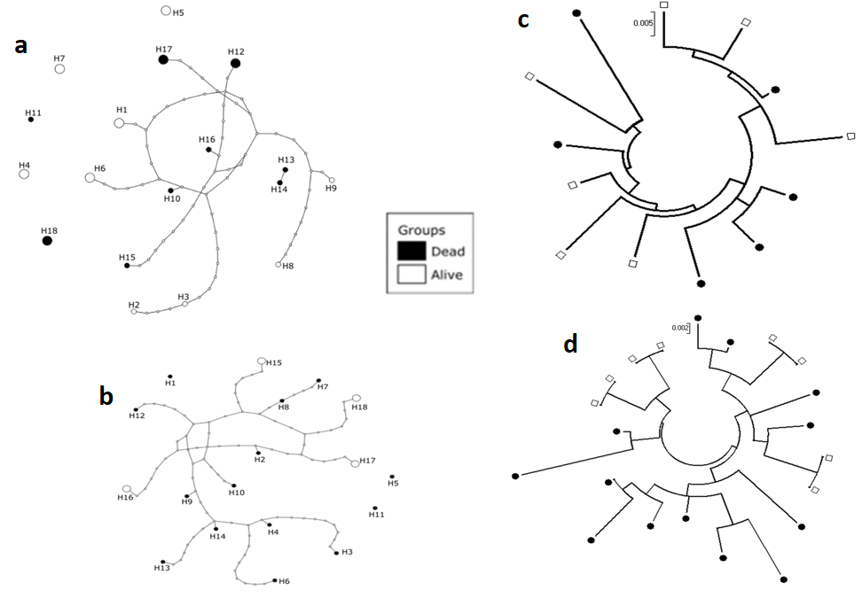
Figure 4: Analysis of the polymorphism of the D7r3 and D7r4 genes in An. funestus s.s. mosquito. Haplotype network showing high diversity in D7r3 (a) and D7r4 (b) genes. Maximum likelihood phylogenetic tree of D7r3 (c) and D7r4 (d) genes showing a lack of association between haplotypes and resistance phenotype to deltamethrin.

3.6. Molecular basis of the insecticide resistance in field malaria vector populations
RDL-A296S and L119F-Gste2 mutations detection in An. funestus s.s. : From a total of 190 field collected An. funestus mosquito randomly genotyped for RDL-A296S mutation, 160 (87%) were homozygous resistant (RR) and 24 (13%) were homozygous susceptible (SS). Concerning the L119F-GSTe2 mutation, 11/73 (15%), 35/73 (48%) and 27/73 (37%) individuals were carried the homozygous resistant (RR), the heterozygote (RS) and the susceptible (SS) genotype, respectively.
L1014F mutations in An. gambiae: The kdr mutation was genotyped in a total of 60 mosquitoes. Of these, 56 (93.3%) were homozygous resistant (RR) and 4 (6.7%) were heterozygous (RS).

4. Discussion
Assessing mechanisms which are associated with the spreading of insecticide resistance in Anopheles mosquitoes is crucial in understanding its impact on malaria transmission. It was reported that insecticide resistance in mosquitoes may impact on their feeding habit and vector competence [29]. Mosquito blood meal intake and pathogens transmission are facilitated by various salivary proteins through their anti-coagulant, anti-platelet aggregation and immunosuppressive properties that help the mosquito to overcome homeostasis and blood feeding [4, 5, 30]. However, few information are available on the impact that insecticide resistance may have on the salivary proteins of malaria vectors. With the purpose to help filling this gap of knowledge, the present study investigated the potential impact of insecticide resistance on the expression and genetic diversity of D7 gene family.
Because no study had previously been conducted in the study area, we firstly characterized the malaria vector populations in the locality by determining their composition specificity as well as their susceptibility to the main insecticides used in public health. The morphological identification of collected mosquitoes revealed that Anopheles funestus s.l. and Anopheles gambiae complex were the sole Anopheline species found indoor of the habitations. Anopheles funestus appeared to be the most abundant malaria vector in Elon, accounting for 78% of the collected mosquitoes. This pattern of malaria vectors composition and abundance is similar to previous reports from a study in Nkoteng, an area located 50Km from Elon [31], but this could vary according to climatic season. Moreover, because the collection method we used specifically targeted indoor resting mosquitoes, the present study is limited on giving an accurate overview of the Anopheline species composition in the study area. The species-typing PCR assays led to the identification of An. funestus s.s as the predominant member of An. funestus group in the study area. This observation is in accordance with what described in several previous studies carried out in Cameroon [28, 31-33]. Nonetheless, even if detected in in very low proportion, the presence of other species such as, An. parensis, rivulorum and rivulorum-like, indicates some diversity in the species composition of An. funestus group in the study area. This species diversity highlights the need of accurate identification of this species group to generate reliable data on these malaria vectors. For the An. gambiae complex, An. gambiae was the only species found. This is probably linked to the fact that the study is carried in a rural area where An. gambiae is more adapted than An. coluzzii [34].
With exception to organophosphates and to propoxur (carbamates), An. funestus mosquito population from Elon exhibited resistance towards several insecticides tested such as deltamethrin, permethrin, dieldrin, and bendiocarb. A high level of resistance to deltamethrin and permethrin was also observed for An. gambiae s.s.. This multiple resistance profile is in line with what was previously reported in different studies in the country [28, 32, 35-37]. This confirms that resistance to several insecticides is widespread in malaria vectors populations in Cameroon. Results of the cone bioassays emphasize with both An. funestus s.s. and An. gambiae s.s. species, showed a low mortality rates with both permethrin (olyset) and deltamethrin (PermaNet) impregnated LLINs. This reduction of bio-efficacy has been previously hypothesized to be due to the selection pressure induced by the massive distribution of bed nets by the government associated to use of pesticide in agriculture [28]. This reduction of bio-efficacy could favor malaria transmission in this area where high Plasmodium infection rates were observed in the main vectors. Nevertheless, distribution of nets with PBO could represent an alternative in this area since almost full recovery of susceptibility to both deltamethrin and permethrin was observed in An. funestus after a pre-exposure to PBO confirming the implication of cytochrome P450s in insecticide resistance of An. funestus populations from Elon as previously observed in other locations in the country [28, 32]. However, the high frequency of kdr mutation detected in these mosquito populations indicates that pyrethroid resistance in these malaria vectors is due to both metabolic resistant and kdr mutation in Elon. This observation confirms the results of several other authors [28, 32, 35, 38-40].
The comparative expression profiling of the D7 family genes in both species in relation to susceptible strains suggests a potential influence of insecticide resistance on some of these genes in An. funestus. The qPCR analyses showed that the expression of D7 family genes is associated with resistance to the two pyrethroids mostly used in malaria vector control tools in Cameroon. Such association was previously detected by microarray analyses in different studies across the African continent [6-11]. Furthermore, a recent study using both microarray and qPCR analysis have reported an overexpression of D7 family genes in bendiocarb resistant An. gambiae mosquito from Uganda [41]. In a previous study, authors hypothesized that D7 proteins may confer insecticide resistance by binding and sequestering insecticide or insecticide metabolites rather than by any direct detoxification. They supported their hypothesis by implementing in silico experimentations to demonstrate the structural compatibility of the D7r4 protein’s central binding pocket and bendiocarb. Additionally, they suggested that the larger pocket found in D7r2 may permit binding of pyrethroids as reported for cytochrome P450 enzymes such as CYP6M2 [42, 43]. However, at this stage, no experimental evidence has been given to prove the involvement of D7 genes in detoxification of insecticide. In our study, a significant overexpression was observed for two short form genes (D7r3 and D7r4) in both permethrin and deltamethrin resistant An. funestus field mosquitoes compared. The overexpression of D7r3 gene was previously reported after microarray assay in bendiocarb and DDT resistant An. funestus mosquito populations from Malawi [42] and Benin [7]. In the other hands, in our knowledge, this is the first time a differential expression of D7r4 gene is reported in insecticide resistant An. funestus mosquito. Further investigations are needed to confirm these results. The D7r2 gene was also found overexpressed in both permethrin and deltamethrin resistant An. funestus mosquito. This overexpression, even if non-significant in the present study, is in accordance with previous microarray studies in permethrin and lambda-cyhalotrin resistant An. funestus population in Malawi [42] in Zambia [43], respectively. These results seem to indicate an association of insecticide resistance with an overexpression of some D7 family genes in An. funestus mosquito from multiple regions of Africa. However, in this stage of the study, we cannot hypothesize whether or not these genes are implicated in the development of pyrethroids resistance in An. funestus or if it’s a result of the mosquito physiological adaptation to resistance.
To investigate whether the overexpression of D7r3 and D7r4 in An. funestus is related to a polymorphism of those genes, we sequenced a full length DNA of both genes from alive and dead mosquitoes after exposure to deltamethrin. Although a high haplotype diversity was observed for both genes, no major haplotype was found associated with either resistant (alive) or susceptible (dead) phenotypes. This indicates that for both genes, there is no selection of a specific haplotype associated to insecticide resistance and consequently, to their over-expression. The high haplotype diversity coupled to the high genetic diversity observed for both genes would suggest that this An. funestus population is expanding as a result of a recent event within these genes. This hypothesis is supported principally for the D7r4 gene, by the negative and statistically significant value of the Fu’s F index. Further studies would be more informative on how important is the expansion of this An. funestus population from Elon.
Regarding Anopheles gambiae, we observed an under-expression of overall members of D7 family genes in both permethrin and deltamethrin resistant field strain compared to Kisumu lab strain. These results are contrasting with the overexpression observed from microarray analyses in pyrethroids resistant An. gambiae mosquito from Zambia [43], in An. coluzzii from Burkina-Faso and Côte-d’Ivoire [9] and in An. arabiensis from Sudan [44] or in Uganda [10] and Zanzibar [6]. The difference between these previous results and what we observed in the present study could be due to specificity of the primers used for qPCR for this species. So, there is a need of further studies to confirm the pattern of differential expression of D7 family genes in pyrethroids resistant An. gambiae populations potentially with new primer sets. However, the fact that, both microarray and qPCR assays recently revealed an overexpression of D7r2 and D7r4 genes in bendiocarb resistant An. gambiae populations from Uganda [41] suggests that D7 is also associated with resistance in this species. Although the difference between these results and ours could be linked to insecticide tested. Indeed, because mosquitoes develop different resistance mechanisms to carbamates and pyrethroids, the impact of the resistance to one family could be different to what observed for the other. However, the down-regulation of D7 family genes observed in our study is in accordance with results of previous studies after comparative proteomic analysis of expressed proteins in bendiocarb susceptible and resistant mosquitoes [45, 46]. Indeed, in these studies conducted in Culex quinquefasciatus [47] and An. gambiae [46], the D7 long form (the sole member of D7 family protein detected) presented lower expression in the resistant strain than the susceptible strain. Globally, it appears that the pattern of how insecticide resistance is associated to the differential expression of D7 family genes remained unclear. This highlights the need to conduct both transcriptomic and proteomic further studies to draw a definite conclusion.
The present study provides some important information that could contribute to fill the gap on knowledge on the impact of insecticide resistance in salivary gland proteins. Nevertheless, certain aspects not taken into account here would contribute to improve the information provided by the present study. Indeed, qPCR analyses were not carried out in all the members of D7 genes for An. funestus, as we did not succeed to have primer for D7r5 and D7L2 for this species. Moreover, it would certainly be more informative to work with resistant and susceptible mosquitoes coming from the same locality, instead of comparing field resistant mosquitoes with lab colonized susceptible strain with very low genes polymorphism as done in the present study.

5. Conclusion
In the present study, after assessing insecticide susceptibility in malaria vectors in Elon, we have compared the expression of D7 family genes in the salivary gland of pyrethroid resistant and susceptible An. gambiae and An. funestus s.s. mosquitoes. We found that An. gambiae and An. funestus s.s. are both multiple resistant to almost all the insecticides currently used in public health. A significant over-expression of two short forms of the D7 family genes (D7r3 and D7r4) in An. funestus s.s., while an under-expression was observed for almost all the D7 genes in An. gambiae This result confirms that insecticide resistance could be associated to the expression of the salivary proteins in malaria vectors. Therefore, because salivary proteins are essential for mosquito blood meal intake and for malaria parasites transmission, additional studies are needed to assess whether the differential expression of D7 genes due to insecticide resistance statute could have an impact on the blood intake success and in the ability of Anopheles mosquitoes to be infected by malaria sporozoites. Such studies will be informative on the profile of malaria transmission in the context of insecticide resistance, as is the case in many countries in Africa. Furthermore, studies exploring how insecticide resistance is associated with the differential expression of salivary glands genes may open the way for screening of novel insecticide resistance candidates genes, as current known resistance mutations explain only a fraction of a resistance phenotype.
Supplementary materials: Table S1: List of primers used in the study for qPCR analysis for the expression of genes encoding D7 salivary proteins in An. funestus and An. gambiae. and for DNA amplification and sequencing
Author Contributions: E.E.N and C.S.W. conceived and designed the study; E.E.N.; B.T.; L.N.; A.B. And M.T. carried out the sample collection; L.N.; A.B. and T.A. reared and maintained the strain in the insectary; L.N., A.B., T.A. performed insecticides bioassays; E.E.N and H.I. performed the molecular analyses; E.E.N, C.N., D.N.N. and C.S.W. analyzed the data; E.E.N and C.S.W. wrote the manuscript with contributions from C.N., B.T. and P.A. All authors approved the manuscript.
Acknowledgments: This study was funded by the Wellcome Trust (Welcome Training fellowship 109930/Z/15/Z) awarded to E.E.N.
Conflicts of Interest: The authors declare no conflict of interest. The sponsors of this study had no role in the design of the study; in the collection, analyses, or interpretation of data; in the writing of this manuscript, and in the decision to publish it.

References

1. WHO, World Malaria Report, Geneva. 2018.
2. WHO, World Malaria Report 2018. World Health Organization. 2018.
3. Bhatt, S., et al., The effect of malaria control on Plasmodium falciparum in Africa between 2000 and 2015. Nature, 2015. 526(7572): p. 207.
4. Calvo, E., et al., Function and evolution of a mosquito salivary protein family. Journal of Biological Chemistry, 2006. 281(4): p. 1935-1942.
5. Francischetti, I.M., et al., Toward a catalog for the transcripts and proteins (sialome) from the salivary gland of the malaria vector Anopheles gambiae. Journal of Experimental Biology, 2002. 205(16): p. 2429-2451.
6. Jones, C.M., et al., The dynamics of pyrethroid resistance in Anopheles arabiensis from Zanzibar and an assessment of the underlying genetic basis. Parasites & vectors, 2013. 6(1): p. 343.
7. Riveron, J.M., et al., The highly polymorphic CYP6M7 cytochrome P450 gene partners with the directionally selected CYP6P9a and CYP6P9b genes to expand the pyrethroid resistance front in the malaria vector Anopheles funestus in Africa. BMC genomics, 2014. 15(1): p. 817.
8. Riveron, J.M., et al., A single mutation in the GSTe2 gene allows tracking of metabolically based insecticide resistance in a major malaria vector. Genome biology, 2014. 15(2): p. R27.
9. Toé, K.H., et al., The recent escalation in strength of pyrethroid resistance in Anopheles coluzzi in West Africa is linked to increased expression of multiple gene families. BMC genomics, 2015. 16(1): p. 1.
10. Wilding, C., et al., Parallel evolution or purifying selection, not introgression, explains similarity in the pyrethroid detoxification linked GSTE4 of Anopheles gambiae and An. arabiensis. Molecular genetics and genomics, 2015. 290(1): p. 201-215.
11. Samb, B., et al., Investigating molecular basis of lambda-cyhalothrin resistance in an Anopheles funestus population from Senegal. Parasites & vectors, 2016. 9(1): p. 449.
12. Arca, B., et al., A cluster of four D7‐related genes is expressed in the salivary glands of the African malaria vector Anopheles gambiae. Insect Molecular Biology, 2002. 11(1): p. 47-55.
13. Arcà, B., et al., An updated catalogue of salivary gland transcripts in the adult female mosquito, Anopheles gambiae. Journal of experimental biology, 2005. 208(20): p. 3971-3986.
14. Lanfrancotti, A., et al., Novel cDNAs encoding salivary proteins from the malaria vector Anopheles gambiae. FEBS letters, 2002. 517(1-3): p. 67-71.
15. Mans, B.J., et al., The crystal structure of D7r4, a salivary biogenic amine-binding protein from the malaria mosquito Anopheles gambiae. Journal of Biological Chemistry, 2007. 282(50): p. 36626-36633.
16. Gillies, M. and M. Coetzee, A supplement to the Anophelinae of Africa south of the Sahara (Afrotropical region). 1987.
17. Morgan, J.C., et al., Pyrethroid resistance in an Anopheles funestus population from Uganda. PLoS One, 2010. 5(7): p. e11872.
18. Livak, K.J., Organization and mapping of a sequence on the Drosophila melanogaster X and Y chromosomes that is transcribed during spermatogenesis. Genetics, 1984. 107(4): p. 611-634.
19. Koekemoer, L., et al., A cocktail polymerase chain reaction assay to identify members of the Anopheles funestus (Diptera: Culicidae) group. The American journal of tropical medicine and hygiene, 2002. 66(6): p. 804-811.
20. Santolamazza, F., et al., Insertion polymorphisms of SINE200 retrotransposons within speciation islands of Anopheles gambiae molecular forms. Malaria journal, 2008. 7(1): p. 163.
21. Bass, C., et al., PCR-based detection of Plasmodium in Anopheles mosquitoes: a comparison of a new high-throughput assay with existing methods. Malaria journal, 2008. 7(1): p. 177.
22. WHO, Test procedures for insecticide resistance monitoring in malaria vector mosquitoes, second edition. 2018.
23. WHO, Test procedures for insecticide resistance monitoring in malaria vector mosquitoes. 2013.
24. Djouaka, R., et al., Exploring mechanisms of multiple insecticide resistance in a population of the malaria vector Anopheles funestus in Benin. PLos one, 2011. 6(11): p. e27760.
25. Martinez‐Torres, D., et al., Molecular characterization of pyrethroid knockdown resistance (kdr) in the major malaria vector Anopheles gambiae ss. Insect molecular biology, 1998. 7(2): p. 179-184.
26. Djouaka, R., et al., Multiple insecticide resistance in an infected population of the malaria vector Anopheles funestus in Benin. Parasites & vectors, 2016. 9(1): p. 453.
27. Tchouakui, M., et al., Fitness Costs of the Glutathione S-Transferase Epsilon 2 (L119F-GSTe2) Mediated Metabolic Resistance to Insecticides in the Major African Malaria Vector Anopheles Funestus. Genes, 2018. 9(12): p. 645.
28. Menze, B.D., et al., Bionomics and insecticides resistance profiling of malaria vectors at a selected site for experimental hut trials in central Cameroon. Malaria journal, 2018. 17(1): p. 317.
29. Rivero, A., et al., Insecticide control of vector-borne diseases: when is insecticide resistance a problem? PLoS pathogens, 2010. 6(8): p. e1001000.
30. Ribeiro, J.M. and I.M. Francischetti, Role of arthropod saliva in blood feeding: sialome and post-sialome perspectives. Annual review of entomology, 2003. 48(1): p. 73-88.
31. Cohuet, A., et al., High malaria transmission intensity due to Anopheles funestus (Diptera: Culicidae) in a village of savannah–forest transition area in Cameroon. Journal of medical entomology, 2004. 41(5): p. 901-905.
32. Menze, B.D., et al., Multiple insecticide resistance in the malaria vector Anopheles funestus from Northern Cameroon is mediated by metabolic resistance alongside potential target site insensitivity mutations. PLoS One, 2016. 11(10): p. e0163261.
33. Ndo, C., et al., High susceptibility of wild Anopheles funestus to infection with natural Plasmodium falciparum gametocytes using membrane feeding assays. Parasites & vectors, 2016. 9(1): p. 341.
34. Kamdem, C., et al., Anthropogenic habitat disturbance and ecological divergence between incipient species of the malaria mosquito Anopheles gambiae. PloS one, 2012. 7(6): p. e39453.
35. Chouaïbou, M., et al., Dynamics of insecticide resistance in the malaria vector Anopheles gambiae sl from an area of extensive cotton cultivation in Northern Cameroon. Tropical Medicine & International Health, 2008. 13(4): p. 476-486.
36. Mueller, P., et al., Pyrethroid tolerance is associated with elevated expression of antioxidants and agricultural practice in Anopheles arabiensis sampled from an area of cotton fields in Northern Cameroon. Molecular ecology, 2008. 17(4): p. 1145-1155.
37. Ndo, C., et al., Elevated Plasmodium infection rates and high pyrethroid resistance in major malaria vectors in a forested area of Cameroon highlight challenges of malaria control. Parasites & vectors, 2018. 11(1): p. 157.
38. Antonio-Nkondjio, C., et al., Anopheles gambiae distribution and insecticide resistance in the cities of Douala and Yaounde (Cameroon): influence of urban agriculture and pollution. Malaria Journal, 2011. 10(1): p. 154.
39. Nwane, P., et al., Multiple insecticide resistance mechanisms in Anopheles gambiae sl populations from Cameroon, Central Africa. Parasites & vectors, 2013. 6(1): p. 41.
40. Tene Fossog, B., et al., Habitat segregation and ecological character displacement in cryptic African malaria mosquitoes. Evolutionary applications, 2015. 8(4): p. 326-345.
41. Isaacs, A.T., et al., Genome-wide transcriptional analyses in Anopheles mosquitoes reveal an unexpected association between salivary gland gene expression and insecticide resistance. BMC genomics, 2018. 19(1): p. 225.
42. Ibrahim, S.S., et al., The P450 CYP 6Z1 confers carbamate/pyrethroid cross‐resistance in a major African malaria vector beside a novel carbamate‐insensitive N485I acetylcholinesterase‐1 mutation. Molecular ecology, 2016. 25(14): p. 3436-3452.
43. Thomsen, E.K., et al., Underpinning sustainable vector control through informed insecticide resistance management. PLoS One, 2014. 9(6): p. e99822.
44. Abdalla, H., et al., Insecticide resistance in Anopheles arabiensis in Sudan: temporal trends and underlying mechanisms. Parasites & vectors, 2014. 7(1): p. 213.
45. Djegbe, I., et al., Differential expression of salivary proteins between susceptible and insecticide-resistant mosquitoes of Culex quinquefasciatus. PLoS One, 2011. 6(3): p. e17496.
46. Cornelie, S., et al., Salivary gland proteome analysis reveals modulation of anopheline unique proteins in insensitive acetylcholinesterase resistant Anopheles gambiae mosquitoes. PloS one, 2014. 9(8): p. e103816.
47. Djègbè, I., et al., Dynamics of insecticide resistance in malaria vectors in Benin: first evidence of the presence of L1014S kdr mutation in Anopheles gambiae from West Africa. Malaria journal, 2011. 10(1): p. 261.

