A new perspective on urogenital schistosomiasis in Malawi: Schistosome interactions within the Schistosoma haematobium group

Bonnie L. Webster¹, Mohammad H. Alharbi^{2,3}, Sekeleghe Kayuni^{2,4}, Peter Makaula⁵, Fenella Halstead², Rosie Christiansen², Lazarus Juziwelo⁶, Michelle C. Stanton⁷, E. James LaCourse², David Rollinson¹, Khumbo Kalua⁸, J. Russell Stothard^{2,*}

¹Department of Life Sciences, Natural History Museum, Cromwell Road, London, SW5 5BD, UK; ²Department of Tropical Disease Biology, Liverpool School of Tropical Medicine, Liverpool, L3 5QA, UK; ³Ministry of Health, Qassim, Kingdom of Saudi Arabia; ⁴Medi Clinic Limited, Medical Aid Society of Malawi (MASM), 22 Lower Sclatter Road, P.O. Box 1254, Blantyre, Malawi; ⁵Research for Health Environment and Development, P.O. Box 345, Mangochi, Malawi; ⁶National Schistosomiasis and STH Control Programme, Ministry of Health, Lilongwe, Malawi; ⁷Lancaster University Medical School, Lancaster, LA1 4YW, UK; ⁸Blantyre Institute for Community Outreach, Lions Sight First Eye Hospital, P. O. Box E180, Post Dot Net, Blantyre, Malawi.

*Address for correspondence: Professor J.R. Stothard, Parasitology Department, Liverpool School of Tropical Medicine, Liverpool, L3 5QA, UK. Tel: +44 (151)7053724. E-mail: russell.stothard@lstmed.ac.uk

Abstract Genetic interactions occurring between human (Schistosoma haematobium) and livestock (S. mattheei and S. bovis) schistosome species were revealed by molecular analysis of atypical schistosome eggs retrieved from Malawian children. Detection of hybrid schistosomes adds an important new perspective to the epidemiology and control of urogenital schistosomiasis in Central Africa.

Urogenital schistosomiasis is a high-ranking waterborne disease, transmitted by certain freshwater snails, that occurs throughout much of sub-Saharan Africa; a disease once commonly held attributable to Schistosoma haematobium alone which has very limited zoonotic potential [1]. This appraisal is being repeatedly revised as new evidence accrues upon genetic analysis of natural infections with non-invasive larval sampling [2]. In West Africa, for example, species interactions with hybrid combinations of Schistosoma haematobium and bovine/ovine species of S. bovis and S. curassoni are being commonly encountered in humans and snails [3]. Whilst key biological features of hybrids may not always be apparent, the risk of zoonotic transmission alongside enhanced definitive and intermediate host compatibilities needs study [2,3]. The public health impact of such genetic introgression is best evidenced by the recent emergence and persistent transmission of S. haematobium-bovis hybrids on the Mediterranean island of Corsica [4].
With regard to Central and Southern Africa, genetic analysis of Schistosoma haematobium group species is priority. Based on atypical egg morphologies, a capacity for natural hybridization of S. haematobium with the bovine species Schistosoma mattheei was suggested long ago and was later confirmed by biochemical markers and experimental infections demonstrating viable progeny [3]. During ongoing surveillance of urogenital schistosomiasis in Chikhwawa District, Malawi, we have encountered atypical S. haematobium eggs in urine samples from several infected children [5]. We report here on the further genetic characterization of atypical eggs collected from epidemiological surveys of children within Chikhawa, Nsanje and Mangochi Districts that has revealed the presence of both S. haematobium-mattheei and S. haematobium-bovis hybrids, Figure.

<please insert Figure near here>

Schistosome eggs were filtered from the urine of infected children, photographed and measured before being stored on Whatman FTA cards for molecular analysis [2]. The DNA from individual eggs was alkaline eluted and genotyped using both the mitochondrial cytochrome oxidase subunit 1 (cox1) and the nuclear ribosomal internal transcribed spacer (rITS) DNA regions [2]. Additionally, for the samples from Mangochi District a partial region (300 bp) of the nuclear ribosomal 18S DNA was analysed to confirm the presence of S. mattheei nuclear DNA [2,6]. For more detailed methods see Supplemental File. From Chikhwawa, 6 atypical eggs were examined all of which had a pure S. haematobium genetic profile, see Figure. From Nsanje, a total of 19 eggs were examined with 3 having atypical morphologies, 18 eggs had a pure S. haematobium genetic profile but one atypical egg presented with a discordant genetic profile (i.e. cox1 S. bovis and rITS S. haematobium). From Mangochi, 16 typical S. haematobium shaped eggs had a pure S. haematobium genetic profile whilst 4 atypical eggs presented identical but discordant genetic profiles (cox1 S. mattheei and rITS S. haematobium-mattheei). Inspection of the partial 18S confirmed S. haematobium-mattheei hybrids. All sequence data can be obtained from GenBank Accession Numbers: MK358841-MK358858.
Our genetic analysis has clearly demonstrated the presence of S. haematobium group hybrids in Malawi as introgressed forms of S. haematobium-mattheei and S. haematobium-bovis. It is worthy to note that an unusual egg morphology may not always correspond with the ability to detect introgression with the current combination of genetic markers used [6]. For further referencing see Supplemental File. As noted previously in Senegal, successive back crossings of hybrid progeny may obscure our ability in the detection of ancestral introgression, the development of a wider panel of nuclear genetic markers is needed. Nonetheless, detection of these two hybrid schistosomes strongly suggests interactions of S. haematobium with two ungulate schistosomes S. mattheei and S. bovis. The latter schistosome has not been reported in Malawi which implies a changing species dynamic with a suspicion of zoonotic transmission along the drainage basin of Lake Malawi. This adds an important new dimension to the epidemiology and control of urogenital schistosomiasis in Malawi [7].
As miracidial hatching was not attempted during this study, we cannot confirm that these hybrids or introgressed forms are fully viable in natural transmission autochthonously. However, the process of ancestral introgression with subsequent natural selection may help to explain in part unexpected shifts in local snail-schistosome relationships, e.g. the changing compatibility of Bulinus nyassanus in Lake Malawi with S. haematobium [8]. Further studies are therefore needed to better characterise schistosomes involved in human infection, investigate more thoroughly any zoonotic potential and assess all possible combinations of inter-species introgressions. Concerning the latter, ancestral hybridization between S. haematobium and Schistosoma mansoni has been noted [9] and given autochthonous transmission of intestinal schistosomiasis in Lake Malawi [10], there may be sufficient epidemiological opportunity for this to further arise. Heightened co-surveillance of urogenital and intestinal schistosomiasis is advised, entailing molecular vigilance for any inter-species interactions, alongside phenotypic assessments for any altered host pathogenicity or susceptibility to praziquantel treatment. The detection of hybrid schistosomes adds an important new perspective to the epidemiology and control of urogenital schistosomiasis in Central Africa.

Dr Bonnie Webster has specific expertise in medical helminthology with a longstanding interest in studies of schistosome hybridization in both natural and experimental settings.
Acknowledgements
MA and SK are funded by PhD scholarships from the Ministry of Health, Kingdom of Saudi Arabia and Commonwealth Scholarship Commission, respectively; SK received a research fellowship from the African Research Network for Neglected Tropical Diseases (ARNTD). We are particularly grateful to the local health and education authorities of Malawi, district teachers, local community health workers involved in schistosome surveys in Chikhawa, Nsanje and Mangochi. We each thank Jahashi Nzalawahe for assistance with measurements and analysis of schistosome egg morphology. Ethical approvals for the epidemiological surveys was granted by Liverpool School of Tropical Medicine, College of Medicine Malawi and Ministry of Health and Population, Malawi. All children found infected were treatment with praziquantel.

References
1. Rollinson D. A wake up call for urinary schistosomiasis: Reconciling research effort with public health importance. Parasitology 2009, 136, 1593-1610.
2. Huyse T, Webster BL, Geldof S, Stothard JR, Diaw OT, Polman K et al. Bidirectional introgressive hybridization between a cattle and human schistosome species. PloS Pathogens 2009, 5.
3. Leger E, Webster JP. Hybridizations within the genus Schistosoma: Implications for evolution, epidemiology and control. Parasitology 2017, 144, 65-80.
4. Boissier J, Grech-Angelini S, Webster BL, Allienne FF, Huyse T, Mas-Coma S, et al. Outbreak of urogenital schistosomiasis in Corsica (France): an epidemiological case study. Lancet Infectious Diseases 2016, 16, 971-979.
5. Poole H, Terlouw DJ, Naunje A, Mzembe K, Stanton M, Betson M, et al. Schistosomiasis in pre-school-age children and their mothers in Chikhwawa District, Malawi with notes on characterization of schistosomes and snails. Parasites & Vectors 2014, 7.
6. Boon NAM, Fannes W, Rombouts S, Polman K, Volckaert FAM, Huyse T. Detecting hybridization in African schistosome species: Does egg morphology complement molecular species identification? Parasitology 2017, 144, 954-964.
7. Makaula P, Sadalaki JR, Muula AS, Kayuni S, Jemu S, Bloch, P. Schistosomiasis in Malawi: A systematic review. Parasites & Vectors 2014, 7.
8. Stauffer JR, Madsen H, Webster B, Black K, Rollinson D, Konings A. Schistosoma haematobium in lake Malawi: Susceptibility and molecular diversity of the snail hosts Bulinus globosus and B. nyassanus. Journal of Helminthology 2008, 82, 377-382.
9. Yohann Le Govic Y, Kincaid-Smith J, Allienne JF, Rey O, de Gentile L, Boissier J. Schistosoma haematobium–Schistosoma mansoni hybrid parasite in migrant boy, France, 2017. Emerging Infectious Diseases 2019, 25.
10. Alharbi MH, Condemine C, Christiansen R, LaCourse EJ, Makaula P, Stanton MC et al. Biomphalaria pfeifferi and intestinal schistosomiasis in Lake Malawi, Africa 2017-2018. Emerging Infectious Diseases 2019, 25.

Figure A. Diagrammatic map of Malawi with sampled Districts indicated (GPS of sampled village where egg-patent S. haematobium urines were collected): Mangochi (Samama 14°417465S, 35°217580E), Chikhwawa (Mpangani 16°036299S, 34°841063) and Nasanje (Kastiano 16°906398S, 35°266578E). About 10% of sampled children had atypical eggs in their urine in an approximate ratio of 1 (atypical):25 (typical) egg shapes. Note that the Shire River flows southward from Lake Malawi, linking all three sampled locations within the same drainage basin. Figure B. Photomicrographs of a representative atypical egg from each location with corresponding genotypes assigned for the mitochondrial cox1 and nuclear rITS loci. Figure C. Bar chart histogram of length measurements for 83 typical S. haematobium eggs collected from Nsanje, the associated density distribution is shown (solid line). The mean length of this sample of typical eggs was 135 ± 28µm (1 standard deviation), with minimum (86 µm) and maximum (180 µm). The length measurements of the 3 atypical eggs are indicated (arrowed dashed lines), indicating they each fall well outside the range of length variation of the 83 eggs [inset photomicrograph of a characteristic S. haematobium egg].

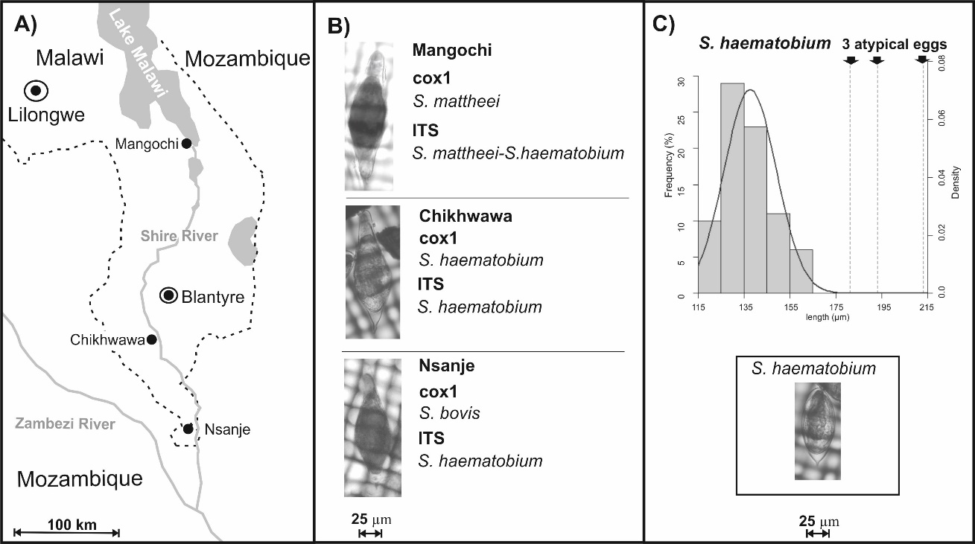

SUPPLEMENTAL INFORMATION
Protocol

DNA preparation from FTA stored schistosome eggs / larvae

Add 14μl of Solution 1 (0.1M NaOH, 0.3mM EDTA, pH13.0) to the punch out 2mm FTA disc

Incubate at room temperature for 5 mins

Add 26μl of Solution 2 (0.1M Tris-HCl, pH7.0)

Pulse vortex 3 times
- Incubate at room temperature for 10 mins
- Pulse vortex 10 times
- 3μl of the DNA elution is used in a 25μl PCR

Table. The PCR primers used to amplify each DNA region and their associated PCR thermal cycle

DNA region | Forward Primer  (name) | Reverse Primer  (name) | PCR thermal cycle
ITS1+2 rDNA | TGCTTAAGTTCAGCGGGT (ITS1) | AACAAGGTTTCCGTAGGTGAA (ITS2) | 5 min at 95°C:  40 cycles of 30 sec at 95°C, 30 sec at 58°C, 1.30 min at 72°C:  10 min at 72°C.
Partial 18S rDNA | GCGAATGGCTCATTAAATCAG (WA) | TCCGGAGAGGGAGCCTGA (300R) | 5 min at 95°C:  40 cycles of 30 sec at 95°C, 30 sec at 60°C, 1 min at 72°C:  10 min at 72°C.
Partial cox1 mt DNA | TAATGCATMGGAAAAAAACA (cox1Schisto5’) | TCTTTRGATCATAAGCG (cox1Schisto3’) | 5 min at 95°C:  40 cycles of 30 sec at 95°C, 30 sec at 40°C and 1.30 min at 72°C  10 min at 72°C.

PCR analysis and sequencing

DNA was eluted as described above from the schistosome eggs stored on the FTA cards. In separate PCR’s, run on a Perkin Elmer 9600 Thermal Cycler, the cox1, ITS and 18S DNA regions were amplified (see Table above with PCR primers). A 25 µl PCR reaction was each performed using illustraTM puReTaq Ready-To-Go PCR Beads (GE Healthcare, UK) and 10 pmol of each primer and 3μl of the DNA elution.

All PCR reactions were checked for positive amplification of the correct band size by gel electrophoresis (0.8% Gelred agarose gels). PCR amplicons were purified and Sanger sequencd in both directions using a dilution of original PCR primer. All sequence data was visualised and manually edited using Sequencher V5.1.

Mitochondrial cox1 sequence identity was confirmed using the Basic Local Alignment Search Tool (BLAST) (Genbank). The ITS and 18S sequence identity was analysed by visual comparison to personal reference sequences for each species (S. haematobium, S. bovis and S. mattheei). Known inter-species SNP regions (see figure below) were visually checked to identity homogenous or heterogenous ITS and 18S DNA.

Genetic profiles, mitochondrial and nuclear, were inspected to identify hybrids (and any discordance of mitochondrial and nuclear DNA data).

Figure. Species specific SNP variation which differentiate the three species at 18S and ITS loci.
Marker | 18S (300bp) |  |  | ITS (906bp)
SNP | 138 | 163 | 210 | 18 | 26 | 50 | 51 | 91 | 92 | 120 | 170 | 225 | 490 | 877
S. haematobium | T | C | T | C | T | G | T | C | G | C | G | C | T | T
S. bovis | C | T | C | C | T | A | T | C | G | T | A | T | T | C
S. mattheei | C | T | T | T | A | A | C | T | A | T | A | T | A | T

Further bibliography on significance of atypical helminth eggs

Blackie WK. A helminthological survey of Southern Rhodesia. Issue 5 of the London School of Hygiene and Tropical Medicine Memoir 1932, Pages 1-91.

Pitchford R. Differences in the egg morphology and certain biological characteristics of some African and Middle Eastern schistosomes, genus Schistosoma, with terminal-spined eggs. Bulletin of the World Health Organization 1965, 32, 105.

Sapp SG, Yabsley MJ, & Bradbury RS. Abnormal helminth egg development, strange morphology, and the identification of intestinal helminth infections. Emerging Infectious Diseases 2018, 24, 1407.

