**SUPPLEMENTARY FILE 1**

**Mucosal lactoferrin responses to genital tract infections are associated with iron biomarkers in iron supplemented young Burkinabé women**

Stephen A. Roberts, Loretta Brabin, Salou Diallo, Sabine Gies, Andrew Nelson, Christopher Stewart, Dorine W. Swinkels, Anneke J. Geurts-Moespot, Adama Kazienga, Sayouba Ouedraogo, Umberto D’Alessandro, Halidou Tinto, Bernard Brabin*.

* Corresponding author

**SUPPLEMENTARY TABLE 1**

Intention to treat analysis of vaginal Lf concentration between iron supplemented and control trial arms for pregnant (ANC1/2) and non-pregnant cohorts.

|  |  |  |  |  |  |  |  |
| --- | --- | --- | --- | --- | --- | --- | --- |
|  |  | Log10Lf (mean±SD) | | Estimated difference between arms (95%CI) | | | |
| Assessment | N | Iron | Control | Unadjusted | P | Adjusted for antibiotic use | P |
| ANC1 | 271 | 2.9±1.1 | 2.9±1.0 | -0.014  (-0.266-0.239) | 0.92 | -0.019  (-0.272-0.234) | 0.88 |
| ANC2 | 241 | 2.8±1.0 | 2.9±1.0 | -0.090  (-0.34-0.16) | 0.49 | -0.092  (-0.347-0.162) | 0.47 |
| Non- pregnant | 777 | 2.5±1.0 | 2.4±0.8 | 0.090  (-0.042-0.222) | 0.18 | 0.090  (-0.042-0.222) | 0.18 |

Estimates from an analysis of covariance, adjusting for use of antibiotics within the month previous to the assessment. For the non-pregnant cohort, end assessment followed a period of up to 18 months supplementation.

The lack of difference in Lf concentration between trial arms is attributed to poor enteric absorption of iron supplements due to concurrent malaria parasitemia, leading to increased hepcidin production inhibiting iron absorption (Cercamondi et al, 2010).

Cercamondi,C.I, Egli, I.M., Ahouandjinou, E., [Dossa, R](https://www.ncbi.nlm.nih.gov/pubmed/?term=Dossa%20R%5BAuthor%5D&cauthor=true&cauthor_uid=20926522)., [Zeder, C](https://www.ncbi.nlm.nih.gov/pubmed/?term=Zeder%20C%5BAuthor%5D&cauthor=true&cauthor_uid=20926522)., [Salami, L](https://www.ncbi.nlm.nih.gov/pubmed/?term=Salami%20L%5BAuthor%5D&cauthor=true&cauthor_uid=20926522). et al. (2010). A febrile *Plasmodium falciparum* parasitemia decreases absorption of fortification iron but does not affect systemic iron utilization: a double stable-isotope study in young Beninese women. *Am. J. Clin. Nutr.* 92, 1385–1392.

**FIGURE S1**

Distribution of log (Lf) values in the non-pregnant and pregnant cohorts at first (ANC1) and second (ANC2) antenatal study visits

Pregnant:ANC1, ANC2

log(Lf)

Density

0

1

2

3

4

5

6

0.0

0.2

0.4

0.6

SD=1.03

Non-Pregnant: End Assessment

log(Lf)

Density

0

1

2

3

4

5

6

0.0

0.2

0.4

0.6

SD=0.92

**SUPPLEMENTARY FIGURE S2**

**Lf concentration (μg/ml) by pregnancy visit and in relation to attainment of menarche**



ANC1: first antenatal study visit

ANC2: second antenatal study visit.

Boxes are interquartile ranges; whiskers are absolute ranges.

**SUPPLEMENTARY FIGURE S3**

**Lf concentration (μg/ml) by infection categories in pregnant and non-pregnant women.**

Boxplots show median, inter-quartile range and absolute range. Numbers in each group indicated.

P values are given for a global test of the difference between infection groups across all visits derived from a mixed model adjusting for visit (fixed effect) and participant (random effect). Antibiotics or antifungal use relates to any prescription within the 6 months prior to the visit. High pH is ≥ 4.5.

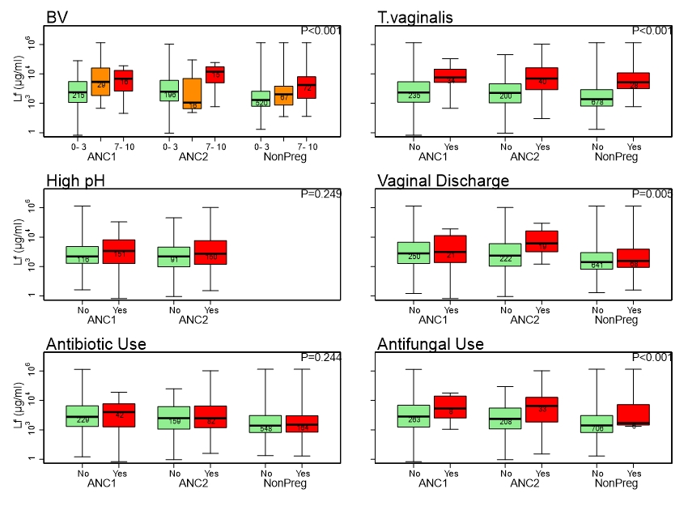

**SUPPLEMENTARY FILE FIGURE S4**

**Lf concentration (μg/ml) for CST I, III and IV by study visit**

Boxplots show median, inter-quartile range and absolute range for each CST state assessed in pregnant women at ANC1 and ANC2 and non-pregnant women at end assessment. Numbers of women in each state indicated.

Log Lf concentration differences for CST III and IV compared to CST 1 were 0.59, 0.46 - 0.73, and 0.58, 0.46 - 0.71, respectively (P <0.001).

