Supplementary Information

Antimalarial activity of primaquine operates via a two-step biochemical relay
Camarda et al.

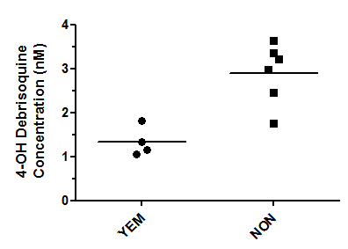
Supplementary Figure 1. CYP2D6 functional assay in YEM and NON hepatocyte lots. Debrisoquine, (100 μM) was added to hepatocyte cultures and collected after 1 h. The amount of 4-hydroxydebrisoquine was measured in the collected supernatant by LC/MS/MS. A single experiment was performed, with 4 and 6 replicates for YEM and NON lots, respectively.

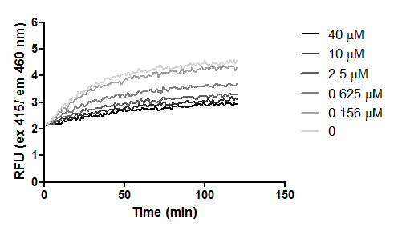
Supplementary Figure 2. Dose-response inhibition of CYP2D6 activity by paroxetine. CYP2D6 activity in the presence of different concentrations paroxetine was measured by recording the conversion of Vivid BOMCC substrate (Life Technologies) into a fluorescent product. Fluorescence was recorded using a microplate spectrophotometer (The Thermo Electron Varioskan). A single experiment was performed.

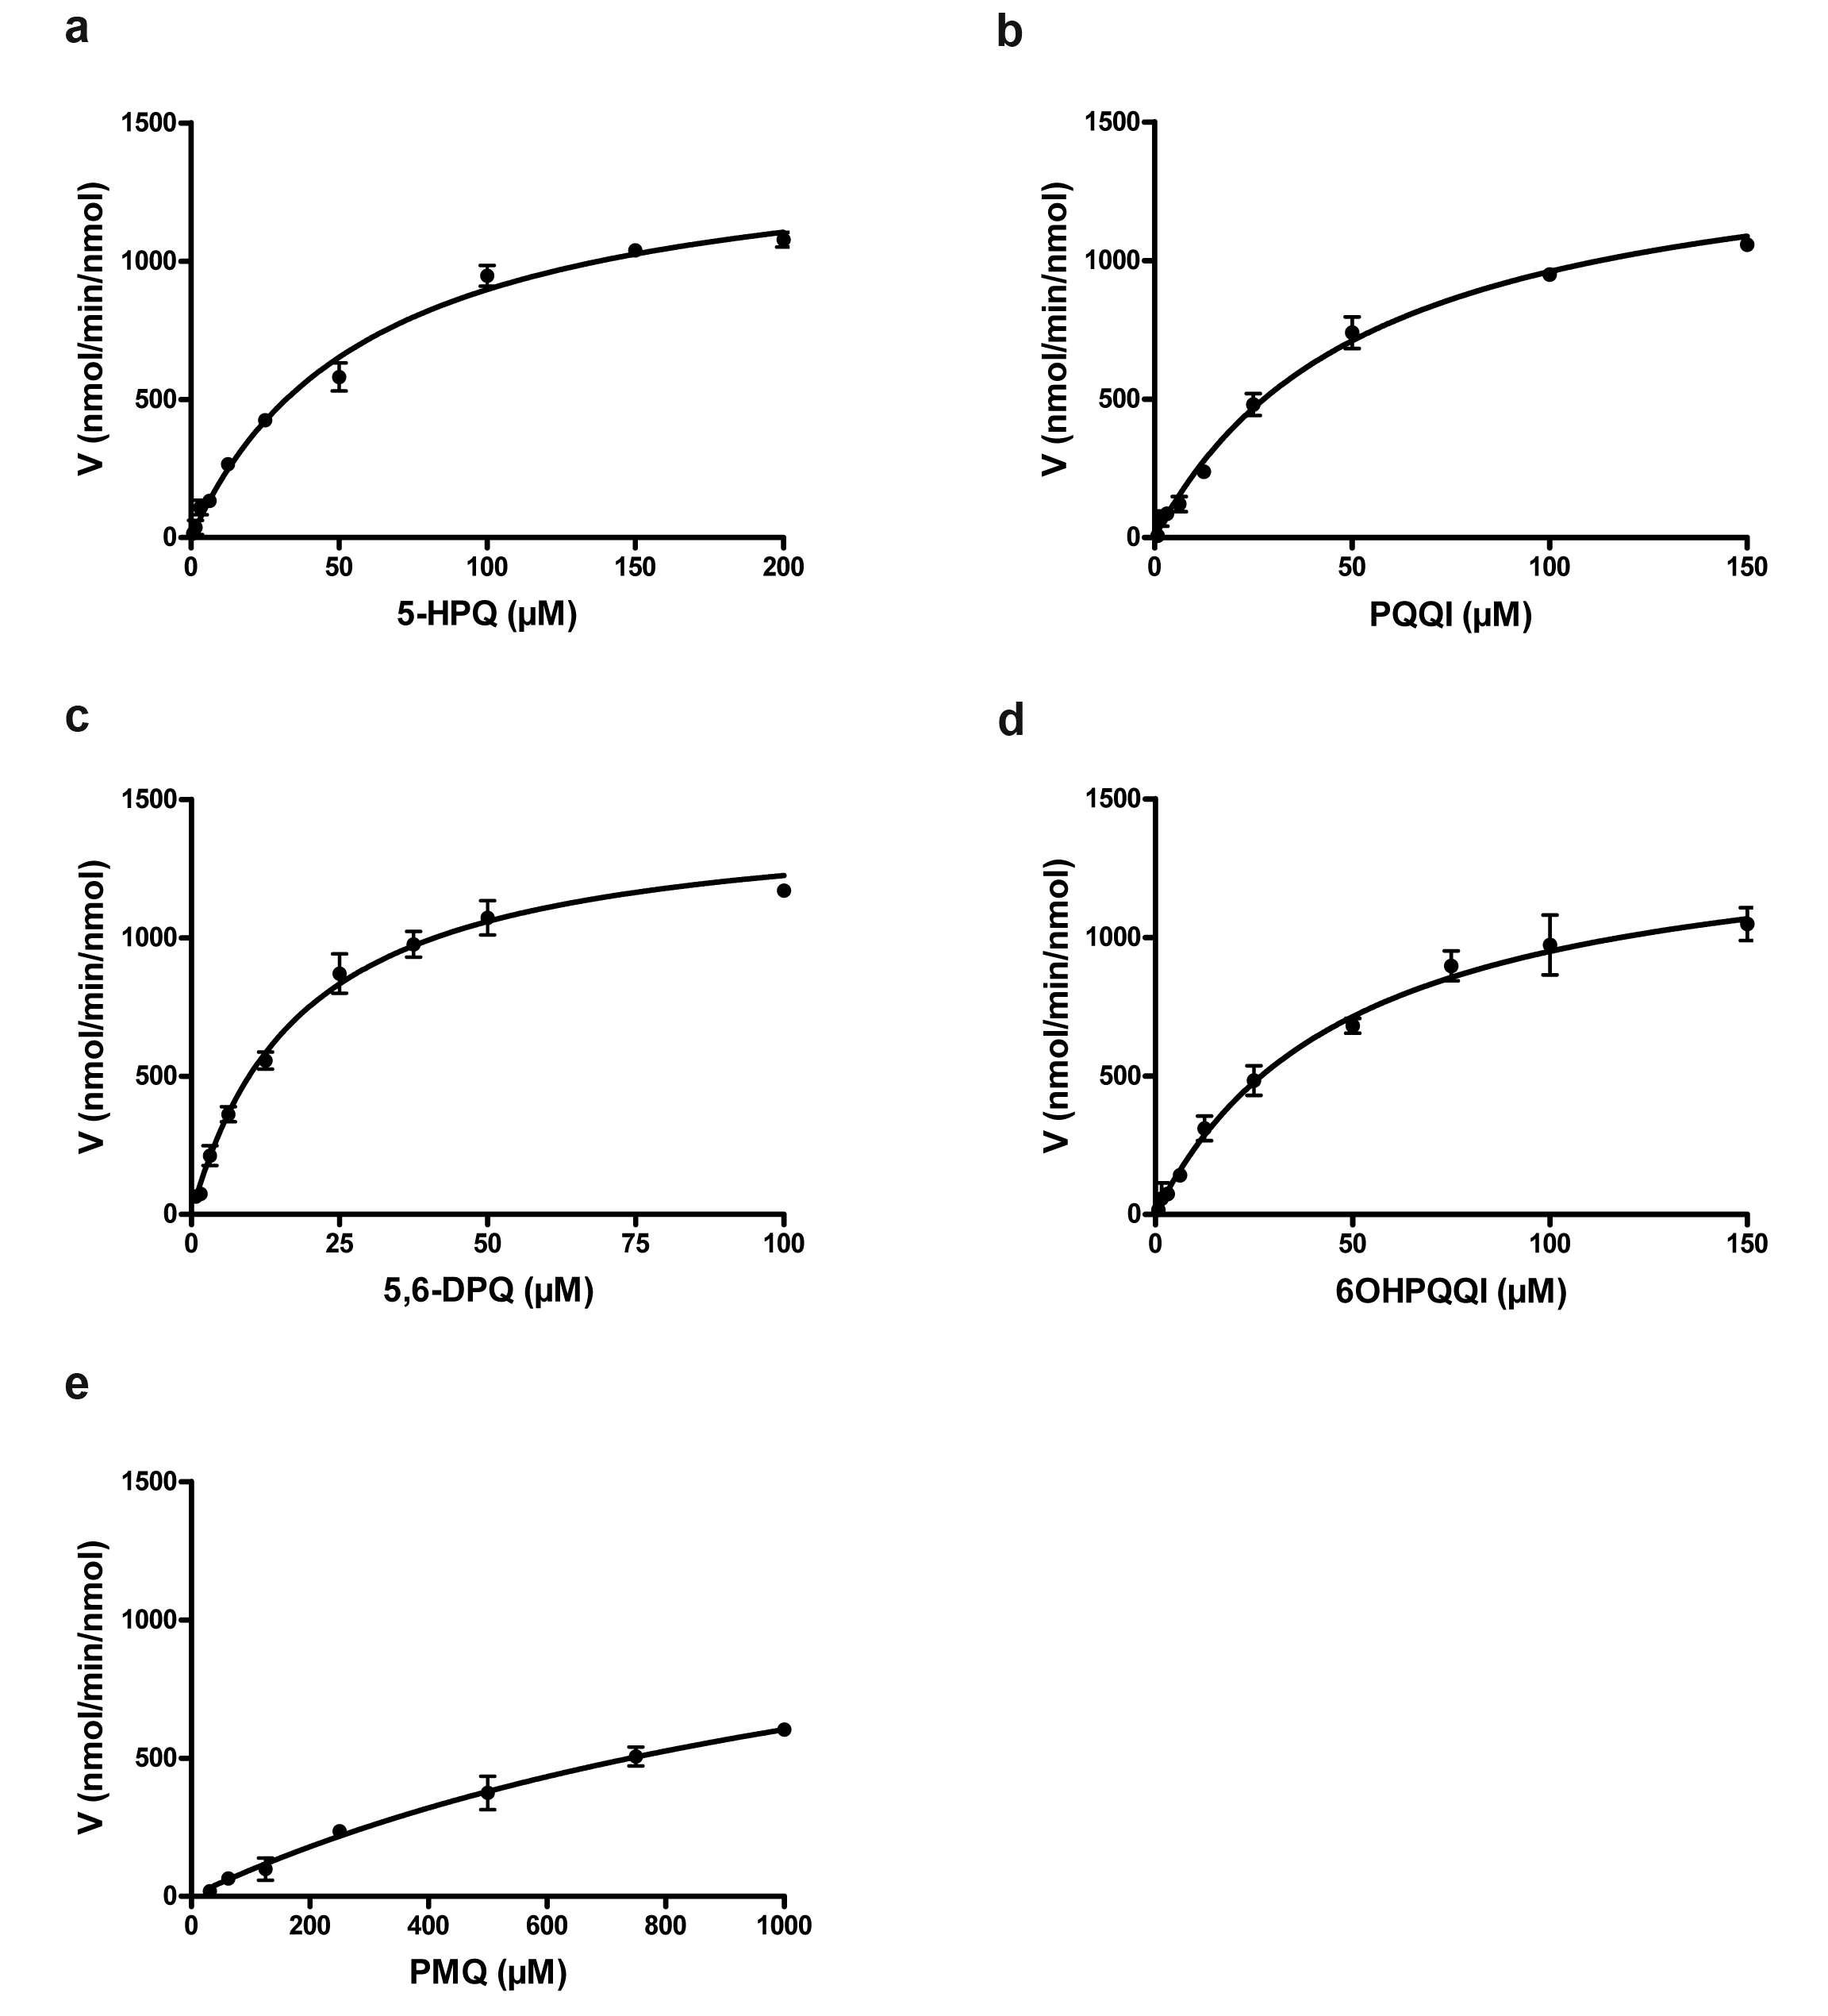

Supplementary Figure 3. Initial reaction rates for human CPR with different primaquine derivatives. NADPH consumption was measured with 25 nM human CPR and various primaquine metabolites concentrations. Initial reaction rates were obtained from four (PQQI, 6OHPQQI, PQ) or five (5-HPQ, 5,6-DPQ) determinations from two independent experimental assay sets. Solid lines represent fits of data to Michaelis–Menten equation using GraphPad Prism v7. a, 5-HPQ; b, PQQI; c, 5,6-DPQ; d, 6OHPQQI; e, PQ.

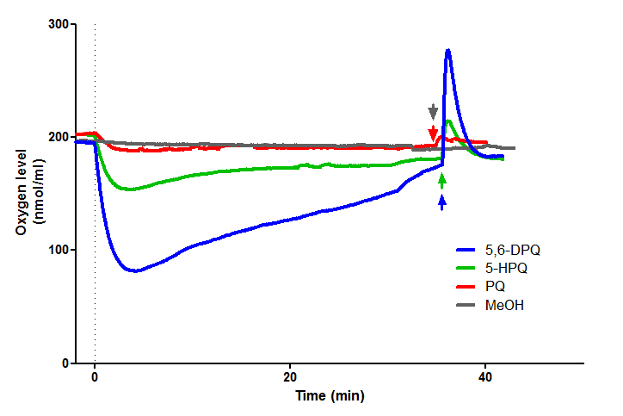
Supplementary Figure 4. Representative full trace of oxygen levels during liver microsomes metabolism of PQ and OH-PQm. Before compound additions, oxygen levels were recorded until stabilisation. PQ, OH-PQm and methanol as a control were added at time t=0. When oxygen levels approached the initial values, catalase was added (color coded arrows).

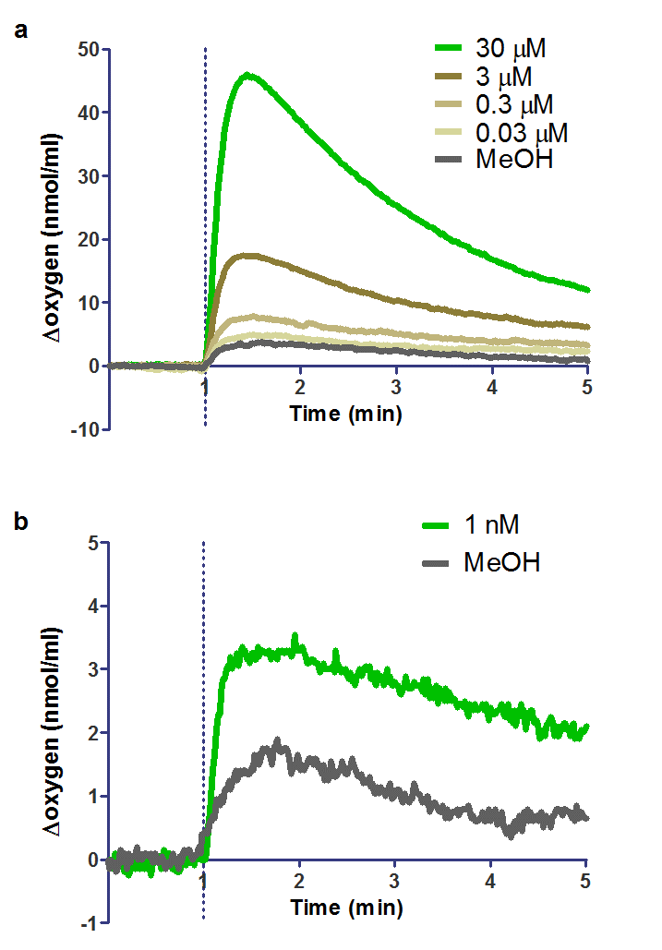

Supplementary Figure 5. H₂O₂ generation by nanomolar addition of 5-HPQ upon incubation with human CPR. a, H₂O₂ production was measured as catalase-mediated oxygen release after incubation (30 – 0.03 μM) with human CPR; b, 5-HPQ at 1 nM was incubated 4 h with human CPR before addition of catalase and oxygen release measurement. The x axis was adjusted by defining the addition of catalase as t=0, and the corresponding y axis value defined as 0 nmol mL⁻¹. The average of two independent experiments are shown.

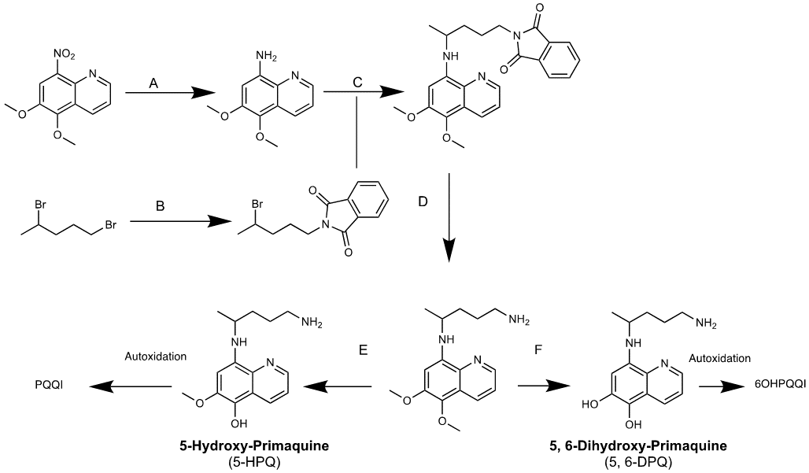

Supplementary Figure 6. Synthesis of Primaquine Metabolites (A) THF, Sodium hypophosphite in water, 10% Pd/C, N₂, 10 min, r.t, 99%. (B) Potassium phthalimide, Acetone, Reflux, 24 h, 91%; C (i) 1-phthalimido-4-bromopentane (1.3 eq), 150°C, Ar(g) (ii) NEt₃ (1.3 eq) added dropwise over 1.5 h. stir 1.5 h (iii) 1-phthalimido-4-bromopentane (1.7 eq) (iv) NEt₃ (0.85 eq) dropwise over 30 min, stir 2 h (v) 1-phthalimido-4-bromopentane (0.325 eq) (vi) NEt₃ (0.36 eq) dropwise over 30 min, stir 2 h, 77%. (D) Hydrazine monohydrate (3.3 eq), Ethanol, reflux, 6 h, 97%; (E) 48% HBr in water, Argon, Reflux at 120°C, 20 Min, ~79% recovery very unstable (F) 48% HBr in water, Argon, 6 h.

Supplementary Table 1
Comparison of anti-gametocyte activity without and after metabolic conversion.
Table Analyzed | 5-HPQ HLM | PQQI HLM | 5,6-DPQ HLM | 6OHPQQI HLM | PQ HLM
Column A | (-)HLM | (-)HLM | (-)HLM | (-)HLM | (-)HLM
vs | vs | vs | vs | vs | vs
Column B | (+)HLM | (+)HLM | (+)HLM | (+)HLM | (+)HLM
Mann Whitney test
P value | < 0.0001 | < 0.0001 | 0.0004 | < 0.0001 | < 0.0001
Exact or approximate P value? | Exact | Exact | Gaussian Approx | Exact | Exact
P value summary | **** | **** | *** | **** | ****
Are medians signif. different? (P < 0.05) | Yes | Yes | Yes | Yes | Yes
One- or two-tailed P value? | Two-tailed | Two-tailed | Two-tailed | Two-tailed | Two-tailed
Sum of ranks in column A,B | 126 , 45 | 126 , 45 | 126 , 45 | 126 , 45 | 126 , 45
Mann-Whitney U | 0 | 0 | 0 | 0 | 0

Supplementary Table 2
GC-LUC assay survival (mean % of vehicle control).
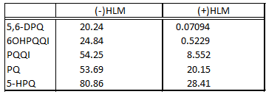

Supplementary Table 3
Comparison of anti-gametocyte activity without and after CYP2D6 conversion.
Table Analyzed | 5-HPQ 2D6 | PQQI 2D6 | 5,6-DPQ 2D6 | 6OHPQQI 2D6 |  | PQ 2D6
Column A | (-)2D6 | (-)2D6 | (-)2D6 |  | (-)2D6 | (-)2D6
vs | vs | vs | vs |  | vs | vs
Column B | (+)2D6 | (+)2D6 | (+)2D6 |  | (+)2D6 | (+)2D6
Mann Whitney test
P value | 0.0079 | 0.0079 | 0.0159 |  | 0.0159 | 0.0079
Exact or approximate P value? | Exact | Exact | Exact |  | Exact | Exact
P value summary | ** | ** | * |  | * | **
Are medians signif. different? (P < 0.05) | Yes | Yes | Yes |  | Yes | Yes
One- or two-tailed P value? | Two-tailed | Two-tailed | Two-tailed |  | Two-tailed | Two-tailed
Sum of ranks in column A,B | 40 , 15 | 40 , 15 | 39 , 16 |  | 39 , 16 | 40 , 15
Mann-Whitney U | 0 | 0 | 1 |  | 1 | 0

Supplementary Table 4
Comparison of anti-gametocyte activity after CYP2D6 conversion in the presence or absence of paroxetine.
Table Analyzed | 5-HPQ Paroxetine | PQQI Paroxetine |  | 5,6-DPQ Paroxetine | 6OHPQQI Paroxetine | PQ Paroxetine
Column A | (+)2D6 |  | (+)2D6 | (+)2D6 | (+)2D6 | (+)2D6
vs | vs |  | vs | vs | vs | vs
Column B | (+)2D6+Paroxetine |  | (+)2D6+Paroxetine | (+)2D6+Paroxetine | (+)2D6+Paroxetine | (+)2D6+Paroxetine
Mann Whitney test
P value | 0.1905 |  | 0.4127 | 0.1905 | 0.1905 | 0.0159
Exact or approximate P value? | Exact |  | Exact | Exact | Exact | Exact
P value summary | ns |  | ns | ns | ns | *
Are medians signif. different? (P < 0.05) | No |  | No | No | No | Yes
One- or two-tailed P value? | Two-tailed |  | Two-tailed | Two-tailed | Two-tailed | Two-tailed
Sum of ranks in column A,B | 19 , 26 |  | 21 , 24 | 19 , 26 | 19 , 26 | 15 , 30
Mann-Whitney U | 4 |  | 6 | 4 | 4 | 0

Supplementary Table 5
Steady-state kinetic parameters of human cytochrome NADH:P450 reductase (CPR) for primaquine and primaquine metabolites.
Compound | K_{m} (µM) | K_{cat} (min⁻¹) | K_{cat}/K_{m} (min⁻¹µM⁻¹)
5-HPQ | 61.56 ± 9.652 | 1,458±80 | 24.019±1.254
PQQI | 55.932±9.776 | 1,498.5±107.075 | 27.159±1.469
5,6-DPQ | 19.624±1.437 | 1,490.6±74.11 | 76.218±2.508
6OHPQQI | 51.397±18.93 | 1,402±204.682 | 29.245±3.555
PQª | 1,655.5±871.791 | 1,574±465.695 | 1.041±0.118

ª The high PQ concentration needed to reach V_{max} interfered with absorbance readings, therefore estimates from Michaelis–Menten fitted equation are shown.

Supplementary Table 6
Comparison of anti-gametocyte activity without and after huCPR conversion.
Table Analyzed | 5-HPQ huCPR | PQQI huCPR | 5,6-DPQ huCPR | 6OHPQQI huCPR
Column A | NoCPR | NoCPR | NoCPR | NoCPR
vs | vs | vs | vs | vs
Column B | huCPR | huCPR | huCPR | huCPR
Mann Whitney test
P value | 0.0002 | 0.0002 | 0.0002 | 0.0002
Exact or approximate P value? | Exact | Exact | Exact | Exact
P value summary | *** | *** | *** | ***
Are medians signif. different? (P < 0.05) | Yes | Yes | Yes | Yes
One- or two-tailed P value? | Two-tailed | Two-tailed | Two-tailed | Two-tailed
Sum of ranks in column A,B | 100 , 36 | 100 , 36 | 100 , 36 | 100 , 36
Mann-Whitney U | 0 | 0 | 0 | 0

Supplementary Table 7
Comparison of anti-gametocyte activity after huCPR conversion in the presence or absence of Pyruvate.
Table Analyzed | 5-HPQ Pyruvate | PQQI Pyruvate | 5,6-DPQ Pyruvate | 6OHPQQI Pyruvate
Column A | huCPR | huCPR | huCPR | huCPR
vs | vs | vs | vs | vs
Column B | huCPR+Pyruvate | huCPR+Pyruvate | huCPR+Pyruvate | huCPR+Pyruvate
Mann Whitney test
P value | 0.004 | 0.004 | 0.004 | 0.004
Exact or approximate P value? | Exact | Exact | Exact | Exact
P value summary | ** | ** | ** | **
Are medians signif. different? (P < 0.05) | Yes | Yes | Yes | Yes
One- or two-tailed P value? | Two-tailed | Two-tailed | Two-tailed | Two-tailed
Sum of ranks in column A,B | 36 , 42 | 36 , 42 | 36 , 42 | 36 , 42
Mann-Whitney U | 0 | 0 | 0 | 0

