Pre-travel malaria enquiries to the United Kingdom National Travel Advice Line 2016: advice mainly needed on malaria maps and risk groups
Dr Natasha Kay (corresponding author)ª, natasha.kay1@nhs.net
Louisa Ive^{b}, louisa.ive@nhs.net
Dr Jakob Petersenª, jakob.petersen@phe.gov.uk
Sanch Kanagarajahª, sanch.kanagarajah@nhs.net
Hilary Simons^{a,c}, hilary.simons@nhs.net
Dr Dipti Patelª, dipti.patel9@nhs.net
ª National Travel Health Network and Centre, University College London Hospital NHS Foundation Trust, London, UK
^{b} St George’s University Hospitals NHS Foundation Trust
^{c} Liverpool School of Tropical Medicine, Liverpool, UK

Pre-travel malaria enquiries to the United Kingdom National Travel Advice Line 2016: advice mainly needed on malaria maps and risk groups

Abstract
Background:
Malaria prevention in travellers can be complex and requires consideration of a number of factors. UK healthcare professionals providing pre-travel malaria advice can access specialist support from the National Travel Health Network and Centre (NaTHNaC) telephone advice line.
The aim of this study is to characterise queries to the NaTHNaC telephone advice line regarding pre-travel malaria advice.
Method:
Telephone calls received to NaTHNaC’s advice line are recorded using an online data capture form. All calls relating to malaria advice during 2016 were selected and data extracted. Analysis was undertaken using Microsoft Excel and STATA.
Results:
During 2016, 1803 malaria-related calls were received; the majority from general practice and calls were from across the UK. The most common type of pre-travel malaria query was country-specific followed by travellers with special health needs. Many queries related to pregnant and breastfeeding travellers, children under 5 years and travellers over 60 years.
Conclusions:
This review presents a large and exceptional dataset and reflects the ambiguity amongst some healthcare professionals regarding malaria advice. We have identified potential knowledge gaps, and as a result will strengthen future guidance, enhance existing malaria maps, and inform the development of future clinical educational activity.
Keywords
Travel medicine, malaria, prevention
Introduction

Malaria is a potentially life-threatening disease which is preventable and curable.
Worldwide there were an estimated 219 million cases of malaria in 2017, from 90 countries, compared to 239 million in 2010. Compared with 2016, 3 million more malaria cases were estimated to have occurred globally in 2017 . The WHO African region carries a disproportionately high percentage of the global malaria burden. In 2017, the region accounted for 92% of malaria cases and 93% of malaria fatalities.
Between 2016 and 2017 an increased number of imported malaria cases were reported. In 2017, 1,792 cases of imported malaria were reported in the United Kingdom, 10.8% higher than reported in 2016 (N=1,618 cases). In the last 10 years (between 2008 and 2017), the total number of malaria cases reported in the UK each year has fluctuated around a mean of 1,558 (95% CI: 1,447-1,668); similar to the mean for the previous 10 years (1,533, 95% CI: 1,440-1,627). The majority of these cases were P.falciparum imported from Western Africa and there were 6 deaths reported in 2017.
Malaria prevention in travellers can be complex and requires consideration of a number of factors including the individual characteristics of the traveller, travel destination, duration of stay and type of travel. It is further complicated by differing international guidelines and prescribing restrictions. The Public Health England Advisory Committee on Malaria Prevention (ACMP) guidelines for malaria prevention in travellers from the UK and WHO guidance adhere with the ‘ABCD’ approach to malaria prevention. This covers awareness of risk of malaria, bite prevention, chemoprophylaxis, early diagnosis and treatment without delay.
UK healthcare professionals providing pre-travel malaria advice can access specialist support from the National Travel Health Network and Centre (NaTHNaC). NaTHNaC was set up by the Department of Health in 2002 with the broad aim of ‘Protecting the Health of British Travellers’. NaTHNaC seeks to improve the quality of travel health advice given by primary care providers, travel clinics, pharmacies and other healthcare providers, and provide up-to-date and reliable information for the traveller, travel industry and national government. A key role of NaTHNaC is to provide guidance and education to health professionals. This is delivered through the website (www.travelhealthpro.org.uk), online courses and a travel health telephone advice line. The telephone advice line receives enquiries from all over the UK. This service is nurse-led with support from travel health physicians. The function of the telephone advice line is to provide support to healthcare professionals who are assessing and managing travellers with complex itineraries or special health needs. The service received 6235 calls during 2016. An electronic data capture system to record details of telephone calls for auditing and research purposes was introduced in January 2016.
The aim of this study was to characterise commonly raised queries to the NaTHNaC telephone advice line regarding pre-travel malaria advice. This data can then be used to highlight areas where generic resources, provided on a national travel health website (Travel Health Pro), and national guidance could be strengthened. The information could also be used to develop country information pages, factsheets traveller advice algorithms (decision aids) and guide future educational activity.
Methods
Telephone calls received to NaTHNaC’s advice line are recorded and coded by a nurse-advisor using an online data capture form. Data on all calls received in 2016 were extracted. All calls which were recorded as ‘malaria advice question’ were selected. In addition, calls with general enquiries regarding malaria and malaria-related clinical incidents were included.
Summary statistics were calculated for traveller age, gender, travel destinations, purpose of travel and reason for enquiry. Further analysis, using STATA (version 14.1, StataCorp) was undertaken for telephone calls which discussed; visiting friends and relatives (VFR) travellers, over-60 year olds, under-5 year olds, and travellers with special health needs.
For calls concerning travellers with special health needs, all data including free text notes for medical conditions and medication of the first mentioned traveller per call were extracted and coded to a medical condition using the International Statistical Classification of Diseases and Related Health Problems, 10th revision (ICD-10). For each traveller the total number of conditions and distinct ICD-10 categories were computed as measures of comorbidity.
Structured and free text information about the destination of travel was coded to a WHO region.

Results
During 2016, 6235 calls were received of which 1803 (28.9%) were malaria-related. The majority of calls (83.3%) concerned only one traveller. These queries were received from a range of settings with GP practices accounting for 87.9% of all calls. Telephone calls were received from all parts of the UK with one fifth of calls (20.2%) being from the London region. The majority of travellers were travelling within 1 to 4 weeks, and 8.7% were travelling within a week. The majority of trips were for 1 to 4 weeks (55.7%). Table 1 shows the different reasons for travel; tourism was the most common reason for travel followed by VFR travellers (26.8%).
Table 1: Purpose of travel
Purpose of travel | N | %
Tourism | 823 | 45.7
VFR | 483 | 26.8
Backpacker | 120 | 6.7
Not known | 94 | 5.2
No data (not recorded) | 73 | 4.1
Business | 52 | 2.9
Other | 36 | 2.0
Educational trip | 35 | 1.9
Volunteer | 35 | 1.9
Multiple categories | 31 | 1.7
Expatriate | 11 | 0.6
Relief aid worker | 10 | 0.6
Total | 1803 | 100.0

The gender of the traveller was documented in 88.1% of calls; of these calls 59.6% of queries concerned female travellers. The majority of travellers were aged between 21 to 59 years. Travellers aged above 60 years accounted for 14.5%, children under the age of 5 years for 10.8%, and children less than one year old accounted for 6.9% of travellers.
The most common type of pre-travel malaria query was country-specific followed by queries regarding travellers with special health needs. Of the queries regarding country-specific advice; 61% were for single country destinations where 12.7% of these had a risk in the whole country and 0.9% had no malaria risk. Where there was variable risk within the country; 34% of countries had malaria recommendation maps available at the time of the query. Table 2 demonstrates the different categories of pre-travel malaria query which included long term travellers, travellers with a history of a medication-related adverse event profile, queries where multiple categories are mentioned and queries where no further data was available.
Table 2: Malaria query type per call
Malaria query type | N | %
Country/itinerary specific | 928 | 51.5
Special health need | 655 | 36.3
No data | 127 | 7.0
Other | 44 | 2.4
Long term traveller | 26 | 1.4
Multiple categories mentioned | 15 | 0.8
Adverse event profile | 8 | 0.4
Total | 1,803 | 100.0

The most commonly mentioned destinations by WHO region were Africa (32%), Americas (22.5%), and South-East Asia (16%). Vietnam, Dominican Republic and Thailand were the most commonly discussed countries. Map 1 illustrates the top 20 single countries mentioned in pre-travel malaria enquiries. The majority of VFR travellers were travelling to Africa (59.4%) followed by Asia (21.9%).
Map 1: The top 20 single countries mentioned in pre-travel malaria telephone enquiries.
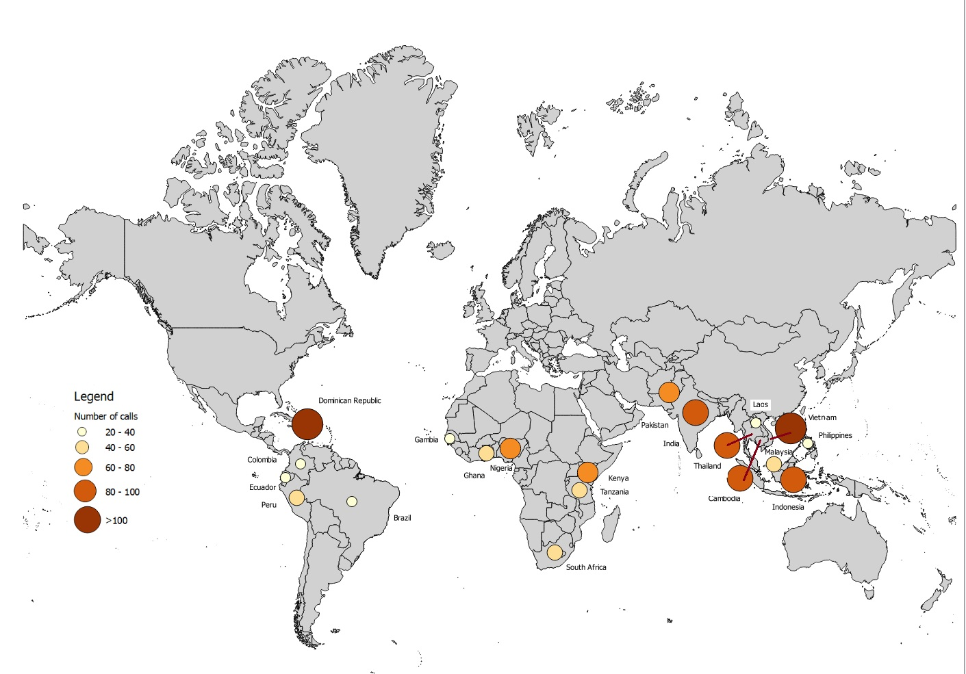

Map 2 illustrates the top 20 countries mentioned in pre-travel malaria enquiries when adjusting for UK traveller trips in 2015. This data has been taken from the International Passenger Survey which collects information about people entering and leaving the UK. Laos is the most frequently discussed country when adjusting for UK traveller trips.

Map 2: Top 20 countries in 2016 adjusted by UK trips in 2015 (International Passenger Survey)
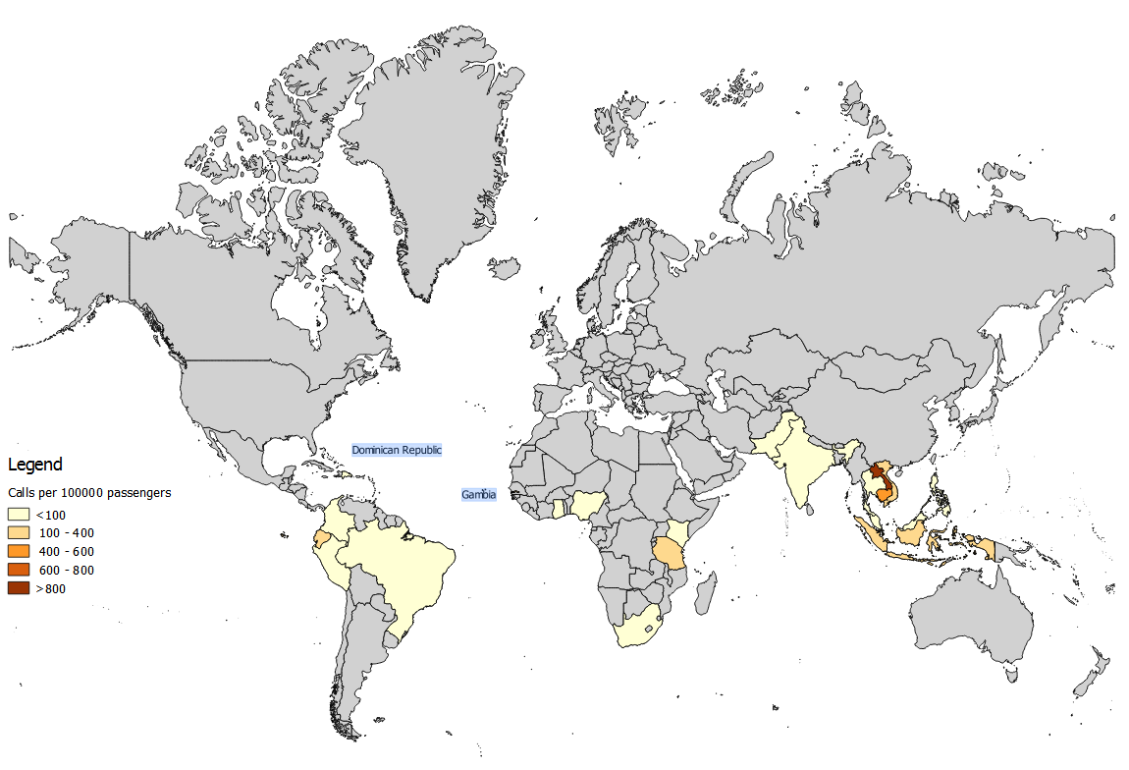
Of all malaria-related calls, a total of 655 (36.3%) concerned travellers with special health needs. Of these queries, 255 calls concerned VFR travellers. The most common ICD-10 categories were ‘Pregnancy, childbirth and the puerperium’, ‘Diseases of the circulatory system’ and ‘Mental and Behavioural Disorders’. The most commonly mentioned medical conditions for this group included pregnancy, anxiety and/or depression and immunosuppression. Seventy-six travellers (11.6%) were considered immunosuppressed secondary to medication. The ‘other’ category was varied with conditions not being listed if their frequency was less than 10 travellers. Examples of conditions were haematological conditions including sickle cell disease, G6PD deficiency and haematological cancers, skin conditions including psoriasis and acne, tuberculosis, breast cancer and multiple sclerosis. The number of conditions per traveller ranged from 1 to 9 with 27.5% of travellers having co-morbidities. The majority of travellers with special health needs were female and aged between 21 to 59 years old; this was followed by men in the same age category. Travellers aged above 60 years old showed an equal split in gender.
Table 3: Most commonly mentioned health conditions associated with malaria-related queries concerning travellers with special health need.
Condition | Freq. | Percent
Pregnancy | 111 | 12.8
Immunosuppression* | 72 | 8.3
Anxiety/depression | 54 | 6.2
Breastfeeding | 45 | 5.2
Epilepsy | 41 | 4.7
Hypertension | 30 | 3.5
HIV | 21 | 2.4
Rheumatoid arthritis | 21 | 2.4
Type 2 diabetes | 19 | 2.2
Pre-conception | 16 | 1.8
Systemic lupus erythematosus | 13 | 1.5
Thromboembolic disease | 13 | 1.5
Atrial fibrillation | 12 | 1.4
Renal transplant | 12 | 1.4
Asthma | 11 | 1.3
Type 1 diabetes | 11 | 1.3
Other | 366 | 42.1
Total | 868 | 100.0
*incl travellers prescribed immunosuppressive drugs without medical history coding (n = 27)
Of the travellers with special health needs, 308 travellers (47%) were reported to be on medication. The most common medication group were immunosuppressant medication (24.7%) followed by antidepressants or neuroleptic medication (12.3%).
Table 4: Medication history of travellers with special health needs
Drug group | Percent
Immunosuppressants | 24.7
Antidepressant or neuroleptic | 12.3
Anticoagulants | 7.8
DMARDs* (i.e. hydroxychloroquine) | 7.7
Antiepileptics | 7.5
Other | 40.0
Total | 100.0
* DMARDs: disease modifying anti-rheumatic drugs
Pregnant women were the most common group of travellers with a special health need. Of these 111 women (66%) were VFR travellers and 19.8% had an additional special health need.
Children under the age of 5 years accounted for 10.8% of calls; of these 63.9% of queries were related to children less than one year old. The majority of these children were VFR travellers. This contrasted to travellers over 60 years old as 78.7% travelled for tourism. For this age group, 54% of calls related to a special health need; 48.4% were taking medication. Almost one third of this age group were travelling on a cruise; the Caribbean and Latin America were the commonest destinations.
Discussion
This study demonstrates that pre-travel malaria advice queries to a national telephone advice line service cover a diverse range of travellers. Queries varied with regard to age of travellers, reason for travel, destination, and a large range of travellers with specific health needs. Pregnant and breastfeeding travellers, children aged under 5 years and travellers with immunosuppression were frequent.
Many of the queries available could have been answered with currently available resources. When healthcare professionals access the telephone line details for NaTHNaC they are directed to the TravelHealthPro website. This site has information on how to contact NaTHNaC but also provides signposting to country specific information and NaTHNaC factsheets. The country specific information pages will provide a malaria prevention advice map of most countries; allowing health care professionals to assess if the traveller will be entering malaria zones. There are no maps available for countries where the advice is the same for the whole country. At the time of this study 12 country maps were available (see appendix for a list of country maps). These maps are based on data from the Public Health England Advisory Committee of Malaria Prevention.
The most commonly discussed WHO region was Africa and this is consistent with the global burden of malaria. The most commonly discussed countries were the Dominican Republic, Vietnam and Thailand accounting for 4.6%, 4.7% and 4.3 % of queries respectively. At the time of this review, UK malaria prevention advice was not uniform throughout the three countries which might explain the high number of calls combined with these countries being popular tourist destinations for UK travellers. However a malaria recommendation map was available for the Dominican Republic which should have helped reduce any confusion regarding malaria risk areas.
Vietnam and Thailand may also have been more commonly discussed due to mefloquine resistance being reported in both countries, and malaria prevention maps for these countries were not available at the time of the review.
Since this review, maps are now available for Vietnam and Thailand, and chemoprophylaxis is no longer recommended for the Dominican Republic. It will be interesting to see if these changes will impact on the number of queries for these three countries in the future. The current Thailand malaria prevention advice map can be seen in Map 3.

Map 3:
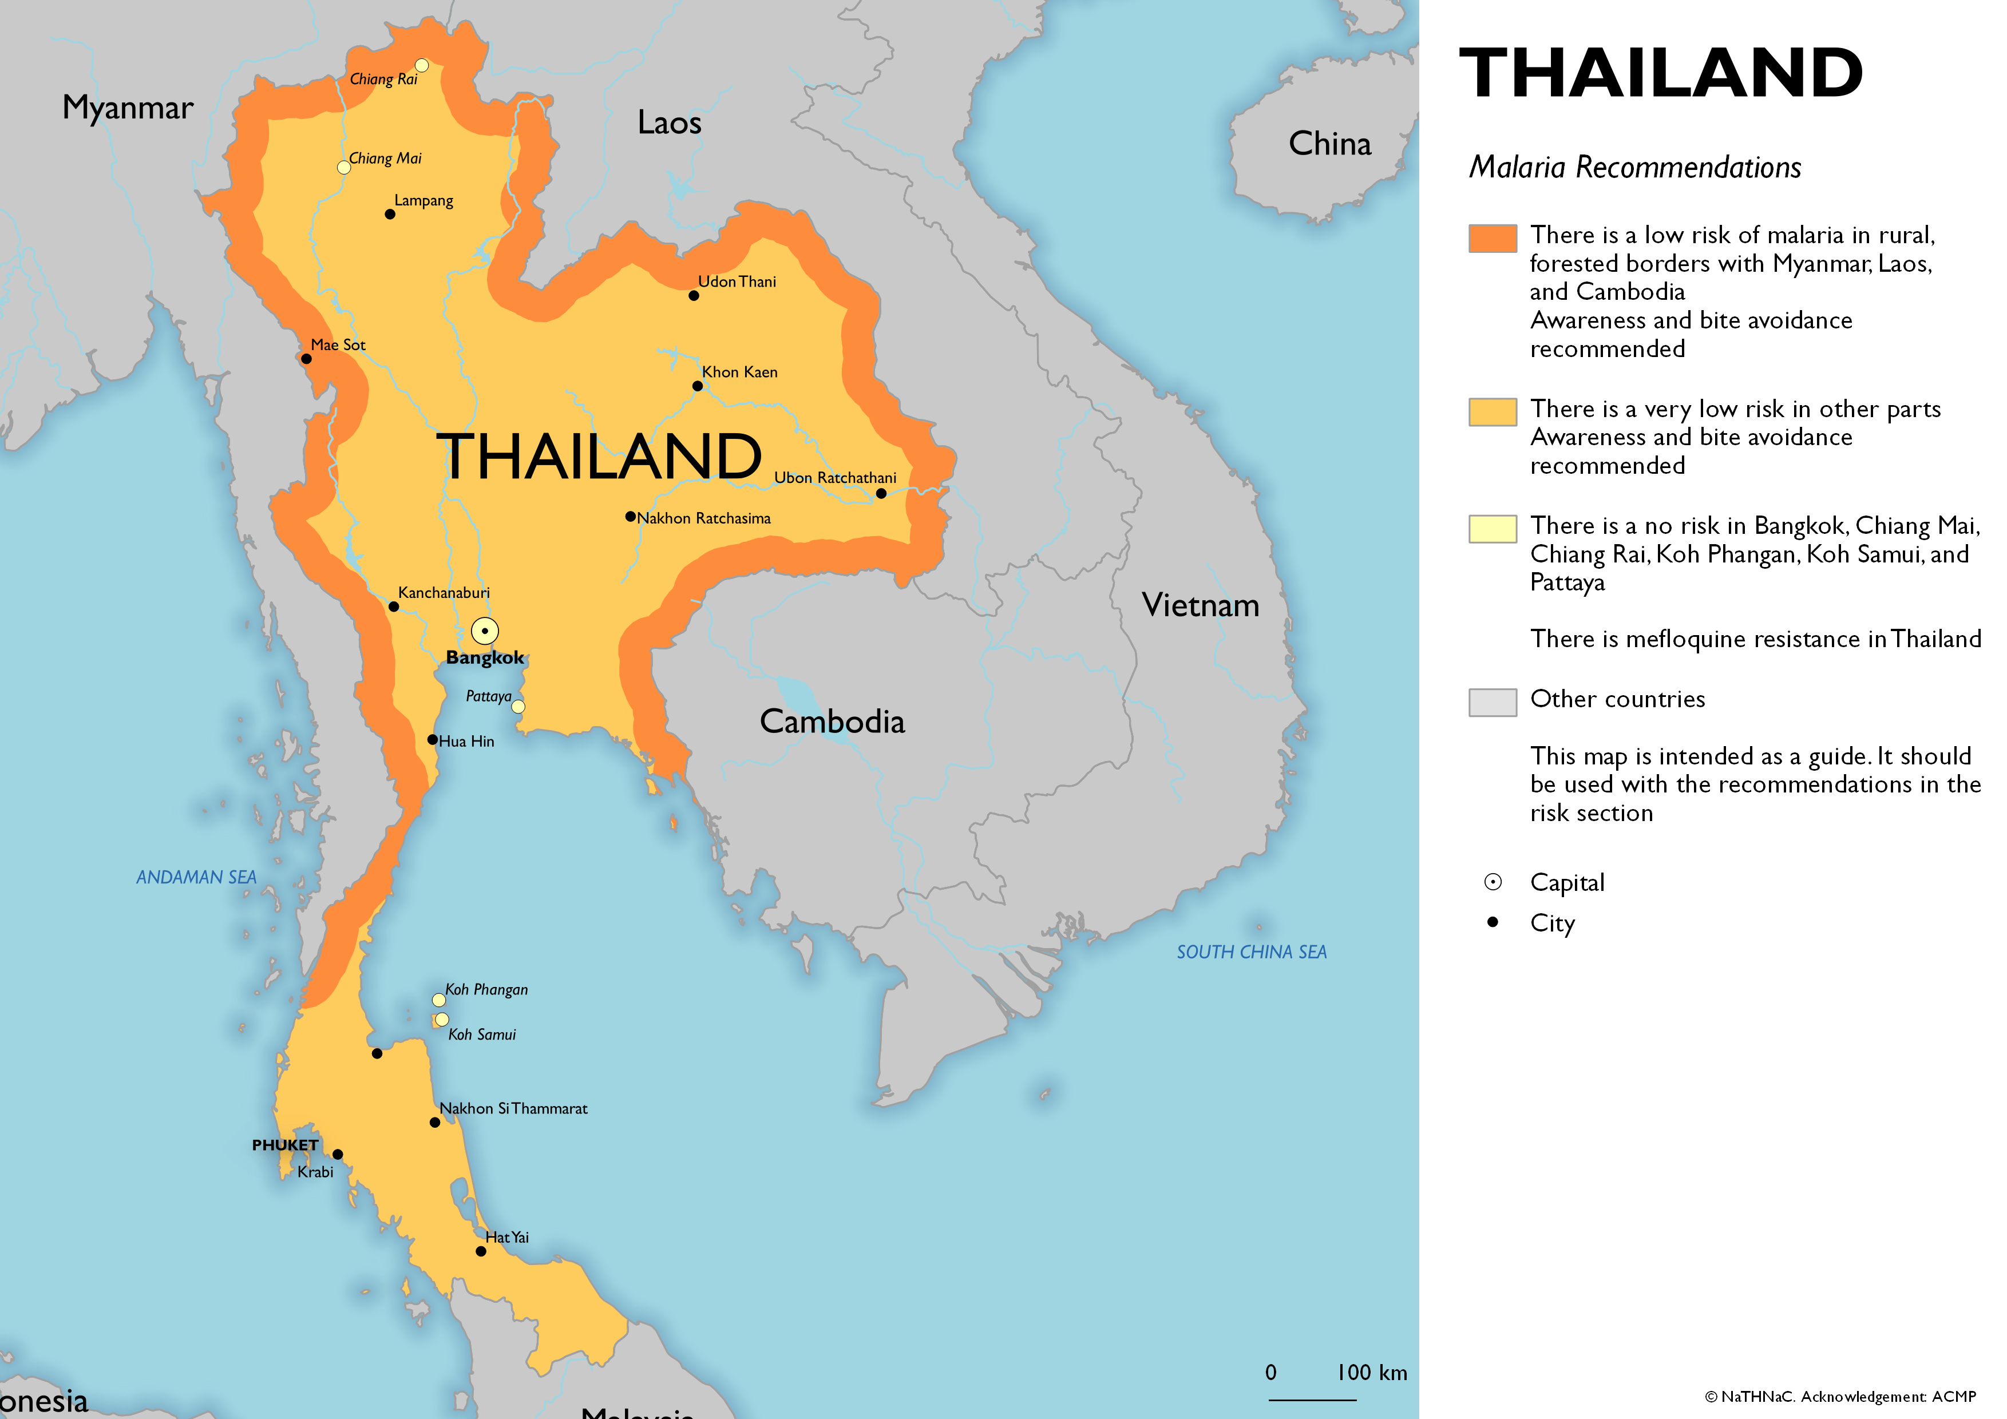
The VFR traveller group represented a majority in the higher risk groups of pregnant and children under 1 year travellers; and two-thirds of travellers with a special health need. This group are also represented as a majority of imported malaria cases in the UK. During 2017, of those cases of imported malaria, 1221 cases travelled abroad from the UK and reason for travel was known for 84% of travellers. Of these, 80% were VFR travellers and the majority of this cohort were visiting friends and relatives in Africa. This is consistent with our finding where the majority of VFR travellers were visiting Africa. This data will allow us to ensure we provide targeted public health messaging to this higher risk group of travellers.
Queries regarding pregnant women (12.8%), breastfeeding travellers (8.3%), children under 5 years (10.8%), and travellers over 60 years (14.5%) were common. NaTHNaC provide factsheets covering pregnant and breastfeeding travellers, older travellers and children. Detailed guidance for these groups is also available in the Public Health England ACMP guidelines. The high call frequency for these groups could be due to a lack of clarity in the factsheets or guidelines, or the healthcare professional being unaware of such resources on the website. More likely it is due to a lack of confidence or need for reassurance particularly due to the higher risk of malaria, or of severe complications from malaria in these groups. In the case of pregnancy this is likely to be compounded by the limited data on medication safety and maternal and foetal outcomes.
Other commonly queried special health needs included immune suppression, mental health conditions (anxiety and depression) and epilepsy. Travellers with these conditions will be over represented for varying reasons. Advising travellers who are immune suppressed can be complex due to their increased risk of serious travel-related infection, furthermore, their underlying condition or medications can contraindicate, or increase the toxicity of malaria chemoprophylaxis. For travellers with mental health conditions restrictions in prescribing mefloquine and interactions with other malaria chemoprophylaxis may be a challenge. Similarly for individuals with epilepsy, the contra-indication of certain chemoprophylactic drugs and the potential for drug interactions can be difficult.
For these complex traveller groups, guidelines cannot cover every scenario, and this may be reflected in the higher call frequency. Even if guidance is available, the more frequent calls for complex groups of travellers could reflect a lack of confidence amongst some healthcare professionals and the preference to telephone for advice, which enables a discussion and reassurance for the healthcare professional, rather than using guidelines. Advising these groups of travellers therefore requires the healthcare professional to be confident and comfortable with their decisions particularly if these scenarios are not commonly encountered, and this may explain why we observed a high frequency of calls.
Female travellers with a special health need were more common in the 21 to 59 years age group, but this is likely to be due to the fact that within this age group 25% of women were pregnant or breastfeeding (p<0.0001).
Overall, the characteristics of travellers most frequently queried are consistent with other studies. In 2012, a French study which summarised the characteristics of international travellers at a pre-travel clinic in Marseille demonstrated 10% of this group were older travellers (greater than 60 years old) and the prevalence of chronic medical conditions in this group was 27%. They found age, last-minute travel, neurological (migraine followed by epilepsy was the most common disease) and psychiatric conditions were the most common factors to influence malaria chemoprophylaxis. Another similar study published by Global TravEpinet demonstrated 59% of travellers had one or more medical condition. In 2013, the Public Health England Malaria Reference Laboratory published a retrospective observational study of enquiries to their specialist advisory service for queries from healthcare professionals. This study also reflected the difficulty in balancing comprehensive guidelines whilst ensuring they are still ‘user-friendly’ and accessible. They concluded pregnant travellers and travellers with epilepsy were areas where guidance needed to be strengthened. Bar the Malaria Reference Laboratory and NaTHNaC, to our knowledge, there are no other published comparable data.
The limitations of this study are its retrospective nature and the dependence on a nurse-advisor entering data and coding call records; not all call records have completed clinical information. This is an observational study and due to the specialist nature of the service, the findings do not necessarily reflect the concerns of practitioners who seek no advice or travellers who do not seek pre-travel advice. However, strengths of this study include the large dataset and national coverage. Telephone calls were documented for research purposes therefore allowing for greater consistency in data collection.
Conclusion
This review presents a large and exceptional dataset and reflects the ambiguity amongst some healthcare professionals regarding malaria advice. Travellers in this review were a very diverse group representing a wide age range, with a varied range of underlying medical conditions and travel destinations.
The types and frequency of enquiries to the advice line are likely to reflect a lack of confidence or need for reassurance in healthcare professionals advising specific groups of travellers about malaria. They may also reflect difficulty in interpreting current guidelines particularly in relation to country specific recommendations where the malaria risk is not considered to be uniform throughout the country. There is also a possibility that there is a lack of awareness of the existence of the available resources, but this seems unlikely by virtue of the fact that the callers had contacted a specialist national travel health advice line for advice.
This research has highlighted some of the concerns of front-line healthcare professionals when advising travellers about malaria. The callers likely represent a range of experience, and the primary motivation of the healthcare professional for calling would be an interesting area to research in the future.
This study has also identified potential knowledge gaps, and the findings will help strengthen future guidance, develop existing malaria maps, and to inform the development of future healthcare professional educational activities. In late 2017, there were major changes to the ACMP guidelines and in late 2018/early 2019 NaTHNaC launched eight interactive malaria maps for Bangladesh, Bolivia, Brazil, Ethiopia, India, Kenya, Pakistan and Tanzania. These searchable malaria recommendation maps have been loaded on the matching Country Information Pages, making it possible to search for individual destinations on each country map and see the malaria recommendations for that region. These changes may result in greater clarity for healthcare professionals particularly for those who have country specific queries for pre-travel malaria advice. It will be interesting to evaluate malaria queries in the future to evaluate the impact of these changes.
Author Declaration
Conflict of Interest
The authors declare that there are no conflicts of interests
Acknowledgements
We would like to thank our excellent team of specialist nurses who provide daily expert advice on the travel health advice line.
This research did not receive any specific grant from funding agencies in the public, commercial, or not-for-profit sectors.

References

World Malaria Report 2018. World Health Organisation. https://www.who.int/malaria/publications/world-malaria-report-2018/en/ [accessed 21/02/19].
World Malaria Report 2017. World Health Organisation.
World Malaria Report 2018. World Health Organisation. https://www.who.int/malaria/publications/world-malaria-report-2018/en/ [accessed 21/02/19].
Malaria imported into the United Kingdom: 2017. Implications for those advising travellers. Public Health England. July 2018. https://assets.publishing.service.gov.uk/government/uploads/system/uploads/attachment_data/file/722591/Malaria_imported_into_the_United_Kingdom_2017.pdf [accessed 21 February2019]
Imported malaria cases by species and region of travel, Public Health England Malaria Reference Laboratory 2017. https://www.gov.uk/government/publications/imported-malaria-in-the-uk-statistics [accessed 24 August 2018]
Imported malaria cases and deaths in the UK 2000 to 2017. Public Health England Malaria Reference Laboratory 2017https://www.gov.uk/government/publications/imported-malaria-in-the-uk-statistics Accessed 24/08/2017.
Shellvarajah M, Hatz C, Schlagenhauf P. Malaria prevention recommendations for risk groups visiting sub-Saharan Africa: A survey of European expert opinion and international recommendations. Travel Med Infect Dis 2017; 19: 49-55
Schlagenhauf P, Hatz C, Behrens R et al. Mefloquine at the crossroads? Implications for malaria chemoprophylaxis in Europe. Travel Med Infect Dis 2015; 13(2): 194-196.
https://assets.publishing.service.gov.uk/government/uploads/system/uploads/attachment_data/file/660051/Guidelines_for_malaria_prevention_in_travellers_from_the_UK_2017.pdf Guidelines for malaria prevention for travellers from the UK 2017. Public Health England. Accessed 31/08/2018
https://travelhealthpro.org.uk/country-details.php?cnt=221#Malaria. Travel Health Pro. Country Information Thailand. Accessed 31/01/19.
https://assets.publishing.service.gov.uk/government/uploads/system/uploads/attachment_data/file/722591/Malaria_imported_into_the_United_Kingdom_2017.pdf Malaria Imported into the United Kingdom: 2017. Implications for those advising travellers. Public Health England. July 2018. Accessed 07/02/19.
Roggelin L, Cramer J.P. Malaria prevention in the pregnant traveller: A review. Travel Med Infect Dis 2014; 12(3): 229-236.
Hamer DH, MacLeod WB, Chen LH et al. Pretravel Health Preparation of International Travelers: Results from the Boston Area Travel Medicine Network. Mayo Clin Proc Innov Qual Outcomes 2017; 1(1): 78-90.
Aubry C, Gaudart J, Gaillard C, Delmont J, Parola P, Brouqui P, et al. Demographics, health and travel characteristics of international travellers at a pre-travel clinic in Marseille, France. Travel Med Infect Dis 2012;10(5-6): 247-56.
LaRocque RC, Rao SR, Lee J, Ansdell V, Yates JA, Schwatrz BS, et al. Global TravEpiNet: a national consortium of clinics providing care to international travellers – analysis of demographic charactersitics, travel destinations, and pretravel healthcare of high-risk US international travellers, 2009-2011. Clin Infect Dis 2012;54(4):455-62.
Godbole G, Blaze M, Smith V, Whitty CJM, Chiodini PL. Requests for malaria prevention advice to Public Health England, Malaria Reference Laboratory: A retrospective observational study. Travel Med Infect Dis 2013;11: 205-209. June 2019: NaTHNaC Malaria Advice Recommendation Maps Afghanistan Argentina: Available in 2016; no longer available Bangladesh: (updated since 2016 map) Belize: Bolivia: Botswana: Brazil: (updated since 2016 map) Cambodia: China: (updated since 2016 map) Columbia: Costa Rica: Dominican Republic: Available in 2016; no longer available Ecuador: Eritrea: Ethiopia: Guatemala: Honduras: India: (updated since 2016 map) Indonesia: Iran: Iraq: Kenya: (updated since 2016 map) Malaysia: Mauritania: Mexico: Available in 2016; no longer available Myanmar: Available in 2016; no longer available Namibia: Nepal: Pakistan: (updated since 2016 map) Panama: Paraguay: Available in 2016; no longer available Peru: Philippines: Papua New Guinea: Saudi Arabia: Sudan: (updated since 2016 map) Swaziland: Tanzania: Thailand: Vietnam: Yemen: Zimbabwe:

