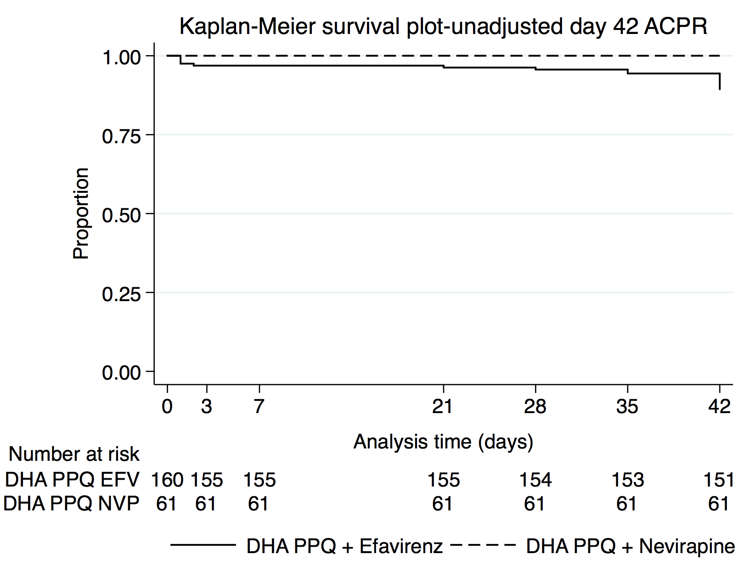
Additional file 2: Day 42 PCR-unadjusted efficacy plot. Kaplan-Meier survival plot of participants who were treated with dihydroartemisinin-piperaquine (DHA PPQ) in the efavirenz (EFV)- and nevirapine (NVP) based antiretroviral therapy (ART) groups according to polymerase chain reaction (PCR) unadjusted adequate clinical and parasitological response (ACPR) by day 42 in the intention-to-treat population with loss to follow up and indeterminate or unavailable PCR samples treated as treatment success.

