Title: Performance of vaginal self-sampling for HPV testing among women living with HIV in Botswana

Abstract
Background: In Botswana, where HIV prevalence remains high, cervical cancer is the leading cause of cancer deaths in women. Multiple organizations recommend high-risk human papillomavirus (hr-HPV) testing as a screening tool, however, high coverage may not be feasible with provider-collected samples. We conducted the first assessment of self- versus provider-collected samples for hr-HPV testing in HIV-positive women in Botswana and report prevalence of hr-HPV and histological outcomes.
Methods: We recruited HIV-positive women ≥25 years attending an HIV clinic in Gaborone. Self- and provider-collected samples from participants were tested for hr-HPV using Cepheid GeneXpert. Women testing positive for any hr-HPV returned for colposcopy. We used unweighted κ statistics to determine hr-HPV agreement.
Results: Thirty-one (30%) of 103 women tested positive for any hr-HPV. The most common genotypes were HPV 31/33/35/52/58. Overall agreement between self- and provider-collected samples for any hr-HPV was 92% with a κ of 0.80. Ten of the 30 hr-HPV positive women attending colposcopy had CIN 2+ (33%).
Conclusions: In this HIV-positive population, hr-HPV prevalence was 30%, with excellent agreement between self and provider samples. Self-sampling may play an important role in screening programs in high HIV burden settings with limited resources like Botswana.

Introduction
Cervical cancer is the second most common cancer among women worldwide, and over 85% of the burden affects women in low- and middle-income countries (LMIC).[1,2] Globally, Human papillomavirus (HPV) 16 and 18 are responsible for 71% of invasive cervical cancers, and a further 21% by types 31, 33, 35, 45, 52 and 58.[3] Although most immunocompetent women clear HPV infections, persistent infections are more common among women living with HIV (WLWH).[4] HIV-infection also increases risk of invasive cervical cancer [5] and poor cancer outcomes.[6] The HIV burden in Southern Africa underscores the importance of scaling up cervical cancer and HPV prevention programs.

In LMIC, cytological screening programs have not been as effective as in developed countries.[7,8] The reasons for this are multi-factorial, including a lack of laboratory infrastructure, trained personnel, and financial resources. Structural and socio-cultural barriers, such as poor access to healthcare and a reluctance to seek pelvic examinations may also contribute to limited screening program success.[9]

In Botswana, a middle-income country in Southern Africa, 27% of women aged 15 to 49 are HIV-positive.[10] Despite wide coverage of antiretroviral treatment (ART), cervical cancer is the leading cause of cancer death.[2] Although cervical cytology with Pap testing has been the primary screening method in Botswana, its impact has been limited.[11] In 2011, Botswana instituted a “see and treat” approach using visual inspection with acetic acid (VIA) as an additional screening modality in the opportunistic program; however, uptake remains low, capacity to perform VIA accurately can be limited, and poor follow-up challenges persist.[11,12]

Multiple professional societies and health organisations recommend testing for high risk HPV (hr-HPV) in place of or in addition to VIA and Pap test screening.[13,14] Hr-HPV testing is more sensitive than cytology and has a better negative predictive value, allowing for longer screening intervals.[15–17] An additional benefit of hr-HPV testing is that women can self-sample – eliminating the need for a pelvic exam, addressing barriers to screening and reducing provider screening workload. A recent meta-analysis found self-sampling was as sensitive but slightly less specific compared to provider-sampling for detection of cervical intra-epithelial neoplasia (CIN) 2+ when using a polymerase chain reaction (PCR) assay.[18] Studies from other LMIC have demonstrated good agreement between collection modalities;[19–21] however, few have focused explicitly on HIV-positive populations and none had been conducted in a local context in Botswana.

Many lab platforms testing for hr-HPV require large batches and can take several hours; however, the GeneXpert HPV Assay (Cepheid, Sunnydale, California, USA) is a real-time PCR assay, which uses a single-use cartridge for the detection of 14 types of hr-HPV. Xpert HPV requires minimal training and results are available within 60 minutes.[22,23] Xpert machines are already used for Tuberculosis screening in clinics and laboratories across Botswana.

Botswana’s National Cervical Cancer Prevention Program aims to incorporate hr-HPV testing as the primary screening method, including options for women to self-sample.[11] To help inform this, we conducted the first assessment of self- versus provider-collected samples for hr-HPV testing using Xpert HPV in Botswana. We also report the prevalence of hr-HPV in an HIV-positive population as well as colposcopy and histology results among women testing positive for hr-HPV.

Materials and Methods

Study setting and sample
This cross-sectional pilot study was conducted at the Infectious Disease Care Clinic (IDCC) at Princess Marina Hospital (PMH), the largest public referral hospital in Botswana. The IDCC is an outpatient clinic which provides care, including cervical cancer screening, for people living with HIV.

We enrolled WLWH aged 25 or over presenting for routine appointments at the IDCC between March and April 2017. Women were excluded if they were currently pregnant, menstruating, had persistent vaginal discharge, or had a history of cervical cancer or total abdominal hysterectomy.

Study procedures
Women were informed about the study as they registered for their appointment with leaflets in Setswana, the local language, and English. Study staff provided additional information to potential participants; after screening and providing consent, eligible women were enrolled.

A brief questionnaire collected data on socio-demographic characteristics, sexual health behaviours, self-sampling experiences, and contact information for follow-up. If available, previous cytology results from the hospital medical records were extracted. We used REDCap to collect and manage study data.[24]

Study staff instructed participants on how to collect a vaginal sample and distributed an instruction handout with explanatory diagrams. Participants were escorted to a private bathroom where they self-sampled using flocked swabs which were placed into transport medium. The study nurse then conducted a speculum exam to take a cervical sample using a cervical brush. Both patient and provider samples were labelled in PreservCyt transport media and stored in a cool temperature-controlled container prior to testing.

All samples were analysed using a Cepheid GeneXpert machine with a four-cartridge configuration. Samples were analysed at the National Health Laboratory (NHL) within 24 hours of collection – either on the same or next day. GeneXpert gives results from 6 separate channels: P1 - HPV 16; P2 - HPV 18/45; P3 - HPV 31/35/33/52/58; P4 - HPV 51/59; P5 - HPV 39/68/56/66; and a sample adequacy control (SAC). If a sample fails on the SAC then the result is invalid, meaning that the presence or absence of HPV target DNA cannot be determined. A positive result for any of the channels P3, P4 and P5 is reported as “other” hr-HPV. We used the standard Xpert HPV cycle threshold (Ct) cut-offs for the purposes of our study: the positivity cut-off for HPV 16 and HPV 18/45 is Ct <40, and Ct <38 for “other” hr-HPV.

All participants were contacted by telephone within 24 hours of result availability. Women who were hr-HPV-negative were advised to return to routine screening as per national Botswana guidelines (i.e., 3 years). Women who were hr-HPV-positive (i.e., for either the self- or provider- collected sample) were asked to return for colposcopy, which were all conducted by a gynaecologist (DR-M) at the women’s health clinic at PMH. For research purposes all women who presented for colposcopy had cervical histopathology regardless of the colposcopy result, either through Loop Electrosurgical Excision Procedure (LEEP) or biopsy depending on clinical findings (Figure 1). Histopathology samples were analysed at the PMH laboratory. Xpert hr-HPV results and clinical reports from colposcopy and histopathology were entered into the study database.

[Insert Figure 1. Study management algorithm]

Statistical analysis
Outcomes of interest included hr-HPV positivity, any hr-HPV and type-specific HPV agreement between self and provider, and clinical outcomes among those testing positive for any hr-HPV. Any hr-HPV included a positive result from either the self- or provider-collected sample. Agreement between self- and provider-collected samples for any hr-HPV and channel specific results were calculated using unweighted kappa statistics to determine percentage agreement beyond that expected by chance.[25] HPV positivity comparisons between socio-demographic and behavioural risk factors were conducted using the appropriate statistical tests (Pearson’s chi squared, Fisher’s exact, Student’s t-test, Wilcoxon rank sum tests). All statistical analyses were conducted in Stata 13 (College Station, Texas, USA). All tests were two-tailed and statistical significance was determined with p-value <0.05.

Ethical approval
The protocol was approved by the Botswana Health Research Development Committee (HRDC) at the Ministry of Health, the University of Botswana Research Ethics Committee and the Research and Ethics Committee of Princess Marina Hospital. We obtained written consent from all participants.

Results

Sample characteristics
We recruited 104 women into this pilot study. We excluded one participant found to be pregnant at the time of colposcopy, leaving 103 in the analytic sample. Median age was 44 years (interquartile range [IQR] 40-51), and all participants were on ART. Nearly all women (94%) reported a history of cervical screening, however we were unable to confirm screening from electronic records for 32 (31%) women. Of those screened, there were 11 women with previous abnormal results (Table 1) either self-reported or extracted from the hospital records system.

hr-HPV positivity
Overall, 31 (30%) of 103 women tested positive for any hr-HPV by either self- or provider-sampling. Excluding the 11 women with a known previous abnormal smear result, 27 (29%) tested positive for hr-HPV. The most common genotypes were HPV 31/35/33/52/58. Ten women tested positive for more than one genotype. Hr-HPV prevalence was highest amongst those aged 30-39 (39%).

In bivariate analyses, we found that women with concurrent sexual partners were more likely to test positive for any hr-HPV (p=0.04). Those reporting higher lifetime number of sexual partners (p=0.07) and shorter duration of ART use (p=0.08) were also more likely to test positive for any hr-HPV.
Table 1. Characteristics of women attending HIV clinic by HPV result
 | Positive for any hr-HPV (%)  31 (30.1) | Negative for any hr-HPV (%)  72 (69.9) | Total (n, %)  103 (100) | p-value
Socio-demographic characteristics
Age |  |  |  | 0.21
<30 | 0 (0) | 2 (100) | 2 (1.9)
30-39 | 9 (39.1) | 14 (60.9) | 23 (22.3)
40-49 | 17 (34.7) | 32 (65.3) | 49 (47.6)
50+ | 5 (17.2) | 24 (82.8) | 29 (28.2)
Single, never married | 24 (32.9) | 49 (67.1) | 73 (70.9) | 0.29
Rural residence | 17 (37.8) | 28 (62.2) | 45 (43.7) | 0.13
Education level |  |  |  | 0.41
None/Primary | 9 (25.0) | 27 (75.0) | 36 (35.0)
Secondary/Tertiary | 22 (32.8) | 45 (67.2) | 67 (65.0)
Occupation |  |  |  | 0.50
Professional/skilled/service/clerical | 11 (32.4) | 23 (67.6) | 34 (33.0)
Manual/unskilled/self-employed | 8 (22.9) | 27 (77.1) | 35 (34.0)
Not working/student | 12 (35.3) | 22 (64.7) | 34 (33.0)
Clinical and behavioural risk factors
CD4 count, median (IQR) | 659 (416-909) | 638 (454-881) | 651 (451-893) | 0.72
Duration of ART use (yrs), median (IQR) | 12 (7-13) | 12 (11-14) | 12 (9-14) | 0.08
Age at sexual debut, median (IQR) | 18 (17-20) | 19 (17-20) | 18 (17-20) | 0.55
Lifetime sexual partners, median (IQR) | 5 (4-10) | 4.5 (3-8) | 5 (3-8) | 0.07
Concurrent sexual partners | 4 (66.7) | 2 (33.3) | 6 (5.8) | 0.04
Contraception |  |  |  | 0.97
None | 12 (30.8) | 27 (69.2) | 39 (37.9)
Hormonal methods | 1 (25.0) | 3 (75.0) | 4 (3.9)
Condoms only | 18 (30.0) | 42 (70.0) | 60 (58.3)
Parity |  |  |  | 0.41
0-1 | 6 (22.2) | 21 (77.8) | 27 (26.2)
2-4 | 22 (34.9) | 41 (65.1) | 63 (61.2)
≥5 | 3 (23.1) | 10 (76.9) | 13 (12.6)
Prior screening history | 28 (28.9) | 69 (71.1) | 97 (94.2) | 0.27
Previous abnormal screening result | 4 (36.4) | 7 (63.6) | 11 (10.7) | 0.63
Notes: hr-HPV, high-risk human papillomavirus; IQR, interquartile range; ART, antiretroviral therapy

Performance of self-sampling
Of the 103 women included in the analysis, overall agreement for testing positive for any hr-HPV between self- and provider-collected samples was 92%, with 71 (69%) of women testing negative and 23 (22%) testing positive by both self-and provider-collected samples. The agreement beyond chance (Cohen’s κ) was 0.80 (95% CI: 0.67-0.93), indicating excellent agreement. Agreement for testing positive by hr-HPV subtype (only HPV 16, only 18/45, only “other”, combination, or negative) was 91% with a κ of 0.79 (95% CI: 0.71-0.89). Excluding three women with invalid self-collected samples, agreement for the remaining 100 women between self and provider for detection of any hr-HPV was 94% with a κ of 0.84 (95% CI: 0.73-0.96). Individual type-specific agreement for these 100 women is reported in Figure 2. Of note, HPV prevalence was higher with self-collected versus provider-collected samples across all subtypes.

[Insert Figure 2. High-risk HPV genotype prevalence and agreement for paired samples
Figure 2 notes: excludes three women with invalid results. Agreement for each high-risk HPV subtype calculated using kappa statistic.]

There were 15 discrepancies between self- and provider- collected results by HPV subtype amongst 11 women, including two invalid results (Table 2). Self-sampling alone would have missed one woman with hr-HPV, plus an additional two with invalid self -samples, and provider-sampling alone would have missed five women with hr-HPV. Excluding the two invalid results, among the remaining 13 discrepant results, ten (77%) tested positive on the self-sample and negative on the provider-collected sample. Discrepant results were mostly positive at higher cycle thresholds (data not shown), which is consistent with lower HPV DNA levels.

Table 2. Type-specific comparison for women with discrepant self- and provider-collected HPV results
 |  | Self
 |  | 16 only | 16 + 18/45 | 16 + other | 18/45 only | 18/45 + other | Other only | Negative | Invalid | Total
Provider | 16 only |  |  |  |  |  |  |  |  | 0
 | 16 + 18/45 |  |  |  |  |  |  |  |  | 0
 | 16 + other |  |  |  |  |  |  |  |  | 0
 | 18/45 only |  |  |  |  |  |  |  |  | 2
 | 18/45 + other |  |  |  |  |  |  |  |  | 1
 | Other only |  |  |  |  |  |  |  | * | 3
 | Negative |  |  | * |  | * |  |  |  | 5
 | Invalid |  |  |  |  |  |  |  |  | 0
 | Total | 0 | 0 | 2 | 1 | 2 | 3 | 1 | 2 | 11
Notes: represents one woman; *tested CIN2+ on histology

Colposcopy and histopathology findings
Of the 31 women testing positive on either self- or provider-collected samples for any hr-HPV, one was unreached after multiple attempts to deliver results, and therefore was lost to follow-up colposcopy. Among the remaining 30 women who attended colposcopy, 14 (47%) had a lesion, 13 (43%) had no visible lesion, and three (10%) were indeterminate (Table 3). Two of the indeterminate colposcopies were noted to have atrophic cervices, and one had a previous cone biopsy. All 30 women had histology samples taken at colposcopy: 23 had a LEEP and seven had a biopsy.

We did not diagnose any cervical cancer cases. Ten (33% of any hr-HPV-positive, 10% of full sample) were diagnosed with CIN2+, three (10%) with CIN1 and 12 (40%) chronic cervicitis (Table 3). Four of the 30 who tested positive for any hr-HPV had previously had an abnormal smear; three of these were diagnosed with cervicitis in our study (one was indeterminate at colposcopy because of atrophy, and one who had previous cone biopsy); one was diagnosed with CIN3. All four of the women with large lesions found on colposcopy were diagnosed with CIN2+. Half of those diagnosed with CIN2+ tested positive for multiple hr-HPV subtypes. The majority of cervicitis diagnoses had only other hr-HPV (11 of 12) and no lesion (8 of 12).

Looking at the discrepant results, among the five women who tested positive with the self-sample and negative with the provider-sample, two were diagnosed with CIN3. Of the two women who had invalid self-samples but tested positive with the provider-sample, one had CIN2.

Table 3: Colposcopy and histology results among HIV positive women by HPV type (n=30)
HPV result | Colposcopy result |  |  |  | Histology result |  |  |  |  | Total
 | No lesion | Small lesion | Large lesion | Indeterminate | Normal | Cervicitis | CIN1 | CIN2 | CIN3
16 only | 0 | 1 | 1 | 0 | 1 | 0 | 0 | 0 | 1 | 2
18/45 only | 1 | 2 | 1 | 0 | 1 | 1 | 1 | 0 | 1 | 4
P3 only | 5 | 2 | 1 | 2 | 1 | 7 | 0 | 1 | 1 | 10
P4 only | 4 | 0 | 0 | 0 | 0 | 3 | 1 | 0 | 0 | 4
P5 only | 1 | 0 | 0 | 1 | 0 | 1 | 0 | 1 | 0 | 2
Combination other | 1 | 0 | 0 | 0 | 0 | 0 | 1 | 0 | 0 | 1
16/other | 0 | 2 | 0 | 0 | 0 | 0 | 0 | 0 | 2 | 2
18/45/other | 1 | 3 | 1 | 0 | 2 | 0 | 0 | 1 | 2 | 5
16/18/45 | 0 | 0 | 0 | 0 | 0 | 0 | 0 | 0 | 0 | 0
Total | 13 | 10 | 4 | 3 | 5 | 12 | 3 | 3 | 7 | 30
 | No lesion |  |  |  | 3 | 8 | 2 | 0 | 0 | 13
 | Small lesion |  |  |  | 2 | 2 | 1 | 1 | 4 | 10
 | Large lesion |  |  |  | 0 | 0 | 0 | 1 | 3 | 4
 | Indeterminate |  |  |  | 0 | 2 | 0 | 1 | 0 | 3

Discussion
In this self-sampling pilot study among WLWH in Botswana, we found that hr-HPV detection using Xpert HPV was comparable between self- and provider-collected samples. Thirty percent of WLWH tested positive for any hr-HPV, and 10 women were diagnosed with and treated for CIN2+. To our knowledge this was the first HPV self-sampling study conducted in Botswana, providing important self-sampling performance and hr-HPV prevalence data on among HIV-positive women in this setting.

With only three invalid self-samples, overall agreement for any hr-HPV was 92% with a κ of 0.8. Our findings support HPV self-sampling with Xpert HPV as a feasible, accurate alternative to provider-sampling in Botswana, and are similar to other comparisons of self- versus provider-sampling for HPV in LMIC. For example, agreement was similarly high using Xpert among women in Papua New Guinea (93%, κ of 0.74). They also found that a majority of the discrepant results were self-positive and provider-negative.[19]

Hr-HPV prevalence in this HIV-positive sample was 30%, which is slightly lower than what has been reported in self-sampling studies from Uganda and Malawi (40% and 38%, respectively).[20,26] All participants in our study reported taking ART, the median CD4 count was high, and nearly all self-reported previous cervical cancer screening. However, previous screening was unconfirmed in nearly a third of participants, which may be due to women confusing a pelvic exam with cervical screening or that VIA was performed at a different facility and not documented in electronic records. Overall, these indicators suggest our sample was well-managed and highly engaged in care which may have influenced the HPV prevalence in this study. Although ART coverage across Botswana is high[10] cervical cancer screening is much lower in the general population, therefore HPV prevalence may also be higher.

In our study, we found that other types of hr-HPV were detected more often than HPV 16 or HPV 18/45, which is consistent with other data from the region and in WLWH[27–29]. Previous data from Botswana has also demonstrated a higher proportion (41%) of non-16/18 hr-HPV in cases of invasive cervical cancer.[30,31] The most common genotypes in our cohort were from channel P3: HPV 31/33/35/52/58, which were also the most common types in studies using GeneXpert among WLWH in Zambia [32] and both WLWH and HIV-negative women in Malawi.[26]

Despite high ART use and the high screening history in our study, 10 (10%) women had CIN2+, confirming the high risk for pre-cancer in WLWH in Botswana. Just less than half (14 out of 30) of those testing hr-HPV positive had visible lesions on colposcopy evaluations. The majority of women without lesions tested positive for other hr-HPV, and none of the women without lesions had CIN2+. These findings would support the use of HPV genotyping for triage in order to optimize resource utilisation, as has been adopted in other primary HPV screening algorithms.[33,34] For example, prioritizing HPV 16/18/45 for colposcopy and LEEP while those with other hr-HPV subtypes receive visual assessment for treatment.

Our study is not without limitations. This was a clinic-based pilot study focused on WLWH, thus we made no comparisons with HIV-negative women nor were we able to test samples collected from women not engaged in health care. Despite informing women we would call with their results within 24 hours and making multiple attempts to contact women, 2 were still lost-to-follow-up, including one who tested positive for hr-HPV. Future studies targeting women with less access to or engagement with the health care system may face even greater loss-to-follow-up and should consider additional intervention designs or communication strategies to ensure women receive their results and appropriate follow-up care. We also faced implementation challenges: we shared the GeneXpert machine with other clinical programs, therefore we were restricted to a few hours of daily use which affected the number of samples we could run each day, and therefore the number of women we were able to screen. However, these are challenges that may be expected in this setting, and may make our study implementation more reflective of real-life programmatic situations.

Despite these limitations, this pilot study provides important locally-relevant data for future implementation given the realities of resource-limited settings, including health care worker shortages and sometimes poor laboratory infrastructure. Among WLWH, Xpert HPV self-sampling performed well and is an accurate screening test. Given the Botswana Ministry of Health and Wellness’ plan to shift to hr-HPV testing, incorporating self-sampling options may help increase access to screening, while helping to prioritize women with true disease in need of treatment. Future research should test different self-sampling delivery models to expand screening coverage and improve linkage to care, including community- and home-based screening as well as same-day test and treat approaches, which would take advantage of the rapid results and near point-of-care feature of the Xpert HPV test and minimize loss-to-follow-up.

Acknowledgements
We would like to acknowledge and thank all the staff in the Infectious Diseases Care Clinic at Princess Marina Hospital, and the staff at the National Health Laboratory for their assistance with this study and without whom this work would not have been possible. We would also like to thank all the women who took part in this research.

Conflicts of interest and sources of funding: REK was supported by NIH grant number 3R25 CA057711. The contents of this manuscript are solely the responsibility of the authors and do not necessarily represent the official views of the NIH. For the remaining authors none were declared.

References
1. Parkin DM, Bray F, Ferlay J, Jemal A. Cancer in Africa 2012. Cancer Epidemiol Biomarkers Prev. 2014 Jun 1;23(6):953–66.
2. Human Papillomavirus and Related Diseases Report WORLD. 2016;
3. de Sanjose S, Quint WG, Alemany L, Geraets DT, Klaustermeier JE, Lloveras B, et al. Human papillomavirus genotype attribution in invasive cervical cancer: a retrospective cross-sectional worldwide study. Lancet Oncol. 2010 Nov;11(11):1048–56.
4. Massad LS, Xie X, Burk R, Keller MJ, Minkoff H, DʼSouza G, et al. Long-term cumulative detection of human papillomavirus among HIV seropositive women. AIDS. 2014 Nov 13;28(17):2601–8.
5. Massad LS, Seaberg EC, Wright RL, Darragh T, Lee Y-C, Colie C, et al. Squamous Cervical Lesions in Women With Human Immunodeficiency Virus. Obstet Gynecol. 2008 Jun;111(6):1388–93.
6. Dryden-Peterson S, Bvochora-Nsingo M, Suneja G, Efstathiou JA, Grover S, Chiyapo S, et al. HIV Infection and Survival Among Women With Cervical Cancer. J Clin Oncol. 2016;34(31):3749–57.
7. Sankaranarayanan R, Gaffikin L, Jacob M, Sellors J, Robles S. A critical assessment of screening methods for cervical neoplasia. 2005;
8. Goldie SJ, Kuhn L, Denny L, Pollack A, Wright TC. Policy analysis of cervical cancer screening strategies in low-resource settings: clinical benefits and cost-effectiveness. JAMA. 2001 Jun 27;285(24):3107–15.
9. McFarland DM, Gueldner SM, Mogobe KD. Integrated Review of Barriers to Cervical Cancer Screening in Sub-Saharan Africa. J Nurs Scholarsh. 2016 Sep 1;48(5):490–8.
10. Botswana | UNAIDS [Internet]. [cited 2018 Mar 31]. Available from: http://www.unaids.org/en/regionscountries/countries/botswana
11. Grover S, Raesima M, Memory B-N, Chiyapo SP, Balang D, Tapela N, et al. Cervical cancer in Botswana : current state and future steps for screening and treatment programs. Front Oncol. 2015;5(November):239.
12. Ramogola-Masire D, de Klerk R, Monare B, Ratshaa B, Friedman HM, Zetola NM. Cervical cancer prevention in HIV-infected women using the “see and treat” approach in Botswana. J Acquir Immune Defic Syndr. 2012;59(3):308–13.
13. WHO guidelines WHO guidelines for screening and treatment of precancerous lesions for cervical cancer prevention.
14. Jeronimo J, Castle PE, Temin S, Denny L, Gupta V, Kim JJ, et al. Secondary Prevention of Cervical Cancer: ASCO Resource-Stratified Clinical Practice Guideline. J Glob Oncol. 2017 Oct;3(5):635–57.
15. Firnhaber C, Mayisela N, Mao L, Williams S, Swarts A, Faesen M, et al. Validation of Cervical Cancer Screening Methods in HIV Positive Women from Johannesburg South Africa. PLoS One. 2013;8(1):2–9.
16. Arbyn M, Ronco G, Anttila A, Meijer CJLM, Poljak M, Ogilvie G, et al. Evidence Regarding Human Papillomavirus Testing in Secondary Prevention of Cervical Cancer. Vaccine. 2012;30:F88–99.
17. Ronco G, Dillner J, Elfström KM, Tunesi S, Snijders PJF, Arbyn M, et al. Efficacy of HPV-based screening for prevention of invasive cervical cancer: follow-up of four European randomised controlled trials. Lancet (London, England). 2014;383(9916):524–32.
18. Arbyn M, Smith SB, Temin S, Sultana F, Castle P, Collaboration on Self-Sampling and HPV Testing. Detecting cervical precancer and reaching underscreened women by using HPV testing on self samples: updated meta-analyses. BMJ. 2018 Dec 5;363:k4823.
19. Toliman P, Badman SG, Gabuzzi J, Silim S, Forereme L, Kumbia A, et al. Field evaluation of xpert HPV point-of-care test for detection of human papillomavirus infection by use of self-collected vaginal and clinician-collected cervical specimens. J Clin Microbiol. 2016;54(7):1734–7.
20. Safaeian M, Kiddugavu M, Gravitt PE, Ssekasanvu J, Murokora D, Sklar M, et al. Comparability of self-collected vaginal swabs and physician-collected cervical swabs for detection of human papillomavirus infections in Rakai, Uganda. Sex Transm Dis. 2007;34(7):429–36.
21. Untiet S, Vassilakos P, McCarey C, Tebeu PM, Kengne-Fosso G, Menoud PA, et al. HPV self-sampling as primary screening test in sub-Saharan Africa: Implication for a triaging strategy. Int J Cancer. 2014;135(8):1911–7.
22. Cuzick J, Cuschieri K, Denton K, Hopkins M, Thorat MA, Wright C, et al. Performance of the Xpert HPV assay in women attending for cervical screening. Papillomavirus Res. 2015;1:32–7.
23. Mbulawa ZZA, Wilkin TJ, Goeieman B, Swarts A, Williams S, Levin S, et al. Xpert human papillomavirus test is a promising cervical cancer screening test for HIV-seropositive women. Papillomavirus Res. 2016;2:56–60.
24. Harris PA, Taylor R, Thielke R, Payne J, Gonzalez N, Conde JG. Research electronic data capture (REDCap)—A metadata-driven methodology and workflow process for providing translational research informatics support. J Biomed Inform. 2009 Apr 1;42(2):377–81.
25. McHugh ML. Interrater reliability: the kappa statistic. Biochem medica. 2012;22(3):276–82.
26. Cubie HA, Morton D, Kawonga E, Mautanga M, Mwenitete I, Teakle N, et al. HPV prevalence in women attending cervical screening in rural Malawi using the cartridge-based Xpert®HPV assay. J Clin Virol. 2017;87:1–4.
27. McKenzie ND, Kobetz EN, Hnatyszyn J, Twiggs LB, Lucci JA. Women with HIV are more commonly infected with non-16 and -18 high-risk HPV types. Gynecol Oncol. 2010 Mar 1;116(3):572–7.
28. Bruni L, Diaz M, Castellsagué X, Ferrer E, Bosch FX, de Sanjosé S. Cervical Human Papillomavirus Prevalence in 5 Continents: Meta‐Analysis of 1 Million Women with Normal Cytological Findings. J Infect Dis. 2010 Dec 15;202(12):1789–99.
29. Denny L, Adewole I, Anorlu R, Dreyer G, Moodley M, Smith T, et al. Human papillomavirus prevalence and type distribution in invasive cervical cancer in sub-Saharan Africa. Int J Cancer. 2014;134(6):1389–98.
30. Ermel A, Qadadri B, Tong Y, Orang’o O, Macharia B, Ramogola-Masire D, et al. Invasive cervical cancers in the United States, Botswana and Kenya: HPV type distribution and health policy implications. Infect Agent Cancer. 2016;11(1):56.
31. Ermel A, Ramogola-Masire D, Zetola N, Tong Y, Qadadri B, Azar MM, et al. Invasive cervical cancers from women living in the United States or Botswana: differences in human papillomavirus type distribution. Infect Agent Cancer. 2014;9:22.
32. Chibwesha CJ, Frett B, Katundu K, Bateman AC, Shibemba A, Kapambwe S, et al. Clinical performance validation of four point-of-care cervical cancer screening tests in HIV-infected women in Zambia. Low Genit Tract Dis. 2016;20(3):218–23.
33. Massad LS, Einstein MH, Huh WK, Katki HA, Kinney WK, Schiffman M, et al. 2012 Updated Consensus Guidelines for the Management of Abnormal Cervical Cancer Screening Tests and Cancer Precursors. J Low Genit Tract Dis. 2013 Apr;17(5 Suppl 1):S1–27.
34. of Health D. Understanding the National Cervical Screening Program Management Pathway: A Guide for Healthcare Providers.

Figures
Figure 1. Study management algorithm
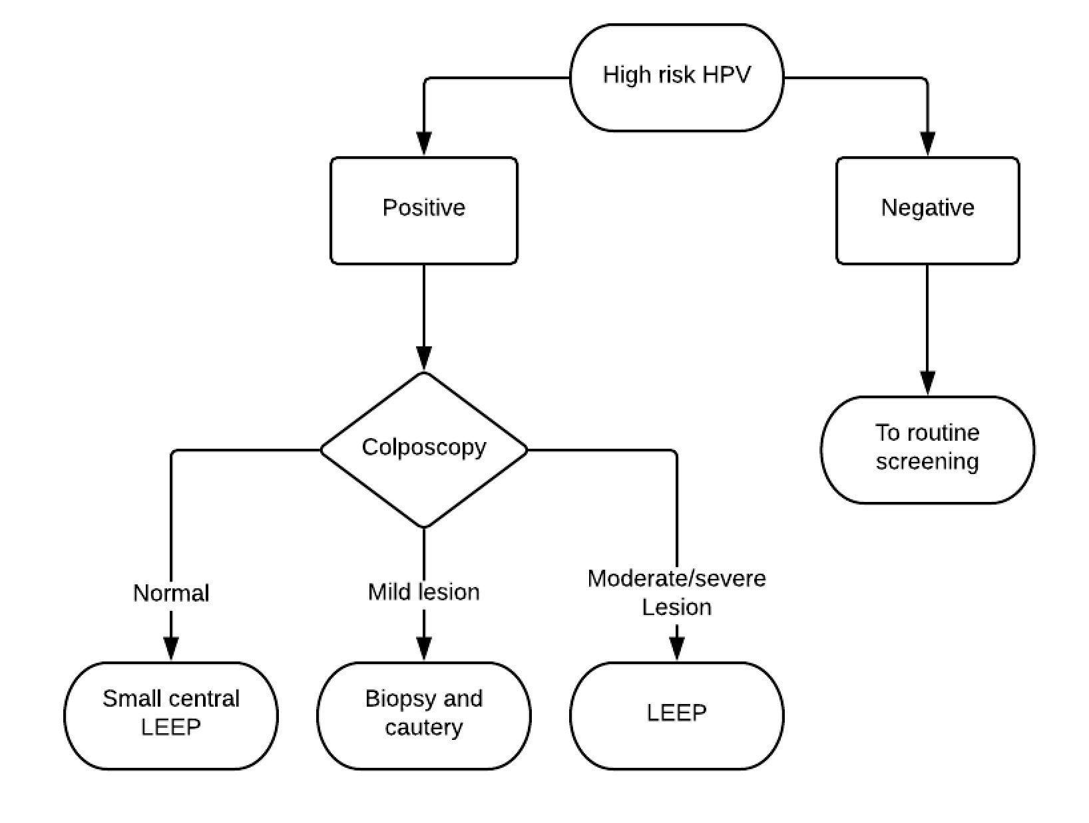

Figure 2. High-risk HPV genotype prevalence and agreement for paired samples
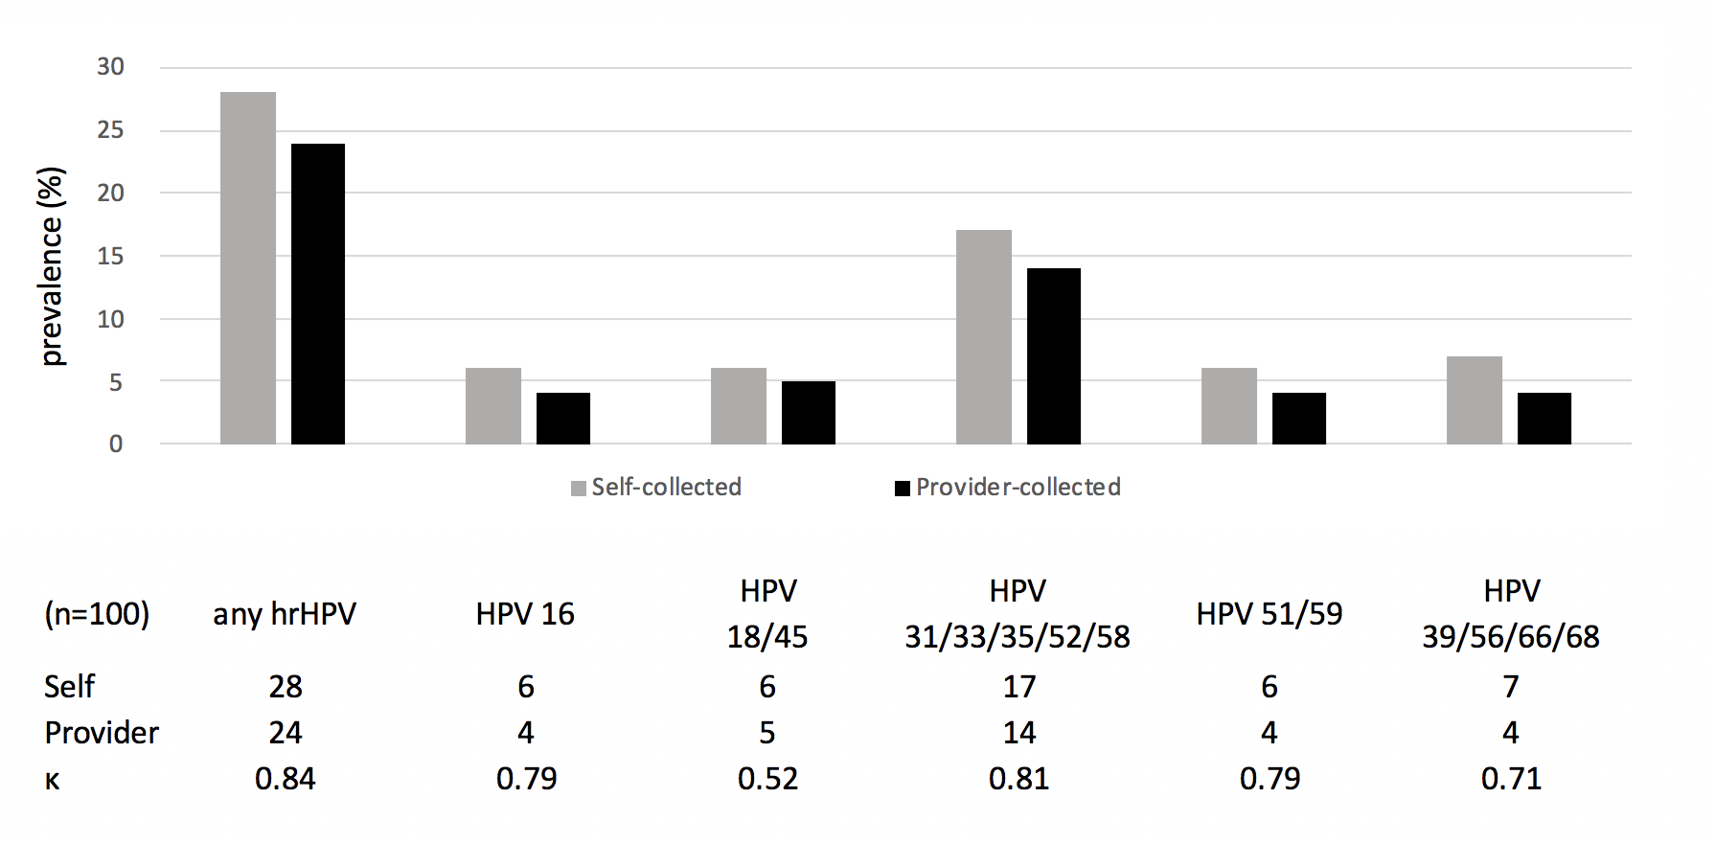
Notes: excludes three women with invalid results. Agreement for each high-risk HPV subtype calculated using kappa statistic.

