See discussions, stats, and author profiles for this publication at: https://www.researchgate.net/publication/336796087

Polymorphisms in GSTE2 is associated with temephos resistance in Aedes aegypti
Article in Pesticide Biochemistry and Physiology · October 2019
DOI: 10.1016/j.pestbp.2019.10.002

CITATIONS
0
READS
18

1 author:

Constancia Ayres Fundação Oswaldo Cruz
84 PUBLICATIONS 1,051 CITATIONS
SEE PROFILE

Some of the authors of this publication are also working on these related projects:

Identification of Zika vectors View project

Development of RT-LAMP for detection of ZIKV in mosquito samples View project

All content following this page was uploaded by Constancia Ayres on 25 October 2019.

The user has requested enhancement of the downloaded file.

Journal Pre-proof

Polymorphisms in GSTE2 is associated with temephos resistance in Aedes aegypti

Elisama Helvecio, Tatiany Patrícia Romão, Danilo de Carvalho Leandro, Iêda Ferreira de Oliveira, Antonio Emanuel Holanda D. Cavalcanti, Lisa Reimer, Milena de Paiva Cavalcanti, Ana Patrícia Silva de Oliveira, Patrícia Maria Guedes Paiva, Thiago Henrique Napoleão, Gabriel Luz Wallau, Osvaldo P. de -Melo-Neto, Maria Alice Varjal de Melo Santos, Constância Flávia Junqueira Ayres

PII: S0048-3575(19)30456-0
DOI: https://doi.org/10.1016/j.pestbp.2019.10.002
Reference: YPEST 4464

To appear in: Pesticide Biochemistry and Physiology

Received date: 9 May 2019
Revised date: 10 September 2019
Accepted date: 13 October 2019

Please cite this article as: E. Helvecio, T.P. Romão, D. de Carvalho Leandro, et al., Polymorphisms in GSTE2 is associated with temephos resistance in Aedes aegypti, Pesticide Biochemistry and Physiology (2019), https://doi.org/10.1016/ j.pestbp.2019.10.002

This is a PDF file of an article that has undergone enhancements after acceptance, such as the addition of a cover page and metadata, and formatting for readability, but it is not yet the definitive version of record. This version will undergo additional copyediting, typesetting and review before it is published in its final form, but we are providing this version to give early visibility of the article. Please note that, during the production process, errors may be discovered which could affect the content, and all legal disclaimers that apply to the journal pertain.

© 2019 Published by Elsevier.

Polymorphisms in GSTE2 is associated with temephos resistance in Aedes aegypti

Elisama Helvecio a†, Tatiany Patrícia Romão a†*, Danilo de Carvalho Leandro c, Iêda Ferreira de Oliveira d, Antonio Emanuel Holanda D. Cavalcantia, Lisa Reimerf, Milena de Paiva Cavalcanti b; Ana Patrícia Silva de Oliveira e, Patrícia Maria Guedes Paiva e, Thiago Henrique Napoleão e, Gabriel Luz Wallau a, Osvaldo P. de-Melo-Neto b, Maria Alice Varjal de Melo Santos a, Constância Flávia Junqueira Ayres a*

aDepartment of Entomology, Instituto Aggeu Magalhães/FIOCRUZ, Recife-PE 50740-465, Brazil; bDepartment of Microbiology, Instituto Aggeu Magalhães/FIOCRUZ, Recife-PE 50740-465, Brazil, cUniversidade Federal de Pernambuco, CAP-UFPE, Recife-PE 50740-550, Brazil; dDepartament of Biology, Universidade Federal Rural de Pernambuco, Recife-PE 52171-900, Brazil; eDepartament of Biochemistry, Universidade Federal de Pernambuco, Recife-PE 50670-420, Brazil; fDepartment of Vector Biology, Liverpool School of Tropical Medicine, United Kingdom.

†These authors contributed equally to this work.

*Corresponding authors. E-mails: tans@cpqam.fiocruz.br and taty@cpqam.fiocruz.br

ABSTRACT

The glutathione S-transferases (GSTs) are enzymes involved in several distinct biological processes. In insects, the GSTs, especially delta and epsilon classes, play a key role in the metabolism of xenobiotics used to control insect populations. Here, we investigated its potential role in temephos resistance, examining the GSTE2 gene from susceptible (RecL) and resistant (RecR) strains of the mosquito Aedes aegypti, vector for several pathogenic arboviruses. Total GST enzymatic activity and the GSTE2 gene expression profile were evaluated, with the GSTE2 cDNA and genomic loci sequenced from both strains. Recombinant GSTE2 and mutants were produced in a heterologous expression system and assayed for enzyme kinetic parameters. These proteins also had their 3D structure predicted through molecular modeling. Our results showed that RecR has a profile of total GST enzymatic activity higher than RecL, with the expression of the GSTE2 gene in resistant larvae increasing six folds. Four exclusive RecR mutations were observed (L111S, I150V, E178A and A198E), which were absent in the laboratory susceptible strains. The enzymatic activity of the recombinant GSTE2 showed different kinetic parameters, with the GSTE2 RecR showing an enhanced ability to metabolize its substrate. The I150V mutation was shown to induce significant changes in catalytic parameters and a 3D modelling of GSTE2 mapped two of the RecR changes (L111S and I150V) near the enzyme’s catalytic pocket, also implying an impact on its catalytic activity. Our results reinforce a potential role for GSTE2 in the metabolic resistance phenotype while contributing to the understanding of the molecular basis for the resistance mechanism.
Keywords: Aedes, Enzymology, Glutathione S-Transferase; Oxidative stress; Gene expression, Insecticide resistance.

INTRODUCTION

The mosquito Aedes aegypti is the main vector of the Dengue, Chikungunya and Zika viruses, responsible for diseases which together affect millions of people worldwide (Murrell et al., 2011; Relich and Loeffelholz, 2017; Vu et al., 2017). An important strategy for the reduction of the burden associated with the diseases caused by these arboviruses is vector control, and this has been based mainly on the elimination of breeding sites and the use of chemical insecticides (Nkya et al., 2013). Resistance to insecticides however is a serious problem that has impacted the effort to reduce mosquito population numbers. Temephos is a powerful organophosphorus larvicide that can effectively be used to control a number of pathogen-carrying insects, including mosquitoes. In Brazil, the intensive use of this larvicide for many years, as part of the national dengue control program, led to the emergence of Ae. aegypti resistant populations (Araújo et al., 2013; Beserra et al., 2007; Braga et al., 2004; Gambarra et al., 2013; Lima et al., 2006; Montella et al., 2007).
There are four main chemical resistance mechanisms know in insects: target site modification, reduced penetrance, behavioral changes and increased metabolic detoxification (metabolic resistance). The metabolic resistance occurs due to the increase in detoxification activity of enzymes responsible for the metabolism of xenobiotics, ensuring the elimination or inactivation of circulating insecticides inside the vector and preventing them from reaching the central nervous system, their final target site (Brogdon and McAllister, 1998; Prapanthadara et al., 2000). Three main enzyme families are associated with metabolic resistance in insects: monoxygenases, esterases and glutathione S-transferases (GSTs). The GSTs are important enzymes found in almost all organisms that are involved with the phase II metabolic detoxification process. They act catalyzing the conjugation of several electrophiles with the reduced glutathione (GSH) and, consequently, detoxifying endogenous and

exogenous toxic compounds. These enzymes can be classified into three main groups according to their location in the cell: cytosolic, microsomal and mitochondrial (Sheehan et al., 2001). Mosquitoes have both cytosolic and microsomal GSTs, but only the cytosolic enzymes are implicated in insecticide resistance (Che-Mendoza et al., 2009). The cytosolic GSTs from arthropods are grouped into eight classes: Delta, Epsilon, Omega, Sigma, Theta, Zeta, Xi and Iota. The delta and epsilon classes are unique to arthropods (Ranson et al., 2001). Most of the GSTs are encoded by multigenic families and their diversity can be increased through alternative splicing (Kampkötter et al., 2003; Ranson, Collins & Hemingway, 1998) and by the formation of heterodimers (Dixon et al., 1999). Due to this high level of diversity, determining the physiological functions of individual GSTs is difficult. Genomic analysis of various organisms revealed the complexity of these genes. For example, ten GST genes were found in Saccharomyces cerevisiae, 57 in Caenorhabditis elegans, 43 in Drosophila melanogaster, 31 in Anopheles gambiae, 48 in Arabidopsis thaliana and 40 in humans (Holt et al., 2002). The GST gene families in An. gambiae and Ae. aegypti have been previously described (Ding et al., 2003; Lumjuan et al., 2007). Overall, 28 genes encoding cytosolic GSTs were found in An. gambiae, with twelve genes classified as encoding Delta class enzymes, eight Epsilon, two Theta and one gene each for the Omega, Sigma and Zeta classes (Strode et al., 2008). The Epsilon GST gene cluster was characterized in more detail in four species of the genus Anopheles and these genes were found to be differentially expressed, with the GSTE2 gene found to be the most conserved among species (Ayres et al., 2011). In Ae. aegypti, there are 26 genes encoding GSTs with two undergoing alternative splicing, resulting in a total of 29 transcripts. The Delta and Epsilon genes are represented by eight members each and four Theta genes were also identified, representing an expansion in comparison to An. gambiae in this gene class, as well as single representatives for the Zeta,

Sigma and Omega class genes (Strode et al., 2008). Recently, after improving the annotation of the Ae. aegypti genome, an expansion on the GSTE family was detected, and GSTE2, along with GSTE5 and GSTE7 displayed evidence of gene duplications in the Liverpool strain (Matthews et al., 2018).
The Delta and Epsilon classes of cytosolic GSTs were found to be prominent in their involvement with resistance to chemical insecticides in species of diptera (Hemingway et al., 2004; Ortelli et al., 2003; Ranson et al., 2001). It was first shown that GST enzymes metabolize the organochlorine insecticide DDT in An. gambiae (Ranson et al., 1997; Ranson et al., 2000; Ranson et al., 2001) and the same was observed for the domestic fly (Tu and Akgül, 2005), Culex quinquefasciatus (Prapanthadara et al., 2000) and Ae. aegypti (Polson et al., 2011). These studies have linked insecticide resistance to increased Epsilon class GST hydrochlorinase activity directed to the DDT molecule (Lumjuan et al., 2005, 2011; Mitchell et al., 2014; Riveron et al., 2014). Specifically regarding temephos resistance, an up regulation of the Epsilon class GSTs was also observed in Ae. aegypti from Peru after five generations under temephos selection pressure in the laboratory (Saavedra-Rodriguez et al., 2014).
In previous studies, a temephos-resistant Ae. aegypti strain, called RecR, from Pernambuco, Brazil, was established in order to understand the dynamics and molecular basis of resistance to this compound (Melo-Santos et al., 2010). Through microarray analysis of the RecR strain, 13 genes were seen to be overexpressed in adult females mosquitoes and implicated in metabolic resistance, with six genes overexpressed in larvae (Strode et al., 2012). The detection of GSTE2 and GSTE3, among the overexpressed genes in RecR adult females has led us to investigate further the real role GSTs might have in the metabolic resistance event in this strain. In Ae. aegypti and An. gambiae, some studies have confirmed

the involvement of GSTE2 in the DDT metabolism (Lumjuan et al., 2005; Ortelli et al., 2003; Ranson et al., 2001), and the silencing of this enzyme in Ae. aegypti reduced DDT resistance (Lumjuan et al., 2011). Here, the role of GSTE2 in metabolic resistance to temephos was then investigated through molecular and biochemical studies comparing its activity between Ae. aegypti strains with different susceptibility profiles. Our study demonstrates genetic, expression and biochemical differences for GSTE2 in the RecR strain, indicating that this enzyme may play a role in the metabolic resistance process against temephos.

MATERIALS AND METHODS

  - Aedes aegypti strains

Four Aedes aegypti laboratory strains with different temephos susceptibility profiles were evaluated here: 1) RecR, a highly resistant strain selected for resistance to temephos (F35, RR95 ~ 225) (Melo-Santos et al., 2010); 2) RecL, a local susceptible strain from the city of Recife, maintained for over 15 years under laboratory conditions (Melo-Santos et al., 2010);
3) Rockefeller, used as an international standard strain susceptible to temephos; 4) RecRev, a substrain established from the 14th RecR generation, submitted to resistance reversion (Melo- Santos et al., 2010). Larvae were reared in dechlorinated tap water and fed with cat food (Wiskas®). The adults were fed on 10% sucrose solution and the females with chicken blood. All larvae and adults were maintained at 26±2°C, 70% humidity, and a photoperiod of 12h light ⁄ 12h darkness. Larvae and adult samples of RecLab and RecR strains were stored at - 80°C until further use.

Insecticide susceptibility assays

Bioassays were performed using pooled adult females, three to four days old, from the Rockefeller, RecL and RecR strains following the WHO protocol (WHO, 1998). Twenty to twenty-five females per tube were exposed to insecticide-impregnated filter paper for 1h and then transferred to recovery tubes containing 10% sugar, with the mortality determined after 24h. The insecticides tested here were cypermethrin (0.4%,), deltamethrin (0.05%), lambda- cyhalothrin (0.03%) and DDT (4%), all from Sigma®. Adult mortality rates below 80% were classified as resistant, while those above 98% were classified as susceptible. Populations with mortality rates ranging from 80 to 98% were classified as having an altered susceptibility status (Davidson and Zahar, 1973).

  - Kdr genotyping

In order to determine if other mechanisms of insecticide resistance were present, target- site alterations (Kdr mutations) were evaluated in the voltage gated sodium channel gene. DNA was individually extracted from a total of 50 female mosquitoes from the RecR and RecL strains using DNAzol® (Invitrogen, USA) and stored at -20°C. PCR reactions were then performed with 30-80 ηg of genomic DNA using the PCR Master Mix (Promega), according to the manufacturer's recommendations. Four Kdr mutations (L982W, I1011M, L1014F and V1016I) in the Nav gene (GenBank accession: AAEL006019) were investigated through PCR using previously described primers (Brengues et al., 2003; Martins et al., 2009a, 2009b; Saavedra-Rodriguez et al., 2007), with the PCR products sequenced and analyzed using the CodonCode Aligner software (3.7.1 for Windows). For the fifth mutation analyzed (F1534C), an allele-specific PCR was performed, as previously described (Ranson et al., 2010).

Assessment of total GST activity

In order to compare the activity profile of total GSTs between the Ae. aegypti strains investigated here (RecR, RecL and Rockefeller), homogenates of larvae and adults from each strain were submitted to enzymatic activity assays using CDNB (1-chloro-2,4- dinitrobenzene), the conventional substrate for quantification of enzyme activity related to insecticide resistance in Ae. aegypti, following the established protocol with modification (BRASIL, 2006). Approximately one hundred 4th instar larvae and one hundred one day-old adult females from each of the Ae. aegypti strains studied here were submitted to enzymatic tests using CDNB. Larvae/adults were homogenized individually with 300 µl of 100 mM potassium phosphate buffer, pH 6.5, in 1.5 ml microtubes and 15 µl of the homogenates were distributed in duplicates in 96-well microplates, with 9.5 mM of the reduced glutathione (GSH) and 1 mM CDNB. Plates were read for absorbance at 340 nm during 20 min with 1 min intervals between readings. The tests were carried out in series of three replicates per strain and all readings were performed on the Elx808 spectrophotometer (BIO-TEK). The absorbance results were analyzed using the software GEN 5.
The specific enzymatic activity for each sample was derived from the ratio between the enzymatic activity and the protein concentration. The enzymatic profiles of the tested strains were classified by comparing with the Rockefeller strain 99th percentile, which expresses the average of the enzymatic activity for 99% of the individuals of this lineage. Populations were considered normal if <15% of the individuals displayed enzymatic activity compatible with the Rockefeller 99th percentile. Values between 15% and 50% classified the populations as altered and above 50%, highly-altered, according to the criteria defined by the Brazilian Ministry of Health (BRASIL, 2006).

Evaluating gene expression by RT-qPCR.

To evaluate the GSTE2 expression (from 4th instar larvae and adult females), we conducted real-time quantitative Reverse Transcription PCR (RT-qPCR), using as forward and reverse primers 5’- AAG ATC TAC GGC TGG CTG GA -3’ and 5’- TCT GCG ACA GGA CAA ACT GC -3’, respectively. For the reference gene, the rpl8 ribosomal gene, the forward and reverse primers were 5’- TGG GGC GTG TTA TTC GTG CAC AG -3’ and 5’- CAG GTA TCC GTG ACG TTC GGC A -3’, respectively. Pools of five 4th instar larvae and five 3 days-old adult females from each strain (RecL and RecRF37) were used for RNA extraction with TRIzol™ (Invitrogen), according to the manufacturer’s instructions. RNA samples were treated with DNase™ (USB) followed by quantification in a NanoDrop 2000c spectrophotometer (Thermo Scientific). Amplifications were performed in 96-well plates using the QuantiTect SYBR Green RT-PCR kit (Qiagen, Hilden, Germany) for one-step quantitative RT-PCR, as recommended by the manufacturer, with the reactions performed in a ABI 7500 Real-Time PCR system (Applied Biosystems). Relative quantification analyses were performed by the 2-ΔΔCT method (Livak and Schmittgen, 2001) using the 7500 software version 2.0.4 (Applied Biosystems).

Cloning and sequencing of the GSTE2 cDNA

To isolate and characterize the GSTE2 cDNA sequences from RecR, RecL, RecRev and Rockefeller strains, the total RNA samples treated with DNase™ (USB) from individual larvae were used for reverse transcription, performed with the Cloned AMV First-Strand cDNA Synthesis Kit and Oligo DT20® primer (Invitrogen, Carslbad, CA, USA), followed by PCR amplification of the GSTE2 cDNA. The primers for the PCR were designed according to the GSTE2 gene sequence available at the VectorBase accession AAEL007951 (forward 5’-

CAA CTG CAT ATG ACG AAG CTC AT -3’; reverse 5’- TAC CTG GAA TTC TTA TGC

CTT TTG AGC -3’) with restrictions sites for the NdeI and EcoRI enzymes included in the forward and reverse cloning primers, respectively (underlined). The 669 bp PCR products were cloned in pGEM-T Easy (Promega), with ten clones for RecL and RecR and three clones for RecRev and Rockefeller submitted to automatic sequencing. Alignment and assembly of the resulting nucleotide and amino acid sequences were performed with the DNAstar software package, and manual refinement was done when needed. All the sequences were aligned with the Ae. aegypti GSTE2 VectorBase reference sequence (VectorBase accession AAEL007951), the GSTE2 gene from the New Orleans strain deposited in the GenBank (GenBank accession AAV68398.1) and the GSTE2 gene from the Anopheles gambiae ZAN/U resistant colony (accession AAG45164.1).

  - Recombinant protein expression in Escherichia coli

GSTE2 cDNAs from both RecL and RecR strains were released from the pGEM-T Easy vectors through digestion with NdeI and EcoRI and subcloned into the same sites of the expression vector pET28a® (Invitrogen). The resulting plasmids were transformed and expressed in E. coli BL21 star™ (DE3) and the recombinant GSTE2 RecL and RecR proteins fused to 6xHis purified through affinity chromatography using Niquel Sepharose® (GE). Prior to the biochemical assays, dialyzed proteins were quantified by comparisons with defined amounts of Bovine Serum Albumin on 15% SDS-PAGE gels.

Site-directed mutagenesis

Mutagenesis was performed with QuikChange® II site-directed mutagenesis kit (Stratagene) and specific oligonucleotides (Table S1) according to the manufacturer's

instructions. Individual and overlapping mutagenesis in the GSTE2 RecL gene sequence cloned in pET28a (Invitrogen) allowed the generation of four single amino acid mutants (MutL111S_ t332c, MutI150V_ a448g, MutE178A_ a533c, MutA198E_ c593a) and a mutant having all of these four amino acids mutated (MutTotal). All mutated sequences were confirmed by automated sequencing. Expression, purification, dialysis and quantification were performed as described in item 2.8.

Determination of recombinant GSTs kinetic parameters

GST activity was measured spectrophotometrically in a microplate reader (GEN5) by quantifying the conjugation of 1-chloro-2,4-dinitrobenzene (CDNB) with reduced glutathione (GSH) (BRASIL, 2006). For determination of kinetic parameters, the GST activity was measured using different concentrations of CDNB (0.4 to 25mM) and fixed concentrations of GSH. The maximal velocity (Vmax) and the Michaelis constant (Km ) were determined by non- linear regression analysis using the software GraphPad Prism 8. Three independent assays were performed for each experiment

Structural analysis and 3D Modelling

GSTE2 was modelled using the Modeller 9.13 software (Šali and Blunde l, 1993), with default parameters, using as reference the epsilon-class Glutathione S-transferase 3D model from the malaria vector Anopheles gambiae showing 71% of amino acid similarity to the reference Ae. aegypti GSTE2 (2imi_A) (Wang et al., 2008). Five best models were generated for each resistant and susceptible protein and the best model output used as input in the ModRefiner webserver (http://zhanglab.ccmb.med.umich.edu/ModRefiner/) in order to refine the 3D structure (Xu and Zhang, 2011). The final refined structures were evaluated by

Ramachandram plot and Verify 3D in the SAVES webserver (http://services.mbi.ucla.edu/SAVES/).

Statistical analysis

Statistically significant differences in gene expression by RT-qPCR between strains were evaluated with Mann-Whitney test using the GraphPad Prism 5 software. For kinetic parameters, the statistically significant differences were determined with the ANOVA test, followed by the Turkey test, using the GraphPad Prism8 software.

RESULTS

  - Evaluation of cross resistance to DDT or pyrethroids by the temephos resistant

Aedes aegypti

It is well known that the resistance to temephos in Aedes aegypti can be mediated mainly by metabolic mechanisms (Araújo et al., 2013; Melo-Santos et al., 2010), although the molecular mechanisms associated with this metabolic resistance still need to be defined. Here, insecticide susceptibility assays were first performed to evaluate if similar mechanisms might be responsible for the resistance to temephos and DDT, as well as other chemical insecticides (pyrethroids), and if cross-resistance has arisen in the RecR strain selected against temephos. Our results revealed that indeed RecR is resistant to DDT, with a 9% mortality rate 24 hours after exposure to the insecticide (Table S2). In contrast, for the control RecL strain, susceptible to temephos, a mortality rate of 86% was observed, with an altered susceptibility phenotype. Mosquitoes from the RecL and RecR strains, and the standard Rockefeller strain, were also tested with different pyrethroids and all three were susceptible to the cypermethrin, deltamethrin and lambda-cyhalothrin adulticides. Indeed, the mortality response to the

pyrethroid diagnostic dose in all strains analyzed, after 24 hours of evaluation, was above 98%. We considered that the RecR strain is susceptible to all the evaluated pyrethroids according to previously established criteria (Davidson and Zahar, 1973).

Screening of Kdr mutations

Mutations in the Nav gene, encoding a voltage-gated sodium channel, have been previously implicated in resistance to DDT and pyrethroids (Brengues et al., 2003; Lima et al., 2011; Martins et al., 2009a; Martins et al., 2009b; Saavedra-Rodriguez et al., 2007). Here, the presence of Kdr (target site resistance) mutations in the Nav gene was investigated by genotyping this gene from the targeted mosquito strains. The analysis revealed that the RecR, RecL and Rockefeller, strains are monomorphic for almost all sites evaluated, except for codon 982, where a synonymous mutation was detected (TTG / TTA) in 23 and 34 RecL and RecR mosquitoes, respectively (results not shown). None of the five Kdr mutations investigated here (L982W, I1011M, L1014F, V1016I and F1534C) were found.

Comparative analysis of total GST activity and GSTE2 expression from the RecL and RecR strains
GST enzymatic tests were performed with 118/113 larvae and 106/78 adults of the RecL/RecR strains, respectively, and the results compared with equivalent tests performed with 89/70 larvae/adults from the standard Rockefe ler strain. They revealed a “highly- altered” profile of activity for the total GSTs from the RecRF35 larvae, with 81% having GST activities higher than the 99th percentile defined from the Rockefeller strain data (Table 1). For the RecR adults, an “altered” profile was observed, with 42% of the mosquitoes having GST values higher than the Rockefeller 99th percentile. In contrast, the tests with the

susceptible strain (RecL) revealed that, for both larvae and adults, none of the individuals had GST activities above the Rockefeller 99th percentile.
Next, considering the previous microarray analysis identifying GST enzymes overexpressed in the RecR larvae and adults, and the GSTE2 specifically overexpressed in adult females (Strode et al., 2012), the expression levels of the GSTE2 mRNA in both RecR and RecL were compared through qRT-PCR. The expression of GSTE2 in the RecR samples was thus found to be significantly increased, with levels approximately three folds higher than RecL for the RecR larvae (Figure 1a), and an equivalent increase also seen for the RecR adults (Figure 1b).

GSTE2 gene polymorphisms analysis in the RecL and RecR strains

To investigate changes in the gene sequence which might be associated with the resistance phenotype, full-length GSTE2 coding sequences were recovered from the RecR, RecL, RecRev (a resistance revertant) and Rockefeller strains. These were then compared with the reference Ae. aegypti and An. gambiae GSTE2 sequences, as well as the one from the previously described New Orleans strain (Lumjuan et al., 2005) and the GSTE2 sequence from the An. gambiae resistant colony ZAN/U, which displays DDT resistance in the absence of known Kdr mutations (Mitchell et al., 2014). A total of eight amino acid substitutions in the GSTE2 polypeptide chain was observed in the various sequences when compared to the Ae. aegypti GSTE2 VectorBase reference: G105S in RecL; C115F in all other strains with the exception of New Orleans; Q139R in Rockefeller; V172E in Rockefeller, RecL and RecRev; and four mutations (L111S, I150V, E178A and A198E) unique to the GSTE2 from RecR (Figure S1). Two GSTE2 alleles are then clearly defined from the RecR and RecL colonies,

which differ in the four mutations unique to the RecR GSTE2 plus the V172E substitution, found in the RecL but not in the RecR allele.

Characterization of kinetic properties of GSTE2 RecL and GSTE2 RecR

To evaluate functional differences between the two GSTE2 alleles identified here, the GSTE2 RecL and RecR genes were subcloned into a bacterial expression vector and the corresponding his-tagged recombinant proteins expressed in Escherichia coli. When separated on SDS-PAGE gels, the corresponding recombinant proteins exhibited a ~26 kDa migration profile that is consistent with its predicted size (Figure 2a). Differences in solubility between the two GSTE2 proteins were clearly visible after bacterial lysis and subsequent purification of the his-tagged proteins, with purification yield for GSTE2 RecR repeatedly greater than GSTE2 RecL (with most of it remaining in the insoluble bacterial sediment). Figure 2b exemplifies one of the purification experiments and for this experiment, performed in parallel for both proteins, the yield for GSTE2 RecR was 2.4 μg/μL, while for GSTE2 RecL was 0.3 μg/μL. To compare the kinetic parameters of GSTE2 RecL, with GSTE2 RecR, the recombinant proteins were diluted to identical concentrations and submitted to biochemical assays to assess their catalytic activity (Figure 2c). GSTE2 RecR showed a greater binding affinity for the CDNB substrate, since the Km value was three times lower than that determined for GSTE2 RecL, and it also achieved a higher Vmax. GSTE2 RecR then metabolizes a greater amount of substrate than GSTE2 RecL in the same time period (Table 2).

Identification of amino acids responsible for differences in catalytic activity

To evaluate the role of individual substitutions found on the RecR GSTE2 on the enzyme performance, four mutant proteins (MutL111S_ t332c, MutI150V_ a448g, MutE178A_ a533c, MutA198E_ c593a) were generated through site-directed mutagenesis of the GSTE2 RecL gene. The mutagenized amino acids were chosen based on the four unique substitutions found on the RecR GSTE2. The mutagenized proteins showed no differences in expression profile and migrated with the same molecular weight. All displayed catalytic activity, although variations were detected for kinetic parameters (Figure 3 and Table 2). The MutI150V protein had a catalytic efficiency greater than the three other mutants (L111S, E178A, A198E). We then generated a fifth mutant having all four GSTE2 RecR mutations introduced into the RecL allele (mutant MutTotal) so that the difference between the RecL and the mutant protein was only the V172E substitution. The catalytic efficiency of MutTotal and its kcat / Km were similar to those for the RecR GSTE2 (Figure 3 and Table 2). Considering that the MutI150V protein display an enhanced catalytic efficiency in relation to the three other single residue mutants, but this efficiency is still lower than that shown by MutTotal, these results indicate that one or more of the exclusive RecR substitutions may also have an additive effect in the presence of the I150V mutation.

GSTE2 tertiary structure and in silico modeling

In silico modeling was performed to investigate the possible impacts of the GSTE2 RecR mutations in the protein’s structure and function. Mode ling was carried out based on the Anopheles gambiae GSTE2 (Wang et al., 2008), which is structured in two domains, a smaller N-terminal domain (residues 1-79) and the larger C-terminal one (residues 90-221) separated by a short linker (Figure 4). Within GSTE2, both glutathione and its substrate bind to a cleft

found between the two domains, with the glutathione binding site (the G-site) and substrate binding site (H-site) indicated in Figure 4. The G-site involves residues H53, I55, E67, S68 and R112, while the H-site was proposed to be a hydrophobic pocket likely dependent on many different residues from the protein’s two domains: L9, L11, S12, P13, P14, L36, L37, H41, I55, F108, M111, F115, L119, F120, L207 and F210. Side chains from residues R112, E116 and F120 form a pocket cap that may help isolate the hydrophobic substrate from the aqueous outside environment (Wang et al., 2008). Here, the modeled polypeptides produced overall satisfactory structures with well-defined angle torsions in the Ramachandram plots. Moreover, 95.50 and 83.33% of the residues presented ≥ 0.2 scores in the 3D/1D profile in the verify 3D analyses for the susceptible and resistant polypeptides, respectively. The four unique amino acid residues mutated in the RecR GSTE2 are all within the C-terminal domain with their positions highlighted in Figure 4. L111 is the only one known to be part of the substrate binding pocket. E178 mapped to the protein’s outer surface and is localized to an unstructured loop, while A198 localizes within one of several alpha helices and also faces externally. The I150 residue, whose substitution clearly impacted on the enzyme’s catalytic activity, is also found in a loop but faces internally. No major changes in the model structure could be observed comparing susceptible with resistant GSTE2 models (not shown). The L111S substitution, however, likely changes the orientation in the resistant protein of the adjacent residue, R112, implicated both in glutathione and substrate binding. The position of the I150 residue is in agreement with the data shown here indicating a possible role in the protein’s catalytic activity.

DISCUSSION

In the present study, we describe significant differences between GSTE2 sequences from temephos resistant and susceptible Aedes aegypti strains. Our results showing the increased GST activity levels in the RecR strain are in agreement with a previous evaluation of total GSTs in this strain (Melo-Santos et al., 2010) and with the observed changes in GST activity seen in field populations after the replacement of organophosphorus insecticides by pyrethroids in adult control programs (Montella et al., 2007). Indeed, we have seen a high resistance rate to temephos, with values above 100 folds, in natural Ae. aegypti populations, with a large number of individuals showing an altered GST activity and representing almost 90% of the mosquitoes analyzed in some populations (Araújo et al., 2013). Here, the absence of Kdr mutations in the RecR strain indicates that the cross-resistance observed to both temephos and DDT might be indeed associated with metabolic mechanisms, possibly linked to the differential GST expression. Our results suggest that common mechanisms might be associated with resistance to both temephos and DDT.
Our data is consistent with both resistant and susceptible GSTE2 alleles being present throughout the RecR selection process, since the complete resistance reversal in the RecRev strain is associated with a GSTE2 sequence identical to the one seen in RecL. The data reinforces the fact that only the continuous temephos selection pressure led to the establishment and high prevalence of the mutated gene in the vector colony. Indeed, the resistance to temephos in the field population from where the eggs used to establish the RecR strain were originally collected, was even higher than the resistance observed for the laboratory selected RecR five years after its establishment (Araújo et al., 2013; Melo-Santos et al., 2010). This could be explained by the likely much higher number of mosquito generations exposed to temephos in the field than the number of generations exposed to the

insecticide during the resistance selection under laboratory conditions. The very fast reversal of the resistance phenotype, with the large increase in frequency of the RecL allele after cessation of exposure to temephos, indicates a fitness cost associated with resistance and expression of the RecR GSTE2 allele. Indeed, a fitness cost causing reproductive disadvantages in RecR was reported previously (Diniz et al., 2015).
Only recently has special attention been given to mutations in the coding region of genes expressing metabolic enzymes. In populations of DDT resistant An. funestus in Benin-Africa, overexpression of the GSTE2 gene has been reported and the single amino acid change L119F shown to confers a high level of metabolic resistance to DDT (Riveron et al. 2014). The L119F resistant allele is fixed only in mosquitoes resistant to DDT and is absent in susceptible populations. For An. gambiae GSTE2, a neighboring amino acid exchange I114T was associated with DDT resistance in field populations in this species, acting together with Kdr mutations (Mitchell et al., 2014b). The four amino acid residues exclusively targeted in the Ae. aegypti GSTE2 RecR gene are also modified in the GSTE2 gene from the An. gambiae ZAN/U, a DDT resistant strain, in the absence of known knockdown resistance (kdr) mutations in the sodium channel (Mitchell et al., 2014b). However, only residue L111 has been suggested to play an important role in the metabolic activity of this enzyme against the insecticide, due to its localization as part of the DDT binding domain (Wang et al., 2008) and its previous association with DDT resistance (Riveron et al. 2014). Our work implicates at least another residue, I150, as being important in insecticide resistance with a likely role also in catalytic activity or its regulation.
A recent study using equine GST as a biosensor for detecting the presence of insecticides demonstrated that temephos is actually a GST inhibitor, and does not compete for the same binding site as CDNB (Borah et al., 2017). This raises the possibility that the GSTE2-based

resistance, in the specific case of temephos, is caused either by a role of the enzyme in the defense against toxic endogenous compounds derived from temephos exposure or else by its resistance to a direct inhibition by the compound. In this case, resistance to temephos would be caused by the mutated GSTE2 eliminating the secondary toxic products generated by insecticide exposure and/or by avoiding the insecticide’s inhibition. The first mechanism has been demonstrated for the planthopper Nilaparvata lugens, involving a GST responsible for protecting tissues from oxidative damage caused by pyrethroid exposure (Vontas et al., 2002). Similarly, An. arabiensis GSTE4 was not capable of metabolizing pyrethroid, although there was a strong evidence of its involvement in insecticide resistance. Any of these mechanisms would be distinct from the one involving esterases where, for instance, the CCEae3a enzyme has been shown to be capable of interacting with temephos and causing resistance by sequestration of the molecule (Grigoraki et al., 2016).
The interest in GSTs has grown considerably due to their potentially practical application. For example, their use in insecticide detection kits in DDT-impregnated mosquito nets has been described (Morou et al., 2008) and the possible use of antifilaricidal drugs based on GST inhibitors has been proposed (Bhargavi et al., 2005). The results described here add to those described in the literature suggesting that GSTE2 is a good target to develop methods for resistance diagnosis and also for the development of new insecticides, such as inhibitors of these detoxification enzymes. Polymorphisms found between resistant and susceptible strains provide valuable information to better understand the mode of interaction between the enzyme, its specific substrates and GSH, although we believe that other GSTs may be also playing a role in metabolic resistance and should be investigated. Overall our results can also be used to support the development of tools useful to monitor the evolution of resistance and to design adequate strategies of resistance management in natural mosquito populations.

In summary, the results of the gene expression analysis indicate that the resistant larvae (RecR) displayed significant levels of GSTE2 overexpression compared to RecL. The genetic and biochemical analysis of GSTE2 of both strains show important differences between them. The RecR I150V mutation was shown to have a relevant role for enzyme efficiency. The dataset provided by this study reinforce that GSTE2 is likely to play an important role together with other epsilon class GST enzymes in the RecR resistance phenotype to temephos.

ACKNOWLEDGMENTS

The authors thank the Program for Technological Development in Tools for Health-PDTIS- FIOCRUZ for use of its automatic sequencing facilities and the insectarium from IAM- FIOCRUZ for the technical support.

REFERENCES

Araújo, A.P., Araujo Diniz, D.F., Helvecio, E., De Barros, R.A., De Oliveira, C.M.F., Ayres, C.F.J., De Melo-Santos, M.A.V., Regis, L.N., Silva-Filha, M.H.N.L., 2013. The susceptibility of Aedes aegypti populations displaying temephos resistance to Bacillus thuringiensis israelensis: A basis for management. Parasites and Vectors 6. https://doi.org/10.1186/1756-3305-6-297
Ayres, C., Müller, P., Dyer, N., Wilding, C., Rigden, D., Donnelly, M., 2011. Comparative genomics of the anopheline glutathione s-transferase epsilon cluster. PLoS One 6, e29237. https://doi.org/10.1371/journal.pone.0029237
Beserra, E.B., Fernandes, C.R.M., Queiroga, M. de F.C. de, Castro Jr., F.P. de, 2007. Resistência de populações de Aedes aegypti (L.) (Diptera: Culicidae) ao organofosforado temefós na Paraíba. Neotrop. Entomol. 36, 303–307. https://doi.org/10.1590/S1519- 566X2007000200019
Bhargavi, R., Vishwakarma, S., Murty, U.S., 2005. Modeling analysis of GST (glutathione-S- transferases) from Wuchereria bancrofti and Brugia malayi. Bioinformation 1, 25–7.
Borah, H., Dutta, R.R., Gogoi, S., Medhi, T., Puzari, P., 2017. Glutathione-S-transferase- catalyzed reaction of glutathione for electrochemical biosensing of temephos, fenobucarb and dimethoate. Anal. Methods 9, 4044–4051. https://doi.org/10.1039/C7AY01258F
Braga, I.A., Lima, J.B.P., Soares, S. da S., Valle, D., 2004. Aedes aegypti resistance to temephos during 2001 in several municipalities in the states of Rio de Janeiro, Sergipe, and Alagoas, Brazil. Mem. Inst. Oswaldo Cruz 99, 199–203.
BRASIL, 2006. Quantification Methodology for Enzyme Activity Related to Insecticide Resistance in Aedes aegypti, Ministry of Health of Brazil, Fundacao Oswaldo Cruz.

Brasilia.
Brengues, C., Hawkes, N.J., Chandre, F., McCarroll, L., Duchon, S., Guillet, P., Manguin, S., Morgan, J.C., Hemingway, J., 2003. Pyrethroid and DDT cross-resistance in Aedes aegypti is correlated with novel mutations in the voltage-gated sodium channel gene. Med. Vet. Entomol. 17, 87–94.
Brogdon, W., McAllister, J.C., 1998. Insecticide Resistance and Vector Control. Emerg.
Infect. Dis. 4, 605–613. https://doi.org/10.3201/eid0404.980410
Che-Mendoza, A., Penilla, R.P., Américo Rodríguez, D., 2009. Insecticide resistance and glutathione S-transferases in mosquitoes: A review. African J. Biotechnol. 8, 1386–1397.
Davidson, G., Zahar, A.R., 1973. The practical implications of resistance of malaria vectors to insecticides. Bull. World Health Organ. 49, 475–83.
Ding, Y., Ortelli, F., Rossiter, L.C., Hemingway, J., Ranson, H., 2003. The Anopheles gambiae glutathione transferase supergene family: annotation, phylogeny and expression profiles. BMC Genomics 4, 35. https://doi.org/10.1186/1471-2164-4-35
Diniz, D.F.A., de Melo-Santos, M.A.V., Santos, E.M. de M., Beserra, E.B., Helvecio, E., de Carvalho-Leandro, D., dos Santos, B.S., de Menezes Lima, V.L., Ayres, C.F.J., 2015. Fitness cost in field and laboratory Aedes aegypti populations associated with resistance to the insecticide temephos. Parasit. Vectors 8, 662. https://doi.org/10.1186/s13071-015- 1276-5
Dixon, D.P., Cole, D.J., Edwards, R., 1999. Dimerisation of maize glutathione transferases in recombinant bacteria. Plant Mol. Biol. 40, 997–1008.
Gambarra, W.P.T., Martins, W.F.S., Filho, M.L. de L., de Albuquerque, I.M.C., Apolinário,
O.K. dos S., Beserra, E.B., 2013. Spatial distribution and esterase activity in populations of Aedes (Stegomyia) aegypti (Linnaeus) (Diptera: Culicidae) resistant to temephos. Rev. Soc. Bras. Med. Trop. 46, 178–184. https://doi.org/10.1590/0037-8682-1727-2013
Grigoraki, L., Balabanidou, V., Meristoudis, C., Miridakis, A., Ranson, H., Swevers, L., Vontas, J., 2016. Functional and immunohistochemical characterization of CCEae3a, a carboxylesterase associated with temephos resistance in the major arbovirus vectors Aedes aegypti and Ae. albopictus. Insect Biochem. Mol. Biol. 74, 61–67. https://doi.org/10.1016/j.ibmb.2016.05.007
Hemingway, J., Hawkes, N.J., McCarroll, L., Ranson, H., 2004. The molecular basis of insecticide resistance in mosquitoes. Insect Biochem. Mol. Biol. 34, 653–665. https://doi.org/10.1016/j.ibmb.2004.03.018
Holt, B.F., Boyes, D.C., Ellerström, M., Siefers, N., Wiig, A., Kauffman, S., Grant, M.R., Dangl, J.L., 2002. An evolutionarily conserved mediator of plant disease resistance gene function is required for normal Arabidopsis development. Dev. Cell 2, 807–17.
Kampkötter, A., Volkmann, T.E., de Castro, S.H., Leiers, B., Klotz, L.O., Johnson, T.E., Link, C.D., Henkle-Dührsen, K., 2003. Functional analysis of the glutathione S- transferase 3 from Onchocerca volvulus (Ov-GST-3): a parasite GST confers increased resistance to oxidative stress in Caenorhabditis elegans. J. Mol. Biol. 325, 25–37.
Lima, E., Paiva, M., de Araújo, A., da Silva, É., da Silva, U., de Oliveira, L., Santana, A.E.G., Barbosa, C., de Paiva Neto, C.C., Goulart, M.O., Wilding, C., Ayres, C., de Melo Santos,
M.A. V, 2011. Insecticide resistance in Aedes aegypti populations from Ceará, Brazil. Parasit. Vectors 4, 5. https://doi.org/10.1186/1756-3305-4-5
Lima, E.P., Oliveira Filho, A.M. de, Lima, J.W. de O., Ramos Júnior, A.N., Cavalcanti, L.P. de G., Pontes, R.J.S., 2006. Resistência do Aedes aegypti ao temefós em Municípios do Estado do Ceará. Rev. Soc. Bras. Med. Trop. 39, 259–263. https://doi.org/10.1590/S0037-86822006000300006

Livak, K.J., Schmittgen, T.D., 2001. Analysis of Relative Gene Expression Data Using Real- Time Quantitative PCR and the 2−ΔΔCT Method. Methods 25, 402–408. https://doi.org/10.1006/meth.2001.1262
Lumjuan, N., McCarroll, L., Prapanthadara, L.A., Hemingway, J., Ranson, H., 2005. Elevated activity of an Epsilon class glutathione transferase confers DDT resistance in the dengue vector, Aedes aegypti White star. Insect Biochem. Mol. Biol. 35, 861–871. https://doi.org/10.1016/j.ibmb.2005.03.008
Lumjuan, N., Rajatileka, S., Changsom, D., Wicheer, J., Leelapat, P., Prapanthadara, L. aied, Somboon, P., Lycett, G., Ranson, H., 2011. The role of the Aedes aegypti Epsilon glutathione transferases in conferring resistance to DDT and pyrethroid insecticides. Insect Biochem. Mol. Biol. 41, 203–209. https://doi.org/10.1016/j.ibmb.2010.12.005
Lumjuan, N., Stevenson, B.J., Prapanthadara, L. aied, Somboon, P., Brophy, P.M., Loftus, B.J., Severson, D.W., Ranson, H., 2007. The Aedes aegypti glutathione transferase family. Insect Biochem. Mol. Biol. 37, 1026–1035.
https://doi.org/10.1016/j.ibmb.2007.05.018
Martins, A.J., Lima, J.B.P., Peixoto, A.A., Valle, D., 2009a. Frequency of Val1016Ile mutation in the voltage-gated sodium channel gene of Aedes aegypti Brazilian populations. Trop. Med. Int. Heal. 14, 1351–1355. https://doi.org/10.1111/j.1365- 3156.2009.02378.x
Martins, A.J., Lins, R.M.M. de A., Linss, J.G.B., Peixoto, A.A., Valle, D., 2009b. Voltage- gated sodium channel polymorphism and metabolic resistance in pyrethroid-resistant Aedes aegypti from Brazil. Am. J. Trop. Med. Hyg. 81, 108–15.
Matthews, B.J., Dudchenko, O., Kingan, S.B., Koren, S., Antoshechkin, I., Crawford, J.E., Glassford, W.J., Herre, M., Redmond, S.N., Rose, N.H., Weedall, G.D., Wu, Y., Batra,
S.S., Brito-Sierra, C.A., Buckingham, S.D., Campbell, C.L., Chan, S., Cox, E., Evans, B.R., Fansiri, T., Filipović, I., Fontaine, A., Gloria-Soria, A., Hall, R., Joardar, V.S., Jones, A.K., Kay, R.G.G., Kodali, V.K., Lee, J., Lycett, G.J., Mitchell, S.N., Muehling,
J., Murphy, M.R., Omer, A.D., Partridge, F.A., Peluso, P., Aiden, A.P., Ramasamy, V., Rašić, G., Roy, S., Saavedra-Rodriguez, K., Sharan, S., Sharma, A., Smith, M.L., Turner, J., Weakley, A.M., Zhao, Z., Akbari, O.S., Black, W.C., Cao, H., Darby, A.C., Hill,
C.A., Johnston, J.S., Murphy, T.D., Raikhel, A.S., Sattelle, D.B., Sharakhov, I. V.,
White, B.J., Zhao, L., Aiden, E.L., Mann, R.S., Lambrechts, L., Powell, J.R.,
Sharakhova, M. V., Tu, Z., Robertson, H.M., McBride, C.S., Hastie, A.R., Korlach, J., Neafsey, D.E., Phillippy, A.M., Vosshall, L.B., 2018. Improved reference genome of Aedes aegypti informs arbovirus vector control. Nature 563, 501–507.
https://doi.org/10.1038/s41586-018-0692-z
Melo-Santos, M.A.V., Varjal-Melo, J.J.M., Araújo, A.P., Gomes, T.C.S., Paiva, M.H.S., Regis, L.N., Furtado, A.F., Magalhaes, T., Macoris, M.L.G., Andrighetti, M.T.M., Ayres, C.F.J., 2010. Resistance to the organophosphate temephos: Mechanisms, evolution and reversion in an Aedes aegypti laboratory strain from Brazil. Acta Trop. 113, 180–189. https://doi.org/10.1016/j.actatropica.2009.10.015
Mitchell, S.N., Rigden, D.J., Dowd, A.J., Lu, F., Wilding, C.S., Weetman, D., Dadzie, S., Jenkins, A.M., Regna, K., Boko, P., Djogbenou, L., Muskavitch, M.A.T., Ranson, H., Paine, M.J.I., Mayans, O., Donnelly, M.J., 2014a. Metabolic and target-site mechanisms combine to confer strong DDT resistance in Anopheles gambiae. PLoS One 9, e92662. https://doi.org/10.1371/journal.pone.0092662
Mitchell, S.N., Rigden, D.J., Dowd, A.J., Lu, F., Wilding, C.S., Weetman, D., Dadzie, S., Jenkins, A.M., Regna, K., Boko, P., Djogbenou, L., Muskavitch, M.A.T., Ranson, H.,

Paine, M.J.I., Mayans, O., Donnelly, M.J., 2014b. Metabolic and target-site mechanisms combine to confer strong DDT resistance in Anopheles gambiae. PLoS One 9, e92662. https://doi.org/10.1371/journal.pone.0092662
Montella, I.R., Martins, A.J., Viana-Medeiros, P.F., Lima, J.B.P., Braga, I.A., Valle, D., 2007. Insecticide resistance mechanisms of Brazilian Aedes aegypti populations from 2001 to 2004. Am. J. Trop. Med. Hyg. 77, 467–77.
Morou, E., Ismail, H.M., Dowd, A.J., Hemingway, J., Labrou, N., Paine, M., Vontas, J., 2008. A dehydrochlorinase-based pH change assay for determination of DDT in sprayed surfaces. Anal. Biochem. 378, 60–4. https://doi.org/10.1016/j.ab.2008.03.046
Murrell, S., Wu, S.-C., Butler, M., 2011. Review of dengue virus and the development of a vaccine. Biotechnol. Adv. 29, 239–247. https://doi.org/10.1016/j.biotechadv.2010.11.008
Nkya, T.E., Akhouayri, I., Kisinza, W., David, J.-P., 2013. Impact of environment on mosquito response to pyrethroid insecticides: Facts, evidences and prospects. Insect Biochem. Mol. Biol. 43, 407–416. https://doi.org/10.1016/J.IBMB.2012.10.006
Ortelli, F., Rossiter, L.C., Vontas, J., Ranson, H., Hemingway, J., 2003. Heterologous expression of four glutathione transferase genes genetically linked to a major insecticide- resistance locus from the malaria vector Anopheles gambiae. Biochem. J. 373, 957–63. https://doi.org/10.1042/BJ20030169
Polson, K.A., Brogdon, W.G., Rawlins, S.C., Chadee, D.D., 2011. Characterization of insecticide resistance in Trinidadian strains of Aedes aegypti mosquitoes. Acta Trop. 117, 31–8. https://doi.org/10.1016/j.actatropica.2010.09.005
Prapanthadara, L., Promtet, N., Koottathep, S., Somboon, P., Ketterman, A.J., 2000. Isoenzymes of glutathione S-transferase from the mosquito Anopheles dirus species B: the purification, partial characterization and interaction with various insecticides. Insect Biochem. Mol. Biol. 30, 395–403.
Ranson, H., Collins, F., Hemingway, J., 1998. The role of alternative mRNA splicing in generating heterogeneity within the Anopheles gambiae class I glutathione S-transferase family. Proc. Natl. Acad. Sci. U. S. A. 95, 14284–9.
Ranson, H., Jensen, B., Wang, X., Prapanthadara, L., Hemingway, J., Collins, F.H., 2000. Genetic mapping of two loci affecting DDT resistance in the malaria vector Anopheles gambiae. Insect Mol. Biol. 9, 499–507.
Ranson, H., Rajatileka, S., Harris, A.F., 2010. Pyrethroid Resistance in Aedes aegypti from Grand Cayman. Am. J. Trop. Med. Hyg. 83, 277–284.
https://doi.org/10.4269/ajtmh.2010.09-0623
Ranson, H., Rossiter, L., Ortelli, F., Jensen, B., Wang, X., Roth, C.W., Collins, F.H., Hemingway, J., 2001a. Identification of a novel class of insect glutathione S-transferases involved in resistance to DDT in the malaria vector Anopheles gambiae. Biochem. J. 359, 295–304.
Ranson, H., Rossiter, L., Ortelli, F., Jensen, B., Wang, X., Roth, C.W., Collins, F.H., Hemingway, J., 2001b. Identification of a novel class of insect glutathione S-transferases involved in resistance to DDT in the malaria vector Anopheles gambiae. Biochem. J. 359, 295–304.
Relich, R.F., Loeffelholz, M., 2017. Zika Virus. Clin. Lab. Med. 37, 253–267.
https://doi.org/10.1016/j.cll.2017.01.002
Riveron, J.M., Yunta, C., Ibrahim, S.S., Djouaka, R., Irving, H., Menze, B.D., Ismail, H.M., Hemingway, J., Ranson, H., Albert, A., Wondji, C.S., 2014. A single mutation in the GSTe2 gene allows tracking of metabolically based insecticide resistance in a major malaria vector. Genome Biol. 15, R27. https://doi.org/10.1186/gb-2014-15-2-r27

Saavedra-Rodriguez, K., Strode, C., Flores, A.E., Garcia-Luna, S., Reyes-Solis, G., Ranson, H., Hemingway, J., Black, W.C., 2014. Differential transcription profiles in Aedes aegypti detoxification genes after temephos selection. Insect Mol. Biol. 23, 199–215. https://doi.org/10.1111/imb.12073
Saavedra-Rodriguez, K., Urdaneta-Marquez, L., Rajatileka, S., Moulton, M., Flores, A.E., Fernandez-Salas, I., Bisset, J., Rodriguez, M., Mccall, P.J., Donnelly, M.J., Ranson, H., Hemingway, J., Black, W.C., 2007. A mutation in the voltage-gated sodium channel gene associated with pyrethroid resistance in Latin American Aedes aegypti. Insect Mol. Biol. 16, 785–798. https://doi.org/10.1111/j.1365-2583.2007.00774.x
Šali, A., Blunde l, T.L., 1993. Comparative Protein Modelling by Satisfaction of Spatial Restraints. J. Mol. Biol. 234, 779–815. https://doi.org/10.1006/jmbi.1993.1626
Sheehan, D., Meade, G., Foley, V.M., Dowd, C.A., 2001. Structure, function and evolution of glutathione transferases: implications for classification of non-mammalian members of an ancient enzyme superfamily. Biochem. J. 360, 1–16.
Strode, C., de Melo-Santos, M., Magalhães, T., Araújo, A., Ayres, C., 2012. Expression profile of genes during resistance reversal in a temephos selected strain of the dengue vector, Aedes aegypti. PLoS One 7, e39439. https://doi.org/10.1371/journal.pone.0039439
Strode, C., Wondji, C.S., David, J.-P., Hawkes, N.J., Lumjuan, N., Nelson, D.R., Drane, D.R., Karunaratne, S.H.P.P., Hemingway, J., Black, W.C., Ranson, H., 2008. Genomic analysis of detoxification genes in the mosquito Aedes aegypti. Insect Biochem. Mol. Biol. 38, 113–123. https://doi.org/10.1016/j.ibmb.2007.09.007
Tu, C.D., Akgül, B., 2005. Drosophila Glutathione S‐Transferases, in: Methods in Enzymology. pp. 204–226. https://doi.org/10.1016/S0076-6879(05)01013-X
Vontas, J.G., Small, G.J., Nikou, D.C., Ranson, H., Hemingway, J., 2002. Purification, molecular cloning and heterologous expression of a glutathione S-transferase involved in insecticide resistance from the rice brown planthopper, Nilaparvata lugens. Biochem. J. 362, 329–37.
Vu, D.M., Jungkind, D., Angelle Desiree LaBeaud, 2017. Chikungunya Virus. Clin. Lab.
Med. 37, 371–382. https://doi.org/10.1016/j.cll.2017.01.008
Wang, Y., Qiu, L., Ranson, H., Lumjuan, N., Hemingway, J., Setzer, W.N., Meehan, E.J., Chen, L., 2008. Structure of an insect epsilon class glutathione S-transferase from the malaria vector Anopheles gambiae provides an explanation for the high DDT- detoxifying activity. J. Struct. Biol. 164, 228–235.
https://doi.org/10.1016/j.jsb.2008.08.003
WHO, 1998. WHO | Test procedures for insecticide resistance monitoring in malaria vectors, bio-efficacy and persistence of insecticides on treated surfaces, in: WHO. World Health Organization.
Xu, D., Zhang, Y., 2011. Improving the Physical Realism and Structural Accuracy of Protein Models by a Two-Step Atomic-Level Energy Minimization. Biophys. J. 101, 2525– 2534. https://doi.org/10.1016/j.bpj.2011.10.024

DATA ACESSIBILITY

The sequence data has been submitted to the National Center for Biotechnology Information (NCBI) with accession number (MK801793-MK801795) and (MK806427- MK806436).

AUTHORS’ CONTRIBUTIONS

EH: acquisition, analysis of data and manuscript revision; TPR: conception of the study, experimental execution support, data analyses, manuscript writing and revision; DCL: experimental execution support and data analyses; IFO: acquisition of data; AEHDC: acquisition of data; LR: acquisition of data; MPC: experimental execution support and data analyses; APSO: experimental execution support and data analyses; PMGP: experimental execution support and data analyses; THN: experimental execution support and data analyses; GLW: data analyses and revision of the manuscript. OPMN: data analysis, manuscript writing and intellectual contributions. MAVMS: conception of the study, data analysis and manuscript writing. CFJA: conception of the study, intellectual contributions, manuscript writing and revision, financial support. All authors reviewed the paper and agreed with the final.

ABREVIATIONS

CDNB: 1-chloro-2,4-dinitrobenzene; GSTE: Gluthathione S-Transferase Epsilon class; GSH, reduced glutathione; Nav: Voltage-gated sodium channel transmembrane protein; RecL: Recife susceptible strain, RecR: Recife resistant strain; RecRev: Recife resistant reversion strain;

DECLARATIONS

Ethics approval and consent to participate

Not applicable

CONSENT FOR PUBLICATION

Not applicable

COMPETING INTERESTS

Authors declare that they have no competing interests

FUNDING

This work was supported by Conselho Nacional de Pesquisa (CNPq Brazil, CNPq/ PAPES VI Fiocruz 407475/2012-5, CAPES/AULP 2501/2013, CNPq 446902/2014-4) and FACEPE- FIOCRUZ (grant APQ-0108-2.08/14; APQ-0661-2.08/15).

TABLES AND FIGURE (WITH CAPTIONS)

Figure 1. Relative quantification of GSTE2 transcript expression in larvae (a) and adults (b) of RecL (RL) and RecR (RR) strains. The rpL8 reference gene was used for normalization. Bars indicate standard deviation, * results are statistically different (p < 0.0005).

Figure 2. Molecular and biochemical evaluation of recombinants GSTE2 proteins from RecL and RecR strains. Proteins were expressed in Escherichia coli as histidine-tagged fusions, purified by affinity chromatography, separated on 15% SDS-PAGE and visualized with Coomassie Blue staining of the gel. (a) SDS-PAGE showing the induction of the recombinant proteins in whole E. coli protein extracts with (+) and without (-) IPTG. (b) SDS-PAGE showing samples of the purified proteins after affinity chromatography. The arrow indicates the RecL and RecR GSTE2 eluted proteins. MW: Sizes of molecular weight markers in kDa.

- Enzymatic kinetics of RecL and RecR recombinant proteins. Bars indicate standard deviation.

Figure 3. Catalytic activity of different recombinant GSTE2 variants. All were incubated with different concentrations of CDNB and 10 mM of GSH. The experiments were conducted at 25°C in 90 mM potassium phosphate buffer at pH 6.5. Bars indicate standard deviation. Statistically significant differences were evaluated with ANOVA test followed by Turkey test (p <0.0001 indicated by *).

Figure 4. 3D model of the RecR GSTE2 protein. The model highlights the alpha helixes, beta sheets and loops found within the enzyme’s two domains: the N-terminal domain, colored in light pink; and the C-terminal Domain, in dark blue. The position of the putative DDT-binding pocket (H-site) and the GSH binding site (G-site) are indicated. The four residues specifically mutated in the RecR allele are shown with those positioned externally colored in yellow (E178A and A198E) while those facing internally are in red (L111S and I150V). The amplified image on the left, rotated in comparison with the main figure, highlights the position of the I150V substitution.

Table 1. Enzymatic activity of total GSTs in larvae and adults of Aedes aegypti strains (Rockefeller, RecL and RecR) using the CDNB as substrate.

Table 2. Kinetic parameters of different recombinant GSTE2 proteins. Results show mean ± standard error (SE). Kinetic studies were determined by varying the concentration of CDNB (0.4 to 25 mM) at fixed saturating GSH of 9.5 mM.

ADDITIONAL FILES

Additional file 1: Table S1.

File format:.doc

Title of data: Primers used to perform site-directed mutagenesis reactions to evaluate the impact of the GSTE2 RecL mutations on its kinetic parameters.

Additional file 2: Table S2.

File format:.doc

Title of data: Mortality rate and susceptibility status of RecL and RecR to pyrethroid insecticides.
Additional file 3: Figure S1.

File format: .eps

Title of data: Multiple sequence alignment of the deduced GSTE2 from selected Aedes aegypti strains. Clustal W sequence alignment comparing the Rockefeller, RecL, RecR, RecRev and GSTE2 sequences with the available Ae. aegypti GSTE2 sequence (AAEL007951) from VectorBase, the Ae. aegypti New Orleans GSTE2 (GenBank accession AAV68398.1) and ZAN/U Anopheles gambiae GSTE2 (accession AAG45164.1). Mutations are signaled by arrows and red arrows indicate specific RecR mutations. *H-site Putative (DDT-binding pocket). The ZAN/U An. gambiae is a DDT resistant strain that lacks the known knockdown resistance mutations (kdr) in the Nav gene.

Table 1. Enzymatic activity of total GSTs in larvae and adults of Aedes aegypti strains (Rockfeller, RecL and RecR) using the CDNB substrate.

Glutationa S-transferase (GST)

Strains 1 Number of larvae2
p993

(mmol/mg ptn/min)
% >p994 Classification5

Rockefeller | 89 | 2.46 | - | -
RecL | 118 | 1.95 | 0 | N
RecR | 113 | 5,39 | 81 | HA

Strains 1 Number of  adults2 | p993  (mmol/mg | % >p994 | Classification5
 | ptn/min)
Rockefeller 70 | 2.84 | - | -

1 Aedes aegypti strains. 2 Number of individuals tested; 3 99th Percentile of population (average of the enzymatic activity for 99% of the individuals tested) 4 Percentage of individuals with enzymatic activity above Rockefeller's 99th percentile 5 Classification of enzymatic activity compared to Rockefeller: N (normal- green),
RecL 106 2.81 0  RecR 78 4.37 42 | N
 | A

HA (highly altered- red), A (altered- yellow). Glutationa S-transferase (mmol/mg ptn/min).

Table 2. Kinetic parameters of different recombinant GSTE2 proteins. Results show mean ± Standart error (SE). Kinetic studies were determined by varying the concentration of CDNB (0.4 to 25 mM) at fixed saturating GSH of 9.5 mM.
GSTE2 | Vmax (µmol/min/µg) | Km (mM) | Kcat (s-1) | Kcat/Km (mM-1 s-1)
RecL | 18.13±0.622 | 1.176±0.188 | 30.5 | 26.29
RecR | 21.85±0.301 | 0.3241±0.038 | 36.41 | 113.78
MutL111S | 19.49±0.818 | 1.269±0.218 | 32.48 | 25.59
MutI150V | 18.08±0.449 | 0.5491±0.084 | 30.13 | 54.87
MutE178A | 17.94±0,572 | 1.117±0.163 | 29.9 | 26.76
MutA198E | 18.83±0.670 | 1.243±0,199 | 31.38 | 25.24
MutTotal | 21.24±0,286 | 0.3542 ±0.044 | 35.8 | 100.0

Highlights

  - The Aedes aegypti strain RecR is highly resistant to the insecticide temephos;
  - RecR strain overexpress the metabolic enzyme GSTE2;
  - Four mutations associated with temephos resistance present in GSTE2RecR;
  - The GSTE2RecR showed an improved metabolization capacity compared to the GSTE2RecL.

Graphical abstract

a Lar vae
10
*

·=!
..
... 8
=!.: . 6
:,
0 4
..
"'
"ij 2

0
RecL RecR
St r ain s

Adult
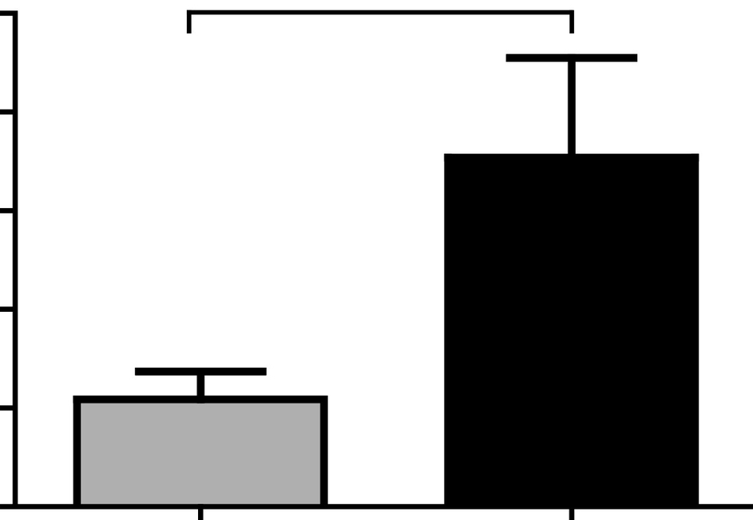b
*

5
=Q
.4..
t:
= .. 3
- 2
] 1
"'
0
RecL RecR
Strains

Figure 1

a b
MW RecL RecR MW RecL RecR

kDa + +
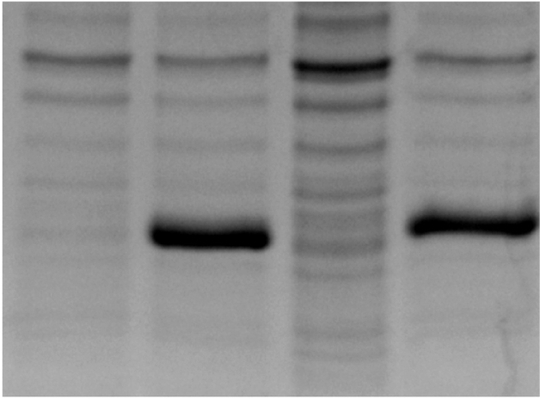
40-

30-

25-

20-

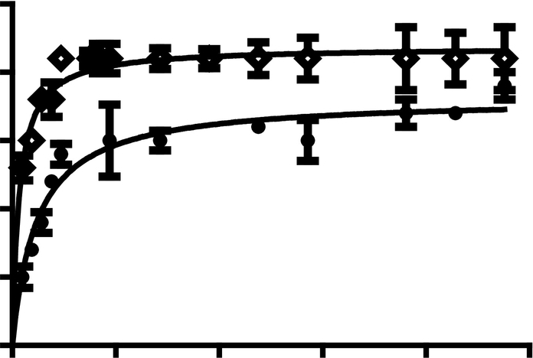C
25
-
=
5
20
+ RecR
RecL
<-
15
0
10
:::l..
5
5

0
0
5
10 15
mM
20
25
kDa 40-

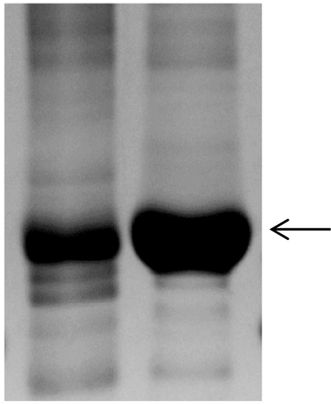
30-

25-

20-

Figure 2

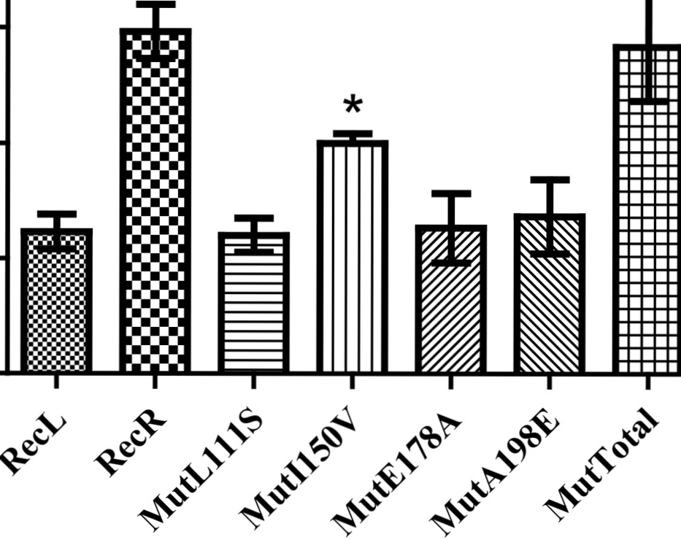20
* *
..
·sC 15
10
0
8
::!. 5

0
'"

Figure 3

E178A
L111S

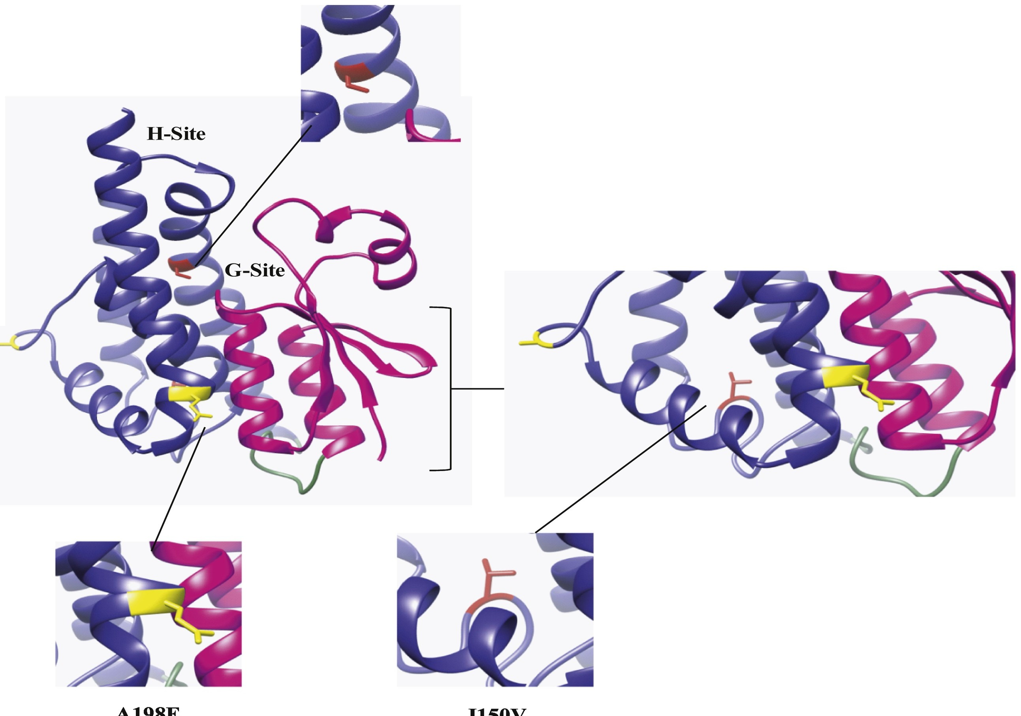
\

Figure 4

A. aegypti AAEL007951-PA
 | 10 20 30 40 | 50 | 60 | 70 |  | 80 90 100
 | ....1 .. .. 1 .. .. 1 .. .. 1....1 ....1 ....1 .... 1 .... 1 .. | .. 1 .. | .. 1 ....1 ....1 .. | .. 1 .. .. | 1 .. | .. 1....1 ....1 .. .. 1 ....1

A. aegypti New Orleans AAV68398 Rockefeller
RecLab RecR RecRev
An. gambiae AAG45164.1 ZAN/U

A. aegypti AAEL007951-PA
A. aegypti New Orleans AAV68398 Rockefeller
RecLab RecR RecRev
An . gambiae AAG45164.l ZAN/U

A. aegypti AAEL007951-PA
A. aegypti New Orleans AAV68398 Rockefeller
RecLab RecR RecRev
An . gambiae AAG45164.1 ZAN/U

View public:atior stats

110 120 130 140 150 160 170 180 190 200
....1.... 1 .... 1 .... 1....1 .. .. 1 ....1 .... 1.... 1 .. .. 1 ....1 ....1....1.... 1 .. .. 1 .. .. 1....1....1 .... 1 ....1

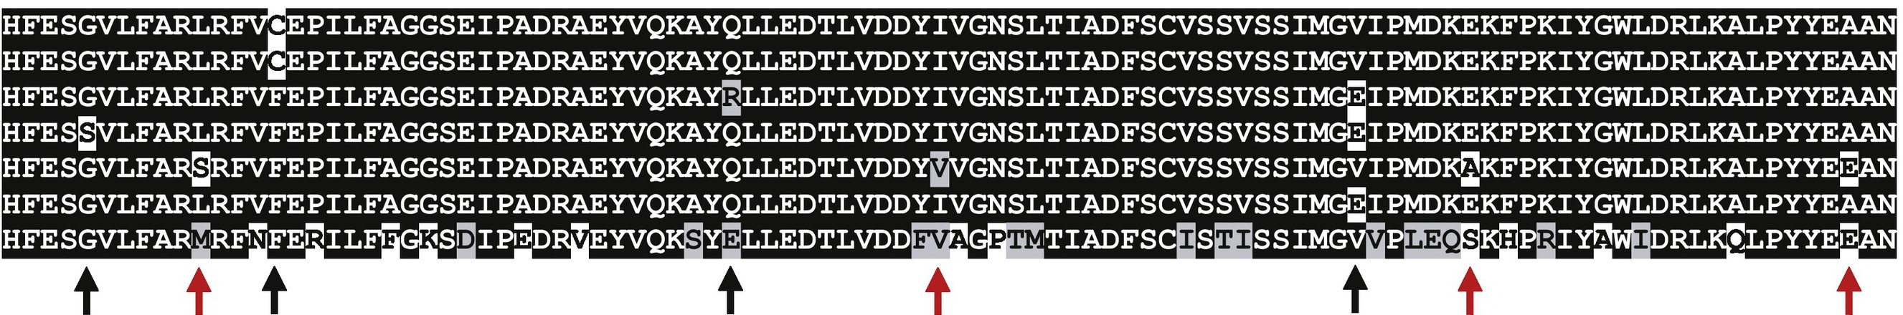

210 220
....1.... 1 .... 1 .. .. 1 ..

Figure 5

