TITLE: To Err is Human: Clinical Incident Calls to a National Travel Health Advice Line

AUTHORS:
Andrew D McCallum ^{a,*}, Sanch Kanagarajah ^{b}, Lisa Ford ^{b,c}, Dipti Patel ^{b}

AFFILIATIONS:
ª Hospital for Tropical Diseases, Capper Street, London, UK, WC1E 6JB
^{b} National Travel Health Network and Centre, UCLH NHS Foundation Trust, 250 Euston Road, London, UK, NW1 2PG
^{c} Liverpool School of Tropical Medicine, Pembroke Place, Liverpool, UK, L3 5QA
*Corresponding Author

CORRESPONDING AUTHOR DETAILS:
Dr Andrew McCallum
C/O Hospital for Tropical Diseases
2nd Floor
Mortimer Market
Capper Street
London WC1E 6JB
United Kingdom
Telephone: +44 20 3447 5959
Email: andrew.mccallum@nhs.net

INTRODUCTION
In 2018, UK residents made 71.7 million visits overseas, with holiday visits accounting for two-thirds of visits [1]. While most trips do not require any specific travel health advice, an increasing number of travellers are visiting destinations where malaria prophylaxis and travel vaccines are advised [1].

Travel advice in the UK is largely delivered in primary care, and typically offered by practice nurses using Patient Group Directions or Patient Specific Directions [2]. Since 2002, the National Travel Health Network and Centre (NaTHNaC) has provided a national telephone advice line for UK healthcare professionals (HCPs) with queries about travel scenarios with complex itineraries or travellers with special health needs. This service is nurse-led and supported by travel medicine physicians. While adverse events or side effects due to vaccines or malaria prophylaxis should be logged through the Medicines and Healthcare products Regulatory Agency (MHRA), the NaTHNaC service commonly receives calls and issues advice concerning clinical incidents. This study investigated the nature of all clinical incident calls to the NaTHNaC advice line between 2016 and 2018 to identify recurrent themes and highlight areas for further education.

METHODS
Since 2016, all telephone enquiries to the national advice line were logged onto a standard electronic record (Formic Limited, Uxbridge) by the nurse-advisor fielding the call. Data captured included details on where the call originated, traveller age, gender, travel destination, purpose of travel, and reason for enquiry. The nurse advisor classified the nature of the call, recorded any advice issued, and the data was stored in a secure database.

All calls logged between January 2016 and December 2018 were included, prior to a revision of the proforma. Episodes recorded by the nurse advisor as a ‘clinical incident’ were collated by interrogation of the database. Clinical incidents were broadly defined by the advisor or caller as episodes where practice was not in accordance with recommended standard practice. Incidents were classified as ‘further action essential’ (e.g. revaccination required, contra-indicated vaccine or prophylaxis given), ‘further action desirable’ (e.g. education required, reflective practice), or ‘no further action required’ (e.g. reassurance given to caller).

NaTHNaC did not routinely report incidents to national regulators directly (GMC, NMC, GPhC), but instead encouraged local incident reporting pathways and duty of candour. In the event of clinical incidents concerning yellow fever vaccines, the NaTHNaC Designation Panel could suspend a YFVC until satisfied with measures taken to prevent further incidents, and would inform the relevant UK regulator as required. Summary statistics were generated using the open-source statistical software R (version 3.5.0) [3].

RESULTS
In a 2-year period, 251 clinical incident calls were recorded from a total of 17,250 calls to the advice line. Two-hundred-and-three (81.2%) were from GP surgeries, with 20 (8.0%) from pharmacies. The remaining 28 (11.2%) came from private travel clinics, health protection / immunisation nurses, and occupational health. One-hundred-and-fifty-two (60.6%) were from Yellow Fever Vaccination Centres (YFVC): travel health clinics registered nationally, signing up to specific training, standards, and audit requirements. Most calls concerned vaccine use, and several calls involved multiple vaccines. Figure 1 illustrates the different vaccines discussed. Yellow fever (YF) was the commonest single vaccine discussed in 28.4% of vaccine clinical incident calls and accounted for 44.4% (7,658/17,250) of all calls to the advice line.

Further action was essential in 128 calls (51.0%). Of these, 51 calls (20.3%) were considered significant given the potential for harm to the traveller, typically due to requirement for further vaccination with live vaccine, or insufficient protection as a consequence of scheduling errors. Further action was desirable in 111 calls (44.2%), typically involving reflective practice and education, and no action was required in the remaining 12 calls (4.8%).

Vaccine Schedule Errors
Table 1 details the nature of clinical incident calls. The commonest reason for calling was wrong vaccine schedule used in 103 (41.0%) calls. Of these, 65 (63.1%) concerned hepatitis A or hepatitis B vaccination, either alone or in combination, followed by the combination of YF and measles, mumps, and rubella (MMR) vaccines in 15 (14.6%) calls. Schedule errors for hepatitis A/B vaccines typically occurred due to confusion when switching between paediatric and adult regimens, when combination vaccines were used, or when rapid immunity was sought using accelerated regimens. Fifty-four (62.1%) of these calls concerned travellers leaving for more than 12 months, at increased risk of hepatitis B. Due to concerns that co-administration of MMR vaccine and YF vaccine may result in sub-optimal antibody responses against YF, mumps and rubella antigens, YF and MMR should ideally be given 28 days apart [4, 5]. In most cases, the YFVC ascertained the use of MMR vaccine within 28 days only after the YF vaccine had been administered.

Advice given in the event of scheduling errors was context specific, but also typically involved Duty of Candour, following in-house critical incident reporting, and encouraging reflective practice. Reassurance was offered where no harm was expected, and additional, off-label, vaccine dosing advice considered where there were concerns about insufficient protection [6]. When YF and MMR vaccines were given less than 1 month apart, the advice given was in accordance with national recommendations and to consider repeat vaccination following a detailed risk assessment [5, 6].

Vaccine given but not recommended
In 26 calls (10.4%), a vaccine was administered that was not recommended. Seven YF vaccines were given to travellers that did not require it: administration to a non-travelling infant, misreading of travel destinations, or not realising that the traveller had received a prior YF vaccine. Three travellers received an additional typhoid vaccine after receiving combined hepatitis A / typhoid vaccine. HCPs were advised to inform and discuss the error with the traveller, and NaTHNaC followed up cases of travellers receiving YF vaccine in error by contacting the HCP after the initial call to assess the circumstances of the incident and offer further assistance.

Dosing error
Dosing errors were recorded in 19 (7.6%) travellers; 10 were hepatitis A and/or B vaccinations alone or in combination. This was typically due to the adult dose being administered instead of the paediatric, or vice versa. Two travellers had vaccine administered, but the HCP noted vaccine leak from the injection site. Where there was concern that insufficient vaccine had been given, revaccination was advised.

Other clinical incident episodes
The remaining 103 (41.0%) clinical incident reports were classed as ‘other’. Five (2%) events were due to cold chain failures, including fridge temperatures outside the recommended range of +2 to +8ºC. Where the stability of the vaccine could not be ensured, and following consultation with the vaccine manufacturers, advice was given regarding revaccination.

Four (1.5%) cases of contraindicated vaccine administration were noted. In each case, travellers were taking doses of immunosuppressant medication for inflammatory bowel disease or rheumatoid arthritis (azathioprine >3 mg/kg/day, mercaptopurine > 1.5 mg/kg/day, or methotrexate > 25 mg/week) that contra-indicated the use of live vaccines. [5]. All calls were risk assessed by a senior NaTHNaC clinician, and clinical advice given and management arranged as required.

Seven calls concerned antimalarial prophylaxis not used in accordance with UK recommendations [7]; for example, chloroquine prophylaxis for a traveller to India for more than 12 months, or long stay travellers to WHO African Region. Three malaria related calls involved contraindicated medications being given; doxycycline for a breastfeeding mother travelling to Nigeria, mefloquine to a traveller with a significant psychiatric history, and a mother who had given her own mefloquine to her child despite atovaquone/proguanil being advised by her HCP. In this case, the HCP had issued the correct advice, but assistance was needed to address the concerns of the mother and the practice.

The remaining calls were a heterogenous group, with 33 (39.8%) concerning the YF vaccine. Recurring issues included confusion between YF certification requirement versus recommendation (n=5, 2.0%), administration of expired vaccine (n=6, 2.4%), or route of vaccination (intramuscular or subcutaneous). Where concern about insufficient protection existed, revaccination was encouraged [6].

DISCUSSION
NaTHNaC receives approximately 6,000 calls for advice each year, with clinical incident calls accounting for 50-100 calls/year (approximately 2% of all calls). These typically take several formats: HCPs seeking advice after a clinical incident, reporting a clinical incident from another setting, or seeking reassurance or clarification. Table 2 details the key points from this study.

Issues around vaccines account for the majority of calls, with YF, hepatitis A, and hepatitis B the commonest vaccines discussed. Most calls concerned the wrong schedule or dose being administered, with advice sought on necessity of additional vaccination and whether the traveller's health was at risk: either from extra dosing or insufficient protection.

While in most cases the risk to the traveller was minimal, this study highlights several important areas for learning. Firstly, hepatitis A and B vaccine scheduling was a common cause of error. Hepatitis A vaccine is available in monovalent formulations, or in combination with typhoid or hepatitis B vaccine. The schedule differs depending on the specific vaccine administered, whether accelerated protection is required, or whether the traveller is a child or an adult. Familiarity with the schedules in the current UK vaccination recommendations (the “Green Book”) is recommended [5], and this information is also available on NaTHNaC’s TravelHealthPro website and provided through webinars [8].

Secondly, YF vaccine was a frequent cause for concern, accounting for 44% of all calls to the advice line. In the UK, this vaccine can only be administered at designated Yellow Fever Vaccination Centres where appropriate training and registration has occurred. Indeed, provision of registration, monitoring, and training for YFVCs was a key goal of setting up the NaTHNaC service. An estimated 500 million doses of YF vaccine have been given worldwide, and most vaccines are administered without complication [9]. However, the YF vaccine is associated with a low risk of serious adverse events following vaccination – including anaphylaxis, YF vaccine-associated neurologic disease (YEL-AND) and YF vaccine-associated viscerotropic disease (YEL-AVD) – such that careful risk-benefit analysis before YF vaccination is essential [5, 9].

Errors involving spacing of live vaccines are of concern given the risk of insufficient protection of travellers; recent reports of unvaccinated European travellers contracting YF after a visit to Brazil serving to illustrate the importance of pre-travel advice and vaccination [10]. Co-administration of YF vaccine alongside MMR is associated with sub-optimal antibody responses [4], and the recommendation stands that these vaccines should be separated by at least 28 days [5]. In several cases, recent administration of MMR vaccine was noted after the YF vaccine had been given, with advice given to consider re-vaccination against YF at an interval to be determined on a case-by-case basis. Equally, repeat MMR vaccination may need to be considered. MMR vaccination typically occurs in primary care rather than YFVC, so there may be a need to educate travellers to avoid YF vaccine for 28 days when they have received MMR, and encourage HCPs to specifically ask about other vaccines given in their risk assessment prior to administering any vaccines. Recent guidance from Public Health England provides advice for those who have received sub-potent vaccine(s) as a result of an error in the preparation or administration of the vaccine [6]. In these recommendations, immunisation providers are encouraged to report vaccine errors and incidents to local Screening and Immunisation Teams or commissioning organisations and seek appropriate advice on rescheduling. Lessons learned from reporting should be used to inform further practice.

Given the potential for serious side effects from unnecessary vaccination, awareness of individual countries YF International Certificates of Vaccination or Prophylaxis (ICVP) requirements versus recommendations could be improved. Outbreaks, and the changing epidemiology of YF transmission, require HCPs to keep up-to-date, and NaTHNaC’s ‘Yellow Fever Zone’ website offers regularly-updated country-specific guidance and is a helpful source of reference for YFVCs [11]. Extra care should be taken when travellers have itineraries involving several countries, and regular YF training and awareness of updates using reliable online resources should help to minimise these errors [5, 8, 11-13].

This study highlights the importance of careful medical and vaccine history taking, particularly to identify immunosuppressed travellers before live vaccines are given. Travel health advice is increasingly being provided outside the traveller’s GP setting, such as in pharmacies or commercial enterprises [14], where the traveller’s health record and vaccination history may be unavailable [15]. Calls to develop and implement digital ICVP and vaccine records may empower travellers and reduce the risk of unnecessary repeat vaccination [16]. While this paper concerned travel health related incidents, the findings are consistent with a review by Lang and colleagues of immunisation incidents reported to a vaccination advice service [17]. As highlighted in this paper, most errors would have been prevented if basic medicine management checks were undertaken.

Private and National Health Service (NHS) providers in the UK are monitored, inspected and regulated by the Care Quality Commission. Unless registering as a YFVC, travel clinics are not subject to specific travel clinic regulations though are subject to the same registration and licensing of healthcare practitioners (GMC, NMC, GPhC), principles of practice, and regulatory oversight. Public Health England has detailed the minimum standards and core curriculum for immunisation training in the UK, with the overarching principles that all practitioners involved in immunisation should have a high level of knowledge and are confident in immunisation policy and procedures [5, 18]. Generic immunisation training does not cover travel vaccines, and as such the Royal College of Nursing has developed a competency framework and defined standards of care for nurses working in travel health [20]. This framework details the standards expected for travel nurses from the level of competent nurse to senior practitioner, and will help the individual HCP identify their current scope of practice and future development needs for optimum safe practice.

Pharmacies accounted for 1,239 (7.2%) of all calls to the advice line, and 8% of clinical incident calls. The lower proportion of calls likely reflects that pharmacies are not the main providers of travel health services rather than systemic under-reporting. As for nurses, there are moves to introduce a minimum competency standard framework for pharmacists, and several multi-professional courses in travel health are available to pharmacists. To date, many of the advanced level courses are restricted to registered doctors and nurses only [14, 21].

To our knowledge, this is the only study reviewing episodes of travel health clinical incident reports to a national body. NaTHNaC is the national advice line for England, Wales, and Northern Ireland, and is likely to be one of the main contacts in the event of travel health related clinical incidents. However, the number of incidents occurring in practice is likely to be higher as the formal route for reporting adverse events due to vaccination is via the MHRA Yellow Card Scheme. Incidents that are unrecognised will not be identified by this study, and several may be dealt with at a local level. During busy periods to the advice line, a HCP may be unable to speak to an advisor so incidents are not logged. Furthermore, this study does not capture outcomes of any vaccine or prescribing errors. We may expect any cases where a traveller came to harm to be reported to NaTHNaC, but follow-up data is not routinely captured with current data collection tools and efforts are underway to improve the systematic capture of follow-up and outcome data from clinical incident calls to NaTHNaC.

NaTHNaC provides support and advice to those working in travel medicine throughout the country, often HCPs working with limited local support. Clinical incidents will occur in routine practice, and even where traveller safety has not been threatened, it can be a cause of considerable anxiety and stress for the individual practitioner. By highlighting common mistakes, sharing with travel health practitioners and providing additional learning materials, we hope to reduce avoidable clinical incidents in travel health.

DECLARATION OF INTEREST
The authors report that they have no conflict of interests.

FUNDING
This research did not receive any specific grant from funding agencies in the public, commercial, or not-for-profit sectors.

AUTHORS CONTRIBUTIONS
ADM and DP conceived and designed the analysis. SK collected the data. ADM performed the analysis and wrote the paper with support from SK, LF, and DP. All authors approved the final version of the manuscript.

ACKNOWLEDGEMENTS
The authors would like to thank the nurse-advisors at NaTHNaC for collecting the data on all calls to the advice line.

REFERENCES

1. Office for National Statistics. Travel Trends: 2018: Office for National Statistics; 2018 [cited 3 July 2019]. Available from: https://www.ons.gov.uk/peoplepopulationandcommunity/leisureandtourism/articles/traveltrends/2018.
2. Boddington NL, Simons H, Launders N, Gawthrop M, Stillwell A, Wong C, Mathewson J, Hill DR. Evaluation of travel medicine practice by yellow fever vaccination centers in England, Wales, and Northern Ireland. J Travel Med. 2012; 19(2): 84-91.
3. R Core Team. R: A language and environment for statistical computing. Vienna, Austria: R Foundation for Statistical Computing; 2017.
4. Nascimento Silva JR, Camacho LA, Siqueira MM, Freire Mde S, Castro YP, Maia Mde L, Yamamura AM, Martins RM, Leal Mde L. Mutual interference on the immune response to yellow fever vaccine and a combined vaccine against measles, mumps and rubella. Vaccine. 2011; 29(37): 6327-34.
5. Public Health England. Immunisation against infectious disease. London: The Stationary Office; 2017.
6. Public Health England. Vaccine Incident Guidance: Responding to errors in vaccine storage, handling and administration. London: PHE Publications; 2019.
7. Lalloo DG, Shingadia D, Bell DJ, Beeching NJ, Whitty CJM, Chiodini PL. UK malaria treatment guidelines 2016. J Infect. 2016; 72(6): 635-49.
8. National Travel Health Network and Centre. Travel Health Pro 2019 [cited 22 July 2019]. Available from: https://travelhealthpro.org.uk/.
9. Lindsey NP, Rabe IB, Miller ER, Fischer M, Staples JE. Adverse event reports following yellow fever vaccination, 2007-13. J Travel Med. 2016; 23(5).
10. National Travel Health Network and Centre. Yellow fever reported in traveller returning from Brazil 2019 [cited 12 August 2019]. Available from: https://www.gov.uk/government/news/yellow-fever-reported-in-traveller-returning-from-brazil.
11. National Travel Health Network and Centre. Yellow Fever Zone 2019 [cited 22 July 2019]. Available from: https://nathnacyfzone.org.uk/.
12. International Society for Infectious Diseases. ProMED 2019 [cited 25 September 2019]. Available from: http://www.promedmail.org/.
13. Health Protection Scotland. TRAVAX 2019 [cited 15 September 2019]. Available from: https://www.travax.nhs.uk/.
14. Evans D. Impact of pharmacy based travel medicine with the evolution of pharmacy practice in the UK. Pharmacy (Basel, Switzerland). 2018; 6(3): 64.
15. Maurer W, Seeber L, Rundblad G, Kochhar S, Trusko B, Kisler B, Kush R, Rath B. Standardization and simplification of vaccination records. Expert Rev Vaccines. 2014; 13(4): 545-59.
16. Wilson K, Atkinson KM, Bell CP. Travel vaccines enter the digital age: Creating a virtual immunization record. Am J Trop Med Hyg. 2016; 94(3): 485-8.
17. Lang S, Ford KJ, John T, Pollard AJ, McCarthy ND. Immunisation errors reported to a vaccine advice service: intelligence to improve practice. Qual Prim Care. 2014; 22(3): 139-46.
18. Public Health England. National minimum standards and core curriculum for immunisation training for registered healthcare practitioners. London: Public Health England; 2018.
19. Chiodini JH, Anderson E, Driver C, Field VK, Flaherty GT, Grieve AM, Green AD, Jones ME, Marra FJ, McDonald AC, Riley SF, Simons H, Smith CC, Chiodini PL. Recommendations for the practice of travel medicine. Travel Med Infect Dis. 2012; 10(3): 109-28.
20. Boyne LC, Chiodini J, Grieve S, Stillwell A. Competencies: Travel health nursing: career and competence development. London, Royal College of Nursing; 2018
21. Evans D. Review of training and education standards applied to pharmacy based travel medicine services in the UK. Travel Med Infect Dis. 2019: 101497.

Figure 1: Vaccines discussed in clinical incident calls
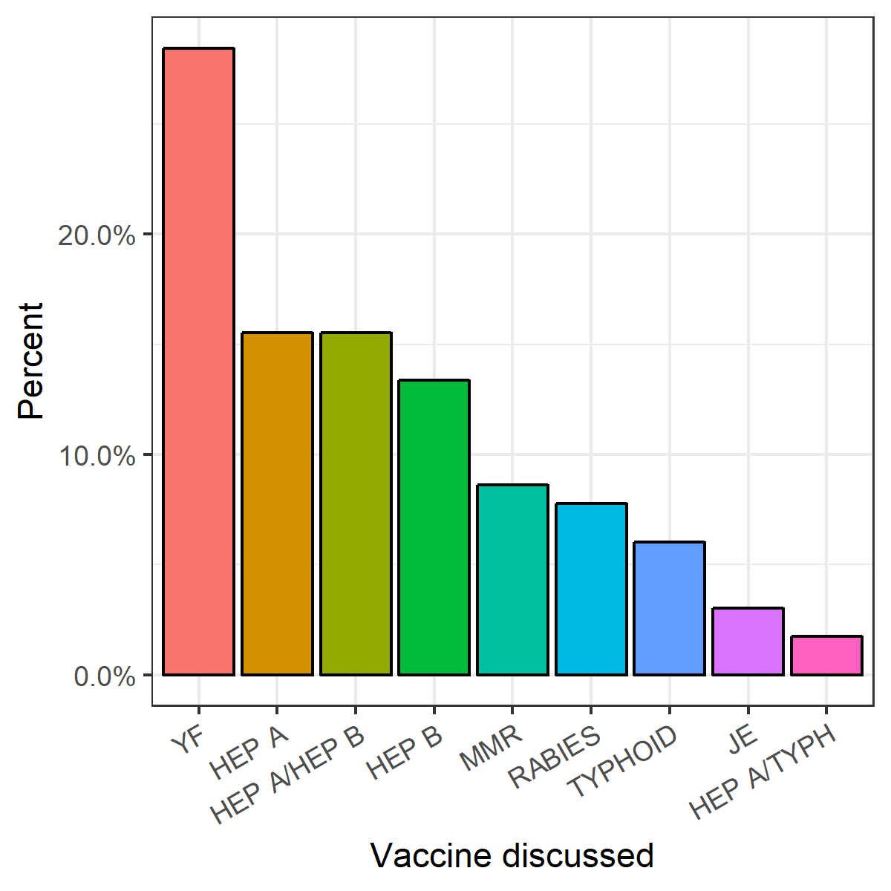
The bar chart illustrates the frequency different vaccines were discussed, with some calls involving more than one vaccine. Abbreviations: HEP: hepatitis; JE: Japanese encephalitis; MMR: measles, mumps, and rubella; TYPH: typhoid; YF: yellow fever.

Table 1: Clinical incident calls to a national enquiry line
Nature of call | Total (n=251)
Wrong vaccine schedule used (n, %) | 103 (41.0)
Vaccine given but not required (n, %) | 26 (10.4)
Dosing error (n, %) | 19 (7.6)
Cold chain problem (n, %) | 5 (2.0)
Wrong malaria prophylaxis for destination (n, %) | 4 (1.6)
Contraindicated vaccine given (n, %) | 4 (1.6)
Contraindicated malaria prophylaxis given (n, %) | 3 (1.2)
Other (n, %) | 87 (34.7)

Table 2: Key Points
Key Points
Clinical incidents concerning travel vaccines or malaria prophylaxis account for approximately 100 calls per year to a national telephone advice line for UK travel health practitioners.
In the majority of cases, the traveller was unlikely to come to harm.
Vaccine scheduling errors (typically hepatitis A or B) were the single commonest reason for calling.
Yellow fever vaccine was the commonest single vaccine discussed. Administration to immunosuppressed travellers has potential for harm.
Suspected adverse events related to travel vaccines or malaria prophylaxis should be reported to the appropriate national post-marketing safety surveillance programme (MHRA in UK).
Online resources are a readily available source of reference and educational materials for individual healthcare practitioners in travel health.

