Sex and area differences in the association between adiposity and lipid profile in Malawi

Ana Luiza G Soares ^{1,2}, Louis Banda ³, Alemayehu Amberbir ^{4,5}, Shabbar Jaffar ⁶, Crispin Musicha ³, Alison Price ^{3,7}, Moffat J Nyrienda ^{3,7}, Deborah A Lawlor ^{1,2}, Amelia C Crampin ^{3,7,8}

1 MRC Integrated Epidemiology Unit at the University of Bristol, Bristol, UK; 2 Population Health Sciences, Bristol Medical School, University of Bristol, Bristol, UK; 3 Malawi Epidemiology and Intervention Research Unit (MEIRU), Lilongwe and Karonga, Malawi; 4 Dignitas International, Zomba, Malawi; 5 Dalla Lana School of Public Health, University of Toronto, Toronto, Canada; 6 Department of International Public Health, Liverpool School of Tropical Medicine, Liverpool, UK; 7 Faculty of Epidemiology and Public Health, London School of Hygiene & Tropical Medicine, London, UK; 8 Institute of Health and Wellbeing, University of Glasgow, Glasgow, UK.

ABSTRACT
Background: Evidence from high-income countries shows that higher adiposity results in an adverse lipid profile, but it is unclear whether this association is similar in Sub-Saharan African (SSA) populations. This study aimed to assess the association between total and central adiposity measures and lipid profile in Malawi, exploring differences by sex and area of residence (rural/urban).

Methods: Data from 12,847 rural and 12,096 urban Malawian residents were used. The associations of body mass index (BMI) and waist-hip ratio (WHR) with fasting lipids (total cholesterol (TC), low density lipoprotein-cholesterol (LDL-C), high density lipoprotein-cholesterol (HDL-C) and triglycerides (TG)) were assessed by area and sex.

Results: A great proportion of adults have high BMI and WHR, and this was associated with adverse lipid profiles; higher BMI and WHR were linearly associated with increased TC, LDL-C and TG and reduced HDL-C. The associations were particularly strong in males, and in general, BMI was more strongly related to fasting lipids than was WHR. The increase in adiposity and abnormalities in lipid profile were higher in urban compared with rural residents.

Conclusions: The consistent associations observed of higher adiposity with adverse lipid profiles in females and males living in rural and urban areas of Malawi highlight the emerging adverse cardio-metabolic epidemic in this poor population. Our findings highlight the potential utility of measures of adiposity in estimating cardiovascular risk and underline the need for greater investment to understand the long-term health outcomes of obesity and adverse lipid profiles and the extent to which lifestyle changes and treatments effectively prevent and modify adverse cardio-metabolic outcomes.
Funding: Wellcome Trust

INTRODUCTION

In sub-Saharan Africa (SSA) the prevalence of overweight/obesity is increasing rapidly¹ in rural and urban populations that are experiencing lifestyle changes (i.e. greater sedentary behaviour, tobacco smoking, alcohol consumption, unhealthy diets and urbanization)²⁻⁶ and increasing life expectancy (due to reductions in child mortality⁷ and adult HIV-related mortality⁸). However, the extent to which this transition is affecting the risk and burden of dyslipidaemia is little understood. Although recent Mendelian randomization (using genetic variants as instrumental variables) and randomised controlled trial (RCT) evidence challenge the role of low levels of high density lipoprotein-cholesterol (HDL-C) in causing coronary heart diseases (CHD), high circulating total cholesterol (TC), low-density lipoprotein-cholesterol (LDL-C) and triglycerides (TG) are key causal risk factors for CHD ^{9,10}, and are effectively and cost-effectively reduced by statins with clear benefits for primary and secondary CHD prevention. In populations of white European origin, higher body mass index (BMI), waist to hip ratio (WHR) and waist circumference (WC) are associated with higher TC, LDL-C and TG ¹¹ but evidence from black SSA populations are limited. Most studies in SSA have been small or focused on HIV-positive individuals, and few have collected fasted blood samples.¹²⁻¹⁴
Some evidence suggests that African females are more adipose than Europeans,¹⁵ yet people of African ancestry have also been shown to have a more favourable lipid profile.¹⁶ In SSA 20 years ago, urban and rural risk profiles differed, with higher BMI associated with insulin resistance, and increased blood pressure, fasting glucose and TG (other lipids were not assayed) in urban residents, and lower lipid levels in rural residents.¹² Nonetheless, the rapid epidemiological transition, and the co-existence of insults such as infection, malnutrition (including undernutrition in early life and emerging overweight and obesity in adulthood)¹⁷, might influence manifestation of adiposity and lead to differences in the associations of adiposity with lipids in SSA populations. For example, in Malawi, a very poor SSA country, affected by childhood undernutrition and food insecurity, nearly 25% of the adult population have raised total cholesterol (≥ 5.0 mmol/l). ¹⁸
A better understanding of the extent to which the associations between adiposity (total and central) and lipids, including the influence of gender and residency (urban/rural) in SSA is essential to inform the long-term impact of obesity and dyslipidaemia on the burden of CHD in SSA countries and the development of tools (including cardiovascular risk scores) and interventions appropriate for the setting.
In this study we use population representative data from urban and rural Malawi to investigate the association between total and central adiposity measures and lipid profile, by sex and area of residence.

METHODS
Study design, setting and participants
The Malawi Epidemiology and Intervention Research Unit (MEIRU) collected baseline non-communicable disease data, including interviewer-led questionnaires, anthropometric and blood pressure measures and fasted blood sample in urban and rural populations using a cross-sectional study design between May 2013 and April 2017. The rural site was in Southern Karonga district, where an established Health and Demographic Health Surveillance Site (HDSS) is located, and the urban site was an enumerated zone in Area 25 of Lilongwe, the capital city, in the Central Region. The two study sites have age and sex structures comparable to the national rural and urban populations and are similar to the national average in most socioeconomic, lifestyle and health indicators ^{19,20}. Details on recruitment and data collection were previously described.²¹⁻²³
For this study, we excluded people without serum lipids and those who reported not fasting before the blood collection. Ethical review for this study was obtained from the Malawi National Health Sciences Research Committee (NHSRC; protocol #1072) and London School of Hygiene and Tropical Medicine (LSHTM) Ethics Committee (protocol #6303).
Recruitment and study information was collected at the participant’s household by interviewers and nurses. Questionnaires were available in English, Chichewa (the main language of the Central Region) and Chitumbuka (the main language of the Northern Region), and the data were collected using Open Data Kit on Android operating system tablets.

Data collection and definitions
Serum lipids (TC, LDL-C, HDL-C and TG) were obtained from a morning venepuncture sample, after a minimum 8-hour fast. Non-fasted participants were re-visited once after a second request to fast overnight. The samples were processed on the same day (within an average of 2.6 hours), and all fasting lipids were assayed using the enzymatic method (Beckman Coulter Chemistry Analyser, model AU480). The two laboratories (one each in the rural and urban centres) participated in external (Thistle RSA system) and internal quality controls (exchanging samples between sites for repeat testing).²³ Inter and intra-batch coefficients of variation were less than 3% for all lipid measures.
TC, LDL-C and TG were considered high if they were ≥5.2 mmol/L, 3.4 mmol/L and 1.7 mmol/L, respectively, and HDL-C was considered low if it was < 1.0 mmol/L. ²⁴
Anthropometric measures using standard protocols were taken twice, and the mean of the two used in all analyses. Participants were asked to remove shoes, outer clothing and headdresses. Electronic scales (accuracy of 100g) were used to measure weight, portable stadiometers (accuracy of 1mm) were used for height, and waist and hip measurements were taken using a non-stretch metallic tape with a narrow blade and a blank lead-in. WC was measured on bare skin in the narrowest part of the abdomen between the ribs and iliac crest, and hip circumference was measured over light clothing at the widest part of the buttock.

Potential confounders
We considered ethnicity, household assets score, education, marital status, parity, smoking status, alcohol intake, physical activity, lipid-lowering medication, and HIV/ antiretroviral therapy (ART) status as confounders. Full details of the methods used to measure and categorise these variables are provided in Supplementary material.

Statistical Analysis
We internally age-standardised all analyses to enable comparisons between women and men in rural and urban areas. We examined associations between adiposity and lipids as continuous measures and as binary measures, the latest presents in Supplementary material.
We used multiple linear regression to examine the association of both BMI and WHR with each lipid measure, adjusted initially for age and then for potential confounding by ethnicity, household assets, education, marital status, parity, smoking, alcohol, physical activity, lipid-lowering medication, and HIV/ART status. We examined the pattern of association (e.g. linear or non-linear) by inspecting the graphs of mean lipid levels by fifths of the BMI and WHR z-scores (by sex and area) and comparing models using z-scored fifths of BMI and WHR included as categorical variable or continuous score using a likelihood ratio test. Considering no evidence of non-linearity in the associations, we present the mean difference in age-standardised lipid level for a 1-SD (z-score) increase in BMI or WHR. Statistical methods for analysis using binary measures are described in Supplementary material.
All associations were undertaken in four strata – females from the rural area, males from the rural area, females from the urban area and males from the urban area, as rural and urban residents have different lifestyles. Evidence for differences by sex or area of residence was determined by comparing results across these strata and computing statistical tests for interactions between sex and each anthropometric measurement and between area of residence and each anthropometric measurement. Considering HIV and ART are associated with adverse lipid profile ²⁵, we further explored whether HIV status modified the association between BMI/WHR and lipids by computing tests for interactions between HIV status and each anthropometric measurement.
The analyses were carried out in the software Stata 15.1® (Statcorp, College Station, TX, USA).

Role of the funding source
The study funders had no role in the study design, collection, analysis, and interpretation of data or report writing. The corresponding author had full access to the data and the final responsibility to submit for publication.

RESULTS
From the 33,177 eligible people aged 18 years and above, 30,575 (13,903 in rural and 16,672 in urban area) provided written informed study consent. Fasting lipid measurements were available for 24,943 individuals (12,847 rural and 12,096 urban setting) (Figure 1). In general, those with missing lipid data were more likely to be males, from urban area, younger, to have lower BMI, and to be unmarried (Supplementary Tables 1 and 2). Females with missing data were also more likely to have a lower number of pregnancies and to have lower levels of physical activity.
Compared to the rural population, urban residents were younger, had higher education and median household assets score, and were more likely to be unmarried and to have lower parity (Table 1). Smoking and alcohol drinking were predominantly male behaviours, and current smoking and a higher frequency of alcohol intake was most prevalent among rural males. Most of the population reported high levels of physical activity, especially among females. Less than 1% have received a diagnosis of high cholesterol, and of those, 85% reported not taking any lipid-lowering medication. HIV prevalence of those consenting to be tested was 10.6% and it was higher in females and rural residents; 90.8% of participants who were HIV positive reported being on ART. Missing data in those included in the analysis represented less than 6%, except for HIV/ART status, which was 18.5%, and higher in rural area (27.5%) (Supplementary Table 3).
BMI was higher in females than males and in urban than rural residents, but WHR was higher in males than females and in rural residents compared to urban residents (Supplementary Table 5). All age-standardised lipid means were higher in urban than rural participants, with TC, LDL-C and HDL-C being higher in females, and TG higher in males in both rural and urban settings (Figure 2, Supplementary Table 4). Of the total participants, 10.8%, 16.4%, 32.9% and 8.9% had high TC, high LDL-C, low HDL-C and high TG, respectively, and 48.9% had any dyslipidaemia, with differences between rural and urban and male and female groups reflecting the pattern of differences in mean levels of these lipids (Supplementary Table 5).
There was no strong evidence of departure from linear associations between BMI/WHR and the lipids in any of the groups (Supplementary Figure 1). In adjusted models, there were positive associations of BMI and WHR with TC, LDL-C and TG and inverse with HDL-C in both males and females in rural and urban areas (Table 1, in mmol/L; Figure 3, in SD). The magnitude of the associations, particularly for TC and LDL-C, were stronger for BMI than WHR. Associations between BMI/WHR and serum lipids were in general similar in magnitude between males and females, but the association between BMI and TG was noticeably stronger in urban males than urban females. Differences by area were observed in associations with BMI, and the associations with all serum lipids were stronger in rural than urban females, except for HDL-C, which was stronger in urban than rural females.
For comparison, age-adjusted only associations are shown in Supplementary Figure 2, and there was little difference in the overall patterns of association between age-only and confounder-adjusted analyses. Associations with binary levels of each lipid (high TC, high LDL-C, low HDL-C and high TG) followed the patterns we would expect from the results presented here with continuously measured outcomes given associations with BMI/WHR with the continuous measures were linear (Supplementary Table 6, Supplementary Figure 3).
Overall, the associations between BMI/WHR and serum lipids were similar in HIV infected and uninfected individuals (Supplementary Figure 4). Noticeable differences were observed for the association between BMI and TG in males, which was stronger in HIV negative than HIV positive men, and between WHR and TG in females, which was stronger in HIV positive than HIV negative women.

DISCUSSION
Our large study in Malawi shows urban residents have a less favourable lipid profile than rural residents and that in both settings females tended to have less favourable profiles than males. We found positive linear associations of both BMI and WHR with TC, LDL-C and TG, and an inverse association with HDL-C in rural and urban Malawian females and males, with little evidence of differences between males and females, but evidence of differences between rural and urban residents. Notably, the association between BMI and all serum lipids, except for HDL-C, was stronger in rural than urban residents, especially in females. The magnitude of the association between adiposity and lipid profile was generally stronger for BMI than WHR. This is consistent with our earlier findings of stronger associations of BMI than WHR with fasting glucose, diabetes, systolic and diastolic blood pressure, and hypertension,²² suggesting that BMI may be a useful predictor of adverse cardio-metabolic outcomes in this population Work to validate cardiovascular risk scores by linking to outcomes in the region is ongoing. Based on the results presented here we would determine the predictive ability (discrimination and calibration) of existing scores (largely developed in high income countries) and also whether these differ between rural and urban populations, as well as developing new tools for this SSA population.
Other studies carried out in SSA countries also found higher BMI (or higher prevalence of obesity) ^{14,26-30} and more adverse lipid profile in women than men ^{14,28,30-32}. Despite differences in adiposity and lipid profiles between males and females, sex differences in the associations between BMI/WHR and lipids were less evident. A markedly stronger association between BMI and TG in urban males than females was observed, and although sex differences were evident in other associations, the magnitudes of the differences were small.
Higher adiposity and poorer lipid profile in urban than rural residents corroborates with finding from other studies in SSA ^{27,29,32,33} Although ethnic differences between rural and urban residents may also play a role, rapid urbanization and its subsequent changes in lifestyle (e.g. decrease in physical activity, and increase in alcohol intake, access to processed food and consumption of unhealthy diets) might explain the more adverse cardiometabolic profile in urban residents compared to the rural setting. Even though Malawi has a low percentage of the population living in urban area (about 16%) and has a lower urbanization rate then other SSA countries, the urban population is expected to double by 2050,⁶ and therefore the consequences related to urbanization might become more worrying.
Stronger associations between BMI and TC, LDL-C and TG, and weaker association with HDL-C were found in rural than urban residents, and this difference was especially observed in females. We were unable to identify other SSA studies that had explored these associations and acknowledge that further replication would be required before we can assume that these are not chance findings.
The prevalence of HIV found in our study is comparable with national estimates, ²⁰ and the majority of participants who were HIV positive reported being on ART. HIV infection and ART are known to be associated with cardiometabolic traits, such as adiposity and lipid profile ²⁵, and in our study most associations were similar between infected and uninfected participants, but the association of WHR and TG in females was particularly stronger in HIV positive women. We did not find other studies that explored the association between BMI/WHR and lipids in HIV-infected and uninfected individuals is SSA.

Strengths and limitations
Our study was sufficiently large to explore associations by sex and urban and rural locations. The use of fasting lipids and of rigorous, standardised protocols and quality control procedures for data collection are also strengths of our study.
A key limitation of this study is its cross-sectional nature which means we cannot assume that the associations of adiposity with lipids that we have found are causal. Mendelian randomization studies and result of trials of bariatric surgery support causal effects of adiposity on HDL-C and TG, though are less clear for LDL-C.^{9,10,34} We adjusted for a wide-range of plausible confounders, but misclassification of self-reported lifestyle characteristics, such as alcohol consumption and physical activity, might mean that we have not fully accounted for these. We did not have data on dietary intake and therefore could not consider it in the analyses.
The high proportion of missing lipid data in urban residents, especially males, might have resulted in some selection bias and is likely to have affected the lipid means and prevalence of dyslipidaemia. The prevalence of high TC, LDL-C and TG was considerably lower than found in a recent meta-analysis of studies in African adults. ³⁵ However, our association results would be biases if, in those with missing lipid data, associations were remarkably different from those with lipid information, even after taking into account age, sex, ethnicity, area of residence, education, household assets, smoking status, alcohol intake, physical activity level, and HIV/ART status. Although we cannot rule out this possibility, it is unlikely to be the case. The much higher level of missing data for HIV/ART status in rural compared with urban areas might mean that we have greater residual confounding by this in rural than urban participants. However, this would tend to result in consistently weaker associations in rural groups, which is not what we have found.

Conclusions and implications
In a large, well-conducted study we have shown that higher BMI and WHR are associated with adverse lipid profiles in females and males in both rural and urban Malawi. Associations were stronger for BMI than WHR, and BMI may be a more reliable indicator of dyslipidaemia than WHR, with greater utility in non-blood based cardiovascular risk score development. Our findings illustrate some of the nature of the emerging cardio-metabolic disease epidemic in Malawi and highlight the need for greater investment to understand the longer-term health outcomes of obesity and adverse lipid profiles and the extent to which lifestyle change and treatments effectively prevent and manage adverse cardio-metabolic outcomes in rural and urban populations in Malawi and potentially in other SSA populations.

Declaration of interests
We declare no competing interests.

Funding
Wellcome (Grant ref: 098610/Z/12/Z and 098610/B/12/A) provides core support for MEIRU. ALGS and DAL work in a Unit that is supported by the University of Bristol and UK Medical Research Council (MC_UU_00011/6) and DAL is a UK National Institute of Research Senior Investigator (NF-SI-0611-10196). No funders had any influence on the analysis plan, results presented or decision to publish. The views expressed in this paper are those of the authors and not necessarily any funding body.

Acknowledgments
We are grateful to the Karonga and Lilongwe communities, participants and traditional authorities, for their engagement in this work. This study would not have been possible without the MEIRU and Malawi Ministry of Health. We thank the Wellcome Trust for supporting our study.

REFERENCES
1. NCD Risk Factor Collaboration (NCD-RisC) – Africa Working Group. Trends in obesity and diabetes across Africa from 1980 to 2014: an analysis of pooled population-based studies. Int J Epidemiol. 2017;46(5):1421-32.10.1093/ije/dyx078
2. Cappuccio FP, Miller MA. Cardiovascular disease and hypertension in sub-Saharan Africa: burden, risk and interventions. Intern Emerg Med. 2016;11(3):299-305.10.1007/s11739-016-1423-9
3. Eriksen M, Mackay J, Schluger N, Gomeshtapeh FI, Drope J. The Tobacco Atlas: Fifth Edition. Atlanta, Georgia: American Cancer Society; 2015.
4. World Health Organization. Global status report on alcohol and health 2014. Geneva: World Health Organization; 2014.
5. Dalal S, Beunza JJ, Volmink J, Adebamowo C, Bajunirwe F, Njelekela M, et al. Non-communicable diseases in sub-Saharan Africa: what we know now. Int J Epidemiol. 2011;40(4):885-901.10.1093/ije/dyr050
6. United Nations. World Urbanization Prospects: The 2014 Revision, Highlights. In: Department of Economic and Social Affairs, editor. 2014.
7. Kanyuka M, Ndawala J, Mleme T, Chisesa L, Makwemba M, Amouzou A, et al. Malawi and Millennium Development Goal 4: a Countdown to 2015 country case study. Lancet Glob Health. 2016;4(3):e201-14.10.1016/S2214-109X(15)00294-6
8. Price AJ, Glynn J, Chihana M, Kayuni N, Floyd S, Slaymaker E, et al. Sustained 10-year gain in adult life expectancy following antiretroviral therapy roll-out in rural Malawi: July 2005 to June 2014. Int J Epidemiol. 2017;46(2):479-91.10.1093/ije/dyw208
9. Xu L, Borges MC, Hemani G, Lawlor DA. What mediates the effect of body mass index on coronary heart disease? A two-step, two-sample Mendelian randomization study. Diabetologia. 2017;60(11):2210:20
10. Herrera MF, Pantoja JP, Velázquez-Fernández D, Cabiedes J, Aguilar-Salinas C, García-García E, et al. Potential additional effect of omentectomy on metabolic syndrome, acute-phase reactants, and inflammatory mediators in grade III obese patients undergoing laparoscopic Roux-en-Y gastric bypass. Diabetes Care. 2010;33(7):1413-8
11. Ashwell M, Gunn P, Gibson S. Waist-to-height ratio is a better screening tool than waist circumference and BMI for adult cardiometabolic risk factors: systematic review and meta-analysis. Obes Rev. 2012;13(3):275-86.10.1111/j.1467-789X.2011.00952.x
12. Mbanya VN, Echouffo-Tcheugui JB, Akhtar H, Mbanya JC, Kengne AP. Obesity phenotypes in urban and rural Cameroonians: a cross-sectional study. Diabetol Metab Syndr. 2015;7.10.1186/s13098-015-0016-5
13. Amberbir A, Singano V, Matengeni A, Ismail Z, Kawalazira G, Chan AK, et al. Dyslipidemia among rural and urban HIV patients in south-east Malawi. Plos One. 2018;13(5):e0197728.10.1371/journal.pone.0197728
14. Asiki G, Murphy GA, Baisley K, Nsubuga RN, Karabarinde A, Newton R, et al. Prevalence of dyslipidaemia and associated risk factors in a rural population in South-Western Uganda: a community based survey. Plos One. 2015;10(5):e0126166.10.1371/journal.pone.0126166
15. World Health Organization. Global status report on non-communicable diseases 2014. Geneva: World Health Organization; 2015.
16. Bentley AR, Rotimi CN. Interethnic Differences in Serum Lipids: Implications for Cardiometabolic Disease Risk in African Ancestry Populations. Glob Heart. 2017.10.1016/j.gheart.2017.01.011
17. Min J, Zhao Y, Slivka L, Wang Y. Double burden of diseases worldwide: coexistence of undernutrition and overnutrition-related non-communicable chronic diseases. Obes Rev. 2018;19(1):49-61.10.1111/obr.12605
18. World Health Organization. Global status report on non-communicable diseases 2010. Geneva: World Health Organization; 2011.
19. National Statistical Office. Malawi 2008 population and housing census results. Zomba, Malawi: National Statistical Office and ICF; 2008.
20. National Statistical Office Malawi and ICF. Malawi demographic and health survey 2015–16. Zomba, Malawi: National Statistical Office and ICF; 2017.
21. Price AJ, Crampin AC, Amberbir A, Kayuni-Chihana N, Musicha C, Tafatatha T, et al. Prevalence of obesity, hypertension, and diabetes, and cascade of care in sub-Saharan Africa: a cross-sectional, population-based study in rural and urban Malawi. Lancet Diabetes Endocrinol. 2018;6(3):208-22.10.1016/S2213-8587(17)30432-1
22. Mudie K, Lawlor DA, Pearce N, Crampin A, Tomlinson L, Tafatatha T, et al. How does the association of general and central adiposity with glycaemia and blood pressure differ by gender and area of residence in a Malawian population: a cross-sectional study. Int J Epidemiol. 2018.10.1093/ije/dyy047
23. Crampin AC, Kayuni N, Amberbir A, Musicha C, Koole O, Tafatatha T, et al. Hypertension and diabetes in Africa: design and implementation of a large population-based study of burden and risk factors in rural and urban Malawi. Emerg Themes Epidemi. 2016;13.10.1186/s12982-015-0039-2
24. National Cholesterol Education Program Expert Panel on Detection E, Treatment of High Blood Cholesterol in A. Third Report of the National Cholesterol Education Program (NCEP) Expert Panel on Detection, Evaluation, and Treatment of High Blood Cholesterol in Adults (Adult Treatment Panel III) final report. Circulation. 2002;106(25):3143-421
25. Dillon DG, Gurdasani D, Riha J, Ekoru K, Asiki G, Mayanja BN, et al. Association of HIV and ART with cardiometabolic traits in sub-Saharan Africa: a systematic review and meta-analysis. Int J Epidemiol. 2013;42(6):1754-71.10.1093/ije/dyt198
26. Ayah R, Joshi MD, Wanjiru R, Njau EK, Otieno CF, Njeru EK, et al. A population-based survey of prevalence of diabetes and correlates in an urban slum community in Nairobi, Kenya. Bmc Public Health. 2013;13.10.1186/1471-2458-13-371
27. Okpechi IG, Chukwuonye II, Tiffin N, Madukwe OO, Onyeonoro UU, Umeizudike TI, et al. Blood Pressure Gradients and Cardiovascular Risk Factors in Urban and Rural Populations in Abia State South Eastern Nigeria Using the WHO STEPwise Approach. Plos One. 2013;8(9).10.1371/journal.pone.0073403
28. Njelekela MA, Mpembeni R, Muhihi A, Mligiliche NL, Spiegelman D, Hertzmark E, et al. Gender-related differences in the prevalence of cardiovascular disease risk factors and their correlates in urban Tanzania. BMC Cardiovasc Disord. 2009;9:30.10.1186/1471-2261-9-30
29. Agyemang C, Meeks K, Beune E, Owusu-Dabo E, Mockenhaupt FP, Addo J, et al. Obesity and type 2 diabetes in sub-Saharan Africans - Is the burden in today's Africa similar to African migrants in Europe? The RODAM study. Bmc Med. 2016;14.10.1186/s12916-016-0709-0
30. Clark SJ, Gomez-Olive FX, Houle B, Thorogood M, Klipstein-Grobusch K, Angotti N, et al. Cardiometabolic disease risk and HIV status in rural South Africa: establishing a baseline. Bmc Public Health. 2015;15:135.10.1186/s12889-015-1467-1
31. Msyamboza KP, Kathyola D, Dzowela T, Bowie C. The burden of hypertension and its risk factors in Malawi: nationwide population-based STEPS survey. Int Health. 2012;4(4):246-52.10.1016/j.inhe.2012.09.005
32. Kodaman N, Aldrich MC, Sobota R, Asselbergs FW, Poku KA, Brown NJ, et al. Cardiovascular Disease Risk Factors in Ghana during the Rural-to-Urban Transition: A Cross-Sectional Study. Plos One. 2016;11(10).10.1371/journal.pone.0162753
33. Obirikorang C, Osakunor DN, Anto EO, Amponsah SO, Adarkwa OK. Obesity and Cardio-Metabolic Risk Factors in an Urban and Rural Population in the Ashanti Region-Ghana: A Comparative Cross-Sectional Study. Plos One. 2015;10(6):e0129494.10.1371/journal.pone.0129494
34. Martins C, Strømmen M, Stavne OA, Nossum R, Mårvik R, Kulseng B. Bariatric surgery versus lifestyle interventions for morbid obesity—changes in body weight, risk factors and comorbidities at 1 year. Obesity Surgery. 2011;21(7):841-9
35. Noubiap JJ, Bigna JJ, Nansseu JR, Nyaga UF, Balti EV, Echouffo-Tcheugui JB, et al. Prevalence of dyslipidaemia among adults in Africa: a systematic review and meta-analysis. Lancet Global Health. 2018;6(9):E998-E1007.Doi 10.1016/S2214-109x(18)30275-4

Table 1. Characteristics of the Malawian population according to area of residence and sex.
 |  | All  N=24,943  (%) | Rural Residents |  | Urban Residents
 |  |  | Females  n=7,096  (58.7%) | Males  n=5,000  (41.3%) | Females  n=8,563  (66.7%) | Males  n=4,284  (33.3%)
Age - mean (SD) |  | 35.2 (14.7) | 37.6 (15.6) | 38.1 (16.5) | 32.4 (12.4) | 33.2 (14.1)
Ethnicity – N (%) | Chewa | 4,934 (19.8) | 180 (2.5) | 106 (2.1) | 3,183 (37.2) | 1,465 (34.2)
 | Tumbuka | 10,815 (43.4) | 5,355 (75.5) | 3,847 (77.0) | 1,025 (12.0) | 588 (13.7)
 | Ngoni | 2,746 (11.0) | 142 (2.0) | 99 (2.0) | 1,691 (19.8) | 814 (19.0)
 | Yao | 1,052 (4.2) | 18 (0.2) | 20 (0.4) | 665 (7.7) | 349 (8.1)
 | Lomwe | 1,810 (7.2) | 13 (0.2) | 10 (0.2) | 1,146 (13.4) | 641 (15.0)
 | Nkonde | 979 (3.9) | 517 (7.3) | 267 (5.3) | 133 (1.5) | 62 (1.5)
 | Other | 2,607 (10.5) | 871 (12.3) | 651 (13.0) | 720 (8.4) | 365 (8.5)
Education – N (%) | No formal | 892 (3.6) | 376 (5.3) | 82 (1.6) | 382 (4.4) | 52 (1.2)
 | Standard 1-5 | 2,632 (10.5) | 1,142 (16.1) | 522 (10.4) | 779 (9.1) | 189 (4.4)
 | Standard 6-8 | 8,352 (33.5) | 3,715 (52.3) | 2,076 (41.5) | 1,958 (22.9) | 603 (14.1)
 | Secondary | 10,722 (43.0) | 1,794 (25.3) | 2,177 (43.6) | 4,315 (50.4) | 2,436 (56.9)
 | Tertiary | 2,345 (9.4) | 69 (1.0) | 143 (2.9) | 1,129 (13.2) | 1,004 (23.4)
Quintiles of household assets score – median (IQR) | 1 | 41.0 (52.5) | 31.5 (31.0) | 33.0 (33.0) | 70.5 (41.0) | 72.5 (39.5)
 | 2 | 117.5 (131.0) | 74.5 (14.0) | 74.5 (16.5) | 205.5 (46.5) | 205.5 (58.5)
 | 3 | 282.5 (209.5) | 115.5 (10.0) | 115.5 (10.0) | 325.5 (183.5) | 325.5 (160.5)
 | 4 | 520.5 (286.0) | 234 (38.5) | 234.5 (39.5) | 520.5 (35.0) | 520.5 (35.0)
 | 5 | 2405.5 (2058.5) | 457.5 (177.2) | 459.5 (200.0) | 2520.5 (35.0) | 2520.5 (35.0)
Marital status –  N (%) | Never married | 5,442 (21.8) | 508 (7.2) | 1,134 (22.7) | 1,777 (20.8) | 2,023 (47.2)
 | Married | 16,119 (64.7) | 4,946 (69.8) | 3,616 (72.5) | 5,490 (64.1) | 2,067 (48.3)
 | Widowed | 1,563 (6.3) | 878 (12.4) | 62 (1.2) | 561 (6.5) | 62 (1.4)
 | Divorced | 1,799 (7.2) | 752 (10.6) | 180 (3.6) | 735 (8.6) | 132 (3.1)
Number of  pregnancies ª –  N (%) | 0 | 2,031 (13.0) | 469 (6.6) | NA | 1,560 (18.2) | NA
 | 1 | 2,181 (13.9) | 704 (10.0) | NA | 1,476 (17.3) | NA
 | 2 | 2,420 (15.5) | 886 (12.5) | NA | 1,534 (17.9) | NA
 | 3 | 2,2254 (14.4) | 937 (13.2) | NA | 1,317 (15.4) | NA
 | 4+ | 6,754 (43.2) | 4,079 (57.7) | NA | 2,675 (31.2) | NA
Smoking status –  N (%) | Never | 23,323 (93.5) | 7,077 (99.7) | 4,114 (82.3) | 8,518 (99.5) | 3,614 (84.4)
 | Former | 565 (2.3) | 8 (0.1) | 227 (4.5) | 29 (0.3) | 301 (7.0)
 | Current | 1,055 (4.2) | 11 (0.2) | 659 (13.2) | 16 (0.2) | 369 (8.6)
Alcohol intake –  N (%) | Never | 20,540 (82.4) | 6,854 (96.6) | 2,906 (58.1) | 8,036 (93.8) | 2,744 (64.0)
 | < 1 month | 1,174 (4.7) | 98 (1.4) | 477 (9.5) | 240 (2.8) | 359 (8.4)
 | 1-3 days/ month | 1,520 (6.1) | 87 (1.2) | 670 (13.4) | 202 (2.4) | 561 (13.1)
 | 1-4 days/ week | 1,333 (5.3) | 49 (0.7) | 759 (15.2) | 63 (0.7) | 462 (10.8)
 | 5+ days/ week | 376 (1.5) | 8 (0.1) | 188 (3.8) | 22 (0.3) | 158 (3.7)
Physical activity level ^{b} - N (%) | Low | 527 (2.1) | 100 (1.4) | 115 (2.3) | 127 (1.5) | 185 (4.3)
 | Moderate | 1,545 (6.2) | 224 (3.2) | 529 (10.6) | 204 (2.4) | 588 (13.7)
 | High | 22,871 (91.7) | 6,772 (94.4) | 4,356 (87.1) | 8,232 (96.1) | 3,511 (82.0)
Lipid-lowering medication – | No raised cholesterol | 24,881 (99.75) | 7,088 (99.9) | 4,997 (99.94) | 8,528 (99.6) | 4,268 (99.63)
N (%) | No medication | 53 (0.21) | 8 (0.1) | 2 (0.04) | 28 (0.3) | 15 (0.35)
 | Taking medication | 9 (0.04) | 0 (0.0) | 1 (0.02) | 7 (0.1) | 1 (0.02)
HIV status – N (%) | HIV negative | 18,739 (89.4) | 4,729 (87.0) | 3,325 (89.5) | 7,203 (89.1) | 3,551 (93.6)
 | HIV positive | 2,217 (10.6) | 709 (13.0) | 381 (10.5) | 883 (10.9) | 244 (6.4)
ART status ^{c} –  N (%) | On ART | 1,440 (90.8) | 482 (94.2) | 239 (89.9) | 573 (89.4) | 139 (86.9)
 | Not on ART | 146 (9.2) | 30 (5.8) | 27 (10.1) | 68 (10.6) | 21 (13.1)
ART: anti-retroviral therapy; HIV: human immunodeficiency virus; IQR: interquartile range; NA: not applicable; SD: standard deviation
ª Information available only for females
^{b} Level of physical activity based on metabolic equivalent (MET)
^{c} Based on those who reported being HIV positive

Table 2. Adjusted association between BMI/WHR and serum lipids in Malawian rural and urban females and males.
 | Adjusted difference in outcome per 1 SD higher BMI (95% CI) | Adjusted difference in outcome per 1 SD higher WHR (95% CI)
Difference in mean TC (mmol/L)
Rural females (N=4,971) (N=4,975) | 0.23 (0.19; 0.26) | 0.06 (0.03; 0.09)
Rural males (N=3,548) (N=3,549) | 0.20 (0.16; 0.23) | 0.07 (0.04; 0.10)
Urban females (N=7,455) | 0.13 (0.11; 0.15) | 0.10 (0.07; 0.12)
Urban males (N=3,705) | 0.15 (0.13; 0.18) | 0.08 (0.06; 0.11)
P-values for difference between sex | 0.009 | 0.412
P-values for difference between area | <0.001 | 0.450
Difference in mean LDL-C (mmol/L)
Rural females (N=4,971) (N=4,975) | 0.22 (0.19; 0.24) | 0.06 (0.04; 0.09)
Rural males (N=3,548) (N=3,549) | 0.18 (0.16; 0.21) | 0.07 (0.05; 0.10)
Urban females (N=7,455) | 0.15 (0.13; 0.17) | 0.10 (0.08; 0.11)
Urban males (N=3,705) | 0.17 (0.15; 0.19) | 0.09 (0.07; 0.11)
P-values for difference between sex | 0.015 | 0.222
P-values for difference between area | 0.001 | 0.045
Difference in mean HDL-C (mmol/L)
Rural females (N=4,971) (N=4,975) | -0.03 (-0.04; -0.02) | -0.03 (-0.04; -0.02)
Rural males (N=3,548) (N=3,549) | -0.03 (-0.04; -0.02) | -0.04 (-0.05; -0.02)
Urban females (N=7,455) | -0.05 (-0.05; -0.04) | -0.03 (-0.04; -0.03)
Urban males (N=3,705) | -0.04 (-0.05; -0.04) | -0.03 (-0.04; -0.03)
P-values for difference between sex | 0.625 | 0.719
P-values for difference between area | 0.004 | 0.006
Difference in mean TG (mmol/L)
Rural females (N=4,971) (N=4,975) | 0.12 (0.10; 0.13) | 0.11 (0.09; 0.12)
Rural males (N=3,548) (N=3,549) | 0.16 (0.14; 0.18) | 0.11 (0.08; 0.13)
Urban females (N=7,455) | 0.09 (0.08; 0.10) | 0.09 (0.08; 0.10)
Urban males (N=3,705) | 0.17 (0.15; 0.19) | 0.13 (0.11; 0.16)
P-values for difference between sex | <0.001 | <0.001
P-values for difference between area | 0.012 | 0.047
Serum lipids were assessed in in mmol/L.
BMI: body mass index; HDL-C: high density lipoprotein-cholesterol; LDL-C: low density lipoprotein-cholesterol; TC: total cholesterol; TG: triglycerides; WHR: waist-hip ratio
Adjusted for age, ethnicity, education, household assets score, marital status, parity (females) use of lipid-lowering medication, smoking status, alcohol intake, physical activity, and HIV/ART status.
BMI and WHR are used in standard deviations
Adults eligible and invited to join MEIRU NCD Study
N = 33,177

Missed or refused (N = 2,602)
- Rural area (n = 433)
- Urban area (n = 2,169)

Urban area
N = 16,672
No lipid information (n= 3,781)
Did not fast (n= 44)

Rural area
N = 13,903

No lipid information (n= 1,807)

Urban area
N = 12,847
Rural area
N = 12,096

Females
N = 8,563
Males
N = 4,284
Males
N = 5,000
Females
N = 7,096

Figure 1. STrengthening the Reporting of OBservational studies in Epidemiology (STROBE) flow chart of the study participants.

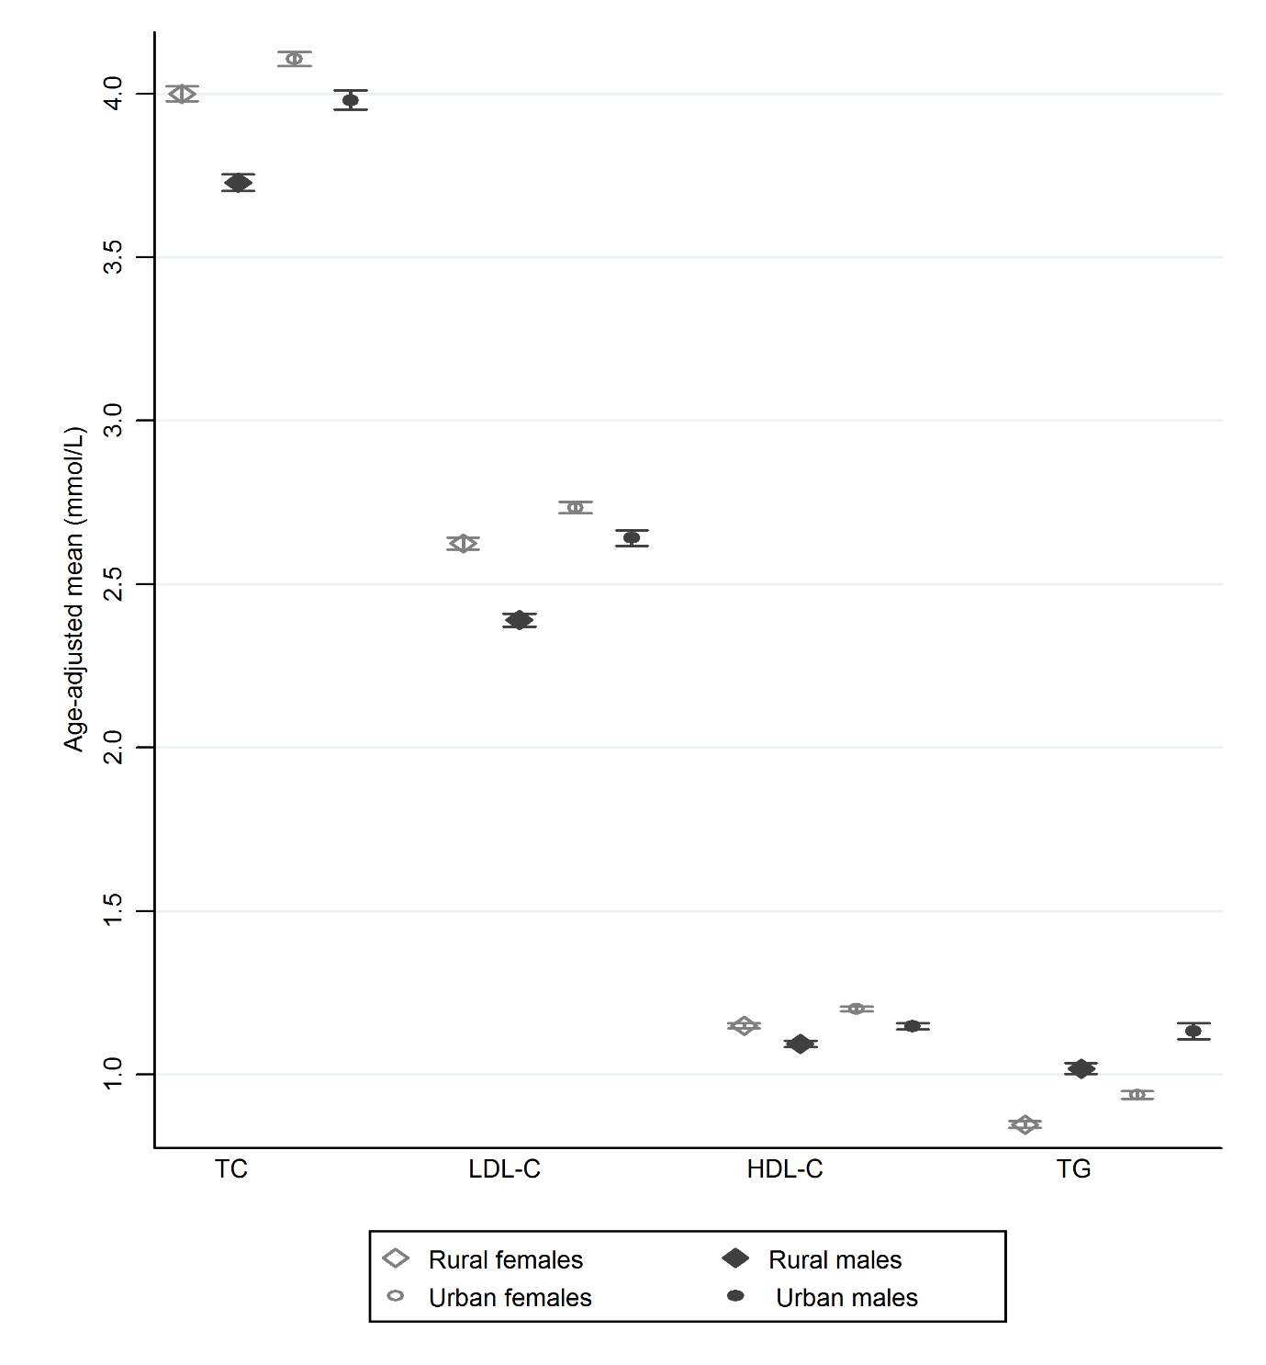
Figure 2. Age-adjusted mean serum lipids in Malawian rural and urban females and males.

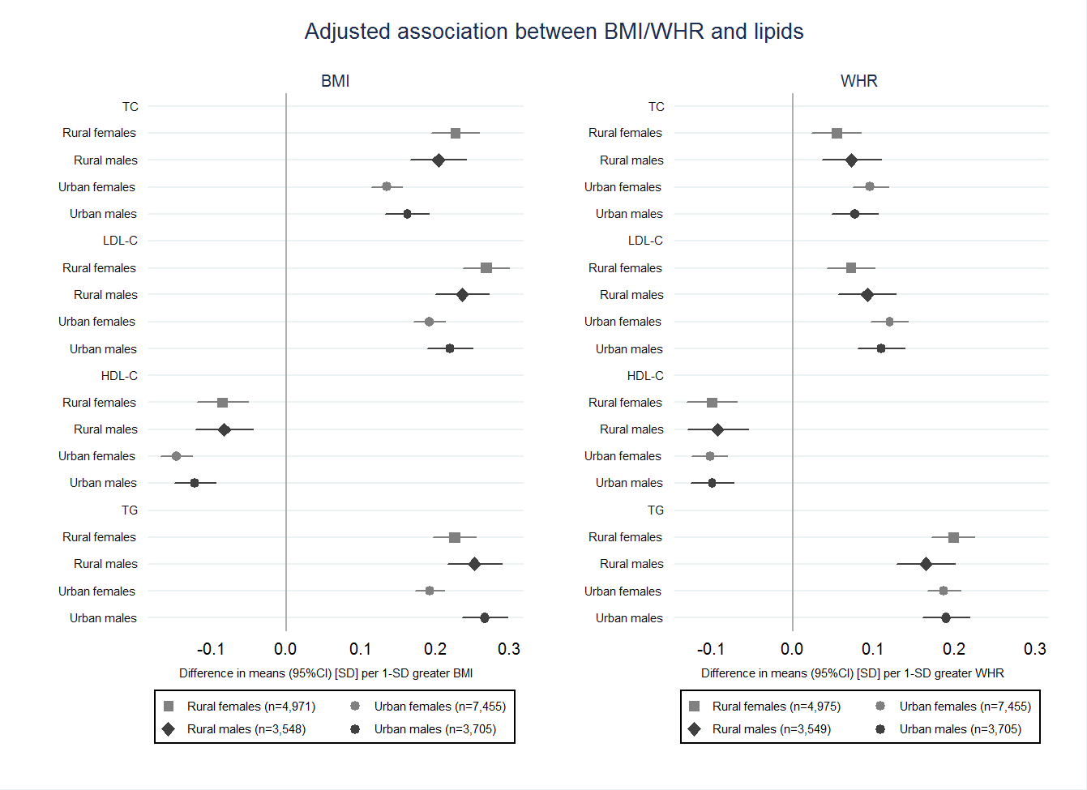

Figure 3. Adjusted association between BMI/WHR and serum lipids in Malawian rural and urban females and males.
Adjusted for age, ethnicity, education, household assets score, marital status, parity (females), use of lipid-lowering medication, smoking status, alcohol intake, physical activity, and HIV/ART status.
BMI, WHR and serum lipids are used in standard deviations.

