Sex and area differences in the association between adiposity and lipid profile in Malawi

CONTENTS

Supplementary methods (page 2)

Supplementary Table 1. Characteristics of the participants with missing and complete lipid data in rural area, by sex (page 3)

Supplementary Table 2. Characteristics of the participants with missing and complete lipid data in urban area, by sex (page 5)

Supplementary Table 3. Missing data according to area of residence and sex (page 7)

Supplementary Table 4. Age-adjusted mean of body mass index (BMI), waist-hip ratio (WHR) and serum lipids in rural and urban residents, by sex (page 8)

Supplementary Table 5. Age-adjusted prevalence of dyslipidaemias in rural and urban residents, by sex (page 9)

Supplementary Table 6. Adjusted association between BMI/WHR and dyslipidaemias in rural and urban females and males (page 10)

Supplementary Table 7. Adjusted association between BMI/WHR and serum lipids in Malawian rural and urban females and males, according to HIV status (page 11).

Supplementary Figure 1. Age-adjusted association between quintiles of BMI (a) and WHR (b) with serum lipids in females and males, by area (page 13)

Supplementary Figure 2. Age-adjusted association between BMI/WHR and serum lipids in rural and urban females and males (page 14)

Supplementary Figure 3. Age-adjusted (a) and fully adjusted (b) associations between BMI/WHR and dyslipidemia in rural and urban females and males (page 15)

Supplementary Figure 4. Adjusted associations of BMI (a) and WHR (b) with lipids in HIV positive and HIV negative individuals, in rural and urban males and females (page 16).

Supplementary methods

Details of assessment of covariates included in the analyses
Ethnicity was assessed in seven groups: Chewa, Tumbuka, Ngoni, Yao, Lomwe, Nkhonde and Other. Household assets score was based on the score of 15 items (paraffin lamp 2,000, radio 8,000, mobile phone 10,000, land phone 15,000, table & chair(s) 31,500, bed & mattress 31,000, bicycle 35,000, TV 85,000, electric/gas cooker 30,000, sofa set 125,000, oxcart 200,000, fridge 200,000, motorbike 350,000, car 2,000,000, and cow 150,000). The sum of the score was divided by 1,000 and categorized into quintiles within each area. Educational level was assessed in 7 categories (illiterate, no formal education; literate, no formal education; standard 1-5 years, illiterate; standard 1-5 years, literate; standard 6-8 years; secondary; and tertiary), and then it was recategorized into: no formal education; standard 1-5 years, standard 6-8 years, secondary, and tertiary. Marital status was assessed as never married, married, widowed or divorced/separated. Parity was considered the number of pregnancies the women ever had, regardless of its outcome. Smoking status comprised regular cigarette smoking (at least weekly), and it was categorized into never smoker, former smoker (stopped more than 6 months ago), and current smoker (smoked in the last 6 months). Alcohol intake in the previous 12 months and its frequency were categorized into: never, less than once a month, 1-3 days per month, 1-4 days per week, and 5 or more days per week. The number of days and frequency of walking, moderate and vigorous physical activity in leisure-time, work and commuting was assessed, and Metabolic Equivalent of Task (MET) was calculated. Physical activity was categorized into low, moderate or high based on the IPAQ (International Physical Activity Questionnaire) scoring protocol. Use of regular lipid-lowering medication was investigated among those who reported medical diagnosis of raised cholesterol, and it was then recategorized into: no raised cholesterol, raised cholesterol not taking medication, and raised cholesterol taking medication. HIV status was investigated as well as the use of antiretroviral therapy (ART) in those who reported being HIV positive.

Statistical Analysis for dyslipidaemia analysis
Age-adjusted prevalence of each dyslipidaemia was described according to area of residence, stratified by sex. Multiple logistic regression analyses were used to examine the association of both BMI and WHR (in standard deviations) with each dyslipidaemia, adjusted initially for age and then for other potential confounders. The same confounders used in the linear regression analyses were used for the logistic regressions.
Differences between the age-adjusted prevalence of each dyslipidaemia and the adjusted associations of anthropometric measurements with dyslipidaemias between rural and urban residents and women and men were compared by examining the point estimates and their 95% confidence intervals. Statistical evidence for sex and area differences were obtained from interaction tests.
Supplementary Table 1. Characteristics of the participants with missing and complete lipid data in rural area, by sex
 |  | Males |  |  | Females
 |  | Missing  n=864  (14.7%) | Non-missing  n=5,000  (85.3%) | p-value | Missing  n=943  (11.7%) | Non-missing  n=7,096  (88.3%) | p-value
Age - mean (SD) |  | 36.2 (16.5) | 38.1 (16.5) | 0.002 | 42.3 (20.6) | 37.6 (15.6) | <0.001
Household assets score - median (IQR) |  | 179.8 (179.8) | 207.2 (183.0) | 0.008 | 194.0 (179.0) | 201.0 (195.5) | 0.497
BMI – mean (SD) |  | 21.2 (2.6) | 21.6 (2.8) | <0.001 | 22.5 (4.1) | 23.5 (4.3) | <0.001
WHR – mean (SD) |  | 0.86 (0.06) | 0.86 (0.05) | 0.105 | 0.86 (0.07) | 0.86 (0.07) | 0.110
Ethnicity  % (95% CI) | Chewa | 2.4 (1.6; 3.7) | 2.1 (1.8; 2.6) | 0.354 | 1.9 (1.2; 3.0) | 2.5 (2.2; 2.9) | 0.009
 | Tumbuka | 77.7 (74.8; 80.3) | 76.9 (75.8; 78.1) |  | 70.5 (67.5; 73.3) | 75.5 (74.4; 76.5)
 | Ngoni | 1.0 (0.5; 2.0) | 2.0 (1.6; 2.4) |  | 2.4 (1.6; 3.6) | 2.0 (1.7; 2.4)
 | Yao | 0.5 (0.2; 1.2) | 0.4 (0.3; 0.6) |  | 0.5 (0.2; 1.3) | 0.3 (0.2; 0.4)
 | Lomwe | 0.3 (0.1; 1.1) | 0.2 (0.1; 0.4) |  | 0.2 (0.1; 0.8) | 0.2 (0.1; 0.3)
 | Nkonde | 6.3 (4.8; 8.1) | 5.3 (4.7; 6.0) |  | 8.6 (7.0; 10.6) | 7.3 (6.7; 7.9)
 | Other | 11.8 (9.8; 14.1) | 13 (12.1; 14.0) |  | 15.8 (13.6; 18.3) | 12.3 (11.5; 13.1)
Education | No formal | 2.0 (1.2; 3.1) | 1.6 (1.3; 2.0) | 0.065 | 12.7 (10.7; 15.0) | 5.3 (4.8; 5.8) | <0.001
% (95% CI) | Standard 1-5 | 13.1 (11.0; 15.5) | 10.4 (9.6; 11.3) |  | 24.1 (21.4; 26.9) | 16.1 (15.3; 17.0)
 | Standard 6-8 | 41 (37.7; 44.3) | 41.5 (40.2; 42.9) |  | 39.8 (36.7; 42.9) | 52.4 (51.2; 53.5)
 | Secondary | 40.3 (37.0; 43.6) | 43.5 (42.2; 44.9) |  | 22.5 (19.9; 25.3) | 25.3 (24.3; 26.3)
 | Tertiary | 3.7 (2.6; 5.2) | 2.9 (2.4; 3.4) |  | 1.0 (0.5; 1.8) | 1.0 (0.8; 1.2)
Marital status  % (95% CI) | Never married | 26.3 (23.5; 29.4) | 22.7 (21.6; 23.9) | 0.015 | 9.7 (7.9; 11.7) | 7.2 (6.6; 7.8)
 | Married | 68.2 (65.0; 71.2) | 72.4 (71.2; 73.7) |  | 60.6 (57.4; 63.6) | 69.8 (68.7; 70.9) | <0.001
 | Widowed | 0.7 (0.3; 1.5) | 1.2 (1.0; 1.6) |  | 20.6 (18.1; 23.3) | 12.4 (11.6; 13.2)
 | Divorced | 4.8 (3.5; 6.4) | 3.6 (3.1; 4.2) |  | 9.2 (7.5; 11.3) | 10.6 (9.9; 11.4)
Number of  pregnancies ª  % (95% CI) | 0 |  |  |  | 10 (8.2; 12.1) | 6.6 (6.1; 7.2) | <0.001
 | 1 |  |  |  | 8.8 (7.2; 10.8) | 10 (9.3; 10.7)
 | 2 |  |  |  | 11.6 (9.7; 13.8) | 12.5 (11.8; 13.3)
 | 3 |  |  |  | 10.9 (9.0; 13.0) | 13.2 (12.5; 14.1)
 | 4+ |  |  |  | 58.7 (55.5; 61.8) | 57.7 (56.5; 58.8)
Smoking status  % (95% CI) | Never | 80.7 (77.9; 83.2) | 82.3 (81.2; 83.3) | 0.220 | 99.5 (98.7; 99.8) | 99.7 (99.6; 99.8) | 0.379
 | Former | 4.1 (2.9; 5.6) | 4.5 (4.0; 5.2) |  | 0.2 (0.1; 0.8) | 0.1 (0.1; 0.2)
 | Current | 15.3 (13.0; 17.8) | 13.2 (12.3; 14.1) |  | 0.3 (0.1; 1.0) | 0.2 (0.1; 0.3)
Alcohol intake  % (95% CI) | Never | 57.6 (54.3; 60.9) | 58.1 (56.7; 59.5) | 0.068 | 95 (93.4; 96.2) | 96.6 (96.1; 97) | 0.038
 | < 1 month | 9.4 (7.6; 11.5) | 9.5 (8.8; 10.4) |  | 1.7 (1.0; 2.8) | 1.4 (1.1; 1.7)
 | 1-3 days/ month | 11.3 (9.4; 13.6) | 13.4 (12.5; 14.4) |  | 1.6 (1.0; 2.6) | 1.2 (1.0; 1.5)
 | 1-4 days/ week | 16.1 (13.8; 18.7) | 15.2 (14.2; 16.2) |  | 1.6 (1.0; 2.6) | 0.7 (0.5; 0.9)
 | 5+ days/ week | 5.6 (4.2; 7.3) | 3.8 (3.3; 4.3) |  | 0.1 (0.0; 0.8) | 0.1 (0.1; 0.2)
Physical activity level ^{b} % (95% CI) | Low | 3.5 (2.4; 4.9) | 2.3 (1.9; 2.8) | 0.104 | 5.1 (3.9; 6.7) | 1.4 (1.2; 1.7) | <0.001
 | Moderate | 11.1 (9.2; 13.4) | 10.6 (9.8; 11.5) |  | 5.9 (4.6; 7.6) | 3.2 (2.8; 3.6)
 | High | 85.4 (82.9; 87.6) | 87.1 (86.2; 88) |  | 89 (86.8; 90.8) | 95.4 (94.9; 95.9)
Lipid-lowering medication  % (95% CI) | No raised cholesterol |  | 99.9 (99.8; 100) | 0.772 | 99.7 (99; 99.9) | 99.9 (99.8; 99.9) | 0.109
 | No medication |  | 0 (0.0; 0.2) |  | 0.3 (0.1; 1.0) | 0.1 (0.1; 0.2)
 | Taking medication |  | 0 (0.0; 0.1) |  | - | -
HIV status | HIV negative | 89.6 (86.7; 91.9) | 89.5 (88.5; 90.5) | 0.975 | 88.4 (85.6; 90.7) | 87.0 (86.0; 87.8) | 0.319
% (95% CI) | HIV positive | 10.4 (8.1; 13.3) | 10.5 (9.5; 11.5) |  | 11.6 (9.3; 14.4) | 13.0 (12.2; 14.0)
ART status ^{c}  % (95% CI) | On ART | 5.7 (1.3; 21.4) | 10.2 (7.0; 14.4) | 0.403 | 11.1 (4.0; 27.1) | 5.8 (4.1; 8.2) | 0.197
 | Not on ART | 94.3 (78.6; 98.7) | 89.8 (85.6; 93.0) |  | 88.9 (72.9; 96) | 94.2 (91.8; 95.9)
ART: anti-retroviral therapy; HIV: human immunodeficiency virus; IQR: interquartile range; NA: not applicable; SD: standard deviation
ª Information available only for females
^{b} Level of physical activity based on metabolic equivalent (MET)
^{c} Based on those who reported being HIV positive

Supplementary Table 2. Characteristics of the participants with missing and complete lipid data in urban area, by sex
 |  | Males |  |  | Females
 |  | Missing  n=1,520  (26.2%) | Non-missing  n=4,284  (73.8%) | p-value | Missing  n=2,304  (21.2%) | Non-missing  n=8,563  (78.8%) | p-value
Age - mean (SD) |  | 32.0 (13.0) | 33.2 (14.1) | 0.003 | 30.9 (12.6) | 32.5 (12.4) | <0.001
Household assets score – median (IQR) |  | 668.2 (358.0) | 793.1 (410.0) | <0.001 | 650.0 (370.0) | 707.4 (436.0) | 0.006
BMI – mean (SD) |  | 22.2 (3.5) | 22.5 (3.6) | 0.002 | 24.7 (5.0) | 25.6 (5.4) | <0.001
WHR – mean (SD) |  | 0.84 (0.06) | 0.84 (0.07) | 0.447 | 0.81 (0.07) | 0.81 (0.07) | 0.025
Ethnicity  % (95% CI) | Chewa | 39.7 (37.3; 42.2) | 34.2 (32.8; 35.6) | 0.002 | 40.2 (38.2; 42.3) | 37.2 (36.2; 38.2) | 0.034
 | Tumbuka | 11.3 (9.8; 12.9) | 13.7 (12.7; 14.8) |  | 12 (10.8; 13.4) | 12 (11.3; 12.7)
 | Ngoni | 17.7 (15.9; 19.7) | 19 (17.9; 20.2) |  | 18.8 (17.3; 20.5) | 19.7 (18.9; 20.6)
 | Yao | 7.6 (6.4; 9.1) | 8.1 (7.4; 9.0) |  | 8.0 (7.0; 9.2) | 7.8 (7.2; 8.4)
 | Lomwe | 15.1 (13.4; 17) | 15 (13.9; 16.1) |  | 11.8 (10.5; 13.2) | 13.4 (12.7; 14.1)
 | Nkonde | 1.8 (1.2; 2.6) | 1.4 (1.1; 1.9) |  | 1.0 (0.6; 1.4) | 1.6 (1.3; 1.8)
 | Other | 6.8 (5.7; 8.2) | 8.5 (7.7; 9.4) |  | 8.1 (7.1; 9.3) | 8.4 (7.8; 9.0)
Education | No formal | 1.7 (1.2; 2.5) | 1.2 (0.9; 1.6) | 0.009 | 5.4 (4.5; 6.4) | 4.5 (4.0; 4.9) | <0.001
% (95% CI) | Standard 1-5 | 5.5 (4.4; 6.7) | 4.4 (3.8; 5.1) |  | 12.1 (10.8; 13.5) | 9.1 (8.5; 9.7)
 | Standard 6-8 | 13.9 (12.3; 15.8) | 14.1 (13.1; 15.2) |  | 23.0 (21.3; 24.7) | 22.9 (22.0; 23.8)
 | Secondary | 59.3 (56.8; 61.8) | 56.9 (55.4; 58.3) |  | 45.5 (43.5; 47.5) | 50.4 (49.3; 51.5)
 | Tertiary | 19.5 (17.6; 21.6) | 23.4 (22.2; 24.7) |  | 14.1 (12.7; 15.5) | 13.2 (12.5; 13.9)
Marital status  % (95% CI) | Never married | 45.8 (43.3; 48.3) | 47.2 (45.7; 48.7) | 0.153 | 23.7 (22.0; 25.4) | 20.8 (19.9; 21.6) | 0.018
 | Married | 48.9 (46.4; 51.5) | 48.2 (46.8; 49.7) |  | 61.5 (59.5; 63.4) | 64.1 (63.1; 65.1)
 | Widowed | 1.1 (0.7; 1.8) | 1.4 (1.1; 1.9) |  | 6.0 (5.1; 7.1) | 6.6 (6.0; 7.1)
 | Divorced | 4.1 (3.2; 5.3) | 3.1 (2.6; 3.6) |  | 8.9 (7.8; 10.1) | 8.6 (8.0; 9.2)
Number of  pregnancies ª  % (95% CI) | 0 |  |  |  | 21 (19.4; 22.7) | 18.2 (17.4; 19.1) | <0.001
 | 1 |  |  |  | 20.4 (18.8; 22.1) | 17.2 (16.5; 18.1)
 | 2 |  |  |  | 18.7 (17.2; 20.4) | 17.9 (17.1; 18.7)
 | 3 |  |  |  | 14.2 (12.8; 15.7) | 15.4 (14.6; 16.2)
 | 4+ |  |  |  | 25.7 (24.0; 27.6) | 31.2 (30.3; 32.2)
Smoking status  % (95% CI) | Never | 81.7 (79.7; 83.6) | 84.4 (83.2; 85.4) | 0.014 | 98.9 (98.4; 99.3) | 99.5 (99.3; 99.6) | 0.008
 | Former | 9.3 (7.9; 10.8) | 7.0 (6.3; 7.8) |  | 0.6 (0.4; 1.0) | 0.3 (0.2; 0.5)
 | Current | 9.0 (7.7; 10.6) | 8.6 (7.8; 9.5) |  | 0.5 (0.3; 0.9) | 0.2 (0.1; 0.3)
Alcohol intake  % (95% CI) | Never | 59.1 (56.6; 61.6) | 64.1 (62.6; 65.5) | 0.002 | 93.6 (92.5; 94.5) | 93.8 (93.3; 94.3) | 0.804
 | < 1 month | 8.4 (7.1; 9.9) | 8.4 (7.6; 9.2) |  | 2.6 (2.0; 3.3) | 2.8 (2.5; 3.2)
 | 1-3 days/ month | 13.8 (12.2; 15.6) | 13.1 (12.1; 14.1) |  | 2.7 (2.1; 3.4) | 2.4 (2.1; 2.7)
 | 1-4 days/ week | 13.7 (12.0; 15.5) | 10.8 (9.9; 11.7) |  | 0.7 (0.5; 1.2) | 0.7 (0.6; 0.9)
 | 5+ days/ week | 4.9 (4.0; 6.1) | 3.7 (3.2; 4.3) |  | 0.3 (0.2; 0.7) | 0.3 (0.2; 0.4)
Physical activity level ^{b} % (95% CI) | Low | 3.6 (2.8; 4.7) | 4.3 (3.7; 5.0) | 0.162 | 2.2 (1.7; 2.9) | 1.5 (1.2; 1.8) | 0.001
 | Moderate | 12.3 (10.7; 14.1) | 13.7 (12.7; 14.8) |  | 3.5 (2.8; 4.3) | 2.4 (2.1; 2.7)
 | High | 84.1 (82.2; 85.8) | 82.0 (80.8; 83.1) |  | 94.3 (93.3; 95.2) | 96.1 (95.7; 96.5)
Lipid-lowering medication  % (95% CI) | No raised cholesterol | 99.8 (99.4; 99.9) | 99.6 (99.4; 99.8) | 0.298 | 99.9 (99.6; 100) | 99.6 (99.4; 99.7) | 0.113
 | No medication | 0.1 (0.0; 0.5) | 0.4 (0.2; 0.6) |  | 0.1 (0.0; 0.4) | 0.3 (0.2; 0.5)
 | Taking medication | 0.1 (0.0; 0.5) | 0.0 (0.0; 0.2) |  | - | 0.1 (0.0; 0.2)
HIV status | HIV negative | 94.9 (93.3; 96.1) | 93.6 (92.7; 94.3) | 0.125 | 92.7 (91.5; 93.8) | 89.1 (88.4; 89.7) | <0.001
% (95% CI) | HIV positive | 5.1 (3.9; 6.7) | 6.4 (5.7; 7.3) |  | 7.3 (6.2; 8.5) | 10.9 (10.3; 11.6)
ART status ^{c}  % (95% CI) | On ART | 8.3 (3.0; 20.8) | 13.1 (8.7; 19.4) | 0.371 | 11.3 (6.8; 18.3) | 10.6 (8.4; 13.2) | 0.822
 | Not on ART | 91.7 (79.2; 97) | 86.9 (80.6; 91.3) |  | 88.7 (81.7; 93.2) | 89.4 (86.8; 91.6)
ART: anti-retroviral therapy; HIV: human immunodeficiency virus; IQR: interquartile range; NA: not applicable; SD: standard deviation
ª Information available only for females
^{b} Level of physical activity based on metabolic equivalent (MET)
^{c} Based on those who reported being HIV positive

Supplementary Table 3. Missing data according to area of residence and sex.
 | All  N=24,943 | Rural Residents |  | Urban Residents
 |  | Females  n=7,096 | Males  n=5,000 | Females  n=8,563 | Males  n=4,284
BMI | 835 (3.3) | 429 (6.0) | 10 (0.2) | 394 (4.6) | 2 (0.05)
WHR | 828 (3.3) | 422 (5.9) | 10 (0.2) | 394 (4.6) | 2 (0.05)
Marital status – N (%) | 20 (0.1) | 12 (0.2) | 8 (0.2) | 0 | 0
Parity ª – N (%) | 22 (0.1) | 21 (0.3) | NA | 1 (0.01) | 0
HIV/ART status – N (%) | 4,618 (18.5) | 1,848 (26.0) | 1,478 (29.6) | 719 (8.4) | 573 (13.4)
All the other variables had no missing data.
ART: anti-retroviral therapy; BMI: body mass index; HIV: human immunodeficiency virus; NA: not applicable; WHR: waist-hip ratio
ª Information considered only for females

Supplementary Table 4. Age-adjusted mean of body mass index (BMI), waist-hip ratio (WHR) and serum lipids in rural and urban residents, by sex.
 | Females  Mean (95% CI) | Males  Mean (95% CI) | p-value
BMI (kg/m²)
Rural (N=6,667) / (N=4,990) | 23.3 (23.2; 23.4) | 21.6 (21.5; 21.6)
Urban (N=8,169) / (N=4,282) | 25.8 (25.7; 25.9) | 22.7 (22.6; 22.8)
P-value for difference between sex |  |  | <0.001
P-value for difference between areas |  |  | <0.001
WHR
Rural (N=6,674) / (N=4,990) | 0.85 (0.85; 0.85) | 0.86 (0.86; 0.86)
Urban (N=8,169) / (N=4,282) | 0.81 (0.81; 0.81) | 0.85 (0.85; 0.85)
P-value for difference between sex |  |  | <0.001
P-value for difference between areas |  |  | <0.001
TC (mmol/L)
Rural (N=7,096) / (N=5,000) | 4.00 (3.98; 4.02) | 3.73 (3.70; 3.75)
Urban (N=8,563) / (N=4,284) | 4.11 (4.09; 4.13) | 3.98 (3.95; 4.01)
P-value for difference between sex |  |  | <0.001
P-value for difference between areas |  |  | <0.001
LDL-C (mmol/L)
Rural (N=7,096) / (N=5,000) | 2.62 (2.61; 2.64) | 2.39 (2.37; 2.41)
Urban (N=8,563) / (N=4,284) | 2.73 (2.72; 2.75) | 2.64 (2.62; 2.67)
P-value for difference between sex |  |  | <0.001
P-value for difference between areas |  |  | <0.001
HDL-C (mmol/L)
Rural (N=7,096) / (N=5,000) | 1.15 (1.14; 1.16) | 1.09 (1.08; 1.10)
Urban (N=8,563) / (N=4,284) | 1.20 (1.19; 1.21) | 1.15 (1.14; 1.16)
P-value for difference between sex |  |  | <0.001
P-value for difference between areas |  |  | <0.001
TG (mmol/L)
Rural (N=7,096) / (N=5,000) | 0.85 (0.84; 0.86) | 1.02 (1.00; 1.04)
Urban (N=8,563) / (N=4,284) | 0.94 (0.93; 0.95) | 1.13 (1.11; 1.16)
P-value for difference between sex |  |  | <0.001
P-value for difference between areas |  |  | <0.001
BMI: body mass index; HDL-C: high density lipoprotein-cholesterol; LDL-C: low density lipoprotein-cholesterol; TC: total cholesterol; TG: triglycerides; WHR: waist-hip ratio

Supplementary Table 5. Age-adjusted prevalence of dyslipidaemias in rural and urban residents, by sex.
 | Females  Prevalence  (95% CI) | Males  Prevalence  (95% CI) | p-values
High TC (≥ 5.2 mmol/L)
Rural (N=7,096) / (N=5,000) | 11.0 (10.3; 11.7) | 6.9 (6.2; 7.5)
Urban (N=8,563) / (N=4,284) | 13.3 (12.6; 14.1) | 11.3 (10.3; 12.3)
P-value for difference between sex |  |  | <0.001
P-value for difference between areas |  |  | <0.001
High LDL-C (≥ 3.4 mmol/L)
Rural (N=7,096) / (N=5,000) | 16.3 (15.5; 17.1) | 9.8 (9.0; 10.6)
Urban (N=8,563) / (N=4,284) | 20.8 (19.9; 21.6) | 17.7 (16.5; 18.8)
P-value for difference between sex |  |  | <0.001
P-value for difference between areas |  |  | 0.016
Low HDL-C (< 1.0 mmol/L)
Rural (N=7,096) / (N=5,000) | 42.5 (41.1; 439.) | 34.4 (33.0; 35.8)
Urban (N=8,563) / (N=4,284) | 33.3 (32.2; 34.4) | 25.7 (24.8; 26.6)
P-value for difference between sex |  |  | <0.001
P-value for difference between areas |  |  | <0.001
High TG (≥ 1.7 mmol/L)
Rural (N=7,096) / (N=5,000) | 6.0 (5.5; 6.6) | 10.4 (9.6; 11.3)
Urban (N=8,563) / (N=4,284) | 8.8 (8.1; 9.4) | 14.1 (13.0; 15.1)
P-value for difference between sex |  |  | <0.001
P-value for difference between areas |  |  | <0.001
Any dyslipidaemia
Rural (N=7,096) / (N=5,000) | 53.6 (52.2; 55.0) | 51.8 (50.3; 53.3)
Urban (N=8,563) / (N=4,284) | 48.2 (47.0; 49.4) | 46.2 (45.3; 47.3)
P-value for difference between sex |  |  | <0.001
P-value for difference between areas |  |  | <0.001
BMI: body mass index; HDL-C: high density lipoprotein-cholesterol; LDL-C: low density lipoprotein-cholesterol; TC: total cholesterol; TG: triglycerides; WHR: waist-hip ratio

Supplementary Table 6. Adjusted association between BMI/WHR and dyslipidaemias in rural and urban females and males.
 | Adjusted OR per 1 SD higher BMI (95% CI) | Adjusted OR per 1 SD higher WHR (95% CI)
OR of high TC (≥ 5.2 mmol/L)
Rural females (N=4,971) / (N=4,975) | 1.53 (1.39; 1.70) | 1.17 (1.07; 1.29)
Rural males (N=3,548) / (N=3,549) | 1.51 (1.31; 1.73) | 1.39 (1.21; 1.61)
Urban females (N=7,455) | 1.30 (1.21; 1.40) | 1.23 (1.14; 1.34)
Urban males (N=3,705) | 1.51 (1.36; 1.67) | 1.48 (1.33; 1.63)
P-values for difference between sex | <0.001 | <0.001
P-values for difference between area | 0.072 | 0.408
OR of high LDL-C (≥ 3.4 mmol/L)
Rural females (N=4,971) / (N=4,975) | 1.71 (1.56; 1.87) | 1.20 (1.10; 1.30)
Rural males (N=3,548) / (N=3,549) | 1.67 (1.48; 1.89) | 1.42 (1.25; 1.61)
Urban females (N=7,455) | 1.50 (1.41; 1.59) | 1.32 (1.24; 1.41)
Urban males (N=3,705) | 1.63 (1.5; 1.78) | 1.45 (1.33; 1.58)
P-values for difference between sex | <0.001 | <0.001
P-values for difference between area | 0.038 | 0.188
OR of low HDL-C (< 1.0 mmol/)
Rural females (N=4,971) / (N=4,975) | 1.15 (1.07; 1.23) | 1.20 (1.12; 1.29)
Rural males (N=3,548) / (N=3,549) | 1.14 (1.05; 1.24) | 1.18 (1.09; 1.29)
Urban females (N=7,455) | 1.30 (1.24; 1.37) | 1.27 (1.21; 1.35)
Urban males (N=3,705) | 1.24 (1.16; 1.32) | 1.23 (1.15; 1.32)
P-values for difference between sex | 0.223 | 0.284
P-values for difference between area | 0.008 | <0.001
OR of high TG (≥ 1.7 mmol/L)
Rural females (N=4,971) / (N=4,975) | 1.89 (1.65; 2.15) | 2.04 (1.77; 2.35)
Rural males (N=3,548) / (N=3,549) | 2.00 (1.77; 2.26) | 1.67 (1.47; 1.89)
Urban females (N=7,455) | 1.60 (1.46; 1.75) | 1.81 (1.65; 1.99)
Urban males (N=3,705) | 1.82 (1.66; 2.01) | 1.69 (1.53; 1.86)
P-values for difference between sex | <0.001 | 0.720
P-values for difference between area | 0.001 | 0.651
BMI: body mass index; HDL-C: high density lipoprotein-cholesterol; LDL-C: low density lipoprotein-cholesterol; SD: standard deviation; OR: odds ratio; TC: total cholesterol; TG: triglycerides; WHR: waist-hip ratio
Adjusted for age, ethnicity, education, household assets score, marital status, use of lipid-lowering medication, smoking status, alcohol intake, physical activity, and HIV/ART status.

Supplementary Table 7. Adjusted association between BMI/WHR and serum lipids in Malawian rural and urban females and males, according to HIV status.
 | HIV negative | HIV positive | p-value
Adjusted difference in outcome per
1 SD higher BMI (95% CI)
Difference in mean TC (mmol/L)
Rural females (N=4,400) / (N=679) | 0.22 (0.19; 0.26) | 0.25 (0.14; 0.36) | 0.678
Rural males (N=3,237) / (N=381) | 0.19 (0.16; 0.23) | 0.20 (0.05; 0.34) | 0.970
Urban females (N=6,841) / (N=859) | 0.13 (0.11; 0.15) | 0.17 (0.11; 0.24) | 0.180
Urban males (N=3,550) / (N=243) | 0.16 (0.13; 0.18) | 0.14 (-0.01; 0.29) | 0.891
Difference in mean LDL-C (mmol/L)
Rural females (N=4,400) / (N=679) | 0.22 (0.19; 0.24) | 0.20 (0.11; 0.28) | 0.669
Rural males (N=3,237) / (N=381) | 0.19 (0.16; 0.21) | 0.20 (0.09; 0.30) | 0.992
Urban females (N=6,841) / (N=859) | 0.15 (0.13; 0.17) | 0.15 (0.09; 0.20) | 0.915
Urban males (N=3,550) / (N=243) | 0.17 (0.15; 0.20) | 0.16 (0.04; 0.28) | 0.768
Difference in mean HDL-C (mmol/L)
Rural females (N=4,400) / (N=679) | -0.03 (-0.04; -0.02) | 0.00 (-0.04; 0.04) | 0.429
Rural males (N=3,237) / (N=381) | -0.04 (-0.05; -0.02) | 0.00 (-0.06; 0.06) | 0.098
Urban females (N=6,841) / (N=859) | -0.05 (-0.06; -0.04) | -0.03 (-0.05; 0.00) | 0.036
Urban males (N=3,550) / (N=243) | -0.05 (-0.06; -0.04) | -0.03 (-0.09; 0.03) | 0.406
Difference in mean TG (mmol/L)
Rural females (N=4,400) / (N=679) | 0.11 (0.10; 0.13) | 0.13 (0.06; 0.19) | 0.235
Rural males (N=3,237) / (N=381) | 0.16 (0.14; 0.18) | 0.04 (-0.09; 0.17) | 0.022
Urban females (N=6,841) / (N=859) | 0.10 (0.09; 0.10) | 0.08 (0.03; 0.13) | 0.950
Urban males (N=3,550) / (N=243) | 0.17 (0.15; 0.19) | 0.02 (-0.16; 0.20) | 0.033
Adjusted difference in outcome per
1 SD higher WHR (95% CI)
Difference in mean TC (mmol/L)
Rural females (N=4,403) / (N=680) | 0.04 (0.01; 0.07) | 0.15 (0.07; 0.23) | 0.105
Rural males (N=3,238) / (N=381) | 0.06 (0.03; 0.10) | 0.17 (0.04; 0.29) | 0.006
Urban females (N=6,841) / (N=859) | 0.10 (0.07; 0.12) | 0.11 (0.04; 0.18) | 0.415
Urban males (N=3,550) / (N=243) | 0.09 (0.06; 0.12) | 0.05 (-0.05; 0.16) | 0.729
Difference in mean LDL-C (mmol/L)
Rural females (N=4,403) / (N=680) | 0.05 (0.03; 0.08) | 0.11 (0.05; 0.18) | 0.439
Rural males (N=3,238) / (N=381) | 0.06 (0.04; 0.09) | 0.12 (0.03; 0.22) | 0.039
Urban females (N=6,841) / (N=859) | 0.09 (0.08; 0.11) | 0.10 (0.05; 0.15) | 0.762
Urban males (N=3,550) / (N=243) | 0.10 (0.08; 0.12) | 0.04 (-0.04; 0.13) | 0.462
Difference in mean HDL-C (mmol/L)
Rural females (N=4,403) / (N=680) | -0.03 (-0.04; -0.02) | 0.00 (-0.03; 0.02) | 0.248
Rural males (N=3,238) / (N=381) | -0.03 (-0.05; -0.02) | 0.01 (-0.04; 0.06) | 0.015
Urban females (N=6,841) / (N=859) | -0.03 (-0.04; -0.02) | -0.02 (-0.05; 0.00) | 0.132
Urban males (N=3,550) / (N=243) | -0.03 (-0.04; -0.02) | -0.03 (-0.07; 0.01) | 0.877
Difference in mean TG (mmol/L)
Rural females (N=4,403) / (N=680) | 0.09 (0.08; 0.11) | 0.14 (0.09; 0.19) | 0.043
Rural males (N=3,238) / (N=381) | 0.11 (0.09; 0.13) | 0.08 (-0.03; 0.20) | 0.648
Urban females (N=6,841) / (N=859) | 0.08 (0.07; 0.09) | 0.16 (0.12; 0.21) | <0.001
Urban males (N=3,550) / (N=243) | 0.14 (0.12; 0.16) | 0.13 (0.00; 0.26) | 0.813
p-value for interaction between HIV/status and anthropometry measures
Serum lipids were assessed in in mmol/L.
BMI: body mass index; HDL-C: high density lipoprotein-cholesterol; LDL-C: low density lipoprotein-cholesterol; TC: total cholesterol; TG: triglycerides; WHR: waist-hip ratio
Adjusted for age, ethnicity, education, household assets score, marital status, parity (females) use of lipid-lowering medication, smoking status, alcohol intake, and physical activity.
BMI and WHR are used in standard deviations
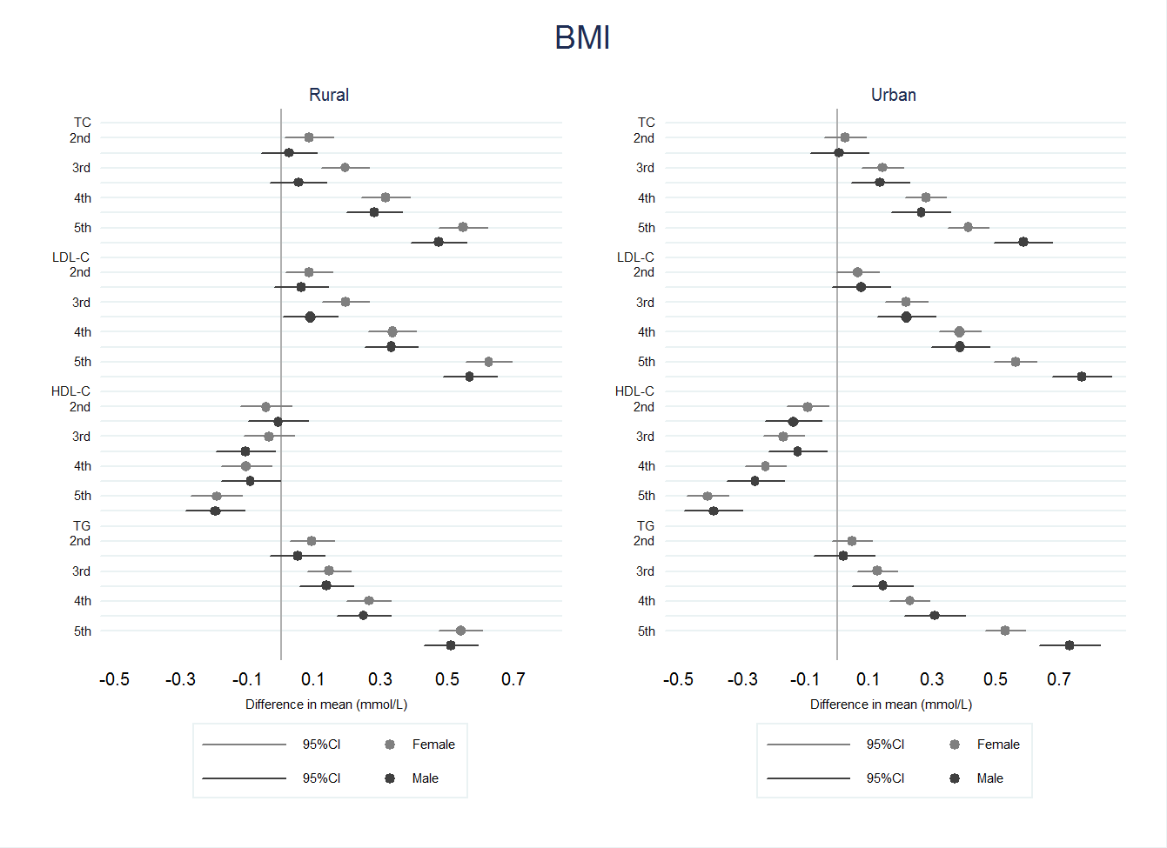
a)
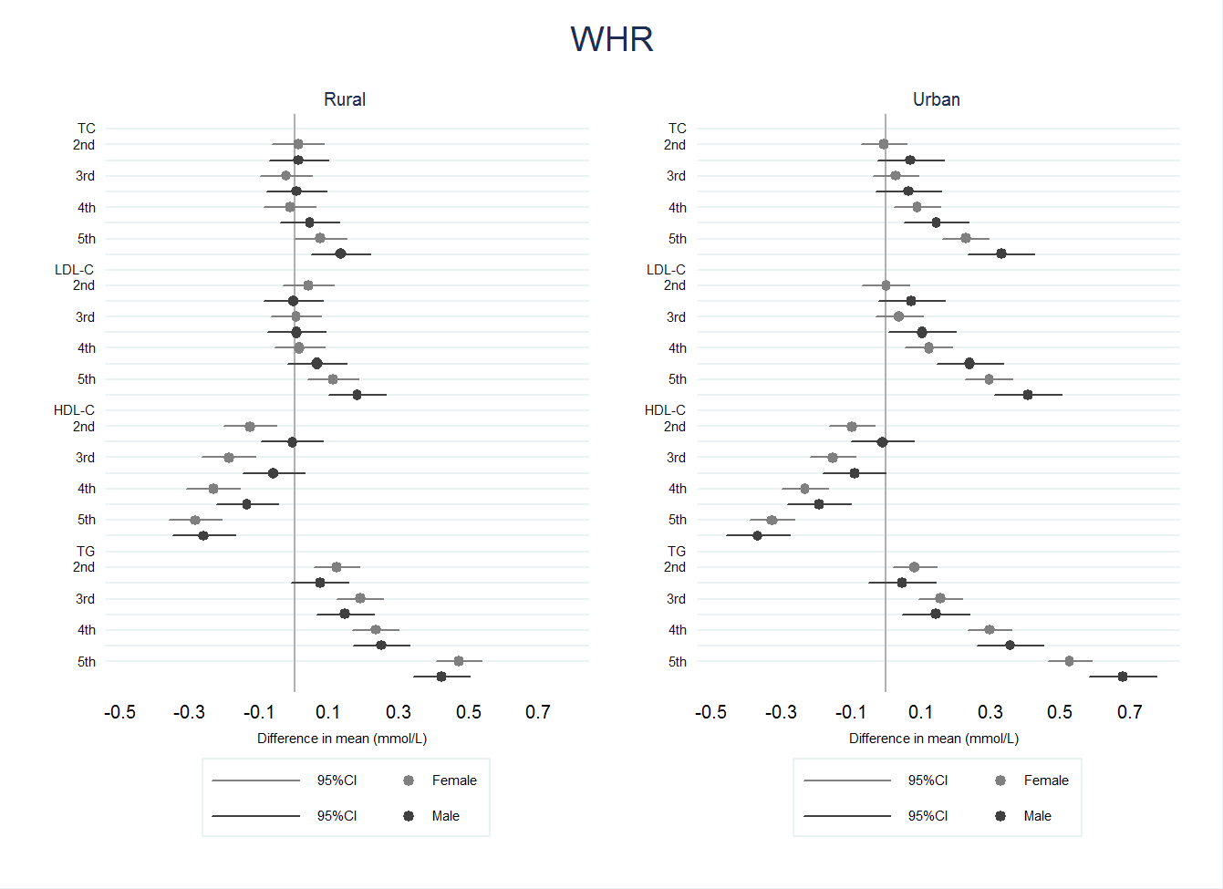
b)

Supplementary Figure 1. Age-adjusted association between quintiles of BMI (a) and WHR (b) with serum lipids in females and males, by area.
Serum lipids are used in standard deviations.

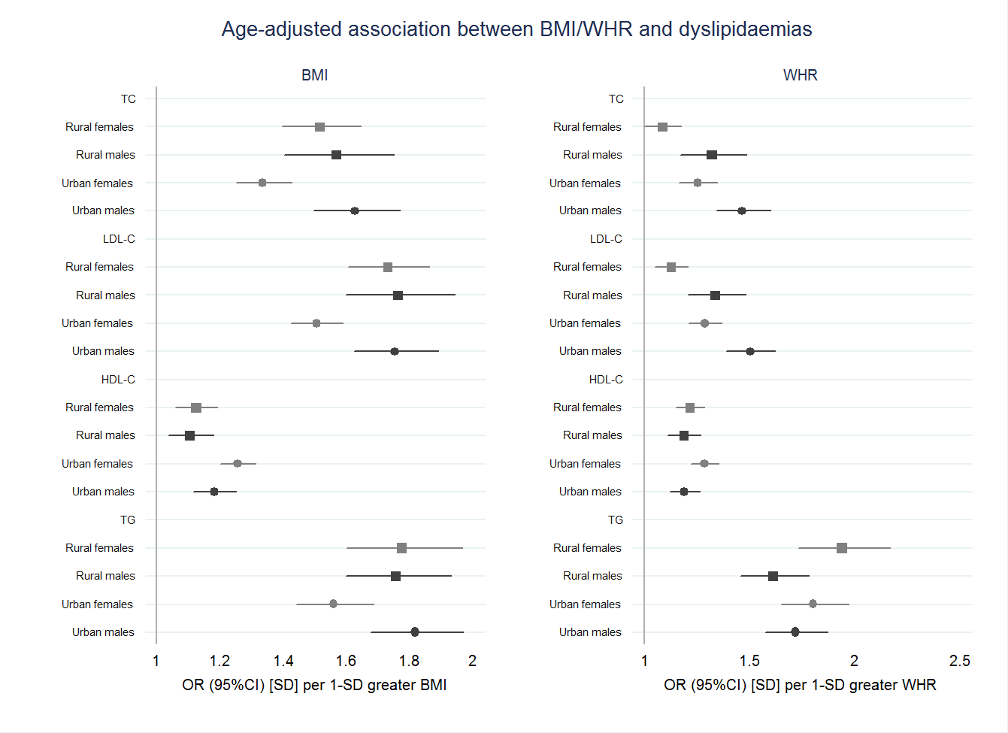Supplementary Figure 2. Age-adjusted association between BMI/WHR and serum lipids in rural and urban females and males.
BMI, WHR and serum lipids are used in standard deviations.

a)
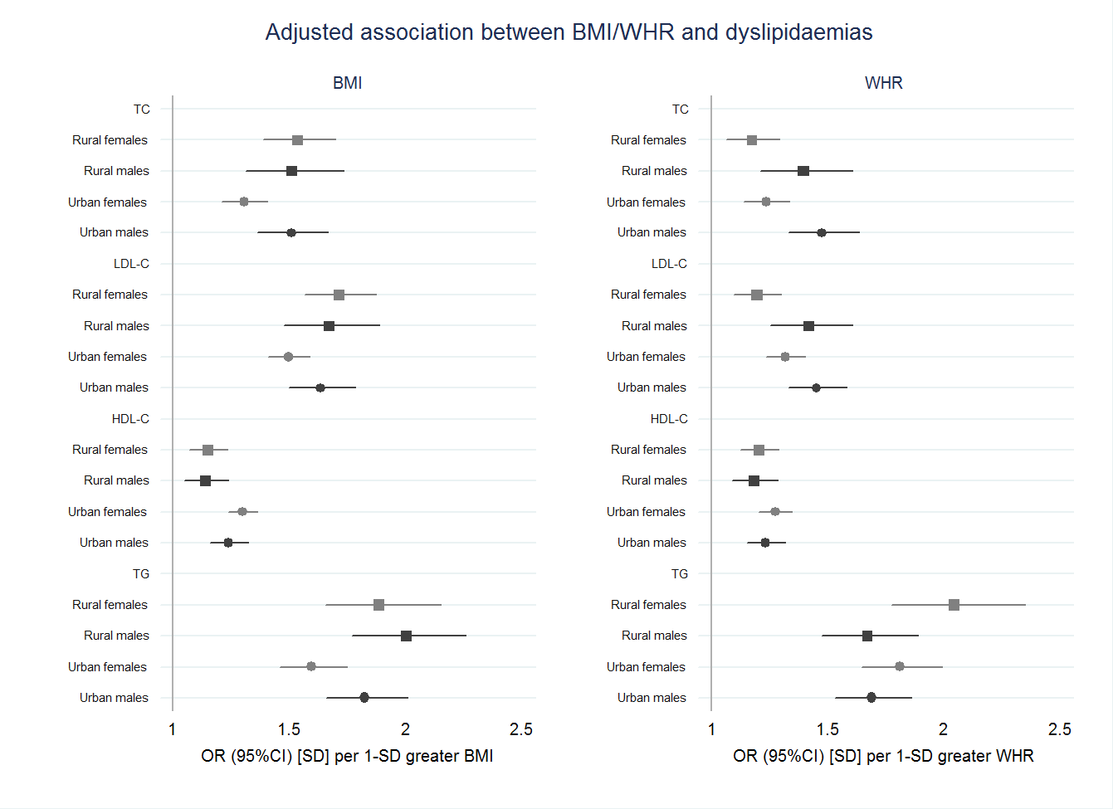
b)
Supplementary Figure 3. Age-adjusted (a) and adjusted (b) associations between BMI/WHR and dyslipidaemia in rural and urban females and males.
Adjusted for age, ethnicity, education, household assets score, marital status, use of lipid-lowering medication, smoking status, alcohol intake, physical activity, and HIV/ART status.
BMI, WHR and serum lipids are used in standard deviations.
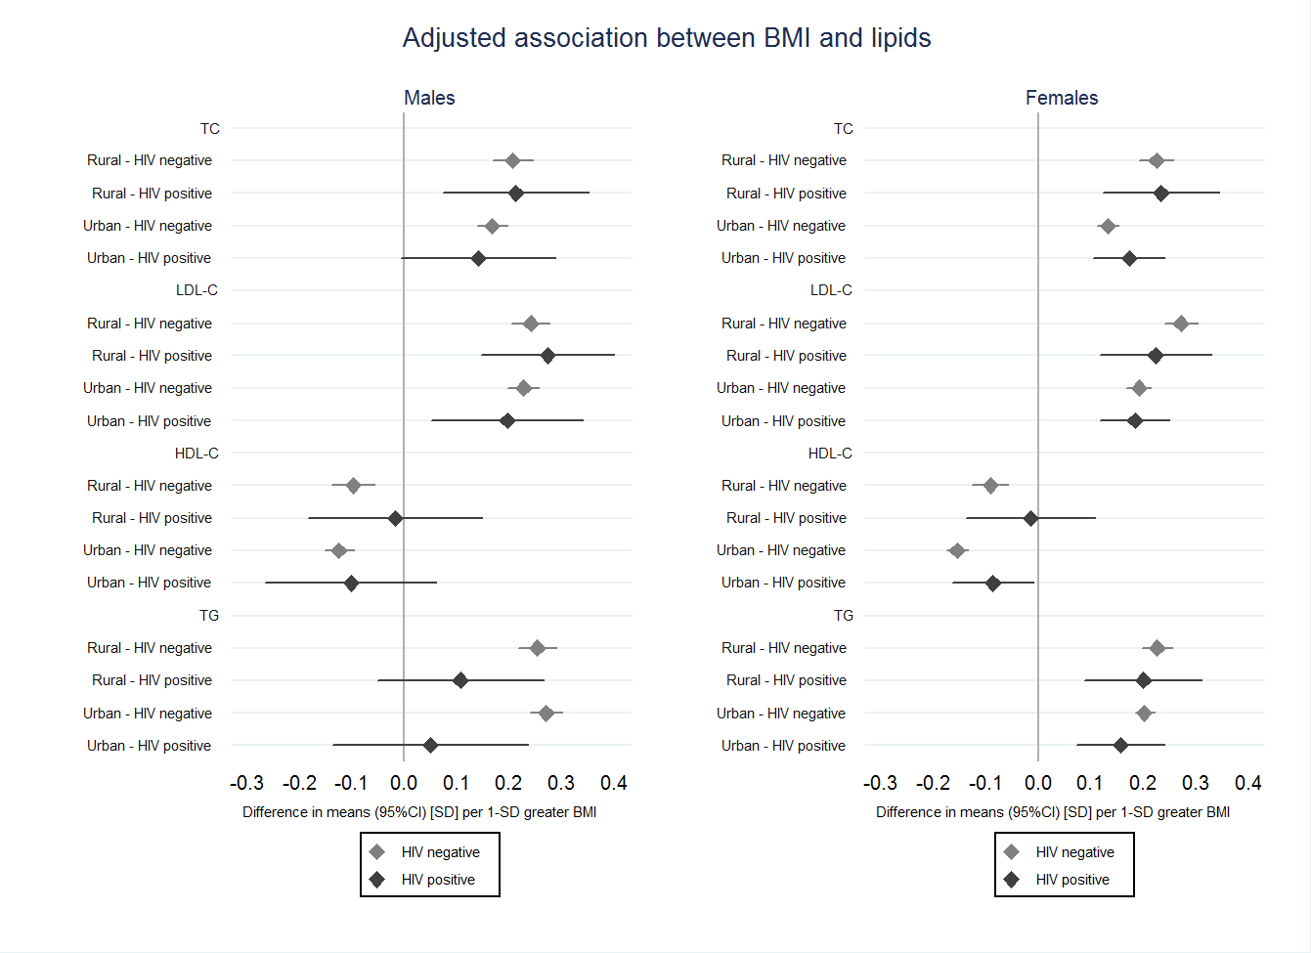
b)
a)
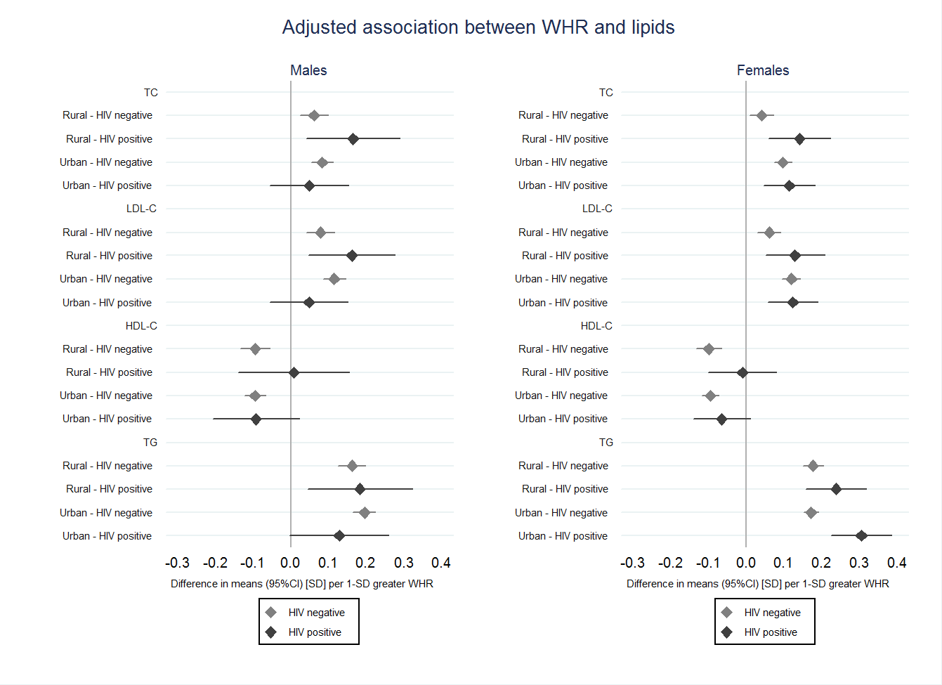
Supplementary Figure 4. Adjusted associations of BMI (a) and WHR (b) with lipids in HIV positive and negative individuals in rural and urban males and females.
Adjusted for age, ethnicity, education, household assets score, marital status, use of lipid-lowering medication, smoking status, alcohol intake, physical activity.
BMI, WHR and serum lipids are used in standard deviations.

