Economic evaluation of a short-standardised regimen for the treatment of rifampicin-resistant tuberculosis from the STREAM trial
Jason J Madan PhD⁺, Laura Rosu MSc⁺, Mamo Girma Tefera MSc, Craig van Rensburg MCom, Denise Evans PhD, Ivor Langley PhD, Ewan M. Tomeny MSc, Andrew Nunn MSc, Patrick PJ Phillips PhD, I.D.Rusen MD, S Bertel Squire PhD and the STREAM Study Health Economic Evaluation Collaborators*
From Warwick Medical School, University of Warwick, Coventry (JJM); Centre for Applied Health Research and Delivery, Liverpool School of Tropical Medicine, Liverpool, UK (LR, IL, EMT, SBS); Addis Ababa Science& Technology University (MGT); Health Economics and Epidemiology Research Office (HE2RO), Department of Internal Medicine, School of Medicine, Faculty of Health Sciences, University of Witwatersrand, Johannesburg, South Africa (CvR, DE); Medical Research Council Clinical Trials Unit at University College London, Institute of Clinical Trials & Methodology (AN, PPJP); Department of Medicine, University of California San Francisco, San Francisco, USA (PPJP); The Union, France, Division of Research and Development, Vital Strategies, New York, USA, and Dalla Lana School of Public Health, University of Toronto, Canada, (IDR).
*A complete list of the STREAM Study Health Economic Evaluation Collaborators is given in the Supplementary Appendix
⁺Contributed equally
Corresponding Author: Prof S Bertel Squire, Centre for Applied Health Research and Delivery, Liverpool School of Tropical Medicine, Pembroke Place, Liverpool, L3 5QA UK, email: bertie.squire@lstmed.ac.uk

Acknowledgements and conflict of interest statement
We wish to thank the independent members of the Trial Steering Committee (TSC): Professor Robert Horsburgh (Chair), Ms Thandie Balfour, Dr Frank Cobelens, Dr Alwyn Mwinga, Professor Jae-Joon Yim. We would also like to thank YaDiul Mukadi of USAID for his support and advice throughout the STREAM trial and the many members of the partner organisations listed in the supplementary appendix who were critical to the conduct of the study. We are grateful to Dr Gillian Mann for her contributions to early stages in designing this economic evaluation.
The authors and collaborating authors have no conflicts of interest to declare.

Ethical approval statement
The study has been evaluated and approved by the Ethics Advisory Group of the International Union Against Tuberculosis and Lung Disease; South African Medical Research Ethics Committee; Wits Health Consortium Protocol Review Committee; University of the Witwatersrand Human Research Ethics Committee; University of Kwazulu-Natal Biomedical Research Ethics Committee; St Peter TB Specialized Hospital Ethical Review Committee; AHRI-ALERT Ethical Review Committee, and all participants provided written informed consent. Trial registration number: ISRCTN78372190.

Evidence before this study
While the World Health Organization (WHO) declared tuberculosis (TB) a global emergency 25 years ago, it is still among the top 10 causes of death worldwide and exacerbated by the rise of multidrug-resistant tuberculosis (MDR-TB). MDR-TB affects almost half a million new people each year and is estimated to account for one third of deaths attributable to antimicrobial resistance globally. From 2011 until recently, WHO recommended multi-drug treatment regimens lasting 20-24 months, including eight months of daily injections in the intensive phase. Previous economic analyses have showed that these long regimens carry prohibitive costs for both TB programmes and patients so that only 25 percent of the estimated number of MDR-TB cases were diagnosed and notified in 2016 and only just over 50 percent of patients enrolled in treatment are successfully treated. A shorter regimen might, therefore, be crucial in improving both enrolment and treatment success and, thereby, achieving the End TB Strategy targets.
Observational cohort studies conducted in Bangladesh identified a 9-11-month “Short regimen” which yielded encouraging results. This shorter MDR-TB treatment was subsequently implemented in several countries in West Africa and WHO updated its guidance and recommended use of the Short month regimen under certain conditions. However, this guidance was based on ‘very low quality’ evidence because there were no published phase III randomised controlled trials of any regimens for MDR-TB. Furthermore, given the evidence on the economic impact of MDR-TB, the global policy goals of financial protection and elimination of catastrophic costs for patients, and the resource constraints facing health systems in countries where MDR-TB is a significant issue, there was a clear need for a within-trial economic evaluation of any phase III randomised controlled trial of a shortened MDR-TB regimen.

Added value of this study
STREAM was the first randomised, non-inferiority phase III trial to compare a Short regimen similar to that given in Bangladesh with the locally used MDR-TB regimen that followed the 2011 WHO guidelines and is the first study to include a prospective assessment of the MDR-TB treatment costs to participants and health systems within the clinical trial. Using cost data and efficacy outcomes from a total of four STREAM trial sites in Ethiopia and South Africa, the cost-effectiveness analysis reported in this paper shows that the probability that the Short regimen is cost-effective is above 95% if the willingness to pay for each additional favourable outcome is less than US$19,000 in Ethiopia and US$14,500 in South Africa. This study provides evidence on the nature, magnitude and timing of changes in costs to participants and health systems that would result from switching to the Short regimen. As the trial demonstrated that the Short regimen is non-inferior to the 20-24-month regimen, the economic evidence presented in this paper will be crucial for health policy and practice decisions about uptake and implementation of the Short regimen. The field of MDR-TB management is advancing rapidly to include all-oral regimens and regimens of varying durations. While these have not been directly assessed within this trial, the comparative data on the nature and magnitude of costs of different regimens and models of care presented here are useful to all who are implementing and investigating improved therapy for MDR-TB.

ABSTRACT (246 words)

OBJECTIVE
STREAM was a phase-III non-inferiority randomised controlled trial (RCT) to evaluate a shortened regimen for multi-drug resistant tuberculosis (MDR-TB), and included the first-ever within-trial economic evaluation of such regimens, reported here.

METHODS
We compared the costs of ‘Long’ (20-22 months) and ‘Short’ (9-11 months) regimens in Ethiopia and South Africa. Cost data were collected from trial participants, and health system costs estimated using ‘bottom-up’ and ‘top-down’ costing approaches. A cost-effectiveness analysis was conducted with the trial primary outcome as the measure of effectiveness, including a probabilistic sensitivity analysis (PSA) to illustrate decision uncertainty.

FINDINGS
The Short-regimen reduced healthcare costs per case by 21% in South Africa (US$8,341 Long vs US$6,619 Short) and 25% in Ethiopia (US$6,097 Long vs US$4,552 Short). The largest component of this saving was medication in South Africa (67%) and social support in Ethiopia (35%). In Ethiopia, participants on the Short-regimen reported reductions in dietary supplementation expenditure (US$225 per case (95%CI 133-297)), and greater productivity (667 additional hours worked, 95%CI 193– 1127). Patient cost savings also arose from fewer visits to health facilities (Ethiopia US$13 (95%CI 11-14), South Africa US$64 (95%CI 50-77) per case). The probability of cost-effectiveness was >95% when favourable outcomes were valued at <US$19,000 (Ethiopia) or <US$14,500 (South Africa).

CONCLUSION
The Short-regimen provided substantial health system cost savings and reduced financial burden on participants. Shorter regimens are likely to be cost-effective in most settings, and an effective strategy to support the WHO goal of eliminating catastrophic costs in TB.

BACKGROUND
Until recently, guidelines for the treatment of MDR-TB recommended a 20-22-month treatment.¹ Previous studies in South Africa suggest there are substantial costs associated with this treatment for both patients and health services with health system costs very dependent on duration of hospitalisation and varying from $17,164 to $1,218.^{2,3,4,5,6}. An alternative shortened regimen requiring 9 to 11 months of treatment was tested in Bangladesh in 2010, with promising results. It was subsequently implemented in several West African countries,⁷ but never formally tested in an RCT, nor subjected to economic evaluation.
Given the sparse evidence and the resource constraints faced by the health systems in high-burden MDR-TB countries⁵, there have been calls for more research on the economic impact of MDR-TB, and there are global policy goals of financial protection and elimination of catastrophic costs for patients.⁸

STREAM was a multi-country, phase-III non-inferiority RCT which demonstrated that a 9-11-month regimen (Short-regimen) had non-inferior efficacy with comparable safety relative to the standard WHO approved regimen of 20-22 months (Long-regimen).⁹ The trial included collection of cost data faced by participants and health systems under each regimen, and the financial wellbeing of participants.^{10,11} The aim of this assessment, reported here, was to provide evidence on the nature, magnitude and timing of changes in costs to participants and health systems that result when switching to the Short-regimen. While WHO guidelines on treatment for MDR-TB are undergoing rapid revision and updating¹² we expect both the overall cost-effectiveness assessment and the detailed cost categorisation, to be helpful to TB programmes and other stakeholders in understanding potential costs and savings of transitioning to shorter and all-oral regimens and in the detailed planning of how to implement these regimens.

METHODS
SCOPE AND SETTING OF THE STUDY
The economic evaluation of STREAM compared the health system and patient costs of the Short-regimen to the Long-regimen that was the standard of care in two countries at the time of the trial –Ethiopia (a median 20-month regimen) and South Africa (a median 22-month regimen). Participants were randomly assigned in a 2:1 ratio to the Short-regimen or the Long-regimen. Randomization was stratified according to trial site and HIV status.¹¹ Data were collected at two sites in Ethiopia (St. Peter’s Specialized Hospital, and Armauer Hansen Research Institute Hospital, both in Addis Ababa) and two in South Africa (Sizwe Tropical Diseases Hospital, Johannesburg and Doris Goodwin Hospital, Pietermaritzburg). Detailed methods are in the supplement¹⁵ and published elsewhere.¹¹

HEALTH-SYSTEM COSTING
A mix of bottom-up and top-down approaches were used to estimate the health system costs for the two countries.^{13,14} Medication, inpatient stay and Serious Adverse Events (SAE) costs were calculated at the individual level, whereas costs for laboratory tests, ECG monitoring, staff time, consumables and social support were based on aggregate level patient pathway data collected during the trial. These resource use data were supplemented with information on the typical activities of care in each country in cases where trial data were insufficiently detailed. The activities representative of typical care, including TB drug use and the resources involved in delivering them, were determined by reviewing national and local guidelines¹⁰ and interviews with relevant clinical and managerial staff. They were costed using relevant unit costs for each country¹⁵.

The policy at all sites was for patients to remain as inpatients from treatment initiation until they were sputum smear-negative. As accurate records of admission and discharge dates were unavailable, we used time to sputum smear conversion in the laboratory as a proxy for inpatient stay, allowing for an additional four weeks for this to be confirmed and communicated back to clinicians. Where participants died within this timeframe or before smear conversion, we assumed inpatient stay duration was equal to the number of days they were under treatment.
A detailed review of care activities was carried out to estimate the health care resources required to manage each SAE episode. We focussed on SAEs as they are the most costly to manage.¹⁶ The SAE costing was performed in Ethiopia, on a purposive sample comprising all SAEs which were identified as being caused by MDR-TB or its treatment¹⁵. Tests, examinations, and care activities relating to the diagnosis and management of these SAEs were identified from interviews with clinical staff and review of case notes.

PARTICIPANT COST ESTIMATION
Data on costs incurred and socioeconomic status were collected from participants at scheduled assessments at 12 and 24 weeks. Information collected included direct costs (e.g. food and transport) and indirect costs (lost income) incurred during the preceding 12 weeks. Participants were asked to base their responses on costs they would have expected to face in routine care (e.g. participants in South Africa were provided free transport by the trial to assist with clinic reviews so they were asked to estimate the costs they would have incurred if they had been required to pay for these trips).
Data were collected between November 2012 and December 2017 in Ethiopia and between August 2014 and January 2018 in South Africa. Questionnaires were developed in English based on the STOP-TB patient cost questionnaire¹⁷, translated into the local languages (Amharic, Zulu, Sesotho), and administered by the same staff who collected clinical data from STREAM participants. This questionnaire was administered 12 weeks after randomisation, and every 12 weeks thereafter, up to the end of follow-up (132 weeks). An additional questionnaire, gathering information on the socioeconomic characteristics of participants was administered at randomisation and then every 24 weeks. The number of participants providing direct costs, supplements costs or working hours data at each site is presented in Table 1.

ANALYSIS
Costs were estimated from a health system and patient perspective separately. All costs are reported in 2017 US Dollars¹⁸. A trial-based perspective was adopted, with a 132-week time horizon used for the patient costing. The health system costs were calculated for each patient completing treatment, with no follow-up costs included for the reason that follow-up after treatment-end was not routine practice. Costs were excluded if they were assessed by the study’s clinical experts as having been solely related to research activities (e.g. samples taken for pharmacokinetic studies).

A cost-effectiveness analysis was performed by calculating the incremental cost per unfavourable outcome avoided. This was the primary efficacy outcome of the trial; unfavourable outcomes were defined as follows: starting two or more drugs not in the allocated regimen; treatment extension beyond the scheduled end of treatment for any reason other than making up for days when no treatment was taken, for a maximum of eight weeks; death from any cause; a positive culture result when last seen; or not seen at 76 weeks⁹. Decision uncertainty was captured by conducting a probabilistic sensitivity analysis (PSA), which involves representing all uncertain parameters as probability distributions, and propagating uncertainty using Monte Carlo simulation¹⁹. PSAs were conducted separately for Ethiopia and South Africa, using bootstrapping to capture parameter uncertainty. 1,000 estimates of mean costs and outcomes were simulated, and these estimates were used to construct 1,000 simulated cost-effectiveness ratios. These results are depicted using cost-effectiveness acceptability curves (CEACs)²⁰ . The CEAC is a graph, based on the results of the PSA, which shows the proportion of simulation results in which the shortened regimen was cost-effective, based on different values (also known as ‘willingness-to-pay thresholds’) that a decision-maker might assign to avoiding an unfavourable MDR-TB outcome. We estimated the probability of cost-effectiveness for willingness-to-pay thresholds of up to USD100, 000 in both Ethiopia and South Africa.

HEALTH-SYSTEM COST ANALYSIS
The inpatient stay costs in Ethiopia were calculated as the sum of ‘ward staff-costs’, ‘inpatient overhead costs’ and a fixed ‘hotel cost’. The hotel cost included bed costs, basic supplies, and patient meal costs, while the overhead costs included hospital administration costs. For AHRI and St. Peter’s, inpatient stay overhead costs were estimated from facility financial records. For the base case in South Africa, where several studies on this topic have been published, inpatient stay unit costs were based on estimates reported by Pooran et al.³ This source was deemed by the authors to be most suitable as the data were collected from a referral hospital similar in size to the two hospitals which recruited to STREAM in South Africa. Sensitivity analysis was carried out to explore how total costs would vary if different inpatient-stay unit costs from other studies had been applied.^{4,21,22}

PARTICIPANT COST ANALYSIS
Patient-reported direct costs were used to estimate the mean cost associated with a single visit to a health facility. This was multiplied by the expected number of times a patient would need to visit the facility during usual clinical management, to estimate the total cost that a patient would incur in routine practice. For Ethiopia, missing values in participant responses were imputed using chained multiple imputation as the reference case²³ . Two categories of responses were imputed – expenditure on nutritional supplements and hours worked¹⁵. Chained imputations could not be performed in South Africa due to the lack of data in both the imputed values as well as in the variables included in the imputation model. All participant cost data analysis was performed in Stata v.15.1 (Stata Corp., USA).
MDR-TB treatment has an intensive phase consisting of at least five different daily antibiotics, including an injectable, followed by a continuation phase consisting of at least four different oral antibiotics. The intensive phase is expected to be costlier to patients because of the need to frequently attend a health facility for administration of injections. For this reason, and because of the greater risk of medication side effects, the intensive phase is expected to be less well tolerated.

RESULTS
HEALTH SYSTEM COSTS
Table 2 gives the cost breakdown for both regimens. The Short-regimen reduced the total cost of treatment per participant by 21% in South Africa (US$8,341 Long vs US$6,619 Short) and 25% in Ethiopia (US$6,097 Long vs US$4,552 Short). The proportion of this saving occurring in the continuation phase was 85% in South Africa and 61% in Ethiopia (Figure 1). The saving in South Africa was primarily from a reduction in the costs of medication (67%) and staff (36%), and in Ethiopia was primarily from savings in social support (35%), laboratory spending (30%), and medication (20%). The cardiac safety monitoring costs for the Short-regimen were US$149·5 per participant in Ethiopia and US$150·9 in South Africa.

In Ethiopia, medication costs did not differ substantially between regimens (US$1,361, 95%CI US$1,256- US$1,466, SD=484·2 Short-regimen vs US$1,663, 95%CI US$1,536- US$1,790, SD=402·4 Long-regimen). There was, however, a significant cost difference between regimens in South Africa in medication costs, US$433·9 (95%CI US$385-481, SD=164·7) Short-regimen vs US$1,590·9 (95%CI US$1284-1899, SD=762·3) Long-regimen.

Inpatient costs were the largest category of expenditure for both regimens even when inpatient stay unit costs were varied in a sensitivity analysis (Table 2 and supplement¹⁴). The inpatient stay duration in Ethiopia was calculated as 9·62 weeks (95%CI 9·01- 10·24 weeks) for the Short-regimen and 9·64 weeks (95%CI 8·74- 10·52 weeks) for the Long-regimen. In South Africa, the inpatient stay duration was 9·02 weeks (95%CI 7·51- 10·52 weeks) for the Long-regimen, compared to 9·43 weeks (95%CI 8·30- 10·56 weeks) for the Short-regimen. As inpatient duration was similar for both regimens in each country, there were no meaningful cost savings arising from changes to inpatient stay as a consequence of the shorter regimen.

The SAE costs were higher for those in the Long-regimen (US$82, 95%CI US$46- 118) compared to the Short-regimen (US$16, 95%CI US$1- 30). Though expensive to treat per episode, SAEs did not contribute substantially to the overall costs of treatment or the savings from the Short-regimen as few patients experienced them.

Our PSA (Fig 4 and Fig 5) shows that the shortened regimen is highly likely to be cost-effective, but this probability declines as the value the decision-maker places on avoiding an unfavourable outcome increases. The probability of cost-effectiveness is >95% if that value is less than US$19,000 in Ethiopia or US$14,500 in South Africa. Even if value placed on avoiding an unfavourable outcome were as high as $100,000, this probability would still be above 77% in both countries.

PARTICIPANT COSTS
Data from 111 participants in Ethiopia and 14 participants in Doris Goodwin (South Africa) were included in the participant perspective analysis. The mean cost per participant of a health facility visit was US$1·14 in Ethiopia ($0·77 transport and US$0·37 food) and US$4·92 for Doris Goodwin, South Africa (US$3·60 transport and US$1·32 food) (Table 2). As explained above, there were insufficient responses to calculate a cost per visit at the Sizwe (SA) site. In Ethiopia, the Long-regimen is 11 months longer than the Short-regimen, implying that adopting the latter would save each patient US$12·54 over the duration of treatment. In South Africa, the difference is 13 months, giving a saving of US$63·96.

In Ethiopia, 94% of participants reported spending on food supplements (e.g. meat, fruit and energy drinks). The cumulative mean spend per participant was US$549·14 (95%CI US$426·70-671·60) in the Long regimen vs US$323·64 (95%CI US$250·64- 396·65) in the Short regimen, a difference of US$225·50 (95%CI US$133·02-297·07) (Figure 2).
The total direct cost per participant receiving MDR-TB treatment was US$575·38 for the Long-regimen and US$337·33 for the Short-regimen, giving a total direct cost saving per participant of US$238·05 of which 95% relates to reduced spend on supplemental food¹⁵.
Participants in Ethiopia were unable or unwilling to provide estimates of their typical monthly income, however, many reported how many hours they were able to work (Figure 3). At 48 weeks, 52% of participants in the Short-regimen were able to work 8 hours per day, compared with 30% in the Long-regimen. Overall, the mean additional productivity per participant in the Short-regimen, over the duration of 132 weeks of treatment and follow-up, was 667 hours (95%CI 193- 1,127 hours).
The mean additional productivity translates to an indirect cost saving of US$175·68, based on reported incomes for MDR-TB patients.²⁴ The total cost saving per participant is therefore US$322·29, with 55% of this saving relating to indirect costs, and 45% relating to direct costs.
There were insufficient data to estimate the supplementary food expenditure or hours worked by participants in South Africa¹⁵.

DISCUSSION
STREAM is the first study to estimate the costs of MDR-TB treatment to participants and the health care system within a Phase III RCT. We found that the Short-regimen led to substantial savings for both health systems and patients. While this was intuitively an expected overall result, there are important unexpected findings. We found that patient cost savings in Ethiopia were driven by substantial reductions in supplementary food expenditure and increased productivity (667 additional hours over 132 weeks), with savings from reduced health facility visits being less important. Productivity differences accrued largely between weeks 16-32, when those on the Long-regimen were receiving injectables and those on the Short-regimen were not. Supplementary food expenditure diverged largely during weeks 48-84, when only those on the Long-regimen were still receiving treatment. While further research is needed to understand these relationships, these may well be some of the key benefits of switching to the Short-regimen for the well-being of patients and their families, given the typical socioeconomic situation of MDR-TB patients. We estimate that the mean costs to participants were roughly 30-50% of the income estimated for MDR-TB patients in Ethiopia by Van Den Hof et al,²⁴ suggesting that a substantial number of participants did experience catastrophic costs, and that the proportion was considerably less for those on the Short-regimen.

While our finding that health system costs for the Short-regimen are considerably lower is unsurprising, our detailed costing analysis across two different settings provide insights into the timing and drivers of these savings, and how they are influenced by health system as well as clinical factors. Differences between hospitals and between countries in the relative importance of wages and prices, and in models of care, influence costs and savings considerably. Particularly important are policies that affect the duration of inpatient stay, as they can be a key driver of the costs of care. For example, if inpatient care were maintained while patients received injectable medication, an additional cost saving of US$1,958 would be achieved in South Africa from switching to the Short-regimen, as it involves a four-week reduction in the duration of injectable therapy (increasing the total saving from the Short-regimen to US$3,818 per patient). As a wholly outpatient management is increasingly common,^{25,26} we also estimated the effect on health system costs for South Africa if outpatient care was the norm. Based on the outpatient unit cost reported by Pooran et al,³ the projected total health system cost of the Long-regimen would be approximately US$5,600, compared to US$3,415 for the Short-regimen, i.e. significant cost savings compared to an inpatient model for both regimens, but still with savings in the Short-regimen compared to the Long-regimen.
Cost savings also depend on the choice of antibiotics – medication cost savings were more significant in South Africa because of the use of costly Terizidone in the Long-regimen there, but not in Ethiopia. On the other hand, the Short-regimen medication costs were lower in South Africa as they are heavily regulated.
The cost of cardiac safety monitoring, needed for participants in the Short-regimen due to the increased risk of prolonged QTc interval, was approximately US$150 per patient, yet was greatly outweighed by the savings in other aspects of care.

Our study does have certain limitations. There were considerable missing data in responses from participants, particularly in South Africa where, for operational reasons, data collection was delayed. These operational reasons also influenced participants’ willingness to provide economic data. However, we carried out sensitivity analyses to vary assumptions around the impact of missing data, and none of these led to any meaningful change in the conclusions reported in this paper¹⁵. The trial setting, while the gold standard for estimating efficacy, meant that the experience of participants differed from routine practice in ways that could influence costs, such as the frequency of visits and the provision of support (e.g. free transport, transport allowances). We have attempted where possible to adjust results for such effects, and to present results in formats that can be adapted for local settings.

We did not include within our scope the costs and consequences of treatment failure, such as retreatment or increased morbidity and mortality. A possible concern of shortened regimens is that they might lead to an increased likelihood of a patient’s need for retreatment in the future and of acquiring additional resistance (e.g. XDR-TB). However, the trial did not identify significant differences in unfavourable outcomes or acquired resistance between regimens, so including such consequences would be unlikely to alter our finding.
A limitation of our cost-effectiveness analysis is that we cannot formally assert that shortened regimens are cost-effective, as we lack a precise estimate of the value of avoiding an unfavourable outcome as defined in the STREAM trial. Further research would be required to determine what this value should be, such as a model-based analysis of the costs and consequences following an unfavourable outcome. However, we can say that a decision maker would need to be willing to pay hundreds of thousands of dollars to avoid such an outcome for there to be substantial doubts that shortened regimens are cost-effective.
We were unable to estimate SAE costs in South Africa, as we could not obtain access to the care records required to do so robustly. However, given the marginal difference between regimens in these SAEs rates,⁹ it is unlikely that a more extensive analysis would have led to any meaningful change in our findings. Metabolism and nutrition disorders were an important component of our SAE cost estimate in Ethiopia, where such SAEs were more frequent than in the trial overall (29% vs 9%). It is likely that this was because Ethiopia was the only trial site which used capreomycin as the injectable. All other STREAM sites used kanamycin or amikacin which are associated with fewer metabolic side effects.

Despite these limitations, a strength of this study is that it provides, for the first time, detailed comparative information on the costs faced by health systems treating MDR-TB patients with different regimens. Furthermore, we show that the savings are substantial, and influenced by local models of care. We report that a significant benefit to participants is that they return to work sooner, helping to safeguard their financial wellbeing, and that of their households.
New evidence is emerging on the efficacy of short, all oral regimens. To date this evidence is not based on phase III randomised controlled trials, but it is informing emerging WHO recommendations to transition away from long regimens and the use of injectables¹². As demonstrated in this study, the economic context for implementing shorter regimens will vary considerably in different countries. These variations are unlikely to change the overall economic case for shorter regimens, but they will be important to consider in developing maximally effective implementation plans. As TB programmes and other stakeholders plan for transition to shorter regimens, we expect them to be able to examine the differing importance of certain cost categories reported here in the two countries (e.g. drugs and social support), reflect on how these categories are likely to be important in their own context and thereby inform the development of implementation plans and budget estimates.

CONCLUSION
The Short-regimen leads to substantial cost savings for health systems and is highly likely to be cost-effective in Low and middle-income countries. It also leads to financial benefits for participants, in terms of expenditure and increased earning capacity, that will be important for the long-term financial well-being of themselves and their households.

This study is made possible by the generous support of the American people through the United States Agency for International Development (USAID). The contents are the responsibility of Liverpool School of Tropical Medicine and do not necessarily reflect the views of USAID or the United States Government

TABLES AND FIGURES
 | St. Peter’s |  | AHRI |  | Doris Goodwin |  | Sizwe
No. of participants | 68 |  | 51 |  | 14 |  | 33
No. providing information on direct cost of visiting health facility | 65 |  | 46 |  | 14 |  | 18
No. providing supplement / working hours data at week: | Supplements | Working Hours | Supplements | Working Hours | Supplements | Working Hours | Supplements | Working Hours
12 | 35 |  | 20 |  | 9 |  | 2
24 | 50 | 56 | 25 | 26 | 12 | 11 | 5 | 6
36 | 48 |  | 26 |  | 13 |  | 6
48 | 53 | 56 | 22 | 30 | 13 | 13 | 2 | 9
60 | 57 |  | 30 |  | 0 |  | 0
72 | 59 | 53 | 36 | 37 | 0 | 13 | 0 | 6
84 | 54 |  | 38 |  | 11 |  | 3
96 | 48 | 39 | 35 | 38 | 4 | 5 | 7 | 0
108 | 50 |  | 42 |  | 2 |  | 2
120 | 49 | 47 | 41 | 41 | 6 | 6 | 2 | 0
132 | 61 | 60 | 39 | 38 | 14 | 0 | 0 | 5

Table 1: Number of participants providing direct costs, supplements costs or working hours data at each site

i) 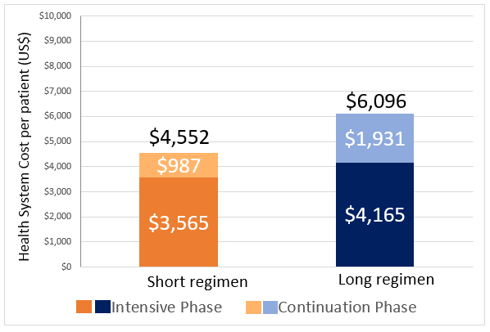 ii) 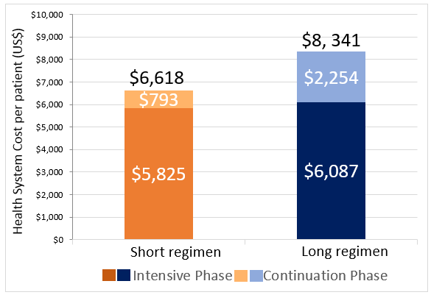
Figure 1 Health System cost per participant of treating MDR-TB in i) Ethiopia and ii) South Africa

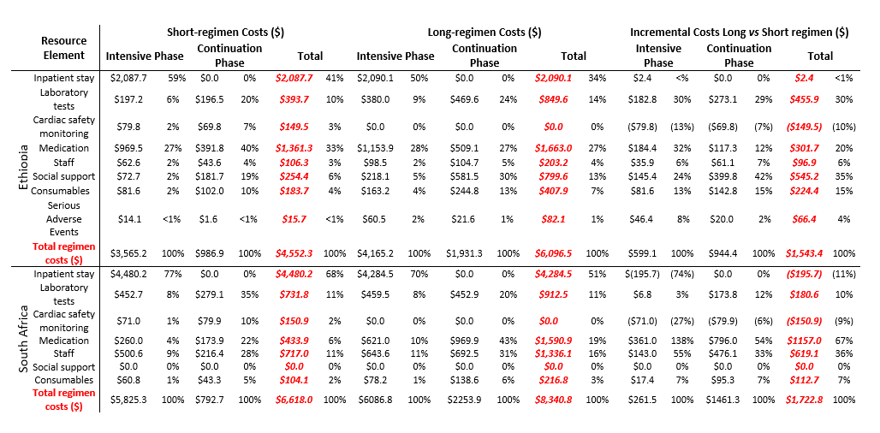
Table 2: Health system costs and break down of incremental cost saving in South Africa and Ethiopia (US$). The zero social-support cost for South Africa refers only to support funded by the health system. (Amounts in brackets are negative and represent dis-savings).

Figure 2. Cumulative supplementary food purchases in Long vs Short regimen in Ethiopia. The vertical lines represent the treatment completion points in the two regimens. Treatment completion in the Short-regimen, is around 40 weeks, but the nearest data collection point after treatment completion is at week 48. The Long-regimen completion is around 86 weeks, but the nearest data collection point after this is at 96 weeks.
†
Supplementary food expenditure data was not collected at week 0.

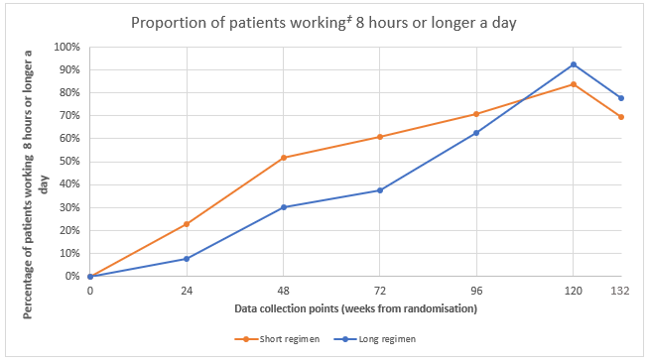
Figure 3: Proportion of participants working full-time (≥ 8 hours per day) in Ethiopia. The vertical lines represent the intensive phase end points for Short (at 16 weeks) and Long (at 32 weeks) regimens. All participants were hospitalised at randomisation.
‡ includes schooling, housework, formal and informal work.

Direct costs |  | Mean (95% CI)
South Africa | Overall | 4.92 (3.88, 5.96)
 | Transport | 3.60 (2.77, 4.44)
 | Food | 1.32 (0.77, 1.87)
Ethiopia | Overall | 1.14 (1.00, 1.25)
 | Transport | 0.77 (0.7, 0.85)
 | Food | 0.37 (0.27, 0.47)

Table 2: Patient direct costs per health centre visit for Ethiopia and South Africa (US$)

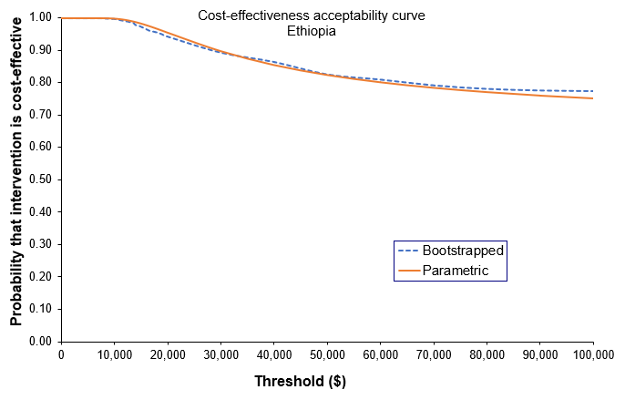
Figure 4. Cost-effectiveness acceptability curve for Ethiopia.
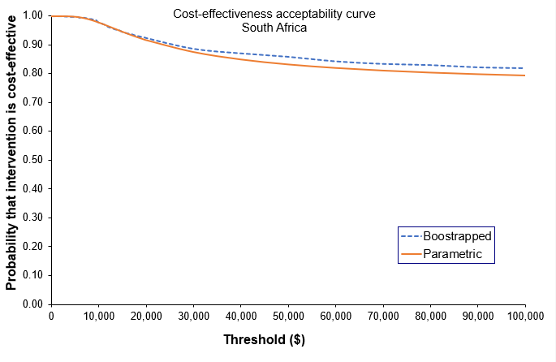
Figure 5. Cost-effectiveness acceptability curve for South Africa.
REFERENCES

- World Health Organization. Duration of second-line anti-tuberculosis regimens 2011. (http://apps.who.int/iris/bitstream/handle/10665/44597/9789241501583_eng.pdf?sequence=1) [Accessed 01.09.2018]

- Schnippel K, Rosen S, Shearer K, et al. Costs of inpatient treatment for multi-drug resistant tuberculosis in South Africa. Tropical Medicine and International Health 2013; 18:109-116. doi: 10.1111/tmi.12018

- Pooran A, Pieterson E, Davids M, Theron G, Dheda K. What is the Cost of Diagnosis and Management of Drug Resistant Tuberculosis in South Africa? PLoS ONE 2013; 8(1):e54587. doi: 10.1371/journal.pone.0054587

- Cox H, Ramma L, Wilkinson L, Azevedo V, Sinanovic E. Cost per patient of treatment for rifampicin-resistant tuberculosis in a community-based programme in Khayelitsha, South Africa. Tropical Medicine and International Health 2015; 20(10):1337-45. doi:10.1111/tmi.12544

- Laurence Y.V, Griffiths U.K, Vassall A, Costs to Health Services and the Patient of Treating Tuberculosis: A Systematic Literature Review. PharmacoEconomics, 2015; 33:939-955. doi= 10.1007/s40273-015-0279-6

- Ramma L, Cox H, Wilkinson L, et al. Patients' costs associated with seeking and accessing treatment for drug-resistant tuberculosis in South Africa. Int J Tuberc Lung Dis. 2015;19(12):1513–1519. doi:10.5588/ijtld.15.0341

- Trebucq A. Schwoebel V, Kashongwe Z et al. Treatment outcome with a short multidrug-resistant tuberculosis regimen in nine African countries. International Journal of Tuberculosis and Lung Disease 2018; 1;22(1):17-25. doi: 10.5588/ijtld.17.0498

- World Health Organization. The End TB Strategy: Global strategy targets for tuberculosis prevention, care and control after 2015, 2014.

- Nunn A, Philips PPJ, Meredith S, et al. STREAM: A trial of a short standardized regimen for rifampicin-resistant tuberculosis. New England Journal of Medicine 2019; 380:1201-1213. doi: 10.1056/NEJMoa1811867

- Gama E, Madan J, Langley I, et al. Economic evaluation of a shortened standardised treatment regimen of antituberculosis drugs for patients with multidrug-resistant tuberculosis (STREAM): study protocol. BMJ Open 2016; 6(10):e014386. doi: 10.1136/bmjopen-2016-014386

- Nunn A, Rusen ID, Van Deun A, et al. Evaluation of a standardized treatment regimen of anti-tuberculosis drugs for patients with multi-drug-resistant tuberculosis (STREAM): study protocol for a randomized controlled trial. Trials 2014; 15: 353. doi: 10.1186/1745-6215-15-353

- Rapid communication: key changes to treatment of drug-resistant tuberculosis. Geneva: World Health Organization; 2019 (WHO/CDS/TB/2019.26). Licence: CC BY-NC-SA 3.0 IGO.

- Wordsworth S et al. Collecting unit cost data in multicentre studies: Creating comparable methods. The European Journal of Health Economics 2005; 50(1): 38–44. Available at: http://www.ncbi.nlm.nih.gov/pubmed/15772871 [Accessed August 11, 2019].

- Hendriks ME, Kundu P, Boers AC et al. Step-by-step guideline for disease-specific costing studies in low-and middle-income countries: a mixed methodology. Global Health Action 2014; 7:1–10. doi: 10.3402/gha.v7.23573

- STREAM Health Economics supplementary appendix, Figshare. Doi: 10.6084/m9.figshare.11368674

- European Medicines Agency. Clinical Safety Data Management: Definitions and Standards for Expedited Reporting, 1995 (https://www.ema.europa.eu/en) [Accessed 27.08.2019].

- Tool to estimate patients’ costs. STOP-TB Partnership. 2008

- XE.com XE Currency Converter, 2019 (https://www.xe.com/currencyconverter/) [Accessed 27.08.2019].

- Baio G, Dawid AP. Probabilistic sensitivity analysis in health economics. Statistical methods in medical research. 2015 Dec;24(6):615-34.

- Fenwick E, O'Brien BJ, Briggs A. Cost‐effectiveness acceptability curves–facts, fallacies and frequently asked questions. Health economics 2004;13(5):405-15

- Sinanovic E, Ramma L, Vassall A et al. Impact of reduced hospitalisation on the cost of treatment for drug-resistant tuberculosis in South Africa. Int J Tuberc Lung Dis. 2015; 19(2): 172–178. doi:10.5588/ijtld.14.0421

- Loveday M, Wallengren K, Reddy T, et al. MDR-TB patients in KwaZulu-Natal, South Africa: Cost-effectiveness of 5 models of care. PLoS One 2018; 13(4):e0196003. doi:10.1371/journal.pone.0196003

- Royston P. Multiple imputations of missing values. The Stata Journal 2004, 3:227-241.

- Van den Hof S, Collins D, Hafidz F, Beyene D, Tursynbayeva A, Tiemersma E. The socioeconomic impact of multidrug resistant tuberculosis on patients: results from Ethiopia, Indonesia and Kazakhstan. BMC Infectious Diseases 2016; 16(1):470. doi: 10.1186/s12879-016-1802-x.

- WHO treatment guidelines for drug-resistant tuberculosis. Geneva: World Health Organization 2016 update. (https://apps.who.int/iris/bitstream/handle/10665/250125/9789241549639-eng.pdf;jsessionid=03C839DA84194B730355700282D2D9F7?sequence=1) [Accessed 27.01.2019].

- Meressa D, Hurtado RM, Andrews JR, et al Achieving high treatment success for multidrug-resistant TB in Africa: initiation and scale-up of MDR TB care in Ethiopia-an observational cohort study, Thorax 2015;70:1181-1188.

