Correspondence: up to 1000 words, 10 references and 1 table Searching for lost time

Thank you for this opportunity to comment on the editorial, “Emergency front of neck access: strategies for addressing its urgency” by Greenland and Sommerville¹. We agree strongly with their analogy of a Formula One pit crew working with precision and efficiency ¹ under conditions of great stress. This construct vividly illustrates how the theatre multi-disciplinary team must perform when faced with a can’t intubate can’t oxygenate (CICO) emergency. Team members are working against the clock in an extremely pressurised situation to restore alveolar oxygenation. In this situation robust training can save invaluable time in each of three phases of airway management:

PRE-INDUCTION: Extend the time to desaturation Anaesthetist optimises both patient positioning and pre-oxygenation.

POST-INDUCTION: Reduce procedural time Anaesthetist and operating department practitioner (ODP) manage the airway expeditiously using familiar techniques.

CICO EMERGENCY: Avoid wasting time Minimise Lost Time by promptly sending for the difficult airway trolley and help. Reduce Deliberation Time by training to improve both clinician emergency front of neck access (eFONA) skills AND a shared team approach to decision making.

The progression to a CICO emergency may be perceived as a personal failure for the anaesthetist². However, once this critical event has occurred, successful management requires a skilled, expedient and coordinated response by the entire theatre team. Our view is that traditional CICO training methods that narrowly focus on commitment of guidelines to memory and acquisition for emergency front of neck access (eFONA) poorly prepare clinicians for the emotion and stress of a real CICO emergency. This view was reinforced by our recently published study that evaluated a CICO training programme for trainee anaesthetists². Informed by this study, and the results of our BJA manuscript, we have developed multidisciplinary CICO simulation training to incorporate the whole theatre team³ (Figure 1).

Our objective for the training programme was to improve performance under stress and in doing so reduce deliberation time, procedural time and any “lost time” spent managing a CICO emergency. Time savings can be found by addressing both individual and team competencies, capabilities and readiness to act in this evolving emergency. The objective of the surgical cricothyroidotomy skills workshop is to improve procedural memory and enhance performance by incorporating elements of applied cognitive psychology used in elite sport and the military⁴. The skills workshop is underpinned by weekly opportunities for anaesthetists to act as first assistant at an elective surgical tracheostomy. A consultant oro-maxillo-facial surgeon teaches the importance of patient positioning, surface anatomy and basic surgical skills on a 1:1 basis.

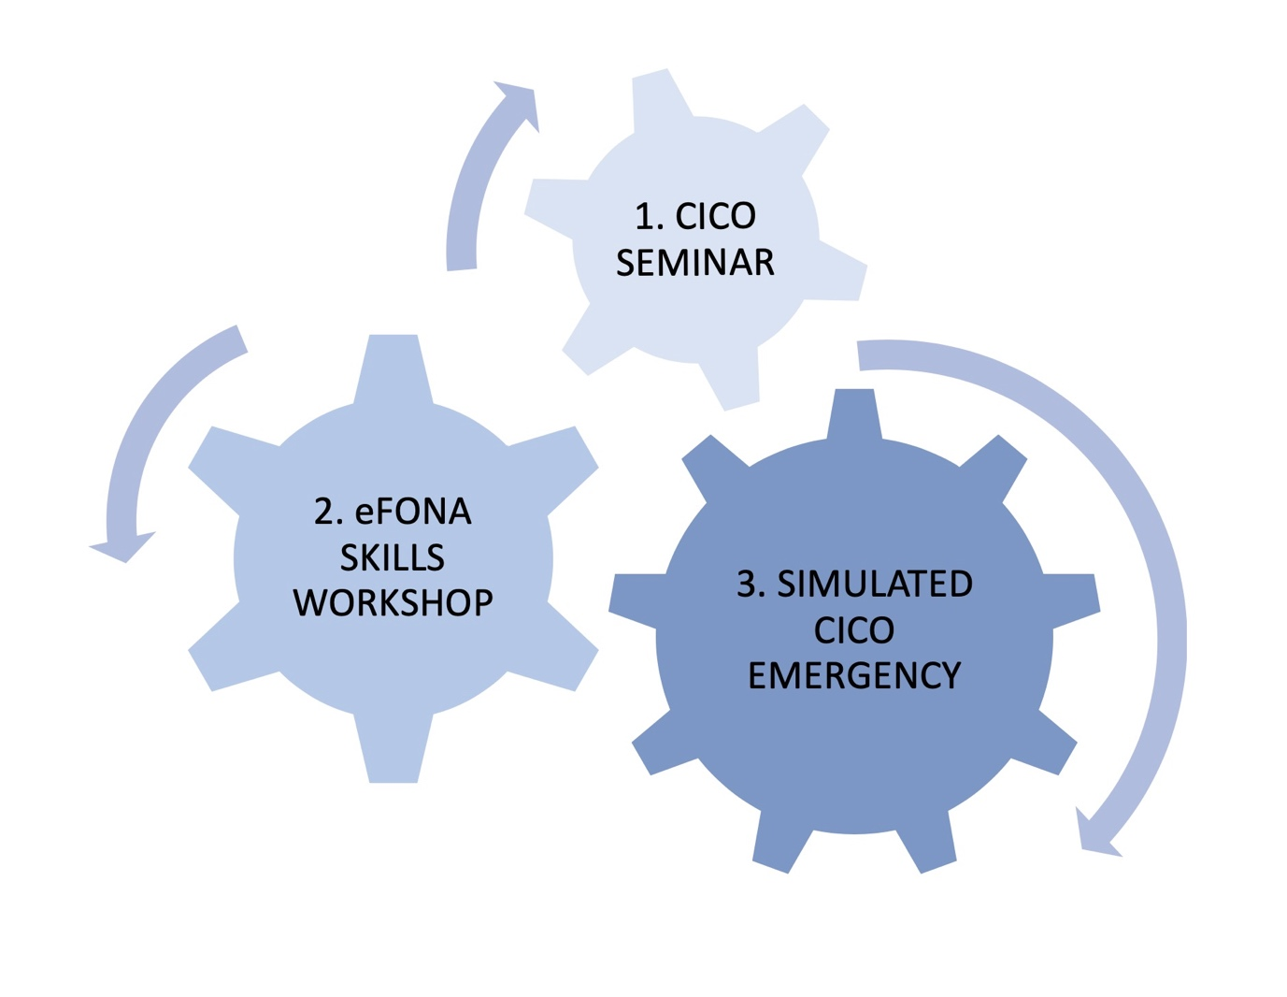Figure 1. Training to optimise performance and save time managing a CICO emergency.
1) CICO SEMINAR: delivered to the whole theatre multidisciplinary team (MDT) to define a shared mental model for dealing with a CICO emergency. Covers the DAS 2015 Guidelines to embed core knowledge and the Vortex cognitive aid to support real time decision making. 2) eFONA SKILLS WORKSHOP for anaesthetists, surgeons and Operating Department Practitioners (ODP’s) to increase confidence in performing surgical cricothyroidotomy⁵. A didactic approach to the procedure is repeatedly drilled on mannikins of increasing fidelity under conditions of increasing stress. 3) SIMULATED CICO EMERGENCY: In-situ, high fidelity simulation for the whole theatre MDT to rehearse their shared mental model of managing this emergency. Each team member drills their assigned role as well as practicing closed loop communication to accelerate the transition to eFONA when CICO is declared.

For the CICO emergency simulation we use the Vortex cognitive aid and assign role specific tasks to individual team members. The healthcare assistant (HCA) retrieves emergency equipment and calls for help, the scrub nurse will scribe and the anaesthetist, surgeon and ODP work together to restore oxygenation. As this training evolved, we developed a checklist for the scrub nurses, using the Vortex cognitive aid, to orientate the team within the emergency and guide appropriate actions by individual team members. Closed loop feedback between colleagues gives the anaesthetist the confidence to transition promptly to eFONA once CICO is declared.

We suggest that Airway Leads in other Hospitals adopt a similar programme of regular CICO “Formula One pit crew” training for their own multidisciplinary theatre teams. It is only by coaching the individual and team together can time can be managed effectively, and the risks of cerebral and cardiac hypoxia minimised. For example, training the health care assistant to promptly find and retrieve the airway trolley without prior context-driven rehearsal is a potential latent error that could contribute to significant lost time. Finally, we suggest the Royal College of Anaesthetists incorporate basic surgical skills training, potentially acquired on a ‘lumps and bumps list’, into the anaesthetic curriculum. Alongside simulation, this was considered one of the most important elements of our emergency surgical cricothyroidotomy training programme².

References
- Greenland KB and Sommerville RS. Emergency front of neck access: strategies for addressing its urgency. Br J Anaesth 2019 https://doi: 10.1016/j.bja.2019.08.008
- Berwick RG, Gauntlett W, Silverio SA, et al. A mixed methods pilot study to evaluate a collaborative anaesthetic and surgical training package for emergency surgical cricothyroidotomy. Anaesth Intensive Care 2019. https://doi.org/10.1177/0310057X19861978
- Groom P, Schofield L, Hettiarachchi N, et al. Performance of emergency surgical front of neck airway access by head and neck surgeons, general surgeons, or anaesthetists: an in-situ simulation study. Br J Anaesth 2019.
https://doi.org/10.1016/j.bja.2019.07.011
- Ward P, Farrow D, Harris KR, Williams AM, Eccles DW and Ericsson AK. Training Perceptual-Cognitive Skills: Can Sport Psychology Research Inform Military Decision Training? Military Psychology 2008. https://doi.org/10.1080/08995600701804814
- Frerk C, Mitchell VS, McNarry AF, et al. Difficult Airway Society 2015 guidelines for management of unanticipated difficult intubation in adults. Br J Anaesth 2015. https://doi.org/10.1093/bja/aev371
- Chrimes N. The Vortex: a universal ‘high-acuity implementation tool’ for emergency airway management. Br J Anaesth 2016. https://doi.org/10.1093/bja/aew175

