Appendix Figure A1: Photographs of the second biological replicate of the 15 ml tube-based biofilm formation experiment. 1) E. coli 10129 in polypropylene, 2) E. coli 10129 in polystyrene, 3) SS141 in polypropylene, 4) SS141 in polystyrene, 5) M9 only in polypropylene and 6) M9 only in polystyrene incubated at A) 37°C and B) room temperature for 24 hours.
A)
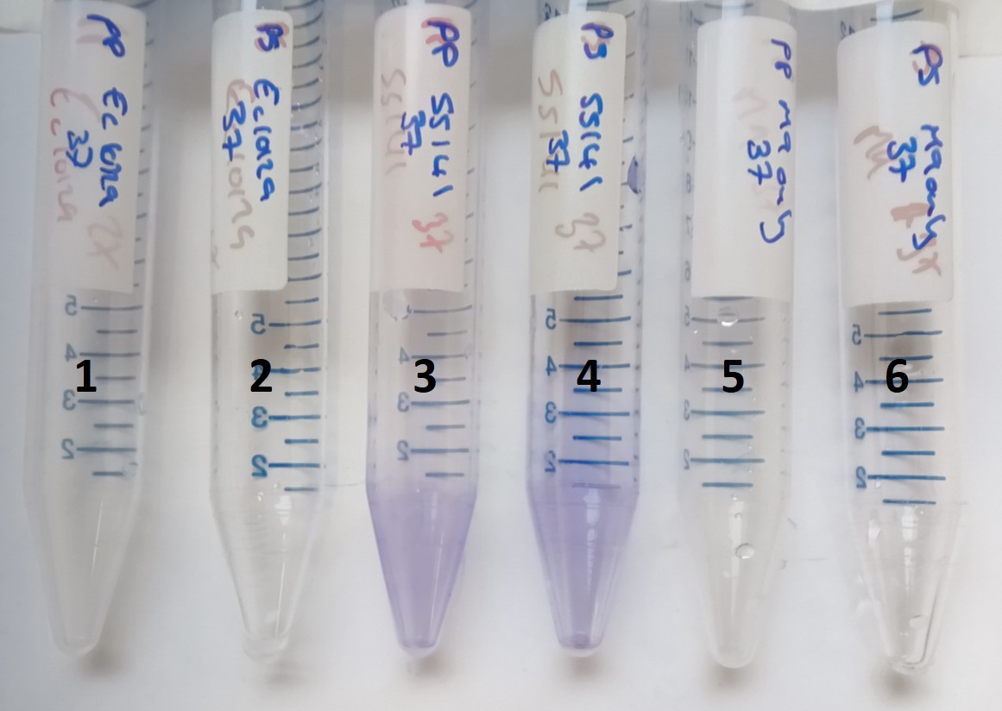
B)
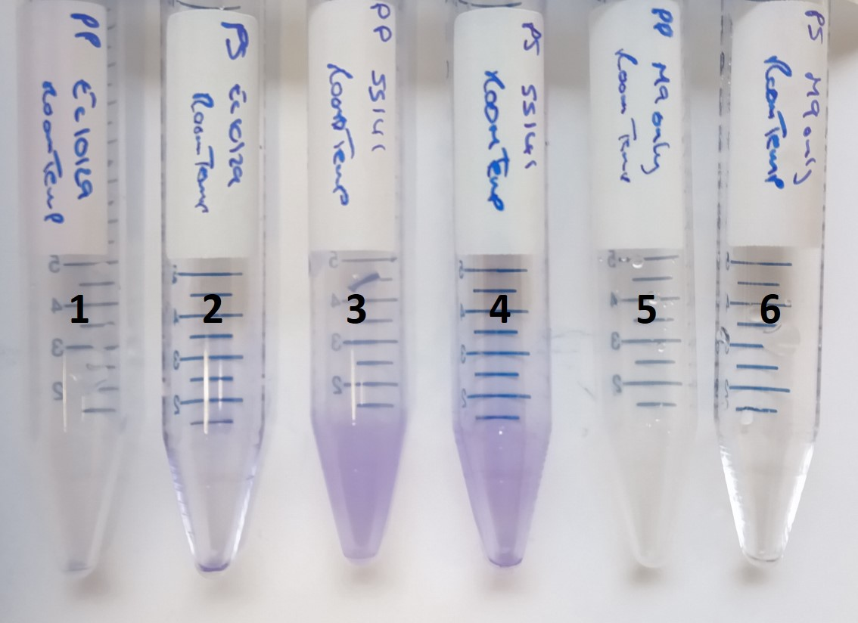
Appendix Figure A2: Photographs of the third biological replicate of the 15 ml tube-based biofilm formation experiment.1) E. coli 10129 in polypropylene, 2) E. coli 10129 in polystyrene, 3) SS141 in polypropylene, 4) SS141 in polystyrene, 5) M9 only in polypropylene and 6) M9 only in polystyrene incubated at A) 37°C and B) room temperature for 24 hours.
A)
1 2 3 4 5 6

B)
1 2 3 4 5 6

