**FIGURE 1 CONSORT diagram for the DolPHIN-2 Study**

Received allocated Dolutegravir intervention (N=135)

Received allocated Efavirenz intervention (N=133)

Excluded after further assessment (n=6)

* Serum hemoglobin <8.0 g/dL (n=6)

Excluded after further assessment (n=5)

* Serum hemoglobin <8.0 g/dL (n=5)

Eligible in Dolutegravir group (n=129)

Eligible in Efavirenz group (n=128)

Premature discontinuations

- Withdrawn (n=3)

- Discontinued Intervention (n=2)

Premature discontinuations

- Withdrawn (n=4)

- Discontinued Intervention (n=4)

Excluded from analysis because baseline viral load <50 copies per mL (n=4)

Excluded from analysis because baseline viral load <50 copies per mL (n=3)

Safety Population (n=133)

ITT Population (n=125)

- Efavirenz Primary Efficacy Endpoint (n= 117)

Safety Population (n=135)

ITT Population (n=125)

- Dolutegravir Primary Efficacy Endpoint (n= 120)

Randomised (n=268)

Excluded (n=12)

- Not meeting inclusion / exclusion criteria (n= 10)

- Declined to participate (n=1)

- Other reasons – trial recruitment stopped (n=1)

Assessed for eligibility (n=280)

**FIGURE 2 Proportion with viral load <50 copies per mL and <1000 copies per mL following randomisation**

a) Time to viral load <50 copies per mL

b) Time to viral load <1000 copies per mL

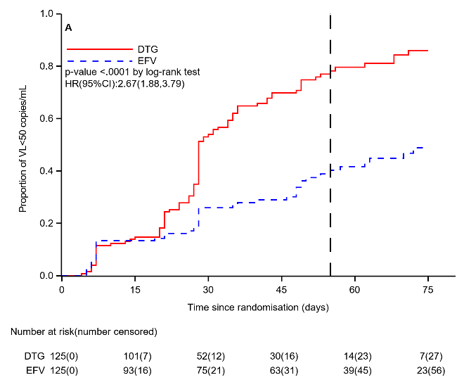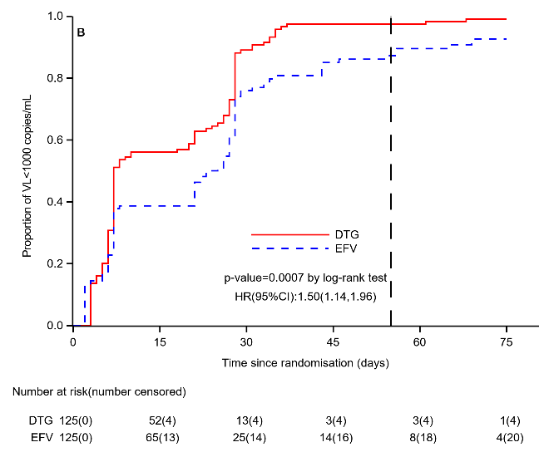

Kaplan-Meier plots of time from randomization to HIV viral load (a) <50 copies per mL and (b) <1000 copies per mL. Dashed vertical line in each plot represents the median time from randomization to delivery (55 days) in the total trial population.