Short Report

Case Report: Traumatic Incomplete Fracture of an Implanon NXT® Contraceptive Implant

Rebecca Howett¹*, Alida M Gertz¹, Tiroyaone Kgaswanyane², Gregory Petro³ and Chelsea Morroni^{1,4,5,6}
Botswana-UPenn Partnership, Gaborone, Botswana¹; Botswana Family Welfare Association (BOFWA), Gaborone, Botswana²; Department of Obstetrics and Gynaecology, New Somerset Hospital, University of Cape Town, Cape Town, South Africa³; Botswana Harvard AIDS Institute, Gaborone, Botswana⁴; Wits Reproductive Health and HIV Institute (Wits RHI), University of the Witwatersrand, Johannesburg, South Africa⁵; Women’s Health Research Unit, School of Public Health and Family Medicine, University of Cape Town, Cape Town, South Africa⁶; Department of International Public Health, Liverpool School of Tropical Medicine, Liverpool, UK⁷.

*For Correspondence: Email: rjhowett@gmail.com; Phone +267 355 4862

Abstract

The etonogestrel (ENG) subdermal contraceptive implant (Implanon NXT®) is a safe and highly effective method of contraception which is increasing in popularity globally. This case report describes a 26-year-old woman who requested removal of the Implanon NXT® contraceptive implant. She reported that her implant had bent following direct trauma. The implant was removed in accordance with her request and without complication, but was noted to be incompletely fractured. We compare this case with a summary of the existing literature on fractured or damaged contraceptive implants. Structural damage detected whilst the implant is in situ is one potential complication of contraceptive implant use. The incidence of this complication and the implications for contraceptive efficacy are unknown. Damaged implants may present healthcare providers with more technically challenging “difficult removals”. With the scale-up of services for implant provision, consideration should be given to this issue in order to inform counselling and removal services.

Keywords: Contraception, contraceptive implant, implant removal, fractured implant, Implanon NXT®

Running Title: Broken Implant Case Report

Introduction

Several subdermal contraceptive implants are currently available: etonogestrel (ENG) implants (Implanon NXT®/Nexplanon®, Merck) and levonorgestrel (LNG) implants (Jadelle®, Bayer; and Sino-implant®/Levoplant®, Shanghai Dahua Pharmaceutical Co Ltd). All types release a progestogen at a controlled rate, providing very effective contraceptive protection over their 3-5-year lifespan. Implants can be bent or broken with or without associated trauma, although the true incidence of implant damage is unknown. Removal of a structurally damaged implant may be more technically challenging compared with standard implant removal.

Case Report

A 26-year-old woman, gravida 1, para 1, presented to our sexual and reproductive health clinic in Botswana in November 2017 requesting removal of her ENG implant, Implanon NXT®, due to concern that it had “broken in half”. The woman reported that four days prior to presentation, her seven-year-old daughter had stamped on her left, inner, upper arm, over the site of the implant. She had immediately noticed a palpable bend in the implant and then unexpected and heavier than usual bleeding within a few days. The ENG implant had been inserted 13 months earlier, in accordance with the manufacturer’s instructions¹ at the same sexual and reproductive health clinic and without complications. She had been satisfied with it prior to this presentation. She had no past medical history, was HIV negative, on no concomitant mediations, and had had a recent normal Pap smear. She reported regular menstrual cycles before initiating the implant and regular monthly bleeding after implant initiation. She had been able to palpate the implant since insertion. On clinical assessment, the implant was palpably bent in the middle section. It was removed via the routine “pop-up” technique, as described in the manufacturer’s prescribing information¹. Inspection confirmed it to be bent and incompletely fractured at the middle (Figure 1). A new ENG implant was inserted through the same removal incision. There were no complications associated with the removal or re-insertion procedures. The woman was advised to return for follow-up in one month and the manufacturer was notified.
Discussion

A contraceptive implant can be broken at the time of insertion, at the time of removal, or whilst in situ. Breakage at the time of insertion may be due to damage inflicted by the insertion needle if the applicator is not pulled back in one smooth motion; even if the implant remains whole, it might be weakened and predisposed to breaks or fractures when an outside force is applied whilst it is in situ. Breakage at the time of removal may be due to inadvertent damage caused by the healthcare provider’s removal scalpel.
Reviewing the literature, we found twenty-one individual case reports of fractured contraceptive implants, in addition to a survey which generated a “crowd-sourced” case series of fifty-four fractured implants, of which fifty-two were ENG implants² (Table 1). All published case reports of damaged/fractured implants are from Europe and the United States, and are likely to represent a small fraction of the total cases globally. Seven of the case reports were associated with trauma³⁻⁷, and fourteen were not associated with trauma^{5,6,8-12}.
No published data exist on the prevalence of implant fracture for Implanon NXT® and Jadelle®. We found no case reports of fractured Jadelle® implants, and other authors have noted that there is no information on this issue from Jadelle® post-marketing surveillance data¹³. The topic of damaged implants is not covered in the manufacturer’s information for Nexplanon^{®1} or Jadelle^{®14}. Implant breakage occurred during 1.7% of Norplant® removal procedures¹⁵.
Based on reported cases, most clients and healthcare providers have preferred removal and replacement of damaged implants for reassurance of consistent hormone release, contraceptive efficacy and side effect profile^{3,5-7,9}. However, no data is available to guide decision-making in this regard. In vitro data from the manufacturer of Implanon NXT® showed a slight increase in etonogestrel release from damaged implants, but this was thought not to be at such rate as to lead to the implant expiring before the end of its usual life span and therefore was not thought to affect contraceptive efficacy¹⁶. Hormone-related side effects have been reported in some cases of implant damage/fracture, particularly abnormal bleeding^{2-5,7,8,10}.
While likely to be an uncommon occurrence, as implant provision is scaled up globally and especially in lower- and middle-income countries (LMICs)¹⁷, healthcare services and healthcare providers need to be aware of the possibility of implant fracture/damage so as to manage this most appropriately and safely.
Careful monitoring and reporting of implant-associated complications is important to establish the true prevalence of implant fracture/damage and outcomes. This should include information about: (a) mechanism i.e. whether associated with trauma or not; (b) time from insertion to damage/fracture and (c) clinical significance i.e. whether considered to be associated with change in contraceptive efficacy or side effects. This data may help inform decisions about whether removal and replacement are indicated, particularly in settings with limited resources or where removal services are in their infancy.
Finally, it is important to consider that the removal of damaged implants may be technically challenging, and healthcare providers need to be to be aware of this in order to perform competent and safe removals. For example, removal of a fractured implant may require multiple incisions⁶, or it may be appropriate to make the removal incision at the site of the implant fracture⁵. If the implant is known to be damaged or if part of the implant is not palpable, then ultrasound assessment prior to attempting removal should be considered¹⁸.

Conclusion

Taken into consideration alongside other cases reported by our colleagues in sexual and reproductive health programmes worldwide, this case highlights the issue of fracture or damage as a potential complication of contraceptive implant use. Healthcare providers need to be aware of this possibility in order to provide appropriate client counselling and safe removal, and consideration should be given to this issue during the development of implant programmes in LMICs.
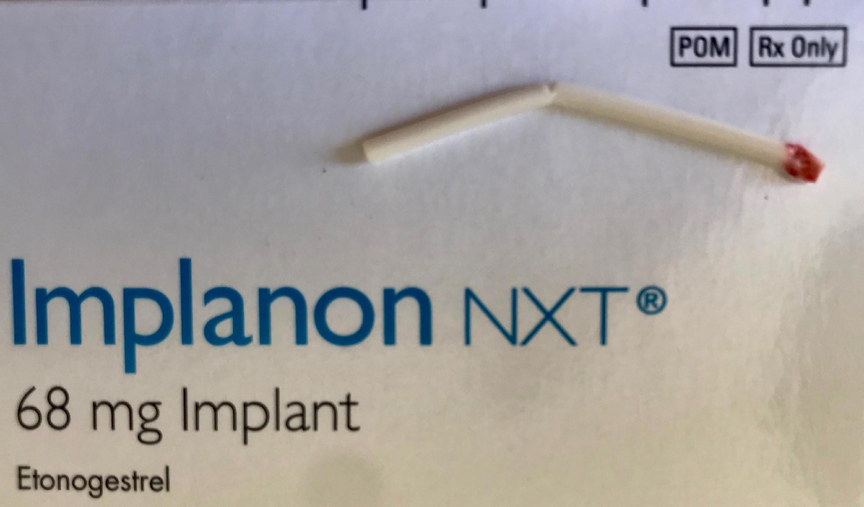

Figure 1: Photograph of the incompletely fractured Implanon NXT® implant presented in this case study, after removal

Table 1: Summary of published case reports of fractured contraceptive implants

Case | Authors | Year | Country | Journal | Type of Implant | Fracture pattern | Associated Trauma | Associated symptoms
1 | Pickard and Bacon | 2002 | UK | J Fam Plann Reprod Health Care | Implanon | Incomplete fracture, one piece | Yes | Change in bleeding pattern
2 | Agrawal and Robinson | 2003 | UK | J Fam Plann Reprod Health Care | Implanon | Complete fracture, two pieces | No | Change in bleeding pattern
3 | Tomás-Tello and Hodgson | 2010 | UK | J Fam Plann Reprod Health Care | Implanon | Incomplete fracture, one piece | Yes | Change in bleeding pattern
4 |  |  |  |  | Implanon | Incomplete fracture, one piece | Yes | Change in bleeding pattern
5 | Doshi | 2011 | UK | J Fam Plann Reprod Health Care | Implanon | Bent | No | Nil
6 | Bentley | 2013 | UK | J Fam Plann Reprod Health Care | Nexplanon | Incomplete fracture, one piece | Yes | Change in bleeding pattern
7* |  |  |  |  | Nexplanon | Complete fracture, two pieces | No | Nil
8* |  |  |  |  | Nexplanon | Bent | No | Burning pain at implant site
9** |  |  |  |  | Nexplanon | Incomplete fracture, one piece | No | Nil
10** |  |  |  |  | Nexplanon | Incomplete fracture, one piece | No | Pain at implant site
11 |  |  |  |  | Nexplanon | Bent | No | Not documented
12 |  |  |  |  | Nexplanon | Bent | No | Not documented
13 |  |  |  |  | Nexplanon | Complete fracture, two pieces | No | Not documented
14 |  |  |  |  | Implanon | Bent | No | Not documented
15 | Torres et al. | 2013 | Portugal | Contraception | Implanon | Complete fracture, two pieces | No | Nil
16 |  |  |  |  | Implanon | Complete fracture, two pieces | Yes | Nil
17 | Elliman | 2013 | UK | J Fam Plann Reprod Health Care | Nexplanon | Incomplete fracture, one piece | No | Change in bleeding pattern
18 | Khatri | 2015 | UK | J Fam Plann Reprod Health Care | Nexplanon | Complete fracture, more than two pieces | No | Nil
19 | Hartnell | 2015 | UK | J Fam Plann Reprod Health Care | Nexplanon | Incomplete fracture, one piece | No | Nil
20 – 73 | Crouthamel et al. | 2018 | USA | J Pediatr Adolesc Gynecol | Implanon x 14; Nexplanon x 38; Histrelin acetate x 2*** | Bent x 7; incomplete fracture, one piece x 23; complete fracture, two pieces x 16; complete fracture, more than two pieces x 8 | Yes x 28; unknown x 25 | Change in bleeding pattern x 4; unknown x 6
74 | Campodonico et al. | 2019 | USA | J Am Board Fam Med | Nexplanon | Incomplete fracture, one piece | Yes | Change in bleeding pattern
75 |  |  |  |  | Nexplanon | Complete fracture, two pieces | Yes | Change in bleeding pattern

*Cases 7 and 8 concern the same client
**Cases 9 and 10 concern the same client
***This case series includes two non-contraceptive implants, which have been included here because the distribution of fracture patterns and fracture mechanisms is unclear between the contraceptive and non-contraceptive implants

Contribution of Authors

RH, AMG, and TK performed the implant removal described in this case report. RH and AMG wrote the first draft of the manuscript under the supervision and guidance of GP and CM. All authors contributed substantially to the revision of the manuscript and approved the final manuscript.
Acknowledgements

AMG’s time working on this publication was supported by the Fogarty International Center of the National Institutes of Health under Award Number D43 TW010543 and the Afya Bora Fellowship Program. The content is solely the responsibility of the authors and does not necessarily represent the official views of the NIH.

References

1. Merck. Nexplanon prescribing information, https://www.merck.com/product/usa/pi_circulars/n/nexplanon/nexplanon_pi.pdf [accessed 11 May 2019].
2. Crouthamel BC, Schiff MA, Amies Oelschlager AE, Prager SW and Debiec KE. Bits and pieces: a crowd-sourced series of 54 cases of fractured hormonal implants. J Pediatr Adolesc Gynecol 2018; 31(2):128-131.
3. Pickard S and Bacon L. Persistent vaginal bleeding in a patient with a broken Implanon®. J Fam Plann Reprod Health Care 2002; 28(4):207-208.
4. Tomas-Tello MD and Hodgson G. Two cases of broken Implanon®. J Fam Plann Reprod Health Care 2010; 36(4):255.
5. Bentley J. Experience and removal of damaged implants. J Fam Plann Reprod Health Care 2013; 39:233-234.
6. Torres R, Mendes N, Machado AI and Marques C. In situ breakage of Implanon® – two cases of a rare occurrence. Contraception 2013; 88:189-191.
7. Campodonico J, Wolfrey J and Buchanan J. Reports of Two Broken Nexplanon® Rods. J Am Board Fam Med 2019; 32(2):269-271.
8. Agrawal A and Robinson C. Spontaneous snapping of an Implanon® in two halves in situ. J Fam Plann Reprod Health Care 2003; 29(4):238.
9. Doshi J. Bent Implanon®. J Fam Plann Reprod Health Care 2011; 37:126.
10. Elliman A. Removal of a fractured Nexplanon®. J Fam Plann Reprod Health Care 2013; 39:66-67.
11. Khatri D. Fractured Nexplanon® implant. J Fam Plann Reprod Health Care 2015; 41:77.
12. Hartnell V. Incidence of fractured implants. J Fam Plann Reprod Health Care 2015; 41:157.
13. Rowlands S and Seattle S. Contraceptive implants: current perspectives. Open Access Journal of Contraception 2014; 5:73-84.
14. Bayer. Jadelle prescribing information, https://www.accessdata.fda.gov/drugsatfda_docs/label/2016/020544s010lbl.pdf [accessed 11 May 2019].
15. Dunson TR, Amatya RN and Krueger SL. Complications and risk factors associated with the removal of Norplant implants. Obstet Gynecol 1995; 85:543-548.
16. Rekers H. Removal of a fractured Nexplanon®: MSD response. J Fam Plann Reprod Health Care 2013; 39:67.
17. Jacobstein, R. Liftoff: The Blossoming of Contraceptive Implant Use in Africa. Global Health, Science and Practice 2018; 6(1):17-39.
18. Petro G. Non-palpable and difficult contraceptive implant removals: The New Somerset Hospital referral-clinic experience. S Afr J Obstet Gynaecol 2017; 23(3):101-104.

