Title:
A steroid hormone agonist reduces female fitness in insecticide-resistant Anopheles populations
Faye Brown ^{a, *}, Douglas G Paton ^{b}, Flaminia Catteruccia ^{b}, Hilary Ranson ª and Victoria A Ingham ª

- Department of Vector Biology, Liverpool School of Tropical Medicine, Pembroke Place, Liverpool, L35QA
- Department of Immunology and Infectious Diseases, Harvard T. H. Chan School of Public Health, 655 Huntington Ave, Boston, MA 02115

* Author’s current address: Department of Epidemiology and Population Health, Faculty of Health and Life Sciences, Leahurst Campus, University of Liverpool, Neston, CH647TE

Abstract
Insecticide based vector control tools such as insecticide treated bednets and indoor residual spraying represent the cornerstones of malaria control programs. Resistance to chemistries used in these programs is now widespread and represents a significant threat to the gains seen in reducing malaria-related morbidity and mortality. Recently, disruption of the 20-hydroxyecdysone steroid hormone pathway was shown to reduce Plasmodium development and significantly reduce both longevity and egg production in a laboratory susceptible Anopheles gambiae population. Here, we demonstrate that disruption of this pathway by application of the dibenzoylhydrazine, methoxyfenozide (DBH-M), to insecticide resistant An. coluzzii, An. gambiae sl and An. funestus populations significantly reduces egg production in both topical and tarsal application. Moreover, DBH-M reduces adult longevity when applied topically, and tarsally after blood feeding. As the cytochrome p450s elevated in pyrethroid resistant Anopheles only bind DBH-M very weakly, this compound is unlikely to be subject to cross-resistance in a field-based setting. Manipulation of this hormonal signalling pathway therefore represents a potential complementary approach to current malaria control strategies, particularly in areas where high levels of insecticide resistance are compromising existing tools.

Keywords
Insecticide resistance; Anopheles; malaria; vector control; Methoxyfenozide; 20-hydroxyecdysone

- Introduction
The most effective form of malaria prevention is the control of the insect vector, the Anopheles mosquito (Bhatt et al., 2015). Vector control relies heavily on pyrethroid insecticides, which are currently used in all long-lasting insecticidal nets (LLINs), the main malaria prevention tool. LLINs provide personal protection through barrier action, preventing a host-seeking female from contacting the bed net user (Hawley et al., 2003). They also reduce the longevity of adult females and the likelihood they will live long enough to acquire and transmit the Plasmodium parasite. The heavy use of pyrethroid insecticides in LLINs, in addition to their use for control of agricultural pests, has inevitably led to widespread resistance to this insecticide class; indeed, pyrethroid resistance is observed in malaria vectors in over 80% of all surveillance sites in the WHO African region (“World Malaria Report.,” 2019) and is likely reducing the effectiveness of LLINs (Protopopoff et al., 2018; Toé et al., 2014). There is a clear and urgent need for new chemistries with distinct modes of action that can be incorporated into LLINs in order to combat increasing insecticide resistance in natural populations.

Resistance to pyrethroid insecticides is caused by at least four characterised mechanisms, several of which can be present in an individual mosquito; changes to the insecticide target site (Martinez‐Torres et al., 1998; Ranson et al., 2000), reduced penetrance due to thickening of the insect cuticle (Balabanidou et al., 2016); sequestration by chemosensory proteins (Ingham et al., 2019) and increased metabolic clearance by detoxification enzymes such as cytochrome p450s (Müller et al., 2008; Stevenson et al., 2011). To restore the efficacy of pyrethroid treated bed nets in areas with resistant vectors, next generation nets impregnated with both pyrethroid insecticides and the cytochrome p450 inhibitor piperonyl butoxide (PBO) (Protopopoff et al., 2018) are now being implemented in several African countries. In addition, dual action nets with pyrethroids plus the sterilising compound pyriproxyfen have been successfully trialled in field settings (Bayili et al., 2017; Protopopoff et al., 2018; Tiono et al., 2018) and this class of nets are expected to be in field use by the end of 2020. Mathematical models demonstrate that these new classes of nets could play a key role in reducing malaria cases in areas with high levels of insecticide resistance (Churcher et al., 2016). Nevertheless, there is a continual need for innovation into new LLINs, to pre-empt future resistance challenges; indeed there are already reports of cross resistance between pyrethroids and pyriproxyfen which may undermine the performance of these dual action nets in some settings (Yunta et al., 2016).

Recently, a 20-hydroxyecdysone (20E) agonist, methoxyfenozide (DBH-M), was shown to impact multiple aspects of Anopheles biology that are relevant to its ability to carry and transmit Plasmodium (Childs et al., 2016). 20E is a major steroid hormone that, in multiple Anopheles species, is important for the reproductive fitness of adult male mosquitoes (Mitchell et al., 2015; Pondeville et al., 2008), alongside its conserved roles in adult female oogenesis (Baldini et al., 2013) and larval development (Gilbert and Rewitz, 2009). Natural male 20E transfer during mating triggers substantial molecular responses within the female (Gabrieli et al., 2014; Mitchell et al., 2015; Peirce et al., 2020; Shaw et al., 2014) leading to dramatic physiological changes including a loss of mating susceptibility, immune modulation, disinhibition of oviposition behaviour (Gabrieli et al., 2014; Mitchell et al., 2015) and upregulation of genes associated with oogenesis (Baldini et al., 2013). In a previous study, direct, topical application of DBH-M onto An. gambiae females (G3 strain) induced a multimodal cascade of effects comprising substantially reduced lifespan and fecundity, reduced mating susceptibility, and partial blockage of Plasmodium falciparum transmission (Childs et al., 2016). Mathematical modelling predicted that, due to the combined effect on multiple traits, the use of DBH-M as a vector control tool could produce comparable reductions in malaria burden to insecticide-based vector control (Childs et al., 2016). However, to be effective in the field, proposed new chemistries for incorporation into LLINs must overcome two key challenges. Firstly, they need to demonstrate efficacy against multiple wild insecticide resistant populations. Secondly, as tarsal uptake is the major route of delivery of insecticides on LLINs, the insecticides must be able to traverse the insect cuticle to reach their target sites.

Here we evaluate the effects of DBH-M treatment in a number of insecticide-resistant Anopheles populations from sub-Saharan Africa, focusing on two important female life history traits: oogenesis and lifespan (Lees et al., 2019). We show that, similar to previous results in insecticide-susceptible An. gambiae, topical application of DBH-M significantly reduces the number of eggs and the adult lifespan of highly pyrethroid resistant populations. Importantly, similar effects were observed when using tarsal uptake bioassays in the presence of an adjuvant. These data provide evidence that chemistries manipulating 20E function could be viable additions to the toolbox for malaria control.

- Materials and Methods

  - Mosquito rearing
All tests were carried out using 2-5 day old non-blood fed female mosquitoes of the resistant An. gambiae s.l. strain Tiassalé, a mixture of An. gambiae and An. coluzzii (Edi et al., 2012) from Cote D’Ivoire, two An. coluzzii strains, VK72014 and Banfora, from Burkina Faso (Namountougou et al., 2012) and An. funestus FUMOZ from Mozambique (Hunt et al., 2005). Details of the resistance levels, species ID and underpinning mechanisms in these strains are provided in (Williams et al., 2019). The lab susceptible An. gambiae G3 strain was used as a control in all experiments. Insectaries were maintained under standard insectary conditions at 26°C ± 2°C and 70% relative humidity ± 10% under L12:D12 hour light:dark photoperiod. All stages of larvae were fed on ground fish food (Tetramin tropical flakes, Tetra, Blacksburg, VA, USA) and adults were provided with 10% sucrose solution ad libitum.

  - Topical application or Methoxyfenozide
An 8% stock solution of the compound methoxyfenozide (DBH-M) (Sigma-Aldrich) was prepared in DMSO; this stock was diluted in acetone to a 0.4% to match the concentration used in previous studies (Childs et al., 2016). Mosquitoes were anesthetized using carbon dioxide, placed on a petri dish lined with filter paper with the thorax exposed and held on a 4°C chill table (BioQuip products, Rancho Dominguez, CA). Using a hand-operated micro applicator (Burkhard Scientific, Uxbridge, UK), 0.5-µl of the 0.4% DBH-M solution or a solvent-only negative control was applied to the dorsal thorax using a 1 cm³ syringe. Mosquitoes were transferred into holding cups, supplied with 10% sucrose solution and held in insectary conditions. Mortality was scored 24 hours post topical treatment and daily thereafter.

  - Tarsal Contact Assay
A 0.1438% solution of DBH-M was prepared in acetone alone or with 0.0392% RME. A 500μl aliquot of the insecticide solution or solvent-only control was applied to the surface of Petri dishes (radius 2.5cm, area 19.64cm²) resulting in a DBH-M concentration of 367mg/m² and where applicable, 100mg/m² RME. The petri dishes were placed onto an orbital shaker for 4 hours to evenly coat the surface and allow the dish to dry. Treated surfaces were used for one day and discarded. A 25ml plastic pot with a hole cut through the base was inverted and used to cover the surface to contain the mosquitoes. Replicates of ten mosquitoes were introduced through the hole and exposed to the surface for 30 minutes in insectary conditions. Mosquitoes were aspirated from the surface and transferred to holding cups, maintained on 10% sucrose solution and mortality scored 24 hours after exposure. Mosquitoes were then used to test the effect on egg production and survival as for the topical assays.

  - Egg Counts
To test the effect of DBH-M on egg production, 24-hour post exposure, surviving mosquitoes were fed on human blood using a Haemotek membrane feeding system. Those that unsuccessfully fed or were partially fed were removed from the experiment. 72 hours post-blood feeding, mosquitoes were knocked down in the freezer and then dissected on glass sides. A few drops of distilled water were used to aid the removal of the ovaries under a dissecting microscope. Ovaries were gently teased apart and the number of eggs were counted and scored. Egg counts were assessed using GraphPad Prism 7.0 software, raw counts were compared using a Mann-Whitney U test and the egg intensity compared using a chi-squared test.

  - Longevity
To assess survival post DBH-M treatment, mosquitoes were transferred into cups of ten and supplied with sugar water. Mortality was recorded every 24 hours, with dead mosquitoes being removed daily and assays continuing until all mosquitoes had died. In separate experiments on G3, Tiassalé and FUMOZ strains, mosquitoes were blood fed 24 hours post exposure to the treated surface and scored every 24 hours until all mosquitoes had died. Longevity was assessed using GraphPad Prism 7.0 using a Mantel-Cox test.

  - Cytochrome P450 competitive binding assays
Competitive binding assays with DBH-M and the fluorescent molecule diethoxyfluorescein (DEF) were carried out as previously described (Yunta et al., 2019) using the identical enzyme batch used in published studies evaluating binding of other public health insecticides (Yunta et al., 2019). Methoxyfenozide concentrations ranged from 0.0013μM to 2000μM final concentration; control wells contained DEF only. Reactions were set up in triplicate in a 96-well flat-bottomed, black plate and fluorescent read out performed on a fluorimeter. IC₅₀ values were calculated on GraphPad Prism 7.

- Results

  - Topical application of methoxyfenozide disrupts egg production and decreases lifespan in multi-resistant Anopheles populations
Methoxyfenozide was applied topically to four insecticide-resistant Anopheles populations, alongside a susceptible control (An. gambiae G3). The four resistant populations included one An. funestus (FUMOZ), one An. gambiae s.l. (Tiassalé), and two An. coluzzii populations (Banfora and VK7). All populations are resistant to pyrethroids but the underpinning mechanisms differ (Williams et al., 2019). 24-hours post-application, the females were blood fed and 72-hours later ovaries were dissected and egg numbers scored. In each population, the total number of eggs in the DBH-M treated group were significantly lower (p _{Mann-Whitney} < 0.0001) than in the respective acetone treated controls (Figure 1A) and in some cases treatment induced almost total suppression of egg development. Furthermore, the proportion of blood fed females that failed to develop eggs was significantly higher in the treated than the control group for all strains (p _{χ2} < 0.0001; df = 1) (Figure 1B). Adult lifespan was also significantly reduced by DBH-M treatment in all populations (p _{Mantel-Cox} ≤ 0.001; df = 1), with the exception of An. funestus (Figure 1C).

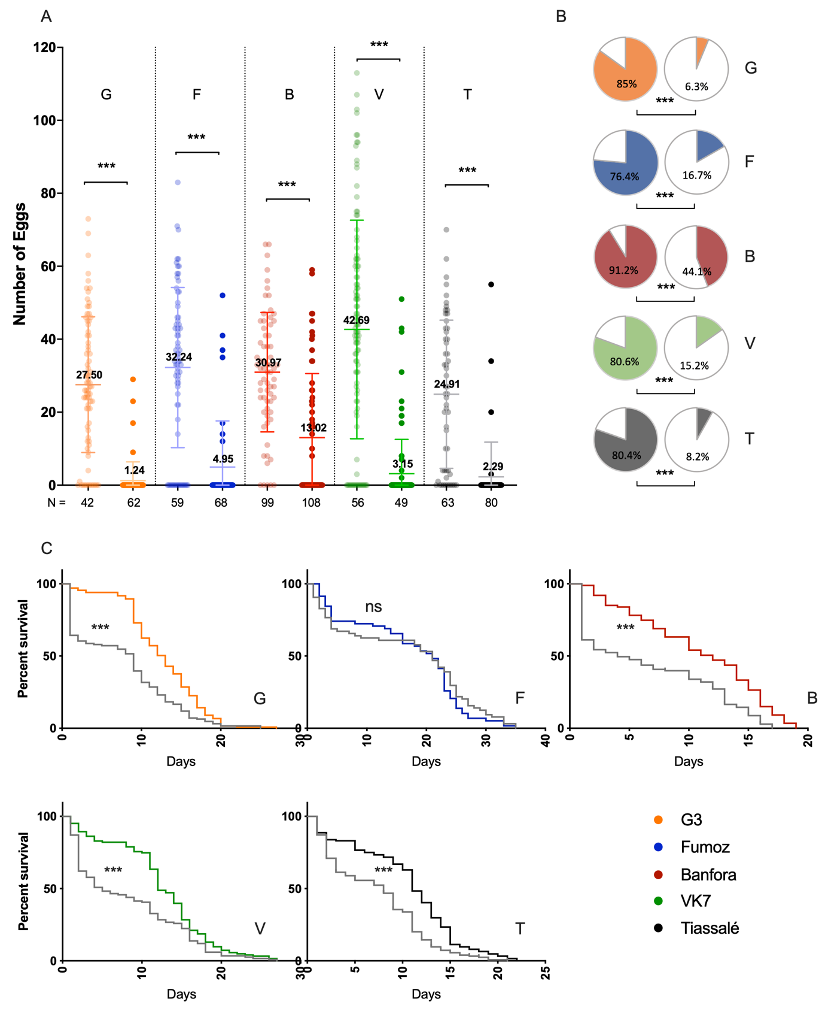
Figure 1. Topical application of 0.4% methoxyfenozide affects egg development and lifespan in multiple insecticide resistant Anopheles populations. A lab susceptible colony (G3: G); a pyrethroid-resistant An. funestus population (FUMOZ: F); two pyrethroid-resistant An. coluzzii populations (Banfora: B and VK7: V); and a pyrethroid-resistant An. gambiae sl population (Tiassalé: T) were subjected to topical application of the 20E agonist 0.4% DBH-M. (A) DBH-M-treated females (rightmost group) developed a significantly lower number of eggs than controls (leftmost group) in each population. *** p ≤ 0.001 as calculated by a Mann-Whitney U test, means and standard deviations are displayed for each group. Mean values are shown in each group. (B) Treatment (right) resulted in a significantly lower number of females developing eggs in each population compared to controls (left). Percentage indicated in pie chart corresponds to percentage developing eggs and is represented by block colour; white shows no egg development. *** p ≤ 0.001 as calculated by χ² test. (C) All An. gambiae sl populations treated with topical DBH-M (grey) show a signficantly reduced lifespan compared to controls, *** p ≤ 0.001 as calculated by a Mantel-Cox test. There was no effect on An. funestus longevity.

  - Tarsal contact with DBH-M induces significant reductions in oogenesis and lifespan in insecticide-resistant Anopheles populations
We next tested whether DBH-M was also active via tarsal contact, using the susceptible G3 and the resistant Tiassalé and FUMOZ populations. While tarsal exposure to DBH-M alone did not significantly reduce oogenesis in these populations, we detected an effect on the lab susceptible G3 population on both total number of eggs (p _{Mann-Whitney} = 0.0410) and number of females developing no eggs (p _{χ2} = 0.0079; df =1) (Supplementary Figure 1). In an attempt to overcome barriers to penetration, tarsal bioassays were repeated in the presence of rapeseed methyl ester (RME), an adjuvant which prevents crystal formation on the glass surface, and improves compound uptake through the insect tarsi (Lees et al., 2019). With the addition of RME, there was significant reduction in the number of eggs in all three populations treated with DBH-M (p _{G3;Mann-Whitney} = 0.0051; p _{FUMOZ;Mann-Whitney} = 0.011; p _{Tiassalé;Mann-Whitney} < 0.0001) (Figure 2A) and significantly more Tiassalé females had complete loss of egg production post-exposure (p _{χ2} = 0.0011; df =1) (Figure 2B). Mosquito lifespan was not significantly affected by DBH-M exposure, with or without RME (Supplementary Figure 1C) if mosquitoes did not receive a blood meal. However, when the females were blood fed 24 hours post exposure, a significant reduction in life span was seen in An. gambiae sl Tiassalé (p _{Mantel-Cox} < 0.0001; df =1) and An. funestus populations (p _{Mantel-Cox} = 0.0457; df = 1) (Figure 2C).

  - DBH-M is not metabolised by the major detoxification enzymes cytochrome P450s
Cytochrome P450s are commonly upregulated in multiple resistant populations (Ingham et al., 2018) and are able to directly bind and metabolise insecticides including pyrethroids and pyriproxyfen (Yunta et al., 2016). To test whether the upregulation of these enzymes would inhibit DBH-M function in a field setting, we performed competitive binding assays with six cytochrome P450s from the An. gambiae s.l. and one from An. funestus with the fluorescent substrate diethoxyfluorescein (DEF). The P450s tested include direct pyrethroid metabolisers CYP6M2 (Stevenson et al., 2011), CYP6P3 (Müller et al., 2008), and CYP6P9a (Ibrahim et al., 2016). All of the 7 cytochrome P450s tested showed weak binding affinity for DBH-M (IC₅₀ > 10 μM) (Table 1), with five of the P450s, including the An funestus CYP6P9a tested having an IC₅₀ > 200μM and CYP6P3 demonstrating no binding activity at all, suggesting that this chemistry is not readily metabolised by the P450s responsible for pyrethroid resistance.

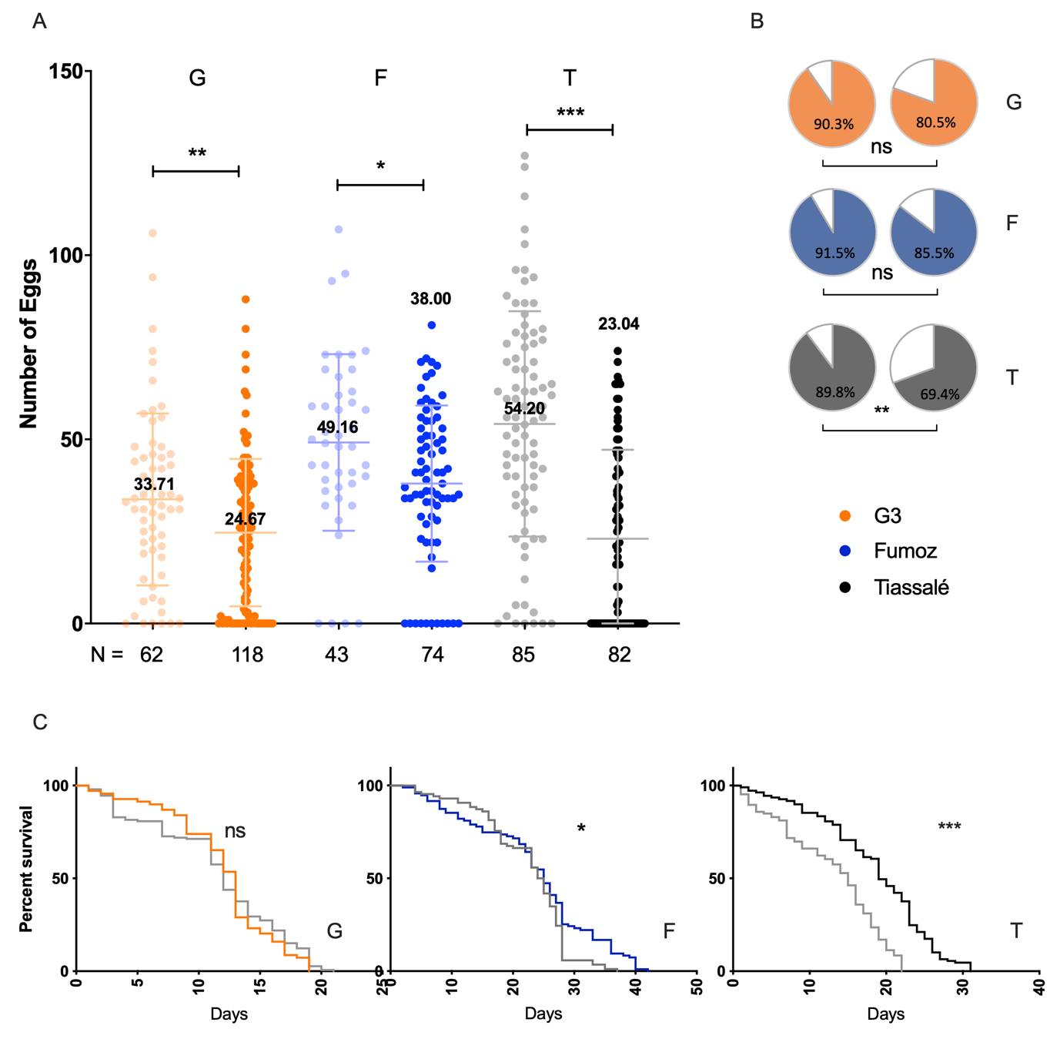

Figure 2. Disruption of steroid hormone signalling by tarsal application of methoxyfenozide + RME affects egg development and lifespan in multiple insecticide resistant Anopheles populations. A lab susceptible colony (G3: G); an An. funestus population (FUMOZ: F); and an An. gambiae sl population (Tiassalé: T) were subjected to tarsal application of the 20E agonist methoxyfenozide, with RME. (A) Methoxyfenozide treated females (rightmost group) developed a significantly lower number of eggs than controls (leftmost group) in each population. * p ≤ 0.05; ** p ≤ 0.01; *** p ≤ 0.001 as calculated by a Mann-Whitney U test, means and standard deviations are displayed for each group. Means are shown for each group. (B) Treatment (right) produced no significant changes in the number of females developing eggs in either the susceptible population nor An. funestus; however, the Tiassalé An. gambiae s.l. population showed a significant reduction in females developing eggs comapred to control (left). Percentage indicated in pie chart corresponds to percentage developing eggs and is represented by block colour; white shows no egg development. ** p ≤ 0.01 as calculated by χ² test. (C) Bloodfed, treated resistant females (grey) show a signficantly reduced lifespan in both An. gambiae s.l. and An. funestus compared to controls, * p ≤ 0.05, *** p ≤ 0.001 as calculated by a Mantel-Cox test. there was no effect of methoxyfenozide on longevity in the susceptible An. gambiae G3 strain.

Cytochrome P450 | Species | Identifier | IC50 (μM) | 95% Confidence Interval | Pyriproxyfen IC50 (μM) ⁺
CYP6M2 | Anopheles gambiae sl | AGAP008212 | 15.75 | 10.12 to 24.38 | 14.14
CYP9K1 | Anopheles gambiae sl | AGAP000818 | 26.39 | 16.60 to 41.46 | -
CYP6P4 | Anopheles gambiae sl | AGAP002867 | 251.4 | 103.7 to 657.6 | -
CYP6Z2 | Anopheles gambiae sl | AGAP008218 | 578.2 | 409.7 to 846.8 | 2.23
CYP6P3 | Anopheles gambiae sl | AGAP002865 | No binding | No binding | 15.82
CYP6Z3 | Anopheles gambiae sl | AGAP008217 | 208.7 | 99.05 to 475.1 | -
CYP6P9a | Anopheles funestus | AFUN015792 | 309.6 | 137.3 to 740.3 | 9.9
+ pyriproxyfen data collected as part of a different study, see ^{16.}

Table 1. Binding activity of insecticide resistance linked cytochrome P450s against methoxyfenozide. A range of DBH-M concentrations ranging from 2000μM to 0.0013μM were used in competitive binding assays with the fluorescent substrate DEF with cytochrome p450s previously linked with insecticide resistance in two mosquito species, An. gambiae sl and An. funestus sl, in order to calculate IC₅₀ values. Classification of binding strength is as follows: Strong inhibitors (IC₅₀ < 1 μM); Moderate inhibitors (IC₅₀ 1-10 μM); Weak inhibitors (IC₅₀ > 10 μM). Gene identifier and 95% confidence interval of the IC₅₀ values are also shown. IC50s of each p450 to pyriproxyfen is also shown, taken from (Yunta et al., 2019, 2016).

- Discussion
The identification of novel compounds to target the Anopheles mosquito is of utmost importance in order to maintain the gains in malaria control and accelerate progress towards elimination. Following on from earlier laboratory studies that demonstrated that topical application of the 20E agonist methoxyfenozide caused sterility and a reduction in lifespan in female An. gambiae mosquitoes (Childs et al., 2016), we demonstrate that this chemistry has a similar effect on multiple insecticide resistant Anopheles populations. Crucially, we also show that, with the addition of the adjuvant RME, methoxyfenozide interrupts egg development through tarsal contact Furthermore, blood-fed females had a significant reduction in life span post methoxyfenozide exposure. Given that Anopheles mosquitoes are anautogenous, meaning they have to blood feed at least once to lay eggs, and need at least two blood meals to transmit pathogens, these findings of a small, but significant reduction in longevity may have important implications for vectorial capacity. The median survival time of Tiassalé and that of FUMOZ fell in a lab-based setting; however, the reductions need to be confirmed under field conditions. A reduction in adult longevity is key to the community impact of LLINs as it reduces the probability that females survive for the duration of the parasite’s extrinsic incubation period in the mosquito. The direct impact on Plasmodium development was not investigated in the current study but previous work on the insecticide susceptible G3 strains found that methoxyfenozide exposure reduced the proportion of mosquitoes developing oocysts after feeding on a P. falciparum infected blood meal under laboratory settings (Childs et al., 2016). If this effect is also maintained in resistant mosquitoes under field settings, the use of methoxyfenozide would further decrease the likelihood of malaria transmission directly via an impact on the parasite and indirectly by shortening lifespan and reducing mosquito numbers in subsequent generations.

This study found that the use of the adjuvant RME was critical to detecting a physiological effect of DBH-M via tarsal contact. RME acts as an emulsifier, reducing crystallisation of the chemical and aiding uptake (Lees et al., 2019). This adjuvant was included as a proof of principle to demonstrate that improving formulation could overcome barriers to uptake. Further work with alternative adjuvants and formulations could well lead to marked improvements in uptake and effect sizes potentially similar to those observed with topical application.

All An. gambiae strains used in this study have multiple resistance mechanisms including target site and metabolic resistance, whereas in the An. funestus strain resistance appears to mediated solely by elevated cytochrome P450 activity (Williams et al., 2019). We observed a minimal interference from these insecticide resistance mechanisms on the effectiveness of DBH-M, suggesting that a DBH-M-based field-intervention could be effective in areas where conventional insecticides have reduced effectiveness. The juvenile hormone agonist, pyriproxyfen, is a more potent inhibitor of P450 enzymes (Yunta et al., 2019, 2016) and, direct metabolism of PPF by P450s has been demonstrated in vitro and associated with a moderate level of PPF resistance in vivo (Yunta et al., 2016). The results of the current study provide encouragement that the 20E agonist, DBH-M, would be active against a wide range of field populations and may have reduced resistance liabilities compared to PPF. Whilst resistance to 20E analogs has been reported in agricultural pests (Ishtiaq et al., 2012; Mosallanejad and Smagghe, 2009; Rehan and Freed, 2014; Smagghe et al., 2012), the fitness cost is such that the effects are reversed soon after removal of this selection pressure (Rehan and Freed, 2014; Smagghe et al., 2012) which may enhance the durability of a 20E agonist-based intervention.

The public health value of incorporating insect growth regulators into LLINs has been previously demonstrated in a clinical trial of a PPF permethrin net from Sumitomo Chemical Ltd (Tiono et al., 2018). This trial, conducted in an area of intense malaria transmission and highly pyrethroid resistant vectors, found that malaria incidence was reduced in clusters using PPF-permethrin nets compared to standard LLINs. Further trials of PPF-permethrin nets are ongoing in Tanzania and Benin (London School of Hygiene and Tropical Medicine, 2018). However, given that potential for cross resistance between pyrethroids and PPF, incorporation of alternative insect growth regulators into LLINs should be considered as part of an insect resistance management strategy.

In conclusion, 20E agonists are a promising class of chemistry for use in vector control. They have low toxicity to non-target organisms (Nakagawa, 2005), are effective against pyrethroid resistant populations and can traverse the insect cuticle. In addition to a potential role as an alternative to PPF in LLINs, other possible applications targeting outdoor resting or feeding mosquitoes, such as attractive targeted sugar baits or push pull approaches should be explored.

Acknowledgements
We would like to thank Rachel Davies, Sara Elg and Marion Morris for insectary support.

Funding
This work was supported by an NIH/NIAID R01 [5R01AI124165-04] to F.C and H.R and an MRC Skills Development Fellowship [MR/R024839/1] to V.A.I.

Author contribution
F.B and V.A.I performed all experiments. D.G.P, F.C, H.R and V.A.I conceived the experimental design. All authors contributed to drafting of the manuscript.

Declaration of interests
Declarations of interest: none.

References
Balabanidou, V., Kampouraki, A., MacLean, M., Blomquist, G.J., Tittiger, C., Juárez, M.P., Mijailovsky, S.J., Chalepakis, G., Anthousi, A., Lynd, A., Antoine, S., Hemingway, J., Ranson, H., Lycett, G.J., Vontas, J., 2016. Cytochrome P450 associated with insecticide resistance catalyzes cuticular hydrocarbon production in Anopheles gambiae. Proc. Natl. Acad. Sci. . https://doi.org/10.1073/pnas.1608295113
Baldini, F., Gabrieli, P., South, A., Valim, C., Mancini, F., Catteruccia, F., 2013. The Interaction between a Sexually Transferred Steroid Hormone and a Female Protein Regulates Oogenesis in the Malaria Mosquito Anopheles gambiae. PLOS Biol. 11, e1001695.
Bayili, K., N’do, S., Namountougou, M., Sanou, R., Ouattara, A., Dabiré, R.K., Ouédraogo, A.G., Malone, D., Diabaté, A., 2017. Evaluation of efficacy of Interceptor® G2, a long-lasting insecticide net coated with a mixture of chlorfenapyr and alpha-cypermethrin, against pyrethroid resistant Anopheles gambiae s.l. in Burkina Faso. Malar. J. 16, 190. https://doi.org/10.1186/s12936-017-1846-4
Bhatt, S., Weiss, D.J., Cameron, E., Bisanzio, D., Mappin, B., Dalrymple, U., Battle, K.E., Moyes, C.L., Henry, A., Eckhoff, P.A., 2015. The effect of malaria control on Plasmodium falciparum in Africa between 2000 and 2015. Nature 526, 207–211.
Childs, L.M., Cai, F.Y., Kakani, E.G., Mitchell, S.N., Paton, D., Gabrieli, P., Buckee, C.O., Catteruccia, F., 2016. Disrupting Mosquito Reproduction and Parasite Development for Malaria Control. PLOS Pathog. 12, e1006060.
Churcher, T.S., Lissenden, N., Griffin, J.T., Worrall, E., Ranson, H., 2016. The impact of pyrethroid resistance on the efficacy and effectiveness of bednets for malaria control in Africa. Elife 5, e16090.
Edi, C. V., Benjamin, K.G., Jones, C.M., Weetman, D., Ranson, H., 2012. Multiple-Insecticide Resistance in Anopheles gambiae Mosquitoes, Southern Côte d’Ivoire. Emerg. Infect. Dis. 18, 1508–1511.
Gabrieli, P., Kakani, E.G., Mitchell, S.N., Mameli, E., Want, E.J., Mariezcurrena Anton, A., Serrao, A., Baldini, F., Catteruccia, F., 2014. Sexual transfer of the steroid hormone 20E induces the postmating switch in &lt;em&gt;Anopheles gambiae&lt;/em&gt; Proc. Natl. Acad. Sci. 111, 16353 LP – 16358. https://doi.org/10.1073/pnas.1410488111
Gilbert, L.I., Rewitz, K.F., 2009. The function and evolution of the halloween genes: the pathway to the arthropod molting hormone, in: Ecdysone: Structures and Functions. Springer, pp. 231–269.
Hawley, W.A., Phillips-Howard, P.A., ter Kuile, F.O., Terlouw, D.J., Vulule, J.M., Ombok, M., Nahlen, B.L., Gimnig, J.E., Kariuki, S.K., Kolczak, M.S., Hightower, A.W., 2003. Community-wide effects of permethrin-treated bed nets on child mortality and malaria morbidity in western Kenya. Am. J. Trop. Med. Hyg. 68, 121–127.
Hunt, R.H., Brooke, B.D., Pillay, C., Koekemoer, L.L., Coetzee, M., 2005. Laboratory selection for and characteristics of pyrethroid resistance in the malaria vector Anopheles funestus. Med. Vet. Entomol. 19, 271–275. https://doi.org/10.1111/j.1365-2915.2005.00574.x
Ibrahim, S.S., Ndula, M., Riveron, J.M., Irving, H., Wondji, C.S., 2016. The P450 CYP6Z1 confers carbamate/pyrethroid cross-resistance in a major African malaria vector beside a novel carbamate-insensitive N485I acetylcholinesterase-1 mutation. Mol. Ecol. 25, 3436–3452. https://doi.org/10.1111/mec.13673
Ingham, V.A., Anthousi, A., Douris, V., Harding, N.J., Lycett, G., Morris, M., Vontas, J., Ranson, H., 2019. A sensory appendage protein protects malaria vectors from pyrethroids. Nature. https://doi.org/10.1038/s41586-019-1864-1
Ingham, V.A., Wagstaff, S., Ranson, H., 2018. Transcriptomic meta-signatures identified in Anopheles gambiae populations reveal previously undetected insecticide resistance mechanisms. Nat. Commun. 9, 5282. https://doi.org/10.1038/s41467-018-07615-x
Ishtiaq, M., Saleem, M.A., Razaq, M., 2012. Monitoring of resistance in Spodoptera exigua (Lepidoptera: Noctuidae) from four districts of the Southern Punjab, Pakistan to four conventional and six new chemistry insecticides. Crop Prot. 33, 13–20. https://doi.org/https://doi.org/10.1016/j.cropro.2011.11.014
Lees, R., Praulins, G., Davies, R., Brown, F., Parsons, G., White, A., Ranson, H., Small, G., Malone, D., 2019. A testing cascade to identify repurposed insecticides for next-generation vector control tools: screening a panel of chemistries with novel modes of action against a malaria vector [version 2; peer review: 3 approved]. Gates Open Res. 3. https://doi.org/10.12688/gatesopenres.12957.2
London School of Hygiene and Tropical Medicine, 2018. Efficacy of Three Different Bi-treated Long Lasting Insecticidal Nets and Deployment Strategy for Control of Malaria Transmitted by Pyrethroid Resistant Vectors: A Randomised Controlled Trial. ClinicalTrials.gov.
Martinez‐Torres, D., Chandre, F., Williamson, M.S., Darriet, F., Berge, J.B., Devonshire, A.L., Guillet, P., Pasteur, N., Pauron, D., 1998. Molecular characterization of pyrethroid knockdown resistance (kdr) in the major malaria vector Anopheles gambiae ss. Insect Mol. Biol. 7, 179–184.
Mitchell, S.N., Kakani, E.G., South, A., Howell, P.I., Waterhouse, R.M., Catteruccia, F., 2015. Evolution of sexual traits influencing vectorial capacity in anopheline mosquitoes. Science (80-. ). 347, 985 LP – 988. https://doi.org/10.1126/science.1259435
Mosallanejad, H., Smagghe, G., 2009. Biochemical mechanisms of methoxyfenozide resistance in the cotton leafworm Spodoptera littoralis. Pest Manag. Sci. 65, 732–736. https://doi.org/10.1002/ps.1753
Müller, P., Warr, E., Stevenson, B.J., Pignatelli, P.M., Morgan, J.C., Steven, A., Yawson, A.E., Mitchell, S.N., Ranson, H., Hemingway, J., Paine, M.J.I., Donnelly, M.J., 2008. Field-Caught Permethrin-Resistant Anopheles gambiae Overexpress CYP6P3, a P450 That Metabolises Pyrethroids. PLoS Genet 4, e1000286.
Nakagawa, Y.B.T.-V.& H., 2005. Nonsteroidal Ecdysone Agonists, in: Insect Hormones. Academic Press, pp. 131–173. https://doi.org/https://doi.org/10.1016/S0083-6729(05)73005-3
Namountougou, M., Simard, F., Baldet, T., Diabaté, A., Ouédraogo, J.B., Martin, T., Dabiré, R.K., 2012. Multiple insecticide resistance in Anopheles gambiae sl populations from Burkina Faso, West Africa. PLoS One 7, e48412.
Peirce, M.J., Mitchell, S.N., Kakani, E.G., Scarpelli, P., South, A., Shaw, W.R., Werling, K.L., Gabrieli, P., Marcenac, P., Bordoni, M., 2020. JNK signaling regulates oviposition in the malaria vector Anopheles gambiae. bioRxiv.
Pondeville, E., Maria, A., Jacques, J.-C., Bourgouin, C., Dauphin-Villemant, C., 2008. Anopheles gambiae males produce and transfer the vitellogenic steroid hormone 20-hydroxyecdysone to females during mating. Proc. Natl. Acad. Sci. 105, 19631–19636.
Protopopoff, N., Mosha, J.F., Lukole, E., Charlwood, J.D., Wright, A., Mwalimu, C.D., Manjurano, A., Mosha, F.W., Kisinza, W., Kleinschmidt, I., 2018. Effectiveness of a long-lasting piperonyl butoxide-treated insecticidal net and indoor residual spray interventions, separately and together, against malaria transmitted by pyrethroid-resistant mosquitoes: a cluster, randomised controlled, two-by-two fact. Lancet 391, 1577–1588.
Ranson, H., Jensen, B., Vulule, J.M., Wang, X., Hemingway, J., Collins, F.H., 2000. Identification of a point mutation in the voltage‐gated sodium channel gene of Kenyan Anopheles gambiae associated with resistance to DDT and pyrethroids. Insect Mol. Biol. 9, 491–497.
Rehan, A., Freed, S., 2014. Resistance selection, mechanism and stability of Spodoptera litura (Lepidoptera: Noctuidae) to methoxyfenozide. Pestic. Biochem. Physiol. 110, 7–12. https://doi.org/10.1016/j.pestbp.2014.02.001
Shaw, W.R., Teodori, E., Mitchell, S.N., Baldini, F., Gabrieli, P., Rogers, D.W., Catteruccia, F., 2014. Mating activates the heme peroxidase HPX15 in the sperm storage organ to ensure fertility in Anopheles gambiae. Proc. Natl. Acad. Sci. 111, 5854 LP – 5859. https://doi.org/10.1073/pnas.1401715111
Smagghe, G., Gomez, L.E., Dhadialla, T.S., 2012. Chapter Two - Bisacylhydrazine Insecticides for Selective Pest Control, in: Dhadialla, T.S.B.T.-A. in I.P. (Ed.), Insect Growth Disruptors. Academic Press, pp. 163–249. https://doi.org/https://doi.org/10.1016/B978-0-12-391500-9.00002-4
Stevenson, B.J., Bibby, J., Pignatelli, P., Muangnoicharoen, S., O’Neill, P.M., Lian, L.-Y., Müller, P., Nikou, D., Steven, A., Hemingway, J., 2011. Cytochrome P450 6M2 from the malaria vector Anopheles gambiae metabolizes pyrethroids: Sequential metabolism of deltamethrin revealed. Insect Biochem. Mol. Biol. 41, 492–502.
Tiono, A.B., Ouédraogo, A., Ouattara, D., Bougouma, E.C., Coulibaly, S., Diarra, A., Faragher, B., Guelbeogo, M.W., Grisales, N., Ouédraogo, I.N., Ouédraogo, Z.A., Pinder, M., Sanon, S., Smith, T., Vanobberghen, F., Sagnon, N., Ranson, H., Lindsay, S.W., 2018. Efficacy of Olyset Duo, a bednet containing pyriproxyfen and permethrin, versus a permethrin-only net against clinical malaria in an area with highly pyrethroid-resistant vectors in rural Burkina Faso: a cluster-randomised controlled trial. Lancet 392, 569–580. https://doi.org/https://doi.org/10.1016/S0140-6736(18)31711-2
Toé, K.H., Jones, C.M., N’Fale, S., Ismail, H.M., Dabiré, R.K., Ranson, H., 2014. Increased pyrethroid resistance in malaria vectors and decreased bed net effectiveness, Burkina Faso. Emerg. Infect. Dis. 20, 1691.
Williams, J., Flood, L., Praulins, G., Ingham, V.A., Morgan, J., Lees, R.S., Ranson, H., 2019. Characterisation of Anopheles strains used for laboratory screening of new vector control products. Parasit. Vectors 12, 522. https://doi.org/10.1186/s13071-019-3774-3
World Malaria Report., 2019.
Yunta, C., Grisales, N., Nász, S., Hemmings, K., Pignatelli, P., Voice, M., Ranson, H., Paine, M.J.I., 2016. Pyriproxyfen is metabolized by P450s associated with pyrethroid resistance in An. gambiae. Insect Biochem. Mol. Biol. 78, 50–57.
Yunta, C., Hemmings, K., Stevenson, B., Koekemoer, L.L., Matambo, T., Pignatelli, P., Voice, M., Nász, S., Paine, M.J.I., 2019. Cross-resistance profiles of malaria mosquito P450s associated with pyrethroid resistance against WHO insecticides. Pestic. Biochem. Physiol. https://doi.org/https://doi.org/10.1016/j.pestbp.2019.06.007

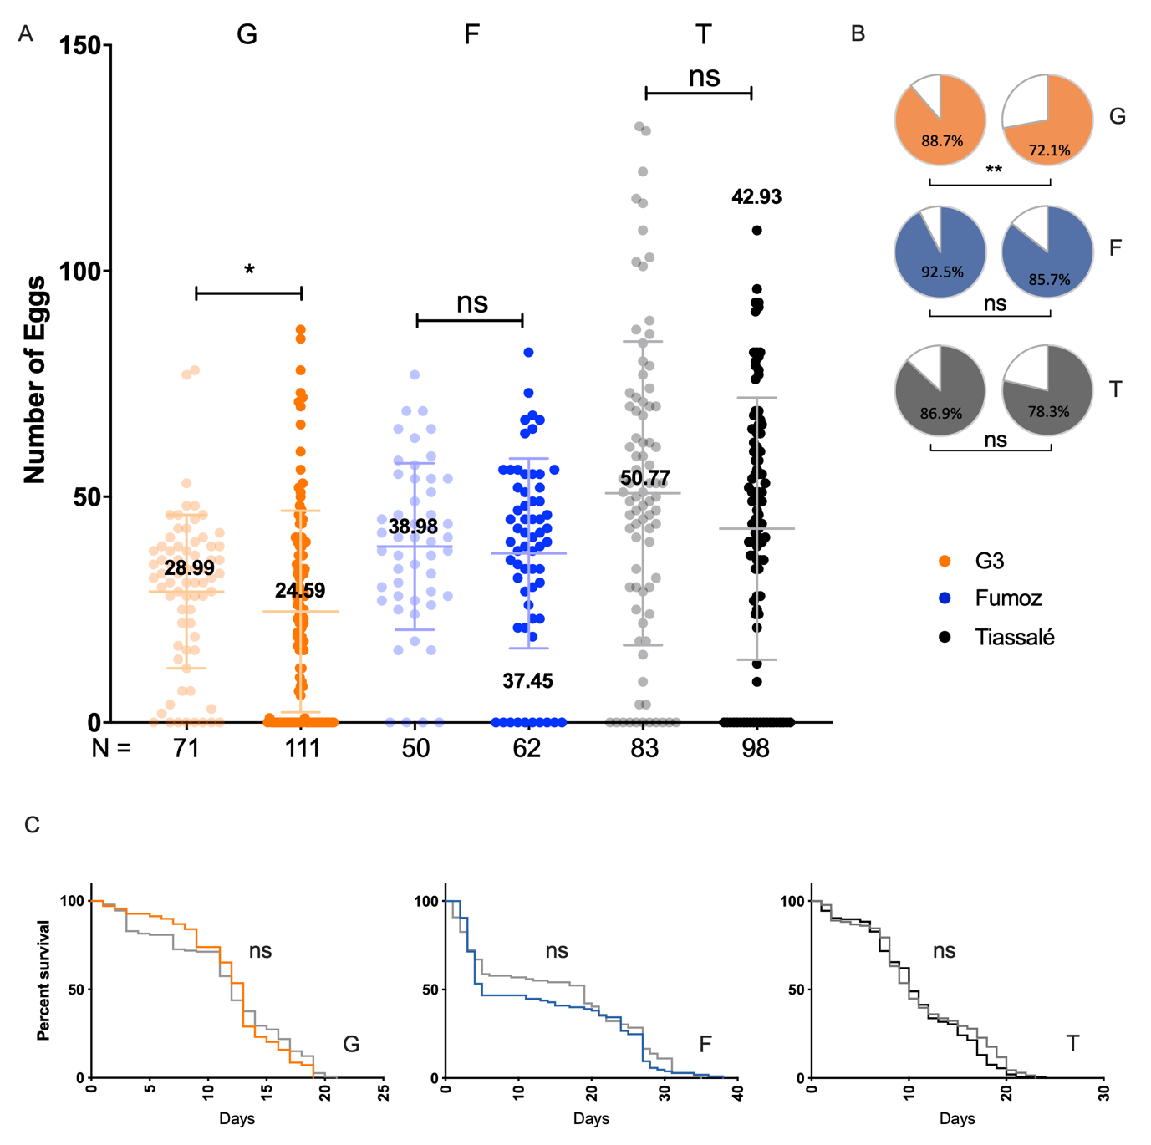

Extended Data Figure 1. Tarsal exposure to 0.4% methoxyfenozide has no effect on multi-resistant Anopheles populations. A lab susceptible colony (G3: G); a multi-resistant An. funestus population (FUMOZ: F); and a multi-resistant An. gambiae sl population (Tiassalé: T) were subjected to tarsal application of the 20E agonist methoxyfenozide (A) Methoxyfenozide treated females (rightmost group) developed a significantly lower number of eggs than controls (leftmost group) in the lab susceptible population G3 but no signficant effect was seen in either resistant colony. * p ≤ 0.05 as calculated by a Mann-Whitney U test, means and standard deviations are displayed for each group. (B) Treatment (right) produced no significant changes in the number of females developing eggs in either of the multi-resistant populations (left); however a signficant effect was seen on the lab susceptible population. ** p ≤ 0.01 as calculated by χ² test. (C) An. gambiae s.l. and An. funestus females treated with tarsal DBH-M and RME (grey) show no change in lifespan compared to controls calculated by a Mantel-Cox test.

