Appendix 1: Population survey and HIS prevalence estimates

Region | Population Survey prevalence (Number HIV+) |  |  |  |  |  | Health Facility Prevalence ( Number HIV+)
 | Tested in Health Facility |  |  | Not tested in health-Facility
 | Male | Female | Male |  | Female | Male |  | Female
Central 1 | 0.132 (13) | 0.120 (61) | 0.074 (50) |  | 0.130 (61) | 0.094 (11,772) |  | 0.095 (29,108)
Central 2 | 0.048 (6) | 0.086 (51) | 0.086 (55) |  | 0.110 (54) | 0.070 (9,308) |  | 0.071 (26,817)
East Central | 0.055 (5) | 0.087 (34) | 0.047 (37) |  | 0.049 (32) | 0.080 (5,927) |  | 0.115 (19,520)
Kampala | 0.048 (7) | 0.088 (55) | 0.040 (37) |  | 0.103 (57) | 0.044 (5,074) |  | 0.035 (12,133)
Mid-Eastern | 0.066 (6) | 0.038 (18) | 0.036 (31) |  | 0.048 (33) | 0.032 (2,695) |  | 0.043 (11,231)
North East | 0.097 (12) | 0.043 (33) | 0.042 (25) |  | 0.068 (28) | 0.026 (3,962) |  | 0.026 (11,144)
Mid Northern | 0.088 (25) | 0.104 (56) | 0.053 (35) |  | 0.097 (43) | 0.039 (2,389) |  | 0.029 (5,369)
Mid-Western | 0.088 (11) | 0.090 (52) | 0.069 (55) |  | 0.094 (52) | 0.072 (9,880) |  | 0.077 (29,679)
West Nile | 0.072 (8) | 0.051 (25) | 0.045 (31) |  | 0.044 (24) | 0.054 (8,513) |  | 0.053 (20,825)
South Western | 0.111 (11) | 0.102 (53) | 0.059 (39) |  | 0.080 (46) | 0.064 (13,712) |  | 0.060 (38,390)
National | 0.085 (104) | 0.084 (438) | 0.057 (395) |  | 0.082 (430) | 0.057 (73,232) |  | 0.059 (204,216)

Appendix 2: HPE HIV prevalence estimates and associated 95% CI
Region and  District | Male |  | Female
 | Estimate | 95% CI | Estimate | (95%CI)
Central 1
Bukomansimbi | 0.036 | (0.000, 0.078) | 0.087 | (0.028, 0.145)
Butambala | 0.079 | (0.000, 0.179) | 0.164 | (0.000, 0.364)
Gomba | 0.074 | (0.010, 0.137) | 0.116 | (0.022, 0.209)
Kalangala | 0.087 | (0.012, 0.162) | 0.216 | (0.072, 0.359)
Kalungu | 0.127 | (0.024, 0.231) | 0.163 | (0.047, 0.280)
Lwengo | 0.124 | (0.051, 0.197) | 0.163 | (0.088, 0.237)
Lyantonde | 0.136 | (0.000, 0.309) | 0.232 | (0.035, 0.429)
Masaka | 0.132 | (0.070, 0.194) | 0.232 | (0.151, 0.312)
Mpigi | 0.073 | (0.038, 0.108) | 0.127 | (0.072, 0.182)
Rakai | 0.072 | (0.032, 0.113) | 0.090 | (0.049, 0.131)
Sembabule | 0.060 | (0.008, 0.112) | 0.080 | (0.032, 0.128)
Wakiso | 0.098 | (0.073, 0.122) | 0.114 | (0.089, 0.138)
Central 2
Buikwe | 0.071 | (0.041, 0.101) | 0.096 | (0.059, 0.132)
Buvuma | 0.140 | (0.060, 0.221) | 0.227 | (0.110, 0.345)
Kayunga | 0.069 | (0.029, 0.109) | 0.071 | (0.033, 0.109)
Kiboga | 0.060 | (0.009, 0.111) | 0.137 | (0.032, 0.241)
Kyankwanzi | 0.105 | (0.027, 0.182) | 0.135 | (0.020, 0.250)
Luwero | 0.098 | (0.050, 0.146) | 0.092 | (0.056, 0.127)
Mityana | 0.113 | (0.070, 0.155) | 0.183 | (0.113, 0.253)
Mubende | 0.083 | (0.046, 0.120) | 0.070 | (0.039, 0.101)
Mukono | 0.095 | (0.053, 0.137) | 0.085 | (0.051, 0.119)
Nakaseke | 0.073 | (0.017, 0.130) | 0.074 | (0.027, 0.121)
Nakasongola | 0.091 | (0.018, 0.164) | 0.075 | (0.028, 0.122)
East Central
Bugiri | 0.029 | (0.005, 0.053) | 0.044 | (0.017, 0.071)
Buyende | 0.088 | (0.015, 0.161) | 0.028 | (0.000, 0.057)
Iganga | 0.037 | (0.008, 0.066) | 0.087 | (0.046, 0.128)
Jinja | 0.072 | (0.038, 0.105) | 0.102 | (0.066, 0.137)
Kaliro | 0.031 | (0.000, 0.081) | 0.040 | (0.000, 0.090)
Kamuli | 0.059 | (0.030, 0.087) | 0.042 | (0.023, 0.061)
Luuka | 0.026 | (0.000, 0.056) | 0.020 | (0.000, 0.041)
Mayuge | 0.030 | (0.004, 0.057) | 0.052 | (0.023, 0.081)
Namayingo | 0.081 | (0.008, 0.153) | 0.093 | (0.032, 0.153)
Namutumba | 0.047 | (0.000, 0.100) | 0.059 | (0.010, 0.107)
Kampala | 0.049 | (0.038, 0.060) | 0.099 | (0.085, 0.114)
Mid Eastern
Budaka | 0.063 | (0.000, 0.130) | 0.070 | (0.004, 0.135)
Bududa | 0.041 | (0.000, 0.095) | 0.048 | (0.000, 0.111)
Bulambuli | 0.044 | (0.000, 0.101) | 0.048 | (0.000, 0.106)
Busia | 0.043 | (0.019, 0.068) | 0.095 | (0.045, 0.145)
Butaleja | 0.029 | (0.000, 0.062) | 0.023 | (0.000, 0.056)
Kapchorwa | 0.105 | (0.000, 0.239) | 0.077 | (0.000, 0.211)
Kibuku | 0.054 | (0.000, 0.116) | 0.074 | (0.000, 0.168)
Kween | 0.037 | (0.000, 0.088) | 0.024 | (0.000, 0.063)
Manafwa | 0.021 | (0.000, 0.045) | 0.046 | (0.013, 0.079)
Mbale | 0.027 | (0.006, 0.048) | 0.044 | (0.022, 0.066)
Pallisa | 0.015 | (0.000, 0.033) | 0.028 | (0.000, 0.056)
Sironko | 0.067 | (0.023, 0.111) | 0.031 | (0.000, 0.064)
Tororo | 0.076 | (0.040, 0.113) | 0.073 | (0.032, 0.113)
Mid Northern
Agago | 0.055 | (0.029, 0.082) | 0.120 | (0.048, 0.191)
Alebtong | 0.069 | (0.028, 0.110) | 0.069 | (0.022, 0.115)
Amolatar | 0.135 | (0.056, 0.215) | 0.078 | (0.024, 0.133)
Amuru | 0.054 | (0.014, 0.094) | 0.064 | (0.014, 0.115)
Apac | 0.056 | (0.031, 0.081) | 0.068 | (0.040, 0.096)
Dokolo | 0.051 | (0.023, 0.080) | 0.089 | (0.043, 0.136)
Gulu | 0.062 | (0.039, 0.085) | 0.120 | (0.079, 0.161)
Kitgum | 0.076 | (0.020, 0.133) | 0.084 | (0.030, 0.139)
Kole | 0.054 | (0.014, 0.094) | 0.067 | (0.024, 0.109)
Lamwo | 0.090 | (0.013, 0.168) | 0.079 | (0.029, 0.129)
Lira | 0.094 | (0.058, 0.130) | 0.131 | (0.081, 0.181)
Nwoya | 0.157 | (0.009, 0.305) | 0.088 | (0.001, 0.175)
Otuke | 0.125 | (0.019, 0.232) | 0.164 | (0.013, 0.316)
Oyam | 0.032 | (0.018, 0.046) | 0.115 | (0.064, 0.166)
Pader | 0.158 | (0.080, 0.236) | 0.122 | (0.058, 0.186)
Mid Western
Buliisa | 0.086 | (0.000, 0.187) | 0.102 | (0.010, 0.193)
Bundibugyo | 0.037 | (0.000, 0.077) | 0.057 | (0.007, 0.107)
Hoima | 0.072 | (0.037, 0.106) | 0.077 | (0.040, 0.114)
Kabarole | 0.140 | (0.093, 0.187) | 0.181 | (0.126, 0.237)
Kamwenge | 0.046 | (0.011, 0.082) | 0.081 | (0.038, 0.125)
Kasese | 0.044 | (0.019, 0.070) | 0.082 | (0.053, 0.112)
Kibaale | 0.055 | (0.023, 0.086) | 0.080 | (0.047, 0.113)
Kiryandongo | 0.045 | (0.000, 0.094) | 0.073 | (0.012, 0.134)
Kyegegwa | 0.123 | (0.038, 0.208) | 0.114 | (0.027, 0.202)
Kyenjojo | 0.080 | (0.033, 0.127) | 0.069 | (0.034, 0.104)
Masindi | 0.066 | (0.025, 0.107) | 0.058 | (0.020, 0.096)
North East
Abim | 0.158 | (0.000, 0.319) | 0.089 | (0.000, 0.198)
Amudat | 0.139 | (0.000, 0.334) | 0.148 | (0.000, 0.381)
Amuria | 0.101 | (0.055, 0.146) | 0.118 | (0.062, 0.174)
Bukedea | 0.063 | (0.020, 0.107) | 0.041 | (0.000, 0.085)
Kaabong | 0.062 | (0.011, 0.113) | 0.043 | (0.011, 0.076)
Kaberamaido | 0.111 | (0.064, 0.157) | 0.075 | (0.021, 0.130)
Katakwi | 0.102 | (0.052, 0.153) | 0.063 | (0.020, 0.105)
Kotido | 0.094 | (0.008, 0.181) | 0.069 | (0.000, 0.147)
Kumi | 0.042 | (0.023, 0.061) | 0.045 | (0.015, 0.076)
Moroto | 0.084 | (0.013, 0.155) | 0.059 | (0.000, 0.120)
Nakapiripirit | 0.098 | (0.000, 0.215) | 0.065 | (0.000, 0.138)
Napak | 0.086 | (0.000, 0.186) | 0.072 | (0.001, 0.144)
Ngora | 0.057 | (0.009, 0.105) | 0.039 | (0.000, 0.082)
Serere | 0.035 | (0.014, 0.055) | 0.062 | (0.025, 0.099)
Soroti | 0.089 | (0.050, 0.127) | 0.097 | (0.051, 0.143)
South Western
Buhweju | 0.072 | (0.000, 0.161) | 0.076 | (0.000, 0.190)
Bushenyi | 0.063 | (0.019, 0.107) | 0.124 | (0.066, 0.181)
Ibanda | 0.055 | (0.000, 0.111) | 0.072 | (0.019, 0.124)
Isingiro | 0.081 | (0.025, 0.138) | 0.122 | (0.061, 0.183)
Kabale | 0.053 | (0.016, 0.090) | 0.035 | (0.016, 0.054)
Kanungu | 0.061 | (0.021, 0.101) | 0.098 | (0.039, 0.157)
Kiruhura | 0.124 | (0.034, 0.214) | 0.066 | (0.021, 0.111)
Kisoro | 0.056 | (0.000, 0.117) | 0.052 | (0.001, 0.102)
Mbarara | 0.091 | (0.042, 0.140) | 0.110 | (0.065, 0.155)
Mitooma | 0.108 | (0.003, 0.213) | 0.088 | (0.026, 0.151)
Ntungamo | 0.057 | (0.021, 0.093) | 0.066 | (0.037, 0.095)
Rubirizi | 0.131 | (0.034, 0.228) | 0.135 | (0.045, 0.224)
Rukungiri | 0.058 | (0.025, 0.091) | 0.104 | (0.057, 0.150)
Sheema | 0.072 | (0.020, 0.125) | 0.116 | (0.058, 0.174)
West Nile
Adjumani | 0.033 | (0.002, 0.064) | 0.068 | (0.029, 0.106)
Arua | 0.051 | (0.031, 0.072) | 0.037 | (0.023, 0.052)
Koboko | 0.049 | (0.009, 0.089) | 0.044 | (0.004, 0.085)
Maracha | 0.042 | (0.000, 0.095) | 0.051 | (0.000, 0.105)
Moyo | 0.052 | (0.007, 0.096) | 0.038 | (0.004, 0.071)
Nebbi | 0.087 | (0.050, 0.124) | 0.050 | (0.024, 0.077)
Yumbe | 0.030 | (0.006, 0.054) | 0.021 | (0.001, 0.041)
Zombo | 0.029 | (0.007, 0.050) | 0.086 | (0.037, 0.135)

Appendix 3: Comparison of district prevalence estimates for the HP and survey-based estimates
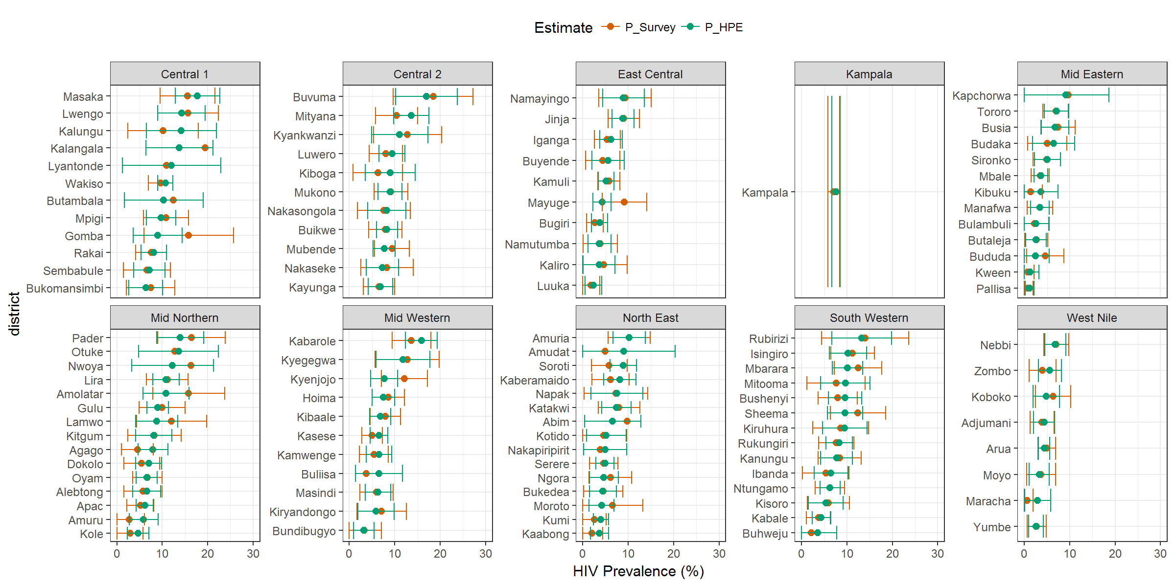

Appendix 4: Comparison of district prevalence estimates for the HP and DHIS-based estimates
