The Impact of COVID-19 and Strategies for Mitigation and Suppression in Low- and Middle-Income Countries
Patrick G.T. Walker¹⁺, Charles Whittaker¹⁺, Oliver J Watson^{1,2+}, Marc Baguelin^{1,3}, Peter Winskill¹, Arran Hamlet¹, Bimandra A. Djafaara¹, Zulma Cucunubá¹, Daniela Olivera Mesa¹, Will Green¹, Hayley Thompson¹, Shevanthi Nayagam¹, Kylie E. C. Ainslie¹, Sangeeta Bhatia¹, Samir Bhatt¹, Adhiratha Boonyasiri¹, Olivia Boyd¹, Nicholas F. Brazeau¹, Lorenzo Cattarino¹, Gina Cuomo-Dannenburg¹, Amy Dighe¹, Christl A. Donnelly^{1,4}, Ilaria Dorigatti¹, Sabine L. van Elsland¹, Rich FitzJohn¹, Han Fu¹, Katy A.M. Gaythorpe¹, Lily Geidelberg¹, Nicholas Grassly¹, David Haw¹, Sarah Hayes¹, Wes Hinsley¹, Natsuko Imai¹, David Jorgensen¹, Edward Knock¹, Daniel Laydon¹, Swapnil Mishra¹, Gemma Nedjati-Gilani¹, Lucy C. Okell¹, H. Juliette Unwin¹, Robert Verity¹, Michaela Vollmer¹, Caroline E. Walters¹, Haowei Wang¹, Yuanrong Wang¹, Xiaoyue Xi¹, David G Lalloo⁵, Neil M. Ferguson^{1*}, Azra C. Ghani^{1*}
On behalf of the Imperial College COVID-19 Response Team

- MRC Centre for Global Infectious Disease Analysis, Department of Infectious Disease Epidemiology, Imperial College London
- Pathology and Laboratory Medicine, Warren Alpert Medical School, Brown University
- Department of Infectious Disease Epidemiology, London School of Hygiene & Tropical Medicine
- Department of Statistics, University of Oxford
- Liverpool School of Tropical Medicine

*Correspondence to: patrick.walker@imperial.ac.uk; a.ghani@imperial.ac.uk; neil.ferguson@imperial.ac.uk;
⁺Contributed equally

Abstract
The ongoing COVID-19 pandemic poses a severe threat to public health worldwide. We combine data on demography, contact patterns, disease severity, and healthcare capacity and quality to understand its impact and inform strategies for its control. Younger populations in lower income countries may reduce overall risk but limited health system capacity coupled with closer inter-generational contact largely negates this benefit. Mitigation strategies that slow but do not interrupt transmission will still lead to COVID-19 epidemics rapidly overwhelming health systems, with substantial excess deaths in lower income countries due to the poorer healthcare available. Of countries that have undertaken suppression to date, lower income countries have acted earlier. However, this will need to be maintained or triggered more frequently in these settings to keep below available health capacity, with associated detrimental consequences for the wider health, well-being and economies of these countries.

One-sentence summary
The limited healthcare capacity in lower income countries is likely to largely nullify the protective effect of their younger demography against COVID-19 mortality and make suppression of the disease more challenging compared to high income countries.

Main Text
The COVID-19 pandemic caused by the SARS-CoV-2 virus is a major global health threat, with 5.4 million cases and 344,000 deaths confirmed worldwide as of the 26th May 2020 (1). The experience in countries to date has emphasised the intense pressure that a COVID-19 epidemic places on national health systems, with demand for intensive care beds and mechanical ventilators rapidly outstripping their availability, even in relatively highly resourced settings (2). This has potentially profound consequences for resource-poor settings where the quality and availability of healthcare and related resources (such as oxygen) is typically poorer (3). We sought to understand the factors that could result in a differential impact of the COVID-19 pandemic in low- and middle-income countries (LMICs) as well as to evaluate the potential strategies for suppression and mitigation in these settings given the current global state of the pandemic.
Demography and Social Contact Patterns
We collated data on global demographic projections of population size by age and country and available data on social mixing patterns by age and country-level income category. We first include these within a simple SIR modelling framework (4) to estimate the theoretical final size of the outbreak (age-specific attack rate) in the absence of non-pharmaceutical interventions (NPIs). To illustrate how these would determine the demand for healthcare over the course of an unmitigated epidemic we applied age-specific estimates of the rates of hospitalisation and of the proportion of these requiring critical care, and of the infection fatality ratio (IFR) (5) under an initial assumption of a consistent underlying role of comorbidities and the same level of medical care supplied during the epidemic in China (see Materials and Methods). On the basis of the observed doubling time in the incidence of deaths across Europe (6), we use a central estimate of the basic reproduction number (R₀) of 3.0 (a 3.5 day doubling time) and investigate scenarios with R₀ between 2.3 (a 5 day doubling time) and 3.5 (a 3 day doubling time).
Figure 1 summarises two of the demographic and societal factors which are likely to determine the burden of COVID-19 disease across different income settings. First, there is a strong correlation between the gross domestic product (GDP) of a country and its underlying demography (Figure 1A). Higher income countries tend to have the oldest populations; lower income countries in contrast have a much smaller proportion of the population who are above 65 and therefore within the age interval currently observed to be at particularly high risk of mortality from COVID-19 disease (5). Second, the household is a key setting for SARS-CoV-2 transmission (7). The average size of households that have a resident over the age of 65 years is substantially higher in lower income countries (Figure 1B) compared with middle- and high-income countries, increasing the potential for spread generally but also specifically to this particularly vulnerable age-group. Contact patterns between age-groups also differ by country (Figure S5); in high-income settings the number of contacts tends to decline steeply with age. This effect is more moderate in middle-income settings and disappears in low-income settings, indicating that elderly individuals in these settings (LICs and MICs) maintain higher contact rates with a wider range of age-groups compared to elderly individuals in high-income countries (HICs). These contact patterns influence the predicted SARS-CoV-2 infection attack rate across age-groups (Figure 1 C-E) with higher attack rates in the elderly predicted in low-income settings compared to high-income settings and middle-income settings showing intermediate patterns.
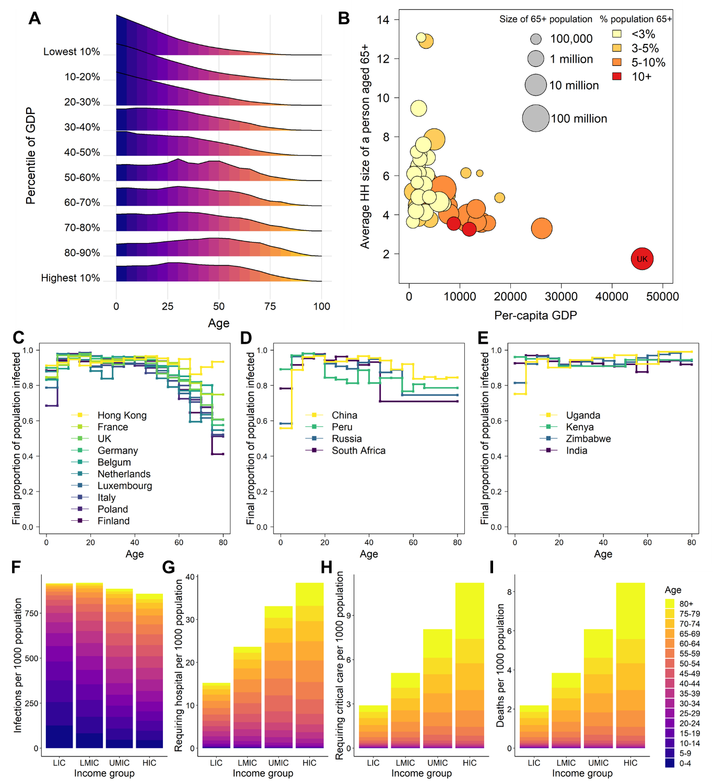
For an unmitigated epidemic, we obtain similar estimates of the distribution of the attack rate across settings for a given $R_{0}$ (Figure 1F), with slightly higher attack rates in lower income countries due to the more homogeneous levels of mixing with age. However, under a baseline assumption of the same comorbidity profile across all settings, we would expect a lower risk of requiring hospitalisation and critical care in lower income settings, driven by the younger demography in these populations (Figure 1G-H). Assuming the same availability of healthcare (equivalent to that provided in China) throughout the pandemic, we would expect a lower overall per-capita risk of mortality in lower income settings due to the younger age of the populations (Figure 1I).
Healthcare Availability and Quality
It is clear from the current epidemics in Europe and the United States that COVID-19 disease will place a severe strain on health systems. This effect is likely to be more extreme in lower-income settings where healthcare capacity is typically limited. To explore this, using data derived from the World Bank and wider literature, we developed a model of the supply of health care relevant to COVID-19 disease. We use a boosted regression tree-based approach to model the likely availability of hospital beds (per 1000 population, from the World Bank) based on a suite of relevant healthcare-related and socio-economic covariates (also from the World Bank, see Materials and Methods). This prediction of hospital bed capacity was then combined with estimates of intensive care unit beds (per 100 hospital beds) across a range of different settings (spanning LICs, LMICs, UMICs and HICs) identified through a systematic literature review (Figure 2). These estimates of healthcare capacity were then integrated with our estimates of the demand that COVID-19 epidemics will place on national health systems.
The boosted regression tree model predicts hospital bed capacity well across the range of countries for which data were available (Figure 2A). We find that hospital bed capacity is strongly correlated with the income status of countries (Figure 2B); LICs have the fewest hospital beds per 1000 population (median 1.28 beds per 1000) and HICs the highest (median 4.68 beds per 1000 population). Lower and upper middle-income countries (LMIC/UMICs) fall between these two extremes (1.77 and 2.63 beds per 1000 population on average, respectively). We find that the percentage of hospital beds that are in intensive care units (ICU) is lowest in LICs (1.47% on average) and highest in HICs (3.30%) with LMICs and UMICs falling in-between (2.00% and 2.88% respectively) (Figure 2C). Note that our estimates of the ICU capacity in HICs are drawn almost exclusively from a recent review of ICU capacity in Asian countries (8) and are not therefore necessarily reflective of ICU capacity in HICs worldwide.
To understand the potential impact of weaker health systems on the IFR, we collated expert clinical opinion on the likely outcomes for COVID-19 patients (Materials and Methods). These expert estimates drew on recent experience treating COVID-19 patients in the UK alongside an understanding of severe pneumonia outcomes in LIC and LMIC settings. Mechanical ventilation (MV) – which has been required by 80% of COVID-19 ICU patients in the UK (9)– is of very limited capacity in many LIC and LMIC countries – across sub-Saharan Africa for example, recent estimates put the average number of ventilators at only 172 per country(10). . In the absence of MV, the consensus was that the mortality rate would be in the range 90-100%. This compares to a mortality rate of 51.6% in those that require MV in the UK (9). Similarly, for the 20% of individuals that would be admitted to ICU in the UK but not require MV, the consensus was that mortality would be 50-65% in an LIC/LMIC setting. It was however noted that there would likely be significant heterogeneity in this rate (not captured here) due to the variation in both the quality of hospital care and availability of hospital facilities within and between countries (with better facilities concentrated in urban areas and capital cities compared to rural areas). For those with severe pneumonia requiring hospitalisation, mortality rates are expected to be higher in LICs and LMICs than in HICs. The values for LICs and LMICs assumed here are a mortality rate across all age-groups of 20-30% if oxygen support is available whilst anticipating that this may not be at sufficiently high-flow directly at the bedside to ensure comparable outcomes to HIC (“Poorer Outcomes” in Figure 2) and 60% if oxygen support is not available (due to healthcare capacity being exceeded). Using these parameters, we expect a larger proportion of deaths to occur in those aged 40 and upwards in LIC and LMIC settings (Figure 2D) and that the lack of quality oxygen support will disproportionately increase mortality in younger age-groups (as these age-groups are more likely to require oxygen support than mechanical ventilation). Importantly, the lack of health system capacity is likely to increase the overall IFR in LIC and LMIC settings, off-setting the apparent protective effects of the younger population (Figure 2E). In our subsequent modelling, we therefore examined three scenarios for LICs/LMICs to examine the impact of healthcare quality and quantity upon potential COVID-19 burden: a scenario where there were no healthcare constraints and quality of care was similar to HICs (“Unlimited healthcare”), a scenario using typical healthcare constraints on hospital and ICU beds in Figure 2B-C (“Limited healthcare”) and a scenario where there is an assume absence of mechanical ventilation and treatment for severe pneumonia is less effective (“Limited healthcare, No MV and poorer outcomes”).
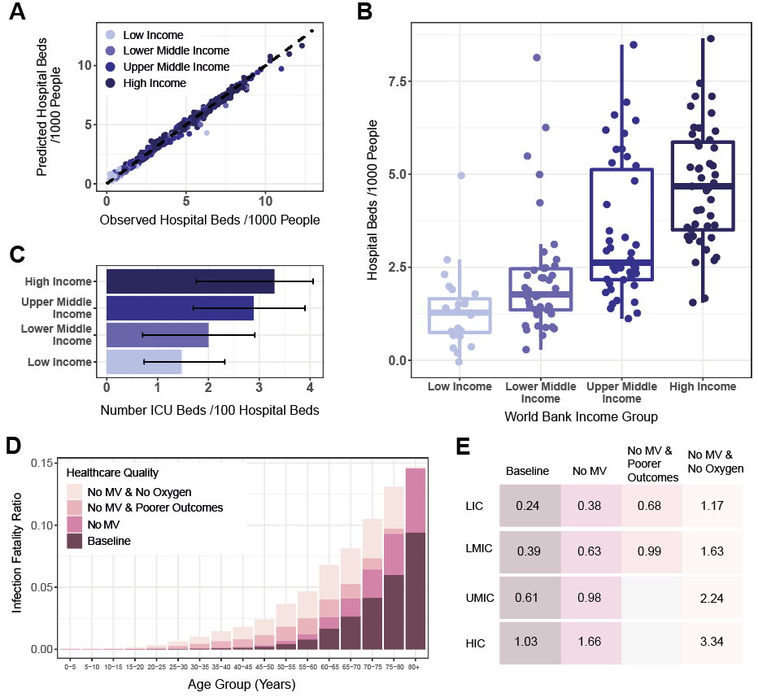
Co-morbidities
There remain large uncertainties in the underlying determinants of the severity of SARS-CoV-2 infection and how these translate across settings. However, clear risk factors include age (5) and underlying co-morbidities that include hypertension, diabetes, coronary vascular disease (CVD) and chronic obstructive pulmonary disease (COPD) which serve to exacerbate symptoms (11). The prevalence of these conditions varies substantially across populations and by age (Figure 3). Using Global Burden of Disease 2017 estimates (12), our unmitigated scenario leads to 6.1%, 3.8% and 13.3% of SARS-CoV-2 infections occurring in individuals with CVD, COPD and diabetes respectively.

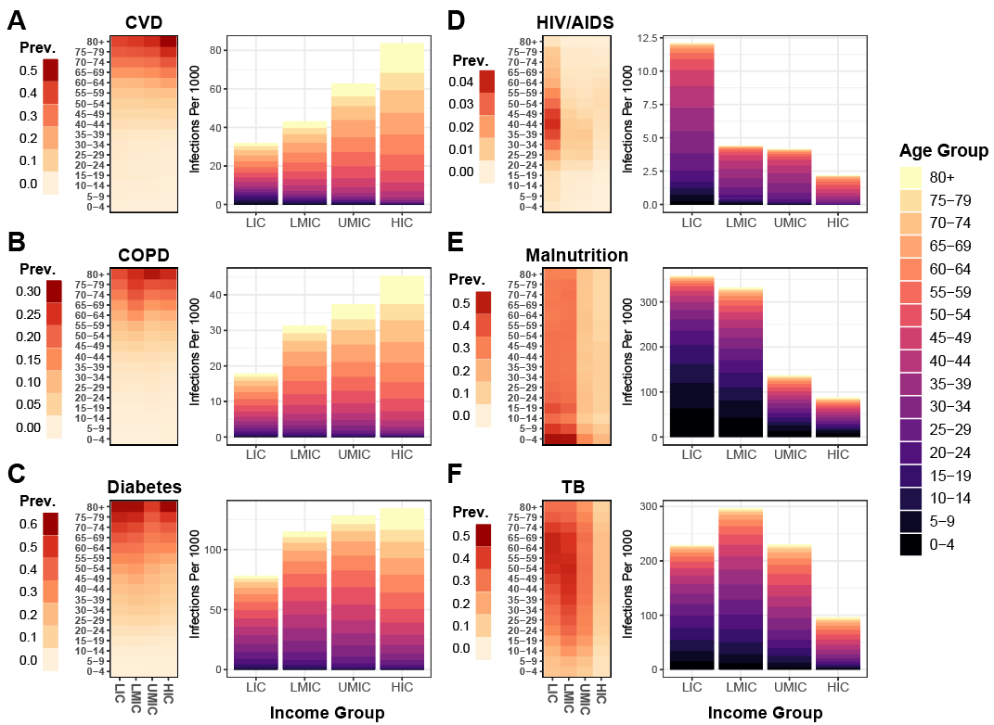
In low-income (LIC) and low-middle income countries (LMIC) there is a higher burden of infectious diseases such as HIV/AIDS and TB, and of poverty-related determinants of poorer health outcomes such as malnutrition than in HICs. These generally occur in younger populations (Figure 3 D,E,F). Whilst infectious diseases and malnutrition are not yet recognised as specific risk-factors for poor prognosis from COVID-19 due to a lack of data from settings in which they are prevalent, it is possible that the risk profile in LIC and LMIC settings will be very different from that observed to date in China, Europe and North America. Understanding the extent to which these potential comorbidities make younger populations more vulnerable to severe sequalae of COVID-19 and designing strategies to protect them will be important in adapting pandemic responses to lower income countries.
Mitigation and Suppression Strategies for Low- and Middle-Income Countries
To understand the consequences of the demographic, social contact and health system patterns on strategies for reducing the spread of SARS-CoV-2 in the context of control measures already enacted by countries, we developed an age-structured SEIR modelling framework to explore the dynamics of the epidemic under different health system capacity constraints (see Materials and Methods). As for the SIR final size calculations, we use demographic data and social contact patterns based on representative settings in the LIC, LMIC, UMIC and HIC strata. Disease progression for those requiring hospitalisation was explicitly modelled in order to track requirements for hospital bed provision for severe pneumonia (for whom we assume oxygen support will be required) and for ICU provision (for whom we assume 80% would require MV in-line with UK data (9)). Durations of stay were based on UK data (9, 13); whilst it is likely that these will be shorter in LIC and LMIC countries, in the absence of data to guide these parameters the results presented here are conservative (i.e. hospital capacity will be exceeded earlier). Whilst healthcare seeking behaviour may also differ across settings, we make the simplifying assumption that all symptomatic cases seek care. To capture the uncertainty in hospital demand we generated 500 parameter sets drawing on uncertainty in key parameters determining the probability of hospitalisation, of requiring critical care, and of outcomes (death or recovery) in each hospital state and ran 10 stochastic realisation using each parameter set (see Materials and Methods). The 95% range across the simulations is presented as an uncertainty interval (UI). We consider two potential strategies (similar to those previously illustrated for pandemic influenza planning and in the early stages of the COVID-19 epidemic (14, 15)); (1) mitigation – whereby transmission is reduced but R_{t} remains above 1 and hence a single-peaked epidemic is predicted due to the build-up of herd immunity; and (2) suppression – whereby transmission is reduced such that R_{t}<1 and hence, if interventions are later released, transmission will be expected to rise as herd immunity will not have been achieved.
We used our final SIR size calculations to estimate the degree of social distancing that results in “optimal” mitigation. This is defined as the maximum reduction in transmission that can be achieved if a uniform reduction in contact rates is implemented at the start of the epidemic for an undefined but finite period such that R_{t}~1 and a single-peaked epidemic is generated (see Materials and Methods). If “optimal” mitigation based on enhanced social distancing is pursued, for an R₀ of 3.0, we estimate a maximum reduction in infections in individual countries in the range 30-38% (median 33%) and a range of reduction in mortality between 19%-55% (median 39%) (assuming the mortality patterns observed in China). These optimal reductions in transmission and burden were achieved with a range of reductions in the overall rate of social contact across countries between 40.0%- 44.9% (median 43.9%), with this range across countries increasing to 42.9%-47.9% (median 46.9%) for an R₀ of 3.5 and decreasing to 31.4%-35.8% across countries (median 35.0%) for an R₀ of 2.3. Combining mitigation with enhanced social distancing of elderly individuals is predicted to result in greater mortality reductions of 23%-67% across countries (median 49%) for R₀=3 (Table S5). However, both of these strategies are predicted to have lower proportional impact in lower income settings compared to higher income settings: median reductions in mortality in the range 19.5%-41.6% (median 25.3%) in LICs in contrast to in the range 21.5%-55.1% (median 49.9%) in HICs for optimised mitigation strategies including social distancing and in the range 25.4%-50.9% (median 32.6%) in LICs in contrast to in the range 23.4%-66.6% (median 60.1%) in HICs for optimised mitigation strategies including enhanced social distancing for elderly (Table S5). This lower proportional reduction in deaths of mitigation scenarios in lower income settings is driven by the more homogeneous contact patterns by age in these settings (Figure 1), resulting in more persistent spread to older age categories as contact rates in the general population are reduced (Figure S6).
Figure 4 highlights the dynamical impact of different control measures on COVID-19 epidemics. Scenarios in which in which the COVID-19 epidemic is suppressed for a period of six months before returning to pre-pandemic social contact patterns leads to rapid resurgence of the virus and a delayed peaking epidemic (Figure 4A). There is significant reduction in disease burden under the optimal mitigation strategy, which results in a single-peaked epidemic with a substantially lower peak compared to the unmitigated epidemic. It should be noted, however, that this single peak relies upon the assumption that recovery from infection confers durable immunity to reinfection which has yet to have been conclusively demonstrated (16). Furthermore, whilst “optimal” mitigation is the strategy that will minimise infections and achieve herd immunity in a single-peaked epidemic, there are multiple other strategies that can also minimise infections over a longer-term (17, 18). Any mitigation scenario will also always be worse in terms of both the peak hospital demand and total predicted deaths than scenarios in which the epidemic is suppressed (i.e. the reproduction number over time, R_{t}, is kept below 1) (Figure 4 A & B). However, if suppression cannot be successfully maintained, then a delayed epidemic may occur which may outweigh the benefits of the original suppression strategy and result in higher mortality than if a mitigation scenario had been successfully pursued. Such a second peak is not inevitable – widescale suppression may provide countries with the time to develop testing and contact tracing systems, as well as locally targeted responses, that can help to maintain lower levels of transmission once the initial suppression interventions are relaxed. It is important to note that our framework does not currently provide insights into the specific combinations of NPIs required to achieve such reductions and these are likely to differ across settings according to various factors such as school attendance and occupational factors. Other factors such as reduced ability to work from home and general economic vulnerability will impact on the abilities of populations to adhere to stringent NPIs that involve restrictions in movement. Meanwhile, larger household sizes, and subsequently higher levels of household-based transmission, may limit the impact of self-isolation and increase the social and economic impact of self-isolation measures in lower income settings.
The comparative benefits and drawbacks of these scenarios (in terms of direct health impact of COVID-19 disease) will differ between settings depending on their healthcare capacity and quality. In all settings, whilst our optimised mitigation scenario is predicted to substantially reduce the gap between demand for hospital beds and capacity, demand for critical care is still predicted to vastly exceed capacity, leading to a substantial additional burden relative to a scenario with unlimited capacity (Figure 4B). Although we predict lower demand for critical care in lower income settings due to their younger populations, this is likely to be offset by a much lower level of supply: for our mitigation scenario including population-level social distancing, peak demand for critical care in our simulation for a typical LIC outstrips supply by a factor of 30.7 (95% UI, 14.7 - 48.8), whereas for the equivalent simulation in a typical HIC this factor was 7.8 (95% UI 3.6 – 13.0) (Figure 4C). Typical LMIC and UMIC produced factors of over-demand of 17.5 (95% UI 8.3 – 28.6) and 10.9 (95% UI 5.1 – 17.7) respectively.
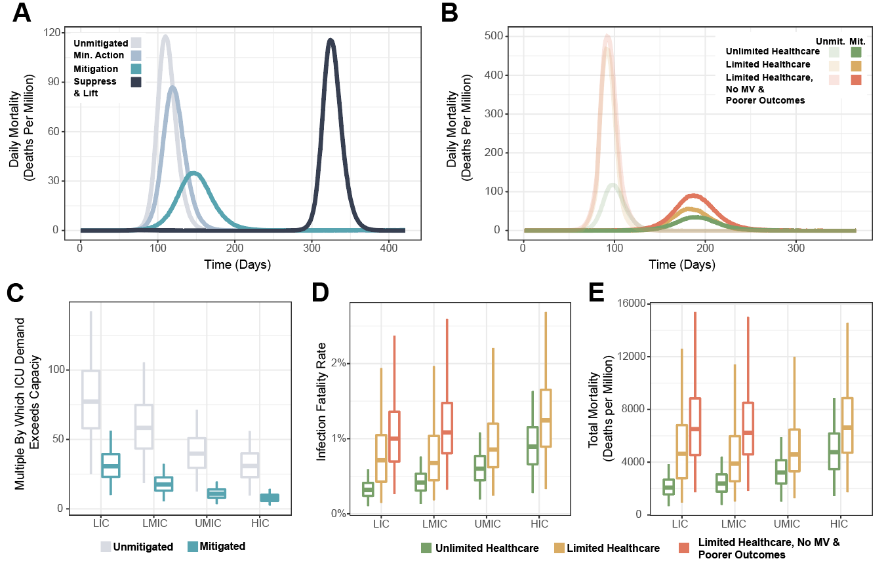

We estimate that constraints on healthcare capacity would be likely to increase the IFR under a mitigation strategy in all settings. However, as has been observed, HICs and UMICs are likely to be able to put in place surge capacity to limit any impact on mortality (19–21). In contrast, in LICs and LMICs we predict that the poorer quality of healthcare available is likely to have a greater impact on the overall IFR than the limits on capacity alone. If the healthcare quality in these settings was at the same level as in HICs and not subject to capacity constraints, we estimate 2.1(95% UI 1.0-3.3) deaths per 1,000 population in an LIC and 2.4 (95% UI 1.1-3.9) deaths per 1,000 population in an LMIC. This increases to 4.6 (95% UI 1.4-10.0) and 3.9 (95% UI 1.5-8.9) deaths per 1,000 population with healthcare capacity limits, in LICs and LMICs respectively, and to 6.5 (95% UI 2.7-12.3) and 6.2(95% UI 2.8-11.9) deaths per 1,000 population, respectively, if the poorer quality healthcare is also factored in. Overall, this represents 4.4 (95% UI 1.7-9.0) and 3.8 (95% UI 1.7-8.0) excess deaths per 1,000 population due to both the poorer quality healthcare and lack of healthcare capacity in LICs and LMICs respectively.
Suppression and Longer-Term Exit Strategies
Almost all countries and territories have now reported at least one COVID-19 case with many now also reporting deaths. Whilst individual countries have responded differently to this threat, the majority have implemented some form of NPI to either mitigate the burden of the epidemic or to suppress transmission (22, 23) . We reviewed data on the interventions that had been collated within the ACAP COVID-19 Government Response Measures dataset to summarise the stage of the epidemic at which countries have implemented suppression measures (23) (see Materials and Methods).
Table 1 summarises the stage of the epidemic at which those countries implementing suppression measures did so (see Supporting Material for country-level analysis). Across the different regions, countries in Europe and Central Asia have initiated suppression measures at a later stage of their epidemics (in terms of per-capita cases and deaths) than other regions to date. This may partly be due to censoring (i.e. other countries have yet to impose suppression measures since the date the dataset was downloaded - April 20th 2020) as well as due to the wider recognition of the potential impact of COVID-19 that countries in other regions can observe from the ongoing epidemics in Europe. However, there is also a strong gradient in the timing of lockdowns with income status – with LIC and LMIC initiating suppression measures earlier than UMIC or HIC.
We used European Centre for Disease Control (ECDC) data prior to the date of implementation of suppression or, in the absence of identified suppression measures, the date of last entry within the ACAPS dataset. We then evaluated the ratio of reported cases to deaths in this period to provide a measure of the capacity of countries to contain transmission through testing-based approaches prior to, or in the absence of, suppression. Our estimates show clear differences by region and gradient across income strata: LICs with three or more deaths prior to suppression reported a country-level median of 8.6 cases per reported death (country-level range of 7.8 - 10.7, n=3) and LMICs a country-level median of 19.3 (country-level range 9 – 80, n=7). In contrast, HICs reported a country-level median of 72.6 (country-level range 9 - 325.2, n=27) cases per reported death. The extent to which reported case-to-death ratios are a reliable indicator of relative case or infection (including asymptomatic) ascertainment rates will depend upon trends in IFR, the reproduction number and the extent to which deaths are reported, all of which are liable to vary across income strata. However, this trend is suggestive of the extent to which testing capacity will need to be developed in LICs/LMICs settings if approaches such as case identification coupled with contact tracing are to form part of a successful mitigation or exit strategy.
Given our estimates suggest that even optimal mitigative strategies will lead to substantial excess mortality and exceedance of healthcare capacity, we explored the impact of potentially different suppressive strategies, accounting for the interventions that countries have implemented to date. Here we define suppression as reducing transmission to a level for which R_{t}<1. To do so we model a 75% reduction in contact rates across all age-groups, giving R_{t}=0.75 for R₀=3.0. We explored different trigger thresholds based on the incidence of cases requiring critical care per 100,000 population) for the implementation of transmission reductions and modelled these as lasting for 30 days before being lifted (typical of the duration of lockdowns occurring to date). Reimplementation then occurs if the trigger threshold is eclipsed again. The level of reduction in contact rates will determine the speed at which the infected population is depleted during the intervention (24). Thus, for a fixed period of intervention (assumed here to be 1 month) either starting earlier (i.e. at lower levels of infection) or suppressing to a greater extent (i.e. higher reductions in contact rates) will mean that interventions can be relaxed for longer before the trigger for reimplementation is reached (Figure 5A). Equally, if a degree of suppression is maintained during the period of relaxation (for example, a 30% reduction in contacts during relaxation compared to 75% during suppression), then the periods in suppression will be shorter as the reduced R_{t} during relaxation will mean that it takes longer to trigger the suppression threshold. Furthermore, a greater health benefit (in terms of reducing cases or deaths) will be achieved for lower trigger levels; however, this is balanced by a slower build-up of herd immunity such that the interventions would need to remain in place for longer in the absence of a vaccine (Figure 5B).
To further understand how such a strategy might differ between LIC/LIMC and UMIC/HIC we explored the full range of incidence thresholds that would allow ICU demand to be kept below 50% of the median ICU capacity for each income strata (setting this threshold lower than maximum capacity to allow for ongoing care provision for non-COVID-19-related disease). For each scenario, we modelled the first suppression to have been initiated at the median threshold for the setting that has been observed to date (i.e. LIC and LMIC initiate earlier than UMIC and HIC, Table 1). We then selected the ICU incidence trigger within this range that minimises COVID-19 mortality over 18 months and remains under our ICU threshold. We use a time window of 18 months as representative of the timescale over which pharmaceutical interventions (e.g. a vaccine) may become available, noting that this duration is highly uncertain (25).
If ICU demand is to be kept below the estimated median ICU capacity for each income strata, all countries are predicted to need to spend a substantial proportion of time in suppression (Figure 5C). In all settings, in the absence of additional effective measures, we estimate that the time spent in suppression to prevent health services becoming overwhelmed will need to be high across all settings, and marginally higher in LICs (77% vs 66% in HICs over an 18-month timeframe) driven by the lower threshold at which suppression has to be reapplied coupled with the resulting less rapid acquisition of immunity. Assuming identical quality but not quantity of care across all settings, the mortality rate under suppression is predicted to be highest in HICs across all suppression threshold triggers considered (and by extension, time in suppression over the next 18 months) due to their older populations (Figure 5D, purple lines). However, once we incorporate our estimates of the poorer quality of care in LICs and LMICs we predict a similar number of deaths in LIC and LMIC compared to HICs across all suppression triggers. Thus, in all settings, sustained periods of suppression over the next 18 months are predicted to be required if ICU demand is to be kept below capacity and large levels of excess mortality are to be averted. Conversely, we also estimate that the risks of not maintaining suppression are likely to be similarly high across all settings. If suppression is not maintained (and hence the proportion of time spent in lockdown over the next 18 months is low), then our results suggest a lower per-capita level of burden LIC/LMIC due to the younger population. However, the uncertainty in our estimates of the quality of care in these settings could mean that this result is reversed (Figure 5D).

 | Countries initiating suppression measures¥ | Median date suppression implemented  (range) | Median Cases/million prior to suppression (range) | Median Deaths/million prior to suppression (range) | With >=3 deaths prior to suppression€ | Median ratio of cases to deaths
Worldwide | 121 | 24/03 (08/03-19/04) | 6.01 (0 -449.24) | 0 (0-10.447) | 50 | 45.8 (5.1 - 325.2)
Region
East Asia & Pacific | 10 | 25/03 (14/03 – 10/04) | 3.08 (0-149.37) | 0 (0-0.549) | 9 | 47.3 (9 - 325.2)
Europe & Central Asia | 34 | 22/03 (08/03- 03/04) | 72.08 (0.07-449.24) | 0.340 (0-10.447) | 20 | 46.7 (9 - 320.3)
Latin America & Caribbean | 21 | 22/03 (16/03- 08/04) | 6.01 (0.18-156.59) | 0 (0-0.393) | 6 | 63.9 (30.2 – 102)
Middle East & North Africa | 14 | 23/03 (17/03 – 30/03) | 12.44 (0-353.31) | 0 (0-1.763) | 6 | 16.5 (5.1 - 139.7)
North America | 0 | NA | NA | NA | 2 | 43.5 (14.5 - 72.6)
South Asia | 4 | 26/03 (20/03-02/04) | 2.41 (0.07-35.15) | 0 (0-0.051) | 1 | 80 (NA)
Sub-Saharan Africa | 38 | 28/03 (21/03 – 19/04) | 0.92 (0-101.68) | 0.002 (0-1.799) | 5 | 10.7 (7.8 - 63.6)
Income Strata
Low income | 23 | 28/03 (20/03-19/04) | 0.57 (0-6.13) | 0 (0-0.791) | 3 | 8.6 (7.8 - 10.7)
Lower middle income | 22 | 25/03 (14/03-10/04) | 0.58 (0.05-30.99) | 0 (0-1.799) | 7 | 19.3 (9 - 80)
Upper middle income | 41 | 24/03 (16/03- 08/04) | 9.98 (0-135.34) | 0.044 (0-3.548) | 13 | 38.8 (5.1 - 191.8)
High income | 35 | 23/03 (08/03-08/04) | 97.30 (5.14-449.24) | 0.202 (0-10.447) | 27 | 72.6 (9 - 325.2)
¥Does not include countries implementing suppression not listed in ACAP data as of April 17th 2020
€Includes countries who have not yet implemented suppression in ACAP data as of April 17th 2020 where infections are assumed to have grown exponentially until the date of most recent measure reported in ACAP. For countries excluded from suppression analysis (Brazil, China, Iran, Japan, Singapore, South Korea and the United States of America) analysis was restricted to the time prior to 10 cumulative deaths reported.

Our estimates of increasing time between suppression triggers in HICs in Figure 5E assume that there is durable immunity to reinfection – this remains uncertain (16). However, given the very low levels of population immunity in LIC/LMICs at 18 months in the presence of this assumption, our results indicate that in these settings measures would have to remain in place well beyond the time window of our simulations in the absence of a vaccine in order to achieve herd immunity, or equivalent effective exit strategy able to maintain control of the epidemic for values of R_{t} that remain close to R_{0.}
Importantly, however, these results do not account for other interventions that could be implemented during periods where suppressive measures are not in place. Once the number of new infections drops to a manageable level, it is likely that more widespread testing and isolation of cases coupled with contact tracing can help to prevent a resurgence of transmission, as has been observed in countries such as South Korea (26–28). However, given the low reported case to reported death ratios in LICs/LMICs during the early stage of the pandemic, for such strategies to be successful it is likely that support to enhance surveillance will be required to increase infection ascertainment rates substantially. Such testing strategies could be supplemented by the additional use of technology including digital apps (29). The appropriateness of these different interventions will be context-specific and hence it is likely that each country will need to develop strategies based on an understanding of the underlying principles outlined here but adapted to suit their needs.

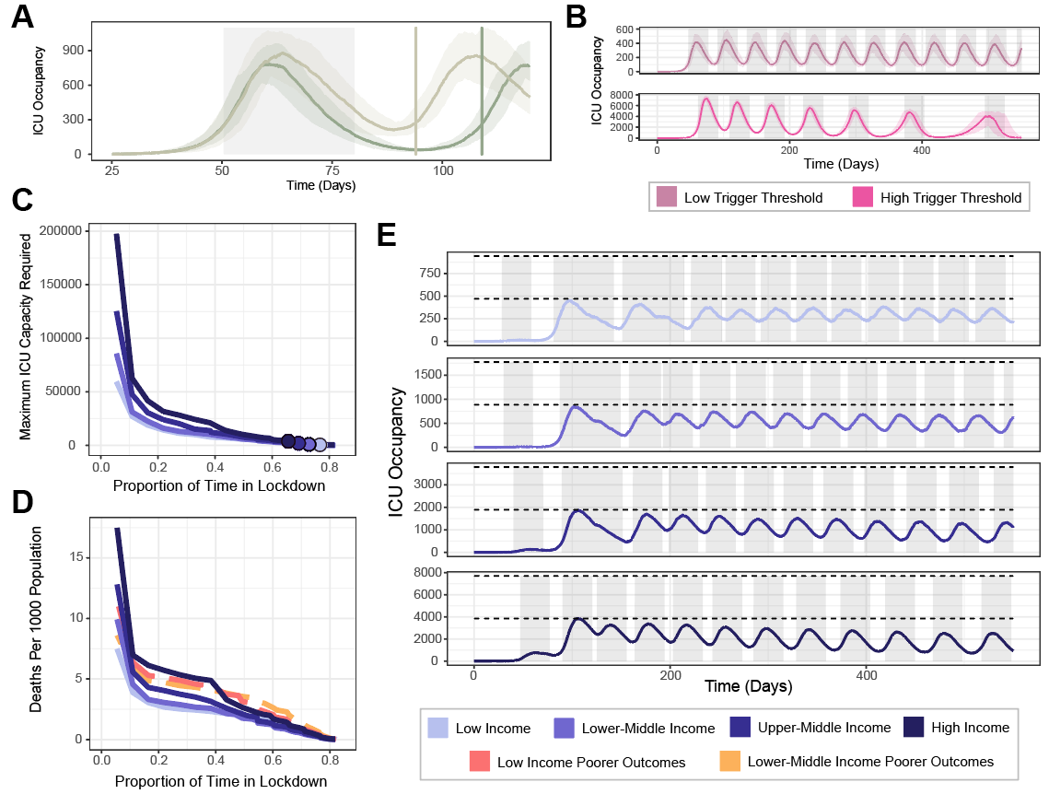

Conclusions
The results presented here illustrate the potential impact of the COVID-19 pandemic in LICs and LMICs compared to the epidemics that have occurred to date in UMICs and HICs. Our analyses give insight into how differences in demography, social structure and healthcare availability and quality combine and potentially influence the impact of measures that can help reduce the spread of the virus. At the current time, it is not possible to predict with any certainty the exact number of cases for any given country, the precise mortality and disease burden that will result or the benefits and drawbacks of the different approaches to control of the virus that are currently being implemented. A full understanding of these will only be available retrospectively.
Whilst our results illustrate the challenges that many countries will face in attempting to mitigate the impact of local COVID-19 epidemics, it is important to bear in mind that even moderate levels of changes in behaviour can avert many infections and hence save millions of lives (30). Whilst suppression will always have the greatest impact on COVID-related morbidity and mortality, the intensity of interventions required needs to be balanced against the wider health risks that diverting all attention to a single disease could entail (31, 32).
It is also important to note that we do not quantify the wider societal and economic impact of the intensive mitigation or suppression approaches, nor address the challenge of intensive suppression initiatives in LIC and LIMC where a high degree of informal labour makes such interventions challenging and may limit the extent to which they can reduce R_{t} below one (33). These are likely to be substantial, particularly in lower income countries where the capacity to provide support in ensuring the livelihoods of the poorest and most vulnerable is most marginal. Moreover, for countries lacking the infrastructure capable of implementing technology-led suppression strategies such as those currently being pursued in Asia (7, 27), and in the absence of a vaccine or other effective therapy, careful thought will need to be given to pursuing such strategies in order to avoid a high risk of future health system failure once suppression measures are lifted.
Our results highlight the difficult decisions countries are faced with in the coming weeks and months irrespective of region or income status. Given the likely worse prognosis of severe COVID-19 cases in settings with weaker health systems coupled with the higher vulnerability of developing economies to the negative effects of stringent NPIs, the trade-offs lower income countries face are complex given the ongoing uncertainty in the most appropriate and effective exit strategies. In the interim, the priority should be to increase the availability of oxygen support to mitigate the health impact alongside enhancing the capacity for surveillance and widescale testing to reduce the spread of infection and tailor appropriate NPIs. In the longer-term, ensuring equitable provision of pharmaceutical interventions to lower income countries once they are developed should be a global priority.
Our analysis demonstrates the extent to which countries have mobilised to combat the COVID-19 pandemic. Many lower income countries have acted whilst transmission remains at low levels which is likely to have substantially slowed the spread of the virus. In the absence of a vaccine, all governments are likely to face challenging decisions around intervention strategies for the foreseeable future. However, the still relevant counterfactual of a largely unmitigated pandemic clearly demonstrates the extent to which rapid, decisive and collective action remains critical to save lives globally.

References
1. WHO, “Coronavirus disease (COVID-19) Situation Report-127” (2020), (available at https://www.who.int/docs/default-source/coronaviruse/situation-reports/20200526-covid-19-sitrep-127.pdf?sfvrsn=7b6655ab_8).
2. A. Remuzzi, G. Remuzzi, COVID-19 and Italy: what next? Lancet. 395 (2020), doi:10.1016/S0140-6736(20)30627-9.
3. A. S. Ginsburg, W. C. Van Cleve, M. I. W. Thompson, M. English, Oxygen and pulse oximetry in childhood pneumonia: a survey of healthcare providers in resource-limited settings. J. Trop. Pediatr. 58, 389–93 (2012).
4. J. Cui, Y. Zhang, Z. Feng, Influence of non-homogeneous mixing on final epidemic size in a meta-population model. J. Biol. Dyn. 13, 31–46 (2019).
5. R. Verity, L. C. Okell, I. Dorigatti, P. Winskill, C. Whittaker, N. Imai, et al., Estimates of the severity of coronavirus disease 2019 : a model-based analysis. Lancet Infect. Dis. 3099, 1–9 (2020).
6. S. Flaxman, S. Mishra, A. Gandy, J. T. Unwin, H. Coupland, T. A. Mellan, et al., Estimating the number of infections and the impact of non-pharmaceutical interventions on COVID-19 in 11 European countries. (Imperial College COVID-19 Response Team) (2020), doi:https://doi.org/10.25561/77731.
7. WHO, Report of the WHO-China Joint Mission on Coronavirus Disease 2019 (COVID-19) (2020), (available at https://www.who.int/publications-detail/report-of-the-who-china-joint-mission-on-coronavirus-disease-2019-(covid-19)).
8. J. Phua, M. O. Faruq, A. P. Kulkarni, I. S. Redjeki, K. Detleuxay, N. Mendsaikhan, et al., Critical Care Bed Capacity in Asian Countries and Regions. Crit. Care Med. 48, 654–662 (2020).
9. Intensive Care National Audit & Research Centre (ICNARC), ICNARC report on COVID-19 in critical care 10 April 2020 (2020) (available at https://www.icnarc.org/About/Latest-News/2020/04/04/Report-On-2249-Patients-Critically-Ill-With-Covid-19).
10. K. Houreld, D. Lewis, R. McNeill, S. Granados, Virus exposes gaping holes in Africa’s health systems. Reuters (2020), (available at https://graphics.reuters.com/HEALTH-CORONAVIRUS/AFRICA/yzdpxoqbdvx/).
11. F. Zhou, T. Yu, R. Du, G. Fan, Y. Liu, Z. Liu, et al., Articles Clinical course and risk factors for mortality of adult inpatients with COVID-19 in Wuhan , China : a retrospective cohort study. Lancet. 6736, 1–9 (2020).
12. S. L. James, D. Abate, K. H. Abate, S. M. Abay, C. Abbafati, N. Abbasi, et al., Global, regional, and national incidence, prevalence, and years lived with disability for 354 Diseases and Injuries for 195 countries and territories, 1990-2017: A systematic analysis for the Global Burden of Disease Study 2017. Lancet. 392, 1789–1858 (2018).
13. A. B. Docherty, E. M. Harrison, C. A. Green, H. E. Hardwick, R. Pius, L. Norman, et al., Features of 16,749 hospitalised UK patients with COVID-19 using the ISARIC WHO Clinical Characterisation Protocol. medRxiv (2020), doi:10.1101/2020.04.23.20076042.
14. T. D. Hollingsworth, D. Klinkenberg, H. Heesterbeek, R. M. Anderson, Mitigation strategies for pandemic influenza a: Balancing conflicting policy objectives. PLoS Comput. Biol. 7 (2011), doi:10.1371/journal.pcbi.1001076.
15. R. M. Anderson, H. Heesterbeek, D. Klinkenberg, T. D. Hollingsworth, How will country-based mitigation measures influence the course of the COVID-19 epidemic? Lancet. 395 (2020), pp. 931–934.
16. D. M. Altmann, D. C. Douek, R. J. Boyton, What policy makers need to know about COVID-19 protective immunity. Lancet. 395 (2020), doi:10.1016/S0140-6736(20)30985-5.
17. D. H. Morris, F. W. Rossine, J. B. Plotkin, S. A. Levin, Optimal, near-optimal, and robust epidemic control (2020) (available at http://arxiv.org/abs/2004.02209).
18. F. Di Lauro, I. Z. Kiss, J. Miller, The timing of one-shot interventions for epidemic control. medRxiv (2020), doi:10.1101/2020.03.02.20030007.
19. L. Carenzo, E. Costantini, M. Greco, F. L. Barra, V. Rendiniello, M. Mainetti, et al., Hospital surge capacity in a tertiary emergency referral centre during the COVID-19 outbreak in Italy. Anaesthesia (2020), doi:10.1111/anae.15072.
20. A. Zangrillo, L. Beretta, P. Silvani, S. Colombo, A. M. Scandroglio, A. Dell’Acqua, et al., Fast reshaping of intensive care unit facilities in a large metropolitan hospital in Milan, Italy: facing the COVID-19 pandemic emergency. Crit. Care Resusc. (2020) (available at http://www.ncbi.nlm.nih.gov/pubmed/32227819).
21. E. Litton, T. Bucci, S. Chavan, Y. Y. Ho, A. Holley, G. Howard, et al., Surge capacity of intensive care units in case of acute increase in demand caused by COVID ‐19 in Australia . Med. J. Aust. (2020), doi:10.5694/mja2.50596.
22. T. Hale, S. Webster, A. Petherick, T. Phillips, B. Kira, “Oxford COVID-19 Government Response Tracker” (2020), (available at https://www.bsg.ox.ac.uk/research/research-projects/coronavirus-government-response-tracker).
23. ACAPS, #COVID19 Government Measures Dataset | ACAPS (2020), (available at https://www.acaps.org/covid19-government-measures-dataset).
24. N. M. Ferguson, D. Laydon, G. Nedjati-Gilani, N. Imai, K. Ainslie, M. Baguelin, et al., Impact of non-pharmaceutical interventions (NPIs) to reduce COVID-19 mortality and healthcare demand (Imperial College COVID-19 Response Team) (2020), doi:10.25561/77482.
25. N. Lurie, M. Saville, R. Hatchett, J. Halton, Developing Covid-19 Vaccines at Pandemic Speed. N. Engl. J. Med. (2020), doi:10.1056/nejmp2005630.
26. Consulate General of the Republic of Korea, “Flattening the curve on COVID-19 - How Korea responded to a pandemic using ICT” (2020), (available at http://overseas.mofa.go.kr/us-houston-en/brd/m_5573/view.do?seq=759765).
27. Korea Centers for Disease Control & Prevention, Contact Transmission of COVID-19 in South Korea: Novel Investigation Techniques for Tracing Contacts. Osong Public Heal. Res. Perspect. 11, 60–63 (2020).
28. K. E. C. Ainslie, C. E. Walters, H. Fu, S. Bhatia, H. Wang, X. Xi, et al., Evidence of initial success for China exiting COVID-19 social distancing policy after achieving containment. Wellcome Open Res. 5, 81 (2020).
29. L. Ferretti, C. Wymant, M. Kendall, L. Zhao, A. Nurtay, L. Abeler-Dörner, et al., Quantifying SARS-CoV-2 transmission suggests epidemic control with digital contact tracing. Science. 368, eabb6936 (2020).
30. P. G. Walker, C. Whittaker, O. Watson, M. Baguelin, K. E. C. Ainslie, S. Bhatia, et al., The Global Impact of COVID-19 and Strategies for Mitigation and Suppression (Imperial College COVID-19 Response Team) (2020), doi:10.25561/77735.
31. A. B. Hogan, B. Jewell, E. Sherrard-Smith, J. Vesga, O. J. Watson, C. Whittaker, et al., The Potential Impact of the COVID-19 Epidemic on HIV, TB and Malaria in Low-and Middle-Income Countries (Imperial College COVID-19 Response Team) (2020), doi:10.25561/78670.
32. E. L. Korenromp, Lives saved from malaria prevention in Africa--evidence to sustain cost-effective gains. Malar. J. 11, 94 (2012).
33. N. V. Loayza, “Costs and Trade-Offs in the Fight Against the COVID-19 Pandemic : A Developing Country Perspective” (Washington, D.C, 2020), (available at http://documents.worldbank.org/curated/en/799701589552654684/Costs-and-Trade-Offs-in-the-Fight-Against-the-COVID-19-Pandemic-A-Developing-Country-Perspective).
34. O. J. Watson, P. G. Walker, P. Winskill, M. Baguelin, E. Knock, J. Lees, et al., Squire (2020), doi:10.5281/zenodo.3872340.
35. covid_global_impact (2020), doi:10.5281/zenodo.3872387.
36. O. J. Watson, R. FitzJohn, J. W. Eaton, rdhs: an R package to interact with The Demographic and Health Surveys (DHS) Program datasets. Wellcome Open Res. 4, 103 (2019).
37. Office for National Statistics, 2011 Census - household type, household size and age of usual residents (people) - England and Wales - (2018), (available at https://www.ons.gov.uk/peoplepopulationandcommunity/housing/adhocs/008635ct08202011censushouseholdtypehouseholdsizeandageofusualresidentspeopleenglandandwales?:uri=peoplepopulationandcommunity/housing/adhocs/008635ct08202011censushouseholdtypehouseholdsiz).
38. T. Hoang, P. Coletti, A. Melegaro, J. Wallinga, C. G. Grijalva, J. W. Edmunds, et al., A Systematic Review of Social Contact Surveys to Inform Transmission Models of Close-contact Infections. Epidemiology. 30, 723–736 (2019).
39. D. Moher, L. Shamseer, M. Clarke, D. Ghersi, A. Liberatî, M. Petticrew, et al., Preferred reporting items for systematic review and meta-analysis protocols (PRISMA-P) 2015 statement. Syst. Rev. 4, 1–9 (2015).
40. S. Kumarid, M. Gosain, H. Sharma, E. Swetts, R. Amarchand, R. Kumar, et al., Who interacts with whom? Social mixing insights from a rural population in India. PLoS One. 13 (2018), doi:10.1371/journal.pone.0209039.
41. O. le Polain de Waroux, S. Cohuet, D. Ndazima, A. J. Kucharski, A. Juan-Giner, S. Flasche, et al., Characteristics of human encounters and social mixing patterns relevant to infectious diseases spread by close contact: A survey in Southwest Uganda. BMC Infect. Dis. 18, 172 (2018).
42. J. Mossong, N. Hens, M. Jit, P. Beutels, K. Auranen, R. Mikolajczyk, et al., Social Contacts and Mixing Patterns Relevant to the Spread of Infectious Diseases. PLoS Med. 5, e74 (2008).
43. G. Béraud, S. Kazmercziak, P. Beutels, D. Levy-Bruhl, X. Lenne, N. Mielcarek, et al., The French Connection: The First Large Population-Based Contact Survey in France Relevant for the Spread of Infectious Diseases. PLoS One. 10, e0133203 (2015).
44. K. Leung, M. Jit, E. H. Y. Lau, J. T. Wu, Social contact patterns relevant to the spread of respiratory infectious diseases in Hong Kong. Sci. Rep. 7, 1–12 (2017).
45. J. Zhang, P. Klepac, J. M. Read, A. Rosello, X. Wang, S. Lai, et al., Patterns of human social contact and contact with animals in Shanghai, China. Sci. Rep. 9, 1–11 (2019).
46. C. G. Grijalva, N. Goeyvaerts, H. Verastegui, K. M. Edwards, A. I. Gil, C. F. Lanata, et al., A household-based study of contact networks relevant for the spread of infectious diseases in the highlands of peru. PLoS One. 10 (2015), doi:10.1371/journal.pone.0118457.
47. M. Ajelli, M. Litvinova, Estimating contact patterns relevant to the spread of infectious diseases in Russia. J. Theor. Biol. 419, 1–7 (2017).
48. S. P. Johnstone-Robertson, D. Mark, C. Morrow, K. Middelkoop, M. Chiswell, L. D. H. Aquino, et al., Social mixing patterns within a South African township community: implications for respiratory disease transmission and control. Am. J. Epidemiol. 174, 1246–55 (2011).
49. M. C. Kiti, T. M. Kinyanjui, D. C. Koech, P. K. Munywoki, G. F. Medley, D. J. Nokes, Quantifying Age-Related Rates of Social Contact Using Diaries in a Rural Coastal Population of Kenya. PLoS One. 9, e104786 (2014).
50. A. Melegaro, E. Del Fava, P. Poletti, S. Merler, C. Nyamukapa, J. Williams, et al., Social Contact Structures and Time Use Patterns in the Manicaland Province of Zimbabwe. PLoS One. 12, e0170459 (2017).
51. K. O. Kwok, B. Cowling, V. Wei, S. Riley, J. M. Read, Temporal variation of human encounters and the number of locations in which they occur: A longitudinal study of Hong Kong residents. J. R. Soc. Interface. 15 (2018), doi:10.1098/rsif.2017.0838.
52. Y. Ibuka, Y. Ohkusa, T. Sugawara, G. B. Chapman, D. Yamin, K. E. Atkins, et al., Social contacts, vaccination decisions and influenza in Japan. J. Epidemiol. Community Health. 70, 162–167 (2016).
53. International Monetary Fund, World Economic Outlook (2016) (available at https://web.archive.org/web/20160421023851/http://www.imf.org/external/pubs/ft/weo/2016/01/pdf/text.pdf).
54. Database of Global Administrative Areas, (available at https://gadm.org/).
55. R. Hijmans, S. Phillips, J. Leathwick, J. Elith, dismo:Species Distribution Modeling. R package (2017), (available at https://rspatial.org/raster/sdm/index.html).
56. S. Murthy, A. Leligdowicz, N. K. J. Adhikari, Intensive Care Unit Capacity in Low-Income Countries: A Systematic Review. PLoS One. 10, e0116949 (2015).
57. European Centre for Disease Control, Situation update worldwide, as of 27 April 2020 (2020), (available at https://www.ecdc.europa.eu/en/geographical-distribution-2019-ncov-cases).
58. N. M. Linton, T. Kobayashi, Y. Yang, K. Hayashi, A. R. Akhmetzhanov, S. Jung, et al., Incubation Period and Other Epidemiological Characteristics of 2019 Novel Coronavirus Infections with Right Truncation: A Statistical Analysis of Publicly Available Case Data. J. Clin. Med. 9, 538 (2020).
59. S. A. Lauer, K. H. Grantz, Q. Bi, F. K. Jones, Q. Zheng, H. R. Meredith, et al., The Incubation Period of Coronavirus Disease 2019 (COVID-19) From Publicly Reported Confirmed Cases: Estimation and Application. Ann. Intern. Med. (2020), doi:10.7326/M20-0504.
60. Q. Bi, Y. Wu, S. Mei, C. Ye, X. Zou, Z. Zhang, et al., Epidemiology and transmission of COVID-19 in 391 cases and 1286 of their close contacts in Shenzhen, China: a retrospective cohort study. Lancet Infect. Dis. 0 (2020), doi:10.1016/S1473-3099(20)30287-5.
61. H. Salje, C. Tran Kiem, N. Lefrancq, N. Courtejoie, P. Bosetti, J. Paireau, et al., Estimating the burden of SARS-CoV-2 in France. Science. (2020) (13 May 2020: eabc3517; doi:10.1126/science.abc3517.

Acknowledgements
Dr Sabine van Elsand is also affiliated to the Department of Paediatrics and Child Health, Stellenbosch University, Tygerberg Hospital, South Africa. We are grateful for the constructive feedback from those that reviewed a preprint of a previous version of this manuscript that was posted on 26th March 2020.
This work is licensed under a Creative Commons Attribution 4.0 International (CC BY 4.0) license, which permits unrestricted use, distribution, and reproduction in any medium, provided the original work is properly cited. To view a copy of this license, visit https://creativecommons.org/licenses/by/4.0/. This license does not apply to figures/photos/artwork or other content included in the article that is credited to a third party; obtain authorization from the rights holder before using such material.

List of Supplementary Materials
Materials and Methods
Table S1: Parameter descriptions and values.
Table S2: Age-stratified parameters including IFR, the proportion of infections hospitalised, the proportion of hospitalised cases requiring critical care and the proportion of non-critical care cases that die.
Table S3: Expert Clinical Opinion for Severity Outcomes
Table S4: Assumed model parameters to capture different outcomes in LIC and LMIC compared to UMIC and HIC.
Table S5: Reduction in infections and deaths, and degree of reduction in social contacts in general population required for optimised mitigation strategies involving social distancing and enhanced protection of elderly within SIR final size modelling framework.
Figure S1: Example of an epidemic under three different mitigation scenarios reducing transmission by 20%, 45% (optimal mitigation) and 60%.
Figure S2: An age-structured SEIR model of SARS-CoV-2 transmission, explicitly incorporating disease severity and passage through different healthcare levels.
Figure S3: The decision tree cascade included to model excess mortality associated with healthcare capacity being exceeded.
Figure S4: Relationship between risk of hospitalisation, the need for critical care and mortality in the presence of oxygen and mechanical ventilation.
Figure S5: Per-capita contacts per day across all identified surveys.
Figure S6: Age stratified final size attack rates for different settings, R₀ and mitigation scenarios.
Appendix 1: (Excel Spreadsheet): Collated data on country-specific suppression measures.

Table Legends
Table 1: Estimated stage of the epidemic at suppression across regions and income strata and ratios of reported cases to deaths prior to suppression.

Figure Legends
Figure 1: Demographic, societal and mixing patterns relevant to SARS-CoV-2 transmission and burden. (A) Aggregated demographic patterns within 2020 World Population Prospects (WPP) projections across countries within each 2018 World Bank (WB) GDP per-capita decile. (B) Average household size within Demographic Health Surveys (DHS) of individuals aged 65 and over by 2018 WB GDP per-capita. For reference, the average household size of contacts in the UK is also provided as an example for a HIC. (C) Final proportion of population infected in an unmitigated epidemic for an age-structured SIR model with $R_{0}=3.0$ and age-specific social mixing based upon contact surveys identified in HICs. (D) and (E) equivalent figure for surveys identified in UMICs and LMIC/LICs respectively. F-I output from simulations across countries of an unmitigated pandemic with $R_{0}=3.0$. (F) shows the attack rate in terms of number of individuals infected per 1000 population, (G) the equivalent rates of infection leading to illness requiring hospitalisation, (H) illness requiring critical care and (I) mortality assuming a health system functioning at the level of China throughout the pandemic. LIC=low income country, LMIC=low-middle income country, UMIC=upper-middle income country, HIC=high income country.
Figure 2: Estimates of Hospital Bed and ICU Capacity, and the Potential Impact of Healthcare Quality on the Infection Fatality Ratio. (A) Comparison of BRT model prediction and empirically observed numbers of hospital beds per 1000 population. Each point represents a country, with the x-axis indicating the observed number of hospital beds per 1000 population for that country, and the y-axis indicating the model predicted number of hospital beds per 1000 population. Colouring of the points indicates which World Bank income strata the country belongs to. (B) Boxplots of the number of hospital beds per 1000 population, stratified by World Bank income group. Points are modelled estimates of hospital beds per 1,000 population obtained from the model. (C) Results from a systematic review describing the percentage of all hospital beds that are in ICUs, stratified by World Bank income group. Error bars indicate the interquartile range of the median. (D) Age-stratified scenarios for the infection fatality ratio under different healthcare quality. The baseline are estimates based on data for high-income settings. “No MV” denotes not being able to access an ICU unit with mechanical ventilation available. “Poorer outcomes” represents a higher risk of mortality from severe pneumonia in an LMIC setting if only limited or poor-quality oxygen support is available. “No Oxygen” represents the outcomes if hospitalised patients do not receive oxygen support. The stacked bars represent the cumulative increase in IFR at each stage. Note that the final stage “No MV and No Oxygen” represents the additional IFR due to increasing mortality rates from 20% in the presence of limited/poor-quality oxygen support to 60% in the absence of any oxygen support. (E) Estimated representative IFR averaged across age-groups in different settings under a range of healthcare quality assumptions. The differences between LIC, LMIC, UMIC and HIC at baseline reflect the demography and social contact patterns but otherwise assume the same healthcare quality. Lower healthcare quality is not shown for UMIC and HIC as these settings are likely to have the quality of healthcare incorporated in the baseline estimates.
Figure 3. The prevalence of different co-morbidities across income settings and the proportion of SARS-CoV-2 infections co-occurring with them. The age-distribution of co-morbidities relevant as modifiers of COVID-19 disease severity was extracted from Global Burden of Disease 2017 estimates (12) and integrated with estimates of the predicted age-distribution of infection in an unmitigated pandemic scenario. For (A) Cardiovascular Disease, (B) Chronic Obstructive Pulmonary Disease, (C) Diabetes, (D) HIV/AIDS, (E) Malnutrition and (F) Tuberculosis, the left heatmap shows the age-distribution of these co-morbidities across different income-settings, expressed as the proportion of the population in that income setting that have the comorbidity. The bar charts (coloured according to age-group) shown the number of infections per 1,000 population that co-occur with the respective co-morbidity.
Figure 4. The impact of healthcare capacity and quality on COVID-19 mortality in different settings (A) Representative epidemic trajectories for an unmitigated epidemic (grey line), an epidemic involving minimal social distancing (pale blue line, 20% reduction in social contacts), an epidemic involving extensive social distancing (teal, 45% reduction in social contacts) and an epidemic trajectory that involves extensive suppression (75% reduction in social contacts) followed by lift after 6 months, leading to resurgence (dark blue line). (B) The excess deaths associated with constraints on healthcare quality and quantity, including the deaths associated with a hypothetical setting with unlimited high quality healthcare (green lines), settings where high quality healthcare is available but limited (yellow lines) and where only limited, poorer quality healthcare is available (orange lines). Pale lines show an unmitigated scenario, coloured lines a mitigated scenario. (C) The multiple by which ICU demand exceeds capacity for each World Bank income strata for an unmitigated (grey) and mitigated (teal) epidemic. (D) The modelled IFR for different World Bank income strata under different scenarios of healthcare quality and quantity available, assuming a mitigated scenario in which baseline contacts are reduced by 45%. (E) The modelled deaths per million population for different World Bank income strata under different assumptions of healthcare quality and quantity available, assuming a mitigated scenario in which baseline contacts are reduced by 45%. Plots show medians (bars) and interquartile ranges (boxes), as well as points <1.5x the IQR (whiskers) and >1.5x (points) from 500 parameter draws.
Figure 5: The proportion of time that countries will need to spend in lockdown in order to remain within health-system critical care capacity. Scenarios are generated using the stochastic SEIR model (see Materials and Methods) (A) The time period between lockdowns for a representative LIC setting, and how it varies with the extent of suppression during lockdown. Grey shaded area denotes time period of first suppression (triggered at a threshold of 60 ICU cases per day) and then brown (75% reduction) and green (85% reduction) vertical lines indicate the next timepoint at which suppression would be implemented (using the same threshold). (B) Time under suppression over the next 18 months for triggering thresholds of 30 (pale pink) and 500 (brighter pink) ICU cases per day respectively. Grey shaded areas indicate time in suppression (a 75% reduction in R₀). (C) The proportion of time required to be spent in lockdown over the next 18 months as a function of the maximum ICU demand for representative LIC, LMIC, UMIC and HIC (coloured purple lines). Coloured points indicate the median ICU capacity for each of these different income strata. (D) The proportion of time required to be spent in lockdown over the next 18 months as a function of the number of deaths caused by the COVID-19 epidemic for representative LIC, LMIC, UMIC and HIC assuming comparable quality (but not quantity) of healthcare across all settings (coloured purple lines), and when assuming a reduction in the quality of healthcare available in LICs and LMICs (red and orange dashed lines respectively). (E) Modelled COVID-19 epidemic trajectories over the next 18 months for representative LIC, LMIC, UMIC and HIC where suppression is implemented at ICU incidence trigger thresholds in order to keep the maximum ICU demand beneath 50% of ICU capacity. Note that the first triggering of suppression has been determined based on the actual patterns of suppression timing observed across LICs, LMICs, UMICs and HICs.

Funding
CW is supported by a UK Medical Research Council Doctoral Training Programme studentship. PW is supported by an Imperial College Junior Research Fellowship. This work was supported by a grant from the Wellcome Trust and Centre funding from the UK Medical Research Council, both under a concordat with the UK Department for International Development. We additionally acknowledge support from Community Jameel and the NIHR Health Protection Research Unit in Modelling Methodology.

Author Contributions
PGTW, CW, NMF and ACG conceived the study. PGTW, CW and OJW undertook the modelling and data analysis with input from MB, PW, AH and BD. ZC, DOM, WG and HT provided additional input into the framing of the results. SN and DGL provided clinical input into the model structure and parameterisation. ACG, PGTW and CW produced the first draft of the manuscript. All authors contributed to the final draft.

Competing Interests
None

Data and Materials Availability
All data used in this study can be freely downloaded from the cited sources. The model underlying the analyses is available in the form of an R package, available at https://github.com/mrc-ide/squire (v0.4.14 DOI: 10.5281/zenodo.3872340) (34). The code used to generate these analyses is available at https://github.com/mrc-ide/covid_global_impact (DOI: 10.5281/zenodo.3872387) (35).
.

Supplementary Materials for

The Impact of COVID-19 and Strategies for Mitigation and Suppression in Low- and Middle-Income Countries
Patrick G.T. Walker¹⁺, Charles Whittaker¹⁺, Oliver J Watson^{1,2+}, Marc Baguelin^{1,3}, Peter Winskill¹, Arran Hamlet¹, Bimandra A. Djafaara¹, Zulma Cucunubá¹, Daniela Olivera Mesa¹, Will Green¹, Hayley Thompson¹, Shevanthi Nayagam¹, Kylie E. C. Ainslie¹, Sangeeta Bhatia¹, Samir Bhatt¹, Adhiratha Boonyasiri¹, Olivia Boyd¹, Nicholas F. Brazeau¹, Lorenzo Cattarino¹, Gina Cuomo-Dannenburg¹, Amy Dighe¹, Christl A. Donnelly^{1,4}, Ilaria Dorigatti¹, Sabine L. van Elsland¹, Rich FitzJohn¹, Han Fu¹, Katy A.M. Gaythorpe¹, Lily Geidelberg¹, Nicholas Grassly¹, David Haw¹, Sarah Hayes¹, Wes Hinsley¹, Natsuko Imai¹, David Jorgensen¹, Edward Knock¹, Daniel Laydon¹, Swapnil Mishra¹, Gemma Nedjati-Gilani¹, Lucy C. Okell¹, H. Juliette Unwin¹, Robert Verity¹, Michaela Vollmer¹, Caroline E. Walters¹, Haowei Wang¹, Yuanrong Wang¹, Xiaoyue Xi¹, David G Lalloo⁵, Neil M. Ferguson^{1*}, Azra C. Ghani^{1*}
On behalf of the Imperial College COVID-19 Response Team

- MRC Centre for Global Infectious Disease Analysis, Department of Infectious Disease Epidemiology, Imperial College London
- Pathology and Laboratory Medicine, Warren Alpert Medical School, Brown University
- Department of Infectious Disease Epidemiology, London School of Hygiene & Tropical Medicine
- Department of Statistics, University of Oxford
- Liverpool School of Tropical Medicine

*Correspondence to: a.ghani@imperial.ac.uk; neil.ferguson@imperial.ac.uk
⁺Contributed equally

Materials and Methods

Data Sources

Patterns of contact, demography and household size across the World
Population sizes and age distributions by country were taken from the 2020 World Population Prospects, the 27th round of the official United Nations population estimates prepared by the Population Division of the Department of Economic and Social Affairs of the United Nations Secretariat (https://population.un.org/wpp/). Estimates of the distribution of household sizes and the age of members of each household were extracted from The Demographic and Health Surveys (DHS) Program using the rDHS package (36); data from a total of 59 LMIC countries with surveys conducted since 2010 were extracted. In addition, we extracted equivalent household information for the United Kingdom as a representative HIC (37).
We updated a recent systematic review of social contact surveys including MICs and LMICs (38) to find patterns of contact by age across different populations and countries that were readily downloadable, including those available through the socialmixR package (https://github.com/sbfnk/socialmixr). In accordance with the Preferred Reporting Items for Systematic Reviews and Meta-Analyses (PRISMA) guidelines (39). We used the same search strings as in the original review, with the following search at NCBI PubMed:
((survey*[Title/Abstract] OR questionnaire*[Title/Abstract] OR diary[Title/Abstract] OR diaries[Title/Abstract]) AND ( social contact*[Title/Abstract] OR mixing behavio*[Title/Abstract] OR mixing pattern*[Title/Abstract] OR contact pattern*[Title/Abstract] OR contact network*[Title/Abstract] OR contact survey*[Title/Abstract] OR contact data[Title/Abstract] ) AND ( "2018/01/31"[PDat] : "2020/12/31"[PDat] ))
And the following comparable search at ISI Web of Science within their Topic search fields (Title, Abstract, Author Keywords, Keywords Plus®️), with the timespan set to 2018-2020:
((([survey*] OR [questionnaire*] OR [diary] OR [diaries]) AND (["social contact*"] OR ["mixing behavio*"] OR ["mixing pattern*"] OR ["contact pattern*"] OR ["contact network*"] OR ["contact survey*"] OR ["contact data"])))
This search yielded 283 articles of which 21 were selected for full text screening after title/abstract screen, 7 were included for extraction, producing a further 2 surveys published since the review where data was readily downloadable (from India (40) and Uganda (41)). As a result, we identified data from 18 countries: 10 were from HIC settings, with 8 (Belgium, Finland, Germany, Italy, Luxembourg, Netherlands, Poland and the United Kingdom) from the POLYMOD social mixing study (42), and 2 further surveys from France (43) and Hong Kong (44). A total of 4 surveys were identified in UMIC settings: China (45), Peru (46), Russia (47) and South Africa (48). and3 surveys in LMIC settings: India (40), Kenya (49) and Zimbabwe (50). A single survey was undertaken in a LIC: Uganda (41). Contact matrices were adjusted to give symmetric age-specific contact rates for each country.
As Figure 1 shows, contact patterns measured within Western Europe suggest attack rates are likely to decline substantially by age. For Hong Kong, the only non-European HIC setting for which contact data were identified, contact rates did not show a similar decline in older age groups, which may suggest this is not a consistent trait across all high-income countries. However, we identified additional surveys in the literature from Hong Kong (51) and Japan (52) where contact rates did appear to decline more substantially with age but were not available in readily downloadable format. Our projections for UMIC settings showed declines in projected attack rates by age, though to a lesser extent than HIC settings. Meanwhile the limited data from LMICs did not indicate substantial declines in attack rate by age.
Given the sparse availability of contact data, we used representative patterns for countries which do not have survey data. For the USA and Canada we used the UK survey data. For other European and Central Asian countries (with available data from Russia also indicating substantial declines in attack rates in older ages – Figure 2B), as well as countries previously classified as advanced economies by the International Monetary Fund (53), we used the patterns from the survey producing the median final attack rate within individuals aged 70 and above from those conducted in Europe (the Netherlands POLYMOD survey (42) – see Figure 1C). Countries from Latin America and the Caribbean were assigned mixing patterns from the Peruvian survey; those from South Asia, mixing patterns from the Indian survey; those from East Asia, mixing patterns from the Chinese survey; those from sub-Saharan Africa, mixing patterns from the Zimbabwean survey (with the exception of South Africa which was assigned patterns from the Chinese survey, which represents a survey from an LMIC country showing similar patterns of contact with age but at finer resolution age-intervals (Figure 1D); whilst those in the Middle-East and North Africa were assigned patterns from the Chinese survey if they were high or upper-middle income and from the Zimbabwean survey if they were low or lower-middle income. These contact patterns, alongside country-specific demography were then used to inform modelled estimates of the number of infections and deaths, demand for health care in an unmitigated pandemic and the impact of control measures for a given basic reproduction number. Maps were produced using shapefiles provided by the Database of Global Administrative Areas (GADM) (54).
Comorbidity Data Collation and Extraction
Data on the prevalence and distribution of various comorbidities by age previously generated for the Global Burden of Disease estimates were downloaded from the Global Health Data Exchange website (http://ghdx.healthdata.org/gbd-results-tool). Specifically, the proportion of individuals by age with chronic obstructive pulmonary disorder (COPD), cardiovascular disease (CVD), diabetes and kidney diseases, HIV/AIDs, Tuberculosis and malnutrition (nutritional deficiencies) were extracted for 195 countries (12) and integrated with model-derived age-specific estimates of attack rates to generate estimates of the numbers of SARS-CoV-2 infections occurring in individuals with these comorbidities.

Hospital Bed Capacity
Data on the number of hospital beds per 1,000 population were available from the World Bank (https://data.worldbank.org/indicator?tab=all) for 201 countries (66 High Income, 58 Upper Middle Income, 47 Lower Middle Income and 30 Low Income). However, many of these records were not recent (earlier than 2015). We therefore use a boosted regression tree-based modelling approach to generate contemporary estimates of hospital beds per 1,000 population using the following covariates: maternal mortality (per 100,000 live births), access to electricity (% of population), population aged 0-14 years (% of population), pupil-teacher ratio in secondary school, rural population (% of population), domestic government health expenditure (% of GDP), infant mortality (per 1,000 live births), the proportion of children enrolled in secondary school, geographical region and income group (with the latter two covariates categorised according to the World Bank’s definitions). The model was fitted using the statistical software R and the dismo package (55), with tree complexity of 12, bag fraction of 0.65, and a learning rate of 0.001. 10-fold cross-validation was implemented to assess overfitting, and error associated with the test and training datasets found to be similar.

Intensive Care Unit Capacity
Intensive care unit capacity data were derived from 3 resources. We extracted data from a previously conducted systematic review of ICU capacity in low-income countries (56), as well as a more recently published review of ICU capacity across Asia (8). In addition, we also carried out a systematic review to identify further references containing information on ICU bed capacity in Lower- and Middle-Income Countries. Web of Science was searched on Friday 13th March using the search terms (“critical care” OR “intensive care” OR “ICU” OR “CCU”) AND capacity AND (country name) where country name refers to 1 of the 138 countries classified as LMIC by the World Bank. This search yielded 174 results, with 30 texts retained after abstract screening, and 22 of these retained following screening of the full text. Due to the requirement for contemporary estimates, balanced by the comparative paucity of data for ICU capacity compared to hospital beds, we excluded papers earlier than 2000. These resources provided a total of 57 data points describing the number of ICU beds per 100 hospital beds across countries belonging to the World Bank’s 4 income strata (LIC, LMIC, UMIC and HIC).
Suppression measures implemented by country.
Data from the ACAPS COVID-19 Government Response Measures dataset (downloaded April 20th 2020) were analysed to obtain the timings at which countries implemented stringent suppression measures (23). Consistently defining what constitutes such an approach is difficult given the context-specific measures that have been applied globally. Here we define “suppression measures” as those which either involve: a) a ‘stay at home’ order; b) a ‘curfew’ applied to all individuals in the population (as opposed to specific risk groups); or c) a ban on public gatherings of more than ten. When measures were not applied uniformly across the country, we included them if they were applied to large population including the capital city. We excluded Brazil and United States from our analysis as the extent and timing of suppression measures in these countries varied substantially at the sub-national level. We also excluded countries where epidemics are at more advanced stages (China, Iran, Japan, Singapore and South Korea). We then cross-referenced the date at which suppression was implemented with the cumulative number of reported cases and deaths within each country at implementation date as recorded in the European Centre for Disease Control (ECDC) COVID-19 case database (57).
A summary of the downloaded data used in this analysis is provided as Excel Spreadsheet (Appendix 1).
Appendix 1: Collated data on country-specific suppression measures. Data include country ISO code, country name, World Bank region, World Bank income group, indicator for suppression based on ACAPs data, the reference number in the ACAPs database, description of the policy from ACAPs database, the source of the data as noted in the ACAPs database, the date of suppression, if not suppressed the date at which the last measure was implemented, population size estimate from UN World Population Prospects database, cumulative cases reported by ECDC on day of suppression, cumulative deaths reported by ECDC on day of suppression, and estimates of exponential growth of cases and deaths.

Models

SIR Final Epidemic Size
We calculated the final epidemic size generated from an age-structured Susceptible-Infected-Recovered model incorporating both the demographic structure of the population and the rates of contact between different individuals across different age groups (4). This numerical solution replicates the total number of infected individuals derived from our individual-based simulation models for the UK and USA which include more detailed contact structure including household workplace-based contacts (24). Final epidemic sizes by age where then generated using a central $R_{0}$ value of 3.0, this value of $R_{0}$ was chosen as it results in a three-day initial doubling time consistent with current observations in Europe (6). We incorporated uncertainty with respect to $R_{0}$ by calculating the range of final size distributions between a range of with uncertainty range between $R_{0}=2.3$ and $R_{0}=3.5$, reflecting a five-day and three-day initial doubling respectively.

Calculation of Optimal Mitigation
For each country we estimated the potential maximum benefits from mitigation through a policy of social distancing within the general population such that subsequently the policy can be lifted (i.e. it is not continued indefinitely) without leading to a second wave of transmission.
We first define $F(G)=\left\{F_{1},…F_{n}|G\right\}$ as the set of final proportion of individuals infected in an unmitigated scenario within the $n$ defined age-strata, of total population size $N=\left\{N_{1},…N_{n}\right\},$ generated by the next generation matrix
$$G=zC=\left(\begin{matrix}zc_{11} & … & zc_{1n} \\ ⋮ & ⋱ & ⋮ \\ zc_{n1} & … & zc_{nn}\end{matrix}\right).$$
where $C$ is the contact matrix, with $c_{ij}$ the per-capita rate at which individuals in age-category $i$ make contact with individuals in age-category $j$, and $z=R_{0}/ρ\left(C\right)$ a scaling factor to achieve the desired $R_{0}$, where $ρ$(.) refers to the leading eigenvalue of a matrix.
We then define $F^{'}(G,x)$ as the final size of an epidemic if mitigation measures reduce contact rates uniformly across the population by a proportion $x$, producing next generation matrix
$(1-x)G=(1-x)zC$.
The maximum reduction in the overall attack rate within the population that can be achieved by such a mitigation approach (and would prevent a second wave occurring once mitigation measures are stopped) is then the maximum value of $x$ (denoted $x^{'}$) satisfying the following criteria:
$$ρ\left(M\left(F'(G,x)\right)\right)<1$$
where $M$ is the next generation matrix produced following the mitigated epidemic which has elements
$m_{ij}=zc_{ij}\left(1-{F'}_{i,j}\right)$.
The same approach was applied to our mitigation scenarios which included enhanced protection for the elderly, adjusted so that reductions $x$ were applied to contacts of those under 70 years old and optimised to achieve mitigation whilst reduction in contacts in those over 70 years old were fixed to 60%.
To illustrate this concept, Figure S1 shows the course of the epidemic under three levels of reduction in transmission - 20%, 45% (“optimal mitigation”) and 60%. The optimal mitigation scenario (45%) is clearly better than the lower reduction in transmission (20%) as the peak of the epidemic is flattened. The 60% reduction scenario, whilst also generating an apparent smaller single-peaked epidemic due to reaching herd immunity whilst at the level under control (R_{t}=0.4R₀=1.2), rebounds once interventions are lifted because the level of herd immunity required at the original R₀ has not been achieved. Mathematically this optimal mitigation scenario is therefore the one that minimises the area under the curve (i.e. total deaths) under the assumption that suppression is not continued indefinitely.

Figure S1: Example of an epidemic under three different mitigation scenarios. Scenarios show reductions in transmission of 20%, 45% (optimal mitigation) and 60%. The optimal mitigation scenario minimises the total area under the curve under the assumption that suppression is not continued indefinitely.

SEIR Model
To model the dynamics of the epidemic and its demand on healthcare over time we used an age-structured stochastic Susceptible-Exposed-Infected-Recovered (SEIR) model (available as an R package at https://github.com/mrc-ide/squire, Version 0.4.14) parameterised to match best estimates of key parameters determining the dynamics of spread of SARS-CoV-2. This model structure is relatively simple as it assumes homogeneous mixing within settings other than the stratification by age. However, as noted above for the final size epidemic calculation, it produces a similar outputs although with a more tightly peaked epidemic curve.
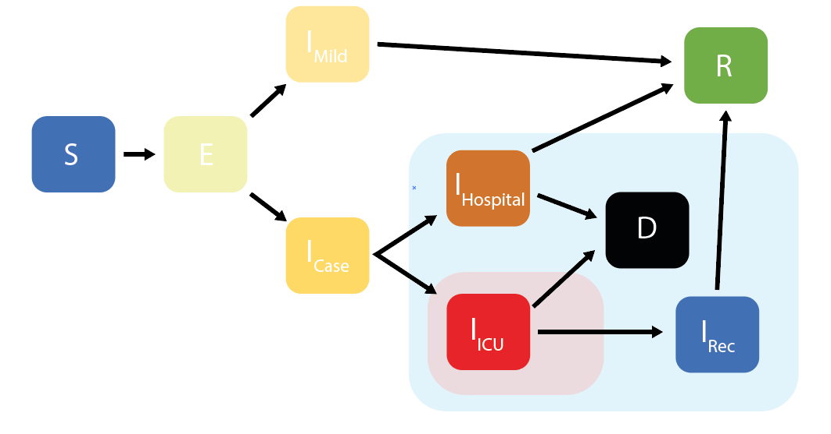
Figure S2: An age-structured SEIR model of SARS-CoV-2 transmission, explicitly incorporating disease severity and passage through different healthcare levels. In the above schematic, $S$ = Susceptibles, $E$ = Exposed (Latent Infection),$I_{Mild}$ = Mild Infections (not requiring hospitalisation), $I_{Case}$ = Infections Requiring Hospitalisation (but not yet hospitalised),$I_{Hospital}$ = Hospitalised Infections (requiring a general hospital bed), $I_{ICU}$= Hospitalised Infections (requiring an ICU bed), $I_{Rec}$ = Hospitalised Infections (requiring a general hospital bed after recovering from ICU stay), $R$ = Recovered and $D$ = Dead. Pale blue box indicates compartments related to hospitalisation and occupation of a general hospital bed, pale red box indicates compartments related to hospitalisation and that occupy an ICU hospital bed.
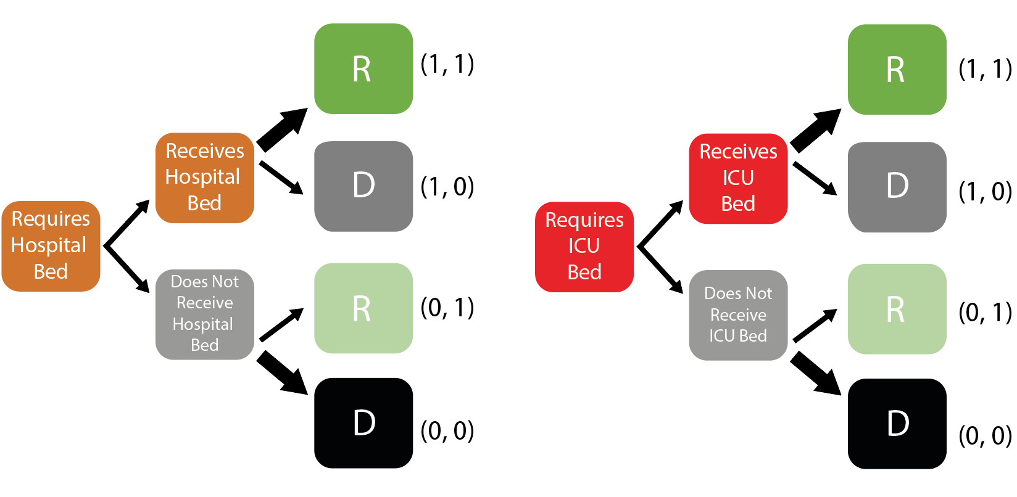
Figure S3: The decision tree cascade included to model excess mortality associated with healthcare capacity being exceeded. The modelling framework utilised here explicitly tracks healthcare capacity and availability. At each timestep, individuals requiring general hospital and ICU beds respectively are assigned available beds (independently of age) Those receiving a bed are subject to a lower probability of mortality than those who do not. Notation to the right hand side of each box describes the compartment in terms of the notation introduced in the details below.
Let S(a) denote the susceptible population in age-group a, E₁(a) and E₂(a) two sequential latent periods, I_{MILD}(a) infections that are either asymptomatic or symptomatic but do not require hospitalisation, I_{CASE,0} (a) and I_{CASE,1} (a) two sequential states for infections that are symptomatic and will subsequently require hospitalisation. I_{HOSPITAl,,0}(a) and I_{HOSPITAL,1}(a) are two sequential states for infections requiring a general hospital bed. I_{ICU,0}(a) and I_{ICU,1}(a) are two sequential states for infections requiring an ICU bed. I_{REC,0}(a) and I_{REC,1}(a) are two sequential states for hospitalised infections in general beds recovering from ICU whilst R(a) those that have recovered (assumed to be immune to re-infection for the duration of the epidemic and D(a) those that die from the disease in age-group a. We further split I_{HOSPITAL,i}(a) and I_{ICU,i}(a) i=1,2 states to track those that either receive or do not receive their hospital or ICU bed respectively (1, 0 respectively depending on capacity constraints) and through these route either die or recover (0 and 1 respectively) in order to capture different durations of stay in hospital dependent on outcome (Figure S3). For example, the state tracking those that require a general bed, receive it and go on to die is I_{HOSPITAL,i}(a,1,0) whilst the state tracking those that require a general bed, do not receive it and go on to die is I_{HOSPITAL,i}(a,0,0). Given the short-term dynamics we do not model births, deaths or aging. The discrete-time stochastic equations are then given by the following equations:

where is the social contact mixing matrix by age and t denotes time. Here denotes the Kronecker delta function such that this equals 1 if there is capacity (Hospital or ICU) and zero otherwise.
The age-independent parameter symbols, description and values are shown in Table S1. The age-dependent probability of hospitalisations and probability of dying are described in subsequent sections.
Table S1: Parameter descriptions and values.
Parameter | Symbol | Value | Description
Transmission parameter |  | - | Calculated from R₀
Basic reproduction number | R₀ | 3.0 (2.3, 3.5) | Estimated from European data (6) consistent with a doubling time of 3.5 days (5 days and 3 days for R₀=2.3 and 3.5 respectively)
Mean Latent Period |  | 4.6 days | Estimated at 5.1 days (58, 59). The last 0.5 days are incorporated in the infectious periods to capture pre-symptomatic infectivity
Mean Duration of Mild Infection |  | 2.1 days | Incorporates 0.5 days of infectiousness prior to symptoms. In combination with mean duration of severe illness this gives a mean serial interval of 6.75 days (60).
Mean Duration of Severe Infection Prior to Hospitalisation |  | 4.5 days | Mean onset-to-admission of 4 days based on unpublished analysis of data from the ICNARC study (9). Includes 0.5 days of infectiousness prior to symptom onset.
Mean Duration of Hospitalisation for non-critical cases if survive |  | 9.5 days | Based on unpublished analysis of data from the ICNARC study (9).
Mean Duration of Hospitalisation for non-critical cases if die |  | 7.6 days | Based on unpublished analysis of data from the ICNARC study (9).
Mean Duration in ICU if survive |  | 11.3 days | Based on data from the ICNARC study (9) adjusted for censoring.
Mean Duration in ICU if die |  | 10.1 days | Based on data from the ICNARC study (9) adjusted for censoring.
Mean Duration in Recovery after ICU |  | 3.4 days | Based on unpublished analysis of data from the ICNARC study (9).

By convoluting the latent periods and the infectious compartments we estimated the mean duration in I_{MILD} in order to obtain an overall serial interval of 6.75 days (60). Unless otherwise stated, an $R_{0}$of 3.0 was used for all scenarios explored and presented in this report based upon estimates observed across Europe (6).

Infection Fatality Ratio
We use age-stratified estimates of the IFR as presented in Verity et al. (5), using linear interpolation on a log10 scale to obtain estimates in 5-year age-bands. These estimates were made assuming a uniform attack rate across all age-groups. To better match model-based estimates of attack rates by age generated in the presence of more detailed mixing patterns, we scale our IFR estimates as follows.
First, we analytically generated the final epidemic size for a Chinese demography using age-based mixing patterns obtained in Zhang et al. (45) Let denote the number of infections generated in age-group a, the underlying population and the attack rate. Then our adjusted IFR is given by:

Probability of Hospitalisation
We use age-stratified estimate of the proportion of infections that require hospitalisation as presented in Verity et al. (5). These estimates were made on a subset of COVID-19 cases reported in China between January and early February 2020. Whilst we have no reason to doubt the validity of the original numbers, the preprint from which these numbers were obtained, whilst still available, has been retracted. These estimates (Figure S4 in blue, used for the analyses here) represent an intermediate assumption between two more recent estimates of the risk of hospitalisation as a function of age. The estimates from France (61) show a steeper increase with age, whilst the more recent study from China shows an increase in risk from age 50 onwards (60).

Figure S4: Relationship between risk of hospitalisation, the need for critical care and mortality in the presence of oxygen and mechanical ventilation. Estimates used in the modelling analyses presented here (left). Comparison of estimated proportion of infections hospitalised from China (used in this analysis) with more recent analyses from France (61) and a second dataset from China (60) (right).
Due to the small numbers of severe cases in younger age-groups, we first need to smooth this pattern to relate it directly to the estimates of IFR to avoid fluctuations in these age-groups in the proportion of hospitalised infections that die.
To do so, we first scale both the original IFR estimates and the proportion of infections hospitalised (PIH) relative to the oldest age group:
We then smooth the ratio of in those aged 40 and under to ensure a constant proportion of deaths in hospitalised cases (of 3%) in this age-group. We subsequently use the smoothed scaling and IFR’(a) to obtain an adjusted PIH’(a) that can be applied to model output for non-uniform attack rates by age.

Estimates of Critical Care Demand
The above calculations allow us to obtain estimates of symptomatic cases, hospitalisations and deaths from the model outputted numbers of infections.
To obtain estimates of the number of cases requiring critical care, we first assume that the overall age-distribution of those in critical care will be the same as the age-distribution of the IFR. If we let the proportion of infections requiring critical care be denoted by then
We fix so that the proportion of overall hospitalised cases requiring critical care is 30% based on early reports from COVID-19 cases in the UK, China and Italy. The number of cases in critical care is therefore whilst the number of cases not in critical care is where H(a) is the number of hospitalised cases in age-group a.
Based on early observations of COVID-19 progression in the UK, we assume that the probability of death in those in critical care is 50% (9). We then obtain age-dependent fatality ratios in non-critical care as:

The key resulting model parameters are shown in Table S2.
Table S2: Age-stratified parameters including IFR, the proportion of infections hospitalised, the proportion of hospitalised cases requiring critical care and the proportion of non-critical care cases that die.
Age-group | Adjusted IFR | Proportion of Infections Hospitalised | Proportion of Hospitalised Cases requiring Critical Care | Proportion of non-critical care cases dying
0 to 4 | 0.003% | 0.001 | 0.050 | 0.013
5 to 9 | 0.002% | 0.001 | 0.050 | 0.013
10 to 14 | 0.004% | 0.001 | 0.050 | 0.013
15 to 19 | 0.01% | 0.002 | 0.050 | 0.013
20 to 24 | 0.02% | 0.005 | 0.050 | 0.013
25 to 29 | 0.04% | 0.010 | 0.050 | 0.013
30 to 34 | 0.06% | 0.016 | 0.050 | 0.013
35 to 39 | 0.09% | 0.023 | 0.053 | 0.013
40 to 44 | 0.13% | 0.029 | 0.060 | 0.015
45 to 49 | 0.21% | 0.039 | 0.075 | 0.019
50 to 54 | 0.44% | 0.058 | 0.104 | 0.027
55 to 59 | 0.80% | 0.072 | 0.149 | 0.042
60 to 64 | 1.68% | 0.102 | 0.224 | 0.069
65 to 69 | 2.65% | 0.117 | 0.307 | 0.105
70 to 74 | 4.16% | 0.146 | 0.386 | 0.149
75 to 79 | 6.01% | 0.177 | 0.461 | 0.203
80+ | 9.42% | 0.180 | 0.709 | 0.580

Modified Standard of Care for LIC and LMIC
Current data on outcomes for hospitalised COVID-19 patients are currently based on data from HIC and MIC (China, Europe and US). Given the substantially weaker health systems in LIC and LMIC, it is likely that these outcomes will differ. To derive estimates for the key parameters determining the severity outcomes, a rapid expert clinical review was convened by DL. Eight clinical experts with experience both in treating COVID-19 patients and the UK and with previous experience in clinical practice in LIC/LMICs were asked to provide their assessment for the questions in Table S3. Using these consensus inputs, we modified the following parameters to explore different IFRs in LIC and LMICs, though it should be noted that there was also consensus that this is likely to be highly heterogeneous both within and between countries due to other factors that are difficult to quantify.
Table S3: Expert Clinical Opinion for Severity Outcomes
Questions | Clinical Inputs | Data Source(s)
Fatality rate in those who require ICU
- If require mechanical ventilation (~80% of UK ICU patients) but ventilation is not available | 95-100% | Multiple clinical opinion
- Do not require invasive ventilation but require UK-level ICU – if in ICU in LMIC setting? | In the UK the CFR is ~20%. In an LMIC setting we estimate 50-65%. This assumes that oxygen support is available. We note that there is enormous heterogeneity – with some LMIC ICUs better equipped than in the UK. | Multiple clinical opinion.
- Do not require invasive ventilation but require UK-level ICU – if not able to access ICU? | Assume that the baseline UK CFR is 20% as above. In an LMIC setting we estimate 75% (though some thought higher).  Malawi pneumonia data (all aetiologies). Cohort of 459 with median age 34.7 (IQR 29.4-41.9) and an HIV prevalence of 78%, the 30-day mortality rate was 14.6% (64/439). Reported 30-day mortality in the UK for individuals under 50 with community-acquired pneumonia is 1.5%. Hypoxaemia at presentation defined as SpO2 <90% was found in 16% (73/450) and was associated with four-fold increased risk of mortality (adjusted OR 4.40). | Multiple clinical opinion + Malawi data on pneumonia
Fatality rate in those that require hospitalisation

- If in hospital but in LMIC setting compared to UK setting? | Highly dependent upon a) who gets into hospital and b) availability of oxygen. Likely to be high if only severe get to hospital and availability is limited.  Range 20-30% if oxygen is available, up to 60% if not for severe pneumonia. Considerations such as severely reduced access to care (transport, fear, lack of funding) will play a big part here in meaning that the hospital population highly likely to be much more severe than in UK | Consensus
- If not able to access hospital? | Could be as high as 50-70% for those with severe pneumonia | Multiple clinical opinion
Length of stay
- How would an LMIC setting affect length of stay in hospital and ICU compared to the data we are seeing in China and high-income countries? | Potential to be shorter; death more rapid or dying patients more likely to be sent home, mild illness less likely to present, length of stay in Europe heavily influenced by co-morbidity/ infection control issues | Consensus

Table S4: Assumed model parameters to capture different outcomes in LIC and LMIC compared to UMIC and HIC.
Parameter | Value | Description
Mean duration of hospitalisation if require critical care (ICU) but only a general bed is available | 1 day | Death is likely to be rapid ((6) in Table S3)
Probability of death if require critical care but do not receive it | 90.5% (range 85%-95%) | (1) and (2) in Table S3 weighted as 80% requiring mechanical ventilation, 20% other ICU
Probability of death if hospitalised (non-ICU) with oxygen available (referred to as “poorer outcomes”). | 25% (range 20-30%) | (4) in Table S3
Probability of death if hospitalised (non-ICU) but no oxygen available | 60% (range 50-70%) | (4) in Table S3
Probability of death if require hospitalisation but no hospital beds are available | 60% (range 50-70%) | We assume that the outcome is similar to not receiving oxygen.

Capturing uncertainty in hospital demand
In our forward projections using the SEIR model we capture uncertainty in key parameters driving hospital demand and outcomes (deaths/recovery) – these include uncertainty in the IFR, the probability of requiring hospitalisation and the assumed probabilities of death under poorer outcomes or in the absence of mechanical ventilation and/or oxygen. As the impact of incorporating uncertainty in durations of hospital stay will be similar to varying the overall level of demand, we kept these fixed. Uncertainty in R₀ is captured through sensitivity analyses; other parameters (the latent period and serial interval) were kept fixed as uncertainty in these has little impact on hospital demand.
To capture uncertainty in the adjusted IFR, the proportion of infections hospitalised, the proportion of hospitalised cases requiring critical care and the proportion of non-critical cases dying by age, we used the same process as described above for the median estimate but applied this to a sample from the posterior distribution of the fits in Verity et al.(5). 500 parameter sets of the age specific IFR were drawn from the fitted joint posterior distribution, whilst holding the relative risk of death following hospitalisation and critical care constant.
Uncertainty in the probability of death if require critical care but do not receive it, the probability of death if hospitalised with oxygen available (poorer outcome), probability of death if hospitalised but no oxygen is available) and probability of death if require hospitalisation but no hospital beds are available were sampled independently using triangular distributions from the ranges as shown in Table S4.
A single stochastic realisation of the model was run for each of the 500 parameter sets with the combined uncertainty presented as a 95% uncertainty interval from these 500 model realisations.

Measuring reported case to reported death ratios prior to suppression.
In countries in which suppression measures were identified estimates were based on reported deaths and cases up to this date (conditional on 3 or more deaths reported prior to suppression). In countries in which suppression measures were not identified estimates were based on reported deaths and cases up to the last date at which a measure was reported within the ACAPs data (conditional on 3 or more deaths reported prior to suppression)In countries where a determination as to whether suppression measures had been applied (Brazil and the United States of America) could not be made and in countries experiencing much earlier epidemics (China Iran, Japan, Singapore and South Korea), estimates were based on reported deaths and cases up to the date at which the tenth cumulative death was reported.

Additional Results
Figure S5: Per-capita contacts per day across all identified surveys.

Figure S6: Age stratified final size attack rates for different settings, R₀ and mitigation scenarios. (A) shows final size attack rates by age for Zimbabwe, China and Netherlands as examples of a LMIC, UMIC and HIC respectively. Thick dark lines show our central estimate of $R_{0}=3.0$, lower and upper lighter lines show $R_{0}=2.3$and $R_{0}=3.5$ respectively. (B-D) show attack rates in unmitigated and mitigation scenarios including social distancing and enhanced protection of the elderly for Zimbabwe, China and Netherlands respectively.

Table S5: Reduction in infections and deaths, and degree of reduction in social contacts in general population required for optimised mitigation strategies involving social distancing and enhanced protection of elderly within SIR final size modelling framework.
 | Median country-level reductions with optimal mitigation including social distancing vs unmitigated scenario (range) |  |  | Median country-level reductions with optimal mitigation including social distancing and enhanced protection of elderly vs unmitigated scenario (range)
Income strata | Social contacts¥ | Infections | Deaths | Social contacts€ | Infections | Deaths
R₀=2.3 (doubling time of 5 days)
LIC | 35.7% (34.7%-35.8%) | 35.9% (35.2%-39.1%) | 31.4% (25.9%-46.1%) | 34.3% (33.6%-34.6%) | 35.4% (34.8%-39.6%) | 42.7% (35.9%-58.6%)
LMIC | 35.6% (33.7%-35.8%) | 36.1% (35.0%-40.3%) | 35.3% (28.5%-53.3%) | 34.0% (32.0%-34.5%) | 35.8% (34.4%-41.3%) | 48.4% (38.8%-66.4%)
UMIC | 34.5% (31.9%-35.7%) | 39.2% (35.7%-42.9%) | 48.6% (30.0%-54.4%) | 33.4% (30.7%-34.4%) | 40.3% (35.4%-44.7%) | 61.1% (40.4%-68.1%)
HIC | 34.2% (31.4%-35.8%) | 39.8% (35.0%-42.2%) | 51.6% (26.9%-55.6%) | 33.2% (30.0%-34.4%) | 41.5% (34.6%-44.5%) | 65.5% (30.9%-70.3%)
R₀=3 (doubling time of 3.5 days)
LIC | 44.8% (43.3%-44.9%) | 31.0% (30.0%-34.2%) | 25.3% (19.5%-41.6%) | 43.9% (42.6%-44.0%) | 30.7% (29.9%-34.2%) | 32.6% (25.4%-50.9%)
LMIC | 44.6% (42.8%-44.9%) | 31.4% (30.0%-35.4%) | 30.0% (22.2%-51.9%) | 43.6% (41.8%-44.0%) | 31.3% (29.7%-35.4%) | 39.0% (28.6%-62.1%)
UMIC | 43.1% (40.5%-44.7%) | 34.6% (30.6%-38.5%) | 45.1% (23.8%-53.5%) | 42.3% (39.4%-43.8%) | 35.3% (30.5%-38.5%) | 54.5% (30.3%-64.1%)
HIC | 42.8% (40.1%-44.9%) | 35.3% (29.8%-38.5%) | 49.9% (21.5%-55.1%) | 42.0% (38.8%-43.7%) | 36.6% (29.7%-38.5%) | 60.1% (23.4%-66.6%)
R₀=3.5 (doubling time of 3 days)
LIC | 49.6% (47.9%-49.7%) | 28.1% (27.0%-31.2%) | 22.0% (16.3%-38.7%) | 47.8% (44.6%-47.9%) | 27.5% (26.6%-31.2%) | 37.3% (29.1%-56.5%)
LMIC | 49.3% (47.3%-49.7%) | 28.7% (27.0%-32.5%) | 27.0% (19.0%-50.8%) | 47.0% (45.0%-47.9%) | 27.7% (26.4%-32.5%) | 44.5% (32.5%-68.8%)
UMIC | 47.7% (45.1%-49.5%) | 31.7% (27.7%-35.8%) | 42.5% (20.5%-52.6%) | 45.9% (42.7%-47.5%) | 32.8% (27.3%-35.8%) | 60.1% (34.2%-71.1%)
HIC | 47.4% (44.6%-49.7%) | 32.7% (26.8%-36.2%) | 48.9% (18.7%-54.5%) | 45.6% (38.9%-47.3%) | 35.0% (24.3%-36.2%) | 67.3% (22.9%-74.2%)
¥Applied evenly to the entire population.
€Applied to under 65s, over 65s reduce contacts by 60%.

Model Code
All data used in this study can be freely downloaded from the cited sources. The model underlying the analyses is available in the form of an R package, available at https://github.com/mrc-ide/squire (version 0.4.14 used for the analyses presented here). The code used to generate these analyses is available at https://github.com/mrc-ide/covid_global_impact.
Data
The accompanying Excel spreadsheet summarises our country-level analysis of the ACAP Government Response database compared to the stage of the epidemic at which lockdowns were initiated.
References
1. WHO, “Coronavirus disease (COVID-19) Situation Report-127” (2020), (available at https://www.who.int/docs/default-source/coronaviruse/situation-reports/20200526-covid-19-sitrep-127.pdf?sfvrsn=7b6655ab_8).
2. A. Remuzzi, G. Remuzzi, COVID-19 and Italy: what next? Lancet. 395 (2020), doi:10.1016/S0140-6736(20)30627-9.
3. A. S. Ginsburg, W. C. Van Cleve, M. I. W. Thompson, M. English, Oxygen and pulse oximetry in childhood pneumonia: a survey of healthcare providers in resource-limited settings. J. Trop. Pediatr. 58, 389–93 (2012).
4. J. Cui, Y. Zhang, Z. Feng, Influence of non-homogeneous mixing on final epidemic size in a meta-population model. J. Biol. Dyn. 13, 31–46 (2019).
5. R. Verity, L. C. Okell, I. Dorigatti, P. Winskill, C. Whittaker, N. Imai, et al., Estimates of the severity of coronavirus disease 2019 : a model-based analysis. Lancet Infect. Dis. 3099, 1–9 (2020).
6. S. Flaxman, S. Mishra, A. Gandy, J. T. Unwin, H. Coupland, T. A. Mellan, et al., Estimating the number of infections and the impact of non-pharmaceutical interventions on COVID-19 in 11 European countries. (Imperial College COVID-19 Response Team) (2020), doi:https://doi.org/10.25561/77731.
7. WHO, Report of the WHO-China Joint Mission on Coronavirus Disease 2019 (COVID-19) (2020), (available at https://www.who.int/publications-detail/report-of-the-who-china-joint-mission-on-coronavirus-disease-2019-(covid-19)).
8. J. Phua, M. O. Faruq, A. P. Kulkarni, I. S. Redjeki, K. Detleuxay, N. Mendsaikhan, et al., Critical Care Bed Capacity in Asian Countries and Regions. Crit. Care Med. 48, 654–662 (2020).
9. Intensive Care National Audit & Research Centre (ICNARC), ICNARC report on COVID-19 in critical care 10 April 2020 (2020), (available at https://www.icnarc.org/About/Latest-News/2020/04/04/Report-On-2249-Patients-Critically-Ill-With-Covid-19).
10. K. Houreld, D. Lewis, R. McNeill, S. Granados, Virus exposes gaping holes in Africa’s health systems. Reuters (2020), (available at https://graphics.reuters.com/HEALTH-CORONAVIRUS/AFRICA/yzdpxoqbdvx/).
11. F. Zhou, T. Yu, R. Du, G. Fan, Y. Liu, Z. Liu, et al., Articles Clinical course and risk factors for mortality of adult inpatients with COVID-19 in Wuhan , China : a retrospective cohort study. Lancet. 6736, 1–9 (2020).
12. S. L. James, D. Abate, K. H. Abate, S. M. Abay, C. Abbafati, N. Abbasi, et al., Global, regional, and national incidence, prevalence, and years lived with disability for 354 Diseases and Injuries for 195 countries and territories, 1990-2017: A systematic analysis for the Global Burden of Disease Study 2017. Lancet. 392, 1789–1858 (2018).
13. A. B. Docherty, E. M. Harrison, C. A. Green, H. E. Hardwick, R. Pius, L. Norman, et al., Features of 16,749 hospitalised UK patients with COVID-19 using the ISARIC WHO Clinical Characterisation Protocol. medRxiv (2020), doi:10.1101/2020.04.23.20076042.
14. T. D. Hollingsworth, D. Klinkenberg, H. Heesterbeek, R. M. Anderson, Mitigation strategies for pandemic influenza a: Balancing conflicting policy objectives. PLoS Comput. Biol. 7 (2011), doi:10.1371/journal.pcbi.1001076.
15. R. M. Anderson, H. Heesterbeek, D. Klinkenberg, T. D. Hollingsworth, How will country-based mitigation measures influence the course of the COVID-19 epidemic? Lancet. 395 (2020), pp. 931–934.
16. D. M. Altmann, D. C. Douek, R. J. Boyton, What policy makers need to know about COVID-19 protective immunity. Lancet. 395 (2020), doi:10.1016/S0140-6736(20)30985-5.
17. D. H. Morris, F. W. Rossine, J. B. Plotkin, S. A. Levin, Optimal, near-optimal, and robust epidemic control (2020) (available at http://arxiv.org/abs/2004.02209).
18. F. Di Lauro, I. Z. Kiss, J. Miller, The timing of one-shot interventions for epidemic control. medRxiv (2020), doi:10.1101/2020.03.02.20030007.
19. L. Carenzo, E. Costantini, M. Greco, F. L. Barra, V. Rendiniello, M. Mainetti, et al., Hospital surge capacity in a tertiary emergency referral centre during the COVID-19 outbreak in Italy. Anaesthesia (2020), doi:10.1111/anae.15072.
20. A. Zangrillo, L. Beretta, P. Silvani, S. Colombo, A. M. Scandroglio, A. Dell’Acqua, et al., Fast reshaping of intensive care unit facilities in a large metropolitan hospital in Milan, Italy: facing the COVID-19 pandemic emergency. Crit. Care Resusc. (2020) (available at http://www.ncbi.nlm.nih.gov/pubmed/32227819).
21. E. Litton, T. Bucci, S. Chavan, Y. Y. Ho, A. Holley, G. Howard, et al., Surge capacity of intensive care units in case of acute increase in demand caused by COVID ‐19 in Australia . Med. J. Aust. (2020), doi:10.5694/mja2.50596.
22. T. Hale, S. Webster, A. Petherick, T. Phillips, B. Kira, “Oxford COVID-19 Government Response Tracker” (2020), (available at https://www.bsg.ox.ac.uk/research/research-projects/coronavirus-government-response-tracker).
23. ACAPS, #COVID19 Government Measures Dataset | ACAPS (2020), (available at https://www.acaps.org/covid19-government-measures-dataset).
24. N. M. Ferguson, D. Laydon, G. Nedjati-Gilani, N. Imai, K. Ainslie, M. Baguelin, et al., Impact of non-pharmaceutical interventions (NPIs) to reduce COVID-19 mortality and healthcare demand (Imperial College COVID-19 Response Team) (2020), doi:10.25561/77482.
25. N. Lurie, M. Saville, R. Hatchett, J. Halton, Developing Covid-19 Vaccines at Pandemic Speed. N. Engl. J. Med. (2020), doi:10.1056/nejmp2005630.
26. Consulate General of the Republic of Korea, “Flattening the curve on COVID-19 - How Korea responded to a pandemic using ICT” (2020), (available at http://overseas.mofa.go.kr/us-houston-en/brd/m_5573/view.do?seq=759765).
27. Korea Centers for Disease Control & Prevention, Contact Transmission of COVID-19 in South Korea: Novel Investigation Techniques for Tracing Contacts. Osong Public Heal. Res. Perspect. 11, 60–63 (2020).
28. K. E. C. Ainslie, C. E. Walters, H. Fu, S. Bhatia, H. Wang, X. Xi, et al., Evidence of initial success for China exiting COVID-19 social distancing policy after achieving containment. Wellcome Open Res. 5, 81 (2020).
29. L. Ferretti, C. Wymant, M. Kendall, L. Zhao, A. Nurtay, L. Abeler-Dörner, et al., Quantifying SARS-CoV-2 transmission suggests epidemic control with digital contact tracing. Science. 368, eabb6936 (2020).
30. P. G. Walker, C. Whittaker, O. Watson, M. Baguelin, K. E. C. Ainslie, S. Bhatia, et al., The Global Impact of COVID-19 and Strategies for Mitigation and Suppression (Imperial College COVID-19 Response Team) (2020), doi:10.25561/77735.
31. A. B. Hogan, B. Jewell, E. Sherrard-Smith, J. Vesga, O. J. Watson, C. Whittaker, et al., The Potential Impact of the COVID-19 Epidemic on HIV, TB and Malaria in Low-and Middle-Income Countries (Imperial College COVID-19 Response Team) (2020), doi:10.25561/78670.
32. E. L. Korenromp, Lives saved from malaria prevention in Africa--evidence to sustain cost-effective gains. Malar. J. 11, 94 (2012).
33. N. V. Loayza, “Costs and Trade-Offs in the Fight Against the COVID-19 Pandemic : A Developing Country Perspective” (Washington, D.C, 2020), (available at http://documents.worldbank.org/curated/en/799701589552654684/Costs-and-Trade-Offs-in-the-Fight-Against-the-COVID-19-Pandemic-A-Developing-Country-Perspective).
34. O. J. Watson, P. G. Walker, P. Winskill, M. Baguelin, E. Knock, J. Lees, et al., Squire (2020), doi:10.5281/zenodo.3872340.
35. covid_global_impact (2020), doi:10.5281/zenodo.3872387.
36. O. J. Watson, R. FitzJohn, J. W. Eaton, rdhs: an R package to interact with The Demographic and Health Surveys (DHS) Program datasets. Wellcome Open Res. 4, 103 (2019).
37. Office for National Statistics, 2011 Census - household type, household size and age of usual residents (people) - England and Wales - (2018), (available at https://www.ons.gov.uk/peoplepopulationandcommunity/housing/adhocs/008635ct08202011censushouseholdtypehouseholdsizeandageofusualresidentspeopleenglandandwales?:uri=peoplepopulationandcommunity/housing/adhocs/008635ct08202011censushouseholdtypehouseholdsiz).
38. T. Hoang, P. Coletti, A. Melegaro, J. Wallinga, C. G. Grijalva, J. W. Edmunds, et al., A Systematic Review of Social Contact Surveys to Inform Transmission Models of Close-contact Infections. Epidemiology. 30, 723–736 (2019).
39. D. Moher, L. Shamseer, M. Clarke, D. Ghersi, A. Liberatî, M. Petticrew, et al., Preferred reporting items for systematic review and meta-analysis protocols (PRISMA-P) 2015 statement. Syst. Rev. 4, 1–9 (2015).
40. S. Kumarid, M. Gosain, H. Sharma, E. Swetts, R. Amarchand, R. Kumar, et al., Who interacts with whom? Social mixing insights from a rural population in India. PLoS One. 13 (2018), doi:10.1371/journal.pone.0209039.
41. O. le Polain de Waroux, S. Cohuet, D. Ndazima, A. J. Kucharski, A. Juan-Giner, S. Flasche, et al., Characteristics of human encounters and social mixing patterns relevant to infectious diseases spread by close contact: A survey in Southwest Uganda. BMC Infect. Dis. 18, 172 (2018).
42. J. Mossong, N. Hens, M. Jit, P. Beutels, K. Auranen, R. Mikolajczyk, et al., Social Contacts and Mixing Patterns Relevant to the Spread of Infectious Diseases. PLoS Med. 5, e74 (2008).
43. G. Béraud, S. Kazmercziak, P. Beutels, D. Levy-Bruhl, X. Lenne, N. Mielcarek, et al., The French Connection: The First Large Population-Based Contact Survey in France Relevant for the Spread of Infectious Diseases. PLoS One. 10, e0133203 (2015).
44. K. Leung, M. Jit, E. H. Y. Lau, J. T. Wu, Social contact patterns relevant to the spread of respiratory infectious diseases in Hong Kong. Sci. Rep. 7, 1–12 (2017).
45. J. Zhang, P. Klepac, J. M. Read, A. Rosello, X. Wang, S. Lai, et al., Patterns of human social contact and contact with animals in Shanghai, China. Sci. Rep. 9, 1–11 (2019).
46. C. G. Grijalva, N. Goeyvaerts, H. Verastegui, K. M. Edwards, A. I. Gil, C. F. Lanata, et al., A household-based study of contact networks relevant for the spread of infectious diseases in the highlands of peru. PLoS One. 10 (2015), doi:10.1371/journal.pone.0118457.
47. M. Ajelli, M. Litvinova, Estimating contact patterns relevant to the spread of infectious diseases in Russia. J. Theor. Biol. 419, 1–7 (2017).
48. S. P. Johnstone-Robertson, D. Mark, C. Morrow, K. Middelkoop, M. Chiswell, L. D. H. Aquino, et al., Social mixing patterns within a South African township community: implications for respiratory disease transmission and control. Am. J. Epidemiol. 174, 1246–55 (2011).
49. M. C. Kiti, T. M. Kinyanjui, D. C. Koech, P. K. Munywoki, G. F. Medley, D. J. Nokes, Quantifying Age-Related Rates of Social Contact Using Diaries in a Rural Coastal Population of Kenya. PLoS One. 9, e104786 (2014).
50. A. Melegaro, E. Del Fava, P. Poletti, S. Merler, C. Nyamukapa, J. Williams, et al., Social Contact Structures and Time Use Patterns in the Manicaland Province of Zimbabwe. PLoS One. 12, e0170459 (2017).
51. K. O. Kwok, B. Cowling, V. Wei, S. Riley, J. M. Read, Temporal variation of human encounters and the number of locations in which they occur: A longitudinal study of Hong Kong residents. J. R. Soc. Interface. 15 (2018), doi:10.1098/rsif.2017.0838.
52. Y. Ibuka, Y. Ohkusa, T. Sugawara, G. B. Chapman, D. Yamin, K. E. Atkins, et al., Social contacts, vaccination decisions and influenza in Japan. J. Epidemiol. Community Health. 70, 162–167 (2016).
53. International Monetary Fund, World Economic Outlook (2016) (available at https://web.archive.org/web/20160421023851/http://www.imf.org/external/pubs/ft/weo/2016/01/pdf/text.pdf).
54. Database of Global Administrative Areas, (available at https://gadm.org/).
55. R. Hijmans, S. Phillips, J. Leathwick, J. Elith, dismo:Species Distribution Modeling. R package (2017), (available at https://rspatial.org/raster/sdm/index.html).
56. S. Murthy, A. Leligdowicz, N. K. J. Adhikari, Intensive Care Unit Capacity in Low-Income Countries: A Systematic Review. PLoS One. 10, e0116949 (2015).
57. European Centre for Disease Control, Situation update worldwide, as of 27 April 2020 (2020), (available at https://www.ecdc.europa.eu/en/geographical-distribution-2019-ncov-cases).
58. N. M. Linton, T. Kobayashi, Y. Yang, K. Hayashi, A. R. Akhmetzhanov, S. Jung, et al., Incubation Period and Other Epidemiological Characteristics of 2019 Novel Coronavirus Infections with Right Truncation: A Statistical Analysis of Publicly Available Case Data. J. Clin. Med. 9, 538 (2020).
59. S. A. Lauer, K. H. Grantz, Q. Bi, F. K. Jones, Q. Zheng, H. R. Meredith, et al., The Incubation Period of Coronavirus Disease 2019 (COVID-19) From Publicly Reported Confirmed Cases: Estimation and Application. Ann. Intern. Med. (2020), doi:10.7326/M20-0504.
60. Q. Bi, Y. Wu, S. Mei, C. Ye, X. Zou, Z. Zhang, et al., Epidemiology and transmission of COVID-19 in 391 cases and 1286 of their close contacts in Shenzhen, China: a retrospective cohort study. Lancet Infect. Dis. 0 (2020), doi:10.1016/S1473-3099(20)30287-5.
61. H. Salje, C. Tran Kiem, N. Lefrancq, N. Courtejoie, P. Bosetti, J. Paireau, et al., Estimating the burden of SARS-CoV-2 in France. Science. (2020), 13 May 2020: eabc3517; doi:10.1126/science.abc3517.

