Lessons Learned from an Underreported Mumps Epidemic Among Rohingya Refugees, Cox’s Bazar, Bangladesh

Luke Mair MBChB* ^{a,b,c}, Pryanka Relan MD MPH^{d}, David Oliver Hamilton BMBS^{e}, Abdullah-Al-Noman MPH^{f}, Timothy O’Dempsey MBChBª

- Department of Clinical Sciences, Liverpool School of Tropical Medicine, UK
- Tropical and Infectious Diseases Unit, Liverpool University Hospitals NHS Foundation Trust, Liverpool UK
- Infectious Diseases Department, Sheffield Teaching Hospitals, UK
- Department of Emergency Medicine, Mount Sinai Health System, New York, New York
- Critical Care Department, Liverpool University Hospitals NHS Foundation Trust, Liverpool UK
- Department of Maternal & Child Health, National Institute of Preventive and Social Medicine(NIPSOM), Dhaka, Bangladesh

Corresponding Author:
Dr Luke Mair. Email: Luke.mair1@nhs.net. Phone: +447969239797

Abstract
Background: In 2018 a large mumps epidemic coincided with an outbreak of diphtheria in refugee camps established in Bangladesh for the Rohingya people. These refugees did not receive a mumps containing vaccine.
Methods: Cases of mumps were reported to the World Health Organisation (WHO) Early Warning, Alert and Response System (EWARS) during the Rohingya refugee crisis. The authors present amalgamated epidemiological data of a major, previously unreported, mumps epidemic.
Results: In total 19 215 mumps cases across a total of 218 facilities were reported to EWARS during 2018. The attack rate was 2.1% of the whole population. 7 687 (40·0%) of these cases were in children under 5 years old. Mumps was more commonly seen among males than females.
Conclusion: Detailed reporting of outbreaks of all vaccine preventable diseases is essential to ensure appropriate vaccination decisions can be made in future humanitarian crises.

Keywords: Diptheria, Mumps, Refugee, Rohingya, Underreported, Vaccination
Introduction:
Since August 2017, over 740 000 Rohingya people have fled violence in Rakhine State, Myanmar and sought refuge in Cox’s Bazar District in Southern Bangladesh. Most have settled in Kutupalong Refugee Camp, which now has a population exceeding 914 000, including Rohingya refugees who fled from previous violence and a small number of Bangladeshi host population.
Limiting vaccine preventable diseases (VPDs) is a key public health intervention, especially in scenarios associated with displacement. VPDs with high morbidity and mortality are prioritised however it is important to consider vaccination against all VPDs, including those with low case fatality rates such as mumps.
Prior to arrival in Bangladesh, the Rohingya population had not received adequate vaccinations. A retrospective survey of vaccination coverage conducted by Médecins Sans Frontières (MSF) estimated measles vaccination coverage of less than 25% among children aged 6 to 59 months at the start of the crisis.¹
During the Rohingya crisis two subsequent measles-rubella (MR) vaccination campaigns took place between September and November 2017. Oral cholera vaccination campaigns were implemented following a risk assessment and Diphtheria, Pertussis and Tetanus (DPT) vaccinations were administered following a diphtheria outbreak. No mumps containing vaccine was given during the campaigns.
We provide the first description of a large mumps epidemic which occurred among Rohingya refugees in 2018. This outbreak was not included in the local weekly epidemiology bulletins created by the World Health Organisation (WHO)², and has not been documented in literature. We discuss how vaccination decisions are made in acute humanitarian emergencies, and how detailed reporting of all outbreaks, including those of low morbidity and mortality, is important to aid future vaccination decisions.

Materials and Methods:
Prior to publication the authors obtained permission from WHO and the Bangladesh Ministry of Health and Family Welfare (MoHFW) to access the amalgamated epidemiological data collected for all suspected mumps cases among the Rohingya refugees from December 2017 to December 2018.
Epidemiological data during the crisis were collected through WHO’s Early Warning, Alert and Response System (EWARS), a disease surveillance system commonly used in humanitarian settings whereby users monitor a maximum of 12-14 selected diseases or health events. These conditions are chosen by consensus between WHO, humanitarian organisations and the local ministry of health. Case definitions and thresholds for reporting and investigating alerts are pre-specified for each condition.
In December 2017, EWARS was initiated in the Rohingya refugee camps through partnership of WHO and the Bangladesh MoHFW. Pre-specified conditions for monitoring were selected.³ Mumps was not among these conditions.
EWARS depends on reporting by local healthcare workers, using either clinical, laboratory or epidemiological definitions for diagnosis. The mumps case definition used during the crisis was as follows. “Acute onset of unilateral or bilateral tender or self-limited swelling of the parotid or other salivary gland lasting ≥ 2 days without other apparent cause”. All cases were reported based on clinical suspicion. No confirmatory laboratory testing was undertaken.
Data were submitted to EWARS via an electronic case report form in real time with smartphone applications or at the end of each working day via laptop. Each case report documented: Patient’s gender, whether under or over 5 years old, patient’s residence by camp number and the camp number of the reporting health facility.
Data for our study were analysed using Microsoft Excel® v1803. Maps were generated using QGIS® v3.6 with files obtained from the Humanitarian Data Exchange.
Results
The first two suspected mumps cases were reported to EWARS 17th January 2018 (Epi week3). Both cases were male and over 5 years old. They were reported from a Ministry of Health Upazila Health Complex (Upazila being the local name for an administrative region). This facility was located on the outside border of Kutupalong refugee camp. It acted as a secondary referral centre with inpatient beds available during the crisis.
Case numbers escalated weekly producing a classic epidemic distribution (Figure 1). More than 500 weekly cases were reported consistently through Epi weeks 9-23. The peak of the outbreak was seen in Epi week 16 when 1 292 cases were reported.
In total 19 215 cases were reported between January 2018 and December 2018. 7 687 (40·0%) of these cases were in children under 5 years old. Mumps was more commonly seen among males than females, and this was consistent for under 5s (males 4 146 (53·9%), females 3 541, (46·1%)) and over 5s (males 5 858 (50·8%), females 5 670 (4·92%)).
Data regarding potential complications of mumps including meningitis, encephalitis, orchitis, oophoritis and pancreatitis were not available to the authors.
Given estimated population data released by International Organisation for Migration in December 2018 totalled 909,207, this produces an estimated attack rate of 2.1%. Population data for those under five years old is not available.
Cases were reported from a total of 218 facilities, including those run by local government health facilities and international non-governmental organisations. MSF reported the majority of cases (13 627/ 19 215 (70·1%)).
Cases were reported from almost all (92%) camps. The highest number of cases came from Camp 9, where 5 401 cases were reported. Facilities in Camp 15 reported 3 047 cases and those in Camps 2W, 14 and 16 reported over 1000 cases. Camps in existence prior to August 2017 (Kutupalong RC and Nayapara) reported far fewer cases (less than 10). (See Supplementary Figures)
Discussion
Our study provides the first description of a major mumps epidemic among Rohingya refugees. Cases were reported across multiple camps over multiple geographical locations, suggesting a high infectivity and high epidemic potential of mumps in a refugee crisis.
The hallmark feature of mumps virus infection is painful swelling of the parotid gland. Although generally benign and self-limiting, complications including aseptic meningitis, encephalitis, epidiymo orchitis and oophoritis can occur. Mumps can also cause spontaneous abortion in the first trimester of pregnancy, which is particularly relevant in a camp with a large population of women of child bearing age.This epidemic was not reported in the weekly epidemiology bulletin.² Whilst it can be understood that concurrent outbreaks of high morbidity and mortality diseases such as diphtheria, measles and acute jaundice syndrome were prioritised, it is nonetheless important that there is a record of this mumps epidemic as it has implications for planning in the current situation and subsequent acute humanitarian emergencies.
WHO has a framework for vaccination decisions in acute humanitarian emergencies.⁴ The framework concentrates on three stages of decision making: Firstly calculating the epidemiological risk posed by each vaccine preventable disease (VPD), secondly considering vaccine properties, and thirdly prioritisation of vaccination alongside other public health interventions.
When considering epidemiological risk it is critical to search the literature for previous documented outbreaks of VPDs. A literature review of VPDs in refugees and internally displaced persons from 2000-2015 documented only one mumps outbreak report, whereas there were 16 articles for measles, 5 for polio and cholera, and 1 for rubella.⁵ This mumps epidemic among Rohingya refugees, the largest ever recorded in a refugee population, until now, has remained unreported in the literature.
During the health sector response to this crisis, Rohingya refugees received measles-rubella (MR) vaccine rather than measles-mumps-rubella (MMR). Despite its low case fatality rate this large mumps epidemic increased pressure on already stretched curative health services. Combining this with the fact that targeting mumps can be opportunistically coupled with vaccinations against measles, consideration should be made for MMR vaccination in similar humanitarian crises in the future.
A key consideration in any vaccination campaign is cost. MR vaccines are cheaper than MMR. An economic cost analysis comparing the cost of an MR vs MMR vaccination campaign with the cost of managing 19,215 cases and potential complications of mumps is an area for further research.
An important confounding factor unique to this crisis was that the mumps epidemic coincided with an ongoing diphtheria outbreak. The most commonly reported symptoms of diphtheria were fever, sore throat and difficulty swallowing. These symptoms were also commonly reported by patients with mumps, leading to large case numbers being referred as suspected diphtheria. This led to patients with mumps waiting in isolation facilities alongside probable diphtheria cases. Given similarities in case presentation it is suspected that patients diagnosed with suspected diphtheria may in fact have had mumps, and indeed some patients diagnosed with suspected mumps may have had, or become infected with, diphtheria. This strengthens the argument for including mumps in vaccination campaigns targeting vulnerable populations with previously low immunization rates. It also raises the question as to why vaccination against diphtheria was not also prioritised. This is another issue requiring further research.
Our study has limitations. Firstly, all cases reported in this mumps epidemic were diagnosed on clinical suspicion. No confirmatory testing for mumps was undertaken. Secondly, when implementing EWARS users must set a locally appropriate threshold for reporting and investigating an alert. As the authors did not work alongside the local epidemiology team the thresholds set for mumps are not known in this paper.

Conclusion
This previously unreported mumps epidemic, among Rohingya refugees, is the largest ever recorded in a refugee population. The mumps epidemic coincided with an outbreak of diphtheria. Clinical similarities between mumps and diphtheria may have led to inappropriate case management and placed individuals at increased risk of acquiring either mumps or diphtheria. Detailed reporting of outbreaks of all VPDs, including diseases of low morbidity and mortality, is essential to ensure appropriate vaccination decisions can be made in future humanitarian crises.

Authors Contributions:
LM and PR conceived the study. TOD provided supervision throughout. All authors were involved in study implementation. DOH acted as liaison with local Ministry of Health and AAN as liaison with WHO in collection and obtaining of data. LM and PR analysed and presented the data. LM,PR and DOH wrote the manuscript. All authors edited the manuscript. All of authors have reviewed and approved the final version of the manuscript.
Acknowledgements:
With great thanks to Jessy Hampton for her time creating the maps shown in Supplementary Data.
Funding: No funding received.
Competing Interests: None declared
References
- Grellety E, Falq G. Retrospective mortality, nutrition and measles vaccination coverage survey in Balukhali 2 and Tasnimarkhola camps. 2017. Epicentre. Médecins Sans Frontières.
https://www.msf.org/sites/msf.org/files/report-rohingyas-emergency-17-vf1.pdf. Accessed September 2019
- World Health Organisation. Bangladesh. Rohingya Crisis. Weekly Epidemiology Bulletin.
http://www.searo.who.int/mediacentre/emergencies/bangladesh-myanmar/en/. Accessed December 2019.
- Karo B, Haskew C, Khan AS et al. World health organization early warning, alert and response system in the Rohingya crisis, Bangladesh, 2017–2018. Emerging Infectious Diseases. 2018. 11: 2074-2076
- World Health Organisation. Vaccination in acute humanitarian emergencies: a framework for decision making. Department for Immunisation Vaccines and Biologicals. 2013. WHO/IVB/13.07.
- Lam E, Mccarthy A, Brennan M. Vaccine-preventable diseases in humanitarian emergencies among refugee and internally-displaced populations. Human vaccines & immunotherapeutics 2015. 11:11: 2627–36

Figure 1: Stacked bar chart depicting mumps case numbers reported to EWARS from January 1st 2018 (Epi week 1) to December 31st 2018.
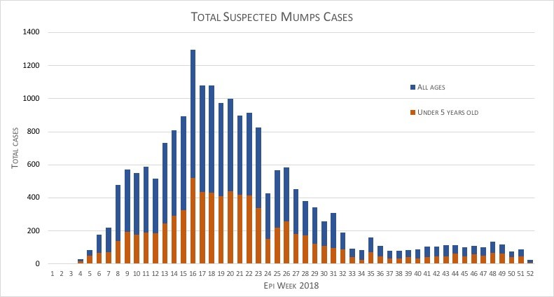

Supplementary Data: 2A
Map depicting total mumps case numbers throughout named refugee camps in Southern Bangladesh. Dotted line represents Bangladesh-Myanmar border.
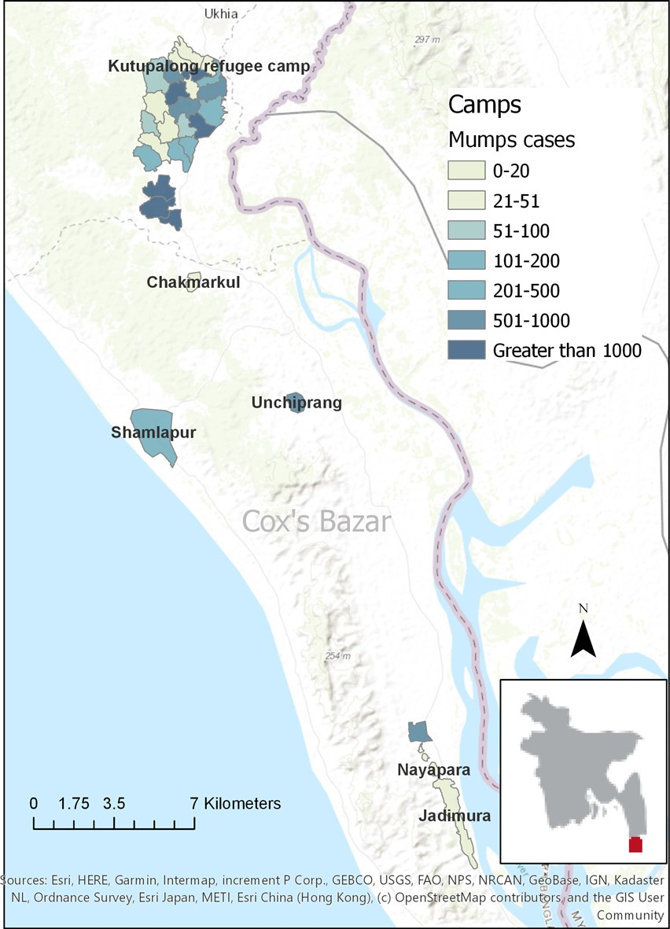

Supplementary Figure 2B
Magnified view of Kutupalong refugee camp showing case numbers of mumps in official camp numbers created during Rohingya refugee crisis.
