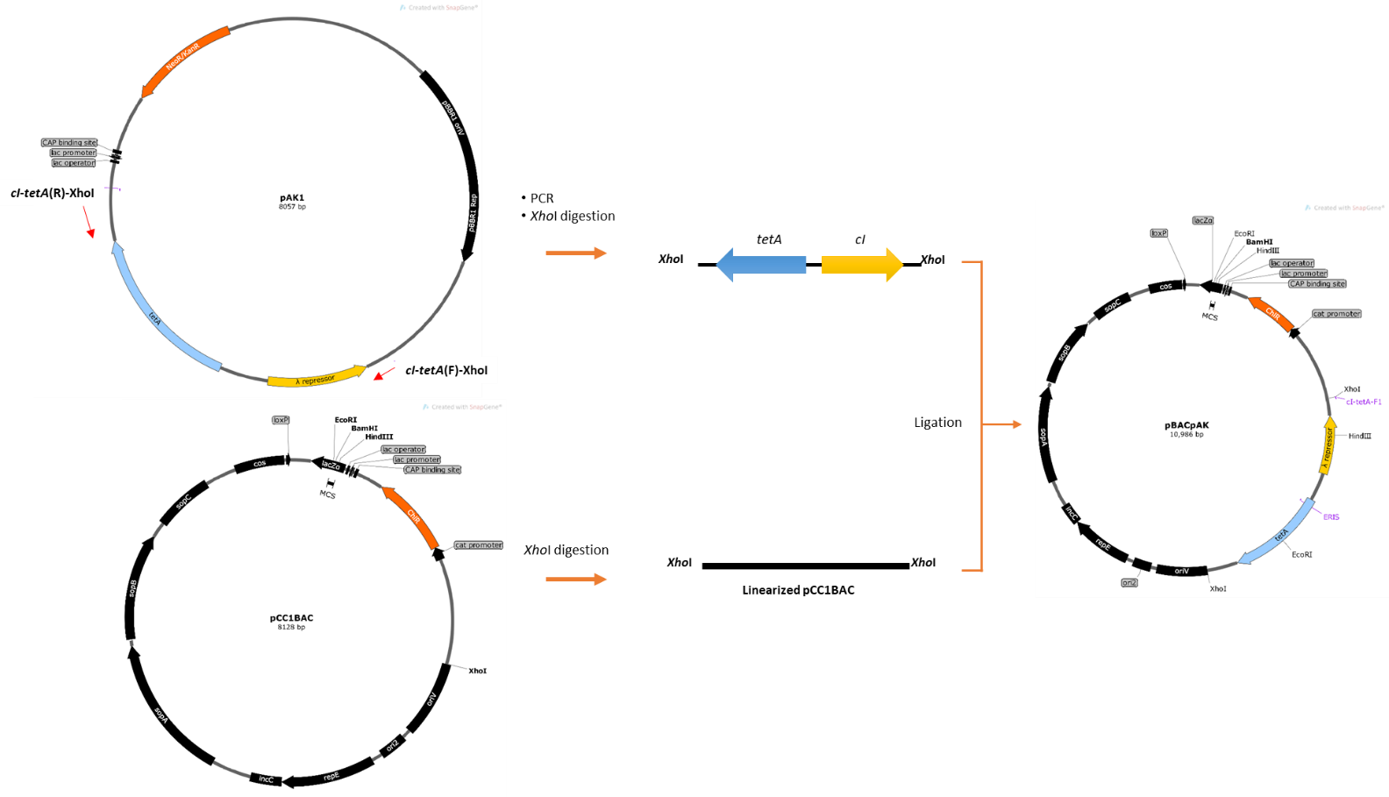
Figure S1. Construction of pBACpAK entrapment vector. The cI-tetA selection cartridge was amplified from pAK1 entrapment vector by using cI-tetA(F)-XhoI and cI-tetA(R)-XhoI primers (red arrows). The amplicon was cloned into pCC1BAC at the XhoI site, resulting in a pBACpAK entrapment vector.

