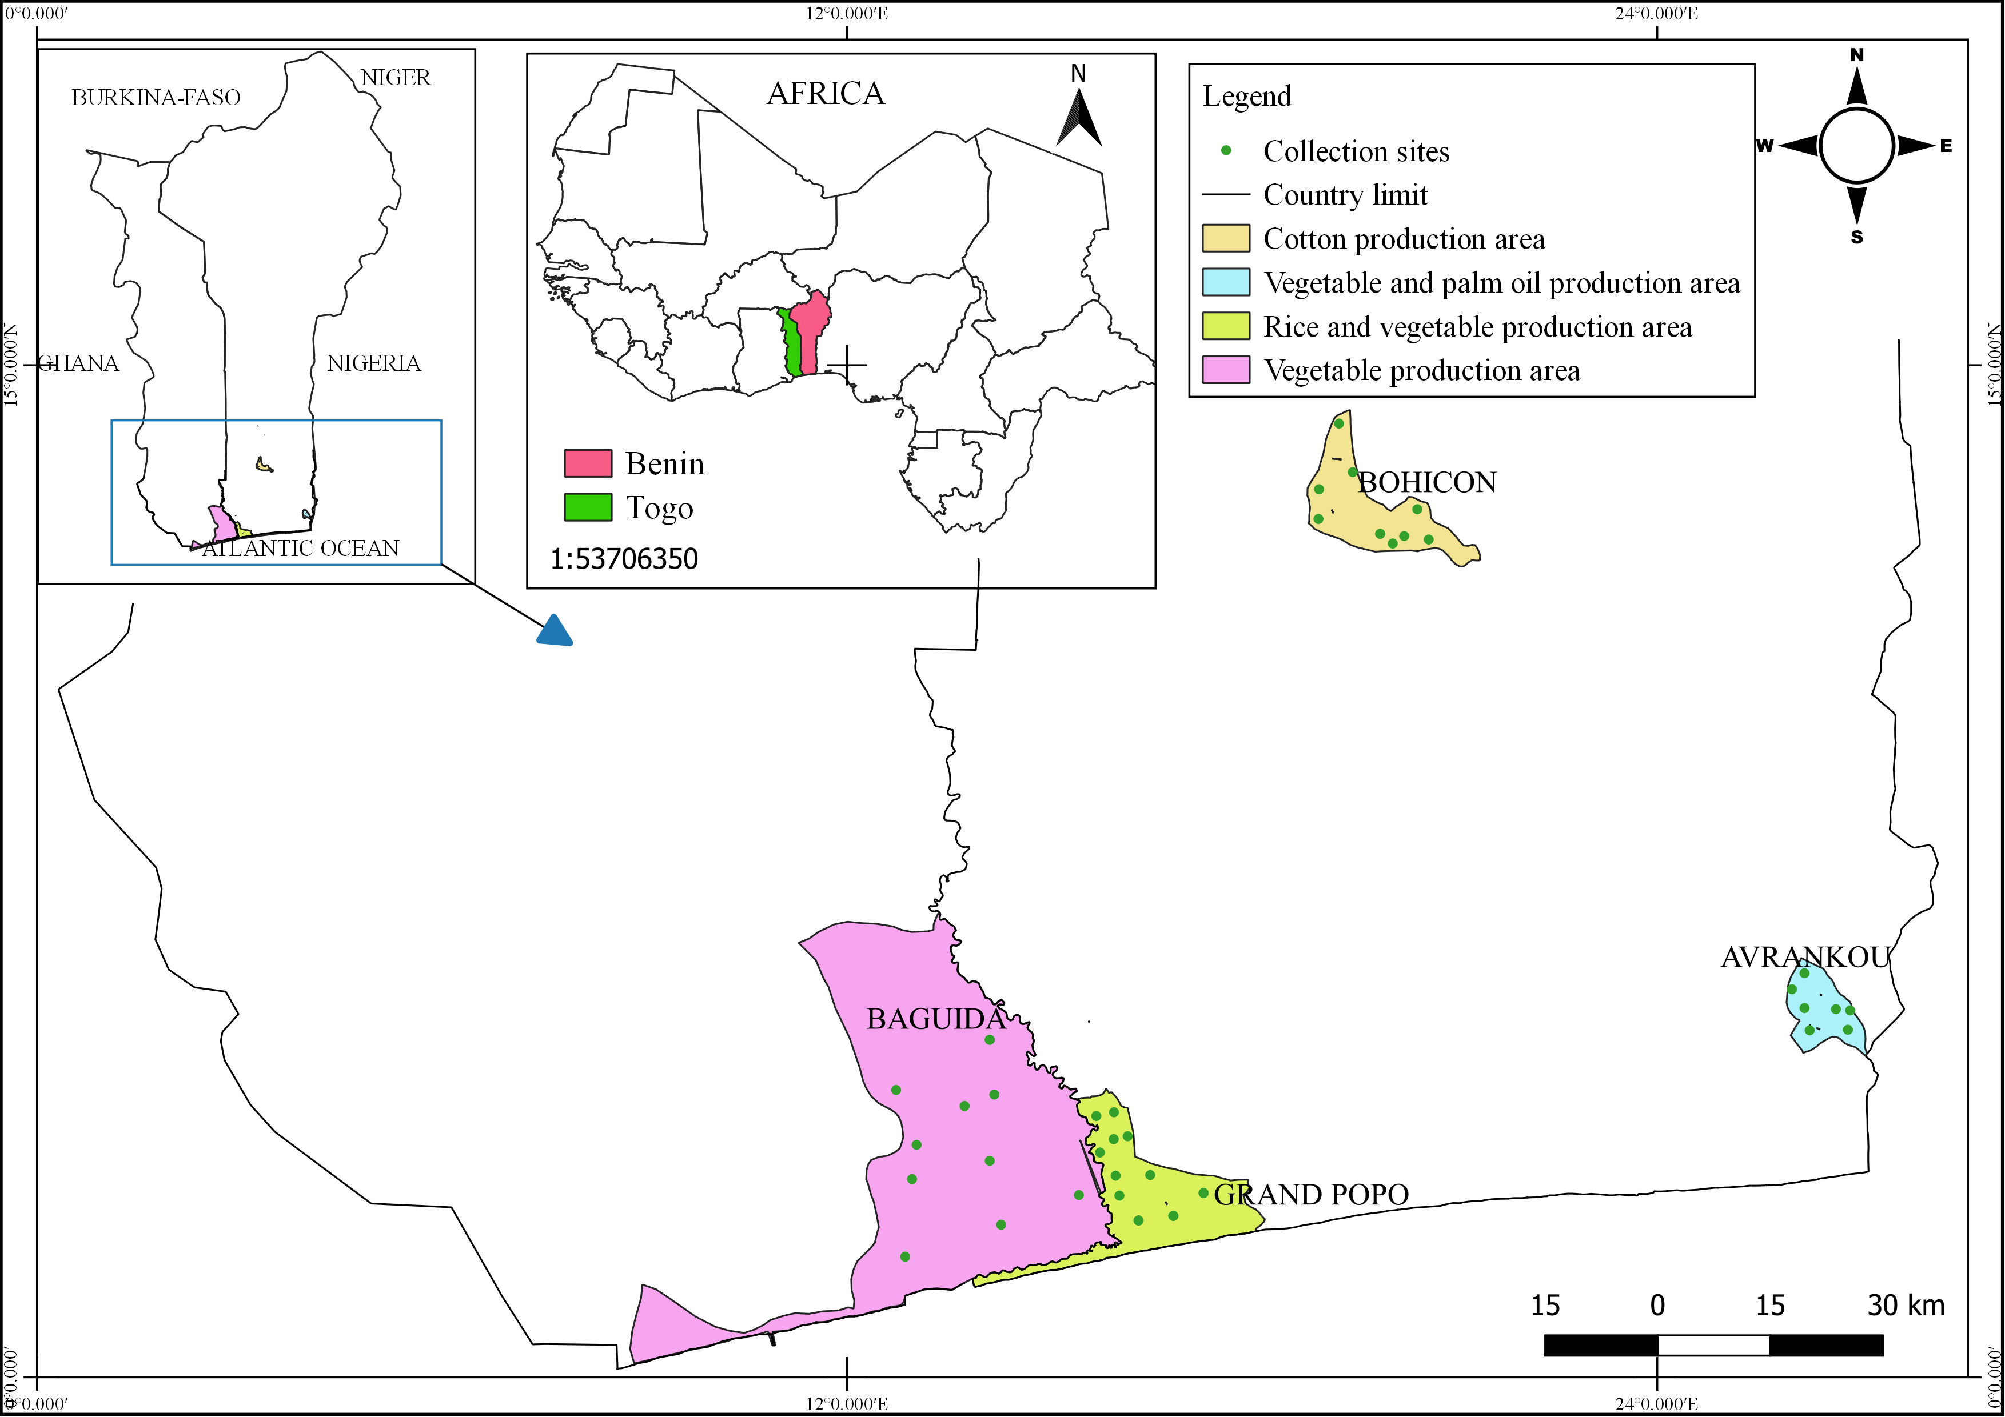
Figure 1. Maps of Benin and Togo showing the distribution of prospective sites and their environnemental characteristics.

