Automated and high throughput digital fluorescence microscopy for diagnosis of
- pulmonary tuberculosis.
5
- Authors: Dumitru Chesov^{1,2}, Victor Lesanu³, Nelly Ciobanu³, Alexandru Codreanu³, Valeriu Crudu³, Luis E.
- Cuevas⁴, Donat Kiss⁵, Nóra Czoboly⁵ and Akos Somoskovi⁶ 8
- Institutions: ¹ Department of Pneumology and Allergology, Nicolae Testemitanu State University of Medicine

- and Pharmacy, Chisinau, Republic of Moldova; ² Clinical Infectious Diseases, Research Center Borstel, Borstel,

- Germany; ³ National TB Reference Laboratory, Chiril Draganiuc Institute of Phthisiopneumology Chisinau,

- Republic of Moldova; ⁴ Liverpool School of Tropical Medicine, Liverpool, UK.⁵ Consultask Ltd., Budapest

- Hungary; ⁶Roche Molecular Systems Inc., Pleasanton, CA, USA;

- Running head: Fluorobot for pulmonary TB 15
- Funding: This research was funded by Consultask Ltd. Hungary, which provides free of charge Fluorobot

- machine and supplies, and in part by the European and Developing Countries Clinical Trial Partnership

- (EDCTP), grant number DRIA2014-309.

19

Word count: Main text: 1098
- References 9

Figures 1
- Key words: Fluorobot, TB, sputum smear, AFB, Mycobacterium tuberculosis
- Corresponding author Dumitru Chesov, Department of Pneumology and Allergology, Nicolae Testemitanu

- State University of Medicine and Pharmacy, Chisinau, Republic of Moldova; email.dumitru.chesov@usmf.md.

1

- Smear-microscopy is still the most frequently used method for diagnosis of tuberculosis (TB) and the primary

- tool used to monitor treatment response in low income settings. However, smear-microscopy is laborious

- and time consuming and prone to human error. Automated smear-microscopy systems could enable high

- laboratory throughput with limited staff time and standardise results in diagnostic centres with large

- numbers of samples.¹ 32
- We evaluated an automated fluorescence microscopy system (Fluorobot, ConsultaSK Ltd., Budapest,

- Hungary) capable of the automated reading of smears using an ultrabright light emitting diode (LED) and

- image interpretation for the detection of bacilli on slides.² The system reads slides stained with auramine-O,

- which are mounted in a conveyer belt, conduct automated image focus, image capture and interpretation.³

- These steps include auto-focusing, image capture, filtering by normalization of noise levels and setting the

- number of view-fields for examination. The default number of fields examined is 100, corresponding to an

- area of 2 mm.⁴ The examination however is halted at 40 view fields if the slide reaches a 2+ grade , and at 20

- fields if 3+. The platforms automatically finds the fields of interest (FOI), determines independent and

- complex morphological parameters and classifies the FOIs using proprietary deep machine learning

- algorithms trained on a repository of 100,000 positive and 100,000 negative smears.² 43
- This was a prospective evaluation of the Fluorobot diagnostic accuracy, and was conducted at the National

- TB Reference Laboratory at Chiril Dragniuc Pthisiopneumology Institute (PPI), Chisinau, Republic of Moldova.

- Consecutive sputum samples of adults (≥ 18 years old) with presumptive TB were (Sept-Dec 2016)

- decontaminated and centrifuged to conduct liquid and solid TB culture ⁵. Aliquots of the processed sputum

- sediment were used to prepare auramine-O-stained smears. Smears were graded manually by experienced

- microscopist unaware to the Fluorobot results and with the automated Fluorobot system. Slides were

- examined manually using the 20X objective and with 26X magnification for Fluorobot, without oil immersion.

- Smears were graded negative, scanty, 1+, 2+ and 3+.⁵ Smears graded manually as scanty by a first

- microscopist were confirmed by a second microscopist and discordant readings were discussed to reach

- consensus. Smears graded scanty by Fluorobot were selected by the software and the digital images were

2

- presented to a microscopist for manual confirmation. Fluorobot smears were classified according to the

- number of images resembling bacilli per FOI and were considered negative if there was no or 1 bacilli per FOI

- 5; scanty if 2-9 bacilli, 1+ if 10-99 bacilli, 2+ if 100-1000 bacilli and 3+ if >1000 bacilli. Culture was considered

- the reference standard for comparison and one positive solid or liquid culture was considered as positive.

- Patients with contaminated or missing cultures were excluded. Statistical analyses was performed in MedCalc

- Statistical Software (MedCalc bvba, Ostend, Belgium; https://www.medcalc.org; 2019, version 19.0.5).

- Analysis included a straight comparison of the manual and automated readings. This was followed by a

- second analysis comparing the manual and the automated readings supplemented by the manual

- confirmation of automated scanty smears. Ethical approval was obtained from the Research Ethics

- Committees of the PPI, Moldova and the Liverpool School of Tropical Medicine, UK.

- Four-hundred and twenty-two sputum samples were available for analysis, of which 80 (18.9%) were culture-

- positive. In the first analysis, 56 of 80 culture-positive samples were graded as smear-positive (sensitivity of

- 70%, 95%CI 58.7% - 79.7%) and 335 of 342 culture-negative samples were graded smear-negative (specificity

- 97.9%, 95%CI 95.8% - 99.2%) by manual examination. Fluorobot graded smear-positive 56 of the 80 culture-

- positive smears (sensitivity 70.0%, 95%CI 58.7% - 79.7%) and smear-negative 280 of 342 culture-negative

- smears (specificity 81.8%, 95%CI 77.4% - 85.8%). Sixty-six smears had been graded scanty by Fluorobot and

- these were reviewed by a microscopist for confirmation, which resulted in a revised scale to regrade smears

- with 2-4 bacilli per FOI as negative. This second analysis with regraded scanty smears resulted in 51 of 80

- culture-positive smears graded smear-positive (sensitivity 63.8%, 95%CI, 52.2 - 74.2) and 329 of 342 culture-

- negative specimens graded smear-negative (specificity 96.2%, 95%CI, 93.6 - 98.0). The difference of Area

- Under the Curve (AUC) of the manual and automated readings for the second analysis was not statistically

- significant (AUC manual grading - AUC fluorobot alone = 0.044, p=0.07; AUC manual grading - AUC fluorobot partially revised = 0.036;

- p = 0.06), as shown in the figure.

- Our findings indicate that the fully automated Fluorobot has similar sensitivity but lower specificity than

- manual smear-microscopy. However, the selection of a small proportion of smears (15%) graded scanty for

- confirmation resulted in similar sensitivity and specificity to manual readings. The selection of digital images

3

- with scanty smears can be automated and images can be transmitted electronically for confirmation. The

- confirmation step only requires reviewing four view fields per smear.

- The integration of automated microscopy tools such as Fluorobot in locations where smear-microscopy is

- still conducted for the diagnosis of large numbers of patients and to monitor treatment response by

- documenting conversion to smear-negative after two and five months has the potential to reduce the

- workload while generating reproducible results that are less prone to human error and dependent on human

- competency.

- Our study has several limitations, as it was conducted in a single laboratory and in a setting with relatively

- low HIV prevalence. HIV status was not available for analysis, which precluded stratifying by this important

- factor ⁶. Moreover, all participants were adults and further studies in children are needed.

- Automated smear microscopy systems could facilitate processing high sample numbers in busy laboratories

- and has the potential to standardize reading procedures, enabling consistency in smear gradings, shorter

- turnaround times, while reducing systematic human errors due to fatigue and low proficiency .^{1,7,8} As the

- digital images can be transmitted electronically, quality assurance can be conducted remotely, without the

- need of physical visits or sample transport. Despite these advantages, the system also requires stable

- electricity, a computer, internet access and establishing procedures for the procurement of proprietary

- smears and stains and the maintenance and calibration of the platform. Although commercial prices are not

- available, it is intended the system would have comparable prices to a good quality, general purpose,

- microscope and further cost-benefit analyses are warranted.

- The WHO recommends conducting sputum smear-microscopy for the diagnosis of TB in locations where

- GeneXpert is not available. ⁹ Smear microscopy also continues to be one of the mainstay methods to monitor

- TB treatment response. The Fluorobot system therefore could be suitable for settings with high laboratory

- workloads, where staff can be overworked and fatigued and could facilitate the establishment of a uniform

- acid-fast microscopy service with minimal human involvement. Further evaluations of the platform are

- warranted in high burden settings.

4

References
  - Nabeta P, Havumaki J, Ha DTM, Caceres T, Hang PT, Collantes J, et al. Feasibility of the TBDx automated digital microscopy system for the diagnosis of pulmonary tuberculosis. Chaturvedi V, editor. PLoS One;12(3):e0173092. Available from: https://dx.plos.org/10.1371/journal.pone.0173092
  - Somoskövi A, Györi Z, Czoboly N, Magyar P. Application of a computer-directed automated microscope in mycobacteriology. Int J Tuberc Lung Dis [Internet]. 1999 Apr;3(4):354–7. Available from: http://www.ncbi.nlm.nih.gov/pubmed/10206508
  - Fluorobot the only dedicated robotic mycroscope, v. 2106. Available from: https://fluorobot.com/fluorobot/fluorobot-ppt/
  - Toman’s Tuberculosis Case detection, treatment, and monitoring-questions and answers Second Edition. 2004.
  - Stinson KW, Eisenach K, Kayes S, Matsumoto M, Siddiqi S, Nakashima S, et al. Mycobacteriology Laboratory Manual. Global Laboratory Intiative, editor. 2014.
  - Smelyanskaya M, John D. Stop TB Partership Key population breif: Rural population [Internet].

Geneva; 2016. Available from: http://www.stoptb.org/assets/documents/resources/publications/acsm/kp_rural_spreads.pdf
  - Law YN, Jian H, Lo NWS, Ip M, Chan MMY, Kam KM, et al. Low cost automated whole smear microscopy screening system for detection of acid fast bacilli. Hasnain SE, editor. PLoS One [Internet]. 2018 Jan 22;13(1):e0190988. Available from: http://dx.plos.org/10.1371/journal.pone.0190988
  - Zingue D, Weber P, Soltani F, Raoult D, Drancourt M. Automatic microscopic detection of mycobacteria in sputum: a proof-of-concept. Sci Rep. 2018;8(1):11308. Available from: http://www.nature.com/articles/s41598-018-29660-8
  - World Health Organization. Systematic screening for active tuberculosis: an operational guide [Internet]. Geneva; 2015. 60 p. Available from: https://apps.who.int/iris/bitstream/handle/10665/181164/9789241549172_eng.pdf
5

Figure. Area under the curve (AUC) of manual, Fluorobot and Fluorobot plus scanty confirmation smear microscopy using culture as reference standard.
For
Review

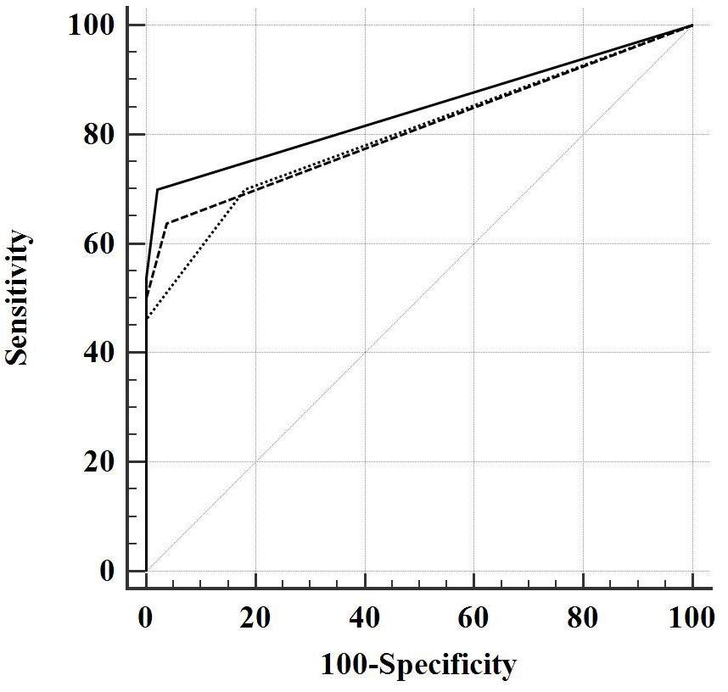
Solid line Manual smear-microscopy (AUC 0.84; 95%CI 0.81 - 0.87)
Dashed line Fluorobot smear-microscopy with confirmation of scanty smears (AUC - 0.81. 95%CI 0.77 - 0.85)
Pointed line Fluorobot alone (AUC - 0.80; 95%CI 0.76 0.84).

6

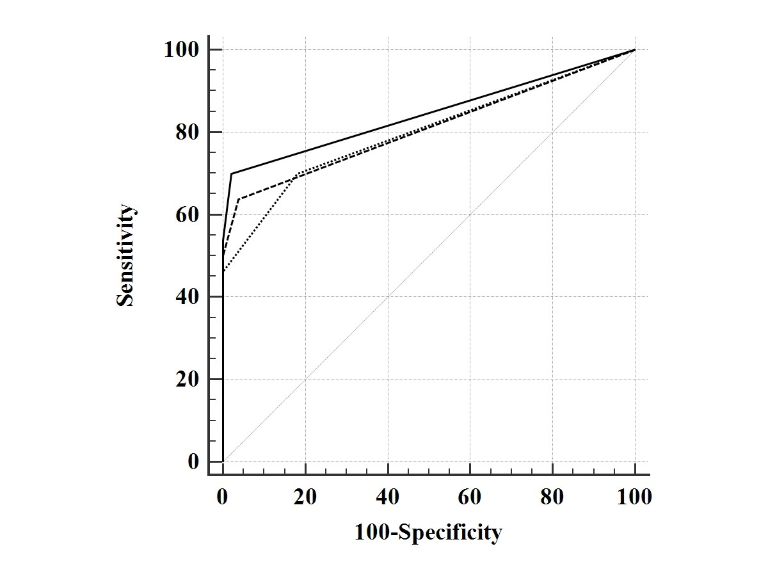

Figure. Area under the curve (AUC) of manual, Fluorobot and Fluorobot plus scanty confirmation smear microscopy using culture as reference standard.
For
Review
Only
Solid line Manual smear-microscopy (AUC 0.84; 95%CI 0.81 - 0.87)
Dashed line Fluorobot smear-microscopy with confirmation of scanty smears (AUC - 0.81. 95%CI 0.77 - 0.85)
Pointed line Fluorobot alone (AUC - 0.80; 95%CI 0.76 ¬ 0.84).

101x76mm (300 x 300 DPI)

