Application of Infrared Thermography in Early Warning of Pressure Injury

Fuman Cai ¹ ², Xiaoqiong Jiang ², Xiangqing Hou ³, Duolao Wang ⁴, Yu Wang ⁵, Haisong Deng ⁶, Hailei Guo ⁶, Haishuang Wang ⁶, Xiaomei Li ¹

Affiliations
¹School of Nursing, Xi'an Jiaotong University Health Science Centre, Xi'an, China.
²School of Nursing, Wenzhou Medical University, Wenzhou, China.
³Faculty of Health Sciences, University of Macau, Macau, China.
⁴Department of Clinical Sciences, Liverpool School of Tropical Medicine Pembroke Place, Liverpool, United Kingdom.
⁵Medical engineering office, the First Affiliated Hospital of Wenzhou Medical University, Wenzhou, China.
⁶The First Affiliated Hospital of Wenzhou Medical University, Wenzhou, China.

Abstract

Aims and objectives: To verify the ability of infrared thermography in objectively identifying pressure injury and its application value in the early warning of pressure injury.

Background: There is subjectivity in assessing the risk of pressure injury as well as diagnosis in clinical settings, which makes early detection and prevention difficult.

Design: Prospective, cohort study.

Method: Four hundred and fifteen patients admitted to the adult intensive care units were enrolled by a convenience sampling method, and they received a follow-up monitoring for 10 days. The risk of pressure injury was assessed via Braden scale, and thermal images of sacral area were obtained by infrared thermal imager once a day. The predictive effects of infrared thermography and Braden scale on pressure injury were compared by the receiver operating characteristic curve from which the optimal cutoff value of skin temperature for predicting pressure injury was determined. The effect of skin temperature on pressure injury was described and compared, using Kaplan-Meier curve and Cox proportional hazard regression model respectively. We followed STROBE checklist for reporting the study.

Results: The relative temperature of sacral area was negatively correlated with the risk of pressure injury. The efficiency of infrared thermography for diagnosing pressure injury was better than that of Braden scale. Based on the relative temperature optimal cutoff value (-0.1°C), Kaplan-Meier curve and Cox proportional hazard regression model analysis showed the incidence of pressure injury with relative temperature below -0.1°C was higher than the group with relative temperature above -0.1°C.

Conclusions: Infrared thermography can objectively and accurately identify local hypothermia warnings of pressure injury before visual recognition. The application of infrared thermography into routine pressure injury risk assessment provides a timely and reliable method for nursing practitioners.

Relevance to clinical practice: Infrared thermography has great value of clinical application in daily pressure injury assessment. It is of great significance to make a faster and more objective clinical judgment for patients at risk of pressure injury.

Keywords: Braden scale; Infrared thermography; Pressure injury; Skin temperature; Thermal image.

What is already known about the topic?
- There is a certain subjectivity in assessing the formation risk of pressure injury as well as diagnosis, which makes early prevention difficult.
- The infrared thermal imager has been widely used in the diagnosis and treatment of some temperature related diseases.
- Infrared thermography has been proved to have the ability of objectively recognizing tissue damage early.
What this paper adds?
- The relative temperature optimal diagnostic threshold (-0.1°C) in sacrum area can be used to predict the risk of pressure injury.
- The incidence of pressure injury was high when the relative temperature in sacrum area was below -0.1°C, increasing the risk by 13.46 times.
- The efficiency of relative temperature to diagnose pressure injury was better than Braden score.
Key words Infrared thermography; pressure injury; skin temperature; thermal image; early warning

1. Background

Pressure Injury (PI), formerly known as Pressure Ulcer (PU), is a local injury to the skin and /or soft tissue located at the bulge site of medical or other instruments, and can be expressed as intact skin or an open ulcer which may be accompanied with pain ^{[1]}. PI has become a global health problem. Its rapid development and long treatment cycle have brought huge economic burdens to the society, medical institutions and families ^{[2]}. Current data show the PI prevalence rate of inpatients to be 1.4%-120% ^{[3]} which has been increasing year by year for the past 10 years ^{[4]}. The reason maybe that tissue damage in an area of intact skin penetrates from the deep layers to the surface within 48 hours ^{[5]}, and within 7 to 10 days further deterioration to necrotic state is observed. It can be seen that PI progresses rapidly without interventions. Therefore, early warning and prevention is the only way to reduce the incidence of PI. However, on the one hand, due to the current clinical application of the scale scoring system it is not possible to achieve an objective and accurate assessment for guiding early warning ^{[6]}. On the other hand, the judgment of PI is mainly depending on the evaluator's perception of vision and touch with the skin surface. However, Inflammatory and apoptotic/necrotic changes in the epidermal and dermal layers may precede surface changes by 3 to 10 days. So, the hysteresis of subjective judgment may lead to some difficulty in early detection of PI ^{[7]}.

The infrared thermal imager is a set of instruments that collect and record the far-infrared light waves radiated by the human body, processed by multimedia image, and displaying the thermal field of the human body ^{[8]}. Due to its advantages of rapid, simple, objective, accurate, sensitive, and being non-invasive ^{[9]}, the infrared thermal imager has been widely used in the diagnosis and treatment of some diseases such as tumor, blood disease, diabetes, rheumatism, nervous system diseases, acute and chronic inflammation ^{[10, 11]}. Infrared thermography is a temperature measurement technology that visualizes the radiant heat of the human body. In the early stage of PI, metabolic abnormalities are caused by partial or complete occlusion of capillaries at the compression site that destroys the local thermal radiation balance, this abnormal change can be recognized by infrared thermography ^{[12]}. Therefore, this study used infrared thermal imager to monitor the sacral area, aiming to utilize the temperature index of thermal imaging to objectively predict PI. This would provide some guidance for the prevention of PI.

2. Methods
2.1. Study design

We completed a prospective observational study that evaluated a cohort of patients admitted to a comprehensive intensive care unit (ICU), neurosurgical ICU, respiratory intensive care unit（RICU）, emergency department intensive care unit（EICU）, Cardiac intensive care unit（CCU）from August 8, 2018 to April 23, 2019 in a Grade 3 Class A general hospital of Wenzhou, Zhejiang province. This study met and was approved by the hospital's ethical standards.

2.2. Participations
A total of 415 subjects were admitted by continuous cluster sampling. Requirements for participation were as follows: (1) age ≥ 18 years old with informed consent. (2) Braden score ≤ 18 points. (3) Hospitalization time ≥ 10 days. (4) PI occurred after 24 hours of admission. (5) There is no history of PI or skin damage. (6) Able to maintain the 90° lateral position for 4 min and can expose skin of the observation area. Exclusion criteria: (1) Transferred from other wards or transferred to other hospitals. (2) Patients with acute or chronic skin disease or burn. (3) It was not suitable for turning over or considering patients who were intolerant of 90° lateral position. (4) Those who have had PI or skin damage at the observation site before, or used protective dressings. (5) Long-term use of cold and heat therapy during the observation period. (6) Braden score >18 points during the monitoring process.

2.3. Data collection and measurement
During the study period, investigators continuously tracked patients for 10 days, with the development of PI as the endpoint event. Everyone who entered the research was initially assessed by the nursing staff using the Braden scale within 2 hours, and then once a day after that. Collection of demographic characteristics and clinical baseline data relied on the self-made PI impact factor questionnaire. The portable infrared thermal imager was used to obtain thermal images of the sacral area, and skin temperature index was read from the thermal image. Finally, 2 senior nurses judged the stage of PI according to the PI staging standard published by the National Pressure Ulcer Advisory Committee (NPUAP) in 2016^{[1]}, as well as simultaneously reviewing the thermal image from the investigator when PI was diagnosed. During the study, all subjects were prevented and treated according to routine PI care.

Research tools
Self-made questionnaire for factors affecting pressure injury
The questionnaire was completed through the hospital electronic medical record system, and the entries included: gender, age, body mass index (BMI), blood pressure; cholesterol, triglycerides, hemoglobin, albumin, oxygen partial pressure (PO₂), oxygen concentration (FiO₂), oxygenation index, Acute Physiology and Chronic Health Assessment II (Apache II), hospitalization time; hypertension, diabetes, etc. All data were based on the results of the latest examination near the first day of hospitalization ^{[13, 14]}.
Portable infrared thermal imager
This study used FILR ONE PRO mobile phone external probe infrared thermal imager (produced by FLIR, USA), the size is 68 mm × 34 mm × 14 mm, and the weight is 36.5g. The device has one optical camera and one infrared camera. The mobile device was connected by USB interface combined with the matching software FLIR One to shoot. The shooting modes included visible light images, normal thermal images, and dynamic enhancement thermal images (MSX). It was capable of taking still images, videos, and time-lapse shots. Its visible light resolution is up to 1440×1080 dpi, thermal resolution is 160×120 dpi, and the temperature range is -20°C to 400°C with resolution of 0.1°C. The mobile device supported simultaneous display of up to 3 movable temperature measurement points and 6 movable temperature measurement areas on the screen.
Acquire the relative temperature and thermal images of sacral area
Thermal images of the sacral area were acquired at 10 o’clock, which was the time for changing position. It was necessary to keep the infrared thermal imager a certain distance (30cm) from the sacral area when shooting. The measuring instrument was kept parallel to the human body, perpendicular to the bed surface, and the lens was at the same height as sacrum. In order to reduce errors, a control area was selected during the study. (1) Sacral area experimental point positioning: The movable cross-shaped temperature measurement point on the infrared thermal image was placed at the bony prominence of sacrum (deemed to have an elevated risk for PI) and centering on this (P1). The skin temperature in the circular area with a diameter of 5 cm was obtained and the average temperature recorded (T1). (2) Sacral area control point positioning: In previous studies ^{[5]}, a remote region that was located at least 10-cm proximal to the sacrum, with an average sacrum-to-remote distance of 10 cm was deemed to be at minimal risk for PI. Considering the accuracy of positioning, another movable cross-shaped temperature measurement point was placed on the midpoint of the anterior superior iliac spine and gluteal cleft line, centering on this (P2). Obtained the skin temperature in the circular area with a diameter of 5 cm was obtained and the average temperature recorded (T2). The calculated the relative temperature (ΔT=T1-T2) is shown in Figure 1.
Position requirements
The subjects were placed at a 90° lateral position. Both arms were bent, one hand on the pillow and the other hand on the chest. The lower leg was straight with the upper leg bent. If necessary, a soft pillow was placed between the knees, chest and abdomen or back respectively. Clothes and dressings were removed fully exposing the sacrum and lower back area for 4 minutes to ensure pressure did not affect the blood perfusion of sacrum, which may result in abnormal skin temperature and thermal images.
Environmental requirements
Doors and windows were closed, as were curtains to protect the privacy of patients and to reduce the interference of external infrared radiation. Ambient airflow was kept relatively constant when measured (air conditioner turned off if necessary), and personnel movement was avoided. The ambient temperature and humidity were measured by a digital thermometer.
Notes
(1) Different postures would affect the skin temperature and thermal image. It was ensured that the patient used the same position throughout the study. (2) Physical therapy, transcutaneous electrical stimulation, ultrasound therapy, acupuncture, physical stimulation, hot or cold compress were prohibited within 1 hour before shooting the thermal image. (3) Prior to shooting, it was not allowed to move, eat, wash and bathe, or clean and disinfect the measurement site within 30 minutes. (4) It was ensured that the instrument, measurement time, control area, distance and the investigator were constant.

Statistical Analysis
The database was established using SAS 9.4 statistical analysis software. The variables were described according to the Kolmogorov-Smirnov normal distribution test. The t-test, Wilcoxon rank-sum test, and 𝜒2 test were used to compare demographic characteristics and clinical baseline data. Spearman rank correlation analysis was used to describe the correlation between skin temperature and PI at different times. The receiving operating curve (ROC) was used to evaluate the predictive effect of skin temperature and Braden score on PI. Subjects were divided into the different risk groups with the optimal cutoff value of skin temperature by ROC. The Kaplan-Meier method was used to display the process of the PI and Cox proportional hazard regression model was used to calculate the risk ratio (hazard ratio [HR] value) and 95% confidence interval (95%CI) by different risk groups of PI. A P-value less than 0.05 was considered as statistically significant.

RESULTS
Demographic characteristics and clinical baseline data
Univariate analysis was performed on whether there was a difference between the PI group and non-PI group. The results showed that there was no significant difference between the 2 groups except hypertension and Apache II score variables (Table 1).
Spearman rank correlation between the relative temperature and pressure injury of sacral area at different times
Since the time taken for PI development was different, not all patients had 10 days data. In retrospective analysis of skin temperature in the previous days when PI was diagnosed (expressed as "lag days"), lag 0 day represented the day when PI occurred, and lag 1 day represented one day before PI occurred, and so on (i.e. ΔT _{lag 0-9 (days)}). Using the medians to describe the relative temperature variables, Spearman rank correlation analysis showed that there was a negative correlation between the relative temperature and PI. The closer to the PI development, the better correlation is between them (Table 2).
The optimal cutoff value of the relative temperature for predicting pressure injury
The relative temperature of lag 0 day, lag 1 day as well as the median relative temperature was chosen for further analysis according to the results of the correlation analysis. Dependent on the predicted probability effect diagram, the relative temperature can be used to PI as shown in Figure 2. All 3 temperatures had good predictive effect, the area under the ROC curve (AUC) was 0.83, 0.77, and 0.90, respectively. The median relative temperature had the best predictive effect with the optimal cutoff value for predicting the risk of pressure injury was -0.1 °C (Table 3).
Univariate and multivariate analysis for the development of pressure injury
The subjects were divided into high risk group (ΔT ≤ -0.1°C) and low risk group (ΔT > -0.1°C). The K-M survival curve suggested that the incidence of PI in the high risk group was higher than that in the low risk group. Looking at the changing trend of curve, the incidence of PI was the highest on the fourth and fifth day (Figure 3). Univariate and multivariate analysis were performed between the development of PI and the lag 0 day, 1 day as well as the median relative temperature by Cox proportional hazard regression model. The variables of P<0.2 in Table 1 were corrected as confounding factors, and the HR value as well as the 95% confidence interval (95% CI) calculated. When the skin relative temperature was below -0.1 °C, the risk of PI increased (HR was 7.31, 4.77, 13.46, respectively), P < 0.001 (Table 4).
The predictive ability of the relative temperature and Braden score for pressure injury
Sensitivity and specificity was used to plot the ROC curve of relative temperature and Braden score, and compares the predictive effects of the different methods on PI (Figure 4). The skin relative temperature (AUC=0.90) was superior to the Braden score (AUC=0.70) in predicting the development of PI. Its Youden’s index was 0.753, with the high sensitivity (85.37%) and specificity (89.89%) (Table 3).
Comparison of Infrared thermal images with or without pressure injury in sacrum
Previous research has shown that different color gradations represent different temperatures in the thermal image: red for hot zone, yellow for warm zone, green for cool zone, blue for cold zone, and purple for supercool zone ^{[9]}. In general, because blood perfusion and tissue metabolism were constant at one anatomical region, its color gradation distribution was uniform. As the adipose tissue generally does not transmit heat, the subcutaneous fat-rich parts have lower body surface temperatures (such as the hip) ^{[15]}. Therefore, the hip area was shown as a yellow warm zone on the thermal image compared to the red hot zone of sacrum. When a PI occurred, the red area of sacrum can at first appeared as a yellow abnormal color gradation. As the tissue damage became aggravated, yellow-green appeared, finally changing into a green abnormal color gradation, which can be used as a characteristic of infrared thermal images when assessing the occurrence of PI, as shown in Figure 5.

DISCUSSION
PI care has become a difficult problem in clinical nursing work. At present, the clinical early warning system for PI is mainly based on the application of various evaluation scales. However, meta-analysis showed that these scales have many problems such as subjective scoring, low predictive ability, and lack of specificity ^{[16-18]}. Therefore, it is necessary to explore a new early warning method to identify the early risk of PI.
Hypothermia imaging signal of sacrum was the early warning information for the development of pressure injury
In the early stage of PI, due to capillary occlusion of the compression site, abnormal blood flow and tissue metabolism lead to local skin temperature changes, accompanied by differences of imaging gradations in thermal image ^{[19]}. Spearman rank correlation analysis showed that the relative temperature was negatively correlated with PI, which mean that the lower the relative temperature was, the more likely to develop PI. In order to eliminate the influence of measurement sites and environmental factors on the accuracy of skin temperature during the study, this study used relative temperature indicators to describe the process of PI in the sacrum. Although there have been many studies on the correlation between skin temperature and PI, a single absolute temperature value was used to predict the risk of PI usually, and considered that the increase of skin temperature was a risk factor for the development of PI ^{[20, 21]}. What is the reason for making the result difference was that there was no way to minimize the variables that could affect the sacrum’s temperature on any given day (eg, the examination room could be warmer or the body temperature could be changed on the day of follow-up than on the day of baseline). Under normal circumstances, due to the rich adipose tissue in the buttocks, the skin temperature is lower than that of sacrum, so the difference between the sacrum and the control area should be above 0℃. When the injury of sacrum occurred, the skin temperature decreased due to blood perfusion and abnormal tissue metabolism, so the relative temperature turned negative. The larger the negative value was, the more serious the damage. However, the single absolute temperature value can’t reflect the change process. Therefore, when the relative temperature of the skin drops to the diagnostic threshold of -0.1 °C, together with the thermal image of sacrum showing abnormal color gradation, the local damage was usually irreversible which resulted in a greater risk of PI development. In summary, the identification of hypothermia imaging warning signals was of great significance for predicting the risk of PI.
Infrared thermography can objectively identify pressure injury prior to the visual evaluation
At present, based on the mechanism of PI, many scholars have proposed that the development of PI begins with muscle tissue damage, penetrating from the deep to the surface within 48 hours. When the pressure is beyond the tissue resistance threshold, tissue damage started immediately, which was often preceded by visual recognition ^{[5, 7, 22]}. Therefore, how to identify potential damage within 48 hours before visual recognition provided a possibility to reduce the incidence of PI to some extent. In this study, the relative skin temperature of 2 days before the PI development was chosen for analysis. The K-M curve suggested that when the skin relative temperature was lower than -0.1 °C, the incidence of PI increased, with the risk increased by 8.12 and 5.30 times, respectively. At this stage, the skin relative temperature change was earlier than the visible damage of skin surface, the time advantage provided the possibility of early intervention. In addition, similar studies have previously proposed -1.5 ° C to -0.75 ° C as the optimal diagnostic threshold of skin relative temperature for predicting PI ^{[5, 23]}. The difference may be that the skin relative temperature obtained in this study was before diagnosed PI. Further reduction of the relative temperature, which resulted from the worsening of local tissue damage remained to be verified by following the progress of PI. It also provided new ideas for predicting different stages of PI by using different skin relative temperature diagnostic thresholds. Therefore, although there were no obvious skin changes with the naked eye, if the relative temperature of sacrum was found to be lower than -0.1° C, it still suggested that PI may occur after 48 hours, preventive measures should be taken in time.
Infrared thermography can improve the early warning effect on the risk of pressure injury
With the application of the early warning concept to the management of PI, the use of PI assessment tools to screen high, moderate and low-risk patients made prevention more focused and targeted ^{[19]}. At present, it was common for application of PI assessment scales in early warning system, but its reliability and validity are moderate ^{[24]}. Therefore, by comparing the skin relative temperature and the Braden score to predict the PI, this study found that the area under the skin relative temperature ROC curve was 0.90 (95% CI: 0.86, 0.94), which had a high predictive effect on PI. The sensitivity (85.37%) and specificity (89.89%) indicated that this index had an ideal discriminating ability for patients with PI ^{[25]}. To some extent, this indicated that local skin relative temperature index was more accurate than the Braden score for predicting the PI, consistent with the views of some researchers such as Oliveira AL ^{[18]}. In addition, the data of this study showed that the best threshold of the Braden score for predicting the risk of PI was 14 points, which was lower than the value of 18 points for the risk of pressure injury development in clinic. A higher warning value may result in too many patients being included in the PI prevention cohort, the application of excessive interventions made prevention less focused and lead to waste of related medical resources. In summary, the use of infrared thermography to obtain local skin temperature index of sacrum can improve the ability to predict the risk of PI, and thus correctly guide the early warning.
The feasibility of Infrared thermography to predict pressure injury
There are many optical technologies used in wound evaluation, including: near-infrared imaging, thermal imaging, optical coherence tomography, orthogonal polarization spectroscopy, fluorescence imaging, laser Doppler imaging, and so on. To some degrees, these optical techniques complement or even replace traditional wound assessments by providing detailed information on skin components that are not readily detectable by visual inspection ^{[26]}. Non-invasive imaging is a promising advancement in wound assessment, especially in the field of PI ^{[27, 28]}. Therefore, this study used the portable infrared thermal imager as a research tool. First, because of its simple operation, portability and easy access, it was superior to the previous studies with the complicated operation, large volume, and high cost of the equipment ^{[29, 30]}, it was feasible for equipment acquisition and promotion. Second, using the turn-over time to shoot the sacral area, the image acquisition was quick and convenient, which was suitable for nurses to operate. Third, the PI was detected by the abnormal color gradation of different anatomical regions on the thermal image with the temperature changing to warn the risk of PI, which was intuitive. Moreover, the infrared thermal imager was a highly efficient temperature information collecting device. It has sensitive recognition ability for hypothermia signals caused by local blood flow and metabolic abnormalities in the early stage of PI. Higher positive and negative predictive values indicated that it had certain clinical application feasibility.

CONCLUSIONS
Infrared thermography can objectively and accurately identify early local hypothermia warning information of PI before visual recognition. The use of infrared thermography to combine quantitative skin temperature measurement into routine PI assessment provides a timely and reliable method for nursing practitioners, which has important applications for early warning and prevention of PI.

Reference
[1] Schank J E. The NPUAP Meeting – This was No Consensus Conference[J]. Journal of the American College of Clinical Wound Specialists, 2015,7(1):19-24.
[2] Chaboyer W, Bucknall T, Webster J, et al. The effect of a patient centred care bundle intervention on pressure ulcer incidence (INTACT): A cluster randomised trial[J]. Int J Nurs Stud, 2016,64:63-71.
[3] Barakat-Johnson M, Lai M, Wand T, et al. The incidence and prevalence of medical device-related pressure ulcers in intensive care: a systematic review[J]. J Wound Care, 2019,28(8):512-521.
[4] VanGilder C, Lachenbruch C, Algrim-Boyle C, et al. The International Pressure Ulcer Prevalence Survey: 2006-2015: A 10-Year Pressure Injury Prevalence and Demographic Trend Analysis by Care Setting[J]. J Wound Ostomy Continence Nurs, 2017,44(1):20-28.
[5] Mayrovitz H N, Spagna P E, Taylor M C. Sacral Skin Temperature Assessed by Thermal Imaging: Role of Patient Vascular Attributes[J]. Journal of wound, ostomy, and continence nursing : official publication of The Wound, Ostomy and Continence Nurses Society, 2018,45(1):17-21.
[6] Satekova L, Ziakova K, Zelenikova R. Predictive validity of the Braden Scale, Norton Scale, and Waterlow Scale in the Czech Republic[J]. Int J Nurs Pract, 2017,23(1).
[7] Moore Z, Patton D, Rhodes S L, et al. Subepidermal moisture (SEM) and bioimpedance: a literature review of a novel method for early detection of pressure‐induced tissue damage (pressure ulcers)[J]. 2017,14(2):331-337.
[8] Farid K J, Winkelman C, Rizkala A, et al. Using temperature of pressure-related intact discolored areas of skin to detect deep tissue injury: an observational, retrospective, correlational study[J]. Ostomy Wound Manage, 2012,58(8):20-31.
[9] Huang C L, Wu Y W, Hwang C L, et al. The application of infrared thermography in evaluation of patients at high risk for lower extremity peripheral arterial disease[J]. J Vasc Surg, 2011,54(4):1074-1080.
[10] Chanmugam A, Langemo D, Thomason K, et al. Relative Temperature Maximum in Wound Infection and Inflammation as Compared with a Control Subject Using Long-Wave Infrared Thermography[J]. Adv Skin Wound Care, 2017,30(9):406-414.
[11] Vardasca R, Magalhaes C, Silva P, et al. Biomedical musculoskeletal applications of infrared thermal imaging on arm and forearm: A systematic review[J]. J Therm Biol, 2019,82:164-177.
[12] Benavent C O, Benavente G N, Priego Q J, et al. Application of infrared thermography in diagnosing peripherally inserted central venous catheter infections in children with cancer[J]. Physiol Meas, 2019,40(4):44002.
[13] Moyse T, Bates J, Karafa M, et al. Validation of a Model for Predicting Pressure Injury Risk in Patients With Vascular Diseases[J]. J Wound Ostomy Continence Nurs, 2017,44(2):118-122.
[14] Isabel Gonzalez-Mendez M, Lima-Serrano M, Martin-Castano C, et al. Incidence and risk factors associated with the development of pressure ulcers in an intensive care unit[J]. JOURNAL OF CLINICAL NURSING, 2018,27(5-6):1028-1037.
[15] Garcia-Mayor S, Morilla-Herrera J C, Lupianez-Perez I, et al. Peripheral perfusion and oxygenation in areas of risk of skin integrity impairment exposed to pressure patterns. A phase I trial (POTER Study)[J]. J Adv Nurs, 2018,74(2):465-471.
[16] Park S H, Lee Y S, Kwon Y M. Predictive Validity of Pressure Ulcer Risk Assessment Tools for Elderly: A Meta-Analysis[J]. West J Nurs Res, 2016,38(4):459-483.
[17] Park S H, Lee H S. Assessing Predictive Validity of Pressure Ulcer Risk Scales- A Systematic Review and Meta-Analysis[J]. Iran J Public Health, 2016,45(2):122-133.
[18] Oliveira A L, Moore Z, O C T, et al. Accuracy of ultrasound, thermography and subepidermal moisture in predicting pressure ulcers: a systematic review[J]. J Wound Care, 2017,26(5):199-215.
[19] Leung I P, Fleming L T, Walton K, et al. Finite element analysis to model ischemia experienced in the development of device related pressure ulcers[J]. Proc Inst Mech Eng H, 2019,233(7):745-753.
[20] Yusuf S, Okuwa M, Shigeta Y, et al. Microclimate and development of pressure ulcers and superficial skin changes[J]. 2015,12(1):40-46.
[21] Yoshimura M, Nakagami G, Iizaka S, et al. Microclimate is an independent risk factor for the development of intraoperatively acquired pressure ulcers in the park-bench position: A prospective observational study[J]. Wound Repair Regen, 2015,23(6):939-947.
[22] Bennett S L, Goubran R, Knoefel F. Long term monitoring of a pressure ulcer risk patient using thermal images[J]. Conf Proc IEEE Eng Med Biol Soc, 2017,2017:1461-1464.
[23] Judy D, Brooks B, Fennie K, et al. Improving the detection of pressure ulcers using the TMI ImageMed system[J]. 2011,24(1):18-24.
[24] Chen H L, Cao Y J, Zhang W, et al. Braden scale (ALB) for assessing pressure ulcer risk in hospital patients: A validity and reliability study[J]. Appl Nurs Res, 2017,33:169-174.
[25] Fraser V, Cossette S, Mailhot T, et al. Evaluation of an Intervention With Nurses for Delirium Detection After Cardiac Surgery[J]. Worldviews Evid Based Nurs, 2018,15(1):38-44.
[26] Paul D W, Ghassemi P, Ramella-Roman J C, et al. Noninvasive imaging technologies for cutaneous wound assessment: A review[J]. Wound Repair Regen, 2015,23(2):149-162.
[27] Ching C T, Chou M Y, Jiang S J, et al. Tissue electrical properties monitoring for the prevention of pressure sore[J]. Prosthet Orthot Int, 2011,35(4):386-394.
[28] Langemo D K, Spahn J G. A Reliability Study Using a Long-Wave Infrared Thermography Device to Identify Relative Tissue Temperature Variations of the Body Surface and Underlying Tissue[J]. 2017,30(3):109-119.
[29] Kanazawa T, Kitamura A, Nakagami G, et al. Lower temperature at the wound edge detected by thermography predicts undermining development in pressure ulcers: a pilot study[J]. Int Wound J, 2016,13(4):454-460.
[30] Bennett S L, Goubran R A, Bennett B, et al. The use of a thermal camera and Eulerian enhancement in the examination of pedal pulse and microvascular health[J]. Conf Proc IEEE Eng Med Biol Soc, 2016,2016:1385-1388.

Table 1 Demographic characteristics and clinical baseline data
Variables | With PI | Without PI | P-value
Age (years) | 66.0(54.0,75.0) | 67.5(56.0,76.0) | 0.251
Weight (kg) | 60.0(52.5,70.0) | 60.0(55.0,68.0) | 0.642
Height (cm) | 165.0(160.0,170.0) | 167.5(160.0,170.0) | 0.138
Body mass index (kg/m2) | 22.5(20.0,25.1) | 22.0(20.2,24.2) | 0.213
Systolic blood pressure (mmHg) | 132.0(118.0,150.0) | 133.5(118.0,148.0) | 0.762
Diastolic blood pressure (mmHg) | 75.6±15.4 | 75.3±17.8 | 0.887
Cholesterol (mmol/L) | 3.9(3.1,4.8) | 3.6(2.8,4.8) | 0.279
Triglyceride (mmol/L) | 1.2(0.8,1.6) | 1.0(0.7,1.5) | 0.111
Hemoglobin(g/L) | 113.0±25.4 | 113.8±23.7 | 0.803
Albumin(g/L) | 32.7±6.2 | 32.5±5.9 | 0.875
PO2(mmHg) | 94.0(86.0,118.0) | 94.0(77.0,127.0) | 0.466
FiO2 (%) | 0.3(0.2,0.4) | 0.3(0.2,0.4) | 0.264
Oxygenation index (mmHg) | 381.5(274.8,444.8) | 354.3(243.9,412.9) | 0.103
Hospitalization time (days) | 20.0(14.0,29.0) | 21.5(15.0,36.0) | 0.263
Apache II (score) | 13.0(9.0,17.0) | 16.0(11.0,21.0) | 0.001
Gender |  |  | 0.220
Female | 176(74.6) | 60(25.4)
Male | 91(80.5) | 22(19.5)
Hypertension |  |  | 0.010
No | 151(82.1) | 33(17.9)
Yes | 116(70.3) | 49(29.7)
Diabetes |  |  | 0.182
No | 199(74.8) | 67(25.2)
Yes | 68(81.9) | 15(18.1)
PI=xxxxx

Table 2 Spearman rank correlation between the relative temperature and pressure injury at different times
Variables | N | r | P-value
ΔT _{lag 0 (days)} | 349 | -0.486 | <0.001
ΔT _{lag 1 (days)} | 349 | -0.396 | <0.001
ΔT _{lag 2(days)} | 346 | -0.400 | <0.001
ΔT _{lag 3 (days)} | 343 | -0.384 | <0.001
ΔT _{lag 4 (days)} | 331 | -0.296 | <0.001
ΔT _{lag 5 (days)} | 319 | -0.362 | <0.001
ΔT _{lag 6 (days)} | 314 | -0.417 | <0.001
ΔT _{lag 7 (days)} | 308 | -0.329 | <0.001
ΔT _{lag 8 (days)} | 305 | -0.301 | <0.001
ΔT _{lag 9 (days)} | 301 | -0.179 | <0.001
ΔT _{m} | 349 | -0.590 | <0.001

Note:ΔT _{m} represents the median relative temperature
Table 3 Prediction ability of the relative temperature and Braden score for pressure injury
Variables | AUC | AUC  (95%CI) | Cut  off | Sensitivity | Specificity | Accuracy | PPV | NPV | Youden's index
ΔT_{lag0 (days)} | 0.83 | 0.78,0.88 | -0.1 | 78.05 | 80.15 | 79.66 | 54.70 | 92.24 | 0.582
ΔT_{lag1 (days)} | 0.77 | 0.71,0.82 | -0.1 | 68.29 | 76.78 | 74.79 | 47.46 | 88.74 | 0.451
ΔT _{m} | 0.90 | 0.86,0.94 | -0.1 | 85.37 | 89.89 | 88.83 | 72.16 | 95.24 | 0.753
B _{m} | 0.70 | 0.64,0.76 | 14 | 65.85 | 66.67 | 66.48 | 37.76 | 86.41 | 0.325
Note: B _{m} represents the median Braden score. AUC=xxx, PPV=xxx, NPV=xxx

Table 4 Univariate and multivariate analysis for the development of pressure injury
Variables | N | YES (%) | Crude |  |  | Adjusted
 |  |  | HR(95% CI) | P-Value |  | HR(95% CI) | P-Value
ΔT _{lag 0 (days)}  ≤-0.1℃ |  |  |  | <0.001 |  |  | <0.001
No | 232 | 18(7.76) | 1.00 |  |  | 1.00
Yes | 117 | 64(54.70) | 8.75(5.18,14.77) |  |  | 7.31 (4.26,12.53)
ΔT _{lag 1 (days)}  ≤-0.1℃ |  |  |  | <0.001 |  |  | <0.001
No | 231 | 26(11.26) | 1.00 |  |  | 1.00
Yes | 118 | 56(47.46) | 5.14(3.22,8.18) |  |  | 4.77(2.95,7.69)
ΔT_{m}  ≤-0.1℃ |  |  |  | <0.001 |  |  | <0.001
No | 263 | 19(7.22) | 1.00 |  |  | 1.00
Yes | 86 | 63(73.26) | 14.24(8.51,23.83) |  |  | 13.46(7.91,22.88)
Note: Correction factors were height, triglycerides, oxygenation index, Apache II score, diabetes, and hypertension. HR=XXX.

Figure Legends
Figure1. Scheme for mobile phone based thermal imaging system
Figure2. Predictive probability effect diagram of the relative temperature at different time
Figure3. Kaplan-Meier curve of the relative temperature by different cutoff time points
Figure4. Predictive ability of the relative temperature and Braden score for pressure injury.
Figure5. Comparison of Infrared thermal images with or without pressure injury in sacrum
Note: Left figure shows visible light image and normal thermal image with PI in sacrum. Right figure shows no PI in sacrum

Figure1
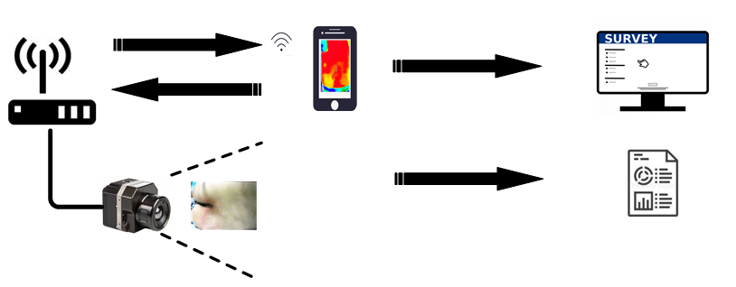
Figure 2
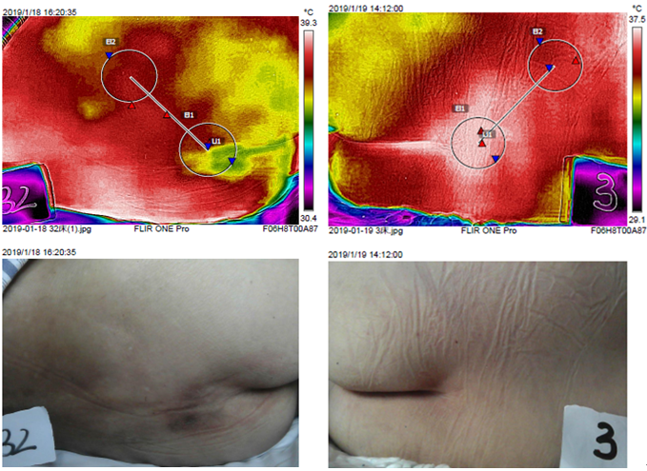

Figure 3
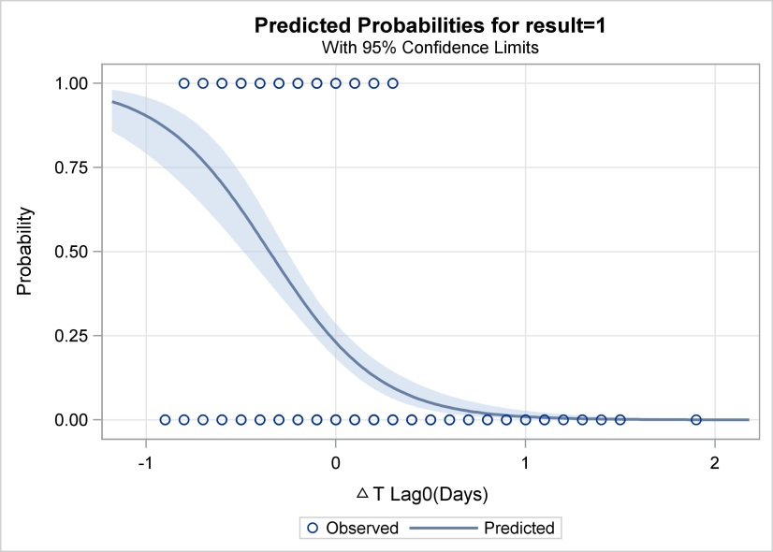
ΔT _{lag 0 (days)}

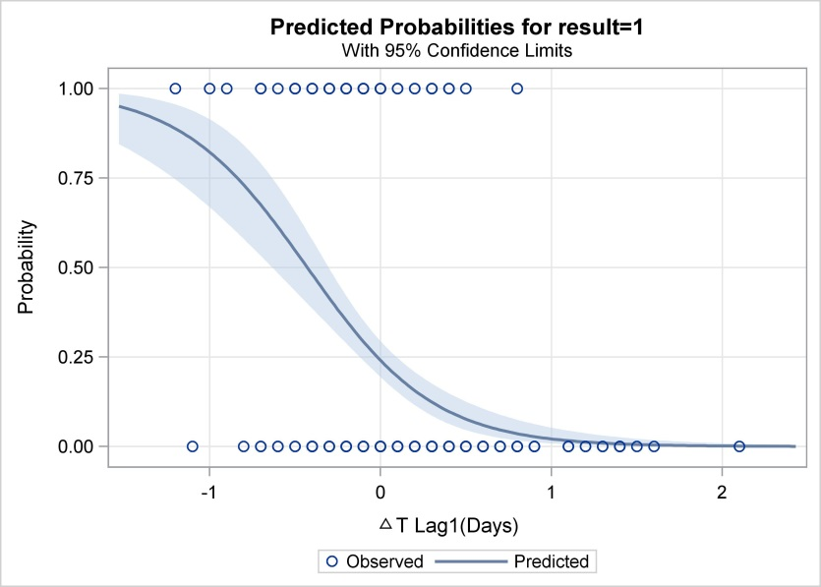
ΔT _{lag 1 (days)}

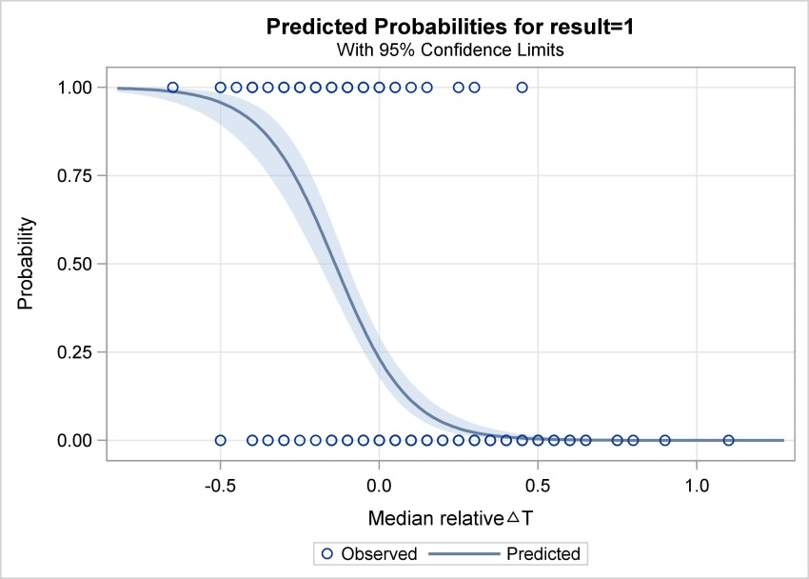
ΔT _{m}

Figure 4
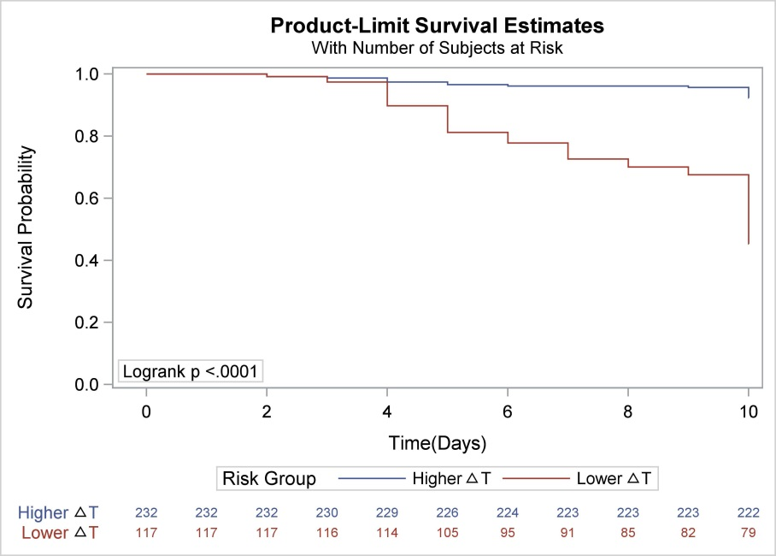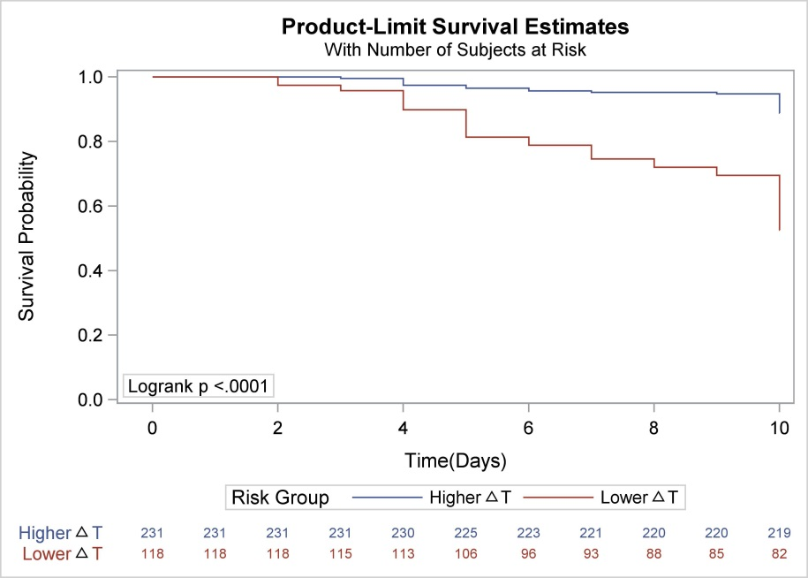
ΔT _{lag 1 (days)}

ΔT _{lag 0 (days)}

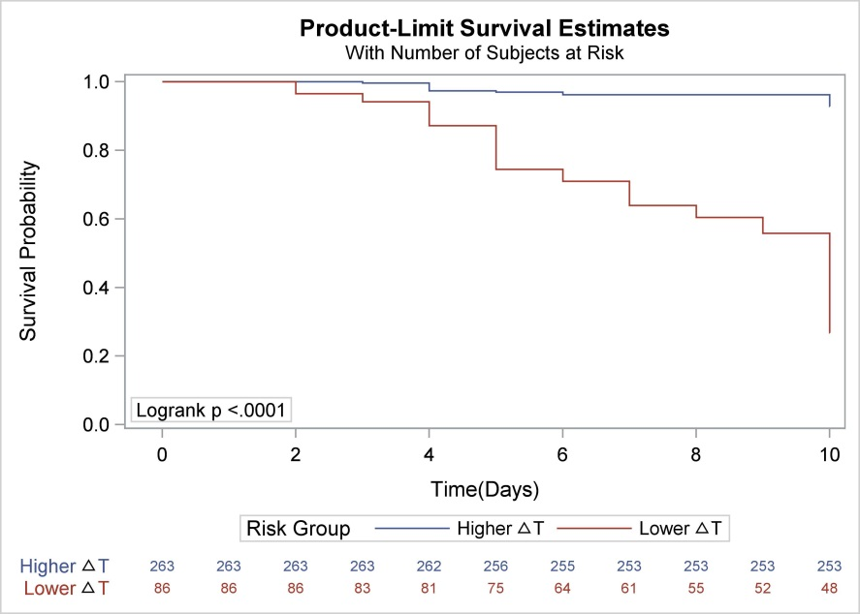
ΔT _{m}

Figure 5
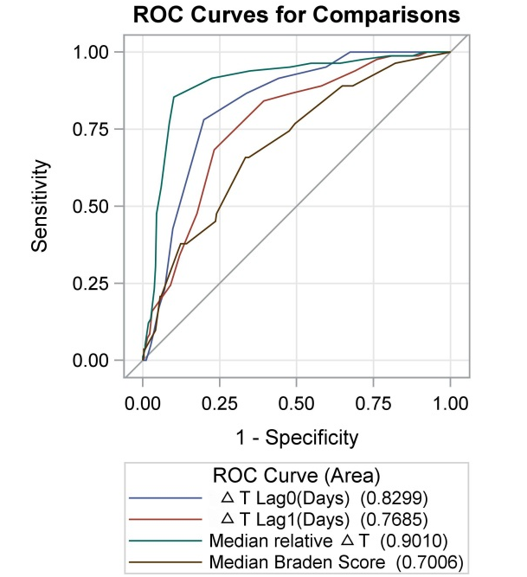
ΔT _{lag 0 (days)} (0.8299)
ΔT _{lag 1 (days)} (0.7685)
ΔT _{m} (0.9010)
B _{m} (0.7006)

