Piperaquine pharmacokinetics during intermittent preventive treatment for malaria in pregnancy

Running title: Piperaquine accumulation during pregnancy

Palang Chotsiri¹, Julie R. Gutman², Rukhsana Ahmed^{3,4}, Jeanne Rini Poespoprodjo^{5,6,7}, Din Syafruddin⁴, Carole Khairallah³, Puji BS Asih⁴, Anne L’lanziva⁸, Kephas Otieno⁹, Simon Kariuki⁹, Peter Ouma⁹, Vincent Were⁹, Abraham Katana¹⁰, Ric N. Price^{1,11,12}, Meghna Desai², Feiko O. ter Kuile³, Joel Tarning^{1,12*}

Affiliations:
¹ Mahidol-Oxford Tropical Medicine Research Unit, Faculty of Tropical Medicine, Mahidol University, Bangkok, Thailand
² Malaria Branch, Division of Parasitic Diseases and Malaria, Center for Global Health, Centers for Disease Control and Prevention, Atlanta, Georgia, USA
³ Department of Clinical Sciences, Liverpool School of Tropical Medicine, Liverpool, UK
⁴ Malaria and Vector Resistance Laboratory, Eijkman Institute for Molecular Biology, Jakarta, Indonesia
⁵ Mimika District Health Authority, District Government Building, Jl. Cendrawasih, Timika, 99910, Papua, Indonesia.
⁶ Timika Malaria Research Programme, Papuan Health and Community Development Foundation, Jl. SP2-SP5, RSMM Area, Timika, 99910, Papua, Indonesia.
⁷ Centre for Child Health and Department of Child Health, Faculty of Medicine, Public Health and Nursing, Universitas Gadjah Mada, Jl. Kesehatan no 1, Sekip, Yogyakarta, 55284, Indonesia
⁸ Centers for Diseases Control and Prevention (CDC), Kisumu, Kenya
⁹ Kenya Medical Research Institute, Centre for Global Health Research, Kisumu, Kenya
¹⁰ Centers for Diseases Control and Prevention (CDC), Nairobi, Kenya
¹¹ Global and Tropical Health Division, Menzies School of Health Research and Charles Darwin University, Darwin, Northern Territory, Australia.
¹² Centre for Tropical Medicine and Global Health, Nuffield Department of Medicine, Oxford University, Oxford, UK.

*Corresponding author:
Professor Joel Tarning, Mahidol-Oxford Tropical Medicine Research Unit, Faculty of Tropical Medicine, Mahidol University, 420/6 Rajvithi Road, Bangkok 10400, THAILAND.

Phone: 66 22036369.
Fax: 66 23546018.
Email: joel@tropmedres.ac

Abstract
Background: Dihydroartemisinin-piperaquine (DP) is a long-acting artemisinin combination treatment that provides effective chemoprevention and has been proposed as an alternative antimalarial drug for intermittent-preventive therapy in pregnancy (IPTp). Several pharmacokinetic studies have shown that dose adjustment may not be needed for the treatment of malaria in pregnancy with DP. However, there are limited data on the optimal dosing for IPTp.
Objective: This study aimed to evaluate the population pharmacokinetics of piperaquine given as IPTp in pregnant women.
Methods: Pregnant women were enrolled in clinical trials conducted in Kenya and Indonesia and treated with standard 3-day courses of DP, administered in 4-8 weeks intervals from the second trimester until delivery. Pharmacokinetic blood samples were collected for piperaquine drug measurements before each treatment round, time of breakthrough symptomatic malaria, and at delivery. Piperaquine population pharmacokinetic properties were investigated using nonlinear mixed-effects modelling with a prior approach.
Results: In total data from 366 Kenyan and 101 Indonesian women were analysed. The pharmacokinetic properties of piperaquine were adequately described using a flexible transit absorption (n=5) followed by a three-compartment disposition model. Gestational age did not affect the pharmacokinetic parameters of piperaquine. After three rounds of monthly IPTp, 9.45% (95% CI: 1.8-26.5) of pregnant women had trough piperaquine concentrations below the suggested target concentration (10.3 ng/mL). Translational simulations suggest that providing the full treatment dose of DP at monthly intervals provides sufficient protection to prevent malaria infection.
Conclusions: Monthly administration of a DP has the potential to offer optimal prevention of malaria during pregnancy.

ClinicalTrial.gov identifiers: NCT01669941
ISRCTN Registry: ISRCTN34010937

Keywords: Dihydroartemisinin-piperaquine; population pharmacokinetic model; intermittent preventive treatment in pregnancy; non-linear mixed-effects modelling

Introduction
Compared to non-pregnant women, pregnant women are at a higher risk of malaria infection and its adverse effects. Pregnant women infected with Plasmodium falciparum can develop placental malaria, with sequestration of the parasite in the placental vasculature. Placental malaria adversely affects both the mother and the infant, with adverse outcomes including maternal anaemia and death, abortion, stillbirth, preterm delivery, low-birthweight, infant mortality, and poor long-term child development (1). Successful malaria treatment and effective chemoprevention during pregnancy are key factors for improving maternal and child outcomes. The World Health Organization (WHO) recommends intermittent preventive treatment in pregnancy (IPTp) with sulfadoxine-pyrimethamine (SP) be administered at every scheduled visit during the second and third trimester of pregnancy, spaced at least one month apart, to prevent the adverse consequences of malaria in pregnancy. However, there is concern that as P. falciparum resistance to SP increases, IPTp with SP will fail to provide adequate protection.

Dihydroartemisinin-piperaquine (DP) is a highly efficacious and well-tolerated antimalarial. The long half-life of piperaquine provides extended malaria chemoprevention for up to six weeks. This antimalarial combination has therefore been suggested for malaria chemoprevention in several populations, including pregnant women. In Thai adults, a monthly dose of DP demonstrated superior protective efficacy (98% efficacy with 95% CI: 96-99%) compared to dosing every two months (86% efficacy with 95% CI: 81-90%) (2, 3). Similarly, the monthly dosing of DP in school-aged children was more effective than quarterly DP or placebo (4). Seasonal malaria chemoprevention with DP in young children has similar efficacy against malaria compared to SP plus amodiaquine in areas with low parasite resistance to SP (5-7). IPTp using DP was more effective at preventing maternal and placental malaria compared to IPTp using SP (relative risk 0.32, 95% CI: 0.18 to 0.56, p-value < 0.0001) (8-10). One of these trials also compared three versus monthly courses of DP and showed that a monthly DP exposure was associated with fewer malaria infections during pregnancy and reductions in placental parasitaemia (9).

Pharmacokinetic properties in pregnancy may be altered because of several physiological changes, including increased water and fat content, increased renal function, and altered enzymatic expression and degree of plasma protein binding. For example, exposure to artemether, artesunate, chloroquine, dihydroartemisinin, lumefantrine, sulfadoxine, pyrimethamine, atovaquone, proguanil, and cycloguanil are altered during pregnancy (11-16). In contrast, the exposure to quinine and amodiaquine are unaffected by pregnancy (17, 18). Therefore, pharmacokinetic investigation in pregnancy is needed to determine if any alterations exist and to optimise the dosing regimen in pregnant women.

Pharmacokinetic properties of piperaquine as part of case-management (i.e. treatment) of women with malaria have been investigated in several pregnant populations (19-25). Several studies reported unaltered piperaquine exposure (AUC) in pregnant women (19-22), while another study reported that exposure was 40% lower in pregnant women compared to non-pregnant women (23). However, one of these studies (20), reporting similar exposures in pregnant and non-pregnant women, still presented altered pharmacokinetic properties in pregnant women (i.e. matched increase in elimination clearance and relative bioavailability, resulting in unchanged total exposure). While population pharmacokinetics of piperaquine has been extensively evaluated in the treatment of acute malaria in pregnant women (19-23, 26), pharmacokinetic properties of piperaquine in monthly IPTp (i.e. chemoprevention) are largely unreported. One previously published IPTp study reported a 72% higher elimination clearance in pregnant compared to post-partum women, resulting in a substantially lower total exposure to piperaquine (25). An increased elimination clearance of piperaquine in pregnant women, reported both in acute treatment and IPTp would have a substantial impact on the total exposure and trough concentrations achieved with repeated monthly IPTp. A recent study, evaluating piperaquine in IPTp, suggested an optimal piperaquine target concentrations of 10.9 ng/mL and 13.9 ng/mL, associated with 95% and 99% protective efficacy, respectively, against P. falciparum infections during pregnancy (24). The study presented here aimed to describe the population pharmacokinetic properties of piperaquine in pregnant women receiving IPTp with DP.

Methods

Study design
This population pharmacokinetic study included pregnant women from two distinct randomised three-arm clinical trials. Both trials included an intermittent screening and treatment in pregnancy (ISTp) with DP (‘ISTp-DP’) and IPTp with DP (‘IPTp-DP’). In Kenya, the third arm consistent of IPTp with SP and in Indonesia, this was single screening and treatment with DP (SSTp-DP) (8, 27). Both studies included pharmacokinetic sampling in the IPTp-DP and ISTp-DP arms and were included in this population pharmacokinetic analysis. Ethical approval for the Kenyan study was obtained from the Kenya Medical Research Institute and the US Centers for Diseases Control and Prevention. This study was registered with ClinicalTrial.gov, number NCT01669941. Ethical approval for the Indonesian study was obtained from Liverpool School of Tropical Medicine (12.28), Eijkman Institute for Molecular Biology (Project N:57), and Litbangkes, Ministry of Health, Jakarta (LB02.01/5.2/KE059/2013). This clinical trial was registered at the ISRCTN registry, number ISRCTN34010937.

All pregnant women received a three-day fixed oral combination of dihydroartemisinin and piperaquine (Eurartesim, Sigma-Tau, Pomezia, Italy; 40 mg dihydroartemisinin and 320 mg piperaquine tetra-phosphate per tablet), dosed by weight at enrolment according to the manufacturer’s recommendation, approximately once a month in the Indonesian study and 4-6 weeks interval in the Kenya study (8, 27). The first day of administration of each month was supervised, and the date and time of the administrations were recorded and used for the further pharmacokinetic analysis. The consecutive doses were taken unsupervised at home. However, healthcare workers visited all participants at home to confirm adherence to the drug regimen. All confirmed malaria cases in Kenya during the follow-up were treated with artemether-lumefantrine (Coartem®). The confirmed recurrent malaria cases in Indonesia were treated with quinine-clindamycin (10 mg/kg twice daily for 7 days). Their data, after the time of malaria recurrent, were excluded from the pharmacokinetic analysis.

Blood sampling
In Kenya, a baseline venous blood sample was collected from all women prior to antimalarial administration. Trough venous samples (1.5 mL) were collected before each monthly drug administration. An additional venous sample was collected at the time of delivery. All blood samples were centrifuged (2000g for 10 minutes), and plasma samples were stored at -80°C until shipment on dry ice. In Indonesia, capillary samples were collected by finger prick following the same schedule. A drop of blood was collected on filter paper (31ETCHR®, Whatman), the filter paper was dried horizontally (1 hour at 50% humidity) and packed into separate plastic bags with silica gel. The plasma samples from Kenya and dried blood spot samples from Indonesia were transported for drug analysis to the Department of Clinical Pharmacology, Mahidol-Oxford Tropical Medicine Research Unit (MORU), Bangkok, Thailand.

Drug quantification
Piperaquine plasma concentrations were measured using solid-phase extraction followed by liquid chromatography coupled with tandem mass spectrometry according to a previously published method (28). Quality control samples at 4.50, 20.0, and 400 ng/mL were analysed in triplicate within each batch of clinical samples to ensure the accuracy and precision of the assay. The relative standard deviation (%RSD) at low, middle, and high concentration levels were 4.70%, 4.38%, 4.92%. The limit of detection (LOD) and the lower limit of quantification (LLOQ) were set to 0.375 and 1.50 ng/mL, respectively. Piperaquine dry blood spot concentrations were measured using solid-phase extraction following a previously published method with modification (29), followed by liquid chromatography coupled with tandem mass spectrometry (28). Quality control samples at 9.00, 40.0, and 800 ng/mL were analysed in triplicate within each batch of clinical samples to ensure the accuracy and precision of the assay. The relative standard deviation (%RSD) at low, middle, and high concentration levels were 4.36%, 3.33%, 3.94%. The limit of detection (LOD) and the lower limit of quantification (LLOQ) were set to 1 and 3 ng/mL, respectively. The laboratory where testing occurred is a participant in the quality assurance/quality control (QA/QC) proficiency testing programme supported by the Worldwide Antimalarial Resistance Network (WWARN) (30).

Population pharmacokinetic analysis
Observed piperaquine concentrations were logarithmic transformed and analysed using non-linear mixed-effects modelling using NONMEM version 7.4 (Icon Development Solution, Ellicott City, MD). Pirana version 2.9.0 (31), Perl-speaks-NONMEM version 4.7.0 (PsN) (32), and R version 3.4.4 were used for automation, model evaluation, and diagnostics during the model building process. The first-order conditional estimation method with interactions (FOCE-I) was used throughout the population pharmacokinetic analysis. The proportion of measured drug concentration below the LLOQ was low (2.47% in total) and therefore omitted from further pharmacokinetic analysis. The $PRIOR functionality in NONMEM was used to stabilise the model performance. A previously published population pharmacokinetic model, describing DP in the treatment of uncomplicated falciparum malaria in pregnant women in Thailand, was used as the prior model (20). The structural model of piperaquine included five-transit absorption compartments followed by a three-compartment disposition model. Final population pharmacokinetic parameter estimates, between-patient variability estimates, and between-occasion variability estimates with their uncertainties were implemented as priors.

Pharmacokinetic parameters were assumed to be log-normally distributed and therefore implemented as an exponential between-patient and between-occasion variabilities as follows:
$$Θ_{ij}=Θ×\exp\left(η_{i, Θ}+κ_{ij, Θ}\right)$$
where $Θ_{ij}$ is the pharmacokinetic parameter estimate for the $i$^{th} patient at the $j^{th}$ occasion, $Θ$ is the typical pharmacokinetic parameter estimate of the population, $η_{i, Θ}$ is the between-patient variability of parameter $Θ$ in the $i$^{th} patient, and $κ_{ij, Θ}$ is the between-occasion variability of parameter $Θ$ in the $i^{th}$ patient at the $j^{th}$ occasion. Both between-patient variability and between-occasion variability were assumed to be normally distributed with a zero mean and $ω^{2}$ variance. Estimated between-patient variability below 10% or variability estimated with poor precision (%RSE > 50%) were fixed to zero. Residual unexplained variability was modelled as an additive error on the log-transformed observed concentrations, which is essentially equivalent to a proportional error on an arithmetic scale.

Individual body-weight (${BW}_{i}$) was measured at enrolment only and introduced into the pharmacokinetic model as a fixed allometric function on all volume (exponent of $n=1.00$) and clearance (exponent of $n=0.75$) parameters, scaled to the median body weight (48.5 kg) of the prior study population as follows:
$$Θ_{i}=Θ×\exp\left(η_{i, Θ}+κ_{ij, Θ}\right)×{\left(\frac{{BW}_{i}}{48.5}\right)}^{n}$$
The population conversion factor (CF) between venous plasma concentrations and capillary blood concentration was estimated without between-patient variability. All other covariates (corrected gestational age, maternal age, and sex) were investigated by a stepwise addition (p < 0.05) and elimination (p < 0.001) approach. The corrected gestational age was implemented as a time-varying covariate. The effect of gestational age was also modelled separately using a full covariate approach in which the gestational age was implemented as a continuous covariate on all pharmacokinetic parameters in the final pharmacokinetic model. Secondary pharmacokinetic parameter estimates were derived from the post hoc pharmacokinetic parameter estimates of the final pharmacokinetic model.

Model diagnostics and evaluations
Model fitness was evaluated primarily by the objective function value (OFV; calculated by NONMEM as proportional to -2×log-likelihood of the data). Model discrimination between two hierarchical models was determined by a likelihood ratio test, based on the Chi-square distribution of the OFV (i.e. p-value < 0.05 then ΔOFV > 3.84, at 1 degree of freedom difference). Potential model misspecification and systematic errors were evaluated by basic goodness-of-fit diagnostics. Eta and epsilon shrinkages were used to assess the ability to detect model misspecifications in goodness-of-fit diagnostics (33). Model robustness and parameter confidence intervals were evaluated by a sampling-important-resampling (SIR) procedure (34, 35). Predictive performances of the final models were illustrated by prediction corrected visual and numerical predictive checks (n = 2,000) (36). The 5th, 50th, and 95th percentiles of the observed concentrations were overlaid with the 95% confidence intervals of each simulated percentile to detect model bias.

Translational simulations
The final population pharmacokinetic model was used to simulate a population pharmacokinetic profile of monthly piperaquine IPTp in 1,000 pregnant women in 1,000 hypothetical clinical trials. The previously suggested target piperaquine concentration of 10.3 ng/mL, which provided 95% protection from P. falciparum infection during pregnancy in a previous IPTp study in Uganda (24), was considered the pharmacokinetic outcome target. The proportion of pregnant women with trough piperaquine plasma concentrations below/above the target concentrations were simulated at each of the monthly doses.

Results
The main results of these two clinical trials have been published previously (8, 27). Part of the IPTp arm from these two clinical trials provided pharmacokinetic samples, including 366 Kenyan pregnant women and 101 Indonesian pregnant women. Full demographic characteristics are presented in Table 1.

Pharmacokinetic properties of piperaquine
The population pharmacokinetic properties of piperaquine were described successfully using a prior approach with a model developed previously (20). The final model showed satisfactory goodness of fit (Figure 1) and predictive performance, as illustrated by the visual predictive check (Figure 2). High eta shrinkages were seen in the final model (i.e. more than 30%) because of the sparseness of the observations, but the epsilon shrinkage was low (20.0% for plasma samples and 22.1% for DBS samples). Allometrically scaled body weight was implemented into the pharmacokinetic model, according to the prior model (20). Pregnancy-related parameters (corrected gestational age as a time-varying covariate) or other admission covariates did not exhibit a significant impact on the pharmacokinetic parameters of piperaquine in this study. Final pharmacokinetic parameter estimates are summarized in Table 2 and secondary pharmacokinetic parameters are summarized in Table 3. Piperaquine peak concentrations (C_{MAX}) of the Kenyan and Indonesian pregnant women were predicted to be 212 ng/mL (95% CI: 144 – 319 ng/mL), and 232 ng/mL (95% CI: 108-396 ng/mL), respectively. Observed trough piperaquine concentrations accumulated substantially with repeated monthly IPTp, but predicted peak concentrations remained similar during the entire duration of IPTp (Figure 3).

Implication on placental malaria
Placental malaria during delivery was assessed by either rapid diagnostic test, blood smear, placental blood PCR, or placental tissue histology, and detected in 3.3% (3/92) of Indonesian women and 31.7% (112/353) of Kenyan women (Table1). However, 27.7% (97/350) of placental malaria infections in Kenyan women were past infections (i.e. malaria pigment present, but no malaria parasites visible). Only 0.9% (3/350) and 1.14% (4/350) of Kenyan woman presented with an acute and chronic infection, respectively. Therefore, the small number of observed active placental malaria was not sufficient to undertake statistical analysis or pharmacodynamic modelling. Translational simulations of the final pharmacokinetic model were conducted to illustrate the possibility of patients having sub-therapeutic concentrations (Figure 4). Based on the reported target trough piperaquine concentrations of 10.3 ng/mL to prevent P. falciparum infection during pregnancy (24), simulations predicted that approximately 35.1% (95% CI: 9.66% to 66.4%), 13.0% (95% CI: 2.29% to 33.5%), and 9.45% (95% CI: 1.80% to 26.5%) of individuals had trough concentrations below the target concentration after the first, second, and third round of IPTp, respectively. The piperaquine plasma concentrations became sub-therapeutic within one week prior to the next IPTp dose, hence new infections acquired within this window are unlikely to develop into a clinical symptom since there is insufficient time for the malaria parasites to replicate to the level of symptomatic parasitaemia (approximately 10⁸ parasite biomass) before the subsequent IPTp dose if taken monthly (Figure 4).

Discussion
Our analysis highlights that a standard three-day treatment course of DP, provided monthly as IPTp, appears to provide sufficient protection from malaria infection in pregnant women. This finding was apparent in both Kenya and Indonesia with only 7 of 350 pregnancies presenting with placental malaria infection at delivery. An estimated 90.6% (95% CI: 73.5-98.2%) of women are likely to maintain piperaquine trough concentrations above 10.3 ng/mL and 66.8% (95% CI: 64.0-70.5%) above 13.9 ng/mL, concentration thresholds previously found to be associated with 95% and 99% malaria protection after three rounds of DP dose, respectively (24). However, these therapeutic target concentrations might need to be substantially higher in areas of emerging drug resistance to DP due to reduced drug susceptibility (37, 38).

Even though our analysis utilised samples collected from two studies and almost 500 recruited pregnant women (>1,500 samples), most samples were collected close to trough concentrations resulting in insufficient data to develop a robust absorption and distribution model of piperaquine. Piperaquine pharmacokinetics are normally described using a multi-phasic disposition model and a transit-compartment absorption (20, 22, 24, 25, 39-41). To overcome this limitation, we applied a frequentist prior approach from a pharmacokinetic study of piperaquine in Thai pregnant women with a rich sampling design (20). The final estimates of absorption parameters (MTT and inter-occasion variabilities on MTT and F) relied heavily on the prior model, resulting in estimated 95% confidence intervals including the prior estimates. On the other hand, the clinical trial data was informative in determining the elimination clearance and predicting the trough concentrations in this study, resulting in a significantly different clearance in this study compared to the prior study (i.e. the 95% confidence interval of the parameter estimate did not include the prior value).

This study did not recruit non-pregnant patients and therefore it was not possible to determine if overall pregnancy had an effect on the pharmacokinetic properties of piperaquine. The potential effects of pregnancy on the pharmacokinetic properties of piperaquine is still unclear. Several previous studies have shown that pregnancy has no effect on the pharmacokinetic properties of piperaquine (19, 22). However, one study showed that pregnant patients showed 45% higher clearance and 47% lower absorption compared with non-pregnant women, resulting in similar drug exposures in two groups (20). A non-compartmental pharmacokinetic study in Sudanese pregnant and non-pregnant patients reported a significantly higher piperaquine exposure in pregnant women after the first dose, but the total piperaquine exposure was not different between the two groups (21). A recent IPTp study showed that pregnant women had a substantially lower exposure to piperaquine compared to post-partum women (i.e. 72% higher clearance) (25). HIV-infected pregnant women on efavirenz based-antiretroviral treatment and pregnant women with low body-mass index in the study also had altered pharmacokinetic properties of piperaquine. Furthermore, we saw no statistically significant effect of gestational age on pharmacokinetic parameters when it was evaluated as a time-varying covariate in these pregnant patients. This finding was supported by a previous published study reporting no difference in the elimination clearance between the second and third trimester (22). This suggests that the same dose regimen could be maintained for the whole duration of IPTp. Pharmacokinetic parameters were also scaled allometrically by bodyweight based on the strong biological prior of such a covariate and the reported literature supporting this relationship (20, 22, 39, 41, 42). Other baseline covariates had no significant impact on any piperaquine pharmacokinetic parameters and were not retained in the final model. The final pharmacokinetic parameter estimates are in agreement with previous pharmacokinetic studies (39, 42).

Venous plasma concentrations from the Kenyan pregnant women and the capillary dried blood spot concentrations from the Indonesian pregnant women were modelled simultaneously using a population conversion factor. Since the different study sites provided different samples (venous plasma versus capillary dry blood spots), the population estimates of the conversion factor between capillary dry blood spot concentrations and venous plasma concentrations might be interpreted as a combination of sampling differences, ethnicity differences and other unknown site-specific differences. However, previously published results have not shown any evidence of clinically important ethnic differences associated with the pharmacokinetic properties of the nine antimalarial drugs used in the standard ACT regimens recommended by WHO (43). Furthermore, the estimated conversion factor was in agreement with previous estimates from studies with both plasma and capillary measurements in each patient (5, 42).

Piperaquine samples were not collected at the time of peak concentrations in this study. Thus, the estimated peak piperaquine concentrations were influenced mainly by the prior model (i.e. the prior estimates of the absorption parameters). Peak piperaquine concentrations were estimated to be approximately 17-fold higher than trough concentrations. Therefore, remaining piperaquine concentrations at the end of the monthly round, associated with accumulation of piperaquine trough concentrations, had a very minor impact on the peak piperaquine concentrations due to the relatively small contribution to total peak concentrations (Figure 3C and 3D). Piperaquine is associated with concentration-dependent QTc prolongation, resulting in the greatest risk of QTc prolongation during peak concentrations, that occur approximately 4-6 hours after the third dose of DP during each course of treatment (39, 44, 45). However, ECG was performed in a small subset of pregnant patients (n = 33) in Indonesia and did not show any increase in absolute QTc or QTc prolongation with repeated cycles of monthly DP dosing (27). This supports further the modelling results showing no substantial accumulation in estimated peak piperaquine concentrations with repeated monthly dosing of DP. Even so, a pharmacokinetic-electrocardiographic study of IPTp-DP in pregnant women is needed to evaluate the cardiac safety of piperaquine.

Monthly dosing of DP provides better protection against malaria than less frequent dosing (2, 3, 24, 46). None of the Indonesian patients presented with active placental malaria at delivery and only 7 out of 350 Kenyan pregnant women who received DP at 4 to 6-week intervals presented active placental malaria. Due to the small number of women with placental malaria, we were unable to determine an exposure-response relationship directly. Thus, we relied on translational simulations to determine the success of the pharmacokinetic outcome. Using a suggested target venous plasma PQ concentration of 10.3 ng/mL, associated with 95% protection of P. falciparum infection (24), approximately 90.6% (95% CI: 73.5-98.2%), 91.3% (95% CI: 75.2-98.0%), and 90.8% (95% CI: 77.2-97.8%) of pregnant women reached the target trough concentration after three, four, and five rounds of monthly dosing, respectively. However, in the women that did not achieve the target trough concentration, the piperaquine concentrations dropped below this target level only just before the next monthly IPTp dose, suggesting that P. falciparum infections acquired during this period would have been treated with the subsequent round of DP. Thus, monthly IPTp dosing of DP was concluded to be appropriate for pregnant women living in malaria-endemic areas. Dosing adjustment in pregnant women in the first round of IPTp would be desirable in order to maintain trough concentrations above the target level. However, several arguments indicate that changing DP dosing in the first round of IPTp might be impractical. An increased DP dose during the first round of IPTp would generate a proportional increase in peak concentrations, which could result in safety concerns (i.e. QTc-prolongation). An altered administration schedule during the first round of IPTp might lead to poor drug adherence. The most important aspect of preventive treatment is adherence, and pregnant women are scheduled to visit the ANC clinic on a monthly basis. The monthly dosing regimen is the most practical way to administer these preventive treatments and is likely to result in high efficacy when taken as instructed. Thus, adherence to the full three-day course of DP is the main concern, and missing the any of the home-administered doses (2nd and/or 3rd dose) will result in sub-therapeutic piperaquine concentrations for a substantial duration of time before the next round of IPT dosing.

This study has several limitations. IPTp is recommended for pregnant women during the 2nd and 3rd trimesters (47). Pregnant women in this pregnancy-period have major physiological differences compared to non-pregnant women and women in the first trimester of pregnancy. All participants in this study were in their 2nd and 3rd trimester of pregnancy. Thus, this study had limited power to detect possible effects of gestational age on the pharmacokinetic properties of piperaquine, and no possibility to detect possible differences between pregnant and non-pregnant women. Different types of sampling methodologies were applied in the two study sites (i.e. venous plasma vs. dried capillary blood on filter paper). Therefore, the conversion between venous and capillary concentrations could not be estimated within a patient, and we cannot exclude that the population-estimated conversion factor includes several confounding study-specific effects (e.g. matrix effects, ethnic differences, demographic study differences, and/or unknown study differences). Only piperaquine trough concentrations were sampled in this study. Therefore, the final pharmacokinetic model structure and its parameter estimates relied heavily on the prior model and the observations during the elimination phase. Especially absorption and early distribution parameter estimates in the final model, where the observations were limited, were very much influenced by the prior model. However, piperaquine trough concentration is the main determinant of successful preventive treatment, and therefore the main clinical interest in this study.

Conclusions
In conclusion, the population pharmacokinetic properties of piperaquine were successfully evaluated in pregnant women receiving IPTp. Five transit-compartments followed by a three-compartment disposition model described the pharmacokinetic properties of piperaquine adequately. Gestational age and other baseline covariates had no significant effect on the pharmacokinetic properties of piperaquine. Modelling and simulation suggested that more than 90.3% of pregnant women who receive three monthly courses of IPTp achieved piperaquine exposures associated with protection against acquired malaria infections. Predicted peak concentrations did not accumulate with repeated dosing courses, suggesting that IPTp with DP is not likely to increase the risk for QT-prolongation associated with piperaquine exposure but further cardiac safety data is still needed. The PK/PD analysis presented here suggested that monthly IPTp with DP is likely to be highly protective against placental malaria.

Disclaimer
The findings and conclusions in this publication are those of the authors and do not necessarily represent the views of the US Centers for Disease Control and Prevention or the US Department of Health and Human Services.

Acknowledgements
The authors would like to thank all the participants, investigators, and the trial site staff who were involved in the conduct of this study.

Compliance with Ethical Standards

Funding: This study was a part of the Wellcome Trust-Mahidol University-Oxford Tropical Medicine Research Program supports by the Wellcome Trust of Great Britain. Part of this work was supported by the Bill and Melinda Gates Foundation (INV-006052). The Indonesian study was funded by the Joint Global Health Trials Scheme of the Medical Research Council, UK, Department for International Development and Wellcome. The Kenya study was funded by the Malaria in Pregnancy Consortium, through a grant from the Bill & Melinda Gates Foundation to the Liverpool School of Tropical Medicine. Co-Funding for the data curation and archiving and data analysis was provided by The World-Wide Antimalarial Resistance Network (WWARN) which are funded through a grant from the Bill and Melinda Gates Foundation to the University of Oxford. The funding bodies did not have any role in the collection, analysis, interpretation of data, writing of the manuscript, or in the decision to submit the manuscript for publication.

Conflict of interest: All authors declare no conflict of interest.

Ethical approval: All procedures performed in studies involving human participants were in accordance with the ethical standards of the institutional and/or national research committee and with the 1964 Helsinki declaration and its later amendments or comparable ethical standards. Written informed consent was obtained from all participants.

Informed consent: Written informed consent was obtained from all participants included in the study.

References
1. Desai M, ter Kuile FO, Nosten F, McGready R, Asamoa K, Brabin B, Newman RD. 2007. Epidemiology and burden of malaria in pregnancy. Lancet Infect Dis 7:93-104.
2. Lwin KM, Phyo AP, Tarning J, Hanpithakpong W, Ashley EA, Lee SJ, Cheah P, Singhasivanon P, White NJ, Lindegardh N, Nosten F. 2012. Randomized, double-blind, placebo-controlled trial of monthly versus bimonthly dihydroartemisinin-piperaquine chemoprevention in adults at high risk of malaria. Antimicrob Agents Chemother 56:1571-7.
3. Bergstrand M, Nosten F, Lwin KM, Karlsson MO, White NJ, Tarning J. 2014. Characterization of an in vivo concentration-effect relationship for piperaquine in malaria chemoprevention. Sci Transl Med 6:260ra147.
4. Nankabirwa JI, Wandera B, Amuge P, Kiwanuka N, Dorsey G, Rosenthal PJ, Brooker SJ, Staedke SG, Kamya MR. 2014. Impact of intermittent preventive treatment with dihydroartemisinin-piperaquine on malaria in Ugandan schoolchildren: a randomized, placebo-controlled trial. Clin Infect Dis 58:1404-12.
5. Chotsiri P, Zongo I, Milligan P, Compaore YD, Somé AF, Chandramohan D, Hanpithakpong W, Nosten F, Greenwood B, Rosenthal PJ, White NJ, Ouédraogo J-B, Tarning J. 2019. Optimal dosing of dihydroartemisinin-piperaquine for seasonal malaria chemoprevention in young children. Nature Communications 10:480.
6. Zongo I, Milligan P, Compaore YD, Some AF, Greenwood B, Tarning J, Rosenthal PJ, Sutherland C, Nosten F, Ouedraogo JB. 2015. Randomized Noninferiority Trial of Dihydroartemisinin-Piperaquine Compared with Sulfadoxine-Pyrimethamine plus Amodiaquine for Seasonal Malaria Chemoprevention in Burkina Faso. Antimicrob Agents Chemother 59:4387-96.
7. von Seidlein L, Olaosebikan R, Hendriksen IC, Lee SJ, Adedoyin OT, Agbenyega T, Nguah SB, Bojang K, Deen JL, Evans J, Fanello CI, Gomes E, Pedro AJ, Kahabuka C, Karema C, Kivaya E, Maitland K, Mokuolu OA, Mtove G, Mwanga-Amumpaire J, Nadjm B, Nansumba M, Ngum WP, Onyamboko MA, Reyburn H, Sakulthaew T, Silamut K, Tshefu AK, Umulisa N, Gesase S, Day NP, White NJ, Dondorp AM. 2012. Predicting the clinical outcome of severe falciparum malaria in african children: findings from a large randomized trial. Clin Infect Dis 54:1080-90.
8. Desai M, Gutman J, L'Lanziva A, Otieno K, Juma E, Kariuki S, Ouma P, Were V, Laserson K, Katana A, Williamson J, ter Kuile FO. 2015. Intermittent screening and treatment or intermittent preventive treatment with dihydroartemisinin-piperaquine versus intermittent preventive treatment with sulfadoxine-pyrimethamine for the control of malaria during pregnancy in western Kenya: an open-label, three-group, randomised controlled superiority trial. Lancet 386:2507-19.
9. Kakuru A, Jagannathan P, Muhindo MK, Natureeba P, Awori P, Nakalembe M, Opira B, Olwoch P, Ategeka J, Nayebare P, Clark TD, Feeney ME, Charlebois ED, Rizzuto G, Muehlenbachs A, Havlir DV, Kamya MR, Dorsey G. 2016. Dihydroartemisinin-Piperaquine for the Prevention of Malaria in Pregnancy. N Engl J Med 374:928-39.
10. Kajubi R, Ochieng T, Kakuru A, Jagannathan P, Nakalembe M, Ruel T, Opira B, Ochokoru H, Ategeka J, Nayebare P, Clark TD, Havlir DV, Kamya MR, Dorsey G. 2019. Monthly sulfadoxine-pyrimethamine versus dihydroartemisinin-piperaquine for intermittent preventive treatment of malaria in pregnancy: a double-blind, randomised, controlled, superiority trial. Lancet 393:1428-1439.
11. Nyunt MM, Adam I, Kayentao K, van Dijk J, Thuma P, Mauff K, Little F, Cassam Y, Guirou E, Traore B, Doumbo O, Sullivan D, Smith P, Barnes KI. 2010. Pharmacokinetics of sulfadoxine and pyrimethamine in intermittent preventive treatment of malaria in pregnancy. Clin Pharmacol Ther 87:226-34.
12. McGready R, Phyo AP, Rijken MJ, Tarning J, Lindegardh N, Hanpithakpon W, Than HH, Hlaing N, Zin NT, Singhasivanon P, White NJ, Nosten F. 2012. Artesunate/dihydroartemisinin pharmacokinetics in acute falciparum malaria in pregnancy: absorption, bioavailability, disposition and disease effects. Br J Clin Pharmacol 73:467-77.
13. McGready R, Stepniewska K, Edstein MD, Cho T, Gilveray G, Looareesuwan S, White NJ, Nosten F. 2003. The pharmacokinetics of atovaquone and proguanil in pregnant women with acute falciparum malaria. Eur J Clin Pharmacol 59:545-52.
14. Tarning J, McGready R, Lindegardh N, Ashley EA, Pimanpanarak M, Kamanikom B, Annerberg A, Day NP, Stepniewska K, Singhasivanon P, White NJ, Nosten F. 2009. Population pharmacokinetics of lumefantrine in pregnant women treated with artemether-lumefantrine for uncomplicated Plasmodium falciparum malaria. Antimicrob Agents Chemother 53:3837-46.
15. Karunajeewa HA, Salman S, Mueller I, Baiwog F, Gomorrai S, Law I, Page-Sharp M, Rogerson S, Siba P, Ilett KF, Davis TM. 2010. Pharmacokinetics of chloroquine and monodesethylchloroquine in pregnancy. Antimicrob Agents Chemother 54:1186-92.
16. Kloprogge F, McGready R, Phyo AP, Rijken MJ, Hanpithakpon W, Than HH, Hlaing N, Zin NT, Day NP, White NJ, Nosten F, Tarning J. 2015. Opposite malaria and pregnancy effect on oral bioavailability of artesunate - a population pharmacokinetic evaluation. Br J Clin Pharmacol 80:642-53.
17. Tarning J, Chotsiri P, Jullien V, Rijken MJ, Bergstrand M, Cammas M, McGready R, Singhasivanon P, Day NP, White NJ, Nosten F, Lindegardh N. 2012. Population pharmacokinetic and pharmacodynamic modeling of amodiaquine and desethylamodiaquine in women with Plasmodium vivax malaria during and after pregnancy. Antimicrob Agents Chemother 56:5764-73.
18. Kloprogge F, Jullien V, Piola P, Dhorda M, Muwanga S, Nosten F, Day NP, White NJ, Guerin PJ, Tarning J. 2014. Population pharmacokinetics of quinine in pregnant women with uncomplicated Plasmodium falciparum malaria in Uganda. J Antimicrob Chemother 69:3033-40.
19. Rijken MJ, McGready R, Phyo AP, Lindegardh N, Tarning J, Laochan N, Than HH, Mu O, Win AK, Singhasivanon P, White N, Nosten F. 2011. Pharmacokinetics of dihydroartemisinin and piperaquine in pregnant and nonpregnant women with uncomplicated falciparum malaria. Antimicrob Agents Chemother 55:5500-6.
20. Tarning J, Rijken MJ, McGready R, Phyo AP, Hanpithakpong W, Day NP, White NJ, Nosten F, Lindegardh N. 2012. Population pharmacokinetics of dihydroartemisinin and piperaquine in pregnant and nonpregnant women with uncomplicated malaria. Antimicrob Agents Chemother 56:1997-2007.
21. Adam I, Tarning J, Lindegardh N, Mahgoub H, McGready R, Nosten F. 2012. Pharmacokinetics of piperaquine in pregnant women in Sudan with uncomplicated Plasmodium falciparum malaria. Am J Trop Med Hyg 87:35-40.
22. Hoglund RM, Adam I, Hanpithakpong W, Ashton M, Lindegardh N, Day NP, White NJ, Nosten F, Tarning J. 2012. A population pharmacokinetic model of piperaquine in pregnant and non-pregnant women with uncomplicated Plasmodium falciparum malaria in Sudan. Malar J 11:398.
23. Kajubi R, Huang L, Jagannathan P, Chamankhah N, Were M, Ruel T, Koss CA, Kakuru A, Mwebaza N, Kamya M, Havlir D, Dorsey G, Rosenthal PJ, Aweeka FT. 2017. Antiretroviral Therapy With Efavirenz Accentuates Pregnancy-Associated Reduction of Dihydroartemisinin-Piperaquine Exposure During Malaria Chemoprevention. Clin Pharmacol Ther 102:520-528.
24. Savic RM, Jagannathan P, Kajubi R, Huang L, Zhang N, Were M, Kakuru A, Muhindo MK, Mwebaza N, Wallender E, Clark TD, Opira B, Kamya M, Havlir DV, Rosenthal PJ, Dorsey G, Aweeka FT. 2018. Intermittent Preventive Treatment for Malaria in Pregnancy: Optimization of Target Concentrations of Dihydroartemisinin-Piperaquine. Clin Infect Dis 67:1079-1088.
25. Hughes E, Imperial M, Wallender E, Kajubi R, Huang L, Jagannathan P, Zhang N, Kakuru A, Natureeba P, Mwima MW, Muhindo M, Mwebaza N, Clark TD, Opira B, Nakalembe M, Havlir D, Kamya M, Rosenthal PJ, Dorsey G, Aweeka F, Savic RM. 2020. Piperaquine exposure is altered by pregnancy, HIV and nutritional status in Ugandan women. Antimicrob Agents Chemother doi:10.1128/AAC.01013-20.
26. Benjamin JM, Moore BR, Salman S, Page-Sharp M, Tawat S, Yadi G, Lorry L, Siba PM, Batty KT, Robinson LJ, Mueller I, Davis TM. 2015. Population pharmacokinetics, tolerability, and safety of dihydroartemisinin-piperaquine and sulfadoxine-pyrimethamine-piperaquine in pregnant and nonpregnant Papua New Guinean women. Antimicrob Agents Chemother 59:4260-71.
27. Ahmed R, Poespoprodjo JR, Syafruddin D, Khairallah C, Pace C, Lukito T, Maratina SS, Asih PBS, Santana-Morales MA, Adams ER, Unwin VT, Williams CT, Chen T, Smedley J, Wang D, Faragher B, Price RN, Ter Kuile FO. 2019. Efficacy and safety of intermittent preventive treatment and intermittent screening and treatment versus single screening and treatment with dihydroartemisinin-piperaquine for the control of malaria in pregnancy in Indonesia: a cluster-randomised, open-label, superiority trial. Lancet Infect Dis doi:10.1016/S1473-3099(19)30156-2.
28. Lindegardh N, Annerberg A, White NJ, Day NP. 2008. Development and validation of a liquid chromatographic-tandem mass spectrometric method for determination of piperaquine in plasma stable isotope labeled internal standard does not always compensate for matrix effects. J Chromatogr B Analyt Technol Biomed Life Sci 862:227-36.
29. Malm M, Lindegardh N, Bergqvist Y. 2004. Automated solid-phase extraction method for the determination of piperaquine in capillary blood applied onto sampling paper by liquid chromatography. J Chromatogr B Analyt Technol Biomed Life Sci 809:43-9.
30. Lourens C, Lindegardh N, Barnes KI, Guerin PJ, Sibley CH, White NJ, Tarning J. 2014. Benefits of a pharmacology antimalarial reference standard and proficiency testing program provided by the Worldwide Antimalarial Resistance Network (WWARN). Antimicrob Agents Chemother 58:3889-94.
31. Keizer RJ, van Benten M, Beijnen JH, Schellens JH, Huitema AD. 2011. Pirana and PCluster: a modeling environment and cluster infrastructure for NONMEM. Comput Methods Programs Biomed 101:72-9.
32. Lindbom L, Ribbing J, Jonsson EN. 2004. Perl-speaks-NONMEM (PsN)--a Perl module for NONMEM related programming. Comput Methods Programs Biomed 75:85-94.
33. Savic RM, Karlsson MO. 2009. Importance of shrinkage in empirical bayes estimates for diagnostics: problems and solutions. AAPS J 11:558-69.
34. Dosne AG, Bergstrand M, Harling K, Karlsson MO. 2016. Improving the estimation of parameter uncertainty distributions in nonlinear mixed effects models using sampling importance resampling. J Pharmacokinet Pharmacodyn 43:583-596.
35. Dosne AG, Bergstrand M, Karlsson MO. 2017. An automated sampling importance resampling procedure for estimating parameter uncertainty. J Pharmacokinet Pharmacodyn 44:509-520.
36. Bergstrand M, Hooker AC, Wallin JE, Karlsson MO. 2011. Prediction-corrected visual predictive checks for diagnosing nonlinear mixed-effects models. AAPS J 13:143-51.
37. Amaratunga C, Lim P, Suon S, Sreng S, Mao S, Sopha C, Sam B, Dek D, Try V, Amato R, Blessborn D, Song L, Tullo GS, Fay MP, Anderson JM, Tarning J, Fairhurst RM. 2016. Dihydroartemisinin-piperaquine resistance in Plasmodium falciparum malaria in Cambodia: a multisite prospective cohort study. Lancet Infect Dis 16:357-65.
38. van der Pluijm RW, Imwong M, Chau NH, Hoa NT, Thuy-Nhien NT, Thanh NV, Jittamala P, Hanboonkunupakarn B, Chutasmit K, Saelow C, Runjarern R, Kaewmok W, Tripura R, Peto TJ, Yok S, Suon S, Sreng S, Mao S, Oun S, Yen S, Amaratunga C, Lek D, Huy R, Dhorda M, Chotivanich K, Ashley EA, Mukaka M, Waithira N, Cheah PY, Maude RJ, Amato R, Pearson RD, Goncalves S, Jacob CG, Hamilton WL, Fairhurst RM, Tarning J, Winterberg M, Kwiatkowski DP, Pukrittayakamee S, Hien TT, Day NP, Miotto O, White NJ, Dondorp AM. 2019. Determinants of dihydroartemisinin-piperaquine treatment failure in Plasmodium falciparum malaria in Cambodia, Thailand, and Vietnam: a prospective clinical, pharmacological, and genetic study. Lancet Infect Dis 19:952-961.
39. Chotsiri P, Wattanakul T, Hoglund RM, Hanboonkunupakarn B, Pukrittayakamee S, Blessborn D, Jittamala P, White NJ, Day NPJ, Tarning J. 2017. Population pharmacokinetics and electrocardiographic effects of dihydroartemisinin-piperaquine in healthy volunteers. Br J Clin Pharmacol 83:2752-2766.
40. Tarning J, Ashley EA, Lindegardh N, Stepniewska K, Phaiphun L, Day NP, McGready R, Ashton M, Nosten F, White NJ. 2008. Population pharmacokinetics of piperaquine after two different treatment regimens with dihydroartemisinin-piperaquine in patients with Plasmodium falciparum malaria in Thailand. Antimicrob Agents Chemother 52:1052-61.
41. Hoglund RM, Workman L, Edstein MD, Thanh NX, Quang NN, Zongo I, Ouedraogo JB, Borrmann S, Mwai L, Nsanzabana C, Price RN, Dahal P, Sambol NC, Parikh S, Nosten F, Ashley EA, Phyo AP, Lwin KM, McGready R, Day NP, Guerin PJ, White NJ, Barnes KI, Tarning J. 2017. Population Pharmacokinetic Properties of Piperaquine in Falciparum Malaria: An Individual Participant Data Meta-Analysis. PLoS Med 14:e1002212.
42. Tarning J, Thana P, Phyo AP, Lwin KM, Hanpithakpong W, Ashley EA, Day NP, Nosten F, White NJ. 2014. Population Pharmacokinetics and Antimalarial Pharmacodynamics of Piperaquine in Patients With Plasmodium vivax Malaria in Thailand. CPT Pharmacometrics Syst Pharmacol 3:e132.
43. Sugiarto SR, Davis TME, Salman S. 2017. Pharmacokinetic considerations for use of artemisinin-based combination therapies against falciparum malaria in different ethnic populations. Expert Opin Drug Metab Toxicol 13:1115-1133.
44. Manning J, Vanachayangkul P, Lon C, Spring M, So M, Sea D, Se Y, Somethy S, Phann ST, Chann S, Sriwichai S, Buathong N, Kuntawunginn W, Mitprasat M, Siripokasupkul R, Teja-Isavadharm P, Soh E, Timmermans A, Lanteri C, Kaewkungwal J, Auayporn M, Tang D, Chour CM, Prom S, Haigney M, Cantilena L, Saunders D. 2014. Randomized, double-blind, placebo-controlled clinical trial of a two-day regimen of dihydroartemisinin-piperaquine for malaria prevention halted for concern over prolonged corrected QT interval. Antimicrob Agents Chemother 58:6056-67.
45. Vanachayangkul P, Lon C, Spring M, Sok S, Ta-Aksorn W, Kodchakorn C, Pann ST, Chann S, Ittiverakul M, Sriwichai S, Buathong N, Kuntawunginn W, So M, Youdaline T, Milner E, Wojnarski M, Lanteri C, Manning J, Prom S, Haigney M, Cantilena L, Saunders D. 2017. Piperaquine Population Pharmacokinetics and Cardiac Safety in Cambodia. Antimicrob Agents Chemother 61.
46. Gutman J, Kovacs S, Dorsey G, Stergachis A, Ter Kuile FO. 2017. Safety, tolerability, and efficacy of repeated doses of dihydroartemisinin-piperaquine for prevention and treatment of malaria: a systematic review and meta-analysis. Lancet Infect Dis 17:184-193.
47. World Health Organization (WHO). 2015. Guidelines for the treatment of malaria, Third ed. World Health Organization (WHO), Geneva, Switzerland.

Tables and figures

Table 1 Demographic parameters and treatment outcome of pregnant women.
Parameters | Kenya site | Indonesia site
Total number of pregnant women | 366 | 101
Total number of samples ª | 1,213 | 342
Total monthly dose of piperaquine base (mg/kg) | 25.7 (13.8-34.7) | 29.3 (21.1-41.3)
Continuous and categorical covariates at admission
Age (years) | 23.0 (14.0-42.0) | 27.0 (16.0-41.0)
Body weight (kg) | 60.9 (44.5-112) | 52.6 (37.4-79.8)
Corrected gestational age at admission (week) | 22.9 (7.57-35.7) | - (14.6-33.0)
Placental malaria outcomes
Past infection by histology | 27.7% (97/350) | 0.00% (0/89)
Chronic infection by histology | 1.14% (4/350) | 2.25% (2/89)
Acute infection by histology | 0.857% (3/350) | 0.00% (0/89)
Any placental malaria (RDT, smear, PCR, histology) | 31.7% (112/353) | 3.26% (3/92)
All values are given as median (range) unless otherwise indicated.
ª Pregnant women from Kenya provided venous plasma samples and pregnant women from Indonesian provided capillary dry blood spot samples.

Table 2 Final population pharmacokinetic parameters
Parameters | Prior estimate ª | Population estimate ^{b} | 95% confidence interval ^{c} | %RSE ^{c}
Pharmacokinetic parameter estimate
MTT (h) | 2.04 | 2.10 | 1.90-2.30 | 4.87%
CL/F (L/h) | 59.4 | 49.0 | 47.0-51.2 | 2.17%
V_{C}/F (L) | 2140 | 2,190 | 1,800-2,560 | 8.91%
Q₁/F (L/h) | 276 | 244 | 200-294 | 9.97%
V_{P1}/F (L/h) | 3560 | 3,270 | 2,460-4,100 | 13.3%
Q₂/F (L) | 105 | 98.2 | 79.3-212 | 11.0%
V_{P2}/F (L/h) | 20700 | 18,800 | 17,500-20,200 | 3.65%
CF_{CAP-VEN} | NA | 2.62 | 2.35-2.87 | 5.18%
F | NA | 1 (fixed) | NA | NA
σ_{CP} | NA | 0.291 | 0.257-0.329 | 3.16%
σ_{DBS} | NA | 0.229 | 0.173-0.290 | 6.45%
Inter-individual variability (%CV)
CL/F (L/h) | 19.6% | 21.0% | 0.0385-0.0502 | 3.42%
V_{C}/F (L) | 38.5% | 38.9% | 0.117-0.169 | 4.75%
Q₂/F (L) | 34.6% | 36.0% | 0.0895-0.175 | 9.03%
Inter-occasion variability (%CV)
MTT (h) | 36.0% | 36.2% | 0.109-0.140 | 3.24%
F | 41.1% | 41.5% | 0.138-0.193 | 6.45%
Abbreviations: CL, elimination clearance; CF_{CAP-VEN}, proportional conversion factor between capillary and venous drug measurements, F, relative bioavailability; MTT, mean absorption transit time; Q, inter-compartment clearance; σ_{CP}, variance of proportional residual errors of plasma samples; σ_{DBS}, variance of proportional residual errors of dry blood spot samples; V_{C}, central volume of distribution; V_{P}, peripheral volume of distribution.
ª The final model and parameter estimates of the pharmacokinetic study of piperaquine in pregnant women (20) was used as a frequentist prior.
^{b} Computed population mean parameter estimates from NONMEM were calculated for a typical pregnant woman at a bodyweight of 48.5 kg. The coefficient of variation (%CV) for inter-individual variability was calculated as$\sqrt{\exp\left(ω^{2}\right)-1}×100$.
^{c} Computed from the sampling important resampling (SIR) procedure (34, 35) of the final pharmacokinetic model with 6 iterations of 1000, 1000, 1000, 2000, 2000, 2000 number of samples and 200, 200, 400, 500, 500, 500, 500 number of resampling.

Table 3 Secondary pharmacokinetic parameters after the first round of IPTp using DP.
Parameters | Kenya site  (Plasma samples) | Indonesia site  (DBS samples)
C_{MAX} (ng/mL) | 212 (144-319) | 232 (108-396)
T_{MAX} (hr) | 2.10 (2.06-2.15) | 2.07 (2.01-2.14)
Terminal half-life (days) | 20.2 (16.2-24.7) | 19.4 (15.5-23.4)
Day-7 plasma concentrations (ng/mL) | 30.1 (17.2-50.6) | 32.4 (14.0-54.5)
Day-28 plasma concentrations (ng/mL) | 12.7 (5.80-151) | 37.5 (13.4-296)
AUC_{28 day} (ng·hr/mL) | 20400 (12400-32600) | 22200 (9550-36800)
Abbreviations: AUC_{28 day}, area under the concentration-time curve up to 28 days; C_{MAX}, maximum concentration; DBS, dry blood spot; T_{MAX,} time to maximum concentration.
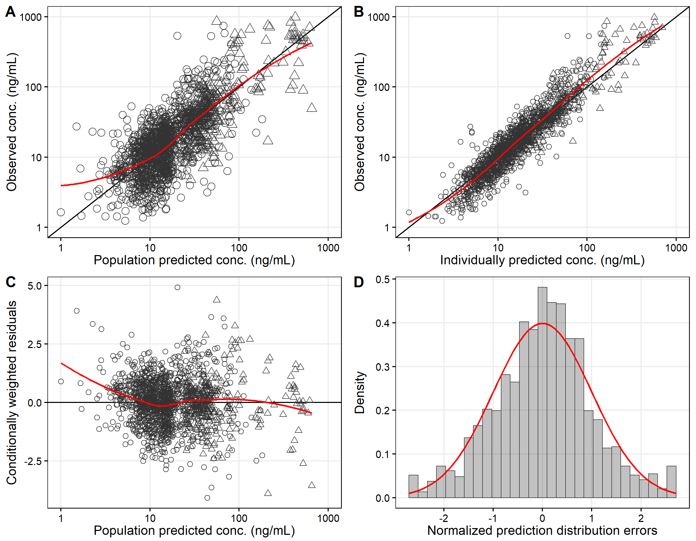
Figure 1 Goodness-of-fit of piperaquine, stratified by study sites. (A) Population predictions versus observations, (B) individual predictions versus observations, (C) population predictions versus conditional weighted residual errors, and (D) distribution of the normalised prediction distribution errors. Open circles are venous plasma concentrations and open triangles are capillary dry blood spot concentrations. Solid lines represent locally weighted least-squares regressions, based on both capillary and venous data.

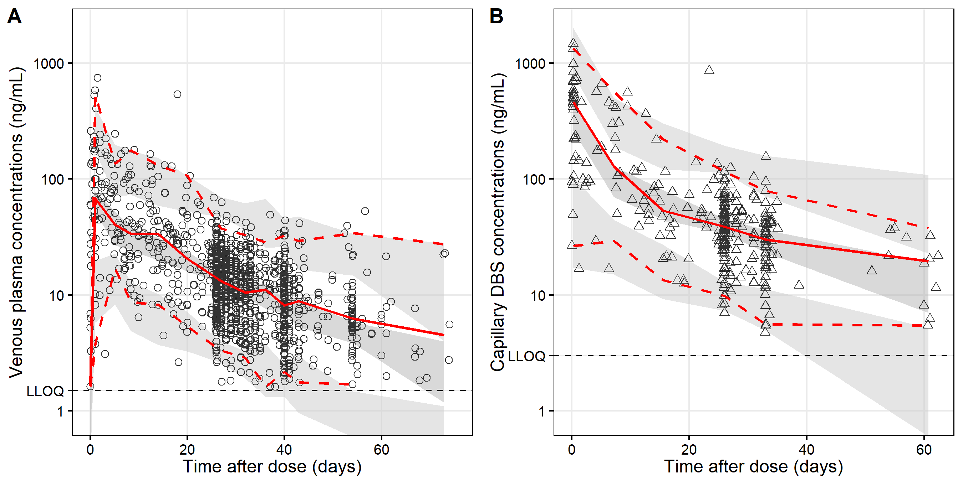
Figure 2 Visual predictive plots of piperaquine in pregnant women in Kenya (A) and Indonesia (B). Open markers represent observed concentrations. Solid and dashed lines represent the median, 5th and 95th percentiles of the observations. Shaded areas represent the predicted 95% confidence intervals of each percentile.

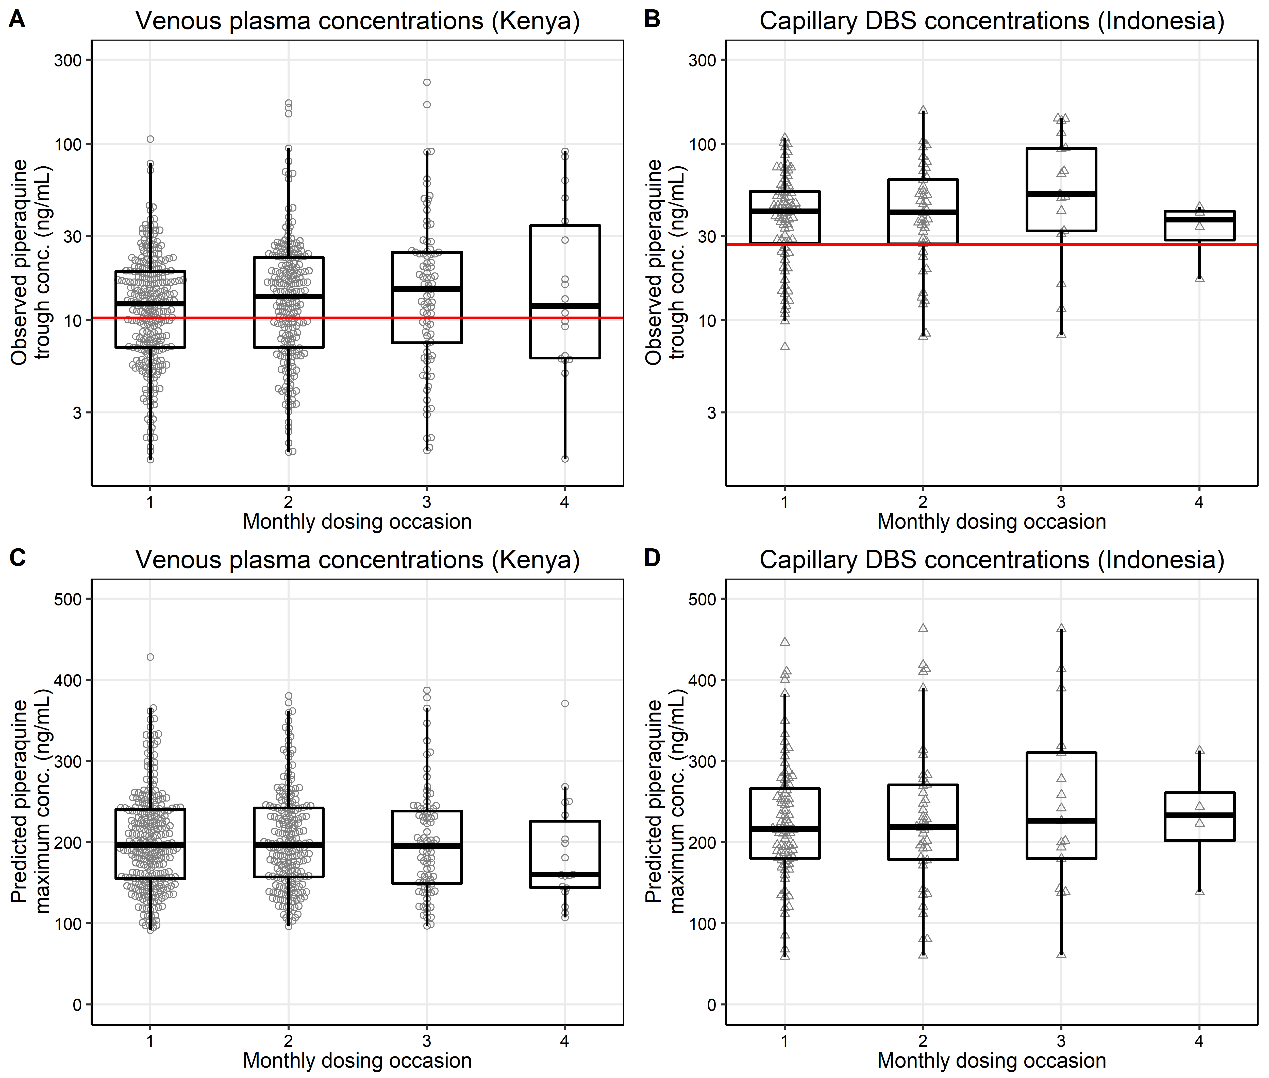
Figure 3 Observed piperaquine trough concentration (C_{MIN}) and Predicted piperaquine maximum concentration (C_{MAX}): (A) Plasma trough concentrations in Kenyan pregnant woman, (B) capillary DBS trough concentrations in Indonesian pregnant women, (C) plasma piperaquine maximum concentrations in Kenyan pregnant women, and (D) capillary DBS piperaquine maximum concentrations in Indonesian women. The box-whisker plots represent the median with inter-quantile range and the 95% prediction interval. The horizontal red lines represent a target piperaquine plasma concentration in pregnant women of 10.3 ng/mL (equivalent to 26.9 mg/mL capillary DBS concentrations) (24).

Figure 4 Simulation of monthly piperaquine dosing in pregnant women receiving IPTp. (A) Venous piperaquine plasma concentrations versus time (n = 1000). The blue solid line represents the predicted median piperaquine concentration-time profile, and the shaded area represents the 95% prediction interval. The horizontal dashed black line represents the proposed target plasma concentration of 10.3 ng/mL (24). (B) The proportion of patients with piperaquine trough concentrations below the target concentration (n = 1000 individuals, 1000 replicates). Box plots represent the median and interquartile range, with whiskers representing the 2.5-97.5 percentiles of the simulated concentrations. (C) The blue solid line represents the cumulative proportion of patients with plasma concentrations below the target concentrations (10.3ng/mL), and the blue shaded area represents the 95% confidence interval. The triple vertical lines represent the monthly dosing. The grey shaded areas represent a one-week time interval, preceding a dose in which sub-microscopic infection can be eliminated by the next IPTp treatment round.

