Journal
Comprehensive Child and Adolescent Nursing

Title
Capacity building for health care workers and support staff in paediatric Emergency Triage Assessment and Treatment (ETAT) at primary health care level in resource limited settings: Experiences from Malawi.

Authorship
Maureen Daisy Majamanda^{a,b}, Mtisunge Joshua Gondwe^{c,d}, Thomasena O’Byrne^{d,h}, Martha Makwero^{e}, Alfred Chalira^{f}, Norman Lufesi^{f}, Queen Dube^{g}, Nicola Desmond^{d,i}.

Abstract
Background: Primary health care facilities offer an entry point to health care system in Malawi. Challenges experienced by these facilities include: limited resources (both material and human), poor or inadequate knowledge, skills and attitudes of health care workers in emergency management, and delay in referral from primary care level to other levels of care. These contribute to poor outcome which see many children die within the first 24 hours of hospital admission. Training of Health care workers and support staff in Emergency Triage Assessment and Treatment in primary care levels can help improve care of children with acute and severe illness.
Methods: Health care workers and support staff in the primary care settings were trained in paediatric Emergency Triage Assessment and Treatment. The training package for health care workers was adapted from the Ministry of Health Emergency Triage Assessment and Treatment training for district and tertiary health care. Support staff content focussed on non-technical responsibility for lifesaving in emergency situations. The primary health care facilities were provided with a minimum treatment package comprising emergency equipment, supplies and drugs. Supportive supervisory visits were conducted quarterly.
Results: The training manual for health care workers was adapted from the MoH package and the support staff training manual was developed from the adapted package. Eight hundred and seventy-seven participants were trained (336 health care workers and 541 support staff). Following the trainings, triaging of patients improved and patients were managed as emergency, priority or non-urgent. This reduced the number of referral cases and children were stabilized before referral.
Conclusion: Capacity building of health care workers and support staff in Emergency Triage Assessment and Treatment and the provision of a basic health centre package improved practice at the primary care level and it was sustained through institutional mentorship and pre-service and in-service training. The practise of triage and treatment including stabilization of children with dangerous signs at the primary health care facility improves emergency care of patients, reduces the burden of patients on referral hospitals and increases number of successful referrals.

Key words: Emergency Triage Assessment and Treatment, task shifting, stabilization, capacity building, interprofessional collaboration, children
*Correspondence: mdmajamanda@kcn.unima.mw
¹ Department of Medical and Surgical Nursing, University of Malawi, Kamuzu College of nursing, Blantyre, Malawi.
² Consortium for Advanced Research Training in Africa (CARTA), Nairobi, Kenya.
ORCID
Maureen D. Majamanda https://orcid.org/0000-0001-8886-3158
Full list of author information is available at the end of the article.

1.0 Introduction
Critically ill infants and children have the greatest risk of dying within the first 24 hours of admission in hospital (Mabey et al 2013; Ralston et al., 2013 & Hategekimana 2012). In 2019, 5.2 million children under the age of 5 years died globally (WHO, 2020). The majority of these deaths occurred in Sub-Saharan Africa and southern Asia (Kruger et al., 2016). Half of the number died from conditions that could be prevented or managed with simple and low cost public health interventions (WHO, 2017 & Adedini et al., 2014). Half of the children that reached the hospital died within the first 24 hours of admission (Adeboye et al., 2010). This indicates that many children report to hospital when they are acutely and severely ill posing a challenge to outcome of care (Kruger et al., 2016). There are many factors that contribute to the deaths. However, community and health facility factors are most prevalent.
Some of the community factors identified from other low and middle income countries (LMIC) include delayed presentation to health facility, childbirth outside a hospital and financial constraints of the caregivers (Ameh et al., 2015; Osifo & Oriaifo, 2008). The most common community factor in the Malawian context, is delay in seeking care. In this regard Desmond et al., (2013), found that the community starts with home remedies then go to hospital when the child is critically ill or when they consider the illness to be life threatening. Long distance to health facility, poor road network and transport problems all contribute to delay in seeking care in the sub Saharan Africa (Adedini et al., 2014 & Kadobera et al., 2012).
Factors from the health care service include limited capacity in emergency patient management. Specific factors include poor or inadequate knowledge, skills and attitudes of health care workers in emergency management and shortage of health care staff (Liang et al., 2019 Irimu et al., 2014 &WHO, 2006). Delay in referral from primary to other levels of care has contributed greatly to poor outcomes in children with acute illnesses in LMIC (Treleaven et al., 2017 & Irimu et al., 2014). The delay results from triage systems being absent at primary care levels which lead to providers’ inability to recognize severe illness in a timely manner (Hodkinson et al., 2016, Samuelson et al., 2013, Achan et al., 2011). In other circumstances, health care workers are unable to institute proper emergency care due to lack of knowledge and skills and there is delayed transportation to the referral facility.
Some interventions have been identified to improve outcome of sick children. At community level members are encouraged to identify problems in children early and report to hospital early (Holtz et al., 2007 & Chuma et al., 2007). Regarding the health care service, improvements have been reported at secondary and tertiary levels of health care in Malawi (Olson et al., 2013; Robison et al., 2012; Molyneux et al., 2006). In this regard, staff were trained in triage and emergency care, patient flow through the busy under five clinics was improved and the physical environment was changed. This led to reduction in inpatient mortality from 10-18% before the initiative to 6-8% after (Molyneux et al., 2006). However, little has been done at primary health care (PHC) level, yet this is the first level of care and the entry point for clients in the Malawi health care system.
World Health Organisation assert that improved patient management at PHC level has been associated with quality referrals, reduced admission days, reduced complications and better patient outcomes (WHO, 2018a). It is against this background that the Achieving Sustainable Primary Improvement and Engagement in Health (ASPIRE) project considered building the capacity of health care workers and support staff in paediatric ETAT in primary health care in Malawi.

1.1 Levels of health care in Malawi.
Malawi’s health care system is in three levels namely: primary, secondary and tertiary levels. Primary care level consists of health promotion, disease prevention and curative activities at community level and in the PHC facility. PHC facilities are the back bone of the health system in Malawi. All medical, surgical and maternity cases report to PHC facility first for management, hence the need for the health care workers and support staff to have the capacity to provide effective, efficient and high quality care to all patients including severely ill infants and children whose risk of death is greatest in the first 24 hours of admission (Mabey et al., 2013; Ralston et al., 2013 & Hategekimana, 2012).

There are 28 district hospitals in Malawi which offer secondary level care for their respective districts (Government of the Republic of Malawi, 2017a, 2017b). Lastly, there are five tertiary hospitals which offer secondary level care for their districts and specialist care for their designated regions. Three of the five tertiary hospitals are in the southern region of Malawi of which one is a mental and psychiatric hospital, one tertiary hospital is in the central region and one in the northern region of Malawi.
1.2 Cadre of health care workers and Support staff at Primary health care facility.
Primary health facilities are mostly managed by nurses, clinical officers, medical assistants and environmental health staff. A few PHC facilities have medical officers. The majority of PHC facility workers are support staff such as health surveillance assistants, patient attendants, ward attendants and security guards. In this situation, task shifting comes in as an alternative to improving service delivery since there is critical shortage of health care workers in PHC facilities. Task shifting involves delegating tasks to less specialized health workers where necessary (WHO, 2007). Task shifting allows more efficient use of available staff and enables staff members to work in a coordinated and organised manner (Okyere et al., 2017; Olson et al, 2013; WHO, 2007a &WHO, 2007b). However, there is a need to regulate task shifting properly to ensure patients’ and health workers’ safety (WHO, 2007b). For example, before shifting the task to less qualified staff, it is important to ensure that the staff is trained and there must be continuing and supportive supervision to ensure safe delivery of the tasks (WHO, 2007b).
1.3 Care pathways for sick children at PHC facility
All sick children who report at PHC facilities queue up to be weighed and are seen in the consultation room by a clinician on a first come first served basis regardless of the presenting condition. Children with emergency conditions, are managed using available resources and are then referred to a secondary or tertiary level hospital. Depending on availability of transport, some patients wait for hours at the PHC level after the time of referral while waiting for transport. Patients are not monitored and some children’s condition will have changed in this time. There is also no monitoring or continued care being offered while in transit to the referral facility. Due to lack of triaging and quality emergency care at the PHC level, there is congestion of patients at secondary and tertiary levels. Referral hospitals are also affected by shortage of health care workers. This leads to some children developing complications or dying while queueing at referral centres.

2.0 Methodology
The practice improvement project was conducted in ten PHC facilities, eight in Blantyre and two in Chikhwawa districts in the Southern Region of Malawi. In total, Blantyre has 31 PHC facilities while Chikhwawa has 28. This project was embedded in a big ASPIRE study designed across two phases. Phase 1 (2013 to 2015) focused on the development and piloting of a digital mobile phone algorithm for sustainable and consistent primary level triage with a comprehensive training package for both clinical and non-clinical staff in seven health centres. Phase 2 (2015 to 2018) extended the initial triage component to the full ETAT package and expanded to a further three primary clinics in Blantyre District. In this paper, we report ETAT training package implemented during second phase of ASPIRE project (between August 2015- August 2018)
The process of capacity building involved review and development of training manuals for health care workers and support staff, recruitment of participants, implementation of the training and training evaluation. The PHC facilities were provided with a minimum treatment package comprising emergency equipment, supplies and drugs to provide quality emergency care to children. Supportive supervisory visits were conducted quarterly to assess implementation of the project which was aimed at identifying strengths, challenges, opportunities and threats.

2.1 Development of training package for Health care workers and Support staff
In collaboration with the Ministry of Health (MoH), we revised the ETAT training manual for health care workers and developed support staff manual for English and Chichewa versions. Training package for health care workers in PHC level was adapted from the MoH ETAT training package used in the district and tertiary health care levels (MoH, 2005). The MoH adapted the package from the World Health Organisation (WHO) manual (WHO, 2005). Members from MoH, government hospitals, mission hospitals, training institutions, Malawi Liverpool Wellcome Trust (MLW) and other partners within Malawi were involved in the revision and development of the training packages.
Initially, MoH delivered ETAT plus Trauma training in four and a half days for health care workers, until October 2017 when simulation based ETAT training was introduced. The Training days reduced to two and a half days for health care workers. This did not affect the content or quality of training. Content looked at how to triage patients as emergency, priority and non-urgent cases, provision of emergency care, stabilisation and referral of patients to another level of care. ASPIRE implemented the short training in 2018.
Considering the staff shortages in the facilities, the training approach was upgraded to using simulation based teaching and learning with more videos, case scenarios, team building exercises and a few hospital visits. Participants were provided with reading materials to prepare in advance for the modules and each module had questions for self-assessment.
The training manual for support staff only focussed on non-technical issues as their main responsibilities in ETAT are to identify signs, triage and guide patients accordingly to where they should be taken care of especially those requiring immediate care. In addition, they position infants and children to open airway, manage a choking infant and child, perform a jaw thrust, immobilise head and neck and log roll trauma patients.
Previously, the support staff were being trained for two and a half days and reduced to one and a half days in 2018. Mode of delivery included simulations, videos, demonstrations and return demonstrations. Each module had assessment questions and this did not affect content and quality of training.
2.2 Recruitment of participants and training period
Participants were invited through the district ETAT coordinator who communicated directly to in-charges of PHC facilities. Participants were purposively selected in that only those who were on off duty during the training days were invited for the trainings to ensure normal functioning of the health facility. There were a number of training sessions to ensure everyone attended. In some facilities, training sessions were conducted in the afternoon. This helped to ensure that participants worked in the mornings when clinics were very busy.

2.3 Health Care Worker training
Health care workers were trained in English language. A pre-test was administered before the training. Teaching methodology included lectures, simulations, skills drills, group discussions, role play and demonstrations. Most practical sessions were done in the training room and these were supplemented by clinical practice in the paediatric accident and emergency Unit at QECH and Chikhwawa district hospital. Facilitation was undertaken by a multidisciplinary team of health care workers from different health facilities and research and training institutions in Malawi. A post-test was administered to assess knowledge gained from the training. Participants also evaluated the quality of training. During the ASPIRE project period (5 years) 877 participants were trained. Out of which 336 were health care workers. This paper will report about 142 health care workers that were trained for two and a half days using the revised training tools in 2018. One hundred and fourteen were trained using the old tools. Eighty were trained in phase 1(2013-2015).
2.4 Support staff training
The training for support staff was conducted in the local language of Chichewa as the highest level of education for most of them was primary level education. Their training integrated both theory and practice. They visited QECH and Chikhwawa district hospitals in the Paediatric Accident and Emergency Unit and the wards where they had a chance to triage and observe some emergency signs on children. A pre-test was not administered to support staff. However, each module had assessment questions. At the end of the training, they evaluated the training using evaluation form (Supplementary file 2). The form had space for a narrative feedback and ten triage questions to assess if the support staff had gained knowledge in triage and management of some emergency conditions. Out of 877 participants that were trained 541 were support staff. This paper will report about 413 support staff that were trained for one and a half days as the other 128 were trained using the old tools.
2.5 Capturing Triage data
We collected triage data using mHealth phones at four stages. First was upon arrival where patients were triaged by support staff as Emergency (E), Priority (P) and Queue (Q). A barcode indicating the prioritisation group was placed in the patient’s health passport. A field worker captured clinician’s outcome data after verifying the triage category in the second phase. Later, data was captured on arrival of patients at the referral facility. During the fourth phase, a research nurse linked triage category and PHC data to admission data at a referral facility. The nurse also collected information on patients’ diagnosis retrospectively.

3.0 Results
3.1 Training manuals
Training manuals for health care workers and support staff were revised and developed. The training manuals were in the English language and a Chichewa version for the support staff.
3.2 Training evaluation
Pre and post-test were administered to health care workers to evaluate the impact of training (supplementary file 4). Post-test findings indicated similarities between old lengthy and new short training. With the majority scoring above 81% (74% of participants in old training, 72% in new training). In the new training 42% were in the highest range of 91-100 versus 38% in the old training (Figure 1).

Figure 1. Pre and Post training results for old lengthy and new short ETAT training for HCW
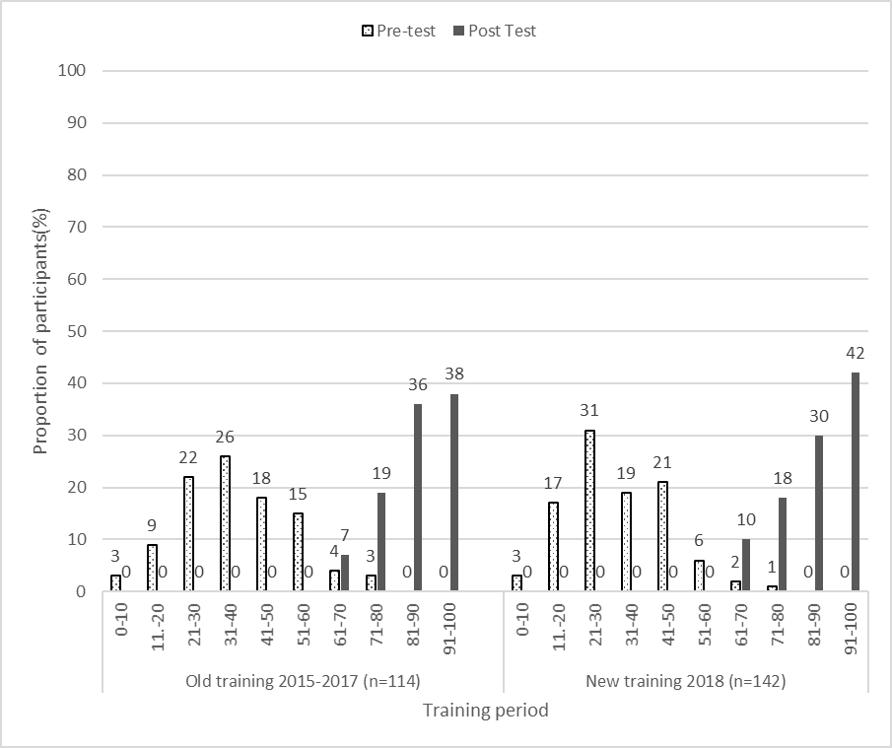

At the end the training session, participants evaluated the training using the form (supplementary file 1). Over 70% of health care workers rated the overall training as good and that they were reminded on how to triage children. They reported that the skills gained will enable them to properly triage, provide emergency care and stabilise children before referral. They indicated that training content and methods used to deliver the training were relevant, the training period was adequate and that the training was beneficial to both health care workers and support staff. These findings are similar to the old lengthy training.
Overall, the support staff indicated that the training was good. Specifically, they reported that the training met their expectations, the content was well organised and easy to follow, the learning materials were useful and relevant, the training period was adequate and that they would be able to put into practice what they had learned.
The evaluation form (Supplementary file 2) had seven short answer questions on triage and three case scenarios where the support staff had to indicate if the case was emergency (E), Priority (P) or non-urgent (Q). There was a correct response rate of more than 50% on all questions from all participants both in old and new training tools (Figure 2).
Figure 2: Proportion of triage questions and case scenarios response for support staff
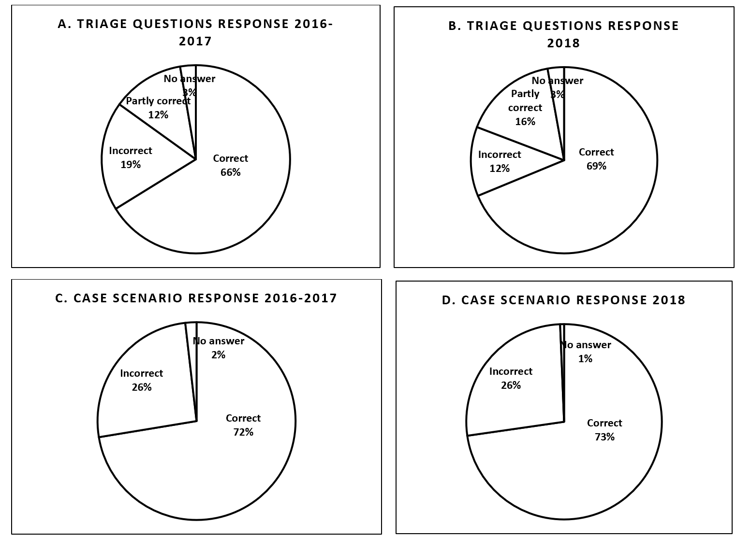

3.3 Implementation of ETAT at primary care level
Triaging of patients had improved and sick children were managed quickly upon arrival at the facilities. Those with emergency signs were taken immediately to clinician’s room or emergency room for stabilisation. Those with priority signs were placed in the front of the queue to be seen within one hour and non-urgent followed the queue to the clinician’s room. Between April 2017 and August 2018, a total of 195, 151 children were triaged in eight PHCs by support staff in Blantyre. Out of these, 518 were triaged as emergency, 60,021 were priority and the majority 134,612 were non urgent. After support staff triage, the clinician confirmed the triage category. From the 518 emergency cases, 356 were triaged as emergency by the clinician. Out of this, 238 were managed as outpatient. Seventy-three were referred to tertiary facility after emergency care, 45 were admitted in short stay/ stabilisation room. Out of the 45, eight were discharged and 18 were referred to tertiary facility. The remaining 19 had no data. Out of 195, 151 that were seen at PHC, 4358 cases were referred to QECH representing 3% of all cases that presented to PHC facilities. (Tables 1 to 4)

Table 1: Number seen and triaged by support staff

Total number seen | 195,151
Triaged as emergency | 518
Triaged as priority | 60, 021
Triaged as Non urgent | 134, 612

Table 2: Number seen, referred and stabilised by clinicians

Total number | 195,151
Referred | 4358
Emergencies confirmed by clinician | 356
Missing data from those triaged as emergency by Support staff | 162

Table 3: Outcome for the 356 emergency cases seen by clinician

Managed and discharged | 238
Managed as emergency and referred | 73
Admitted in short stay/ stabilisation room | 45
Table 4: Outcome for the 45 in short stay

Discharged after stabilisation | 8
Referred | 18
Missing data | 19

During one of the supervision visits, a security guard brought a child who had fever to the front of the queue. He explained to other caregivers the reasons for his actions and the caregivers cooperated. In a separate supervision visit, a child with laboured breathing was identified on the queue and was immediately taken to the consultation room where two clinical officers worked together with the support staff in managing the child.
Each facility identified an observation room where all referred patients were kept. A support staff was allocated to this room to monitor the patients, and inform clinicians and nurses of any changes that needed their attention. The support staff were guided by the monitoring form which was adapted from secondary and tertiary critical care pathway form (Supplementary file 3). This saw some children who had emergency conditions stabilising and recovering at the PHC facility such that they were discharged home. This helped to reduce the burden of patients on referral hospitals. There was also an increased number of successful referrals which is arrival at a tertiary hospital following a clinician’s referral at PHC facility. At baseline (2013-2015), successful referral was only 37% and increased to 52% following implementation of full ETAT (2015-2018) at PHC facility. In addition, 94% of the children who made it to the referral facility made it within 24 hours.
The project also developed and provided a health centre package which helped health care workers to provide quality care to children.
Table 6: Health Centre package
Emergency equipment | Emergency supplies | Emergency drugs
Oxygen concentrators | Pulse oximeter | Anticonvulsants (diazepam, paraldehyde, phenobarbital)
Suction machine | Glucometer and glucose sticks | Paracetamol suppositories
Nebuliser | Oxygen delivering tubes | 50% dextrose
Emergency box | Guedel airways | Antibiotics(benzylpenicilline and gentamycin)
 | Ambu bags | IV fluids (normal saline, ringers lactate)
 | Suction catheters | Salbutamol inhalation solution
 | Nasogastric tubes
 | Colourless plaster
 | Cannula
 | Giving sets
 | Thermometers

4.0 Discussion
4.1 Training manuals
Effective delivery of any training requires a guideline to ensure all relevant content is covered. Clinical guidelines are a vital tool for health practitioners in improving the quality of health care delivery across various clinical situations (Reddy et al., 2015 & Farquhar et al., 2002). The process of reviewing and developing the training manuals involved experts from the field of paediatrics and child health from different sectors. These experts formed a working group as they represented all those that would implement the guidelines (Maher and Ford, 2017). The training manual acts as reference guide in how content should be organised and delivered to a group of participants. McLachlan, (2020) assert that clinical guidelines standardize care and enable delivery of evidence-based practice. When successfully implemented clinical guidelines decrease variation within the everyday clinical practice and, as a result, optimize the health of the patients and communities in which the guidelines have been adopted (Reddy et al., 2015).

4.2 Training of health care workers and support staff
Gaps in knowledge and skills among healthcare professionals working within the health care system affect effective delivery of life -saving interventions for children (Ralston et al., 2013, Khilnani et al., 2010, English et al., 2004, Nolan, 2001). To ensure that PHC facilities have the capacity to provide effective, efficient and high quality care to severely ill infants and children the project provided training to health care workers and support staff in ETAT to empower them with the necessary knowledge, skills and attitudes. The training period was also reduced and post-test results revealed that length of training had no effect on quality of training as evidenced by similar test results. Similarly, Misko & Korbel (2019), reported that high quality training is not only determined by the length of the course, but includes other factors such as: teaching skills, student’s ability and talent, relevant practical experiences and up to date learning resources.

Training conducted to health care workers at district and tertiary hospitals in Malawi in ETAT was associated with a reduction in early hospital mortality in under-five children from 47.6 to 37.9 deaths per 1000 admissions after the intervention (Molyneux, 2010). A further reduction is expected with effective emergency care starting from PHC levels. However, in a resource-constrained country like Malawi where health care workers are few, task shifting in other programs helps relieve pressure from the health care workers while ensuring quality care to patients. Task-shifting makes use of already available human resource by delegating tasks requiring less skills to support staff and health workers with lower qualification (Okyere and Ward, 2017& Olson et al., 2013)
In this regard, the project empowered support staff with knowledge and skills in ETAT including observations of patients while waiting for transport to a referral centre. This proved to be effective as support staff helped triage patients and were able to assist with non-technical activities in paediatric ETAT.
4.3 Emergency package
Primary care facilities in Malawi and other LMIC’s face challenges in delivering life-saving interventions to children due to limited material and human resources (Hategeka et al., 2017). In addition to training, the project developed and provided a minimum health care package for PHC facilities to provide emergency care to children before referring them to the next level of care. Hategeka et al., (2017) agree that every health facility needs to have equipment, supplies and drugs deemed necessary for resuscitation or emergency care. Provision of the minimum health package in the implementing facilities enabled health care workers and support staff to stabilize patients at the PHC facility. In addition, some patients with emergency conditions got better and were managed as outpatients. This helped reduce number of referral cases there by reducing the burden on referral facilities.

4.4 Observation room
Primary care facilities have no specific area to keep patients for observations or continued management after referral is made. Patients wait outside while waiting for transport. This has seen many children deteriorating while at the facility as there is no one to observe and manage them. In management of emergencies at PHC, World Health Organisation recommends proper infrastructure to improve care of emergencies (WHO, 2018b). Under this project, implementation sites were helped to identify and designate an area or room to keep patients for observations and further management. In this room a support staff was allocated daily to monitor patients and report any problems to the nurses or clinicians who continue to render care during the waiting period. This has seen a lot of children being stabilized before referral and other children were discharged home.

4.5 Benefits of the project
The project has resulted in benefits to the patient, family, health care workers, support staff and the referral centres. Some children with emergency conditions improve while at the PHC facility and do not require referral anymore. This brings about family satisfaction as they are saved from the financial burden that accompany hospitalisation at a referral hospital.
The training has equipped support staff with emergency care knowledge and skills. This has brought satisfaction as they are able to contribute to the wellbeing of the children. Similarly, health care workers are now embracing team work and have been equipped with knowledge and skills in emergency care which has brought confidence in emergency management.
At the referral centres, there is reduced workload as most emergencies are managed at PHC facility. Similar findings indicate that effective management and treatment of emergency conditions at primary care levels significantly prevents admission at referral hospitals (Pol et al., 2019).

4.6 Challenges
During the development of training materials, there was delay in finalisation of material as the technical working group was busy with other responsibilities. There were a number of training sessions for both support staff and health care workers as all could not be withdrawn at once. Some sessions were delayed as they depended on trainers’ availability. The other challenge that is common in all PHC facilities is that most nurses are allocated to maternity ward, as such, no nurse is allocated to the outpatient department (OPD). Despite being trained, most nurses did not practice emergency care due to this reason. These challenges were addressed through conducting refresher trainings and allocating nurses to the outpatient department on specific days so as to ensure nurses retained skills while implementing ETAT.
Not all staff were trained due to staff turnover. Some trained health care workers moved to other areas while some new members joined the facilities. This left the implementing facilities with few or no trained staff which brought a challenge in sustainability.

4.7 Lessons learnt
In implementing this project, we have learnt the following: there is power in Multidisciplinary team working. This was evident during development of training manuals and in the facilitation of trainings. Professional networking had improved and this has seen participants and trainers communicating even after the trainings and consulting one another on emergency care issues. Coordination among team members was promoted and there was collective ownership of the project which ensured sustainability through resource mobilisation. Supportive supervision was enhanced and it acted as a motivating factor to PHC facility members.
Task shifting of non-technical skills has made implementation of ETAT and stabilising of patients possible regardless of shortage of health care workers. Similar lessons have been drawn from other settings and studies. A systematic review by Reeves et al., (2017), reported that multidisciplinary team working improves team communication, coordination and practice systems. They further recommend that multidisciplinary team working should occur in different settings and at different levels of health care so as to improve patient care. In this practice improvement initiative, members from different training institutions, public and mission health facilities, research institution and MoH worked together to improve care of children with acute and severe illnesses at primary care level.

4.8 Limitations
The project was implemented in two PHC facilities in Chikhwawa district and eight in Blantyre district. It would be better if the all PHC facilities in these districts were reached.

4.9 Recommendations
Drawing on the experiences from this project, we recommend that pre- service training for nurses, clinical officers, medical assistants and medical officers should be started and continued in all training institutions. Important to consider is interprofessional training during pre-service training.
The government of Malawi should invest in capacity building of all health care workers and support staff at PHC facilities in ETAT. The in-service training should be driven by district ETAT coordinator while utilising inter professional teaching/ learning and facilitation.
Other countries facing similar problems as Malawi, can include ETAT in the pre-service curriculum and provide in-service training to all health care workers working with children. This should be done at all levels of care so that no time is lost in the management of children with acute and severe illness.
There is need to include ETAT hours in the continuous professional development that should be achieved every year by health care workers. This will ensure health care workers are always up to date with knowledge and skills. This is also cost effective as there is no need to organise a formal training.

5.0 Conclusion
Capacity building of health care workers and support staff in and the provision of health centre package improve practice at primary care level. Capacity building is also sustainable through: institutional mentorship, pre-service and in-service training.
Quality assessment, triage, treatment including stabilization at primary health care facility improve emergency care of patients, reduce the burden of patients on referral hospitals and increase successful referrals.

6.0 Acknowledgements:
We are grateful to Meningitis Research Foundation and Scottish government for the financial support (MRF 453). We are also thankful to all Primary ETAT Advisory Group members, Technical Working Group, training Facilitators, ASPIRE team members, Malawi Liverpool Wellcome Trust, The District Health Officers for Blantyre and Chikhwawa and health care workers and support staff from implementing primary health care facilities.
Ethical approval and consent to participate
This was a practice improvement project which was part of Achieving Sustainable Primary Improvement and Engagement in Health (ASPIRE) project. Approval of a larger project was obtained from College of Medicine Research Ethics Committee (P.09/16/2021) and ethics board of Liverpool School of Tropical Medicine
Availability of data and materials
The data sets used and analysed during the current study are available from the corresponding author and Wellcome trust Malawi through data department on reasonable request.
Consent for publication
Not applicable
Declaration of interest/ Competing interests
The authors declare that they have no competing interests.
Author contribution
MDM, MJG, TO, ND contributed to the conception, design and implementation of the project. MDM & MJG developed the first draft of the manuscript, MM, ND, AC, NL, QD revised the work. MDM & MJG finalised the manuscript. All authors have read and approved the manuscript.

Author details
ª Department of Medical and Surgical Nursing, University of Malawi, Kamuzu College of nursing, Blantyre, Malawi.
^{b} Consortium for Advanced Research Training in Africa (CARTA), Nairobi, Kenya.
^{c} Department of Clinical Sciences, Liverpool School of Tropical Medicine, United Kingdom
^{d} Behaviour and Health Group, Malawi- Liverpool Wellcome Trust, Clinical Research Programme, Malawi
^{e} Department of Family Medicine, University of Malawi, College of Medicine, Blantyre, Malawi
^{f} Department of Clinical Services, Ministry of Health, Lilongwe, Malawi
^{g} Department of Paediatrics, Queen Elizabeth Central Hospital, Blantyre, Malawi
^{h} Centre for Global Health, Trinity College, University of Dublin, Ireland
^{i} Department of International Public Health, Liverpool School of Tropical Medicine, Liverpool, UK

Reference
Achan, J., Tibenderana, J., Kyabayinze, D., Mawejje, H., Mugizi, R., Mpeka, B., Talisuna, A., & D’Alessandro, U. (2011). Case Management of Severe Malaria - A Forgotten Practice: Experiences from Health Facilities in Uganda. PLoS ONE, 6(3), e17053. https://doi.org/10.1371/journal.pone.0017053
Adeboye, M., Ojuawo, A., Ernest, S., Fadeyi, A., & Salisu, O. (2011). Mortality pattern within twenty-four hours of emergency paediatric admission in a resource-poor nation health facility. West African Journal of Medicine, 29(4: 249–252.
Adedini, S. A., Odimegwu, C., Bamiwuye, O., Fadeyibi, O., & De Wet, N. (2014). Barriers to accessing health care in Nigeria: implications for child survival. Global health action.7 (1), 23499. https://doi.org/10.3402/gha.v7.23499
Ameh, E. A., Seyi-Olajide, J. O., & Sholadoye, T. T. (2015). Neonatal surgical care: a review of the burden, progress and challenges in sub-Saharan Africa. Paediatrics and International Child Health, 35(3), 243–251. https://doi.org/10.1179/2046905515Y.0000000033
Chuma, J., Gilson, L., & Molyneux, C. (2007). Treatment-seeking behaviour, cost burdens and coping strategies among rural and urban households in Coastal Kenya: an equity analysis. Tropical Medicine and International Health. 12(5):673-86. https://doi:10.1111/j.1365-3156.2007.01825.x.
Desmond, N. A., Nyirenda, D., Dube, Q., Mallewa, M., Molyneux, E., Lalloo, D. G., & Heyderman, R. S. (2013). Recognising and treatment seeking for acute bacterial meningitis in adults and children in resource-poor settings: a qualitative study. PloS one, 8(7), e68163. https://doi.org/10.1371/journal.pone.0068163

English, M., Esamai, F., Wasunna, A., Were, F., Ogutu, B., Wamae, A., Snow, R. W., & Peshu, N. (2004). Delivery of paediatric care at the first-referral level in Kenya. Lancet (London, England), 364(9445), 1622–1629. https://doi.org/10.1016/S0140-6736(04)17318-2

Farquhar, C. M., Kofa, E. W., & Slutsky, J. R. (2002). Clinicians' attitudes to clinical practice guidelines: a systematic review. The Medical journal of Australia, 177(9), 502–506. https://doi.org/10.5694/j.1326-5377.2002.tb04920.x
Government of the Republic of Malawi. (2017a). Health sector strategic plan II (2017- 2022): Towards universal health coverage. Lilongwe, Malawi: Ministry of Health.
Government of the Republic of Malawi. (2017b). National community health strategy 2017 - 2022: Integrating health services and engaging communities for the next generation. Lilongwe, Malawi: Ministry of Health.

Hategeka, C., Shoveller, J., Tuyisenge, L., Kenyon, C., Cechetto, D. F., & Lynd, L. D. (2017). Pediatric emergency care capacity in a low-resource setting: An assessment of district hospitals in Rwanda. PLOS ONE, 12(3), e0173233. https://doi:10.1371/journal.pone.0173233

Hategekimana C., Nshuti S., Mucumbitsi J., Muvunyi C., Mutesa L & Rusingiza E. (2012). Management challenges of paediatric infective endocarditis at tertiary level in Rwanda. Rwanda Medical Journal. 69(3):34–42.

Hodkinson, P., Argent, A., Wallis, L., Reid, S., Perera, R., Harrison, S., Thompson, M., English, M., Maconochie, I., & Ward, A. (2016). Pathways to care for critically ill or injured children: a cohort study from first presentation to healthcare services through to admission to intensive care or death. PloS one.11(1), e0145473. https://doi.org/10.1371/journal.pone.0145473
Holtz, T. H., Kachur, S. P., Marum, L. H., Mkandala, C., Chizani, N., Roberts, J. M., Macheso, A &Parise, M.E. (2003). Care seeking behaviour and treatment of febrile illness in children aged less than five years: a household survey in Blantyre District, Malawi. Transactions of the Royal Society of Tropical Medicine and Hygiene, 97(5), 491–497. https://doi:10.1016/s0035-9203(03)80003-2

Irimu, G. W., Greene, A., Gathara, D., Kihara, H., Maina, C., Mbori-Ngacha, D., Zurovac, D., Migiro, S & English, M. (2014). Factors influencing performance of health workers in the management of seriously sick children at a Kenyan tertiary hospital - participatory action research. BMC Health Services Research. 14(1). https://doi:10.1186/1472-6963-14-59

Kadobera, D., Sartorius, B., Masanja, H., Mathew, A., & Waiswa, P. (2012). The effect of distance to formal health facility on childhood mortality in rural Tanzania, 2005-2007. Global health action. 5, 1–9. https://doi.org/10.3402/gha.v5i0.19099
Khilnani, P., Singhi, S., Lodha, R., Santhanam, I., Sachdev, A., Chugh, K., Jaishree, M., Ranjit, S., Ramachandran, B., Ali, U., Udani, S., Uttam, R., & Deopujari, S. (2010). Pediatric Sepsis Guidelines: Summary for resource-limited countries. Indian Journal of Critical Care Medicine. 14(1), 41–52. https://doi.org/10.4103/0972-5229.63029

Kruger, I., Gie, R. P., Harvey, J., & Kruger, M. (2016). Outcome of children admitted to a general high care unit in a regional hospital in the Western Cape, South Africa. South African Journal of Child Health, 10(3), 156. https://doi.org/10.7196/sajch.2016.v10i3.981
Liang, S., Macinko, J., Yue, D., & Meng, Q. (2019). The impact of the health care workforce on under-five mortality in rural China. Human Resources for Health.17(1). https://doi:10.1186/s12960-019-0357-5

Mabey D., Gill G., Weber M.W., & Whitty C.J. (2013). Principles of medicine in Africa. Cambridge University Press.

Maher, D., & Ford, N. (2017). A public health research agenda informed by guidelines in development. Bulletin of the World Health Organisation. 95(12):795–795A. World Health Organization. https://dx.doi.org/10.2471/BLT.17.200709

Government of Republic of Malawi. (2005). Emergency Triage Assessment and Treatment (ETAT) plus Trauma: Participant Manual Ministry of Health, WHO and USAID. Lilongwe, Malawi

McLachlan S., Kyrimi E., Dube K., Hitman G., Simmonds J., Fenton N. (2020). Towards standardisation of evidence-based clinical care process specifications. Health Informatics Journal. 26(4) 2512–2537. https://doi.org/10.1177/1460458220906069
Misko, J., & Korbel, P. (2019). Do course durations matter to training quality and outcomes? Research Report. National Centre for Vocational Education Research. Australia. Accessed https://www.ncver.edu.au/__data/assets/pdf_file/0036/6634719/Do_course_durations_matter_to_training_quality_and_outcomes.pdf 25/02/2021

Molyneux, E. (2010). Paediatric emergency care in resource-constrained health services is usually neglected: time for change. Annals of Tropical Paediatrics. International Child Health. 30(3):165-76.

Molyneux, E., Ahmad, S., & Robertson, A. (2006). Improved triage and emergency care for children reduces inpatient mortality in a resource-constrained setting. Bulletin of the World Health Organization, 84(4), 314–319. https://doi.org/10.2471/blt.04.019505

Nolan, T., Angos, P., Cunha, A. J., Muhe, L., Qazi, S., Simoes, E. A., Tamburlini, G., Weber, M., & Pierce, N. F. (2001). Quality of hospital care for seriously ill children in less-developed countries. Lancet (London, England), 357(9250), 106–110. https://doi.org/10.1016/S0140-6736(00)03542-X

Okyere E., Mwanri L., & Ward P. (2017). Is task-shifting a solution to the health workers' shortage in Northern Ghana? PLoS ONE. 12(3): e0174631. https://doi.org/10.1371/journal.pone.0174631

Olson, D., Preidis, G. A., Milazi, R., Spinler, J. K., Lufesi, N., Mwansambo, C., Hosseinipour… M.C., & McCollum, E. D. (2013). Task shifting an inpatient triage, assessment and treatment programme improves the quality of care for hospitalised Malawian children. Tropical Medicine & International Health, 18(7), 879–886. https://doi.org/10.1111/tmi.12114

Osifo, D. O., & Oriaifo, I. A. (2008). Factors affecting the management and outcome of neonatal surgery in Benin City, Nigeria. European Journal of Pediatric Surgery. 18(2), 107–110. https://doi.org/10.1055/s-2008-1038485
Pol van der M., Olajide D., Dusheiko M., Elliott R., Guthrie B., Jorm L.,
& Leyland A.H. (2019). The impact of quality and accessibility of
primary care on emergency admissions for a range of chronic ambulatory care sensitive conditions (ACSCs) in Scotland: longitudinal analysis. BMC Family Practice. 20:32. https://doi.org/10.1186/s12875-019-0921-z

Ralston M.E., Day L.T., Slusher T.M., Musa N.L., Doss H.S. (2013). Global Paediatric Advanced Life Support: Improving child survival in limited-resource settings. The Lancet. 381(9862):256–65. https://doi.org/10.1016/S0140-6736(12)61191-X

Reddy, S., Wakerman, J., Westhorp, G., & Herring, S. (2015). Evaluating impact of clinical guidelines using a realist evaluation framework. Journal of Evaluation in Clinical Practice. 21(6), 1114–1120. https://doi.org/10.1111/jep.12482

Reeves, S., Pelone, F., Harrison, R., Goldman, J., & Zwarenstein, M. (2017). Interprofessional collaboration to improve professional practice and healthcare outcomes. Cochrane Database of Systematic Reviews. doi:10.1002/14651858.cd000072.pub3

Robison, J. A., Ahmad, Z. P., Nosek, C. A., Durand, C., Namathanga, A., Milazi, R., &Torrey, S. B. (2012). Decreased Pediatric Hospital Mortality After an Intervention to Improve Emergency Care in Lilongwe, Malawi. Pediatrics, 130(3), e676–e682. https://doi.org/10.1542/peds.2012-0026

Samuelsen, H., Tersbøl, B. P., & Mbuyita, S. S. (2013). Do health systems delay the treatment of poor children? A qualitative study of child deaths in rural Tanzania. BMC Health Services Research.13, 67. https://doi.org/10.1186/1472-6963-13-67
Treleaven, E., Pham, T.N., Le, D.N., Brooks, T.N., Le, H.T., & Partridge J. C. (2017). Referral patterns, delays, and equity in access to advanced paediatric emergency care in Vietnam. International Journal for Equity in Health.16, 215. https://doi.org/10.1186/s12939-017-0703-y
World Health Organisation (2020). Children: Improving survival and wellbeing. Retrieved from https://www.who.int/news-room/fact-sheets/detail/children-reducing-mortality# on 19/02/2021
World Health Organisation. (2018a). Building the economic case for primary health care: a scoping review. Geneva, Switzerland. Accessed https://www.who.int/publications/i/item/WHO-HIS-SDS-2018.48 on 19/02/2021

World Health Organisation. (2018b). Primary health care and health emergencies. Geneva, Switzerland. https://apps.who.int/iris/handle/10665/328105.

World Health Organization, 2017. Child Mortality Report World Health Organisation. Geneva, Switzerland: WHO
World Health Organization, PEPFAR & UNAIDS. (‎2007a)‎. Task shifting : rational redistribution of tasks among health workforce teams : global recommendations and guidelines. Geneva : World Health Organization. https://apps.who.int/iris/handle/10665/43821
World Health Organisation. (2007b). Taking stock: task shifting to tackle health worker shortages. Accessed https://www.who.int/healthsystems/task_shifting_booklet.pdf on 10/12/2020

World Health Organisation. (2006). Improving health worker performance: in search of promising practices. Evidence and Information for Policy, Department of Human Resources for Health, Geneva Accessed on 18/01/2021 from https://www.who.int/hrh/resources/improving_hw_performance.pdf

World Health Organization, 2005. Emergency Triage Assessment and Treatment (ETAT): Manual for Participants. Geneva, Swirtzerland.

