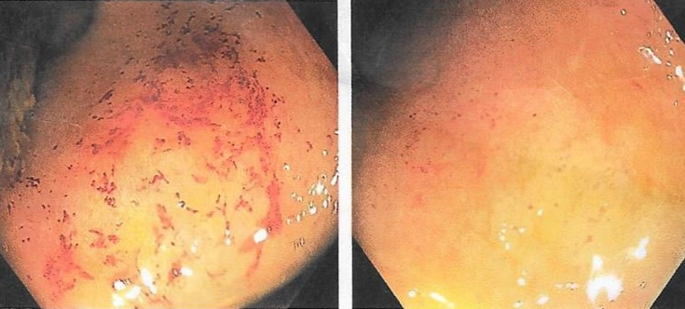

Figure I: Endoscopy pictures taken from the colon, showing marked distortion of the anatomy of the colon; the haustral markings and mucosal pattern were disrupted with widespread mucosal oedema and erosions.

