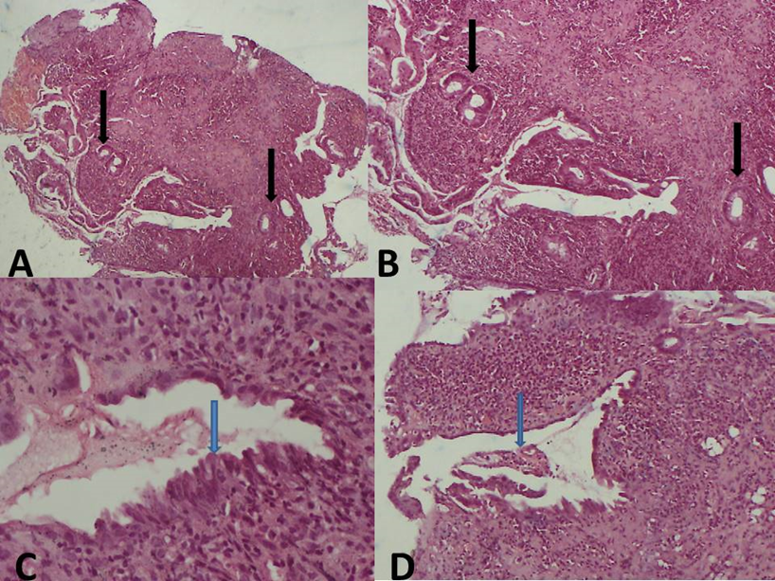

Figure 2: Histology of the colonic biopsies with haematoxylin and eosin stain (H&E stain)
A-B. Photomicrograph demonstrating widely spaced glands with intense lymphoplasmacytic and eosinophilic infiltration between the branched and distorted glands and crypts, and crypt inflammation (arrow).
C-D. Shows a regenerated gland lining with no goblet cells (arrow) (2C, ×400) and crypt inflammation (2D, ×100).

