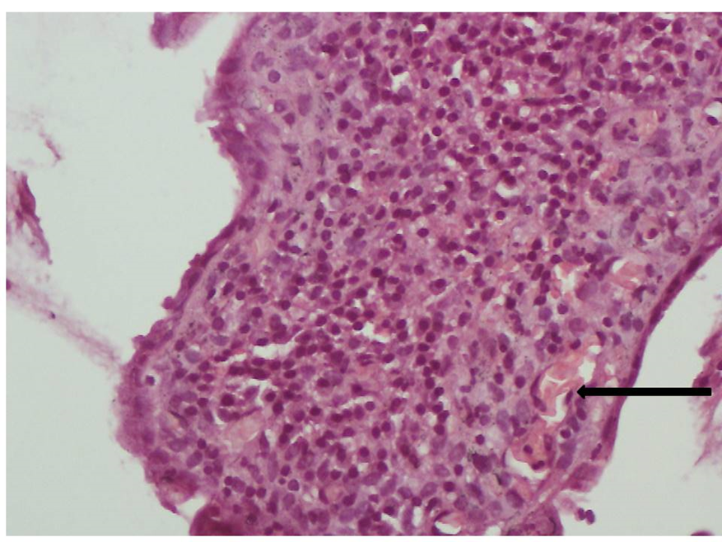
Figure 3: (×400) Histology of the colonic biopsies with haematoxylin and eosin stain (H&E stain) shows intense lymphoplasmacytic infiltrate of the lamina propria of the mucosa and sickle erythrocytes in the microvasculature (arrow)

