Dietary omega-3 polyunsaturated fatty acids and fish intake and risk of age-related macular degeneration

Hong Jiang^{a,b,c}, Xin Shi^{c}, Yahui Fan^{c}, Duolao Wang^{d}, Baoyu Li^{c}, Jin Zhou^{e, ***}, Cheng Pei^{a,**}, Le Ma^{c,f,*}

Author Affiliations:
ª the First Affiliated Hospital, Xi’an Jiaotong University Health Science Center, Xi’an, China;
^{b} Key Laboratory of Shaanxi Province for Craniofacial Precision Medicine Research, College of Stomatology, Xi’an Jiaotong University, Xi’an, China
^{c} School of Public Health, Xi’an Jiaotong University Health Science Center, Xi’an, China;
^{d} Department of Clinical Sciences, Liverpool School of Tropical Medicine, Liverpool, UK;
^{e} Beijing Zhongyinghui Nutrition and Health Research Institute, the Chinese Nutrition Society Academy of Nutrition and Health, Peking, China;
^{f} Key Laboratory of Environment and Genes Related to Diseases (Xi’an Jiaotong University), Ministry of Education of China, Xi’an, China

*Correspondence Author. School of Public Health, Xi’an Jiaotong University Health Science Center, 76 Yanta West Road, Xi’an, China.
** Correspondence Author. Department of Ophthalmology, the First Affiliated Hospital of Xi’an Jiaotong University Health Science Center, Xi’an, China.
*** Correspondence Author. Beijing Zhongyinghui Nutrition and Health Research Institute, the Chinese Nutrition Society Academy of Nutrition and Health, Peking, China.
E-mail address: male@mail.xjtu.edu.cn (L. Ma), peich71@163.com (C. Pei), zj@cnsoc.org (J. Zhou)

Abstract:
Background & aims: Epidemiologic studies are inconsistent regarding the association of dietary omega-3 polyunsaturated fatty acids (PUFA) and/or fish intake with risk of age-related macular degeneration (AMD) incidence and progression. The objective was to determine these associations by conducting a meta-analysis of available studies.
Methods: Three electronic databases were searched for studies that quantified dietary omega-3 PUFA and/or fish intake from inception to December 2020 without language restriction. Three investigators independently assessed for inclusion and extracted data. Study-specific risk estimates were combined using random-effects model. Potential dose-response associations were explored with the use of generalized least-squares trend estimation.
Results: 21 studies were included in the meta-analysis. Higher dietary intakes of omega-3 PUFA was significantly associated with 14% (relative risk [RR]: 0.86, 95% confidence interval [CI]: 0.77, 0.96) and 29% (RR: 0.71, 95% CI: 0.55, 0.91) lower risk of early and late AMD, respectively. The dose-response analysis showed a 6% and 22% decrease in the risk of early and late AMD for each additional 1g/d omega-3 PUFA intake. For individual omega-3 PUFA, the intake of eicosapentaenoic acid and docosahexaenoic acid was inversely associated with lower AMD risk, whereas no association was found for the alpha-linolenic acid. Consistent inverse associations were also found between fish intake and AMD. The pooled RRs comparing extreme categories of fish intake were 0.79 (95% CI: 0.70, 0.90) and 0.71 (95% CI: 0.60, 0.85) for early and late AMD risk, respectively. Every 15 g/d of fish consumption was associated with 13% and 14% lower early and late AMD. In addition, fish intake was associated with a significantly reduced risk of AMD progression (RR: 0.73, 95% CI: 0.53, 1.00).
Conclusions: A high intake of dietary omega-3 PUFA or fish was associated with a reduced risk of developing of AMD, which further supports that consumption of omega-3 PUFA-rich foods may be a new avenue nutritional approach to preventing AMD.

Key words: Omega-3 polyunsaturated fatty acids; Fish; Age-related macular degeneration, Meta-analysis

Abbreviations:
AHRQ, Agency for Healthcare Research and Quality; ALA, alpha-linolenic acid, AMD, age-related macular degeneration; BMI, body mass index; CIs, confidence intervals; CVD, cardiovascular disease; DHA, docosahexaenoic acid; EPA, eicosapentaenoic acid; FFQ, food frequency questionnaire; NOS, Newcastle-Ottawa Scale; PUFA, polyunsaturated fatty acids; RR, relative risk.

1. Introduction
Age-related macular degeneration (AMD) was the leading cause of irreversible visual impairment and blindness among people 55 years or older in industrialized countries [1]. It has been estimated that AMD affects 8.7% of the worldwide population and the number of people with the disease is expected to increase to 288 million in 2040[1,2]. Although promising new therapies for AMD have emerged, these treatments are only partially effective for a few patients with exudative AMD, and the identification of modifiable risk factors is the substantial strategy available to prevent the onset and progression of the disease [3,4].
Cumulative oxidative stress in the retinal pigment epithelium (RPE) is hypothesized to be the main mechanism in AMD pathogenesis and progression. Marine-based omega-3 polyunsaturated fatty acids (PUFA; eicosapentaenoic acid [EPA] +docosahexaenoic acid [DHA]) in the retina has been suggested to decrease the risk of AMD based on their anti-oxidative and anti-inflammatory properties [5,6]. As major lipid components of retinal photoreceptor outer segments, DHA is also thought to have the beneficial effects on maintaining retina photoreceptor cell development [7]. Meanwhile, available evidence seems to suggest that EPA may have anti-inflammatory roles in AMD prevention by improving immune response [7+X]. PUFA has been widely recommended in numerous dietary guidelines for decreasing the risk of cardiac deaths among individuals with cardiovascular disease (CVD). CVD shares a similar pathogenesis of AMD, suggesting that dietary intake of omega-3 PUFA and/or their main dietary sources (e.g. fish) might also have the capacity to reduce the risk of AMD development [8-10]. To date, results from epidemiologic studies on omega-3 PUFA intake and/or fish consumption and risk of AMD have reported mixed results [11-13]. Although a previous meta-analysis of nine studies in 2008 has suggested that consumption of omega-3 PUFA and foods rich in it may be associated with a reduced risk of AMD, it is not clear whether the observed association was in a dose response manner. In addition, data are limited for the association of omega-3 PUFA with a lower risk of progression of AMD [14].
Therefore, we aimed to conduct this comprehensive meta-analysis to examine the association of dietary omega-3 PUFA and fish intake with the primary and secondary prevention of AMD.
2. Methods
The present study was registered in PROSPERO International Prospective Register of Systematic Reviews (www.crd.york.ac.uk/PROSPERO/; registration code CRD42021267311) and reported following the MOOSE (Meta-analysis of Observational Studies in Epidemiology) [15].
2.1 Literature search strategy
The electronic databases of PubMed, ISI Web of Science, and Embase were searched from inception to December 2020 for observational studies examining the association of fish and/or omega-3 fatty acids with AMD by using the following search keywords: “fatty acid” or “omega-3 fatty acid” or “n-3 fatty acid” or “α-linolenic acid” or “polyunsaturated fatty acid” or “eicosapentaenoic acid” or “docosapentaenoic acid” or “docosahexaenoic acid” or “long-chain n-3” or “long-chain omega-3” or “fish” or “seafood” in combination with “age-related macular degeneration” or “neovascular age-related macular degeneration” or “age-related maculopathy” or “choroidal neovascularization” or “geographic atrophy” or “macular degeneration”, and “drusen”. The research was conducted to human studies without language or publication date restriction. Additionally, reference lists from relevant articles and reviews were manually scanned to identify any missing related manuscripts. Investigators of the eligible articles were also contacted for further information.
2.2 Study Selection
Studies were considered for inclusion if they satisfied the following criteria: 1) the study design was the cohort study, case-control study, or cross-sectional study; 2) the exposure of interest was fish consumption and total or individual omega-3 PUFA (alpha-linolenic acid [ALA], EPA, DHA) from diet. Omega-3 PUFA consumption from supplements would have been considered, but none were found; 3) the outcome of interest was the incidence of AMD (early or late AMD) and progression of AMD; 4) risk estimates (odds ratios [ORs] or relative risks [RRs]) with corresponding 95% confidence intervals (CIs) were reported or could be calculated. If multiple articles were on the same study population, only the one with the largest number of cases or the most informative was retained. Three investigators (HJ, XS, and YHF) assessed all identified relevant studies for eligibility independently with disagreements resolved by discussion.
2.3 Data Extraction and Quality Assessment
The following information were extracted from selected observational study using a specially designed data-collection form: the first author, publication year, country of origin, study name, participant mean age or age range, sex, dietary assessment method, types of omega-3 PUFA intake, follow-up duration for cohort study, AMD clarification criteria, number of cases and participants, risk estimate, and potential covariates adjusted for in the statistical models. For articles that reported results only by subgroups, risk estimates were combined using fixed-effects model.
Methodological quality of cohort and case-control study was assessed according to Newcastle-Ottawa Scale (NOS) [16]. A maximum of 9 points coming from three domains were assigned to each study: selection, comparability, and ascertainment of exposures (for case-control study) or outcomes (for cohort study), with a score 0-3, 4-6, and 7-9 reflecting low, moderate, and high quality, respectively. The Agency for Healthcare Research and Quality (AHRQ) was used to assess the quality of included cross-sectional studies, with 0-3 points, 4-7 points, and 8-11 points reflecting low, moderate, and high quality, respectively [17]. Three researchers (XS, YHF and BYL) separately performed the extraction of data and conducted the quality assessments. Any discrepancy was primarily resolved by consensus or adjudicated by a senior investigator if necessary (LM).
2.4 Statistical analysis
RRs were used as measures of the association between dietary omega-3 PUFA or fish intake with the primary and secondary prevention of AMD. In case-control/cross-sectional studies, reported ORs were assumed to approximate RRs. Random effects model was used to estimate an overall summary effect size for the associations between AMD and the highest compared with the lowest intake category of omega-3 PUFA or fish intake. Heterogeneity was assessed based on Cochran Q test and I² statistic, where P<0.1 from Q test and I² value >50% indicated substantial heterogeneity [18]. To further investigate the possible sources of heterogeneity, pre-specified subgroup analyses were then performed by study design (cohort, case-control, or cross-sectional), location (United States, Australia, Europe, or Japan), participants type (population-based, volunteer based, or hospital-based), AMD classification criteria (Clinical Age-Related Maculopathy Staging System; International Classification and Grading System, Wisconsin Age-Related Maculopathy Grading System, or Age-Related Eye Disease Study classification system), and adjusting for the supplement use of omega-3 PUFA (yes or no). Potential dose-response relationship was estimated by using the method previously described [19]. Studies that reported fewer than three quantitative categories risk estimate were not included in the dose-response analyses. The mean or median exposure values in each quantile was assigned to the corresponding estimate. For studies that reported consumption by ranges, the midpoint of the upper and lower cut-oﬀ point in each category was assumed as a proxy for the median of closed categories. When the highest category was open ended, the midpoint of the category was set at the 1.5 times lower boundary. When the extreme lower category was open ended, zero was assigned to the lower boundary [20]. For fish consumption, different units in individual studies were standardized for analyses, for example, serving/week or g/day was converted to g/day using the approach described in detail elsewhere [21]. For omega-3 PUFA, dose-response analysis was only conducted among studies presented units as g/day. Sensitivity analyses by systematically removing a single study in each turn were performed to test the robustness of findings. Visual inspection of funnel plots and Begg’s and Egger’s tests were used to test the presence of publication bias. All statistical analyses were performed by using Stata software version 12.0 (Stata Corp, College Station, TX, USA). P value less than 0.05 was considered statistically significant, except where otherwise specified.

3. Results
3.1 Literature search
The literature search strategy identified a total of 4,876 potentially eligible citations, with 4,484 records remained after exclusion of duplicates. A further 4,381 citations were excluded after initial screening, leaving 103 publications for more detailed reviews. Of these reports, 20 observational articles (21 studies) met the inclusion criteria and included in the present study (Figure 1) [11,12,22-39].
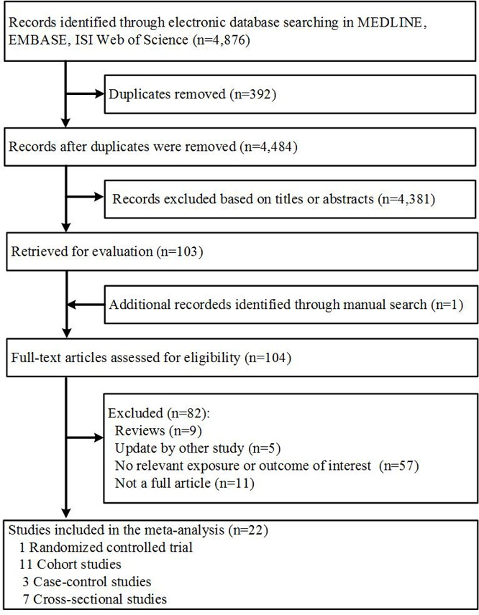
Figure 1. Flow diagram for the literature search and study selection in meta-analysis of omega-3 polyunsaturated fatty acids and fish intake and risk of age-related macular degeneration.

3.2 Study characteristics
The characteristics of the selected studies were presented in Table 1 and Table 2, respectively. Ten studies were prospective cohort studies, three were case-control studies, and the other eight were cross-sectional studies. Among the included studies, 13 studies were carried out in the United States, four in Australia, three in European countries, and one in Japan. Most included studies (n=17) enrolled participants of both sexes, apart from two studies concerned only women, and two concerned only men. The primary outcome of 17 studies was the primary prevention of AMD, while the remaining studies were mainly focus on the secondary prevention of AMD. Dietary information was assessed by food frequency questionnaires (FFQ) in all studies. All of the included studies matched or adjusted for age and smoking, and other adjustment factors included gender (n=15), body mass index (n=11), energy intake (n=9), and alcohol consumption (n=7). Most studies (n=16) were deemed to be of high quality, and the others (n=5) was judged to be of medium quality.
3.3 Dietary omega-3 PUFA and fish intake and risk of early AMD
Seven studies reported data on dietary omega-3 PUFA consumption and the risk of early AMD [11,23,24,29,30,32]. The pooled results revealed that dietary omega-3 PUFA intake was associated with a significantly reduced risk of early AMD (RR: 0.86, 95% CI: 0.77, 0.96) without significant heterogeneity (I² = 0.0%, P_{heterogeneity} =0.55; Figure 2). When each individual omega-3 PUFA was evaluated, increased dietary intakes of EPA (RR: 0.85; 95% CI: 0.76, 0.95; Supplemental Figure 1) and DHA (RR: 0.79, 95% CI: 0.70, 0.90; Supplemental Figure 1) were inversely associated with the risk of early AMD, whereas increased intake of ALA was not associated with early AMD risk (RR: 1.03, 95% CI: 0.84, 1.26; Supplemental Figure 1). The additional dose-response analysis indicated that the risk of developing early AMD decreased significantly by 6% for every 1g/d increase in dietary omega-3PUFA intake (RR: 0.94, 95% CI: 0.88, 1.00; Figure 4A). In terms of specific types of omega-3 PUFA, the summary RRs were 0.88 (95% CI: 0.80, 0.96; Supplemental Figure 3A) and 0.91 (95% CI: 0.87, 0.97; Supplemental Figure 3B) for per 0.15g/d increment in EPA or DHA consumption.
Ten studies contributed to the summary estimate of the association between dietary fish intake and early AMD risk [11,22-25,31-35]. The combined RR for the highest versus the lowest category of intake was 0.79 (95% CI: 0.70, 0.90; I²=27.6%, P_{heterogeneity} =0.19; Figure 2). The dose-response analysis showed that each 15 g/d increase in dietary fish intake was significantly associated with a 13% (95% CI: 4%, 21%; Figure 4B) reduction in early AMD risk. In the stratified analysis by study design, stronger findings were noted in cohort studies (RR: 0.69; 95% CI: 0.58, 0.83) than among cross-sectional studies (RR: 0.89, 95% CI: 0.78, 1.02). No significant difference was found for other prespecified subgroup analysis (Supplemental Table 2).
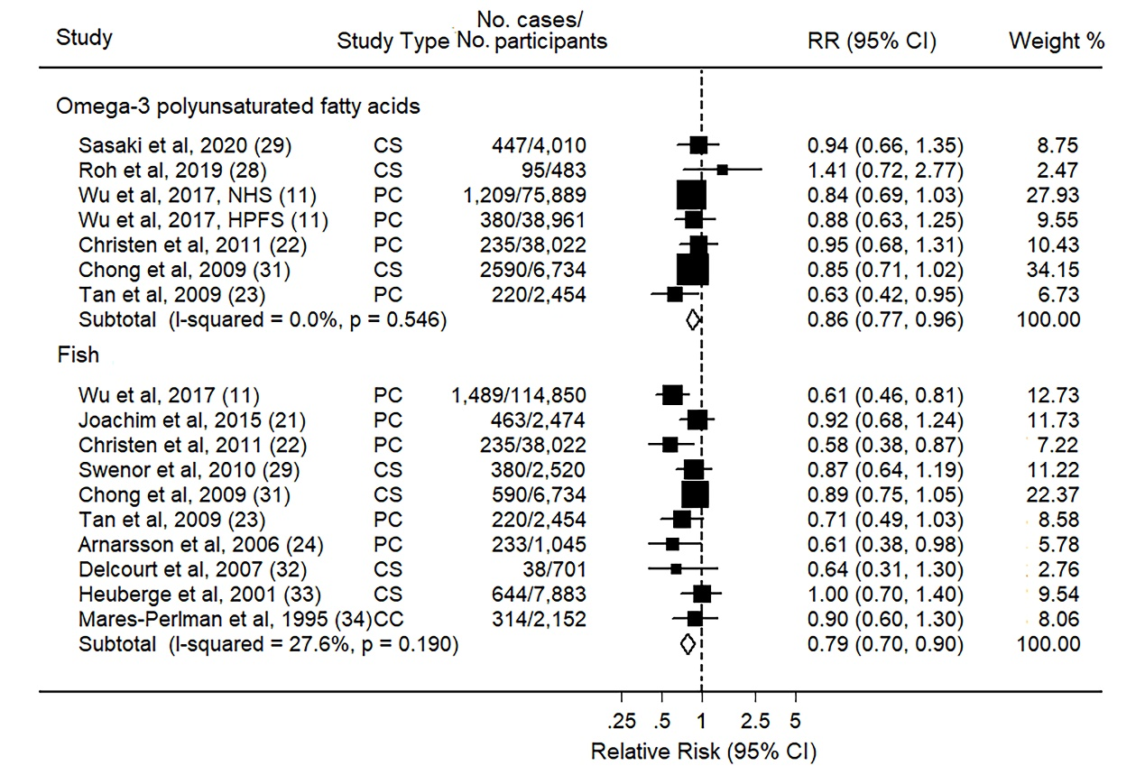
Figure 2. Pooled RRs of early age-related macular degeneration comparing the highest with the lowest categories of dietary intake of omega-3 polyunsaturated fatty acids and fish. The size of the black squares indicates the relative weight of each estimate, horizontal lines indicate 95% CIs, and diamonds indicate the synthesized RR estimates with 95% CIs.
CC, case-control study; CI, confidence interval; CS, cross-sectional study; PC, prospective cohort study; RR, relative risk.

3.4 Dietary omega-3 PUFA and fish intake and risk of late AMD
Nine studies were included to evaluate the association between dietary omega-3 PUFA intake and risk of late AMD [11,12,24,26-29,32]. The pooled RR for late AMD comparing the highest with the lowest category of omega-3 PUFA was 0.71 (95% CI: 0.55, 0.91), with little evidence of statistical heterogeneity (I² = 52.3%, P_{heterogeneity} =0.03) (Figure 3). Among the specific omega-3 PUFA examined, the associations were consistent in the protective direction, but they tended to be weak and statistically nonsignificant (Supplemental Figure 2). In the dose-response analysis, an increment of 1g a day of dietary omega-3 PUFA was associated with 22% (95% CI: 3%, 36%) reduced risk of late AMD (Figure 4C). For individual omega-3 PUFA, each 0.13g/d increase of daily EPA or DHA was associated with a 15% (1%, 27%) and 11% (3%, 18%) lower risk of late AMD, respectively (Supplemental Figure 2C and 2D).
The association between dietary fish consumption and late AMD incidence was evaluated in nine studies [11,12,26-28,31,32,34,35]. No evidence of heterogeneity was detected across these studies (I²=0.0%, P_{heterogeneity} =0.76) and the results indicated a reduced risk of late AMD when extreme fish intake levels were compared (RR: 0.71, 95% CI: 0.60, 0.85). The dose-response analysis found that each increment of 15g/d in fish intake corresponded to a 14% reduction in late AMD risk (95% CI: 10%, 18%; Figure 4D). In stratified analyses, no significant heterogeneity was detected by any of potential risk factors with late AMD risk.
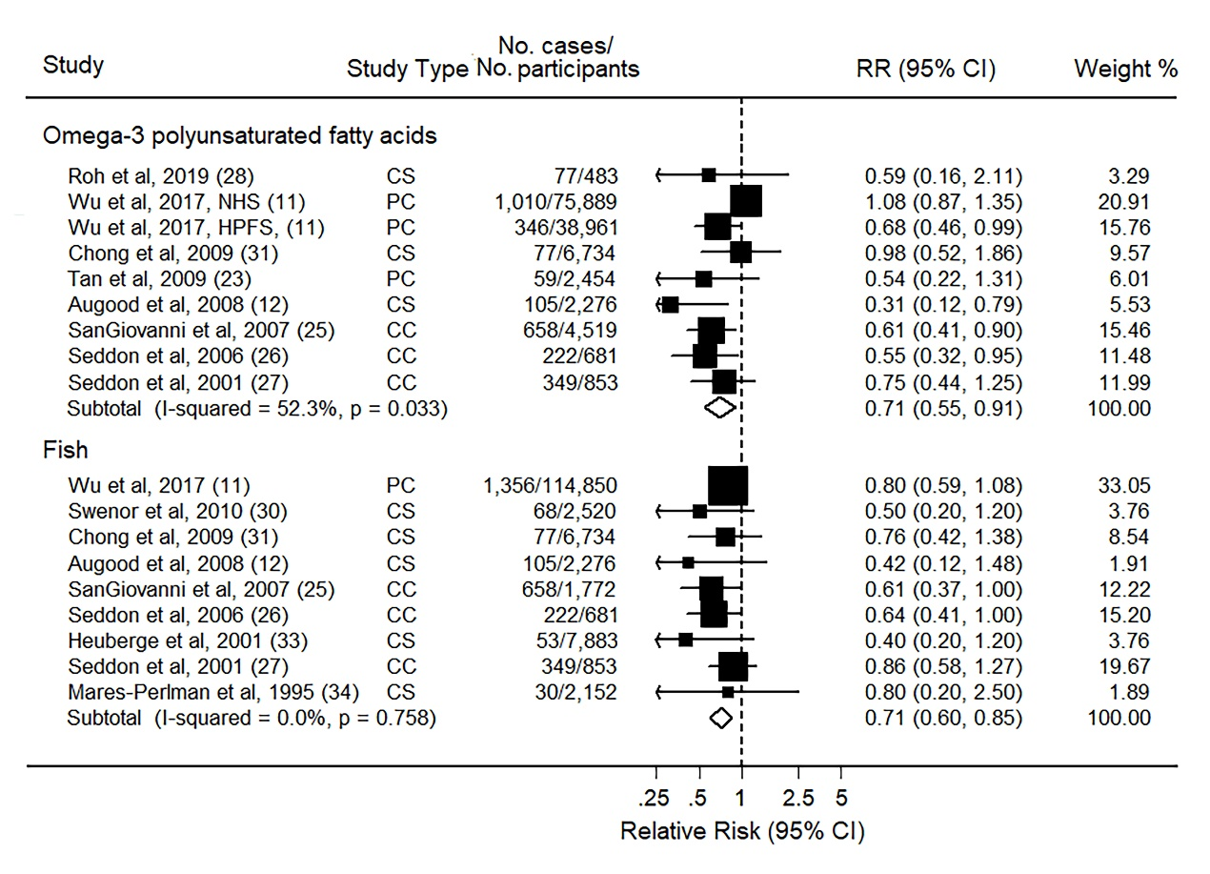
Figure 3. Pooled RRs of late age-related macular degeneration comparing the highest with the lowest categories of dietary intake of omega-3 polyunsaturated fatty acids and fish. The size of the black squares indicates the relative weight of each estimate, horizontal lines indicate 95% CIs, and diamonds indicate the synthesized RR estimates with 95% CIs.
CC, case-control study; CI, confidence interval; CS, cross-sectional study; PC, prospective cohort study; RR, relative risk.
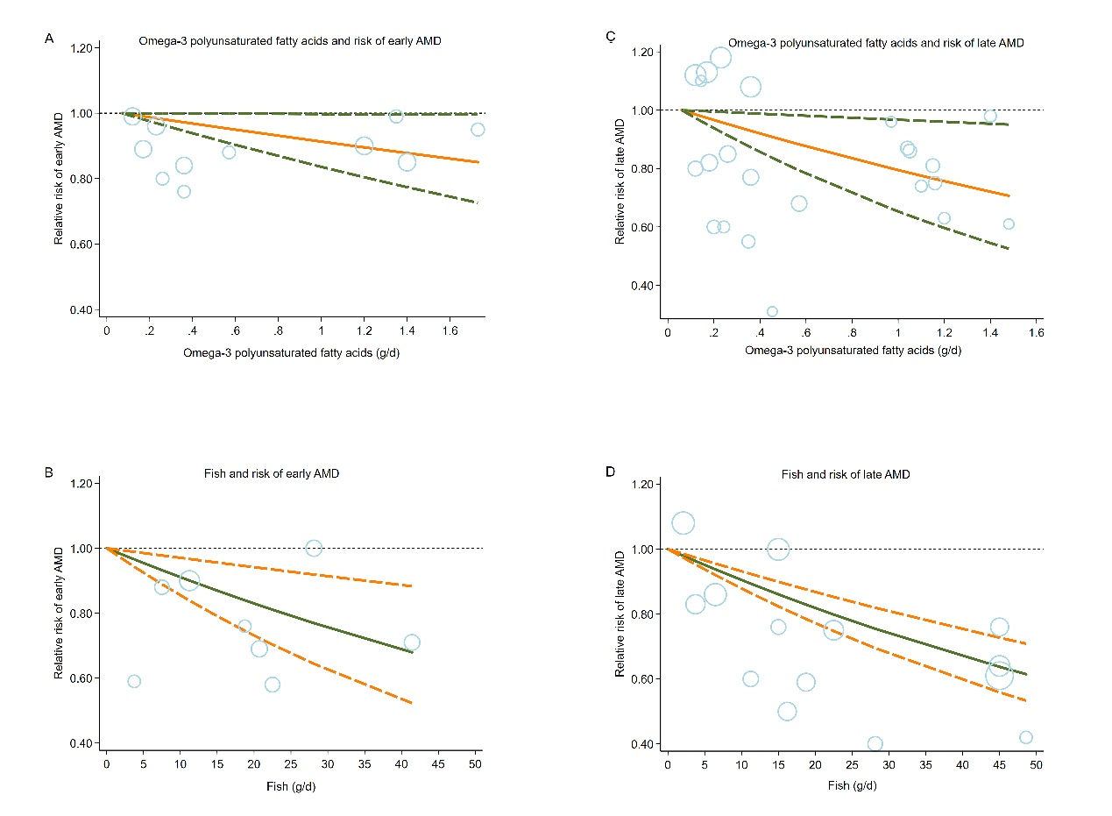
Figure 4. Dose-response relationship of dietary omega-3 polyunsaturated fatty acids and fish consumption with early age-related macular degeneration (AMD) (4-A and 4-B) and late AMD (4-C and 4-D). Circles represent point estimates plotted over precision measures. The solid line and the dotted lines represent the estimated relative risks and their 95% confidence interval.

3.5 Dietary omega-3 PUFA and fish intake and AMD progression
Two studies assessed the association between intake of omega-3 PUFA from diet and the progression of AMD [36,37], and the pooled results showed a nonsignificant estimated risk of AMD progression for intake of dietary omega-3 PUFA (RR:1.12, 95% CI: 0.52, 2.41; I²=67.0%, P_{heterogeneity} =0.08; Figure 5). For individual omega-3 PUFA, dietary intake of EPA (RR: 0.83, 95% CI: 0.74, 0.93) and DHA (RR: 0.83, 95% CI: 0.74, 0.93) appeared to have a nonsignificant inverse association with AMD progression.
Three studies examined associations between fish intake and risks of the AMD progression [22,38,39]. Consumption of fish was significantly associated with a 36% lower risk of progression to advanced AMD when comparing the highest to the lowest category (RR: 0.73, 95% CI: 0.53, 1.00; I² = 51.2%, P_{heterogeneity} =0.13; Figure 5).
3.6 Sensitivity analysis and publication bias
In sensitivity analyses, the significance or direction of the association did not significantly change when omitting one study at a time, which indicated the robustness of the results. No indication of publication bias was found with respect to fish and omega-3 PUFA intake from diet in relation to risk of AMD incidence or progression by using Egger’s test (P ≥ 0.05) and Begg’s test (P ≥ 0.05) and visual inspection of the funnel plot (Supplemental Figure 3).
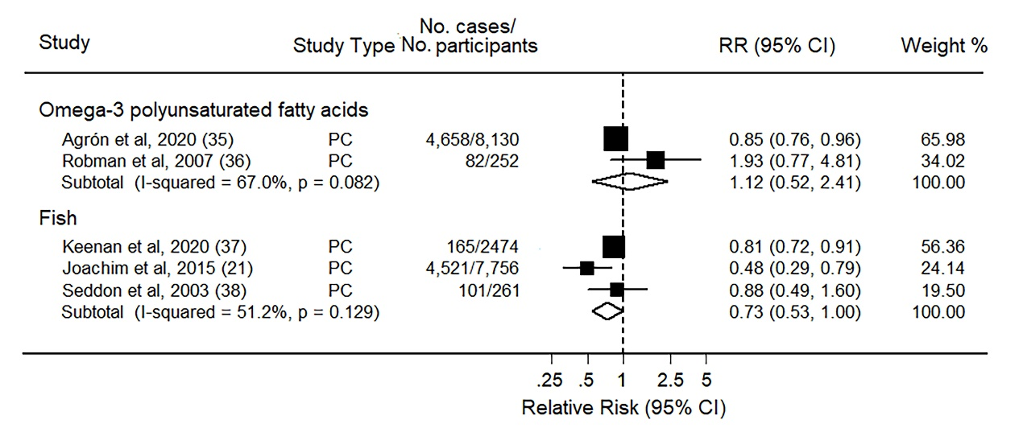
Figure 5. Pooled RRs of age-related macular degeneration progression comparing the highest with the lowest categories of dietary intake of omega-3 polyunsaturated fatty acids and fish. The size of the black squares indicates the relative weight of each estimate, horizontal lines indicate 95% CIs, and diamonds indicate the synthesized RR estimates with 95% CIs.
CI, confidence interval; PC, prospective cohort study; RR, relative risk.

4. Discussion
In the present meta-analysis, a higher dietary omega-3 PUFA intake was associated with a significant decrease in the risk of AMD. Significant inverse association was also consistently observed for dietary fish consumption with risk of developing or progression of AMD. Our results support a protective effect of greater consumption of omega-3 PUFAs and their predominant source, which raise the possibility of generating public health recommendations and nutritional guidelines in AMD prevention.
Numerous studies over the past decades showed that omega-3 PUFA and fish, the main source of omega-3 PUFA in the diet, were significantly associated with a reduced risk of CVD, which not only promotes these nutrients included in the current healthy eating guidelines for preventing noncommunicable diseases, but also leads to the detection of potential effect of omega-3 PUFA on AMD on the basis of notion that cardiovascular episodes and AMD share similar pathophysiological determinants [8,10]. SanGiovanni et al. reported an inverse association of omega-3 PUFA and fish intake and prevalence of late AMD among 4,519 individuals in the Age-Related Eye Disease Study case-control study [26]. Similarly, among 39,876 females in the Women’s Health Study without AMD at baseline, Christen et al. found an approximately 35% to 45% reduction in early AMD risk corresponding to regular DHA and EPA and fish consumption as compared with those who rarely consumed it [23]. Nonetheless, in another cohort study conducted among 3,654 Australia residents, a modest non-significant inverse relationship with AMD was found among persons with relatively high dietary omega-3 PUFA intake over 10 years [24]. A meta-analysis of nine observational studies published in 2008, finding that high dietary intakes of fish was associated with a 24% decrease in the risk of early AMD, which was similar to that of the association of fish and foods rich in omega-3 PUFA with late AMD [14]. A meta-analysis conducted by Zhu et al. evaluated findings from observational studies on fish consumption and the risk of AMD and found that fish consumption could reduce AMD risk [40]. Our results are consistent with those of the previous meta-analysis that found a clear benefit of increasing dietary intake of omega-3 PUFA and the main sources of omega-3 PUFA in the diet on the primary prevention of AMD. This result was supported by our dose-response analysis that increment in omega-3 PUFA and fish intake corresponded to the reduction in AMD risk. The strength of the inverse associations with risk of early and late AMD were similar for fish and omega-3 PUFA, indicating that the potential benefit of fish consumption may mainly be attributed to omega-3 PUFA.
Several mechanisms have been suggested to be underlying the protective effects of omega-3 PUFA and fish on the AMD prevention, including alleviation of oxidative stress and inflammation, and improvement of photoreceptor cell function [5-7]. Accumulating evidence suggests that oxidative damage and inflammation might play a central role in the RPE injury and the accumulation of degradative end-products in the retina, which directly contribute to the formation of drusen [41]. It has been proposed that omega-3 PUFA have active biological properties relevant to inhibiting the expression of inﬂammation-related gene. Oh et al. demonstrated that EPA and DHA could inhibit both TLR and TNF-α inflammatory signaling pathways by signaling through GPR120 in obese WT and GPR120 knockout mice [42]. In CCL₂^{−/−}/CX₃CR₁^{−/−} induced AMD animal model, Tuo et al. reported that treatment with high levels of omega-3 PUFA could neutralize the underlying detrimental effect of these vivo derivatives by decreasing the pro-inflammatory derivatives derived from arachidonic acid and increasing anti-inflammatory derivative, which further mitigate the progression of retinal lesions [43-45]. Using a NaIO₃-induced retinal damage rat model, Qiu et al. observed a substantial increase in superoxide dismutase activity and Nrf2 expression after intravitreal DHA injection, suggesting that DHA could attenuate oxidative stress in the retina [46]. Another probable mechanism by which omega-3 PUFA may affect AMD development is through influence biochemical and biophysical properties of photoreceptor cells. DHA is a major structural component of the retinal outer segments of photoreceptor, accounting for more than 80% of PUFAs in photoreceptor disk membranes, and therefore, the deficiency of this nutrients might impair retinal function and promote AMD [47]. As another important component of omega-3 PUFA, EPA have been shown to suppress the formation of a vascular endothelial growth factor directly via downregulating activation and expression of tyrosine kinase receptor that decreases the probability of endothelial cell migration and proliferation [7+X]. Results from a four-week EPA and DHA supplementation trial (3 g/day) suggested that EPA had more prominent effect on anti-inflammatory cytokine balance, while DHA appeared to be more favorable in inhibiting pro-inflammatory cytokines of peripheral immune system [7+XX].
In the present study, no significant inverse association was found between dietary omega-3 PUFA intake and progression of AMD, which was in line with the result from observed in the Age-Related Eye Disease Study (AREDS) 2 that supplementation with DHA and EPA did not reduce risk of progression to advanced AMD [48]. The inconsistent association of AMD risk and AMD progression may be explained by changes in diet as a consequence of development of AMD. If participants reported a diagnosis of AMD, they could have changed dietary and lifestyle patterns, and substantially increased omega-3 PUFA consumption. Thus, changes in diet after development of AMD may confound the relationship between diet and AMD progression. Previous studies had found that no significant inverse association was observed between coffee consumption and deaths attributed to colorectal cancer (CRC); however, intake of coffee after diagnosis of CRC was associated with lower risk of CRC-specific death and overall death [49, 50]. For most included studies examining the association between dietary omega-3 PUFA intake and AMD progression, dietary omega-3 PUFA consumption was measured only once at baseline and pre- and post-diagnostic omega-3 PUFA intake were not accounted for. Further prospective cohort studies in AMD patients are warranted to confirm our findings and needed to better understand the potential role of pre- and post-diagnostic omega-3 PUFA intake in the progression to advanced AMD.
Increasing omega-3 PUFA consumption has been considered as part of an important modifiable prevention strategy for preventing or delaying the onset of chronic disorders [51, 52]. Dietary guidelines of the International Society for the Study of Fatty Acids and Lipids (ISSFAL) recommend a daily consumption of at least 500 mg EPA and DHA for cardiovascular health [53]. However, it has been estimated that over 80% of the world population consumes less than 250 mg/d of seafood omega-3 PUFA [54]. Considering the global high prevalence of AMD and low intake of omega-3 PUFA, increasing intake of foods rich in omega-3 PUFA in the general population is of great public health significance in terms of AMD prevention. For the majority of the subjects who consumed a low omega-3 PUFA diet, the favorable effect seems to exist persistently with increasing values of omega-3 PUFA. Because of the relatively small sample size of participants with a dietary EPA and DHA intake above 500 mg, our study had limited power to study associations with more extreme categories (i.e., beyond 500 mg/d) of EPA and DHA consumption. Further studies are needed to investigate the additional benefit from consuming EPA and DHA above the recommended level.
Several limitations of the current study should be mentioned. First, although all included studies took into account known confounding factors, the possibility of other unknown or residual confounding covariates could not be excluded. For instance, individuals with higher omega-3 PUFA and fish intake often clusters with healthier background characteristics, such as higher physical activity and less smoking, and were more likely to result in an attenuation of the association [55]. Second, all studies included in our analysis assessed levels of dietary omega-3 PUFA and fish intake using self-report FFQ. Even though several of which were relied on validity of questionnaires, measurement error in assessment was inevitable. Moreover, the contents of omega-3 PUFA could alter depending on different cooking methods of food, which might have confounded the true associations [56]. Third, the definition of AMD varied across different studies. Although subgroup analysis by the definition of AMD showed no statistically significant variation in risk of AMD among subgroups with different classification and grading systems for AMD, we cannot fully exclude the possibility of the discrepancy of AMD definition, which might have led to underestimation or overestimation of the association. Fourth, omega-3 PUFA supplement use may also have a potential effect on the outcome of interest. The included studies did not examine the association of the omega-3 PUFA supplement use with AMD risk, and we could only investigate the pooled risk estimate of AMD associated with dietary omega-3 PUFA intake. Although our subgroup analysis further suggested that adjustment for omega-3 PUFA supplement use did not significantly alter the association between dietary omega-3 PUFA intake and AMD risk, the possibility that nutritional supplements might affect the AMD risk interactively with dietary omega-3 PUFA cannot completely rule out in the present study. Future research may be needed to evaluate the interaction between omega-3 PUFA supplement use and dietary omega-3 PUFA intake in relation to risk of AMD. Fifth, as the participants of the included studies were predominantly Caucasian, the generalizability of the observed associations may be limited to similar populations. Finally, although no indication of publication bias was found with statistical tests and visual inspection, the likelihood of publication bias cannot be fully ruled out.
5. Conclusion
In summary, results from the present study suggest that dietary omega-3 PUFA and fish intake was inversely associated with risk of both early and late AMD. These findings not only provide a foundation of knowledge on which public health benefits at the population level can be discussed but also expand existing evidence of dietary omega-3 PUFA on health outcome. However, considering the potential limitations of the current study, additional studies that provide a more accurately quantified estimates of dietary omega-3 PUFA consumption were required.

Author Contributions: LM, CP, and JZ generated the idea for the study, formulated an analytical plan. All authors acquired, analyzed, or interpreted the data. HJ and XS designed the search strategy, and HJ, XS, Y-HF and performed the literature search and screened studies for eligibility. XS, Y-HF and B-YL extracted data. XS and B-YL assessed the risk of bias. HJ and Y-HF performed data analysis. D-LW, HJ, and LM interpreted the data analysis and assessed the certainty of evidence. HJ drafted the manuscript and all other authors revised the manuscript. LM, CP, and JZ supervised the study. The corresponding author attests that all listed authors meet authorship criteria and that no others meeting the criteria have been omitted.
Conflict of interest: The authors declare no conflicts of interest.
Funding: This work was Supported by the National Natural Science Foundation of China (NSFC-82022062; NSFC-81973025; NSFC-81473059); Beijing Zhongyinghui Nutrition and Health Research Institute, the Chinese Nutrition Society Academy of Nutrition and Health (CNSCI2021043); Nutrition Science Research Foundation of BY-HEALTH (TY0181101); the Natural Science Foundation of Shaanxi Province of China (2017JM8041); New-star Plan of Science and Technology of Shaanxi Province (2015LJXX-07); the Nutrition Research Foundation Fund of the Chinese Nutrition Society-DSM Special Research Foundation (CNSDSM 2016-041); and the Fundamental Research Funds for the Central Universities (qngz2016004; xzy032019008).

References
[1] Wong WL, Su X, Li X, Cheung CMG, Klein R, Cheng CY. Global prevalence of age-related macular degeneration and disease burden projection for 2020 and 2040: a systematic review and meta-analysis. Lancet Glob Health 2014; 2(2): e106-16.
[2] Mitchell P, Liew G, Gopinath B, Wong TY. Age-related macular degeneration. Lancet 2018; 392(10153):1147-59.
[3] Nguyen QD, Das A, Do DV, Dugel PU, Gomes A, Holz FG, Koh A, Pan CK, Sepah YJ, Patel N, MacLeod H, Maurer P. Brolucizumab: evolution through preclinical and clinical studies and the implications for the management of neovascular age-related macular degeneration. Ophthalmology 2020; 127(7):963-76.
[4] Rosenfeld PJ, Brown DM, Heier JS, Boyer DS, Kaiser PK, Chung CY, Kim RY; MARINA Study Group. Ranibizumab for neovascular age-related macular degeneration. N Engl J Med 2006; 355(14):1419-31.
[5] Khandhadia S, Lotery A. Oxidation and age-related macular degeneration: insights from molecular biology. Expert Rev Mol Med 2010; 12:e34.
[6] Swanson D, Block R, Mousa SA. Omega-3 fatty acids EPA and DHA: health benefits throughout life. Adv Nutr 2012; 3(1):1-7.
[7] Abokyi S, To CH, Lam TT, Tse DY. Central role of oxidative stress in age-related macular degeneration: evidence from a review of the molecular mechanisms and animal models. Oxid Med Cell Longev 2020; 2020: 7901270.
[8] Herforth A, Arimond M, Álvarez-Sánchez C, Coates J, Christianson K, Muehlhoff E. A global review of food-based dietary guidelines. Adv Nutr 2019; 10(4):590-605.
[9] von Schacky C, Angerer P, Kothny W, Theisen K, Mudra H. The effect of dietary omega-3 fatty acids on coronary atherosclerosis. A randomized, double-blind, placebo-controlled trial. Ann Intern Med 1999; 130(7):554-62.
[10] Aldosari S, Awad M, Harrington EO, Sellke FW, Abid MR. Subcellular reactive oxygen species (ROS) in cardiovascular pathophysiology. Antioxidants (Basel) 2018; 7(1):14.
[11] Wu J, Cho E, Giovannucci EL, Rosner BA, Sastry SM, Willett WC, Schaumberg DA. Dietary intakes of eicosapentaenoic acid and docosahexaenoic acid and risk of age-related macular degeneration. Ophthalmology 2017; 124(5):634‐43.
[12] Augood C, Chakravarthy U, Young I, et al. Oily fish consumption, dietary docosahexaenoic acid and eicosapentaenoic acid intakes, and associations with neovascular age-related macular degeneration. Am J Clin Nutr 2008; 88(2):398‐406.
[13] Parekh N, Voland RP, Moeller SM, Blodi BA, Ritenbaugh C, Chappell RJ, Wallace RB, Mares JA; CAREDS Research Study Group. Association between dietary fat intake and age-related macular degeneration in the Carotenoids in Age-Related Eye Disease Study (CAREDS): an ancillary study of the Women's Health Initiative. Arch Ophthalmol 2009; 127(11):1483‐93.
[14] Chong EW, Kreis AJ, Wong TY, Simpson JA, Guymer RH. Dietary omega-3 fatty acid and fish intake in the primary prevention of age-related macular degeneration: a systematic review and meta-analysis. Arch Ophthalmol 2008; 126(6):826‐33.
[15] Stroup DF, Berlin JA, Morton SC, Olkin I, Williamson GD, Rennie D, et al. Meta-analysis of Observational Studies in Epidemiology (MOOSE) Group. Meta-analysis of observational studies in epidemiology: a proposal for reporting. JAMA 2000; 283(15): 2008-12.
[16]Wells GA, Shea B, O’Connell D, Peterson J, Welch V, Losos M, et al. The Newcastle-Ottawa Scale (NOS) for assessing the quality of nonrandomised studies in meta-analyses. (Accessed December 15, 2020, at www.ohri.ca/programs/clinical_epidemiology/oxford.html.)
[17] Zeng X, Zhang Y, Kwong JS, Zhang C, Li S, Sun F, Niu Y, Du L. The methodological quality assessment tools for preclinical and clinical studies, systematic review and meta-analysis, and clinical practice guideline: a systematic review. J Evid Based Med 2015; 8(1):2‐10.
[18] Huedo-Medina TB, Sanchez-Meca J, Marin-Martinez F, Botella J. Assessing heterogeneity in meta-analysis: Q statistic or I2 index? Psychol Methods 2006; 11:193-206.
[19] Orsini N, Bellocco R, Greenland S. Generalized least squares for trend estimation of summarized dose-response data. Stata J 2006; 6:40-57.
[20] Rong Y, Chen L, Zhu T, et al. Egg consumption and risk of coronary heart disease and stroke: dose-response meta-analysis of prospective cohort studies. BMJ 2013; 346: e8539.
[21] Zheng JS, Hu XJ, Zhao YM, Yang J, Li D. Intake of fish and marine n-3 polyunsaturated fatty acids and risk of breast cancer: meta-analysis of data from 21 independent prospective cohort studies. BMJ 2013; 346: f3706.
[22] Joachim N, Mitchell P, Burlutsky G, Kifley A, Wang JJ. The incidence and progression of age-related macular degeneration over 15 years: The Blue Mountains Eye Study. Ophthalmology 2015; 122(12):2482‐9.
[23] Christen WG, Schaumberg DA, Glynn RJ, Buring JE. Dietary ω-3 fatty acid and fish intake and incident age-related macular degeneration in women. Arch Ophthalmol 2011; 129(7):921‐9.
[24] Tan JS, Wang JJ, Flood V, Mitchell P. Dietary fatty acids and the 10-year incidence of age-related macular degeneration: The Blue Mountains Eye Study. Arch Ophthalmol 2009; 127(5):656‐65.
[25] Arnarsson A, Sverrisson T, Stefánsson E, Sigurdsson H, Sasaki H, Sasaki K, Jonasson F. Risk factors for five-year incident age-related macular degeneration: the Reykjavik Eye Study. Am J Ophthalmol 2006; 142(3):419-28.
[26] SanGiovanni JP, Chew EY, Clemons TE, et al. The relationship of dietary lipid intake and age-related macular degeneration in a case-control study: AREDS Report No. 20. Arch Ophthalmol 2007; 125(5):671‐9.
[27] Seddon JM, George S, Rosner B. Cigarette smoking, fish consumption, omega-3 fatty acid intake, and associations with age-related macular degeneration: the US Twin Study of Age-Related Macular Degeneration. Arch Ophthalmol 2006; 124(7):995‐1001.
[28] Seddon JM, Rosner B, Sperduto RD, Yannuzzi L, Haller JA, Blair NP, Willett W. Dietary fat and risk for advanced age-related macular degeneration. Arch Ophthalmol 2001; 119(8):1191‐9.
[29] Roh M, Shin HJ, Laíns I, et al. Higher intake of polyunsaturated fatty acid and monounsaturated fatty acid is inversely associated with AMD. Invest Ophthalmol Vis Sci 2020; 61(2):20.
[30] Sasaki M, Harada S, Tsubota K, Yasukawa T, Takebayashi T, Nishiwaki Y, Kawasaki R. Dietary saturated fatty acid intake and early age-related macular degeneration in a Japanese population. Invest Ophthalmol Vis Sci 2020; 61(3):23.
[31] Swenor BK, Bressler S, Caulfield L, West SK. The impact of fish and shellfish consumption on age-related macular degeneration. Ophthalmology 2010; 117(12):2395‐401.
[32] Chong EW, Robman LD, Simpson JA, Hodge AM, Aung KZ, Dolphin TK, English DR, Giles GG, Guymer RH. Fat consumption and its association with age-related macular degeneration. Arch Ophthalmol 2009; 127(5):674‐80.
[33] Delcourt C, Carrière I, Cristol JP, Lacroux A, Gerber M. Dietary fat and the risk of age-related maculopathy: the POLANUT study. Eur J Clin Nutr 2007; 61(11):1341‐4.
[34] Heuberger RA, Mares-Perlman JA, Klein R, Klein BE, Millen AE, Palta M. Relationship of dietary fat to age-related maculopathy in the Third National Health and Nutrition Examination Survey. Arch Ophthalmol 2001; 119(12):1833‐8.
[35] Mares-Perlman JA, Brady WE, Klein R, VandenLangenberg GM, Klein BE, Palta M. Dietary fat and age-related maculopathy. Arch Ophthalmol 1995; 113(6):743‐8.
[36] Agrón E, Mares J, Clemons TE, Swaroop A, Chew EY, Keenan TDL, AREDS and AREDS2 Research Groups. Dietary nutrient intake and progression to late age-related macular degeneration in the Age-Related Eye Disease Studies 1 and 2. Ophthalmology 2021; 128(3):425-42.
[37] Robman L, Vu H, Hodge A, Tikellis G, Dimitrov P, McCarty C, Guymer R. Dietary lutein, zeaxanthin, and fats and the progression of age-related macular degeneration. Can J Ophthalmol 2007; 42(5):720-6.
[38] Keenan TD, Agrón E, Mares J, Clemons TE, van Asten F, Swaroop A, Chew EY; Age-Related Eye Disease Studies (AREDS) 1 and 2 Research Groups. Adherence to the Mediterranean diet and progression to late age-related macular degeneration in the Age-Related Eye Disease Studies 1 and 2. Ophthalmology 2020; 127(11):1515-28.
[39] Seddon JM, Cote J, Rosner B. Progression of age-related macular degeneration: association with dietary fat, transunsaturated fat, nuts, and fish intake. Arch Ophthalmol 2003; 121(12):1728-37.
[40] Zhu W, Wu Y, Meng YF, Xing Q, Tao JJ, Lu J. Fish consumption and age-related macular degeneration incidence: a meta-analysis and systematic review of prospective cohort studies. Nutrients. 2016 22; 8(11):743.
[41] Crabb JW, Miyagi M, Gu X, et al. Drusen proteome analysis: an approach to the etiology of age-related macular degeneration. Proc Natl Acad Sci USA 2002; 99(23):14682-7.
[42] Oh DY, Talukdar S, Bae EJ, Imamura T, Morinaga H, Fan W, Li P, Lu WJ, Watkins SM, Olefsky JM. GPR120 is an omega-3 fatty acid receptor mediating potent anti-inflammatory and insulin-sensitizing effects. Cell 2010; 142(5):687-98.
[43] Kishan AU, Modjtahedi BS, Martins EN, Modjtahedi SP, Morse LS. Lipids and age-related macular degeneration. Surv Ophthalmol 2011; 56(3):195‐213.
[44] Agbaga MP, Merriman DK, Brush RS, et al. Differential composition of DHA and very-long-chain PUFAs in rod and cone photoreceptors. J Lipid Res 2018; 59(9):1586‐96.
[45] Tuo J, Ross RJ, Herzlich AA, Shen D, Ding X, Zhou M, Coon SL, Hussein N, Salem N Jr, Chan CC. A high omega-3 fatty acid diet reduces retinal lesions in a murine model of macular degeneration. Am J Pathol 2009; 175(2):799‐807.
[46] Qiu S, Wei Y, Zhou X, Jiang Z, Zhang T, Jiang X, Zhang S. Intravitreal injection of docosahexaenoic acid attenuated photoreceptor cell injury in a NaIO₃-induced age-related macular degeneration rat model. Neurosci Lett 2017; 657:53‐61.
[47] Vinding T, Appleyard M, Nyboe J, Jensen G. Risk factor analysis for atrophic and exudative age-related macular degeneration. An epidemiological study of 1000 aged individuals. Acta Ophthalmol (Copenh) 1992; 70(1):66-72.
[48] Age-Related Eye Disease Study 2 Research Group. Lutein + zeaxanthin and omega-3 fatty acids for age-related macular degeneration: the Age-Related Eye Disease Study 2 (AREDS2) randomized clinical trial. JAMA 2013; 309(19):2005-15.
[49] Ding M, Satija A, Bhupathiraju SN, Hu Y, Sun Q, Han J, Lopez-Garcia E, Willett W, van Dam RM, Hu FB. Association of coffee consumption with total and cause-specific mortality in 3 large prospective cohorts. Circulation 2015; 132(24):2305-15.
[50] Hu Y, Ding M, Yuan C, et al. Association between coffee intake after diagnosis of colorectal Cancer and reduced mortality. Gastroenterology 2018; 154 (4):916-26.
[51] Chowdhury R, Stevens S, Gorman D, et al Association between fish consumption, long chain omega 3 fatty acids, and risk of cerebrovascular disease: systematic review and meta-analysis. BMJ 2012; 345:e6698.
[52] Jiang L, Wang J, Xiong K, Xu L, Zhang B, Ma A. Intake of fish and marine n-3 polyunsaturated fatty acids and risk of cardiovascular disease mortality: A meta-analysis of prospective cohort studies. Nutrients 2021; 13(7):2342.
[53] International Society for the Study of Fatty Acids (June 2004). Report of the sub-committee on recommendations for intake of polyunsaturated fatty acids in healthy adults. [online] Available at: https://www.issfal.org/assets/issfal%2003%20pufaintakereccomdfinalreport.pdf.
[54] Micha R, Khatibzadeh S, Shi P, et al. Global, regional, and national consumption levels of dietary fats and oils in 1990 and 2010: a systematic analysis including 266 country-specific nutrition surveys. BMJ 2014; 348: g2272.
[55] Zhang Y, Zhuang P, He W, Chen JN, Wang WQ, Freedman ND, Abnet CC, Wang JB, Jiao JJ. Association of fish and long-chain omega-3 fatty acids intakes with total and cause-specific mortality: prospective analysis of 421 309 individuals. J Intern Med 2018; 284(4):399-417.
[56] Leung KS, Galano JM, Durand T, Lee JC. Profiling of omega-3 polyunsaturated fatty acids and their oxidized products in salmon after different cooking methods. Antioxidants (Basel) 2018; 7(8):96.

Table 1. General characteristics of included studies evaluating omega-3 fatty acids and fish intake for the developing of AMD
Characteristics of the study |  |  |  | Characteristics of the participant |  | Characteristics of the exposure |  | Characteristics of the outcome |  | Adjustment for confounding  factors | Study quality*
Author, publication year, country | Study name | Design | Follow up (year) | Participants | Men (%) | Exposure assessment | Exposure | Clarification  criteria | Cases of AMD (n)
Wu et al, 2017, United States ^{[11]} | Nurses’ Health Study  (VBS) | Prospective cohort | 28.0 | 75,889 women aged ≥ 50y | 0.0 | 130-item validated FFQ | Fish, omega-3, ALA, EPA, DHA | NR | 1,209 early AMD, 1,010 late AMD | Age, race, smoking, BMI, physical activity, aspirin use, HT use, postmenopausal status, energy intake, history of hypertension and hypercholesterolemia | High
Wu et al, 2017, United States ^{[11]} | Health Professional Follow-up Study (VBS) | Prospective cohort | 24.0 | 38,961 men aged ≥ 50y | 100.0 | 130-item validated FFQ | Fish, omega-3, ALA, EPA, DHA | NR | 380 early AMD, 346 late AMD | Age, race, smoking, BMI, physical activity, aspirin use, energy intake, history of hypertension and hypercholesterolemia | High
Joachim et al, 2015, Australia ^{[22]} | Blue Mountains Eye Study (PBS) | Prospective cohort | 15.0 | 2,474 men and women aged ≥ 49y | 42.4 | 145-item validated FFQ | Fish | WARMGS | 463 early AMD | Age, sex, smoking, CFH, ARMS2 polymorphisms | High
Christen et al, 2011, United States ^{[23]} | Women’s Health Study (VBS) | Prospective cohort | 10.0 | 38,022 women aged ≥ 45y | 0.0 | 131-item validated FFQ | Fish, omega-3, ALA, EPA, DHA | NR | 235 early AMD | Age, smoking, alcohol, BMI, aspirin and vitamin E treatment assignment, menopausal status, HT use, multivitamin use, saturated fat, monounsaturated fat, and trans unsaturated fats intake, history of diabetes, hypertension, high cholesterol, and eye examination | High
Tan et al, 2009, Australia ^{[24]} | Blue Mountain Eye Study (PBS) | Prospective cohort | 10.5 | 2,454 men and women aged ≥ 49y | 51.8 | 145-item validated FFQ | Fish, omega-3, ALA | WARMGS | 220 early AMD, 59 late AMD | Age, sex, smoking | High
Arnarsson et al, 2006, Iceland ^{[25]} | Reykjavik Eye Study  (PBS) | Prospective cohort | 5.0 | 1,045 men and women aged ≥ 50y | NR | 16-item FFQ | Fish | ICGS | 233 early AMD | Age, sex, smoking | High
SanGiovanni et al, 2007, United States ^{[26]} | AREDS (VBS) | AREDS 1 and 2 | - | 4,519 men and women aged 60-80y | NR | 90-item FFQ | Fish, omega-3, ALA, EPA, DHA | AREDS classification system | 658 late AMD | Age, sex, race, smoking, alcohol, education, refractive error, BMI, lutein, zeaxanthin, and energy intake, history of hypertension and lens opacity | High
Seddon et al, 2006, United States ^{[27]} | United States Twin Study of AMD (PBS) | Case-control | - | 681 men aged ≥ 60y | 100.0 | FFQ | Fish, omega-3 | CARMS | 222 late AMD | Age, smoking, alcohol, education, BMI, physical activity, SBP, β-carotene, zinc, vitamins E and C, and energy intake, history of CVD | Medium
Seddon et al, 2001, United States ^{[28]} | Eye Disease Case Control Study (HBS) | Case-control | - | 853 men and women aged 55-80y | NR | FFQ | Omega-3 | NR | 349 late AMD | Age, sex, smoking, alcohol, education, BMI, physical activity, clinic, carotenoid and energy intake, history of hypertension | High
Roh, et al, 2020, United States ^{[29]} | United States cohort (VBS) | Cross-sectional | - | 483 men and women aged ≥ 50y | 39.4 | 86-item validated FFQ for the Portuguese population; 61- item validated FFQ for the American population | Omega-3 | AREDS classification system | 95 early AMD, 77 late AMD | Age, sex, race, smoking,  physical activity, history of hypertension | High
Sasaki et al, 2020, Japan ^{[30]} | Tsuruoka Metabolomics Cohort Study (PBS) | Cross-sectional | - | 4,010 men and women aged 35-74y | 44.5 | Validated FFQ | Omega-3 | WARMGS | 447 early AMD | Age, sex, BMI, smoking, hypertension, dyslipidemia, β-carotene, vitamin C, and vitamin E intake, history of diabetes | Medium
Swenor et al, 2010, United States ^{[31]} | Salisbury Eye Evaluation Study (PBS) | Cross-sectional | - | 2,520 men and women aged 65-84y | 42.8 | 91-item validated FFQ | Fish | NR | 380 early AMD, 68 late AMD | Age, sex, race,  smoking, correlation between eyes | High
Chong et al, 2009, Australia ^{[32} | Melbourne Collaborative Cohort Study (VBS) | Cross-sectional | - | 6,734 men and women aged 66-85y | 38.9 | 121-item FFQ | Omega-3, ALA, EPA, DHA | ICGS | 2,590 early AMD, 77 late AMD | Age, sex, smoking, dietary vitamin C, vitamin E, β-carotene, zinc, lutein, zeaxanthin, and energy intake, supplements use | High
Augood et al, 2008, Europe ^{[12]} | European Eye Study (PBS) | Cross-sectional | - | 2,276 men and women aged ≥ 65y | 44.9 | 130-item FFQ | Fish, omega-3, EPA, DHA | ICGS | 105 late AMD | Age, sex, smoking, aspirin use, energy intake, history of diabetes | Medium
Delcourt et al, 2007, France ^{[33} | Pathologies Oculaires Lie´es a` l’Age study (PBS) | Cross-sectional | - | 701 men and women aged ≥ 60y | NR | 165-item validated FFQ: | Fish | ICGS | 38 early AMD, 10 late AMD | Age, sex, smoking, BMI, history of CVD | Medium
Heuberger et al, 2001, United States ^{[34]} | National Health and Nutrition Examination Survey 3 (PBS) | Cross-sectional | - | 7,883men and women aged 40-79y | NR | 66-item validated FFQ: | Fish | Modified WARMGS | 644 early AMD, 53 late AMD | Age, race, smoking | Medium
Mares-Perlman et al, 1995, United States ^{[35]} | Beaver Dam Eye Study (PBS) | Cross-sectional | - | 2,152 men and women 45-84y | NR | Validated FFQ | Fish | WARMGS | 314 early AMD, 30 late AMD | Age, smoking, alcohol | High
ALA, alpha -linolenic acid; AMD, age-related macular degeneration; AREDS, Age-Related Eye Disease Study; ARMS2, age-related maculopathy susceptibility gene 2; BMI, body mass index; CARMS, Clinical Age-Related Maculopathy Staging System; CFH, complement factor H; CVD, cardiovascular disease; EPA, eicosapentaenoic acid; DHA, docosahexaenoic acid; FFQ, food frequency questionnaire; HBS, hospital-based study; HT, hormone therapy; ICGS, International Classification and Grading System; NR, not reported; PBS, population-based study; SBP, systolic blood pressure; VBS, volunteer-based study; WARMGS, Wisconsin Age-Related Maculopathy Grading System.
*Study quality for cohort and case-control studies was assessed with the use of Newcastle-Ottawa Scale and cross-sectional studies was assessed with the use of Agency for Healthcare Research and Quality.

Table 2. General characteristics of included studies evaluating omega-3 fatty acids and fish intake for the progression of AMD
Characteristics of the study |  |  |  | Characteristics of the participant |  | Characteristics of the exposure |  | Characteristics of the outcome |  | Adjustment for confounding  factors | Study quality*
Author, publication year, country | Study name | Design | Follow up (year) | Participants | Men (%) | Exposure assessment | Exposure | Clarification  criteria | Cases of AMD (n)
Agrón et al, 2020, United States ^{[36]} | AREDS 1 and 2 (VBS) | Prospective cohort | 10.2 | 8,130 men and women aged 50-85y | 43.5 | 90-item FFQ (AREDS); 131 FFQ (AREDS2) | Omega-3, EPA, DHA | AREDS classification system | 4,658 late AMD | Age, sex, geographic region, smoking, BMI, correlation between eyes, energy intake | High
Robman et al, 2007, Australia ^{[37]} | Cardiovascular Health and Age-Related Maculopathy Study (VBS) | Prospective cohort | 7.0 | 252 men and women aged 51-89y | 47.0 | 121-item validated FFQ | Omega-3 | ICGS | 82 late AMD | Age, smoking, source study, follow-up duration, family history of AMD | High
Joachim et al, 2015, Australia ^{[22]} | Blue Mountains Eye Study (PBS) | Prospective cohort | 15.0 | 2,474 men and women aged ≥ 49y | 42.4 | 145-item validated FFQ | Fish | WARMGS | 165 late AMD | Age, sex, smoking, CFH, ARMS2 polymorphisms | High
Keenan et al, 2020, United States ^{[38]} | AREDS 1 and 2 (VBS) | Prospective cohort | 10.2 | 7,756 men and women aged 50-85y | 43.5 | 90-item FFQ (AREDS); 131 FFQ (AREDS2) | Fish | AREDS classification system | 4,521 late AMD | Age, sex, smoking, BMI, correlation between eyes, calorie intake | High
Seddon et al, 2003, United States ^{[39]} | Progression of Age-Related Macular Degeneration Study (VBS) | Prospective cohort | 4.6 | 261 men and women aged ≥ 60y | 38.7 | 61-item FFQ | Fish | AREDS classification system | 101 late AMD | Age-sex group, smoking, alcohol, education, BMI, physical activity, SBP, log energy, protein and energy-adjusted log β-carotene intake and log zinc, vitamin C, and vitamin E intake, initial AMD status, history of CVD | High
AMD, age-related macular degeneration; AREDS, Age-Related Eye Disease Study; ARMS2, age-related maculopathy susceptibility gene 2; BMI, body mass index; CVD, cardiovascular disease; CFH, complement factor H; EPA, eicosapentaenoic acid; DHA, docosahexaenoic acid; FFQ, food frequency questionnaire; ICGS, International Classification and Grading System; NR, not reported; PBS, population-based study; SBP, systolic blood pressure; VBS, volunteer-based study; WARMGS, Wisconsin Age-Related Maculopathy Grading System.
*Study quality was assessed with the use of Newcastle-Ottawa Scale.

