A modelling framework to support the selection and implementation of new tuberculosis diagnostic tools
Hsien-Ho Lin*^{1,2,3}, Ivor Langley*⁴, Reuben Mwenda⁵, Basra Doulla⁶, Saidi Egwaga⁶, Kerry A. Millington⁴, Gillian H. Mann⁴, Megan Murray⁷, S Bertel Squire⁴ and Ted Cohen^{7,8}

*Joint first authors
¹Institute of Epidemiology and Preventive Medicine, National Taiwan University, Taiwan
²International Union Against Tuberculosis and Lung Disease
³Department of Community Health, Mennonite Christian Hospital, Taiwan
⁴Liverpool School of Tropical Medicine, Liverpool, UK
⁵Health Technical Support Services (Diagnostics), Ministry of Health, Lilongwe, Malawi
⁶National Tuberculosis and Leprosy Control Program, Ministry of Health and Social Welfare, Dar es Salaam, United Republic of Tanzania
⁷Department of Epidemiology, Harvard School of Public Health, Boston, MA, USA
⁸Division of Global Health Equity, Brigham and Women's Hospital, Boston, MA, USA

Corresponding author: Ted Cohen, Division of Global Health Equity, Brigham and Women's Hospital, Assistant Professor in Epidemiology, Harvard School of Public Health, Boston, USA
Running head (max 45 letters and spaces): Modelling new tuberculosis diagnostic tools

Word count: 3,461
References: 41

Key words: Modelling, TB Diagnostics, Simulation, Transmission

Summary
Efforts to stimulate technological innovation in the diagnosis of tuberculosis have resulted in the recent introduction of several novel diagnostic tools. As these products come to market, policy makers must make difficult decisions about which of the available tools to implement. This choice should depend not only on the tools’ test characteristics (e.g. sensitivity and specificity), but also on how they will be used within the existing health care infrastructure. Accordingly, policy makers choosing between diagnostic strategies must decide: 1) What is the best combination of tools to select?; 2) Who should be tested with the new tools?; and 3) Will these tools complement or replace existing diagnostics? The best choice of diagnostic strategy will likely vary between settings with different epidemiology (e.g. levels of TB incidence, HIV co-infection, and drug-resistant TB) and structural and resource constraints (e.g. existing diagnostic pathways, human resources and laboratory capacity).

We propose a joint modelling framework that includes a TB transmission component (a dynamic epidemiological model) and a health system component (an operational systems model) to support diagnostic strategy decisions. This modelling approach captures the complex feedback loops in this system: new diagnostic strategies alter the demands on and the performance of health systems which impact TB transmission dynamics which, in turn, result in further changes to the demands on the health system. We demonstrate the use of a simplified model to support the rational choice of diagnostic strategy based on health systems requirements, patient outcomes, and population level TB impact.

INTRODUCTION
Investment in and coordination of efforts to develop new diagnostic tests for TB have resulted in promising new tools (e.g. PCR-based DNA amplification tests), and modifications of existing approaches (e.g. LED microscopy, front-loading, and sputum processing with bleach or by centrifugation).¹⁻⁶ Faced with this growing arsenal of diagnostic options, policy makers must make difficult choices about which new technology or combination of technologies to implement, and how to incorporate them in diagnostic algorithms. These choices are further complicated by the rapidly-changing policy environment where investments made based on current recommendations might need to be modified in response to subsequent recommendations.⁷ Ideally, policy makers would select the most cost-effective tools that best improve patient outcomes and, by reducing the expected duration of undetected infectious disease, limit transmission in the community. In reality, understanding the health system requirements and population-level impact of diagnostic tools is challenging because the long-term dynamics of TB epidemics make it difficult to measure the epidemiological impact of interventions and the wide array of tools (and potential combination of these tools) makes testing and comparing all options impossible.

While most previous studies of the potential impact of new TB diagnostics have focused on the test characteristics of the tools (i.e. sensitivity and specificity), we suggest that a more complete understanding of impact also requires consideration of how these tools will be used within diagnostic pathways. Accordingly, these decisions require the comparison of different diagnostic strategies that incorporate consideration of both the technical characteristics of the tools and how these tools will actually be implemented within a health system, and at what cost. Different diagnostic strategies may prove superior in settings with different levels of HIV-associated TB or drug-resistant TB or in areas with a different existing health care infrastructure.

Traditionally, separate modelling approaches have been used to project the impact of new interventions on disease dynamics (i.e. dynamic epidemiological modelling) and to understand the impact of new technologies on the performance of health systems (i.e. operational modelling). While several previous studies have discussed the importance of the health system context for TB diagnostics, a practical methodology for bringing this context into rational policy decision-making has not been suggested. We therefore propose a new type of linked model to assess the potential impact of new diagnostic strategies on health system costs and infrastructure, patient access and outcomes, and the TB epidemic. Since there is feedback between the dynamic epidemiological and operational aspects of the system (Figure 1), this linked modelling approach provides a natural framework for these comparisons.

Here, using a simplified example of a new diagnostic tool that requires less processing time, fewer patient visits, and has increased test sensitivity in comparison to smear microscopy, we illustrate the development and use of a linked modelling approach for assessing effects. We first introduce each modelling component separately; we then describe how they can be linked to compare different diagnostic strategies.

DEFINING POTENTIAL IMPACT OF A NEW DIAGNOTIC TOOL
Standard approaches for the diagnosis of pulmonary TB rely on microscopic examination of sputum samples collected from TB suspects over at least two days. This approach has several clear limitations: it requires that a patient return to a health care facility more than once resulting in higher costs to patients¹⁴ and more opportunity for losses to follow up,¹⁵⁻¹⁷ cannot differentiate between M. tuberculosis and other non-tuberculosis mycobacteria, and does not detect drug resistance.

There are several different potential levels of effect from a new diagnostic tool that overcomes these limitations (Table 1). First, the new diagnostic may have a beneficial effect for patients who receive early diagnosis because of a test with increased sensitivity. A test not requiring multiple visits will reduce patient costs and limit losses to follow up⁴ and individuals detected at earlier disease stages may have improved treatment outcome.¹⁵ Second, the new diagnostic will have effects at the health systems level; in particular, there may be initial, or ongoing, investment in equipment, training, and personnel requirements associated with the new tool. Third, new diagnostics may also positively impact the epidemiology of TB in a community. In particular, if the new tool is associated with increased case detection and treatment, it will likely reduce the prevalence of infectious source cases and thus reduce TB transmission.

Understanding the overall impact of a new diagnostic is challenging not only because it is necessary to consider several levels of effect, but also because there is complicated feedback among these levels. While some health system effects are easy to anticipate (e.g. the upfront costs of new equipment and training requirements), there are also other, less obvious consequences of the introduction of new diagnostic tools. A new tool may reduce one source of delay in the laboratory, only to result in the appearance of a new downstream bottleneck that prevents the full effects of the new tool from being appreciated. Conversely, a new tool may reduce the need for alternative testing among those not diagnosed by the less sensitive existing diagnostic (i.e. “smear negative TB suspects”) thereby unexpectedly freeing up additional resources. Changing patterns of patient diagnosis can also change demand in other areas of the health system. For example, a more sensitive TB diagnostic may initially produce increases in the number of TB patients that are detected and thus require treatment. This initially raises the burden on health care providers and requires additional investment to support treatment, but over time, may actually reduce transmission in the population and relieve these burdens.

METHODS
Assessing the total effect of a new diagnostic tool requires attention not only to individual benefits, but also health systems-level and population-level impact of interventions. Because field-testing of all possible uses and combinations of interventions is not feasible and the effects will likely differ between settings, we propose a modelling framework to help inform local decision-making. The interrelated nature of the patient-, heath system-, and population-level effects suggests the benefit of developing a linked operational and transmission model that can simulate feedback in the system and expand our ability to compare the total effect of diagnostic strategies. Before presenting our linked model, we briefly describe the general approaches typically used for operational and dynamic epidemiological modelling.

Operational Models
Operational models have been widely used to plan and assess the performance and efficiency of processes in industrial and commercial settings¹⁸⁻²⁰ and have been increasingly used to help improve the performance in the health sector. Some previous applications include models of automotive manufacturing facilities and retail operations.²⁵ While there are many examples of operational modelling of health systems in the developed world, to our knowledge there are few applied to model health systems in low or middle income countries.

Many operational models use a discrete event simulation approach where the system modelled is first defined in terms of its most important elements including the items or people processed through the facility, resources, activities, rules, and the process flow. The required outputs of the model are defined (e.g. productivity, costs, identification of bottlenecks, capacity, and sensitivity to changes) along with the key input parameters to be investigated. Once the system is defined and appropriate parameter inputs are assigned (e.g. the number of items entering the system, the quantity of resources, and the time for completing particular activities), then simulations can be run to assess the relative effect of different assumptions about the values of input parameters on model output.

Dynamic Epidemiological Models
Mathematical models that describe the within-host natural history of infection and allow for the simple representation of transmission have offered many insights into the dynamics of infectious diseases in communities and approaches for disease control.²⁸

Many of these models are formulated as differential equation models that specify how a population is divided into mutually exclusive health states (e.g. susceptible to infection, infectious, recovered) and how the flow of individuals between states depends on the current state of the system (e.g. how the incidence of infection depends on the prevalence of disease in the population). Outputs of these models are most naturally shown as trends in the proportion of population in each state over time (e.g. the prevalence of disease), but can also provide insight into more complex considerations of cost-effectiveness associated with interventions. While some insight from simple models can be gained through analytical approaches, more complicated models usually require numerical simulation. Once the model equations and input parameters (e.g. rate of recovery from infectiousness, treatment coverage levels, disease associated mortality) are defined, simulation permits the rapid comparison of the relative impact of different modelled interventions.

A Linked Operational and Dynamic Epidemiological Model for a new TB diagnostic
The operational model component is structured to reflect diagnostic pathways for TB suspects, specimen collection and laboratory procedures, and treatment algorithms for TB patients based on the current WHO guidelines.³¹ The model structure includes entities (e.g. patients, sputum, samples, and vehicles), activities (e.g. sputum collection, microscopy, and diagnosis), queues (e.g. patient waiting areas and samples waiting to be processed), and resources (e.g. microscopy technicians and clinicians). A simplified diagram of the process for suspects seeking TB diagnosis and then subsequent treatment as appropriate is shown in Figure 2. All activities from TB suspects arriving at the diagnostic centre, through reception, sputum collection, consultation, diagnosis, and treatment are modelled. This includes patients returning home between sputum sample collections and before diagnosis is received. Diagnostic algorithms for new TB suspects and retreatment patients are represented in the model. Sample collection and sputum examination by microscopy are also modelled in detail at the diagnostic centre and in the reference laboratory. At the reference laboratory culture and drug sensitivity testing is performed consistent with current diagnostic and treatment algorithms.²⁷

Necessary input data for and output from the operational model are provided in Table 2. We use the WITNESS modelling tool,³² which is discrete event simulation software, to produce the simulation results. The WITNESS software utilizes a graphical-based approach that allows for a simple visual representation of model processes; these graphical features facilitate communication between model developers and decision makers and allows for rapid development, validation, and simulation.

The dynamic epidemiological component is based in a differential equation model that captures the most important features of the natural history of TB (Figure 3, top panel)³³. As with many TB transmission models, we include states that include individuals who are Susceptible (S), Latently infected (Lf and Ls), Infectious (Isp and Isn), and Recovered (R). Several previous assessments of the potential impact of new diagnostics on transmission dynamics of TB have simply decreased the average infectious period for those with TB by increasing the rate at which individuals recover, but this approach cannot account for how the diagnostic will operate within existing diagnostic pathways. To incorporate the health system context where the diagnostic tool will be employed, we further expand the active disease states of the model to include the details of the pathway from disease onset to TB diagnosis and initiation of treatment. Figure 3 (top and bottom panels together) illustrates an expanded transmission model using a diagnostic algorithm for a pulmonary TB suspect that is based on sputum smear microscopy and chest X-ray for smear negative cases. By incorporating the patient pathway and mechanisms of action of diagnostic tools within the health system context, the expanded transmission model provides a platform to systematically understand how the improved test characteristics of new tools can be translated into population impact on transmission and epidemiology of TB. Necessary input data for and output from the transmission model are provided in Table 2. We use Berkeley Madonna (Berkeley Madonna 8.3.18) as our numerical solver for this differential equation model.

The operational and dynamic epidemiological model components are linked by using selected outputs of one model to serve as the inputs into the other. For example the incidence of TB is an output of the transmission model; this informs the input into the operational model through the number of TB suspects coming for diagnosis in the health system (see Table 2).

Model scenarios
While several novel diagnostic tools are now available that address one or more limitations of standard smear microscopy,⁸ for illustrative purposes, we consider the potential impact of a new generic diagnostic that has improved sensitivity, requires a shorter laboratory processing time, and may decrease the number of patient visits compared with standard smear microscopy. We use information that we collected from Tanzania and Malawi to demonstrate the development and application of a linked modelling approach. We compare a base case where sputum smear examination using Ziehl Neelsen and light microscopy is used as the diagnostic to an alternative scenario with an improved diagnostic requiring fewer sputum samples, shorter laboratory processing times, and increased diagnostic sensitivity (Table 3). The inputs and outputs of the operational and dynamic epidemiological models are exchanged annually; we present results over ten years to illustrate short-term and longer-term effects of these two diagnostic strategies.

RESULTS

To illustrate the need of a combined modelling approach for evaluating the impact of new diagnostics and to demonstrate the feasibility of such an approach through actual development and linkage of the models we present selected results from our linked models. (Table 4). The results from the operational component of the linked model illustrates that the alternative diagnostic strategy can substantially decrease the average time to diagnosis (~60%), nearly eliminate the fraction of suspects lost to follow-up (~100%), and increase the number of patients accessing treatment at a diagnostic centre (~20%). The linked model was fit to country settings in which TB incidence and prevalence are in decline when smear microscopy (base case) is in use. The transmission model component projects that the alternative diagnostic scenario may result in a more rapid decline in TB incidence, and that the proportional reduction in incidence (compared to the base case) will increase over time (~1% in Year 1, ~3% in Year 5, and ~6% in Year 10). These results demonstrate some of the effects different diagnostic tools may have on key outcomes and are only intended to illustrate the feasibility of a linked modelling approach. Further calibration and analysis is required before more detailed results from such an approach can be presented.

DISCUSSION
The Stop TB Partnership's New Diagnostics Working Group has described a pathway from need assessment to delivery for evidence-based policies for TB diagnosis; this includes concept formation, development, evaluation, demonstration, scale-up, and epidemiological impact.³⁶ Most existing research on TB diagnostics has taken the form of studies to measure the sensitivity and specificity of new tools, systematic reviews of these types of studies, and demonstration projects.³⁸ While accurate and efficient diagnostic tools are essential, technological advances alone will not ensure better TB control. The overall effect of these diagnostic tools depends on whether the tools improve the timeliness of administration of effective treatment. Accordingly, understanding the potential effects of diagnostic tools requires consideration of how these tools may modify access to diagnostic services, the loss of patients during the diagnostic (and treatment) processes, and the burdens on and performance of the health system itself.¹⁰

Projecting the overall effects of scaled-up use of a diagnostic tool with improved test characteristics is not easy. First, the design of field studies to evaluate the epidemiological impacts of a new tool presents a major challenge: the impact on transmission cannot be easily observed because of the slow intrinsic dynamics of TB. Incomplete case notification in most areas further complicates the interpretation of trend data for TB incidence. Second, understanding how the adoption of a new diagnostic tool affects overall flow of patients and specimens (and resultant burdens on personnel and equipment) is not easy to predict and requires a detailed understanding of diagnostic pathways and health systems infrastructure. In this paper, we discuss the role of operational and dynamic epidemiological models for comparing the potential overall effects of different diagnostic tools and strategies.

We have provided a rationale for linking operational and dynamic epidemiological models and the simple results included here show how the test characteristics of diagnostic tools (e.g. sensitivity and number of specimens required for diagnosis) have an effect on important epidemiological parameters (e.g. initial defaults during diagnosis and thus the average duration of infectiousness). Similarly, changing epidemiological parameters (e.g. TB incidence) affect the demand on health systems (e.g. TB suspects requiring diagnostic services). However, we also believe that operational models and dynamic epidemiological models can also be of tremendous use when used independently of one another. For example, analysis of the operational model developed here shows the non-trivial impact of a new, more sensitive diagnostic tool on the number of patients requiring treatment services (see Table 4). This type of effect is important to anticipate in advance of adopting a new diagnostic strategy. Similarly, the dynamic epidemiological model can itself provide important insight into how improved diagnostic performances (e.g., test sensitivity) translate into reduced TB incidence and how external factors (e.g., patient delay in seeking medical attention and lost to follow-up along the patient pathway) could undermine their effects. Further research is required to identify the circumstances in which linked models result in substantially different inference than models used in parallel.

This modelling framework identifies several types of input that are important to project the impact of diagnostic tools. In many settings, detailed knowledge of flows (of patients, specimens, and information) and related bottlenecks in the health system may not be available. Models that include operational components demonstrate why these logistical issues are important for predicting the effectiveness of diagnostic tools and sensitivity and uncertainty analysis can be used to identify which unknown operational components are most important to measure.

The goal of this model development activity is to demonstrate the feasibility of the linked modelling approach. An essential consideration that we have not included in the model results presented here is the costs and comparative cost-effectiveness of different diagnostic strategies. As noted above, modelling provides an opportunity for attaching health system and patient costs to the different elements of a diagnostic process and weighting them by the probability of each element taking place, including accounting for the impact of bottlenecks and economies of scale. The operational model can be run for multiple years enabling longer term cost projections to be considered.

Health economic modelling has typically used static decision-models with a focus on health system costs.³⁹ Such models do not allow for assessing the longer-term impacts on epidemiology. In our linked model, the long term impact of a new diagnostic on TB epidemiology can be projected from the dynamic epidemiological component of the model. Linked modelling therefore allows for a broader range of outcomes to be assessed against cost, such as infections or deaths averted over longer time frames. Models can also be structured to allow for outcomes and costs faced by groups of patients disaggregated by factors such as HIV status, poverty and gender. Thus, the likely effects of new diagnostic strategies on health equity can also be assessed.

We have also not included drug-resistant TB in the transmission component of the current model, but plan to expand this work to consider diagnostics that detect drug-resistant TB. Models that include drug resistance and costs will be used in future work that addresses more realistic decisions faced by country-level decision makers. For example, there are many current questions related to the potential impact of GeneXpert³ as a replacement for (or in addition to) microscopy as specified in the WHO recommended algorithms that would be amenable to study with these models.

In conclusion, we suggest that operational and dynamic epidemiological models can serve to support inference on the overall effects of diagnostic strategies. In this paper, we developed a simple example to demonstrate the structure and use of a linked model that can be used to compare the projected individual, health-systems, and population-level effects of diagnostic strategies that incorporate the use of new diagnostic technologies. The proposed models are flexible and can be used to assess different diagnostic options (e.g. different tools and different ways of using those tools within the health system) and can be adjusted to reflect specific epidemiological situations and health system infrastructures. Accordingly, this linked modelling approach can serve as an appropriate method for comparing strategies and helping policy makers who must simultaneously consider their existing infrastructure and capabilities, their local epidemiology, and what future tools may be in the pipeline before committing to a particular decision. This assistance is particularly important as local policy makers grapple with a rapidly expanding list of diagnostic recommendations from WHO.⁷

ACKNOWLEDGEMENTS

This document has been produced thanks to a grant from USAID. The contents of this document are the sole responsibility of the authors and can under no circumstances be regarded as reflecting the positions of the International Union Against Tuberculosis and Lung Disease (The Union) nor those of its Donors. The authors would like to thank Christy Hanson and YaDiul Mukadi of USAID for their support and direction during the research. The research is part of the TREAT TB initiative funded by USAID, and Anne Detjen of TREAT-TB has been involved in providing guidance throughout. The operational modelling could not have been achieved in the timescales available without the pilot models developed by Gautam Potadar and Hui Lu, students of the University of Liverpool School of Management, who were ably supervised by Dr. Hossam Ismail. The authors would also like to thank Raymond Shirima of the National Tuberculosis Programme in Tanzania for provision of data which enabled the modelling work to be progressed.

Author contributions. HL, IL, GM, MM, SBS, and TC conceived of the study. HL and TC developed the dynamic epidemiological component of the linked model; IL, SBS and KAM developed the operational component of the model. HL and IL conducted the analysis. HL, IL, and TC wrote the first draft of this report and all authors contributed to the final draft.

REFERENCES
1. Marais BJ, Brittle W, Painczyk K, Hesseling AC, Beyers N, Wasserman E, et al. Use of light-emitting diode fluorescence microscopy to detect acid-fast bacilli in sputum. Clin Infect Dis. 2008; 47(2): 203-7.
2. Morgan M, Kalantri S, Flores L, Pai M. A commercial line probe assay for the rapid detection of rifampicin resistance in Mycobacterium tuberculosis: a systematic review and meta-analysis. BMC Infect Dis. 2005; 5: 62.
3. Boehme CC, Nabeta P, Hillemann D, Nicol MP, Shenai S, Krapp F, et al. Rapid molecular detection of tuberculosis and rifampin resistance. N Engl J Med. 2010; 363(11): 1005-15.
4. Ramsay A, Yassin MA, Cambanis A, Hirao S, Almotawa A, Gammo M, et al. Front-loading sputum microscopy services: an opportunity to optimise smear-based case detection of tuberculosis in high prevalence countries. J Trop Med. 2009; 2009: 398767.
5. Mase SR, Ramsay A, Ng V, Henry M, Hopewell PC, Cunningham J, et al. Yield of serial sputum specimen examinations in the diagnosis of pulmonary tuberculosis: a systematic review. Int J Tuberc Lung Dis. 2007; 11(5): 485-95.
6. Angeby KA, Hoffner SE, Diwan VK. Should the 'bleach microscopy method' be recommended for improved case detection of tuberculosis? Literature review and key person analysis. Int J Tuberc Lung Dis. 2004; 8(7): 806-15.
7. van Kampen SC, Ramsay AR, Anthony RM, Klatser PR. Retooling national TB control programmes (NTPs) with new diagnostics: the NTP perspective. PLoS One. 2010; 5(7): e11649.
8. Wallis RS, Pai M, Menzies D, Doherty TM, Walzl G, Perkins MD, et al. Biomarkers and diagnostics for tuberculosis: progress, needs, and translation into practice. Lancet. 2010; 375(9729): 1920-37.
9. Pai M, Ramsay A, O'Brien R. Evidence-based tuberculosis diagnosis. PLoS Med. 2008; 5(7): e156.
10. Mann G, Squire SB, Bissell K, Eliseev P, Du Toit E, Hesseling A, et al. Beyond accuracy: creating a comprehensive evidence base for TB diagnostic tools. Int J Tuberc Lung Dis. 2010; 14(12): 1518-24.
11. Small PM, Pai M. Tuberculosis diagnosis--time for a game change. N Engl J Med. 2010; 363(11): 1070-1.
12. Small PM. Strengthening laboratory services for today and tomorrow. Plenary Lecture given during the 38th Union World Lung Conference on Lung Health, Cape Town, South Africa, 8-12 November 2007. Int J Tuberc Lung Dis. 2008; 12(10): 1105-9.
13. Perkins MD, Cunningham J. Facing the crisis: improving the diagnosis of tuberculosis in the HIV era. J Infect Dis. 2007; 196 Suppl 1: S15-27.
14. Kemp JR, Mann G, Simwaka BN, Salaniponi FM, Squire SB. Can Malawi's poor afford free tuberculosis services? Patient and household costs associated with a tuberculosis diagnosis in Lilongwe. Bull World Health Organ. 2007; 85(8): 580-5.
15. Squire SB, Belaye AK, Kashoti A, Salaniponi FM, Mundy CJ, Theobald S, et al. 'Lost' smear-positive pulmonary tuberculosis cases: where are they and why did we lose them? Int J Tuberc Lung Dis. 2005; 9(1): 25-31.
16. Creek TL, Lockman S, Kenyon TA, Makhoa M, Chimidza N, Moeti T, et al. Completeness and timeliness of treatment initiation after laboratory diagnosis of tuberculosis in Gaborone, Botswana. Int J Tuberc Lung Dis. 2000; 4(10): 956-61.
17. Nyirenda T, Harries AD, Banerjee A, Salaniponi FM. Registration and treatment of patients with smear-positive pulmonary tuberculosis. Int J Tuberc Lung Dis. 1998; 2(11): 944-5.
18. Robinson S. Simulation: The Practice of Model Development and Use. Warwick Business School, University of Warwick: John Wiley & Sons; 2003.
19. Lanner. Case studies. [cited 26 Jan 2011]; Available from: http://www.lanner.com/en/case-studies.cfm?offset=6
20. SIMUL8 Corporation. Solutions Case studies. [cited 26 Jan 2011]; Available from: http://www.simul8.com/solutions/case_studies/
21. Günal M, Pidd M. Discrete event simulation for performance modelling in health care: a review of the literature. Journal of Simulation. 2010; 4: 42-51.
22. Brailsford S, Harper P, Patel B, M P. An analysis of the academic literature on simulation and modelling in health care. Journal of Simulation. 2009; 3: 130-40.
23. Williams E.J, VanBelle R. Exploring Alternatives in an Automotive Industry Job Shop Using Simulation. SIMULATION. 2005; 81: 637.
24. Mayer G, Spieckermann S. Life-cycle of simulation models: requirements and case studies in the automotive industry. Journal of Simulation. 2010; 4: 255-9.
25. Siebers P, Aickelin U, Celia H, Clegg C. Towards the development of a simulator for investigating the impact of people management practices on retail performance. Journal of Simulation. online publication 1 October 2010; doi: 10.1057/jos.2010.20.
26. Katsaliaki K, Mustafee N. Applications of simulation within the healthcare context. Journal of the Operational Research Society. 2010; doi:10.1057/ jors.2010.20
27. Rauner MS, Brailsford SC, Flessa S. Use of discrete-event simulation to evaluate strategies for the prevention of mother-to child transmission of HIV in developing countries. Journal of the Operational Research Society. 2005; 56(2): 222-33.
28. Anderson RM, May RM. Infectious Diseases of Humans: Dynamics and Control. Oxford University Press. 1991.
29. Murray CJ, Salomon JA. Modeling the impact of global tuberculosis control strategies. Proc Natl Acad Sci U S A. 1998; 95(23): 13881-6.
30. Baltussen R, Floyd K, Dye C. Cost effectiveness analysis of strategies for tuberculosis control in developing countries. BMJ. 2005; 331(7529): 1364.
31. World Health Organization. Treatment of tuberculosis: guidelines – 4th ed. WHO/HTM/TB/2009.420; 2009.
32. Lanner. WITNESS PwE 2.0 Service and Process Performance Edition. [cited 26 Jan 2011]; Available from: http://www.lanner.com/en/witness.cfm
33. Blower SM, McLean AR, Porco TC, Small PM, Hopewell PC, Sanchez MA, et al. The intrinsic transmission dynamics of tuberculosis epidemics. Nat Med. 1995; 1(8): 815-21.
34. Abu-Raddad LJ, Sabatelli L, Achterberg JT, Sugimoto JD, Longini IM, Jr., Dye C, et al. Epidemiological benefits of more-effective tuberculosis vaccines, drugs, and diagnostics. Proc Natl Acad Sci U S A. 2009; 106(33): 13980-5.
35. Dowdy DW, Chaisson RE, Maartens G, Corbett EL, Dorman SE. Impact of enhanced tuberculosis diagnosis in South Africa: a mathematical model of expanded culture and drug susceptibility testing. Proc Natl Acad Sci U S A. 2008; 105(32): 11293-8.
36. Stop TB Partnership's New Diagnostics Working Group WHO. Pathways to better diagnostics for tuberculosis: a blueprint for the development of TB diagnostics. Geneva, Switzerland: WHO, 2009.
37. Steingart KR, Henry M, Ng V, Hopewell PC, Ramsay A, Cunningham J, et al. Fluorescence versus conventional sputum smear microscopy for tuberculosis: a systematic review. Lancet Infect Dis. 2006; 6(9): 570-81.
38. Barnard M, Albert H, Coetzee G, O'Brien R, Bosman ME. Rapid molecular screening for multidrug-resistant tuberculosis in a high-volume public health laboratory in South Africa. Am J Respir Crit Care Med. 2008; 177(7): 787-92.
39. Soares-Weiser K, Bravo Vergel Y, Beynon S, Dunn G, Barbieri M, Duffy S, et al. A systematic review and economic model of the clinical effectiveness and cost-effectiveness of interventions for preventing relapse in people with bipolar disorder. Health Technol Assess. 2007; 11(39): iii-iv, ix-206.
40. World Health Organization. WHO endorses new rapid tuberculosis test. [cited 17 January 2011]; Available from: http://www.who.int/tb/laboratory/new_rapid_test/en/index.html
41. Roadmap for rolling out Xpert MTB/RIF for rapid diagnosis of TB and MDR-TB. 2010 [cited 26 Jan 2011]; Available from: http://www.who.int/tb/laboratory/roadmap_xpert_mtb_rif_rev23dec2010.pdf

Table 1: Potential effects of a new diagnostic tool

EFFECT LEVEL | METRICS
Patient | Diagnosis outcomes and time to diagnosis  Treatment outcomes and time to cure/fail  Number of visits to health system required  Cost per health facility visit
Health System | Staff requirements by skill type and shift pattern  Equipment requirements  Health system investment and ongoing costs  Treatment requirements and costs  Capacity of the health system and bottlenecks
Population | TB prevalence  TB Incidence

Table 2 – List of inputs into and outputs from the operational model and transmission model. The linkage between the two models results from using model outputs from one model as inputs for the other.

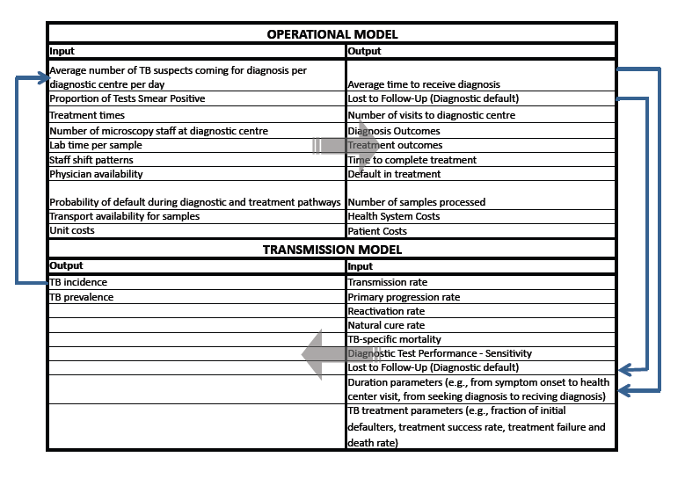
Table 3: Test Scenarios
TEST SCENARIOS | Number of sputum samples | Lab Time needed per sample | Sensitivity of Diagnostic among new pulmonary TB cases
Base Case | 2 (spot - morning) | 15mins | 50%
Alternative | 1 (spot) | 5mins | 65%

Table 4: Selected inputs for and outputs from the illustrative linked model

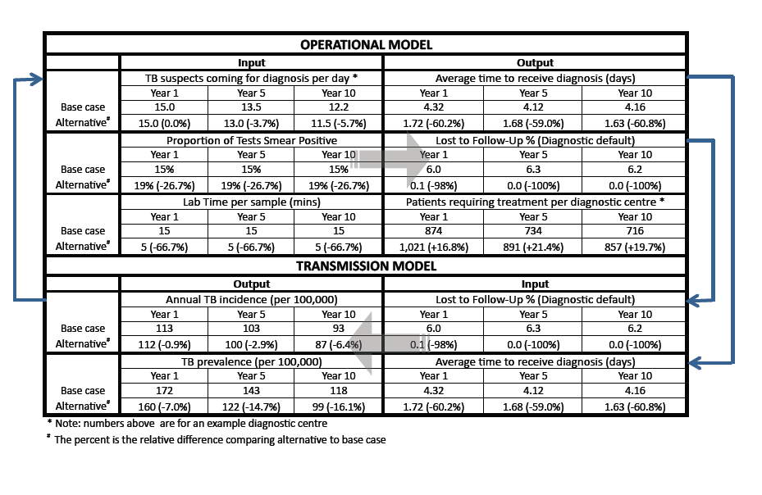

Figure legends:

Figure 1: Feedback loop between operational and dynamic epidemiological models
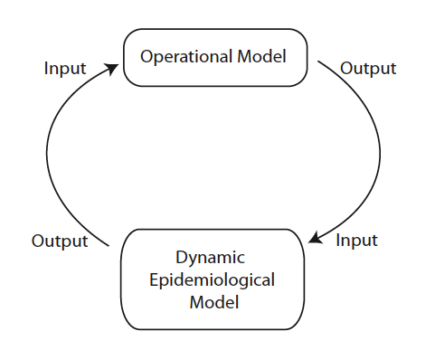

Figure 2: Simplified diagram of TB diagnostic and treatment process
The figure shows the flow for patients and samples through a single diagnostic centre with samples being transported to a central reference laboratory for drug sensitivity if that is necessary. TB suspects are referred to the diagnostic centre for testing where they provide a sputum sample which is examined using microscopy. In the base case a second sample is required so suspects return home, returning the next day to provide a second sample. Some suspects will receive diagnosis the same day, others may have to return home and return a subsequent day to receive diagnosis. If diagnosed with TB they will receive treatment and return home – see icon in top right. TB patients are required to return to the diagnostic centre every 2 weeks to receive subsequent medication. Therapeutic monitoring requires TB patients to return to the diagnostic centre for further sputum examination at three points during therapy: at the end of the intensive phase (month 2 for new patients, month 3 for retreatment patients), at month 5 for all patients and at treatment completion (month 6 for new patients and month 8 for retreatment patients). If smears are positive during these follow up assessment, further specimens are required for microscopy, culture and DST at the reference laboratory in accordance with current WHO guidelines.³¹ Every time a patient returns home there is a probability that they will not return to the diagnostic centre and therefore will be lost to follow-up or treatment.

Figure 3: Graphical representation of the compartmental transmission dynamic model.
The upper part of the figure shows a structure that is similar to many TB transmission models: The susceptible population (S), once exposed to infectious cases, may be infected and enter the latent infection states (Lf for early latent stage and Ls for late latent stage). Latently infected people can progress (from Lf) or reactivate (Ls) to the active disease state. Patients with active disease have either smear-positive pulmonary (Isp) or smear-negative pulmonary (Isn) disease (those with extrapulmonary TB do not contribute to the transmission dynamics of TB and therefore are not accounted for in this model). Those with TB may recover from disease through case detection and treatment (R), self-cure and return to the latent infection state, or die from TB.
The lower part of the figure shows how this simple standard TB transmission model is further expanded to investigate the effect of diagnostic tools within health systems. This requires additional representations of patient diagnostic pathways within the model. Here we include an early TB disease state ("Sick") that prompts a person to visit a local health centre for medical attention ("Health centre"). After some delay, a clinician might suspect TB and refer them to a diagnostic centre for sputum exam ("Sputum exam"). The TB suspect may be lost to follow up during this process ("LTFU"). Among those receiving a diagnostic test, there is a delay before the results become available ("Results"). Some of these tested suspects will test positive ("Test+") and this fraction represents the sensitivity of sputum smear microscopy ("σ", true positive). Those who test negative ("Test-") will either receive chest X-ray if it is available ("CXR"), or be lost to follow up with the false impression of not having TB ("LTFU"). A fraction of patients who receive chest X-ray will test positive ("Test+"). For those who are test positive (from either sputum exam or chest X-ray), a proportion of them will never initiate treatment because they are lost to follow up ("LTFU", also known as initial defaulters). The rest of those testing positive will be treated ("Treatment") after some delay and may then have different treatment outcomes ("R", "Default", "Fail").

