Levels of DNA Adducts in the Blood and Follicular Fluid of Women Undergoing In Vitro Fertilization Treatment and Its Correlation with the Pregnancy Outcome

Iman Al-Saleh,¹ Inaam El-Doush, ¹ Jamal Arif,² Serdar Coskun,² Kamal Jaroudi,⁴ Abdulaziz Al-Shahrani,⁴ Gamal El-Din Mohamed ⁵

¹ Biological & Medical Research Department, King Faisal Specialist Hospital & Research Centre, PO Box: 3354, Riyadh 11211, Saudi Arabia
² Department of Biotechnology, Integral University, Lucknow 226026, India,
³ Pathology Laboratory Medicine Department, King Faisal Specialist Hospital & Research Centre, PO Box: 3354, Riyadh 11211, Saudi Arabia
⁴ Obstetrics & Gynecology Department, King Faisal Specialist Hospital & Research Centre, PO Box: 3354, Riyadh 11211, Saudi Arabia
⁵ Disease Control Strategy Group, Liverpool School of Tropical Medicine, Liverpool, Pembroke Place, L3 5QA, United Kingdom

¹ Corresponding Address:
Dr. Iman Al-Saleh (MBC#03)
Biological & Medical Research Department
King Faisal Specialist Hospital & Research Centre
P.O. Box: 3354, Riyadh 11211
Saudi Arabia
E-mail: iman@kfshrc.edu.sa

Abstract.
This study is designed to investigatethe impact of DNA damage on the pregnancy and fertilization rate outcome in a sub-sample of women undergoing IVF treatments that were recruited previously in the following project “Exposure to environmental pollutants and its effect on the outcome of in vitro fertilization treatment”. A total of 60 samples of blood and follicular fluid were analyzed for DNA adducts by ³²P-postlabelling technique. Though no BPDE-DNA adduct were detected, other unknown adducts were seen in both blood and follicular fluid samples. The mean DNA adducts in blood and follicular fluids of our participants were 148.14 + 453.61 per 10¹⁰ nucleotides and 553.83 + 1687.14 per 10¹⁰ nucleotides respectively. Looking at the effect of heavy metals, DDT and smoking on the formation of DNA adducts, only follicular cotinine levels were significantly associated with the DNA adduct levels in blood and follicular fluid with P-values of 0.011 and 0.018 respectively. Women who failed to achieve pregnancy had higher DNA adducts in their follicular fluid (468.13 + 1273.42 adducts 10¹⁰ nucleotides) than those who succeeded (295.58 + 1283.28 adducts per 10⁸ nucleotides) with a P-value of 0.016. The formation of adducts in follicular fluid may be a potential source of DNA damage which might prevent egg fertilization or the development of embryo. Evaluation of DNA damage resulting from oxidative stress could have a role in predicting IVF success rate.

Keywords: DNA adducts; ³²P-Postlabeling technique; in vitro fertilization; Saudi Arabia; pregnancy outcome; fertilization rate

Introduction.
Exposure to chemicals may disrupt any process of the maturation and transport of the germ cells, fertilization, implantation, placentation and development of the conceptus causing reproductive dysfunction or adverse pregnancy outcome (Paul, 1997). The mechanism by which chemicals alter reproductive function in all species is complex and may involve hormonal and or/immune disruption, DNA adducts formation, altered cellular proliferation, or inappropriate cellular death (Sharara et al., 1998). DNA damage produced by reactive oxygen species (ROS) is the most frequently occurring damage (De Bont and van Larebeke, 2004). Wang (2008) described a group of bulky, oxidatively generated DNA lesions in which they could markedly block DNA replication and transcription. These lesions could contribute significantly to the development of human health disorders such infertility, genetic instability, neurological and the natural processes of aging (Wang et al., 2008; Paul et al., 2008; Leduc et al., 2008). Few studies have linked DNA damage in human sperm with impaired infertility (Horak et al., 2003a,b; Gaspari et al., 2003; Bennettset al., 2008). Many environmental pollutants such as heavy metals, polycyclic aromatic hydrocarbons, pesticides, radiations …etc were shown to cause oxidative DNA damage (Banerjee et al., 2001; Valko et al., 2005; Valavanidis et al., 2006).
Cigarette smoke contains >4,000 chemical compounds. Genotoxicity studies revealed that tobacco smoke may be a human germ-cell mutagen (DeMarini, 2004). Benzo[a]pyrene (B[a]P) is a potent carcinogen of the polycyclic aromatic hydrocarbon group (IARC, 1983), present in cigarette smoke in amounts of 20-40 ng per cigarette. B[a]P has tendency to bind covalently to DNA giving rise to 7β, 8α-dihydroxy-9α, 10α-epoxy-7, 8,10-tetrahydro-benzo[a]pyrene adducts-BPDE-DNA adducts (Boysen and Hecht, 2003). Zenes et al. (1998) have shown that B[a]P tends to form DNA adducts in ovarian cells of women exposed to cigarette smoke. Recent study by Neal et al. (2008) showed that B[a]P reaches the follicular fluid and its level was higher in women who smoke suggesting its toxic role on follicular development and subsequent fertility. Cooper and Moley (2008) reported the negative consequences of tobacco smoke in active and passive smokers on IVF outcome. Cotinine, the main metabolite of nicotine and a reliable biomarker of tobacco smoke (Benowitz, 1999) was detected at higher levels in follicular fluids of women who smoke compared to nonsmokers (Sterzick et al., 1996; Zenzes et al., 1996; Zenzes and Reed, 1998; Motejlek et al., 2006). It seems that cotinine easily crosses the blood/follicle barrier (Ginekologii et al., 1998). A study by Paszkowski et al. (2002) indicated that active smoking affects the pro-oxidant/antioxidant balance inside the pre-ovulatory ovarian follicle by inducing intra-follicular oxidative stress providing another possible explanation for impaired folliculogenesis in female smokers.

Our previous studies provided evidence that Saudi women might exposed increasingly to a variety of chemicals such as lead, cadmium, mercury, DDT and polycyclic aromatic hydrocarbons due to cultural habits, for example use of traditional cosmetics, remedies, diet and socioeconomic status (Al-Saleh, 2004). In 1999, Jaroudi et al. reported that 10% pregnancy and 4.5% implantation rates were achieved at the in vitro fertilization clinic (IVF) of King Faisal Specialist Hospital & Research Centre (KFSH&RC). Exposure to environmental pollutants might have a role in the etiology of such repeated IVF failure.

The purpose of this study was to measure bulky DNA adducts including aromatic adducts such as BPDE-DNA by ³²P-postlabeling technique and relate it to pregnancy outcome and fertilization rate in a sub-sample of women undergoing IVF treatment that were recruited previously in the following project “Exposure to environmental pollutants and its effect on the outcome of in vitro fertilization treatment”.

Materials and method.
The data evaluated in this study originated from samples and questionnaires collected from women previously recruited in the IVF Project, which has been described in details elsewhere (Al-Saleh et al., 2008). The primary aim of the project was to evaluate the influence of pollutant exposure on in-vitro fertilization treatment outcome such as fertilization and pregnancy rate. Blood and follicular fluid samples were collected from 619 women undergoing IVF treatment at the in vitro Fertilization (IVF)-embryo transfer unit, KFSH&RC during the period between 12/01/2002 to the 16/10/2003. The mean age of these women was 31.76 + 5.12 years old. A sub-sample of 67 women was only selected for this study because DNA adducts procedure is lengthy and time-consuming. Women with positive ßeta-human chorionic gonadotropin (β-hCG) were considered pregnant. Pregnancy was subdivided into biochemical (positive β-hCG, negative ultrasound), abortion or ongoing. Written informed consent was obtained from each participant approved by the Research Ethic Committee of King Faisal Specialist Hospital and Research Centre.
Analyses of lead, cadmium, mercury and cotinine in blood and follicular fluid samples were measured as described previously (Al-Saleh et al., 2008).

B[a]P analysis. Serum and follicular fluid B[a]P levels were determined by a modified method of Sirimanne et al. (1996) using the Alliance Waters HPLC 2690 system and a Hewlett Pacakard, Model 1046A fluorescence detector equipped with a 8-µL flow cell. Excitation and emission wavelengths were 290 nm and 430 nm respectively. This system was operated by a Dell Optiplex GX1 computer and Millenium³² software. The reversed-phase analytical HPLC column was a Waters Symmetry TM C₁₈ (4.6 mm x 30.0 cm), packed with Waters Symmetry TM C₁₈ (5-µm particle size). A guard column, Waters Symmetry TM C₁₈ (4.6 mm x 2 cm, 5-μm particle size) with the same packing materials was placed in front of the analytical column for protection. 3-methylcholanthrene (1 µg) was added to each serum or follicular sample, working standards, and spiked samples as an internal standard. This was followed with addition of 1ml 5% Triton X-100 and 0.584 gm of crystalline sodium chloride. The solution was then mixed well and incubated for 20 minutes at 50⁰C in water bath. A surfactant-rich phase was obtained by centrifuging at 3500rpm for 20 minutes. The greasy surfactant-rich phase was then diluted with 0.5ml acetonitrile, mixed well and centrifuged at 3700rpm for 10 minutes. The supernatant was transferred to a micro vial. A mobile phase of acetonitrile:water (90:10) was used at a flow rate of 1.5 mL/minute. Injection volume was 100 μL. The peak was measured as peak height. About 10.0 min was required for each analysis. Five ranges of calibration curve (0.5-8.0μg/L) was constructed by adding aliquots of B[a]P to 1ml of serum or follicular fluid sample. Linear calibration curves were generated and the mean regression coefficient r was 0.9991 + 0.0015 for the spiked serum samples and 0.9994 + 0.0006 for spiked follicular fluid samples. The analytical recovery for spiked serum and follicular fluid with B[a]P at various concentration levels (0.8-5.0 µg/L) were 101.3-104.9% and 99.7-101.2% respectively. An additional test was conducted to check the performance of the solid-phase extraction step. The extraction efficiency for B[a]P was determined by dividing the peak height ratio of serum or follicular fluid samples spiked with various concentrations to those obtained by direct injection of organic standards. The method gave an extraction efficiency of 92.0%-102.2% for B[a]P in serum and 97.2-104.1% in follicular fluid in the range of 0.8 to 5.0 µg/L.

Analysis of DNA adduct by ³²P-postlabeling
DNA was isolated from blood lymphocytes and follicular fluid using the PureGene kit (Gentra Systems, Minneapolis, MN) according to the manufacturers’s protocol. For ³²P-postlabeling, DNA (10-25 µg) was digested with a mixture of micrococcal nuclease (Sigma Chemical Co., St. Louis, MO) and spleen phosphodiesterase (Boehringer Mannheim Corp., Indianapolis, IN) according to the method of Gupta (1996). Enriched adducts were labeled by T4 polynucleotide kinase (10 U/µl) in the presence of molar excess of commercial [γ-³²P]ATP (20 µCi; 7000 Ci /mmol specific activity) Pl (ICN Pharmaceutical, Inc., Costa Mesa, CA), and resolved by multi-directional polyethyleneimine (PEI)-cellulose-TLC in the solvent system: D1 = 1 M sodium phosphate, pH 6.0; D3 = 4 M lithium formate/8.5 M urea, pH 3.5; D4 = 0.8 M lithium formate/8.5 M urea/0.5 M Tris-HCl, pH 8.0; and D5 = 1 M sodium phosphate, pH 6.0. An aliquot of diluted DNA digest (2 ng) was also labeled in parallel with adducts and normal nucleotides converted to 5’-monophosphate were resolved using 0.5 M acetic acid (Gupta and Arif, 2001). For quantification purposes, only standard of BPDE modified DNA with known concentration (0.62 µg/ml) was run in parallel in all experiments. Adduct DRZs were visualized and quantified by Typhoon 8600 variable mode imager and followed by quantification by ImageQuant software (Molecular Dynamics, Sunnyvale, CA, USA) (Arif et al., 2004). The relative adduct labeling (RAL) was calculated as follows: RAL = cpm in adducts/cpm in total nucleotides x 1/dilution factor. Adducts were expressed as adducts per 10¹⁰ nucleotides.

Statistical analysis. Data are reported as means + SD. Women with successful pregnancy or fertilization outcome constitute controls and the rest as cases. The fertilization rate was defined as the percentage of the fertilized eggs to the number of eggs. Although large number of confounding variables were collected originally in the IVF project, we were not able to perform logistic regression analysis because insufficient number of cases. We had to add a value of 1 to the adduct data in order to account for values of zero (0). Differences between groups were tested for significance using the Mann-Whitney U test. Spearman rank correlation coefficients (r) were calculated to evaluate the closeness of relationship between two continuous variables. Values were considered significant at P < 0.05.

Results and discussion.
General description. This paper reported the levels of DNA adducts in the blood and follicular fluid of women undergoing IVF treatment and its relationship to pregnancy outcome and fertilization rate. The absence of BPDE-DNA adduct in our women might result from either low levels of B[a]P exposure or genetic polymorphisms (Boysen and Hecht, 2003). On the other hand, other unknown adducts were seen in both blood and follicular fluid samples as displayed in Figure 1. The total level of DNA adducts in blood and follicular fluid of 60 women undergoing IVF treatment were 148.14 + 453.61 per 10¹⁰ nucleotides and 553.83 + 1687.14 per 10¹⁰ nucleotides respectively. There was large inter-individual variations in DNA adduct levels which might be due to the nature of their metabolic/detoxification and DNA repair pathways. The study of Ketelslegers et al. (2006) showed that analysis of multiple genetic polymorphisms can give better explanation of observed inter-individual variation in the levels of DNA adducts. A strong positive correlation was observed between the blood and follicular fluid total adducts (r=0.445, P=0.001). As shown in Figure 2, the levels of the average adducts in follicular fluid was significantly higher than in blood samples (P=0.019). Different lipid characteristics between serum and follicular fluid could also account for these differences (Neal et al., 2008). Mlynarcikova et al. (2005) suggested that many chemicals can be absorbed into the ovary via blood supply which could have a negative impact on the intra-follicular processes leading to unsuccessful fertilization.

Environmental pollutants. In this study, heavy metals (lead, cadmium and mercury), p,p-DDE and cotinine were detected in both blood and follicular fluid of women as shown in Table 1. The levels of p,p-DDE, lead, cadmium and mercury in the blood were of higher magnitude (5.45, 5.96, 1.56 and 1.47 respectively) than their counterparts in the follicular fluid. There were 3% of the women had blood lead levels >10 µg/dL, the Centers for Disease Control and Prevention criterion for elevated blood levels in children and pregnant women (CDC, 2002), but none for the follicular fluid. The threshold limit of cadmium’s clinical importance (1 µg/L) was found in the blood and follicular fluid of 10.8% and 7.5% of women respectively. While 13.4% and 7.5% of the women had respectively blood and follicular fluid mercury levels ≥ 5.8 μg/L (the EPA safety limit) that is assumed to be without appreciable harm (CDC, 2004). p,p’-DDE (the major metabolite of DDT) was detected in 81.3% of the serum and 49.3% of the follicular fluid samples of our participants, but the majority were below the DLs. Only 23.7% of the women had p,p’-DDE levels in the serum above the DL of 2.1 µg/L, while one women had follicular p,p’-DDE above the DL of 1.8 µg/L. Though, the levels of these environmental contaminants (lead, cadmium, mercury and DDT) were low but their presence particularly in the follicular fluid of our participants could raise some concern about their possible negative effects on the ovarian function. As a biomarker of active or passive smoking exposure to tobacco, cotinine was measured in the blood and follicular fluid of our participants. Based on self-reporting, 2 women and the husbands of 14 women were active smokers. Serum cotinine was only high in one woman who is active smoker (16.17 µg/L) and the rest were in the range of 0-0.03 µg/L. On the other hand, 17 women (30.4%) had detectable cotinine in follicular, ranging between 1.62 and 35.21µg/L (mean + SD: 1.657 + 5.448 µg/L. Our results are comparable to the one reported by Zenzes et al (1996) in which the cotinine levels in 50 nonsmoker women were 4.2 + 2 µg/L. Furthermore, the level of cotinine in serum was 4.6 less than in follicular fluid. Study by Zenzes et al. (1997) showed that cotinine interacts directly and incorporates into the cells of follicle as well as the developing oocyte leading to detrimental consequences after conception. No B[a]P was found in the serum or follicular fluid of our participants. It is clear that cotinine can be detected in follicular fluid of women irrespective of their smoking status.

Role of environmental pollution in the formation of DNA adducts. There are many theories regarding the adverse effects of pollutants on the reproductive system. Agarwal et al. (2003) emphasized the role of ROS in the pathophysiology of human reproduction for both male and female. Authors showed that follicular fluid ROS, at low concentrations, may be a potential marker in predicting the outcome of IVF treatment. Similar observation was reported by Das et al. (2006). Oxidative damage to DNA is a result of interaction of DNA with reactive ROS, in particular the hydroxyl radical. When we looked at the possible effect of heavy metals, DDT and smoking on the formation of DNA adducts, positive correlations were seen only between the follicular cotinine and blood DNA adducts (r=0.361, P=0.011) and follicular fluid DNA adducts (r=0.334, P=0.018). Though most women were nonsmokers, it seems that they were exposed to enough tobacco smoke that has played a role in induction of DNA adducts in both matrixes. Husgafvel-Pursiainen (2004) reviewed human biomarker studies that were conducted among non-smokers with involuntary exposure to tobacco smoke. The presence of DNA adducts, urinary metabolites of carcinogens, urinary mutagenicity, SCEs and gene mutations suggest that the risk of genetic alterations in passive smokers as equal as smokers. Exposure to metals and tobacco smoke has been reported to induce intra-follicular oxidative stress that may lead to DNA damage (Zenes et al., 1998; Paszkowski et al., 2002). Though no association was seen, one should not exclude the fact that lead, cadmium, mercury and DDT are known to exert some adverse effect on ovarian function in human or animal studies (Shen et al., 2000; Paksy et al., 2001; Piasek and Laskey, 1999; Khan et al., 2004; Holloway et al., 2007).

DNA adducts and IVF outcome. In this study, we tested the impact of DNA adducts in the blood and follicular fluid of women undergoing IVF treatment and the pregnancy and fertilization outcome. Using Mann-Whitney U test, it seems that cases and controls of the pregnancy outcome were significantly different with regard to follicular DNA adducts levels but not blood. Women who failed to achieve pregnancy had higher DNA adducts in their follicular fluid (468.13 + 1273.42 per 10¹⁰ nucleotides, n=27) than those who succeeded (295.58 + 1283.28 per 10¹⁰ nucleotides, n=20) with a P-value of 0.016 as displayed in Figure 3. Though, the levels of DNA in blood samples of women who failed pregnancy were higher (137.04 + 434.63 per 10¹⁰ nucleotides, n=29) than those who succeed (78.31 + 207.57 per 10¹⁰ nucleotides, n=18), it was not significant (P=0.245). Surprisingly, the levels of DNA adducts in the blood and follicular fluid of women who failed fertilization were lower (19.71 + 16.44 per 10¹⁰ nucleotides, n=7 and 99.85 + 168.42 per 10¹⁰ nucleotides, n=7 respectively) than those who succeed (165.10 + 48.54 per 10¹⁰ nucleotides, n=53 and 613.78 + 1787.43 per 10¹⁰ nucleotides, n=53 respectively), but were not significant with P-values of 0.804 and 0.512 respectively as shown in Figure 4. The formation of adducts in follicular fluid may be a potential source of DNA damage which might prevent egg fertilization or the development of embryo. Wiener-Megnazi et al. (2004) regarded follicular fluid as a biological “window,” reflecting metabolic and hormonal processes occurring in the microenvironment of the maturing oocyte before ovulation, and also as a predictor of outcome parameters such as fertilization, embryo cleavage, and pregnancy rates in IVF.

Regardless of the sensitivity of our post-labeling method in detecting these unknown adducts, it has limitation in characterizing its structure directly. Therefore, the origin and exact nature of these adducts are unclear. It is therefore important to characterize these adducts in order to identify environmental factors that play a role in the etiology of IVF failure or infertility problems.

In spite of our small sample size, the findings might support the hypothesis that oxidative stress in follicular fluid could affect IVF outcome parameters leading to lower pregnancy success rate. Therefore, evaluation of follicular fluid oxidative stress status in women undergoing IVF treatment could have a role in predicting its success rate. It is also recommended to examine the potential of oxidative stress biomarkers in revealing unexplained infertility in women before deciding to embark on ^{IVF} treatment.

Acknowledgment.

The authors are thankful to the staff of the IVF clinic and laboratory and participants for their cooperation during the study. This study (RAC#2010 006) was supported by King Faisal Specialist Hospital and Research Centre.
References
Agarwal, A., Saleh, R.A., Bedaiwy, M.A. 2003. Role of reactive oxygen species in the pathophysiology of human reproduction. Fertility & Sterility 79, 829–843.
Al-Saleh, I., Coskun, S., Mashhour, A., Shinwari, N., El-Doush, I., Billedo, G., Jaroudi, K., Al-Shahrani, A., Mohamed, G. 2008. Exposure to heavy metals (lead, cadmium and mercury) and its effect on the outcome of in-vitro fertilization treatment. International Journal of Hygiene & Environmental Health 211, 560-579.
Al-Saleh, I. 2004. Potential effects of environmental exposure on pregnancy outcome: with special reference Saudi Arabia. Current Topics in Toxicology 1, 1-17.
Arif, J.M., Kunhi, M., Siddiqui, Y.M., El-Sayed, K.A., Orabi, K.Y., Al-Hazzani, A.A., Al-Ahdal, M.N., Al-Khodairy, F.M. 2004. Differential modulation of benzo[a]pyrene-derived DNA adducts in MCF-7 cells by marine compounds. International Journal of Cancer Prevention 1, 259-268.
Banerjee, B.D., Seth, V., Ahmed, R.S. 2001. Pesticide-induced oxidative stress: perspectives and trends. Reviews on Environmental Health. 16, 1-40.
Bennetts, L.E., De Iuliis, G.N., Nixon, B., Kime, M., Zelski, K., McVicar, C.M., Lewis, S.E., Aitken, R.J. 2008. Impact of estrogenic compounds on DNA integrity in human spermatozoa: evidence for cross-linking and redox cycling activities. Mutation Research 641, 1-11.
Benowitz, N.L. 1999. Biomarkers of environmental tobacco smoke exposure. Environmental Health Perspectives 107, 349-355.
Boysen, G., Hecht, S.S. 2003. Analysis of DNA and protein adducts of benzo[a]pyrene in human tissues using structure-specific methods. Mutation Research 543, 17-30.
CDC, Centers for Disease Control and Prevention. 2002. Managing Elevated Blood Lead Levels Among Young Children: Recommendations From the Advisory Committee on Childhood Lead Poisoning Prevention. Atlanta, Ga: Centers for Disease Control and Prevention.
CDC, Centers for Disease Control and Prevention. 2004. Blood mercury levels in young children and childbearing-aged women–United States, 1999-2002. MMWR 53, 1018-1020.
Cooper, A.R., Moley, K.H. 2008. Maternal tobacco use and its preimplantation effects on fertility: more reasons to stop smoking. Seminars in Reproductive Medicine 26, 204-212.
Das, S., Chattopadhyay, R., Ghosh, S., Ghosh, S., Goswami, S.K., Chakravarty, B.N., Chaudhury, K. 2006. Reactive oxygen species level in follicular fluid--embryo quality marker in IVF? Human Reproduction 21, 2403-2407.
De Bont R., van Larebeke, N. 2004. Endogenous DNA damage in humans: a review of quantitative data. Mutagenesis 19, 169-185.
DeMarini, D.M. 2004. Genotoxicity of tobacco smoke and tobacco smoke condensate: a review. Mutation Research 567, 447-474.
Gaspari, L., Chang, S.S., Santella, R.M., Garte, S., Pedotti, P., Taioli, E. 2003. Polycyclic aromatic hydrocarbon-DNA adducts in human sperm as a marker of DNA damage and infertility. Mutation Research 535, 155-160.
Ginekologii, K., Poloznictwa, K., Kobiecych, C., Medycznej, A., Lublinie, W. 1998. Concentration gradient of cotinine between blood serum and preovulatory follicular fluid. Ginekologia Polska 69, 1131-1136.
Gupta, R.C., Arif, J.M. 2001. An improved ³²P-postlabeling assay for the sensitive detection of 8-oxo 2’-deoxyguanosine in tissue DNA. Chemical Research. Toxicology 14, 951-957.
Holloway, A.C., Petrik, J.J., Younglai, E.V. 2007. Influence of dichlorodiphenylchloroethylene on vascular endothelial growth factor and insulin-like growth factor in human and rat ovarian cells. ReproductiVe Toxicology 24, 359-364.
Horak, S., Polanska, J., Widlak, P. 2003a. Bulky DNA adducts in human sperm: relationship with fertility, semen quality, smoking, and environmental factors. Mutation Research 537, 53-65.
Horak, S., Polanska, J., Widlak, P. 2003b. High levels of bulky DNA adducts in human sperm correlate with impaired fertility. Acta Biochimica Polonica 50, 197-203.
Husgafvel-Pursiainen, K. 2004. Genotoxicity of environmental tobacco smoke: a review. Mutation Research, 567, 427-445.
IARC, International Agency for Research on Cancer. 1983. Polynuclear aromatic compounds, part 1, chemical, environmental and experimental data. In Monographs on the evaluation of carcinogenic risk of chemicals to man. IARC, Lyon, France, pp.35-48.
Jaroudi, K.A., Hollanders, J.M., Elnour, A.M., Roca, G.L., Atared, A.M., Coskun, S. 1999. Embryo development and pregnancies from in-vitro matured and fertilized human oocytes. Human Reproduction 14, 1749-1751.
Ketelslegers, H.B., Gottschalk, R.W., Godschalk, R.W., Knaapen, A.M., van Schooten, F.J., Vlietinck, R.F., Kleinjans, J.C., van Delft, J.H. 2006. Interindividual variations in DNA adduct levels assessed by analysis of multiple genetic polymorphisms in smokers. Cancer Epidemiology, Biomarkers & Prevention 15, 624-629.
Khan, A.T., Atkinson, A., Graham, T.C., Thompson, S.J., Ali, S., Shireen, K.F. 2004. Effects of inorganic mercury on reproductive performance of mice. Food & Chemical Toxicology 42, 571-577.
Leduc, F., Nkoma, G.B., Boissonneault, G. 2008. Spermiogenesis and DNA repair: a possible etiology of human infertility and genetic disorders. Systems Biology in Reproductive Medicine 54, 3-10.
Mlynarcikova, A., Fickova, M., Scsukova, S. 2005. Ovarian intrafollicular processes as a target for cigarette smoke components and selected environmental reproductive disruptors. Endocrine Regulations 39, 21-32.
Motejlek, K., Palluch, F., Neulen, J., Grummer, R. 2006. Smoking impairs angiogenesis during maturation of human oocytes. Fertility & Sterility 86, 186-191.
Neal, M.S., Zhu, J., Foster, W.G. 2008. Quantification of benzo[a]pyrene and other PAHs in the serum and follicular fluid of smokers versus non-smokers. Reproductive Toxicology 25, 100-106.
Paksy, K., Gati, I., Naray, M., Rajczy, K. 2001. Lead accumulation in human ovarian follicular fluid, and in vitro effect of lead on progesterone production by cultured human ovarian granulosa cells. Journal of Toxicology & Environmental Health A 62, 359-366.
Paszkowski, T., Clarke, R.N., Hornstein, M.D. 2002. Smoking induces oxidative stress inside the Graafian follicle. Human Reproduction 17, 921-925.
Paul, M. 1997. Occupational reproductive hazards. Lancet 349, 1385-1388.
Paul, C., Melton, D.W., Saunders, P.T. 2008. Do heat stress and deficits in DNA repair pathways have a negative impact on male fertility?. Molecular Human Reproduction 14, 1-8.
Piasek, M., Laskey, J.W. 1999. Effects of in vitro cadmium exposure on ovarian steroidogenesis in rats. Journal of Applied Toxicology 19, 211-217.
Sharara, F.I., Seifer, D.B., Flaws, J.A. 1998. Environmental toxicants and female reproduction. Fertility & Sterility 70, 613-622.
Shen, W., Chen, Y., Li, C., Ji, Q. 2000. Effect of mercury chloride on the reproductive function and visceral organ of female mouse. Wei Sheng Yen Chiu/Journal of Hygiene Research 29, 75-77.
Sirimanne, S., Barr, J.R., Patterson, D.G. 1996. Quantification of polycyclic aromatic hydrocarbons and polychlorinated dibenzo-p-dioxins in human serum by combined Micelle-Mediated extraction (Cloud-point extraction) and HPLC. Analytical Chemistry 68, 1556-1560.
Sterzick, K., Strehler, E., De Santo, M., Trumpp, N., Abt, M., Rosen-busch, B., Schneider, A. 1996. Influence of smoking on fertility in women attending an in vitro fertilization program. Fertility & Sterility 65, 810-814.
Valavanidis, A., Vlahogianni, T., Dassenakis, M., Scoullos, M. 2006. Molecular biomarkers of oxidative stress in aquatic organisms in relation to toxic environmental pollutants. Ecotoxicology & Environmental Safety 64, 178-189.
Valko, M., Morris, H., Cronin, M.T. 2005. Metals, toxicity and oxidative stress. Current Medicinal Chemistry 12, 1161-1208.
Wang, Y. 2008. Bulky DNA lesions induced by reactive oxygen species. Chemical Research in Toxicology 21, 276-281.
Wiener-Megnazi, Z., Vardi, L., Lissak, A., Shnizer, S., Reznick, A.Z., Ishai, D., Lahav-Baratz, S., Shiloh, H., Koifman, M., Dirnfeld, M. 2004. Oxidative stress indices in follicular fluid as measured by the thermochemiluminescence assay correlate with outcome parameters in in vitro fertilization. Fertility & Sterility 82, 1171–1176.
Zenzes, M.T., Reed, T.E., Wang, P., Klein, J. 1996. Cotinine, a major metabolite of nicotine, is detectable in follicular fluids of passive smokers in in-vitro fertilization therapy. Fertility & Sterility 66, 614-619.
Zenzes, M.T., Puy, L.A., Bielecki, R. 1997. Immunodetection of cotinine protein in granulosa-lutein cells of women exposed to cigarette smoke. Fertility & Sterility 68, 76-82.
Zenzes, M.T., Puy, L.A., Bielecki, R. 1998. Immunodetection of benzo(a)pyrene adducts in ovarian cells of women exposed to cigarette smoke. Molecular Human Reproduction 4, 159-165.

Table 1
Descriptive statistics of variables.

Measured variables | N | Mean + SD | Range
Total DNA adducts in blood (per 10¹⁰ nucleotides) | 60 | 148.136 + 453.609 | (0-2435.1)
Total DNA adducts in follicular fluid (per 10¹⁰ nucleotides) | 60 | 553.825 + 1687.136 | 0-8896.9
Women’s age (years) | 67 | 31.90 + 5.692 | 20-44
Age when started menstruating in years | 67 | 12.84 + 1.238 | 10-16
Days of menstrual cycle | 67 | 5.64 + 1.058 | 3-7
Women’s BMI (Kg/m²) | 67 | 28.826 + 5.025 | 17.75-40
Number of good embryo | 67 | 1.81 + 2.704 | 0-17
Number of fair embryo | 67 | 0.52 + 0.877 | 0-3
Number of poor embryo | 67 | 1.22 + 1.929 | 0-9
Total number of embryo | 67 | 3.54 + 3.645 | 0-20
Number of eggs | 67 | 8.91 + 7.012 | 0-30
Number of fertilized eggs | 67 | 4.76 + 4.589 | 0-23
Number of transferred embryo | 67 | 1.54 + 1.035 | 0-4
Number of implanted embryo | 67 | 0.13 + 0.385 | 0-2
Number of biochemical pregnancy | 67 | 0.03 + 0.171 | 0-1
Number of aborted | 67 | 0.03 + 0.171 | 0-1
Blood cadmium levels (µg/L) | 65 | 0.547 + 0.335 | 0-1.508
Blood lead levels (µg/dL) | 67 | 3.159 + 2.246 | 0.674-12.219
Blood mercury levels (µg/L) | 67 | 3.604 + 4.066 | 0-30.345
Serum p,p-DDE levels (µg/L) | 59 | 1.653 + 2.212 | 0-8.82
Follicular cadmium levels (µg/L) | 67 | 0.350 + 0.510 | 0-2.902
Follicular lead levels (µg/dl) | 67 | 0.530 + 0.557 | 0-3.731
Follicular mercury levels (µg/L) | 67 | 2.454 + 4.857 | 0-38.302
Follicular p,p-DDE levels (µg/L) | 67 | 0.302 + 0.491 | 0-2.424
Serum cotinine (µg/L) | 45 | 0.360 + 2.410 | 0-16.17
Follicular cotinine levels (µg/L) | 56 | 1.657 + 5.448 | 0-35.21

Blood total adducts=1864.6 per 10¹⁰ nucleotides
Follicular fluid total adduct=6043.4 per 10¹⁰ nucleotides

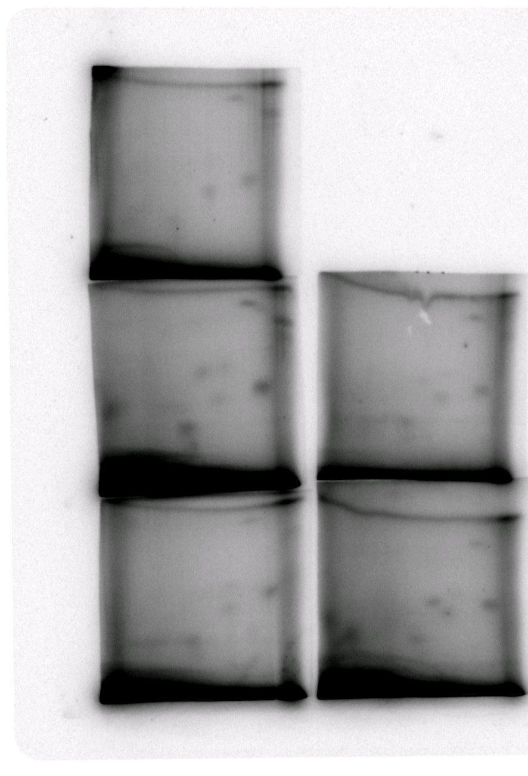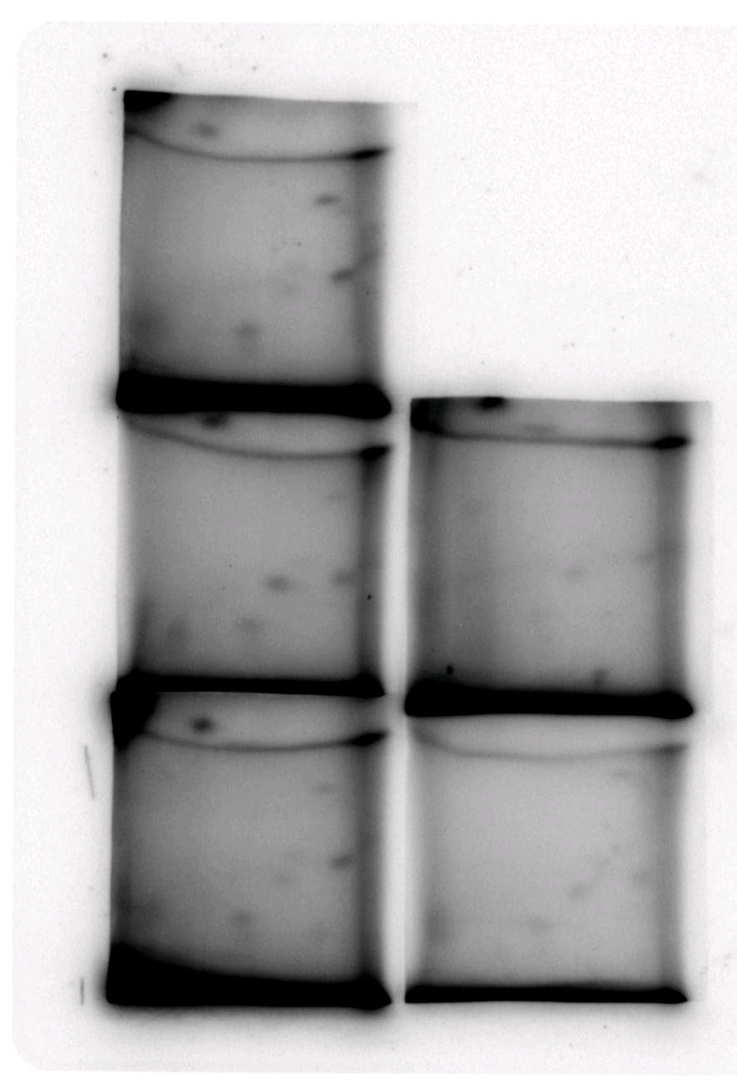
Blood total adducts=2435.1 per 10¹⁰ nucleotides

Follicular fluid total adduct=5082.6 per 10¹⁰ nucleotides

Fig. 1. ³²P-postlabelling analysis of DNA taken from the blood and follicular fluid of two participants with high total DNA adducts.

Fig. 2. The levels of DNA adducts in the blood and follicular fluid of women undergoing IVF treatment. Error bars show mean + SE.

Fig. 3. The levels of adducts in the blood and follicular fluid of women undergoing IVF treatment as classified by their pregnancy outcome. Error bars show mean + SE.

Fig. 4. The levels of adducts in the blood and follicular fluid of women undergoing IVF treatment as classified by their fertilization rate outcome. Error bars show mean + SE.

