Materials and Methods

Mosquitoes

*Anopheles gambiae* (G3 and Kisumu strains) and *Anopheles arabiensis* (Moz strain) mosquitoes were reared according to the standard protocol (*39*). Time-expired human blood from a blood bank was used for female feeding.

Collection of sex-specific RNA from embryos

Individual embryos were karyotyped by polymerase chain reaction (PCR) using primers 124678F2 (5’-TTTGAGCATGTGTTTAAAGG-3’) and 124678R2 (5’-AGGTTTTGCCGACTACAAT-3’) that target satellite DNAs AgX367 and AgY477 located on the X and the Y chromosomes, respectively (*4**0*). Their monomers have highly similar sequences, but differ in length due to a 110 bp indel. As a result, a 477 bp long male-specific PCR product can be easily differentiated from a 367 bp long non-sex-specific product on an agarose gel, allowing unequivocal discrimination between male (XY) and female (XX) samples (fig. S1). Owing to the highly repetitive nature of the satellite DNA targets, trace amounts of DNA template suffice to obtain robust PCR products. In addition to the two diagnostic fragments, faint PCR products corresponding to longer regions (dimers, trimers, or tetramers) of the same satellite species, as well as a shorter male-specific fragment corresponding to another minor Y-linked satellite species belonging to the AgY477 family, are sometimes amplified. We found that in some *A. gambiae* lines sexing with the above primers may not be 100% effective. In a proportion of female individuals from such lines we could detect a faint male band, apparently because rare recombination events between the X and the Y chromosome satellite DNA regions could have led to a transfer of AgY477 copies into the AgX367 arrays.

Embryo sexing was coupled with RNA collection as follows. Each embryo in turn was transferred to a numbered 0.5 ml tube, probed with a thin needle to collect a DNA sample, ground in 3 μl of TRIzol (Life Technologies) and, afterwards, stored at -70°C until RNA extraction. Immediately after embryo probing, each DNA sample was rinsed by immersing the needle into a PCR mix aliquot in a separate, numbered PCR tube. To prevent DNA carryover, the needle was flame-sterilized and cooled in sterile water prior to processing each embryo. PCR was performed in 20 μl volume containing 1x Thermopol buffer (20mM Tris-HCl pH 8.8, 10mM (NH4)2SO4, 10mM KCl, 2mM MgSO4, 0.1% Triton X-100; New England Biolabs), 1 mM MgCl2, 0.2 mM each dNTP, 1.25 U *Taq* polymerase (New England Biolabs), and 25 pmol of each primer. PCR thermal cycling included 3 min initial denaturation at 93 °C, followed by 35-40 cycles of 30 s at 94 °C, 30 s at 52 °C, and 30 s at 72 °C, and a final elongation for 5 min at 72 °C. The sex of each embryo was determined based on a banding pattern of the PCR products fractionated on a 1% agarose gel (note, that use of a PCR buffer lacking the Triton X-100 detergent can result in sex-specific banding pattern different from that shown in fig. S1, with preferential amplification of AgX367 and a shorter Y-specific satellite species). Then, batches of TRIzol-ground samples of the same sex were pooled and total RNA isolated according to the TRIzol manufacturer’s recommendations. Following RNA isolation, DNA was extracted from each TRIzol batch according to manufacturer recommendations and 1 μl of the DNA solution used as template in sexing PCR assay to ascertain sex-specificity of each batch (strictly, lack of contamination of female batches with male nucleic acids could only be tested, but when confirmed, it was used as an indication that the male samples from a batch were likely not contaminated with female nucleic acids). Finally, the RNA batches were pooled into male and female samples, and, after TURBO DNase (Ambion) treatment, integrity of the RNA was evaluated using the Agilent 2100 Bioanalyzer. PolyA+ mRNA was isolated using Oligotex mRNA Mini Kit (Qiagen). In total 90 and 731 male, and 77 and 351 female embryos collected at 4-6 hr and 18-21 hr after oviposition, respectively, were used to extract RNA for construction of RNA-seq libraries.

Collection of RNA from sexed postembryonic stages

Larvae were sexed using a G3-derived transgenic *A. gambiae* strain, carrying a single X-linked insertion of a constitutively expressed eGFP tag controlled by the *alpha-tubulin1b* promoter and a neuronal-specific dsRED marker (*4**1*). Males of that strain were crossed with wild type females and their progeny sorted under a fluorescence stereomicroscope. Only female progeny from crosses are fluorescent, allowing fast sexing of larvae from each instar. Pupae and adults were sexed based on morphology. RNA samples originating from individuals collected at multiple developmental time points and used in the analysis of temporal profile of transcription were extracted following the previously described method (*4**2*).

cDNA synthesis, amplification and pyrosequencing

cDNA was synthesized using SMARTer cDNA synthesis kit (Clontech) and amplified using Advantage 2 PCR kit (Clontech) according to manufacturer’s recommendations. Approximately 1 μg of cDNA was used for construction of sequencing libraries. cDNA fragmentation, preparation of sequencing libraries and pyrosequencing on the 454 GS FLX platform (Roche 454 Life Sciences) using Titanium chemistry were conducted following manufacturer’s protocols.

454 sequence analysis

The raw reads were cleaned to remove poor quality sequences, 454 adaptor sequences, cDNA amplification primer sequences, and reads less than 30 bp long using Seqclean (http://compbio.dfci.harvard.edu/tgi/software/), and then mapped against the *A. gambiae* PEST genome using GMAP/GSNAP(http://research-pub.gene.com/gmap/) (*4**3*). In addition to the male embryo transcriptome, BLASTN (*4**7*) search identified reads corresponding to the *Yob* gene in the *A. gambiae* testis transcriptome that we have generated (European Nucleotide Archive; study accession ERP009392). TBLASTN (*4**4*) with increasingly relaxed search parameters was used in an unsuccessful attempt to identify homologues of *Yob* in the locally created nr and *A. gambiae* genome databases. Open reading frames (ORFs) were identified using the ORF Finder (http://www.ncbi.nlm.nih.gov/projects/gorf/). Secondary structure prediction of the putative protein encoded by *Yob* was done using Jpred (*4**5*).

Rapid Amplification of cDNA ends (RACE)

5’- and 3’-rapid amplification of cDNA ends (RACE) experiments were carried out using SMARTer RACE cDNA amplification kit (Clontech). Briefly, 1 μg of adult male *A. gambiae* totalRNA was used to synthesise RACE ready cDNAs according to manufacturer’s recommendations. A diluted (1:10) 5’ RACE ready cDNA was amplified using Universal Primer Mix and the contig-specific primer 8484F, followed by reamplification of the product using Nested Universal Primer Mix and the nested contig-specific primer 8484NF, with an initial denaturation at 94 °C for 2 min, followed by 35 cycles of 94 °C for 30 s, 60 °C for 30 s, and 72 °C for 3 min, and the final elongation step at 72 °C for 10 min. 3’ RACE ready cDNA was similarly amplified using the same universal primers with combination with the primers 8484R and nested 8484NR. Transcript sequences were assembled following cloning and sequencing of the amplified cDNA ends. An additional round of RACE experiment was undertaken using, where possible, transcript-specific primers to increase the chances of full length transcript recovery. Sequences of primers used in RACE are provided in table S2. Analysis of the intron splice sites revealed that the targeted Y chromosome region was transcribed from both DNA strands. Three transcripts originated from the forward strand and four transcripts from the reverse strand (fig. S2). We named the corresponding gene encoded on the forward strand *Yoa* (Y originating gene A) and the gene from the reverse strand *Yob* (Y originating gene B). In British English, a ‘yob’ is a rude, aggressive, and violent young man, which fits well with the gene’s function and properties!

RT-PCR and Sanger sequencing

The patterns of gene expression were examined by RT-PCR using the SuperScript® III One-Step RT-PCR System with Platinum® Taq DNA Polymerase (Invitrogen) according to the manufacturer’s guidelines. In all experiments a fragment of the ribosomal protein S7 gene mRNA was amplified to serve as an internal control of equal sample loading. Primer information is provided in table S3. Identity of the RT-PCR products with the target sequences was confirmed by Sanger sequencing using ABI BigDye terminator chemistry (PE Applied Biosystems) on an ABI 3130xl Genetic Analyzer.

mRNA synthesis

Full-length *Yob* transcripts were amplified by RT-PCR from adult male total RNA using primers T7YobF and Yob_endR (primer sequences provided in table S3). cDNA corresponding to the shortest transcript was cloned into pGEM-T Easy (Promega) and used as template to synthesize capped polyadenylated mRNA using the mMessage mMachine T7 Ultra kit (Life Technologies). Modified *Yob* constructslacking either a methionine start codon (*Yob_noMet*) or containing a premature stop codon (*Yob_Stop*) were generated by fusion PCR using Phusion high-fidelity polymerase (NEB) and *Yob* cDNA as template. The following primers were used to introduce non-synonymous point mutations into a putative coding open reading frame: *Yob_noMet*: T7YobF and Yob_noMet-R, Yob_noMet-F and Yob_endR; *Yob_Stop*: T7YobF and Yob_Stop-R, Yob_Stop-F and Yob_endR. Subsequently, the pairs of products were fused in a PCR reaction using the external T7YobF and Yob_endR primers. Following gel purification, the fusion PCR products were used as templates to synthesize capped polyadenylated mRNAs as described above.

dsRNA synthesis

A cloned *Yob* cDNA (see above) flanked on both sides by T7 RNA polymerase promoters (in the T7_YobF primer and within the pGEM-T Easy vector) was PCR-amplified with T7_YobF and M13 forward universal primers. A fragment of *lacZ* gene was amplified by PCR from the pGEM-T Easy vector using primers LacZF_T7 (5’-TAATACGACTCACTATAGGGAACTTTATCCGCCTCCATCC-3’) and LacZR_T7 (5’-TAATACGACTCACTATAGGGGCTATGTGGCGCGGTATTAT-3’), each containing T7 promoter sequences. Following gel purification, the PCR products (1 μg) were used as templates for double-stranded RNA synthesis using Megascript RNAi kit (Life Technologies) according to manufacturer’s recommendation.

Cell culture and transfection

Initially, transfection experiments were conducted by injecting a solution containing *Yob* mRNA (3 µg/µl), a polyubiquitin:eGFP plasmid (0.4 µg/µl) (as an internal control of transfection efficiency), Cellfectin II Reagent (Invitrogen) (25% v/v), and food dye (to control correct delivery of the solution) suspended in injection buffer (*4**1**, 4**6*) into approximately 400 early 4th instar female larvae. The larval integument was pierced at the frontal part of the thorax with a long glass needle, and the nucleic acid solution (69 nl) was delivered to the abdomen using a hand-held Nanoject II Auto-Nanoliter injector (Drummond Scientific). However, the transfection efficiency was low, with only a relatively small number of cells transfected. Moreover, the transfection efficiency was difficult to control, and the results, while indicative, were not conclusive (fig. S5). Consequently, we used the *An. gambiae* Sua5.1 cell line (*41*) as a simpler, but equally adequate system (no Y chromosomeor *Yob* expression; fig. S4).

The Sua5.1 cells were kept in culture at 28°C in Schneider’s Modified medium (Lonza) supplemented with 10% fetal bovine serum (PAA) and 100 U/ml Penicillin and 100 µg/ml Streptomycin (Life Technologies). One day before transfection, cells were split into new culture flasks; those with 60-80% confluence were used in transfection experiments. Approximately 1 x 106 cells were seeded onto 24 well plates and transfected in suspension, using 3 µl of Lipofectamine 2000 transfection reagent (Life Technologies) and 1.5 µg of mRNA per well. In parallel, cells in a separate set of wells were transfected with a polyubiquitin:eGFP plasmid (0.3 µg per well) as a control of transfection efficiency. In addition, non-transfected control cells were cultured in a set of wells in each experiment. Cells were incubated at 28°C, and after 24 h the transfection efficiency was evaluated using fluorescence microscopy. If at least 30% of the plasmid control cells per well were GFP-positive on a given plate, experimental and non-transfected control cells from that plate were collected at 24 h and 48 h post transfection and total RNA was isolated using PureLink Micro kit (Life Technologies). Transfection experiments were repeated at least 3 times. The *dsx* splicing was examined by RT-PCR as described above, using primers dsxF2 and dsxR5m (table S3). The primers yield a single product in males and two products in females and the Sua5.1 cells (a female-specific predominant fragment and a faint fragment identical with the male product; Fig. 2A, figs. S5 and S7). To evaluate changes in the *dsx* splicing pattern after transfections, we used Image Lab v.4.1 (Bio-Rad Laboratories) to measure relative intensities of male and female bands, compared to combined intensity of both bands in each lane. A quantitative RT-PCR (qRT-PCR) could more accurately measure the shift in splicing pattern; however, it would require primer pairs or TaqMan probes targeting exclusively male and female transcripts. In *A. gambiae*, no male-specific qRT-PCR markers could be designed, because all male *dsx* exonic fragments are shared with the female transcripts, and sex-specificity of transcript isoforms is defined only by the presence of a female-specific exon. A strategy similar to ours was used by Kiuchi *et al.* (*32*) to evaluate the effects of knock-down of sex determination genes on the splicing of *dsx* in *Bombyx mori*, in which sex-specific isoforms are also distinguished by an exon skipping event. We have not used TaqMan probes that target sex-specific exon junctions, because that method is known to be seriously impaired and offer no advantage over semi-quantitative methods if levels of each isoform are considerably different (*47*)).

Embryo microinjection

Early preblastoderm embryos of unknown sex were injected with a solution containing *Yob* mRNA (1 µg/µl), or dsRNA (1 µg/µl), and a plasmid (0.2 µg/µl) with the GFP gene under control of the *Drosophila melanogaster* *actin 5C* promoter (*48*), or with plasmid alone (~250 embryos injected) as a control. Microinjections were performed following previously described methods (*3*). Two and four independent experiments for *A. arabiensis* (~1100 embryos injected) and *A. gambiae* (~1700 embryos injected), respectively, were done using *Yob* mRNA mix. For gene silencing, double-stranded RNAs of *Yob* and *lacZ* (as a control) were used, and the experiments were repeated four (~1800 embryos injected) and three times (~1100 embryos injected), respectively, in *A. gambiae*. Surviving larvae were screened for the presence of GFP marker in the midgut cells using a Leica MZ FLIII or M165 FC microscope equipped with a GFP filter, and after pupation sex was determined based on morphological characters. In the *Yob* mRNA injections experiments, the larvae were sorted into two groups (GFP-positive and GFP-negative). In the gene silencing experiments, the GFP-positive larvae were further sorted into individuals with weak and strong GFP expression. Larvae in the former group had GFP detectable in a small number of individual, usually scattered, midgut cells (Fig. S9A). In the latter group, GFP signal was confluent and present along at least half of the midgut (Fig. S9B), and frequently, with variable intensity, in the Malpighian tubules (Fig. S9C). In both *Yob* mRNA and dsRNA microinjection studies the numbers of GFP-positive larvae were comparable to the numbers of pupating individuals, indicating that the observed sex biases resulted from lethal effects in embryos. Images of larvae were captured with a Canon D1000 camera mounted on a Leica MZ FLIII microscope (Fig. 1C), or with a Leica DFC365 FX camera mounted on a Leica M165 FC microscope, and pseudocoloured using Adobe Photoshop (Fig. S9).

Mating experiments, dissections, and karyotyping microinjected GPF-positive *A. gambiae* individuals

Newly emerged GFP-positive males from the *Yob* mRNA injection experiments were each transferred to a separate cage containing 10 newly emerged wild type females. After 7 days to allow mating, females were offered a bloodmeal. Three days post-bloodfeeding, eggs were collected overnight. After oviposition, mosquitoes of both sexes were dissected. In females, spermathecae were checked under a compound microscope for the presence of motile spermatozoa. The development of male reproductive organs was evaluated under a stereomicroscope. Then, the testes were lightly squashed under a cover slip and examined for the presence and motility of spermatozoa using a compound microscope. Legs from each dissected male were stored in ethanol. A fragment of a single leg from each individual was used as a source of genomic DNA for amplification and put directly into a PCR tube for karyotyping using sexing PCR. Female individuals strongly expressing GFP from the *Yob* silencing experiment were also karyotyped using sexing PCR.

Statistical analysis

The probability of the observed microinjection results under the null hypothesis that there is no sex bias difference between the GFP-positive and GFP-negative (or control) groups was calculated using Fisher’s exact test. In case of gene silencing experiments, no difference between GFP-negative and weakly GFP-positive individuals was observed. Therefore, the corresponding data sets were combined and used for a comparison with the group with strong GFP expression. The data from transfection experiments were subjected to Mann-Whitney test.

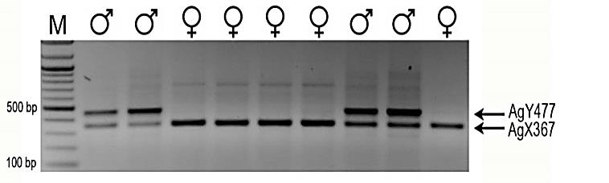

M

F

M

F

F

F

M

M

F

1.0

0.5

kb

AgY477

AgX367

Fig. S1.

PCR-based karyotype analysis of individual *A. gambiae* embryos.The Y and the X chromosome-linked satellite sequences AgY477 and AgY367 were targeted using the same primer pair, thus, the assay is highly sensitive and unequivocal for both males (M) and females (F).

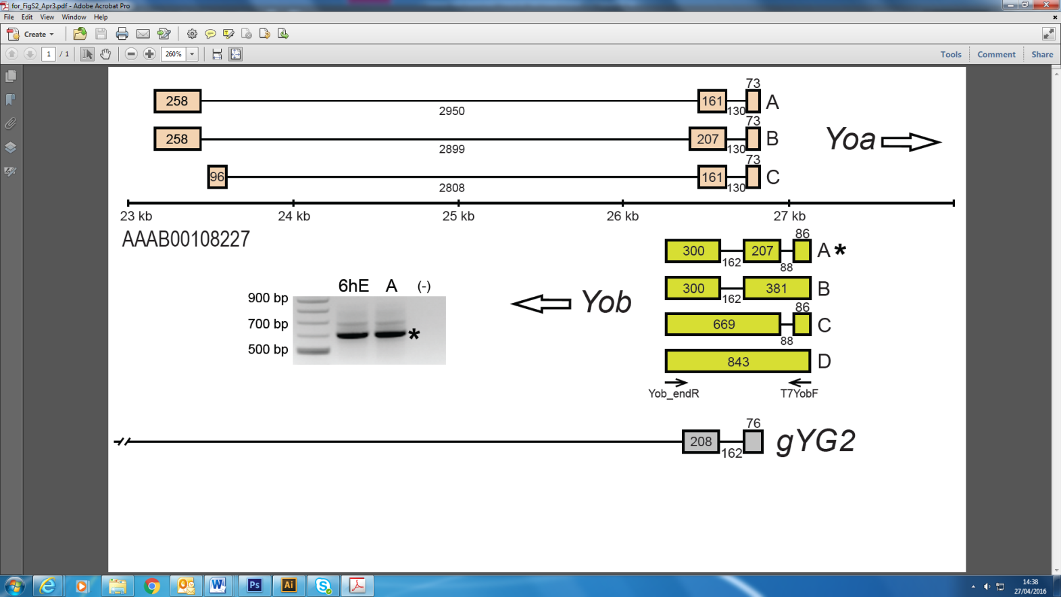

Fig. S2.

Structure of the *Yob* gene in the context of the *A. gambiae* genome.*Yob* is encoded on the scaffold AAAB01008227 and overlaps the *Yoa* gene, which we discovered during RACE fragments analysis. An overlapping fragment of the *gYG2* gene *(19)* is also shown. Exons are depicted as boxes and introns as lines; the numbers represent lengths in nucleotides. Open arrows show direction of transcription. Transcripts of *Yoa* and *Yob-C* have been identified during RACE experiments, but could not be validated by RT-PCR. Inset shows the *Yob* gene RT-PCR products in the 6 h old embryos and in adult males. An asterisk indicates the transcript used in transfection and microinjection experiments.



­

Fig. S3.

Temporal profile of transcription of *Yob* and orthologs of *even skipped* and *hunchback* during development of *A. gambiae.* (**A**)RT-PCR products of *Yob*. (**B**) Putative orthologs of *even skipped* (AGAP010279) and *hunchback* (AGAP010777). Numbers above the gels denote age of embryos in hours; L1-L4, first-fourth instar larvae; P, pupae; A, adults; (-), negative control. Ribosomal protein *S7* (*rpS7*) transcript levels were used as a gel loading control.

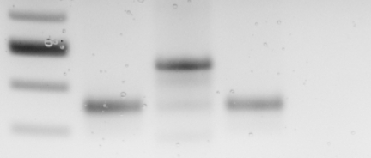

Sua

M

F

(-)

0.5

0.4

Sua

M

(-)

0.5

1.0

kb

**A**

**B**

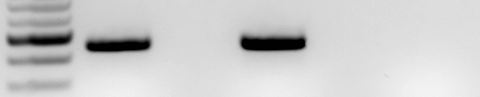

0.5

0.4

*Yob*

*rpS7*

Fig. S4.

*A. gambiae* Sua5.1 cell line lacks the Y chromosome and the *Yob* gene expression. (**A**) Sexing PCR analysis of genomic DNA from Sua 5.1 cells (Sua), and male (M) and female (F) pupae. (-), negative control. (**B**) RT-PCR analysis of *Yob* and *rpS7* mRNA from Sua 5.1 cells (Sua) and male (M) pupae. (-), negative control.

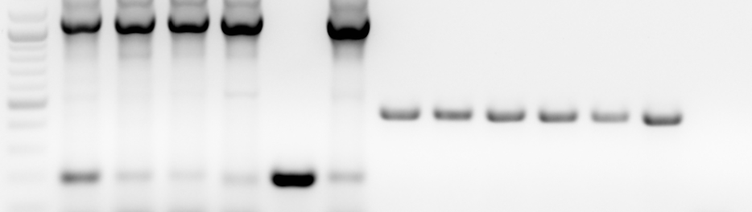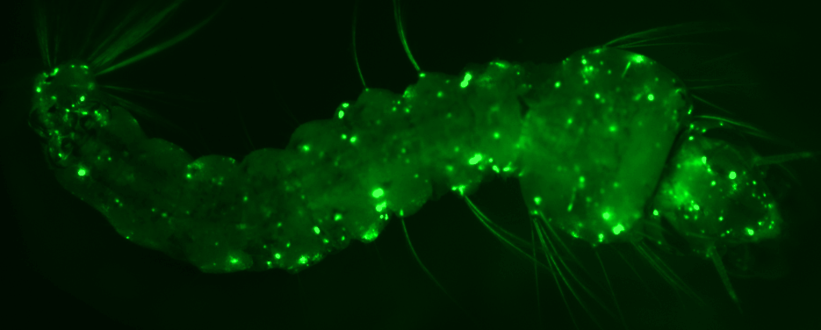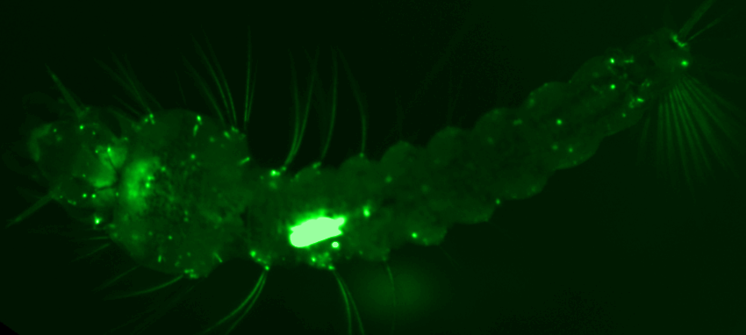

**A**

**B**

1

2

3

4

M

F

1

2

3

4

M

F

(-)

*dsx*

*rpS7*

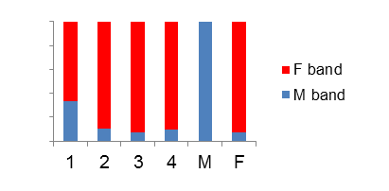

Band intensity (%)

100

80

60

40

20

**C**

1.0

0.5

kb

0.2

Fig. S5.

*In vivo* transfection in *A. gambiae* larvae. **(A**) Femalelarvae transfected with a mixture of *Yob* mRNA and polyubiquitin:eGFP plasmid. Intensive green fluorescence (left panel, circled) corresponds to groups of highly efficiently transfected thoracic muscle cells torn from the thorax and translocated to the abdomen during injection. These cells were viable and able to contract; they were dissected with the neighboring tissues for RNA extraction to test the effect of *Yob* RNA on *dsx* splicing. Usually, the transfected cells were scattered throughout the body (right panel). (**B**) RT-PCR showing splicing pattern of *dsx* in transfected larval samples. Only in the dissected sample (line 1), in which the proportion of transfected cells was greater, did we observe elevated levels of the *dsx* male isoform, comparable to the levels observed in the *Yob* mRNA-transfected Sua5.1cells (cf. Fig. 2 and fig. S7). No effect on *dsx* could be detected in the whole-body samples, even in the most efficiently transfected larvae (B, lines 2-4), indicating that the level of transfection was probably insufficient. M and F, male and female non-transfected larvae; (-), negative control. Ribosomal protein *S7* (*rpS7*) transcript levels were used as a sample loading control. (**C**) Digital representation of the relative amounts (band intensities) of *dsx* splice forms shown in panel B.

*A. gambiae*  ATGTTTGTTTTGTATGTGTCGTACGTTTGTGTATTATTTGTAATTGAGCGGATTTATCAT

*A. arabiensis*  ATGTTTGTTTTGTATGTGTCGTCCTTTTGTGTATTATTTGTAATTGAGCGGATTCATCAT

*A. quadriannulatus*  ATGTTTGTTTTGTATGTGTCGTACGTTTGTGTATTATTTGTAACTGAGCGGATTCATCAT

********************** * ****************** ********** *****

*A. gambiae*  ATTTAAAATTACTCATTTTC---TGAGTTGTATGATTTTCCATCATTTCGATACAATTTC

*A. arabiensis*  ATTTAAAATTACTTATTTTCTAATGAGTTGTACGATTTTCCAACATTTCTATACAATTTC

*A. quadriannulatus*  ATTTAAAATTACTTATTTTCTAATGAGTTGTATGATTTTTCAACATTTCGATACAATTTC

************* ****** ********* ****** ** ****** **********

*A. gambiae*  CTTCTTACACTAATATCTCATAGAATTTTTCTTGTGTTTACAATGTTTTTCAATTAGACT

*A. arabiensis*  CTACTTACACTAATATCTCATAGAATTTTTCTTGTGTTTGCAATGTTTTTCAATTAGACT

*A. quadriannulatus*  CTACCTACACTAATATCTCATAGAATTTTTCTTGTGTTTACAATGTTTTTCAATTAGACT

** * ********************************** ********************

123123123123123123123123123123123**1**231231231231**2**31231231231

*A. gambiae*  CA**ATG**AAATCGGCCAATCCAGAACTGGAAGTTGCCTATGTAAAGCATTTCATAATCGCTA

*A. arabiensis*  CA**ATG**AAATCGGCCAATCCAGAACTGGAAGTTGCCGATGTAAAGCATTCCATAATCGCTA

*A. quadriannulatus*  CA**ATG**AAATCGGCCAATCCAGAACTGGAAGTTGCCGATGTAAAGCATTCCATAATCGCTA

*********************************** ************ ***********

23123123**1**231231231231231231231**2**3123123123123123123**1**231231231

*A. gambiae*  TGATGCTTCCAAAGAAAACGTTAAAATACGATATAAGGCGAATTCAGTTCAGTCATTTTG

*A. arabiensis*  TGATGCTTTCAAAGAAAACGTTAAAATACGATATAAGGCGAATTCAGTTCCGTCATTTTG

*A. quadriannulatus*  TGATGCTTTCAAAGAAAACGTTAAAATACGCTATAAGGCGAATTCAGTTCAGTCATTTTG

******** ********************* ******************* *********

231231231231231**2**3123123123123123123123123**1**231231231231231231

123

*A. gambiae*  CGCAGCATAAACAAGCACAGCTCAACAACGTTTTGTTAGAGAAGAAATCATCCAGCC**ATG**

*A. arabiensis*  CGCAGCATAAACAAGTACAGCTCAACAACGTTTTGTTAGAGGAGAAATCATCCAGCC**ATG**

*A. quadriannulatus*  CGCAGCATAAACAAGTACAGCTCAACAACGTTTTGTTAGAGGAGAAATCATCCAGCC**ATG**

*************** ************************* ******************

231231231231231231231231

123123123123123123123123

*A. gambiae*  TTTTCGCAATCAGCCTGTGTACAAGTAAGAGGGAAAAGGAACTGAGGCAACTAATGTTTG

*A. arabiensis*  TTTTCGCAATCAGCCTGTGTACAAGTAAGAGGGGAAAGGAACTAAGGCAACTAATGTTTG

*A. quadriannulatus*  TTTTCGCAATCAGCCTGTGTACAAGTAAGAGGGAAAAGGAACTAAGGCAACTAATGTTTG

********************************* ********* ****************

*A. gambiae*  GAATCCCATATGTCTATACAAGGGCGGTGGTTATATTTGT---AAAAAAAAAAATTTGGG

*A. arabiensis*  GAATCCCATATGTCTATACAAGGGCGGTGCTTATATTTG--AAAAAAAAACAATTTCGGG

*A. quadriannulatus*  GAAGCCCATATGTCTATACAAGGGCAGTGCTTATATTTGTAAAAAAAAAACAATTTTGGG

*** ********************* *** ********* ******* ** ** ***

*A. gambiae*  AATGCTAGGAACAATTTAATTCCTTACCTGATGATTCAAAATATAATAGAATGATCTGTA

*A. arabiensis*  AATGCTAGGAACAATTTAATTCCTTACTTGATGATTCAAAATATAATAGAATGATCTGTA

*A. quadriannulatus*  AATGCTAAGAACAATATAATTCTTTACCTGATGATTCAAAATATAATAGAATGATCTGTA

******* ******* ****** **** ********************************

231**2**3123123123123123

123**1**2312312312312312312312312312312312312312312**3**123

*A. gambiae*  CTTTTACAGGTTCACATAAAAACAAA**TGA**GCTGCACACCGCTGTTGTCGAGAAAGTTATT

*A. arabiensis*  CTTTTACAGGTTCACATAAAAACAAA**TGA**GCTGCACACCGCTGTTGTCGAGAAAGTAATT

*A. quadriannulatus*  CTTTTACAGGTTTACATAAAAACAAA**TGA**GCTGCACACCGCTGTTGTCGAGAAAGTAATT

************ ******************************************* ***

12312312312312312312312312312312**3**12312312312312312312312**3**123

*A. gambiae*  CTTGCCATGATATCGTCCTGCAGAACGGACAACAATCAGGCCCTCCATAAGCTGCTTCAC

*A. arabiensis*  CTTGCCATGATATCGTCCTGCAGAACGGACAACAATCAGGCCCTCCATAAGCTGCTACAC

*A. quadriannulatus*  CTTGCCATGATATCGTCCTGCAGAACGGACAAGAATCAGGCCCTCCATAAGCTGCTTCAC

******************************** *********************** ***

123123123123123123123123123123123

*A. gambiae*  GTTGCGGTCTGCGAAGAGAATTATAATGTT**TGA**CACACCACCGTCACGAACATAGGGTTC

*A. arabiensis*  GTTGCGGTCTGCGAAGAGAATTATAATGTT**TGA**CACACCACCGTCACGAACATAGGGTTC

*A. quadriannulatus*  GTTGCGGTCTGCGAAGAGAATTATAATGTT**TGA**CACACCACCGTCACGAACATAGGGTTC

************************************************************

*A. gambiae*  TGTATCACTCGCCGGTATAGTGTAAATTAGATATAGGTAAGTAGAGGAATTAGGGAGCTG

*A. arabiensis*  TGTATCACTCGCCGGTATAGTGTAAATTAGATATAGGCAAGTAGAGGAATTAGTGAGCTG

*A. quadriannulatus*  TGTATCACTCGCCGGTATAGTGTAAATTAGATATAGGCAGGTAGAGGAATAAGTGAGCTG

************************************* * ********** ** ******

*A. gambiae*  CCGCATTATTGATCGCCTTTTTCCTTAAAAATACGATTCGCCCGCTCGAATAAAAACAAT

*A. arabiensis*  CCGCATTATTGATCGCTTTATTCCTTAAAAATATGATTCGCCCGCTGGAATAAAAACAAT

*A. quadriannulatus*  CCGCATTATTGATCGCTTTTTCTCTAAAAAATATGATTCGCCCGCTGGAATAAAAACAAT

**************** **** ** ******* **************************

*A. gambiae*  TAAAATATC

*A. arabiensis*  TAAAATATC

*A. quadriannulatus*  TAAAATATC

*********

Fig. S6.

Alignment of the *Yob* gene sequences from three members of the *A. gambiae* complex.Exons are shaded yellow. Numbers above the alignment indicate codon positions of two open reading frames (ORF). Codon positions with substitutions are underlined. Substitutions exclusively in the 1st and 2nd positions indicate that the ORF marked in red is less likely to encode a protein than the ORF marked in blue (consisting of 56 triplets, excluding stop codon), in which substitutions were predominantly in the 3rd codon positions. Target sites for the T7YobF and Yob_endR primers used for amplification of the gene are underlined. Asterisks indicate identical positions.

**A**

control

*Yob*

*Yob_*stop

*Yob_*noMet

(-)

F

M

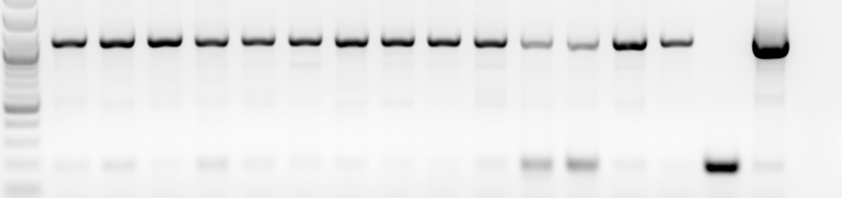

kb

1.0

*dsx*

0.5

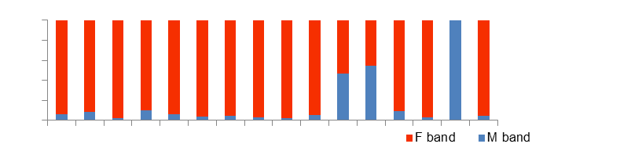

0.2

**B**

60

80

100

Band intensity (%)

20

40

**C**

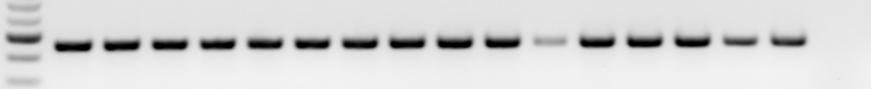

*rpS7*

kb

0.4

0.5

Fig. S7.

*Yob* is a protein coding gene. (**A**) RT-PCR analysis showing a representative *dsx* splicing pattern in the *A. gambiae* Sua5.1cells transfected with modified *Yob* transcripts containing premature stop codon (*Yob*-stop) or lacking methionine in the first codon position (*Yob*-noMet), as compared to cells transfected with native *Yob* transcripts (*Yob*) and non-transfected cells (control). M and F, *A. gambiae* male and female pupae; (-), negative control. Similar results were obtained in three independent experiments. (**B**) Digital representation of the relative amounts of *dsx* splice forms shown in panel A. (**C**) RT-PCR analysis of ribosomal protein *S7* transcript levels used as a sample loading control.

# *Yob* -------EEEEEE---HHHHHHHHHHHHHHH------HHHHHHHHHHHH-------

# *Yob* MFSQSACVQVHIKTNELHTAVVEKVILAMISSCRTDNNQALHKLLHVAVCEENYNV

# *Guy1* MNSQSRRYKNIELVNNLKAYLTWNDKSSFQVKHSAVTLEKKKSKTKICNVLYEAIT

***Guy1* ----------HHHHHHHHHHEEE------EEEEEEEEEEHH----HHHHHHHHH--**

**\* *** : .*:*:: :. : :: . : . : :. ::. : .**

Fig. S8.

Amino acid alignment and a predicted secondary structure of YOB and a putative protein encoded by the *GUY1* gene from *A*. *stephensi*.In the secondary structure prediction lines, H denotes alpha helix, E - extended strand, and dash – random coil. Asterisks indicate positions with identical residues; colons and periods indicate positions with amino acids possessing, respectively, strongly and weakly similar physicochemical properties. Identical length and similar structure suggest that both proteins may have originated from a common ancestor and/or may be structurally constrained by the same sex-determining function; however, low similarity precludes unambiguous conclusion regarding their homology.

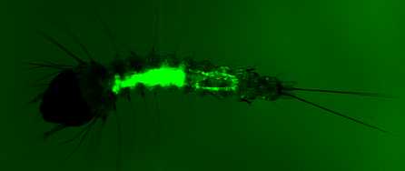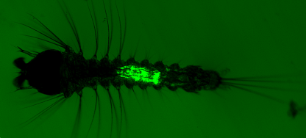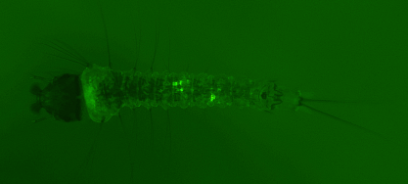

**A**

**B**

**C**

Fig. S9.

Larvae hatched from eggs injected with a nucleic acid mix containing a plasmid with a GFP expression cassette.Varied intensity of GFP expression shown (weak in **A**, strong in **B** and **C**) reflects difference in the amounts of nucleic acids delivered during embryo injections.

**?*tra***

**DC**

***dsx*F**

**XX**

**?*tra***

**DC**

**?**

***dsx*M**

**XY**

***Yob***

**X over-**

**expression**

**?**

**?**

**?*tra***

**DC**



**?**

**?**

***dsx*M**

**XX**



***Yob***

**?*tra***

**DC**

**?**

**?**

**X over-**

**expression**

***dsx*M**

**XY**

***Yob***

**X under-**

**expression**

**?**

**?**



**?**

**?**

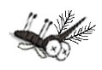

**ds*Yob***

**?**

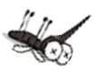

Fig. S10.

*Yob* is a male sex determiner gene, directly or indirectly controlling dosage compensationand *dsx* splicing. (**A**) According to the proposed model, presence of YOB protein in normal physiological conditions leads to male-specific splicing of *dsx* and to activation of dosage compensation machinery, both of which may be mediated through inhibition of active *tra* (or analog) protein production (*9*-*12*), or through other unidentified intermediate molecules. (**B**) In females, delivery of *Yob* mRNA causes abnormal activation of dosage compensation, which results in over-transcription from both X chromosomes and death at the embryo stage. Conversely, silencing of *Yob* in male embryos by injection of double-stranded RNA prevents activation of dosage compensation, which leads to insufficient transcription from the single X chromosome and, in result, death, rather than feminization of the XY individuals.

Table S1.

The results of mating experiments with GFP-positive *A. gambiae* males and the results of dissections.

|  |  |  |  |  |  |  |
| --- | --- | --- | --- | --- | --- | --- |
| **Male** | **Eggs laid** | **Progeny** | **Male dissections** | | | **Female dissections**  **Sperm in spermathecae** |
| **Testes** | **Spermatozoa** | **Accessory glands** |
| **1** | yes1 | no | not examined2 | not examined2 | not examined2 | no |
| **2** | yes1 | 10 ♂, 15 ♀ | normal | motile | Normal | motile |
| **3** | yes1 | no | not examined3 | not examined3 | Normal | no |
| **4** | yes1 | 10 ♂, 15 ♀ | normal | motile | Normal | motile |
| **5** | yes1 | no | normal | motile | Normal | motile |
| **6** | no | N/A | normal | motile | Normal | no |
| **7** | yes1 | no | not examined3 | not examined3 | Normal | motile |
| **8** | yes1 | 8 ♂, 19 ♀ | normal | motile | Normal | motile |
| **9** | yes1 | 15 ♂, 18 ♀ | normal | motile | Normal | motile |
| **10** | yes1 | no | not examined3 | not examined3 | Normal | no |
| **11** | yes | 99 ♂, 88 ♀ | normal | motile | Normal | motile |
| **12** | yes1 | 1, died as larva | normal | motile | Normal | motile |
| **13** | yes1 | 10 ♂, 11♀ | normal | motile | Normal | motile |
| **14** | yes | 51 ♂, 69 ♀ | normal | motile | Normal | motile |
| **15** | yes1 | 9 ♂, 20 ♀ | normal | motile | Normal | motile |

1Less than 50 eggs laid.

2The male died before the dissection day.

3Testes damaged during dissection

Table S2.

Sequences of transcript-specific primers used in RACE experiments. Primers in parentheses were used as nested primers.

|  |  |  |
| --- | --- | --- |
| **Primer target** | **5’ end (5’ – 3’)** | **3’ end (5’ – 3’)** |
| **Yoa A and B** | YoaAB5 TACTCGGTTTCTGGGTTCCCTA (YoaABN5 CTCGAATATCCGCGTAAGTCAAAT) | YoaAB3 ACCACCGAGTAACCAATCGTGT (YoaABN3 GATATTCGAGTTACGCGGATTCCT) |
| **Yoa-C** | YoaC5 CGATTCTTCTTCCACCTAGCTGTC (YoaCN5 ACGGGCTTATAACTTGGCCTGATA) | YoaC3 GGGGTTATACCAAGGACCGTA  (YoaCN3 TATAAGCCCGTTTTGACAGCTAGG) |
| **Yob C and D** | none | YobCD3 AGAGGGAAAAGGAACTGAGGCAAC (YobCDN3 TATGTCTATACAAGGGCGGTGGTT) |
| **Yob A-D** | 8484NF GCCTGATTGTTGTCCGTTCT  (YobN5 CACAAACGTACGACACATACAAAAC) | Yob3 CCGCTGTTGTCGAGAAAGTAATTC  (YobN3 CTGCAGAACGGACAACAATCAG) |

Table S3.

Sequences of primer pairs used in RT-PCR experiments.

|  |  |  |
| --- | --- | --- |
| **Primer target** | **Forward primer (5’ – 3’)** | **Reverse primer (5’ – 3’)** |
| ***dsx* male-specific** | dsxF AAAGCACACCAGCGGATCGA  dsxF2 CCAGAACCTGTAAATCTCCTAC | dsxR1 GGACGAGAACATCTCGGTG  dsxR5m GATGACTTCACCACCGCTTC |
| ***dsx* female-specific** | dsxF AAAGCACACCAGCGGATCGA | dsxR2 CGCAATACCACCCGTCAGAGTGGA |
| ***Yoa* A and B** | Yoa-F1 ACCACCGAGTAACCAATCGTGT | 8484NR GCAGCATAAACAAGCACAGC |
| ***Yoa* C** | Yoa-F2 GGGGTTATACCAAGGACCGTAAAG | 8484NR GCAGCATAAACAAGCACAGC |
| ***Yob* A-D** | 8484R GGAAGTTGCCGATGTAAAGC  Yob-R TTGTATGTGTCGTACGTTTGTG  T7YobF  TAATACGACTCACTATAGGGATGTTTGTTTTGTATGTGTCG | 8484F CGGCAGCTCACTAATTCCTC  8484F GCCTGATTGTTGTCCGTTCT  Yob_endR  GATATTTTAATTGTTTTTATTCGAGCGG |
| **AGAP010279** | 279F CGGATTAGCGGTGGATCTAA | 279R GTGGCCGTGAGACGTAGTTT |
| **AGAP010777** | 777F TCCCAGGAGGACAGTGAATC | 777R TAGCCCATGTGGATCGTGTA |
| ***S7*** | S7F TGCTGCAAACTTCGGCTAT | S7R CGCTATGGTGTTCGGTTCC |

**References**

39. M. Q. Benedict, in *The Molecular Biology of Insect Disease Vectors,* J. M. Crampton, C. B. Beard, C. Louis, Eds. (Chapman & Hall, London, 1997), pp. 3-12.

40. J. Krzywinski, D. Sangare, N. J. Besansky, *Genetics* **169**, 185-196 (2005).

41. G. J. Lycett, D. Amenya, A. Lynd, *Insect Mol. Biol.* **21**, 79-88 (2012).

42. L. A. Bertucci, M. A. Noor, *Dros. Inf. Serv.* **84**, 166-168 (2001).

43. T. D. Wu, C. K. Watanabe, *Bioinformatics* **21**, 1859-1875 (2005).

44. S. F. Altschul *et al.*, *J. Mol. Biol.* **215**, 403-410 (1990).

45. C. Cole, J. D. Barber, G. J. Barton, *Nucleic Acids Res.* **36**, W197-201 (2008).

46. G. Cheng *et al.*, *PloS ONE* **6**, e22786 (2011).

47. I. Vandenbroucke, J. Vandesompele, A. D. Paepe, L. Messiaen, *Nucleic Acids Res.* **29**, E68-68 (2001).

48. G. J. Lycett, F. C. Kafatos, T. G. Loukeris, *Genetics* **167**, 1781-1790 (2004).