Top-down venomics of the East African green mamba, Dendroaspis angusticeps, and the black mamba, Dendroaspis polylepis, highlight the complexity of their toxin arsenals

Daniel PETRAS^{1,*}, Paul HEISS¹, Roderich D. SÜSSMUTH¹, Robert A. HARRISON², Juan J. CALVETE^{3,*}

¹ Technische Universität Berlin, Institut für Chemie, Berlin, Germany
² Alistair Reid Venom Research Unit, Liverpool School of Tropical Medicine, Liverpool, United Kingdom.
³ Instituto de Biomedicina de Valencia, CSIC, Valencia, Spain

Running title: Top-down venomics of African mambas

* Corresponding authors: For questions concerning snake venoms and venomics, please contact Juan J. Calvete (jcalvete@ibv.csic.es), Laboratorio de Venómica Estructural y Funcional, Instituto de Biomedicina de Valencia, C.S.I.C., Jaime Roig 11, 46010 Valencia, Spain. Phone: +34 96 339 1778, Fax: 34 96 369 0800. For questions regarding top-down analysis, please contact Daniel Petras (daniel.petras@chem.tu-berlin.de), Technische Universität Berlin, Institut für Chemie, Müller-Breslau-Straße 10, 10623 Berlin, Germany. Phone: +49 (0)30 314 21329.

Keywords: Snake venomics, Elapidae, Dendroaspis, black mamba venom, eastern green mamba venom, Top-down proteomics, Top-down venomics

SUMMARY
We report the characterization, by combination of high-resolution on-line molecular mass and disulfide bond profiling and top-down MS/MS analysis, of the venom proteomes of two congeneric African snake species of medical importance, Dendroaspis angusticeps (green mamba) and D. polylepis (black mamba). Each of these mamba venoms comprised more than two-hundred polypeptides belonging to just a few toxin families. Although both venom proteomes are overwhelmingly composed of post-synaptically-acting short- and long-chain neurotoxins that potently inhibit muscle- and neuronal-type nicotinic acetylcholine receptors; muscarinic cardiotoxins; and dendrotoxins, that block some of the Kv1, n-class of K⁺ channels, the identity of the major proteins and their relative abundances exhibit marked interspecific variation. In addition, the greater resolution of the top-down venomic analytical approach revealed previously undetected iso- and proteoforms of known venom proteins, including the identification and precise location of acetylated lysine residues in a number of molecules in both venoms, but particularly in green mamba toxins. The comparative top-down venomic analysis revealed the untapped complexity of Dendroaspis venoms and lay the foundations for rationalizing the notably different potency of green and black mamba lethal arsenals at locus resolution.

INTRODUCTION
Mambas are venomous snakes classified under the genus Dendroaspis (Schlegel 1848) (1) in the family Elapidae. The six extant mamba species and subspecies (eastern green mamba, D. angusticeps (2), Jameson's mamba, D. jamesoni (3) and its subspecies: the nominotypical D. j. jamesoni, and the eastern Jameson's mamba, D. j. kaimosae (4), black mamba, D. polylepis (5), and western green mamba, D. viridis (6)) are endemic to sub-Saharan Africa. The generic name, Dendroaspis, derived from Ancient Greek "Dendro" (tree) and "asp" (snake). Thus, Dendroaspis literally means "tree snake", which refers to the arboreal nature of most of the species within the genus, the exception being the black mamba, which is terrestrial. The eastern green mamba and the black mamba are the subject of the venomic investigations reported here.
The eastern green mamba is a large (adult males and females' average total length is around 1.8 m and 2.0 m) and very slender bodied snake indigenous to more coastal regions of southern Africa and east Africa. Its range extends from Kenya south through Tanzania, Mozambique, Malawi, eastern Zimbabwe, eastern Zambia into South Africa, as far as southern Natal and northern Pondoland (7, 8). In addition to wild forest habitats, this diurnal arboreal species, thought to be a relatively sedentary ambush predator, is also commonly found in thickets and farm trees (such as citrus, mango, coconut, and cashew), where it preys chiefly on birds, eggs, and rodents, although it has also been documented to prey on bats (9, 10).
The black mamba is a diurnal, terrestrial species that actively hunts its prey, which consists of small mammals, such as hyrax and rock hyrax, bushbabies, and bats (11). Capable of reaching 16-20 km/h over short distances (12), the black mamba is the fastest moving snake found in Africa (12, 13). Adult black mamba average 2.4-3 m total length, but may exceptionally reach 4.5 m, making it the second longest venomous snake in the world, exceeded in length only by the king cobra, Ophiophagus hannah (14). D. polylepis occurs across a wide and occasionally fragmented range, from north east Democratic Republic of the Congo, south western Sudan to Ethiopia, Eritrea, Somalia, Kenya, eastern Uganda, Tanzania, Burundi, Rwanda, southwards to Mozambique, Swaziland, Malawi, Zambia, Zimbabwe and Botswana to KwaZulu-Natal in South Africa, and Namibia, then north easterly through Angola to south eastern Democratic Republic of the Congo (7, 15).
The eastern green mamba and the black mamba are highly venomous snakes. It is estimated that 10-15 mg venom will kill a human adult (16). The black mamba, D. polylepis, is regarded as the most dangerous and feared snake in Africa (17). When cornered or threatened it will deliver a series of bites in rapid succession, injecting large amounts (up to 400 mg) of potent neurotoxic venom (subcutaneous LD₅₀ for mice, 0.28 mg/kg) with each strike (18, 19), potentially causing collapse in humans within 30-45 minutes or less (8, 20, 21). The eastern green mamba, D. angusticeps, also has a potent neurotoxic venom (subcutaneous LD₅₀ in mice is 1.3 mg/kg) (8), but unlike the black mamba, it is a shy and not so aggressive species, which unless motivated by thirst, prey, or the need to bask in the sun, tends to spend most of its time above the ground in relatively dense brush, where it is well camouflaged (8, 9, 17).
Mamba venoms contain a high diversity of pharmacologically active peptides, which belong to just a few protein families (22). Venom of both the eastern green mamba and the black mamba consist predominantly of extremely rapid-acting toxins. Dendrotoxins are uniquely found in Dendroaspis venoms (23, 24). Dendrotoxins, 57-60-amino-acid-residue, single-chain polypeptides structurally homologous to the Kunitz-type serine protease inhibitors (KSI) [1DTK, 1DEM, 1DEN, 1DTX], block some of the Kv1, n-class of K⁺ channels, enhancing thereby acetylcholine release at the presynaptic nerve terminal of neuromuscular junctions, provoking an excitatory effect and strong central neurotoxicity (23, 24).
Voltage-dependent Ca²⁺ channels play important roles in transmitting signals by neurons and in contraction of cardiac or smooth muscle cells (25). Calcicludine (from D. angusticeps venom) [1BF0] and calciseptine (D. polylepis) [1TFS] block most of the high-threshold Ca²⁺ channels (L-, N-, or P-type) in the 10-100 nM range. These 60-amino acid polypeptides of the KSI fold family show particular potency for L-type Ca²⁺ channels (26), key components for the excitation-contraction coupling of skeletal, smooth, and cardiac muscle, thus inhibiting smooth muscle contraction and cardiac function (27). Calcicludine appears also to be a selective blocker of a subtype of L-type Ca²⁺ channel that is predominantly expressed in cerebellar granule cells (28), and calciseptine binds to a 1,4-dihydropyridine recognition site of L-type calcium channel of rat synaptosomal membranes (29).
Post-synaptically-acting α-neurotoxins (α-NTX) belong to the long (L)- or short (S)-chain subfamilies of the 3FTx family (30). Lα-NTXs (65-72 residues, 5 disulphide linkages) and Sα-NTXs (60-62 amino acids crosslinked by 4 intramolecular disulphide bonds) antagonize the function of muscular nicotinic cholinoceptor (nAChR), and Lα-NTXs exhibit also high specificity towards neuronal-type α7, α8 and α9 nAChR. Alpha-neurotoxins play a central role in the neurotoxicity of mamba venoms, rapidly blocking neuro-muscular transmission causing rapid onset of neuromuscular flaccid paralysis in victims, that can lead to respiratory failure and death (31).
Muscarinic receptors are widely spread throughout the body, and are involved in the regulation of fundamental physiological processes such as modulation of heart rate and control of motor systems. In the central nervous system, cholinergic transmission is mainly mediated by muscarinic receptors. Dendroaspis venoms contain toxins that potently inhibit muscle- and neuronal-type nicotinic acetylcholine receptors (32, 33). Cardiotoxins present in mamba venoms include D. polylepis (MTα, MTβ and MTγ) and D. angusticeps (MT1-MT7) muscarinic toxins, 65-66-residue polypeptides of the three-finger toxin (3FTx) family [MT1, 4DO8, MT2, 1FF4, MT7, 2VLW], which preferentially recognize the M1 and M4 muscarinic receptor subtypes (34, 35), and α-adrenergic toxins from D. angusticeps and D. polylepis that interact with α1- and α2-adrenoceptors (36, 37).
Acetylcholinesterase (AChE) of the neurotransmitter acetylcholine, at cholinergic synapses in the central and peripheral nervous systems, is a target site of mamba venom fasciculins (Fas), 61-amino acid peptides of the 3FTx toxin family (38, 39). This terminology reflects the fact that these proteins cause severe, generalized and long-lasting (5-7 hours) fasciculations (38). X-ray crystal structures of Fas-AChE complexes [1FSS, 1KU6, 4EY8] (40-42) have revealed a synergistic and conformationally flexible three-point anchorage, consistent with the picomolar K_{D} of the complex, and which may serve as a model for the binding mechanism of structurally related α-neurotoxins and muscarinic agonists to their respective ACh receptors.
D. polylepis toxin (MIT1, prokineticin, P25687]), a structural homologue of colipase [1IMT] (43), a protein involved in fatty acid digestion, is a 81-amino acid polypeptide that potently contracts gastrointestinal smooth muscle (44). The receptor for this toxin is present both in the CNS and in the smooth muscle, and might be an as yet unidentified K⁺ channel (44).
Mambalgins [2MFA], 57-amino acid peptides, are a novel functional new class of snake venom short-chain three-finger toxins that exert potent analgesic effects mediated through the inhibition of acid-sensing ion channels (ASICs) associated with pain (45).
Without appropriate treatment, patients bitten by Dendroaspis species typically progress to severe reactions such as tachydysrhythmias, convulsions and neurogenic shock, leading to death by asphyxiation, cardiovascular collapse, or respiratory failure. Biochemical studies on the venom of D. polylepis and D. angusticeps have focused on the biochemical and pharmacological characterization of their most relevant toxins to rationalize the common neurological and neuromuscular symptoms of envenomings caused by these species (8, 19-21, 46). In addition, studies on isolated toxins are being pursued to study receptor pharmacology, physiology and structure/function relationships, as well as to explore their potential use as leads for the development of novel therapeutic molecules (35, 45, 47-51).
Only very recently an overview of the composition of the venom of a Dendroaspis species, D. polylepis, and the identity of the major toxins coupled to their in vivo potency, has been reported (52). This study was performed using a bottom-up venomics platform. Peptide-centric approaches provide incomplete sequence coverage, and in general do not allow to distinguish between different proteoforms or closely related toxin isoforms. Top-down mass spectrometry has the potential to eliminate this shortcoming (53, 54). The aim of the present study was to to complement and extend the work of Laustsen and co-workers (52) by applying a combined bottom-up and top-down venomics approach to unveil the complexity of the lethal arsenals of the black mamba and the eastern green mamba at locus resolution.

EXPERIMENTAL PROCEDURES
Venom samples
Venoms of green mamba (Dendroaspis angusticeps) and black mamba (Dendroaspis polylepis) were both pooled from specimens caught in Tanzania and maintained in captivity in the Herpetarium of the Liverpool School of Tropical Medicine. Crude venoms were lyophilized and stored at 4 °C till analysis.

Top-down venomics
For top-down MS analysis, the venoms were dissolved in 1% formic acid (HFO) in ultrapure water to a final concentration of 10 mg/mL, and centrifuged at 20,000 g for 5 min. To reduce the disulfide bonds, 10 µL of venom were mixed with 10 µL of 0.5 M tris (2-carboxyethyl)phosphine (TCEP) and 30 µL of 0.1 M citrate buffer, pH 3, and incubated for 30 min at 65 °C. The samples were then mixed with an equal volume of 1% HFO and centrifuged at 20,000 g for 5 min. 10 µL of each, reduced and non-reduced samples, were submitted to reverse-phase (RP) HPLC-high-resolution(HR)-MS/MS top-down analyses. RP-HPLC-HR-MS/MS experiments were performed on an an Agilent 1260 HPLC system (Agilent, Waldbronn, Germany) online with an electrospray ionization (ESI) source and an LTQ Orbitrap XL mass spectrometer (Thermo, Bremen, Germany). RP-HPLC separation was performed on a Supelco Discovery Biowide C18 column (300Å pore size, 2 x 150 mm column size, 3 µm particle size). The flow rate was set to 0.3 mL/min and the column was eluted with a gradient of 0.1% HFO in water (solution A) and 0.1% HFO in acetonitrile (ACN) (solution B): 5% B for 1 min, followed by 5-40% B for 89 min, and 40-70% for 20 min. Finally the column was washed out with 70% B for 10 min and re-equilibrated at 5% B for 10 min. ESI settings were 11 L/min sheath gas, 35 L/min auxiliary gas, spray voltage, 4.8 kV, capillary voltage, 63 V, tube lens voltage, 135 V, and capillary temperature, 330 °C.
MS/MS spectra were obtained in information dependent acquisition (IDA) mode. FTMS measurements were performed with 2 micro scans and 500 ms maximal C-trap fill time. The survey scan and both data dependent MS/MS scans were performed with a mass resolution (R) of 100,000 (at m/z 400). For MS/MS the two most abundant ions of the survey scan with known charge were selected. Normalized CID energy was set to 30% for the first, and 35% for the second, MS/MS event of each duty cycle. The default charge state was set to z =6, and the activation time to 30 msec. Mass window for precursor ion selection was set to 2 m/z. A window of 3 m/z was set for dynamic exclusion of up to 50 precursor ions with a repeat of 1 within 10 sec for the next 20 sec. For data analysis, the .raw data were converted to .mzXML files using MSconvert of the ProteoWizard package (http://proteowizard.sourceforge.net) and the multiple charged spectra were deconvoluted using MS-Deconv (http://bix.ucsd.edu/projects/msdeconv). Protein spectra matching was performed using TopPIC (http://proteomics.informatics.iupui.edu/software/toppic/) against a database comprising all NCBI protein entries of Dendroaspis (165 sequences, 11th March 2015). TopPIC mass error tolerance was set to 10 ppm. A FDR cut-off was set to 0.01. Maximal allowed unexpected PTMs were set to two. For manual validation and graphical visualization MS/MS spectra were deconvoluted using the XTRACT algorithm of the Xcalibur Qual Browser (Thermo, Bremen, Germany). For isotopically unresolved spectra, charge distribution deconvolution was performed using the Zscore algorithm of the magic transformer (MagTran) (55).

Bottom-up venomics
1 mg of crude venom was dissolved in 100 μL of 5% ACN and 1% HFO in ultrapure water, and centrifuged at 20,000 x g for 5 min. 90 µL of the soluble proteins were loaded onto a Supelco Discovery Biowide C18 column (300 Å pore diameter, 4.6 ×150 mm column size, 3 μm particle size) using an Agilent 1260 Low Pressure Gradient System (Agilent, Waldbronn, Germany). The column was equilibrated and developed with 0.1% HFO in water (solvent A) and 0.1% HFO in ACN (solvent B), isocratically (5% B) for 5 min, followed by a lineat gradient of 5-40% B for 85 min and 40−70% B for 20 min. Finally, the column was washed with 70% B for 10 min and re-equilibrated at 5% B for 10 min. Peak detection was performed at 214 nm using a 1200 diode array detector (Agilent, Waldbronn, Germany). Fractions, collected manually in 2 mL tubes, were dried overnight in a vacuum centrifuge (Thermo speedvac, Bremen, Germany), redisolved in ultra pure water, and submitted to SDS-PAGE analysis (in 15% polyacrylamide gels under reducing conditions). Gels were stained with Coomassie Brilliant Blue G250. PageRuler Unstained Protein Ladder (Thermo, Bremen, Germany) was used as a standard for apparent molecular weight determination. Stained electrophoretic protein bands were excised from the gels and subjected to in-gel reduction (10 mM dithiothreitol in 25 mM ammonium bicarbonate buffer, pH 8.3, for 45 min at 65 °C.) and alkylation (50 mM iodacetamide in in 50 mM ammonium bicarbonate buffer for 30 min at 25 °), followed by overnight sequencing-grade trypsin digestion (66 ng/μl in 25 mM ammonium bicarbonate buffer, containing 10% ACN, pH 8.3 , 0.25 μg/sample) in an automated processor (Genomics Solution ProGest Protein Digestion Workstation) following the manufacturer's instructions. The resulting tryptic peptides were extracted with 100 µL of 5% HFO and 30% ACN in 100 mM ammonium bicarbonate for 20 min, and dried in a vacuum centrifuge (SPD SpeedVac®, ThermoSavant , Bremen, Germany). After re-dissolving the peptides in 15 μL of a 5% ACN and 0.1% HFO, 10 µL were submitted to LC-MS/MS analysis.
LC-MS/MS experiments were performed on an Orbitrap XL mass spectrometer (Thermo, Bremen, Germany) coupled to an Agilent 1260 HPLC system (Agilent Thechnologies, Waldbronn, Germany). HLPC separation was performed on a Grace Vydac 218MSC18 column (2.1 x 15 mm, 5μm) at 0.4 mL/min flow rate using a gradient of 0.1% HFO in water (solution A) and ACN + 0.1% HFO (solution B), isocratically (5%B) for 1 min, followed by 5-40% B for 10 min, and 40-99% B for 3 min. Finally the column was washed with 99% B for 3 min, and re-equilibrated in 5% B for 3 min.
The Orbitrap was set at a resolution (R) of 15,000 at m/z 400, and a mass range of 300-3,000 m/z in FT mode, for MS1 survey scans. MS/MS spectra were acquired in IDA mode in the LTQ. The 3 most abundant ions of the survey scan were fragmented using CID using 35 msec activation time and 30% collision energy. Precursor ion selection was performed within a 3 m/z window for doubly (z = 2) , triply (z = 3), and quadruply (z = 4) charged ions. A window of 3 m/z was set for dynamic exclusion of up to 50 precursor ions with a repeat of 1 within 15 sec for the next 30 sec.
MS/MS data analysis was performed with PeptideShaker (http://peptide-shaker.googlecode.com) (56), that uses the target-decoy search strategy (57), using X!Tandem as search engine against a database comprising all NCBI protein entries of Dendroaspis spp. (164 sequences, 11th March 2015). PeptideShaker provides statistical confidence estimates for each peptide and protein, taking into account protein inference issues (58). For peptide spectra matching, the search engine was set to 10 ppm precursor mass tolerance ± 0.5 Da MS/MS mass tolerance. Carbamidomethyl cysteine was set as fixed modifications. Acetylation of Lys and N-terminal residue, oxidation of Met, and 5-oxoproline (pyroglutamate) formation from N-terminal Glu or Gln residues, were set as variable modifications. Only protein identifications with at least two peptides and spectra database matches with a confidence score of 100% were considered. Additionally all spectra database hits were manually inspected and validated.
Interpretation of MS/MS spectra from high molecular mass proteins (e.g. SVMPs) not available in the NCBI database was performed de novo using DeNovoGUI. Deduced sequence tags were searched against the Elapidae (taxid:8602) subset of the non-redundant protein database using BLASTP (http://blast.ncbi.nlm.nih.gov).
For relative quantification of the total venom proteins, protein families were displayed as the sum of the areas of the reverse-phase chromatographic peaks compared to the sum of all UV peak areas. The ratios of RP-HPLC co-eluting proteins were estimated in a second level of quantification by the relative abundance of their deconvoluted top-down spectra. On the other hand, the relative abundances of proteins co-eluting by RP-HPLC and whose ratio of deconvoluted mass spectra could not be determined, were estimated by densitometry of the Coomassie-stained SDS-PAGE-separated protein bands (59).

RESULTS AND DISCUSSION
Overview of D. angusticeps and D. polylepis venom proteomes by on-line mass and disulfide bond profiling
High-resolution LC-MS analysis was used to determine the molecular masses of native and reduced D. angusticeps and D. polylepis venom proteins (Fig.1). The green mamba venom comprised ≥ 215 polypeptides distributed in the following mass ranges: 8 (3.8-5.9 kDa, 0.8% TIC), 187 (6-9 kDa, 83% TIC), 18 (13-14 kDa, 1.56% TIC), 1 (16 kDa, 0.02% TIC), 3 (25 kDa, 0.02% TIC), 9 (26-28 kDa, 2.4% TIC), and 6 (47-49 kDa, 1.1% TIC). On the other hand, the black mamba venom appeared to contain ≥ 264 polypeptides distributed as follows 4 (3.5-4.1 kDa, 0.7% TIC), 191 (6-9.8 kDa, 75.8% TIC), 21 (13-15 kDa, 1.6% TIC), 2 (16 kDa, 0.02% TIC), 10 (23 kDa, 0.02% TIC), 4 (25 kDa, 0.002% TIC), 34 (29 kDa, 1.8% TIC), 2 (47-51 kDa, 0.68% TIC). These figures clearly indicated that D. angusticeps and D. polylepis venom comprise a much higher complexity than represented by the 20 and the 27 toxin sequences available, respectively for these snake species, in the non-redundant NCBI database (Supplementary Table S1). Initial bottom-up MS/MS analyses identified 3FTx and Kunitz-type peptides in the 6-9 kDa proteins of both green mamba (Supplementary Table S2) and black mamba (Supplementary Table S3) venoms. Similarly, the 26-29 kDa proteins were assigned to C-type lectin-like molecules, and venom proteins of 47-51kDa molecular mass matched to PIII-SVMPs. Although no specific tryptic peptide ion sequences were found to support the tentative assignment of the minor 14-15 kDa, 16 kDa, and 25 kDa components as PLA₂, svNGF, and CRISP molecules, respectively, trace amounts of proteins with these molecular masses and similar reverse-phase chromatographic behaviour have been characterized by MS/MS by Laustsen et al. in the venom proteome of D. polylepis (52), and a weak phospholipase A₂ activity has been described for the same venom (60). On the other hand, to gain a deeper understanding of the molecular composition of these medically relevant venoms, we have conducted an initial assignment of the known components of Dendroaspis venoms by correlating their calculated monoisotopic masses to the experimental ESI-MS molecular masses determined for native and reduced reverse-phase separated venom toxins (Tables 1-3).
Mass signals ranging 3.8-5.9 kDa, eluted, respectively, in fractions 3-7 and 5-7 of the reverse-phase HPLC separation of green mamba and black venoms correspond to vasoactive peptides. Thus, green mamba peptides 4011.86 Da matched the natriuretic peptide [P28374] (61) Z¹-T³⁶ (C⁷-C²³), and peptides of molecular masses 3883.79 Da, 5808.49 Da, 3741.83 Da, and 4106.97 Da were assigned, respectively, to natriuretic peptide [AAL99383] Z¹-A³⁵, Z¹-A⁵², K³-A³⁶, and D⁵-R⁴¹ (Table 3A). Similarly, black mamba peptides of masses 3674.87 Da and 3490.73 Da correspond, respectively, to [P28374] Y⁴-T³⁶ and Y⁴-P³⁴ (Table 1A), whereas peptides 4106.97 Da and 3603.83 Da match, respectively, to natriuretic peptide [AAL99383] D⁵-R⁴¹ and V²-A³³ (Table 1B). These peptides have natriuretic and vasodilating properties that are mediated by the second messenger guanosine 3′,5′-cyclic monophosphate (cGMP) (62), and possess direct inotropic and lusitropic myocardial actions (63). Thus, Dendroaspis natriuretic peptides (DNP) have been shown to inhibit the L-type Ca²⁺ channel activity by phosphorylating the Ca²⁺ channel protein via PKG activation (64).
Mass shift between native and reduced components enabled calculation of the number of disulfide linkages present in the corresponding RP-HPLC separated toxin molecule. The binomial mass and number of disulfide bonds (SS) is a distinctive feature of many protein folds (65), and thus represents a useful proxy for the preliminary classification of toxins into protein families. Reverse-phase HPLC fractions 1-34 from D. angusticeps venom (Fig.1A) and 1-19 from D. polylepis venom (Fig.1B), which account for 94% and 90% of their respective total UV chromatographic areas (Fig.2), contained 188 (D. angusticeps) and 197 (D. polylepis) proteins of molecular masses in the 6-9 kDa range. Mass profiling and disulfide bond determination (Tables 2 and 3) identified 56 (D. angusticeps) and 89 (D. polylepis) of these proteins as belonging to the Kunitz-type serine protease inhibitor fold (Kun, 3 SS), the short-chain subfamily of the 3FTx superfamily (sc3FTx, 4 SS), and prokineticin (Prokin) and/or long-chain 3FTxs (lc3FTx) (5 SS). Peptide-centric MS/MS analyses of reverse-phase HPLC-separated venom fractions (Supplementary Tables S2 (D. angusticeps) and S3 (D. polylepis)) fully confirmed these assignment. However, the results summarized in Tables 1-3 also showed that only a fraction of the mass signals recorded in each Dendroaspis venoms could be matched to toxin sequences available in the non-redundant NCBI database (compiled in Supplementary Table S1). In addition, an attempt to assign those peptide masses for which, due to their low intensity, no reliable information about their disulfide bond content could be gathered (listed in Tables S2 and S3), only yielded 3 new hits (D. angusticeps sc3FTx MT4 [Q9PSN1] and D. polylepis sc3FTxs mambalgin-1 [P0DKR6] (Table 1A) and mambalgin-2 [P0DKS3] (Table 1B)).
In conjunction, the above results are consistent with several scenarios: (i) it can be argued that the information available in the databases is still very rudimentary, (ii) it is also possible that the lack of hits can be ascribed to the venom proteins being post-translationally modified or processed, or (iii) perhaps a combination of both. In any case, it seems clear that the inability to properly separate the components of Dendroaspis venoms drastically reduces the usefulness of bottom-up venomics (66), particularly in the absence of a species-specific venom gland transcriptome (59, 67). Top-down venomics has proved capable of overcoming these limitations (68), and we here used this strategy to analyze the complexity of subproteome comprising the 6-9.8 kDa toxins.

Top-down venomics: identification of acetylated lysine residues
Reversed-phase HPLC separation and on-line high-resolution top-down MS/MS in Δm/z mode of the monoisotopic topoisomer of the multiple charged MS1-resolved protein species co-eluting in the same chromatographic peak, encompasing as above fractions 1-34 from D. angusticeps venom (Fig.1A) and 1-19 from D. polylepis venom (Fig.1B), yielded good quality fragmentation spectra (Fig. 3) enabling identification of 71 D. angusticeps venom components (Table 4) and 70 toxin sequences in the venom of D. polylepis (Table 5). In addition of fully confirming native protein assignments by mass + S-S (Tables 1-3), the top-down MS/MS-derived sequences showed the occurrence, in both species, of a number of homologs (proteoforms and/or isoforms sensu (69)) of known proteins belonging to the Kun, sc3FTx, and lc3FTx toxin families (Tables 4 and 5). Three prokineticin homologs were also identified in D. polylepis venom (Table 5). Thirty-eight (D. angusticeps) and 61 (D. polylepis) venom protein homologs harbour unexplained mass discrepancies. Without the support of a comprehensive species-specific genomic or venom gland transcriptomic database, we can not ascertain if these mass differences are due to combinations of diverse post-translational modifications of the same gene product (proteoforms) or to isoforms originating from members of a gene family or from alternative splicing.
On the other hand, 36 (D. angusticeps) and 3 (D. polylepis) minor (≤ 0.85% TIC) venom proteins showed +42 Da modifications (Tables 4 and 5), suggesting the presence of monoacetyl lysine residues. As illustrated in Fig. 4 and detailed in Tables 4 and 5, MS/MS-derived sequence-specific daughter ions bearing the mass increment of 42 Da allowed the assignment of site-specific lysine acetylation sites in green mamba fasciculin 2 [P0C1Z0], muscarinic toxin 2 [P18328], toxin DaF8 [P01404], and toxin C13S1C1 [P18329], and black mamba neurotoxin α [P01416], dendrotoxin K [P00981], and calciseptine [P22947].
Acetylation of the ε‐amino group on lysines was first reported by Vincent Allfrey and colleagues half a century ago (70). More recently, mass spectrometric studies on the identification and quantification of lysine acetylation have advanced our understanding of this specific site modification in biological processes such as the regulation of protein interactions, activity and cellular localization (71). Experiments involving chemical acetylation of native dendrotoxin I, from D. polylepis (72), and fasciculin 2, from D. angusticeps (73), have been performed in order to identify lysine residues important for the interaction of these toxins with their receptor molecules, K⁺ channels (23, 24) and acetylcholinesterase (74), respectively. However, the functional impact of the lysine acetylated proteoforms described here in their natural context within the venom, and in the envenoming process, remains elusive and deserves detailed structure-function correlation studies.

Comparison of the venom proteomes of D. angusticeps and D. polylepis
Although both venoms comprise very similar global molecular compositions (Fig. 5, panels A and B), the identity of the major proteins (≥ 1% TIC) and their relative abundances vary between D. angusticeps (Fig. 5C) and D. polylepis venoms (Fig. 5D). Thus, short-chain neurotoxin DaF8 [P01404] represents the most abundant individual protein of D. angusticeps venom, followed by dendrotoxin α [P00980] and fasciculin 2 [P0C1Z0], whereas the highest ranking positions in the venom of D. polylepis are for dendrotoxin I [P00979], the short-chain neurotoxin α [P01416] and two isoforms of long-chain 3FTx, elapidotoxin Dpp2d [C0HJD7]. In the green mamba venom, medium abundance toxins (2-4% of TIC) are represented by short-chain toxin C10S2C2 [P25684], and the muscarinic toxins MT2 [P18328] and an isoform of MTβ [~P80495], but they are Kunitz-type fold proteins, dendrotoxin K [P00981] and calciseptine [P22947], and the long-chain elapidotoxins Dv2a [P01395], Dpp2b Isoform 1 [~P25667], and Da1b isoform 1 [~P86419] in black mamba venom.
Our results, along with those of a recent toxicovenomic study revealing that post-synaptic neuromuscular junctions blockers α-neurotoxins are largely responsible for the toxicity of black mamba venom (with presynaptic voltage-dependent neuronal Kv1-channel blocking dendrotoxins playing a secondary role (52)), lay the foundations for rationalizing the notably different venom LD₅₀ toxicity profiles (in mice) of green mamba (1.3 mg/kg) (8) and black mamba (0.28 mg/kg) (16, 17). In line with this evidence, the venom LD₅₀ of green mamba DaF8 [P01404], a short-chain three-finger toxin of the orphan group XI sub-subfamily, is >250 μg/g by subcutaneous injection (76), whereas neurotoxin α [P01416] exhibited the lowest LD₅₀ (0.08 mg/kg) among black mamba venom toxins (52, 75), and α-EPTX-Dpp2d was found to potently inhibit α7 neuronal nicotinic acetylcholine receptors (nAChR, IC₅₀, 58 ± 24 nM) and muscle-type nAChR (IC₅₀, 114 ± 37 nM) (33).

CONCLUDING REMARKS
The locus-specific assignment inherent to next-generation venomic analysis is an important progression in our general understanding of venom composition (67), and particularly for toxicovenomics, a new discipline recently coined by Bruno Lomonte (77), aimed at correlating the venom toxin composition and pathogenic activity. Identification of the toxicologically most relevant toxins in venoms is required for the à-la-carte design of antivenoms (please add here Wagstaff et al 2006, PLos Med and Harrison et al 2011 J Proteomics 78, 79). Key elements towards this goal are i) high resolution mass measurement of the venom proteins, a piece of information without which it is difficult to ensure a complete insight on a venom's complexity, and ii) locus-resolved toxin identification by top-down MS/MS analysis. In previous work,
we proved that top-down venomics represents a fast and accurate tool for locus-specific assignment of venom proteins (68), thereby extending the limits of whole venom analysis. For this initial proof-of-concept we chose the venom of king cobra, Ophiophagus hannah, the only venomous snake species whose genome and venom gland transcriptome have been sequenced (80). We have now applied top-down venomics for a comparative study of the venoms of two Dendroaspis species of medical concern, but for which only fragmentary public species-specific databases are available. Using PeptideShaker, a software that provides statistical estimates for confident sequence variations and post-translational modification site inference (58), many previously undetected iso- and proteoforms of known venom proteins were mapped, including the identification and precise location of acetylated lysine residues in a number of toxin molecules in both venom, but particularly in green mamba Kunitz-type and 3FTxs. This output resulted in a ~3-fold increase in our knowledge of Dendroaspis venom toxin proteome coverage. However, the number of masses that could not be identified due to the lack of reference databases clearly indicate that the complexity of these venoms is much larger. Integrated with comprehensive venom gland transcriptomic and/or genomic datasets and computational tools for optimizing protein identification results (81-83), top-down venomics may represent the cornerstone for achieving the challenging task of full description of venom proteomes.

ACKNOWLEDGMENTS
This study was supported in part by grants BFU2013-42833-P (Ministerio de Economía y Competitividad, Madrid, Spain) and MR/L01839X/1 (Medical Research Council, UK).

REFERENCES
1. Schlegel, H. (1848) Over Elaps jamesonii Traillust. Bijdragen tot de Dierkunde 1, 5.
2. Smith, A. (1848) Illustrations of the zoology of South Africa, Reptilia. Smith, Elder, and Co., London.
3. Traill, T. (1843) Description of the Elaps Jamesoni, a New Species from Demerara. Edinburgh New. Phil. J. 34 (67), 53-55.
4. Loveridge, A. (1936) New tree snakes of the genera Thrasops and Dendraspis from Kenya Colony. Proc. Biol. Soc. Washington 49, 63-66.
5. Günther, A. (1864) Report on a collection of reptiles and fishes made by Dr. Kirk in the Zambesi and Nyassa Regions. Proc. Zool. Soc. London, pp. 303-314.
6. Hallowell, E. (1844) Description of new species of African reptiles. Proc. Acad. Nat. Sci. Philadelphia, pp. 169-172.
7. FitzSimons, V. (1970) A Field Guide to the Snakes of Southern Africa. London: Collins.
8. Spawls, S., Branch, B. (1995) The dangerous snakes of Africa. Blandford, London.
9. Angilletta, M.J. (1994) Sedentary behaviors by Green Mambas Dendroaspis angusticeps. Herpetol. Natl. History 2, 105-111.
10. Haagner, G.V., Morgan, D.R. (1989) The captive propagation of the Eastern green mamba Dendroaspis angusticeps. International Zoo Yearbook 28, 195-199.
11. Haagner, G.V., Morgan, D.R. (1993). The maintenance and propagation of the Black mamba Dendroaspis polylepis at the Manyeleti Reptile Centre, Eastern Transvaal. International Zoo Yearbook 32, 191-196.
12. Glenday, C. (2009) Guinness World Records, Bantam. p. 57.
13. Van Der Vlies, C. (2010) Southern Africa Wildlife and Adventure. Trafford Publishing, British Columbia, Canada/Indiana, United States, 180-181.
14. Mattison, C. (1987). Snakes of the World. Facts on File Inc., New York, p. 164.
15. Håkansson, T., Madsen, T. (1983). On the Distribution of the Black Mamba (Dendroaspis polylepis) in West Africa. J. Herpetol. 17, 186-189.
16. Brown, J.H. (1973) Toxicology and Pharmacology of Venoms from Poisonous Snakes. Thomas, Springfield, IL.
17. O'Shea, M. (2005) Venomous Snakes of the World. New Holland Publishers, United Kingdom.
18. Minton, S.A. Jr., Minton, M.R. (1969). Venomous Reptiles. New York Charles Scribner's Sons, USA.
19. Chippaux, J-P. (2006) Snake Venoms and Envenomations. Krieger Publishing Company, United States.
20. Warrell, D.A. (1995) Clinical toxicology of snakebite in Africa and the Middle East/Arabian peninsula. Handbook of clinical toxicology of animal venoms and poisons (Meier, J., White, J, eds.), CRC Press, Inc., p. 433-492.
21. Hodgson, P.S., Davidson, T.M. (1996) Biology and treatment of the mamba snakebite. Wilderness Environ. Med. 7, 133-145.
22. Schweitz, H., Moinier, D. (1999) Mamba Toxins. In Perspectives in: Drug Discovery and Design – Animal Toxins and Potassium Channels (Darbon, H., Sabatier, J.-M., eds.), , Vol. 15/16, Kluwer Academic, Dordrecht, pp. 83-110.
23. Harvey, A.L., Robertson, B. (2004) Dendrotoxins: structure-activity relationships and effects on potassium ion channels. Curr. Med. Chem. 11, 3065-3072.
24. Harvey, A.L. (2001) Twenty years of dendrotoxins. Toxicon 39, 15-26.
25. Spedding, M., Paoletti, R. (1992) Classification of calcium channels and the sites of action of drugs modifying channel function. Pharmacol. Rev. 44, 363 -376.
26. De Weille, J.R., Schweitz, H., Maes, P., Tartar, A., Lazdunski, M. (1991) Calciseptine, a peptide isolated from black mamba venom is a specific blocker of the L-type calcium channel. Proc. Natl. Acad. Sci. USA 88, 2437-2440.
27. Watanabe, T.X., Itahara, Y., Kuroda, H., Chen, Y.N., Kimura, T., Sakakibara, S. (1995) Smooth muscle relaxing and hypotensice activities of synthetic calciseptine and the homologous snake venom peptide FS2. Jpn. J. Pharmacol. 68, 305-313.
28. Schweitz H, Heurteaux C, Bois P, Moinier D, Romey G, Lazdunski M. (1994) Calcicludine, a venom peptide of the Kunitz-type protease inhibitor family, is a potent blocker of high-threshold Ca²⁺ channels with a high affinity for L-type channels in cerebellar granule neurons. Proc. Natl. Acad. Sci. USA 91, 878-882.
29. Yasuda, O., Morimoto, S., Chen, Y., Jiang, B., Kimura, T., Sakakibara, S., Koh, E., Fukuo, K., Kitano, S., Ogihara, T. (1993) Calciseptine binding to a 1,4-dihydropyridine recognition site of the L-type calcium channel of rat synaptosomal membranes. Biochem. Biophys. Res. Commun. 194, 587-594.
30. Kini, R.M., Doley, R. (2010) Structure, function and evolution of three-finger toxins: mini proteins with multiple targets. Toxicon 56, 855-867.
31. Nirthanan, S., Gwee, M.C. (2004) Three-finger alpha-neurotoxins and the nicotinic acetylcholine receptor, forty years on. J. Pharmacol. Sci. 94, 1-17.
32. Patrick J, Stallcup WB, Zavanelli M, Ravdin P. (1980) Binding properties of a neurotoxin from the venom of the green mamba, Dendroaspis viridis. J. Biol. Chem. 255, 526-533.
33. Wang, C.I., Reeks, T., Vetter, I., Vergara, I., Kovtun, O., Lewis, R.J., Alewood, P.F., Durek, T. (2014) Isolation and structural and pharmacological characterization of α-elapitoxin-Dpp2d, an amidated three finger toxin from black mamba venom. Biochemistry 53, 3758-3766.
34. Servent, D., Blanchet, G., Mourier, G., Marquer, C., Marcon, E., Fruchart-Gaillard, C. (2011) Muscarinic toxins. Toxicon, 58, 455-463.
35. Jerusalinsky, D., Kornisiuk, E., Alfaro, P., Quillfeldt, J., Ferreira, A., Rial, V.E., Durán, R., Cerveñansky, C. (2000) Muscarinic toxins: novel pharmacological tools for the muscarinic cholinergic system. Toxicon 38, 747-761.
36. Nareoja, K., Kukkonen, J.P., Rondinelli, S., Toivola, D.M., Meriluoto, J., Nasman, J. (2011) Adrenoceptor activity of muscarinic toxins identified from mamba venoms. Br. J. Pharmacol. 164, 538-550.
37. Blanchet, G., Upert, G., Mourier, G., Gilquin, B., Gilles, N., Servent, D. (2013) New alpha-adrenergic property for synthetic MTβ and CM-3 three-finger fold toxins from black mamba. Toxicon, 75, 160-167.
38. Karlsson, E., Mbugua, P.M., Rodríguez-Iturralde, D. (1984) Fasciculins, anticholinesterase toxins from the venom of the green mamba Dendroaspis angusticeps. J. Physiol. Paris 79, 232-240.
39. Cerveñansky, C., Dajas, F., Harvey, A.L., Karlsson, E. (1991) Fasciculins, anticholinesterase toxins from mamba venoms: biochemistry and pharmacology. Snake Toxins (Harvey, A.L., ed.), Pergamon, New York, pp. 131-164,
40. Bourne, Y., Taylor, P., Marchot, P. (1995) Acetylcholinesterase inhibition by fasciculin: crystal structure of the complex. Cell 83, 503-12.
41. Harel, M., Kleywegt, G.J., Ravelli, R.B., Silman, I., Sussman, J.L. (1995) Crystal structure of an acetylcholinesterase-fasciculin complex: interaction of a three-fingered toxin from snake venom with its target. Structure 3, 1355-1366.
42. Cheung, J., Rudolph, M., Burshteyn, F., Cassidy, M., Gary, E., Love, J., Height, J., Franklin, M.J. (2012) Structures of human acetylcholinesterase in complex with pharmacologically important ligands. J. Med. Chem. 55, 10282-10286.
43. Boisbouvier, J., Albrand, J.P., Blackledge, M., Jaquinod, M., Schweitz, H., Lazdunski, M., Marion, D. (1998) A structural homologue of colipase in black mamba venom revealed by nmr floating disulphide bridge analysis. J. Mol. Biol. 283, 205-
44. Schweitz, H., Pacaud, P., Diochot, S., Moinier, D., Lazdunski, M. (1999) MIT1, a black mamba toxin with a new and highly potent activity on intestinal contraction. FEBS Lett. 461, 183-188.
45. Diochot S, Baron A, Salinas M, Douguet D, Scarzello S, Dabert-Gay AS, Debayle D, Friend V, Alloui A, Lazdunski M, Lingueglia E. (2012) Black mamba venom peptides target acid-sensing ion channels to abolish pain. Nature 490, 552-555.
46. Dreyer, S.B., Dreyer, J.S. (2013) Snake Bite: A review of Current Literature. East and Central African Journal of Surgery 18, 45–52.
47. King, G.F. (2011) Venoms as a platform for human drugs: translating toxins into therapeutics. Expert Opin. Biol. Ther. 11, 1469-1484.
48. Rouget, C., Quinton, L., Maïga, A., Gales, C., Masuyer, G., Malosse, C., Chamot-Rooke, J., Thai, R., Mourier, G., De Pauw, E., Gilles, N., Servent, D. (2010) Identification of a novel snake peptide toxin displaying high affinity and antagonist behaviour for the α2-adrenoceptors. Br. J. Pharmacol. 161, 1361-1374.
49. Maïga, A., Mourier, G., Quinton, L., Rouget, C., Gales, C., Denis, C., Lluel, P., Sénard, J.M., Palea, S., Servent, D., Gilles, N. (2012) G protein-coupled receptors, an unexploited animal toxin targets: Exploration of green mamba venom for novel drug candidates active against adrenoceptors. Toxicon 59, 487-496.
50. Schroeder, C.I., Rash, L.D., Vila-Farrés, X., Rosengren, K.J., Mobli, M., King, G.F., Alewood, P.F., Craik, D.J., Durek. T. (2014) Chemical synthesis, 3D structure, and ASIC binding site of the toxin mambalgin-2. Angew. Chem. Int. Ed. Engl. 53, 1017-1020.
51. Harvey, A.L., Bradley, K.N., Cochran, S.A., Rowan, E.G., Pratt, J.A., Quillfeldt, J.A., Jerusalinsky, D.A. (1998) What can toxins tell us for drug discovery? Toxicon 36, 1635-1640.
52. Laustsen, A.H., Lomonte, B., Lohse, B., Fernández, J., Gutiérrez, J.M. (2015) Unveiling the nature of black mamba (Dendroaspis polylepis) venom through venomics and antivenom immunoprofiling: Identification of key toxin targets for antivenom development. J. Proteomics 119, 126-142.
53. Catherman, A.D., Skinner, O.S., Kelleher, N.L. (2014) Top Down proteomics: facts and perspectives. Biochem. Biophys. Res. Commun. 445, 683-693.
54. Dang, X., Scotcher, J., Wu, S., Chu, R.K., Tolić, N., Ntai, I., Thomas, P.M., Fellers, R.T., Early, B.P., Zheng, Y., Durbin, K.R., Leduc, R.D., Wolff, J.J., Thompson, C.J., Pan, J., Han, J., Shaw, J.B., Salisbury, J.P., Easterling, M., Borchers, C.H., Brodbelt, J.S., Agar, J.N., Paša-Tolić, L., Kelleher, N.L., Young, N.L. (2014) The first pilot project of the consortium for top-down proteomics: a status report. Proteomics 14, 1130-1140.
55. Zhang, Z., Marshall, A.G. (1998) A universal algorithm for fast and automated charge state deconvolution of electrospray mass-to-charge ratio spectra. J. Am. Soc. Mass Spectrom. 9, 225-233.
56. Vaudel, M., Burkhart, J.M., Zahedi, R.P., Oveland, E., Berven, F.S., Sickmann, A., Martens, L., Barsnes, H. (2015) PeptideShaker enables reanalysis of MS-derived proteomics data sets. Nat. Biotechnol. 33, 22-24.
57. Elias, J.E., Gygi, S.P. (2007) Target-decoy search strategy for increased confidence in large-scale protein identifications by mass spectrometry. Nat. Methods 4, 207-214.
58. Nesvizhskii, A.I., Aebersold, R. (2005) Interpretation of shotgun proteomic data: the protein inference problem. Mol. Cell. Proteomics 4, 1419-1440.
59. Calvete, J.J. (2014) Next-generation snake venomics: protein-locus resolution through venom proteome decomplexation. Expert Rev. Proteomics 11, 315-329.
60. Ibrahim, S.A., Masr, A.R.M. (1975) Action of phospholipase A from black mamba (Dendroaspis polylepis) venom on phospholipids of human blood. Toxicon 13, 99.
61. Schweitz,H., Vigne,P., Moinier,D., Frelin,C., Lazdunski,M. (1992) A new member of the natriuretic peptide family is present in the venom of the green mamba (Dendroaspis angusticeps) J. Biol. Chem. 267, 13928-13932.
62. Collins, E., Bracamonte, M.P., Burnett, J.C. Jr., Miller, V.M. (2000) Mechanism of relaxations to dendroaspis natriuretic peptide in canine coronary arteries. J. Cardiovasc. Pharmacol. 35, 614-618.
63. Lainchbury, J.G., Burnett, J.C. Jr., Meyer, D., Redfield, M.M. (2000) Effects of the natriuretic peptides on load and myocardial function in normal and heart failure dogs. Am. J. Physiol. Heart. Circ. Physiol. 278, H33-H40.
64. Park, S.A., Kim, T.G., Han, M.K., Ha, K.C., Kim, S.Z., Kwak, Y.G. (2012). Dendroaspis natriuretic peptide regulates the cardiac L-type Ca²⁺ channel activity by the phosphorylation of α1c proteins. Exp. Mol. Med. 44, 363-368.
65. Juárez, P., Sanz, L., Calvete, J.J. (2004) Snake venomics: characterization of protein families in Sistrurus barbouri venom by cysteine mapping, N-terminal sequencing, and tandem mass spectrometry analysis. Proteomics 4, 327-338.
66. Calvete, J.J., Juárez, P., Sanz, L. (2007) Snake venomics. Strategy and applications. J. Mass Spectrom. 42, 1405-1414.
67. Eichberg, S., Sanz, L., Calvete, J.J., Pla, D. (2015) Constructing comprehensive venom proteome reference maps for integrative venomics. Expert Rev. Proteomics 12, 557-573.
68. Petras, D., Heiss, P., Süssmuth, R.D., Calvete, J.J. (2015) Venom proteomics of Indonesian king cobra, Ophiophagus hannah: integrating top-down and bottom-up approaches. J. Proteome Res. 14, 2539-2556.
69. Smith, L.M., Kelleher, N.L., Consortium for Top Down Proteomics. (2013) Proteoform: a single term describing protein complexity. Nat. Methods 10, 186-187.
70. Allfrey, V.G., Faulkner, R., Mirsky, A.E. (1964) Acetylation and methylation of histones and their possible role in the regulation of Rna synthesis. Proc. Natl Acad. Sci. USA 51, 786-794.
71. Choudhary, C., Weinert, B.T., Nishida, Y., Verdin, E., Mann, M. (2014) The growing landscape of lysine acetylation links metabolism and cell signalling. Nat. Rev. Mol. Cell. Biol. 15, 536-550.
72. Harvey, A.L., Rowan, E.G., Vatanpour, H., Engström, A., Westerlund, B., Karlsson, E. (1997) Changes to biological activity following acetylation of dendrotoxin I from Dendroaspis polylepis (black mamba). Toxicon 35, 1263-1273.
73. Cerveñansky, C., Engström, A., Karlsson, E. (1994) Study of structure-activity relationship of fasciculin by acetylation of amino groups. Biochim. Biophys. Acta 1199, 1-5.
74. Larréché, S., Mion, G., Clapson, P., Debien, B., Wybrecht, D., Goyffon, M. (2008) Neurotoxins from snake venom. Ann. Fr. Anesth. Reanim. 27, 310-316.
75. Strydom, D.J. (1972) Snake venom toxins. The amino acid sequences of two toxins from Dendroaspis polylepis polylepis (black mamba) venom. J. Biol. Chem. 247, 4029-4042.
76. Conlon, J.M., Prajeep, M., Mechkarska, M., Arafat, K., Attoub, S., Adem, A., Pla, D., Calvete, J.J. (2014) Peptides with in vitro anti-tumor activity from the venom of the Eastern green mamba, Dendroaspis angusticeps (Elapidae). J. Venom Res. 5, 16-21.
77. Calvete, J.J., Lomonte, B. (2015) A bright future for integrative venomics. Toxicon 107, 159-161.
Wagstaff, SC, Laing, G.D., Theakston R.D.G., Papaspyridis, C. and Harrison R.A. (2006) Bioinformatics and multiepitope DNA immunization to design rational snake antivenom PLOS Medicine 3(6):184
Harrison RA, Cook DA, Renjifo C, Casewell NR, Currier RB and Wagstaff SC. (2011) Research strategies to improve snakebite treatment: challenges and progress. Journal of Proteomics 74:1768-1780.
78. Laustsen, A.H., Lohse, B., Lomonte, B., Engmark, M., Gutiérrez, J.M. (2015) Selecting key toxins for focused development of elapid snake antivenoms and inhibitors guided by a Toxicity Score. Toxicon 104, 43-45.
79. Laustsen, A.H., Gutiérrez, J.M., Rasmussen, A.R., Engmark, M., Gravlund, P., Sanders, K.L., Lohse, B., Lomonte, B. (2015) Danger in the reef: Proteome, toxicity, and neutralization of the venom of the olive sea snake, Aipysurus laevis. Toxicon 107, 187-196.
80. Vonk, F.J., Casewell, N.R., Henkel, C.V., Heimberg, A.M., Jansen, H.J., McCleary, R.J., Kerkkamp, H.M., Vos, R.A., Guerreiro, I., Calvete, J.J., Wüster, W., Woods, A.E., Logan, J.M., Harrison, R.A., Castoe, T.A., de Koning, A.P., Pollock, D.D., Yandell, M., Calderon, D., Renjifo, C., Currier, R.B., Salgado, D., Pla, D., Sanz, L., Hyder, A.S., Ribeiro, J.M., Arntzen, J.W., van den Thillart, G.E., Boetzer, M., Pirovano, W., Dirks, R-P., Spaink, H.P., Duboule, D., McGlinn, E., Kini, R.M., Richardson, M.K. (2013) The king cobra genome reveals dynamic gene evolution and adaptation in the snake venom system. Proc. Natl. Acad. Sci. USA 110, 20651-20656.
81. Liu, X., Sirotkin, Y., Shen, Y., Anderson, G., Tsai, Y.S., Ting, Y.S., Goodlett, D.R., Smith, R.D., Bafna, V., Pevzner, P.A. (2012) Protein identification using top-down. Mol. Cell. Proteomics 11(6):M111.008524.
82. Liu, X., Segar, M.W., Li, S.C., Kim, S. (2014) Spectral probabilities of top-down tandem mass spectra. BMC Genomics 15 Suppl S1-S9.
83. Cai, W., Guner, H., Gregorich, Z.R., Chen, A.J., Ayaz-Guner, S., Peng, Y., Valeja, S.G., Liu, X., Ge, Y. (2015) MASH Suite Pro: A Comprehensive Software Tool for Top-down Proteomics. Mol. Cell. Proteomics Nov 23. pii: mcp.O115.054387.

LEGENDS TO FIGURES

Figure 1. Total ion current (TIC) profiles of native (panel A and C) and reduced (panels B and D) venom proteins of green and black mamba separated by reverse-phase HPLC. Correspondence between native and reduced ESI-MS masses and their calculated number of disulfide bonds are listed in Tables 1 and 2.

Figure 2. Reverse-phase high-performance chromatographic separation of the venom proteins of green mamba (upper panel) and black mamba (lower panel). Fractions were analyzed by SDS-PAGE reduced conditions.

Figure 3. Representative anotated top-down MS/MS spectra of the monoisotopic 6⁺ topoisomers of reverse-phase HPLC peaks L of green mamba venom (panel A), and W of black mamba venom (panel B). Raw data were converted to mzXML files and deconvoluted with MSDecon. Protein spectra matching and fragment annotation was performed with TopPIC. For manual validation and graphical visualization MS/MS spectra were deconvoluted using the XTRACT algorithm of the Xcalibur Qual Browser, and sequence-specific b- and y-fragments were annotated with TopPIC along the protein sequence.

Figure 4. Panel A, detail of MS1 survey scan of reduced black mamba venom proteins showing protein ion masses differing in 42 Da. Panel B and C, deconvoluted top-down MS/MS spectra of the monoisotopic 8⁺ topoisomers of the protein ions at m/z 6561.3 and 6603.3, (fractions 4e and 8d, Table 5), respectively. These proteins were identified as reduced Dendrotoxin K [P00981] and its Lys-24 acetylated proteoform, respectively. Sequence-specific daughter ions bearing the mass increment of 42 Da, that allowed assignment of the specific site of modification, are labeled with arrows.

Figure 5. Overview of Dendroaspis venoms. Upper panels, pie charts of the occurrence of the estimated number of protein species from the different toxin families identified in the current work for D. angusticeps (A) and D. polylepis (B) venoms. 3FTx, three-finger toxin, KUN, Kunitz-type fold prteins, Prokin, prokineticin, DNP, Dendroaspis natriuretic peptide, PLA₂, phospholipase A₂, NGF, nerve growth factor, CRISP, cysteine-rich secretory proteins, CTL, C-type lectin-like, SVMP, snake venom metalloproteinase of class PIII. The lower pie chart shows the relative contributions (in percentage of the TIC) separated venom of the major (≥ 1% TIC) individual toxins identified in D. angusticeps (C) and D. polylepis (D) venoms (listed in Tables 1A, 1B, 4 and 5).

Table 1A. Mass-matching- and/or bottom-up MS-assigned toxins of Green Mamba (D. angusticeps) venom
Locus-specific assigned green mamba toxins by mass and MS/MS derived peptide sequences listed in Table S2. Relative abundances, as % of the TIC, are listed. Proteins with abundance >2% are highlighted in boldface. Peak numbering as in Fig. 1A and Table 1. Kunitz-type inhibitor, sc3FTX, short-chain three-finger toxin. Z, pyroglutamic acid.
Peak | Polypeptide sequence | [% TIC] |  |  | Protein ID |  |  |  | Protein fold
3 | ZVKYDPCFGHKIDRINHVSNLGCPSLRDPRPNAPST | 0.01 |  | [P28374] 1-36 C7-C23 |  |  |  |  | Natriuretic peptide
4 | ZVKYDPCFGHKIDRINHVSNLGCPSLRDPRPTAPA | 0.001 |  | [AAL99383] 1-35 C7-C23 |  |  |  |  | Natriuretic peptide
4 | ZVKYDPCFGHKIDRINHVSNLGCPSLRDPRPTAPAALRIIRDLHPDSKQSQA | 0.002 |  | [AAL99383] 1-52 C7-C23 |  |  |  |  | Natriuretic peptide
4 | RICHSQMSSQPPTTTFCRVNSCYRRTLRDPHDPRGTIIVRGCGCPRMKPGTKLECCTSDKCNV | 0.02 |  | Muscarinic m2-toxin [P60237] |  |  |  |  | sc3FTx
5 | LQHRTFCKLPAEPGPCKASIPAFYYNWAAKKCQLFHYGGCKGNANRFSTIEKCRRACVG | 0.02 |  | ε-dendrotoxin Arg55 [Q7LZS8] |  |  |  |  | Kun
7 | KYDPCFGHKIDRINHVSNLGCPSLRDPRPTAPAA | 0.08 |  | [AAL99383] 3-36 C7-C23 |  |  |  |  | Natriuretic peptide
7 | DPCFGHKIDRINHVSNLGCPSLRDPRPTAPAALRIIR | 0.69 |  | [AAL99383] 5-41 C7-C23 |  |  |  |  | Natriuretic peptide
7 | TMCYSHTTTSRAILTNCGENSCYRKSRRHPPKMVLGRGCGCPPGDDYLEVKCCTSPDKCNY | 0.03 |  | Fasciculin-1 [P0C1Y9] |  |  |  |  | Kun
9c | LICYNQLGTKPPTTETCGDDSCYKMIWTYDGVIRRGCGCFTPRGDMPRPRCCKSDKCNL | 0.90 |  | Trombostatin [P81946] |  |  |  |  | Kun
9d | TMCYSHTTTSRAILTNCGENSCYRKSRRHPPKMVLGRGCGCPPGDDNLEVKCCTSPDKCNY | 10.2 |  | Fasciculin 2 [P0C1Z0] |  |  |  |  | Kun
15 | WQPPWYCKEPVRIGSCKKQFSSFYFKWTAKKCLPFLFSGCGGNANRFQTIGECRKKCLGK | 0.07 |  | Calcicludine [P81658] |  |  |  |  | Kun
21 | LTCVTSKSIFGITTENCPDGQNLCFKKWYYIVPRYSDITWGCAATCPKPTNVRETIHCCETDKCNE | 0.01 |  | Muscarinic Toxin MT4 [Q9PSN1] |  |  |  |  | sc3FTx
28 | RICYSHKLLQAKTTKTCEENSCYKRSLPKIPLIIIGRGCGCPLTLPFLRIKCCTSDKCN | 0.003 |  | Toxin C13S1C1[P18329] |  |  |  |  | sc3FTx
 |  | ∑= 12.03
Table 1B. Mass-matching- and/or bottom-up MS-assigned toxins of Black Mamba (D. polylepis) venom
Locus-specific assigned black mamba toxins by mass and MS/MS derived peptide sequences listed in Table S3. Relative abundances, as % of the TIC, are listed. Peak numbering as in Fig. 1C and Table S2. Kunitz-type inhibitor, sc3FTX, short-chain three-finger toxin.
Peak | Polypeptide sequence | [% TIC] |  | Protein ID |  |  | Protein fold
5 | DPCFGHKIDRINHVSNLGCPSLRDPRPTAPAALRIIR | 0.16 | [AAL99383] 5-41 C7-C23 |  |  |  | Natriuretic peptide
6 | YDPCFGHKIDRINHVSNLGCPSLRDPRPNAPST | 0.32 | [P28374] 4-36 C7-C23 |  |  |  | Natriuretic peptide
6 | VKYDPCFGHKIDRINHVSNLGCPSLRDPRPTA | 0.19 | [AAL99383] 2-33 C7-C23 |  |  |  | Natriuretic peptide
7 | YDPCFGHKIDRINHVSNLGCPSLRDPRPNAP | 0.02 | [P28374] 4-34 C7-C23 |  |  |  | Natriuretic peptide
7 | LKCYQHGKVVTCHRDMKFCYHNTGMPFRNLKLILQGCSSSCSETENNKCCSTDRCNK | 0.96 | Mambalgin 1 [P0DKR6] |  |  |  | sc3FTx
13 | WQPPWYCKEPVRIGSCKKQFSSFYFKWTAKKCLPFLFSGCGGNANRFQTIGECRKKCLGK | 0.02 | Calcicludine [P81658] |  |  |  | Kun
17 | LTCVTSKSIFGITTEDCPDGQNLCFKRRHYVVPKIYDITRGCVATCPIPENYDSIHCCKTEKCNN | 0.0008 | Muscarinic toxin 3 [P25518] |  |  |  | sc3FTx
17 | LKCFQHGKVVTCHRDMKFCYHNTGMPFRNLKLILQGCSSSCSETENNKCCSTDRCNK | 0.0006 | Mambalgin 2 [P0DKS3] |  |  |  | sc3FTx
 |  | ∑= 1.67

 |  |  | Table 2
Deconvoluted ESI-MS masses of native (NAT) and reduced (RED) proteins from green mamba, D. angusticeps, venom separated as in Figure 1A. Peak numbering is as in Figure 1A, except that letters denote different masses coeluting in the same peak. S-S, calculated number of disulfide bonds. Green mamba venom proteins identified by the binomial (mass + SS) are listed.
Peak NAT | M NAT [Da] |  | Peak RED |  | M RED [Da] |  | S-S Protein ID
3a |  | 6562.25 |  | U |  | 6570.02 | 4 Mamb-3 [C0HJB0]
4a |  | 6387.08 |  | U |  | 6393.13 | 3
4b |  | 6759.98 |  | K |  | 6768.07 | 4
4c |  | 7118.41 |  | Q |  | 7124.44 | 3
5a |  | 6744.97 |  | I |  | 6753.05 | 4 Fas2 [P0C1Z0]
5b |  | 6760.98 |  | F |  | 6769.01 | 4
6a |  | 7044.43 |  | M |  | 7050.47 | 3
6d |  | 7087.43 |  | N |  | 7095.47 | 4
6e |  | 7061.39 |  | Q |  | 7069.35 | 4
6f |  | 6761.00 |  | F |  | 6769.01 | 4
7a |  | 6787.01 |  | J |  | 6795.01 | 4 m2-toxin [P60237]
7b |  | 6577.08 |  | O |  | 6587.11 | 5
7c |  | 3741,83 |  | C |  | 3743.84 | 1 DNP [AAL99383] K³-A³⁶
7d |  | 3944.94 |  | C |  | 3946,92 | 1
8c |  | 6367.97 |  | U |  | 6373.01 | 3
8d |  | 7071.24 |  | S |  | 7079.30 | 4 MT2 [P18328]
9b |  | 6367.96 |  | U |  | 6373.01 | 3
9c |  | 6746.01 |  |  |  | 6752.02 | 3
10a |  | 6786.99 |  | J |  | 6795.01 | 4 m2-toxin [P60237]
10b |  | 7113.24 |  | T |  | 7121.30 | 4
11a |  | 6794.01 |  | J |  | 6802.08 | 4 Fas1 [P0C1Y9]
11c |  | 7421.31 |  | b |  | 7427.42 | 3
11d |  | 6433.87 |  | c |  | 6439.86 | 3
11e |  | 6658.00 |  | c |  | 6666.06 | 4
13 |  | 6534.97 |  | Y |  | 6542.00 | 4
14a |  | 6805.07 |  | S |  | 6813.14 | 4 C10S2C2 [P25684]
14b |  | 6593.15 |  | L |  | 6601.18 | 4 DaF8 [P01404]
14c |  | 6609.12 |  | J |  | 6617.17 | 4 ε-Dendro [Q7LZE3]
14d |  | 6636.11 |  | O |  | 6643.18 | 4
15a |  | 6608.17 |  | L |  | 6615.20 | 4
15b |  | 6636.13 |  | N |  | 6643.19 | 4
15d |  | 6623.12 |  | I |  | 6631.15 | 4
16a |  | 7467.34 |  |  |  | 7475.38 | 4 MT7 [Q8QGR0]
16b |  | 6635.15 |  | O |  | 6643.18 | 4
16c |  | 7024.29 |  | f |  | 7030.37 | 3
16d |  | 6650.15 |  | P |  | 6658.20 | 4
18a |  | 7303.42 |  | W |  | 7311.46 | 4
18b |  | 6847.10 |  | T |  | 6855.11 | 4
18d |  | 7573.31 |  | e |  | 7582.33 | 4
19a |  | 7348.47 |  | V |  | 7355.48 | 4 Toxin M1 [AAB28452]
19b |  | 7504.46 |  |  |  | 7512.50 | 4 MT1 [P81030]
19c |  | 7330.42 |  | e |  | 7338.43 | 4
20a |  | 7278.36 |  | T |  | 7286.39 | 4 EPTX Da1a [P85092]
21a |  | 6649.14 |  | O |  | 6657.20 | 4
21b |  | 7420.35 |  | b |  | 7427.42 | 4
22 |  | 6635.14 |  | O |  | 6643.18 | 4
23a |  | 7374.38 |  |  |  | 7382.45 | 4 MT3 [P81031]
23b |  | 6649.14 |  | O |  | 6657.20 | 4
24 |  | 6883.09 |  | a |  | 6891.14 | 4
25a |  | 8511.12 |  | Y |  | 8521.15 | 5
26b |  | 7572.29 |  | e |  | 7582.33 | 5
27c |  | 6536.30 |  | Z |  | 6542.04 | 3
28 |  | 6658.06 |  | c |  | 6666.06 | 4 Thrombostatin [P81946]
29b |  | 6690.40 |  | e |  | 6698.45 | 4
30 |  | 6648.43 |  | d |  | 6656.45 | 4 C13S1C1 [P18329]
33c |  | 7031.35 |  | X |  | 7039.30 | 4

 |  |  | Table 3
Deconvoluted ESI_MS masses of native (NAT) and reduced (RED) proteins from black mamba, D. polylepis, venom separated as in Figure 1B. Peak numbering is as in Figure 1B, except that letters have been added to denote different masses co-eluting in the same peak. S-S, calculated number of disulfide bonds. Black mamba venom proteins identified by the binomial (mass + SS) are listed.
Peak NAT |  | Mass NAT [Da] |  | Peak RED | Mass RED [Da] |  |  | S-S Protein ID
1 |  | 6902.12 |  | X | 6910.22 |  |  | 4 αNT1 [P01416]
3a |  | 6944.13 |  | B | 6952.22 |  |  | 4
3b |  | 6885.12 |  |  | 6891.20 |  |  | 3
3c |  | 6918.09 |  | A | 6924.23 |  |  | 4
3d |  | 6986.13 |  | M | 6994.19 |  |  | 3
3e |  | 7094.14 |  |  | 7100.57 |  |  | 3
3f |  | 6858.08 |  | A | 6866.16 |  |  | 4
3g |  | 6888.13 |  | A | 6894.19 |  |  | 3
4a |  | 7126.54 |  | E | 7132.57 |  |  | 3 Den1 [1DEN_A]
4b |  | 7170.51 |  | G | 7176.56 |  |  | 3
4c |  | 8069.68 |  | M | 8079.82 |  |  | 5
4d |  | 6628.22 |  | I | 6634.29 |  |  | 3
4e |  | 6555.27 |  | F | 6561.31 |  |  | 3 DenK [P00981]
4f |  | 7084.47 |  | M | 7092,45 |  |  | 4
4g |  | 8051.68 |  | W | 8061,77 |  |  | 5
5a |  | 8030.68 |  | X | 8040.73 |  |  | 5
5b |  | 8010.69 |  | M | 8020.74 |  |  | 5
5c |  | 8070.77 |  | T | 8080.77 |  |  | 5
5d |  | 7001.45 |  | B | 7011.31 |  |  | 5
5e |  | 7170.52 |  | F | 7176.56 |  |  | 3
5f |  | 7000.44 |  | M | 7006.46 |  |  | 3
5g |  | 7434.44 |  | I | 7442.49 |  |  | 4
5h |  | 6760.99 |  | D | 6769.04 |  |  | 4
5g |  | 8052.68 |  | U | 8062.75 |  |  | 5
5h |  | 7992.65 |  | P | 8002.75 |  |  | 5
5i |  | 6667.19 |  | D | 6675.25 |  |  | 4
6a |  | 8031.71 |  | O | 8041.80 |  |  | 5
6b |  | 8000.67 |  | U | 8010.72 |  |  | 5
6c |  | 7417.32 |  | M | 7427.37 |  |  | 5
6e |  | 3490.74 |  | B | 3492.74 |  |  | 1 DNP [P28374] Y⁴-T³⁴
6f |  | 7435.43 |  | P | 7443.52 |  |  | 4
6g |  | 8112,75 |  | P | 8122.83 |  |  | 5
7a |  | 8001.67 |  | T | 8011.76 |  |  | 5
7b |  | 7982.71 |  | N | 7992.77 |  |  | 5
7c |  | 8012.66 |  | M | 8020.72 |  |  | 4
7d |  | 7305.27 |  | G | 7313.36 |  |  | 4
7f |  | 7418.31 |  | W | 7428.38 |  |  | 5
7h |  | 3674.84 |  | A | 3676.88 |  |  | 1 DNP [P28374] Y⁴-T³⁶
8a |  | 7040.23 |  | F | 7048.28 |  |  | 4
8b |  | 6394.94 |  | I | 6400.97 |  |  | 3
8c |  | 7129.49 |  | E | 7135.54 |  |  | 3
8d |  | 6597.28 |  |  | 6603.31 |  |  | 3
8f |  | 7540.38 |  | W | 7548.42 |  |  | 4 MTα [P80494]
8g |  | 7418.33 |  | U | 7426.47 |  |  | 4
8h |  | 6351.96 |  | G | 6360,06 |  |  | 4
8i |  | 6381,95 |  | G | 6390.01 |  |  | 4
8j |  | 8023.69 |  | S | 8033.78 |  |  | 5
9a |  | 6804.08 |  |  | 6810.16 |  |  | 3 Fas3 [P25681]
9b |  | 7305.32 |  | G | 7313.36 |  |  | 4
9c |  | 7417.32 |  | P | 7427.42 |  |  | 5
9e |  | 6394.96 |  | G | 6400,97 |  |  | 3
9f |  | 6591.91 |  | G | 6599.99 |  |  | 4
9g |  | 7448.34 |  | M | 7458.41 |  |  | 5
10a |  | 7541.38 |  |  | 7549.46 |  |  | 4
10b |  | 7418.33 |  |  | 7426.47 |  |  | 3
11a |  | 7073.21 |  |  | 7081.29 |  |  | 4
11b |  | 7032.28 |  | I | 7040.26 |  |  | 4
11c |  | 6553.29 |  |  | 6559.32 |  |  | 3
11d |  | 7015.20 |  | B | 7025.35 |  |  | 5
11e |  | 7533.32 |  | I | 7541.36 |  |  | 4
11f |  | 6571.34 |  | G | 6577,34 |  |  | 4
11g |  | 6975,47 |  | N | 6981,46 |  |  | 3 Calcicludine [P81658]
12a |  | 7982.73 |  | W | 7992.78 |  |  | 5
12b |  | 6941.47 |  | N | 6947.46 |  |  | 3
12c |  | 6848.34 |  |  | 6854.37 |  |  | 3
12d |  | 6813.35 |  |  | 6819.39 |  |  | 3
12e |  | 6552.30 |  |  | 6558.29 |  |  | 3
12g |  | 8532.05 |  | K | 8542.11 |  |  | 5
12i |  | 8501.04 |  | K | 8512.09 |  |  | 5 MIT-1 [1_IMTA]
12k |  | 7073.26 |  |  | 7082.34 |  |  | 4
13a |  | 6847.35 |  |  | 6853.41 |  |  | 3
13b |  | 6813.37 |  |  | 6819.43 |  |  | 3
13c |  | 7323.39 |  |  | 7331.45 |  |  | 4
13e |  | 7376.39 |  | K | 7384.45 |  |  | 4
13f |  | 7304.37 |  |  | 7312.37 |  |  | 4
13g |  | 7347.36 |  |  | 7355.31 |  |  | 4
13h |  | 7982,73 |  | P | 7992,80 |  |  | 5
14a |  | 7981.76 |  | J | 7991.81 |  |  | 5
14b |  | 7418.42 |  | M | 7426.49 |  |  | 5
14c |  | 7376.42 |  | P | 7384.46 |  |  | 4
14d |  | 7965.73 |  |  | 7975.80 |  |  | 5
16a |  | 6481.01 |  | U | 6487.04 |  |  | 3
16b |  | 7331.35 |  | K | 7339.45 |  |  | 4 MT3 [P25518]
16c |  | 7046.04 |  | B | 7054.34 |  |  | 4
16d |  | 7571.24 |  | X | 7581.36 |  |  | 5
16e |  | 7314.28 |  | A | 7324.42 |  |  | 5
16f |  | 7436.47 |  | M | 7444.47 |  |  | 4
17a |  | 6481.01 |  | T | 6487.04 |  |  | 3
17b |  | 6522.99 |  |  | 6529.07 |  |  | 3
17c |  | 6465.97 |  | R | 6472.04 |  |  | 3 DenB [P00983]
19a |  | 6523.01 |  | S | 6529.07 |  |  | 3

Table 4. Overview of Green Mamba, Dendroaspis angusticeps, venom protein sequences assigned by Top-Down venomics
Top-down derived MS/MS sequences used for protein assignments by BLASTP, and the corresponding P-values of the identifications. Relative abundances, as % of the TIC, are listed. Proteins with abundance >1.5% are highlighted in boldface. Peak numbering as in Fig. 1A and Table 1. MOD, number of modified residues. The mass of the modification is indicated in between square brackets, and the polypeptide region affected by the modification is in parentheses. Site-specific lysine acetylation (Ac-K) are indicated in the Protein ID column. sc3FTX, short-chain three-finger toxin, lc3FTx, long-chain three-finger toxin, Kun, Kunitz-type inhibitor, Prokin, prokineticin. Z, pyroglutamic acid.
Peak | Protein sequence | MOD | P-value | [% TIC] | Protein ID | Protein fold
3a | LKCYQHGKVVTCHRDMKFCYHNIGMPFRNLKLILQGCSSSCSETENNKCCSTDRCNK | 0 | 3.6E-40 | 0.21 | Mambalgin-3 [COHJB0] | sc3FTx
3b | ECYRCGVSGCHLRTTCSAKEKFCAKQHNRISTLWWHGCVETCTEDE(TWKF)[-511.22]YRKCCTTNLCNI | 1 | 4.0E-08 | 0.01 | Toxin S6C6 Isoform1 [~P25682] | lc3FTx
4a | LQHRTFCKLPAEPGPCKASIPAFYYNWAAKKCQLFHYGGCKGNANRFSTIEKCRRACVG | 0 | 2.8E-32 | 0.39 | Dendrotoxin DaE1 [Q7LZS8] | Kun
4b | RICYNHQSNTPATTKSCVENSCYKS(IWADHRGTIIKRGCGCPR)[250.978]VKSKIKCCKSDNCNL | 1 | 8.3E-07 | 0.01 | Toxin S5C10 Isoform1 [~PO1419] | sc3FTx
5a | TMCYSHTTTSRAILTNCGENSCYRKSRRHPPKMVLGRGCGCPPGDDNLEVKCCTSPDKCNY | 0 | 9.4E-35 | 0.07 | Fasciculin-2 [POC1Z0] | sc3FTx
5b | RICYNHLGTKPPT(TEC)[-250.04]TQEDSCYKNIWRNITFDNIRRGCGCFTPRGDMPGPYCCESDKCNL | 1 | 5.3E-05 | 0.15 | Toxin S5C1 Isoform [~PO1413] | sc3FTx
6a-c | ZPRRKLCILHRNPGRCYDKIPAFYYNQKKKQCERFDWSGCGGNSNRFKTIEECRRTCIG | 0 | 2.4E-34 | 11.41 | Dendrotoxin α [P00980] | Kun
6d | ZPRRKLCILHRNPGR(CYDKIPAFYYNQKKKQCERFDWSGC)[42.02]GGNSNRFKTIEECRRTCIG | 1 | 1.8E-16 | 0.34 | Dendrotoxin α Isoform3 [~P00980] | Kun
6e | LTCVTGKSIGGISTEEC(AAGQKICFK)[58.00]KWTKMGPKLYDVSRGCTATCPKADEYGCVKCCKTDRCNK | 1 | 1.3E-25 | 0.15 | Toxin C9S3 chain 1 Isoform1 [~P01408] | sc3FTx
6f | LTCVTSKSIFGITTEDCPDGQNLCFKRRHYVVPKIYDSTRGCAATCPIPENYDSIHCCKTDKCNE | 0 | 1.7E-07 | 1.03 | Rho-elapitoxin-Da1a [P85092] | sc3FTx
7a | TMCYSHTTTSRAILTNCGE(NSCYRKSRRHPPKMVLGRGCGCP)[42.03]PGDDNLEVKCCTSPDKCNY | 1 | 2.1E-25 | 0.06 | Fasciculin-2 Isoform1 [~POC1Z0] | Kun
8a | (ZPRRKLCILHRNPGRCYD)[-547.35]KIPAFYYNQKKKQCERFDWSGCGGNSNRFKTIEECRRTCIG | 1 | 1.4E-13 | 0.03 | Dendrotoxin α Isoform1 [~P00980] | Kun
8b | (ZPRRKLCILHR)[7.96]NPGRCYDKIPAFYYNQKKKQCERFDWSGCGGNSNRFKTIEECRRTCIG | 1 | 3.8E-20 | 0.04 | Dendrotoxin α Isoform1 [~P00980] | Kun
8c | R(PYACELIVAAGPCMFFI)[-21.04]SAFYYSKGANKCYPFTYSGCRG(NANRFKTIEECRRTCVV)[-77.02] | 2 | 5.1E-05 | 0.29 | Dendrotoxin B Isoform2 [~P00980] | Kun
8d | LTCVTTKSIGGVTTEDCPAGQNVCFKRWHYVTPKNYDIIKGCAATCPKVDNNDPIRCCGTDKCND | 0 | 1.2E-39 | 3.77 | Muscarinic toxin 2 [P18328] | sc3FTx
8e | ECYRCGVSGCHLRTTCSAKEKFCAKQHNRISTLWWHGCVETCTEDETWKFYRKCC(TTNLC)[-479.22]NI | 1 | 4.3E-09 | 0.04 | Toxin S6C6 Isoform2 [~P25682] | lc3FTx
9a | TMCYSHTTTSRAILTNCGENSCYRKSRRHPPKMVLGRGCGCPPGDDNLEVKCCTSPD(K)[42.01]CNY | 1 | 1.7E-15 | 0.19 | Fasciculin-2 Isoform2 [~P0C1Z0] Ac-K58 | Kun
9b | RICYSHKASLPRATKTCVENSCYKMFIRTSPDYISDRGCGCPTAMWP(YQTAC)[-440.13]CKGDRCNK | 1 | 9.8E-07 | 0.14 | Toxin C10S2C2 Isoform1 [~P25684] | sc3FTx
10a | TMCYSHTTTSRAILTNCGENSCYRKSRRHPPKMVLGRGCGCPPGDDNLEV(K)[42.01]CCTSPDKCNY | 1 | 1.6E-22 | 0.10 | Fasciculin-2 Isoform3 [~P0C1Z0] Ac-K51 | Kun
10b | LTCVTTKSIGGVTTEDCPAGQNVCFKRWHYVTPKNYDIIKGCAATCPKVDNNDPIRCCGTD(K)[41.99]CND | 1 | 1.9E-18 | 0.02 | Muscarinic toxin 2 Isoform [~P18328] Ac-K62 | sc3FTx
11a | TMCYSHTTTSRAILTNCGENSCYRKSRRHPPKMVLGRGCGCPPGDDYLEVKCCTSPDKCNY | 0 | 5.5E-32 | 0.15 | Fasciculin-1 [POC1Y9] | Kun
11b | TMCYSHTTTSRAILTNCGENSCYRKSRRHPPKMVLGRGCGCPPGDDNLEV(K)[42.01]CCTSPDKCNY | 1 | 8.9E-27 | 0.07 | Fasciculin-2 Isoform4 [~POC1Z0] Ac-K51 | Kun
11c | LECYRCGVSGCHLRTTC(SAKEKFCAKQHNRISTLWWHGCVETCTEDE)[35.03]TWKFYRKCCTTNLCNI | 1 | 1.5E-15 | 0.15 | Toxin S6C6 Isoform3 [~P25682] | lc3FTx
13 | LKCYQHGKVVTCHRDMKFCYHNIGMPF(R)[-28.02]NLKLILQGCSSSCSETENNKCCSTDRCNK | 1 | 1.3E-35 | 1.72 | Mambalgin-3 Isoform [~COHJB0] | sc3FTx
14a | RICYSHKASLPRATKTCVENSCYKMFIRTSPDYISDRGCGCPTAMWPYQTACCKGDRCNK | 0 | 5.0E-43 | 2.36 | Toxin C10S2C2 [P25684] | sc3FTx
14b | MICYSHKTPQPSATITCEEKTCYKKSVRKLPAIVAGRGCGCPSKEMLVAIHCCRSDKCNE | 0 | 4.6E-43 | 15.3 | Toxin DaF8 [P01404] | sc3FTx
14c | MICYSHKTPQPSATITCEE(K)[15.02]TCYKKSVRKLPAIVAGRGCGCPSKEMLVAIHCCRSDKCNE | 1 | 3.6E-29 | 0.17 | Toxin DaF8 Isoform1 [~P01404] | sc3FTx
14d | (MICYSHKTPQPSAT)[42.03]ITCEEKTCYKKSVRKLPAIVAGRGCGCPSKEMLVAIHCCRSDKCNE | 1 | 9.3E-30 | 0.75 | Toxin DaF8 Isoform2 [~P01404] Ac-K7 | sc3FTx
15a | MICYSHKTPQPSATITCEEKT(CYKKSVRKLPAIVAGRGCGC)[14.03]PSKEMLVAIHCCRSDKCNE | 1 | 2.9E-35 | 7.20 | Toxin DaF8 Isoform3 [~P01404] | sc3FTx
15b | MICYSHKTPQPSATITCEEK(TCYKKSVRKLPAIVAGRGCGC)[42.03]PSKEMLVAIHCCRSDKCNE | 1 | 4.3E-32 | 0.19 | Toxin DaF8 Isoform4 [~P01404] | sc3FTx
15c | MICYSHKTPQPSATITCEEK(TCYKKSVRKLPAIVAGRGCGCPSKE)[56.02]MLVAIHCCRSDKCNE | 1 | 4.8E-30 | 0.33 | Toxin DaF8 Isoform5 [~P01404] | sc3FTx
16a | LTCVKSNSIWFPTSEDCPDGQNLCFKRWQYISPRMYDFTRGCAATCPKAEYRDVINCCGTDKCNK | 0 | 2.2E-23 | 0.24 | Muscarinic toxin 7 [Q8QGR0] | sc3FTx
16b | MICYSHKTPQPSATITCEEKTCYKKSVRKLPAIVAGRGCGC(PSK)[42.03]EMLVAIHCCRSDKCNE | 1 | 2.1E-26 | 0.05 | Toxin DaF8 Isoform6 [~P01404] Ac-K44 | sc3FTx
16c | KSCVENSCYKSIWADHRGTIIKRGCGCPRVKSKIKC(CKSD)[2100.01]NCNL | 1 | 4.5E-07 | 0.70 | Toxin S5C10 Isoform2 [~P01419] | Kun
17a | MCYSHTTTSRAILTNCGENSCYRK(SRRHPPKMVLGRGCGCPPGDDYLEVKCCTSPDK)[742.36]CNY | 1 | 6.0E-07 | 0.02 | Fasciculin-1 Isoform [~POC1Y9] | Kun
17b | LTCVTGKSIGGISTEECA(A)[15.98]GQKICFKKWTKMGPKLYDVSRGCTATCPKADEYGCVKCCKTDRCNK | 1 | 8.0E-36 | 0.02 | Toxin C9S3 chain 1 Isoform2 [~P01408] | sc3FTx
17c | MICYSHKT(PQ)[56.04]PSATITCEEKTCYKKSVRKLPAIVAGRGCGCPSKEMLVAIHCCRSDKCNE | 1 | 6.6E-22 | 0.03 | Toxin DaF8 Isoform7 [~P01404] | sc3FTx
18a | LTCVTSKSIFGITTEDCPDGQNLCFKRRHYVVPKIYD(ITRGCVA)[-28.99]TCPIPENYDSIHCCKTDKCNE | 1 | 5.9E-28 | 2.19 | Muscarinic toxin β Isoform1 [~P80495] | sc3FTx
18b | RICYSHKASLPRATKTCVENS(CYKMFIRTSPD)[42.02]YISDRGCGCPTAMWPYQTACCKGDRCNK | 1 | 9.0E-15 | 0.02 | Toxin C10S2C2 Isoform2 [~P25684] AcK24 | sc3FTx
18c | MICYSHKTPQPSA(T)[56.04]ITCEEKTCYKKSVRKLPAIVAGRGCGCPSKEMLVAIHCCRSDKCNE | 1 | 7.4E-27 | 0.02 | Toxin DaF8 Isoform8 [~P01404] | sc3FTx
18d | LECY(R)[189.99]CGVSGCHLRTTCSAKEKFCAKQHNRISTLWWHGCVETCTEDETWKFYRKCCTTNLCNI | 1 | 2.4E-06 | 1.60 | Toxin S6C6 Isoform4 [~P25682] | lc3FTx
19a | LTCVTSKSIFGITTEDCPDGQNLCFKRRHYVVPKIYDITRGCVATC(PI)[15.05]PENYDSIHCCKTDKCNE | 1 | 2.5E-36 | 0.76 | Muscarinic toxin β Isoform2 [~P80495] | sc3FTx
19b | LTCVTSKSIFGITTENCPDGQNLCFKKWYYIVPRYSDITWGCAATCPKPTNVRETIRCCETDKCNE | 0 | 9.5E-29 | 0.20 | Muscarinic toxin 1 [P81030] | sc3FTx
19c | LTCVTSKSIFGITTEDCPD(GQNLCFKRRHYVVPKIYDSTRGCAATCPI)[52.07]PENYDSIHCCKTDKCNE | 1 | 4.5E-10 | 0.93 | Rho-elapitoxin-Da1a Isoform2 [~P85092] | sc3FTx
19d | MICYSHKTPQPSATITCEEKTCYKKSVRKLPAIVAGRGCGCP(S)[56.06]KEMLVAIHCCRSDKCNE | 1 | 4.1E-25 | 0.04 | Toxin DaF8 Isoform9 [~P01404] | sc3FTx
20a | LTCVTSKSIFGITTEDCPDGQNLCFKRRHYVVPKIYDSTRGCAATCPIPENYDSIHCCKTDKCNE | 0 | 1.6E-31 | 0.42 | Rho-elapitoxin-Da1a [P85092] | sc3FTx
20b | MICYSHKTPQPSATITCEEKTCYKKSVR(KLPAIVAGRGCGCPSKEML)[42.00]VAIHCCRSDKCNE | 1 | 2.9E-32 | 0.05 | Toxin DaF8 Isoform10 [~P01404] | sc3FTx
21a | MICYSHKTPQPSATITCEEKT(CYKKSVRKLPAIVAGRGCGC)[56.03]PSKEMLVAIHCCRSDKCNE | 1 | 6.0E-30 | 0.01 | Toxin DaF8 Isoform11 [~P01404] | sc3FTx
21b | LECYRCGVSGCHLRTTCSAKEK(FCAKQHNRISTLWWHGCVETC)[35.03]TEDETWKFYRKCCTTNLCNI | 1 | 1.3E-18 | 0.01 | Toxin S6C6 Isoform5 [~P25682] | lc3FTx
22 | MICYSHKTPQPSATITCEEKT(CYKKSVRKLPAIVAGRGCGC)[42.03]PSKEMLVAIHCCRSDKCNE | 1 | 3.9E-34 | 0.06 | Toxin DaF8 Isoform12 [~P01404] | sc3FTx
23a | LTCVTKNTIFGITTENCPAGQNLCFKRWHYVIPRYTEITRGCAATCPIPENYDSIHCCKTDKCNE | 0 | 6.8E-25 | 0.02 | Muscarinic toxin 3 [P81031] | sc3FTx
23b | MICYSHKTPQPSATITCEEK(TCYKKSVRKLPAIVAGRGCGCPSK)[56.03]EMLVAIHCCRSDKCNE | 1 | 6.1E-27 | 0.06 | Toxin DaF8 Isoform13 [~P01404] | sc3FTx
23c | VITGACERDLQCGKGTCCAV(S)[150.01]LWIKSVRVCTPVGTSGEDCHPASHKIPFSGQRMHHTCPCAPNLACVQT | 1 | 7.7E-06 | 0.23 | Intestinal toxin 1 Isoform1 [~P25687] | Prokin
24 | RICHSQMSSQPPTTTFCRVNSCYRR(TLRDPHDPRGTIIVRGCGCPRMKPG)[-204.21]TKLECCTSDKCNV | 1 | 4.3E-14 | 0.06 | Muscarinic m2-toxin Isoform 1 [~P60237] | sc3FTx
25a | AVITGACERDLQCGKGTCCAVSLWIKSVRVCTPVGTSGEDCHPASHKIPFSGQRMHHTCPCAPNLACVQTSPKKFKCLSK | 0 | 4.0E-38 | 0.02 | Mamba intestinal toxin 1 [P25687] | Prokin
25b | LECYRCGVSGCHLRT(TCSAKEKFCAKQHNRISTLWWHGCVETCTEDETW)[37.99]KFYRKCCTTNLCNI | 1 | 7.8E-14 | 0.01 | Toxin S6C6 Isoform6 [~P25682] | lc3FTx
26a | MICYSH(KTPQPSATITCEEKTCYKKSVRKLP)[-663.38]AIVAGRGCGCPSKEMLVAIHCCRSDKCNE | 1 | 1.0E-08 | 0.01 | Toxin DaF8 Isoform14 [~P01404] | sc3FTx
26b | LECY(R)[417.09]CGVSGCHLRTTCSAKEKFCAKQHNRISTLWWHGCVETCTEDETWKFYRKCCTTNLC | 1 | 2.5E-05 | 0.05 | Toxin S6C6 Isoform7 [~P25682] | lc3FTx
26c | L(E)[38.99]CYRCGVSGCHLRTTCSAKEKFCAKQHNRISTLWWHGCVETCTEDETWKFYRKCCTTNLCNI | 1 | 6.4E-09 | 0.01 | Toxin S6C6 Isoform8 [~P25682] | lc3FTx
27a | LECY(R)[189.99]CGVSGCHLRTTCSAKEKFCAKQHNRISTLWWHGCVETCTEDETWKFYRKCCTTNLCNI | 1 | 2.4E-06 | 0.04 | Toxin S6C6 Isoform10 [~P25682] | lc3FTx
27b | LECYRCGVSGCHLR(TTCSAKEKFCAKQHNRISTLWWHGCVE)[35.049]TCTEDETWKFYRKCCTTNLCNI | 1 | 6.4E-11 | 0.08 | Toxin S6C6 Isoform9 [~P25682] | lc3FTx
28 | LICYNQLGTKPPTTETCGDDSCYKMIWTYDGVIRRGCGCFTPRGDMPRPRCCKSDKCNL | 0 | 4.8E-32 | 0.69 | Thrombostatin [P81946] | sc3FTx
29a | WQPPWYCKEPVRIGSCKKQFSSFYFKWTAKKCLPFLFSGCGGNANRFQTIGECRKKCLGK | 0 | 1.9E-27 | 0.03 | Calcicludine [P81658] | Kun
29b | RICYSHKLLQAKTTKTCEE(NSCYKRSL)[42.00]PKIPLIIIGRGCGCPLTLPFLRIKCCTSDKCN | 1 | 4.1E-17 | 0.02 | Toxin C13S1C1 Isoform1 [~P18329] Ac-K24 | Kun
30 | RICYSHKLLQAKTTKTCEENSCYKRSLPKIPLIIIGRGCGCPLTLPFLRIKCCTSDKCN | 0 | 4.4E-43 | 1.93 | Toxin C13S1C1 [P18329] | Kun
31 | RICYSHKL(LQAKTTKTCEENSCYKRSLPK)[42.00]IPLIIIGRGCGCPLTLPFLRIKCCTSDKCN | 1 | 2.1E-14 | 0.13 | Toxin C13S1C1 Isoform2 [~P18329] | Kun
32 | (RICYSHKLL)[42.01]QAKTTKTCEENSCYKRSLPKIPLIIIGRGCGCPLTLPFLRIKCCTSDKCN | 1 | 2.7E-18 | 0.01 | Toxin C13S1C1 Isoform3 [~P18329] Ac-K7 | Kun
33a | (RPYA)[175.07]CELIVAAGPCMFFISAFYYSKGANKCYPFTYSGCRGNANR | 1 | 3.0E-05 | 0.01 | dendrotoxin B Isoform1 [~P00983] | Kun
33b | LKCF(QHGKVVTCHRDMKFCYHNTGMPFRNLKLILQGC)[2294.82]SSSCSETE | 1 | 1.6E-06 | 0.04 | Mambalgin-2 Isoform [~PODKS3] | sc3FTx
33c | LTCVTGKSIGGISTEECAAGQKICFKKWTKMGPKLYD(VSRGCTATCPKAD)[27.98]EYGCVKCCKTDRCNK | 1 | 2.4E-29 | 0.02 | Protein C9S3 chain 1 Isoform3 [~P01408] | sc3FTx
34 | RICYSHKLLQA(KTTKTCEENSCYKRSL)[42.02]PKIPLIIIGRGCGCPLTLPFLRIKCCTSDKCN | 1 | 3.1E-13 | 0.02  ∑= 58,5 | Toxin C13S1C1 Isoform4 [~P18329] | Kun

Table 5. Overview of Black Mamba, Dendroaspis polylepis, venom protein sequences assigned by Top-Down venomics
Top-down derived MS/MS sequences used for protein assignments by BLASTP, and the corresponding P-values of the identifications. Relative abundances, as % of the TIC, are isted, and those >1.5% are highlighted in boldface. Peak numbering as in Fig. 1B and Table 2. MOD, number of modified residues. The mass of the modification is indicated in between square brackets, and the polypeptide region affected by the modification is in parentheses. Site-specific lysine acetylation (Ac-K) are indicated in the Protein ID column. sc3FTX, short-chain three-finger toxin, lc3FTx, long-chain three-finger toxin, Kun, Kunitz-type inhibitor, Prokin, prokinecetin. Z, pyroglutamic acid.

Peak | Protein sequence/Protein tag | MOD | P-Value | % | Protein ID | Protein fold
1 | RICYNHQSTTRATTKSCEENSCYKKYWRDHRGTIIERGCGCPKVKPGVGIHCCQSDKCNY | 0 | 9.0E-33 | 7.60 | Neurotoxin α [P01416] | sc3FTx
2a | (R)[41.98]ICYNHQSTTRATTKSCEENSCYKKYWRDHRGTIIERGCGCPKVKPGVGIHCCQSDKCNY | 1 | 9.4E-26 | 0.01 | Neurotoxin α Isoform1 [~P01416] | sc3FTx
2b | RICYNHQSTTRATTKSCEENSCYKKYWRD(HR)[-18.01]GTIIERGCGCPKVKPGVGIHCCQSDKCNY | 1 | 1.1E-22 | 0.01 | Neurotoxin α Isoform2 [~P01416] | sc3FTx
2c | RICYNHQ(STTRATTKS)[83.99]CEENSCYKKYWRDHRGTIIERGCGCPKVKPGVGIHCCQSDKCNY | 1 | 4.5E-13 | 0.01 | Neurotoxin α Isoform3 [~P01416] | sc3FTx
2d | Q(PLRKLCILHRN)[-50.04]PGRCYQKIPAFYYNQKKKQCEGFTWSGCGGNSNRFKTIEECRRTCIRK | 1 | 4.9E-07 | 0.01 | Dendrotoxin 1 Isoform1 [~P00979] | Kun
3a | RICYNHQ(STTRATTK)[41.98]SCEENSCYKKYWRDHRGTIIERGCGCPKVKPGVGIHCCQSDKCNY | 1 | 6.0E-24 | 0.85 | Neurotoxin α Isoform4 [~P01416] Ac-K15 | sc3FTx
3b | RICYNHQSTTRATTKSCEENSCYKKYWRD(HRGTIIERGCGCPK)[-19.02]VKPGVGIHCCQSDKCNY | 1 | 1.4E-22 | 0.05 | Neurotoxin α Isoform5 [~P01416] | sc3FTx
3c | RICYNHQSTTRATTKSCEENSCYKKYWRDHRGTIIERGCGCPKVKPGVGIHCCQSDKCN(Y)[13.93] | 1 | 1.7E-09 | 0.05 | Neurotoxin α Isoform6 [~P01416] | sc3FTx
3d | (RICYNHQSTTRATTKSCEENSCYKKYWRD)[83.99]HRGTIIERGCGCPKVKPGVGIHCCQSDKCNY | 1 | 1.9E-08 | 0.03 | Neurotoxin α Isoform7 [~P01416] | sc3FTx
3e | Z(PLRK)[-32.06]LCILHRNPGRCYQKIPAFYYNQKKKQCEGFTWSGCGGNSNRFKTIEECRRTCIRK | 1 | 1.2E-09 | 0.04 | Dendrotoxin I Isoform1 [~P00979] | Kun
4a | ZPLRKLCILHRNPGRCYQKIPAFYYNQKKKQCEGFTWSGCGGNSNRFKTIEECRRTCIRK | 1 | 2.7E-27 | 20.2 | Dendrotoxin 1 [P00979] | Kun
4b | QPLRKLCILHRNPG(RCYQKI)[25.96]PAFYYNQKKKQCEGFTWSGCGGNSNRFKTIEECRRTCIRK | 1 | 1.6E-20 | 0.94 | Dendrotoxin I Isoform2 [~P00979] | Kun
4c | RTCNKTFSDQSKICPPGENICYTKTWCDAWCSRRGKIVELGCAATCPKVKAGVGI(KCCSTDNCNLFKFGKPR)[145.99] | 1 | 2.4E-15 | 0.14 | α-elapitoxin-Dpp2b Isoform1 [~P25667] | 
4d | LQHRTFCKLPAEPGPCKASIPAFYYNWAAKKCQLFHYGGCKGNANRFSTIEKCRRACVG | 0 | 2.4E-33 | 0.15 | Dendrotoxin DaE2 [Q7LZS8] | Kun
4e | AAKYCKLPLRIGPCKRKIPSFYYKWKAKQCLPFDYSGCGGNANRFKTIEECRRTCVG | 0 | 1.6E-34 | 3.75 | Dendrotoxin K [P00981] | Kun
4f | (RICYNH)[174.01]QSTTRATTKSCEENSCYKKYWRDHRGTIIERGCGCPKVKPGVGIHCCQSDKCNY | 1 | 1.9E-09 | 0.05 | Neurotoxin α Isoform8 [~P01416] | sc3FTx
5a | RTCYKTYSDKSKTCPRGE(D)[-114.07]ICYTKTWCDGFCSQRGKRVELGCAATCPKVKTGVEIKCCSTD(YCNPFPVWNPR)[-24.99] | 2 | 8.3E-15 | 0.84 | α-elapitoxin-Djk2a Isoform1 [~P01393] | lc3FTx
5b | RTCNKTFSDQSKICPPGENICYTKTWCD(AFCSQRGKRVELGCAATCPKV)[23.95]KAGVEIKCCSTDNCNKFQFGKPR | 1 | 1.5E-21 | 4.10 | α-elapitoxin-Dpp2d Isoform1 [~C0HJD7] | lc3FTx
5c | RTCNKTFSDQSKICPPGENICYTKTWCDAWCSRRGKIVELGCAATCPKVKAGVGI(KCCSTDNCNLFKF)[146.98]GKPR | 1 | 3.0E-16 | 2.28 | α-elapitoxin-Dpp2b Isoform2 [~P25667] | 
5d | RICHSQMSSQPPTTTFCRVNSCYRRTLRDPHD(PRGTIIVR)[-84.05]GCGCPRMKPGTKLECCTSDKCNV | 1 | 7.0E-21 | 0.08 | Muscarinic m2-toxin Isoform1 [~P60237] | sc3FTx
5e | Q(PLRKLCILHRN)[25.94]PGRCYQKIPAFYYNQKKKQCEGFTWSGCGGNSNRFKTIEECRRTCIRK | 1 | 2.4E-19 | 0.33 | Dendrotoxin 1 Isoform3 [~P00979] | Kun
5f | (QPLRKLCILHRN)[-16.06]PGRCYQKIPAFYYNQKKKQCEGFTWSGCGGNSNRFKTIEECRRTCIR | 1 | 9.6E-16 | 0.11 | Dendrotoxin 1 Isoform4 [~P00979] | Kun
5g | LTCVTKDTIFGITTQNCPA(GQNLCFIRRHYINHRYTEITRG)[937.22]CTATCPKPTNVRETIH | 1 | 5.2E-25 | 1.80 | Rho-elapitoxin-Da1b Isoform1 [~P86419] | sc3FTx
5h | RICYNHQSNTPATTKSCVENSCYKSIWAD(HRGTIIKRGCGCPR)[251.97]VKSKIKCCKSDNCNL | 1 | 6.9E-08 | 0.80 | Toxin S5C10 Isoform [~P01419] | sc3FTx
6a | RTCYKTPSVKPETCPHGENICYT(E)[-6.96]TWCDAWCSQRGKRVELGCAATCPKVKAGVGIKCCSTDNCNPFPVWNPRG | 1 | 4.8E-10 | 2.83 | α-elapitoxin-Dv2a [~P01395] | lc3FTx
6b | RTCNKTFSDQSKICPPGENICYTKTWCDAFCSQRGKRVELGCAATCP(K)[-15.1]VKAGVEIKCCSTDNCNKFQFGKP(R)[28.99] | 2 | 6.4E-12 | 4.38 | α-elapitoxin-Dpp2d Isoform2 [~C0HJD7] | 
6c | LECYRCGVSGCHL(RTTCSAKEKFCAKQHNRISTLWWH)[35.01]GCVETCTEDETWKFYRKCCTTNLCNI | 1 | 1.9E-15 | 0.21 | Toxin S6C6 Isoform1 [~P25682] | lc3FTx
7a | RTCNKTFSDQSKICPPGENIC(YTKTWCDAWCSQRGKRVE)[-54.06]LGCAATCPKVKAGVEIKCCSTDDCDKFQFGK(PR)[28.06] | 2 | 2.5E-07 | 0.32 | α-elapitoxin-Dpp2c Isoform1 [~P13097] | lc3FTx
7b | RTCNKT(P)[50.00]SDQSKICPPGENICYTKTWCDAWCSQRGKIVELGCAATCPKVKAGVEIKCCSTDNCNKFKFGKPR | 1 | 7.3E-29 | 0.33 | α-elapitoxin-Dpp2c Isoform2 [~P13097] | lc3FTx
7c | RTCNKTFSDQSKICPPGENICYTKTWCD(AFCSQRGKRVELGCAATC)[23.96]PKVKAGVEIKCCSTDNCNKFQFGKPR | 1 | 8.2E-31 | 0.03 | α-elapitoxin-Dpp2d Isoform3 [~C0HJD7] | lc3FTx
7d | LTCVTSKSIFGITTEDCPD(GQNLCFKRRHYVVPKIYDSTRGCAATC)[26.94]PIPENYDSIHCCKTDKCNE | 1 | 9.6E-31 | 0.27 | Rho-elapitoxin-Da1a Isoform1 [~P85092] | sc3FTx
7e | (R)[27.03]ICYSHKASLPRATKTCVENTCYKMFIRTHRQYISERGCGCPTAMWPYQTECCKGDRCNK | 1 | 2.7E-17 | 0.02 | Toxin FS-2 Isoform1 [P01414] | sc3FTx
8a | RICYIHKASLPRATKTCVE(NTCYKMFIRTQREYISER)[8.96]GCGCPTAMWPYQTECCKGDRCNK | 1 | 1.3E-19 | 0.64 | Calciseptine Isoform2 [~P22947] | Kun
8b | (LQHRTFCK)[-233.098]LPAEPGPCKASIPAFYYNWAAKKCQLFHYGGCKGNANRFSTIEKCRRACVG | 1 | 1.4E-13 | 0.22 | Dendrotoxin DaE2 isoform1 [Q7LZS8] | Kun
8c | QP(LRKLCILHRN)[-15.02]PGRCYQKIPAFYYNQKKKQCEGFTWSGCGGNSNRFKTIEECRRTCIRK | 1 | 2.7E-10 | 0.02 | Dendrotoxin 1 Isoform 3 [~P00979] | Kun
8d | AAKYCKLPLRIGPCKRKIPSFYY(K)[41.99]WKAKQCLPFDYSGCGGNANRFKTIEECRRTCVG | 1 | 7.4E-27 | 0.01 | Dendrotoxin K Isoform1 [~P00981] Ac-K24 | Kun
8e | LTCVTSKSIFGITTENCPDGQNLCFKKWYYLNHRYSDITWGCAATCPKPTNVRETIHCCETDKCNE | 0 | 3.0E-37 | 0.54 | Muscarinic toxin α P80494 | sc3FTx
8f | LTCVTSKSIFGITTENC(PDGQNLCFKKWYYIVPRYSDITW)[939.28]GCAATCPKPTNVRETIR | 1 | 5.2E-17 | 0.12 | Muscarinic Toxin MT1 Isoform1 [~P81030] | sc3FTx
9a | TICYSHTTTSRAILKDCGENSCYRKSRRHPPKMVLGRGCGCPPGDDYLEVKCCTSPDKCNY | 0 | 2.2E-31 | 0.15 | Fasciculin 3 [P25681] | Kun
9b | LTCVTSKSIFGITTEDCPD(GQNLCFKRRHYVVPKIYDSTRGCAATC)[26.94]PIPENYDSIHCCKTDKCNE | 1 | 9.6E-31 | 0.02 | Rho-elapitoxin-Da1a Isoform2 [~P85092] | sc3FTx
9c | LECYRCGVSGCHLRTTCSAKEKFCAKQHNRISTLWWHGCVETCTEDETWKFY(RKCCTTN)[34.99]LCNI | 1 | 1.3E-07 | 0.13 | Toxin S6C6 Isoform2 [~P25682] | lc3FTx
10a | LTCVTSKSIFGITTENC(P)[0.95]DGQNLCFKKWYYLNHRYSDITWGCAATCPKPTNVRETIHCCETDKCNE | 1 | 2.1E-20 | 0.04 | Muscarinic toxin α Isoform1 ~P80494 | sc3FTx
11a | RICYIHKA(SLPRATKTCVE)[41.97]NTCYKMFIRTQREYISERGCGCPTAMWPYQTECCKGDRCNK | 1 | 6.0E-24 | 0.01 | Calciseptine Isoform1 [~P22947] Ac-K15 | Kun
11b | RICYIHKASLPRATKTCVENTCYKMFIRTQREYISERGCGCPTAMWPYQTECCKGDRCNK | 1 | 1.0E-24 | 2.13 | Calciseptine [P22947] | Kun
11c | AAKYCKL(PL)[-2.00]RIGPCKRKIPSFYYKWKAKQCLPFDYSGCGGNANRFKTIEECRRTCVG | 1 | 2.5E-10 | 0.11 | Dendrotoxin K Isoform2 [~P00981] | Kun
11d | RICHSQMSSQPPTTTFCRVNSCYRRTLRDPHD(PRGTIIVRGCGCPRMKPGTK)[-70.01]LECCTSDKCNV | 1 | 1.3E-19 | 0.01 | Muscarinic m2-toxin Isoform2 [~P60237] | sc3FTx
12a | RTCNKT(P)[50.00]SDQSKICPPGENICYTKTWCDAWCSQRGKIVELGCAATCPKVKAGVEIKCCSTDNCNKFKFGKPR | 1 | 7.3E-29 | 0.12 | α-elapitoxin-Dpp2c Isoform3 [~P13097] | 
12b | WQPP(WYCKEPVRIGSCKKQFSSFYFK)[-33.99]WTAKKCLPFLFSGCGGNANRFQTIGECRKKCLGK | 1 | 9.4E-18 | 0.02 | Calcicludine Isoform2 [~P81658] | Kun
12c | WQPPWYCKEPVRIGSCKK(QFSSFYFK)[0.97]WTAKKCLPFLFSGCGGNANRFQTIGECRKKCLG | 1 | 2.0E-18 | 0.02 | Calcicludine Isoform3 [~P81658] | Kun
12d | WQPPWYCKEPVRIGSCKK(QF)[-33.99]SSFYFKWTAKKCLPFLFSGCGGNANRFQTIGECRKKCLG | 1 | 4.3E-15 | 0.03 | Calcicludine Isoform 4 [~P81658] | Kun
12e | AAKYCKLPL(RIGPCKRKI)[-3.04]PSFYYKWKAKQCLPFDYSGCGGNANRFKTIEECRRTCVG | 1 | 5.6E-30 | 0.01 | Dendrotoxin K Isoform3 [~P00981] | Kun
12f | AVITGACERDLQCGKGTCCAVSLWIKSVRVCTPVGTSGEDCHPASHKIPFSGQRMHHTCPCAPN(LACVQTSPKKFKCLSKS)[-13.04] | 1 | 6.7E-09 | 0.15 | Intestinal toxin 1 Isoform1 [~P25687] | Prokin
12g | AVITGACERDLQCGKGTCCAVSLWIKSVRVCTPVGTSGEDCHPASHKIPFSGQRMHHTCPCAPNLACVQT(SPKKFKCLSK)[31.00] | 1 | 2.6E-24 | 1.07 | Intestinal Toxin 1 Isoform2 [~P25687] | Prokin
12h | AVITGACERDLQCGKGTCCAVSLWIKSVRVCTPVGTSGEDCHPASHKIPFSGQRMHHTCPCAPNL(A)[31.98]CVQTSPKKFKCLSK | 1 | 7.0E-14 | 0.03 | Intestinal Toxin 1 Isoform3 [~P25687] | Prokin
12i | AVITGACERDLQCGKGTCCAVSLWIKSVRVCTPVGTSGEDCHPASHKIPFSGQRMHHTCPCAPNLACVQTSPKKFKCLSK | 0 | 8.9E-16 | 0.27 | Intestinal Toxin 1 [P25687] | Prokin
12j | AVITGACERDLQCGKGTCCAVSLWIKSVRVCTPVGTSGEDCHPASHKIPFSGQRMHHTCPCAPNLACVQTSP(K)[30.99]KFKCLSK | 1 | 1.6E-27 | 0.02 | Intestinal Toxin 1 Isoform 4 [~P25687] | Prokin
12k | RICYTHKSLQA(KTTKSCEGNTCYKMFIRTSREYISERGCGCPTA)[119.09]MWPYQTECCKGDRCNK | 1 | 1.2E-13 | 0.12 | Toxin S4C8 Isoform [~P25683] | sc3FTx
13a | WQPPWYCKEPVRIGSCKKQFSSFYFKWTAKKCLPFLFSGCGGNANRFQTIGECRKKCLG | 0 | 7.8E-25 | 0.03 | Calcicludine [P81658] | Kun
13b | WQPPWYCKEPVRIGSCK(KQF)[-34.03]SSFYFKWTAKKCLPFLFSGCGGNANRFQTIGECRKKCLG | 1 | 4.4E-17 | 0.01 | Calcicludine Isoform1 [~P81658] | Kun
13c | LTCVTSKSIFGITTENCPDGQNLCFKRWQYISPRMYDFTRGCAATCPKAEYRDVINCC(G)[-30.96]TDKCNK | 1 | 3.5E-25 | 0.24 | Muscarinic Toxin Mt7 Isoform1 [3FEV_A] | sc3FTx
13d | AVITGACERDLQCGKGTCCAVSLWIKSVRVCTPVGTSGEDCHPASHKIPFSGQRMHHTCPCAPNLA(CVQTSPKKFKCL)[31.99]SK | 1 | 4.7E-24 | 0.01 | Intestinal Toxin 1 Isoform 5 [~P25687] | Prokin
13e | LTCVTSKSIFGITTENCP(DGQNLCFKKWYYIVPRYSDITWGCAATC)[1053.35]PKPTNVRETI | 1 | 3.2E-20 | 0.01 | Muscarinic toxin 4 Isoform1 [~Q9PSN1] | sc3FTx
13f | LTCVTSKSIFGITTEDCPDGQNLCFKRRHYVVPKIYD(ITRGCVATCPI)[-28.07]PENYDSIHCCKTDKCNE | 1 | 5.0E-32 | 0.30 | Muscarinic toxin 1 isoform2 [~P81030] | sc3FTx
13g | LTCVTSKSIFGITTENCPDGQNLCF(KKWYYIV)[-157.16]PRYSDITWGCAATCPKPTNVRETIRCCETDKCNE | 1 | 4.7E-21 | 0.01 | Muscarinic Toxin MT1 Isoform2 [~P81030] | sc3FTx
14a | RTCNKTFSDQSKICPPGENICYTKTWCD(AFCSQRGKRVELGCAATCPKVK)[-4.98]AGVEIKCCSTDNCNKFQFGKPR | 1 | 3.1E-27 | 0.92 | α-elapitoxin-Dpp2d Isoform2 [~C0HJD7] | 
14b | LTCVTSKSIFGITTENCPDGQNLCFKKWYYLNHRYSDITWGCAATCPKPTNVRETIHCCETD(KCN)[-122.02]E | 1 | 9.8E-15 | 0.04 | Muscarinic toxin α Isoform1 [~P80494] | sc3FTx
14c | LTCVTSKSIFGITTENC(PDGQNLCFKKWYYIVPRYSDI)[-128.07]TWGCAATCPKPTNVRETIRCCETDKCNE | 1 | 8.5E-20 | 0.31 | Muscarinic toxin MT1 Isoform3 [~P81030] | sc3FTx
16 | RPYACELIVAAGPCMFFISAFYYSKGANKCYPFTYSGCRGNANRFKTIE(ECRRTCVV)[15.97] | 1 | 4.1E-23 | 0.98 | Dendrotoxin B Isoform1 [~P00983] | Kun
17a | RPYACELIVAAGPCMFFISAFYYSK(GANK)[15.97]CYPFTYSGCRGNANRFKTIEECRRTCVV | 1 | 4.1E-23 | 0.24 | Dendrotoxin B Isoform2 [~P00983] | Kun
17b | RPYACELIVAAGPCMFFISAFYYSKGANKCYPFTYSGCR(GNANRFK)[57.96]TIEECRRTCVV | 1 | 1.1E-18 | 0.01 | Dendrotoxin B Isoform3 [~P00983] | Kun
 |  |  |  | ∑= 61.5

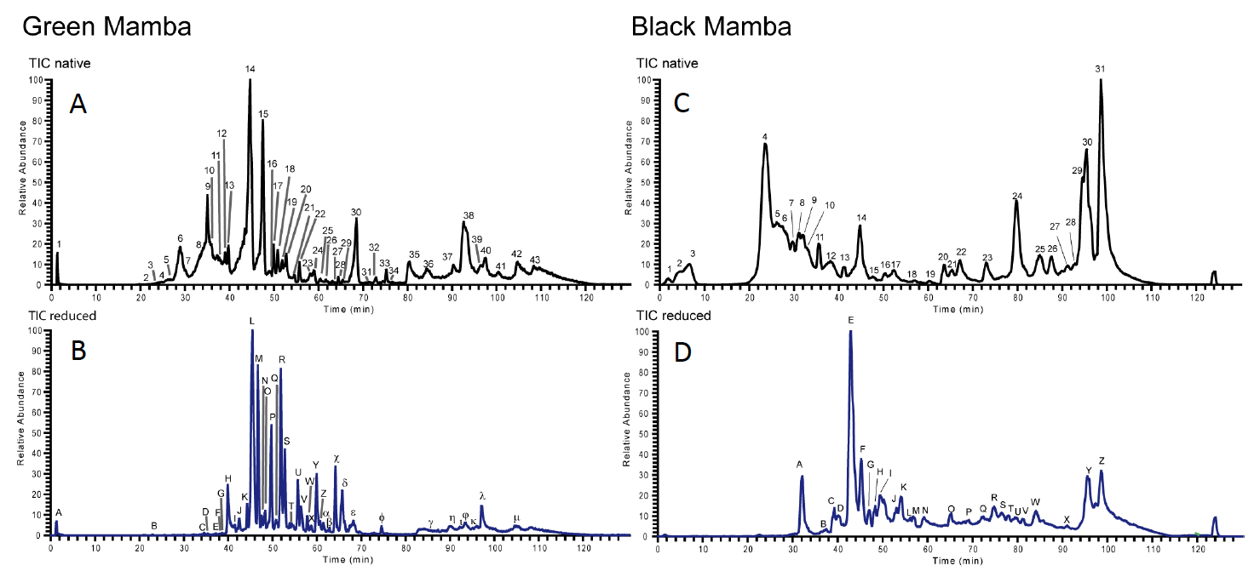
Figure 1

Figure 2
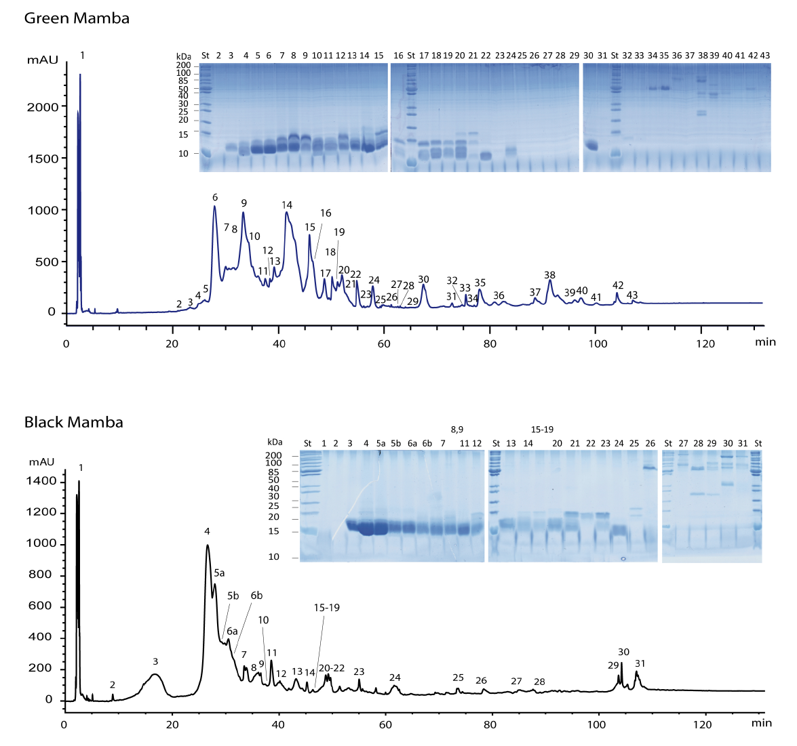

Figure 3A
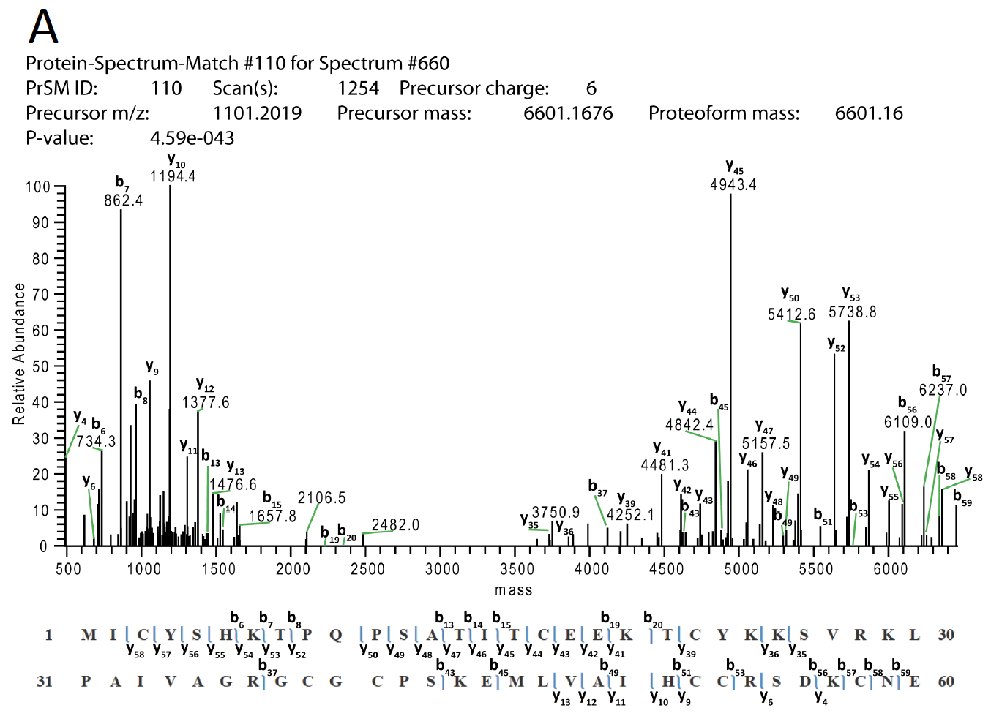
Figure 3B
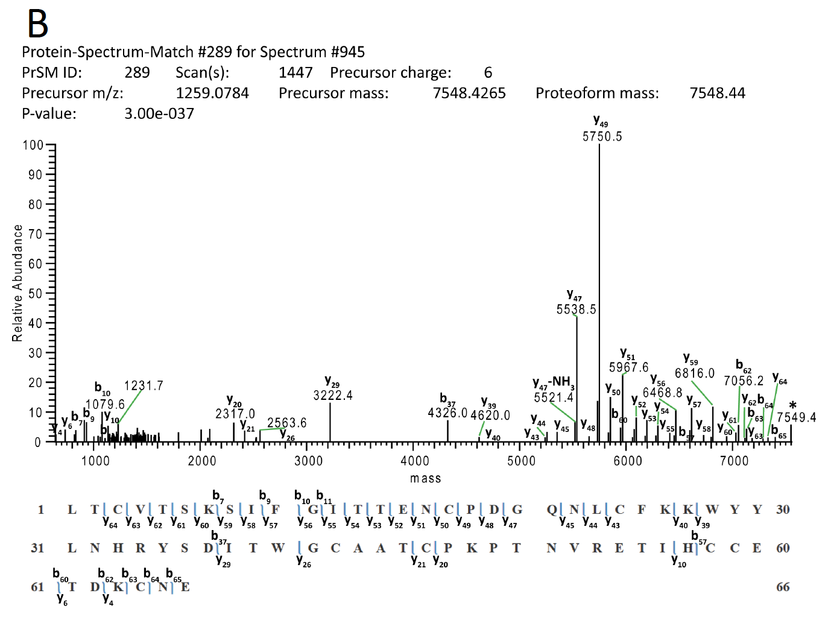

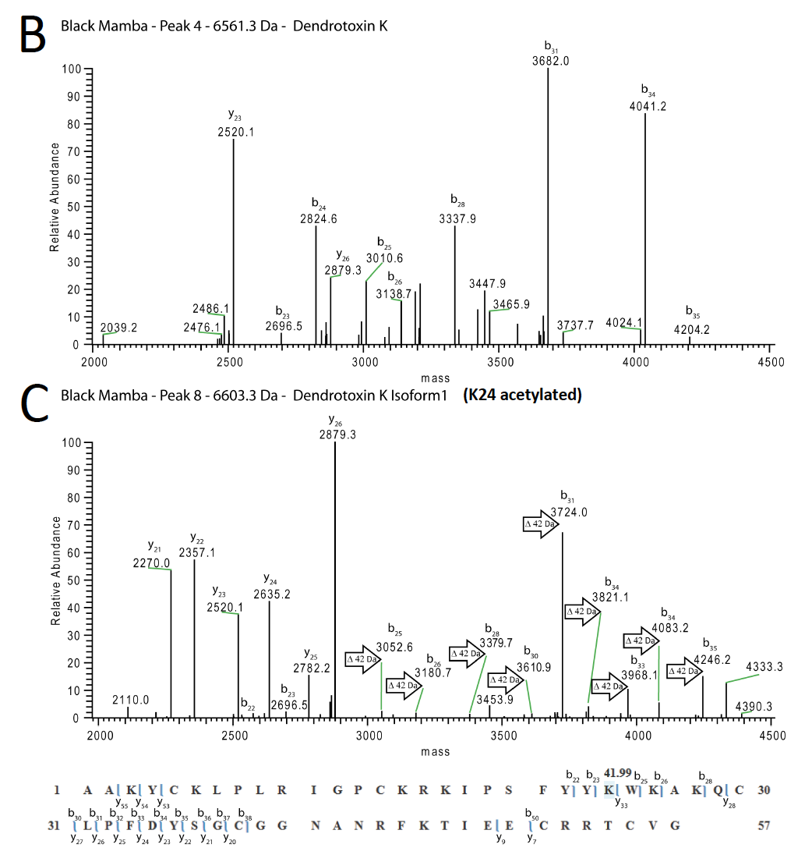
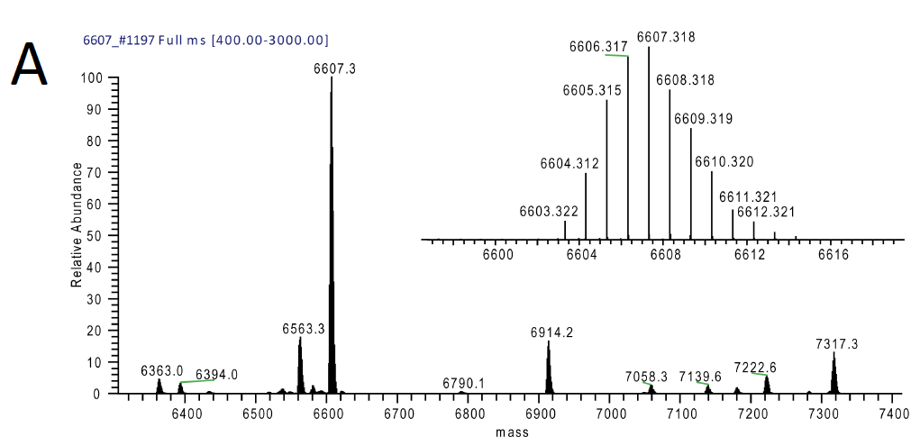
Figure 4

Figure 5
