Phagocytosis of hemozoin by RAW 264.7 cells, but not THP-1 cells, promotes infection by Leishmania donovani with a nitric oxide-independent mechanism

Erika van den Bogaarta^{a,*,1}, Pètra F. Mens^{b,c}, Emily R. Adams^{d}, Martin P. Grobusch^{c}, Henk D. F. H. Schallig^{b}

ªParasitology Unit, Department of Biomedical Research, Royal Tropical Institute (KIT), Meibergdreef 39, 1105 AZ Amsterdam, The Netherlands
^{b}Parasitology Unit, Department of Medical Microbiology, Academic Medical Center, Meibergdreef 9, 1105 AZ Amsterdam, The Netherlands
^{c}Center of Tropical Medicine and Travel Medicine, Department of Infectious Diseases, Division of Internal Medicine, Academic Medical Center, Meibergdreef 9, 1105 AZ Amsterdam, The Netherlands
^{d}Department of Parasitology, Liverpool School of Tropical Medicine, Pembroke Pl, Liverpool, Merseyside L3 5QA, United Kingdom

* Corresponding author: Erika van den Bogaart

Email: Erika.vandenbogaart@mondialdx.com

Tel: 0031 20 5665469

¹Present address: Mondial Diagnostics Foundation, Meibergdreef 39, 1105 AZ Amsterdam, The Netherlands

Abstract
During its intra-erythrocytic development, the malarial parasite Plasmodium falciparum synthesizes insoluble hemozoin (HZ) crystals that are released into the circulation upon rupture of parasitized red blood cells, and rapidly phagocytized by host mononuclear cells. Here, HZ persists undigested, causing functional impairment and possibly leading to increased host susceptibility to secondary infections. In patients with malaria and visceral leishmaniasis (VL) co-infections, HZ-loaded macrophages are likely to co-harbor Leishmania donovani parasites, but whether this might influence the course of the Leishmania infection is unknown. In this study, L. donovani amastigote growth was monitored in mouse RAW 264.7 macrophages and PMA-differentiated THP-1 cells previously exposed to increasing amounts of HZ or its synthetic analogue β-hematin (BH). Latex beads were used as a phagocytic control. Data demonstrate that phagocytosis of HZ and BH by RAW 264.7 cells promoted infection therein by L. donovani parasites in a dose-dependent fashion. Similar results were not observed when using THP-1 cells, despite a clear persistence of undigested heme up to 48 h after phagocytosis.
Conditioning with lipopolysaccharide (LPS)/interferon-gamma (IFN-γ) prior to Leishmania infection triggered the release in RAW 264.7 cells of nitric oxide (NO), a highly leishmanicidal metabolite. However, neither HZ nor BH pre-ingestion were able to inhibit NO production following stimulation with LPS/IFN-γ, suggesting that the HZ- and BH-promoting effect on L. donovani infection occurred with an NO-independent mechanism. In conclusion, these preliminary findings highlight a possible detrimental effect of HZ on the course of VL, warranting further investigation into the clinical relevance of the current models.

Keywords: hemozoin, Leishmania donovani, Plasmodium falciparum, macrophage, co-infection, nitric oxide.

Introduction
Immunosuppression is a major hallmark of Plasmodium falciparum malaria.^{1,2} Its effects range from an impaired response to certain vaccines³ to an increased susceptibility for bacterial (most notably Gram negative bacteria), viral and protozoal infections.⁴⁻¹¹ Data on all-cause child mortality across sub-Saharan Africa suggest that the indirect burden of malaria, largely caused by its secondary infections, may equal the direct burden of disease,^{9,11-14} with young children bearing the brunt due to their immunological immaturity. Interestingly, whilst immunopathology of severe malaria predominantly arises from excessive host inflammation,¹⁵ the risk of developing malaria co-morbidities mainly relies on its immunosuppressive effects.^{1,5}
To date, no single mechanism can explain the immunomodulating effects of malaria completely, but several parasite-driven abnormalities in the innate immune function have been shown to compromise host ability to clear infections.¹⁶⁻¹⁸ Phagocytic cell functions, in particular, were found to be deranged by the ingestion of malaria pigment (hemozoin, HZ),^{16,17,19,20} an insoluble polymer of β-hematin crystallites produced by the malaria parasite to dispose of toxic free heme. While growing inside the red blood cells (RBCs), P. falciparum digests considerable amounts of host cell hemoglobin, releasing free heme that accumulates in the food vacuole upon conversion to HZ. At schizont burst, the pigment is expelled into the blood stream where it is avidly phagocytized, along with HZ-containing late parasite stages (trophozoites and schizonts), by circulating and resident phagocytes (granulocytes, monocytes and macrophages). Evidences of HZ accumulation in the microvasculature of deep organs and their tissues (spleen, liver, bone marrow, kidney, lung and brain) confirm that the malaria pigment persists undigested within the host leukocytes,²⁰⁻²² where it exerts a variety of biological effects. HZ-loaded monocytes, in particular, appear to be viable, but functionally impaired, failing to repeat phagocytosis,¹⁷ to generate oxidative burst upon appropriate stimulation,¹⁷⁻²³ or to kill ingested bacteria, fungi or tumor cells.¹⁶ In addition, ingestion of HZ causes the monocytes/macrophages to release large amounts of cytokines (IL-1β,²⁴ IL-12,²⁵ TNF-α,²⁴⁻²⁷ and IL-10²⁵), chemokines (MIP-1α and MIP-1β [27]) and nitric oxide (NO),²⁸ while altering membrane translocation and activity of protein kinase C (PKC),²⁹ Major Histocompatibility Complex (MHC) class II-dependent antigen presentation³⁰ and differentiation and maturation to monocyte-derived dendritic cells (DCs).³¹ Whether those effects are caused by the HZ itself, however, remains controversial, as recent studies suggest that other HZ-associated molecules, such as Plasmodium DNA,³² host fibrinogen³³ or RBC lipids³⁴ may be responsible for the immunomodulating activity of the malarial pigment.
Pathogenic manipulation of the host immune system is not unique to P. falciparum infection; on the contrary, it is a common feature of several microbial survival strategies.^{35,36} In some cases, as for the macrophage-tropic parasites of the Leishmania donovani complex, the pathogen has evolved mechanisms that enable it to resist intracellular destruction and to proliferate within the reticuloendothelial system.³⁷ Following transmission to the vertebrate host, L. donovani promastigotes are largely engulfed by macrophages of the inner organs (spleen, liver and bone marrow especially), where they differentiate into obligate intracellular amastigotes that reside within the phagolysosomal compartment. Here, Leishmania parasites disrupt several key functions involved in the microbicidal activities of macrophages, including their ability to produce NO and radical oxygen species (ROS), to perform proteolytic digestion and to activate adaptive immunity via antigen presentation and cytokine release.³⁷ This suggests the possibility that subversion of macrophage functions by other pathogens or related products, such as the Plasmodium HZ, might benefit the survival of Leishmania parasites.
In areas where malaria and visceral leishmaniasis (VL) are co-endemic, co-infections with the two pathogens have been documented.³⁸⁻⁴¹ However, little is known on how the two infections impact each other in the co-infected host. Early studies conducted in animal models have produced conflicting results on the effect of the two diseases upon each other, with mice suffering from an exacerbated leishmanial disease course⁴²⁻⁴⁴ and golden hamsters remaining unaffected.⁴⁵ In particular, doubts remain as whether HZ accumulation in the macrophages may affect L. donovani growth therein. The present study represents the first attempt to address this question. In this experimental setting, human and murine macrophage-like cells were allowed to phagocytize increasing amounts of P. falciparum native HZ and its synthetic form (β-hematin, BH), prior to being infected with L. donovani promastigotes. After removal of non-internalized parasites, intracellular amastigote growth was monitored using the previously described trypanothione reductase (TryR)-based assay.⁴⁶ The possible involvement of the NO pathway was assessed by stimulating the cells with LPS/IFN-γ, and by measuring the levels of nitrites/nitrates in the corresponding supernatants. Finally, persistence of HZ and BH heme was monitored overtime in PMA-differentiated THP-1 cells and compared to a control of anti-Rhesus IgG treated RBCs.
Materials and methods
Cell and parasite cultures
The murine RAW 264.7 macrophage cell line (ATCC: TIB-71)⁴⁷ and the human THP-1 monocyte cell line (ATCC: TIB 202)⁴⁸ were grown in RPMI-1640 medium supplemented with 10% heat-inactivated fetal bovine serum (FBS) (Sigma Aldrich Co., St Louis, USA), HEPES 25 mM, L-glutamine 2 mM, penicillin 100 IU/mL and streptomycin 100 μg/mL, in a 5% CO₂ atmosphere at 37 °C. Prior to each experiment, cells were sub-cultured once in IMDM medium supplemented with 10% heat-inactivated FBS, HEPES 25 mM, L-glutamine 2 mM, penicillin 100 IU/mL and streptomycin 100 μg/mL. In vitro cultures of P. falciparum were adapted from Trager and Jensen.⁴⁹ Briefly, the chloroquine-sensitive P. falciparum strains NF54 and 3D7 (MR4/ATCC: MRA-1000 and MRA-102) were grown at 5% hematocrit (0⁺ human erythrocytes) in RPMI-buffered medium supplemented with 10% heat-inactivated human AB⁺ serum (Sanquin, Amsterdam, the Netherlands) and 50 μg/mL gentamycin. Cultures were maintained at 37 °C in candle jars under continuous agitation at 40 rpm/min and with daily refreshment of medium. When parasitaemia exceeded 7-8%, sub-cultures were made.
The antimonial-resistant L. donovani strain MHOM/IN/2010/BHU814, isolated by Prof. S. Sundar at the Banaras Hindu University, Varanasi, India,⁵⁰ was kindly provided by Prof. J. C. Dujardin, Institute of Tropical Medicine, Antwerp, Belgium. Promastigotes were maintained at 27 °C with a weekly passage in RPMI-1640 medium supplemented with 15% FBS, HEPES 25 mM, L-glutamine 2 mM and 1% antibiotics. For infection of RAW 264.7 and THP-1 cells, promastigotes were diluted in IMDM medium supplemented with 10% heat-inactivated FBS, HEPES 25 mM, L-glutamine 2 mM, penicillin 100 IU/mL and streptomycin 100 μg/mL. All cell culture reagents were purchased from Gibco (Bleiswijk, the Netherlands), unless otherwise stated.
Preparation of native hemozoin (HZ) and β-hematin (BH)
For isolation of hemozoin (HZ), mature-stage P. falciparum cultures were washed three times with serum-free RPMI-buffered medium and fractionated at 25% hematocrit on a discontinuous Percoll (GE Healthcare, Uppsala, Sweden)/4% sorbitol (wt/vol) gradient (0, 40, 80%). After centrifugation at 2500 rpm, HZ was collected at the top of the gradient, 0-40% interphase, washed three times with phosphate-buffered saline (PBS) and stored at -20 °C. No further purification of HZ was undertaken to prevent removal of adherent molecules, such as membranes necessary for HZ opsonization and phagocytosis¹⁷ or P. falciparum DNA, involved in immune-modulation.⁵¹ Synthetic malaria pigment, β-hematin (BH), was donated by Prof. D. Taramelli, University of Milan, Italy. BH was synthesized from hematin in methanol, as previously described,⁵² and its purity confirmed by infrared spectroscopy. The heme content of a weighed amount of HZ and BH dissolved in 1 M NaOH was determined against a standard curve of hemin (Sigma-Aldrich Co.), by reading its absorbance at 405 nm (Soret band) with an Infinite M200Pro multimode plate reader (Tecan, Männedorf, Switzerland).
Phagocytic meals
Hemozoin and BH along with latex beads or RBCs as controls were used as phagocytic meals. Latex beads served as phagocytic control when assessing the effects of HZ and BH on Leishmania intracellular growth and NO production, whereas RBCs were used as a control for the chemiluminescent assay measuring phagocytosis and overtime persistence of heme. The concentrations of HZ and BH used in the experiments were determined according to their heme content, while RBCs and latex beads were added in equivalent amounts, based on the assumption that one RBC contains approximately 2 fmol of heme.¹⁷ Immediately before the phagocytosis experiment, washed HZ, BH and latex beads were sonicated and opsonized with human plasma at 37 °C, 5% CO₂ for 30 minutes, to enable binding to plasmatic fibrinogen.³³ Thereafter, they were diluted to 10% hematocrit (or 10% vol/vol in the case of latex beads) in PBS supplemented with 10 mM glucose (PBS-G) and added to the cells. Washed uninfected RBCs were suspended at 20% hematocrit in PBS-G and incubated for 30 minutes at 37 °C, under a 5% CO₂ atmosphere with human anti Rhesus IgG antibodies, according to the manufacturer’s instructions (Bio-Rad Laboratories Inc., Hercules, CA). Afterwards, RBCs were washed three times with PBS-G, re-suspended at 10% hematocrit in PBS-G and kept at 4 °C until used.
Cell treatment
THP-1 monocytes (2.5 x 10⁵ cells/mL) were differentiated into adherent, non-dividing macrophage-like cells by a 72 h-incubation with 10 ng/mL phorbol 12-myristate 13-acetate (Sigma-Aldrich Co.), subsequently removed by 3 washes in medium. On day 3 of THP-1 differentiation, RAW 264.7 cells were seeded at 5 x 10⁵ cells/mL in 96-well flat bottom tissue culture microplates (Greiner Bio-One, Alphen aan de Rijn, the Netherlands) and allowed to adhere for 4-5 h at 37 °C, 5% CO₂. Pre-treatment with phagocytic meals was performed by incubating adherent THP-1 and RAW 264.7 monolayers overnight (unless otherwise stated) at 37 °C, 5% CO₂, with increasing amounts of opsonized HZ, BH or latex beads or with culture medium as a control. After removal of non-ingested material by washing once briefly with water and twice with medium, part of the cells were stimulated for 8 h with 1 μg/mL of lipopolysaccharide (LPS from E. coli 0111:B4, Sigma-Aldrich Co.) and 100 IU/mL of human (Sigma-Aldrich Co.) or mouse (BioLegend, San Diego, USA) IFN-γ, prior to being incubated overnight with stationary-growth phase L. donovani promastigotes at a parasite/cell ratio of 10/1. Non-internalized promastigotes were then removed by washing cells three times in excess of medium and the cultures re-incubated at 37 °C, 5% CO₂ for an additional 72 h. A number of non-infected control cells treated as described above was also included in each experiment for both cell lines. In all experiments, RPMI-1640 medium (used for long-term culturing) was replaced by IMDM medium, due to incompatibility of the former with NO measurements (RPMI-1640 medium contains large amounts of nitrites/nitrates).
Assessment of Leishmania growth
The growth of L. donovani parasites in THP-1 and RAW 264.7 cells was assessed by measuring the activity of a parasite-specific enzyme, the TryR, as previously described.⁴⁶ Briefly, after a pre-wash with PBS, cells were chemically lysed by a 15 min incubation with a lysing buffer (200 μL/well), consisting of EDTA (1 mM), HEPES (40 mM), Tris (50 mM; pH 7.5) and Triton X-100 (2% vol/vol), and supplemented immediately prior to use with the protease inhibitor phenylmethanesulfonyl fluoride (1 mM). Enzymatic reduction of T[S]₂ (Bachem AG, Bubendorf, Switzerland) was monitored in a 200 μL reaction mixture consisting of 75 μL of sample lysate, 25 μL of NADPH 1.6 mM (Sigma-Aldrich Co.), 75 μL of T[S]₂ 200 μM and 25 μL of DTNB 800 μM (Sigma-Aldrich Co.). A blank was set for each sample, consisting of sample lysate supplemented with the reaction mixture described above, in which the substrate T[S]₂ had been replaced by Tris 0.05 M buffer, pH 7.5. After 2 h of incubation for the RAW 264.7 cells and 3 h of incubation for the THP-1 cells at 27 °C, absorbance was measured with an Infinite M200Pro multimode plate reader at a wavelength of 412 nm. The optical density, as measured in the blank, was subtracted from the corresponding sample signal, yielding the enzyme-specific activity responsible for reduction of the DTNB.
Microscopy
Microscopic examinations were performed with an optical microscope (Leitz, Wetzlar, Germany), using a 10x ocular and a 100x oil-immersion objective. Cells were plated onto 16-well or 4-well chamber slides (Lab-Tek, Nunc, Waltham, USA) at the same concentrations as for the culture plates, and treated as described above. After 72 h of incubation with Leishmania parasites or culture medium (for uninfected cells), cell supernatants were discarded and the slides subjected to methanol-fixation and Field’ staining. Pictures were acquired with a MikroCam microscope camera (Bresser GmbH, Rhede, Germany). Microscopic counts of parasites were expressed by mean of the parasite index (percentage of infected macrophages × mean number of amastigotes per macrophage), after examining a minimum of 100 macrophages per sample. The average number of cells containing HZ, BH or latex beads was assessed on the same slides, after examining a minimum of 100 macrophages per sample in two replicate samples.
Assessment of cell viability
Viability of cells exposed to the various phagocytic meals was measured by monitoring the reduction of the alamarBlue reagent (Bio-Rad Laboratories). In this assay, the non-fluorescent resazurin dye contained in the alamarBlue reagent is reduced by the activity of viable cells, resulting into a highly fluorescent product (resorufin) that serves as an indicator of cell growth. The assay can be used to monitor cytotoxicity, too, as nonviable cells are unable to convert resazurin into resorufin following loss of their enzymatic activity and can be easily distinguished from living cells. Uninfected RAW 264.7 and PMA-differentiated THP-1 cells exposed to increasing amounts of opsonized HZ, BH or latex beads, or to culture medium as a control, and in the presence or absence of LPS/IFN-γ, were incubated with the alamarBlue reagent (10% vol/vol) at 37 °C, 5% CO₂. After 2 h of incubation, fluorescence was measured with a Tecan Infinite M200Pro multimode plate reader, with excitation and emission wavelengths of 560 and 590 nm, respectively, and a plate-tailored optimal gain setting. Measurements were taken on the same day that the TryR-based assay was performed to assess the growth of Leishmania in infected cells. Viability of infected cells was not determined, as the Leishmania parasites contribute to reduction of resazurin, thereby interfering with the assay.
Nitric oxide (NO) measurement in cell supernatants
Nitric oxide determination in cells supernatants was based on quantification of total nitrite and nitrate contents by the Griess reaction,⁵³ performed according to manufacturer’s instructions (Assay Designs, Inc., Ann Arbor, USA). Briefly, aliquots of (pre-diluted) cell-free supernatants were diluted with NADH (25 μL) and nitrate reductase (25 μL) for conversion of nitrates into nitrites. Samples were then incubated with 50 μL of 2% sulfanilamide and 0.2% N-(1-Naphthyl)ethylenediamine in 2 M hydrochloric acid, at room temperature, for 10 minutes. Total nitrite concentration was determined against a standard curve by measuring the optical density at 540 nm with an Infinite M200Pro multimode plate reader.
Assessment of HZ and BH phagocytosis
Phagocytosis of HZ and BH by the adherent cells was quantified by measuring the chemiluminescence generated by the peroxidase activity of the heme.⁵⁴ At alkaline pH, heme catalyzes the production of chemiluminescence by luminol and tert-butylhydroperoxide, in amounts that are proportional to the heme concentration. For this purpose, cells were incubated for 3 h with anti-Rhesus IgG treated RBCs as a control (30 RBCs/cell) or with opsonized HZ or BH in equivalent amounts, as determined by their heme content. After removal of non-internalized material, cells were chemically lysed and assessed for their chemiluminescent signal (time point 0 h) or re-incubated for later assessments (15, 24 or 48 h). The chemiluminescent assay was performed as previously described,⁵⁴ with some modifications. Briefly, adherent cells were lysed in 100 μL NaOH 0.1 N containing 0.05% (vol/vol) Triton X-100 and 3 mM EDTA. The lysate (5 μL) was then assayed in 96-well flat bottom white plates (Greiner Bio-One) containing 100 μL luminol (Fluka, Sigma-Aldrich Co.) 1 mg/mL, prepared by diluting a 10 mg/mL stock solution of luminol in DMSO with NaOH 0.1 N/EDTA 3 mM. Chemiluminescence was elicited by injecting 100 μL of a tert-butylhydroperoxide (Sigma-Aldrich Co.)/EDTA solution (80% tert-butylhydroperoxide in di-tert-butyl peroxide/water 3:2 diluted 2.2 times in 0.1 N NaOH/EDTA 3 mM), which triggered photon emission and counting. Photon counting was performed with an Infinite M200Pro multimode plate reader, using an integrated photon counting time set at 2000 milliseconds. Photon counts per cell were transformed into a number of RBC ingested per cell (RBC equivalent) by comparison with the signal produced by a known amount of heme contained in the HZ and BH samples. Each phagocytosis value represents the average of data obtained from three different wells.
Data analysis
Data analysis was performed using Microsoft Excel (Microsoft Office Inc., Seattle, USA) and Prism V5.03 software (GraphPad Prism, Software Inc.; San Diego, USA). Graphically displayed data were examined by mean of visual analysis only, being the sample size too small for any meaningful statistical analysis.
Results
Phagocytosis of HZ, BH and latex beads
Exposure of PMA-differentiated THP-1 cells and RAW 264.7 cells to increasing amounts of opsonized HZ, BH or latex beads resulted in the internalization of these three phagocytic meals, as confirmed by the microscopic (Fig. 1A) and chemiluminescent (Fig. 1B) assessments performed 96 h later. Cells displaying HZ crystals were more numerous than those containing BH – a result that can be easily explained by the tendency of BH to aggregate and form bigger clusters – but the amount of heme persisting in the samples, albeit dose-dependent in the case of HZ, did not always exceed the one in BH-laden cells (Fig. 1B). Latex beads were more avidly phagocytized than were HZ and BH, as judged by the number of macrophages containing this phagocytic meal, but the overall number of beads in the sample was not quantified.
Phagocytosis of HZ and BH promotes growth of L. donovani amastigotes in RAW 264.7 cells, but not in THP-1 cells
To assess the potential effect of malarial pigment ingestion on L. donovani growth, RAW 264.7 and PMA-differentiated THP-1 cells were incubated with increasing amounts of opsonized HZ, BH or latex beads prior to being infected with L. donovani promastigotes. Intra-macrophage amastigote growth was then assessed 72 h later, by measuring the activity of TryR. This enzyme acts as a good indicator of Leishmania growth, as demonstrated by the high level of correlation between enzymatic activities and microscopic counts in infected THP-1 cells (Fig. 2). For infected RAW 264.7 cells, a similar dose-dependent curve was obtained when plotting the TryR activities against the number of seeded host cells (data not shown), but the enzymatic activities could not be related to the microscopic counts, as the different seeding densities resulted in different cell growth rates that disproportionally affected the parasite indexes – these indexes express the relative, rather than absolute, parasite loads and are directly influenced by the total number of host cells in the sample.
Phagocytosis of HZ and BH by RAW 264.7 cells substantially increased the uptake and/or intracellular replication of L. donovani, as confirmed by its enhanced enzymatic activity in cells pre-exposed to HZ and BH versus control infected cells (Fig. 3). The effect followed a dose-dependent course and became more pronounced at the concentrations of 25 and 50 μg/mL. Conversely, ingestion of latex beads by the RAW 264.7 cells resulted in a slight or no alteration of L. donovani loads in comparison with the control infected cells. When PMA-differentiated THP-1 cells were pre-treated with HZ, BH or latex beads, no clear effect was observed on parasite growth, for which comparable signals to the control infected cells were displayed (Fig. 3).
Activation of macrophages by LPS/IFN-γ following exposure to phagocytic meals partly inhibited the parasite-promoting effect displayed by HZ and BH, leading to a dose-dependent, but highly variable improvement of Leishmania growth in RAW 264.7 cells containing the malarial pigment (Fig. 3). Addition of LPS/IFN-γ to THP-1 cells resulted in no clear pattern on the L. donovani load in cells pre-treated with phagocytic meals, despite an overall, but considerably variable increase in parasite numbers per effect of HZ (Fig. 3).
Phagocytosis of HZ, BH or latex beads does not affect cell viability
To exclude that HZ- and BH-laden cells may have suffered from potential cytotoxic effects upon internalization of the malarial pigment, viability of RAW 264.7 and PMA-differentiated THP-1 cells was investigated. Overall, phagocytosis of HZ, BH or latex beads appeared to neither reduce nor improve survival of macrophage-like cells as compared to the control cells, regardless of whether cells were subsequently treated with LPS/IFN-γ or not (Fig. 4), indicating that in our experiments, none of the phagocytic meals was cytotoxic. Notwithstanding, a dose-dependent, but highly variable increase in resazurin reduction rate was evident for RAW 264.7 cells exposed to opsonized HZ, BH or latex beads, suggesting either an increased antioxidant capacity triggered by the phagocytic process or, more likely, a delay in cell apoptosis.
HZ and BH promote infection by L. donovani with an NO-independent mechanism
Nitric oxide is a major mammalian secretory product involved in the microbicidal activity of macrophages against a number of intracellular pathogens, including Leishmania parasites. Its release from LPS- and/or IFN-γ-stimulated macrophages has been shown to be impaired or potentiated, respectively, following ingestion of malarial pigment by immortalized or primary murine macrophages,^{28,55,56} supporting a possible NO-mediated mechanism for the promoting effect displayed by HZ on L. donovani growth. To verify this hypothesis, the total content of two stable NO breakdown products, nitrites and nitrates, was measured in cell supernatants, providing an indirect assessment of NO interaction in the biological system.
Infection of RAW 264.7 and PMA-differentiated THP-1 cells by L. donovani did not trigger release of NO, as confirmed by the comparable amounts of nitrites and nitrates detected in the supernatant of uninfected and infected cells (Table 1). Similarly, pre-exposure of both RAW 264.7 and PMA-differentiated THP-1 cells to HZ, BH or latex beads did not alter cellular NO production either in L. donovani-infected cells (Fig. 5) or in uninfected cells (data not shown). Activation of cells by LPS/IFN-γ resulted in considerable differences between RAW 264.7 and PMA-differentiated THP-1 cells. Whilst the latter showed no change in the supernatant level of nitrites and nitrates following addition of LPS/IFN-γ (Table 1), neither after ingestion of phagocytic meals nor in the presence of L. donovani parasites (Fig. 5, Table 1), in line with previous reports⁵⁷⁻⁵⁹ and in contrast with others,^{60,61} RAW 264.7 cells markedly up-regulated NO release in response to immunomodulatory agents (Table 1). This increased production of NO did not affect infection by L. donovani, for which comparable, although highly variable, parasite loads were observed in unstimulated and LPS/IFN-γ−stimulated RAW 264.7 cells (Table 1). Conversely, consistently decreased parasite loads were observed in LPS/IFN-γ−stimulated THP-1 cells (Table 1). Cell exposure to HZ, BH or latex beads prior to LPS/IFN-γ stimulation did not reduce NO release from RAW 264.7 cells neither in uninfected nor in L. donovani-infected cells. On the contrary, it displayed a slightly stimulating effect, which was evident with latex beads and, to a lesser extent, with BH (Fig. 5).
Persistence of HZ and BH over time
To investigate whether the lack of effects displayed by HZ and BH in THP-1 cells might have been due to a reduced internalization of the malarial pigment and/or its degradation, cellular phagocytosis of HZ and BH was assessed overtime in PMA-differentiated THP-1 cells, by measuring the chemiluminescence generated by the peroxidase activity of the heme group (Fig. 6). Measurement of heme content immediately after removal of non-internalized material revealed that THP-1 cells avidly phagocytized BH as well as HZ, despite a 3-fold difference in the number of RBC equivalents per cell. The difference became particularly striking with respect to the anti-D treated RBCs, for which less than 2 RBC equivalents/cell were measured. When measured overtime, the heme contained in the HZ and BH showed to persist undigested within the cells, whereas the heme contained in the anti-D treated RBCs was progressively degraded.
Discussion
The present study demonstrates that phagocytosis of native (HZ) and synthetic (BH) malarial pigment by RAW 264.7 cells promotes infection therein by L. donovani with an NO-independent mechanism. This conclusion is based on the following observations: (a) ingestion of HZ and BH, but not latex beads, prior to L. donovani infection resulted in a dose-dependent increase in the number of amastigotes; (b) infection with L. donovani did not trigger NO release neither in control nor in HZ- and BH-fed cells; (c) LPS/IFN-γ pre-conditioning did not hamper L. donovani infection despite triggering NO release and (d) activation by LPS/IFN-γ partly inhibited the Leishmania-promoting effect displayed by HZ and BH, with no effect on the NO levels as measured in the supernatant of LPS/IFN-γ−stimulated cells fed with HZ- and BH versus the control cells. These results were not observed when PMA-differentiated human THP-1 cells were used instead of mouse RAW 264.7 macrophages, providing evidence of a species- and/or cell- specific effect.
Accumulation of HZ in host leukocytes and organs is a characteristic, though non-pathognomonic, feature of blood-stage malaria. Its sequestration within the mononuclear system begins upon rupture of parasitized RBCs and continues throughout multiple generations of phagocytes,^{62,63} leading to the aggregation of undigested HZ crystals from different phagosomes and the functional derangement of their host cells. Accordingly, human monocytes fed with HZ failed to respond to IFN-γ stimulation,³⁰ repeat the phagocytic cycle¹⁷ and kill ingested bacteria, fungi and tumor cells,¹⁶ raising the question that prompted this study, as whether HZ accumulation during malaria may alter the course of secondary infections. In this regard, associations between increased levels of HZ in pulmonary tissue and malaria-associated acute respiratory distress syndrome⁶⁴ or between HZ and increased susceptibility of mice to Mycobacterium tuberculosis have been reported in the literature.⁶⁵ Here, we provide evidence of a HZ- and BH-mediated enhancement of L. donovani infection load in RAW 264.7 cells. The effect in our study was shown to be dose-dependent and malarial pigment-specific, as phagocytosis of latex beads failed to trigger a similar outcome. Both HZ and BH exhibited Leishmania-promoting activities, but at equal content of heme, HZ was more effective in stimulating L. donovani growth. Multiple explanations may account for this observation, the most likely of which recognizes a cell-modulating activity to the non-hematin content of HZ (fibrinogen excluded, as both HZ and BH were plasma-opsonized). Addition of LPS/IFN-γ to the culturing medium resulted in the release by RAW 264.7 cells of large quantities of NO, the most powerful leishmanicidal agent produced by phagocytic cells.⁶⁶ Intriguingly, production of this metabolite appeared not to affect L. donovani infection rates, in agreement with literature data reporting cross-resistance of Leishmania isolates to antimonial drugs and NO toxicity,⁶⁷ but in contrast to the widely accepted notion that NO is detrimental to Leishmania survival. Additional testing examining the effect of macrophage activation before and after infection with Leishmania, using both susceptible and resistant strains, will be required to confirm this finding, particularly given the fact that highly variable infection rates were obtained in LPS/IFN-γ-stimulated control RAW 264.7 cells. When cells were pre-treated with HZ and BH prior to LPS/IFN-γ stimulation, an increased production of NO was evident, but the effect was neither significant nor pigment-specific, as phagocytosis of latex beads appeared to trigger a similar outcome. Whilst this HZ- and BH-sustained release of IFN-γ-inducible NO has been clearly demonstrated in a number of murine phagocytic cell lines,^{28,68} it finds no evidence in studies performed with mouse peritoneal macrophages, where a reduction in cytokine- and/or LPS-induced NO production was observed.^{55,56} This differential susceptibility of macrophages with different tissue origin has been attributed to the HZ-mediated induction of ROS, whose signaling pathway has been found to lead to ROS-dependent transcription factor up- or down-regulation in different cell types, according to their susceptibility to ROS.²⁸
To investigate whether degradation of the malarial pigment could have accounted for the lack of effects observed on L. donovani growth in THP-1 cells, the HZ and BH cell content was followed over time. In human monocytes, persistence of HZ results from inability of proteolytic enzymes to de-polymerize the HZ moiety and release free heme, while retaining full activity, as confirmed by the degradation of HZ-associated proteins.⁶⁹ A similar scenario seemed to apply to our PMA-differentiated THP-1 cell model. When monitored up to 48 h after phagocytosis, in fact, these cells retained 36% and 100% of their initial HZ- and BH-heme content, respectively, whilst no RBC-containing heme could be detected 15-h post-incubation already. This partial decrease in the HZ-associated heme content is likely to be caused by degradation of HZ-bound heme proteins, given that the HZ used here was subjected to minimal purification, thus increasing the likelihood of a native-resembling pigment carrying proteins and RBC remnants. However, whether the differential phagocytic efficiency manifested by the cells towards the three meals may have partly biased the results is unclear, as cells were incubated with equal amounts of HZ, BH and RBCs, as established on the basis of their heme content, but appeared to have internalized as much as 26 and 3 times more BH than HZ and RBCs, respectively. Importantly, these findings on the intracellular stability of the malarial pigment appear to comply with the relative literature,^{69,70} showing persistence of undigested HZ within human monocytes, while they contrast with a previous report in which BH appeared to be degraded by RAW 264.7 macrophages.³⁴
In the present study, Leishmania growth was measured indirectly, through the activity of a parasite-specific enzyme, rather than by conventional microscopic counting, as visualization of Leishmania amastigotes was hindered by the presence of phagocytic meals in the host cells. This may cast doubt on whether the HZ- and BH-mediated increases in TryR activity truly arose from higher parasite burdens rather than from enzymatic up-regulation. Trypanothione reductase is constitutively expressed in Leishmania parasites.⁷¹ Its activity levels are not rate-limiting for the enzymatic regeneration of the thiol pool,^{72,73} which explains why overexpression of TryR does not alter the in vitro sensitivity of L. donovani to pro-oxidant agents, such as nifurtimox.⁷² Failure to amplify TryR in response to a number of compounds, including nifurtimox, was also evident in a previous study conducted by our group,⁴⁶ wherein microscopy and the presently used TryR-based assay yielded comparable growth curves for the drug-sensitive L. donovani 1S strain. A linear correlation between TryR activities and parasite numbers as assessed by microscopy was also demonstrated here using a dilution series of differentiated THP-1 cells harboring L. donovani intracellular amastigotes. This supports the assumption that the increased TryR activities, as they were measured here, truly resulted from an improved growth of the antimonial-resistant strain L. donovani BHU814, with a rise in enzymatic activity likely resembling the increase in parasite numbers. It should be noted that increased levels of TryR have been described in L. donovani isolates unresponsive to sodium stibogluconate as compared with sensitive strains,⁷⁴ but this feature appears to be part of a stable antimony resistance-associated phenotype, with little or no evidence of a transient TryR up-regulation in response to thiol depletors or TryR inhibitors. In any case, confirmation of increased parasite rates in HZ- and BH-fed cells using alternative assays, such as reporter gene-based methods,⁷⁵ the promastigote transformation growth assay⁷⁶ or quantitative PCR,⁷⁷ would be beneficial to banish all doubts on the effect of the malarial pigment on TryR activity.
Additional testing that could confirm the findings reported here and help unveil the mechanisms behind them will be required, as current data do not provide sufficient evidence to truly speculate on them. In particular, emphasis should be given on understanding whether the improved Leishmania growth, as observed here, resulted from a reduced leishmanicidal activity of RAW 264.7 cells or from an enhanced parasite replication rather. Monitoring Leishmania growth overtime along with the release of NO and ROS may help addressing this important question, as it could clarify whether the increased Leishmania growth begins with an enhanced phagocytosis of promastigotes or arises only during the exponential growth phase of the parasites.
Supported by the geographical overlapping of malaria- and VL-endemic areas and the occurrence of co-infection cases, the true biological relevance of the present model roots in the visceral tropism of L. donovani spp. Within their mammalian host, in fact, parasites of the L. donovani complex infect the mononuclear phagocytes of liver, spleen and bone marrow, where most of the HZ accumulates and displays its cytotoxic effects. This supports the possibility that in a co-infected patient, HZ-fed macrophages may become host of L. donovani amastigotes. However, whether these cells will develop increased Leishmania parasitaemias, as observed with RAW 264.7 cells here, remains to be elucidated, particularly in the light of the discrepancies towards the THP-1-derived results. RAW 264.7 and PMA-differentiated THP-1 cells are commonly used surrogates of mouse and human macrophages, respectively, due to their high phagocytic activity, adherence capability and ease of culturing,^{47,48,78} but their interchangeability and equivalence to primary macrophages remains limited.^{79,80} This holds true, particularly, with respect to the hosting of Leishmania parasites, as some of the cellular pathways responsible for parasite clearance in vivo (e.g. NO release) remain silent in human monocytic cell lines when applying standard stimulation in vitro. Replication of the present experiments, including monitoring of HZ and BH degradation over time, in primary macrophages as well as in other cell lines (e.g., U937, Mono Mac 6, J774A.1 and IC-21) is, therefore, necessary to corroborate findings presented in our study and clarify their biological relevance with respect to human infections. Importantly, even in the absence of a HZ-mediated effect on human VL, a deep understanding of its effects on host cell biology may prove very useful for providing new insights into the cellular mechanisms of the host-parasite interaction, given that many of the cell functions impaired by HZ ingestion are likely to play a role in the intracellular parasitism of Leishmania spp.
Conclusions
In conclusion, if the RAW 264.7 cell line may be considered as a model of the human macrophage behavior and the amounts of HZ and BH used be close to the physiological situation, it could be justly concluded that a recent or concomitant infection with P. falciparum is likely to exacerbate the course of VL in co-infected patients. On the other hand, if the PMA-differentiated THP-1 macrophages may more closely resemble the cells of the reticuloendothelial system, this would imply that data originating from mouse macrophage cell lines should be handled with great caution, as they may lead to misleading conclusions. In either case, further research is required to substantiate these preliminary findings and demonstrate their applicability to the complex reality of the malaria-VL co-infection.
Acknowledgments
We are grateful to Prof. Donatella Taramelli (University of Milan, Italy) for the kind gift of β-hematin and to Prof. Jean Claude Dujardin (University of Antwerp and Institute of Tropical Medicine, Belgium) and Prof. Shyam Sundar (Banaras Hindu University, India) for providing the L. donovani strain BHU814. We also thank Dr. Masja Straetemans (Royal Tropical Institute) for her expert advice on data analysis. The following reagents were obtained through the MR4 as part of the BEI Resources Repository, NIAID, NIH: Plasmodium falciparum NF54, MRA-1000, deposited by Megan Dowler (Walter Reed Army Institute of Research) and Plasmodium falciparum 3D7, MRA-102, deposited by Daniel Carucci. We thank all anonymous blood donors from Sanquin blood bank (Amsterdam, the Netherlands) for their participation in this study.

References
References
[1] B.M. Greenwood, A.M. Bradley-Moore, A.D. Bryceson, A. Palit A, lmmunosuppression in children with malaria, Lancet 1 (1997) 169-72.
[2] H. Nielsen, A. Kharazmi, T.G. Theander, Suppression of blood monocyte and neutrophil chemotaxis in acute human malaria, Parasite Immunol. 8 (1986) 541-550.
[3] A.J. Cunnington, E.M. Riley, Suppression of vaccine responses by malaria: insignificant or overlooked?, Expert Rev. Vaccines 9 (2010) 409-429.
[4] R. N. Bronzan, T.E. Taylor, J. Mwenechanya, M. Tembo, K. Kayira, L. Bwanaisa, A. Njobvu, W. Kondowe, C. Chalira, A.L. Walsh, A. Phiri, L.K. Wilson, M.E. Molyneux, S.M. Graham SM, Bacteremia in Malawian children with severe malaria: prevalence, etiology, HIV co-infection, and outcome, J. Infect. Dis. 195 (2007) 895-904.
[5] G.P. Gómez-Pérez, R. van Bruggen, M.P. Grobusch, C. Dobaño, Plasmodium falciparum malaria and invasive bacterial co-infection in young African children: the dysfunctional spleen hypothesis, Malaria J. 13 (2014) 335.
[6] J.G. Kublin, P. Patnaik, C.S. Jere, W.C. Miller, I.F. Hoffman, N. Chimbiya, R. Pendame, T.E. Taylor , M.E. Molyneux, Effect of Plasmodium falciparum malaria on concentration of HIV-1-RNA in the blood of adults in rural Malawi: a prospective cohort study, Lancet 365 (2005) 233-240.
[7] D.C.W. Mabey, A. Brown, B.M. Greenwood, Plasmodium falciparum malaria and Salmonella infections in Gambian children J. Infect. Dis. (1987) 1319-1321.
[8] A.M. Moormann, K. Chelimo, P.O. Sumba, D.J. Tisch, R. Rochford, J.W. Kazura, Exposure to holoendemic malaria results in suppression of Epstein-Barr virus-specific T cell immunosurveillance in Kenyan children, J. Infect. Dis. (2007) 799-808.
[9] B. Nannyonga, J.Y.T. Mugisha, L.S. Luboobi, Does co-infection with malaria boost persistence of trypanosomiasis?, Nonlinear Anal. Real World Appl. (2012) 1379-1390.
[10] P. Olupot-Olupot, B.C. Urban, J. Jemutai, J. Nteziyaremye, H.M. Fanjo, H. Karanja, J. Karisa, P. Ongodia, P. Bwonyo, E.N. Gitau, A. Talbert, S. Akech, K. Maitland, Endotoxaemia is common in children with Plasmodium falciparum malaria, BMC Infect. Dis. 13 (2013) 117.
[11] R.W. Snow, E.L. Korenromp, E. Gouws, Pediatric mortality in Africa: Plasmodium falciparum malaria as a cause or risk?, Am. J. Trop. Med. Hyg. 71 (2004) 16-24.
[12] P.L. Alonso, S.W. Lindsay, J.R.M. Armstrong, A. De Francisco, F.C. Shenton, B.M. Greenwood, Conteh, K. Cham, A.G. Hill, P.H. David, G. Fegan, A.J. Hall, The effect of insecticide-treated bed nets on mortality of Gambian children, Lancet 337 (1991) 1499-1502.
[13] I. Kleinschmidt, C. Schwabe, L. Benavente, M. Torrez, F.C. Ridl, J.L. Segura, P. Ehmer, G.N. Nchama, Marked increase in child survival after four years of intensive malaria control, Am. J. Trop. Med. Hyg. 80 (2009) 882-888.
[14] A. Ross, N. Maire, L. Molineaux, T. Smith, An epidemiologic model of severe morbidity and mortality caused by Plasmodium falciparum, Am. J. Trop. Med. Hyg. 75 (2006) 63-73.
[15] C.R Newton, S. Krishna, Severe falciparum malaria in children: current understanding of pathophysiology and supportive treatment, Pharmacol. Ther. 79 (1998) 1-53.
[16] P.L. Fiori, P. Rappelli, S.N. Mirkarimi, H. Ginsburg, P. Cappuccinelli, F. Turrini F, Reduced microbicidal and anti-tumour activities of human monocytes after ingestion of Plasmodium falciparum-infected red blood cells, Parasite Immunol. 15 (1993) 647-655.
[17] E. Schwarzer, F. Turrini, D. Ulliers, G. Giribaldi, H. Ginsburg, P. Arese, Impairment of macrophage functions after ingestion of Plasmodium falciparum-infected erythrocytes or isolated malarial pigment, J. Exp. Med. 176 (1992) 1033-1041.
[18] B.C. Urban, D.J. Roberts, Malaria, monocytes, macrophages and myeloid dendritic cells: sticking of infected erythrocytes switches off host cells, Curr. Opin. Immunol. 14 (2002) 458-465.
[19] T. Scorza, S. Magez, L. Brys, P. De Baetselier, Hemozoin is a key factor in the induction of malaria-associated immunosuppression, Parasite Immunol. 21 (1999) 545-554.
[20] A.D. Sullivan, I. Ittarat, S.R. Meshnick, Patterns of haemozoin accumulation in tissue, Parasitol. 112 (1996) 285-294.
[21] R. Frita, D. Carapau, M.M. Mota, T. Hänscheid, In vivo hemozoin kinetics after clearance of Plasmodium berghei infection in mice, Malar. Res. Treat. 373086 (2012).
[22] M.A. Levesque, A.D. Sullivan, S.R. Meshnick, Splenic and hepatic hemozoin in mice after malaria parasite clearance, J. Parasitol. 85 (1999) 570-573.
[23] E. Schwarzer, P. Arese, Phagocytosis of malarial pigment hemozoin inhibits NADPH-oxidase activity in human monocyte-derived macrophages, Biochim. Biophys. Acta 1216 (1996) 169-175.
[24] S. Pichyangkul, P. Saengkrai, H.K. Webster, Plasmodium falciparum pigment induces monocytes to release high levels of tumor necrosis factor-α and interleukin-1β, Am. J. Trop. Med. Hyg. 51 (1994) 430-435.
[25] B. Mordmüller, F. Turrini, H. Long, P.G. Kremsner, P. Arese, Neutrophils and monocytes from subjects with the Mediterranean G6PD variant: effect of Plasmodium falciparum hemozoin on G6PD activity, oxidative burst and cytokine production, Eur. Cytokine Netw. 9 (1998) 239-245.
[26] J. Prada, J. Malinowski, S. Müller, U. Bienzle, P.G. Kremsner, Hemozoin differentially modulates the production of interleukin 6 and tumor necrosis factor in murine malaria, Eur. Cytokine Netw. 6 (1995) 109-112.
[27] B.A. Sherry, G. Alava, K.J. Tracey, J. Martiney, A. Cerami, A.F.G. Slater, Malaria-specific metabolite hemozoin mediates the release of several potent endogenous pyrogens (TNF, MIP-1α, and MIP-1β) in vitro, and altered thermoregulation in vivo, J. Inflammation 45 (1995) 85-96.
[28] M. Jaramillo M, D.C. Gowda, D. Radzioch, M. Olivier, Hemozoin increases IFN-γ-inducible macrophage nitric oxide generation through extracellular signal-regulated kinase- and NF-κB-dependent pathways, J. Immunol. 171 (2003) 4243-4253.
[29] E. Schwarzer, F. F. Turrini, G. Giribaldi, M. Cappadoro, P. Arese, Phagocytosis of P. falciparum malarial pigment hemozoin by human monocytes inactivates monocyte protein kinase C, Biochim. Biophys. Acta. 1181 (1993) 51-54.
[30] E. Schwarzer, M. Alessio, D. Ulliers, P. Arese, Phagocytosis of malarial pigment, hemozoin, impairs expression of major histocompatibility complex class II antigen, CD54, and CD11c in human monocytes, Infect. Immun. 66 (1998) 1601-1606.
[31] O.A. Skorokhod, M. Alessio, B. Mordmüller, P. Arese, E. Schwarzer, Hemozoin (malarial pigment) inhibits differentiation and maturation of human monocyte-derived dendritic cells: a peroxisome proliferator-activated receptor-gamma-mediated effect, J. Immunol. 173 (2004) 4066-4074.
[32] X. Wu, N.M. Gowda, S. Kumar, D.C. Gowda, Protein-DNA complex is the exclusive malaria parasite component that activates dendritic cells and triggers innate immune responses, J. Immunol. 184 (2010) 4338-4348.
[33] V. Barrera, O.A. Skorokhod, D. Baci, G. Gremo, P. Arese, E. Schwarzer, Host fibrinogen stably bound to hemozoin rapidly activates monocytes via TLR-4 and CD11b/CD18-integrin: a new paradigm of hemozoin action, Blood 117 (2011) 5674-5682.
[34] C.K. Carney, A.C. Schrimpe, K. Halfpenny, R.S. Harry, C.M. Miller, M. Broncel, S.L. Sewell, J.E. Schaff, R. Deol, M.D. Carter, D.W. Wright, The basis of the immunomodulatory activity of malaria pigment (hemozoin), J. Biol. Inorg. Chem. 11 (2006) 917-929.
[35] J. Aliberti, A. Bafica, Anti-inflammatory pathways as a host evasion mechanism for pathogens, Prostaglandins Leukot. Essent. Fatty Acids. 73 (2005) 283-288.
[36] S. Mariotti, R. Teloni, E. Iona, L. Fattorini, F. Giannoni, G. Romagnoli, G. Orefici, R. Nisini, Mycobacterium tuberculosis subverts the differentiation of human monocytes into dendritic cells, Eur. J. Immunol. 32 (2002) 3050-308.
[37] M. Olivier, D.J. Gregory, G. Forget, Subversion mechanisms by which Leishmania parasites can escape the host immune response: a signaling point of view, Clin. Microbiol. Rev. 18 (2005) 293-305.
[38] A. Nandy, M. Addy, S.K. Guha, A.K. Maji, D. Chaudhuri, P. Chatterjee, Co-existent kala-azar and malaria in India, Trans. R. Soc. Trop. Med. Hyg. 89 (1995) 516.
[39] S.P. Sah, S.K. Sharma, S. Rani, Kala azar associated with malaria, Arch. Pathol. Lab. Med. 126 (2002) 383-383.
[40] E. van den Bogaart, M.M. Berkhout, E.R. Adams, P.F. Mens, E. Sentongo, D.B. Mbulamberi, M. Straetemans, H.D. Schallig, F. Chappuis, Prevalence, features and risk factors of malaria co-infections among visceral leishmaniasis patients from Amudat Hospital, Uganda, PLoS Negl. Trop. Dis. 6 (2012) e1617.
[41] E. van den Bogaart, M.M. Berkhout, A.B. Nour, P.T. Mens, A.B. Talha, E.R. Adams, H.B. Ahmed, S.H. Abdelrahman, K. Ritmeijer, B.Y. Nour, H.D. Schallig, Concomitant malaria among visceral leishmaniasis in-patients from Gedarif and Sennar States, Sudan: a retrospective case-control study, BMC Public Health 13 (2013) 332.
[42] R.E. Coleman, J.D. Edman, L.H. Semprevivo, Interactions between Plasmodium yoelii and Leishmania mexicana amazonensis in Leishmania resistant C57B1/6 mice, Am. J. Trop. Med. Hyg. 39 (1988) 540-544.
[43] R.E. Coleman, J.D. Edman, L.H. Semprevivo, Leishmania mexicana: effect of concomitant malaria on cutaneous leishmaniasis. Development of lesions in a Leishmania-susceptible (BALB/c) strain of mouse, Exp. Parasitol. 65 (1988) 269-276.
[44] C.S. Marques, N. Rolão, S. Centeno-Lima, H. Lousada, C. Maia, L. Campino, V.E. do Rosário, H. Silveira. Studies in a co-infection murine model of Plasmodium chabaudi chabaudi and Leishmania infantum: interferon-gamma and interleukin-4 mRNA expression, Mem. Inst. Oswaldo Cruz 100 (2005) 889-892.
[45] S. Adler, The behaviour of Plasmodium berghei in the golden hamster Mesocricetus auratus infected with visceral leishmaniasis, Trans. R. Soc. Trop. Med. Hyg. 48 (1954) 431-440.
[46] E. van den Bogaart, G.J. Schoone, P. England, D. Faber, K.M. Orrling, J.C. Dujardin, S. Sundar, H.D. Schallig, E.R. Adams, Simple colorimetric trypanothione reductase-based assay for high-throughput screening of drugs against Leishmania intracellular amastigotes, Antimicrob. Agents Chemother. 58 (2014) 527-535.
[47] W.C. Raschke, S. Baird, P. Ralph, I. Nakoinz, Functional macrophage cell lines transformed by Abelson leukemia virus, Cell 15 (1978) 261-267.
[48] S. Tsuchiya, Y. Kobayashi, Y. Goto, H. Okumura, S. Nakae, T. Konno T, K. Tada, Induction of maturation in cultured human monocytic leukemia cells by a phorbol diester, Cancer Res. 42 (1982) 1530-1536.
[49] W. Trager, J.B. Jensen, Human malaria parasites in continuous culture, Science 193 (1976) 673-675.
[50] R. Mukhopadhyay, S. Mukherjee, B. Mukherjee, K. Naskar, D. Mondal, S. Decuypere, B. Ostyn, V.K. Prajapati, S. Sundar, J.C. Dujardin, S. Roy, Characterisation of antimony resistant Leishmania donovani isolates: biochemical and biophysical studies and interaction with host cells, Int. J. Parasitol. 41 (2011) 1311–1321.
[51] P. Parroche, F.N. Lauw, N. Goutagny, E. Latz, B.G. Monks, A. Visintin, K.A. Halmen, M. Lamphier, M. Olivier, D.C. Bartholomeu, R.T. Gazzinelli, D.T. Golenbock, Malaria hemozoin is immunologically inert but radically enhances innate responses by presenting malaria DNA to Toll-like receptor 9, Proc. Natl. Acad. Sci. USA 104 (2007) 1919-1924.
[52] A.F. Slater, W.J. Swiggard, B.R. Orton, W.D. Flitter, D.E. Goldberg, A. Cerami, G.B. Henderson, An iron-carboxylate bond links the heme units of malaria pigment, Proc. Natl. Acad. Sci. USA 88 (1991) 325-329.
[53] P. Griess, Bemerkungen zu der Abhandlung der HH. Weselsky und Benedikt „Ueber einige Azoverbindungen Ber”, Dtsch. Chem. Ges. 12 (1876) 426-428.
[54] E. Schwarzer, F. Turrini, P. Arese, A luminescence method for the quantitative determination of phagocytosis of erythrocytes, of malaria-parasitized erythrocytes and of malarial pigment, Br. J. Haematol. 88 (1994) 740-745.
[55] J. Prada, J. Malinowski, S. Muller, U. Bienzle, P.G. Kremsner, Effects of Plasmodium vinckei hemozoin on the production of oxygen radicals and nitrogen oxides in murine macrophages, Am. J. Trop. Med. Hyg. 54 (1996) 620-624.
[56] D. Taramelli, N. Basilico, E. Pagani, R. Grande, D. Monti, M. Ghione, P. Ollirao, The heme moiety of malaria pigment (β-hematin) mediates the inhibition of nitric oxide and tumor necrosis factor-α production by lipopolysaccharide-stimulated macrophages, Exp. Parasitol. 81 (1995) 501-511.
[57] T.N.Q. Pham, B.L. Brwon, P.R.M. Dobson, V.J. Richardson, Protein kinase C-eta (PKC-η) is required for the development of inducible nitric oxide synthase (iNOS) positive phenotype in human monocytic cells, Nitric Oxide 9 (2003) 123-134.
[58] R.E. Barnewall, Y. Rikihisa, Abrogation of gamma interferon-induced inhibition of Ehrlichia chaffeensis infection in human monocytes with iron-transferrin, Infect. Immun. 62 (1994) 4804-4810.
[59] M. Zinetti, G. Fantuzzi, R. Delgado, E. Di Santo, P. Ghezzi, M. Fratelli, Endogenous nitric oxide production by human monocytic cells regulates LPS-induced TNF production, Eur. Cytokine Netw. 6 (1995) 45-48.
[60] N. Reiling, A.J. Ulmer, M. Duchrow M, M. Ernst, H.D. Flad, S. Hauschildt, Nitric oxide synthase: mRNA expression of different isoforms in human monocytes/macrophages, Eur. J. Immunol. 24 (1994) 1941-1944.
[61] J. Liu, S. Hong, Z. Feng, Y. Xin, Q. Wang, J. Fu, C. Zhang, G. Li, L. Luo, Z. Yin, Regulation of lipopolysaccharide-induced inflammatory response by heat shock protein 27 in THP-1 cells, Cell Immunol. 264 (2010) 127-134.
[62] M. Boura, R. Frita, A. Góis, T. Carvalho, T. Hänscheid, The hemozoin conundrum: is malaria pigment immune-activating, inhibiting, or simply a bystander?, Trends Parasitol. 29 (2013); 469-76.
[63] T. Hänscheid, T.J. Egan, M.P. Grobusch, Haemozoin: from melatonin pigment to drug target, diagnostic tool, and immune modulator, Lancet Infect. Dis. 7 (2007) 675-685.
[64] K. Deroost, A. Tyberghein, N. Lays, S. Noppen, E. Schwarzer, E. Vanstreels, M. Komuta, M. Prato, J.W. Lin, A. Pamplona, C.J. Janse, P. Arese, T. Roskams, D. Daelemans, G. Opdenakker, P.E. Van den Steen, Hemozoin induces lung inflammation and correlates with malaria-associated acute respiratory distress syndrome, Am. J. Respir. Cell Mol. Biol. 48 (2013) 589-600.
[65] M. Hawkes, X. Li, M. Crockett, A. Diassiti, W.C. Liles, J. Liu, K.C. Kain, Malaria exacerbates experimental mycobacterial infection in vitro and in vivo, Microb. Infect. 12 (2010) 864-874.
[66] F.Y. Liew, S. Millott, C. Parkinson, R.M. Palmer, S. Moncada, Macrophage killing of Leishmania parasite in vivo is mediated by nitric oxide from l-arginine, J. Immunol. 144 (1990) 4794-4797.
[67] T.R. de Moura, M.L. Santos, J.M. Braz, L.F. Santos, M.T. Aragão, F.A. de Oliveira, P.L. Santos, Â.M. da Silva, A.R. de Jesus, R.P. de Almeida, Cross-resistance of Leishmania infantum isolates to nitric oxide from patients refractory to antimony treatment, and greater tolerance to antileishmanial responses by macrophages, Parasitol. Res. 115 (2016) 713–721.
[68] O.A. Skorokhod, E. Schwarzer, M. Ceretto, P. Arese, Malarial pigment haemozoin, IFN-gamma, TNF-alpha, IL-1beta and LPS do not stimulate expression of inducible nitric oxide synthase and production of nitric oxide in immuno-purified human monocytes, Malar. J. 6 (2007) 73.
[69] E. Schwarzer, F. De Matteis, G. Giribaldi, D. Ulliers, E. Valente, P. Arese, Hemozoin stability and dormant induction of heme oxygenase in hemozoin-fed human monocytes, Mol. Biochem. Parasitol. 100 (1999) 61-72.
[70] E. Schwarzer, G. Bellomo, G. Giribaldi, D. Ulliers, P. Arese, Phagocytosis of malarial pigment haemozoin by human monocytes: a confocal microscopy study, Parasitology. 123 (2001) 125-131.
[71] J. Tovar, S. Wilkinson, J.C. Mottram, A.H. Fairlamb, Evidence that trypanothione reductase is an essential enzyme in Leishmania by targeted replacement of the tryA gene locus, Mol. Microbiol. 29 (1998) 653-60.
[72] J. Tovar, M.L. Cunningham, A.C. Smith, S.L. Croft, A.H. Fairlamb, Down-regulation of Leishmania donovani trypanothione reductase by heterologous expression of a trans-dominant mutant homologue: Effect on parasite intracellular survival, Proc. Natl. Acad. Sci. USA 95 (1998) 5311-5316.
[73] J.M. Kelly, M.C. Taylor, K. Smith, K.J. Hunter, A.H. Fairlamb, Phenotype of recombinant Leishmania donovani and Trypanosoma cruzi which over-express trypanothione reductase. Sensitivity towards agents that are thought to induce oxidative stress, Eur. J. Biochem. 218 (1993) 29-37.
[74] M.K. Mittal, S. Rai, Ashutosh, Ravinder, S. Gupta, S. Sundar, N. Goyal, Characterization of natural antimony resistance in Leishmania donovani isolates, Am. J. Trop. Med. Hyg. 276 (2007) 681-688.
[75] G. Roy, C. Dumas, D. Sereno, Y. Wu, A.K. Singh, M.J. Tremblay, M. Ouellette, M. Olivier, B. Papadopoulou, Episomal and stable expression of luciferase reporter gene for quantifying Leishmania spp. infection in macrophages and animal models, Mol. Biochem. Parasitol. 110 (2000) 195-206.
[76] S.K. Jain, R. Sahu, L.A. Walker, B.L. Tekwani BL, A parasite rescue and transformation assay for antileishmanial screening against intracellular Leishmania donovani amastigotes in THP1 human acute monocytic leukemia cell line, J. Vis. Exp. 70 (2012) 4054.
[77] E. van den Bogaart, G.J. Schoone, E.R. Adams, H.D. Schallig, Duplex quantitative Reverse-Transcriptase PCR for simultaneous assessment of drug activity against Leishmania intracellular amastigotes and their host cells, Int. J. Parasitol. Drugs Drug Resist. 4 (2013) 14-19.
[78] J. Auwerx, The human leukemia cell line THP-1: A multifacetted model for the study of monocyte-macrophage differentiation, Experientia 47 (1991) 22-31.
[79] A. Schildberger, E. Rossmanith, T. Eichhorn, K. Strassl, V. Weber, Monocytes, peripheral blood mononuclear cells, and THP-1 cells exhibit different cytokine expression patterns following stimulation with lipopolysaccharide, Mediators Inflamm. 2013 (2013) 697972.
[80] L.M. Chamberlain, M.L. Godek, M. Gonzalez-Juarrero, D.W. Grainger, Phenotypic non-equivalence of murine (monocyte-) macrophage cells in biomaterial and inflammatory models, J. Biomed. Mater. Res. A. 88 (2009) 858-871.

Fig. 1. (A) L. donovani-infected RAW 264.7 cells (a-c) and PMA-differentiated THP-1 cells (d-f) pre-exposed to HZ (a, d), BH (b, e) or latex beads (c, f). RAW 264.7 cells and PMA-differentiated THP-1 cells were allowed to phagocytize 50 μg/ml of HZ, BH or an equivalent amount latex beads overnight, prior to be washed and infected with L. donovani BHU814. After 72 h of incubation, microscopy slides were methanol-fixed, Field’ stained and examined with an oil immersion microscope (1000x magnification). The percentage of cells containing HZ, BH or latex beads was assessed after examining a minimum of 100 macrophages per sample in two replicate samples and the corresponding average values are indicated in the box at the top of each image (a-f). (B) Phagocytosis of HZ and BH by RAW 264.7 cells and PMA-differentiated THP-1 cells. RAW 264.7 cells and PMA-differentiated THP-1 cells were incubated overnight with increasing amounts of HZ or BH, prior to be washed and re-incubated with culture medium. Phagocytosis was assessed 96 h later (corresponding to the moment in which Leishmania growth was measured in infected cells) by measuring the chemiluminescence generated by the heme moieties. Data were calculated as the number of RBC equivalents (each RBC equivalent corresponds to 2 fmol heme) ingested in each microplate well and plotted as the means of three replicates. Data refer to one of the two experiments shown in Fig. 3-5.

Fig. 2. Correlation between TryR-based activities and parasite indexes, as measured in a dilution series of L. donovani-infected cells. PMA-differentiated THP-1 cells were plated at concentrations ranging from 2.5x10⁵ cells/mL to 2x10⁶ cells/mL and infected with L. donovani BHU814 promastigotes at a ratio of 10 parasites per cell. After an overnight incubation, non-internalized parasites were removed and infected cells were re-incubated for an additional 72 h, prior to be assessed by the TryR-based assay or by light microscopy. Microscopic counts of parasites are expressed by mean of the parasite index (percentage of infected macrophages × mean number of amastigotes per macrophage), after examining a minimum of 100 macrophages per sample. The correlations between the TryR activities and the parasite indexes are shown. Data are plotted as the means ± standard error of the means (SEM) of three independent experiments, each one performed in quadruplicate for the TryR-based assay and in duplicate for microscopic counting.

Fig. 3. Relative load of Leishmania donovani BHU814 amastigotes in cells pre-exposed to increasing doses of HZ, BH or latex beads, in the presence or absence of LPS/IFN-γ. RAW 264.7 cells and PMA-differentiated THP-1 cells were allowed to phagocytize increasing amounts of HZ, BH or latex beads overnight, prior to be washed and stimulated for 8 h with culture medium or LPS/IFN-γ. Thereafter, cells were infected with L. donovani promastigotes at a ratio of 1 to 10. After an overnight incubation, non-internalized parasites were washed away and cells were re-incubated for an additional 72 h, prior to be measured by the TryR-based assay. Data were calculated as the percentage of TryR activity in the treated sample versus the untreated control and plotted as the means ± standard error of the means (SEM) of two independent experiments, each one performed in triplicate.
Fig. 4. Viability of uninfected cells exposed to increasing concentrations of HZ, BH or latex beads, in the presence or absence of LPS/IFN-γ. RAW 264.7 cells and PMA-differentiated THP-1 cells were incubated overnight with increasing amounts of HZ, BH or latex beads, prior to be washed and stimulated for 8 h with culture medium or LPS/IFN-γ. Thereafter, cells were re-incubated with culture medium for an additional 96 h, after which reduction of the alamarBlue reagent was measured (corresponding to the moment in which Leishmania growth was assessed in infected cells). Data were calculated as the percentage of resazurin reduction in the treated sample versus the untreated control and plotted as the means ± standard error of the means (SEM) of two independent experiments, each one performed in triplicate.
Fig. 5. Nitric oxide (NO) release by Leishmania donovani BHU814-infected cells pre-exposed to increasing doses of HZ, BH or latex beads. RAW 264.7 cells and PMA-differentiated THP-1 cells were incubated overnight with increasing amounts of HZ, BH or latex beads. Thereafter, cells were washed and stimulated for 8 h with culture medium or LPS/IFN-γ, prior to being infected with the antimonial–resistant strain L. donovani BHU814. Supernatants were harvested at 72 h and the level of NO₂– and NO₃– determined by the Griess reaction. Data were plotted as the means ± standard error of the means (SEM) of two independent experiments, each one performed in triplicate (the results of Leishmania growth for the same experiments are shown in Fig. 1).
Fig. 6. Time-dependent course of heme digestion in PMA-differentiated THP-1 cells exposed to anti-D treated red blood cells (RBCs), HZ or BH Data were calculated as the number of RBC equivalents ingested per cell (each RBC equivalent corresponds to 2 fmol heme) and plotted as the means ± standard error of the means (SEM) of two independent experiments, each one performed in triplicate. For anti-D IgG treated RBCs, data refer to a single experiment, performed in triplicate.

Table 1. Nitric oxide (NO) release and relative burden of Leishmania donovani BHU814 in RAW 264.7 and PMA-differentiated THP-1 cells, after stimulation with culture medium or LPS/IFN-γ.
 | NO release (μM) |  |  | % relative load of L. donovani
 | medium | LPS/IFN-γ | medium |  | LPS/IFN-γ
RAW 264.7 cells
uninfected | 1.00 ± 0.93 | 29.35 ± 2.98
L. donovani-infected | 0.71 ± 0.71 | 31.04 ± 2.12 | 100% |  | 90.03 ± 49.07%
THP-1 cells
uninfected | 0.47 ± 0.46 | 0.40 ± 0.03
L. donovani-infected | 0.47 ± 0.46 | 0.42 ± 0.06 | 100% |  | 68.45 ± 0.02%
Data are shown as the means ± standard error of the means (SEM) of two independent experiments, each one performed in triplicate.

Figure 1

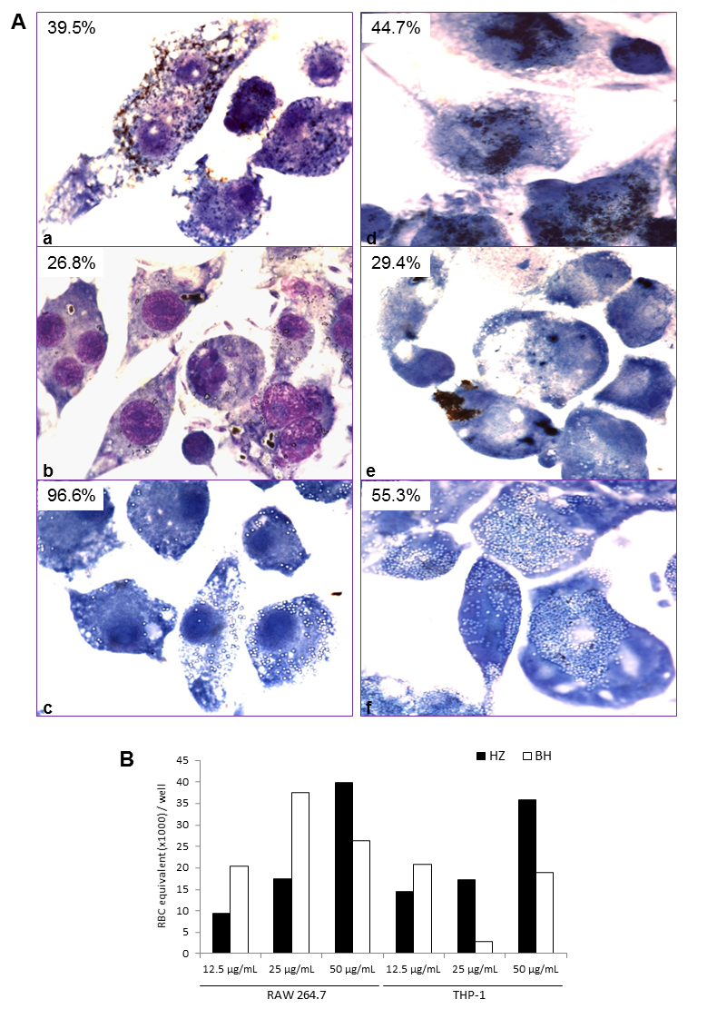
Figure 2

Figure 3

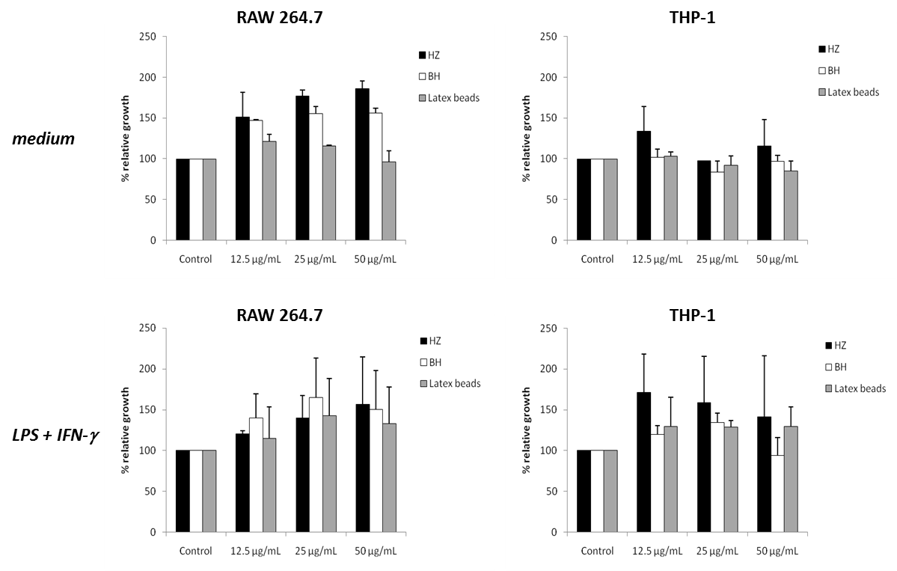

Figure 4
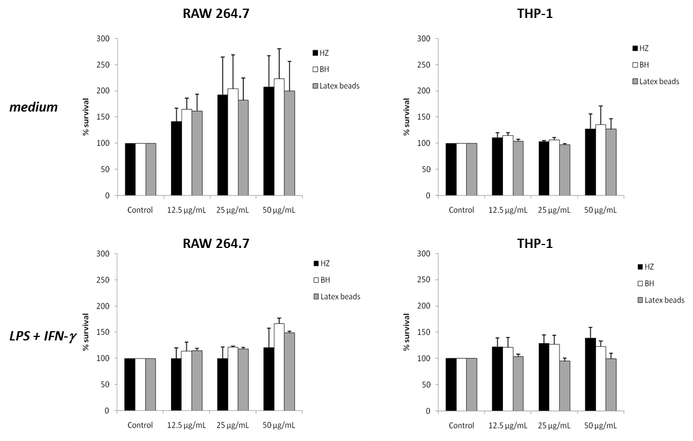

Figure 5
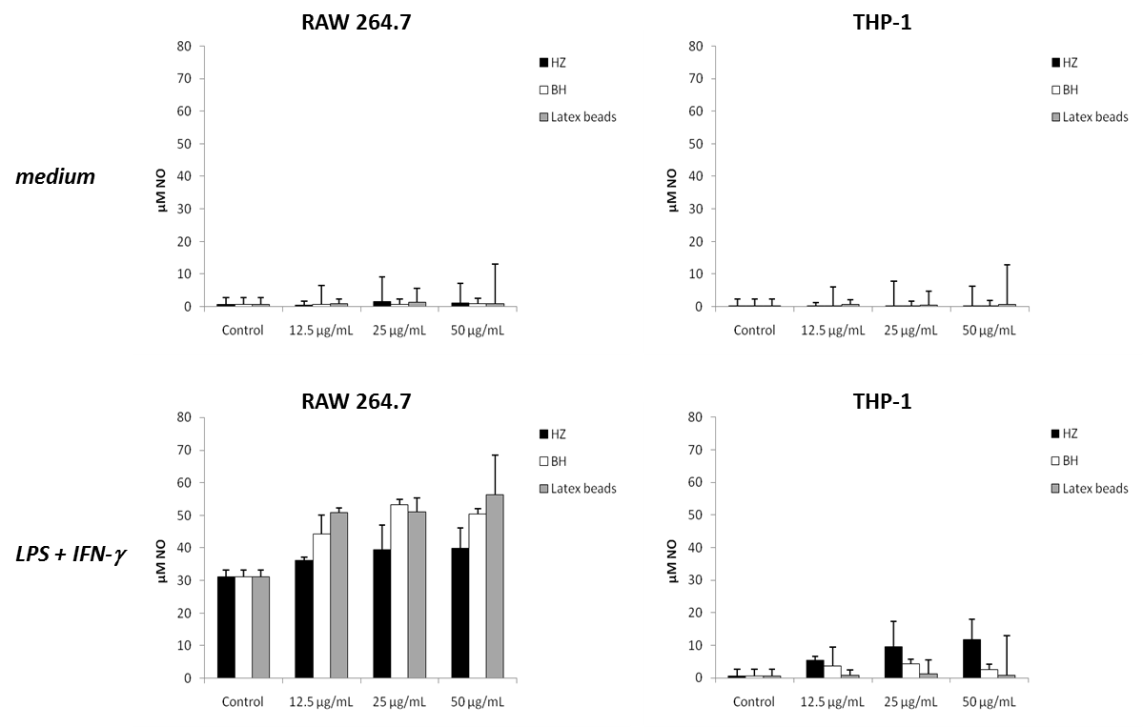

Figure 6

