Puggioli et al.: Rearing Aedes albopictus

Journal of Medical Entomology
Vector Control, Pest Management,
Resistance, Repellents

Arianna Puggioli
Medical and Veterinary Entomology
Department, Centro Agricoltura Ambiente ‘G. Nicoli’, Via Argini Nord 3351, 40014 Crevalcore, Italy
Phone: +39 051 6802240
Fax: +39 051 981908
E-mail: apuggioli@caa.it

Development of Aedes albopictus (Diptera: Culicidae) Larvae Under Different Laboratory Conditions

A. Puggioli¹, M. Carrieri¹, M. L. Dindo³, A. Medici¹, R. S. Lees², J. R. L. Gilles², R. Bellini¹

¹ Medical and Veterinary Entomology Department, Centro Agricoltura Ambiente ‘G. Nicoli’, Via Argini Nord 3351, 40014 Crevalcore, Italy.
² Insect Pest Control Laboratory, Joint FAO/IAEA Division of Nuclear Techniques in Food and Agriculture, International Atomic Energy Agency, Wagramerstrasse 5, A-1400 Vienna, Austria.
³ Dipartimento di Scienze e Tecnologie Agroambientali, Università di Bologna, Viale G. Fanin 42, 40127 Bologna, Italy.
ABSTRACT Critical to successful application of the sterile insect technique against Aedes albopictus (Skuse) is the development of an efficient and standardized rearing protocol to be employed in the mass production system. In this study several life history traits of Ae. albopictus were analyzed to identify upper and lower thresholds of larval density and diet concentration. Survival to pupation, time to pupation and sex ratio were evaluated under a range of larval densities (0.5 to 5 larvae/ml) and food doses (0.05 to 1.6 mg/larva/day) using two larval diets (one locally developed; one developed by the FAO/IAEA). The larvae reared at 28°C, at a density of 2 larvae/ml and receiving a food dose equal to 0.6 mg/larva/day of a diet consisting of 50% tuna meal, 50% bovine liver powder (the FAO/IAEA diet) and, as an additive, 0.2 gr of Vitamin Mix per 100 ml of diet solution, developed in 5 days and had 90% survival to the pupal stage. With this rearing regime the male pupae production by 24 h after the onset of pupation was the highest; these pupae were ~ 94% male.

KEY WORDS Aedes albopictus, larval rearing, sterile insect technique, survival rate, development time
Aedes albopictus (Skuse) is an aggressive, daytime biting mosquito that ranked as one of the top 100 most invasive alien species worldwide and is recognized as an increasingly important vector (Gratz 2004, Invasive Species Specialist Group 2009, Medlock et al. 2012). Part of its impact on human health is due to its rapid spread to Europe, the Western Hemisphere and other areas from its native home-range in East Asia and islands of the western Pacific and Indian Ocean (Reiter and Sprenger 1987, Benedict et al. 2007, Scholte and Schaffner 2007, Caminade et al. 2012, Guillaumot et al. 2012). During the past 10 years this species has been the main vector for a number of dengue and chikungunya outbreaks in Hawaii, Indian Ocean islands, Central Africa, southern China and the first autochthonous transmission of the dengue virus in Europe (de Lamballerie et al. 2008, Paupy et al. 2009, Wu et al. 2010, Gasperi et al. 2012, Rezza 2012, Bonizzoni et al. 2013, Shaffner et al. 2013).
In the absence of an efficient vaccine to protect human populations from mosquito-transmitted diseases such as dengue, chikungunya, zika and even malaria, the difficult and complex task of mosquito control is one of the few proven ways to reduce the risk of transmission of many pathogens (Benedict and Robinson 2003, Townson et al. 2005, Alphey et al. 2010, Bonizzoni et al. 2013, Wong et al. 2013, Rainey et al. 2014).
When used with well integrated conventional control methods, the sterile insect technique (SIT) has proven to be an effective tool to control various insect species of agricultural interest (Dyck et al. 2005). Field studies conducted in the 1970s and 1980s showed that the SIT could also be effective against mosquitoes, including Culex quinquefasciatus Say, Culex pipiens Linnaeus, Anopheles albimanus Wiedemann and Culex tarsalis Coquillett (Laven 1967, Patterson et al. 1970, Laven et al. 1971, Lofgren et al. 1974, Reisen et al. 1982, Benedict and Robinson 2003). Interest in applying the SIT against mosquito vectors has re-emerged recently following the development of new genetic and technological tools that could deliver significant improvements to the technique, including genetic modification of mosquitoes and the use of the maternally-inherited intracellular bacterium Wolbachia (Alphey et al. 2010, Calvitti et al. 2010, Harris et al. 2011, Hoffmann et al. 2011, Slatko et al. 2014). Adoption of an integrated management approach together with the engagement of the local communities are key factors to achieving great benefits to health and to socioeconomic development (WHO 2004).
Feasibility studies have been conducted in Italy regarding the possibility of integrating the SIT strategy into the control programs of Ae. albopictus (Bellini et al. 2007). Several trials have been performed between 2005 and 2009 in urban and suburban areas of the Emilia-Romagna region, northern Italy (Santamonica 43°57’22”N 12°41’18”E, Boschi 44°38’51”N 11°32’7”E, Budrio di Correggio 44°45’11”N 10°44’36”E and Caselline di Albinea 44°37’0”N 10°36’0”E) where the releases of male Ae. albopictus sterilized with irradiation resulted in suppression of the local population. In particular, it was shown that 70-80% egg sterility was sufficient to cause a decrease in egg collection of the same magnitude, indicating a substantial reduction of the adult population density (Bellini et al. 2013).
SIT programs involve the release into the environment of sterile males in high numbers (Knipling 1955, Knipling 1979, Coleman and Alphey 2004, Hendrichs and Robinson 2009). The mass-reared male insects produced must retain the necessary ability to locate and mate with wild females for sterility to be induced. In general, the quality of reared insects (not only mosquitoes, but also entomophagous and herbivorous insects) is of fundamental importance for the majority of entomological research (Knipling 1979, Cohen 2001, Dindo et al. 2006, Dindo and Grenier 2014, Leppla 2014). Even though efforts to assess the quality of laboratory and mass-reared insects have increased recently due to the relevance for the implementation of SIT programs, there are many questions still to be answered about how to maintain critical characteristics due, in part, to a lack of data on male biology and mating behavior as well as a difficulty in developing meaningful protocols to study, and to validate laboratory evaluations of mass reared insects that result in successful field application (Lees et al. 2014). The effects of diet quality and quantity and insect handling during the mass rearing process are also subjects needing further investigation (Benedict and Robinson 2003, Benedict et al. 2009, Madakacherry et al. 2014).
Standardized protocols for each process involved in an SIT program, including large-scale rearing, are needed in order to allow comparison of results from different studies (Cohen 2001, Bonizzoni et al. 2013, Couret and Benedict 2014, Hapairai et al. 2014). In this work, we investigated the effect of two larval diets and a range of larval densities and diet concentrations on several life history traits of Ae. albopictus in order to determine the optimum conditions for larval development, a critical aspect for developing standardized rearing and the success of SIT as it strongly influences the quality of insects produced.

Materials and Methods
Mosquito Rearing. The strain used for this experiment originated from eggs collected in the field in Rimini, Italy (44°03'24''N 12°33'52''E) in 2009, and kept for one generation at the Centro Agricoltura Ambiente laboratory (CAA) in Crevalcore (BO), where the experiments were carried out. Adults were maintained in a climatic chamber under standard conditions (28±1°C, 80 ± 5% RH and a 12:12 h L:D photoperiod), in Plexiglas cages (40 x 40 x 40 cm) provided with 10% sucrose solution, and females were offered fresh, mechanically defibrinated rabbit blood, provided through a thermostatically controlled device that heats and maintains the blood at a temperature of 37°C (Bellini et al. 2013, Puggioli et al. 2013, Balestrino et al. 2014b).
Eggs were laid by the females on white filter paper contained in plastic beakers filled with dechlorinated water. Once removed from the cage, the eggs were left to dry under standard conditions for 24 h then stored, in the climatic chamber, in a sealed plastic container with a saturated potassium sulfate solution to maintain a value of relative humidity inside the container of ~ 97% (Balestrino et al. 2010). For hatching, eggs were put in a closed, one liter capacity jar with 0.7 liters of deionized water, 0.25 grams of Bacto Nutrient Broth and 0.05 grams of brewer’s yeast (Bellini et al. 2007, Zheng et al. 2015b).
Preparation of Diets. We compared the effect of food concentration and larval density on development of immature Ae. albopictus using two diets of different composition: 1) CAA diet (developed at the CAA) - 80% Friskies® dry adult cat food (Nestlé S.A., Vevey, Switzerland), 14% brewer's yeast (Sigma Aldrich Inc., St. Louis, MO) and 6% Tetramin® fish food (Tetra Pro, Melle, Germany) (Bellini et al. 2007, Medici et al. 2011); 2) IAEA diet (developed at the FAO/IAEA Insect Pest Control Laboratory) - 50% bovine liver powder (MP Biomedicals, Santa Ana, CA), 50% tuna meal (T. C. Union Agrotech, Thailand) and, as an additive, 0.4% w/v of Vitamin Mix (Vanderzant Vitamin Mix, Bio-Serv, Frenchtown, NJ) (Damiens et al. 2012). A slurry of each diet was prepared by manually mixing the solid components, consisting of small particles, in deionized water. Ten ml aliquots were stored at –20°C to prevent the proliferation of microorganisms and diet degradation (Puggioli et al. 2013).
Experimental Protocol. In the two trials described below, ~ 2 h after hatching, first instars larvae (L1) were transferred into standard 90 mm-diameter disposable polystyrene petri dishes containing 32 ml of deionized water resulting in a depth of 5 mm. The dishes, placed inside a climatic chamber under standard conditions (28±1°C, 80 ± 5% RH and a 12:12 h L:D photoperiod), were covered with the supplied lids to minimize evaporation. Regardless of the day of development or number of larvae present, 640 μl of diet (at the different concentrations described below) was provided daily following the experimental design described by Gilles et al. (2011) for Anopheles arabiensis (Patton). The dishes were examined daily for pupae which were removed and transferred to tubes for emergence; the sex of resulting adults was determined. Survival to pupation (proportion of larvae that survived from L1 to the pupal stage), time to pupation (development duration, in days, between L1 and pupa) and sex ratio (proportion of males among the total number of adults emerging from a treatment) were recorded. Three replicates were set up for each of the combinations of larval density and diet concentration (mg/ml/day) for each given diet.

Trial 1. Diet quality - Effect of larval density and diet concentration on larval development. The CAA and IAEA larval diets were compared at four larval densities (0.5, 1, 2 and 4 larvae/ml, i.e. 16, 32, 64, or 128 larvae/dish, respectively) and four diet concentrations (1, 2, 3 and 4 % wt:vol slurry of diet in water; 0.2, 0.4, 0.6 and 0.8 mg diet/ml/day). The factorial design and the resulting food doses (mg/larva/day) are shown in Table 1.

Trial 2. Determination of the optimal rearing conditions. Based on the results obtained in Trial 1, the IAEA diet was selected for the second trial to optimize productivity with higher larval densities (2, 3, 4, 5 larvae/ml, i.e. 64, 96, 128 or 160 larvae/dish, respectively) and diet concentrations (4, 6, 8 or 10 % wt:vol slurry of diet in water; 0.8, 1.2, 1.6 and 2 mg diet/ml/day). The factorial design and the resulting food doses (mg/larva/day) are shown in Table 2. Observations were carried out until all the larvae pupated or died. At 24 h after the beginning of pupation we assessed the effect of larval density and food concentration on sex ratio and male pupae production rate (number of male pupae obtained which formed within 24 h of the first pupation divided by the total number of male pupae collected from each treatment). The male productivity was calculated as the absolute number of males produced from each treatment in the first 24 h. These parameters were observed at 24 h after the onset of pupation, because this is the period when protandry and the smaller size of male compared with female pupae can be best exploited for mechanical sex separation (Bellini et al. 2007, Medici et al. 2011, Puggioli et al. 2013, Balestrino et al. 2014b).
Statistical Analysis. The data obtained by the comparison of the two diets, CAA and IAEA, at different larval densities and food concentration, were analyzed by three-way analysis of variance (STATISTICA 7.2), while the data obtained testing the performance of the IAEA diet were analyzed by two-way analysis of variance (STATISTICA 7.2). The percentages were transformed for the analysis using an arcsine transformation. To evaluate the performance of the IAEA diet, differences in sex ratio, male pupae production rate at 24 h and male productivity at 24 h were also analyzed.

Results
Trial 1. Diet quality - Effect of larval density and diet concentration on larval development. The comparison of survival to pupation as a function of the concentration of CAA or IAEA diet and the larval density showed that higher survival was obtained with the IAEA diet (F_{1, 64} = 54.39; P < 0.0001), especially at the lowest diet level (1%) (F_{3, 64} = 16.82; P < 0.0001) (Figure 1–A). Differences were also observed between the two diets as a function of larval density, in particular at the highest density (4 larvae/ml) (F_{3, 64} = 12.09; P < 0.0001) (Figure 1–B). The effect of the interaction of diet, food amount and density was also significant, with the IAEA diet producing higher survival rates (F_{9, 64} = 6.78; P < 0.0001).
A significant difference in the time to pupation was also found depending on the diet (F_{1, 64} = 99.45; P < 0.0001), both in relation to the diet concentration (F_{3, 64} = 312.48; P < 0.0001) and to the larval density (F_{3, 64} = 750.61; P < 0.0001) (Figure 1–C and 1–D respectively). The interaction between development rate and diet was also significant; time to pupation was shorter with the IAEA diet for all the treatments (F_{9, 64} = 5.42; P < 0.0001).
No significant differences were observed in the sex ratio (proportion of males) between the diet treatments (F_{1, 64} = 0.15; P = 0.70), while the effects of the diet concentration (F_{3, 64} = 3.67; P < 0.05) and larval density (F_{3, 64} = 5.00; P < 0.01) were significant, as was the interaction (F_{9, 64} = 3.18; P < 0.01) and 1–F).

Trial 2. Determination of the optimal rearing conditions. The effect of diet concentration on survival to pupation was significant (F_{3, 32} = 10.11; P < 0.001); no significant effect was observed either for larval density (F_{3, 32} = 0.58; P = 0.63) nor the interaction between diet concentration and larval density (F_{9, 32} = 0.91; P = 0.53). The highest survival rate was obtained with the lowest diet treatment (4%) and a larval density of 3 larvae/ml; similar results were also obtained with all the other larval densities tested both with 4% and 6% diet treatments (Figure 2). A decrease in the survival to pupation was observed with the highest diet level (10%) especially at the lower larval densities (Figure 2).
Food concentration and larval density both significantly affected time to pupation (F_{3, 32} = 22.66; P < 0.001 and F_{3, 32} = 21.35; P < 0.001 respectively); their interaction was also significant (F_{9, 32} = 2.99; P < 0.01). Lower diet concentration increased time to pupation, especially at the higher larval densities. The fastest development was observed at a density of 2 larvae/ml and a diet level of 6%. A similar time to pupation was also observed at the higher larval densities but with higher food availability (8% and 10% treatments) (Figure 3).
No significant difference was observed in the overall sex ratio caused by the parameters tested: diet level (F_{3, 32} = 0.69; P = 0.57), larval density (F_{3, 32} = 0.53; P = 0.66) or their interaction (F_{9, 32} = 0.24; P = 0.99). The minimum and the maximum proportion of males ranged from 0.48 to 0.6. A high variability was observed particularly at the highest diet treatment (10%).
The effect of diet concentration and larval density on sex ratio at 24 h was significant (F_{3, 32} = 9.22; P < 0.001 and F_{3, 32} = 7.17; P < 0.001 respectively), while the interaction between the two was not significant (F_{9, 32} = 1.03; P < 0.44). A high percentage of males were recovered from pupae resulting from the 4% diet treatment, regardless of larval density, while at higher diet levels the percentage of males was lower (Figure 4).
Male pupae production rate at 24 h was significantly affected by the diet concentration and larval density (F_{3, 32} = 6.3; P < 0.05 and F_{3, 32} = 6.18; P < 0.05 respectively), though the interaction between the variables was not significant (F_{9, 32} = 1.72; P = 0.13). The highest proportion of male pupae was obtained with a density of 2 larvae/ml and the 6% food treatment. A similar male pupae production rate was also obtained at a density of 3 and 4 larvae/ml, but with a higher food treatment (8%) (Figure 5).
Male productivity in the first 24 h was significantly affected by the larval density (F_{3, 32} = 14.81; P < 0.001): increasing larval density increased the number of male pupae produced, while the diet concentration didn’t have a significant effect (F_{3, 32} = 0.67; P = 0.57). The interaction was also not significant (F_{9, 32} = 0.83; P = 0.6). The lowest male productivity was observed at 2 larvae/ml (Figure 6).

- Discussion
This investigation into the effect of two larval diets, a range of food concentrations and a range of larval densities on several life history traits of Ae. albopictus attempted to define conditions for efficient large-scale rearing, a crucial step in the success of the SIT (Benedict et al. 2009, Balestrino et al. 2014b, Carvalho et al. 2014). Results from the first trial indicated higher survival rates were obtained with the IAEA diet, particularly at the 1% food treatment and 4 larvae/ml larval density. When using the CAA diet there appears to be a more pronounced negative dependence of survival as a function of increased larval density when diet is limiting as was also observed by Gilles et al. (2011) in An. arabiensis. The time to pupation was also significantly shorter using the IAEA diet. These results were consistent with previous experiments (Puggioli et al. 2013) where the efficiency of different larval diets for Ae. albopictus mass rearing was studied in bigger containers than 90-mm-diameter petri dishes, using a larval density of 1.5 larvae/ml, a water depth of around 2 cm and a diet concentration of 4% (wt:vol) (corresponding to 0.53 mg/larva/day). Larvae reared with the IAEA diet probably reached their critical weight earlier than those reared with CAA diet because of the diet composition. As reported by Couret et al. (2014), to reach the next stage mosquito larvae need a minimum amount of nutrition in order to trigger hormonal developmental cascades. Nutrition is one of the environmental factors which affects the growth rate, and thus the time, required to get to the critical weight, but it does not affect the value of the critical weight (Nijhout et al. 2010). Moreover single-species studies showed that diet choice can influence the growth of Ae. albopictus and Ae. aegypti larvae, due to the amount and quality of microorganisms that the mosquito larvae consume (Murrell and Juliano 2008). Previous data suggested a lack of carbohydrates in the IAEA diet; integrating brewer’s yeast improved the accuracy of the sex separation, probably because carbohydrates play a role in increasing the dimensional difference between male and female pupae (Puggioli et al. 2013, Balestrino et al. 2014b).
A narrower range of conditions for the second trial, where the effect of two variables (food concentration and larval density) were investigated employing only the IAEA diet showed higher survival rate and shorter time to pupation without affecting the sex ratio. The highest survival to pupation was obtained with the lowest food treatment (4%) and a larval density of 3 larvae/ml (equal to 0.27 mg/larva/day). The highest food treatment (10%) resulted in a decrease in larval survival particularly at the lower larval densities (0.67 and 1 mg/larva/day). Adequate diet increases survival but excessive diet diminishes it because the larvae are unable to consume all diet. As a consequence, microorganisms proliferate in the unconsumed diet ultimately resulting in degradation and larval mortality (Gilles et al. 2011). Furthermore, as reported by Bargielowski et al. (2011), it is possible that bacterial or fungal growth affects life history parameters in mass rearing trays. The impact on larval development can either be positive or negative, depending on the microbial community present which could indirectly affect the larvae by contaminating their food supply, causing it to become less nutritious or inedible, or provide additional nutrition to the filter-feeding larvae.
The fastest development was observed at a density of 2 larvae/ml and a food treatment of 6% (0.6 mg/larva/day). A short time to pupation was also observed at 2 larvae/ml and 3 larvae/ml but with a higher diet level (8% and 10%) (0.53 mg/larva/day). Increasing larval density at the lower diet levels prolonged the development time while at higher food doses the time to pupation was shorter (as in Gilles et al. 2011, Yoshioka et al. 2012). The length of rearing time is an important aspect to be considered for mass rearing in the context of SIT as it affects production costs. Moreover, as shown in previous studies, pupation occurring late (between 48 and 72 h from pupation onset) is less productive in terms of overall collection of male pupae (Medici et al. 2011, Puggioli et al. 2013, Balestrino et al. 2014b, Hapairai et al. 2014).
In order to produce an optimal protocol for standardized mass rearing of Ae. albopictus, several parameters were investigated at 24 h after the beginning of pupation, because this is the period when pupae are sieved from the rearing water to separate the male pupae from the females to best exploit protandry. The highest sex ratio (males: females) was observed at the lowest food treatment. This male-biased sex ratio may suggest an effect of underfeeding (Chambers and Klowden 1990, Puggioli et al. 2013, Balestrino et al. 2014b), but is favorable when selecting the males to be released in SIT application. The male pupae production rate at 24 h is a very important parameter because it determines the quantity of males that can be selected for release as a proportion of the total males produced. This parameter was higher at the larval density of 2 larvae/ml compared to the other larval densities, with the highest value with a 6% food treatment (0.6 mg/larva/day). Increased larval densities also produced a good proportion of males when higher food doses were given (3 and 4 larvae/ml using 8% food treatment, corresponding to 0.53 and 0.4 mg/larva/day respectively). Higher male productivity (absolute number of male pupae produced per dish) in the first 24 h was obtained by increasing diet levels only at higher larval densities. The highest number of males was produced with 5 larvae/ml provided with 8% and 10% diet treatments (0.32 and 0.4 mg/larva/day).
These results demonstrate that a good survival of larvae is obtained at higher densities but only with higher doses of diet. The concept of "quantity" and "quality" are not absolute, but depend on the purposes for which the rearing is done (Grenier 2009, Sighinolfi et al. 2013, Dindo and Grenier, 2014). For SIT mass rearing, the greatest male production for a given space and manpower is critical. It is necessary to select the conditions which optimize survival, absolute number of males, and rearing schedule time in order to maximize quantity but without overly adverse effects on quality. Economic factors must also be considered; administering more diet is more expensive and must be balanced against production numbers, labor costs, and the advantages of shorter rearing times. Further research will be necessary to evaluate the quality of the sterile males produced which, in mass rearing facilities, should be checked regularly with methods able to evidence possible losses in quality. While in other species guidelines are available for quality control evaluation (van Lenteren et al. 2003; Leppla 2009, 2014; FAO/IAEA/USDA 2014), in the case of mosquitoes standard methods for quality control are not yet well defined (Madakacherry et al. 2014). The standardization of all the steps required for the mass production cycle, including the larval rearing schedule, are therefore of paramount importance (Carvalho et al. 2014, Zheng et al. 2015a).
With this experimental approach it was possible to develop a standardized laboratory protocol for Ae. albopictus rearing. The protocol was also used as a standard in tests to evaluate alternate diet compositions, different rearing temperatures and the possibility of scaling up the rearing system employing mass production equipment (Puggioli et al. 2013, Balestrino et. al 2014a, Balestrino et. al 2014b). A rearing protocol providing 2 larvae/ml and 0.6 mg/larva/day is recommended as a good basis for mass production of Aedes albopictus for male release, and has already been used in experiments to test the effect of the cage dimensions on Ae. albopictus adult size selection (R.B., unpublished data).

- Acknowledgements
We acknowledge grants from the Emilia-Romagna Regional Bureau-Public Health Department managed by the Local Health Agency of Cesena, supporting the Ph.D. scholarship of A.P. We are grateful to F. Giovannini for her valuable contribution during the experiments.

- References Cited
Alphey, L., M. Benedict, R. Bellini, G. G. Clark, D. A. Dame, M. W. Service, and S. L. Dobson. 2010. Sterile-insect methods for control of mosquito-borne diseases: an analysis. Vector Borne Zoonotic Dis. 10: 295–311.
Balestrino, F., A. Medici, G. Candini, M. Carrieri, B. Maccagnani, M. Calvitti, S. Maini, and R. Bellini. 2010. γ ray dosimetry and mating capacity studies in the laboratory on Aedes albopictus males. J. Med. Entomol. 47: 581–591.
Balestrino, F., A. Puggioli, R. Bellini, D. Petric, and J.R.L. Gilles. 2014a. Mass production cage for Aedes albopictus (Diptera: Culicidae). J. Med. Entomol. 51: 155–163.
Balestrino, F., A. Puggioli, J. R. L. Gilles, and R. Bellini. 2014b. Validation of a new larval rearing unit for Aedes albopictus (Diptera: Culicidae) mass rearing. PLoS ONE 9: e91914.
Bargielowski, I., D. Nimmo, L. Alphey, and J. C. Koella. 2011. Comparison of life history characteristics of the genetically modified OX513A line and a wild type strain of Aedes aegypti. PLoS ONE 6: e20699.
Bellini, R., M. Calvitti, A. Medici, M. Carrieri, G. Celli, and S. Maini. 2007. Use of the sterile insect technique against Aedes albopictus in Italy: first results of a pilot trial, pp. 505–515. In M. J. B. Vreysen, A. S. Robinson and J. Hendrichs (eds.), Area-wide control of insect pests: from research to field implementation. Springer, Dordrecht, The Netherlands.
Bellini, R., A. Medici, A. Puggioli, F. Balestrino, and M. Carrieri. 2013. Pilot field trials with Aedes albopictus irradiated sterile males in Italian urban areas. J. Med. Entomol. 50: 317–325.
Benedict, M., and A. Robinson. 2003. The first releases of transgenic mosquitoes: an argument for the sterile insect technique. Trends Parasitol. 19: 349–355.
Benedict, M. Q., R. S. Levine, W. A. Hawley, and L. P. Lounibos. 2007. Spread of the tiger: global risk of invasion by the mosquito Aedes albopictus. Vector Borne Zoonotic Dis. 7: 76–85.
Benedict, M. Q., B. G. J. Knols, H. C. Bossin, P. I. Howell, E. Mialhe, C. Caceres, and A. S. Robinson. 2009. Colonisation and mass rearing: learning from others. Malar. J. 8: S4.
Bonizzoni, M., G. Gasperi, X. Chen, and A. A. James. 2013. The invasive mosquito species Aedes albopictus: current knowledge and future perspectives. Trends Parasitol. 29: 460–8.
Calvitti, M., R. Moretti, E. Lampazzi, R. Bellini, and S. L. Dobson. 2010. Characterization of a new Aedes albopictus (Diptera: Culicidae)-Wolbachia pipientis (Rickettsiales: Rickettsiaceae) symbiotic association generated by artificial transfer of the wPip strain from Culex pipiens (Diptera: Culicidae). J. Med. Entomol. 47:179–187.
Caminade, C., J. M. Medlock, E. Ducheyne, K. M. McIntyre, S. Leach, M. Baylis, and A. P. Morse. 2012. Suitability of European climate for the Asian tiger mosquito Aedes albopictus: recent trends and future scenarios. J. R. Soc. Interface 9: 2708–2717.
Carvalho, D. O., D. Nimmo, N. Naish, A. R. McKemey, P. Gray, A. B. B. Wilke, M. T. Marrelli, J. F. Virginio, L. Alphey, and M. L. Capurro. 2014. Mass production of genetically modified Aedes aegypti for field releases in Brazil. J. Vis. Exp. 83: e3579.
Chambers, G. M., and M. J. Klowden. 1990. Correlation of nutritional reserves with a critical weight for pupation in larval Aedes aegypti mosquitoes. J. Am. Mosq. Control Assoc. 6: 394–399.
Cohen, A. C. 2001. Formalizing insect rearing and artificial diet technology. Am. Entomol. 47: 198–206.
Coleman, P. G., and L. Alphey. 2004. Genetic control of vector populations: an imminent prospect. Trop. Med. Int. Health 9: 433–437.
Couret, J., and M. Q. Benedict. 2014. A meta-analysis of the factors influencing development rate variation in Aedes aegypti (Diptera: Culicidae). BMC Ecol. 14: 3.
Couret, J., E. Dotson, and M. Q. Benedict. 2014. Temperature, larval diet, and density effects on development rate and survival of Aedes aegypti (Diptera: Culicidae). PLoS ONE 9: e87468.
Damiens, D., M. Q. Benedict, M. Wille, and J. R. L. Gilles. 2012. An inexpensive and effective larval diet for Anopheles arabiensis (Diptera: Culicidae): eat like a horse, a bird, or a fish? J. Med. Entomol. 49: 1001–1011.
Dindo, M. L., S. Grenier, L. Sighinolfi, and P. Baronio. 2006. Biological and biochemical differences between in vitro- and in vivo-reared Exorista larvarum. Ent. Exp. et Appl. 120: 167–174.
Dindo, M. L., and S. Grenier. 2014. Production of Dipteran parasitoids. pp. 101-143. In J.A. Morales-Ramos, M.G. Rojas and D.I. Shapiro-Ilan (eds.), Mass production of beneficial organisms: invertebrates and entomopathogens. Academic Press, London, UK.
Dyck, V. A., J. Hendrichs, and A. S. Robinson, eds. 2005. Sterile insect technique: principles and practice in area-wide integrated pest management. Dordrecht, The Netherlands: Springer.
FAO/IAEA/USDA. 2014. Product quality control for sterile mass-reared and released
Tephritid fruit flies, Version 6.0. International Atomic Energy Agency, Vienna, Austria. 164 pp.
Gasperi, G., R. Bellini, A. R. Malacrida, A. Crisanti, M. Dottori, and S. Aksoy. 2012. A new threat looming over the Mediterranean basin: emergence of viral diseases transmitted by Aedes albopictus mosquitoes. PLoS Negl. Trop. Dis. 6: e1836.
Gilles, J. R. L., R. S. Lees, S. M. Soliban, and M. Q. Benedict. 2011. Density-dependent effects in experimental larval populations of Anopheles arabiensis (Diptera: Culicidae) can be negative, neutral, or overcompensatory depending on density and diet levels. J. Med. Entomol. 48: 296–304.
Gratz, N. G. 2004. Critical review of the vector status of Aedes albopictus. Med. Vet. Entomol. 18: 215–227.
Grenier, S. 2009. In vitro rearing of entomophagous insects - Past and future trends: a minireview. B. Insectol. 62: 1–6.
Guillaumot, L., R. Ofanoa, L. Swillen, N. Singh, H. C. Bossin, and F. Schaffner. 2012. Distribution of Aedes albopictus (Diptera, Culicidae) in southwestern Pacific countries, with a first report from the Kingdom of Tonga. Parasites & Vectors 5: 247.
Hapairai, L. K., J. Marie, S. P. Sinkins, and H. C. Bossin. 2014. Effect of temperature and larval density on Aedes polynesiensis (Diptera: Culicidae) laboratory rearing productivity and male characteristics. Acta Trop. 132S: S108–S115.
Harris, A. F., D. Nimmo, A. R. McKemey, N. Kelly, S. Scaife, C. A. Donnelly, C. Beech, W. D. Petrie, and L. Alphey. 2011. Field performance of engineered male mosquitoes. Nat. Biotechnol. 29: 1034–1037.
Hendrichs, J., and A. S. Robinson. 2009. Sterile insect technique, pp. 953–957. In V. H. Resh and R. T. Cardé (eds.), Encyclopedia of Insects, 2nd ed. Academic, Burlington, MA.
Hoffmann, A. A., B. L. Montgomery, J. Popovici, I. Iturbe-Ormaetxe, P. H. Johnson, F. Muzzi, M. Greenfield, M. Durkan, Y. S. Leong, Y. Dong, et al. 2011. Successful establishment of Wolbachia in Aedes populations to suppress dengue transmission. Nature. 476: 454–457.
Invasive Species Specialist Group. 2009. Global Invasive Species Database–Aedes albopictus. http://www.issg.org/database/species/ecology.asp?si=109&fr=1&sts=sss&lang=EN
Knipling, E. 1955. Possibilities of insect control or eradication through use of sexually sterile males. J. Econ. Entomol. 48: 459–462.
Knipling, E. F. 1979. The basic principles of insect population suppression and management. USDA Agric. Handb. 512.
de Lamballerie, X., E. Leroy, R. N. Charrel, K. Ttsetsarkin, S. Higgs, and E. A. Gould. 2008. Chikungunya virus adapts to tiger mosquito via evolutionary convergence: a sign of things to come? Virol. J. 5: 33.
Laven, H. 1967. Eradication of Culex pipiens fatigans through cytoplasmic incompatibility. Nature 216: 383–384.
Laven, H., J. Cousserans, and G. Guille. 1971. Experience de lutte genetique contre Culex pipiens dans la rgion de Montpellier. Bull. Biologique 105: 358–367.
Lees, R. S., B. Knols, R. Bellini, M. Q. Benedict, A. Bheecarry, H. C. Bossin, D. D. Chadee, J. Charlwood, R. K. Dabiré, L. Djogbenou, A. Egyir-Yawson, R. Gato, L. C. Gouagna, S. A. Khan, L. L. Koekemoer, G. Lemperiere, N. C. Manoukis, R. Mozuraitis, R. J. Pitts, F. Simard, and J. R. L. Gilles. 2014. Review: Improving our knowledge of male mosquito biology in relation to genetic control programmes. Acta Trop. 132S: S2–S11.
Leppla, N. C. 2009. The basics of quality control for insect rearing. In: Schneider, J. C. (Ed.), Principles and procedures for rearing high quality insects, Mississippi State University, Mississippi State, pp. 289–306.
Leppla, N. C. 2014. Concepts and methods of quality assurance for mass-reared parasitoids and predators. In “Mass production of beneficial organisms – Invertebrates and Entomopathogens”, J. Morales-Ramos, M. G. Rojas and D.I. Shapiro-Ilan (Eds.), Academic Press, pp. 277–317.
Lofgren, C. S., D. A. Dame, S. G. Breeland, D. E. Weidhaas, G. M. Jeffery, R. Kaiser, H. R. Ford, M. D. Boston, and K. F. Baldwin. 1974. Release of chemosterilized males for the control of Anopheles albimanus in El Salvador III. Field methods and population control. Am. J. Trop. Med. Hyg. 23: 288–297.
Madakacherry, O., R. S. Lees, and J. R. L. Gilles. 2014. Aedes albopictus (Skuse) males in laboratory and semi-field cages: release ratios and mating competitiveness. Acta Trop. 132S: S124–S129.
Medici, A., M. Carrieri, E. J. Scholte, B. Maccagnani, M. L. Dindo, and R. Bellini. 2011. Studies on Aedes albopictus larval mass-rearing optimization. J. Econ. Entomol. 104: 266–273.
Medlock, J. M., K. M. Hansford, F. Schaffner, V. Versteirt, G. Hendrickx, H. Zeller, and W. Van Bortel. 2012. A review of the invasive mosquitoes in Europe: ecology, public health risks, and control options. Vector Borne Zoonotic Dis. 12: 435–447.
Murrell, E. G., and S. A. Juliano. 2008. Detritus type alters the outcome of interspecific competition between Aedes aegypti and Aedes albopictus (Diptera: Culicidae). J. Med. Entomol. 45: 375–383.
Nijhout, H. F., D. A. Roff, and G. Davidowitz. 2010. Conflicting processes in the evolution of body size and development time. Philos. T. R. Soc. B. 365: 567–575.
Patterson, R. S., D. E. Weidhaas, H. R. Ford, and C. S. Lofgren. 1970. Suppression and elimination of an island population of Culex pipiens quinquefasciatus with sterile males. Science 168: 1368–1370.
Paupy, C., H. Delatte, L. Bagny, V. Corbel, and D. Fontenille. 2009. Aedes albopictus, an arbovirus vector: from the darkness to the light. Microbes Infect. 11: 1177–1185.
Puggioli, A., F. Balestrino, D. Damiens, R. S. Lees, S. M. Soliban, O. Madakacherry, M. L. Dindo, R. Bellini and J. R. L. Gilles. 2013. Efficiency of three diets for larval development in mass rearing Aedes albopictus (Diptera: Culicidae). J. Med. Entomol. 50: 819–825.
Rainey, S. M., P. Shah, A. Kohl and I. Dietrich. 2014. Understanding the Wolbachia-mediated inhibition of arboviruses in mosquitoes: progress and challenges. J. Gen. Virol. 95: 517–530.
Reisen, W. K., M. M. Milby, S. M. Asman, M. E. Bock, R. P. Meyer, P. T. Mcdonald, and W. C. Reeves. 1982. Attempted suppression of a semi-isolated Culex tarsalis population by the release of irradiated males: a second experiment using males from a recently colonized strain. Mosq. News 42: 565–575.
Reiter, P., and D. Sprenger. 1987. The used tire trade: a mechanism for the worldwide dispersal of container breeding mosquitoes. J. Am. Mosq. Control Assoc. 3: 494–501.
Rezza, G. 2012. Aedes albopictus and the reemergence of dengue. BMC Public Health 12, 72.
Schaffner, F., J. M. Medlock, and W. Van Bortel. 2013. Public health significance of invasive mosquitoes in Europe. Clin. Microbiol. Infect. 19: 685–692.
Scholte, E. J., and F. Schaffner. 2007. Waiting for the tiger: establishment and spread of the Aedes albopictus mosquito in Europe, pp. 241–260. In W. Takken and B. Knols (eds.), Emerging pests and vector-borne diseases in Europe. Wageningen Academic Publishers, Wageningen, The Netherlands.
Sighinolfi, L., G. Febvay, M. L. Dindo, M. Rey, J. F. Pageaux, and S. Grenier. 2013. Biochemical content in fatty acids and biological parameters of Harmonia axyridis reared on artificial diet. Bull. Insectol. 66: 283-290.
Slatko, B. E., A. N. Lucka, S. L. Dobsonb, and J. M. Foster. 2014. Wolbachia endosymbionts and human disease control. Mol. Biochem. Parasit. 195: 88–95.
Townson, H., M. B. Nathan, M. Zaim, P. Guillet, L. Manga, R. Bos, and M. Kindhauser. 2005. Exploiting the potential of vector control for disease prevention. B. World Health Organ. 83: 942–947.
van Lenteren, J. C., A. Hale, J. N. Klapwijk, J. van Schelt, S. Steinberg. 2003. Guidelines for quality control of commercially produced natural enemies. In: van Lenteren, J.C. (Ed.), Quality control and production of biological control agents: theory and testing procedures. CAB International, Wallingford, pp. 265–303.
WHO. 2004. Global Strategic Framework for Integrated Vector Management (Document WHO_CDS_CPE_PVC_2004), World Health Organization.
Wong, P-S. J., M-z. I. Li, C-S. Chong, L-C. Ng, and C-H. Tan. 2013. Aedes (Stegomyia) albopictus (Skuse): A potential vector of zika virus in Singapore. PLoS Negl. Trop. Dis. 7: e2348.
Wu, J. Y., Z. R. Lun, A. A. James, and X. G. Chen. 2010. Dengue fever in mainland China. Am. J. Trop. Med. Hyg. 83: 664–671.
Yoshioka, M., J. Couret, F. Kim, J. McMillan, T. R. Burkot, E. M. Dotson, U. Kitron, and G. M. Vazquez-Prokopec. 2012. Diet and density dependent competition affect larval performance and oviposition site selection in the mosquito species Aedes albopictus (Diptera: Culicidae). Parasites & Vectors 5: 225.
Zheng, M., D. Zhang, D. D. Damiens, H. Yamada, and J. R .L. Gilles. 2015a. Standard operating procedures for standardized mass rearing of the dengue and chikungunya vectors Aedes aegypti and Aedes albopictus (Diptera: Culicidae) - I - egg quantification. Parasites & Vectors 8: 42.
Zheng, M., D. Zhang1, D. D. Damiens, R. S. Lees, and J. R.L. Gilles. 2015b. Standard operating procedures for standardized mass rearing of the dengue and chikungunya vectors Aedes aegypti and Aedes albopictus (Diptera: Culicidae) - II - Egg storage and hatching. Parasites & Vectors 8: 348.
Table 1. Factorial design of diet level, larval density and the resultant food doses of mg/larva/day tested with CAA and IAEA diets in Trial 1
Diet level (CAA or IAEA) |  |  |  | 1% | 2% | 3% | 4%
larvae/ml |  | larvae/dish |  | mg/larva/day
0.5 |  | 16 |  | 0.4 | 0.8 | 1.2 | 1.6
1 |  | 32 |  | 0.2 | 0.4 | 0.6 | 0.8
2 |  | 64 |  | 0.1 | 0.2 | 0.3 | 0.4
4 |  | 128 |  | 0.05 | 0.1 | 0.15 | 0.2

Table 2. Factorial design of diet level, larval density and the resultant food doses of mg/larva/day tested with IAEA diet in Trial 2
Diet level (IAEA) |  |  |  | 4% | 6% | 8% | 10%
larvae/ml |  | larvae/dish |  | mg/larva/day
2 |  | 64 |  | 0.4 | 0.6 | 0.8 | 1
3 |  | 96 |  | 0.27 | 0.4 | 0.53 | 0.67
4 |  | 128 |  | 0.2 | 0.3 | 0.4 | 0.5
5 |  | 160 |  | 0.16 | 0.24 | 0.32 | 0.4

A | 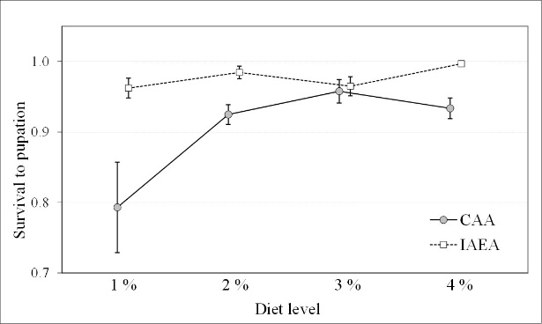 | B | 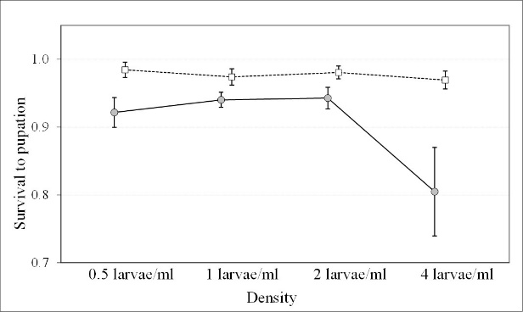
C | 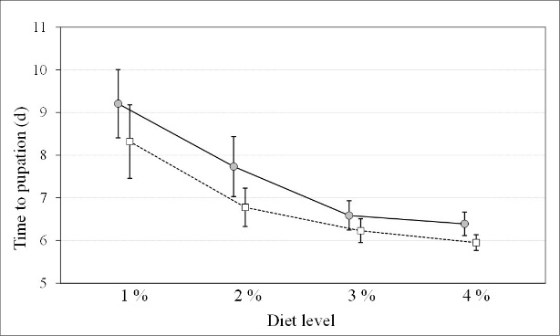 | D | 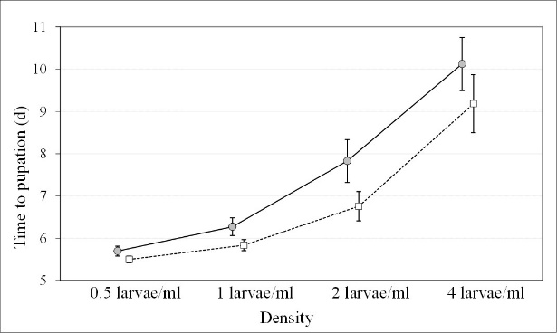
E | 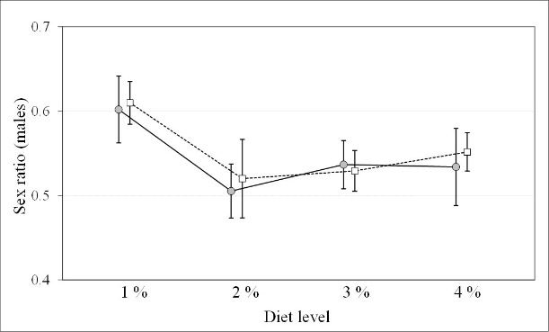 | F | 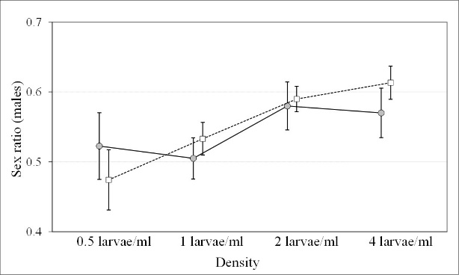

Fig. 1. Effect of diet concentration (% wt:vol) and larval density (larvae/ml) on Aedes albopictus survival to pupation (A and B respectively), time to pupation (C and D), adult sex ratio (males: females) (E and F), employing two diets (CAA and IAEA). Vertical bars indicate standard error. Solid line indicates CAA diet, dotted line indicates IAEA diet.
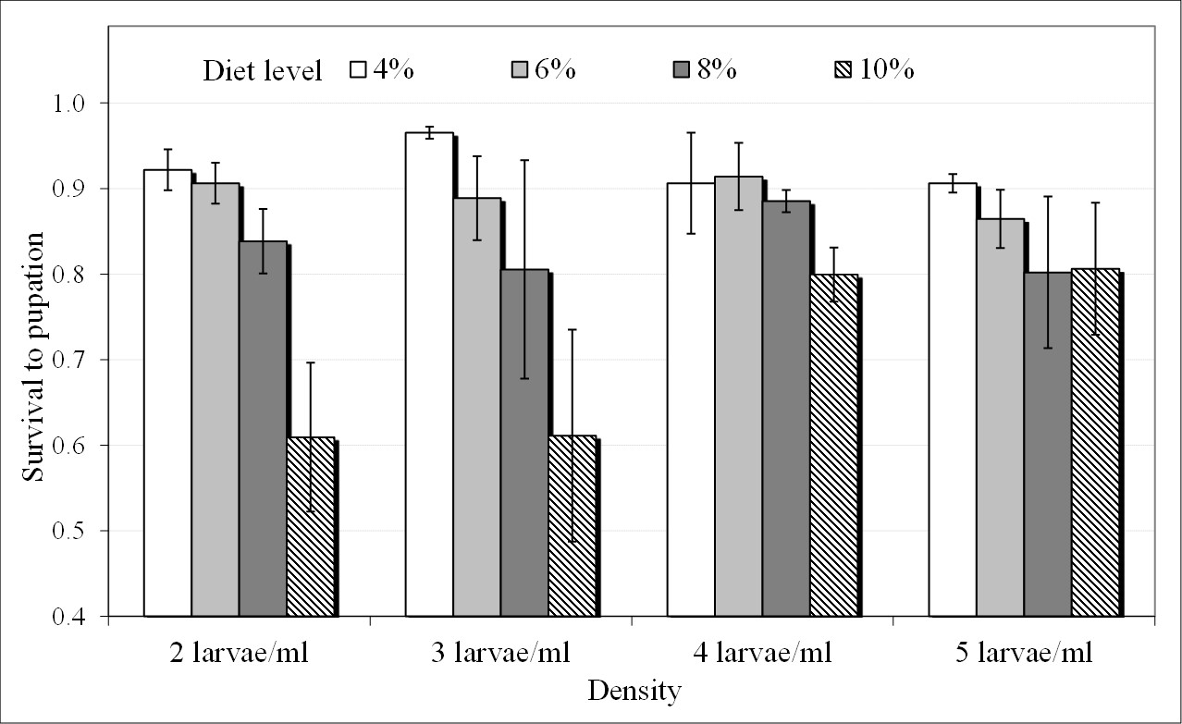

Fig. 2. Effect of diet concentration (% wt:vol) and larval density (larvae/ml) on Aedes albopictus survival to pupation employing IAEA diet. Vertical bars indicate standard error.
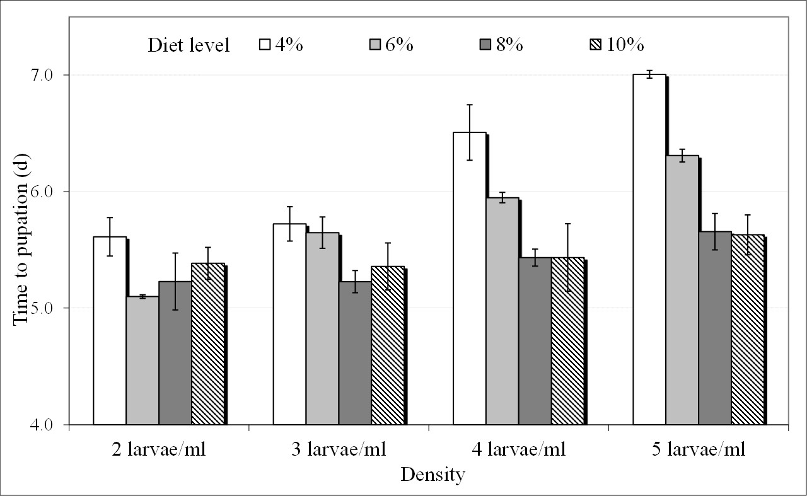

Fig. 3. Effect of diet concentration (% wt:vol) and larval density (larvae/ml) on Aedes albopictus time to pupation employing IAEA diet. Vertical bars indicate standard error.
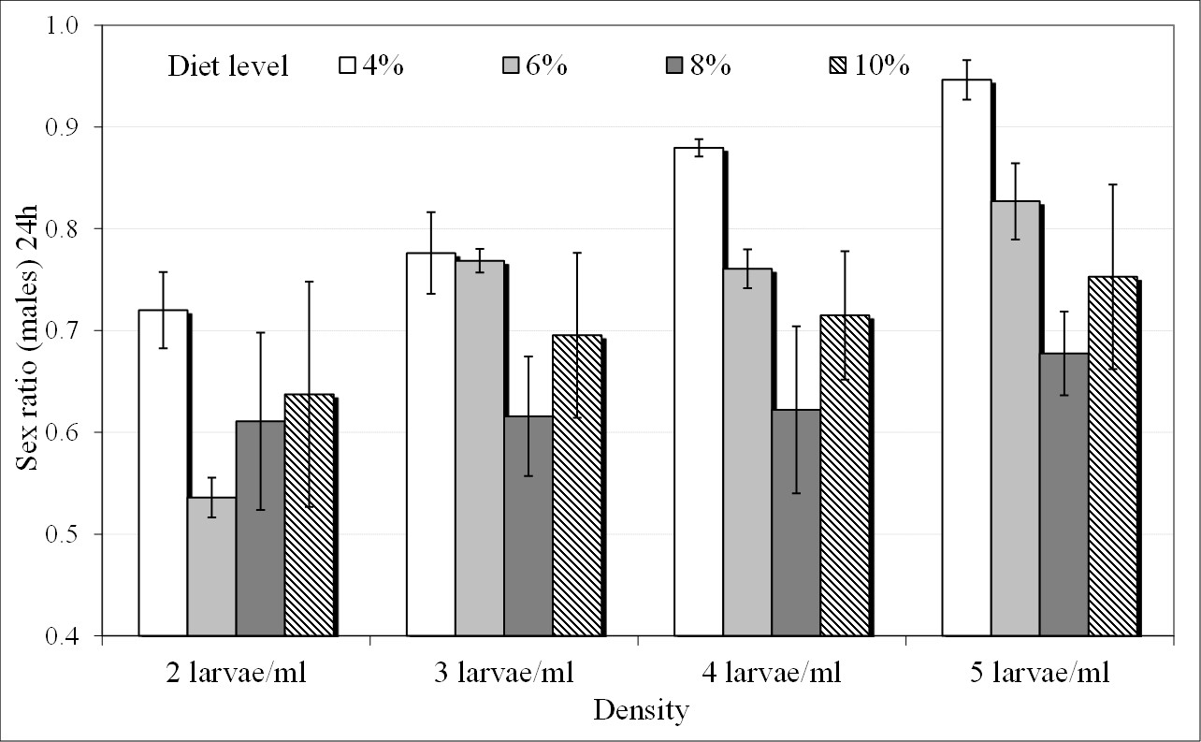

Fig. 4. Effect of diet concentration (% wt:vol) and larval density (larvae/ml) on Aedes albopictus adult sex ratio (males: females) at 24 h after pupation onset employing IAEA diet. Vertical bars indicate standard error.
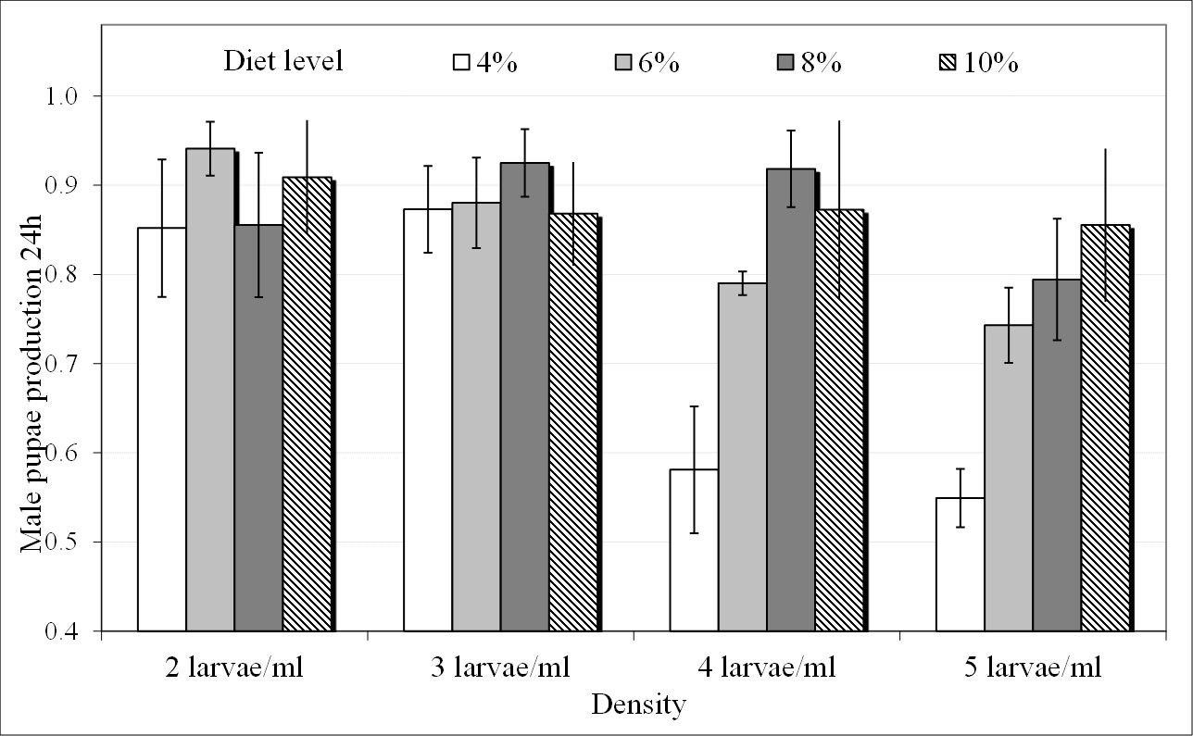

Fig. 5. Effect of diet concentration (% wt:vol) and larval density (larvae/ml) on male pupae production rate at 24 h after pupation onset employing IAEA diet. Vertical bars indicate standard error.
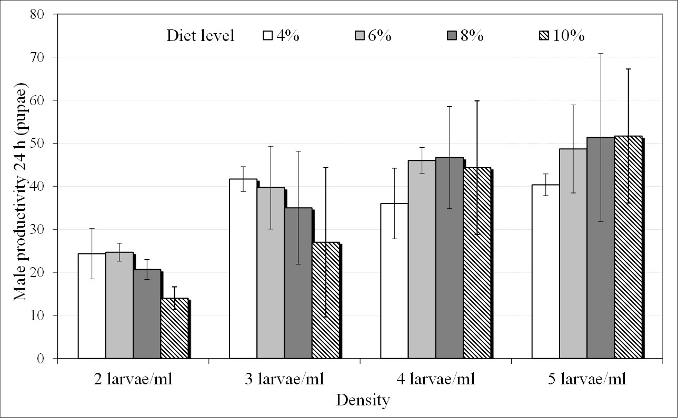

Fig. 6. Male productivity in the first 24 h after the onset of pupation. Vertical bars indicate standard error.

