Fig 2a | Fig 2b
 | 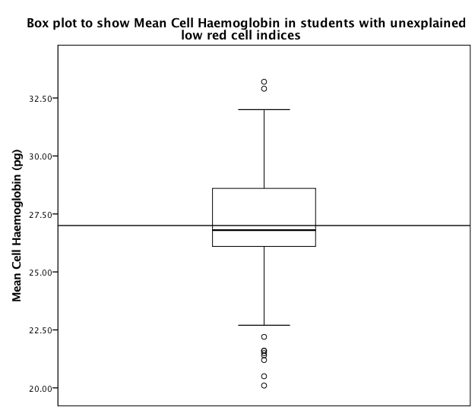

.

Figure 2. Box plots to show mean cell volume and mean cell haemoglobin in secondary school students from Sri Lanka with unexplained low red cell indices The horizontal line represents the reference cut-off value, horizontal lines inside the box show the median value, box length is the interquartile range and whiskers show the range, excluding outliers. Outlying values 1.5 to 3, or > 3 box lengths from the upper and lower edge of the box are shown as open circles and stars respectively.

