Title
Efficacy and safety of high-dose ivermectin on mosquito mortality when co-administered with dihydroartemisinin-piperaquine in Kenyan adults with uncomplicated malaria (IVERMAL): a randomised, double-blind, placebo-controlled trial.

Citation
Smit MR, Ochomo EO, Aljayyoussi G, Kwambai TK, Abong’o BO, et al. Efficacy and safety of high-dose ivermectin on mosquito mortality when co-administered with dihydroartemisinin-piperaquine in Kenyan adults with uncomplicated malaria (IVERMAL): a randomised, double-blind, placebo-controlled trial. The Lancet Infectious Diseases. 2018. Accepted 14-Feb-2018; in press.

Authors
Menno R. Smit, Eric O. Ochomo, Ghaith Aljayyoussi, Titus K. Kwambai, Bernard O. Abong’o, Tao Chen, Teun Bousema, Hannah C. Slater, David Waterhouse, Nabie M. Bayoh, John E. Gimnig, Aaron M. Samuels, Meghna R. Desai, Penelope A. Phillips-Howard, Simon K. Kariuki, Duolao Wang, Steve A. Ward, Feiko O. ter Kuile.
Liverpool School of Tropical Medicine, Liverpool, UK (MR Smit MD, G Aljayyoussi PhD, T Chen PhD, D Waterhouse MSc, PA Phillips-Howard PhD, Prof D Wang PhD, Prof SA Ward PhD, Prof FO ter Kuile PhD); Kenya Medical Research Institute, Centre for Global Health Research, Kisumu, Kenya (EO Ochomo PhD, TK Kwambai MD, BO Abong’o MSc, SK Kariuki PhD); Kenya Ministry of Health, Kisumu County, Kisumu, Kenya (TK Kwambai MD); Radboud University Medical Center, Nijmegen, The Netherlands (T Bousema PhD); London School of Hygiene and Tropical Medicine, London, UK (T Bousema PhD); Imperial College London, Department of Infectious Disease Epidemiology, London, UK (HC Slater PhD); U.S. Centers for Disease Control and Prevention, Center for Global Health, Division of Parasitic Diseases and Malaria, Atlanta, GA, USA (NM Bayoh PhD, JE Gimnig PhD, AM Samuels MD, MR Desai PhD).
Correspondence to: Dr Menno R. Smit, Liverpool School of Tropical Medicine, Pembroke Place, Liverpool L3 5QA, United Kingdom. E-mail: menno.smit@lstmed.ac.uk.

Abstract

Background
Ivermectin is being considered for mass-drug-administration for malaria due to its ability to kill mosquitoes feeding on recently treated individuals. However, standard, single-doses of 150-200 mcg/kg used for onchocerciasis and lymphatic filariasis have a short-lived mosquitocidal-effect (<7 days). Ivermectin is well-tolerated up to 2,000 mcg/kg. Multi-day regimens of high-doses of ivermectin could generate longer mosquitocidal-effects required for malaria elimination.

Methods
Randomized, double-blind, placebo-controlled trial comparing the safety, tolerability, and efficacy of 3-day ivermectin 0, 300, or 600 mcg/kg/day, co-administered with dihydroartemisinin-piperaquine, in randomly assigned (1:1:1) adults with uncomplicated malaria in Kenya. Randomisation lists were computer-generated. Sequentially numbered, opaque envelopes concealed allocation. Patients’ blood taken on post-treatment days 0, 2+4h (Cmax), 7, 10, 14, 21, and 28, was fed to laboratory-reared Anopheles gambiae s.s.; mosquito survival was assessed daily for 28-days post-feeding. The primary outcome was 14-day-cumulative-mortality of mosquitoes fed 7-days post-treatment; secondary outcomes included 14-day-survival-time of mosquitoes fed at each post-treatment visit. Safety outcomes included pupil-diameter, QT-interval, and adverse events. Analyses were by intention-to-treat. Ivermectin’s effect on malaria transmission was modelled. Trial registration:ClinicalTrials.gov-NCT02511353.

Findings
Between 20-Jul-2015 and 07-May-2016, 141 patients were randomized to ivermectin 600 mcg/kg/day (n=47), 300 mcg/kg/day (n=48), or placebo (n=46). 128 patients (90.8%) attended the primary outcome visit 7-days post-treatment. Compared to placebo, ivermectin was associated with higher 14-day-post-feeding mosquito mortality when fed on blood taken 7-days-post-treatment (600 mcg/kg/day: risk ratio [RR] 2.26, 95% confidence interval [1.93-2.65], p<0.0001; hazard ratio [HR] 6.32 [4.61-8.67], p<0.0001; 300 mcg/kg/day: RR=2.18 [1.86-2.57], p<0.0001; HR=4.21 [3.06-5.79], p<0.0001). Mosquito mortality remained significantly increased 28-days-post-treatment. The incidence of related adverse events were: 5/45 (11%), 2/48 (4%), and 0/46 (0%) with 600, 300, and 0 mcg/kg/day. Ivermectin didn’t modify piperaquine’s QT-prolonging-effect. Modelling predicted that adding 3-day ivermectin 600 or 300 mcg/kg/day to mass drug administration with dihydroartemisinin-piperaquine enhances malaria prevalence reduction by an additional 56% (600 mcg) and 44% (300 mcg) in low prevalence areas (10%), and 61% (600 mcg) and 54% (300 mcg) in high prevalence areas (30%).

Interpretation
3-day ivermectin at both 600 and 300 mcg/kg/day is well tolerated and reduces mosquito survival for at least 28-days-post-treatment. The latter regimen would provide a good balance between efficacy and tolerability. Ivermectin shows promise as a potential new tool for malaria elimination.

Funding
The Malaria Eradication Scientific Alliance (MESA) and U.S. Centers for Disease Control and Prevention (CDC).

Keywords
Malaria, Plasmodium falciparum, ivermectin, dihydroartemisinin-piperaquine, Anopheles gambiae s.s., insecticide, clinical trial, randomized controlled trial, mass drug administration, Kenya.

Background
Ivermectin, a broad spectrum antiparasitic endectocide used for onchocerciasis and lymphatic filariasis control,¹ also kills malaria mosquitoes (Anopheles spp.) feeding on recently treated individuals and has been proposed as a potential novel tool to reduce malaria transmission.² It has a different mode of action than other insecticides, and may be effective against mosquito populations that rest and feed outdoors which escape the killing effects of contact insecticides deployed on long-lasting insecticidal nets (LLINs) and through indoor residual spraying (IRS), as well as against mosquitoes that are resistant to insecticides used for LLINs and IRS.³
However, several entomological studies have shown that the mosquitocidal effects of standard 150-200 mcg/kg doses of ivermectin are short-lived (<7 days).⁴⁻⁹ Population-level modelling suggests higher doses of ivermectin, resulting in longer lasting mosquitocidal activity, could provide a significant boost to the impact of Mass Drug Administration (MDA) with the antimalarial dihydroartemisinin-piperaquine (DP), a strategy that is currently being deployed for malaria transmission reduction and elimination.^{10, 11}
Ivermectin has an excellent safety profile.² To date more than 2.5 billion treatments have been distributed as part of MDA for onchocerciasis and lymphatic filariasis control.¹² A single-dose of 300-400 mcg/kg is recommended for these MDA’s when conducted yearly,¹³ a dose of 400 mcg/kg repeated after 1 week has been shown safe and effective in children with head lice,¹⁴ and doses of 800 mcg/kg repeated yearly or 3-monthly were safely tested in hundreds of adults with onchocerciasis.¹⁵⁻¹⁹ Experience with higher doses shows that it is remarkably well tolerated in humans,¹⁵⁻²⁰ up to 2,000 mcg/kg,²⁰ i.e. ten times the dose currently approved by the US Food and Drug Administration.
We conducted a trial to determine the safety, tolerability and mosquitocidal efficacy of 3-day courses of ivermectin 600 or 300 mcg/kg/day, co-administered with a standard 3-day course of DP to identify safe and practical regimens for malaria elimination.

Research in context
Evidence before this study
We searched PubMed on Nov 15, 2017 for studies assessing Anopheles mortality following feeding on blood of humans treated with ivermectin. We used the search terms: ivermectin AND (anopheles OR malaria) AND “clinical trial”[publication type]. The search
was unrestricted by language or publication date. Through this search, and by scanning reference lists of articles and trial registers, we identified a total of three publications in peer reviewed journals. An early study found that a single-dose of 250 mcg/kg in a human volunteer (N=1) had an effect for 2 weeks post-treatment, but subsequent trials with a single-dose 200 mcg/kg showed no effect on mosquito survival at 14 days post-treatment and a repeated dose of 200 mcg/kg given on days 0 and 2 showed only a modest effect on survival 7 days post-treatment. Population modelling predicted that the mosquitocidal effects found in these trials would only have a limited effect on reducing malaria prevalence if distributed in mass drug administration with dihydroartemisinin-piperaquine, while higher doses of ivermectin were predicted to have a greater and longer-lasting effect.
Added value of this study
We present the first trial assessing the safety, tolerability, and mosquitocidal efficacy of repeated, high-doses of ivermectin on mosquito mortality.
Implications of all the available evidence
Our findings show that ivermectin at both 600 and 300 mcg/kg/day for 3 days is well tolerated and increases mosquito mortality for at least 28 days post-treatment, making ivermectin a promising new tool for malaria elimination. Using population-level modelling, we also show that adding ivermectin 600 or 300 mcg/kg/day for 3 days to mass drug administration with dihydroartemisinin-piperaquine reduces malaria prevalence by an additional 56% (600 mcg) and 44% (300 mcg) in low prevalence areas (10%), and 61% (600 mcg) and 54% (300 mcg) in high prevalence areas (30%).

Methods

Trial Design
Details of the study design and procedures were published elsewhere.²¹ The study was a randomized, double-blind, placebo-controlled, parallel 3-arm, superiority trial and was conducted at the Jaramogi Oginga Odinga Teaching and Referral Hospital (JOOTRH) in Kisumu, western Kenya. The dose of ivermectin was based on previous pharmacokinetic modelling which showed that a 3-day regimen of 600 mcg/kg/day achieves similar median (5-95 percentiles) maximum drug concentrations (Cmax) of ivermectin to single-dose 800 mcg/kg regimens, the highest dose with which there was significant clinical experience, while increasing the median time above the lethal concentration able to kill 50% of mosquitoes (LC50, 16 ng/mL) from 2 to 7 days. The 300 mcg/kg/day dose was chosen at 50% of the higher dose to allow evaluation of the dose response.²¹ As the mosquito feeding involved approximately 150 mosquitoes per feed, the study had a clustered design with the patient as the unit of randomization and the mosquito as the unit of analysis. The study was approved by the ethics committees of: (1) JOOTRH, (2) Kenya Medical Research Institute [KEMRI], (3) Liverpool School of Tropical Medicine, and (4) U.S. Centers for Disease Control and Prevention; the latter approving reliance on KEMRI’s ethics committee.

Study Patients
Adults attending the outpatient departments were eligible if they gave written informed consent, had symptomatic uncomplicated P. falciparum malaria confirmed by microscopy or rapid diagnostic test, were aged 18-50 years, and agreed to the follow-up schedule. Exclusion criteria included pregnancy, breast feeding, known hypersensitivity to ivermectin or DP, QTc ≥460 ms on ECG, body mass index (BMI) <16 or ≥32 kg/m2, haemoglobin (Hb) concentration <9 g/dL, history of ivermectin use in the last month, DP use in the last 12 weeks, travel to Loa loa endemic countries, history of chronic illness (e.g. HIV-AIDS, TB, diabetes, etc), current use of tuberculosis or anti-retroviral medication, and previous enrolment in the same study.

Randomisation and masking
Patients were randomly assigned (1:1:1) to receive either 0, 300, 600 mcg/kg/day ivermectin for 3 days (placebo, IVM-3x300, IVM-3x600), co-administered with DP. Because ivermectin accumulates in fat tissue,²² potentially acting as a slow-release reservoir, and has a longer effective half-life in women,⁹ randomization was stratified by body mass index (BMI, 2 strata) and sex. An independent statistician generated the randomization sequence per strata using permuted blocks of 3. Allocation concealment was achieved using sequentially numbered, sealed opaque envelopes. Participants were enrolled, randomised and followed-up by study staff. Each participant, regardless of arm, received the same number of tablets based on their weight. IVM-3x600 received only ivermectin tablets, IVM-3x300 received half the number of ivermectin tablets and an equal number of placebo tablets, and the placebo arm received only placebo tablets.

Procedures
Patients received a bodyweight-based dose of DP (36-75kg: 3 tablets, ≥75kg: 4 tablets of 320/40mg Eurartesim®, Sigma Tau, Italy) once-a-day for 3 days, together with ivermectin and/or placebo (45-55kg: 5 tablets, 55-65kg: 6 tablets, 65-75kg: 7 tablets, 75-85kg: 8 tablets, 85-95kg: 9 tablets, 95-105kg: 10 tablets of 6mg Iver P® per day [Laboratorio Elea, Argentina]). Ivermectin/placebo tablets had a break line, such that half-tablets could be given. All treatment was directly observed. Patients were seen on days 2, 7, 10, 14, 21 and 28 for outcome assessments.

Outcomes
The primary outcome was cumulative mosquito mortality 14 days after membrane feeding (henceforth referred to as post-feeding) on blood taken from patients who started the 3-day ivermectin/DP regimen 7 days earlier (henceforth referred to as post-treatment). Secondary efficacy outcomes were daily survival of mosquitoes up to day 10, 14, or 28 post-feeding performed at days 0 (enrolment), 2+4 hours (‘day-2+4h’) [Cmax], 7, 10, 14, 21, and 28 post-treatment. Oocyst prevalence by PCR was determined 10 days post-feeding for every feed. Safety outcomes included pupil-diameter, haemoglobin and adverse events, assessed at each post-treatment study visit, aspartate transaminase (AST) and alanine transaminase (ALT) measured each visit until day-14, and QT-interval determined at days 0, 2 [pre 3rd dose], 2+4h [Cmax], and 28.

Sample Size and Statistical Analysis
Details of the sample size and power calculations have been published elsewhere,²¹ in brief: The study required 141 participants (47/arm) and was designed (power=80%, α=0.05) to detect a relative increase in the 14-day post-feeding cumulative mortality among mosquitoes 7 days post-treatment of 30% (RR 1.30) from 24% in the placebo group to 31.2% in the IVM-3x300 group, and a further 25% (RR 1.246) increase from 31.2% in IVM-3x300 group to 38.9% with IVM-3x600 group, using clusters of 100 anopheline mosquitoes assuming an intracluster correlation coefficient (ICC) of 0.0622,⁹ and allowing for 10% non-feeders and 6.5% loss-to follow-up of participants by day 7. A Statistical Analytical Plan was developed prior to analysis.²¹ The analysis was based on the intention-to-treat (ITT) population. The effects on the primary and secondary binary endpoints, were compared using log-binomial regression to derive risk ratios (RR) estimated with Generalized Estimating Equations (GEE) using an exchangeable covariance structure, taking the cluster design into account. Survival time of mosquitoes post-feeding was analysed using Cox-regression with shared frailty to derive hazard ratios (HR). Continuous safety outcomes were analysed with GEE models (Gaussian distribution, identity link function, exchangeable covariance structures) to derive mean differences, or Generalized Linear Models (GLM) when no cluster effect existed for an outcome. Secondary per-protocol (PP) analysis and multi-variable analysis adjusted for sex, BMI, mosquito age and mosquito crowding was also performed. Per-protocol analysis included participants that took all 3 doses of both ivermectin and DP, daily at the same time as the first dose (+/-6 hours), and as per their weight-band and study-arm allocation. Pre-specified subgroup analysis included sex and BMI. Analyses were performed using SAS-v9.4 and Stata-v14.2. Post-hoc population modelling was conducted using the Imperial College malaria transmission model to predict the impact of adding ivermectin to MDA on all-age malaria prevalence (see Supplementary Appendix).¹⁰ A data monitoring committee oversaw the study (see Acknowledgements). Trial registration number, ClinicalTrials.gov: NCT02511353.

Role of the funding source
The funders of the study had no role in study design, data collection, data analysis, data interpretation, or writing of the report. The corresponding author (MS) and trial statisticians (DW, TC) had full access to all the data in the study and MS and FtK had final responsibility for the decision to submit for publication.

Results
Between Jul 20, 2015 and May 7, 2016, 141 patients were randomized (Fig. 1). Baseline characteristics were similar between arms (Table 1). Overall, 128 patients (90.8%) attended the primary outcome visit 7 days post-treatment (Fig. 1). All mosquitoes contributed to the analyses (no missing mosquito data).
Mosquitoes fed on blood taken from patients 7 days post-treatment had a higher mortality by day-14 post-feeding relative to blood from placebo recipients in GEE models (primary analysis) (IVM-3x600: RR=2.26, 95% CI 1.93-2.65, p<0.0001; IVM-3x300: RR=2.18, 1.86-2.57, p<0.0001; Table S2 in the Supplementary Appendix) and Cox-regression models (secondary analysis) (IVM-3x600: HR=6.32, 4.61-8.67, p<0.0001; IVM-3x300: HR=4.21, 3.06-5.79, p<0.0001) (Fig. 2, and Table S3 in the Supplementary Appendix). The effect on mosquito mortality declined post-treatment but remained significantly increased 28 days post-treatment for IVM-3x600 (HR=1.65, 1.18-2.31, p=0.0034). The corresponding figures for IVM-3x300 were: HR=1.33, 0.96-1.84, p=0.08, adjusted HR=1.37, 1.00-1.89, p=0.0493 (Fig. 2, and Tables S2-S5 in the Supplementary Appendix). Similar results were seen in per-protocol and multivariable analyses (Tables S2-S7 in the Supplementary Appendix). IVM-3x600 was more lethal than IVM-3x300 (Fig. 2), and this was statistically significant up to 14 days post-treatment (HR 1.67, 1.19-2.34, p=0.0033) (Tables S2-S7 in the Supplementary Appendix). Sub-group analysis showed that the effect was greatest in women (interaction term for sex on day 7 post-treatment: IVM-3x600, p=0.0078; IVM-3x300: p=0.0087) and patients with an above median BMI (≥22 kg/m2) (interaction term for BMI on day 7 post-treatment: IVM-3x600, p=0.0007; IVM-3x300, p=0.0019) (Table S8 in the Supplementary Appendix). Mosquito median survival times, for both IVM-3x600 and IVM-3x300, remained below 10 days (short duration of the extrinsic cycle) for at least 14 days post-treatment, and remained below 14 days (long duration of the extrinsic cycle) for the entire 28 day study duration post-treatment. By contrast, median survival in the placebo arm was always >14 days for all feeds post-treatment (Fig. 3). Gametocytaemia and oocyst prevalence were low in all study arms from baseline onwards (Table S9).
Two serious adverse events (SAEs) were reported: one QT-prolongation of 510 ms with T-wave inversion in the IVM-3x300 group and one anaphylactic reaction to likely piperaquine or ivermectin, in the IVM-3x600 group (Table 2, and Table S10 in the Supplementary Appendix). The latter was the only patient who discontinued treatment due to adverse events.
Relative to placebo, more ivermectin recipients experienced an adverse event (AE): 10/45 (22%) with IVM-3x600, 4/48 (8%) with IVM-3x300, and 3/46 (7%) with placebo (risk difference IVM-3x600: 15.7%, 1.6%-29.8%, p=0.0289; IVM-3x300: 1.8%, -8.8% to 2.4%, p=0.74) (Table 2). Related AE’s showed evidence of a dose-response, predominantly reflecting transient minor visual disturbances: 4/45 (9%) with IVM-3x600, 2/48 (4%) with IVM-3x300, and 0/46 (0%) with placebo (risk difference IVM-3x600: 8.9%, 0.6%-17.2%, p=0.0360; IVM-3x300: 4.2%, -4.0% to 12.3%, p=0.32) (Table 2, and Tables S11-S13 in the Supplementary Appendix). All AE’s were non-severe (grade ≤2), except for 3 patients with pre-existing liver enzyme elevations (grade-1: n=2, grade-3: n=1) who exhibited grade-3 elevations post-treatment (Table S14 in the Supplementary Appendix).
Maximum change from baseline in QTcF-interval (on day 2+4h), pupil diameter, AST and ALT values (during follow-up), and malaria recurrence did not differ between treatment groups (Table 2). There was a greater fall in haemoglobin in IVM-3x600 vs placebo (-1.9 vs -1.5 g/dL; mean difference -0.35 [-0.64, -0.05], p=0.0202). The maximum fall in the IVM-3x300 group was -1.7 g/dL (mean difference vs placebo -0.10 [-0.39, 0.19], p=0.49) (Fig. S3-S7 and Tables S15-S19 in the Supplementary Appendix).
The Imperial College malaria transmission model predicted that adding IVM-3x600 or IVM-3x300 to MDA with DP could result in greater reductions in all-age population prevalence of malaria versus DP alone, particularly in low-transmission settings (baseline prevalence 10%), where it results in the prevalence remaining <0.1% for over 6 months, indicating that local elimination would be possible in the absence of importation (Fig. 4, and Fig. S8-S11 and Tables S20-S20 in the Supplementary Appendix).

Discussion
The addition of 3-days of 300 or 600 mcg/kg/day ivermectin to a standard 3-day treatment course of DP was well tolerated and associated with a marked impact on A. gambiae s.s. mortality among laboratory-reared mosquitoes that had fed on blood taken from ivermectin treated patients. The mosquitocidal effects were much stronger and lasted 28 days compared to 7 days observed in previous studies using the standard 200 mcg/kg single dose (on day-0) or repeated doses (on days 0 and 2).⁹ Parameterising post-feeding mosquito mortality rates in the Imperial College malaria transmission model using estimates from this trial predicted that adding either ivermectin 300 or 600 mcg/kg/day for 3 days to repeated rounds of MDA with DP would provide at least a 50% boost to the population-level impact on malaria transmission reduction. The combination of an ACT and ivermectin targets both the malaria parasite and its vector, a unique property amongst malaria interventions that has the potential to reduce the onward transmission of antimalarial drug resistant parasites. These regimens’ long effect-duration, tolerability and unique mosquito killing action, make ivermectin a promising new tool for malaria elimination.
The >50% predicted boost to the impact of MDA, even with 300 mcg/kg/day, is remarkable especially against a background of existing LLIN use, and is much higher than the estimated effect of adding low-dose primaquine.²³ Whereas primaquine only prevents transmission from individuals that are gametocytemic, all individuals receiving ivermectin contribute to suppressing the vector population regardless of whether they have malaria or are gametocytemic. Reduced mosquito numbers plus the killing of mosquitoes before any ingested gametocytes complete sporogony, help to prevent the resurgence of transmission during the waning of DP’s prophylactic period. It is possible that the modelled estimates for ivermectin are conservative, as mosquitoes in the wild, that endure adverse natural conditions, might be more vulnerable to its lethal effects than mosquitoes kept in a laboratory in optimal survival conditions. Furthermore, we only considered the impact on the life-span of the mosquitoes, and not any secondary effects such as the impact on fecundity, or the ability of affected but surviving mosquitoes to fly, feed and/or transmit malaria.^{3, 5}
The observed 28-day mosquitocidal effect was longer than the 7-days predicted by our pharmacodynamic simulation model based on published pharmacokinetic parameters of ivermectin and LC50 values for A.gambiae.²¹ Three previous human studies have assessed the long-term effect of ivermectin on mosquito survival.^{4, 6, 9} An early study found that a single-dose of 250 mcg/kg in a human volunteer (N=1) had an effect for 2 weeks post-treatment,⁴ but subsequent trials with a single-dose of 200 mcg/kg showed no effect on mosquito survival at 14 days post-treatment⁶ and a repeated dose of 200 mcg/kg given on days 0 and 2 showed only a modest effect on survival 7-days post-treatment.⁹ Further pharmacokinetic and pharmacodynamic modelling of our data is ongoing to determine whether this prolonged mosquitocidal effect is due to an unidentified active ivermectin metabolite, or can be solely explained by residual concentrations of the parent compound. Future studies should also assess any potential drug-drug interactions between ivermectin and possible antimalarial partner drugs, including dihydroartemisinin-piperaquine, sulfadoxine-pyrimethamine-amodiaquine, and triple ACT’s. In this study we did not see any effect of ivermectin on piperaquine induced QT-prolongation. The current study also intended to assess ivermectin’s sporogonic effect, however gametocyte and oocyst rates were already low pre-treatment, perhaps unsurprising in this malaria exposed, adult population; future studies assessing in vivo effects on sporogony might consider enrolling only gametocytaemic individuals.
The study allocation was stratified by sex and BMI as these are known determinants of the pharmacokinetics of ivermectin.⁹ Sub-group analysis confirmed that the effect of ivermectin on mosquito mortality was significantly greater in women, and in those with higher BMI. The greater effect in women could have been driven by accumulation of ivermectin in fat tissue,²² as within the inclusion range of our study (age: 18-50; BMI: 16-32), at an equal age and BMI, women have 1.3-2.5 times more body-fat than men.²⁴
There is extensive experience with ivermectin attesting to its safety. Ivermectin’s excellent safety profile can be explained by its principal pharmacological mechanism of action; in invertebrates, ivermectin causes the opening of glutamate-gated chloride channels resulting in flaccid paralysis and death.² Glutamate-gated chloride channels do not exist in humans. Other weakly sensitive channels are found in the human central nervous system, but the blood-brain barrier limits drug access to these channels.² Severe adverse events have predominantly been in individuals with Loa loa, likely due to rapid lysis of parasite biomass.²⁵ In areas endemic for Loa loa filariasis, pre-treatment assessment of individuals for Loa loa is recommended.²⁶
In previous studies in >400 individuals, single-dose ivermectin ≥800 mcg/kg, achieving similar predicted Cmax as IVM-3x600, was safe and well tolerated.²¹ In the current study, both high-dose ivermectin regimens seemed well tolerated overall, although more patients experienced AEs over the 28-day follow-up period with IVM-3x600 (22%) compared to placebo (7%) and IVM-3x300 (8%) (Table 2). This was partially explained by a higher number of patients with pneumonia, but these were unlikely due to ivermectin as only one occurred in the week of ivermectin administration and with no cases in the IVM-3x300 group there was no evidence of a dose-response. However, ivermectin was associated with dose-dependent visual disturbances during the dose-administration period (4 and 2 cases in the IVM-3x600 and IVM-3x300 groups respectively vs none in the placebo group). These were all mild, transient and of short duration (a few minutes to a few hours), consistent with transient subjective ocular complaints reported in previous onchocerciasis studies, which could not be explained by microfilaria concentrations and were hypothesized to reflect mild dose-related toxic effects of ivermectin.¹⁷⁻¹⁹ IVM-3x600 was also associated with a 0.35 g/dL greater fall in haemoglobin, but the clinical relevance of this is unclear as by 28 days post-treatment haemoglobin concentrations were similar. It warrants further exploration in future studies to determine if this was a chance finding, as this did not occur with IVM-3x300 and ivermectin is not known to decrease hemoglobin.¹³ As expected, DP was associated with prolongation of the QTc-interval, which exceeded 500ms in one patient. However, there was no suggestion that the piperaquine-induced QT-prolongation differed between the arms. One IVM-3x600 patient developed an anaphylactic reaction after the first dose of DP and ivermectin which resolved rapidly following treatment. Allergic and anaphylactic reactions are known side-effects of both DP and ivermectin. Since, the same patient tolerated artemether-lumefantrine, which also contains an artemisinin derivative, the reaction may reflect the use of piperaquine or ivermectin. Three patients had grade-3 elevated liver enzymes; while all had pre-existent increases, two were just above the upper-limit of normal (grade-1) at baseline and increased to grade-3, whereas the third had grade-3 elevation at baseline. Liver enzyme increases are known to be caused by both ivermectin and DP. The frequency of liver enzyme elevations, allergic reactions to either DP or ivermectin, and the subjective visual complaints may be important determinants of the potential use of IVM-3x600 or IVM-3x300 as part of MDA requiring further evaluation in larger population based studies.
A limitation of this study is that it enrolled participants with symptomatic malaria, whereas possible future applications of IVM-3x600 or IVM-3x300 may involve MDA with artemisinin-based combination therapies (ACTs) targeting mostly asymptomatic carriers and uninfected individuals. Symptomatic patients were chosen as this group was thought to potentially benefit from, and be the most likely to comply with, the frequent follow-up schedule. Although it is not likely that symptomatic malaria significantly modifies the mosquitocidal effect of ivermectin, it remains to be determined if the good tolerance of IVM-3x600 and IVM-3x300 ivermectin observed in our study applies to uninfected and asymptomatic individuals. This should be assessed in future (field) studies. A further limitation recognises that programme implementation for malaria prevention will also include children, and use multiple MDA rounds. It is thus important further pharmacokinetic, tolerability, safety and efficacy studies be conducted with repeated courses of ivermectin, as well as among children, whose pharmacokinetics of ivermectin may differ from that in adults. The population-level model presumed similar efficacy in children ≥4 years as in adults, as no studies were identified that assessed the pharmacokinetics of ivermectin in children. In areas of piperaquine resistance such as the Greater Mekong Sub-region, future studies should assess the safety and efficacy of ivermectin when used in combination with other ACTs, including with Triple ACT’s (TACT’s).²⁷ Another possible limitation is that this study used a homogeneous laboratory-reared mosquito colony known to be sensitive to pyrethroids and other classes of public health insecticides which may not be reflective of wild populations. However, previous work has demonstrated that ivermectin affects survival of all tested anophelines (≥17 species tested),²⁸ and there is no evidence that pyrethroid resistance mechanisms cross-target ivermectin,³ thus there is no reason to believe the findings from this study would be much different for other anopheles species. Nevertheless, future studies would be beneficial to examine possible (heterogeneity of) effects of ivermectin against wild populations and other species, including examining any possible cross-resistance with other insecticides. Although no resistance in mosquitoes has been described following decades of ivermectin MDA for onchocerciasis and lymphatic filariasis, vigilant resistance monitoring should be ensured if high-dose ivermectin is deployed at scale. Based on An.gambiae anthropophily, the model assumed 92% of bloodmeals are taken from humans, however in areas where more zoophilic vectors such as An.arabiensis are prevalent, administering endectocides to animals may be considered though the impact of such intervention remains to be explored. Furthermore, we did not adjust for multiple comparisons as per the protocol and the statistical analysis plan, although published views regarding this differ. Lastly, the model does not take importation of new infections into the area into account which results in more optimistic predictions about the impact of MDA with ivermectin. Estimating realistic importation rates is problematic as this is highly heterogenous in different areas and at different times of the transmission season and depends on the size of the implementation area.
The relatively small difference in predicted impact between IVM-3x300 and IVM-3x600 in the Imperial College malaria transmission model reflects the difference between daily-mortality and cumulative-mortality in the first 10- to 14-days post-feeding; the latter being the main determinant of transmission potential in the model. Although with IVM-3x300 more mosquitoes survive for 2-days, which is the time when they are due for their next, potentially infectious, bloodmeal, by the time that they have completed sporogony and become infectious, i.e. from around 10-days post-feeding onward, the difference in cumulative mortality, and thus the potential for onwards transmission, is smaller. This is illustrated by a lack of difference in mosquitocidal effect at day-7 post-treatment between the 600 and 300 mcg/kg/day dose in the GEE model (RR=1.03, Table S2), which compares cumulative-mortality, versus the Cox model (HR=1.50, Table S3), which compares daily hazards. The difference between IVM-3x600 and IVM-3x300 becomes more apparent post-treatment from day 10 onwards when ivermectin levels wain further (Table S2). Our data suggests that a dose of IVM-3x300 would provide a good balance between efficacy and tolerance, considering the limited difference in cumulative-efficacy and the higher rate of AE’s with IVM-3x600. The relatively wide therapeutic index of ivermectin, also suggests that practical dosing regimens could be considered that are based on age or height, or fewer weight-strata than used in the current study.
High-dose ivermectin could potentially also have important implications for other vector-borne diseases, transmitted by Aedes mosquitoes (incl. zika, dengue, chikungunya, and yellow fever) or Culex mosquitoes (incl. West Nile fever, lymphatic filariasis, and Japanese encephalitis), and other insect- and tick-borne diseases (incl. sleeping sickness and Lyme disease).³ Ivermectin is already being distributed at scale for lymphatic filariasis and onchocerciasis control. Combining high-dose ivermectin MDA for malaria with these other programs could offer many synergistic benefits in terms of logistics and cost-savings in areas where these diseases are co-endemic.²⁹ Furthermore, it could be considered to distribute high-dose ivermectin as part of seasonal malaria chemoprevention (SMC), which also involves 3-day regimens and monthly population-based campaigns 3-4 times per year, and this could include older siblings and adults living in the same communities as children targeted by SMC.³⁰
This study showed that ivermectin 600 or 300 mcg/kg/day for 3 days was well-tolerated and able to kill mosquitoes feeding on humans for at least 28 days post-treatment, making ivermectin a promising new tool for malaria elimination. Next steps should include assessing high-dose ivermectin’s safety, tolerability, mosquitocidal efficacy and pharmacokinetics in younger age groups, and with repeated courses, before its effect on malaria transmission can be assessed through MDA.

List of abbreviations
95% CI | 95 percent Confidence Interval
ACT | Artemisinin-based combination therapy
AE | Adverse event
AST | Aspartate transaminase
ALT | Alanine transaminase
BMI | Body Mass Index
CDC | Centers for Disease Control and Prevention
Cmax | Maximum drug concentration
DP | Dihydroartemisinin-piperaquine
ECG | Electrocardiogram
FDA | Food and Drug Administration
GEE | Generalized Estimating Equations
GLM | Generalized Linear Model
Hb | Haemoglobin
HR | Hazard Ratio
IRS | Indoor Residual Spraying
ITT | Intention-to-treat
IVM | Ivermectin
JOOTRH | Jaramogi Oginga Odinga Teaching and Referral Hospital
KEMRI | Kenya Medical Research Institute
LC50 | Lethal Concentration 50%
LLIN’s | Long-lasting Insecticide Treated Nets
LSHTM | London School of Hygiene and Tropical Medicine
LSTM | Liverpool School of Tropical Medicine
MDA | Mass drug administration
MESA | Malaria Eradication Scientific Alliance
MoH | Ministry of Health
RR | Risk Ratio
RRR | Relative Risk Reduction
SAE | Serious adverse event
QTc | Electrocardiogram QT-interval, corrected for heart rate
QTcF | Electrocardiogram QT-interval, corrected for heart rate using Fredericia’s formula

Appendixes
Supplementary Appendix

Contributors
FtK and MS conceived the study. MS, PPH and FtK wrote the grant. MS, EO, and FtK drafted the protocol. All investigators contributed to its refinement and approved the final version, except for HS and TC, who joined later. DW and TC were the trial statisticians. GA and SW conducted the Monte Carlo simulations to define the dosing regimens and further developed the pharmacokinetic sub-studies. MS, EO, TK, and BO performed the field work. DW and SW developed, validated, and carried-out the drug analytical quantification. MS, TC and DW analysed the data. HS performed the population modelling. MS and FtK drafted the manuscript. All authors read and approved the final manuscript prior to submission.

Declaration of interests
We declare no competing interests.

Acknowledgements
This study is funded by the Malaria Eradication Scientific Alliance (MESA), through a sub-grant from the Bill and Melinda Gates Foundation (BMGF). Co-funding was provided by the U.S. Centers for Disease Control and Prevention, through a Cooperative Agreement between CDC and LSTM. Many thanks to all those that made this study possible, including the study participants and staff, the members of the Trial Steering Committee (Teun Bousema, Kevin Kobylinski, and Brian Foy), and of the Data Monitoring & Ethics Committee (Alejandro Krolewiecki, James Oloo, Timothy Collier, and Carlos Chaccour). Further thanks to the Mundo Sano Foundation and Elea Laboratories for donating the ivermectin, and NeurOptics for donating pupillometers. Finally, we would also like to thank the Jaramogi Oginga Odinga Teaching and Referral Hospital (JOOTRH) and the Kisumu County Ministry of Health (MoH), for hosting the study, Donald Tjia, Ophthalmologist, for his support, and Jacco Veldhuyzen, Emergency Medicine Physician, for assistance in interpreting ECGs. This paper is published with the permission of KEMRI Director. The findings and conclusions in this paper are those of the authors and do not necessarily represent the official position of the U.S. Centers for Disease Control and Prevention.

References
1. Gonzalez P, Gonzalez FA, Ueno K. Ivermectin in human medicine, an overview of the current status of its clinical applications. Current Pharmaceutical Biotechnology. 2012 May;13(6):1103-9. PubMed PMID: 22039800. Epub 2011/11/02.
2. Chaccour CJ, Kobylinski KC, Bassat Q, Bousema T, Drakeley C, Alonso P, et al. Ivermectin to reduce malaria transmission: a research agenda for a promising new tool for elimination. Malaria Journal. 2013 May 07;12:153. PubMed PMID: 23647969. Pubmed Central PMCID: PMC3658945. Epub 2013/05/08.
3. Foy BD, Kobylinski KC, da Silva IM, Rasgon JL, Sylla M. Endectocides for malaria control. Trends in Parasitology. 2011 Oct;27(10):423-8. PubMed PMID: 21727027. Pubmed Central PMCID: PMC3178713. Epub 2011/07/06.
4. Foley DH, Bryan JH, Lawrence GW. The potential of ivermectin to control the malaria vector Anopheles farauti. Transactions of the Royal Society of Tropical Medicine and Hygiene. 2000 Nov-Dec;94(6):625-8. PubMed PMID: 11198644. Epub 2001/02/24.
5. Kobylinski KC, Deus KM, Butters MP, Hongyu T, Gray M, da Silva IM, et al. The effect of oral anthelmintics on the survivorship and re-feeding frequency of anthropophilic mosquito disease vectors. Acta Tropica. 2010 Nov;116(2):119-26. PubMed PMID: 20540931. Pubmed Central PMCID: PMC2939250. Epub 2010/06/15.
6. Chaccour C, Lines J, Whitty CJ. Effect of ivermectin on Anopheles gambiae mosquitoes fed on humans: the potential of oral insecticides in malaria control. The Journal of Infectious Diseases. 2010 Jul 01;202(1):113-6. PubMed PMID: 20482251. Epub 2010/05/21.
7. Sylla M, Kobylinski KC, Gray M, Chapman PL, Sarr MD, Rasgon JL, et al. Mass drug administration of ivermectin in south-eastern Senegal reduces the survivorship of wild-caught, blood fed malaria vectors. Malaria Journal. 2010 Dec 20;9:365. PubMed PMID: 21171970. Pubmed Central PMCID: PMC3016374. Epub 2010/12/22.
8. Kobylinski KC, Sylla M, Chapman PL, Sarr MD, Foy BD. Ivermectin mass drug administration to humans disrupts malaria parasite transmission in Senegalese villages. American Journal of Tropical Medicine and Hygiene. 2011 Jul;85(1):3-5. PubMed PMID: 21734116. Pubmed Central PMCID: PMC3122335. Epub 2011/07/08.
9. Ouedraogo AL, Bastiaens GJ, Tiono AB, Guelbeogo WM, Kobylinski KC, Ouedraogo A, et al. Efficacy and safety of the mosquitocidal drug ivermectin to prevent malaria transmission after treatment: a double-blind, randomized, clinical trial. Clinical Infectious Diseases. 2015 Feb 01;60(3):357-65. PubMed PMID: 25414262. Epub 2014/11/22.
10. Slater HC, Walker PG, Bousema T, Okell LC, Ghani AC. The potential impact of adding ivermectin to a mass treatment intervention to reduce malaria transmission: a modelling study. The Journal of Infectious Diseases. 2014 Dec 15;210(12):1972-80. PubMed PMID: 24951826. Epub 2014/06/22.
11. WHO. Mass drug administration, mass screening and treatment and focal screening and treatment for malaria. Geneva, 2016.
12. Mectizan Donation Program. Annual Highlights 2016. Available from: http://www.mectizan.org/resources/annual-highlights-2016-english, Archived at: http://www.webcitation.org/6st5HcLlY.
13. Merck & Co. Ivermectin product information 2011. Available from: http://www.medsafe.govt.nz/profs/Datasheet/s/Stromectoltab.pdf, Archived at: http://www.webcitation.org/6ssaG1QhA.
14. Chosidow O, Giraudeau B, Cottrell J, Izri A, Hofmann R, Mann SG, et al. Oral ivermectin versus malathion lotion for difficult-to-treat head lice. The New England Journal of Medicine. 2010 Mar 11;362(10):896-905. PubMed PMID: 20220184. Epub 2010/03/12.
15. Awadzi K, Opoku NO, Addy ET, Quartey BT. The chemotherapy of onchocerciasis. XIX: The clinical and laboratory tolerance of high dose ivermectin. Tropical Medicine and Parasitology : Official Organ of Deutsche Tropenmedizinische Gesellschaft and of Deutsche Gesellschaft fur Technische Zusammenarbeit (GTZ). 1995 Jun;46(2):131-7. PubMed PMID: 8525285. Epub 1995/06/01.
16. Awadzi K, Attah SK, Addy ET, Opoku NO, Quartey BT. The effects of high-dose ivermectin regimens on Onchocerca volvulus in onchocerciasis patients. Transactions of the Royal Society of Tropical Medicine and Hygiene. 1999 Mar-Apr;93(2):189-94. PubMed PMID: 10450448. Epub 1999/08/18.
17. Kamgno J, Gardon J, Gardon-Wendel N, Demanga N, Duke BO, Boussinesq M. Adverse systemic reactions to treatment of onchocerciasis with ivermectin at normal and high doses given annually or three-monthly. Transactions of the Royal Society of Tropical Medicine and Hygiene. 2004 Aug;98(8):496-504. PubMed PMID: 15186939. Epub 2004/06/10.
18. Fobi G, Gardon J, Kamgno J, Aimard-Favennec L, Lafleur C, Gardon-Wendel N, et al. A randomized, double-blind, controlled trial of the effects of ivermectin at normal and high doses, given annually or three-monthly, against Onchocerca volvulus: ophthalmological results. Transactions of the Royal Society of Tropical Medicine and Hygiene. 2005 Apr;99(4):279-89. PubMed PMID: 15708387. Epub 2005/02/15.
19. Gardon J, Boussinesq M, Kamgno J, Gardon-Wendel N, Demanga N, Duke BO. Effects of standard and high doses of ivermectin on adult worms of Onchocerca volvulus: a randomised controlled trial. Lancet. 2002 Jul 20;360(9328):203-10. PubMed PMID: 12133654. Epub 2002/07/23.
20. Guzzo CA, Furtek CI, Porras AG, Chen C, Tipping R, Clineschmidt CM, et al. Safety, tolerability, and pharmacokinetics of escalating high doses of ivermectin in healthy adult subjects. Journal of Clinical Pharmacology. 2002 Oct;42(10):1122-33. PubMed PMID: 12362927. Epub 2002/10/05.
21. Smit MR, Ochomo E, Aljayyoussi G, Kwambai T, Abong'o B, Bayoh N, et al. Efficacy and Safety of High-Dose Ivermectin for Reducing Malaria Transmission (IVERMAL): Protocol for a Double-Blind, Randomized, Placebo-Controlled, Dose-Finding Trial in Western Kenya. JMIR Research Protocols. 2016 Nov 17;5(4):e213. PubMed PMID: 27856406. Pubmed Central PMCID: PMC5133431. Epub 2016/11/20.
22. Baraka OZ, Mahmoud BM, Marschke CK, Geary TG, Homeida MM, Williams JF. Ivermectin distribution in the plasma and tissues of patients infected with Onchocerca volvulus. European Journal of Clinical Pharmacology. 1996;50(5):407-10. PubMed PMID: 8839664. Epub 1996/01/01.
23. Okell LC, Griffin JT, Kleinschmidt I, Hollingsworth TD, Churcher TS, White MJ, et al. The potential contribution of mass treatment to the control of Plasmodium falciparum malaria. PLoS One. 2011;6(5):e20179. PubMed PMID: 21629651. Pubmed Central PMCID: PMC3101232. Epub 2011/06/02.
24. Deurenberg P, Weststrate JA, Seidell JC. Body mass index as a measure of body fatness: age- and sex-specific prediction formulas. The British Journal of Nutrition. 1991 Mar;65(2):105-14. PubMed PMID: 2043597. Epub 1991/03/01.
25. Gardon J, Gardon-Wendel N, Demanga N, Kamgno J, Chippaux JP, Boussinesq M. Serious reactions after mass treatment of onchocerciasis with ivermectin in an area endemic for Loa loa infection. Lancet. 1997 Jul 05;350(9070):18-22. PubMed PMID: 9217715. Epub 1997/07/05. eng.
26. Wanji S, Akotshi DO, Mutro MN, Tepage F, Ukety TO, Diggle PJ, et al. Validation of the rapid assessment procedure for loiasis (RAPLOA) in the Democratic Republic of Congo. Parasites & Vectors. 2012 Feb 02;5:25. PubMed PMID: 22300872. Pubmed Central PMCID: PMC3292485. Epub 2012/02/04.
27. van der Pluijm RW. Pre-final results of the efficacy, safety, and tolerability of Triple Artemisinin Combination Therapies (TACTs). ASTMH Annual Meeting 2017; Baltimore, MD.
28. Chaccour CJ, Rabinovich NR, Slater H, Canavati SE, Bousema T, Lacerda M, et al. Establishment of the Ivermectin Research for Malaria Elimination Network: updating the research agenda. Malaria Journal. 2015 Jun 11;14:243. PubMed PMID: 26068560. Pubmed Central PMCID: PMC4475618. Epub 2015/06/13.
29. Richards FO, Jr. Upon entering an age of global ivermectin-based integrated mass drug administration for neglected tropical diseases and malaria. Malaria Journal. 2017 Apr 24;16(1):168. PubMed PMID: 28438168. Pubmed Central PMCID: PMC5404338. Epub 2017/04/26.
30. WHO. Seasonal malaria chemoprevention 2017. Available from: http://www.who.int/malaria/areas/preventive_therapies/children/, Archived at: http://www.webcitation.org/6v96GFpiw.

Figure 1: Enrolment, Randomisation, and Follow-up.
IVM-3x600=ivermectin 600 mcg/kg/day for 3 days. IVM-3x300=ivermectin 300 mcg/kg/day for 3 days.
*As per the protocol, dosing should take place daily at the same time as the first dose (+/-6 hours).

Table 1: Baseline characteristics
 | IVM-3x600  (n=47) | IVM-3x300  (n=48) | Placebo  (n=46)
Age (years) | 25.4 (6.0) | 25.5 (6.9) | 25.1 (5.0)
Sex
Male | 27 (57%) | 29 (60%) | 27 (59%)
Female | 20 (43%) | 19 (40%) | 19 (41%)
Body mass index (kg/m²) | 22.5 (2.9) | 22.0 (3.1) | 22.3 (2.8)
Pupil diameter (mm) | 4.2 (0.6) | 4.2 (0.7) | 4.4 (0.7)
QTcF interval (ms) | 397 (20) | 400 (22) | 398 (21)
Haemoglobin (g/dL) | 14.1 (2.2) | 14.2 (1.8) | 13.9 (1.7)
AST (iu/L) | 35.5 (36.0) | 27.3 (8.6) | 29.7 (27.1)
ALT (iu/L) | 25.1 (24.1) | 19.5 (10.1) | 19.6 (13.5)
Parasite density (per µL) | 2,939 (1,574-5,490) | 6,557 (4,109-10,464) | 3,403 (1,969-5,880)
Data are n (%), mean (SD), or geometric mean (95% confidence interval). IVM-3x600=ivermectin 600 mcg/kg/day for 3 days. IVM-3x300=ivermectin 300 mcg/kg/day for 3 days. QTcF=electrocardiogram QT interval, corrected for heart rate using Fredericia’s formula. AST=aspartate transaminase. ALT=alanine transaminase.

Figure 2: Mosquito survival following feeding at different time points post-treatment on blood from patients who received IVM-3x600, IVM-3x300, or Placebo.
Baseline  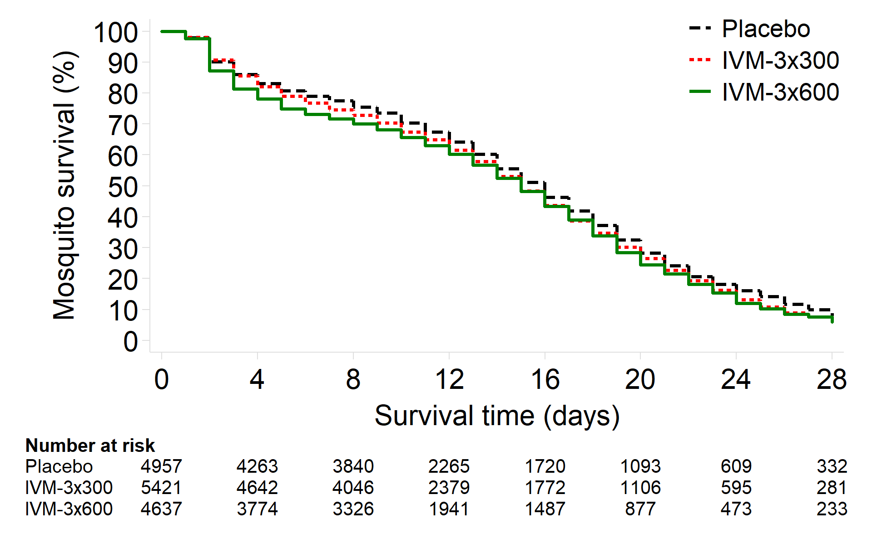 | Day 2+4h (Cmax)  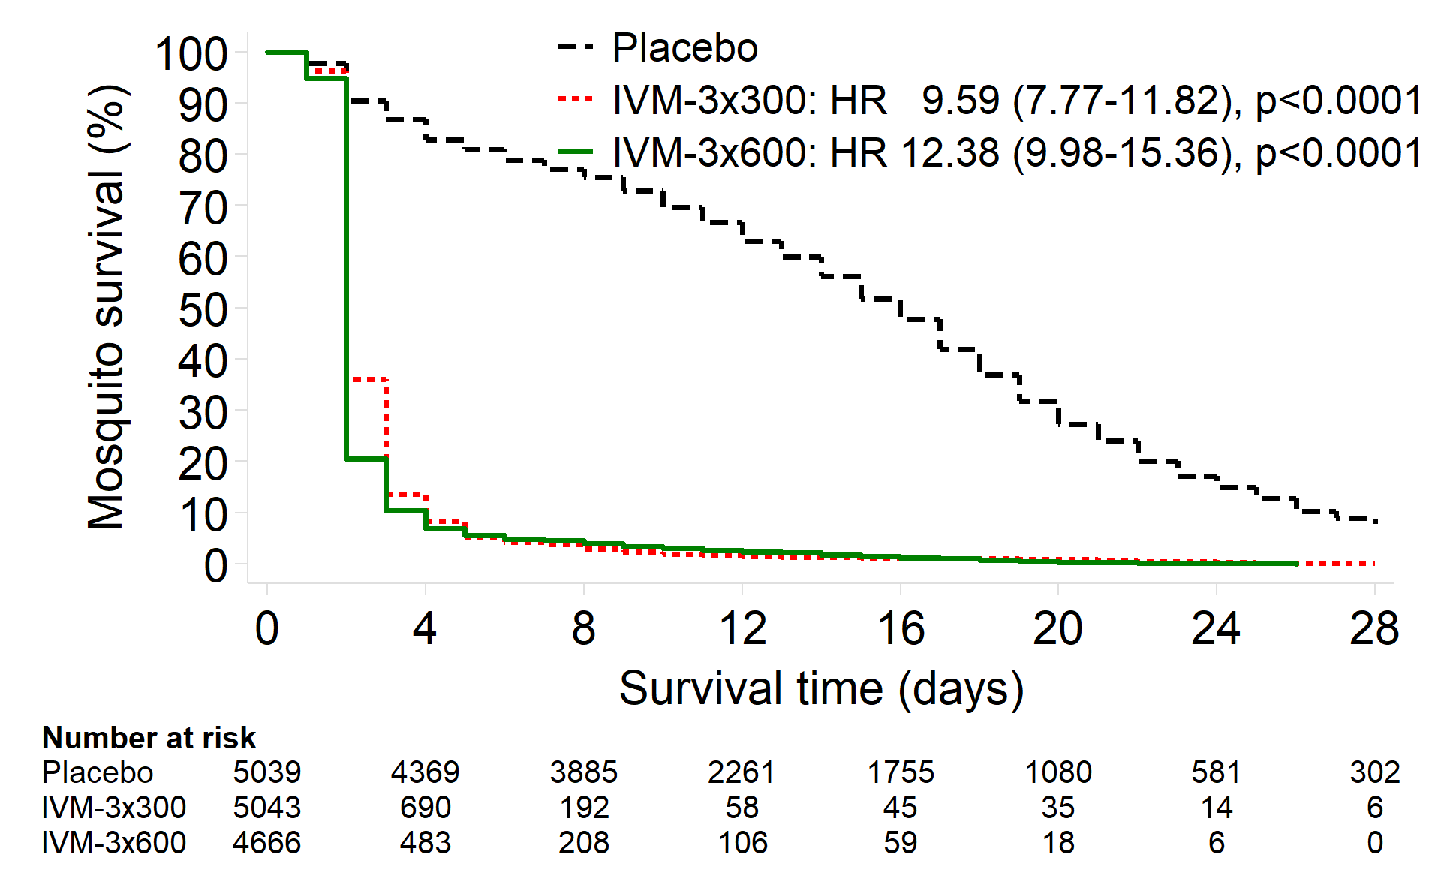
Day 7 (Primary Outcome Visit)  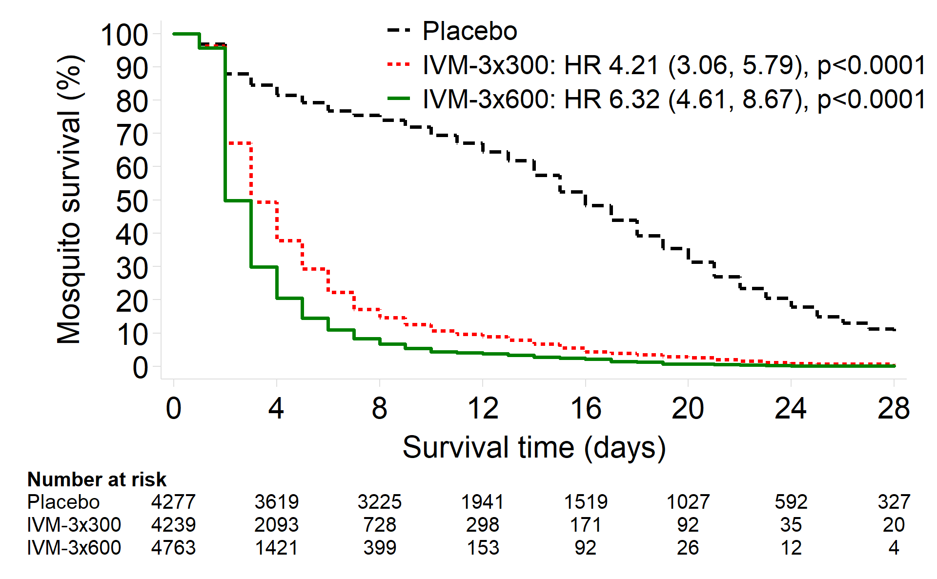 | Day 10  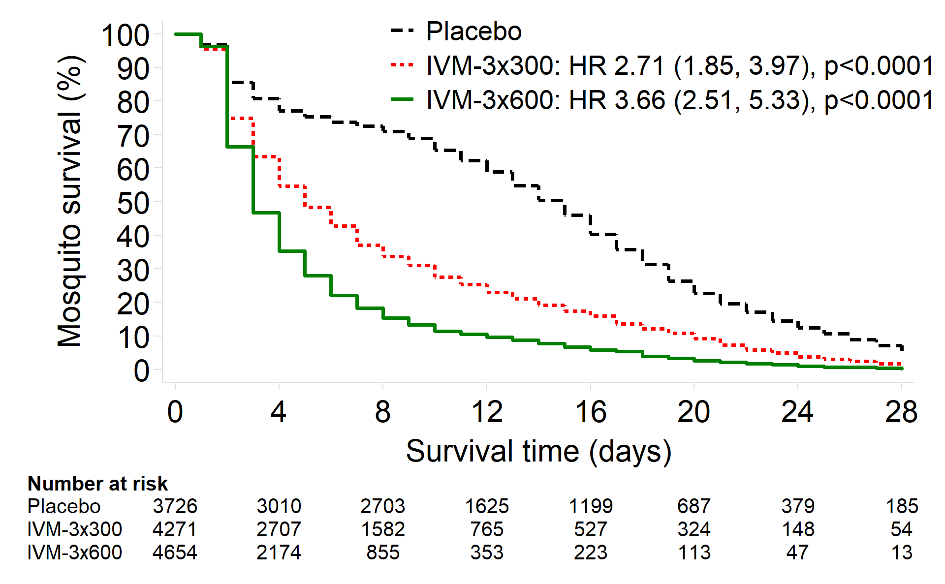
Day 14  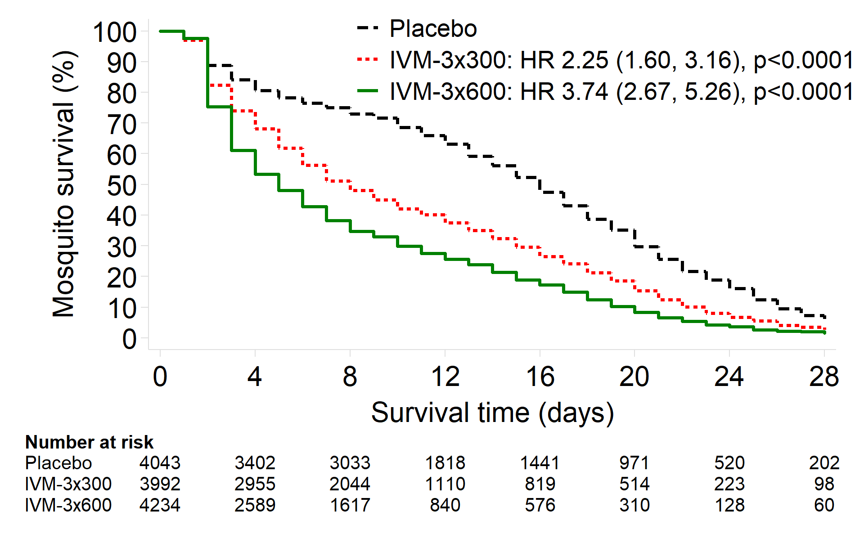 | Day 21  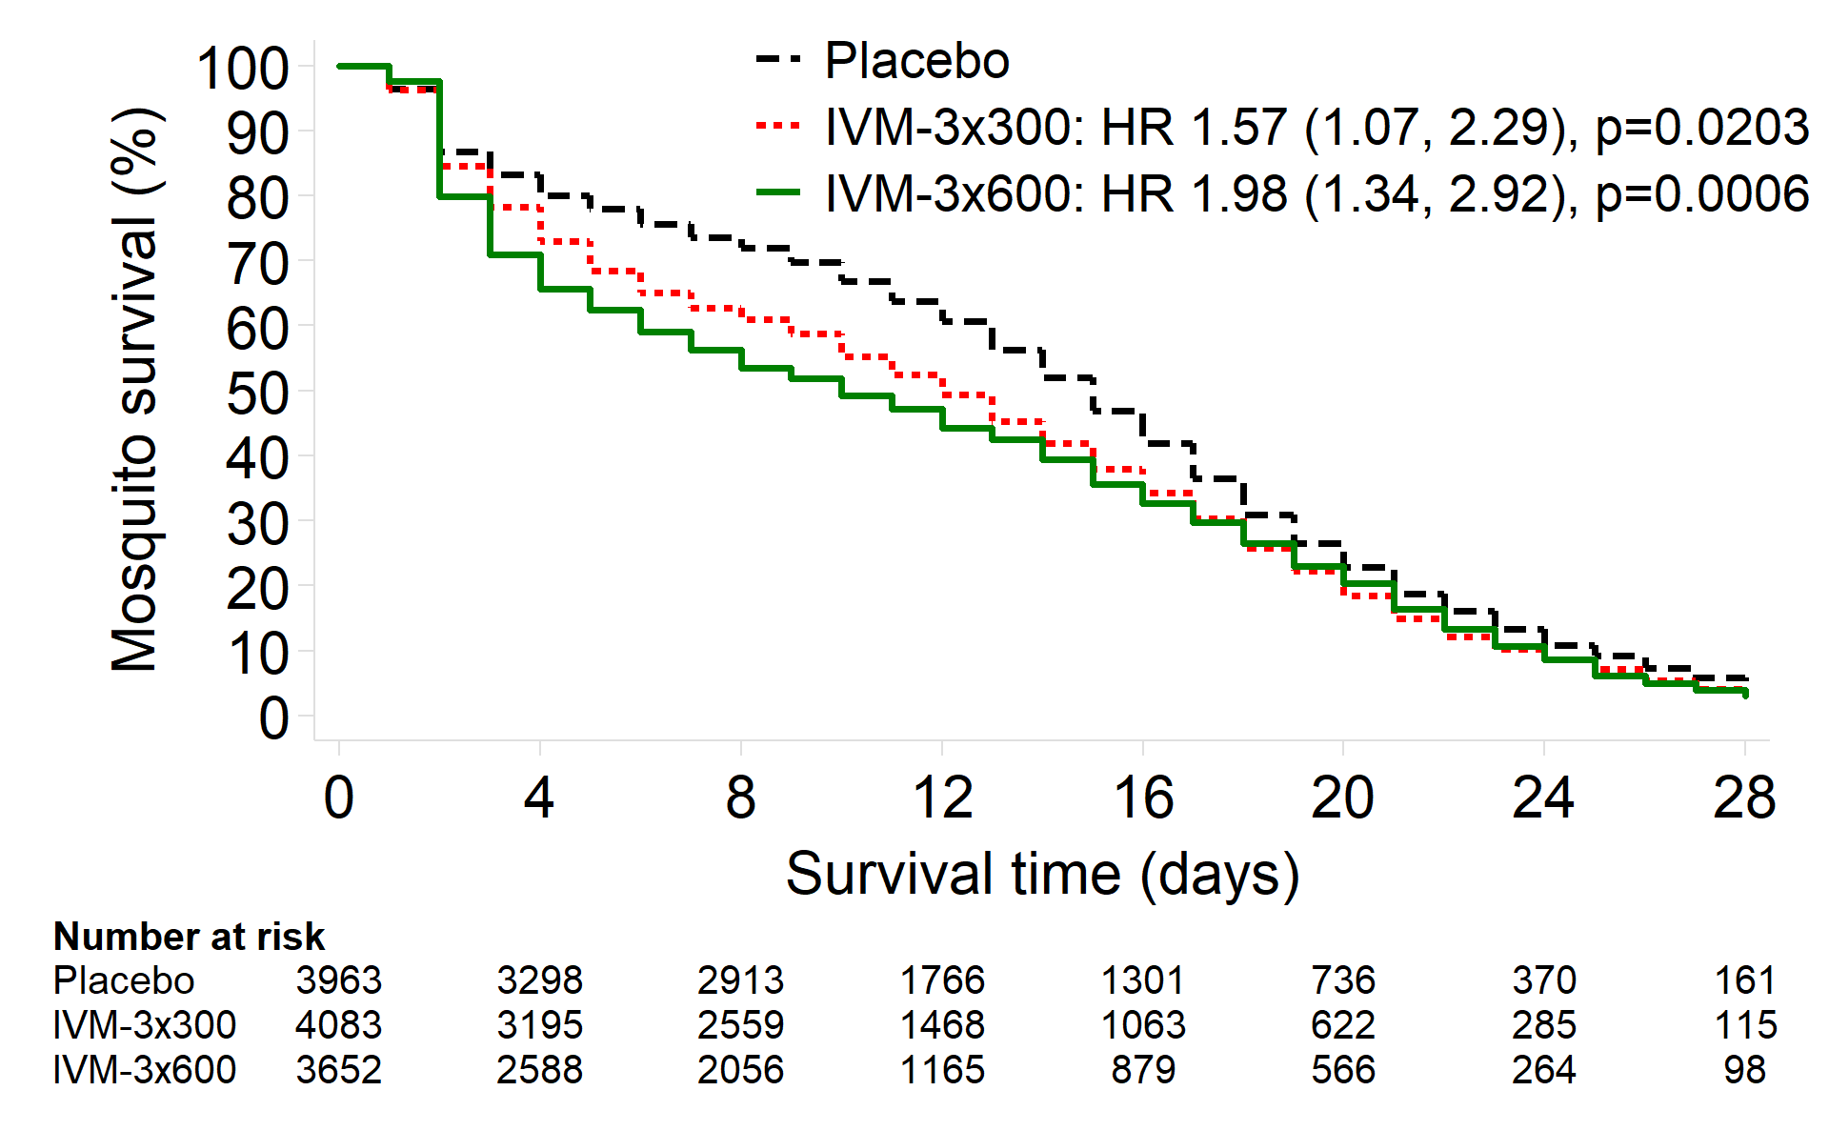
Day 28  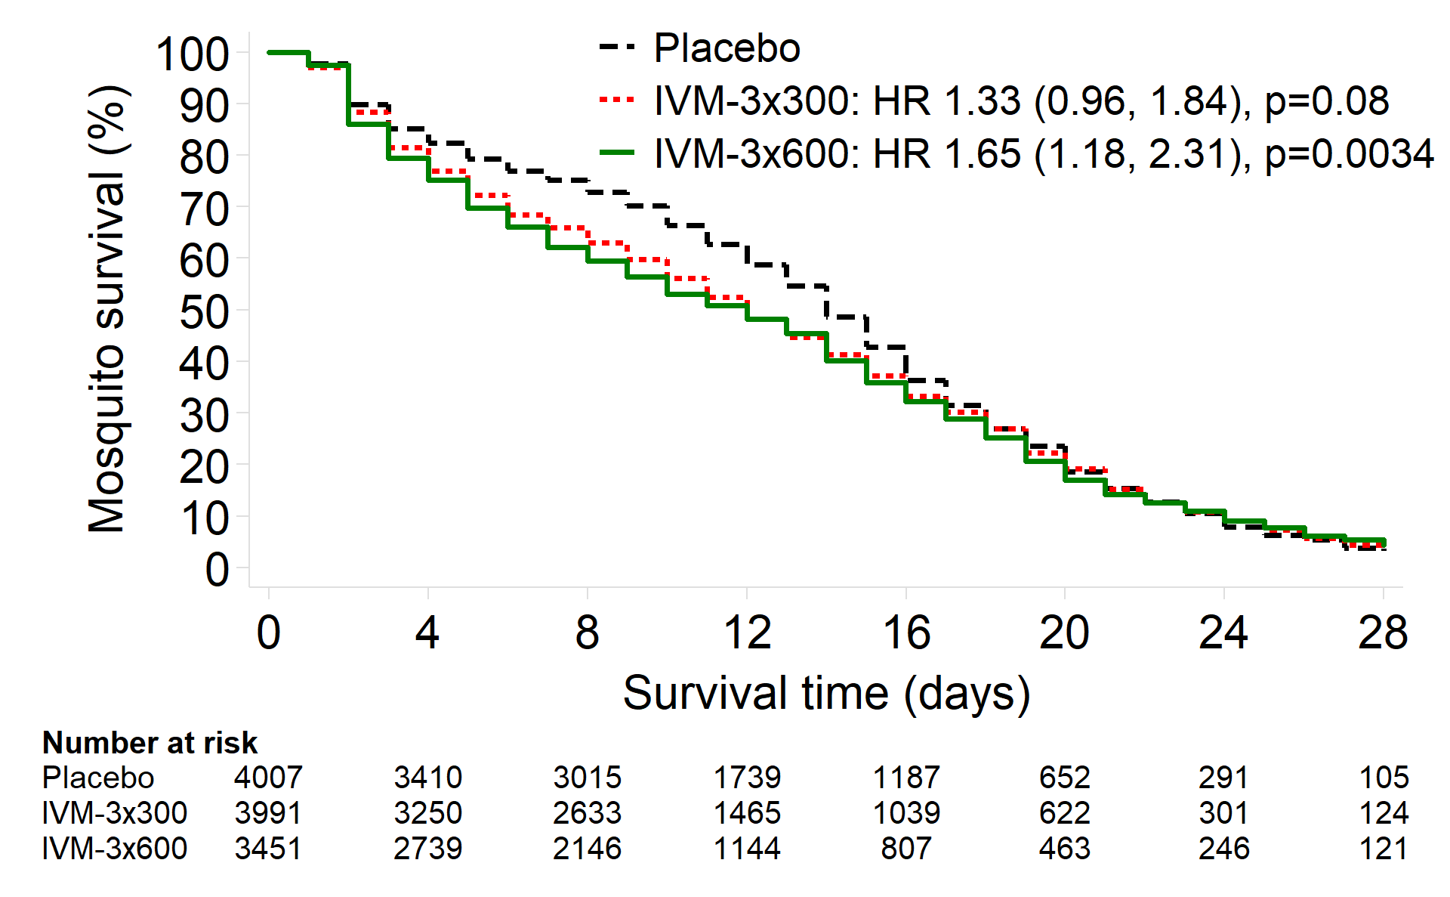 | Summary of HR’s by patient visit  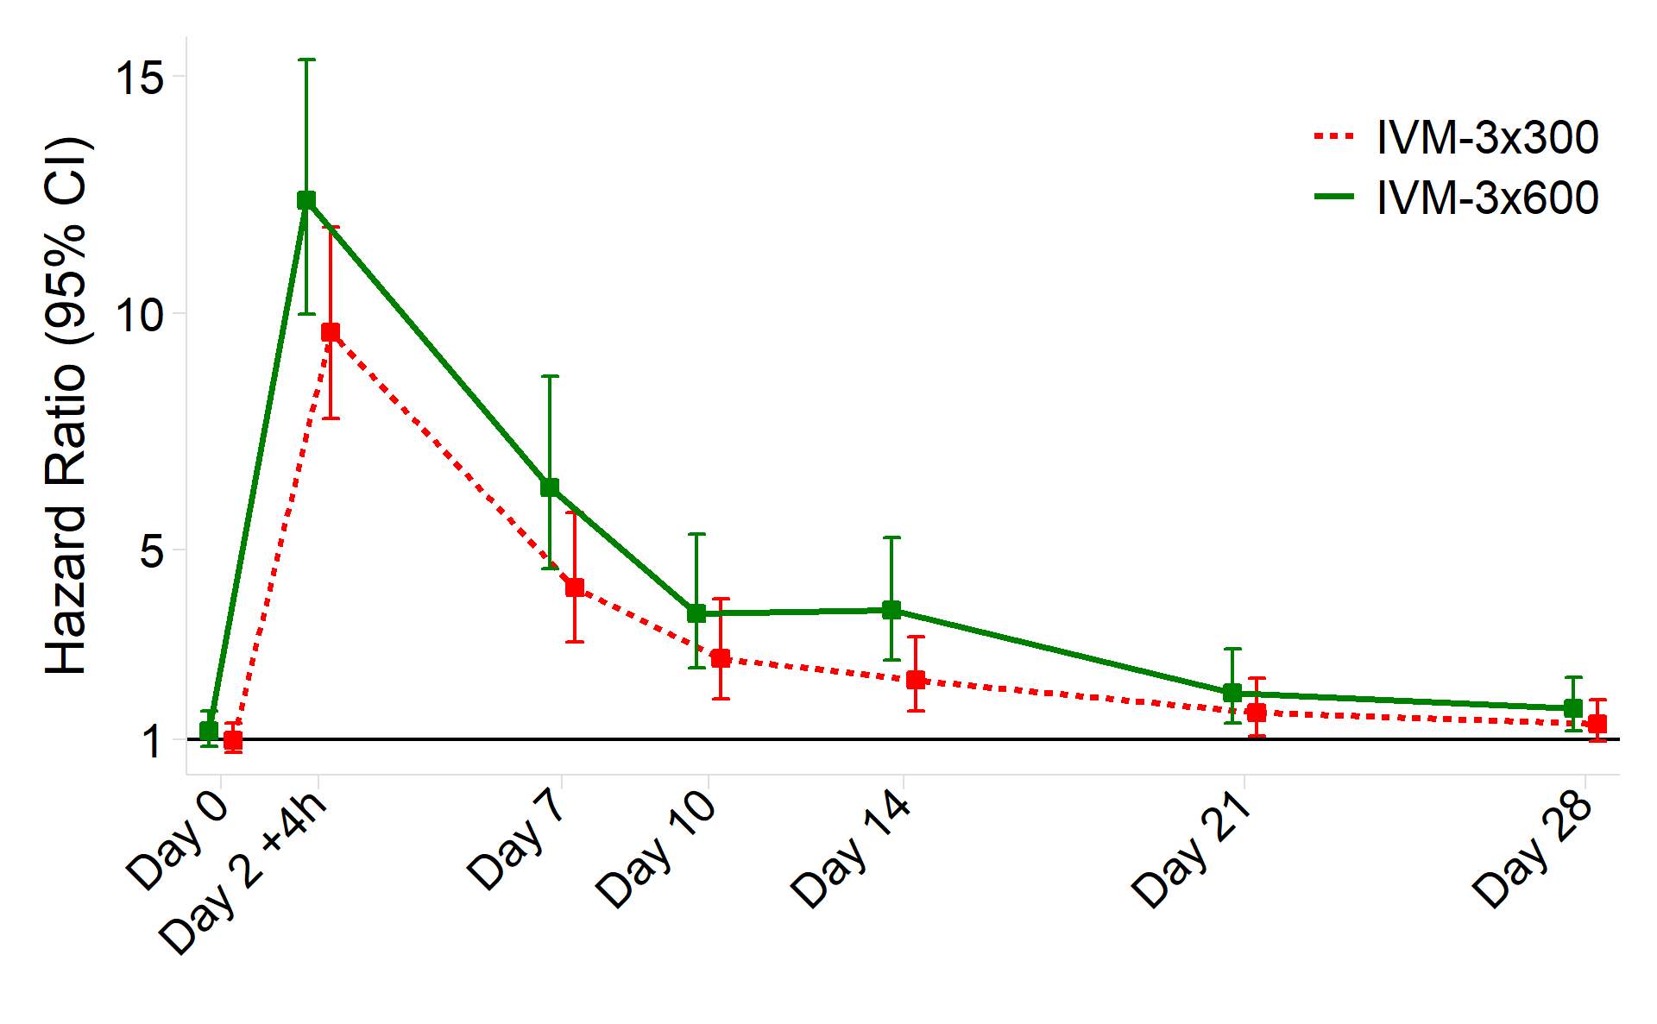
Hazard ratio (HR) and 95% confidence interval (95% CI) by study arm relative to placebo for mosquito mortality by day 14 using Cox regression adjusted for mosquito clusters. See the Supplementary Appendix for hazard ratios of: IVM-3x600 versus IVM-3x300, and adjusted and per-protocol analyses (Tables S3 and S7). IVM-3x600=ivermectin 600 mcg/kg/day for 3 days. IVM-3x300=ivermectin 300 mcg/kg/day for 3 days.

Figure 3: Median survival times of mosquitoes following feeding on patients’ blood at different time points post-treatment
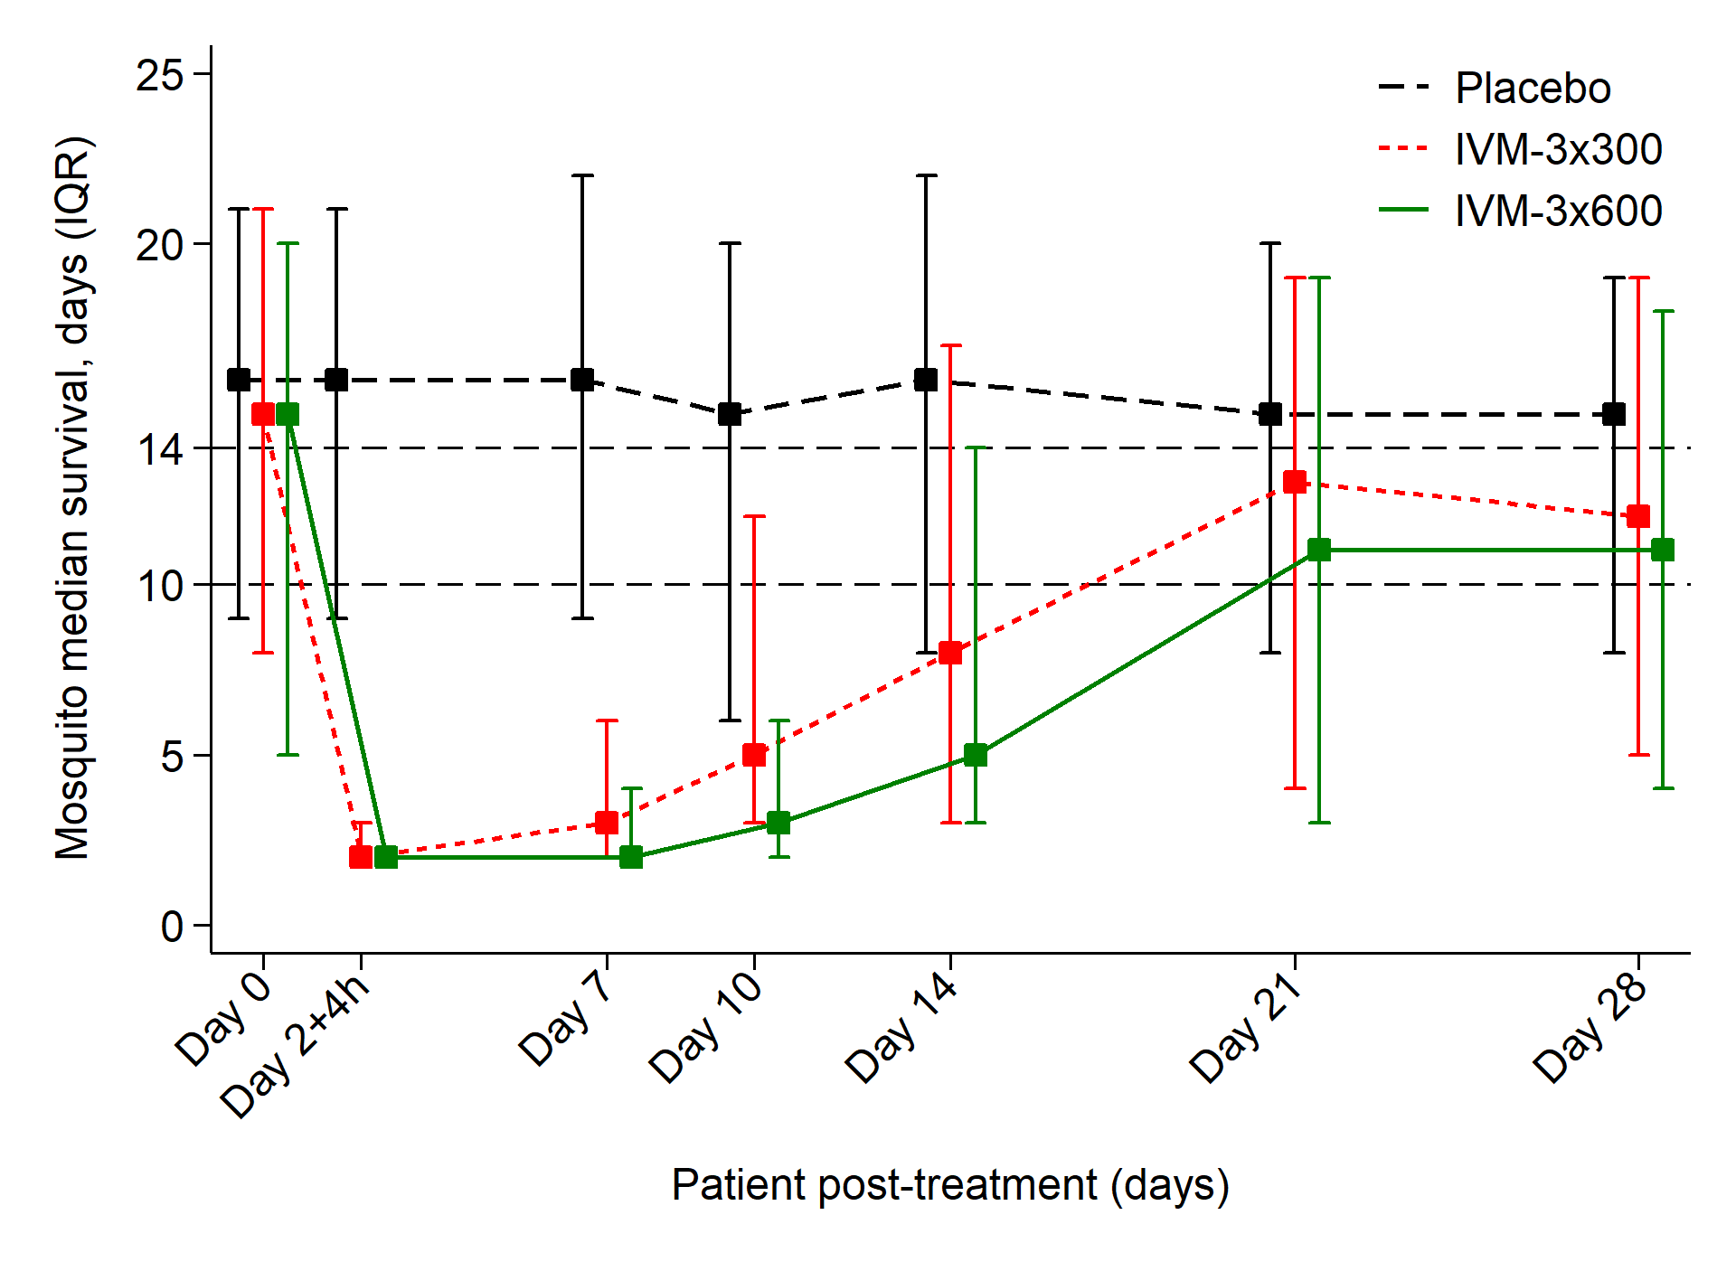
Median survival times and interquartile range of mosquitoes feeding at different days post-treatment. Dashed horizontal lines represent the longest (14 days) and shortest (10 days) duration of the extrinsic cycle of P. falciparum in Anopheles gambiae s.s. in western Kenya. IVM-3x600=ivermectin 600 mcg/kg/day for 3 days. IVM-3x300=ivermectin 300 mcg/kg/day for 3 days.

Table 2: Safety and Tolerability
Outcome | IVM-3x600  (N=47) | IVM-3x300  (N=48) | Placebo  (N=46) | Mean*†‡ or Risk# difference (95% CI), p-value
 |  |  |  | IVM-3x600 vs Placebo | IVM-3x300 vs Placebo | IVM-3x600 vs IVM-3x300
Pupil diameter (max), maximum increase from baseline during follow-up (mm) | 0.5 (0.4) (n=45) | 0.5 (0.4) (n=47) | 0.4 (0.4) (n=46) | 0.09 (-0.07, 0.25), 0.28† | 0.08 (-0.08, 0.23), 0.33† | 0.01 (-0.15, 0.18), 0.88†
QTcF interval (Day 2+4h), change from baseline (ms) | 27 (17) (n=42) | 33 (17) (n=45) | 29 (18) (n=44) | -0.8 (-8.0, 6.5), 0.84‡ | 4.7 (-2.6, 11.9), 0.21‡ | -5.4 (-12.3, 1.5), 0.13‡
QTcF interval (Day 2+4h), ≥500 ms | 0/42 (0%) | 1/45 (2.2%) | 0/44 (0%) | 0.0% (-0.4%, 3.7%), 1.00# | 2.2% (-1.4%, 5.8%), 0.23# | -2.2% (-5.9%, 1.5%), 0.24#
Piperaquine plasma concentration (Day 2+4h) (ng/mL) | 313 (208-586) (n=43) | 327 (179-545) (n=45) | 269 (169-399) (n=45) | 35.8 (-107.2, 178.7), 0.62* | 28.9 (-108.1, 165.9), 0.68* | 6.9 (-126.3, 140.0), 0.92*
AST (max), maximum increase from baseline during follow-up (iu/L) | 10 (38) (n=33) | 5 (9) (n=42) | 6 (11) (n=43) | 4.0 (-9.3, 17.4), 0.56† | -0.9 (-5.0, 3.3), 0.69† | 4.9 (-8.3, 18.1), 0.47†
with normal baseline (<45 iu/L) | 3 (6) (n=29) | 5 (9) (n=39) | 5 (10) (n=40) | -2.6 (-6.2, 1.0), 0.16† | -0.3 (-4.3, 3.8), 0.90† | -2.3 (-5.8, 1.1), 0.18†
with abnormal baseline (≥45 iu/L) | 62 (106) (n=4) | 5 (9) (n=3) | 14 (24) (n=3) | 48.3 (-49.5, 146.0), 0.33† | -8.7 (-33.9, 16.6), 0.50† | 56.9 (-38.4, 152.2), 0.24†
AST, development of elevation§ (≥45 iu/L) | 1/29 (3%) | 2/39 (5%) | 2/40 (5%) | -1.6% (-11.7%, 8.6%), 0.77# | 0.1% (-9.3%, 9.5%), 0.98# | -1.7% (-11.9%, 8.6%), 0.75#
ALT (max), maximum increase from baseline during follow-up (iu/L) | 9 (24) (n=41) | 7 (13) (n=46) | 9 (21) (n=46) | -0.4 (-9.8, 9.0), 0.94† | -2.5 (-9.6, 4.5), 0.49† | 2.1 (-6.2, 10.4), 0.62†
with normal baseline (<35 iu/L) | 6 (12) (n=34) | 5 (10) (n=42) | 8 (19) (n=43) | -2.4 (-9.4, 4.6), 0.51† | -3.3 (-9.8, 3.2), 0.32† | 0.9 (-4.2, 6.0), 0.73†
with abnormal baseline (≥35 iu/L) | 23 (53) (n=7) | 24 (28) (n=4) | 22 (38) (n=3) | 1.1 (-51.1, 53.3), 0.97† | 2.5 (-41.1, 46.1), 0.91† | -1.4 (-46.5, 43.7), 0.95†
ALT, development of elevation§ (≥35 iu/L) | 4/34 (12%) | 4/42 (10%) | 4/43 (9%) | 2.5% (-11.2%, 16.2%), 0.73# | 0.2% (-12.7%, 13.2%), 0.97# | 2.2% (-11.5%, 16.0%), 0.75#
Haemoglobin (nadir), maximum decrease from baseline during follow-up (g/dL) | -1.9 (1.0) (n=44) | -1.7 (1.0) (n=47) | -1.5 (0.7) (n=46) | -0.35 (-0.64, -0.05), 0.0202† | -0.10 (-0.39, 0.19), 0.49† | -0.24 (-0.58, 0.09), 0.15†
Haemoglobin; development of moderate anaemia§ (<9 g/dL) | 2/44 (5%) | 2/47 (4%) | 1/46 (2%) | 2.4% (-5.5%, 10.2%), 0.55# | 2.1% (-5.7%, 9.8%), 0.60# | 0.3% (-7.5%, 8.1%), 0.94#
Malaria recurrence, between day 2 to 28 | 0/44 (0%) | 0/47 (0%) | 0/46 (0%) | - | - | -
Serious Adverse Events~ (SAE) | 1/45 (2%) | 1/48 (2%) | 0/46 (0%) | 2.2% (-2.7%, 7.2%), 0.38# | 2.1% (-2.8%, 6.9%), 0.40# | 0.1% (-4.7%, 5.0%), 0.96#
Adverse Events~ (AE)
Participants with ≥1 AE | 10/45 (22%) | 4/48 (8%) | 3/46 (7%) | 15.7% (1.6%, 29.8%), 0.0289# | 1.8% (-8.8%, 2.4%), 0.74# | 13.8% (-0.6%, 28.3%), 0.06#
Participants with ≥1 AE, related | 5/45 (11%) | 2/48 (4%) | 0/46 (0%) | 11.1% (2.2%, 20.0%), 0.0143# | 4.2% (-4.6%, 12.9%), 0.35# | 6.9% (-1.9%, 15.7%), 0.12#
Transient minor visual disturbances~ | 4/45 (9%) | 2/48 (4%) | 0/46 (0%) | 8.9% (0.6%, 17.2%), 0.0360# | 4.2% (-4.0%, 12.3%), 0.32# | 4.7% (-3.5%, 12.9%), 0.26#
Data are mean (SD), median (IQR), or n/N (%), unless otherwise specified. IVM-3x600=ivermectin 600 mcg/kg/day for 3 days. IVM-3x300=ivermectin 300 mcg/kg/day for 3 days. QTcF=electrocardiogram QT interval, corrected for heart rate using Fredericia’s formula. AST=aspartate transaminase. ALT=alanine transaminase.
* Mean difference (95% CI), p-value: obtained from GLM models.
† Mean difference (95% CI), p-value: obtained from GLM models adjusted for baseline measurement.
‡ Mean difference (95% CI), p-value: obtained from GEE models adjusted for baseline measurement and repeated measures.
# Risk Difference (95% CI), p-value: obtained from GLM models.
§ Incident abnormal values in those with normal values at baseline.
~ See Supplementary Appendix for case descriptions of SAE’s and transient minor visual disturbances, and a full list of AE’s by system organ class (Tables S10-S13).

Figure 4: Population modelling of predicted impact on malaria prevalence in high and low transmission settings
High transmission (30% baseline prevalence)
Low transmission (10% baseline prevalence)
DP=dihydroartemisinin-piperaquine for 3 days. IVM-1x150=ivermectin 150 mcg/kg for 1 day. IVM-3x300=ivermectin 300 mcg/kg/day for 3 days. IVM-3x600=ivermectin 600 mcg/kg/day for 3 days.
The Imperial College malaria transmission model predicted that adding IVM-3x600 to mass drug administration with DP (4 rounds per year one month apart towards the end of the dry season for 2 years; indicated with red arrows) could result in a greater 2-year-mean reduction in all-age population prevalence of malaria (61.0% and 55.6% relative risk reduction [RRR]) in high and low transmission areas respectively). For IVM-3x300 this was 54.3% and 44.4% (Fig. S8-S11 and Tables S20-S21 in the Supplementary Appendix). In low transmission settings, DP plus IVM-3x300 or IVM-3x600 could reduce slide prevalence to <0.1% for over 6 months, meaning that elimination could occur in the absence of importation.

