Supplementary Appendix
Smit MR, Ochomo EO, Aljayyoussi G, Kwambai TK, Abong’o BO, et al. Efficacy and safety of high-dose ivermectin on mosquito mortality when co-administered with dihydroartemisinin-piperaquine in Kenyan adults with uncomplicated malaria (IVERMAL): a randomised, double-blind, placebo-controlled trial. The Lancet Infectious Diseases. 2018. Accepted 14-Feb-2018; in press.
Contents
1. Supplementary Methods 3
1.1. Pupil measurement 3
1.2. Analysis of Mosquito Mortality 3
1.3. Population Modelling 3
2. Supplementary Results 5
2.1. Mosquito Feeding 5
2.2. Intracluster Correlation Coefficient 5
2.3. Mosquitocidal Effect Post-Feeding 5
2.4. Population Modelling 5
3. Supplementary Figures 7
3.1. Efficacy 7
Figure S1: Mosquitocidal effect post-treatment, by subgroup 7
Figure S2: Mosquitocidal effect post-feeding, by post-treatment day 8
3.2. Safety 9
Figure S3: Pupil diameter 9
Figure S4: QTcF interval 10
Figure S5: Haemoglobin 11
Figure S6: Aspartate transaminase (AST) 12
Figure S7: Alanine transaminase (ALT) 13
3.3. Population Modelling 14
Figure S8: Hazard model fits 14
Figure S9: Predicted daily post-treatment hazard ratios 15
Figure S10: Predicted proportion of mosquitoes surviving until next blood meal or sporogony 16
Figure S11: Predicted impact on malaria prevalence 17
4. Supplementary Tables 18
4.1. Efficacy 18
Table S1: Mosquito feeding rates 18
Table S2: Mosquito mortality at day 14 (GEE model; intention-to-treat population) 19
Table S3: Mosquito mortality up to day 14 incl. (Cox model; intention-to-treat population) 20
Table S4: Mosquito mortality up to day 28 incl. (Cox model; intention-to-treat population) 21
Table S5: Mosquito mortality up to day 10 incl. (Cox model; intention-to-treat population) 22
Table S6: Mosquito mortality at day 14 (GEE model; per-protocol population) 23
Table S7: Mosquito mortality up to day 14 inclusive (Cox model; per-protocol population) 24
Table S8: Mosquito mortality at day 14, by sub-group 25
Table S9: Patient gametocytemia and Mosquito oocyst prevalence 27
4.2. Safety 28
Table S10: Serious Adverse Events: case descriptions 28
Table S11: Summary of all clinical adverse events, during the full 28 days of the study 29
Table S12: Summary of all clinical adverse events, during the first 7 days post-treatment 30
Table S13: Case descriptions of transient minor visual disturbances 31
Table S14: Case descriptions of liver function test abnormalities (grade ≥3) 33
Table S15: Pupil diameter, mean and change from baseline (mm) 34
Table S16: QTcF interval, mean and change from baseline (ms) 35
Table S17: Haemoglobin, mean and change from baseline (g/dL) 36
Table S18: Aspartate transaminase (AST), mean and change from baseline (iu/L) 37
Table S19: Alanine transaminase (ALT), mean and change from baseline (iu/L) 38
4.3. Population Modelling 39
Table S20: Population model covariates 39
Table S21: Predicted impact on malaria prevalence 40
5. Supplementary References 41

Supplementary Methods

Pupil measurement
Patients’ pupil diameters were measured in triplicate at each time point using an automatic pupillometer (NeurOptics VIP 200®). The handheld device was held up to the patients’ eye. The internal video camera automatically locks onto the pupil circumference. A total of 150 measurements were made, at a rate of 30 measurements/second, for 5 seconds. Results were displayed in an onscreen graph as pupil diameter over time and summarized as pupil diameter mean and standard deviation (SD). Clinicians were instructed to repeat the measurement if the SD was ≥0.08 mm to ensure each measurement reflected a constant value, to prevent undesirable variability due to for example the patient blinking. The first three measurements with SDs <0.08 mm were recorded. Focal length was kept constant at each visit by requesting participants to sit in the same location and focus on a Snellen chart on the opposing wall. A darkroom lit with 3 fluorescent tubes kept luminance constant at 23 candela/m² (as measured using a Canon D550 with aperture f=3.5, exposure time 1/30 sec, and ISO 200).¹

Analysis of Mosquito Mortality
Mosquito mortality was analysed at 3 different time points (day 10, 14, and 28) based on the longest (14 days) and shortest (10 days) duration of the extrinsic cycle of P. falciparum in Anopheles gambiae s.s. in western Kenya² and the total duration of mosquito follow-up (28 days) (see Tables S2-S8). Two different models were used per post-feeding time point: A Generalized Estimating Equations (GEE) model using log-binomial distribution (or in case of non-convergence a Gaussian distribution), comparing the cumulative risk of mosquito mortality (e.g. by Day 14 post-feeding) with results expressed as risk ratios (RR), and a Cox proportional hazards (Cox) model, adjusted for mosquito clusters (using gamma distribution for frailty) with results expressed as hazard ratios (HR). The GEE model (cumulative mortality) compared the proportion of mosquitoes that survived long enough to become infective to humans by completing a full sporogonic cycle, while the Cox model assessed the time-to-death, which impacts mosquitos’ ability to live long enough to lay eggs, re-feed, and complete a sporogonic cycle from a previous bloodmeal. A separate model was used for each post-treatment day sampled. Multi-variable models adjusted for pre-specified covariates included sex, BMI, mosquito age (at feeding), and mosquito crowding (the number of mosquitoes that fed fully and were kept for survival monitoring per cage of the 50 mosquitoes offered a blood meal).³

Population Modelling
A Cox proportional hazards model was simultaneously fitted to data from all post-treatment days censored at post-feeding day 14 to allow for prediction of hazard ratios for post-treatment days on which mosquito feeding did not take place. Hazard ratios and corresponding confidence intervals were adjusted to take the cluster design into consideration (mosquito clusters). These daily hazard ratios were then used to parameterize ivermectin-induced mosquito mortality in an existing model describing the impact of ivermectin on malaria transmission dynamics,⁴ that in turn is based on the Imperial College malaria transmission model.⁵ Previously a PK model was used to inform the vector component,⁴ however in this study by relating the time post-treatment with the mosquito mortality rate, the pharmacodynamic impact of ivermectin over time could be directly inferred, circumventing some of the uncertainties and extrapolation involved with the PK model. For the purpose of the model, similar mosquitocidal efficacy was presumed in children, as no studies were identified that assessed the pharmacokinetics of ivermectin in children. Secondary effects of ivermectin, such as the impact on fecundity, or the ability of affected but surviving mosquitoes to fly, feed and/or transmit malaria, were not included based on previous modelling work indicating that these effects are minor in comparison to the primary mosquitocidal effect (Supplementary Material 3 in Slater 2014).⁴ Only Anopheles gambiae, the primary malaria vector in Africa, were included in the model. Mosquitoes are assumed to be highly anthropophilic (92% of bloodmeals are taken from humans).
The transmission model was then used to estimate the potential impact of adding ivermectin 300 or 600 mcg/kg/day for 3 days (IVM-3x300 or IVM-3x600, respectively) to mass drug administration (MDA) with dihydroartemisinin-piperaquine (DP) in an area based on malaria transmission data from western Kenya with intense perennial transmission, a double-peaked transmission season and an all-age malaria prevalence by microscopy of 30%. Initially we assumed four rounds of MDA per year spaced one month apart for two years. Coverage of DP was set at 80% of the all-age population and coverage of ivermectin at 80% of the population over the age of 4 years. We assumed high correlation of treatment coverage between rounds with 90% of those receiving drugs treated every round and the remaining 10% randomly distributed amongst the remaining population. The impacts of “DP + IVM-3x600” and “DP + IVM-3x300” are compared to: (1) no intervention, (2) DP alone and (3) DP + a single low dose of ivermectin 150 mcg/kg (IVM-1x150).
We assumed that a mosquito biting an ivermectin treated individual will experience a post-treatment day dependent increased mortality rate for the duration of its lifespan based on the relationship derived using the Cox proportional hazards model. The model also assumed that only mosquitoes feeding on individuals that have taken ivermectin in the previous 28 days experience increased mortality, while mortality was assumed constant for all other mosquitoes.
We also considered the impact of this intervention in an area with low prevalence (10% malaria prevalence by microscopy) and for fewer monthly rounds (2 and 3 rounds/year).

Supplementary Results

Mosquito Feeding
A median of 6 mosquito feeds per patient were conducted, totalling 850 feeds. Of 127,683 mosquitoes offered patients’ blood, 91,109 (71.4%) fed fully and were included in the analysis, giving 853,501 observed mosquito days. Per feed, of the 150 mosquitoes offered feeding, the median number of fully fed mosquitoes was 110 (IQR: 84-137). The median age of mosquitoes at feeding was 3 days (IQR: 3-4). The proportion of fully fed mosquitoes was similar across all treatment arms, suggesting that treatment group did not affect feeding rates (see Table S1).

Intracluster Correlation Coefficient
Intracluster correlation coefficients (ICC or ρ) were determined using the mean estimated within-group correlations method, with an exchangeable correlation structure. The ICC of mosquito mortality in all three arms pooled was 0.165 in the primary outcome GEE model that assessed mortality at day-14 post-feeding among mosquitoes that fed on blood taken 7 days post-treatment, and included treatment as a fixed effect and the subject as the cluster effect (median cluster size: 76 fully fed mosquitoes [IQR: 48-88]). The ICC in the natural, untreated population (mosquitoes fed at baseline visit for all arms, plus mosquitoes fed at follow-up visits for the placebo arm) was 0.065 in a GEE model that assessed mortality by day-14 post-feeding, and did not include treatment as a fixed effect, but did include the subject as the cluster effect (median cluster size: 90 fully fed mosquitoes [IQR: 67-376]).

Mosquitocidal Effect Post-Feeding
The daily HR for mosquito mortality initially increased in the days post-feeding, peaking around days 3-5 post-feeding (for mosquitoes fed day 2+4h post-treatment) and days 7-8 post-feeding (for mosquitoes fed 7-28 days post-treatment). The duration of the mosquitocidal effect (defined as the lower 95% CI of the HR exceeding 1) varied by post-treatment day and treatment arm. For IVM-3x600, among mosquitoes fed on samples taken on days 2+4h, 7, 10, 14, 21 and 28 the duration of increased mosquito mortality (defined as the lower 95% CI of the HR exceeding 1) was approximately 28, 25, 16, 26, 9, and 9 days respectively (Fig. S2). For IVM-3x300, the durations were 12, 17, 16, 11, 7, and 7 days respectively.

Population Modelling
The Cox proportional hazards model is presented in Table S20. An interaction term between dose and a second order polynomial function of day post-treatment were used to capture the waning mosquitocidal effect of ivermectin post-treatment. Additionally, the model was adjusted for sex, BMI, mosquito crowding and mosquito age and a subject level cluster effect, consistent with the other analyses in this study. Figure S8 shows the predicted survival curves (dashed lines) compared to the Kaplan-Meier survival curves constructed from the raw data (solid lines) for each sampled day post-treatment. This Cox proportional hazards model is then used to estimate the daily hazard for the unsampled days post-treatment. Results are presented in Figure S9.
At the predicted Cmax (Day 2+4h), the predicted hazard ratio versus placebo is 12.9 for IVM-3x600 and 10.5 for IVM-3x300. The HR predictions before this time are likely to be overestimates, as while the model predicts HR’s larger than at the predicted Cmax, plasma concentrations are still increasing post-treatment. This however will have only a very marginal impact as it is only a small proportion of the total duration of effect.
Translation of this estimated daily hazard of mortality to the population-level impact on malaria transmission is shown in Figure 3 (Main Text), Table S21 and Figure S11 (Supplementary Appendix). We predict that in high transmission areas, 4 rounds per year for 2 years of MDA with DP alone would reduce the mean all-age population prevalence by 65.0% from 30% at baseline to 10.5%. Adding IVM-3x300 would result in an 81.3% reduction from 30% to 5.6% (i.e. adding IVM-3x300 to DP is predicted to result in a 46.7% greater reduction in malaria prevalence (relative risk reduction [RRR]) compared to DP alone (prevalence ratio [PR] 0.553), whereas IVM-3x600 results in an 84.3% reduction to 4.7% (PR compared to DP alone 0.448; RRR 55.2%). Similar RRR values were predicted for low transmission areas with a baseline prevalence of 10%: 44.4% with IVM-3x300 and 55.6% with IVM-3x600.

Supplementary Figures

Efficacy

Figure S1: Mosquitocidal effect post-treatment, by subgroup
 | 2-way interaction | 3-way interaction
IVM-3x600 vs Placebo | 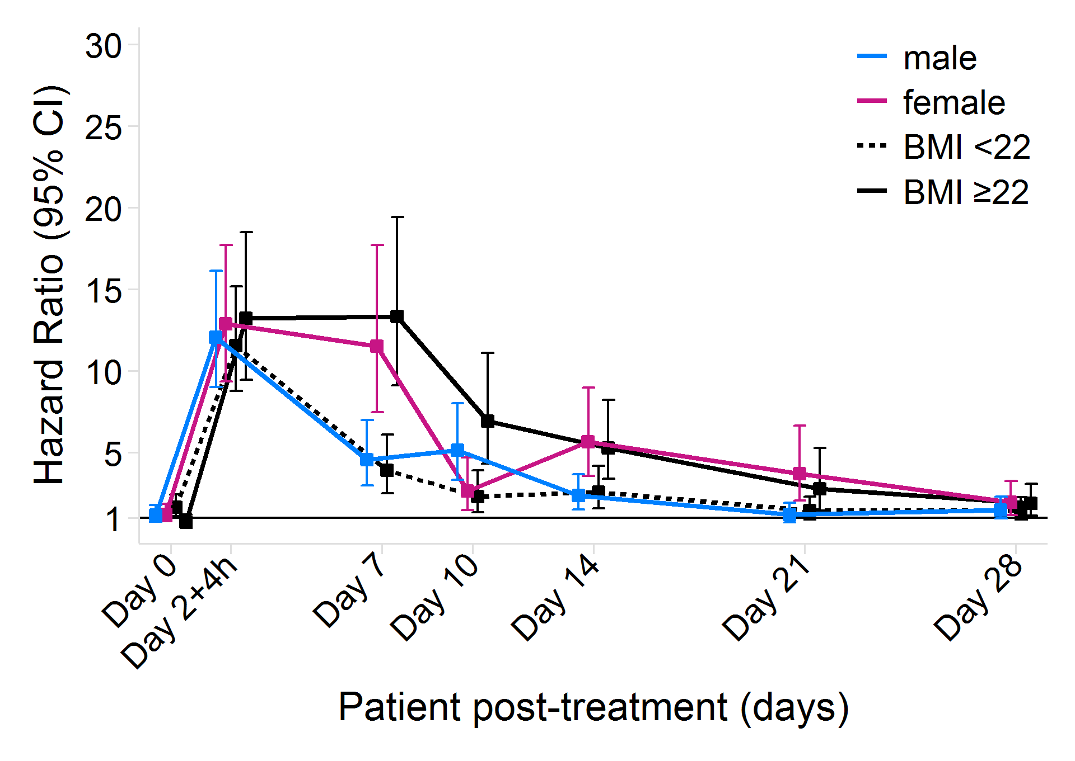  Interaction on Day 7: sex (p=0.0078), BMI (p=0.0007) | 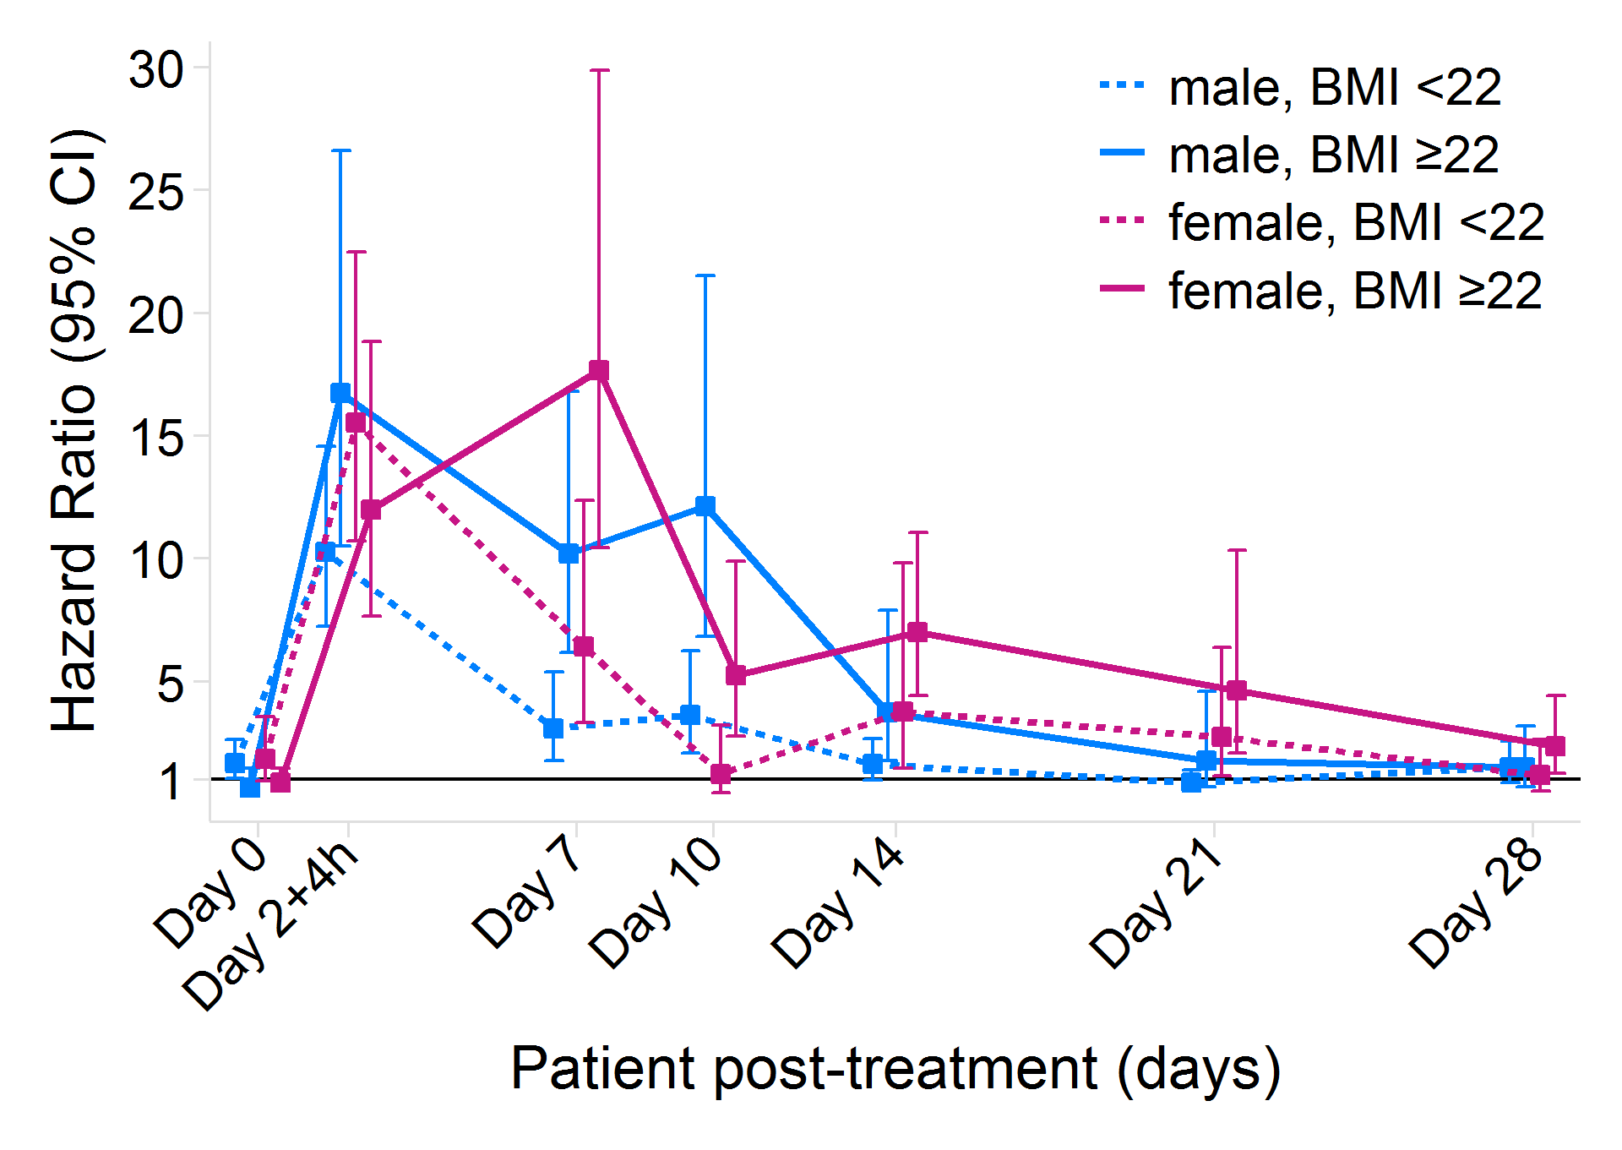  Interaction on Day 7: sex*BMI (p=0.47)
IVM-3x300 vs Placebo | 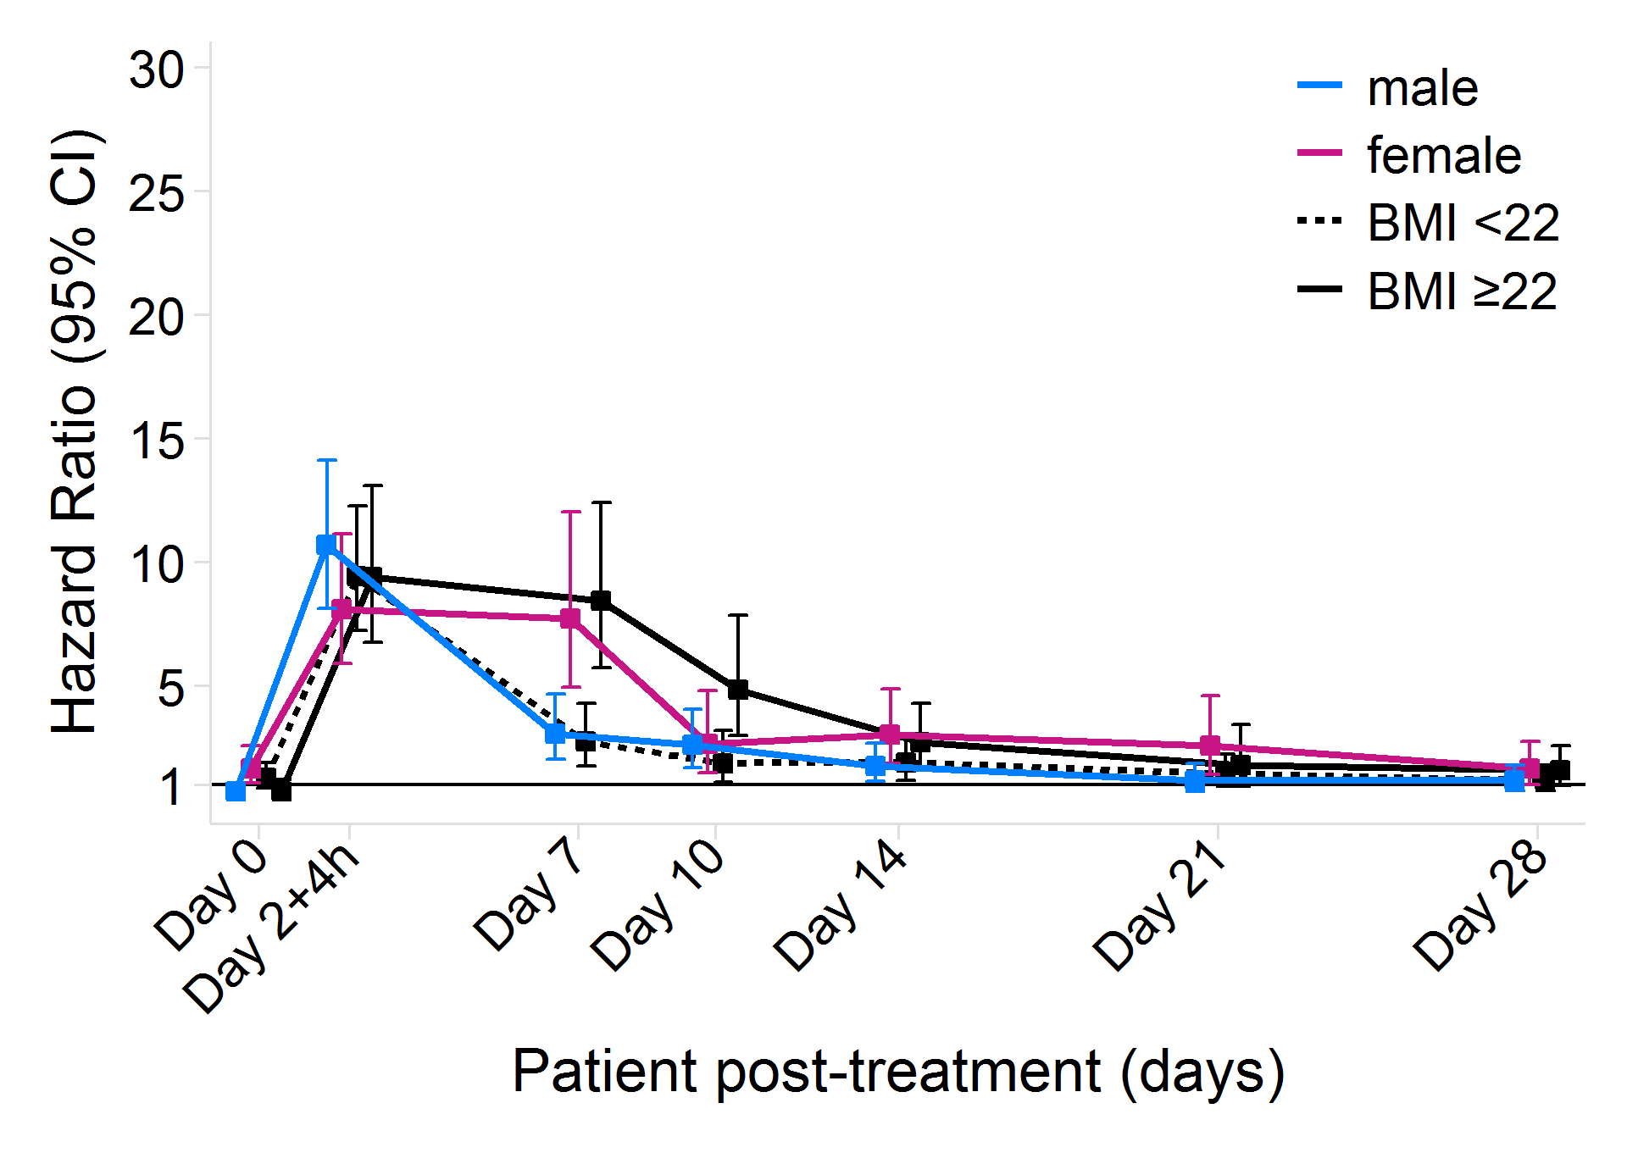  Interaction on Day 7: sex (p=0.0087), BMI (p=0.0019) | 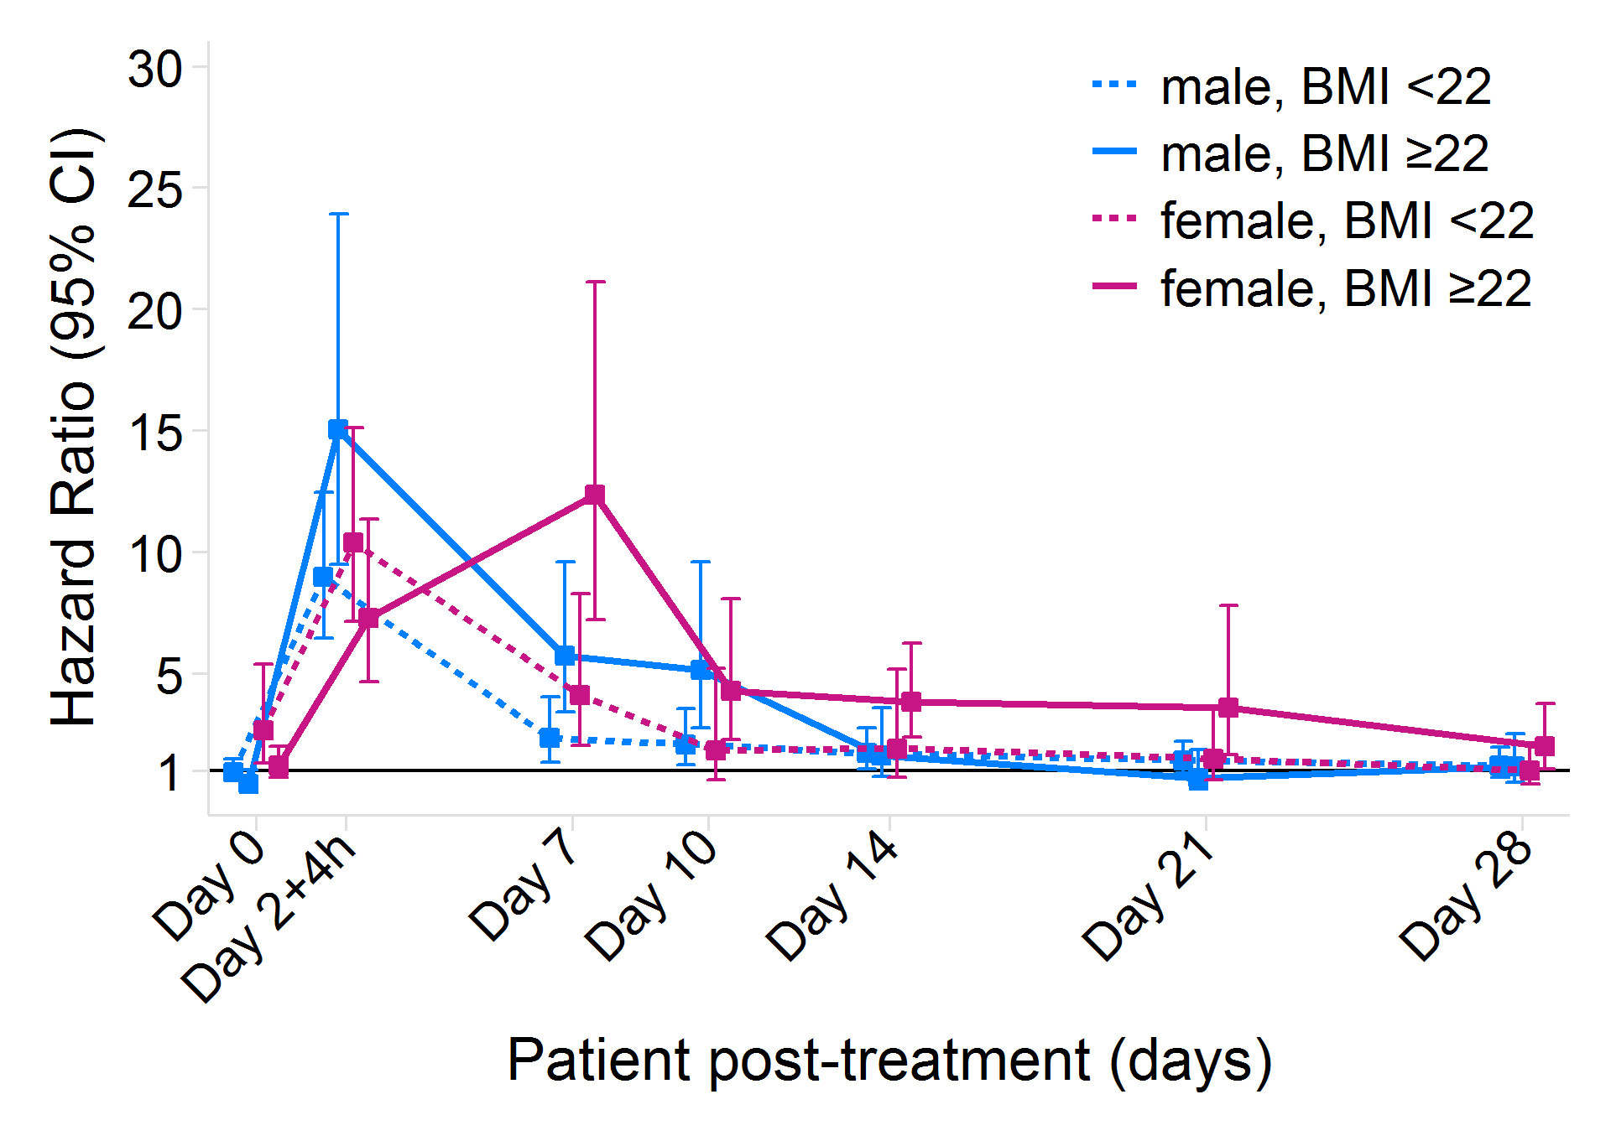  Interaction on Day 7: sex*BMI (p=1.00)
IVM-3x600 vs IVM-3x300 | 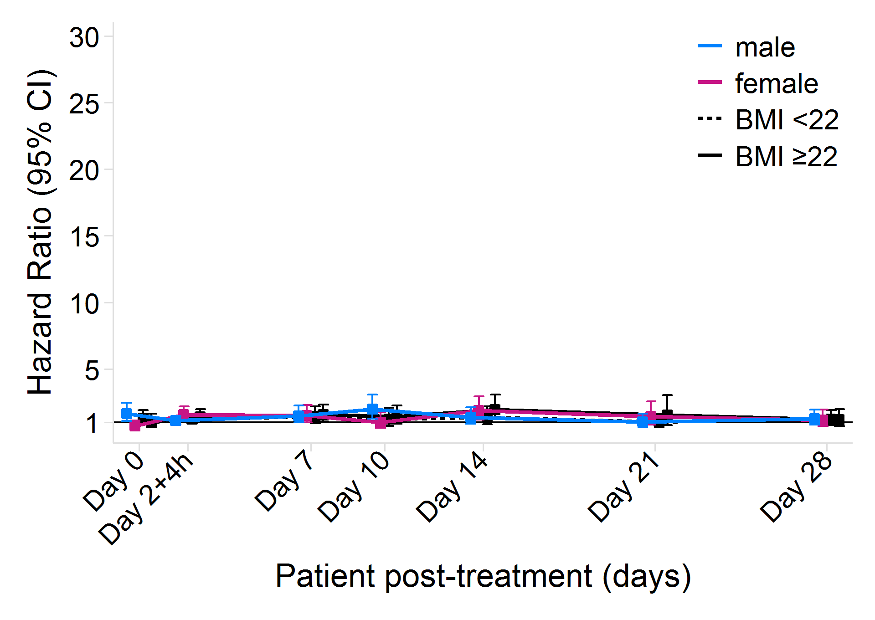  Interaction on Day 7: sex (p=1.00), BMI (p=0.75) | 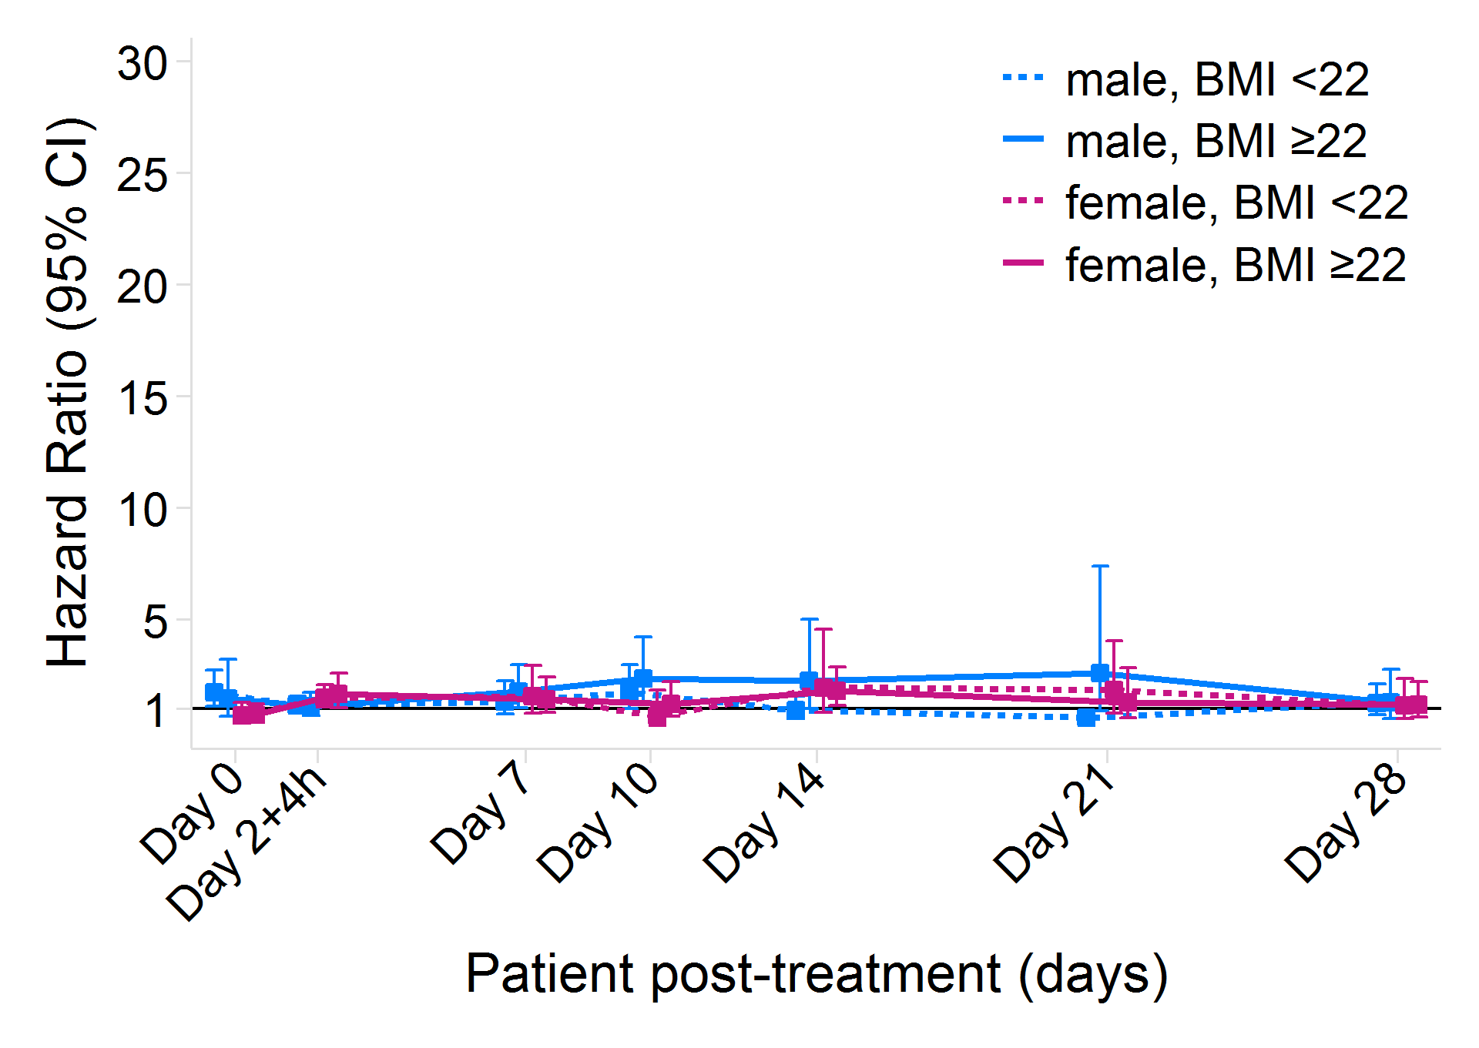  Interaction on Day 7: sex*BMI (p=0.26)
 | Hazard ratios (95% CI) by subgroup for mosquito mortality by day 14 post-feeding, using Cox regression adjusted for mosquito clusters. The p-values from the interaction terms on day 7 post-treatment are presented as evidence of treatment heterogeneity. See also: Table S8 in the Supplementary Appendix. IVM-3x600=ivermectin 600 mcg/kg/day for 3 days. IVM-3x300=ivermectin 300 mcg/kg/day for 3 days.

Figure S2: Mosquitocidal effect post-feeding, by post-treatment day
Baseline  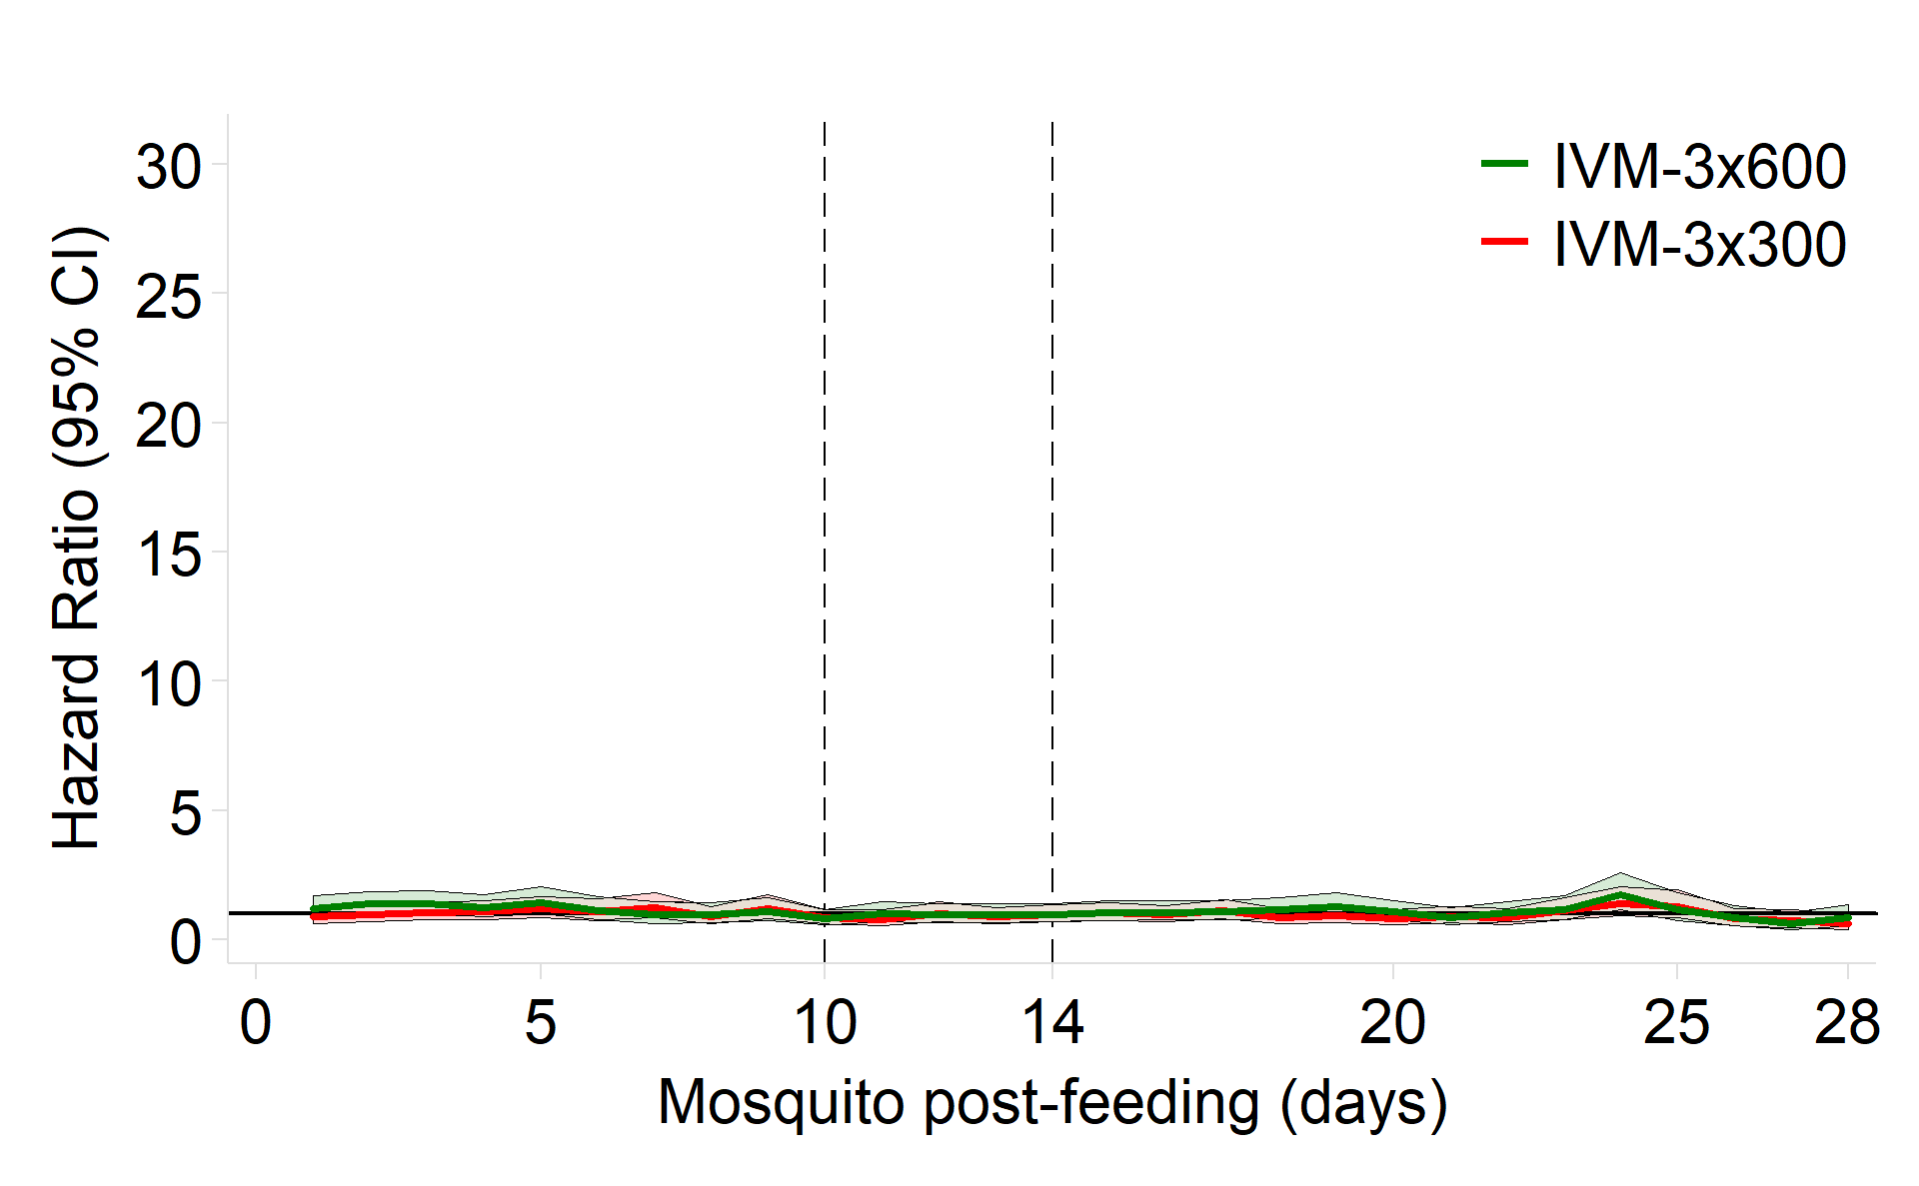 | Day 2+4h*  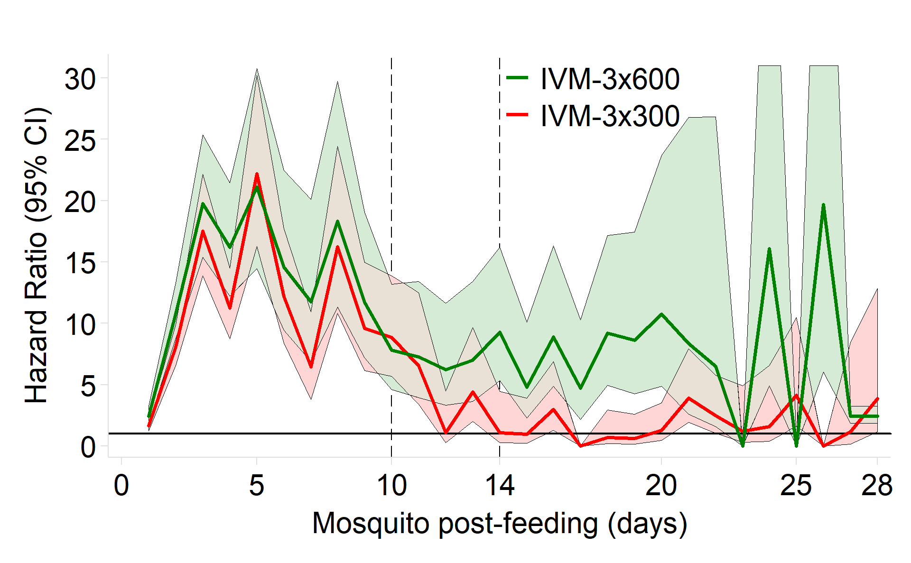
Day 7  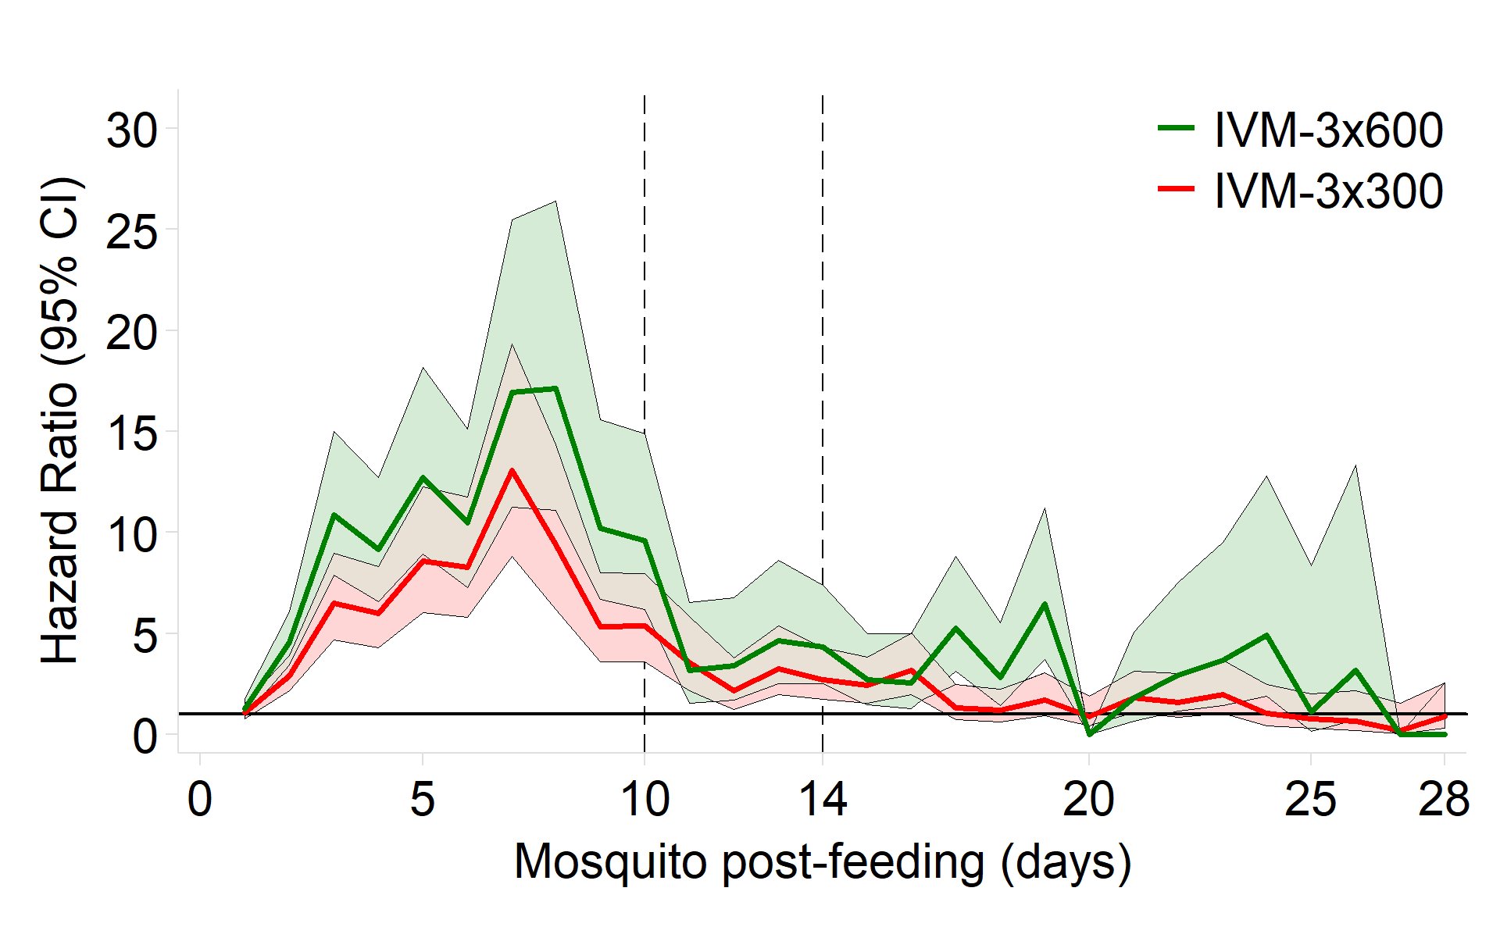 | Day 10  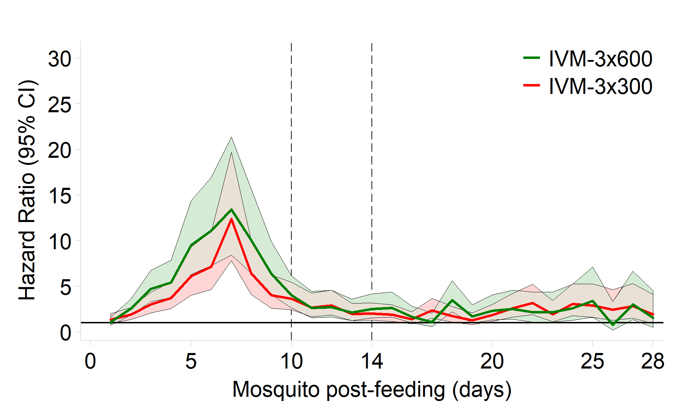
Day 14  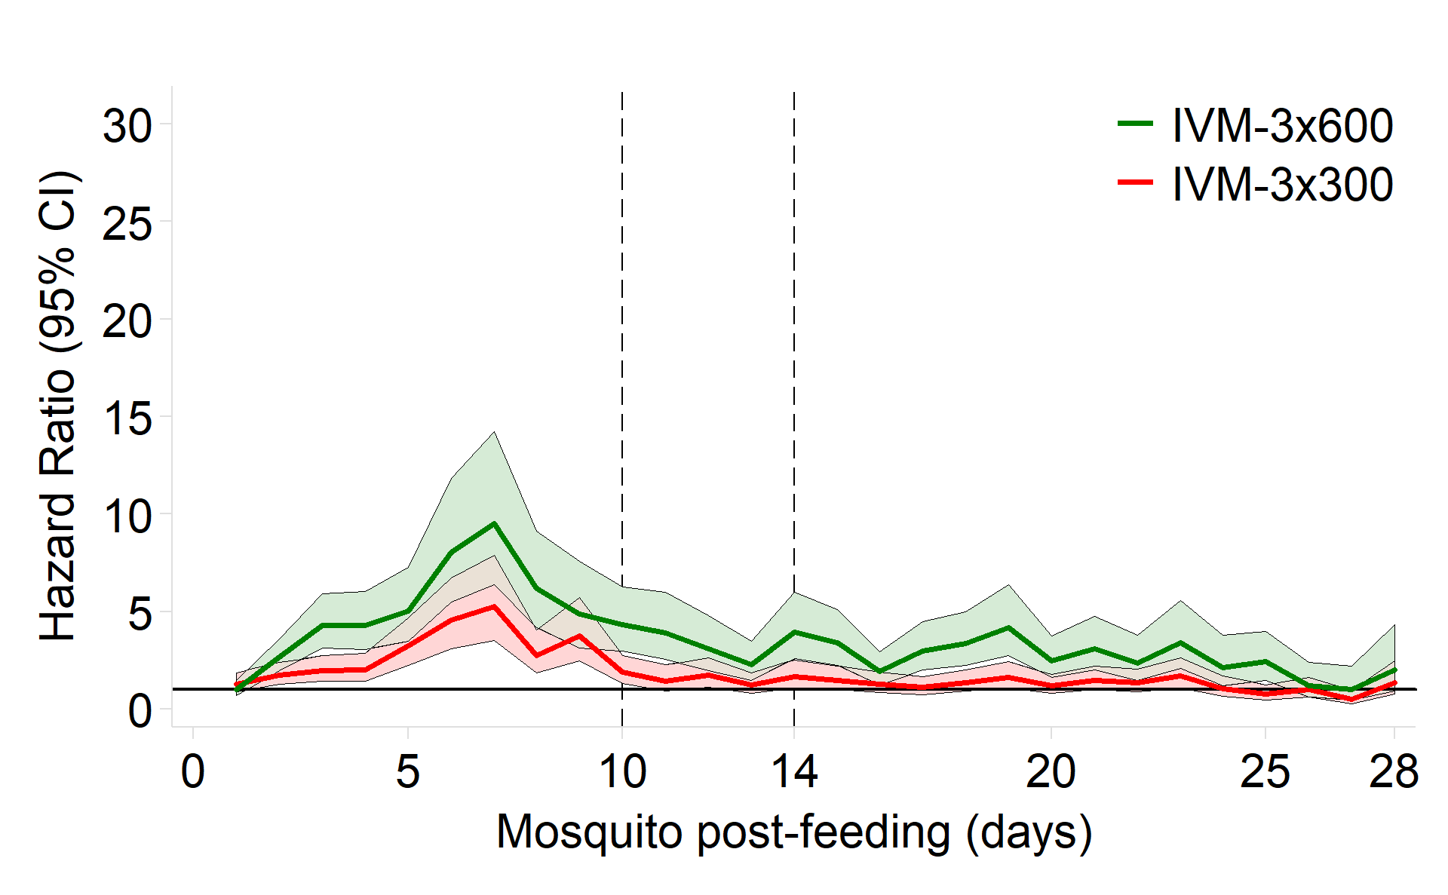 | Day 21  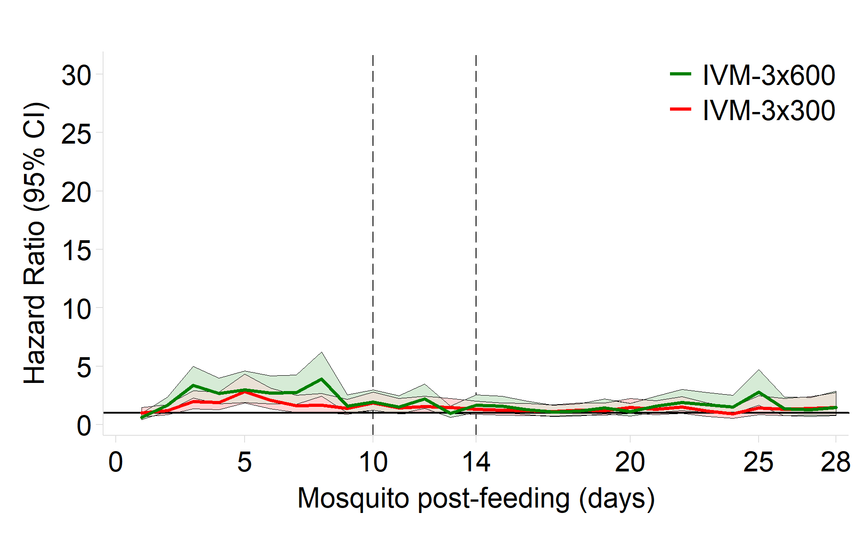
Day 28
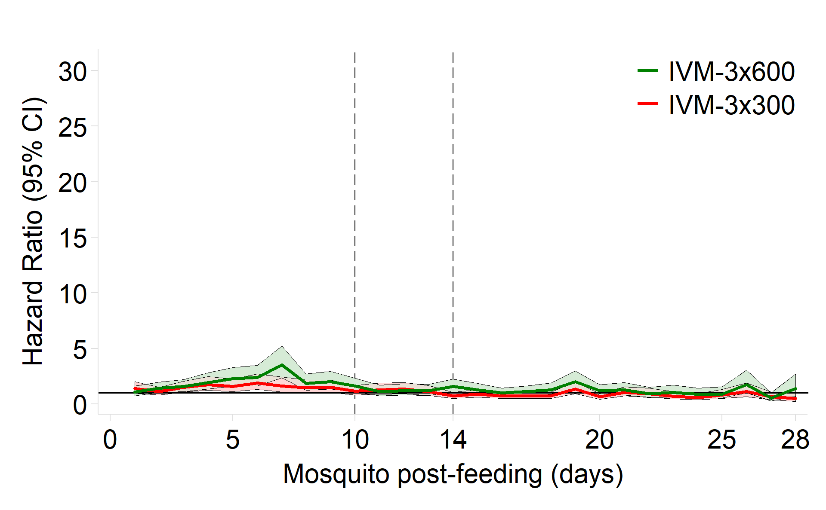
Daily hazard ratios for mosquito mortality post-feeding among mosquitoes fed on blood taken at different days post-treatment with IVM-3x600 or IVM-3x300, relative to placebo. A piecewise exponential model⁶ was used for the analysis of each post-treatment visit. All models included treatment, post-feeding-day, and treatment-by-post-feeding-day interaction as fixed, categorical effects, and subject as the cluster variable. Estimates displayed as zero were not obtained due to sparse data. IVM-3x600=ivermectin 600 mcg/kg/day for 3 days. IVM-3x300=ivermectin 300 mcg/kg/day for 3 days. *For illustrative purposes, on the Day 2+4h IVM-3x600 curve, the upper 95% CI’s on post-feeding days 24 and 26, which are 52.6 and 64.2 respectively, are capped at 31.0.

Safety

Figure S3: Pupil diameter
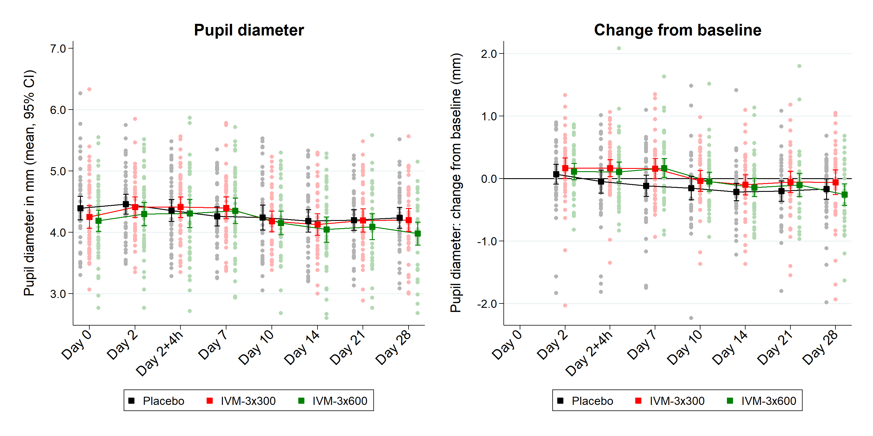
Each patient’s pupil diameter was calculated as the mean of triplicate measurements taken at the same timepoint. See Table S15. IVM-3x600=ivermectin 600 mcg/kg/day for 3 days. IVM-3x300=ivermectin 300 mcg/kg/day for 3 days.

Figure S4: QTcF interval
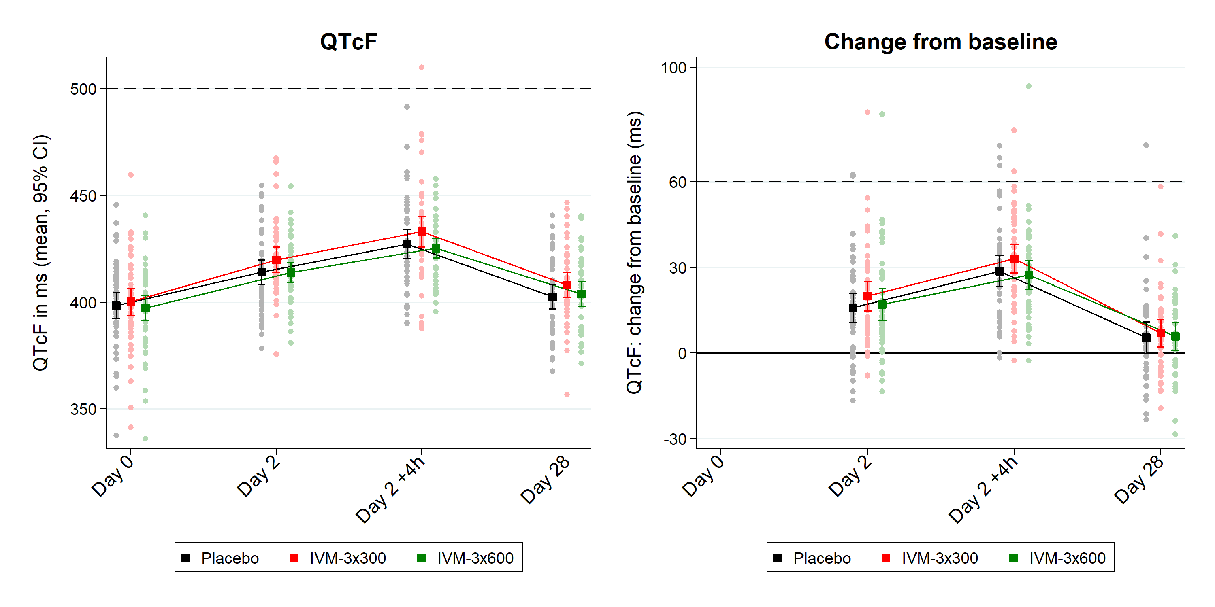
Each patient’s QTcF value was calculated as the mean of triplicate electrocardiograms (ECGs) taken approximately 30 seconds apart at each timepoint.
The dashed horizontal lines represent severe QTc prolongation (≥500 ms) or severe increase in QTc relative to baseline (≥60 ms). See Table S16. IVM-3x600=ivermectin 600 mcg/kg/day for 3 days. IVM-3x300=ivermectin 300 mcg/kg/day for 3 days.

Figure S5: Haemoglobin
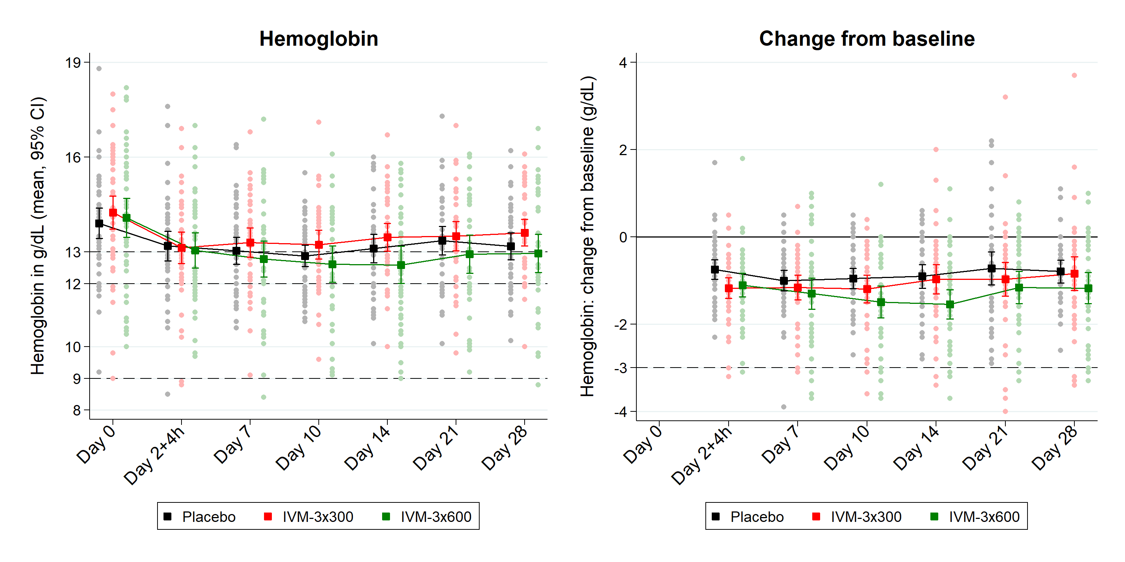
The dashed horizontal lines represent haemoglobin thresholds for normal: men (≥13 g/dL), women (≥12 g/dL), mild anaemia (9.0 to LLN [lower limit of normal] g/dL), and moderate anaemia (<9 g/dL). See Table S17. IVM-3x600=ivermectin 600 mcg/kg/day for 3 days. IVM-3x300=ivermectin 300 mcg/kg/day for 3 days.

Figure S6: Aspartate transaminase (AST)
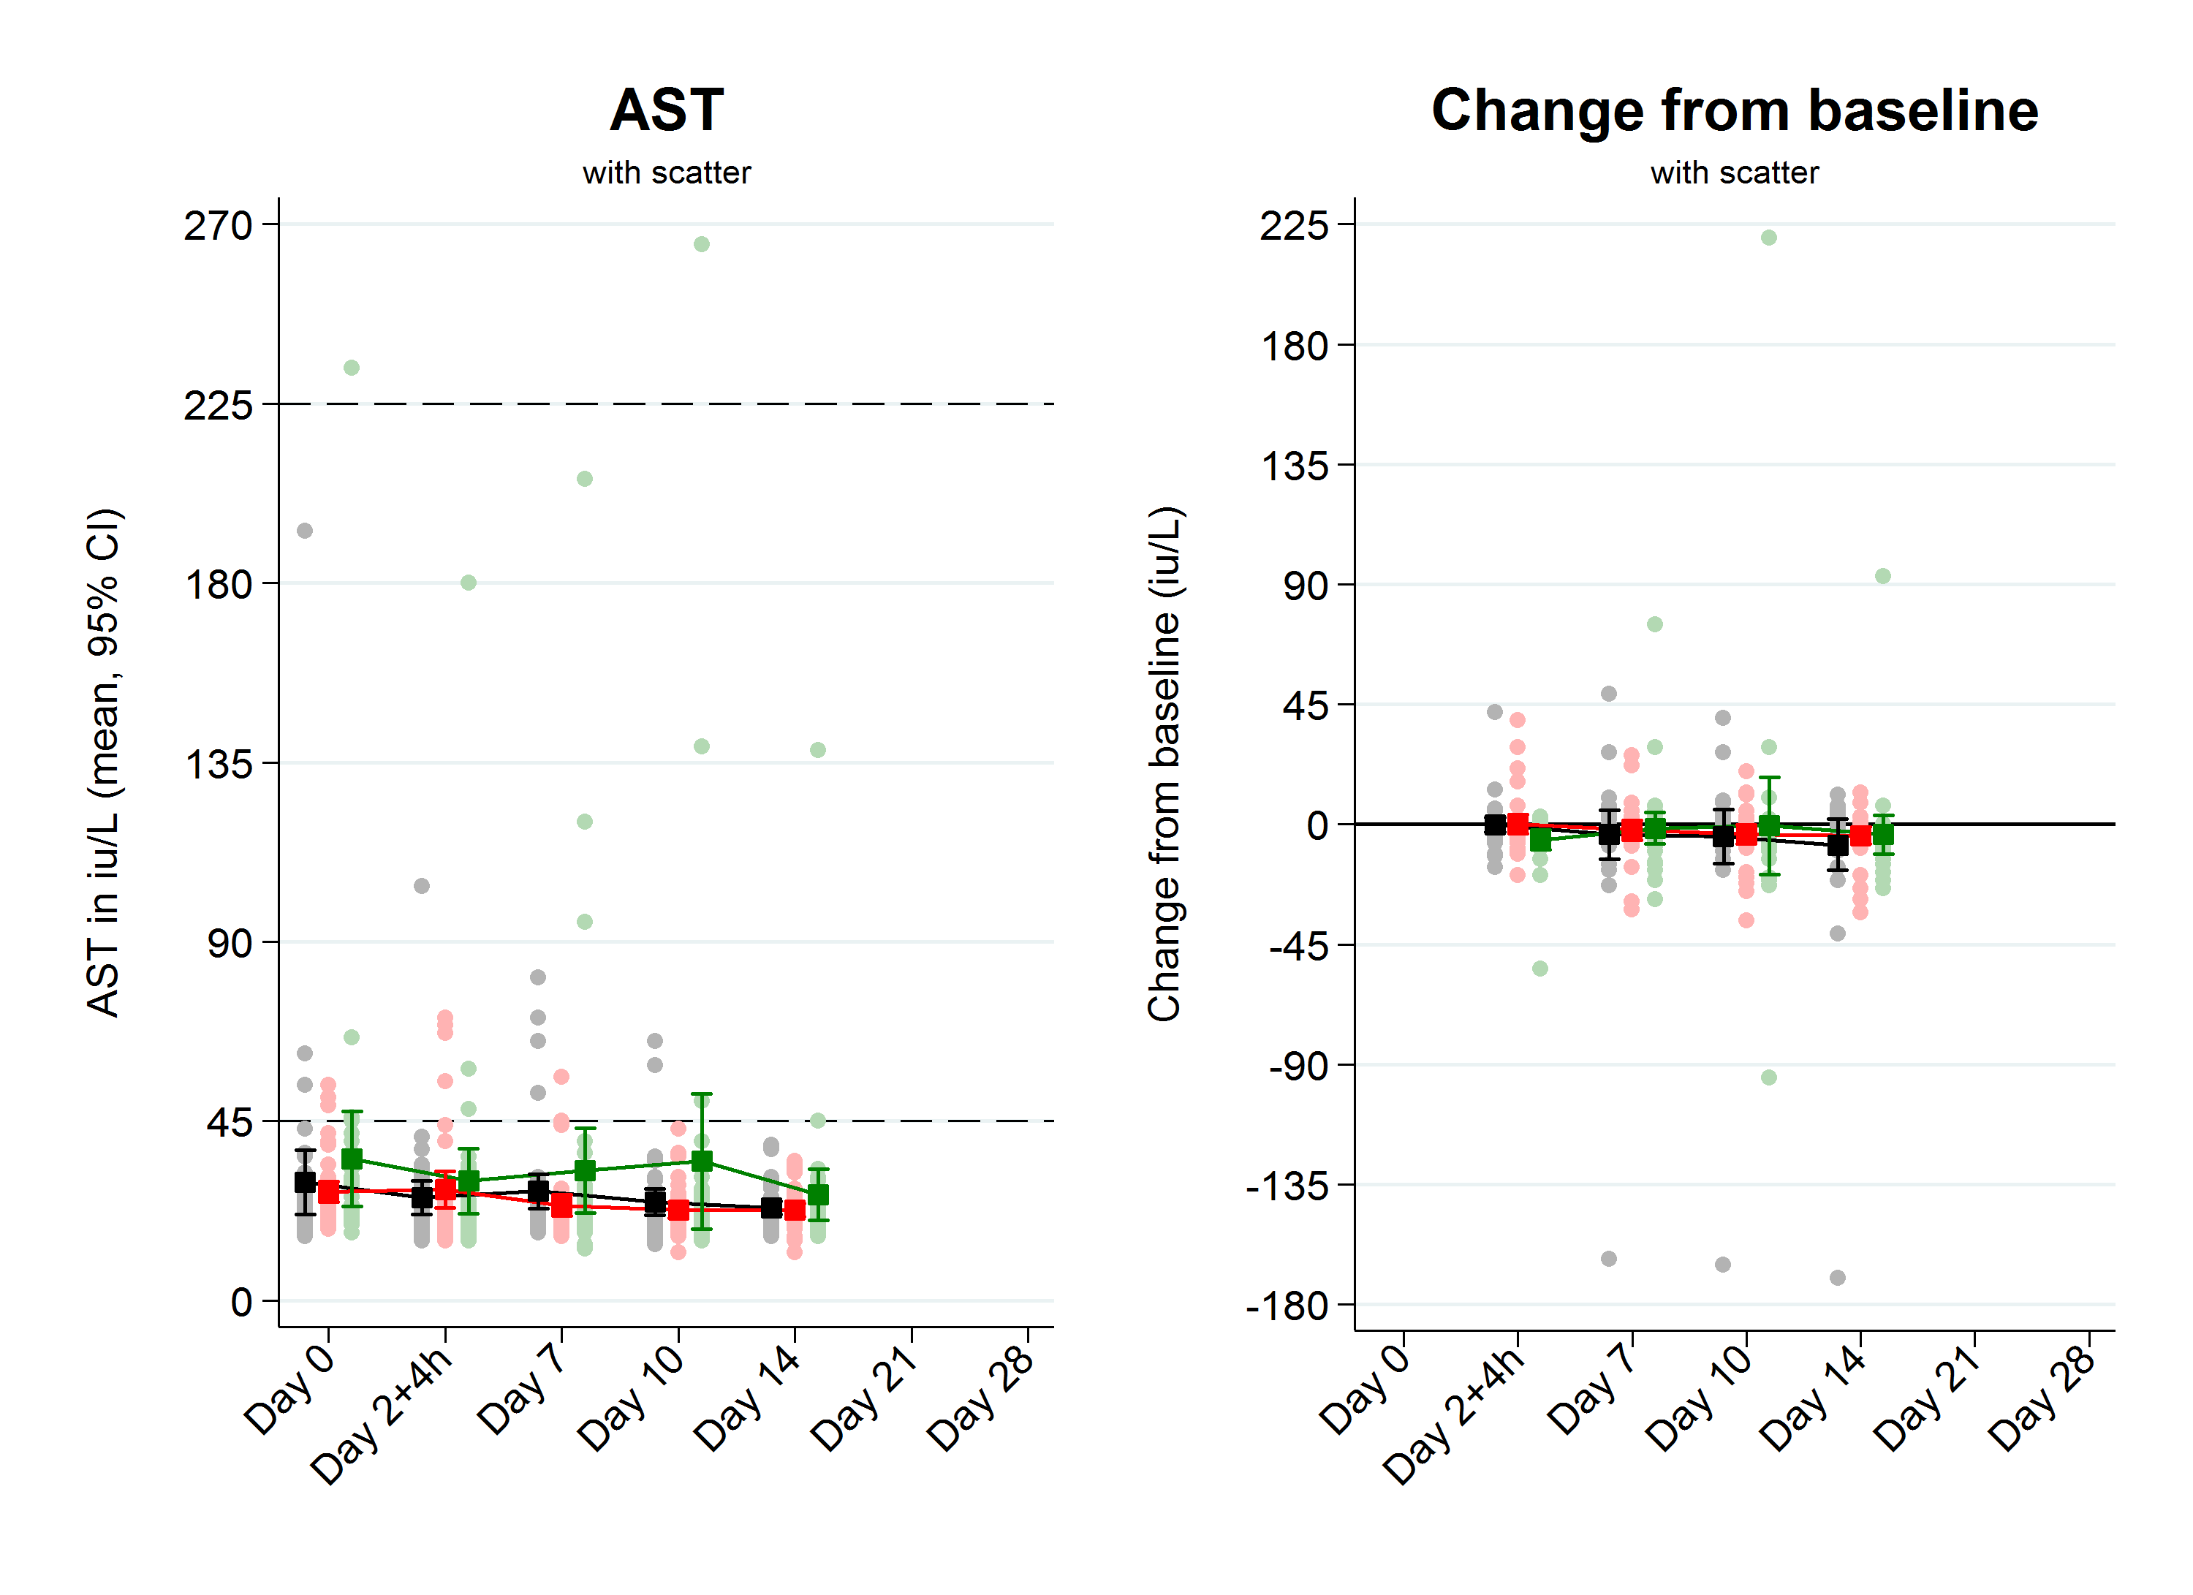
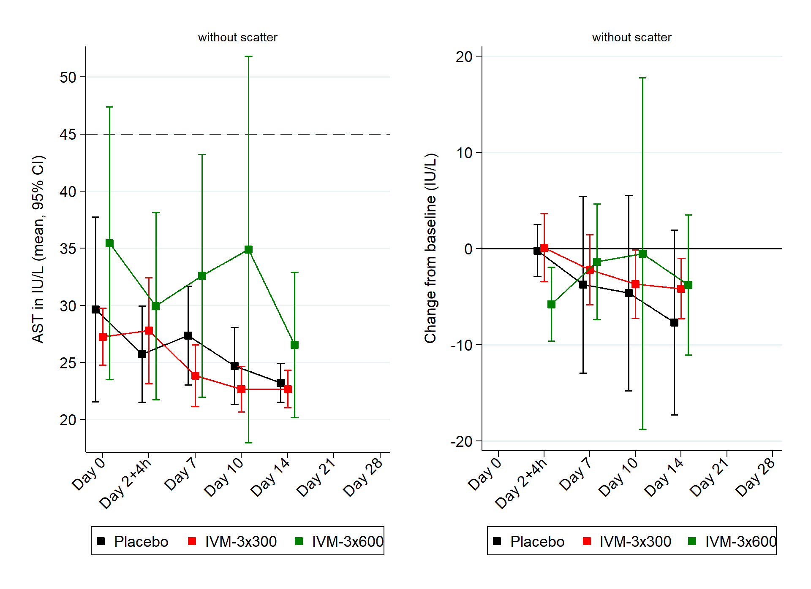
Normal: <45 iu/L. Abnormal: grade 1-2 (45 to <225 iu/L), grade 3 (225 to <900 iu/L), and grade 4 (≥900 iu/L). See Table S18. IVM-3x600=ivermectin 600 mcg/kg/day for 3 days. IVM-3x300=ivermectin 300 mcg/kg/day for 3 days.

Figure S7: Alanine transaminase (ALT)
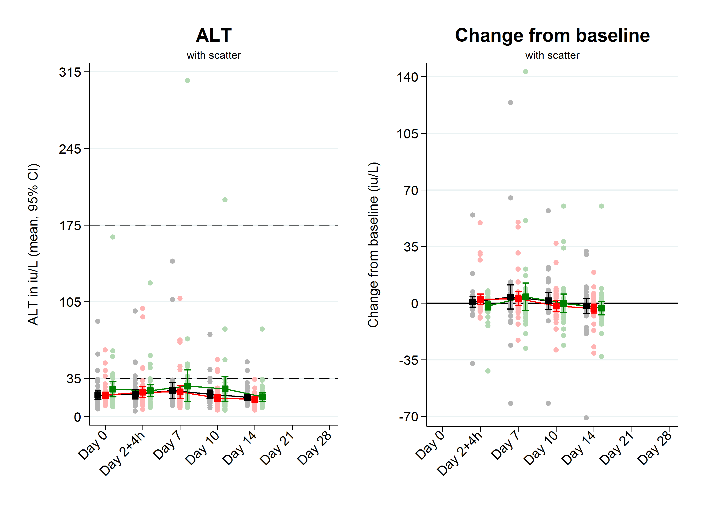
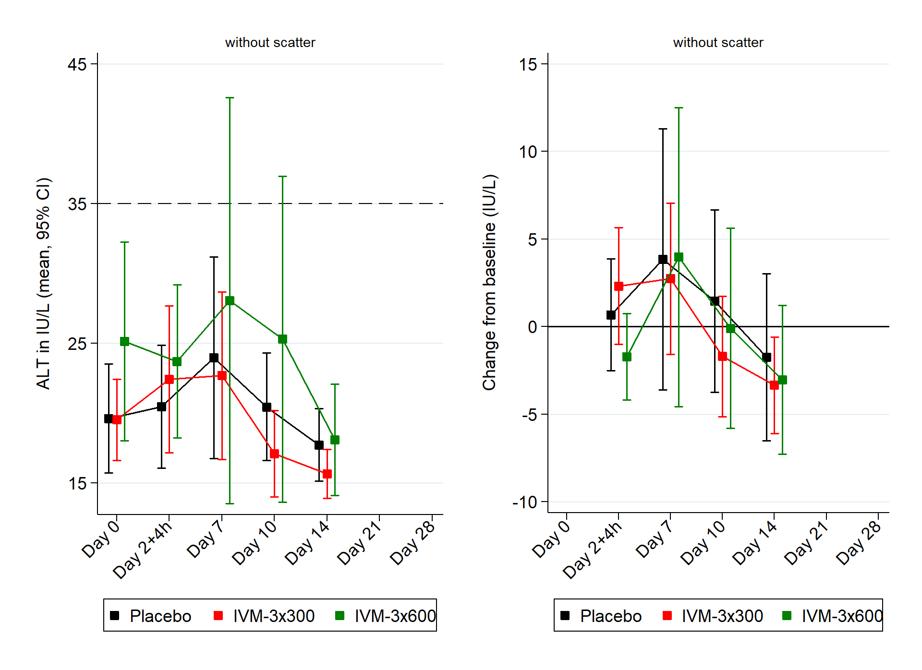
Normal: <35 iu/L. Abnormal: grade 1-2 (35 to <175 iu/L), grade 3 (175 to <700 iu/L), and grade 4 (≥700 iu/L). See Table S19. IVM-3x600=ivermectin 600 mcg/kg/day for 3 days. IVM-3x300=ivermectin 300 mcg/kg/day for 3 days.

Population Modelling

Figure S8: Hazard model fits
Mosquito survival data (solid lines) and Cox proportional hazard model fits (dashed lines) following feeding on patients at different time points post-treatment. IVM-3x600=ivermectin 600 mcg/kg/day for 3 days. IVM-3x300=ivermectin 300 mcg/kg/day for 3 days.

Figure S9: Predicted daily post-treatment hazard ratios
Estimated hazard ratio (dashed line = 1) of mortality versus placebo (curves) and 95% CI (shaded areas) experienced by mosquitoes taking their first ivermectin blood meal on a given day post-treatment using the model presented in Table S20. The points and associated 95% confidence intervals are taken from the visit-specific Cox proportional hazards models (Table S3) to confirm that they are consistent with the combined model. IVM-3x600=ivermectin 600 mcg/kg/day for 3 days. IVM-3x300=ivermectin 300 mcg/kg/day for 3 days.

Figure S10: Predicted proportion of mosquitoes surviving until next blood meal or sporogony
Proportion of mosquitoes that survive to either 2 days (to take another potentially infectious bloodmeal) or survive to 10 days (to become infectious after completing sporogony), assuming they feed on a given day post-treatment (x-axis). IVM-3x600=ivermectin 600 mcg/kg/day for 3 days. IVM-3x300=ivermectin 300 mcg/kg/day for 3 days.

Figure S11: Predicted impact on malaria prevalence
High transmission, 2 rounds | High transmission, 3 rounds | High transmission, 4 rounds
Low transmission, 2 rounds | Low transmission, 3 rounds | Low transmission, 4 rounds
Impact of ivermectin+DP on all-age malaria prevalence by blood slide in a low (10% baseline prevalence) and high (30% baseline prevalence) transmission settings with 2, 3, or 4 MDA rounds per year for 2 years (indicated by the red arrows). DP=dihydroartemisinin-piperaquine for 3 days. IVM-1x150=ivermectin 150 mcg/kg for 1 day. IVM-3x300=ivermectin 300 mcg/kg/day for 3 days. IVM-3x600=ivermectin 600 mcg/kg/day for 3 days.

Supplementary Tables

Efficacy

Table S1: Mosquito feeding rates
Patient Post-  Treatment Visit | Mosquitoes fully fed (%)* |  |  | Risk ratio (95% CI), p-value
 | IVM-3x600 | IVM-3x300 | Placebo | IVM-3x600 vs Placebo | IVM-3x300 vs Placebo | IVM-3x600 vs IVM-3x300
Combined | 30,057 / 41,928 (71.7) | 31,040 / 43,210 (71.8) | 30,012 / 42,545 (70.5) | 1.00 (0.94, 1.08), 0.90 | 1.01 (0.95, 1.08), 0.72 | 0.99 (0.93, 1.07), 0.84
1. A Generalized estimating equation (GEE) model was used for the analysis. The GEE model included treatment as fixed effect and subject as cluster effect.
2. Analysis was based on data collected for approximately 150 mosquitoes per visit (3 cups of 50).
*The number of mosquitoes fully fed out of the number of mosquitoes offered a blood meal.

Table S2: Mosquito mortality at day 14 (GEE model; intention-to-treat population)
Patient Post-  Treatment Visit | Mosquito mortality (%) |  |  | Risk ratio (95% CI), p-value
 | IVM-3x600 | IVM-3x300 | Placebo |  | IVM-3x600 vs Placebo | IVM-3x300 vs Placebo | IVM-3x600 vs IVM-3x300
Day 0 | 1506/3124 (48.2) | 1645/3589 (45.8) | 1441/3308 (43.6) | Crude | 1.09 (0.90, 1.31), 0.38 | 1.02 (0.85, 1.23), 0.83 | 1.07 (0.88, 1.29), 0.51
 |  |  |  | Adjusted | 1.22 (0.97, 1.54), 0.09 | 1.04 (0.85, 1.27), 0.73 | 1.18 (0.95, 1.46), 0.14
Day 2+4h | 3017/3084 (97.8) | 3328/3375 (98.6) | 1436/3339 (43.0) | Crude | 2.32 (2.04, 2.65), <0.0001 | 2.34 (2.06, 2.67), <0.0001 | 0.99 (0.97, 1.02), 0.52
 |  |  |  | Adjusted | 2.31 (2.03, 2.62), <0.0001 | 2.32 (2.04, 2.64), <0.0001 | 0.99 (0.97, 1.02), 0.60
Day 7* | 3084/3190 (96.7) | 2638/2846 (92.7) | 1175/2837 (41.4) | Crude | 2.26 (1.93, 2.65), <0.0001 | 2.18 (1.86, 2.57), <0.0001 | 1.03 (0.99, 1.08), 0.13
 |  |  |  | Adjusted | 2.26 (1.93, 2.64), <0.0001 | 2.16 (1.85, 2.53), <0.0001 | 1.05 (1.00, 1.09), 0.0391
Day 10 | 2867/3125 (91.7) | 2261/2839 (79.6) | 1209/2523 (47.9) | Crude | 1.89 (1.62, 2.20), <0.0001 | 1.65 (1.39, 1.96), <0.0001 | 1.14 (1.04, 1.26), 0.0079
 |  |  |  | Adjusted | 1.81 (1.53, 2.14), <0.0001 | 1.60 (1.33, 1.92), <0.0001 | 1.13 (1.03, 1.24), 0.0084
Day 14 | 2231/2881 (77.4) | 1865/2763 (67.5) | 1180/2727 (43.3) | Crude | 1.81 (1.51, 2.18), <0.0001 | 1.56 (1.29, 1.90), <0.0001 | 1.16 (1.00, 1.34), 0.0444
 |  |  |  | Adjusted | 1.79 (1.49, 2.15), <0.0001 | 1.58 (1.31, 1.91), <0.0001 | 1.13 (1.01, 1.27), 0.0346
Day 21 | 1455/2426 (60.0) | 1582/2754 (57.4) | 1234/2677 (46.1) | Crude | 1.28 (1.03, 1.58), 0.0229 | 1.24 (1.01, 1.53), 0.0367 | 1.03 (0.85, 1.25), 0.78
 |  |  |  | Adjusted | 1.33 (1.07, 1.65), 0.0093 | 1.28 (1.04, 1.57), 0.0180 | 1.04 (0.87, 1.24), 0.68
Day 28 | 1388/2290 (60.6) | 1565/2719 (57.6) | 1305/2652 (49.2) | Crude | 1.23 (1.01, 1.50), 0.0374 | 1.21 (1.01, 1.44), 0.0337 | 1.02 (0.85, 1.22), 0.85
 |  |  |  | Adjusted | 1.25 (1.03, 1.51), 0.0234 | 1.22 (1.02, 1.45), 0.0289 | 1.02 (0.86, 1.22), 0.78
1. A Generalized estimating equation (GEE) model was used for the analysis of each visit. All GEE models included treatment as fixed effect and subject as cluster effect. The adjusted models also included participant’s sex and BMI, and mosquitoes’ age and crowding conditions at the time of feeding.
2. Analysis was based on data collected for approximately 100 mosquitoes per visit (an additional 50 mosquitoes used for oocyst PCR were excluded from the GEE analyses on day 14 as they had all been euthanized after 10 days of mosquito follow-up). The denominators in the table reflect the mosquitoes included in each analysis, considering fully fed status and the number of participants per feed (Fig. 1, main text).
* The crude analysis of the Day 7 visit was the trial’s primary outcome (in bold).

Table S3: Mosquito mortality up to day 14 incl. (Cox model; intention-to-treat population)
Patient Post-  Treatment Visit | Mosquito mortality (%) |  |  | Hazard ratio (95% CI), p-value
 | IVM-3x600 | IVM-3x300 | Placebo |  | IVM-3x600 vs Placebo | IVM-3x300 vs Placebo | IVM-3x600 vs IVM-3x300
Day 0 | 1999/4637 (43.1) | 2290/5421 (42.2) | 1967/4957 (39.7) | Crude | 1.18 (0.86, 1.61), 0.30 | 0.99 (0.72, 1.35), 0.94 | 1.19 (0.88, 1.62), 0.26
 |  |  |  | Adjusted | 1.29 (0.94, 1.77), 0.11 | 0.99 (0.72, 1.35), 0.93 | 1.31 (0.96, 1.79), 0.09
Day 2+4h | 4577/4666 (98.1) | 4973/5043 (98.6) | 1990/5039 (39.5) | Crude | 12.38 (9.98, 15.36), <0.0001 | 9.59 (7.77, 11.82), <0.0001 | 1.29 (1.05, 1.59), 0.0148
 |  |  |  | Adjusted | 12.39 (9.99, 15.37), <0.0001 | 9.59 (7.77, 11.83), <0.0001 | 1.29 (1.05, 1.59), 0.0144
Day 7 | 4612/4763 (96.8) | 3910/4239 (92.2) | 1654/4277 (38.7) | Crude | 6.32 (4.61, 8.67), <0.0001 | 4.21 (3.06, 5.79), <0.0001 | 1.50 (1.10, 2.05), 0.0104
 |  |  |  | Adjusted | 6.40 (4.59, 8.92), <0.0001 | 4.22 (3.03, 5.89), <0.0001 | 1.52 (1.10, 2.08), 0.0107
Day 10 | 4246/4654 (91.2) | 3347/4271 (78.4) | 1680/3726 (45.1) | Crude | 3.66 (2.51, 5.33), <0.0001 | 2.71 (1.85, 3.97), <0.0001 | 1.35 (0.93, 1.96), 0.11
 |  |  |  | Adjusted | 3.77 (2.58, 5.52), <0.0001 | 2.59 (1.78, 3.76), <0.0001 | 1.46 (1.01, 2.09), 0.0416
Day 14 | 3228/4234 (76.2) | 2580/3992 (64.6) | 1613/4043 (39.9) | Crude | 3.74 (2.67, 5.26), <0.0001 | 2.25 (1.60, 3.16), <0.0001 | 1.67 (1.19, 2.34), 0.0033
 |  |  |  | Adjusted | 3.19 (2.29, 4.45), <0.0001 | 2.07 (1.49, 2.87), <0.0001 | 1.54 (1.11, 2.14), 0.0098
Day 21 | 2097/3652 (57.4) | 2203/4083 (54.0) | 1726/3963 (43.6) | Crude | 1.98 (1.34, 2.92), 0.0006 | 1.57 (1.07, 2.29), 0.0203 | 1.27 (0.86, 1.86), 0.23
 |  |  |  | Adjusted | 1.76 (1.19, 2.60), 0.0046 | 1.51 (1.04, 2.20), 0.0312 | 1.17 (0.80, 1.71), 0.43
Day 28 | 1912/3451 (55.4) | 2165/3991 (54.2) | 1839/4007 (45.9) | Crude | 1.65 (1.18, 2.31), 0.0034 | 1.33 (0.96, 1.84), 0.08 | 1.24 (0.89, 1.73), 0.21
 |  |  |  | Adjusted | 1.65 (1.19, 2.29), 0.0028 | 1.37 (1.00, 1.89), 0.0493 | 1.20 (0.87, 1.66), 0.27
1. A Cox model was used for the analysis of each visit. All Cox models included treatment as fixed effect and subject as cluster effect. The adjusted models also included participant’s sex and BMI, and mosquitoes’ age and crowding conditions at the time of feeding.
2. Analysis was based on data collected from approximately 150 mosquitoes per visit. This included 2 cups of 50 mosquitoes each that were followed up to day 28 inclusive, but mosquito follow-up data were censored at 14 days for this analysis, and 1 cup of 50 mosquitoes that was used for oocyst PCR for which all mosquitoes were euthanized at 10 days follow-up. The latter mosquitoes contributed a maximum of 10 days to the survival data. The denominators in the table reflect the mosquitoes included in each analysis, considering fully fed status and the number of participants per feed (Fig. 1, main text).

Table S4: Mosquito mortality up to day 28 incl. (Cox model; intention-to-treat population)
Patient Post-  Treatment Visit | Mosquito mortality (%) |  |  | Hazard ratio (95% CI), p-value
 | IVM-3x600 | IVM-3x300 | Placebo |  | IVM-3x600 vs Placebo | IVM-3x300 vs Placebo | IVM-3x600 vs IVM-3x300
Day 0 | 3431/4637 (74.0) | 3998/5421 (73.8) | 3567/4957 (72.0) | Crude | 1.14 (0.88, 1.48), 0.31 | 0.98 (0.76, 1.26), 0.86 | 1.17 (0.91, 1.51), 0.22
 |  |  |  | Adjusted | 1.24 (0.95, 1.61), 0.11 | 0.98 (0.76, 1.28), 0.90 | 1.26 (0.97, 1.64), 0.08
Day 2+4h | 4644/4666 (99.5) | 5017/5043 (99.5) | 3632/5039 (72.1) | Crude | 11.45 (9.45, 13.88), <0.0001 | 8.86 (7.35, 10.67), <0.0001 | 1.29 (1.08, 1.55), 0.0058
 |  |  |  | Adjusted | 11.48 (9.48, 13.91), <0.0001 | 8.86 (7.35, 10.68), <0.0001 | 1.30 (1.08, 1.56), 0.0054
Day 7 | 4714/4763 (99.0) | 4102/4239 (96.8) | 3029/4277 (70.8) | Crude | 5.75 (4.32, 7.64), <0.0001 | 3.76 (2.82, 5.02), <0.0001 | 1.53 (1.15, 2.03), 0.0033
 |  |  |  | Adjusted | 5.79 (4.29, 7.81), <0.0001 | 3.76 (2.78, 5.07), <0.0001 | 1.54 (1.15, 2.06), 0.0034
Day 10 | 4495/4654 (96.6) | 3882/4271 (90.9) | 2848/3726 (76.4) | Crude | 3.50 (2.49, 4.90), <0.0001 | 2.59 (1.84, 3.65), <0.0001 | 1.35 (0.97, 1.89), 0.08
 |  |  |  | Adjusted | 3.39 (2.40, 4.77), <0.0001 | 2.38 (1.69, 3.34), <0.0001 | 1.42 (1.02, 1.98), 0.0358
Day 14 | 3828/4234 (90.4) | 3407/3992 (85.3) | 2991/4043 (74.0) | Crude | 3.30 (2.51, 4.35), <0.0001 | 1.85 (1.40, 2.44), <0.0001 | 1.78 (1.35, 2.35), <0.0001
 |  |  |  | Adjusted | 2.88 (2.20, 3.76), <0.0001 | 1.75 (1.34, 2.27), <0.0001 | 1.65 (1.26, 2.15), 0.0002
Day 21 | 2991/3652 (81.9) | 3289/4083 (80.6) | 3038/3963 (76.7) | Crude | 1.79 (1.28, 2.51), 0.0008 | 1.43 (1.03, 1.99), 0.0330 | 1.25 (0.89, 1.75), 0.19
 |  |  |  | Adjusted | 1.61 (1.15, 2.26), 0.0054 | 1.41 (1.02, 1.95), 0.0394 | 1.15 (0.82, 1.60), 0.41
Day 28 | 2717/3451 (78.7) | 3208/3991 (80.4) | 3099/4007 (77.3) | Crude | 1.49 (1.13, 1.96), 0.0044 | 1.14 (0.88, 1.49), 0.32 | 1.30 (0.99, 1.71), 0.06
 |  |  |  | Adjusted | 1.50 (1.15, 1.97), 0.0031 | 1.17 (0.90, 1.52), 0.23 | 1.28 (0.98, 1.68), 0.07
1. A Cox model was used for the analysis of each visit. All Cox models included treatment as fixed effect and subject as cluster effect. The adjusted models also included participant’s sex and BMI, and mosquitoes’ age and crowding conditions at the time of feeding.
2. Analysis was based on data collected from approximately 150 mosquitoes per visit. This included 2 cups of 50 mosquitoes each that were followed up to day 28 inclusive, contributing in full to this analysis, and 1 cup of 50 mosquitoes that was used for oocyst PCR for which all mosquitoes were euthanized at 10 days follow-up. The latter mosquitoes contributed a maximum of 10 days to the survival data. The denominators in the table reflect the mosquitoes included in each analysis, considering fully fed status and the number of participants per feed (Fig. 1, main text).

Table S5: Mosquito mortality up to day 10 incl. (Cox model; intention-to-treat population)
Patient Post-  Treatment Visit | Mosquito mortality (%) |  |  | Hazard ratio (95% CI), p-value
 | IVM-3x600 | IVM-3x300 | Placebo |  | IVM-3x600 vs Placebo | IVM-3x300 vs Placebo | IVM-3x600 vs IVM-3x300
Day 0 | 1592/4637 (34.3) | 1765/5421 (32.6) | 1469/4957 (29.6) | Crude | 1.23 (0.86, 1.74), 0.25 | 0.99 (0.70, 1.40), 0.97 | 1.23 (0.87, 1.74), 0.23
 |  |  |  | Adjusted | 1.33 (0.93, 1.88), 0.11 | 0.98 (0.69, 1.39), 0.90 | 1.35 (0.96, 1.91), 0.09
Day 2+4h | 4525/4666 (97.0) | 4951/5043 (98.2) | 1528/5039 (30.3) | Crude | 12.97 (10.28, 16.37), <0.0001 | 10.02 (8.00, 12.57), <0.0001 | 1.29 (1.04, 1.61), 0.0226
 |  |  |  | Adjusted | 12.97 (10.28, 16.35), <0.0001 | 10.03 (8.00, 12.57), <0.0001 | 1.29 (1.04, 1.61), 0.0228
Day 7 | 4555/4763 (95.6) | 3787/4239 (89.3) | 1306/4277 (30.5) | Crude | 6.50 (4.67, 9.06), <0.0001 | 4.35 (3.11, 6.08), <0.0001 | 1.50 (1.08, 2.07), 0.0160
 |  |  |  | Adjusted | 6.55 (4.60, 9.31), <0.0001 | 4.36 (3.06, 6.21), <0.0001 | 1.50 (1.07, 2.10), 0.0180
Day 10 | 4120/4654 (88.5) | 3097/4271 (72.5) | 1289/3726 (34.6) | Crude | 3.69 (2.46, 5.52), <0.0001 | 2.73 (1.81, 4.12), <0.0001 | 1.35 (0.91, 2.01), 0.14
 |  |  |  | Adjusted | 3.98 (2.65, 5.97), <0.0001 | 2.68 (1.80, 3.99), <0.0001 | 1.48 (1.01, 2.18), 0.0458
Day 14 | 2967/4234 (70.1) | 2313/3992 (57.9) | 1270/4043 (31.4) | Crude | 3.92 (2.70, 5.69), <0.0001 | 2.40 (1.65, 3.50), <0.0001 | 1.63 (1.12, 2.37), 0.0105
 |  |  |  | Adjusted | 3.34 (2.31, 4.84), <0.0001 | 2.22 (1.54, 3.20), <0.0001 | 1.51 (1.05, 2.17), 0.0272
Day 21 | 1852/3652 (50.7) | 1828/4083 (44.8) | 1317/3963 (33.2) | Crude | 2.08 (1.37, 3.15), 0.0006 | 1.62 (1.08, 2.44), 0.0194 | 1.28 (0.85, 1.93), 0.24
 |  |  |  | Adjusted | 1.81 (1.18, 2.76), 0.0063 | 1.55 (1.03, 2.32), 0.0356 | 1.17 (0.78, 1.76), 0.46
Day 28 | 1621/3451 (47.0) | 1749/3991 (43.8) | 1345/4007 (33.6) | Crude | 1.74 (1.19, 2.54), 0.0044 | 1.41 (0.98, 2.04), 0.07 | 1.23 (0.85, 1.80), 0.28
 |  |  |  | Adjusted | 1.75 (1.21, 2.54), 0.0029 | 1.50 (1.05, 2.14), 0.0277 | 1.17 (0.81, 1.69), 0.39
1. A Cox model was used for the analysis of each visit. All Cox models included treatment as fixed effect and subject as cluster effect. The adjusted models also included participant’s sex and BMI, and mosquitoes’ age and crowding conditions at the time of feeding.
2. Analysis was based on data collected from approximately 150 mosquitoes per visit. This included 2 cups of 50 mosquitoes each that were followed up to day 28 inclusive, but mosquito follow-up data were censored at 10 days for this analysis, and 1 cup of 50 mosquitoes that was used for oocyst PCR for which all mosquitoes were euthanized at 10 days follow-up. The latter mosquitoes contributed their full 10 days of the survival data. The denominators in the table reflect the mosquitoes included in each analysis, considering fully fed status and the number of participants per feed (Fig. 1, main text).

Table S6: Mosquito mortality at day 14 (GEE model; per-protocol population)
Patient Post-  Treatment Visit | Mosquito mortality (%) |  |  | Risk ratio (95% CI), p-value
 | IVM-3x600 | IVM-3x300 | Placebo |  | IVM-3x600 vs Placebo | IVM-3x300 vs Placebo | IVM-3x600 vs IVM-3x300
Day 0 | 1340/2718 (49.3) | 1616/3466 (46.6) | 1397/3221 (43.4) | Crude | 1.10 (0.91, 1.33), 0.34 | 1.04 (0.86, 1.26), 0.66 | 1.05 (0.87, 1.28), 0.62
 |  |  |  | Adjusted | 1.26 (0.99, 1.59), 0.06 | 1.06 (0.86, 1.30), 0.59 | 1.19 (0.95, 1.48), 0.13
Day 2+4h | 2831/2866 (98.8) | 3275/3322 (98.6) | 1402/3264 (43.0) | Crude | 2.34 (2.05, 2.68), <0.0001 | 2.35 (2.05, 2.68), <0.0001 | 1.00 (0.98, 1.02), 0.96
 |  |  |  | Adjusted | 2.33 (2.04, 2.65), <0.0001 | 2.32 (2.04, 2.65), <0.0001 | 1.00 (0.98, 1.03), 0.92
Day 7 | 2818/2907 (96.9) | 2553/2761 (92.5) | 1132/2749 (41.2) | Crude | 2.27 (1.93, 2.68), <0.0001 | 2.19 (1.86, 2.58), <0.0001 | 1.04 (0.99, 1.09), 0.09
 |  |  |  | Adjusted | 2.27 (1.94, 2.67), <0.0001 | 2.16 (1.84, 2.54), <0.0001 | 1.05 (1.01, 1.10), 0.0285
Day 10 | 2624/2825 (92.9) | 2213/2783 (79.5) | 1166/2446 (47.7) | Crude | 1.92 (1.64, 2.24), <0.0001 | 1.66 (1.39, 1.98), <0.0001 | 1.16 (1.05, 1.28), 0.0044
 |  |  |  | Adjusted | 1.84 (1.54, 2.19), <0.0001 | 1.60 (1.32, 1.93), <0.0001 | 1.15 (1.05, 1.26), 0.0026
Day 14 | 2044/2632 (77.7) | 1830/2720 (67.3) | 1173/2679 (43.8) | Crude | 1.79 (1.49, 2.15), <0.0001 | 1.53 (1.26, 1.86), <0.0001 | 1.17 (1.01, 1.36), 0.0389
 |  |  |  | Adjusted | 1.73 (1.45, 2.07), <0.0001 | 1.52 (1.27, 1.83), <0.0001 | 1.13 (1.01, 1.28), 0.0361
Day 21 | 1370/2300 (59.6) | 1566/2682 (58.4) | 1234/2677 (46.1) | Crude | 1.27 (1.02, 1.58), 0.0324 | 1.26 (1.03, 1.55), 0.0237 | 1.00 (0.82, 1.22), 0.97
 |  |  |  | Adjusted | 1.31 (1.05, 1.63), 0.0162 | 1.29 (1.05, 1.59), 0.0144 | 1.01 (0.84, 1.22), 0.88
Day 28 | 1169/1997 (58.5) | 1542/2668 (57.8) | 1273/2586 (49.2) | Crude | 1.20 (0.98, 1.47), 0.08 | 1.22 (1.02, 1.46), 0.0323 | 0.98 (0.81, 1.19), 0.87
 |  |  |  | Adjusted | 1.21 (0.99, 1.49), 0.06 | 1.22 (1.02, 1.46), 0.0332 | 1.00 (0.83, 1.20), 0.99
1. A Generalized estimating equation (GEE) model was used for the analysis of each visit. All GEE models included treatment as fixed effect and subject as cluster effect. The adjusted models also included participant’s sex and BMI, and mosquitoes’ age and crowding conditions at the time of feeding.
2. Analysis was based on data collected for approximately 100 mosquitoes per visit (an additional 50 mosquitoes used for oocyst PCR were excluded from the GEE analyses on day 14 as they had all been euthanized after 10 days of mosquito follow-up), and that were fed on the blood of participants that were treated per protocol. The denominators in the table reflect the mosquitoes included in each analysis, considering fully fed status and the number of participants per feed (Fig. 1, main text).

Table S7: Mosquito mortality up to day 14 inclusive (Cox model; per-protocol population)
Patient Post-  Treatment Visit | Mosquito mortality (%) |  |  | Hazard ratio (95% CI), p-value
 | IVM-3x600 | IVM-3x300 | Placebo |  | IVM-3x600 vs Placebo | IVM-3x300 vs Placebo | IVM-3x600 vs IVM-3x300
Day 0 | 1782/4026 (44.3) | 2248/5227 (43.0) | 1900/4820 (39.4) | Crude | 1.10 (0.80, 1.51), 0.55 | 1.01 (0.75, 1.37), 0.93 | 1.09 (0.80, 1.48), 0.60
 |  |  |  | Adjusted | 1.19 (0.87, 1.63), 0.27 | 1.01 (0.74, 1.37), 0.95 | 1.18 (0.87, 1.61), 0.29
Day 2+4h | 4303/4342 (99.1) | 4895/4965 (98.6) | 1936/4941 (39.2) | Crude | 13.02 (10.47, 16.18), <0.0001 | 9.79 (7.95, 12.07), <0.0001 | 1.33 (1.08, 1.63), 0.0071
 |  |  |  | Adjusted | 13.08 (10.53, 16.25), <0.0001 | 9.76 (7.93, 12.02), <0.0001 | 1.34 (1.09, 1.65), 0.0057
Day 7 | 4205/4334 (97.0) | 3800/4128 (92.1) | 1595/4139 (38.5) | Crude | 6.29 (4.54, 8.73), <0.0001 | 4.14 (2.98, 5.73), <0.0001 | 1.52 (1.10, 2.10), 0.0109
 |  |  |  | Adjusted | 6.41 (4.54, 9.07), <0.0001 | 4.23 (3.00, 5.95), <0.0001 | 1.52 (1.09, 2.11), 0.0133
Day 10 | 3886/4208 (92.3) | 3285/4201 (78.2) | 1632/3608 (45.2) | Crude | 3.60 (2.44, 5.31), <0.0001 | 2.69 (1.83, 3.98), <0.0001 | 1.34 (0.91, 1.96), 0.14
 |  |  |  | Adjusted | 3.69 (2.51, 5.41), <0.0001 | 2.56 (1.75, 3.73), <0.0001 | 1.44 (1.00, 2.08), 0.05
Day 14 | 2947/3849 (76.6) | 2527/3918 (64.5) | 1589/3957 (40.2) | Crude | 3.73 (2.63, 5.30), <0.0001 | 2.23 (1.57, 3.16), <0.0001 | 1.68 (1.18, 2.38), 0.0040
 |  |  |  | Adjusted | 3.07 (2.17, 4.34), <0.0001 | 2.02 (1.44, 2.81), <0.0001 | 1.52 (1.09, 2.14), 0.0148
Day 21 | 1991/3474 (57.3) | 2180/3965 (55.0) | 1726/3963 (43.6) | Crude | 2.02 (1.36, 3.00), 0.0005 | 1.60 (1.09, 2.34), 0.0161 | 1.26 (0.85, 1.87), 0.24
 |  |  |  | Adjusted | 1.78 (1.19, 2.65), 0.0051 | 1.54 (1.05, 2.25), 0.0255 | 1.15 (0.78, 1.71), 0.48
Day 28 | 1593/3010 (52.9) | 2142/3938 (54.4) | 1793/3899 (46.0) | Crude | 1.53 (1.08, 2.16), 0.0164 | 1.34 (0.97, 1.86), 0.08 | 1.14 (0.81, 1.60), 0.46
 |  |  |  | Adjusted | 1.56 (1.11, 2.21), 0.0108 | 1.38 (1.00, 1.91), 0.0499 | 1.13 (0.81, 1.59), 0.48
1. A Cox model was used for the analysis of each visit. All Cox models included treatment as fixed effect and subject as cluster effect. The adjusted models also included participant’s sex and BMI, and mosquitoes’ age and crowding conditions at the time of feeding.
2. Analysis was based on data collected from approximately 150 mosquitoes per visit. This included 2 cups of 50 mosquitoes each that were followed up to day 28 inclusive, but mosquito follow-up data were censored at 14 days for this analysis, and 1 cup of 50 mosquitoes that was used for oocyst PCR for which all mosquitoes were euthanized at 10 days follow-up. The latter mosquitoes contributed a maximum of 10 days to the survival data. The denominators in the table reflect the mosquitoes included in each analysis, considering fully fed status and the number of participants per feed (Fig. 1, main text).

Table S8: Mosquito mortality at day 14, by sub-group
Patient Post-  Treatment Visit | Mosquito mortality (%) |  |  |  | Risk ratio* (95% CI), p-value |  |  | Interaction (p-value)
 | Subgroup | IVM-3x600 | IVM-3x300 | Placebo | IVM-3x600 vs Placebo | IVM-3x300 vs Placebo | IVM-3x600 vs IVM-3x300 | 600 vs 0 | 300 vs 0 | 600 vs 300
Day 7 (GEE) | Overall | 3084/3190 (96.7) | 2638/2846 (92.7) | 1175/2837 (41.4) | 2.26 (1.93, 2.65), <0.0001 | 2.18 (1.86, 2.57), <0.0001 | 1.03 (0.99, 1.08), 0.13
 | Male | 1733/1787 (97.0) | 1473/1609 (91.5) | 778/1653 (47.1) | 2.05 (1.70, 2.46), <0.0001 | 1.94 (1.61, 2.35), <0.0001 | 1.05 (1.00, 1.11), 0.06 | 0.09 | 0.05 | 0.31
 | Female | 1351/1403 (96.3) | 1165/1237 (94.2) | 397/1184 (33.5) | 2.72 (2.07, 3.59), <0.0001 | 2.70 (2.06, 3.55), <0.0001 | 1.01 (0.94, 1.08), 0.84
 | BMI<22 | 1624/1718 (94.5) | 1406/1533 (91.7) | 685/1405 (48.8) | 1.96 (1.60, 2.40), <0.0001 | 1.93 (1.57, 2.37), <0.0001 | 1.02 (0.95, 1.09), 0.66 | 0.0377 | 0.07 | 0.33
 | BMI≥22 | 1460/1472 (99.2) | 1232/1313 (93.8) | 490/1432 (34.2) | 2.73 (2.15, 3.46), <0.0001 | 2.58 (2.03, 3.28), <0.0001 | 1.06 (1.01, 1.10), 0.0093
 | M, <22 | 1082/1134 (95.4) | 973/1081 (90.0) | 515/1041 (49.5) | 1.94 (1.54, 2.45), <0.0001 | 1.85 (1.46, 2.35), <0.0001 | 1.05 (0.98, 1.13), 0.19 | 0.38 | 0.59 | 0.19
 | M, ≥22 | 651/653 (99.7) | 500/528 (94.7) | 263/612 (43.0) | 2.28 (1.70, 3.07), <0.0001 | 2.16 (1.60, 2.92), <0.0001 | 1.06 (1.00, 1.12), 0.06
 | F, <22 | 542/584 (92.8) | 433/452 (95.8) | 170/364 (46.7) | 2.07 (1.37, 3.13), 0.0005 | 2.21 (1.49, 3.29), <0.0001 | 0.94 (0.82, 1.07), 0.34
 | F, ≥22 | 809/819 (98.8) | 732/785 (93.2) | 227/820 (27.7) | 3.27 (2.32, 4.59), <0.0001 | 3.09 (2.19, 4.36), <0.0001 | 1.06 (1.00, 1.12), 0.07
Patient Post-  Treatment Visit | Mosquito mortality (%) |  |  |  | Hazard ratio* (95% CI), p-value |  |  | Interaction (p-value)
 | Subgroup | IVM-3x600 | IVM-3x300 | Placebo | IVM-3x600 vs Placebo | IVM-3x300 vs Placebo | IVM-3x600 vs IVM-3x300 | 600 vs 0 | 300 vs 0 | 600 vs 300
Day 7 (Cox) | Overall | 4612/4763 (96.8) | 3910/4239 (92.2) | 1654/4277 (38.7) | 6.32 (4.61, 8.67), <0.0001 | 4.21 (3.06, 5.79), <0.0001 | 1.50 (1.10, 2.05), 0.0104
 | Male | 2600/2685 (96.8) | 2177/2386 (91.2) | 1096/2548 (43.0) | 4.57 (2.98, 6.99), <0.0001 | 3.06 (2.01, 4.66), <0.0001 | 1.49 (0.98, 2.27), 0.06 | 0.0078 | 0.0087 | 1.00
 | Female | 2012/2078 (96.8) | 1733/1853 (93.5) | 558/1729 (32.3) | 11.51 (7.49, 17.70), <0.0001 | 7.70 (4.93, 12.03), <0.0001 | 1.50 (0.98, 2.29), 0.06
 | BMI<22 | 2419/2550 (94.9) | 2093/2295 (91.2) | 996/2144 (46.5) | 3.91 (2.51, 6.10), <0.0001 | 2.74 (1.76, 4.28), <0.0001 | 1.43 (0.92, 2.20), 0.11 | 0.0007 | 0.0019 | 0.75
 | BMI≥22 | 2193/2213 (99.1) | 1817/1944 (93.5) | 658/2133 (30.8) | 13.32 (9.13, 19.42), <0.0001 | 8.42 (5.72, 12.40), <0.0001 | 1.58 (1.08, 2.32), 0.0192
 | M, <22 | 1654/1737 (95.2) | 1438/1605 (89.6) | 751/1614 (46.5) | 3.07 (1.75, 5.37), <0.0001 | 2.35 (1.36, 4.05), 0.0021 | 1.31 (0.76, 2.26), 0.34 | 0.47 | 1.00 | 0.26
 | M, ≥22 | 946/948 (99.8) | 739/781 (94.6) | 345/934 (36.9) | 10.19 (6.18, 16.78), <0.0001 | 5.72 (3.42, 9.58), <0.0001 | 1.78 (1.06, 2.98), 0.0289
 | F, <22 | 765/813 (94.1) | 655/690 (94.9) | 245/530 (46.2) | 6.40 (3.32, 12.35), <0.0001 | 4.12 (2.05, 8.27), <0.0001 | 1.55 (0.82, 2.95), 0.18
 | F, ≥22 | 1247/1265 (98.6) | 1078/1163 (92.7) | 313/1199 (26.1) | 17.63 (10.42, 29.83), <0.0001 | 12.35 (7.22, 21.12), <0.0001 | 1.43 (0.84, 2.41), 0.18
* Risk ratios: Generalized estimating equation (GEE) model. Hazard ratios: Cox model (Cox).
Three-way interactions between treatment, sex and BMI were not significant.
1. Both a GEE and a Cox model was used for the analysis of each subgroup at the primary outcome visit (7 days post-treatment). All models included treatment as fixed effect and subject as cluster effect.
2. Assessment of the homogeneity of treatment effect by subgroup variable(s) was conducted using treatment, subgroup variable(s), and interaction between treatment and subgroup variable(s) as fixed effects, and subject as cluster effect. The p-value from the interaction term is presented as evidence of treatment heterogeneity.
3. For the GEE model, analysis was based on data collected for approximately 100 mosquitoes per participant (an additional 50 mosquitoes used for oocyst PCR were excluded from the GEE analyses on day 14 as they had all been euthanized after 10 days of mosquito follow-up).
4. For the Cox model, analysis was based on data collected from approximately 150 mosquitoes per participant. This included 2 cups of 50 mosquitoes each that were followed up to day 28 inclusive, but mosquito follow-up data were censored at 14 days for this analysis, and 1 cup of 50 mosquitoes that was used for oocyst PCR for which all mosquitoes were euthanized at 10 days follow-up. The latter mosquitoes contributed a maximum of 10 days to the survival data.
5. For both the GEE and Cox model, the denominators in the table reflect the mosquitoes included in each analysis, considering fully fed status and the number of participants per feed (Fig. 1, main text).

Table S9: Patient gametocytemia and Mosquito oocyst prevalence
Patient Post-  Treatment Visit | Gametocytemic patients (%) |  |  |  | Oocyst prevalence (%)
 | IVM-3x600 | IVM-3x300 | Placebo | IVM-3x600 |  | IVM-3x300 | Placebo
Day 0 | 2 / 47 (4%) | 2 / 48 (4%) | 3 / 46 (7%) | 1 / 47 (2%) |  | 0 / 48 (0%) | 2 / 45 (4%)
Day 2+4h | 1 / 43 (2%) | 0 / 45 (0%) | 1 / 45 (2%) | 1 / 4 (25%) |  | 2 / 10 (20%) | 2 / 42 (5%)
Day 7 | 0 / 43 (0%) | 0 / 41 (0%) | 1 / 44 (2%) | 1 / 13 (8%) |  | 3 / 29 (10%) | 0 / 43 (0%)
Day 10 | 0 / 39 (0%) | 0 / 38 (0%) | 0 / 41 (0%) | 1 / 20 (5%) |  | 0 / 26 (0%) | 0 / 33 (0%)
Day 14 | 0 / 41 (0%) | 0 / 40 (0%) | 0 / 41 (0%) | 0 / 31 (0%) |  | 0 / 35 (0%) | 2 / 39 (5%)
Day 21 | 0 / 36 (0%) | 0 / 41 (0%) | 0 / 40 (0%) | 1 / 32 (3%) |  | 0 / 35 (0%) | 0 / 36 (0%)
Day 28 | 0 / 37 (0%) | 0 / 41 (0%) | 0 / 40 (0%) | 0 / 31 (0%) |  | 0 / 38 (0%) | 0 / 37 (0%)
1. Gametocytaemia: by microscopy.
2. Oocyst prevalence: During each visit a cup of 50 mosquitoes were offered membrane feeding of patients’ blood. Those that had not fully fed were discarded one hour after feeding. Mosquitoes that survived for 10 days were divided into 2 groups and a pooled PCR was performed on each group. If any of the pooled PCR tests were positive, then the cup was considered oocyst positive.

Safety

Table S10: Serious Adverse Events: case descriptions
Arm | Description
IVM-3x300 | ECG abnormalities: Asymptomatic QT-prolongation (510 ms) with T-wave inversion  This 24 year old male (BMI 21.1, baseline QTcF 432 ms) was found to have QT-prolongation (QTcF 510 ms) when his ECG was performed 5 hours after the 3rd dose of study drugs. At the time of examination, the participant reported mild dizziness and no other symptoms. Physical exam was unremarkable with no evidence of vertigo or cardiac arrhythmia. Post-hoc piperaquine plasma concentration was 593 ng/m on Day 2+4h, which was similar to other patients (see Table 2 in Main Text). On ECG performed 1 hour later (=6 hours after drug administration), the QTcF had decreased to 488 ms. Remote read of the ECG’s by a consultant in emergency medicine, identified a negative pre-terminal T-wave, also known as a biphasic T-wave, a potential sign of myocardial ischemia. The report was discussed with the DMEC’s local physician who suggested that as the patient reported no symptoms of ischemia the participant could be evaluated by a cardiologist in the morning. Overnight, the patient complained of excessive fatigue and visual disturbances (darkening of the vision after changing the field of vision), both of which had resolved by morning. On the ECG performed in the morning, the QTcF had decreased to within normal limits (479 ms) and no ECG abnormalities were identified. Serum electrolytes were normal. Review of the patient by the cardiologist found no abnormalities. AST and ALT remained normal through-out follow-up. The cardiologist determined that an ischemic event was unlikely and that the biphasic T-wave was likely a result of the prolonged QT-interval. QT-prolongation is a known side-effect of dihydroartemisinin-piperaquine. It is unlikely that the event was related to ivermectin.
IVM-3x600 | Anaphylactic reaction: Generalized urticaria and severe abdominal cramping  This 23 year old male (BMI 20.8) developed an anaphylactic reaction after taking the 1st dose of study drugs at 12:00. Symptoms developed as follows: 17:00 fever; 19:00 severe abdominal pain; 23:00 urticaria, itching, and headache. The participant presented the following day at 10:00 to the clinic, a few hours before the scheduled day 1 visit. Vital signs were normal, however the patient reported severe abdominal cramping and appeared to be in moderate distress with generalized urticaria, predominantly on the extremities. The case met the study criteria for anaphylaxis, and was treated as per protocol with intravenous chlorpheniramine and hydrocortisone. Symptoms quickly resolved and the patient was switched to oral treatment with chlorpheniramine 4 mg four times daily and prednisolone 20 mg twice daily, both for two days. The study drugs, ivermectin and dihydroartemisinin-piperaquine, were both stopped. The participant started a full course of artemether-lumefantrine (AL), which he had previously taken without any adverse effects. The case was discussed with the DMEC’s local physician who further advised baseline liver and renal function tests to be performed and repeated 1 week later (all normal). The patient was observed in the clinic for 5 hours after which he was discharged home. He returned for follow-up on Days 1, 2 and 7. He experienced no recurrent or new symptoms and completed the course of AL. Allergic and anaphylactic reactions are known side-effects of both dihydroartemisinin-piperaquine and ivermectin. The patient has been able to take artemisinins without any problems, so in this case the adverse event could be related to piperaquine or ivermectin.

Table S11: Summary of all clinical adverse events, during the full 28 days of the study
 | Number (%) of patients with AE+SAE’s
System Organ Class and Preferred Term (MedDRA code) | IVM-3x600  (N=45†) | IVM-3x300  (N=48†) | Placebo  (N=46†)
Eye disorders§ | 4 (8.9%) | 2 (4.2%) | 0 (0.0%)
Photophobia | 1 (2.2%) | 0 (0.0%) | 0 (0.0%)
Vision blurred | 1 (2.2%) | 1 (2.1%) | 0 (0.0%)
Visual impairment | 2 (4.4%) | 1 (2.1%) | 0 (0.0%)
Gastrointestinal disorders | 0 (0.0%) | 0 (0.0%) | 1 (2.2%)
Abdominal pain | 0 (0.0%) | 0 (0.0%) | 1 (2.2%)
General disorders and administration site conditions | 1 (2.2%) | 2 (4.2%) | 2 (4.3%)
Fatigue | 0 (0.0%) | 1 (2.1%) | 0 (0.0%)
Pyrexia | 1 (2.2%) | 1 (2.1%) | 2 (4.3%)
Immune system disorders | 1 (2.2%) | 0 (0.0%) | 0 (0.0%)
Anaphylactic reaction | 1 (2.2%) | 0 (0.0%) | 0 (0.0%)
Infections and infestations | 4 (8.9%) | 0 (0.0%) | 1 (2.2%)
Pneumonia$ | 4 (8.9%) | 0 (0.0%) | 1 (2.2%)
Injury, poisoning and procedural complications | 1 (2.2%) | 0 (0.0%) | 0 (0.0%)
Arthropod sting (bee sting) | 1 (2.2%) | 0 (0.0%) | 0 (0.0%)
Investigations | 0 (0.0%) | 1 (2.1%) | 0 (0.0%)
Electrocardiogram abnormal | 0 (0.0%) | 1 (2.1%) | 0 (0.0%)
Musculoskeletal and connective tissue disorders | 0 (0.0%) | 1 (2.1%) | 1 (2.2%)
Arthralgia | 0 (0.0%) | 0 (0.0%) | 1 (2.2%)
Back pain | 0 (0.0%) | 1 (2.1%) | 0 (0.0%)
Nervous system disorders‡ | 2 (4.4%) | 2 (4.2%) | 3 (6.5%)
Dizziness | 1 (2.2%) | 1 (2.1%) | 0 (0.0%)
Headache‡ | 1 (2.2%) | 1 (2.1%) | 3 (6.5%)
Respiratory, thoracic and mediastinal disorders | 0 (0.0%) | 0 (0.0%) | 1 (2.2%)
Dyspnoea | 0 (0.0%) | 0 (0.0%) | 1 (2.2%)
Vascular disorders | 1 (2.2%) | 0 (0.0%) | 0 (0.0%)
Orthostatic hypotension | 1 (2.2%) | 0 (0.0%) | 0 (0.0%)
1. Table includes all serious and non-serious events. The number (%) of patients with at least one event are given. 2. MedDRA (Medical Dictionary for Regulatory Affairs) is an internationally agreed list of terms used for events, diagnoses, signs, symptoms, procedures and investigations. Terms are contained in a hierarchical structure, with the SOC (System Organ Class) being the highest and most general level. The lowest and most specific level is the PT (Preferred Term), which is defined as the distinct descriptor (single medical concept) for a particular term.
† Safety population: as per intention to treat population and followed-up at least once.
§ All classified as “Transient Minor Visual Disturbances” (see main text “Table 2: Safety and Tolerability”).
$ Clinical pneumonia, no investigations were performed.
‡ One participant in the 0 mcg arm experienced two episodes of headache, which in this table has only been counted once.

Table S12: Summary of all clinical adverse events, during the first 7 days post-treatment
 | Number (%) of patients with AE+SAE’s (%)
System Organ Class and Preferred Term (MedDRA code) | IVM-3x600  (N=45†) | IVM-3x300  (N=48†) | Placebo  (N=46†)
Eye disorders§ | 4 (8.9%) | 2 (4.2%) | 0 (0.0%)
Photophobia | 1 (2.2%) | 0 (0.0%) | 0 (0.0%)
Vision blurred | 1 (2.2%) | 1 (2.1%) | 0 (0.0%)
Visual impairment | 2 (4.4%) | 1 (2.1%) | 0 (0.0%)
Gastrointestinal disorders | 0 (0.0%) | 0 (0.0%) | 1 (2.2%)
Abdominal pain | 0 (0.0%) | 0 (0.0%) | 1 (2.2%)
General disorders and administration site conditions | 0 (0.0%) | 2 (4.2%) | 2 (4.3%)
Fatigue | 0 (0.0%) | 1 (2.1%) | 0 (0.0%)
Pyrexia | 0 (0.0%) | 1 (2.1%) | 2 (4.3%)
Immune system disorders | 1 (2.2%) | 0 (0.0%) | 0 (0.0%)
Anaphylactic reaction | 1 (2.2%) | 0 (0.0%) | 0 (0.0%)
Infections and infestations | 1 (2.2%) | 0 (0.0%) | 0 (0.0%)
Pneumonia$ | 1 (2.2%) | 0 (0.0%) | 0 (0.0%)
Injury, poisoning and procedural complications | 0 (0.0%) | 0 (0.0%) | 0 (0.0%)
Arthropod sting (bee sting) | 0 (0.0%) | 0 (0.0%) | 0 (0.0%)
Investigations | 0 (0.0%) | 1 (2.1%) | 0 (0.0%)
Electrocardiogram abnormal | 0 (0.0%) | 1 (2.1%) | 0 (0.0%)
Musculoskeletal and connective tissue disorders | 0 (0.0%) | 0 (0.0%) | 1 (2.2%)
Arthralgia | 0 (0.0%) | 0 (0.0%) | 1 (2.2%)
Back pain | 0 (0.0%) | 0 (0.0%) | 0 (0.0%)
Nervous system disorders‡ | 2 (4.4%) | 2 (4.2%) | 2 (4.3%)
Dizziness | 1 (2.2%) | 1 (2.1%) | 0 (0.0%)
Headache‡ | 1 (2.2%) | 1 (2.1%) | 2 (4.3%)
Respiratory, thoracic and mediastinal disorders | 0 (0.0%) | 0 (0.0%) | 1 (2.2%)
Dyspnoea | 0 (0.0%) | 0 (0.0%) | 1 (2.2%)
Vascular disorders | 1 (2.2%) | 0 (0.0%) | 0 (0.0%)
Orthostatic hypotension | 1 (2.2%) | 0 (0.0%) | 0 (0.0%)
1. Table includes all serious and non-serious events. The number (%) of patients with at least one event are given.
2. MedDRA (Medical Dictionary for Regulatory Affairs) is an internationally agreed list of terms used for events, diagnoses, signs, symptoms, procedures and investigations. Terms are contained in a hierarchical structure, with the SOC (System Organ Class) being the highest and most general level. The lowest and most specific level is the PT (Preferred Term), which is defined as the distinct descriptor (single medical concept) for a particular term.
† Safety population: as per intention to treat population and followed-up at least once.
§ All classified as “Transient Minor Visual Disturbances” (see main text “Table 2: Safety and Tolerability”).
$ Clinical pneumonia, no investigations were performed.
‡ One participant in the 0 mcg arm experienced two episodes of headache, which in this table has only been counted once.

Table S13: Case descriptions of transient minor visual disturbances
Patient ID | Study arm |  | Age |  | Sex | BMI |  | Event Term (as reported) | MedDRA Preferred Term (PT)
IVM00000 | IVM-3x600 |  | 21 |  | M | 19.8 |  | PHOTOPHOBIA | Photophobia
Max. Severity |  | First Dose to Onset |  | Last Dose to Onset |  |  | Causality |  |  | Outcome
mild |  | 2 days |  | 0 days |  |  | possible |  |  | resolved
Clinical Description
Day 2 report:
Chief complaint: Photophobia
Participant took the 2nd dose of study drugs yesterday at 14:00. Participant had no symptoms until waking earlier today when he complained of photophobia which forced him to return to bed for one hour. When he woke up again, he reported that the photophobia had mostly resolved, and he came to the study clinic for his scheduled Day 2 visit. On presentation, he reported mild, improving photophobia only when staring at bright light. On examination all systems were normal and he had a blood pressure of 120/60 mmHg. Day 2 procedures were carried out and the 3rd dose of study drugs was administered. The participant remained without complaint after the 3rd dose of study drugs was administered.
Patient ID | Study arm |  | Age |  | Sex | BMI |  | Event Term (as reported) | MedDRA Preferred Term (PT)
IVM00010 | IVM-3x300 |  | 24 |  | M | 21.1 |  | VISUAL DISTURBANCE | Visual impairment
Max. Severity |  | First Dose to Onset |  | Last Dose to Onset |  |  | Causality |  |  | Outcome
mild |  | 2 days |  | 0 days |  |  | probable/likely |  |  | resolved
Clinical Description
Day 3 report:
Chief complaint: Fatigue and visual disturbance
Five hours after ingesting the 3rd dose of study drugs the patient complained of excessive fatigue and visual disturbances (darkening of vision after changing the visual field) during the night, both of which had resolved by morning. See also SAE report regarding ECG abnormalities (Table S10).
Patient ID | Study arm |  | Age |  | Sex | BMI |  | Event Term (as reported) | MedDRA Preferred Term (PT)
IVM00026 | IVM-3x300 |  | 30 |  | M | 18.6 |  | BLURRED VISION | Vision blurred
Max. Severity |  | First Dose to Onset |  | Last Dose to Onset |  |  | Causality |  |  | Outcome
mild |  | 2 days |  | 0 days |  |  | probable/likely |  |  | resolved
Clinical Description
Day 2 report:
Chief complaint: Visual disturbance and pruritis
At presentation on day 2, the patient complained of waking up with blurring of vision, which lasted for 30 minutes and then spontaneously resolved. It was associated with pruritis on the lateral aspect of both eyes and slight pain.
On examination there was no redness of the eye, no foreign body and no discharge. All other systems were normal.
Participant was given the 3rd dose. During follow-up 2 days later, the participant reported no symptoms following the 3rd dose.
Patient ID | Study arm |  | Age |  | Sex | BMI |  | Event Term (as reported) | MedDRA Preferred Term (PT)
IVM00032 | IVM-3x600 |  | 26 |  | M | 18.2 |  | VISION DARK | Visual impairment
Max. Severity |  | First Dose to Onset |  | Last Dose to Onset |  |  | Causality |  |  | Outcome
mild |  | 2 days |  | 0 days |  |  | possible |  |  | resolved
Clinical Description
Day 2 report:
Chief complaint: Visual disturbance
The morning after the 2nd dose the participant woke up and reported he “could not see properly especially light for 20 minutes”. He reported that he went back to sleep and woke up 20 minutes later, at which point he could see properly. He reported he had not taken any additional medications.
The 3rd dose was given. During follow-up 2 days later, no symptoms were reported following the 3rd dose.
Patient ID | Study arm |  | Age |  | Sex | BMI |  | Event Term (as reported) | MedDRA Preferred Term (PT)
IVM00082 | IVM-3x600 |  | 35 |  | M | 31.6 |  | VISION ABNORMALITY | Visual impairment
Max. Severity |  | First Dose to Onset |  | Last Dose to Onset |  |  | Causality |  |  | Outcome
mild |  | 2 days |  | 0 days |  |  | possible |  |  | resolved
Clinical Description
Day 7 report:
Chief complaint: Blurry vision
Participant reported blurring of vision after 3rd dose (on Day 2) in the evening, which was aggravated by bright lights and spontaneously resolved the following day.
The patient was re-assured and Day 7 procedures done.
Patient ID | Study arm |  | Age |  | Sex | BMI |  | Event Term (as reported) | MedDRA Preferred Term (PT)
IVM00096 | IVM-3x600 |  | 20 |  | M | 19.5 |  | BLURRED VISION | Vision blurred
Max. Severity |  | First Dose to Onset |  | Last Dose to Onset |  |  | Causality |  |  | Outcome
mild |  | 2 days |  | 0 days |  |  | possible |  |  | resolved
Clinical Description
Day 2 report:
Chief complaint: Blurry vision
After the 2nd dose, participant reported blurred vision when he awoke in the morning that lasted for approximately 30 minutes and then resolved. The participant was re-assured of the condition and Day 2 procedures were performed (including giving 3rd dose). He was reminded to communicate in case of a problem.
During follow-up the following day, no symptoms were reported after the 3rd dose.

Table S14: Case descriptions of liver function test abnormalities (grade ≥3)
Patient ID | Study arm |  | Age |  | Sex | BMI |  | Event Term (as reported) | MedDRA Preferred Term (PT)
IVM00077 | IVM-3x300 |  | 34 |  | M | 25.5 |  | - | AST + ALT increased
Max. Severity |  | First Dose to Onset |  | Last Dose to Onset |  |  | Causality |  |  | Outcome
severe |  | 0 days |  | -2 days |  |  | possible |  |  | resolved
Clinical Description
Participant had increased AST and ALT (both grade 1) at enrolment, which increased further with a peak at day 5 (AST: grade 1, ALT: grade 3), and returned to normal values by day 22. All visits were attended except days 10 and 14 due to other commitments by participant. Participant did not experience any symptoms or complaints during the entire follow-up and was closed-out at day 28. |  |  |  |  |  |  |  |  |  |  | Day | AST | ALT
 |  |  |  |  |  |  |  |  |  |  | 0 | 51 | 61
 |  |  |  |  |  |  |  |  |  |  | 2 | 67 | 91.1
 |  |  |  |  |  |  |  |  |  |  | 5 | 128 | 177
 |  |  |  |  |  |  |  |  |  |  | 8 |  | 108
 |  |  |  |  |  |  |  |  |  |  | 22 | 31 | 30
 |  |  |  |  |  |  |  |  |  |  | 28 | 31 | 30
Patient ID | Study arm |  | Age |  | Sex | BMI |  | Event Term (as reported) | MedDRA Preferred Term (PT)
IVM00115 | IVM-3x600 |  | 19 |  | M | 21.9 |  | - | AST + ALT increased
Max. Severity |  | First Dose to Onset |  | Last Dose to Onset |  |  | Causality |  |  | Outcome
severe |  | 0 days |  | -2 days |  |  | unrelated |  |  | unchanged
Clinical Description
Participant had increased AST and ALT (AST: grade 3, ALT: grade 2) at enrolment. AST values during follow-up were lower, however ALT peaked at day 7 (grade 3). Participant experienced two brief episodes of dizziness, one the evening of day 1, and one the morning of day 2, both resolved spontaneously within 30 mins. There were no further symptoms or complaints during the follow-up period. All visits were attended until day 10. The participant was reminded of the day 14 visit by phone, however stated he would come for the day 21 visit. Participant’s phone remained off during days 21-28 and the participant was marked as lost to follow-up. |  |  |  |  |  |  |  |  |  |  | Day | AST | ALT
 |  |  |  |  |  |  |  |  |  |  | 0 | 234 | 164
 |  |  |  |  |  |  |  |  |  |  | 2 | 180 | 122
 |  |  |  |  |  |  |  |  |  |  | 2.9 | 150 | 129
 |  |  |  |  |  |  |  |  |  |  | 3.0 | 144 | 105
 |  |  |  |  |  |  |  |  |  |  | 7 | 206 | 307
 |  |  |  |  |  |  |  |  |  |  | 10 | 139 | 198
Patient ID | Study arm |  | Age |  | Sex | BMI |  | Event Term (as reported) | MedDRA Preferred Term (PT)
IVM00131 | IVM-3x600 |  | 37 |  | M | 21.3 |  | - | AST + ALT increased
Max. Severity |  | First Dose to Onset |  | Last Dose to Onset |  |  | Causality |  |  | Outcome
severe |  | 0 days |  | -2 days |  |  | possible |  |  | persisting
Clinical Description
Participant had increased AST (grade 1) at enrolment. At day 10, peaks were seen for both AST (grade 3) and ALT (grade 1). On day 28, a second ALT peak was observed (grade 1) and AST remained high (grade 2). All visits were attended. The participant did not experience any symptoms or complaints during the entire follow-up and was closed-out at day 28. |  |  |  |  |  |  |  |  |  |  | Day | AST | ALT
 |  |  |  |  |  |  |  |  |  |  | 0 | 45 | 20
 |  |  |  |  |  |  |  |  |  |  | 2 | 48 | 22
 |  |  |  |  |  |  |  |  |  |  | 4 | 186 | 68
 |  |  |  |  |  |  |  |  |  |  | 5 | 102 | 52
 |  |  |  |  |  |  |  |  |  |  | 7 | 120 | 71
 |  |  |  |  |  |  |  |  |  |  | 10 | 265 | 80
 |  |  |  |  |  |  |  |  |  |  | 14 | 138 | 80
 |  |  |  |  |  |  |  |  |  |  | 21 | 189 | 64
 |  |  |  |  |  |  |  |  |  |  | 28 | 202 | 95

Table S15: Pupil diameter, mean and change from baseline (mm)
Patient Post-  Treatment Visit | Mean or change from baseline (SD) |  |  |  | Mean difference (95% CI), p-value
 |  | IVM-3x600 | IVM-3x300 | Placebo |  | IVM-3x600 vs Placebo | IVM-3x300 vs Placebo | IVM-3x600 vs IVM-3x300
Day 0 | Mean | 4.2 (0.6) | 4.2 (0.7) | 4.4 (0.7) | Crude | -0.21 (-0.47, 0.05), 0.12 | -0.15 (-0.41, 0.11), 0.27 | -0.06 (-0.32, 0.20), 0.63
 |  |  |  |  | Adjusted | -0.21 (-0.48, 0.05), 0.11 | -0.15 (-0.41, 0.12), 0.28 | -0.07 (-0.33, 0.19), 0.61
Day 2 | Mean | 4.3 (0.6) | 4.4 (0.6) | 4.5 (0.6) | Crude | -0.04 (-0.22, 0.13), 0.64 | 0.03 (-0.15, 0.22), 0.75 | -0.07 (-0.26, 0.11), 0.44
 | Change | 0.1 (0.4) | 0.2 (0.6) | 0.1 (0.5) | Adjusted | -0.03 (-0.21, 0.14), 0.71 | 0.04 (-0.15, 0.23), 0.67 | -0.07 (-0.25, 0.10), 0.42
Day 2+4h | Mean | 4.3 (0.8) | 4.4 (0.6) | 4.4 (0.6) | Crude | 0.08 (-0.13, 0.29), 0.45 | 0.15 (-0.04, 0.33), 0.12 | -0.07 (-0.26, 0.12), 0.49
 | Change | 0.1 (0.5) | 0.2 (0.5) | 0.0 (0.6) | Adjusted | 0.09 (-0.12, 0.30), 0.40 | 0.16 (-0.02, 0.34), 0.08 | -0.07 (-0.26, 0.12), 0.47
Day 7 | Mean | 4.3 (0.7) | 4.4 (0.6) | 4.3 (0.5) | Crude | 0.22 (0.03, 0.41), 0.0260 | 0.25 (0.07, 0.43), 0.0070 | -0.03 (-0.22, 0.17), 0.78
 | Change | 0.2 (0.5) | 0.2 (0.5) | -0.1 (0.6) | Adjusted | 0.23 (0.03, 0.42), 0.0217 | 0.26 (0.08, 0.43), 0.0044 | -0.03 (-0.22, 0.16), 0.75
Day 10 | Mean | 4.2 (0.6) | 4.2 (0.5) | 4.2 (0.7) | Crude | 0.01 (-0.20, 0.22), 0.92 | 0.11 (-0.10, 0.31), 0.31 | -0.10 (-0.28, 0.09), 0.31
 | Change | 0.0 (0.5) | 0.0 (0.5) | -0.2 (0.6) | Adjusted | 0.02 (-0.20, 0.23), 0.86 | 0.12 (-0.09, 0.32), 0.27 | -0.10 (-0.28, 0.08), 0.28
Day 14 | Mean | 4.0 (0.7) | 4.1 (0.6) | 4.2 (0.6) | Crude | 0.01 (-0.17, 0.20), 0.90 | 0.10 (-0.08, 0.28), 0.28 | -0.09 (-0.28, 0.10), 0.36
 | Change | -0.1 (0.5) | -0.1 (0.5) | -0.2 (0.5) | Adjusted | 0.02 (-0.16, 0.20), 0.84 | 0.11 (-0.06, 0.29), 0.22 | -0.09 (-0.27, 0.09), 0.32
Day 21 | Mean | 4.1 (0.6) | 4.2 (0.6) | 4.2 (0.5) | Crude | 0.01 (-0.19, 0.21), 0.93 | 0.10 (-0.10, 0.29), 0.32 | -0.09 (-0.29, 0.12), 0.41
 | Change | -0.1 (0.6) | -0.1 (0.6) | -0.2 (0.5) | Adjusted | 0.02 (-0.18, 0.21), 0.87 | 0.11 (-0.08, 0.29), 0.26 | -0.09 (-0.30, 0.12), 0.39
Day 28 | Mean | 4.0 (0.6) | 4.2 (0.6) | 4.2 (0.6) | Crude | -0.18 (-0.37, 0.01), 0.07 | 0.05 (-0.16, 0.26), 0.63 | -0.23 (-0.44, -0.02), 0.0332
 | Change | -0.3 (0.5) | -0.1 (0.6) | -0.2 (0.5) | Adjusted | -0.17 (-0.37, 0.03), 0.09 | 0.06 (-0.14, 0.26), 0.56 | -0.23 (-0.44, -0.02), 0.0338
1. Each patient’s pupil diameter was calculated as the mean of triplicate pupillometry performed at the same timepoint.
2. Two Generalized Estimating Equations (GEE) models were used for the crude analysis and two for the adjusted analysis. The pre-treatment (Day 0) model included: treatment as fixed, categorical effect. The post-treatment (Days 2-28) model included: treatment, visit and treatment-by-visit interaction as fixed, categorical effects, as well as the continuous, fixed covariates of baseline pupil diameter and baseline pupil diameter-by-visit interaction, and subject as the cluster variable. Adjusted models also included the fixed, categorical effects of: age, sex and BMI.

Table S16: QTcF interval, mean and change from baseline (ms)
Patient Post-  Treatment Visit | Mean or change from baseline (SD) |  |  |  | Mean difference (95% CI), p-value
 |  | IVM-3x600 | IVM-3x300 | Placebo |  | IVM-3x600 vs Placebo | IVM-3x300 vs Placebo | IVM-3x600 vs IVM-3x300
Day 0 | Mean | 397 (20) | 400 (22) | 398 (21) | Crude | -1.2 (-9.8, 7.5), 0.79 | 1.8 (-6.8, 10.4), 0.68 | -3.0 (-11.6, 5.6), 0.49
 |  |  |  |  | Adjusted | -2.0 (-10.1, 6.0), 0.63 | 1.4 (-6.7, 9.5), 0.74 | -3.4 (-11.3, 4.5), 0.40
Day 2 | Mean | 414 (16) | 420 (20) | 414 (20) | Crude | 0.9 (-5.1, 6.9), 0.76 | 5.3 (-1.0, 11.5), 0.10 | -4.3 (-10.4, 1.7), 0.16
 | Change | 17 (19) | 20 (18) | 16 (17) | Adjusted | 1.2 (-4.6, 7.0), 0.68 | 6.1 (-0.2, 12.4), 0.06 | -4.9 (-10.8, 1.0), 0.10
Day 2+4h | Mean | 425 (15) | 433 (24) | 427 (23) | Crude | -1.3 (-7.6, 5.0), 0.69 | 5.3 (-1.6, 12.2), 0.13 | -6.6 (-12.6, -0.5), 0.0336
 | Change | 27 (17) | 33 (17) | 29 (18) | Adjusted | -1.1 (-7.1, 4.9), 0.73 | 6.1 (-0.6, 12.9), 0.07 | -7.2 (-13.3, -1.1), 0.0208
Day 28 | Mean | 404 (18) | 408 (19) | 403 (19) | Crude | -0.1 (-6.5, 6.3), 0.99 | 3.4 (-2.4, 9.1), 0.25 | -3.4 (-9.3, 2.5), 0.25
 | Change | 6 (15) | 7 (15) | 5 (18) | Adjusted | 0.2 (-5.8, 6.1), 0.95 | 4.1 (-1.1, 9.4), 0.12 | -4.0 (-9.5, 1.6), 0.16
1. Each patient’s QTcF value was calculated as the mean of triplicate electrocardiograms (ECGs) taken at the same timepoint.
2. Two Generalized Estimating Equations (GEE) models were used for the crude analysis and two for the adjusted analysis. The pre-treatment (Day 0) model included: treatment as fixed, categorical effect. The post-treatment (Days 2-28) model included: treatment, visit and treatment-by-visit interaction as fixed, categorical effects, as well as the continuous, fixed covariates of baseline QTcF interval and baseline QTcF interval-by-visit interaction, and subject as the cluster variable. Adjusted models also included the fixed, categorical effects of: age, sex and BMI.

Table S17: Haemoglobin, mean and change from baseline (g/dL)
Patient Post-  Treatment Visit | Mean or change from baseline (SD) |  |  |  | Mean difference (95% CI), p-value
 |  | IVM-3x600 | IVM-3x300 | Placebo |  | IVM-3x600 vs Placebo | IVM-3x300 vs Placebo | IVM-3x600 vs IVM-3x300
Day 0 | Mean | 14.1 (2.2) | 14.2 (1.8) | 13.9 (1.7) | Crude | 0.18 (-0.59, 0.95), 0.65 | 0.33 (-0.43, 1.10), 0.39 | -0.16 (-0.92, 0.60), 0.68
 |  |  |  |  | Adjusted | 0.31 (-0.32, 0.94), 0.33 | 0.44 (-0.19, 1.07), 0.17 | -0.13 (-0.75, 0.49), 0.68
Day 2+4h | Mean | 13.0 (1.9) | 13.1 (1.7) | 13.2 (1.6) | Crude | -0.32 (-0.63, -0.01), 0.0413 | -0.35 (-0.65, -0.04), 0.0243 | 0.02 (-0.29, 0.34), 0.89
 | Change | -1.1 (0.9) | -1.2 (0.8) | -0.7 (0.8) | Adjusted | -0.32 (-0.64, 0.00), 0.0471 | -0.35 (-0.68, -0.02), 0.0351 | 0.03 (-0.29, 0.35), 0.86
Day 7 | Mean | 12.8 (1.9) | 13.3 (1.5) | 13.0 (1.4) | Crude | -0.28 (-0.66, 0.09), 0.14 | -0.07 (-0.41, 0.27), 0.68 | -0.21 (-0.61, 0.18), 0.29
 | Change | -1.3 (1.2) | -1.2 (0.9) | -1.0 (0.8) | Adjusted | -0.28 (-0.64, 0.09), 0.14 | -0.06 (-0.39, 0.26), 0.70 | -0.21 (-0.58, 0.16), 0.27
Day 10 | Mean | 12.6 (1.8) | 13.2 (1.4) | 12.9 (1.1) | Crude | -0.44 (-0.79, -0.09), 0.0126 | 0.03 (-0.31, 0.37), 0.87 | -0.47 (-0.87, -0.08), 0.0191
 | Change | -1.5 (1.2) | -1.2 (1.0) | -1.0 (0.8) | Adjusted | -0.44 (-0.78, -0.09), 0.0123 | 0.04 (-0.28, 0.36), 0.81 | -0.48 (-0.86, -0.09), 0.0148
Day 14 | Mean | 12.6 (1.9) | 13.5 (1.4) | 13.1 (1.5) | Crude | -0.53 (-0.92, -0.15), 0.0070 | 0.07 (-0.31, 0.46), 0.71 | -0.61 (-1.01, -0.20), 0.0031
 | Change | -1.5 (1.1) | -1.0 (1.1) | -0.9 (0.9) | Adjusted | -0.52 (-0.91, -0.14), 0.0080 | 0.08 (-0.29, 0.46), 0.67 | -0.61 (-1.00, -0.21), 0.0024
Day 21 | Mean | 12.9 (1.8) | 13.5 (1.5) | 13.4 (1.5) | Crude | -0.39 (-0.83, 0.06), 0.09 | -0.08 (-0.56, 0.41), 0.76 | -0.31 (-0.76, 0.13), 0.17
 | Change | -1.2 (1.1) | -1.0 (1.3) | -0.7 (1.2) | Adjusted | -0.38 (-0.80, 0.04), 0.08 | -0.07 (-0.52, 0.38), 0.76 | -0.31 (-0.72, 0.10), 0.14
Day 28 | Mean | 13.0 (1.9) | 13.6 (1.4) | 13.2 (1.4) | Crude | -0.25 (-0.64, 0.13), 0.20 | 0.14 (-0.28, 0.55), 0.52 | -0.39 (-0.84, 0.06), 0.09
 | Change | -1.2 (1.1) | -0.8 (1.3) | -0.8 (0.8) | Adjusted | -0.25 (-0.61, 0.11), 0.18 | 0.14 (-0.24, 0.52), 0.47 | -0.39 (-0.81, 0.03), 0.07
1. Two Generalized Estimating Equations (GEE) models were used for the crude analysis and two for the adjusted analysis. The pre-treatment (Day 0) model included: treatment as fixed, categorical effect. The post-treatment (Days 2-28) model included: treatment, visit and treatment-by-visit interaction as fixed, categorical effects, as well as the continuous, fixed covariates of baseline haemoglobin and baseline haemoglobin-by-visit interaction, and subject as the cluster variable. Adjusted models also included the fixed, categorical effects of: age, sex and BMI.

Table S18: Aspartate transaminase (AST), mean and change from baseline (iu/L)
Patient Post-  Treatment Visit | Mean or change from baseline (SD) |  |  |  | Mean difference (95% CI), p-value
 |  | IVM-3x600 | IVM-3x300 | Placebo |  | IVM-3x600 vs Placebo | IVM-3x300 vs Placebo | IVM-3x600 vs IVM-3x300
Day 0 | Mean | 35.5 (36.0) | 27.3 (8.6) | 29.7 (27.1) | Crude | 5.81 (-5.57, 17.19), 0.32 | -2.38 (-13.04, 8.27), 0.66 | 8.19 (-3.07, 19.46), 0.15
 |  |  |  |  | Adjusted | 6.10 (-5.53, 17.73), 0.30 | -3.78 (-14.76, 7.20), 0.50 | 9.88 (-1.66, 21.42), 0.09
Day 2+4h | Mean | 29.9 (26.1) | 27.8 (14.5) | 25.7 (14.0) | Crude | -1.15 (-7.06, 4.76), 0.70 | 0.94 (-4.42, 6.29), 0.73 | -2.09 (-6.77, 2.59), 0.38
 | Change | -5.8 (10.7) | 0.1 (10.8) | -0.2 (8.6) | Adjusted | -0.82 (-6.85, 5.21), 0.79 | 0.54 (-5.22, 6.29), 0.85 | -1.35 (-6.67, 3.96), 0.62
Day 7 | Mean | 32.6 (34.3) | 23.9 (8.2) | 27.4 (14.1) | Crude | 4.71 (-5.05, 14.47), 0.34 | 0.08 (-5.53, 5.69), 0.98 | 4.63 (-2.89, 12.15), 0.23
 | Change | -1.4 (17.3) | -2.2 (10.7) | -3.7 (28.9) | Adjusted | 5.10 (-3.91, 14.10), 0.27 | -0.18 (-5.79, 5.43), 0.95 | 5.27 (-2.62, 13.17), 0.19
Day 10 | Mean | 34.9 (48.0) | 22.7 (6.2) | 24.7 (10.4) | Crude | 8.37 (-8.67, 25.41), 0.34 | -1.38 (-6.02, 3.27), 0.56 | 9.74 (-6.59, 26.08), 0.24
 | Change | -0.5 (48.4) | -3.7 (10.6) | -4.6 (30.2) | Adjusted | 8.72 (-7.41, 24.85), 0.29 | -1.70 (-6.12, 2.72), 0.45 | 10.41 (-6.39, 27.22), 0.22
Day 14 | Mean | 26.5 (19.7) | 22.7 (5.1) | 23.2 (5.4) | Crude | 5.37 (-2.42, 13.16), 0.18 | 1.04 (-2.04, 4.12), 0.51 | 4.34 (-2.83, 11.50), 0.24
 | Change | -3.8 (20.0) | -4.1 (9.3) | -7.7 (29.4) | Adjusted | 5.74 (-1.21, 12.70), 0.11 | 0.74 (-2.34, 3.82), 0.64 | 5.00 (-2.64, 12.64), 0.20
1. Two Generalized Estimating Equations (GEE) models were used for the crude analysis and two for the adjusted analysis. The pre-treatment (Day 0) model included: treatment as fixed, categorical effect. The post-treatment (Days 2-28) model included: treatment, visit and treatment-by-visit interaction as fixed, categorical effects, as well as the continuous, fixed covariates of baseline AST and baseline AST-by-visit interaction, and subject as the cluster variable. Adjusted models also included the fixed, categorical effects of: age, sex and BMI.

Table S19: Alanine transaminase (ALT), mean and change from baseline (iu/L)
Patient Post-  Treatment Visit | Mean or change from baseline (SD) |  |  |  | Mean difference (95% CI), p-value
 |  | IVM-3x600 | IVM-3x300 | Placebo |  | IVM-3x600 vs Placebo | IVM-3x300 vs Placebo | IVM-3x600 vs IVM-3x300
Day 0 | Mean | 25.1 (24.1) | 19.5 (10.1) | 19.6 (13.5) | Crude | 5.51 (-1.43, 12.44), 0.12 | -0.10 (-6.92, 6.72), 0.98 | 5.60 (-1.29, 12.50), 0.11
 |  |  |  |  | Adjusted | 5.47 (-1.57, 12.52), 0.13 | -0.52 (-7.49, 6.44), 0.88 | 6.00 (-0.94, 12.94), 0.09
Day 2+4h | Mean | 23.7 (18.3) | 22.4 (17.8) | 20.5 (14.9) | Crude | -1.38 (-5.25, 2.49), 0.48 | 1.48 (-3.14, 6.11), 0.53 | -2.87 (-7.16, 1.43), 0.19
 | Change | -1.7 (7.9) | 2.3 (11.2) | 0.7 (10.8) | Adjusted | -1.17 (-4.99, 2.65), 0.55 | 1.32 (-3.30, 5.93), 0.58 | -2.48 (-6.86, 1.89), 0.27
Day 7 | Mean | 28.1 (46.9) | 22.7 (19.4) | 24.0 (23.8) | Crude | -1.78 (-12.14, 8.59), 0.74 | -1.31 (-10.29, 7.68), 0.78 | -0.47 (-6.89, 5.95), 0.89
 | Change | 4.0 (26.5) | 2.7 (13.7) | 3.8 (24.6) | Adjusted | -1.34 (-11.42, 8.75), 0.80 | -1.28 (-10.04, 7.47), 0.77 | -0.05 (-6.47, 6.36), 0.99
Day 10 | Mean | 25.3 (34.1) | 17.1 (9.7) | 20.5 (11.9) | Crude | -1.02 (-8.47, 6.43), 0.79 | -3.08 (-8.80, 2.64), 0.29 | 2.05 (-4.07, 8.17), 0.51
 | Change | -0.1 (16.5) | -1.7 (10.7) | 1.5 (16.2) | Adjusted | -0.59 (-7.91, 6.73), 0.87 | -3.02 (-8.51, 2.48), 0.28 | 2.43 (-3.73, 8.58), 0.44
Day 14 | Mean | 18.1 (12.5) | 15.7 (5.6) | 17.7 (8.3) | Crude | 1.09 (-4.16, 6.33), 0.68 | -0.88 (-4.71, 2.95), 0.65 | 1.97 (-2.54, 6.48), 0.39
 | Change | -3.0 (13.0) | -3.3 (8.7) | -1.7 (15.2) | Adjusted | 1.51 (-3.66, 6.68), 0.57 | -0.86 (-4.56, 2.85), 0.65 | 2.37 (-2.37, 7.10), 0.33
1. Two Generalized Estimating Equations (GEE) models were used for the crude analysis and two for the adjusted analysis. The pre-treatment (Day 0) model included: treatment as fixed, categorical effect. The post-treatment (Days 2-28) model included: treatment, visit and treatment-by-visit interaction as fixed, categorical effects, as well as the continuous, fixed covariates of baseline ALT and baseline ALT-by-visit interaction, and subject as the cluster variable. Adjusted models also included the fixed, categorical effects of: age, sex and BMI.

Population Modelling

Table S20: Population model covariates
Covariate | Hazard Ratio (95% CI) | p-value
IVM-3x300 | 16.073 (11.687, 22.106) | <0.0001
IVM-3x600 | 18.107 (12.095, 27.106) | <0.0001
Visit (post-treatment day) | 1.013 (0.978, 1.051) | 0.46804
Visit² (=second order polynomial) | 1.000 (0.999, 1.001) | 0.73835
Sex (F) | 1.205 (0.997, 1.455) | 0.05349
BMI | 1.124 (0.935, 1.350) | 0.21403
Mosquito Age | 1.012 (0.899, 1.139) | 0.84758
Crowding | 1.006 (0.946, 1.070) | 0.8403
Interaction IVM-3x300xVisit | 0.814 (0.773, 0.857) | <0.0001
Interaction IVM-3x300xVisit² | 0.851 (0.803, 0.902) | <0.0001
Interaction IVM-3x600xVisit | 1.004 (1.003, 1.006) | <0.0001
Interaction IVM-3x600xVisit² | 1.002 (1.001, 1.004) | 0.009
1. Mosquito mortality up to day 14 inclusive. A Cox model was used for the analysis of all visits simultaneously. The model included dose, visit, participant’s sex and BMI, and mosquitoes’ age and crowding conditions at the time of feeding as fixed effects and subject as cluster effect.
2. Analysis was based on data collected from approximately 150 mosquitoes per visit. This included 2 cups of 50 mosquitoes each that were followed up to day 28 inclusive, but mosquito follow-up data were censored at 14 days for this analysis, and 1 cup of 50 mosquitoes that was used for oocyst PCR for which all mosquitoes were euthanized at 10 days follow-up. The latter mosquitoes contributed a maximum of 10 days to the survival data.

Table S21: Predicted impact on malaria prevalence
 | High transmission (baseline prevalence 30%) |  |  | Low transmission (baseline prevalence 10%)
Number of MDA rounds per year | Prevalence (mean during 2 years) | vs. baseline prevalence | vs. MDA with DP alone | Prevalence (mean during 2 years) | vs. baseline prevalence | vs. MDA with DP alone
 |  | ARR% | PR | RRR (%) | ARR% | PR | RRR (%) |  | ARR% | PR | RRR (%) | ARR% | PR | RRR (%)
2 rounds
DP only | 17.1% | 12.9%|0.570|43.0% | Reference | 2.3% | 7.7%|0.230|77.0% | Reference
DP + IVM-1x150 | 15.4% | 14.6%|0.513|48.7% | 1.7%|0.901|9.9% | 1.8% | 8.2%|0.180|82.0% | 0.5%|0.783|21.7%
DP + IVM-3x300 | 12.1% | 17.9%|0.403|59.7% | 5.0%|0.708|29.2% | 1.2% | 8.8%|0.120|88.0% | 1.1%|0.522|47.8%
DP + IVM-3x600 | 11.5% | 18.5%|0.383|61.7% | 5.6%|0.673|32.7% | 1.2% | 8.8%|0.120|88.0% | 1.1%|0.522|47.8%
3 rounds
DP only | 13.7% | 16.3%|0.457|54.3% | Reference | 1.4% | 8.6%|0.140|86.0% | Reference
DP + IVM-1x150 | 11.4% | 18.6%|0.380|62.0% | 2.3%|0.832|16.8% | 1.0% | 9.0%|0.100|90.0% | 0.4%|0.714|28.6%
DP + IVM-3x300 | 7.8% | 22.2%|0.260|74.0% | 5.9%|0.569|43.1% | 0.7% | 9.3%|0.070|93.0% | 0.7%|0.500|50.0%
DP + IVM-3x600 | 7.1% | 22.9%|0.237|76.3% | 6.6%|0.518|48.2% | 0.6% | 9.4%|0.060|94.0% | 0.8%|0.429|57.1%
4 rounds
DP only | 10.5% | 19.5%|0.350|65.0% | Reference | 0.9% | 9.1%|0.090|91.0% | Reference
DP + IVM-1x150 | 7.9% | 22.1%|0.263|73.7% | 2.6%|0.752|24.8% | 0.6% | 9.4%|0.060|94.0% | 0.3%|0.667|33.3%
DP + IVM-3x300 | 4.8% | 25.2%|0.160|84.0% | 5.7%|0.457|54.3% | 0.5% | 9.5%|0.050|95.0% | 0.4%|0.556|44.4%
DP + IVM-3x600 | 4.1% | 25.9%|0.137|86.3% | 6.4%|0.390|61.0% | 0.4% | 9.6%|0.040|96.0% | 0.5%|0.444|55.6%
ARR absolute risk reduction; PR prevalence ratio; RRR relative risk reduction
DP=dihydroartemisinin-piperaquine for 3 days. IVM-1x150=ivermectin 150 mcg/kg for 1 day. IVM-3x300=ivermectin 300 mcg/kg/day for 3 days. IVM-3x600=ivermectin 600 mcg/kg/day for 3 days.
Explanatory note: For high transmission areas, 2 rounds/year of DP only over 2 years (4 rounds in total) is predicted to reduce the 2-year-mean all-age population prevalence of malaria from 30% to 17.1%, which is an absolute risk reduction of 12.9% (30%-17.1%) and a relative risk reduction of 43.0% (100x[12.9%/30.0%]). Adding a single dose of ivermectin 150 mcg/kg (IVM-1x150) results in an absolute risk reduction of 1.7% relative to MDA with DP only (17.1%-15.4%), and a prevalence ratio of 0.901 (15.4%/17.1%) which corresponds to a relative risk reduction of 9.9% (100x[15.4%/17.1%]).

Supplementary References

1. Hiscocks PD. Measuring Luminance with a Digital Camera. 2014.
2. Afrane YA, Little TJ, Lawson BW, Githeko AK, Yan G. Deforestation and vectorial capacity of Anopheles gambiae Giles mosquitoes in malaria transmission, Kenya. Emerg Infect Dis 2008; 14(10): 1533-8.
3. Smit MR, Ochomo E, Aljayyoussi G, et al. Efficacy and Safety of High-Dose Ivermectin for Reducing Malaria Transmission (IVERMAL): Protocol for a Double-Blind, Randomized, Placebo-Controlled, Dose-Finding Trial in Western Kenya. JMIR Res Protoc 2016; 5(4): e213.
4. Slater HC, Walker PG, Bousema T, Okell LC, Ghani AC. The potential impact of adding ivermectin to a mass treatment intervention to reduce malaria transmission: a modelling study. J Infect Dis 2014; 210(12): 1972-80.
5. Griffin JT, Hollingsworth TD, Okell LC, et al. Reducing Plasmodium falciparum malaria transmission in Africa: a model-based evaluation of intervention strategies. PLoS Med 2010; 7(8).
6. Gutierrez RG. Parametric frailty and shared frailty survival models. Stata Journal 2002; 2(1): 22-44.

