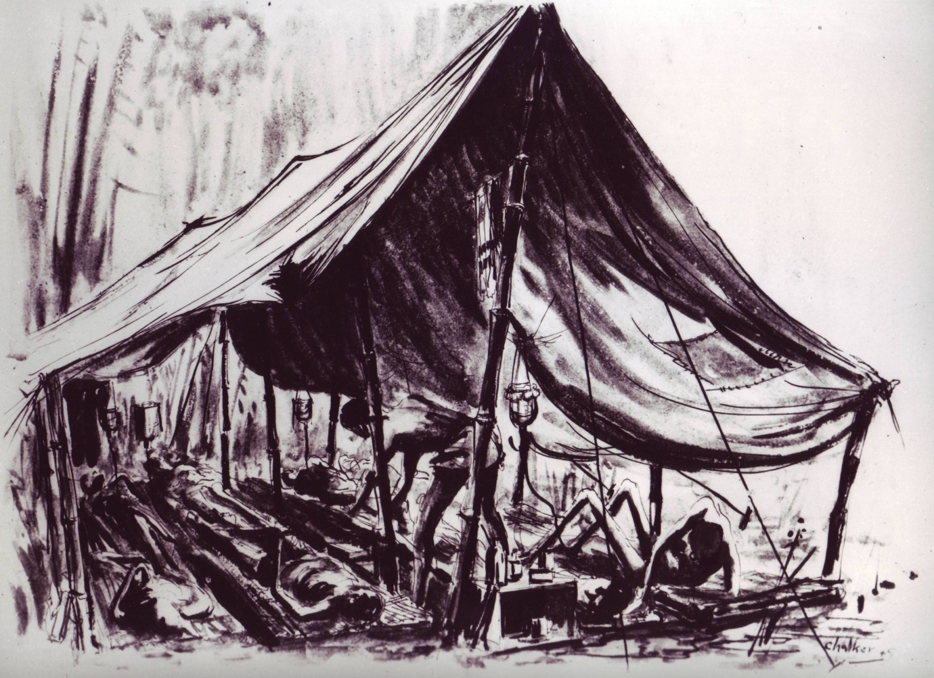

Figure 2. A tent for the treatment of cholera cases at Hintok Camp during railway construction. Note the makeshift intravenous saline equipment to the right of the medical orderly leaning down to tend to one of the sick POWs (copyright Jack Chalker).

