## Supplementary material to:

**Efficacy of Olyset Duo, a bednet containing pyriproxyfen and permethrin, versus a permethrin-only net against clinical malaria in an area with highly pyrethroid-resistant vectors in rural Burkina Faso: a cluster-randomised controlled trial**

## A: Supplementary tables and figures

## Table A1. Characteristics of study area according to the census.

|  |  |  |  |  |  |  |  |  |  |
| --- | --- | --- | --- | --- | --- | --- | --- | --- | --- |
|  | **Month of rollout of PPF-LLINs** | | | | | | | |  |
|  | **June 2014** | **July 2014** | **Aug 2014** | **Sept 2014** | **June 2015** | **July 2015** | **Aug 2015** | **Sept 2015** | **Total** |
| Number of clusters | 5 | 5 | 5 | 5 | 5 | 5 | 5 | 5 | 40 |
| Number of villages | 10 | 11 | 11 | 12 | 11 | 13 | 15 | 8 | 91 |
| Number of households | 812 | 1004 | 917 | 842 | 517 | 546 | 685 | 739 | 6062 |
| Population | 8739 | 7620 | 9505 | 8597 | 5758 | 6170 | 8043 | 9054 | 63486 |
| Children aged 6-35 months | 880 | 717 | 905 | 872 | 564 | 621 | 796 | 892 | 6247 |
| Children aged 3-5 years | 663 | 564 | 738 | 713 | 505 | 504 | 644 | 748 | 5079 |

Values are numbers.

**Table A2. Characteristics of replacement children enrolled into the cohort at the third survey (May 2015).**

|  |  |  |  |  |  |  |  |  |  |
| --- | --- | --- | --- | --- | --- | --- | --- | --- | --- |
|  | **Month of rollout of PPF-LLINs** | | | | | | | |  |
| **Characteristics** | **June 2014** | **July 2014** | **Aug 2014** | **Sept 2014** | **June 2015** | **July 2015** | **Aug 2015** | **Sept 2015** | **Total** |
| Children enrolled, N | 73 | 63 | 99 | 84 | 101 | 76 | 84 | 95 | 675 |
| Female, N (%) | 41/73 (56%) | 33/63 (52%) | 50/99 (51%) | 41/84 (49%) | 54/101 (53%) | 41/76 (54%) | 35/84 (42%) | 47/95 (49%) | 342/675 (51%) |
| Age (months), median (IQR) | 30 (21,39) | 29 (21,43) | 30 (18,41) | 29 (20,41) | 29 (17,40) | 29 (19,46) | 34 (24,47) | 29 (21,40) | 29 (20,42) |
| Sleeps under a mosquito net, N (%) | 73/73 (100%) | 61/63 (97%) | 99/99 (100%) | 84/84 (100%) | 100/101 (99%) | 75/76 (99%) | 83/84 (99%) | 94/95 (99%) | 669/675 (99%) |
| Took anti-malarials in last 14 days, N (%) | 0/73 (0%) | 1/63 (2%) | 0/99 (0%) | 2/84 (2%) | 1/101 (1%) | 1/76 (1%) | 0/84 (0%) | 0/95 (0%) | 5/675 (1%) |
| Sick with a fever during previous 48 hours, N (%) | 1/73 (1%) | 4/63 (6%) | 4/99 (4%) | 11/84 (13%) | 2/101 (2%) | 4/76 (5%) | 1/84 (1%) | 2/95 (2%) | 29/675 (4%) |
| Axillary temperatures (°C), median (IQR) | 36.4 (36.2,36.5) | 36.4 (36.2,36.7) | 36.3 (36.2,36.7) | 36.5 (36.2,36.9) | 36.4 (36.2,36.8) | 36.4 (36.2,36.8) | 36.5 (36.2,36.7) | 36.5 (36.2,36.8) | 36.4 (36.2,36.7) |
| Positive rapid diagnostic test, N (%) | 1/1 (100%) | 3/6 (50%) | 3/4 (75%) | 7/12 (58%) | 3/3 (100%) | 4/6 (67%) | 0/1 (0%) | 3/4 (75%) | 24/37 (65%) |
| Presence of *Plasmodium falciparum* parasites by microscopy, N (%) | 26/73 (36%) | 29/62 (47%) | 47/98 (48%) | 40/83 (48%) | 50/99 (51%) | 31/71 (44%) | 38/83 (46%) | 44/95 (46%) | 305/664 (46%) |
| >5000 *Plasmodium falciparum* parasites per μl, N (%) | 6/73 (8%) | 9/62 (15%) | 7/98 (7%) | 15/83 (18%) | 19/99 (19%) | 12/71 (17%) | 5/83 (6%) | 13/95 (14%) | 86/664 (13%) |
| *Plasmodium falciparum* parasite density (per μl), geometric mean (geometric SD) of non-zero values | 2162 (5·3) | 2043 (4·8) | 1634 (5·1) | 2923 (6·0) | 2865 (6·8) | 3203 (5·9) | 1293 (3·6) | 2308 (5·7) | 2211 (5·5) |
| Presence of *Plasmodium falciparum* gametocytes, N (%) | 3/73 (4%) | 4/62 (6%) | 6/98 (6%) | 4/83 (5%) | 6/99 (6%) | 4/71 (6%) | 7/83 (8%) | 5/95 (5%) | 39/664 (6%) |
| Haemoglobin level (g/L), median (IQR) | 112.0 (107.0,115.0) | 101.0 (94.0,111.0) | 103.0 (98.0,111.0) | 105.0 (99.0,111.0) | 102.0 (96.0,111.0) | 103.5 (96.0,111.0) | 102.0 (99.0,110.0) | 103.0 (100.0,109.0) | 104.0 (99.0,111.0) |
| Moderate anaemia (haemoglobin <80 g/L), N (%) | 2/73 (3%) | 4/57 (7%) | 2/99 (2%) | 3/84 (4%) | 6/101 (6%) | 4/76 (5%) | 1/83 (1%) | 3/95 (3%) | 25/668 (4%) |
| Severe anaemia (haemoglobin <50 g/L), N (%) | 0/73 (0%) | 0/63 (0%) | 0/99 (0%) | 0/84 (0%) | 0/101 (0%) | 0/76 (0%) | 0/84 (0%) | 0/95 (0%) | 0/668 (0%) |
| Enlarged spleen (defined as score >0 using Hackett classification), N (%) | 6/73 (8%) | 1/63 (2%) | 0/99 (0%) | 1/84 (1%) | 3/101 (3%) | 3/76 (4%) | 7/84 (8%) | 0/95 (0%) | 21/675 (3%) |

IQR, interquartile range.

**Table A3. Incidence of clinical malaria in the cohort: unadjusted and adjusted regression models.**

|  |  |  |  |  |
| --- | --- | --- | --- | --- |
| **Model adjusted for [1]** | **RR (95% CI) for PPF-LLINs vs. standard LLINs** | **P value for PPF-LLINs vs. standard LLINs** | **P value for adjustment variable** | **AIC** |
| Nothing | 0·72 (0·66,0·78) | <0·001 | - |  |
| Calendar month [2] | 0·89 (0·78,1·01) | 0·07 | <0·001 |  |
| Calendar month and health facility [2,3] | 0·88 (0·77,0·99) | 0·04 | Month: <0·001  Health facility: <0·001 | 27361 |
| **All the following adjusted for calendar month [2], health facility and:** |  |  |  |  |
| Age (categorised) | 0·87 (0·77,0·99) | 0·04 | <0·001 |  |
| When joined the cohort (survey 1 or 3) | 0·87 (0·77,0·98) | 0·03 | <0·001 |  |
| Coverage (whether slept under bed net last night, defined at entry into the cohort) | 0·88 (0·77,0·99) | 0·04 | 0·84 |  |
| Cluster size, defined by number of children per cluster | 0·88 (0·77,0·99) | 0·04 | 0·33 |  |
| Random effect for village, instead of cluster | 0·86 (0·76,0·97) | 0·02 | - |  |
| **Alterative adjustments for time (all adjusted for health facility):** |  |  |  |  |
| Year only (2014, 2015), ignoring month | 0·95 (0·86,1·05) | 0·29 |  | 28494 |
| Month only (May, June, …, Dec), ignoring year | 0·72 (0·66,0·79) | <0·001 |  | 27463 |
| Month and year as separate variables (May, June, …, Dec; and 2014, 2015) | 0·87 (0·77,0·99) | 0·03 |  | 27449 |
| **Repeating with ONLY months where there are data from both arms (all adjusted for health facility):** |  |  |  |  |
| Calendar month [2] | 0·86 (0·73,1·01) | 0·07 |  | 16656 |
| Year only (2014, 2015), ignoring month | 1·04 (0·88,1·22) | 0·69 |  | 17220 |
| Month only (May, June, …, Dec), ignoring year) | 0·86 (0·74,1·00) | 0·05 |  | 16654 |
| Month and year as separate variables (May, June, …, Dec; and 2014, 2015) | 0·86 (0·73,1·01) | 0·07 |  | 16656 |

AIC=Akaike information criterion. [1] Poisson models with offset for exposure time (natural log transformed), with random intercept for cluster (unless otherwise indicated). [2] Calendar month defined as May 2014, June 2014, …, Dec 2015. [3] This is the model reported in the final column of Table 3

**Table A4. Secondary and tertiary endpoints at the second cross-sectional survey, by arm: stratified by aged <30 versus ≥30 months.**

|  |  |  |  |  |  |  |  |
| --- | --- | --- | --- | --- | --- | --- | --- |
|  | Aged <30 months | | | Aged ≥30 months | | | |
| Characteristics | **Standard LLINs**  **(n=520)** | **PPF-LLINs**  **(n=578)** | **Odds ratio (OR) or coefficient (95% CI; p) [1]** | | **Standard LLINs**  **(n=1279)** | **PPF-LLINs**  **(n=1296)** | **Odds ratio (OR) or coefficient (95% CI; p) [1]** |
| Presence of *Plasmodium falciparum* parasites by microscopy, N (%) | 274/511 (54%) | 300/571 (53%) | OR=0·92 (0·65,1·28; p=0·61) | | 822/1250 (66%) | 824/1272 (65%) | OR=0·94 (0·75,1·18; p=0·60) |
| >5000 *Plasmodium falciparum* parasites per μl, N (%) | 104/511 (20%) | 112/571 (20%) | OR=0·93 (0·68,1·25; p=0·62) | | 254/1250 (20%) | 226/1272 (18%) | OR=0·84 (0·68,1·02; p=0·08) |
| Haemoglobin level (g/L), mean (SD) | 95·4 (14·38) | 99·3 (11·81) | Coefficient=3·5 (0·9,6·1; p=0·008) | | 103·8 (12·87) | 105·3 (11·23) | Coefficient=1·2  (-1·1,3·5; p=0·29) |
| Moderate anaemia (haemoglobin <80 g/L), N (%) | 66/512 (13%) | 32/544 (6%) | OR=0·41 (0·19,0·84; p=0·02) | | 47/1256 (4%) | 22/1238 (2%) | OR=0·48 (0·26,0·91; p=0·02) |
| Severe anaemia (haemoglobin <50 g/L), N (%) | 4/512 (1%) | 0/544 (0%) | Not estimable | | 3/1256 (0%) | 0/1238 (0%) | Not estimable |
| Enlarged spleen (defined as score >0 using Hackett classification), N (%) | 148/520 (28%) | 146/578 (25%) | OR=1.00 (0.16,6.45; p=1.00) | | 382/1279 (30%) | 275/1296 (21%) | OR=0.66 (0.09,4.86; p=0.68) |

Analyses stratified by age were pre-specified for haemoglobin levels but not for the other secondary outcomes. Includes cohort and additional children, but excluding children during the month of and month after the introduction of the intervention. [1] Odds ratio or coefficient with 95% confidence interval and p-value for PPF-LLINs versus standard LLINs, using logistic and linear regression models for categorical and continuous variables, respectively, with cluster as a random effect and health facility as a fixed effect.

**Table A5. Secondary and tertiary endpoints at the second cross-sectional survey, by arm: stratified by cohort versus additional children.**

|  |  |  |  |  |  |  |  |
| --- | --- | --- | --- | --- | --- | --- | --- |
|  | Cohort children (survey 2) | | | Additional children (survey 2) | | | |
| Characteristics | **Standard LLINs**  **(n=887)** | **PPF-LLINs**  **(n=908)** | **Odds ratio (OR) or coefficient (95% CI; p) [1]** | | **Standard LLINs**  **(n=912)** | **PPF-LLINs**  **(n=966)** | **Odds ratio (OR) or coefficient (95% CI; p) [1]** | |
| Presence of *Plasmodium falciparum* parasites by microscopy, N (%) | 475/866 (55%) | 494/892 (55%) | OR=1·03 (0·80,1·32; p=0·84) | | 621/895 (69%) | 630/951 (66%) | OR=0·82 (0·64,1·05; p=0·12) | |
| >5000 *Plasmodium falciparum* parasites per μl, N (%) | 146/866 (17%) | 150/892 (17%) | OR=1·00 (0·77,1·28; p=0·98) | | 212/895 (24%) | 188/951 (20%) | OR=0·80 (0·61,·0·96; p=0·02) | |
| Haemoglobin level (g/L), mean (SD) | 101·7 (13·78) | 104·4 (11·78) | Coefficient=2·2 (0·0,4·4; p=0·05) | | 101 (13·9) | 103 (11·6) | Coefficient=1·5  (-1·0,4·0; p=0·23) | |
| Moderate anaemia (haemoglobin <80 g/L), N (%) | 50/875 (6%) | 25/868 (3%) | OR=0·52 (0·30,0·88; p=0·02) | | 63/893 (7%) | 29/914 (3%) | OR=0·48 (0·20,1·16; p=0·10) | |
| Severe anaemia (haemoglobin <50 g/L), N (%) | 3/875 (0%) | 0/868 (0%) | Not estimable | | 4/893 (0%) | 0/914 (0%) | Not estimable | |
| Enlarged spleen (defined as score >0 using Hackett classification), N (%) | 248/887 (28%) | 208/908 (23%) | OR=1.82 (0.17,19.2; p=0.62) | | 282/912 (31%) | 213/966 (22%) | OR=0.43 (0.06,3.29; p=0.42) | |

Analyses stratified by cohort versus additional children were not pre-specified but were performed to check whether there were important differences between the children later enrolled as replacements compared to those enrolled at the start of the study. Includes cohort and additional children, but excluding children during the month of and month after the introduction of the intervention. [1] Odds ratio or coefficient with 95% confidence interval and p-value for PPF-LLINs versus standard LLINs, using logistic and linear regression models for categorical and continuous variables, respectively, with cluster as a random effect and health facility as a fixed effect.

**Table A6. Adverse events (AEs).**

|  |  |  |  |
| --- | --- | --- | --- |
|  | **Standard LLINs** | **PPF-LLINs** | **Total** |
| Number of children with at least one AE | 11 | 1 | 12 |
| Number of AEs | 21 [1] | 1 [2] | 22 |
| Diagnosis |  |  |  |
| Bronchitis | 2 | 1 | 3 |
| Conjunctivitis | 1 | 0 | 1 |
| Eye pruritus | 1 | 0 | 1 |
| Pelvic pain | 2 | 0 | 2 |
| Pruritus | 6 | 0 | 6 |
| Rhinitis | 5 | 0 | 5 |
| Cough | 3 | 0 | 3 |
| Watering eyes | 1 | 0 | 1 |
| Severity |  |  |  |
| Mild | 13 | 1 | 14 |
| Moderate | 8 | 0 | 8 |
| Relationship to study |  |  |  |
| None | 16 | 0 | 16 |
| Related | 5 | 1 | 6 |
| Outcome |  |  |  |
| Resolved | 21 | 1 | 22 |
| Action taken |  |  |  |
| None | 5 | 0 | 5 |
| Medication | 16 | 1 | 17 |

Presented by arm at time of AE. [1] One child had cough, followed the next day by watering eyes. One child had rhinitis and cough, followed by rhinitis again one month later. One child had pruritus, followed the next day by rhinitis. One child had pruritus on two consecutive days, followed two days later by cough and pelvic pain, followed the next day by rhinitis. One child had bronchitis, followed two days later by conjunctivitis. One child had pruritus twice, approximately two months apart. [2] AE occurred <1 month after rollout of PPF-LLINs.

**Table A7. Serious adverse events (SAEs).**

|  |  |  |  |
| --- | --- | --- | --- |
|  | **Standard LLINs** | **PPF-LLINs** | **Total** |
| Number of children with at least one SAE | 9 | 9 | 18 |
| Number of SAEs | 10 [1] | 9 [2] | 19 |
| Diagnosis |  |  |  |
| Severe malaria | 6 | 1 | 7 |
| Severe malaria and pneumonia | 0 | 1 | 1 |
| Severe malaria and urinary infection | 1 | 0 | 1 |
| Severe malaria and skin infection | 0 | 1 | 1 |
| Uncomplicated malaria and vomiting | 1 | 0 | 1 |
| Gastro-enteritis and severe dehydration | 0 | 1 | 1 |
| Pneumonia | 1 | 0 | 1 |
| No information | 1 | 5 | 6 [3] |
| Type of SAE |  |  |  |
| Died | 1 | 5 | 6 |
| Hospitalisation | 9 | 4 | 13 |

Presented by arm at time of SAE. [1] One child was diagnosed with severe malaria followed by pneumonia two months later (both before rollout of PPF-LLINs in her village). [2] Median time since rollout of PPF-LLINs at the time of the SAE was 1.5 months (IQR 0.03 to 11 months). [3] All deaths.

**Table A8. Pregnancies.**

|  |  |  |  |
| --- | --- | --- | --- |
|  | **Standard LLINs** | **PPF-LLINs** | **Total** |
| Number of pregnancies | 602 | 961 | 1563 |
| Delivery |  |  |  |
| Normal | 594 (99%) | 935 (97%) | 1529 (98%) |
| Forceps/Ventouse | 1 (<1%) | 0 (0%) | 1 (<1%) |
| Caesarean section | 0 (0%) | 3 (0%) | 3 (<1%) |
| Spontaneous abortion | 1 (<1%) | 8 (1%) | 9 (1%) |
| Missing | 6 (1%) | 15 (2%) | 21 (1%) |
| Neonate |  |  |  |
| Normal | 591 (98%) | 914 (95%) | 1505 (96%) |
| Abnormal | 1 (<1%) | 6 (1%) | 7 (<1%) |
| Still born | 3 (<1%) | 13 (1%) | 16 (1%) |
| Missing [1] | 7 (1%) | 28 (3%) | 35 (2%) |
| Low birth weight (<2.5 kg) | 29 (5%) | 62 (7%) | 91 (6%) [2] |

Presented by arm at time of delivery. [1] Includes those with missing delivery information and spontaneous abortion. [2] Missing for 10 and 46 pregnancies in the standard LLIN and PPF-LLIN groups, respectively (percentages are of non-missing values).

**Table A9. Asthma.**

|  |  |  |
| --- | --- | --- |
|  | **Standard LLINs** | **PPF-LLINs** |
| Number of children with asthma [1] | 40 | 15 |
| Score |  |  |
| <15 (asthma not under control) | 0 | 0 |
| 15-19 (asthma partially under control) | 4 (10%) | 3 (20%) |
| 20-25 (asthma under control) | 36 (90%) | 12 (80%) |

For study subjects identified with asthma, we used the asthma control test method to monitor them for the month following the net donation (standard or PPF LLINs) to document any aggravation of symptoms.1 33 children had data only from the period during which they were in the standard LLIN arm, 8 children had data only from the period during which they were in the PPF-LLIN arm, and 7 children had data from both the period during which they were in the standard LLIN arm and during which they were in the PPF-LLN arm (these children contribute data to both columns). For multiple visits for the same child within one arm of the trial, the mean score was taken. The median number of visits per child was 5.5 and 4 within the standard and PPF-LLN arms, respectively (range 1-8 and 1-7, respectively).

Whilst the number of serious adverse events were similar in both study arms, there were fewer adverse events in the PPF-LLIN arm than with standard LLINs. In absolute numbers there were more spontaneous abortions in women with PPF-LLINs than standard LLINs, although this was not statistically significant (Fisher’s exact test, p = 0.08), nor was clustering considered in the analysis. There were fewer children with asthma in the PPF-LLIN arm than those with standard LLINs, with no children having asthma that could not be controlled by therapy.

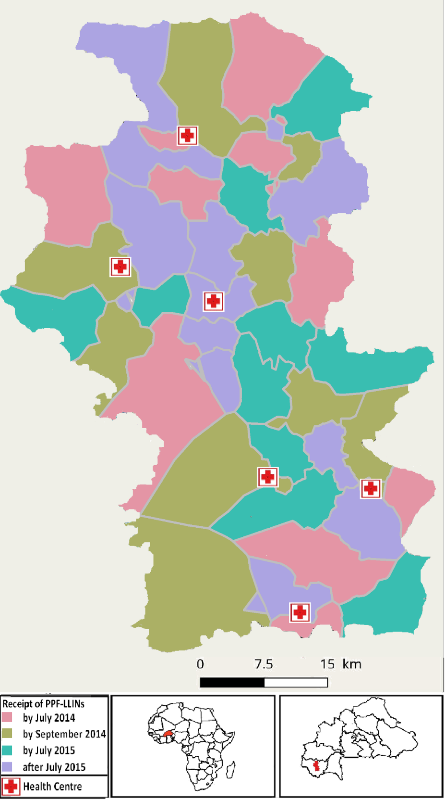

**Figure A1. Roll out of the pyriproxyfen and permethrin long-lasting insecticidal nets.**

Grey lines indicate cluster boundaries, defined by villages or groups of neighbouring villages with at least 50 children aged 6 months to 5 years. The colours indicate the order of the rollout of the pyriproxyfen and permethrin long-lasting insecticidal nets. There are 40 clusters, and the rollout was performed in 8 rounds (5 clusters per round) with order randomly assigned.



**Figure A2. Malaria events outside the study area.**

Malaria events defined by positive rapid diagnostic test.

**B: Operating characteristics of different parasitaemia cutoffs**

**Introduction**

In areas highly endemic for *Plasmodium falciparum*, many individuals who have no acute symptoms of the disease carry malaria parasites in their blood. The detection of parasites in patients presenting with fever is often used as an operational definition of clinical malaria in epidemiological studies and field trials. In such areas, some patients so diagnosed as clinical malaria are suffering from fevers of non-malaria etiology, but are considered as clinical malaria cases because of incidental parasitaemia. This leads to overestimation of the number of cases, and reduces the specificity of the definition of clinical malaria, leading to a downward bias in estimates of efficacy in comparative field trials.

The specificity of the case-definition can be improved by imposing a requirement for parasite densities in fever patients to exceed a threshold value, before classifying them as clinical malaria (often a cut-off of 5000 parasites/μl, as determined by microscopy is used). Formal statistical analysis of the quantitative relationship between disease incidence and parasite density can be carried out to estimate the operating characteristics of different thresholds.2 This is achieved by comparing the distribution of parasite densities in population surveys, with that in fever patients. This analysis also provides an estimate of the proportion of the malaria attributable fraction of fevers, $λ$.

This document reports the application of this analysis to the data of the pyriproxyfen net trial. The sensitivities, specificities, and attributable fractions were estimated separately for each arm of the trial. The values obtained are used to estimate the bias in effectiveness estimates that would apply if different density thresholds were adopted. The analysis also provides an estimate of effectiveness that avoids these biases by using the attributable fractions to estimate the numbers of clinical malaria episodes in each arm, without the need to classify each individual patient.

**Methods**

The analytical approach treats the parasite densities for fever patients, $x_{1},x_{2},…x_{n},$ as a sample from a mixture with two components, $θ$ (corresponding to negative samples equivalent to control (population survey) samples) and $ϕ$ (corresponding to positive samples with higher values of *x* than the controls) so that:

$p_{i}=\left(1-λ_{i}\right)θ_{i}+ λ_{i}ϕ_{i}$ (C1)

where: $p_{i}=P\left(x ϵ category i\right)$; $θ_{i}=P\left(x ϵ category i | x ϵ θ\right); ϕ_{i}=P\left(x ϵ category i | x ϵ ϕ\right);$ and $λ_{i}$ is the probability that a fever case in category *i* has true malaria etiology (this increases with *i* Aparasitaemic patients cannot be true malaria cases, so $λ_{1}=0$, making $ϕ_{i},θ_{i},$ and $λ_{i}$ identifiable.

A latent class model, using the method of Vounatsou *et al* 3 is used to obtain Bayesian estimates of all the quantities in equation C1 using a Markov chain Monte Carlo algorithm in the package WinBUGS.4 The WinBUGS code used to fit this model is provided below**.**

The sensitivities and specificities of different candidate threshold parasite densities can be expressed as functions of $ϕ_{i},θ_{i},$ and $λ_{i}$. For the case definition using the *i* th parasite density threshold, (corresponding to the lower boundary of the category) these are computed as:

$sensitivity=\sum_{j=i}^{k}{ϕ_{j} }$, and

$${specificity=1-\sum_{j=i}^{k}{θ_{j} }}/{\sum_{j=i}^{k}{p_{j} }}$$

where *k* is the total number of parasite density categories included in the analysis. Correspondingly, the proportion of fever cases that are malaria attributable (the attributable fraction, $λ$) is computed as:

$$λ=\sum_{i=1}^{k}{λ_{i} ϕ_{i} }$$

Using the microscopy results from the trial, the effectiveness estimated using each parasite density threshold, is:

$$E_{i}=1-\frac{n_{C}m_{I}\sum_{j=i}^{k}{ p_{i,C} }}{n_{I}m_{C}\sum_{j=i}^{k}{ p_{i,I} }}$$

where the subscripts *C* and *I* refer to the control and intervention arms respectively, the quantities *n* and *m* are the total numbers of patients and surveyed individuals in the corresponding arms, and the sums, $\sum_{j=i}^{k}{ p_{i}}$, give the proportions of fever cases satisfying the case definition. This is the conventional estimate of effectiveness (the values of $m_{I}$ and $m_{C}$ appear in order to scale the corresponding counts of episodes by the person-time-at-risk, assumed to be proportional to the number of survey attendees).

The estimate of effectiveness that uses the attributable fractions, $λ$, to estimate the numbers of clinical malaria episodes in each arm without classifying each individual patient is then the adjusted effectiveness estimate:

$$E=1-\frac{n_{C}m_{I}λ_{C}}{n_{I}m_{C}λ_{I}}$$

**Results**

The samples used for analysis were grouped into 9 categories of parasite density (Table C1).

**Table C1: Numbers of samples included in analysis of parasite densities**

|  |  |  |  |  |
| --- | --- | --- | --- | --- |
| Lower bound of density  (parasites per µl) | Cross-sectional surveys | | Fever cases | |
| Control | Inter-vention | Control | Inter-vention |
| 0 | 2225 | 3415 | 324 | 525 |
| 1 | 486 | 753 | 91 | 104 |
| 500 | 388 | 636 | 71 | 86 |
| 1000 | 499 | 890 | 113 | 120 |
| 2500 | 419 | 588 | 115 | 113 |
| 5000 | 311 | 515 | 104 | 121 |
| 10000 | 279 | 431 | 208 | 270 |
| 25000 | 88 | 136 | 293 | 317 |
| 50000 | 81 | 91 | 507 | 660 |

Just less than half of the survey samples analysed in each arm were positive by microscopy, and most of the positive survey samples had low densities (less than 5000 parasites/μl) (Figure C1).

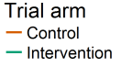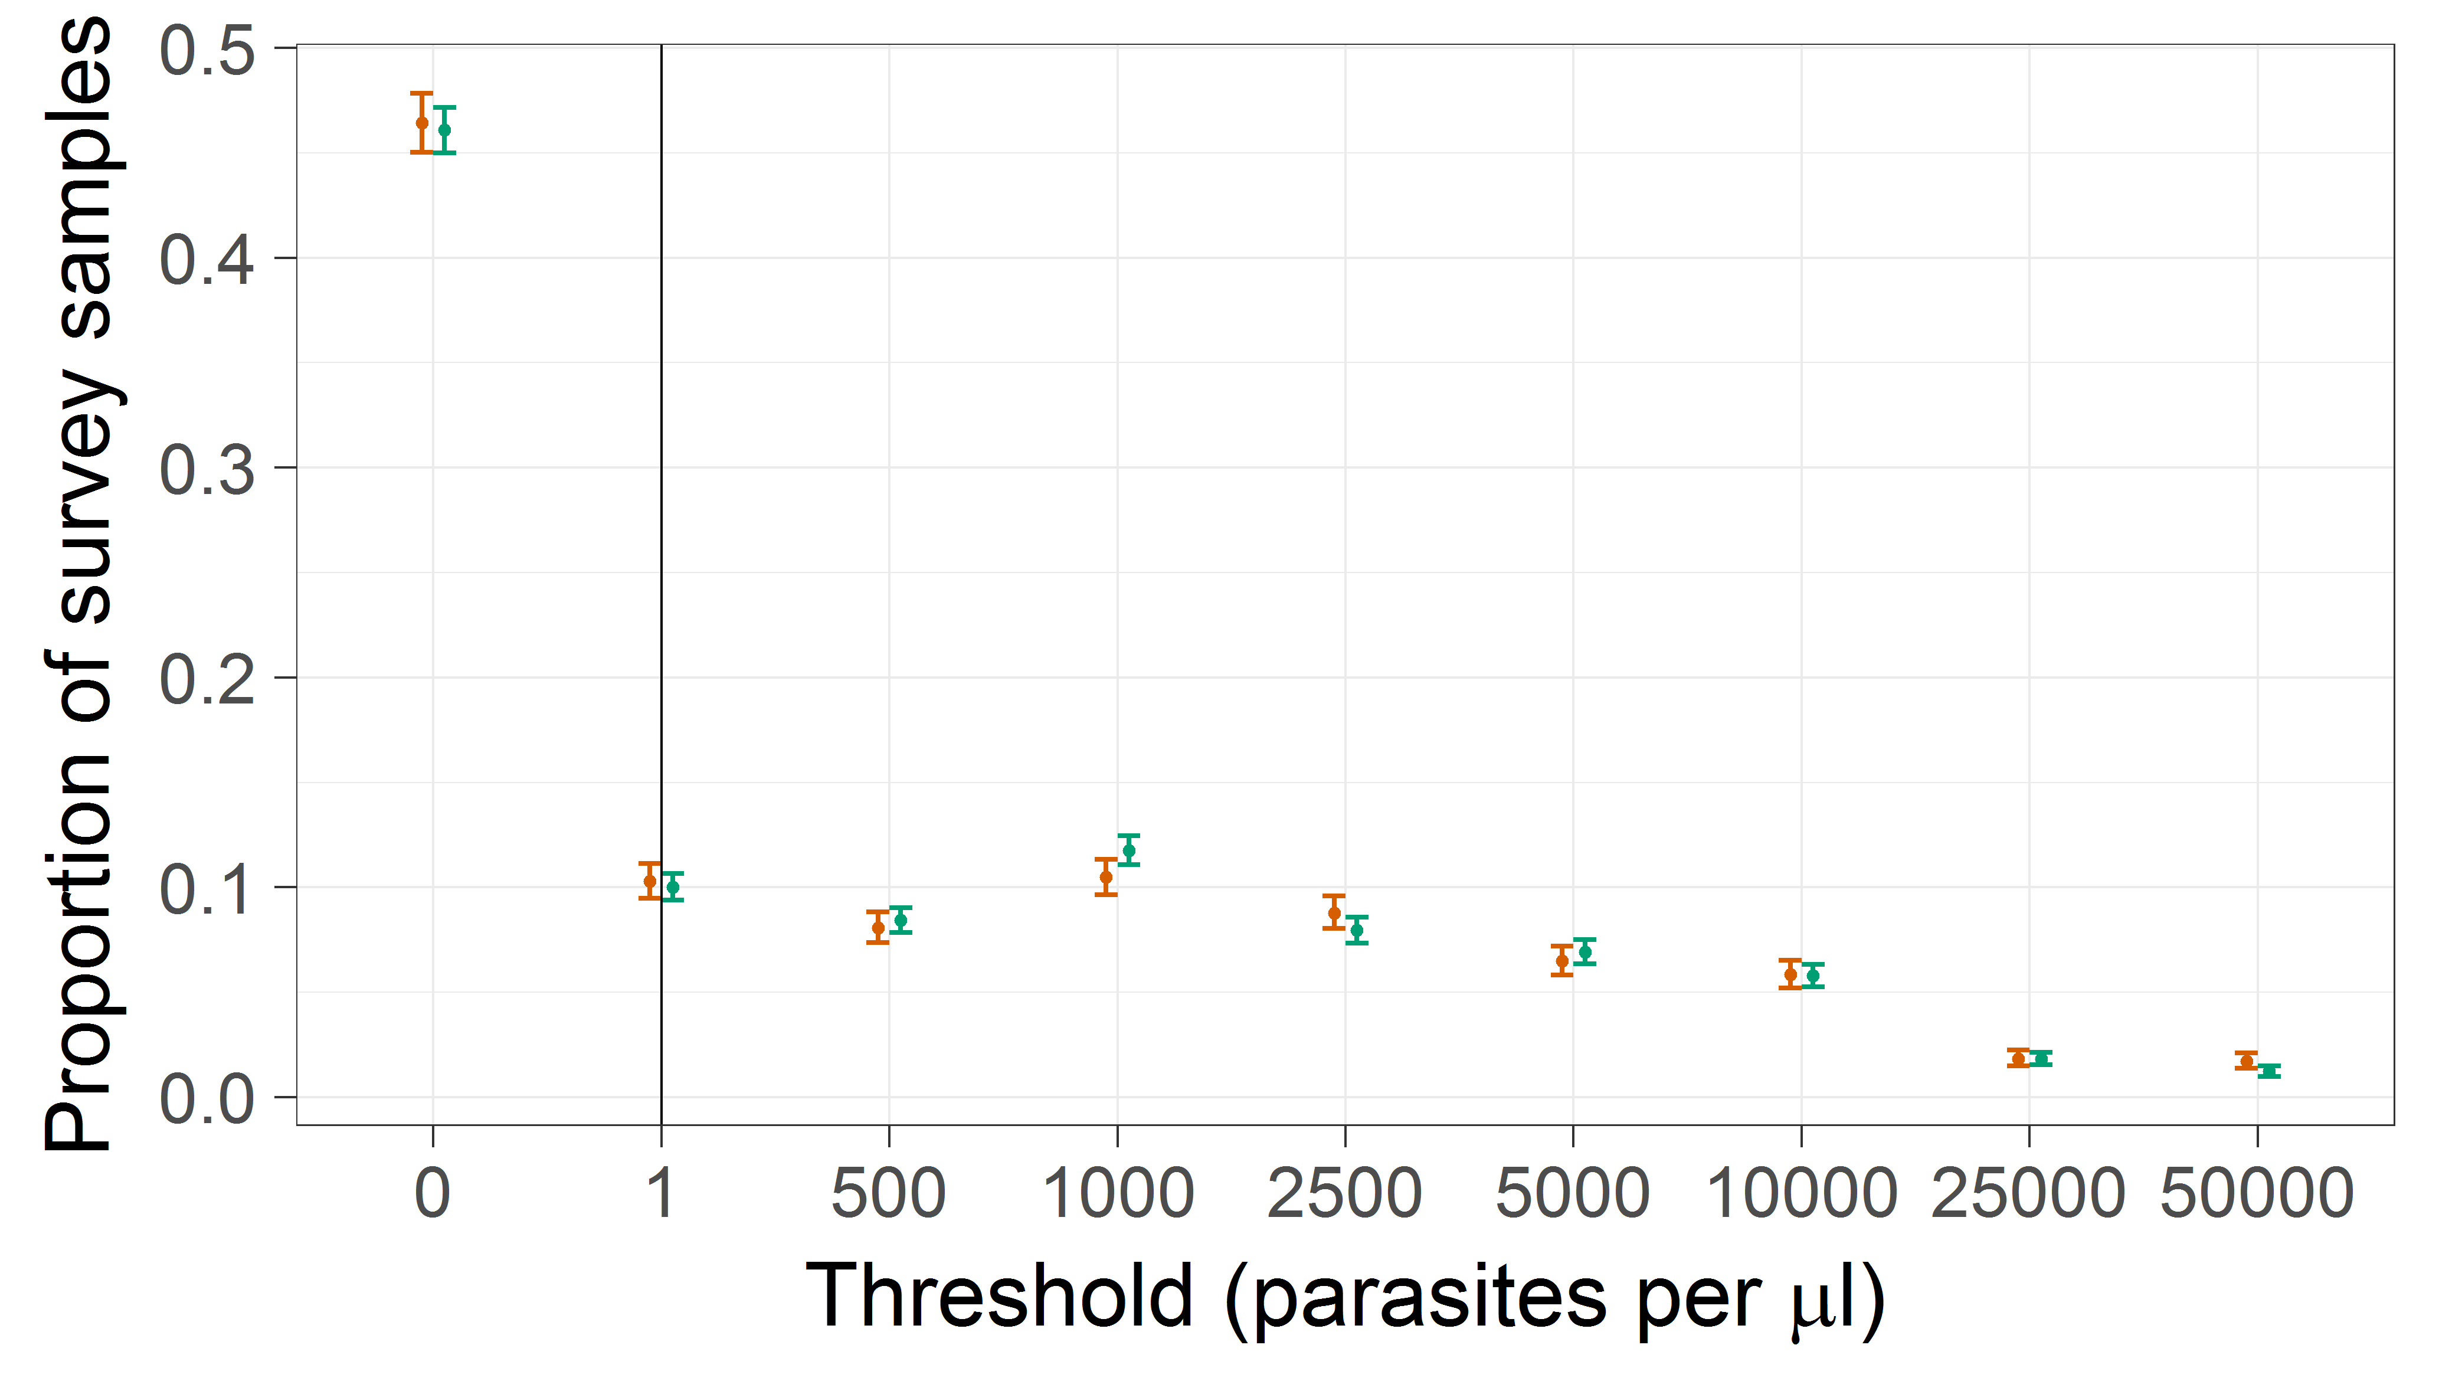

**Figure C1: Estimates of $θ_{i}$ (distribution of parasite densities in non-malaria fever or survey samples)**

Error bars correspond to 95% credible intervals; vertical lines to a threshold of any parasitaemia by microscopy.

The constraints that the ratio of malaria:non-malaria cases increases with parasite density, and that fevers in aparasitaemic (or sub-patent) patients are assumed to be of non-malaria etiology, lead to estimates of $λ_{i}$ that increase strongly with parasite density around values of around 5000 parasites/μl (Figure C2).

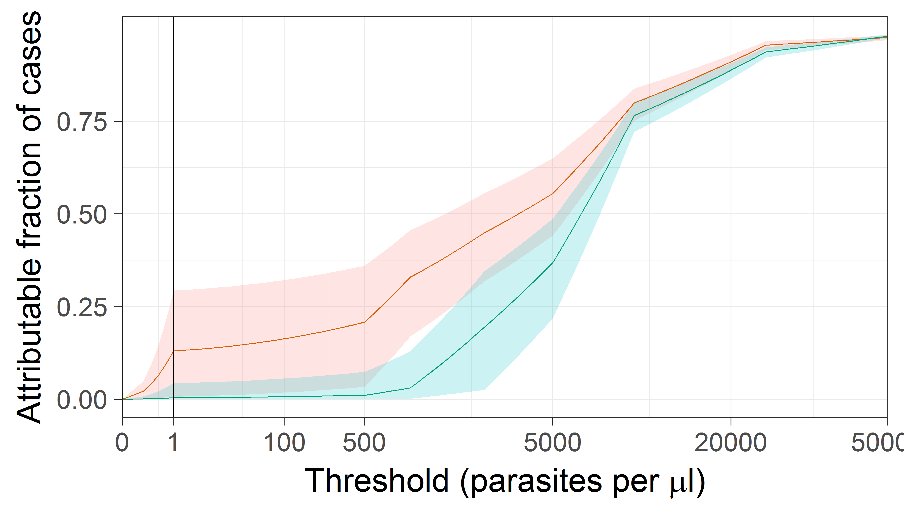

**Figure C2: Estimates of the probability cases are malaria attributable, $λ_{i}$**  **, by parasite density.**

Shaded envelopes correspond to 95% credible intervals; Colours and vertical lines as per Figure C1.

The overall estimates of the attributable fractions, $λ$, are 0·609 (95% CI 0·569-0·648) for the control arm, with a slightly lower value of 0·528 (95% CI 0·500-0·556) for the intervention arm.

Since values of $λ_{i}$ vary considerably with *i*, the estimated distributions of parasite densities in the malaria attributable fever cases (Figure C3) are very different from those in the surveys.

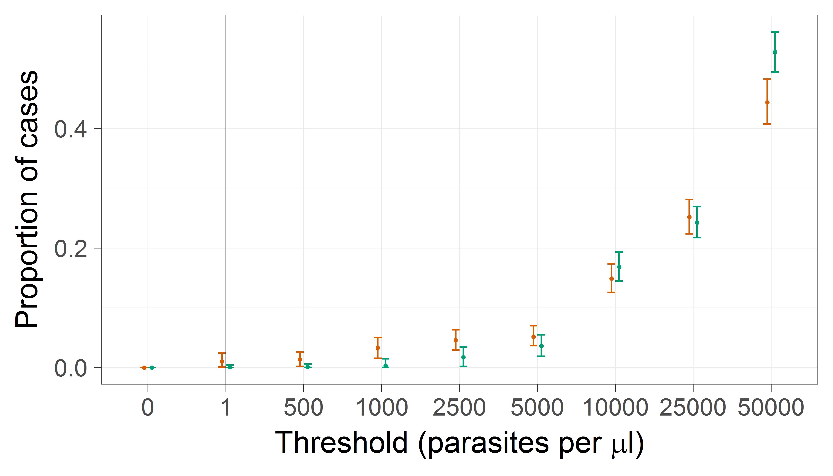

**Figure C3: Estimates of $ϕ_{i}$ (distribution of parasite densities in true malaria cases)**

Colours and lines as per Figure C1**.**

At lower densities than around 5000 parasites/μl this, the probabilities that a clinical case is malaria attributable at a given density diverge (Figure C2). This is because there was a higher ratio of clinical cases to survey samples at these densities in the control arm. However there is little difference between arms in the estimates of $ϕ_{i}$ shown in Figure C3. Correspondingly, the estimates of the sensitivities (Figure C4) and specificities (Figure C5) for different parasite density thresholds are similar for both trial arms.

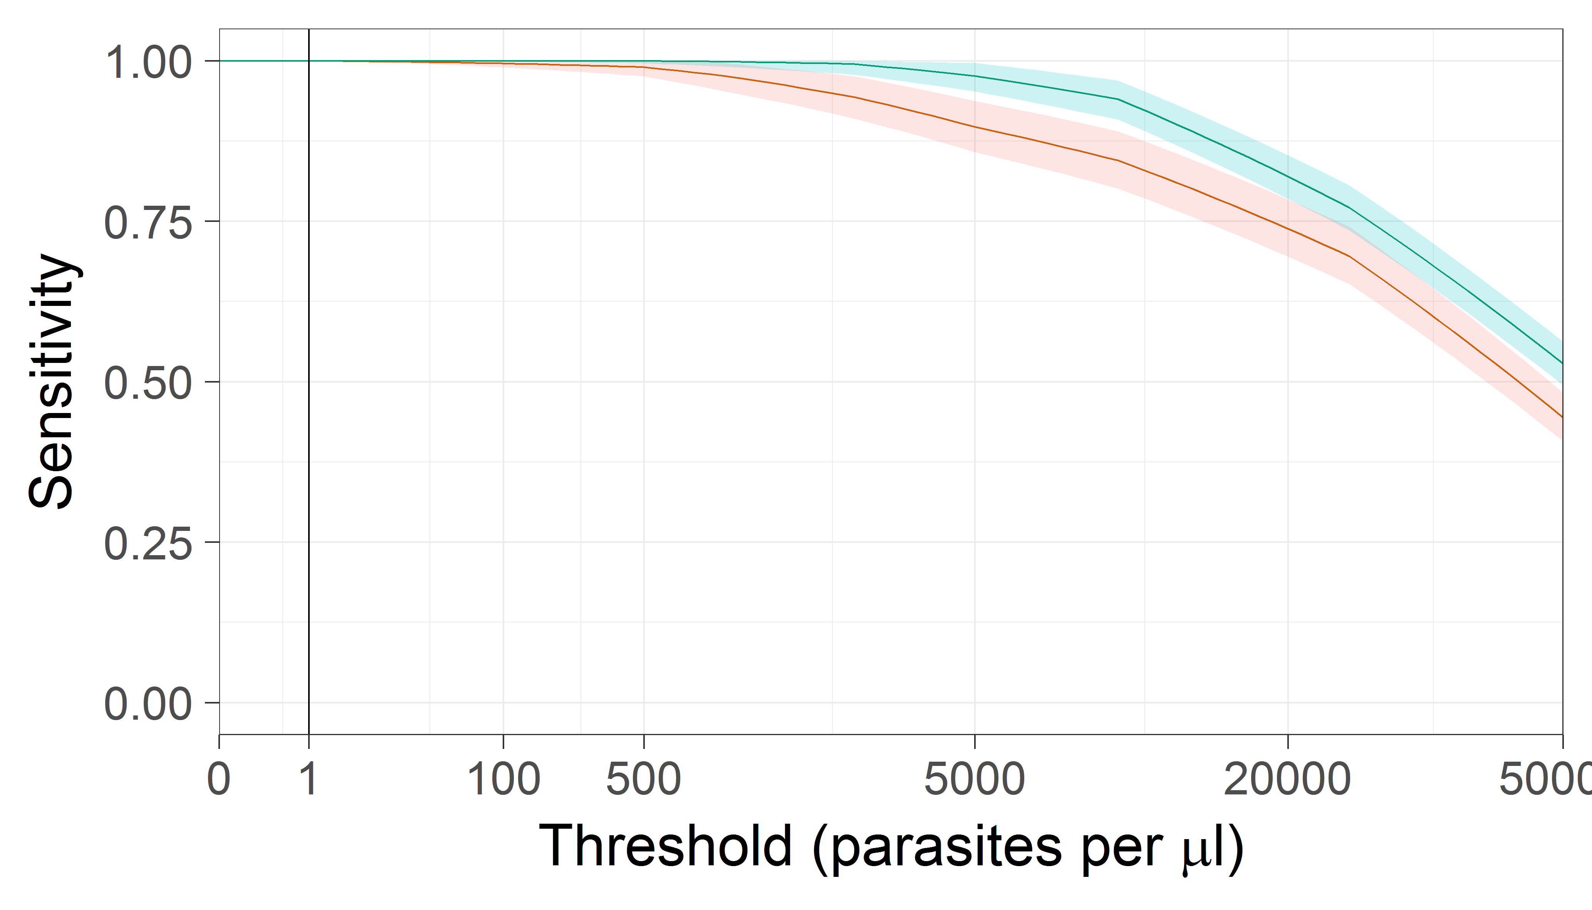

**Figure C4: Sensitivity of parasite density thresholds**

Colours, shading and vertical lines as Figure C2.

As anticipated, there is a substantial increase in specificity with parasite density, with a threshold value of around 5000 parasites/μl required to achieve a specificity above 80% (Figure C5). This implies that many cases with low parasite densities included in the primary trial analysis are sick because of causes other than clinical malaria.

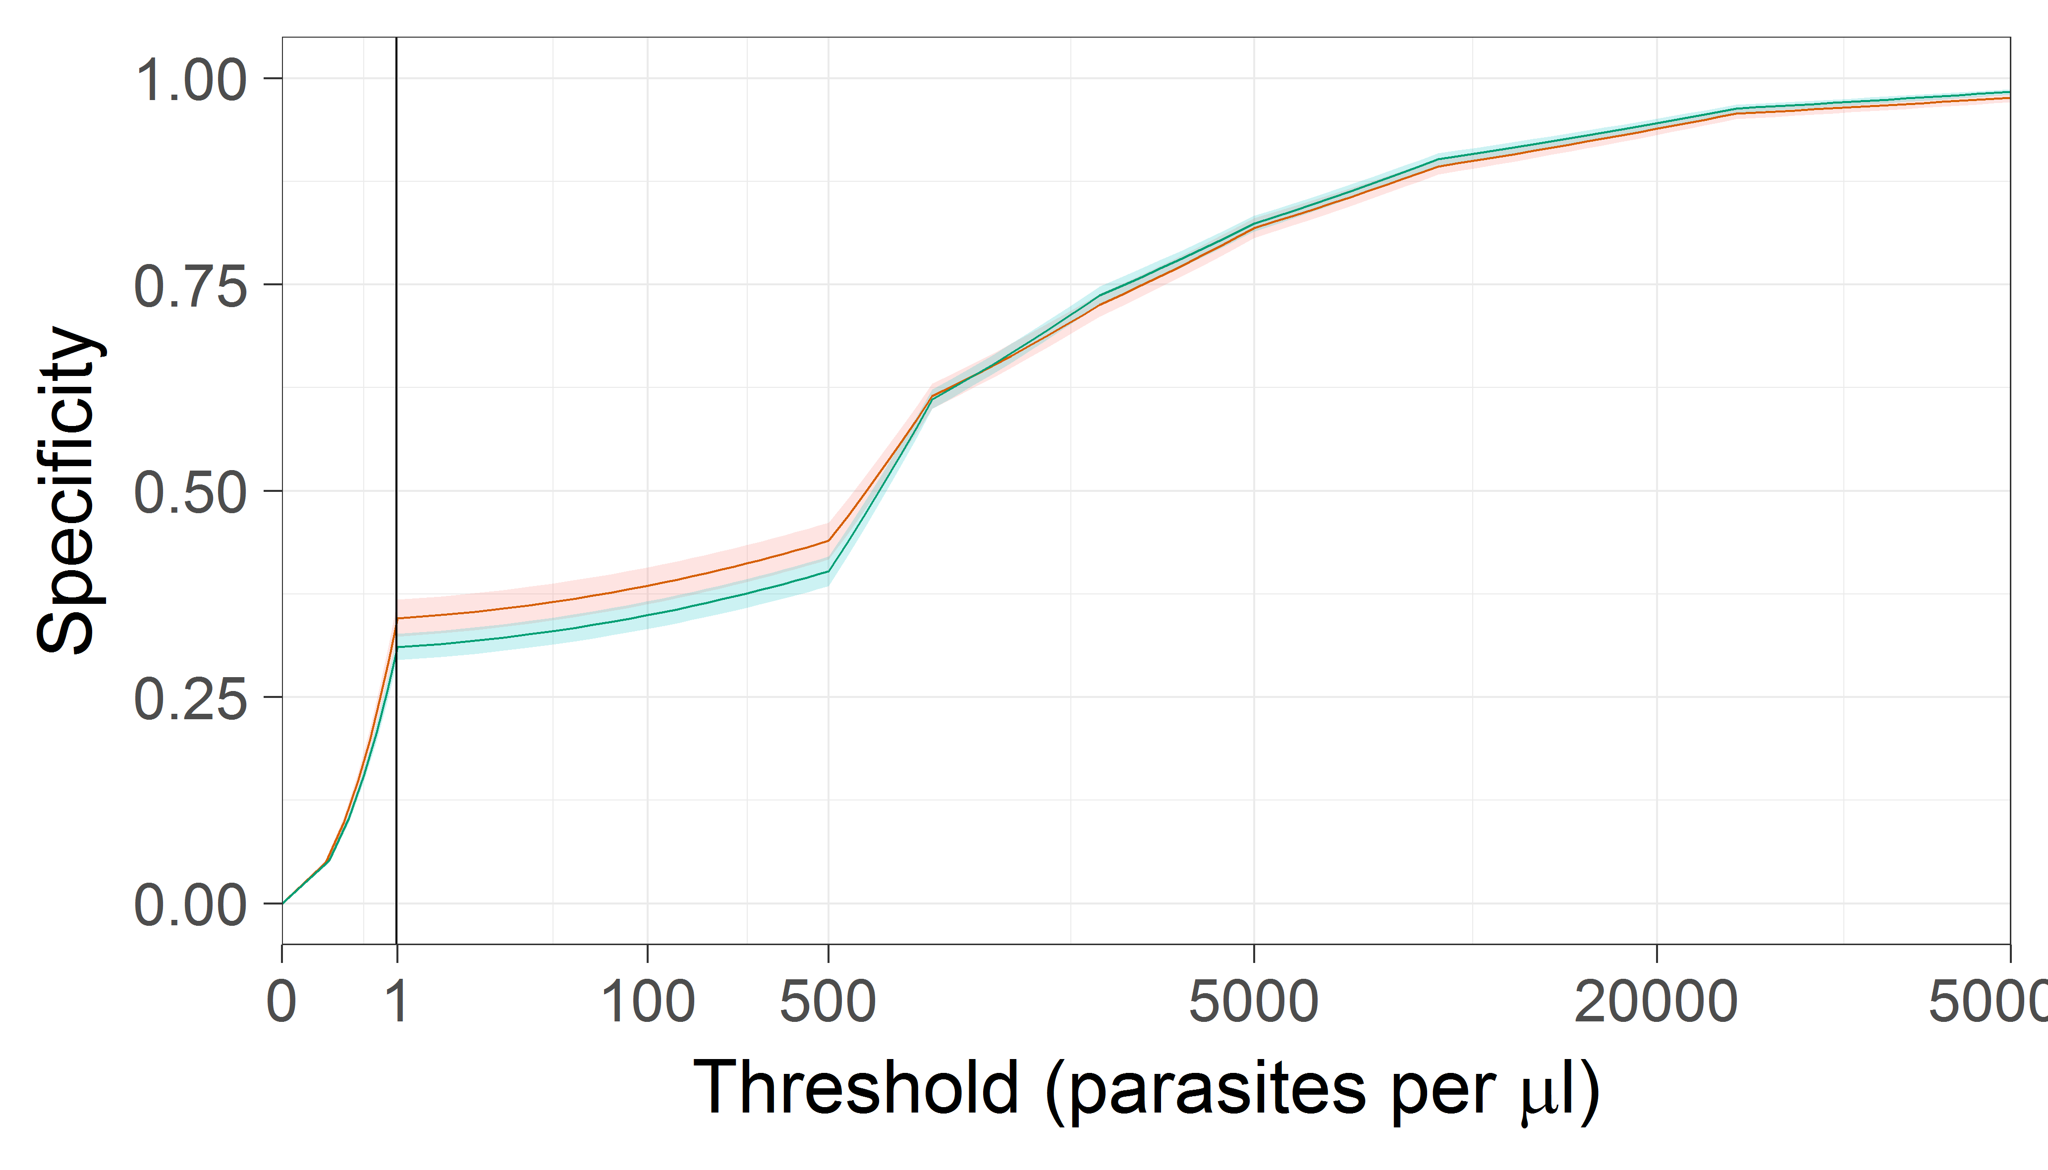

**Figure C5: Specificity of parasite density thresholds**

Colours, shading and vertical lines as Figure S2.

The extent to which the inclusion of non-malaria fevers biases the estimate of effectiveness is illustrated by the effectiveness estimates made using the different thresholds (Figure C6).

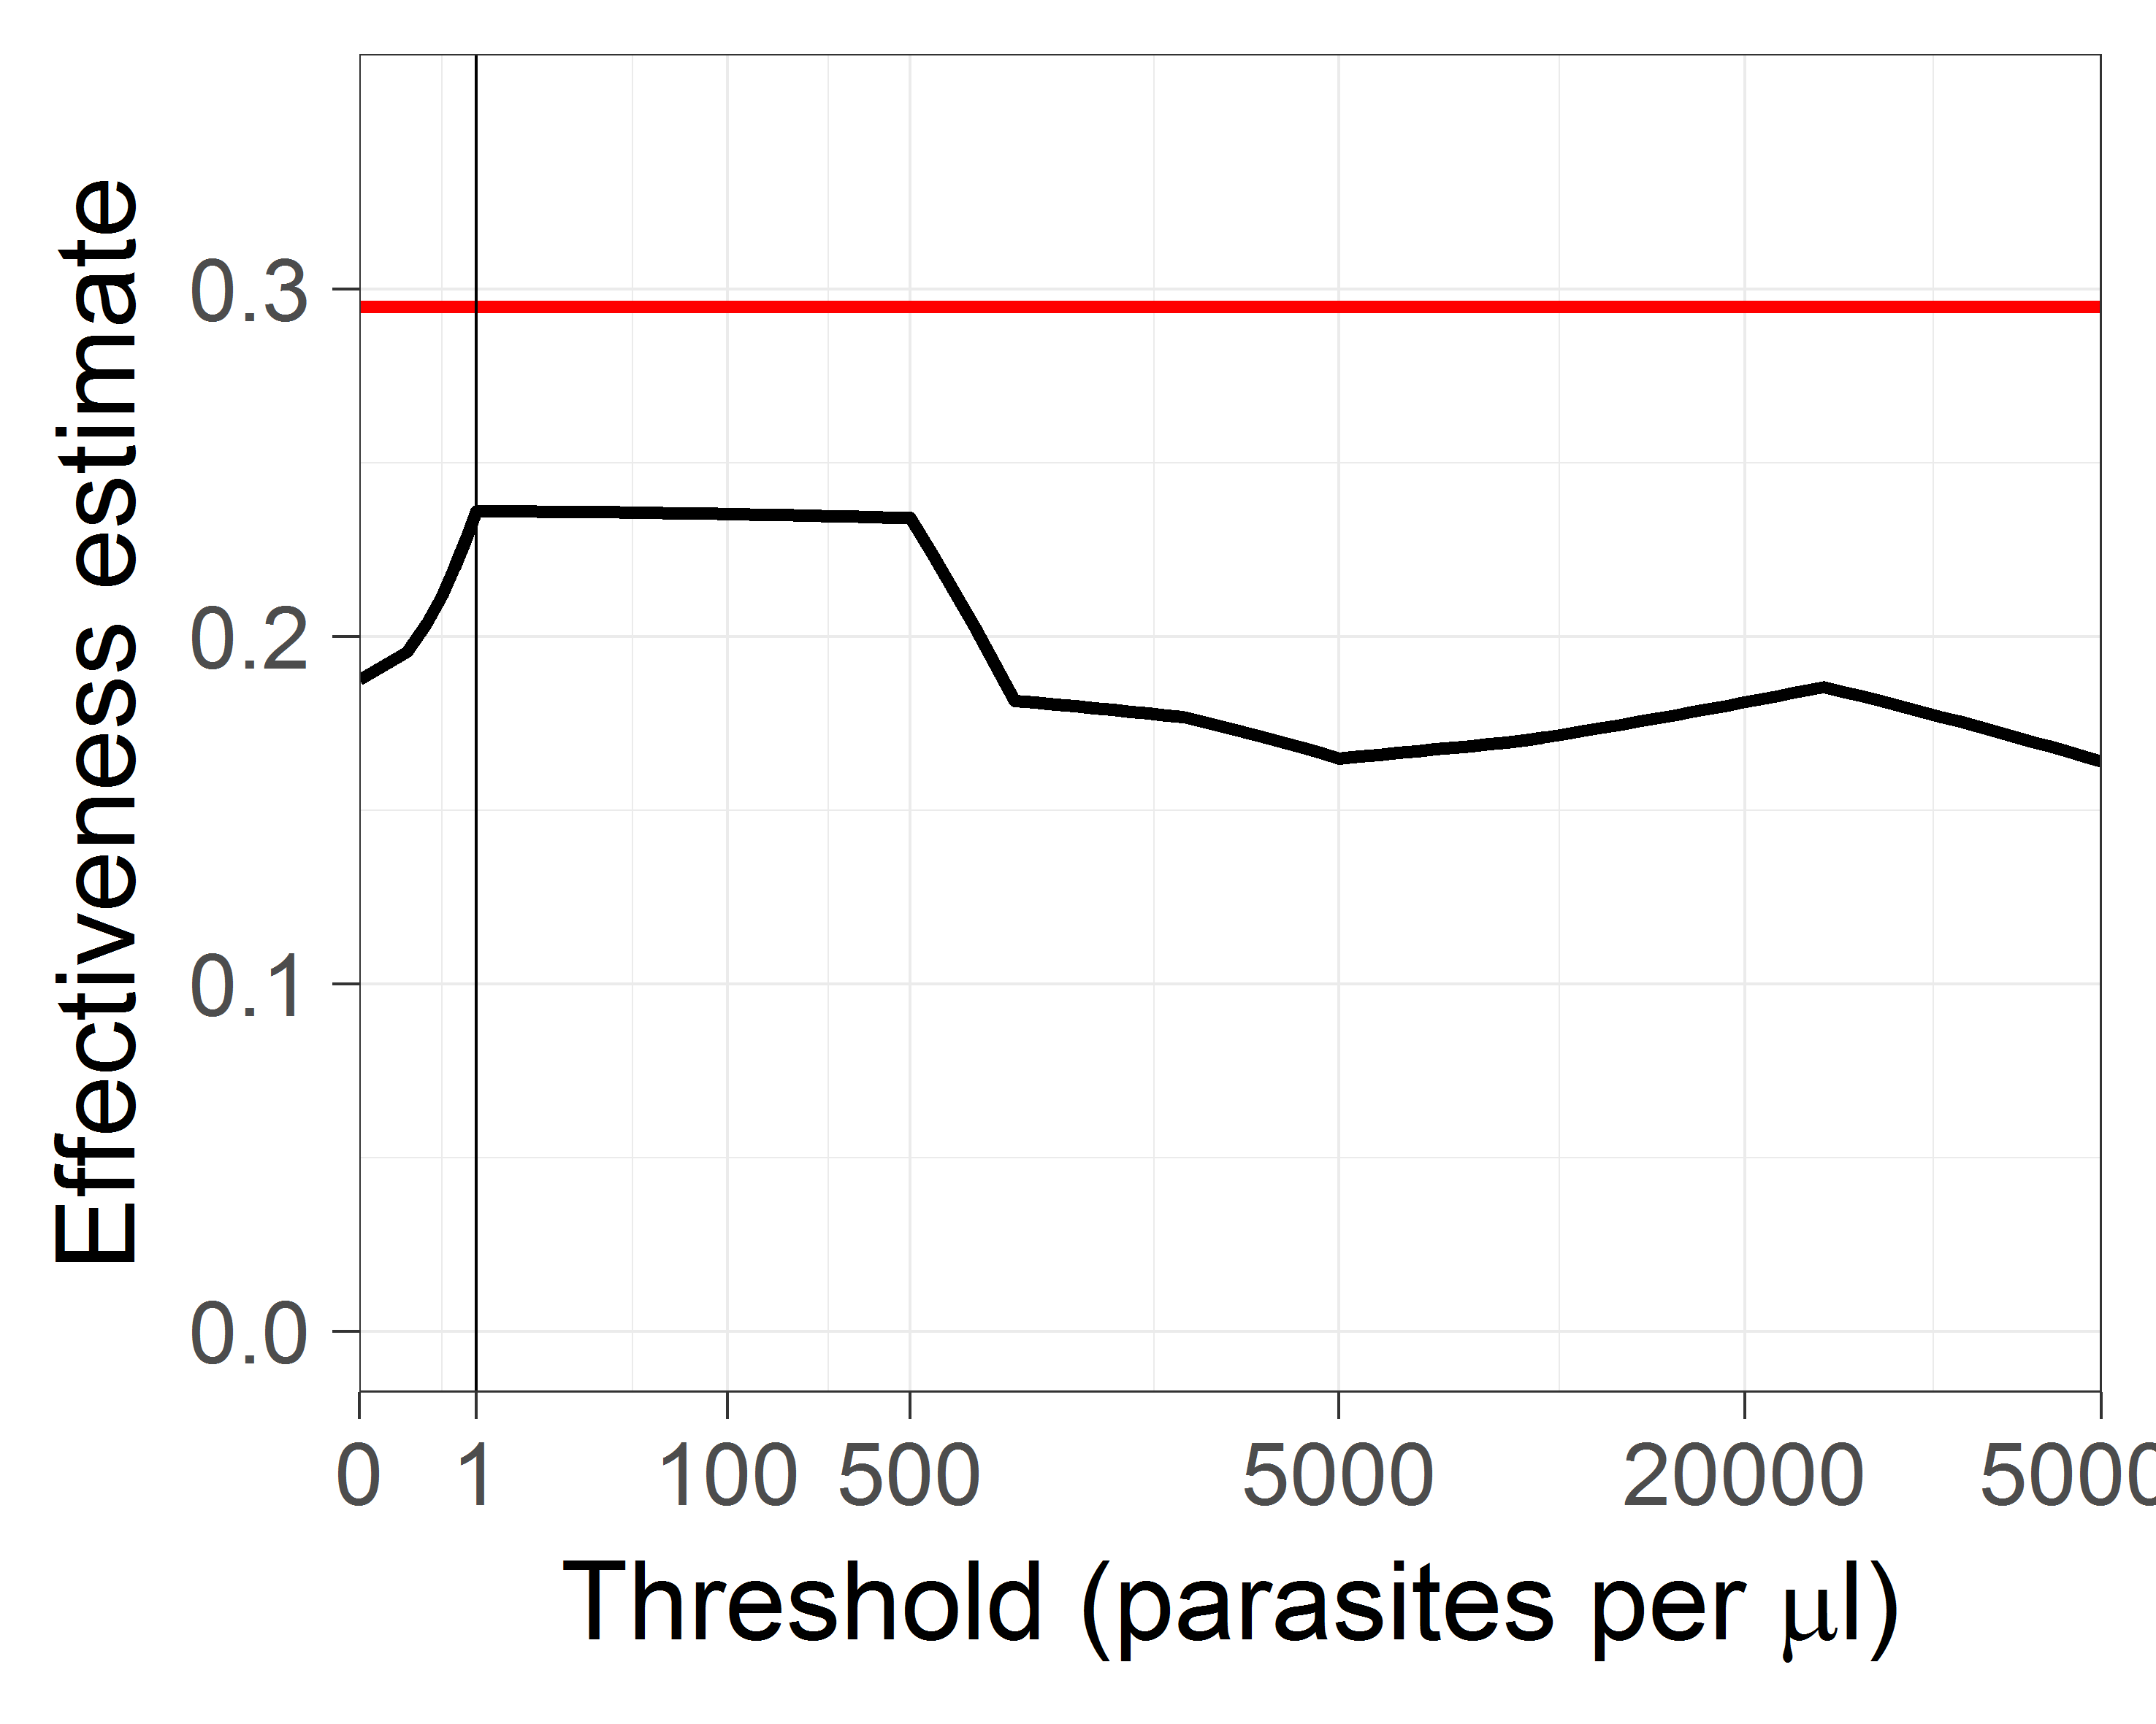

**Figure C6. Effectiveness estimates made using different thresholds**

Thick black line, unadjusted estimates; red line adjusted estimate; vertical line corresponds to threshold of any parasitaemia by microscopy.

Somewhat contrary to expectations, the effectiveness estimates do not increase with the use of higher (more specific) thresholds. However, the adjusted estimate of effectiveness of 0·295 (95% CI: 0·232-0·351), (obtained by assigning probabilities that fevers are malaria attributable as functions of the parasite density) is higher than the effectiveness estimates obtained by using any fixed cutoff. In particular, the estimate obtained using the threshold of any parasitaemia by microscopy, of 0·236 is 20% lower than the adjusted value. This suggests that there is a considerable downward bias in the primary efficacy measure because of inclusion of non-malaria fevers, but that the fevers with the highest parasite densities were no more likely to be in the control arm than were malaria fevers with lower densities.

**Discussion and conclusions**

There is no evidence in these data of any important imbalances between the arms in terms of the distributions of parasite densities in infected individuals, and clinical malaria cases in the two arms have similar parasite density distributions.

The specificity of clinical malaria definitions increases with the use of a higher parasite density threshold, as expected. Nevertheless with this dataset, the use of a more specific case definition would not lead to a higher effectiveness estimate.

At the same time, the analysis suggests that the misclassification of cases of non-malaria fever with incidental parasitaemia introduces a substantial downward bias in the efficacy estimates. The true effectiveness of the intervention in averting clinical malaria is approximately 20% higher than the estimates obtained from the primary analysis.

**Winbugs code**

model latentclass

{

for (a in 1:arms) {

for (i in 1:2){

z0[a,i]<-(i-1)*0.0001

phi0[a,i]<-theta[a,i]*z0[a,i]

}

theta[a,1]<-1-St[a]

eltheta[a,1]~ dgamma(1.0,1.0)

theta[a,2]<-eltheta[a,2]/(1+Sr[a])

eltheta[a,2]~ dgamma(1.0E-2,1.0E-2)

for (i in 3:K){

phi0[a,i]<-theta[a,i]*z0[a,i]

eltheta[a,i]~ dgamma(1.0E-2,1.0E-2)

theta[a,i]<-eltheta[a,i]/(1+Sr[a])

z0[a,i]<-z0[a,i-1]/q[a,i]

}

Sn[a]<-sum(n[a,])

Sm[a]<-sum(m[a,])

Sr[a]<-sum(eltheta[a,2:K])

St[a]<-sum(theta[a,2:K])

Sp[a]<-sum(p0[a,])

Sphi0[a]<-sum(phi0[a,])

for (i in 1:K){

phi[a,i]<-phi0[a,i]/Sphi0[a]

z[a,i]<-z0[a,i]/Sphi0[a]

q[a,i]~dunif(0.001,0.999)

p0[a,i]<- theta[a,i]*(1-lambda[a])+lambda[a]*phi[a,i]

p[a,i]<-p0[a,i]/Sp[a]

lami[a,i]<-lambda[a]*phi[a,i]/p0[a,i]

}

# Computation of sensitivities and specificities of cutoffs

sens[a,1] <- 1.0

spec[a,1] <- 0.0

cum_theta[a,1] <- theta[a,1]

cum_phi[a,1] <- phi[a,1]

cum_p[a,1] <- p[a,1]

unadj_cases[a,1] <- Sn[a]/Sm[a]

adj_cases[a,1] <- Sn[a]*lambda[a]/Sm[a]

for (i in 2:K){

sens[a,i] <- sens[a,i-1]-phi[a,i-1]

cum_theta[a,i] <- cum_theta[a,i-1] + theta[a,i]

cum_phi[a,i] <- cum_phi[a,i-1] + phi[a,i]

cum_p[a,i] <- p[a,i-1] + p[a,i]

spec[a,i] <- 1 - (1 - cum_theta[a,i-1])/(1 - cum_p[a,i-1])

# Total cases included by threshold,

# scaled by population at risk (via total of m)

# adj_ refers to adjustment for incidental parasitaemia

unadj_cases[a,i] <- (1 - cum_p[a,i-1])*Sn[a]/Sm[a]

adj_cases[a,i]<-(1-cum_phi[a,i-1])*Sn[a]*lambda[a]/Sm[a]

}

m[a,1:K]~ dmulti(theta[a,1:K], Sm[a])

n[a,1:K]~ dmulti(p[a,1:K], Sn[a])

lambda[a]~ dunif(0.00001,0.99999)

}

# Comparisons between arms by cutoff

for (i in 1:K){

unadj_eff[i] <- 1 - unadj_cases[2,i]/unadj_cases[1,i]

adj_eff [i]<- 1 - adj_cases[2,i]/adj_cases[1,i]

}

}

## C: Estimation of EIR

To model the numbers of female *A. gambiae* collected per trap, we used a negative binomial model, with village cluster as a random effect, and treatment arm, month and health facility as fixed effects. The means by arm were estimated marginally over month and health facility, assuming a random effect of zero. We used a logistic regression model with the same random and fixed effects to model the sporozoite prevalence, and the prevalences by arm were estimated similarly.

For arm $i=0$ (standard LLINs) and $i=1$ (PPF-LLINS), let ${HDM}_{i}$ indicate the household density of mosquitoes and ${SPR}_{i}$ indicate the sporozoite proportion, estimated as described above. Let $n$ represent the number of days in the transmission season ($n=214$). As per the main manuscript, the entomological inoculation rate (EIR) was estimated for each arm $i$ as follows:

$${EIR}_{i}={HDM}_{i}×{SPR}_{i}×n$$

The ratio of the EIR was determined as ${EIR}_{1}/{EIR}_{0}$.

To estimate 95% confidence intervals, we treated ${HDM}_{i}$ and ${SPR}_{i}$ as independent variables and used an asymptotic approximation following Armitage and Berry (1). Let the means of ${HDM}_{i}$ and ${SPR}_{i}$ be denoted $μ_{i1}$ and $μ_{i2}$, respectively, and their variances $σ_{i1}$ and $σ_{i2}$, respectively. Then the variances of the product of ${HDM}_{i}$ and ${SPR}_{i}$ for each arm $i$ are given by:

$$var\left({HDM}_{i} {SPR}_{i}\right)=μ_{i1}^{2}σ_{i2}^{2}+μ_{i2}^{2}σ_{i1}^{2}+σ_{i1}^{2}σ_{i2}^{2}$$

We then used a Normal approximation to estimate the confidence intervals for the product ${HDM}_{i} {SPR}_{i}$, and finally multiplied the confidence limits by $n=214$.

For the confidence interval of the ratio ${EIR}_{1}/{EIR}_{0}$, we used the approximation:

$$var\left({EIR}_{1}/{EIR}_{0}\right)=\frac{var({EIR}_{1})}{{E({EIR}_{0})}^{2}}+\frac{{E\left({EIR}_{1}\right)}^{2}}{{E\left({EIR}_{0}\right)}^{4}}var({EIR}_{0})$$

assuming that the coefficient of variation of ${EIR}_{1}$ is small (1). We obtained a p-value using a Wald test.

**D: Insecticide-susceptibility tests.**

**Discriminating Dose Assays**

Results of the WHO susceptibility tests performed during the study. Mosquitoes were collected from three health districts in the Cascades region, Burkina Faso. Health districts are specified within brackets. Mosquitoes were collected as larvae in July (Tiefora and Bakaridjan in 2014) or October (Naniagara and Bakaridjan 2015).

|  |  |  |  |  |  |  |  |  |
| --- | --- | --- | --- | --- | --- | --- | --- | --- |
|  |  | 2014 | | |  | 2015 | | |
| Village |  | Replicate | Mortality | n |  | Replicate | Mortality | n |
| Tiefora Centre (Tiefora) |  | 1 | 2 | 22 |  | 1 | 0 | 25 |
|  | 2 | 4 | 25 |  | 2 | 1 | 27 |
|  | 3 | 6 | 27 |  | 3 | 0 | 24 |
|  | 4 | 1 | 23 |  | 4 | 0 | 21 |
|  | Total | 13 | 97 |  | Total | 1 | 97 |
|  |  | % mortality | 13.4 |  |  | % mortality | 1.03 |  |
|  |  |  |  |  |  |  |  |  |
| Naniagara (Kankounadeni) |  | 1 | 5 | 29 |  | 1 | 1 | 27 |
|  | 2 | 1 | 25 |  | 2 | 2 | 27 |
|  | 3 | 2 | 26 |  | 3 | 6 | 23 |
|  | 4 | 2 | 19 |  | 4 | 11 | 24 |
|  |  | Total | 10 | 99 |  | Total | 20 | 101 |
|  |  | % mortality | 10.1 |  |  | % mortality | 19.8 |  |
|  |  |  |  |  |  |  |  |  |
| Bakaridjan (Koflande) |  | 1 | 7 | 21 |  | 1 | 4 | 24 |
|  | 2 | 9 | 22 |  | 2 | 3 | 29 |
|  | 3 | 3 | 18 |  | 3 | 6 | 31 |
|  | 4 | 1 | 26 |  | 4 | 4 | 31 |
|  | 5 | 7 | 30 |  | 5 | 6 | 22 |
|  |  | 6 | 3 | 18 |  |  |  |  |
|  |  | 7 | 2 | 32 |  |  |  |  |
|  |  | Total | 32 | 167 |  | Total | 23 | 137 |
|  |  | % mortality | 19.2 |  |  | % mortality | 16.8 |  |

**Measurements of intensity of permethrin resistance.**

A modified version of the CDC bottles assay was used to estimate the permethrin Lethal Concentration 50 (LC50), which is the dose that kills 50% of a population for mosquitoes collected from the three health districts in October 2013. Bottles were coated internally with different concentrations of permethrin (ranging from 5 ppm to 120 ppm) following the procedure described by CDC5 and the modifications proposed by Bagi *et al* 6Four groups of approximately 25 three to five days old female mosquitoes were aspirated into the bottles and exposed for 60 min. Mosquitoes were then transferred to paper cups with 10% sucrose available, and mortality recorded 24h later. In every experiment control bottles impregnated only with the solvent (acetone) were also tested.

The permethrin LC50 ranged from 17.8 ppm in Bakaridjan mosquitoes to 29.7 ppm in Naniagara mosquitoes (Figure D1). There was a significant difference in the LC50 between Bakaridjan and the other two sites although the difference between the highest and lowest value was less than 1.7-fold. The permethrin LC50 for the Kisumu susceptible strain was previously calculated as 0.284 ppm6, and thus estimates of the resistance ratio of the field populations range from 60.7 to 115.1 fold.

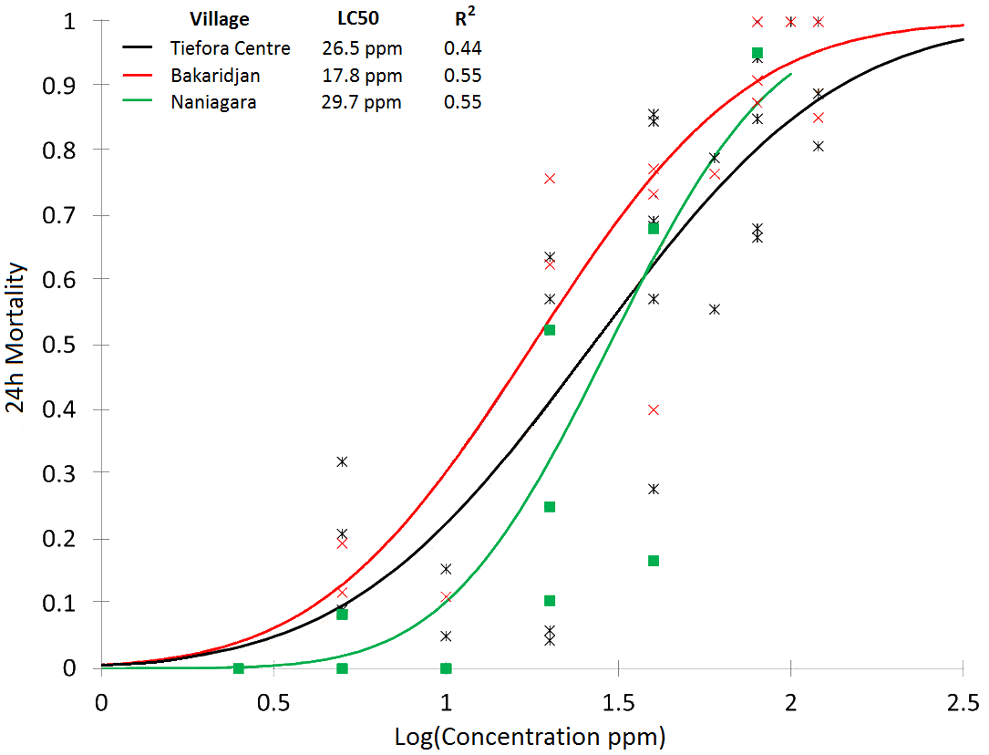

**Figure D1 Permethrin LC50**. Mortality curve showing the effect of different permethrin (log) concentrations on survival of *An. gambiae* *s.l.* collected from three sites in 2013.

**References**

1. Armitage P, Berry G. Statistical methods in medical research. Oxford: Blackwell Scientific; 1994.

2. Smith T, Amstrong Schellenberg J, Hayes R. Attributable fraction estimates and case definitions for malaria in endemic areas. *Statistics in Medicine* 1994; **13**: 439-42.

3. Vounatsou P, Smith T, Smith AFM. Bayesian analysis of two-component mixture distributions applied to estimating malaria attributable fractions. *AJ R Stat Soc Ser C Appl Stat* 1998; **47**: 575-87.

4. Spiegelhalter D, Thomas A, Best N, Lunn D. WinBUGS Version 1.4 Cambridge, England MRC-BSU; 2003.

5. Brogdon W, Chan A. Guideline for evaluating insecticide resistance in vectors using the CDC bottle bioasssay. . Atlanta: CDC, 2010.

6. Bagi J GN, Corkill R, Morgan JC, N’Falé S, Brogdon WG, et al. . When a discriminating dose assay is not enough: measuring the intensity of insecticide resistance in malaria vectors. . *Malaria J* 2015; **14**: e210.